
COMSATS University Islamabad (CUI)

Project Proposal
for
ForiFlow
(SME Credit Scoring & Early Warning System for Pakistani Banks)
Version 2.4
By
Ramzan Ahmed Idreesi CIIT/SP23-BBD-056/ISB
Zakria Saeed Abbasi CIIT/SP23-BBD-073/ISB

Supervisor
Ms. Sarah Tariq

Bachelor of Science (Business Data Analytics)
(2023-2027)
Revision history. Version 1.0: original CUI proposal draft. Version 1.1: aligned datasets, AUC, UI, and EWS with the running prototype. Version 1.2: full API surface, SMOTE-in-CV, relative-ranking caveat. Version 2.0: complete product alignment. Version 2.1: served-artefact metrics restated to four decimals (CV 0.7758 +/- 0.0075); AUC ladder ceiling 0.7776 documented as not shipped; EWS described as rule-based rather than ensemble re-inference; Give Me Some Credit recorded as a consumer-credit proxy that is not production; SME census vintage and NPL citations clarified. Version 2.2: Docker/pilot database is PostgreSQL 16.6 with Alembic (0001_initial, 0002_users); on-premise JWT login (HS256, eight hours; roles admin and analyst share the scoring and EWS API); the first officer is created with python -m scripts.seed_admin after the backend is healthy; pytest still uses in-memory SQLite. Version 2.3: everyday Windows start is start.bat / start.ps1 (starts Docker Desktop if needed, no rebuild); API, dashboard, and Postgres are published on 127.0.0.1 only; unused intake fields carry an amber label; SHAP summary cards are rounded so they add to the displayed score; EWS filters are All / Active / Resolved; sidebar copy is on-premise explainability (no live ECIB, not SBP-certified), not 'SBP compliance mode'; live MVP click-through verified 5 September 2026. Version 2.4: collapsed a duplicated sentence in the SHAP waterfall description (FE-1); retired the duplicate in-app /poster marketing route in favor of one canonical printable A1 poster (docs/foriflow-poster.html); renamed the ml-served payment-history feature label from '(ECIB)' to '(officer-entered)' for consistency with the no-live-ECIB language used everywhere else; full backend test suite (105/105) reverified against a live PostgreSQL 16 instance and the trained ensemble on 18 September 2026. Version 2.5 (25 September 2026): the Random Forest member now carries the same monotone constraints as XGBoost, so the served score is monotone in every input (served metrics restated: CV 0.7752 +/- 0.0073, hold-out 0.7731); the trained artefacts are committed; scikit-learn 1.8.0 and xgboost 3.4.0 pinned on Python 3.12; payment history read as clean (53-100) or adverse (0-52); resolving EWS alerts and creating officer accounts are admin-only; Rejected applications cannot be monitored; screenshots recaptured from the rebuilt app; 121 backend tests pass on PostgreSQL 16 with both scoring engines.
Table of Contents
Abstract 1
1. Introduction 2
2. Problem Statement 2
3. Problem Solution/Objectives of the Proposed System 3
3.1 Objectives 4
4. Related System Analysis/Literature Review 5
5. Vision Statement 6
6. Scope 7
7. Modules 9
8. System Limitations/Constraints 12
9. Data Gathering Approach 13
10. Tools and Technologies 18
11. Project Stakeholders and Roles 19
12. Module based Work Division 20
13. WBS and Gantt Chart 21
14. 14. Risk Analysis and Mitigation 23
15. 15. Testing Plan and Evaluation Criteria 26
16. Mockups 27
17. References 31
18. Plagiarism Report 34

Project Category: Artificial Intelligence / Machine Learning; Data Analytics; Web Application; Financial Technology (SME credit scoring and Early Warning System).
A-Desktop Application/Information System B-Web Application/Web Application based Information System C-Problem Solving and Artificial Intelligence D-Simulation and Modeling E-Smartphone Application
F-Smartphone Game G-Networks H-Image Processing
Other (specify category) ________________

Abstract
Pakistani SMEs are commonly reported as about 98.6% of enterprises and about 40% of GDP (ADB Asia SME Monitor 2024 / SMEDA). Formal credit access remains thin: the State Bank of Pakistan's SME financing tables for 31 December 2024 report 183,987 SME borrowers and SME financing equal to 6.06% of private-sector credit. Underwriting is still largely collateral- and ECIB-based; post-disbursement monitoring is periodic. ForiFlow is an on-premise Final Year Project prototype that scores officer-entered SME data and tracks borrower health after disbursement. Origination uses an XGBoost-Random Forest soft-voting ensemble (served weights 0.60 / 0.40) that returns a 0-100 score defined as risk_score = 100 x (1 - PD), with SHAP TreeExplainer explanations in probability space. Because SMOTE is applied inside each cross-validation fold, that score is a relative creditworthiness ranking, not a calibrated absolute default probability. The served model uses three features that map cleanly from the winning public file credit_risk_dataset.csv (credit_risk_shared, n = 32,581, default rate 21.82%): loan_to_income, payment_history_score, and years_in_operation. Measured performance of the served artefacts (trained 25 September 2026, both ensemble members monotone-constrained): 5-fold stratified CV AUC-ROC 0.7752 +/- 0.0073 (mean F1 0.543); hold-out AUC-ROC 0.7731, F1 0.546, PR-AUC 0.564, Brier 0.185. Candidate selection on the same file reported AUC-ROC 0.7752. A later AUC ladder on these three features, run on the earlier forest-unconstrained ensemble (class weight, 20-trial Optuna, blend 0.65/0.35) reached 0.7776 +/- 0.0067 and was not shipped, because the +0.0018 gain sits inside fold noise; AUC-ROC 0.85 is not reachable on this feature set. A separate Give Me Some Credit consumer-credit experiment (cs-training.csv, n = 150,000) reached 0.8656 +/- 0.0033 when days-past-due, utilisation, DebtRatio, and income were available; that result is not an SME or Pakistani-bank figure and did not replace production pickles. The Early Warning System does not re-run the ensemble: an officer submits a monthly observation and a rule-based score is derived from the origination baseline using installment ageing, bureau leverage, and POS coverage. An alert fires when that score drops more than 15 points. Estimated days-to-default is a heuristic, not a validated 60-90 day lead time. The stack is FastAPI, React 18, PostgreSQL 16.6 (Alembic-managed schema), on-premise JWT login, and Docker Compose (nginx proxies /api). Officers sign in at /login; scoring and EWS routes require a Bearer token. GET /health and GET / remain public. The first officer account is created with python -m scripts.seed_admin after the backend is healthy, not automatically at startup. On Windows, start.bat (or start.ps1) starts Docker Desktop if needed, brings existing images up, and reminds the officer to seed only when no user exists. The API, dashboard, and PostgreSQL are published on 127.0.0.1 only. Unused intake fields show an amber label that they do not move this score. SHAP summary cards are rounded so a credit officer can add them to the displayed 1-decimal score. EWS filters are All, Active, and Resolved (In Review is a backend enum only). ForiFlow is designed to support SBP-oriented explainability; it is not SBP-certified. The sidebar states that there is no live ECIB feed.

Introduction
This proposal outlines the design, development, and delivery of ForiFlow, an on-premise credit-intelligence prototype that combines AI origination scoring with a post-disbursement Early Warning System (EWS) for Pakistani SME lenders. ADB (2024) reports Pakistan's MSMEs as 98.6% of enterprises. The 3.2 million enterprise count still quoted in many policy briefs is the 2005 Economic Census vintage; later PBS establishment work records about 7 million units. The sector is commonly cited at about 40% of GDP and about 25% of export value. Formal credit remains limited: SBP SME financing tables for 31 December 2024 report 183,987 SME borrowers and SME financing equal to 6.06% of private-sector credit. The Electronic Credit Information Bureau (ECIB) captures formal borrowers, so most informal SMEs remain invisible to conventional scorecards. Banks commonly reject SME applications that lack collateral or documented history (a figure often cited at over 60%). After approval, monitoring is typically manual. ADB (2024) puts Pakistan's MSME NPL ratio at 15.0% in 2023; SBP 2024 quarterly tables are the source for the 14.16%-17.36% intra-year range used in the original draft. Those NPL figures describe the SME/MSME book, not the 6.3% banking-system NPL ratio for December 2024.
ForiFlow closes these gaps with a working Final Year Project prototype: an XGBoost and Random Forest soft-voting ensemble (served weights 0.60 XGB / 0.40 RF), SHAP TreeExplainer, a FastAPI backend, a React 18 dashboard, PostgreSQL persistence (Alembic), on-premise JWT authentication, and Docker Compose for on-premise deployment. If trained artefacts are missing, the API falls back to a linear surrogate so the dashboard still boots (the trained pickles are committed, and GitHub Actions tests both engines). The officer intake form collects alternative-data fields (digital receipts, inventory turnover, order consistency, cash-flow proxy, headcount, existing debt, tenure). The served ensemble uses three features: loan_to_income (from requested amount and estimated gross turnover = max(monthly digital payments, cash-flow proxy) x 12), payment_history_score, and years_in_operation. Inventory turnover, order consistency, employee count, existing debt, and requested tenure are stored for policy review and a future bank-data retrain; they do not move the present ML score. The surrogate engine, used only when pickles are absent, does use those extra fields. Live screens are in docs/screenshots/. This document describes the problem context, objectives, literature, architecture, work plan, measured metrics, and the delivered prototype.

Problem Statement
Pakistani SME lenders still lack a widely deployed, explainable alternative-data scoring stack. After approval, most books also lack a working Early Warning System that flags deteriorating borrower health before default. The market fails SMEs twice: at the point of application, and throughout the loan lifecycle.
The root cause of the first failure is the exclusive reliance on collateral and formal credit records reported by the ECIB. Because most SMEs operate in the informal economy, they lack the documented financial history required by conventional underwriting models; consequently, applications that lack collateral or a bureau file are routinely declined (a figure commonly cited at over 60%). The second failure is a monitoring gap. Once a loan is disbursed, banks rely on periodic, manual reviews that rarely detect early signs of distress. By the time a missed payment is recorded, the borrower may already be beyond viable restructuring, contributing to elevated SME/MSME NPLs (ADB 2024: 15.0% for Pakistan in 2023; SBP 2024 quarterly SME tables: 14.16%-17.36% intra-year). Those figures describe the SME/MSME book, not the 6.3% banking-system NPL ratio for December 2024. A further structural weakness is the opacity of existing credit models: those few that exist are proprietary, focused on consumer lending, and cannot provide the audit trail required by SBP's evolving governance framework. ForiFlow is designed to address all three challenges with an interpretable, officer-operated credit-intelligence prototype for Pakistani SME lending.

Problem Solution/Objectives of the Proposed System
ForiFlow provides an integrated web platform that lets a bank officer score an SME applicant from the intake form, store a SHAP explanation with every decision, and monitor a disbursed borrower by submitting a monthly observation. Collateral is not required at the point of scoring. Origination scoring is the ensemble described above. Post-disbursement scoring is not a second ensemble pass: EWS derives a current score from the origination baseline by applying installment-ageing penalties, extra bureau leverage, and weak POS coverage. An alert is written when that score drops more than 15 points. Estimated days-to-default is a heuristic (base runway by ageing bucket, shortened by excess drop); it is not an empirically validated 60-90 day forecast.
The solution is a containerised FastAPI REST backend with endpoints POST /auth/login, POST /score, GET /score/applications, GET /score/applications/{id}, GET/POST /explain/{id}, POST /ews/monitor, GET /ews/alerts, PATCH /ews/alerts/{id}/resolve, GET /ews/borrowers/{id}/history, GET /auth/me, GET/POST /auth/users, GET /health, and GET /, integrated with a React 18 dashboard. Training is python -m ml.train_real_model from backend/. SMOTE runs inside each StratifiedKFold split (5 folds, shuffle=True, random_state=42) so synthetic rows do not leak into validation. Pytest covers scoring, SHAP additivity, EWS alert contracts, and JWT login. There is no MLflow registry. Officers authenticate with on-premise JWT (HS256, eight-hour lifetime, roles admin and analyst). Both roles may score and monitor; only admin may resolve EWS alerts or list and create officer accounts, and the role is read from the database on every request. Served public-data results: AUC-ROC 0.7752 +/- 0.0073 (5-fold CV), hold-out AUC-ROC 0.7731, F1 0.546, Brier 0.185. AUC-ROC 0.85 and F1 0.80 are not current results and, on the three served features, are not reachable by further tree tuning (ladder ceiling 0.7776 +/- 0.0067). Scoring one applicant took about 230 ms on the development laptop with the earlier, larger forest; the constrained forest takes about 17 ms in the cloud test environment. Interventional TreeSHAP dominates the time. Repository: https://github.com/Idreesi8/ForiFlow.
Figure: Delivered ForiFlow architecture. Officer intake to FastAPI origination scoring (XGBoost + Random Forest, three features, SHAP TreeExplainer) to decision bands 0-40 Rejected / 41-70 Manual Review / 71-100 Approved. React dashboard on 127.0.0.1:3000 proxies /api to FastAPI on 127.0.0.1:8000. Everyday start is start.bat / start.ps1. PostgreSQL is bound to 127.0.0.1:5432. Protected routes require a JWT from POST /auth/login. EWS is officer-submitted monthly monitoring with a rule-based score derived from the origination baseline; an alert fires if that score drops more than 15 points. Served public-data 5-fold CV AUC-ROC is 0.7752 +/- 0.0073. AUC-ROC 0.85 is a bank-data target that is not met on three features. Not SBP-certified.

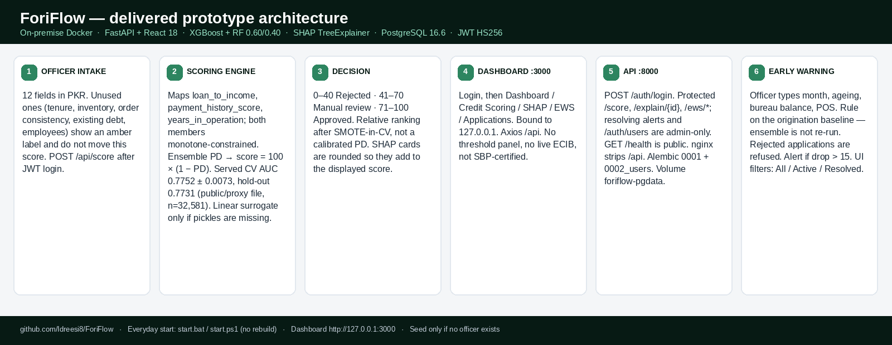

Objectives
Main Objective: Design and implement an SME credit scoring and Early Warning System for Pakistani banks using an XGBoost-Random Forest ensemble for origination, SHAP explainability, and officer-submitted rule-based monthly monitoring, delivered through a REST API and React dashboard. This objective is met by the running FYP prototype.
- BO-1: Train and select a credit scoring model from two public files, credit_risk_dataset.csv and Loan_default.csv, via a three-candidate bake-off (credit_risk_shared, loan_default_full, combined_shared). The selected and served candidate is credit_risk_shared (3 features, 32,581 rows, 7,108 defaults, 21.82% default rate) with selection AUC-ROC 0.7752, full-data 5-fold CV AUC-ROC 0.7752 +/- 0.0073 (F1 0.543), and hold-out AUC-ROC 0.7731, F1 0.546, PR-AUC 0.564, Brier 0.185. Rejected candidates: loan_default_full AUC-ROC 0.644; combined_shared AUC-ROC 0.635. SMOTE is applied inside each CV fold. Served ensemble weights are 0.60 XGB / 0.40 RF, and both members carry the same monotone constraints (loan_to_income +, payment_history_score -, years_in_operation -), so the served score is monotone in every input. A post-build AUC ladder on the same three features, run before the Random Forest was constrained, reached 0.7776 +/- 0.0067 and was not written to production pickles. AUC-ROC >= 0.85 and F1 >= 0.80 remain targets only for a future retrain on Pakistani SME data that actually contains richer fields; they are not claimed now.
- BO-2: Integrate SHAP TreeExplainer so every stored decision includes feature contributions that add back to the 0–100 score. Met: waterfall on Credit Scoring and SHAP Reports; payload stored with the application.
- BO-3: Develop an Early Warning System that records a monthly monitoring observation (installment status, bureau balance, POS cash balance, data source). The current score is derived from the origination baseline by a published rule set, not by re-inferring the ensemble. An alert is raised when the derived score drops more than 15 points (strictly greater than 15.0). Each alert stores a heuristic estimated-days-to-default (7-365 days, or 0 on Default); that figure is not a validated 60-90 day lead time. Unresolved alerts are updated in place; re-submitting a month overwrites that observation.
- BO-4: Deploy a FastAPI REST backend with POST /auth/login, GET /auth/me, GET/POST /auth/users (admin), /score, /score/applications, /explain/{id}, /ews/monitor, /ews/alerts, /ews/alerts/{id}/resolve, /ews/borrowers/{id}/history, and /health, served on-premise via Docker Compose (nginx proxies /api; images foriflow-backend:1.0.0 and foriflow-frontend:1.0.0). Persistence in the Docker/pilot stack is PostgreSQL 16.6 (named volume foriflow-pgdata). Schema is owned by Alembic: backend startup runs upgrade head (0001_initial, then 0002_users). JWT_SECRET_KEY is required for compose to start. The first officer is seeded with docker compose exec backend python -m scripts.seed_admin (password from FORIFLOW_ADMIN_PASSWORD; --reset-password rotates an existing hash). Everyday start on this laptop is start.bat / start.ps1 (127.0.0.1 bind, no rebuild). Pytest uses in-memory SQLite so the suite does not need a live database. GitHub: https://github.com/Idreesi8/ForiFlow. CI (GitHub Actions, Python 3.12) runs on every push: pytest against PostgreSQL 16 with both the surrogate and the committed trained ensemble, plus a frontend production build.
- BO-5: Deliver a React dashboard with sidebar routes Dashboard, Credit Scoring, SHAP Reports, EWS Alerts, and Applications; a 0–100 score gauge (0–40 Rejected, 41–70 Manual Review, 71–100 Approved); SHAP waterfall; EWS monitoring form and alert table; application list with per-decision SHAP retrieval. Unused intake fields show an amber 'not currently used in this risk score' label. SHAP summary cards add to the displayed score. EWS filters are All / Active / Resolved. Met in the running prototype. Risk bands are code constants, not a live Threshold Configuration panel.
- BO-6: Contribute a validated prototype methodology for explainable SME credit scoring and data-driven borrower monitoring within the Pakistani banking context.

Related System Analysis/Literature Review
Sixteen peer-reviewed and institutional sources published between 2024 and 2026, plus the Give Me Some Credit file used only as a post-build diagnostic, inform ForiFlow's design. The review is organised around credit risk in Pakistan, model selection, alternative data, and early warning systems.

Table 1 Related System Analysis with proposed project solution
Application Name | Weakness | Proposed Project Solution
Traditional Pakistani bank underwriting (SBP ECIB-based) | Requires collateral/formal history; high rejection rate for thin-file SMEs (often cited at over 60%); no data-driven alternative for unbanked SMEs. | ForiFlow scores without requiring collateral; the intake form collects alternative-data fields, while the current ensemble uses loan_to_income, payment_history_score, and years_in_operation.
Rizvi (2025) – AI Framework for Pakistani SME Credit Risk | Conceptual framework only; no implemented system. | ForiFlow operationalises the framework as a fully functional platform with API and dashboard.
Jan & Ahmed (2025) – AI & Financial Inclusion in Pakistan | Demonstrates the value of alternative data but uses generic international datasets; no EWS or explainability. | ForiFlow adds SHAP explainability and a dedicated EWS, mapping public credit columns onto ForiFlow intake fields. That mapping is not Pakistani SME data.
Akhmetova et al. (2026) – Interpretable EWS for SME Delinquency | Model validated on non-Pakistani data; no integration with credit scoring or API delivery. | ForiFlow combines origination scoring with a rule-based EWS and a REST API that a bank could later integrate; this FYP does not connect to core banking.
Existing credit models used by fintechs (opaque, consumer-focused) | Black-box; no SHAP; not designed for SME portfolios or SBP audit requirements. | ForiFlow provides SHAP waterfall charts for every decision; designed for SBP-oriented explainability (not certified).
Zhang et al. (2025) – Gradient Boosting for Loan Default Prediction | Single model (Gradient Boosting) with F1=0.8084; no ensemble, no EWS, not contextualised for Pakistan. | ForiFlow uses an XGBoost+RF ensemble (Ayari et al., 2026) plus a rule-based EWS. Served public-data 5-fold CV AUC-ROC is 0.7752 +/- 0.0073; 0.85 is reserved for a bank-data retrain with richer features, not claimed now.

Key Literature Insights: Malik et al. (2025) found digital payment engagement strongly correlates with financial inclusion (r=0.684), which supports collecting digital receipts on the intake form even though only their contribution to loan_to_income currently moves the ensemble. Ayari et al. (2026) reviewed 63 papers and concluded XGBoost+RF outperforms deep learning on tabular credit data. HKMA & CRIF (2024) support inventory turnover and order consistency as MSME predictors; those fields are collected but not yet in the served model. Lin & Wang (2025) demonstrated SHAP stability across XGBoost runs, which is why TreeExplainer values are stored per decision. ADB (2024) reports Pakistan MSME NPL at 15.0% in 2023, higher than the system-wide bank NPL ratio. The research gap is that published Pakistani SME credit work does not combine ensemble scoring, SHAP, EWS, and a REST API in one implemented stack. ForiFlow is an FYP prototype that fills that gap. It is designed for SBP-oriented explainability; it is not certified.

Vision Statement
For Pakistani commercial and microfinance banks who need to expand SME lending while controlling default risk, the ForiFlow prototype is an AI-powered credit-intelligence system that generates officer-triggered, collateral-free origination scores with stored SHAP explanations and accepts monthly surveillance observations after disbursement. Unlike current manual underwriting that leaves most SMEs outside the formal book, the product combines ensemble origination, stored SHAP audit trails, and a dedicated EWS in a single on-premise Docker interface. EWS estimated days-to-default is a heuristic, not a proven 60-90 day forecast. This FYP is a prototype, not a live bank deployment.

Scope
ForiFlow's scope is a complete, working FYP prototype. Training evaluates two public files: credit_risk_dataset.csv and Loan_default.csv. A three-candidate bake-off selects credit_risk_shared (loan_to_income, payment_history_score, years_in_operation; 32,581 rows; selection AUC-ROC 0.7752; served 5-fold CV 0.7752 +/- 0.0073). The served model is an XGBoost and Random Forest soft-voting ensemble (0.60/0.40) trained with 5-fold StratifiedKFold, SMOTE inside each fold, StandardScaler, learned 1st/99th percentile clip bounds, and monotone constraints on both the XGBoost and the Random Forest member. SHAP TreeExplainer values are computed at inference in probability space. EWS does not ingest Home Credit time-series tables and does not re-run the ensemble; an officer submits monthly observations and a rule-based score is compared with the origination baseline. The backend is FastAPI, containerised via Docker, with PostgreSQL for applications, alerts, EWS tracking, and users. The frontend is a React 18 dashboard with routes /login, Dashboard, Credit Scoring, SHAP Reports, EWS Alerts, and Applications; unauthenticated visitors are redirected to /login. Explicitly out of scope: real Pakistani bank loan data (SBP/SECP restricted), live production deployment, deep learning, mobile apps, fraud detection, multi-bank federated learning, MLflow, a full RBAC permission matrix (admin and analyst share scoring and EWS; only admin resolves alerts and creates officer accounts), a dashboard threshold editor, and treating Give Me Some Credit metrics as SME performance. Home Credit (307,511), UCI German Credit, and CredXAI are not used in training or EWS. Give Me Some Credit (cs-training.csv) was used only as a post-build consumer-credit architecture test; it is not served in the API.
6.1 ForiFlow vs. Traditional Banking: A Comparison
The table below compares conventional Pakistani bank underwriting with this FYP prototype across the credit lifecycle. ForiFlow is an officer-operated demo, not a live core-banking replacement.
Dimension | Traditional Pakistani Banking | ForiFlow
Credit Evaluation Basis | Depends on collateral and formal financial statements | Uses officer-entered SME data; ML currently uses leverage, payment history, and years in operation
Review Process | Manual, time-consuming review by loan officers | AI-driven instant scoring via XGBoost–Random Forest ensemble
Loan Evaluation Type | Static — assessed once at application stage only | Officer-submitted monthly observation; a rule-based score is derived from the origination baseline (the ensemble is not re-run)
Default Detection | Reactive — discovered after missed payments are recorded | EWS alerts when the score drops more than 15 points; days-to-default is a heuristic
Decision Transparency | Opaque — officer judgment with no structured audit trail | Full SHAP explainability — every decision has a stored waterfall audit trail
Financial Data Required | Formal audited statements, tax records, collateral documents | Digital receipts (turnover proxy), payment history score, years in operation; other intake fields stored
SME Inclusion | SME applications without collateral are commonly declined (a figure often cited at over 60%) | Can score an applicant who lacks collateral if an officer enters alternative-data fields; the prototype does not acquire customers
Regulatory Compliance | No explainability mechanism; limited SBP audit capability | Designed for SBP-oriented explainability with a per-decision SHAP audit trail (not certified)

Modules
7.1 Module 1: Credit Scoring Engine

- FE-1: The bank officer submits an SME applicant's data using a structured web form. Required fields are: Applicant name, Business name, Loan amount (PKR), Tenure (months), Monthly digital payments (PKR), Payment history score (0-100), Inventory turnover (times/year), Order consistency (0-100), Existing debt (PKR), Monthly cash flow proxy (PKR), Years in operation, and Employees. Fields are numeric with min/max validation; they are not letter grades. A 'Score application' button posts to /score. The system returns a 0-100 risk score categorised as Approved (71-100), Manual Review (41-70), or Rejected (0-40). These bands are code constants (not a live management panel). Of the intake fields, the served ensemble uses loan_to_income (from loan amount and max(digital receipts, cash-flow proxy)), payment_history_score, and years_in_operation. Inventory turnover, order consistency, headcount, existing debt, and tenure are persisted but do not move the present ML score; each of those fields shows an amber label on the intake form.
- FE-2: Scoring is deterministic for a given model artefact: resubmitting the same applicant yields the same 0–100 score. Each response also includes a confidence heuristic (0–100) from member agreement and distance to the nearest policy band; it is a decision-stability indicator, not a statistical confidence interval. The dashboard does not display a prior-run count or ±variance badge; consistency is verified by Pytest.
- FE-3: Class imbalance in training is addressed by SMOTE inside each cross-validation fold. Because SMOTE balances the prior to 50%, the served 0–100 score is a relative ranking of creditworthiness, not an absolute default probability. Officers should not read the score as a calibrated PD percentage.
- FE-4: Each /score response includes a model_version string (ensemble identifier and training timestamp) which is persisted with the application. Officers can see that version on stored records. There is no MLflow model registry and no dashboard model-version selector in this prototype.

7.2 Module 2: SHAP Explainability
- FE-1: After scoring, the officer sees a SHAP waterfall on the Credit Scoring result and can open the same explanation on the SHAP Reports page (/shap/{application_id}). The Applications table links to that page; it is a dedicated route, not an auto-opening modal. The chart is a horizontal waterfall from the model base value, with bars for risk-increasing and risk-reducing features, ending at the 0–100 score. The on-screen summary cards (base, positive, negative, final) are rounded so they add to the displayed score. Stored SHAP payloads support audit retrieval. The prototype is designed to support SBP-oriented explainability; it is not an SBP certification.
- FE-2: The SHAP Reports page lists scored applications so an officer can review explanations across recent decisions. There is no separate portfolio SHAP bar chart in a dashboard right sidebar in this prototype.
- FE-3: The officer can retrieve stored explanation records for any past decision. Each row in the Applications table includes a SHAP action that opens /shap/{id} for that decision, not merely the application details.

7.3 Module 3: Early Warning System (EWS)
- FE-1: The bank officer monitors an active borrower by submitting a monthly observation through the EWS form: borrower (from scored applications), month number, installment status (On Time / Late 1-29 / Late 30-59 / Late 60-89 / Default), bureau balance, POS cash balance, and data source (ECIB / POS / Bank Statement / Self Reported). The backend derives a current score from the origination baseline: installment penalties 0 / 6 / 14 / 26 / 45 points, plus up to 12 points if bureau balance exceeds the original facility, plus up to 15 points if POS inflow is below the underwritten cash-flow proxy. History is available via /ews/borrowers/{id}/history. This prototype does not run a scheduler, does not re-infer XGBoost, and does not render a labelled Month 1-12 line chart; monitoring is form-plus-table.
- FE-2: The officer can view each borrower's origination risk score, stored with the scored application, as the baseline for tracking change over time. The prototype does not disburse a loan.
- FE-3: The officer receives an alert when the derived EWS score drops more than 15 points from origination. Alerts appear on the EWS Alerts page in a dedicated table (timestamp, scores, drop, estimated days to default, recommended action) and can be resolved. There is no notification bell, toast, or sidebar badge counter. Estimated days-to-default is a heuristic computed with the alert, not a validated 60-90 day lead time. The trigger is strictly greater than 15.0 points.
- FE-4: The officer can view an alert feed displaying borrower details, baseline score, current score, score drop, estimated days to default, and the recommended action. The feed filters client-side as All / Active / Resolved (In Review is not shown). Resolve updates the queue without a refresh. The feed filters client-side as All / Active / Resolved (In Review is not shown). Resolve updates the queue without a refresh. The feed filters client-side as All / Active / Resolved (In Review is not shown). Resolve updates the queue without a refresh. The feed filters client-side as All / Active / Resolved (In Review is not shown). Resolve updates the queue without a refresh. The API returns alerts worst-first. Clicking through can open the related SHAP report; it does not load a Month 1–12 trend chart.
- FE-5: To monitor a borrower, the officer selects them from the monitoring form’s borrower list (populated from scored applications) and submits the monthly observation. There is no separate searchable dropdown that drives a 12-month trend chart.

7.4 Module 4: Bank Officer Dashboard & REST API
- FE-1: The bank officer can submit applicant data through the dashboard (via the structured form in Module 1) and instantly receive a credit score, SHAP explanation, or EWS status without writing any code.
- FE-2: The officer interacts with a visual dashboard: score dial with fixed risk bands, SHAP waterfall on the scoring and SHAP Reports pages, EWS alert table with severity, and an application list with per-row SHAP access. There is no SHAP modal and no live threshold editor.
- FE-3: The officer can access the platform reliably across environments, as the system is delivered in a containerised setup (Docker) that ensures consistent behaviour.
- FE-4: System endpoints are covered by Pytest (HTTPX): POST /auth/login, POST /score, GET /score/applications, GET/POST /explain/{id}, POST /ews/monitor, GET /ews/alerts, PATCH /ews/alerts/{id}/resolve, GET /ews/borrowers/{id}/history, and GET /health, including 401 without a token on protected routes and 422 responses for malformed inputs. The test client attaches a JWT; an anonymous client is used to assert 401.
- FE-5: The dashboard is a React single-page application with a login page and a left navigation sidebar for Dashboard, Credit Scoring, SHAP Reports, EWS Alerts, and Applications. Unauthenticated users are redirected to /login. After POST /auth/login the SPA stores the JWT and Axios sends Authorization: Bearer on subsequent /api calls; a 401 clears the session. There is no notification bell, model-version selector, or System settings page. The sidebar states on-premise explainability, officer-typed bureau fields, and that ForiFlow is not SBP-certified. Docker nginx (or Vite in development) proxies /api to FastAPI. Ports are published on 127.0.0.1 only.

System Limitations/Constraints
- LI-1: Training and validation of the served model are performed on public credit files (credit_risk_dataset.csv, selected as credit_risk_shared with 32,581 rows; Loan_default.csv evaluated but not selected) rather than real Pakistani SME loan records, because SBP and SECP regulations restrict public release of such data. Home Credit, UCI German Credit, and CredXAI are not used. Give Me Some Credit was used only as a consumer-credit architecture test and is not served. The winning public dataset only supports three ML features; four requested concepts (DTI, cash-flow volatility, revenue slope, payment-delay frequency) have no counterpart and were not fabricated.
- LI-2: The system will not be deployed on a live bank production server within this FYP; deployment requires SBP Regulatory Sandbox approval and rigorous external security audits.
- LI-3: Deep learning architectures are excluded, as Ayari et al. (2026) show ensemble tree-based methods perform better on tabular datasets of this size.
- LI-4: The initial release will not include a mobile application, fraud detection module, or federated learning across multiple banks.
- LI-5: All risk thresholds are heuristics subject to bank-specific calibration. The EWS alert trigger (score drop greater than 15 points) and the credit score category bands (0–40 Rejected, 41–70 Manual Review, 71–100 Approved) are code constants in this prototype. They are not exposed as a Threshold Configuration panel. An institution must change those constants (and ideally retrain) before production use.
LI-6: The ensemble's 0-100 score is a relative creditworthiness ranking. Training on SMOTE-balanced data calibrates probabilities to a 50% prior rather than the 21.82% file default rate. Inventory turnover, order consistency, employees, existing debt, and tenure are stored but do not move the served ML score. If model artefacts are absent, the API serves a linear surrogate instead of the ensemble. EWS current scores are rule-based adjustments of the origination baseline, not new ensemble inferences. AUC-ROC 0.85 is not a property of the served three-feature model.

Data Gathering Approach
Primary origination training uses two public files in backend/ml/data/ (gitignored CSVs): credit_risk_dataset.csv and Loan_default.csv. Three candidates were compared on cross-validated AUC: credit_risk_shared (3 features, 32,581 rows, selection AUC-ROC 0.7752, F1 0.543), loan_default_full (6 features, 255,347 rows, AUC-ROC 0.644), and combined_shared (3 features, 287,928 rows, AUC-ROC 0.635); the two large candidates are cross-validated on a stratified 60,000-row subsample. credit_risk_shared was selected and is the served model. Full-data 5-fold CV on the winner is AUC-ROC 0.7752 +/- 0.0073. Home Credit Default Risk, UCI German Credit, CredXAI, and Home Credit installment/bureau/POS tables are not used. Give Me Some Credit is not used for production training (see 9.7). Because no public Pakistani SME credit file is available, dataset selection follows the precedent of Rizvi (2025) and Jan & Ahmed (2025). Preprocessing maps onto ForiFlow features, StandardScaler, SMOTE inside each CV fold, and learned 1st/99th percentile clips at serve time. Currency is handled as ratios (loan_to_income), so PKR intake does not require an FX assumption.
9.1 Why Pakistani Bank Data Is Needed
The current ForiFlow prototype uses international public datasets because real Pakistani SME banking data is restricted. A production deployment in a Pakistani bank would have to learn from local borrower behaviour, repayment patterns, and business conditions: informal firms are common, wallet usage is high, and regional conditions differ from the public training files. Local labelled SME data is required before the model can be treated as a Pakistani production scorecard; public international files cannot supply that calibration.
9.2 Data Required from Pakistani Microfinance Banks
When ForiFlow transitions to real-world deployment, the following nine categories of data will be required from Pakistani microfinance banks.
(i) Loan Application Data. Required fields include loan amount, loan tenure, loan purpose, business type, business age, monthly income/revenue, existing liabilities, number of employees, and region/city. This data creates the borrower’s basic financial profile, enabling the AI model to identify which businesses are riskier, which sectors perform better, and which applicants are more likely to repay loans.
(ii) Repayment History Data. This is the most critical data category for credit scoring, default prediction, and the EWS. Required fields include installment payment dates, late payments, missed installments, partial payments, days past due (DPD), and loan restructuring history. Repayment behaviour is one of the strongest indicators of future default risk; borrowers who begin paying late repeatedly signal financial stress that the system can detect early.
(iii) Mobile Wallet and Digital Payment Data. Many Pakistani SMEs do not maintain formal financial statements but actively use digital wallets such as JazzCash and Easypaisa. Required data includes transaction volume, incoming and outgoing payments, payment consistency, merchant activity, and wallet balance trends. This alternative data helps ForiFlow evaluate SMEs that are normally rejected by traditional banks by identifying healthy cash flow, stable business activity, and operational consistency.
(iv) Bank Transaction Data. Required fields include monthly inflows and outflows, average account balance, deposit frequency, withdrawal behaviour, and seasonal trends. Consistent deposits indicate stable business performance while sudden balance drops may signal financial problems, improving both scoring accuracy and EWS monitoring.
(v) Credit Bureau Data. Required fields include previous loans, outstanding debt, default records, credit exposure, and loan inquiry history. This data helps the system understand existing financial obligations, detect overleveraged borrowers, identify multiple active loans, and flag high-risk credit behaviour, reducing the probability of approving risky applicants.
(vi) POS and Merchant Data. Required fields include daily sales, transaction counts, inventory turnover, and peak/low sales periods. Declining sales may indicate future repayment problems while slow inventory movement can signal business weakness, making this data highly valuable for the Early Warning System.
(vii) Demographic and Geographic Data. Required fields include city, province, urban/rural location, business sector, and market type. Risk patterns vary across regions and industries in Pakistan: agricultural loans carry seasonal risk, some regions exhibit higher economic instability, and certain sectors perform better than others, enabling the AI model to make more locally calibrated decisions.
(viii) Loan Outcome Labels. Each historical loan record must include its final outcome: successfully paid, delinquent, defaulted, restructured, or written off. This is essential for supervised machine learning; the AI model learns by comparing good borrowers against bad borrowers, and without historical outcome labels it cannot learn to predict default risk.
(ix) Monthly Monitoring Data for the EWS. Required fields include monthly repayment activity, transaction behaviour, balance changes, overdue trends, and business activity changes. In the current prototype an officer submits each month through the EWS form (installment status, bureau balance, POS cash balance); the backend derives a rule-based score and alerts on a drop greater than 15 points. Automatic ingest from core banking or wallet APIs is a production-phase change, not part of this FYP.
9.3 Core Dataset Features Used by ForiFlow
ForiFlow’s intake form collects a broader SME profile than the current ML model can consume. Public training files only support three features that actually move the ensemble score. The remaining fields are stored with each application for policy review and for a future bank-data retrain. Officers should not read unused fields as if they changed the 0–100 score.
Repayment behaviour: the intake form collects payment_history_score (0–100). In the current model that field is the repayment feature that moves the origination score. Richer signals such as days past due, missed installments, and overdue history are in scope for a bank-data retrain and appear in EWS as installment_status on each monthly observation; they are not separate origination-model columns today.
Debt and credit exposure: existing_debt_pkr is collected on the form and stored with the application, but it does not move the present ML score (no counterpart in the selected public dataset). Bureau balance is an EWS monitoring input, not an origination feature. A future bank-data retrain can bring exposure into the ensemble.
Cash flow and transactions: monthly digital payments and the cash-flow proxy are used to estimate gross turnover, which is the denominator of loan_to_income — the leverage feature that does move the score. POS cash balance is an EWS monthly input. Wallet and bank-statement time series are future bank-data fields, not current training columns.
Business stability: years_in_operation is an ML feature. Number of employees, inventory turnover, and order consistency are collected and stored but do not move the present ML score. They remain on the form so a later retrain can use them if bank data supports them.
Loan application fields: loan amount enters the model only through loan_to_income. Requested tenure is stored but does not currently affect the ensemble (no installment-affordability label in the selected public data). Loan purpose is not collected.
EWS time-series inputs: after disbursement an officer submits month number, installment status, bureau balance, and POS cash balance. The backend derives a rule-based score from the origination baseline and alerts on a drop greater than 15 points. This is officer-submitted surveillance, not automatic ingest of Home Credit installment tables and not a second ensemble inference.
The three features currently used by the served ML ensemble are: (1) loan_to_income - requested facility relative to estimated gross annual turnover, where monthly turnover = max(monthly digital payments, cash-flow proxy); (2) payment_history_score - 0-100 repayment signal bridged in training from a clean/adverse bureau flag; (3) years_in_operation - business age. Intake fields stored but not used by the served ensemble: inventory turnover, order consistency, employee count, existing debt, and requested tenure. Digital payments and the cash-flow proxy do affect the score, but only through loan_to_income. EWS monthly inputs (installment status, bureau balance, POS cash balance) affect the rule-based surveillance score, not origination training.
9.4 Why International Data Is Acceptable for the Current Prototype
Using international datasets is both acceptable and common in academic research. Pakistani SME loan data is restricted by banking regulations, public Pakistani credit datasets are extremely limited, and many published Pakistani AI credit-risk studies also use international datasets under identical constraints. At the current FYP stage, the primary goal is to build the AI architecture, validate the machine learning pipeline, test the scoring engine, implement SHAP explainability, develop the EWS, and verify that the complete system works end-to-end. The files actually used — credit_risk_dataset.csv and Loan_default.csv — provide default labels and overlapping numeric fields that can be mapped onto ForiFlow’s three-feature model. They do not contain Home Credit-style installment, bureau-balance, or POS time-series tables.
Although the datasets are international, core financial behaviours (leverage, prior default, business age) are usable for a prototype. The project does not claim that international borrowers are identical to Pakistani SMEs. The datasets develop the technical framework, validate the methodology, and produce a deployable on-premise architecture — a widely accepted academic approach when local banking data is unavailable. The selected file is smaller than Home Credit and supports static scoring only; EWS time-series behaviour is captured through officer-submitted monthly observations in the running system, not from millions of Home Credit installment rows.
9.5 Changes Required for Real Pakistani Microfinance Deployment
If ForiFlow is implemented in a real Pakistani microfinance bank, the overall architecture will remain unchanged but the data and calibration will be updated. The specific changes required are as follows.
Data Replacement: The current datasets will be replaced or supplemented with Pakistani repayment history, Pakistani SME transaction behaviour, JazzCash/Easypaisa activity, local bureau records, and Pakistani SME operational data to improve local accuracy.
Model Retraining: The XGBoost and Random Forest models will be retrained on Pakistani borrower behaviour so the system learns local repayment habits, regional risk patterns, and informal SME financial activity.
Risk Threshold Recalibration: The current score thresholds (0–40 Rejected, 41–70 Manual Review, 71–100 Approved) will be adjusted by each institution according to their risk appetite, portfolio strategy, regulatory requirements, and historical default patterns.
Banking System Integration: The FastAPI backend will be connected to core banking systems, credit bureau APIs, digital wallet APIs, and internal bank databases to enable automatic real-time scoring and monitoring.
Enhanced Feature Engineering: Additional locally relevant features may be added, including mobile wallet activity, utility bill behaviour, seasonal business patterns, agricultural cycles, and informal business indicators, to improve prediction accuracy for Pakistani SMEs.
Regulatory and Security Enhancements: Production deployment will additionally require SBP regulatory approval, data privacy compliance, security audits, infrastructure scaling, and production-grade on-premise (or bank-approved private cloud) deployment. The FYP delivery itself is on-premise Docker Compose (PostgreSQL + JWT), not a public cloud SaaS.
9.6 Prototype-to-Production Transition Plan
The transition from prototype to real banking deployment will occur in four phases. Phase 1 (Prototype Development) uses international datasets to build and validate the system - the current FYP stage. Phase 2 (Pilot Data Collection) would collect limited Pakistani banking data from a partner. Phase 3 (Model Retraining and Calibration) would retrain on local labels and recalibrate score thresholds. Phase 4 (Production Deployment) would integrate ForiFlow into bank systems. The current public files are adequate to prove the architecture (served CV AUC-ROC 0.7752 +/- 0.0073 on three features); they do not represent Pakistani SME behaviour, local repayment habits, informal-economy patterns, Pakistani wallet usage, or regional conditions. The system is a validated prototype, not a localised production scorecard.
9.7 Consumer-credit architecture test (Give Me Some Credit) - not production
After the prototype was frozen, the same ensemble recipe was run on Give Me Some Credit (cs-training.csv, n = 150,000, target SeriousDlqin2yrs, default rate 6.684%). This file is consumer credit, not SME credit, and it is not served by the API. Production pickles were not overwritten. The point of the test was to measure whether AUC-ROC 0.85 is an architecture failure or a feature-set failure. Untuned SMOTE baseline on GMSC already reached 0.8533 +/- 0.0041. Kept feature engineering: an income-missing flag (+0.0008) and 99th-percentile winsorisation of revolving utilisation (+0.0065); recoding DPD 96/98 sentinels was dropped (-0.0016). Combined kept features: 0.8605 +/- 0.0038. Class weight, Optuna (20 trials), and blend 0.55/0.45 reached 0.8656 +/- 0.0033 (train AUC 0.8848, gap +0.019). Interpretation: the jump from 0.7752 (three ForiFlow features) to 0.8533 (GMSC) is explained by feature types that credit_risk_shared does not contain - days past due, utilisation, DebtRatio, and income - not by more trees on the three served columns. GMSC must not be quoted as ForiFlow SME performance, as Pakistani-bank validation, or as FYP-II completion.

Tools and Technologies
Table 2: Tools and Technologies for Proposed Project
Tools  And  Technologies | Tools | Version | Rationale
Tools  And  Technologies | Python | 3.12 | Primary language; origination training is python -m ml.train_real_model
Tools  And  Technologies | Optuna | 4.0+ | AUC-ladder / GMSC experiments only; not used to write served pickles
Tools  And  Technologies | VS Code | Latest | Development environment
Tools  And  Technologies | Vite | 6.4 | Bundles the React officer dashboard
Tools  And  Technologies | Docker | Compose | foriflow-backend:1.0.0 (python:3.12-slim) and foriflow-frontend:1.0.0 (nginx 1.27)
Tools  And  Technologies | Pytest | 8.3+ | HTTPX integration tests; CI runs both the surrogate and the trained ensemble on PostgreSQL 16
Tools  And  Technologies | Git/GitHub | Latest | Version control; GitHub Actions on every push: pytest on PostgreSQL 16 with both engines plus a frontend build (Python 3.12)
Tools  And  Technologies | Technology | Version | Rationale
Tools  And  Technologies | XGBoost | 3.4.0 | Primary classifier; monotone constraints on served features (pinned 3.4.0)
Tools  And  Technologies | scikit-learn | 1.8.0 | Random Forest (monotonic_cst), StandardScaler, StratifiedKFold, metrics (pinned 1.8.0)
Tools  And  Technologies | SHAP | 0.46+ | Interventional TreeExplainer in probability space
Tools  And  Technologies | Imbalanced-learn | 0.12+ | SMOTE inside each CV fold for the served model
Tools  And  Technologies | FastAPI | 0.115+ | REST API backend (Pydantic 2.9+, SQLAlchemy 2.0+)
Tools  And  Technologies | React | 18.3 | Frontend dashboard (react-router-dom 7, Axios 1.7+)
Tools  And  Technologies | Recharts | 2.15+ | Score mix and SHAP waterfall charts
Tools  And  Technologies | Tailwind CSS | 4.x | Dashboard styling via @tailwindcss/vite
Tools  And  Technologies | Axios | 1.7+ | SPA calls relative /api; nginx or Vite proxies to FastAPI
Tools  And  Technologies | PostgreSQL | 16.6 | PostgreSQL 16.6 is the Docker/pilot database (volume foriflow-pgdata; Alembic owns schema). Pytest uses in-memory SQLite. JWT_SECRET_KEY is required at compose time.

Project Stakeholders and Roles
Table 3 Project Stakeholders for Proposed Project
Project Sponsor | COMSATS University Islamabad, Islamabad Campus
Stakeholder | - Ramzan Ahmed Idreesi (Co-developer): model training, SHAP integration, EWS logic, FastAPI backend, Docker, Pytest.  - Zakria Saeed Abbasi (Co-developer): data engineering, SMOTE-in-CV, React dashboard, integration testing.  - Ms. Sarah Tariq (Supervisor): academic guidance, scope validation, progress review.  - Final Year Project Committee: deliverable evaluation and academic grading.  - Credit officer (intended user, not a current customer): scores applicants in the prototype and reviews stored SHAP; the policy band is recorded, not a live disbursement.  - Risk manager (intended user): reviews EWS alerts raised when the derived score drops more than 15 points.  - Bank IT (intended): copies .env.example to .env, sets POSTGRES_* and JWT_SECRET_KEY, double-clicks start.bat (or runs start.ps1), then seeds the admin user only if start.ps1 reports none. This FYP ships Docker Compose on a laptop; Postgres, the API, and the dashboard are bound to 127.0.0.1 only.  - Compliance officer (intended): reviews per-decision SHAP payloads. This FYP is designed for SBP-oriented explainability; it is not SBP-certified.  - Senior bank management (intended): would set risk appetite. In this prototype the 0-40 / 41-70 / 71-100 bands are code constants.  - Pakistani commercial banks (intended future adopters, not current customers of this FYP).  - Microfinance banks (intended future adopters): collateral is not required on the scoring form.  - SME borrowers (indirect beneficiaries only if a bank later adopts the prototype).  - State Bank of Pakistan (regulator for any later live deployment): does not certify this FYP. SHAP audit trails are built to support a future sandbox review.  - SECP (regulator): data-privacy constraints are why real Pakistani SME loan files are out of scope.  - ECIB (bureau context): the intake is designed to complement formal bureau records; there is no live ECIB API in the prototype.  - Fintech partners (future ecosystem): not part of this FYP.  - Auditors / third-party validators (future): not part of this FYP.  - Donors / DFIs (future): not part of this FYP.

Module based Work Division
Table 4 Team Member Work Division for Proposed Project
Student Name | Student Registration Number | Responsibility/ Module / Feature
Ramzan Ahmed Idreesi | SP23-BBD-056 | - Module 1 (Scoring Engine) XGBoost+RF training, CV, ensemble voting  - Module 2 (SHAP Explainability) – SHAP integration, waterfall charts, audit trail  - Module 3 (EWS) – Monthly monitoring, >15-point alert logic, history and resolve  - Module 4 (Backend) – FastAPI endpoint development, Docker, Pytest
Zakria Saeed Abbasi | SP23-BBD-073 | - Module 1 - EDA, feature mapping, SMOTE-in-CV / Module 4 (Frontend) - React dashboard (score dial, SHAP chart, EWS feed, application table) / Module 4 - end-to-end integration, Pytest/HTTPX, UI polish. Joint: system buffer and integration testing.

WBS and Gantt Chart
The Work Breakdown Structure records the 14-week FYP build that produced the running prototype (Docker Compose, pytest, five dashboard routes). After that freeze, two diagnostics were run without changing the officer-facing product: a production AUC ladder on the three served features, and a Give Me Some Credit consumer-credit proxy. Neither diagnostic replaced foriflow_model.pkl. The Gantt below is the historical 14-week plan with labels corrected to the delivered work.
ID |  | Task | Duration | Resources
1 | Data Preparation |  | 2 w | Zakria
1.1 |  | EDA and map public CSVs | 5 d | Zakria
1.2 |  | Feature mapping (ratios) | 3 d | Zakria
1.3 |  | Feature Engineering | 3 d | Zakria
1.4 |  | SMOTE-in-CV + StandardScaler | 3 d | Zakria
2 | Model Development |  | 2 w | Ramzan
2.1 |  | XGBoost+RF bake-off (credit_risk_shared) | 5 d | Ramzan
2.2 |  | 5-Fold Cross-Validation | 3 d | Ramzan
2.3 |  | SHAP Integration | 3 d | Ramzan
2.4 |  | TreeExplainer + feature_names.json | 3 d | Ramzan
3 | EWS Module |  | 2 w | Ramzan
3.1 |  | EWS monitor endpoint and persistence | 5 d | Ramzan
3.2 |  | Officer monthly observation mapping | 3 d | Ramzan
3.3 |  | Alert trigger (>15-point drop) | 3 d | Ramzan
3.4 |  | EWS penalty constants (code) | 3 d | Ramzan
4 | Backend API |  | 2 w | Ramzan; Zakria
4.1 |  | FastAPI routers + SQLAlchemy / Alembic | 6 d | Ramzan
4.2 |  | REST endpoints (/score, /explain, /ews, /health) | 3 d | Ramzan
4.3 |  | Docker Containerisation | 2 d | Ramzan
4.4 |  | Pytest Tests | 3 d | Zakria
5 | Frontend & Integration |  | 6 w | Zakria; Ramzan
5.1 |  | React dashboard (5 sidebar routes) | 11 d | Zakria
5.2 |  | End-to-End Tests | 10 d | Zakria; Ramzan
5.3 |  | System Buffer & Final Deployment | 21 d | Zakria; Ramzan

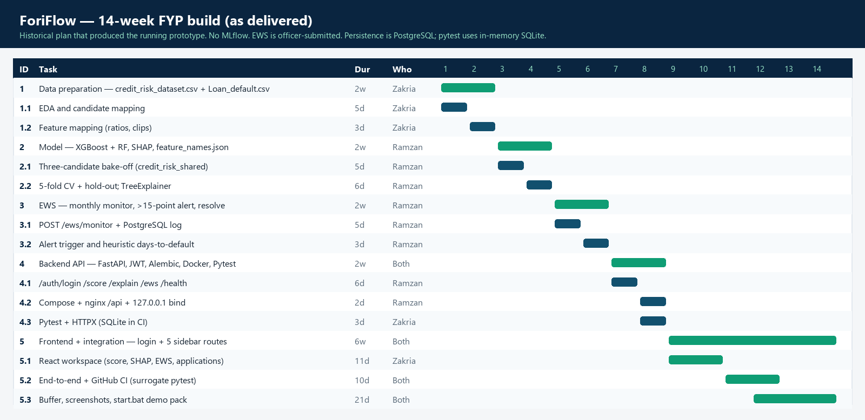

14. Risk Analysis and Mitigation
The following table identifies the key technical, data, timeline, and deployment risks associated with ForiFlow, along with their likelihood, potential impact, and concrete mitigation strategies.
Risk | Likelihood | Impact | Mitigation Strategy
Public-data AUC (0.7752) is below 0.85, and the three-feature ladder ceiling is 0.7776 | Medium | High | The served result is documented (5-fold CV AUC-ROC 0.7752 +/- 0.0073). Hyperparameter tuning, class weight, and blend were already measured: +0.0018, inside noise. The path to 0.85 is Pakistani SME data with DPD, utilisation, DTI, and cash-flow series, not more trees on three columns. GMSC (0.8656) is a consumer proxy only.
International dataset does not transfer well to Pakistani SME behaviour | High | Medium | This is explicitly declared as LI-1. Feature mappings simulate Pakistani SME signals. The architectural separation means models can be retrained on local data without altering the pipeline. Accepted precedent in Pakistani AI credit-risk literature (Rizvi, 2025; Jan & Ahmed, 2025).
EWS alert threshold (15-point drop) is miscalibrated | Medium | Medium | The 15-point trigger is a code constant (LI-5). Banks must change that constant (and ideally retrain) to match their own default experience; there is no dashboard threshold panel in this prototype.
Timeline overrun within the 14-week window | Medium | High | The WBS includes a dedicated 3-week system buffer (Phase 5.3). Work is divided between two developers by module. Weekly supervisor check-ins allow early detection of delays. Deep learning and mobile features are explicitly excluded to protect scope.
FastAPI–React integration failures | Low | Medium | Endpoints are contract-tested with Pytest/HTTPX (/score, /explain/{id}, /ews/monitor, /ews/alerts, /health). Docker Compose removes environment-specific failures.
SHAP computation too slow for real-time use | Low | Low | Interventional TreeSHAP on the ensemble takes about 17 ms (measured in the cloud test environment; the earlier, larger forest took about 230 ms on the development laptop) per applicant after warm start — acceptable for officer interactive use, not a high-frequency trading loop. Lin & Wang (2025) confirmed SHAP stability across repeated XGBoost runs, validating this approach.
Regulatory non-compliance in future live deployment | Low | High | Live production deployment is explicitly out of scope (LI-2). SHAP audit trails are built into the system from day one to align with SBP’s explainability requirements. SBP Regulatory Sandbox approval and security audits are planned for the post-FYP production phase.

15. Testing Plan and Evaluation Criteria
ForiFlow is validated through four tiers of testing covering model performance, API correctness, EWS behaviour, and end-to-end system behaviour, plus two post-build diagnostics (15.1a, 15.1b). Automated tests use Pytest. There is no MLflow experiment registry; training writes metrics into ml/feature_names.json. Ladder results live in ml/auc_ladder.json and ml/gmsc_auc_ladder.json.
15.1 Tier 1 – Model Performance Testing
The served XGBoost-Random Forest ensemble is evaluated with StratifiedKFold (5 folds, shuffle=True, random_state=42) and a stratified 80/20 hold-out. On credit_risk_shared the served artefacts report: selection AUC-ROC 0.7752; 5-fold CV AUC-ROC 0.7752 +/- 0.0073 (fold AUCs 0.7757, 0.7877, 0.7765, 0.7659, 0.7703); hold-out AUC-ROC 0.7731, F1 0.546, PR-AUC 0.564, Brier 0.185. Hold-out policy-band mix is 18.6% Rejected, 63.5% Manual Review, 18.0% Approved. Both members are monotone-constrained; before the Random Forest was constrained (25 September 2026) the ensemble scored CV 0.7758 +/- 0.0075 and hold-out 0.7756 but was not monotone in years in operation, and it approved 38.8% of the hold-out outright. Pass criteria for this FYP: the selected candidate is documented, artefacts (foriflow_model.pkl, scaler.pkl, shap_explainer.pkl, feature_names.json) are reproducible from python -m ml.train_real_model, SHAP additivity holds, and Pytest passes. AUC-ROC >= 0.85 and F1 >= 0.80 are not pass criteria for the current public-data model.
15.1a Production AUC ladder (same three features; artefacts not replaced)
A six-step ladder was run on credit_risk_shared with the production CV protocol, before the Random Forest member was monotone-constrained. Baseline SMOTE-in-fold: 0.7758 +/- 0.0075. Feature engineering: no extra columns are derivable (no existing-debt, no panel cash-flow, no DPD counts), so AUC unchanged. Replacing SMOTE with scale_pos_weight / RF class_weight: 0.7765 +/- 0.0071. SHAP ranking on 1,000 hold-out rows: loan_to_income 0.132, payment_history_score 0.059, years_in_operation 0.043 mean |SHAP|; dropping years_in_operation ablated to 0.7753, so all three were kept. Optuna 20 trials: 0.7774 +/- 0.0067. OOF blend 0.65/0.35: 0.7776 +/- 0.0067. Final versus baseline: +0.0018, inside fold noise. Those tuned weights were not written to foriflow_model.pkl. Conclusion used in this proposal: further hyperparameter search on three features will not deliver 0.85.
15.1b Give Me Some Credit proxy (consumer credit; not served)
The GMSC ladder (backend/ml/auc_ladder_gmsc.py, results in gmsc_auc_ladder.json) is a diagnostic, not a production metric. Final 5-fold test AUC-ROC 0.8656 +/- 0.0033; per-fold 0.8634, 0.8653, 0.8704, 0.8610, 0.8682. It is cited only to show that 0.85 is reachable for this ensemble family when DPD, utilisation, DebtRatio, and income exist. It is not a ForiFlow SME AUC.
15.2 Tier 2 – SHAP Explainability Testing
SHAP value correctness is verified in Pytest by the additivity property: the sum of feature contributions plus the base value reproduces the 0–100 score (within a small numeric tolerance). Score stability is tested by resubmitting the same applicant and asserting an identical score for a given artefact. GET/POST /explain/{id} must return a stored payload retrievable by application id. TreeSHAP is interventional, in probability space, so each contribution converts directly into score points.
15.3 Tier 3 – Early Warning System Testing
The EWS is tested with Pytest against /ews/monitor using scored applications as borrowers, not Home Credit time-series tables and not the ML ensemble. Scenario types include: (a) a borrower whose derived score stays within 15 points of baseline - no alert; (b) a drop of more than 15 points - an alert must fire with estimated_days_to_default; (c) a drop of exactly 15 points - no alert; (d) alert persistence (PostgreSQL in Docker; in-memory SQLite in Pytest) and retrieval via /ews/alerts; (e) re-submitting a month overwrites that observation. Estimated days-to-default is asserted as a bounded heuristic field (0 on Default, otherwise 7-365), not as a validated calendar lead time.
15.4 Tier 4 – End-to-End and API Integration Testing
End-to-end tests exercise officer workflows with a JWT on protected routes: score an applicant, retrieve SHAP by application id, submit a monthly monitor record, list alerts, and resolve an alert. GET /health remains unauthenticated. Pytest plus HTTPX cover the endpoint set in BO-4, including validation errors. The React dashboard renders the score dial, SHAP waterfall page, EWS alert feed, and application table (captured in docs/screenshots/). Docker Compose is the on-premise packaging path. Passing Pytest is the automated acceptance criterion.

Mockups
Mockup 1: Application Management Dashboard
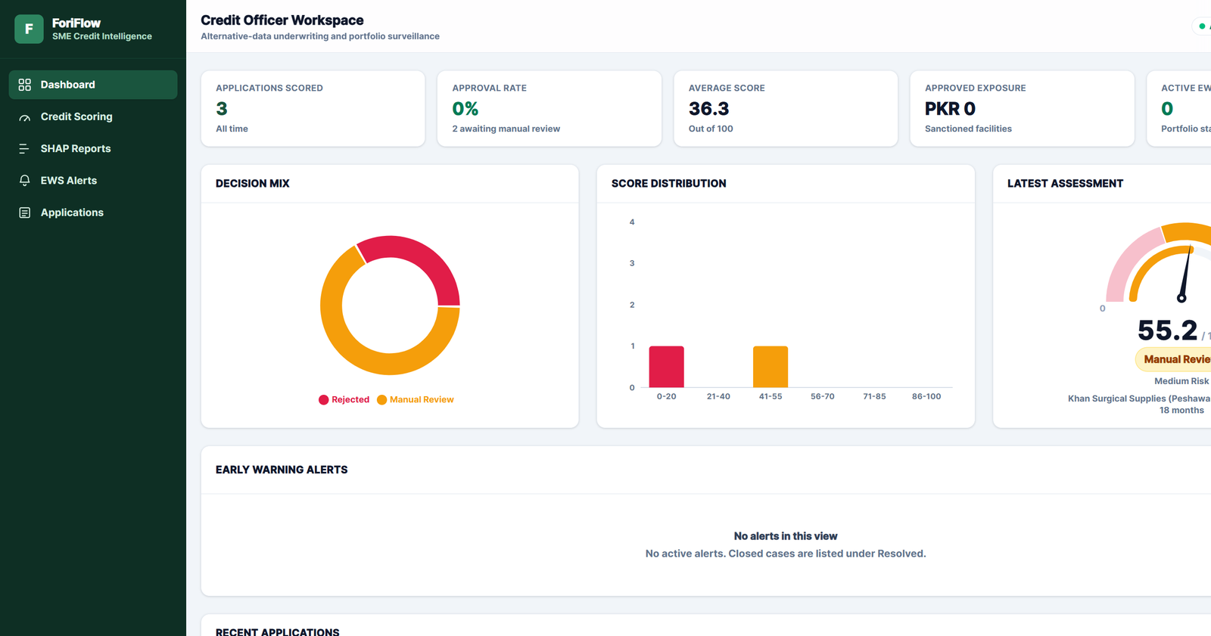
Description: This screen is the live Credit Officer Dashboard (docs/screenshots/01-dashboard.png): KPI cards, decision mix, latest gauge, EWS table, and recent applications. It satisfies Module 4 – FE-2 and FE-5. Sidebar routes are Dashboard, Credit Scoring, SHAP Reports, EWS Alerts, and Applications. The live app requires JWT login (unauthenticated browsers go to /login). The sidebar reads on-premise explainability, not SBP compliance mode. There is no notification bell. Screenshots in this section were recaptured from the officer workspace after the API is online.

Mockup 2: Credit Risk Assessment
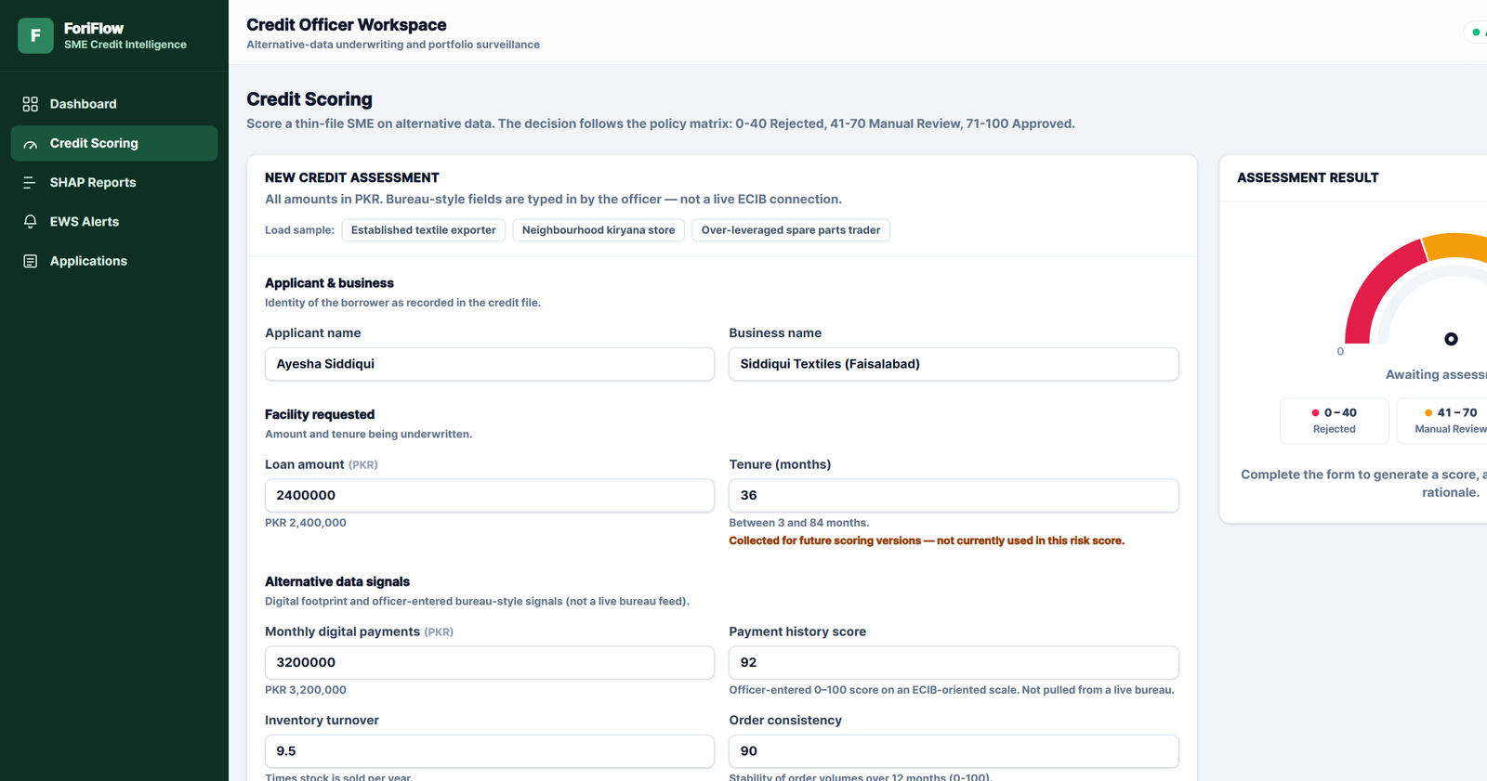
Description: This screen is the live Credit Scoring page (docs/screenshots/02-scoring-form.png and 03-score-result.png). It satisfies Module 1 – FE-1: a structured form with numeric validation, amber unused-field labels, and a “Score application” button that returns a 0–100 gauge using bands 0–40 / 41–70 / 71–100, plus an inline SHAP waterfall.

Mockup 3: SHAP Explainability Report
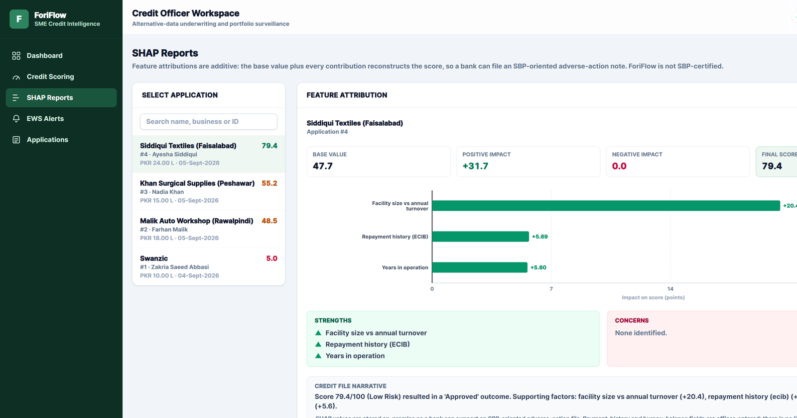
Description: This screen is the live SHAP Reports page (docs/screenshots/04-shap-chart.png). It satisfies Module 2 – FE-1 and FE-3: a stored waterfall by application id on a dedicated route, not an auto-opening modal.

Mockup 4: EWS Alerts Interface
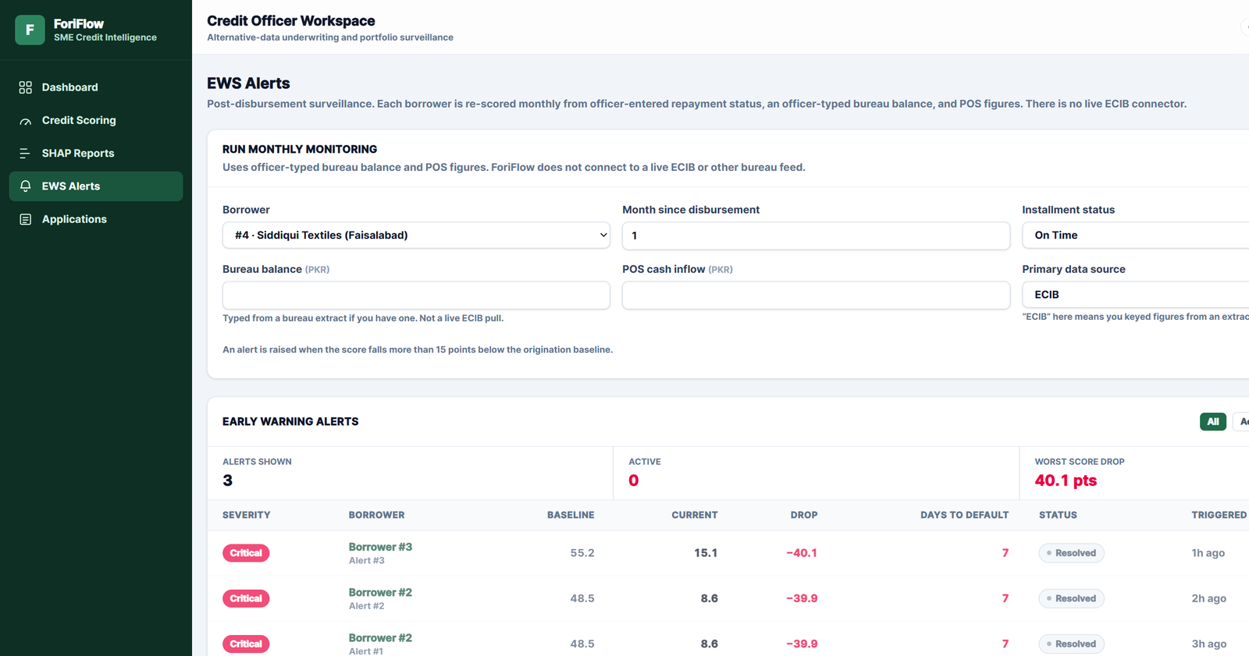
Description: This screen is the live EWS page (docs/screenshots/05-ews-alerts.png): a monthly monitoring form and an alert table. It satisfies Module 3. The trigger is a derived-score drop greater than 15 points. Filters are All / Active / Resolved. Estimated days-to-default is a heuristic. The monthly score is rule-based, not a second XGBoost pass.

References
- Ahmed, F., & Iqbal, A. (2025). The role of artificial intelligence in enhancing credit risk management: A systematic literature review. Pakistan Journal of Humanities and Social Sciences (PJHSS), 13(1), 478–492.
- Akhmetova, A., Shayakhmetova, A., & Abdurakhmanov, N. (2026). Interpretable multi-model framework for early warning of SME loan delinquency. Risks, 14(2), Article 25. https://doi.org/10.3390/risks14020025
- Asian Development Bank. (2024). Asia Small and Medium-Sized Enterprise Monitor 2024: Designing an MSME Ecosystem for Resilient Growth in Asia and the Pacific (Pakistan country notes). Asian Development Bank. https://www.adb.org/sites/default/files/publication/1011576/asia-sme-monitor-2024.pdf
- Ayari, H., Guetari, R., & Kraïem, N. (2026). Machine learning powered financial credit scoring: A systematic literature review. Artificial Intelligence Review, 59, Article 13. https://doi.org/10.1007/s10462-025-11416-2
- Ha, D., Le, P., & Nguyen, D. K. (2025). Financial inclusion and fintech: A state-of-the-art systematic literature review. Financial Innovation, 11(1), Article 69. https://doi.org/10.1186/s40854-024-00741-0
- Hong Kong Monetary Authority, & CRIF. (2024). Alternative credit scoring for micro-, small and medium-sized enterprises. Hong Kong Monetary Authority.
- Hlongwane, R., Ramabao, K., & Mongwe, W. (2024). A novel framework for enhancing transparency in credit scoring: Leveraging Shapley values for interpretable credit scorecards. PLOS ONE, 19(8), e0308718. https://doi.org/10.1371/journal.pone.0308718
- Jan, A., & Ahmed, N. (2025). AI-driven credit risk assessment and financial inclusion in emerging markets: Evidence from Pakistani firms. SES Journal, 4(2), 55–71.
- Lin, L., & Wang, Y. (2025). SHAP stability in credit risk management: A case study in credit card default model. Risks, 13(12), Article 238. https://doi.org/10.3390/risks13120238
- Malik, M., Khan, L., Maqbool, H. N., & Anwar, M. (2025). Mobile wallets and digital payments: Assessing the impact on financial inclusion and consumer trust in Pakistan. Review of Applied Management and Social Sciences (RAMSS), 8(3), 1349–1362.
- Ozili, P. K. (2024). Digital financial inclusion research and developments around the world. Advisory Services Group, Central Bank of Nigeria.
- Rizvi, S. A. A. (2025). AI-driven credit risk assessment for SMEs: A framework for financial inclusion and responsible innovation. Center for Management Science Research (CMSR), 3(3), 1–15.
- State Bank of Pakistan. (2025). SME financing data tables—December 31, 2024. SBP Infrastructure, Housing and SME Finance Department.
- Vakrani, D. S., Patel, R., Shah, H., & Mehta, K. (2026). Evaluating AI-driven credit scoring models versus traditional statistical techniques. Discover Artificial Intelligence, 6, Article 72. https://doi.org/10.1007/s44163-025-00772-1
- Zhang, X., Li, Y., Chen, H., & Wang, T. (2025). Data-driven loan default prediction: A machine learning approach for enhancing business process management. Systems, 13(7), Article 581. https://doi.org/10.3390/systems13070581
- Zhang, Z., Zhu, Z., & Hua, Y. (2025). Research on financial early warning models based on ensemble learning algorithms. PLOS ONE, 20(4), e0323737. https://doi.org/10.1371/journal.pone.0323737
- Give Me Some Credit. (2011). cs-training.csv consumer credit dataset (Kaggle / Credit Scoring Data Sets). Used in this FYP only as a post-build architecture test; not used to train or serve the ForiFlow origination model.

Plagiarism Report
Plagiarism / originality report (Turnitin-style scan of the original FYPI draft): overall similarity 6% (internet sources 4%, student papers 6%, publications 0%). Versions 2.0-2.4 rewrote the body to match the implemented repository, measured AUCs, PostgreSQL, JWT login, start.bat, and the live officer UI. A fresh scan should be attached here before final submission if the committee requires it.
