***Air quality Analysis and Prediction in Tamilnadu***

***Team member***

***723721205028:A.Mohammad Idrish***

***Phase-1 Document submission***

***Project: Air quality Analysis and Prediction in Tamilnadu***

An air quality analysis project involves monitoring and assessing the quality of the air in a specific area to understand the concentration of various pollutants and their potential impact on human health and the environment. Such projects are critical for addressing environmental concerns, public health issues, and regulatory compliance. Below are the key steps and components typically involved in an air quality analysis project.

**Project Definition and Objectives:**

- Clearly define the goals of your project. Determine if you are conducting baseline air quality assessment, investigating a specific issue (e.g., industrial emissions, traffic-related pollution), or monitoring compliance with air quality regulations.

- Identify the key questions you aim to answer through the analysis, such as understanding pollutant sources or assessing health risks.

**Study Area Selection:**

- Choose the geographic area where you will conduct air quality analysis. Consider factors like population density, industrial activity, traffic volume, and known sources of pollution.

- Determine the spatial extent of your study area, whether it's a single city, a region, or a specific site.

**Data Collection:**

- Acquire the necessary equipment for air quality monitoring, including:

- Ambient air monitoring stations: Install air quality sensors and monitors at strategic locations within your study area.

- Mobile monitoring: Use vehicles equipped with air quality measurement instruments to assess air quality in different areas on the move.

- Remote sensing: Utilize satellite or aerial imagery to monitor air quality over larger geographic regions.

- Collect meteorological data, such as wind speed, direction, temperature, and humidity, as these parameters can affect the dispersion of pollutants.

**Pollutant Monitoring:**

- Measure the concentrations of specific air pollutants at your monitoring stations. Common pollutants include:

- Particulate matter (PM2.5 and PM10)

- Ground-level ozone (O3)

- Nitrogen dioxide (NO2)

- Sulfur dioxide (SO2)

- Carbon monoxide (CO)

- Volatile organic compounds (VOCs)

- Ensure that monitoring equipment is properly calibrated and maintained to provide accurate measurements.

**1. Equipment Selection:**

- Choose appropriate monitoring instruments for each specific pollutant you intend to measure. Common monitoring equipment includes:

- Particulate Matter (PM): PM monitors that measure PM2.5 and PM10, which are fine and coarse particulates, respectively.

- Ground-Level Ozone (O3): Ozone analyzers or UV photometric analyzers.

- Nitrogen Dioxide (NO2): NO2 analyzers based on chemiluminescence or other detection methods.

- Sulfur Dioxide (SO2): SO2 analyzers based on ultraviolet fluorescence or pulsed fluorescence.

- Carbon Monoxide (CO): CO analyzers based on non-dispersive infrared (NDIR) technology.

- Volatile Organic Compounds (VOCs): Gas chromatographs, flame ionization detectors (FID), or photoionization detectors (PID).

- Ensure that the selected instruments meet accuracy and precision requirements for air quality monitoring. Calibration and routine maintenance are essential to maintain accuracy.

**2. Monitoring Stations Placement:**

- Carefully select the locations for monitoring stations within your study area. Consider factors like population density, pollution sources, prevailing wind patterns, and topography.

- Ensure that monitoring stations are distributed to capture variations in pollutant concentrations across the study area.

**3. Data Collection Frequency:**

- Determine the frequency of data collection based on project goals. Continuous monitoring provides real-time data, while periodic sampling can be sufficient for some studies.

**4. Data Quality Assurance:**

- Implement a rigorous data quality assurance program. This includes regular calibration of monitoring instruments, routine maintenance, and data validation to identify and correct errors.

**5. Data Logging and Transmission:**

- Install data logging systems at monitoring stations to record pollutant measurements.

- Establish a data transmission mechanism, such as cellular networks or telemetry, to transfer data to a central database in real-time if applicable.

**6. Quality Control Checks:**

- Conduct quality control checks to identify and correct data anomalies or outliers.

- Verify that data from different monitoring stations are consistent and representative of the study area.

**7. Data Analysis and Reporting:**

- Analyze the pollutant concentration data to identify temporal trends and spatial patterns.

- Generate reports and visualizations that present the data in a clear and understandable manner, including time series plots, maps, and statistical summaries.

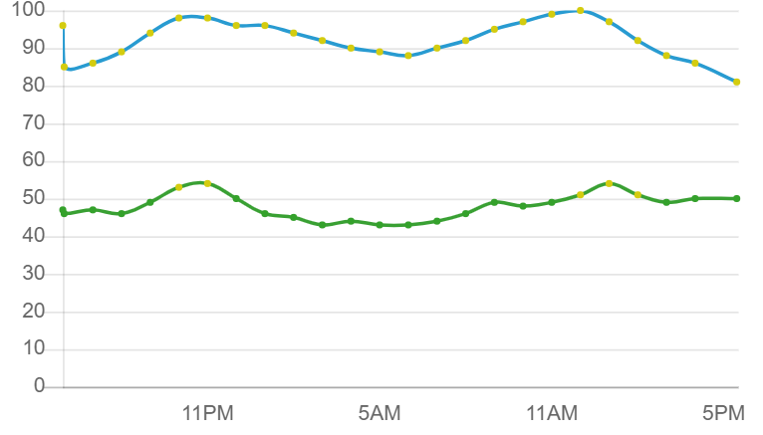

**8. Calibration and Maintenance:**

- Regularly calibrate monitoring instruments to ensure accurate measurements.

- Implement a maintenance schedule for sensors, filters, and other components to minimize downtime and data inaccuracies.

**9. Data Validation:**

- Implement data validation processes to identify and rectify erroneous data. Data validation involves checking for missing data, outliers, and instrument malfunctions.

**10. Data Management:**

- Establish a secure and well-organized data management system to store and retrieve monitoring data efficiently.

- Ensure data is properly archived for future reference.

**11. Compliance with Regulatory Standards:**

- Ensure that your monitoring methods and equipment comply with relevant air quality regulations and standards, such as those set by environmental agencies or regulatory bodies.

**12. Data Accessibility:**

- Make air quality data accessible to stakeholders, researchers, and the public through websites or other platforms for transparency and public awareness.

**13. Data Interpretation:**

- Interpret the monitoring data in the context of local sources, meteorological conditions, and health guidelines to assess potential health risks and environmental impacts.

**14. Continuous Improvement:**

- Regularly review monitoring practices and update equipment or methodologies as necessary to enhance accuracy and effectiveness.

-Effective pollutant monitoring is crucial for understanding air quality, identifying pollution sources, and taking action to mitigate adverse effects on public health and the environment. It forms the foundation of any air quality analysis project.

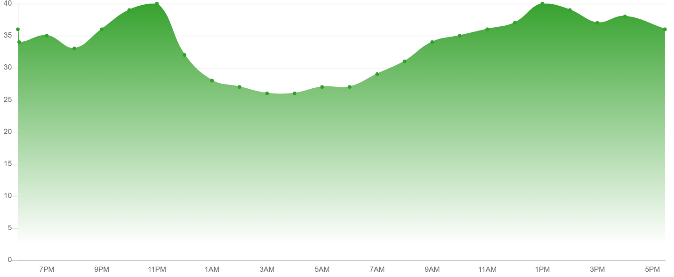

**Data Analysis:**

- Process and analyze the collected data to uncover trends, patterns, and spatial variations in pollutant concentrations.

- Utilize statistical analysis techniques to assess air quality, such as calculating averages, percentiles, and standard deviations.

- Employ geospatial analysis methods to create maps and visualize pollutant distribution across the study area.

**Health and Environmental Impact Assessment:**

- Evaluate the potential health and environmental impacts of the observed pollutant concentrations:

- Assess exposure levels by considering factors like population density and proximity to pollution sources.

- Identify vulnerable populations, such as children, the elderly, and individuals with pre-existing health conditions.

- Compare pollutant levels with regulatory standards and guidelines to determine compliance.

**Report and Visualization:**

- Create a comprehensive report that communicates your findings effectively. The report should include:

- Clear data summaries, visualizations (graphs, maps, charts), and tables.

- Detailed analysis of trends and potential sources of pollution.

- Assessment of health and environmental impacts.

- Recommendations for improving air quality, if necessary.

**Data of 2014 analysis and predictionsss:**

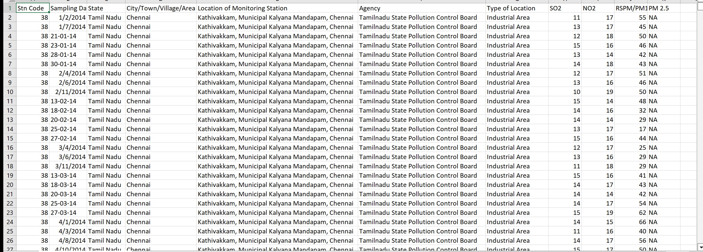

**Communication and Stakeholder Engagement:**

- Share your results with relevant stakeholders, including government agencies, local communities, and industry groups.

- Conduct outreach and education efforts to inform the public about air quality issues, potential health risks, and recommended actions.

**Mitigation and Policy Recommendations:**

- Provide specific recommendations for mitigating air quality issues based on your analysis.

- Advocate for policy changes, regulatory enforcement, or industry practices that can help reduce pollution and improve air quality.

**Long-Term Monitoring:**

- Consider establishing a long-term air quality monitoring program to track changes over time and evaluate the effectiveness of mitigation measures and policy changes.

**Continuous Improvement:**

- Periodically review and update your air quality analysis project to adapt to changing conditions, incorporate new technologies, and refine methodologies for more accurate and comprehensive assessments.

A well-executed air quality analysis project can serve as a valuable tool for decision-makers, regulators, and the community to address air pollution and protect public health and the environment.

**CODE:**

<?xml version="1.0"?>

<result>

<index_name>cdaf4155-5772-44da-9bff-3dae9e2ec01d</index_name>

<title>Location wise daily Ambient Air Quality of Tamil Nadu for the year 2014</title>

<desc>Location wise daily Ambient Air Quality of Tamil Nadu for the year 2014</desc>

<org_type>Central</org_type>

<org>

<item>Ministry of Environment, Forest and Climate Change</item>

<item>Central Pollution Control Board</item>

</org>

<sector>

<item>Environment and Forest</item>

<item>Industrial Air Pollution</item>

<item>Residential Air Pollution</item>

<item>Vehicular Air Pollution</item>

</sector>

<source>data.gov.in</source>

<catalog_uuid>c0025cca-0daa-4fcf-93f8-36e6466d6c34</catalog_uuid>

<visualizable>0</visualizable>

<active>1</active>

<created>1668829387</created>

<updated>1668868750</updated>

<created_date>2022-11-19T04:43:07Z</created_date>

<updated_date>2022-11-19T20:09:10Z</updated_date>

<external_ws>0</external_ws>

<external_ws_url/>

<target_bucket>

<index>api</index>

<type>c0025cca-0daa-4fcf-93f8-36e6466d6c34</type>

<field>cdaf4155-5772-44da-9bff-3dae9e2ec01d</field>

</target_bucket>

<field>

<item>

<id>stn_code</id>

<name>Stn Code</name>

<type>keyword</type>

</item>

<item>

<id>_sampling_date</id>

<name>Sampling Date</name>

<type>date</type>

</item>

<item>

<id>state</id>

<name>State</name>

<type>keyword</type>

</item>

<item>

<id>city_town_village_area</id>

<name>City/Town/Village/Area</name>

<type>keyword</type>

</item>

<item>

<id>location_of_monitoring_station</id>

<name>Location of Monitoring Station</name>

<type>keyword</type>

</item>

<item>

<id>agency</id>

<name>Agency</name>

<type>keyword</type>

</item>

<item>

<id>type_of_location</id>

<name>Type of Location</name>

<type>keyword</type>

</item>

<item>

<id>so2</id>

<name>SO2</name>

<type>double</type>

</item>

<item>

<id>no2</id>

<name>NO2</name>

<type>double</type>

</item>

<item>

<id>rspm_pm10</id>

<name>RSPM/PM10</name>

<type>double</type>

</item>

<item>

<id>_pm_2_5</id>

<name>PM 2.5</name>

<type>keyword</type>

</item>

</field>

<message>Resource lists</message>

<version>2.2.0</version>

<status>ok</status>

<total>2879</total>

<count>10</count>

<limit>10</limit>

<offset>0</offset>

<records>

<item>

<stn_code>38</stn_code>

<_sampling_date>2014-02-01T04:43:24Z</_sampling_date>

<state>Tamil Nadu</state>

<city_town_village_area>Chennai</city_town_village_area>

<location_of_monitoring_station>Kathivakkam, Municipal Kalyana Mandapam, Chennai</location_of_monitoring_station>

<agency>Tamilnadu State Pollution Control Board</agency>

<type_of_location>Industrial Area</type_of_location>

<so2>11</so2>

<no2>17</no2>

<rspm_pm10>55</rspm_pm10>

<_pm_2_5>NA</_pm_2_5>

</item>

<item>

<stn_code>38</stn_code>

<_sampling_date>2014-07-01T04:43:24Z</_sampling_date>

<state>Tamil Nadu</state>

<city_town_village_area>Chennai</city_town_village_area>

<location_of_monitoring_station>Kathivakkam, Municipal Kalyana Mandapam, Chennai</location_of_monitoring_station>

<agency>Tamilnadu State Pollution Control Board</agency>

<type_of_location>Industrial Area</type_of_location>

<so2>13</so2>

<no2>17</no2>

<rspm_pm10>45</rspm_pm10>

<_pm_2_5>NA</_pm_2_5>

</item>

<item>

<stn_code>38</stn_code>

<_sampling_date>2014-01-21T04:43:24Z</_sampling_date>

<state>Tamil Nadu</state>

<city_town_village_area>Chennai</city_town_village_area>

<location_of_monitoring_station>Kathivakkam, Municipal Kalyana Mandapam, Chennai</location_of_monitoring_station>

<agency>Tamilnadu State Pollution Control Board</agency>

<type_of_location>Industrial Area</type_of_location>

<so2>12</so2>

<no2>18</no2>

<rspm_pm10>50</rspm_pm10>

<_pm_2_5>NA</_pm_2_5>

</item>

<item>

<stn_code>38</stn_code>

<_sampling_date>2014-01-23T04:43:24Z</_sampling_date>

<state>Tamil Nadu</state>

<city_town_village_area>Chennai</city_town_village_area>

<location_of_monitoring_station>Kathivakkam, Municipal Kalyana Mandapam, Chennai</location_of_monitoring_station>

<agency>Tamilnadu State Pollution Control Board</agency>

<type_of_location>Industrial Area</type_of_location>

<so2>15</so2>

<no2>16</no2>

<rspm_pm10>46</rspm_pm10>

<_pm_2_5>NA</_pm_2_5>

</item>

<item>

<stn_code>38</stn_code>

<_sampling_date>2014-01-28T04:43:24Z</_sampling_date>

<state>Tamil Nadu</state>

<city_town_village_area>Chennai</city_town_village_area>

<location_of_monitoring_station>Kathivakkam, Municipal Kalyana Mandapam, Chennai</location_of_monitoring_station>

<agency>Tamilnadu State Pollution Control Board</agency>

<type_of_location>Industrial Area</type_of_location>

<so2>13</so2>

<no2>14</no2>

<rspm_pm10>42</rspm_pm10>

<_pm_2_5>NA</_pm_2_5>

</item>

<item>

<stn_code>38</stn_code>

<_sampling_date>2014-01-30T04:43:24Z</_sampling_date>

<state>Tamil Nadu</state>

<city_town_village_area>Chennai</city_town_village_area>

<location_of_monitoring_station>Kathivakkam, Municipal Kalyana Mandapam, Chennai</location_of_monitoring_station>

<agency>Tamilnadu State Pollution Control Board</agency>

<type_of_location>Industrial Area</type_of_location>

<so2>14</so2>

<no2>18</no2>

<rspm_pm10>43</rspm_pm10>

<_pm_2_5>NA</_pm_2_5>

</item>

<item>

<stn_code>38</stn_code>

<_sampling_date>2014-04-02T04:43:24Z</_sampling_date>

<state>Tamil Nadu</state>

<city_town_village_area>Chennai</city_town_village_area>

<location_of_monitoring_station>Kathivakkam, Municipal Kalyana Mandapam, Chennai</location_of_monitoring_station>

<agency>Tamilnadu State Pollution Control Board</agency>

<type_of_location>Industrial Area</type_of_location>

<so2>12</so2>

<no2>17</no2>

<rspm_pm10>51</rspm_pm10>

<_pm_2_5>NA</_pm_2_5>

</item>

<item>

<stn_code>38</stn_code>

<_sampling_date>2014-06-02T04:43:24Z</_sampling_date>

<state>Tamil Nadu</state>

<city_town_village_area>Chennai</city_town_village_area>

<location_of_monitoring_station>Kathivakkam, Municipal Kalyana Mandapam, Chennai</location_of_monitoring_station>

<agency>Tamilnadu State Pollution Control Board</agency>

<type_of_location>Industrial Area</type_of_location>

<so2>13</so2>

<no2>16</no2>

<rspm_pm10>46</rspm_pm10>

<_pm_2_5>NA</_pm_2_5>

</item>

<item>

<stn_code>38</stn_code>

<_sampling_date>2014-11-02T04:43:24Z</_sampling_date>

<state>Tamil Nadu</state>

<city_town_village_area>Chennai</city_town_village_area>

<location_of_monitoring_station>Kathivakkam, Municipal Kalyana Mandapam, Chennai</location_of_monitoring_station>

<agency>Tamilnadu State Pollution Control Board</agency>

<type_of_location>Industrial Area</type_of_location>

<so2>10</so2>

<no2>19</no2>

<rspm_pm10>50</rspm_pm10>

<_pm_2_5>NA</_pm_2_5>

</item>

<item>

<stn_code>38</stn_code>

<_sampling_date>2014-02-13T04:43:24Z</_sampling_date>

<state>Tamil Nadu</state>

<city_town_village_area>Chennai</city_town_village_area>

<location_of_monitoring_station>Kathivakkam, Municipal Kalyana Mandapam, Chennai</location_of_monitoring_station>

<agency>Tamilnadu State Pollution Control Board</agency>

<type_of_location>Industrial Area</type_of_location>

<so2>15</so2>

<no2>14</no2>

<rspm_pm10>48</rspm_pm10>

<_pm_2_5>NA</_pm_2_5>

</item>

</records>

</result>Top of Form

**Dataset Information:**

**Index Name**: cdaf4155-5772-44da-9bff-3dae9e2ec01d

**Title**: Location-wise daily Ambient Air Quality of Tamil Nadu for the year 2014

**Description:** Location-wise daily Ambient Air Quality of Tamil Nadu for the year 2014

**Organization Type**: Central

**Organization(s):**Ministry of Environment, Forest and Climate Change

Central Pollution Control Board

**Sectors**:

Environment and Forest

Industrial Air Pollution

Residential Air Pollution

Vehicular Air Pollution

**Source**: https://data.gov.in/

**Catalog UUID**: c0025cca-0daa-4fcf-93f8-36e6466d6c34

**Visualizable**: No (0)

**Active**: Yes (1)

**Created Timestamp:** 2022-11-19T04:43:07Z

**Updated Timestamp**: 2022-11-19T20:09:10Z

**External Web Service:** No (0)

Target Bucket:

**Index**: api

**Type:** c0025cca-0daa-4fcf-93f8-36e6466d6c34

**Field:** cdaf4155-5772-44da-9bff-3dae9e2ec01d

**Message:** Resource lists

**Version**: 2.2.0

**Status**: OK

**Total Records:** 2879

**Count (Displayed Records):** 10

**Limit:** 10

**Offset:** 0

Reference URl:

**https://api.data.gov.in/resource/cdaf4155-5772-44da-9bff-3dae9e2ec01d?api-key=579b464db66ec23bdd000001cdd3946e44ce4aad7209ff7b23ac571b&format=xml**

**curl -X 'GET' \**

**'https://api.data.gov.in/resource/cdaf4155-5772-44da-9bff-3dae9e2ec01d?api-key=579b464db66ec23bdd000001cdd3946e44ce4aad7209ff7b23ac571b&format=xml' \**

**-H 'accept: application/xml'**