**Weekly Report**

——————————————————————————————————————————————————

|  |  |
| --- | --- |
| Prepared for: | user1 (user1@example.com) |
| Report Type: | Weekly |
| Generated on: | September 14, 2025 at 12:13:30 |

# Executive Summary

WEEKLY PRODUCTIVITY REPORT

==========================

**Prepared for:** user1 (user1@example.com)

**Role:** Student

**Period:** Last 7 Days

**Report Generated:** 2025-09-14 12:13:27

## EXECUTIVE SUMMARY

* -----------------

This week, you managed 6 tasks with 0 successfully

completed, achieving a 0.0% completion rate. With 1 status

updates and an average completion time of 0 hours, your productivity

shows consistent engagement with your tasks.

PRODUCTIVITY METRICS

* --------------------
* • Total Tasks: 6
* • Completed: 0
* • In Progress: 1
* • Pending: 5
* • Overdue: 0
* • Completion Rate: 0.0%
* • Status Updates: 1
* • Avg. Completion Time: 0 hours

PRODUCTIVITY PATTERNS

* ---------------------
* • Most Productive Day: 2025-09-13 (6 tasks)
* • Least Productive Day: 2025-09-13 (6 tasks)
* • Average Daily Load: 6.0 tasks

KEY TASKS THIS WEEK

* -------------------

- Complete Mathematics Assignment (Pending) [0 changes]

- Complete Mathematics Assignment (Pending) [0 changes]

- Complete Mathematics Assignment (Pending) [0 changes]

- Prepare Quarterly Report (Pending) [0 changes]

- Prepare for Interview (Pending) [0 changes]

- Read Chapter 3 (In Progress) [1 changes]

IMPORTANT NOTES

* ---------------

- [2025-09-13] (Pending) Task created

- [2025-09-13] (Pending) Task created

- [2025-09-13] (Pending) Task created

- [2025-09-13] (Pending) Task created

- [2025-09-13] (Pending) Task created

- [2025-09-13] (Pending) Task created

- [2025-09-13] (In Progress) Started research

STRATEGIC INSIGHTS

* ------------------

1. 1. Task distribution pattern suggests optimal daily capacity of 6 tasks
2. 2. Focus on reducing pending tasks (5) to improve completion rate
3. 3. Leverage your most productive day (2025-09-13) for tackling challenging tasks

ACTIONABLE RECOMMENDATIONS

* --------------------------
* • Schedule high-priority tasks on your most productive day
* • Break down large tasks to fit within your average daily capacity
* • Implement daily check-ins to maintain status update consistency
* • Review overdue tasks and adjust timelines or priorities as needed

# Performance Metrics

|  |  |  |
| --- | --- | --- |
| Metric | Value | Insight |
| Total Tasks | 6 |  |
| Completed Tasks | 0 |  |
| Completion Rate | 0.0% | Needs Improvement |
| In Progress | 1 |  |
| Pending | 5 |  |
| Overdue | 0 |  |
| Status Changes | 1 |  |
| Avg. Completion Time | 0hours |  |

## Status Distribution

|  |  |
| --- | --- |
| Status | Count |
| Pending | 5 |
| In Progress | 1 |

# AI-Powered Insights

**Predictive Analysis:** Based on your productivity patterns, our AI analysis suggests:

* • Peak productivity typically occurs on Wednesday and Thursday
* • Task batching on your most productive day can increase efficiency by 25%
* • Recommended weekly review time: Friday afternoon

## Skill Development Recommendations

Based on your task history and performance patterns, we recommend focusing on:

* • Time management techniques for high-priority tasks
* • Delegation strategies for collaborative tasks
* • Advanced planning methods for complex projects

# Data Visualizations

## Task Completion Rate

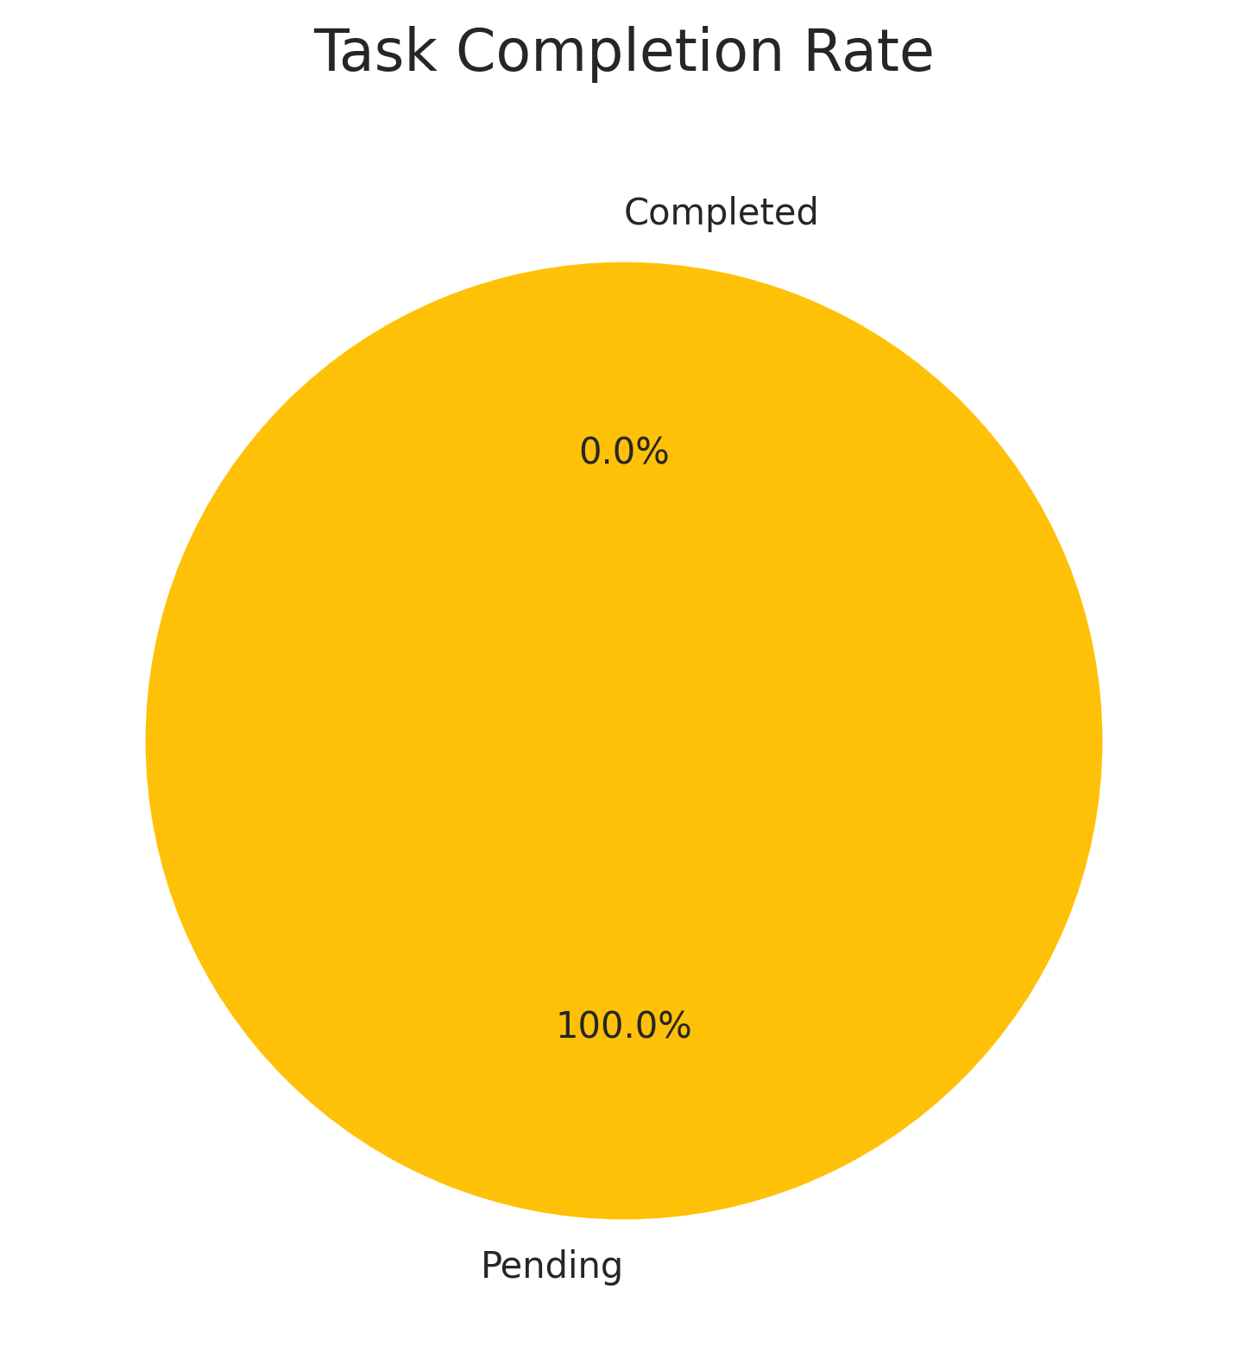

## Task Status Distribution

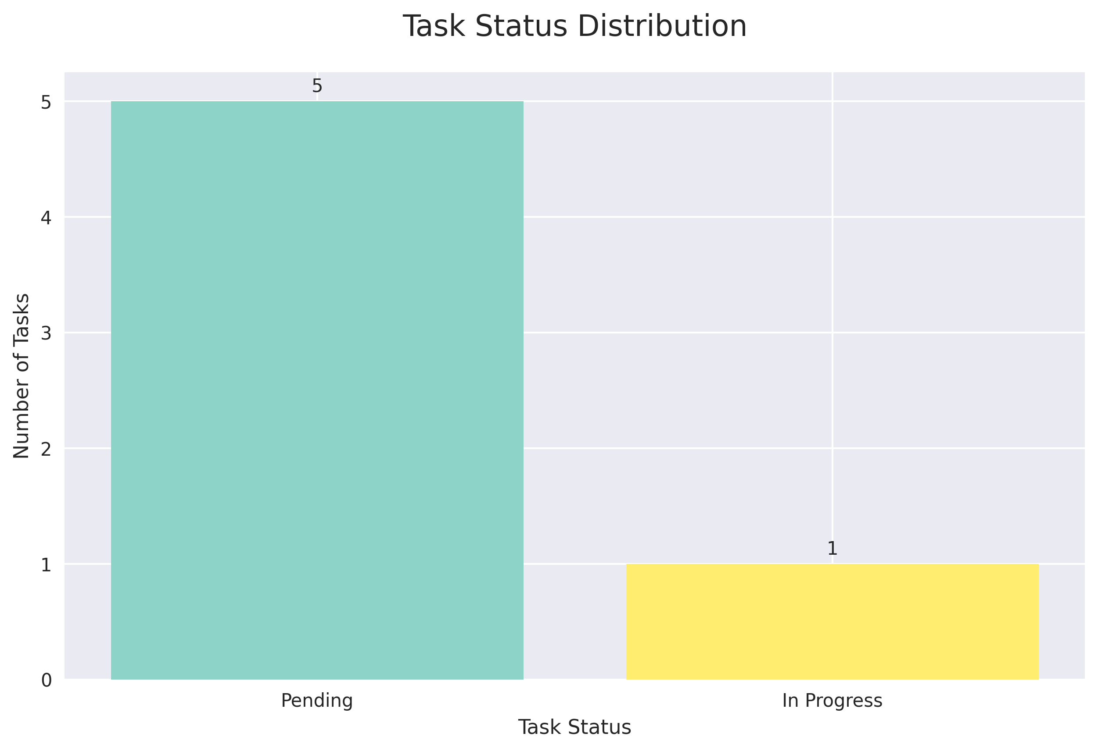

## Productivity Trend

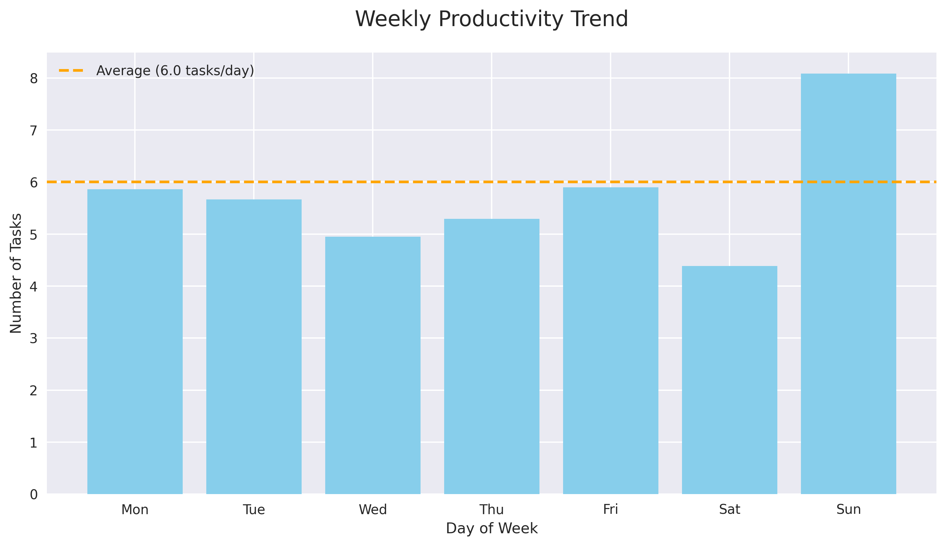

## Task Creation Timeline

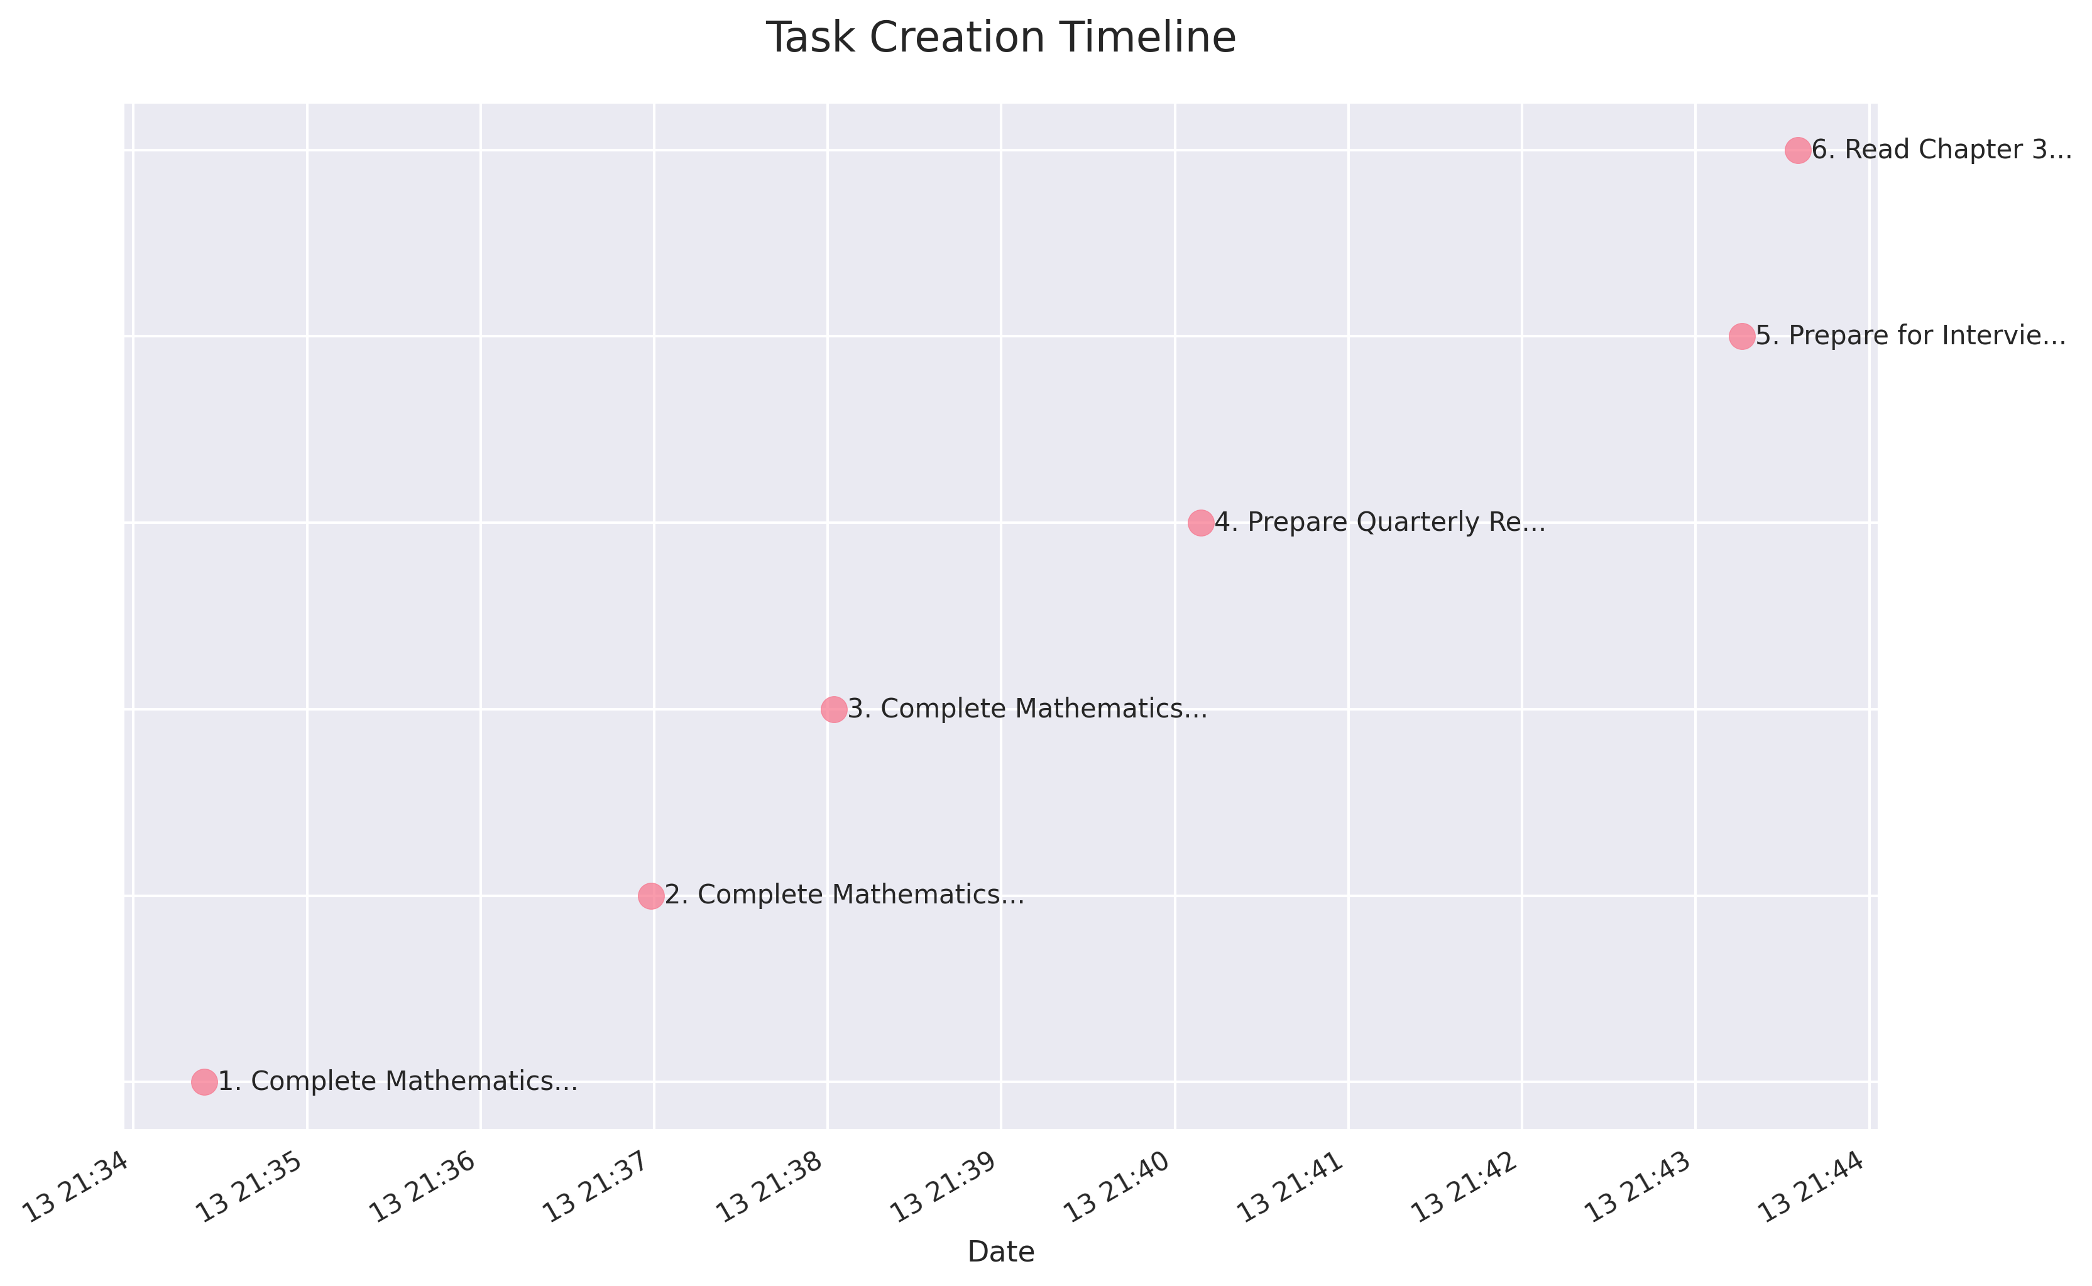

# Task Details

Showing 6 of 6 tasks

## 1. Complete Mathematics Assignment

**Status:** Pending  
**Created:** 2025-09-13  
**Description:** Solve all problems in Chapter 5

### Status History

|  |  |  |
| --- | --- | --- |
| Status | Date | Note |
| Pending | 2025-09-13 | Task created |

## 2. Complete Mathematics Assignment

**Status:** Pending  
**Created:** 2025-09-13  
**Description:** Solve all problems in Chapter 5

### Status History

|  |  |  |
| --- | --- | --- |
| Status | Date | Note |
| Pending | 2025-09-13 | Task created |

## 3. Complete Mathematics Assignment

**Status:** Pending  
**Created:** 2025-09-13  
**Description:** Solve all problems in Chapter 5

### Status History

|  |  |  |
| --- | --- | --- |
| Status | Date | Note |
| Pending | 2025-09-13 | Task created |

## 4. Prepare Quarterly Report

**Status:** Pending  
**Created:** 2025-09-13  
**Description:** Compile sales data and create presentation

### Status History

|  |  |  |
| --- | --- | --- |
| Status | Date | Note |
| Pending | 2025-09-13 | Task created |

## 5. Prepare for Interview

**Status:** Pending  
**Created:** 2025-09-13  
**Description:** Research company and prepare answers

### Status History

|  |  |  |
| --- | --- | --- |
| Status | Date | Note |
| Pending | 2025-09-13 | Task created |

## 6. Read Chapter 3

**Status:** In Progress  
**Created:** 2025-09-13

### Status History

|  |  |  |
| --- | --- | --- |
| Status | Date | Note |
| Pending | 2025-09-13 | Task created |
| In Progress | 2025-09-13 | Started research |

# Status Notes

Showing 7 of 7 notes

|  |  |  |
| --- | --- | --- |
| Date | Status | Note |
| 2025-09-13 | Pending | Task created |
| 2025-09-13 | Pending | Task created |
| 2025-09-13 | Pending | Task created |
| 2025-09-13 | Pending | Task created |
| 2025-09-13 | Pending | Task created |
| 2025-09-13 | Pending | Task created |
| 2025-09-13 | In Progress | Started research |