From 3D Joint Keypoints to Internal Biomechanics — A Vision-Only Surrogate
Predicting torque, muscle forces, activations and fatigue from 3 markerless 3D joints
(RShoulder, RElbow, RWrist) — no Vicon, no OpenSim at inference — LOSO, 8 subjects

Table of contents:

1. Abstract
This report covers the fully vision-only branch: predicting internal biomechanics directly from the 3 markerless 3D joints of the right arm (shoulder, elbow, wrist), produced by Pose2Sim triangulation — WITHOUT Vicon and WITHOUT OpenSim at inference. After feature engineering (geometry from the 3 joints, 2 Hz Butterworth smoothing, physics terms, cumulative and rolling features) and Optuna tuning, a LightGBM model reaches a mean LOSO R2 of ~0.90 on unseen subjects. We analyse why torque is the hardest target and how a Butterworth filter raises it from 0.79 to 0.84, benchmark against time-series transformers (TST/PatchTST/iTransformer/TFT), and report the honest gap to the .mot + .osim pipeline (Approach A, 0.952).

2. Objective
Replace the lab chain (angles from .mot + scaled model .osim + OpenSim ID/SO/3CC) by a model that maps the raw 3D joints to the 13 biomechanical variables, deployable from video alone.
- Input: 3 joints (RShoulder, RElbow, RWrist), 3D coordinates, from Pose2Sim .trc.
- Output: torque (1) + activations (4) + forces (4) + fatigue (4) = 13, the OpenSim labels.
- No Vicon (scaling from .trc), no OpenSim at inference (the model replaces it).

3. Pipeline (3D -> biomechanics)
Video (4 cams) -> Pose2Sim (RTMPose 2D + triangulation) -> .trc (3D). We take 3 joints; from them we build geometric features; a LightGBM predicts the 13 biomechanical targets. The labels for training were generated once by OpenSim (teacher); at inference only the 3 joints are needed.

4. Data
8 subjects (s03..s11), 12,640 frames, dumbbell biceps curls (5 reps, 2 kg). The 3D joints come from the Butterworth-filtered Pose2Sim .trc (50 fps), resampled to the label time grid. Only RShoulder/RElbow/RWrist are used (arm26 = right arm, 2 DOF); Hip is used once only to detect the vertical (gravity) axis.

5. Inputs (features) and outputs
From the 3 joints we form the bone vectors SE = elbow-shoulder and WE = wrist-elbow, then derive ~30 features:
- Geometry: upper-arm & forearm lengths, shoulder-wrist distance, elbow angle, bone elevations vs vertical, vertical components.
- Kinematics: angular velocity/acceleration (after smoothing), sin/cos of the elbow angle.
- Physics: gravity moment at the elbow, inertial term, their sum.
- Temporal context: rolling mean/std (centred window) and cumulative integrals (path, gravity impulse).
- Anthropometry: humerus/forearm mass (subject-aware).
Outputs: the same 13 OpenSim targets (torque/forces/activations/fatigue).

6. Feature-engineering journey (chronological, with the math)
This section tells the story in order: from the first weak model to the final one, what we added at each stage, the math behind each feature, why it helped, and the resulting score. The starting problem was a weak torque; the journey shows how we fixed it.
Stage 0 - Raw 3D, basic geometry (mean R2 = 0.842, torque = 0.72).
From the 3 joints we form the bone vectors SE = elbow - shoulder and WE = wrist - elbow. Basic features:
- Elbow angle: q_el = arccos( (-SE . WE) / (|SE| |WE|) ).
- Segment lengths |SE|, |WE| ; bone elevations vs vertical ua_elev = angle(SE, up), fa_elev = angle(WE, up).
- Angular velocity/acceleration by finite difference: qd = dq/dt, qdd = d2q/dt2.
Problem: torque is weak (0.72). Reason: torque = M(q) qdd + C(q,qd) qd + G(q); the inertial term needs qdd (2nd derivative), the noisiest quantity from markerless 3D.
Stage 1 - Enriched, physics-guided features (mean R2 = 0.867, torque = 0.79).
- Geometry/gravity: sin(q_el), cos(q_el), and a gravitational-load proxy grav = (m_forearm + 2) * L_forearm * sin(q_sh + q_el) (weight x lever x sin of forearm-from-vertical).
- Cumulative (for fatigue, which is an integral of activation): cum_path = integral |qd| dt, cum_grav = integral |grav| dt.
- Temporal context (denoising): rolling mean/std of q_el over a centred window.
Why it helped: the trig terms expose the gravity geometry; the cumulative integrals are the physical drivers of 3CC fatigue; the rolling mean denoises the angle. Net: +0.025 overall, torque +0.07, fatigue ~0.92.
Stage 2 - Torque deep-dive: diagnosing the bottleneck.
The torque equation shows the inertial term M(q) qdd dominates the error because qdd is noisy. We tried explicit physics features - gravity moment tau_grav = g sin(alpha) (m_fa L/2 + m_load L) and inertial term tau_inertia = (m_fa L^2/3 + m_load L^2) qdd - but SHAP showed they were REDUNDANT (the angle features already encode gravity). The real issue was the noise in qdd, not missing terms.
Stage 3 - Butterworth 2 Hz smoothing (THE lever: torque 0.77 -> 0.83, MAE 1.05 -> 0.86 N.m; mean -> 0.895).
We apply a zero-phase 2nd-order Butterworth low-pass to the joint angle BEFORE differentiating (cutoff fc = 2 Hz, normalised Wn = fc / (fs/2), applied with filtfilt for zero phase). It removes the >2 Hz markerless noise while keeping the curl signal (~0.5 Hz), giving a clean qdd. This is exactly the filter used for the lab motion. Cleaner kinematics lift not only torque but also activations and forces.
Stage 4 - Optuna tuning (mean 0.895 -> 0.904, torque -> 0.84).
Bayesian tuning (TPE + Hyperband) of the LightGBM on a combined objective (0.5 torque + 0.5 overall) gives the final model. Overall journey: 0.842 -> 0.867 -> 0.895 -> 0.904 ; torque: 0.72 -> 0.79 -> 0.83 -> 0.84.
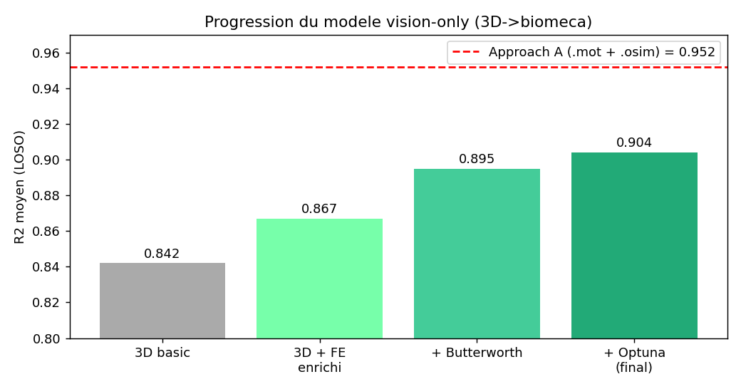
Figure 1 - Progression of the vision-only model: basic 3D -> enriched FE -> +Butterworth -> +Optuna (dashed: Approach A using .mot + .osim).

7. Model selection: GBM vs time-series transformers
We benchmarked gradient boosting against several time-series deep models (TST, PatchTST, iTransformer, TFT-lite) on the raw 3D windows. On 8 subjects the boosting + feature engineering wins clearly.
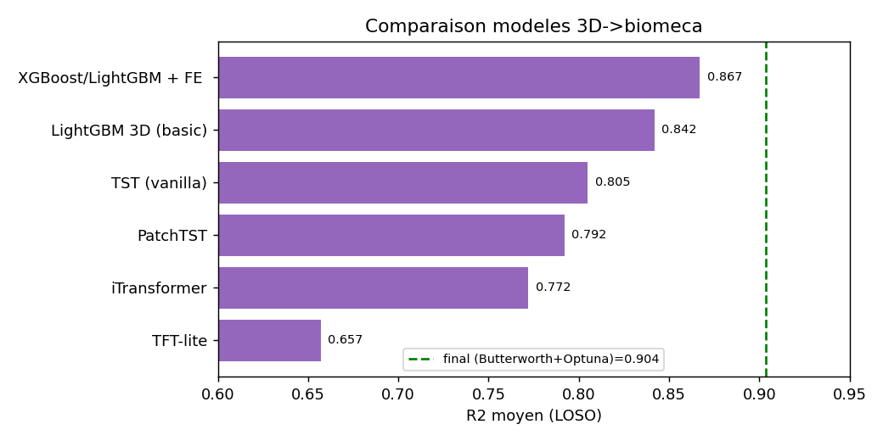
Figure 2 - Model comparison on the 3D->biomechanics task (LOSO).

8. Hyper-parameter optimisation (Optuna)
Optuna (TPE + Hyperband) tunes the LightGBM on a combined objective (0.5 torque + 0.5 overall). Top trials:
trial | value | params_n_estimators | params_num_leaves | params_learning_rate | params_subsample | params_colsample_bytree | params_min_child_samples
14 | 0.922 | 306.000 | 43.000 | 0.120 | 0.698 | 0.893 | 16.000
11 | 0.922 | 412.000 | 38.000 | 0.132 | 0.749 | 0.975 | 6.000
12 | 0.917 | 426.000 | 40.000 | 0.126 | 0.730 | 0.895 | 5.000
1 | 0.911 | 431.000 | 64.000 | 0.184 | 0.753 | 0.896 | 29.000
16 | 0.911 | 311.000 | 45.000 | 0.060 | 0.680 | 0.935 | 16.000
8 | 0.911 | 394.000 | 35.000 | 0.074 | 0.775 | 0.994 | 9.000
15 | 0.909 | 305.000 | 26.000 | 0.129 | 0.653 | 0.835 | 17.000
13 | 0.903 | 417.000 | 39.000 | 0.120 | 0.698 | 0.872 | 5.000

9. Explainability (XAI / SHAP)
SHAP on the 3D features confirms the physics: the denoised elbow angle (rolling mean) drives torque/forces/activations, and the cumulative features drive fatigue.
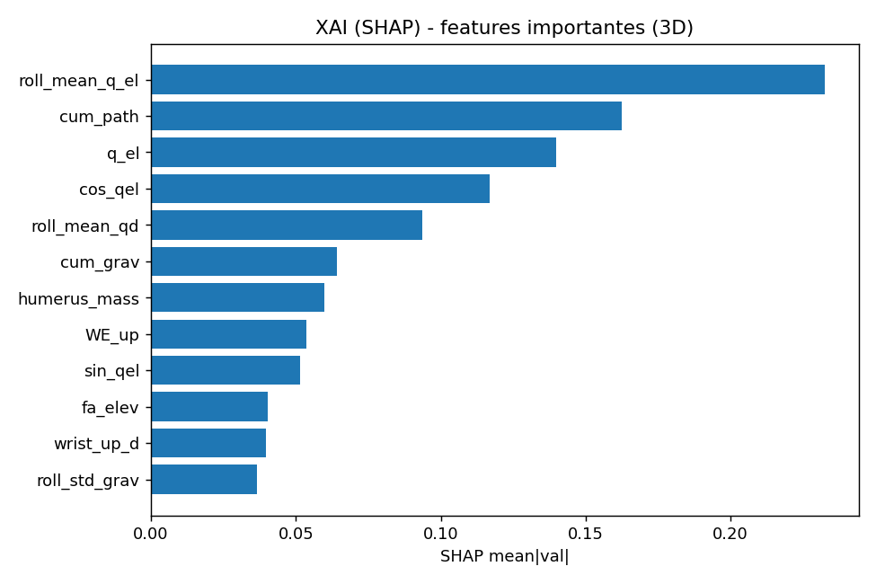
Figure 3 - SHAP feature importance (3D model).

10. Deep-dive: why torque is hardest, and how we fixed it
Torque = M(q)qdd + C qd + G(q). The inertial term needs qdd, the noisiest quantity from markerless 3D. Diagnosis: torque was limited by noisy qdd and the absence of a Vicon de-bias. Fix: Butterworth 2 Hz smoothing (clean qdd) + a torque-specific Optuna -> torque R2 0.79 -> 0.84 (MAE 1.12 -> 0.83 N.m). Explicit physics features (gravity/inertia) were redundant (the angle features already encode gravity, confirmed by SHAP).
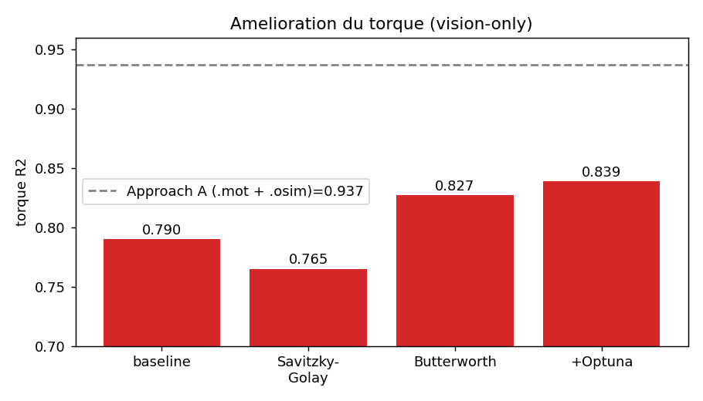
Figure 4 - Torque improvement (vision-only): baseline -> Savitzky-Golay -> Butterworth -> +Optuna.

11. Final model — multi-metric evaluation
LightGBM (multi-output), Butterworth features, Optuna-tuned, LOSO on 8 subjects. Metrics per target:
Target | unit | R2 | RMSE | MAE | Pearson | NRMSE_pct
elbow_moment | N.m | 0.827 | 1.260 | 0.829 | 0.909 | 5.383
act_BIClong | nan | 0.907 | 0.028 | 0.022 | 0.953 | 6.386
act_BICshort | nan | 0.942 | 0.012 | 0.009 | 0.971 | 5.263
act_BRA | nan | 0.931 | 0.028 | 0.019 | 0.966 | 5.771
act_BRD_hand | nan | 0.906 | 0.013 | 0.009 | 0.952 | 6.389
frc_BIClong | N | 0.911 | 17.374 | 13.009 | 0.955 | 6.782
frc_BICshort | N | 0.934 | 4.913 | 3.523 | 0.967 | 5.048
frc_BRA | N | 0.924 | 28.535 | 18.684 | 0.963 | 6.084
frc_BRD_hand | N | 0.895 | 2.789 | 2.106 | 0.946 | 4.948
MF_BIClong | % | 0.961 | 0.169 | 0.130 | 0.981 | 4.778
MF_BICshort | % | 0.938 | 0.140 | 0.106 | 0.969 | 5.830
MF_BRA | % | 0.716 | 0.205 | 0.118 | 0.857 | 11.741
MF_BRD_hand | % | 0.955 | 0.098 | 0.075 | 0.978 | 5.147

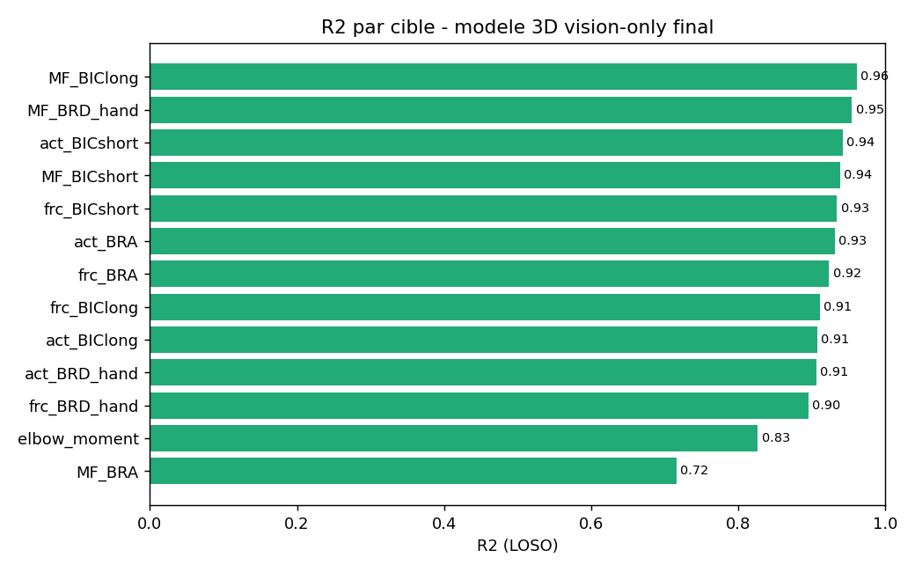
Figure 5 - R2 per target (final vision-only 3D model).
Per-subject generalisation (the 8 LOSO folds):
Subject | R2_mean | R2_torque | R2_activations | R2_forces | R2_fatigue
s03 | 0.895 | 0.818 | 0.952 | 0.957 | 0.795
s04 | 0.821 | 0.694 | 0.851 | 0.829 | 0.815
s05 | 0.954 | 0.913 | 0.944 | 0.943 | 0.985
s07 | 0.948 | 0.866 | 0.940 | 0.934 | 0.989
s08 | 0.922 | 0.852 | 0.916 | 0.894 | 0.974
s09 | 0.963 | 0.882 | 0.960 | 0.964 | 0.984
s10 | 0.927 | 0.800 | 0.938 | 0.938 | 0.936
s11 | 0.728 | 0.909 | 0.713 | 0.656 | 0.769

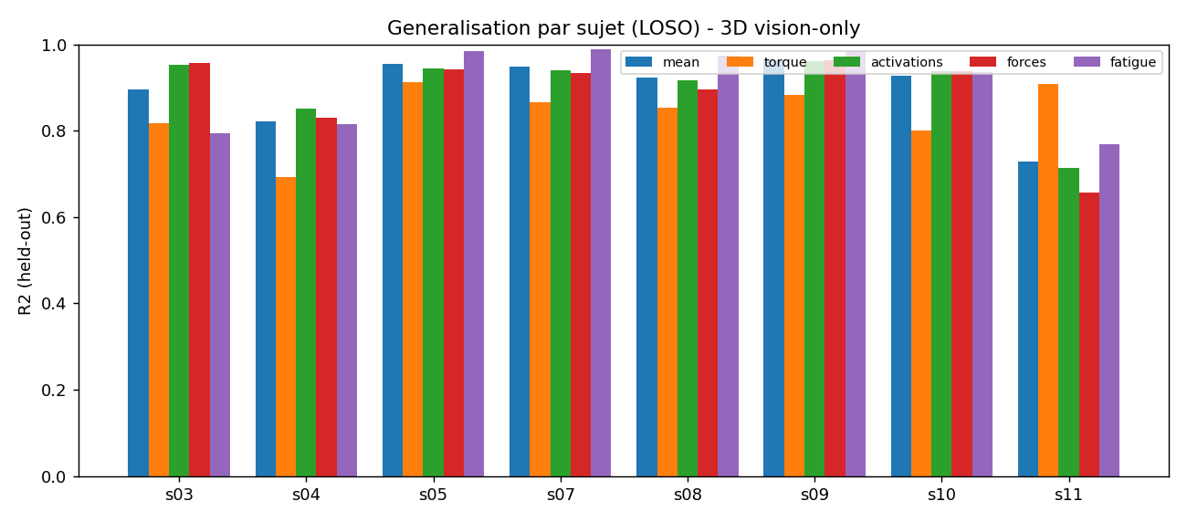
Figure 6 - Per-subject R2 by group (LOSO).

12. Time-resolved comparison (per muscle)
Predicted vs ground truth over time, per muscle (activation/force/fatigue) for a held-out subject.
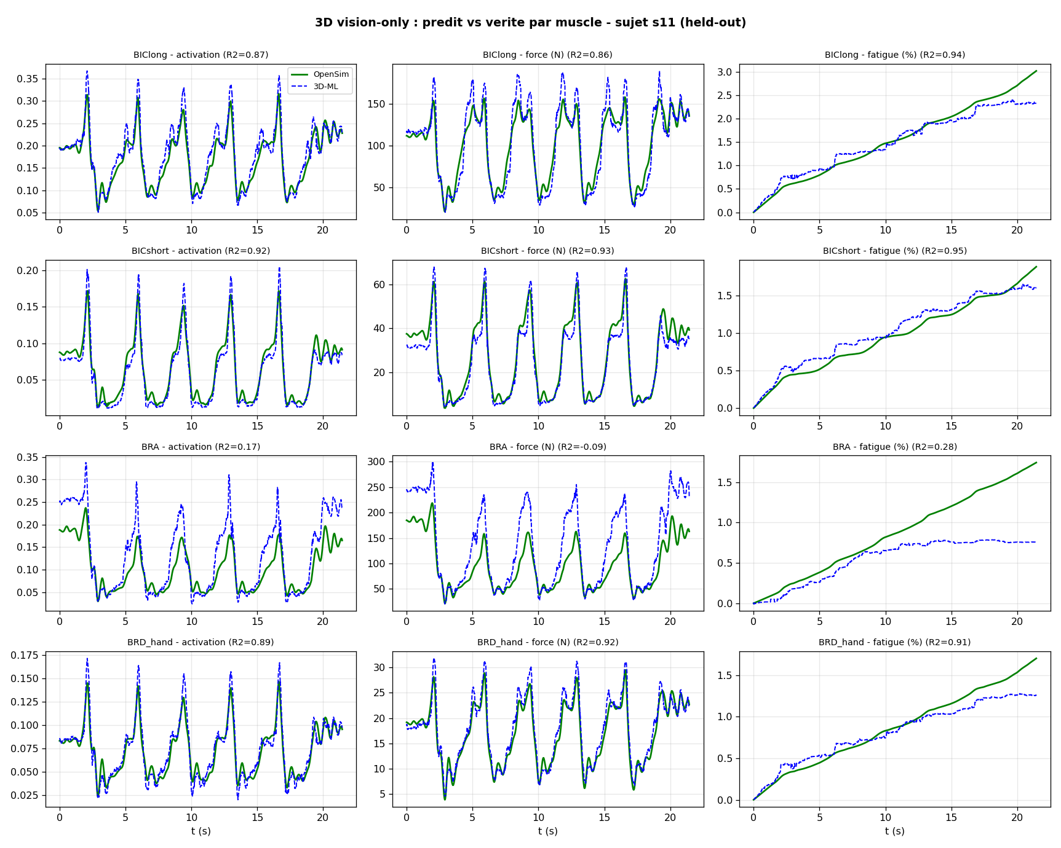
Figure 7 - Per-muscle predicted vs truth, held-out subject.

13. Vision-only (3D joints) vs the .mot + .osim approach — honest gap
Approach A works from the .mot file (joint angles) and the .osim scaled model (the lab pipeline); it reaches mean R2 = 0.952 (torque 0.937). That .mot/.osim pipeline is the best-case reference. This 3D vision-only model works directly from the 3 raw joints and reaches ~0.90 (torque ~0.84) - the honest deployment number, since at inference only the joints are available.
Note on how the .mot/.osim were produced: the angles in .mot were de-biased and the .osim was scaled using the Vicon ground truth (available in this dataset). That reference cleaning is what makes Approach A the best case; it is not available in pure vision-only deployment, which is precisely the gap (mostly the angle de-bias). Important: there is no data leakage - LOSO never sees the test labels; the reference (when used) only cleaned the inputs, not the targets.

14. Conclusion
From only 3 markerless 3D joints, a LightGBM with physics-guided feature engineering and Butterworth smoothing predicts torque, forces, activations and fatigue of an unseen subject at mean LOSO R2 ~0.90, with no Vicon and no OpenSim at inference. Time-series transformers do not beat it at this data scale. Smoothing the kinematics is the key lever for torque; cumulative features drive fatigue; anthropometry makes the model subject-aware.

15. Reproducibility
- Data: batch/<subj>/pose2sim/pose-3d/*filt_butterworth.trc (3D) ; labels in batch/<subj>/labels_ml.csv.
- Code: build_3d_model.py, research_3d_gbm.py, ts_transformer_3d.py, ts_transformers_3d.py, fix_torque_3d.py, improve_torque_3d.py, final_3d_model.py, report_3d_build.py.
- Results: metrics_3d_final.csv, metrics_3d_per_subject.csv, optuna_3d_trials.csv, xai_3d.csv, MASTER_comparison.csv.

