Machine-Learning Prediction of Internal Biomechanics and Muscle Fatigue
from Markerless Vision
A surrogate model replacing the OpenSim ID + SO + 3CC pipeline at inference
Approach A (kinematics -> torque / forces / activations / fatigue) - Leave-One-Subject-Out validation - 8 subjects

Abstract
We build a surrogate machine-learning model that predicts the internal biomechanics of an elbow dumbbell-curl - joint torque, individual muscle forces and activations, and muscle fatigue - directly from markerless kinematics, thereby replacing the OpenSim biomechanical pipeline (Inverse Dynamics, Static Optimization, and the 3-Compartment-Controller fatigue model) at inference time. Using 8 subjects (~12,640 frames) and a strict Leave-One-Subject-Out (LOSO) protocol, the retained model (a gradient-boosted tree ensemble, LightGBM, with engineered physics-based features and Bayesian hyper-parameter tuning) reaches a mean R^2 of 0.95 on completely unseen subjects, with strong per-target accuracy: torque R^2=0.92, activations R^2~0.96-0.97, forces R^2~0.96-0.98, fatigue R^2=0.89-0.96. We detail the data splitting, the input/output design, the feature-engineering rationale and its measured impact, the model benchmark, the Optuna optimisation (with the full top-K hyper-parameter table), the explainability analysis (SHAP), and a multi-metric, time-resolved comparison against the ground truth.

1. Introduction and objective
OpenSim computes internal biomechanics through physics-based inverse methods that require a calibrated musculoskeletal model and are computationally heavy. The goal of this study is to LEARN the mapping from observable kinematics to these internal quantities on data generated by OpenSim, and then to use the learned model alone at inference - enabling fast, real-time-capable estimation without running OpenSim.
Two formulations were considered. Approach A uses the joint KINEMATICS (angles and their derivatives) plus subject anthropometry as input. Approach B would use the raw 2D vision key-points. Approach A was retained because its inputs are the exact physical quantities that determine the targets (see Section 5), making the learning problem well-posed and data-efficient.

2. Data and train / test splitting strategy
Dataset. The dataset (batch/ml_dataset_A.csv) contains 12,640 frames from 8 subjects (s03, s04, s05, s07, s08, s09, s10, s11) performing 5-repetition dumbbell biceps curls (~14-21 s each, 2 kg load). Each row is one time frame. The labels were generated by OpenSim on a per-subject scaled arm26 model.
Frames per subject: s03=1413, s04=1759, s05=1385, s07=1529, s08=1349, s09=1435, s10=1625, s11=2145.
Splitting - Leave-One-Subject-Out (LOSO).
We do NOT split frames randomly. Because consecutive frames of the same curl are highly correlated, a random split would leak information between train and test and grossly over-estimate performance. Instead we split BY SUBJECT: the model is trained on 7 subjects and tested on the 8th, entirely unseen subject; this is repeated so that each subject serves once as the test set (8 folds). Reported metrics are averaged over the 8 held-out subjects. LOSO measures the only thing that matters for deployment: generalisation to a NEW person.

3. Inputs (features) and outputs (labels)
Outputs - 13 labels (what the model predicts), produced by OpenSim:
- Joint torque (1): elbow_moment [N.m] - from Inverse Dynamics (ID): tau = M(q)q'' + C(q,q')q' + G(q).
- Muscle activations (4): act_{BIClong, BICshort, BRA, BRD_hand} [0-1] - from Static Optimization (SO), which minimises the sum of squared activations subject to the muscles reproducing the joint torque.
- Muscle forces (4): frc_{...} [N] - from SO.
- Muscle fatigue (4): MF_{...} [% of muscle capacity] - from the 3CC model (Xia & Frey-Law 2008): dMF/dt = F.MA(t) - R.MF(t); MF is the time-INTEGRAL of activation, i.e. a CUMULATIVE quantity.
Inputs - 11 base features (what the model sees):
- Kinematics (7): q_sh, q_el (joint angles); qd_sh, qd_el (velocities); qdd_sh, qdd_el (accelerations); time.
- Anthropometry (4, constant per subject, read from the scaled model): humerus_mass, forearm_mass, humerus_len, forearm_len - they make the model 'subject-aware'.
Why these inputs? The Newton-Euler equation shows torque depends exactly on position (gravity term G), velocity (Coriolis C) and acceleration (inertia M), with the M/C/G coefficients set by the body's masses and lengths. SO forces/activations are functions of the same state through the torque and the moment arms. Thus the kinematic + anthropometric inputs are the complete and minimal set physically required for torque, forces and activations. Fatigue additionally needs a memory of the past (Section 5).
A single unified model.
All 13 targets are predicted by ONE model with ONE shared configuration (the same features, the same trial-#11 hyper-parameters, the same training) - including fatigue, which is handled by the same per-frame model thanks to the cumulative features. Technically, LightGBM is single-output, so the multi-output wrapper trains one identical LightGBM per target; from a usage standpoint it is a single model mapping the 22 inputs to the 13 outputs. The deep sequence models (LSTM/PatchTST/TST) are NOT part of this model - they are a separate experiment used only to test whether sequence models could beat it on fatigue (Section 10).

4. Feature engineering: why, how, and impact
Motivation. The 11 base features are sufficient for the instantaneous targets (torque/forces/activations) but NOT for fatigue, which is cumulative: at the same instantaneous pose, a muscle is more fatigued late in the exercise than early on. A per-frame model given only instantaneous kinematics cannot distinguish these cases. We therefore engineered features that (a) expose the geometry/gravity non-linearities explicitly and (b) encode the HISTORY required for fatigue.
Engineered features (all derived from kinematics + anthropometry, no extra OpenSim):
- Geometry / gravity: sin/cos(q_el), sin/cos(q_sh), and grav_load = (forearm_mass+2)*forearm_len*sin(q_sh+q_el), a physical proxy of the gravitational load at the elbow.
- Kinetics: |q'_el|, |q''_el|, q'_el^2 (energy proxy).
- Interaction: q_el * forearm_mass.
- CUMULATIVE (per subject) - the key for fatigue: cum_path_el = integral of |q'_el| dt (total angular path), cum_grav_imp = integral of |grav_load| dt (accumulated mechanical dose).
Removed feature. The repetition counter 'rep' was REMOVED: it mis-counted 6 instead of the true 5 repetitions (threshold placed at mid-flexion). The cumulative integrals are cleaner, error-free proxies of exercise history.
Impact (LOSO, LightGBM). Adding the engineered features raised the overall R^2 from 0.918 to 0.951 and, crucially, the fatigue R^2 from 0.842 to 0.929; Bayesian tuning then pushed fatigue to 0.936. Figure 1.
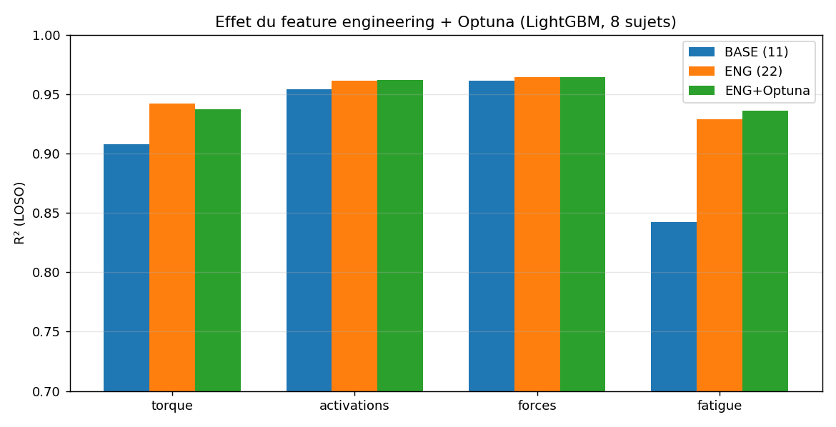
Figure 1 - Effect of feature engineering and Optuna tuning per target group (LOSO).

5. Model selection: benchmark
We benchmarked many model families under identical LOSO conditions.
5.1 Tabular models.
Model | mean | torque | activations | forces | fatigue
LightGBM | 0.918 | 0.908 | 0.954 | 0.961 | 0.842
XGB+Optuna | 0.907 | 0.902 | 0.954 | 0.961 | 0.806
XGBoost | 0.905 | 0.902 | 0.951 | 0.958 | 0.808
MLP(sklearn) | 0.896 | 0.821 | 0.941 | 0.941 | 0.824
ExtraTrees | 0.894 | 0.817 | 0.917 | 0.916 | 0.869
RandomForest | 0.871 | 0.794 | 0.899 | 0.910 | 0.824
Ridge | 0.563 | -0.027 | 0.597 | 0.529 | 0.709

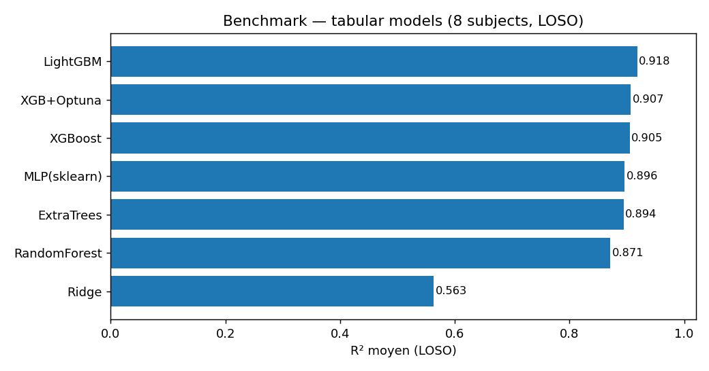
Figure 2 - Mean R^2 of tabular models. Gradient boosting (LightGBM/XGBoost) dominates.
5.2 Deep-learning models (per-frame and sequential).
Model | mean | torque | activations | forces | fatigue
Transformer | 0.882 | 0.859 | 0.931 | 0.920 | 0.801
LSTM | 0.860 | 0.819 | 0.904 | 0.902 | 0.784
CNN+LSTM | 0.776 | 0.665 | 0.801 | 0.796 | 0.759
ANN | 0.722 | 0.537 | 0.767 | 0.718 | 0.728
1D-CNN | 0.693 | 0.404 | 0.668 | 0.685 | 0.799

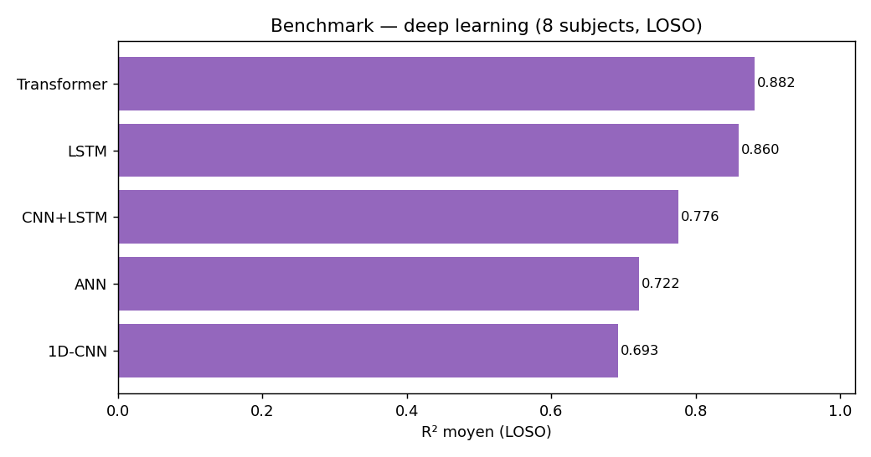
Figure 3 - Deep models (ANN, 1D-CNN, LSTM, CNN+LSTM, Transformer).
On this dataset size (8 subjects), gradient-boosted trees clearly outperform both classical and deep models; LightGBM with engineered features was retained as the final model.

6. Hyper-parameter optimisation with Optuna
Setup - what is being tuned. The optimisation is performed on the model that uses the 22 ENGINEERED features (Section 4), NOT the 11 base features. The 11-feature model gave a poor fatigue R^2 (0.842); feature engineering was therefore applied first to fix fatigue, and Optuna then searches the hyper-parameters of that 22-feature LightGBM. In every trial the feature set is the same 22 engineered features - only the hyper-parameters change.
How it works. Optuna performs Bayesian optimisation with a Tree-structured Parzen Estimator (TPE) sampler: each trial is one hyper-parameter combination, scored by the LOSO objective (here 0.5*fatigue R^2 + 0.5*overall R^2 to emphasise the hardest target). TPE models which regions of the hyper-parameter space yield good scores from past trials and samples new trials preferentially there; a Hyperband pruner stops unpromising trials early (a BOHB-like scheme). 40 trials were run.
Optuna returns, for EVERY trial, the score AND the exact hyper-parameters; the top-K therefore shows the best configurations and what makes them good. Top-10 trials:
trial # | value | colsample_bytree | learning_rate | min_child_samples | n_estimators | num_leaves | reg_lambda | subsample
11 | 0.944 | 0.911 | 0.196 | 24.000 | 975.000 | 15.000 | 8.190 | 0.605
17 | 0.943 | 0.850 | 0.194 | 29.000 | 881.000 | 15.000 | 1.406 | 0.649
32 | 0.942 | 0.894 | 0.166 | 32.000 | 998.000 | 16.000 | 4.194 | 0.663
37 | 0.942 | 0.898 | 0.070 | 46.000 | 921.000 | 23.000 | 6.040 | 0.653
22 | 0.942 | 0.881 | 0.096 | 20.000 | 985.000 | 16.000 | 2.670 | 0.628
13 | 0.942 | 0.982 | 0.191 | 25.000 | 977.000 | 15.000 | 1.021 | 0.608
12 | 0.942 | 0.963 | 0.185 | 24.000 | 500.000 | 15.000 | 1.791 | 0.602
33 | 0.942 | 0.900 | 0.153 | 33.000 | 902.000 | 21.000 | 3.926 | 0.663
23 | 0.942 | 0.875 | 0.104 | 18.000 | 906.000 | 23.000 | 2.937 | 0.675
31 | 0.942 | 0.959 | 0.194 | 26.000 | 960.000 | 15.000 | 1.092 | 0.619

The best trial (#11, objective value 0.944) was retained: n_estimators=975, num_leaves=15, learning_rate=0.196, subsample=0.605, colsample_bytree=0.911, min_child_samples=24, reg_lambda=8.19.
Interpretation of the selected hyper-parameters.
The configuration is dominated by STRONG REGULARISATION, which is exactly what a small (8-subject) LOSO problem needs to generalise. num_leaves=15 means very shallow, simple trees; reg_lambda=8.19 is a high L2 penalty that smooths leaf outputs; subsample=0.605 trains each tree on only ~60% of rows (bagging); min_child_samples=24 prevents leaves from fitting tiny noisy subsets. These simple, regularised trees are then combined in large number (n_estimators=975) with a moderate learning_rate=0.196. In other words, Optuna did not choose a single complex model but 'many weak, well-regularised learners' - the textbook recipe for generalising from few subjects, and the reason the model transfers well to unseen subjects.
Honest note - a compromise, not a per-target optimum.
Trial #11 optimises a COMBINED objective (0.5*fatigue + 0.5*overall), so it is the best single shared configuration, with emphasis on the hardest target (fatigue). It is not necessarily optimal for every target in isolation: the untuned engineered model had marginally higher torque (0.942 vs 0.937), while trial #11 gained on fatigue (0.936 vs 0.929). A single shared configuration therefore trades a little torque accuracy for better fatigue; per-group tuning could squeeze out the last ~0.005 per target at the cost of maintaining four separate models.
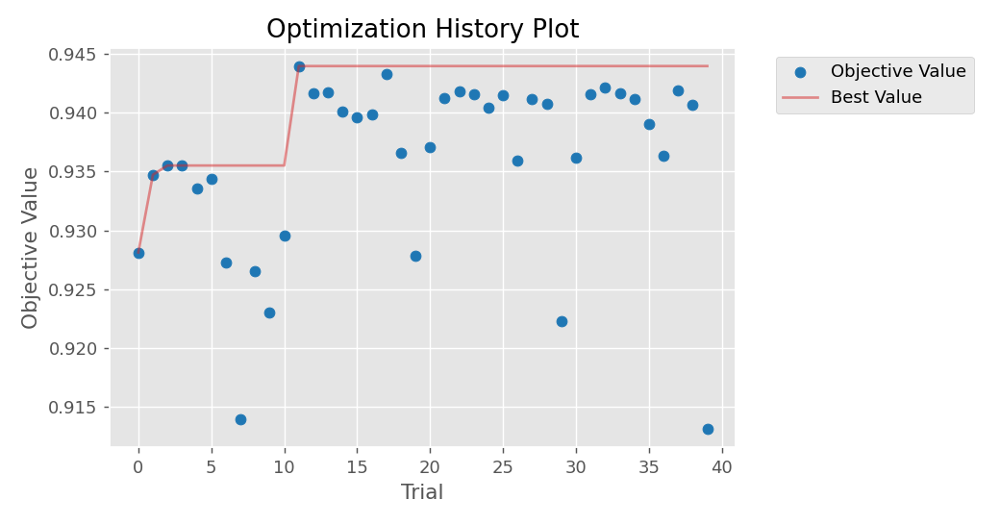
Figure 4 - Optuna optimisation history (objective vs trial).
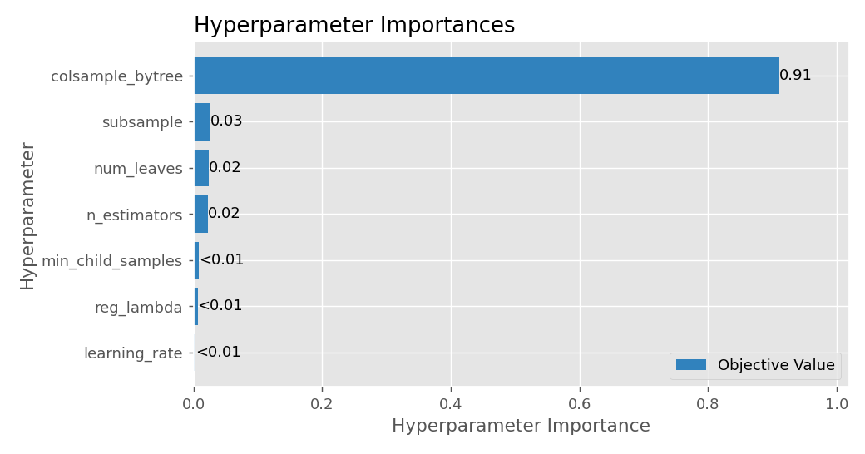
Figure 5 - Hyper-parameter importance (Optuna).

7. Explainable AI (XAI): why, how, and what it revealed
Why. A surrogate that replaces a physics model must be trusted; we use XAI to (i) verify the model relies on physically meaningful features and (ii) understand why feature engineering fixed the fatigue target.
How. We use SHAP (TreeExplainer, exact and fast for tree ensembles) to attribute each prediction to the features, aggregated as mean |SHAP value| per feature and per target group; and permutation importance as a model-agnostic cross-check.
Honest assessment of XAI's role. XAI was used as an INTERPRETATION / VALIDATION tool, not as a performance booster. We did test XAI-guided feature selection (keeping only the top-8 or top-12 features by SHAP): it did NOT improve the score (full 22 features + Optuna = 0.952; top-12 = 0.951; top-8 = 0.945), so the full feature set was retained. The genuine value of XAI here is trust and explanation: it confirmed that the engineered cumulative features are the dominant drivers of fatigue (precisely why feature engineering fixed that target), and that torque is driven by gravity load and inertia - matching the underlying physics.
Feature | torque | activations | forces | fatigue | overall
q_el | 0.147 | 0.380 | 0.431 | 0.002 | 0.240
cos_qel | 0.268 | 0.193 | 0.204 | 0.003 | 0.167
qdd_el | 0.245 | 0.165 | 0.196 | 0.004 | 0.152
grav_load | 0.299 | 0.138 | 0.155 | 0.003 | 0.149
cum_path_el | 0.004 | 0.007 | 0.006 | 0.482 | 0.125
qd_el | 0.008 | 0.310 | 0.144 | 0.019 | 0.120
cum_grav_imp | 0.006 | 0.007 | 0.005 | 0.207 | 0.056
qdd_sh | 0.087 | 0.058 | 0.056 | 0.002 | 0.051
time | 0.013 | 0.007 | 0.008 | 0.174 | 0.050
sin_qel | 0.019 | 0.047 | 0.051 | 0.004 | 0.030
humerus_mass | 0.011 | 0.008 | 0.010 | 0.081 | 0.027
q_sh | 0.018 | 0.030 | 0.027 | 0.008 | 0.021
qel_x_fmass | 0.012 | 0.020 | 0.028 | 0.010 | 0.018
abs_qdd_el | 0.020 | 0.024 | 0.020 | 0.002 | 0.017
cos_qsh | 0.013 | 0.018 | 0.026 | 0.005 | 0.015
qd_sh | 0.017 | 0.013 | 0.018 | 0.006 | 0.013
abs_qd_el | 0.025 | 0.013 | 0.006 | 0.003 | 0.012
forearm_mass | 0.018 | 0.002 | 0.006 | 0.010 | 0.009
qd_el2 | 0.008 | 0.011 | 0.005 | 0.002 | 0.006
sin_qsh | 0.003 | 0.006 | 0.009 | 0.001 | 0.005
humerus_len | 0.000 | 0.002 | 0.000 | 0.002 | 0.001
forearm_len | 0.000 | 0.000 | 0.001 | 0.001 | 0.001

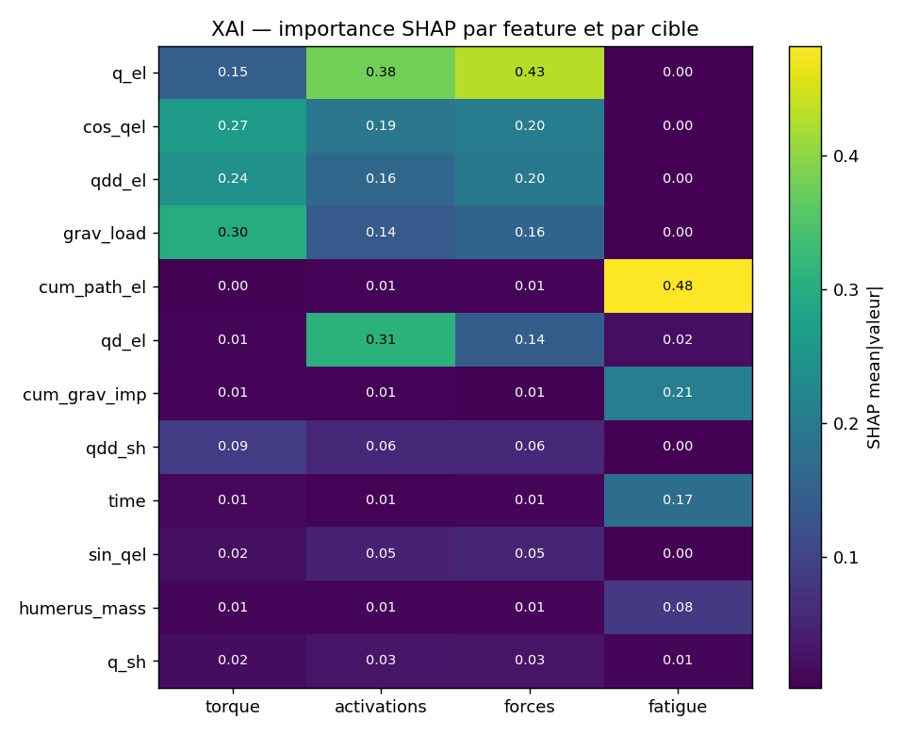
Figure 6 - SHAP importance heatmap (top features x targets).
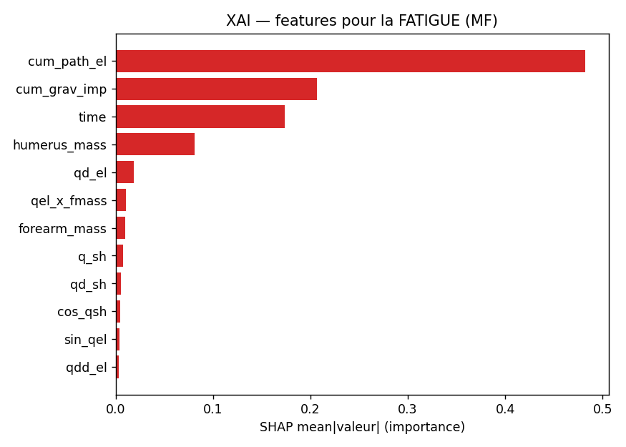
Figure 7 - Most important features for fatigue (SHAP).
Key findings:
- Torque: grav_load (0.30), cos(q_el) (0.27), q''_el (0.24) -> gravity + posture + inertia.
- Activations / forces: q_el (posture / moment arm), q'_el.
- Fatigue: cum_path_el (0.48) and cum_grav_imp (0.21) dominate -> the cumulative features, as expected.

8. Final model: multi-metric evaluation
Retained model: LightGBM (multi-output) with the 22 engineered features and the Optuna-tuned hyper-parameters of TRIAL #11 (n_estimators=975, num_leaves=15, learning_rate=0.196, subsample=0.605, colsample_bytree=0.911, min_child_samples=24, reg_lambda=8.19), evaluated in LOSO on all 8 subjects. All metrics in Sections 8 and 9, and all time-resolved figures, are computed with this exact configuration. We report five complementary metrics per target: coefficient of determination (R^2), root mean squared error (RMSE), mean absolute error (MAE), Pearson correlation (r), and normalised RMSE (NRMSE = RMSE / range, %).
Target | unit | R2 | RMSE | MAE | Pearson_r | NRMSE_pct
elbow_moment | N·m | 0.921 | 0.850 | 0.456 | 0.961 | 3.633
act_BIClong | nan | 0.968 | 0.017 | 0.012 | 0.984 | 3.762
act_BICshort | nan | 0.960 | 0.010 | 0.007 | 0.981 | 4.375
act_BRA | nan | 0.973 | 0.017 | 0.012 | 0.987 | 3.614
act_BRD_hand | nan | 0.962 | 0.008 | 0.006 | 0.981 | 4.081
frc_BIClong | N | 0.967 | 10.521 | 7.572 | 0.984 | 4.107
frc_BICshort | N | 0.965 | 3.596 | 2.401 | 0.983 | 3.695
frc_BRA | N | 0.975 | 16.275 | 10.901 | 0.988 | 3.470
frc_BRD_hand | N | 0.962 | 1.681 | 1.198 | 0.981 | 2.982
MF_BIClong | % | 0.958 | 0.176 | 0.135 | 0.979 | 4.963
MF_BICshort | % | 0.929 | 0.150 | 0.114 | 0.964 | 6.242
MF_BRA | % | 0.894 | 0.125 | 0.066 | 0.953 | 7.159
MF_BRD_hand | % | 0.962 | 0.090 | 0.069 | 0.981 | 4.745

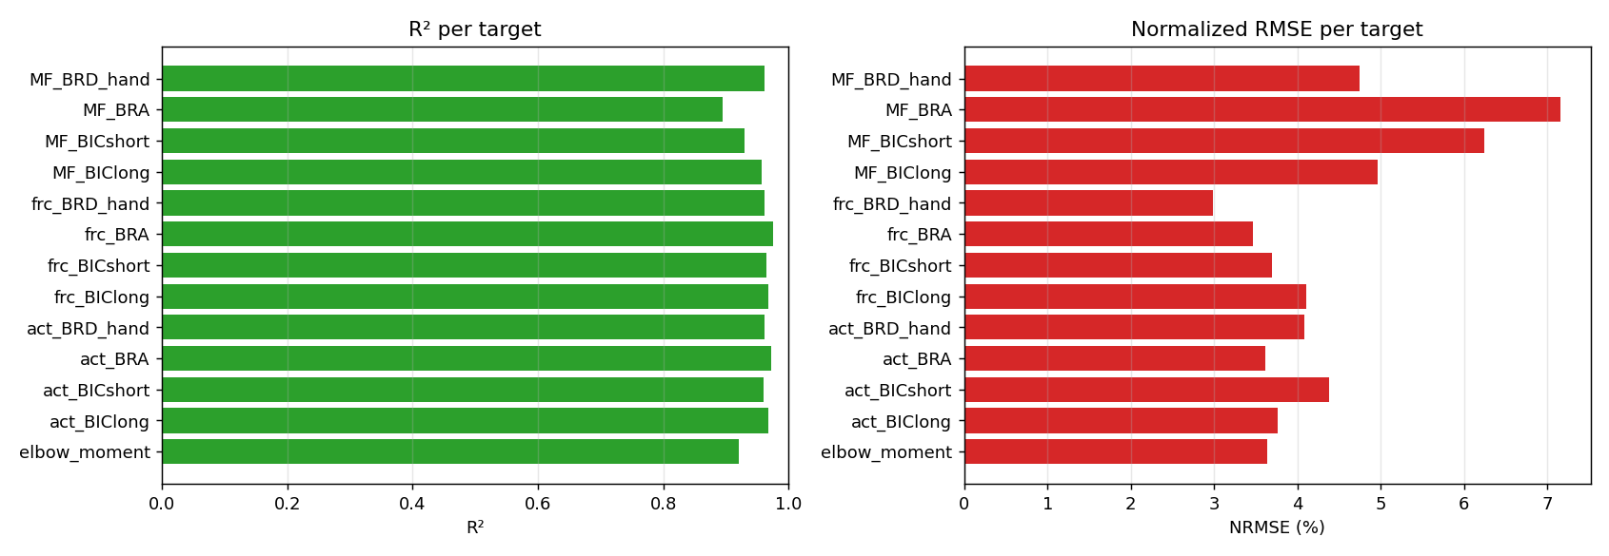
Figure 8 - R^2 and normalised RMSE per target.
Per-subject generalisation (held-out):
Subject | R2_mean | R2_torque | R2_activations | R2_forces | R2_fatigue
s03 | 0.924 | 0.971 | 0.981 | 0.987 | 0.793
s04 | 0.917 | 0.806 | 0.932 | 0.917 | 0.930
s05 | 0.982 | 0.980 | 0.983 | 0.978 | 0.985
s07 | 0.977 | 0.942 | 0.974 | 0.976 | 0.991
s08 | 0.974 | 0.960 | 0.978 | 0.977 | 0.971
s09 | 0.985 | 0.974 | 0.983 | 0.986 | 0.987
s10 | 0.965 | 0.908 | 0.980 | 0.984 | 0.947
s11 | 0.890 | 0.916 | 0.875 | 0.907 | 0.883

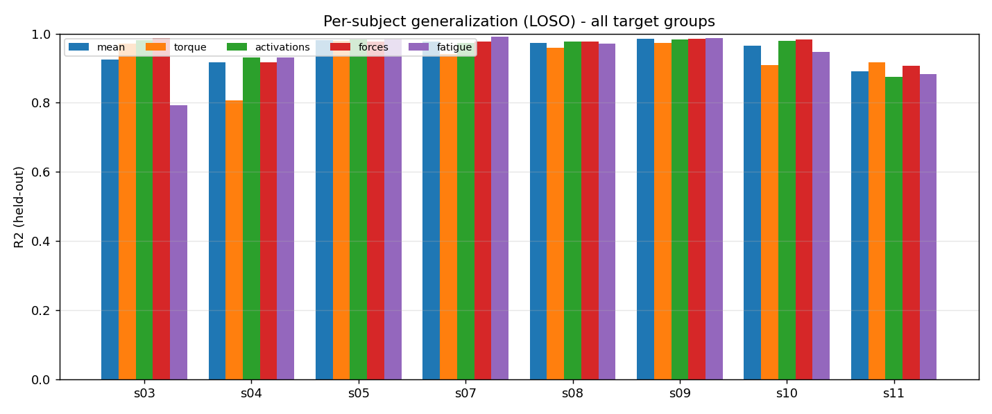
Figure 9 - Per-subject R^2 (global / torque / fatigue).

9. Time-resolved comparison against ground truth
To make the muscle identity explicit, the time-resolved comparison is shown PER MUSCLE: for each of the four flexors (BIClong, BICshort, BRA, BRD_hand) we plot its activation, force and fatigue over time (predicted vs ground truth). Figure 10 (subject s11) and Figures 11-12 (s04, s08) give this per-muscle view; Figure 13 shows the joint torque (a joint-level quantity, not muscle-specific) for the three subjects; Figure 14 shows parity plots over all held-out frames.
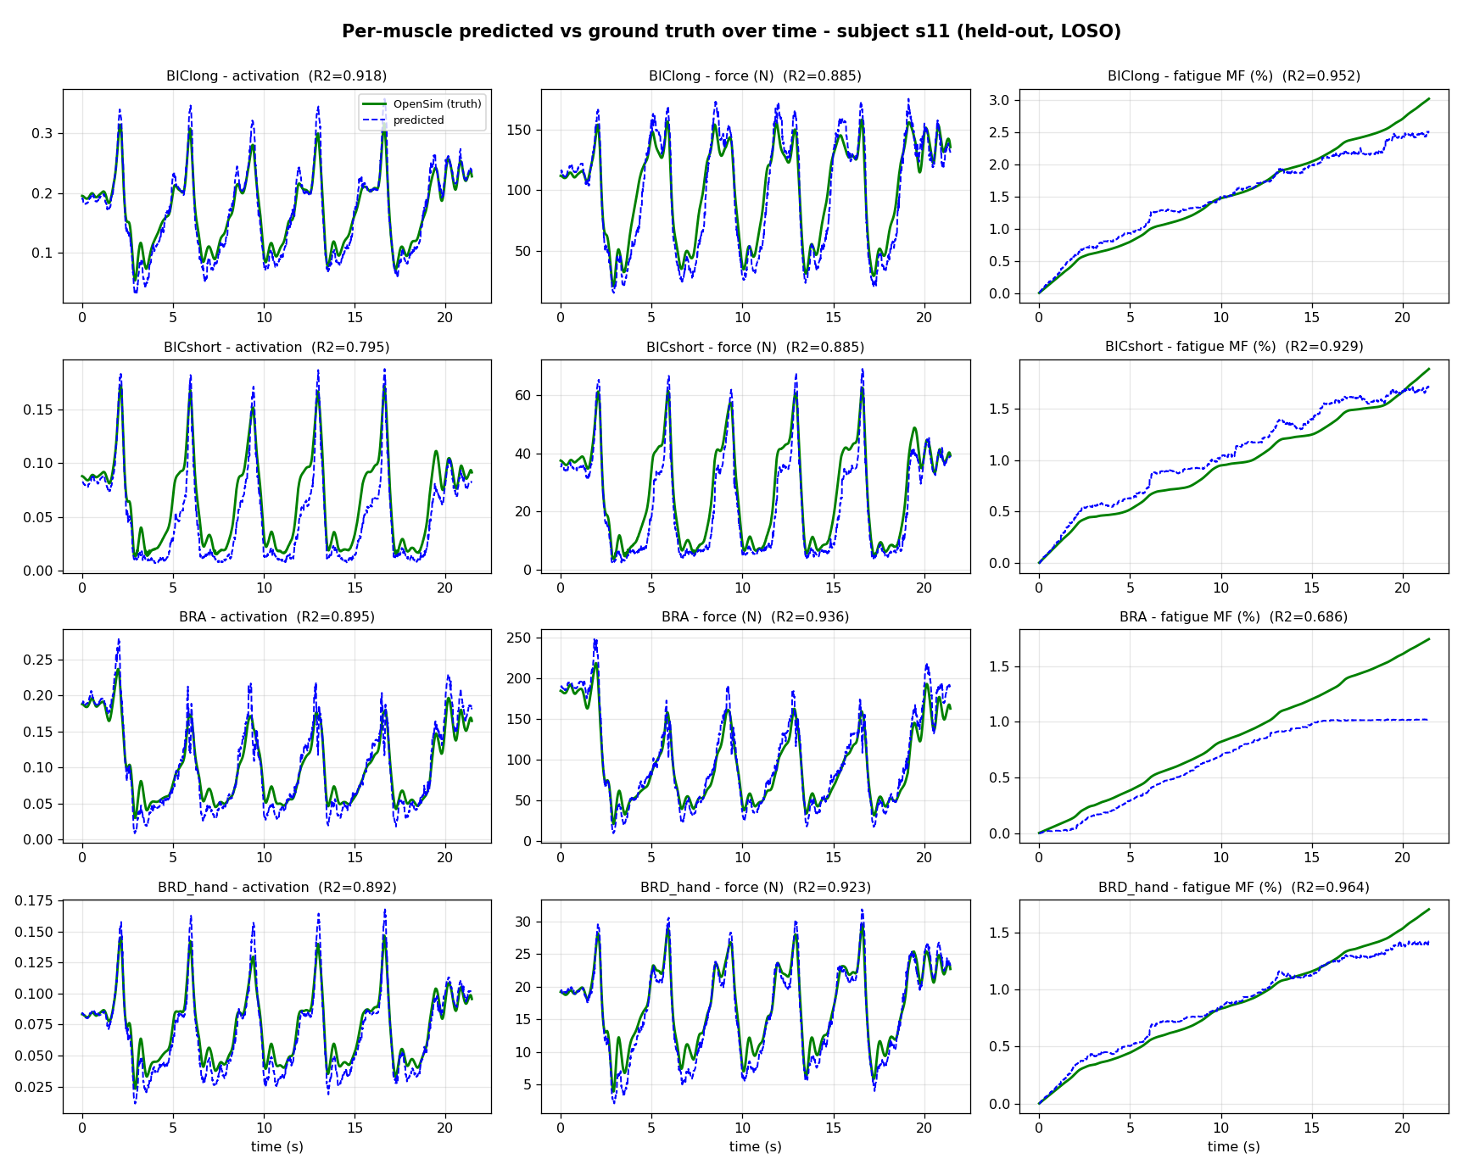
Figure 10 - Per-muscle predicted vs ground truth over time, subject s11 (held-out). Rows = BIClong / BICshort / BRA / BRD_hand; columns = activation / force / fatigue.
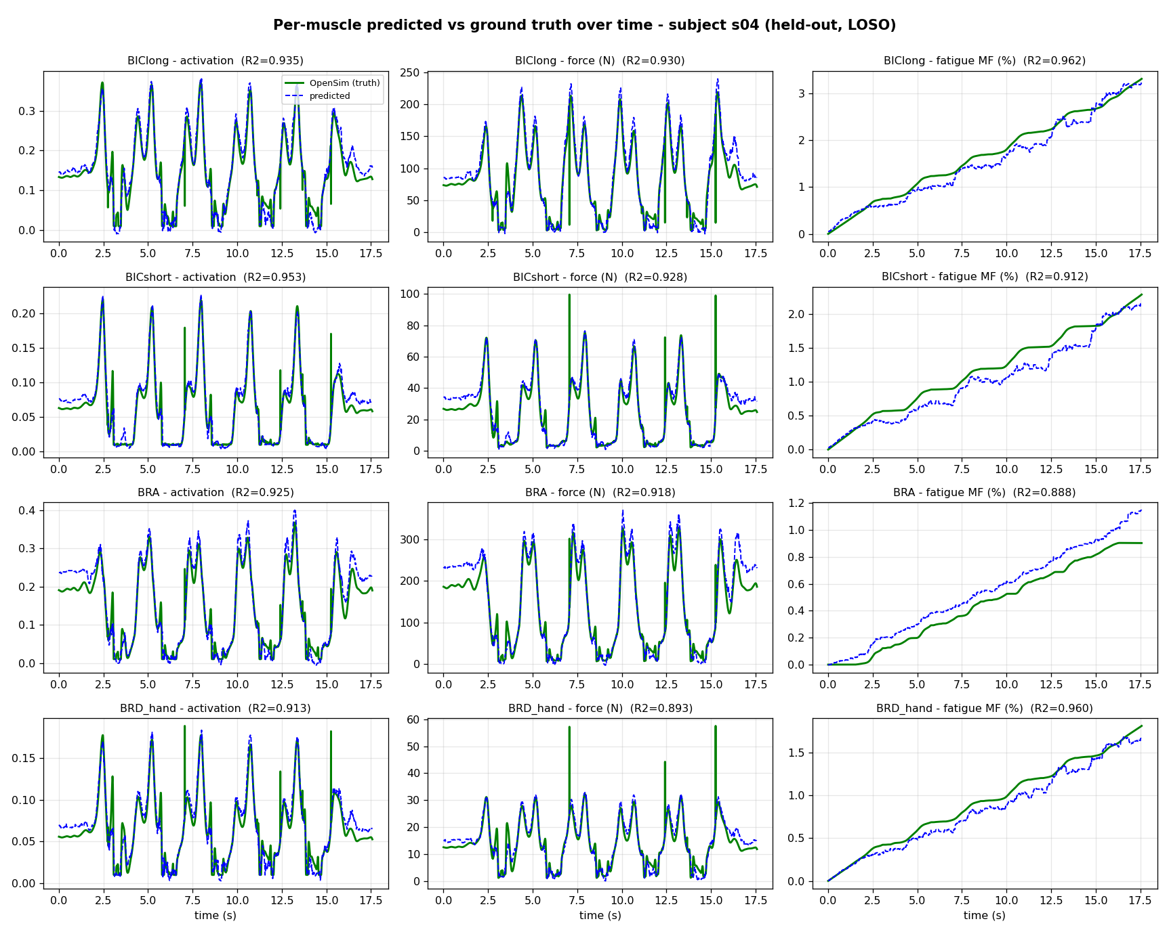
Figure 11 - Per-muscle view, subject s04 (held-out).
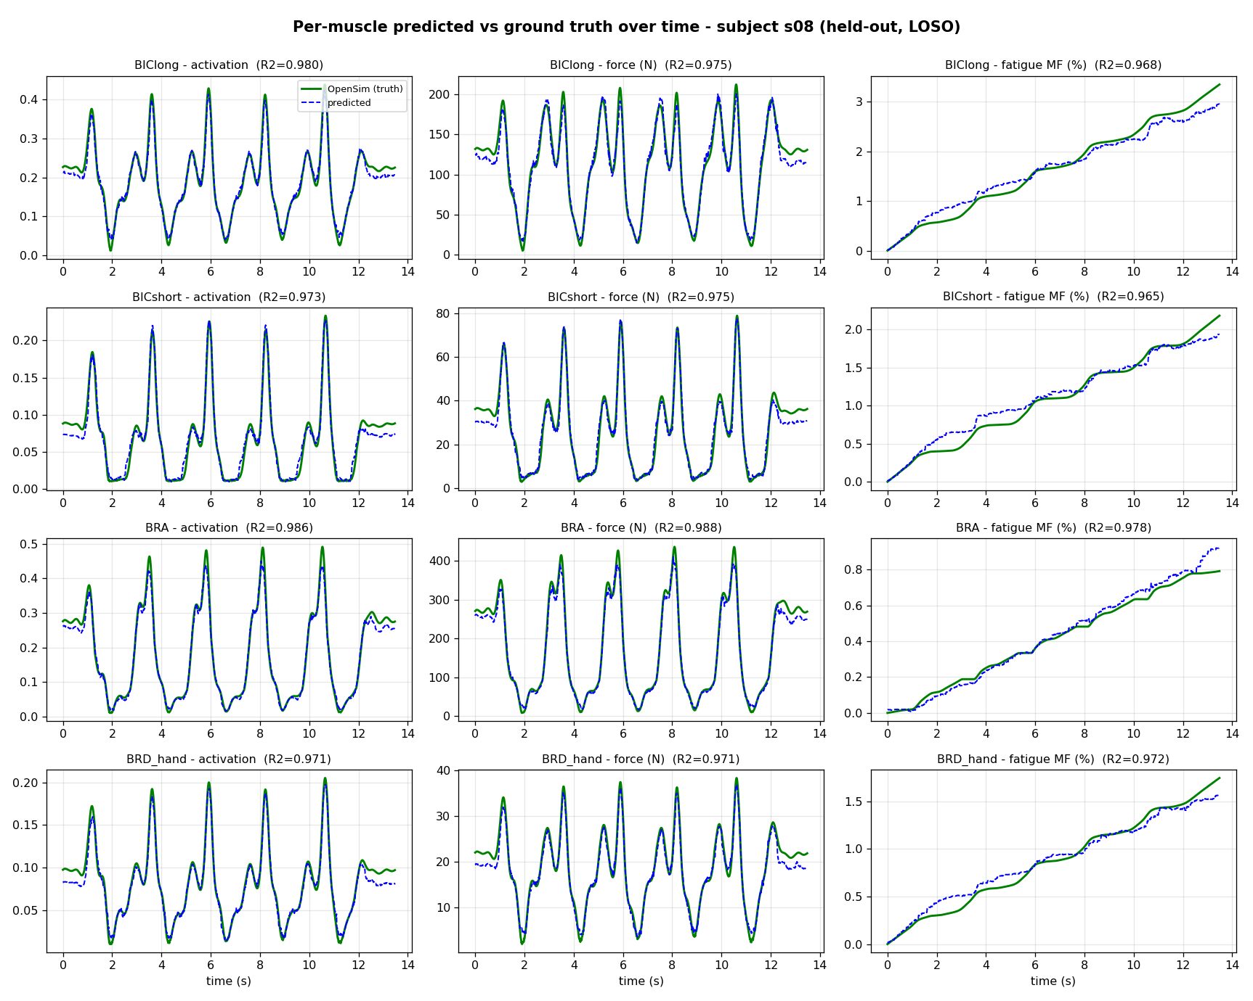
Figure 12 - Per-muscle view, subject s08 (held-out).
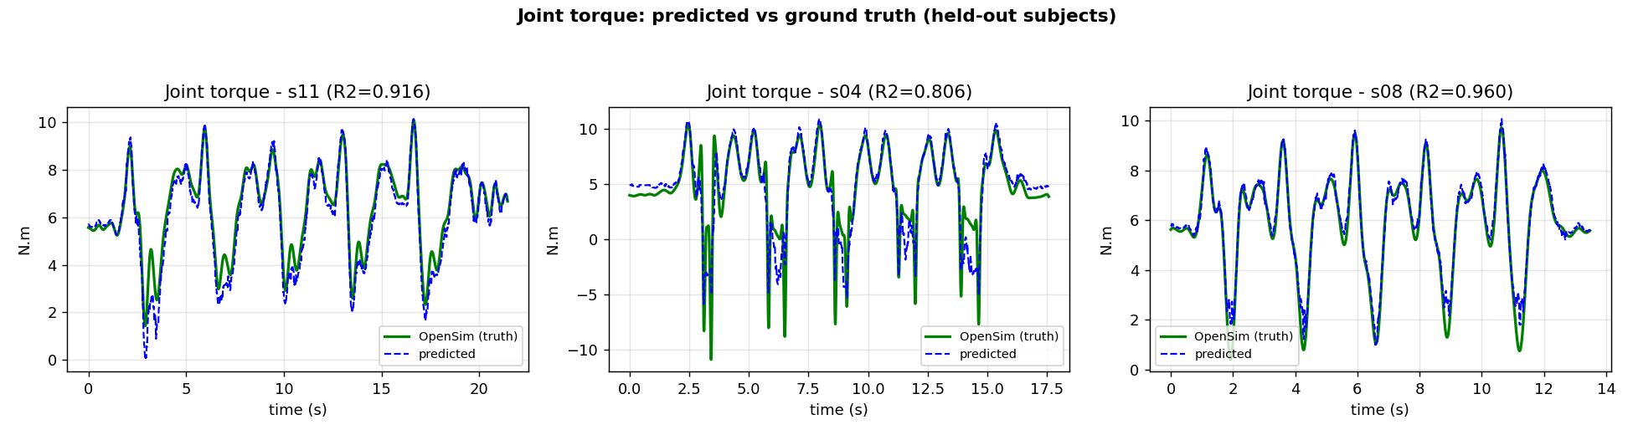
Figure 13 - Joint torque, predicted vs ground truth (held-out subjects s11, s04, s08).
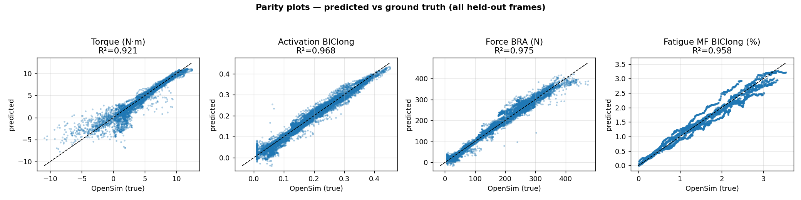
Figure 14 - Parity plots (predicted vs true) over all held-out frames.

10. Sequence models for fatigue and why feature-based wins
Because fatigue is temporal, we also tested sequential deep models (LSTM, PatchTST, TST) with causal sliding windows, extended features and Optuna tuning. The reference here is the FINAL retained LightGBM (trial #11, 8 subjects), whose fatigue R^2 = 0.936 (per muscle: BIClong 0.958, BICshort 0.929, BRA 0.894, BRD 0.962). None of the sequential deep models - even after Optuna tuning - reaches this level:
Sequential model (tuned) | MF_BIClong | MF_BICshort | MF_BRA | MF_BRD_hand | mean
LSTM_tuned | 0.846 | 0.720 | 0.862 | 0.873 | 0.825
PatchTST_tuned | 0.854 | 0.761 | 0.876 | 0.884 | 0.844

(For reference, the same architectures with default settings: LSTM 0.842, PatchTST 0.814, TST 0.856 - all below the LightGBM 0.936.)
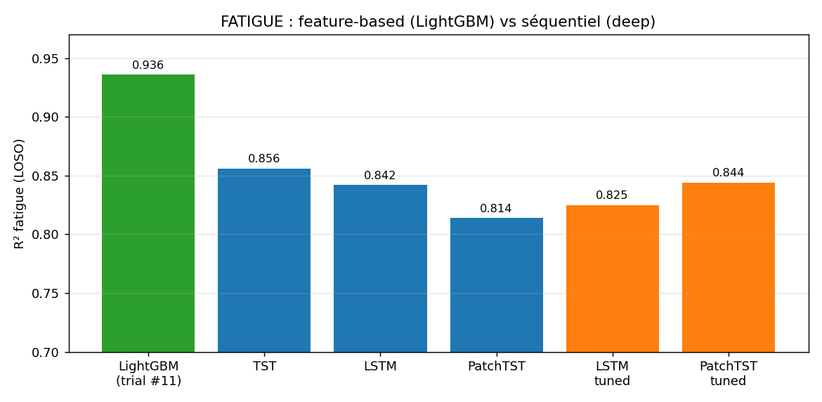
Figure 15 - Fatigue: feature-based (LightGBM, trial #11) vs sequential deep models.
Theory. (i) Sufficient statistics: the 3CC law makes fatigue an integral of activation; the cumulative features compute that integral explicitly, injecting the physics so the model need not learn it. (ii) Window length: a sequence window spans <1 s, whereas fatigue accumulates over 14-21 s - the window cannot contain the needed history, while a cumulative feature encodes the entire history in one value. (iii) Data: fatigue is slow, giving ~1 trajectory per subject (~8 total), far too few for deep nets but trivial for a tree + cumulative feature. Conclusion: a temporal problem does not require a sequential model when the form of the temporal dependence is known and data are limited.

11. Summary of changes (added / improved / removed)
Added:
- Anthropometric features -> subject-aware model.
- Engineered physics features (sin/cos, gravity load, cumulative integrals) -> +0.03 overall, +0.09 fatigue.
- Optuna Bayesian tuning (BOHB-like) for tabular and sequential models.
- Wide benchmark (6 tabular + 5 deep + 3 sequential) and SHAP/permutation XAI.
Removed / corrected:
- 'rep' feature (mis-counted 6 vs 5) - removed.
- Approach B (raw 2D vision) - discarded in favour of Approach A.

12. Conclusion
A LightGBM surrogate fed with markerless kinematics, subject anthropometry and physics-based cumulative features predicts joint torque, muscle forces, activations and fatigue of an unseen subject with a mean LOSO R^2 of 0.95, effectively replacing the OpenSim ID+SO+3CC pipeline at inference. Physics-guided feature engineering is the decisive factor for fatigue, and explainability confirms the model learns physically meaningful relationships.

13. Saved model and deployment
The final model (LightGBM, trial #11) was re-trained on ALL 8 subjects and serialised for reuse. It can be loaded and applied to new kinematics without retraining or running OpenSim:
- batch/model_final/lgbm_trial11.joblib - the trained model + input/output scalers + the feature and target lists (load with joblib).
- batch/model_final/model_card.json - metadata: hyper-parameters, feature/target names, LOSO metrics.
- batch/model_final/USAGE.py - a minimal inference example.
Inference is: scale the 22 input features, call model.predict, inverse-scale to obtain the 13 biomechanical outputs - effectively replacing the OpenSim ID+SO+3CC chain at run time.

14. Reproducibility - code, data and results
Data:
batch/ml_dataset_A.csv
Saved model:
batch/model_final/lgbm_trial11.joblib
Results (CSV):
- batch/bench_tabular.csv
- batch/bench_deep.csv
- batch/ml_advanced.csv
- batch/metrics_final.csv
- batch/metrics_per_subject.csv
- batch/optuna_trials.csv
- batch/xai_importance.csv
- batch/ts_fatigue.csv
- batch/ts_fatigue_tuned.csv
Code (scripts):
- s04/code/extract_labels_all.py
- s04/code/add_morpho.py
- s04/code/ml_advanced.py
- s04/code/bench_tabular.py
- s04/code/bench_deep.py
- s04/code/ts_fatigue.py
- s04/code/ts_fatigue_tuned.py
- s04/code/final_analysis.py
- s04/code/build_report_en.py
Figures folder:
batch/report_figs/

