Imara Afya — Auth System Design
As of 18 September 2026 · Idriss Murenga · Imara Company
MVP authentication for the Imara Afya backend — Node/TypeScript, Express, graphql-yoga, Mongoose. Replaces the current password-only auth with email OTP verification.

Contents
1. Scope and decisions
2. Architecture overview
3. Data model
4. Token design
5. Signup and email verification
6. Login and device trust
7. Password reset
8. Password change
9. Sequence diagrams
10. OTP rules
11. Rate limiting
12. GraphQL API surface
13. Error codes
14. Email templates
15. Client integration
16. Implementation map
17. Migration from the current auth
18. Test checklist
19. Open items and risks

1. Scope and decisions
Auth covers account creation, email verification, session issue and renewal, password change and password reset. Nothing else moves through this module.
Four decisions are locked:
Decision | Choice | Reason
OTP on login | New or untrusted device only | Password alone on a known phone; a code only when the device is unrecognised
Email verification | Does not block signup | An OTP that never arrives must not trap a new user on the first screen
OTP channel | Email now, schema ready for SMS | Email is not the primary channel in Burundi; the column exists from day one
Session | 7-day sliding token, 30-day origin cap | Already built and working; OTP layers on top of it, nothing replaces it
Out of scope for the MVP: social login, magic links, biometric unlock, TOTP authenticator apps, and account recovery without email access.

2. Architecture overview
Where auth sits in the request pipeline, and what each piece owns.
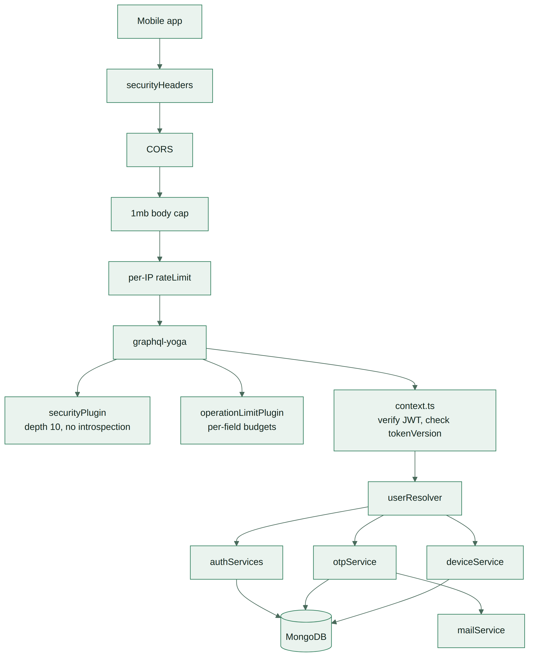
Request pipeline and service ownership
Request pipeline and service ownership

New service files
File | Owns
services/otpService.ts | Generate, hash, store, verify, consume, resend, cooldown
services/deviceService.ts | Trust lookup, trust grant, expiry, revoke, list
services/authServices.ts | Existing — gains reset-token sign and verify
services/mailService.ts | Existing — gains the OTP template
Nothing in otpService or deviceService imports GraphQL or Context. They take plain arguments and throw plain errors; the resolver translates those into GraphQLError codes. Same separation the repo already keeps between datetime.ts, validation.ts and resolverHelpers.ts.

3. Data model
Three collections: user gains four fields, otp and trustedDevice are new.

user — fields added
Field | Type | Default | Purpose
emailVerified | Boolean | false | Set once a SIGNUP code is consumed
emailVerifiedAt | Date | null | Audit trail, and evidence for a support request
failedPasswordAttempts | Number | 0 | Feeds the five-attempt lockout on change password
tokenVersion | Number | 0 | Already present; bumped on logout, password change, password reset
Email stays unique and lowercased on write. passwordHash stays bcrypt.

otp — new collection
Field | Type | Notes
user | ObjectId ref User | Indexed
codeHash | String | bcrypt of the 6 digits, never the digits
purpose | String enum | SIGNUP / LOGIN / RESET
channel | String enum | EMAIL now, SMS later — no migration needed
deviceId | String, optional | Set on LOGIN codes; the device this code will trust
expiresAt | Date | Now + 10 minutes; TTL index drops the row
attempts | Number | Verify attempts spent, ceiling 5
consumedAt | Date, null | Non-null means dead; never reusable
ip | String | Where it was requested from
createdAt | Date | Drives the resend cooldown
Indexes: { user: 1, purpose: 1, consumedAt: 1 } for the lookup on verify, and a TTL index on expiresAt so expired codes clear themselves without a cron job.
One live code per user per purpose. Requesting a new one consumes the old one, so a user reading the newest email is never fighting a stale code.

trustedDevice — new collection
Field | Type | Notes
user | ObjectId ref User | Indexed
deviceId | String | Client-generated UUID, stored in the phone’s secure storage
label | String | “Android 14 · Tecno” — shown in settings so a user can recognise it
lastSeenAt | Date | Refreshed on every successful login
expiresAt | Date | lastSeenAt + 90 days; TTL index
Index: { user: 1, deviceId: 1 } unique.
Both new models carry user: { ref: "User" }, so both must be added to USER_OWNED in accountService.ts or assertPurgeCoverage() refuses to boot.

4. Token design
Two token kinds, both HS256 with a pinned issuer, verified with the algorithm and issuer pinned on the way back in.

Session token
Claim | Meaning
sub | User id
v | The user’s tokenVersion at issue time
o | Session origin — when the password was last actually typed
iss | Pinned issuer string
exp | Issue + 7 days
context.ts rejects any token whose v is behind the user’s current tokenVersion. Bumping tokenVersion therefore revokes every token ever issued, instantly — that is what logout, password change and password reset each do.
refreshSession mints a new 7-day token but keeps the original o. Once o is more than 30 days old the refresh is refused and the password must be typed again. An already-issued token still works until its own exp, so a refresh cap is not a logout.

Reset token
Issued only by verifyPasswordResetOtp, and it is not a session token.
Claim | Meaning
sub | User id
purpose | PASSWORD_RESET — checked explicitly, so it cannot be used as a session
exp | Issue + 15 minutes
It exists so the OTP is not re-sent with the new password. The user proves the code once, gets a short-lived ticket, then sets the password. resetPassword accepts nothing else, and a session token presented in its place is refused on the purpose claim.
On a successful reset: tokenVersion bumps, every trusted device for that user is deleted, and a fresh session token is returned. Someone who resets a password because they think the account was taken should not leave the attacker’s phone trusted.

5. Signup and email verification
Signup returns a working session token immediately. Verification happens after, not before.
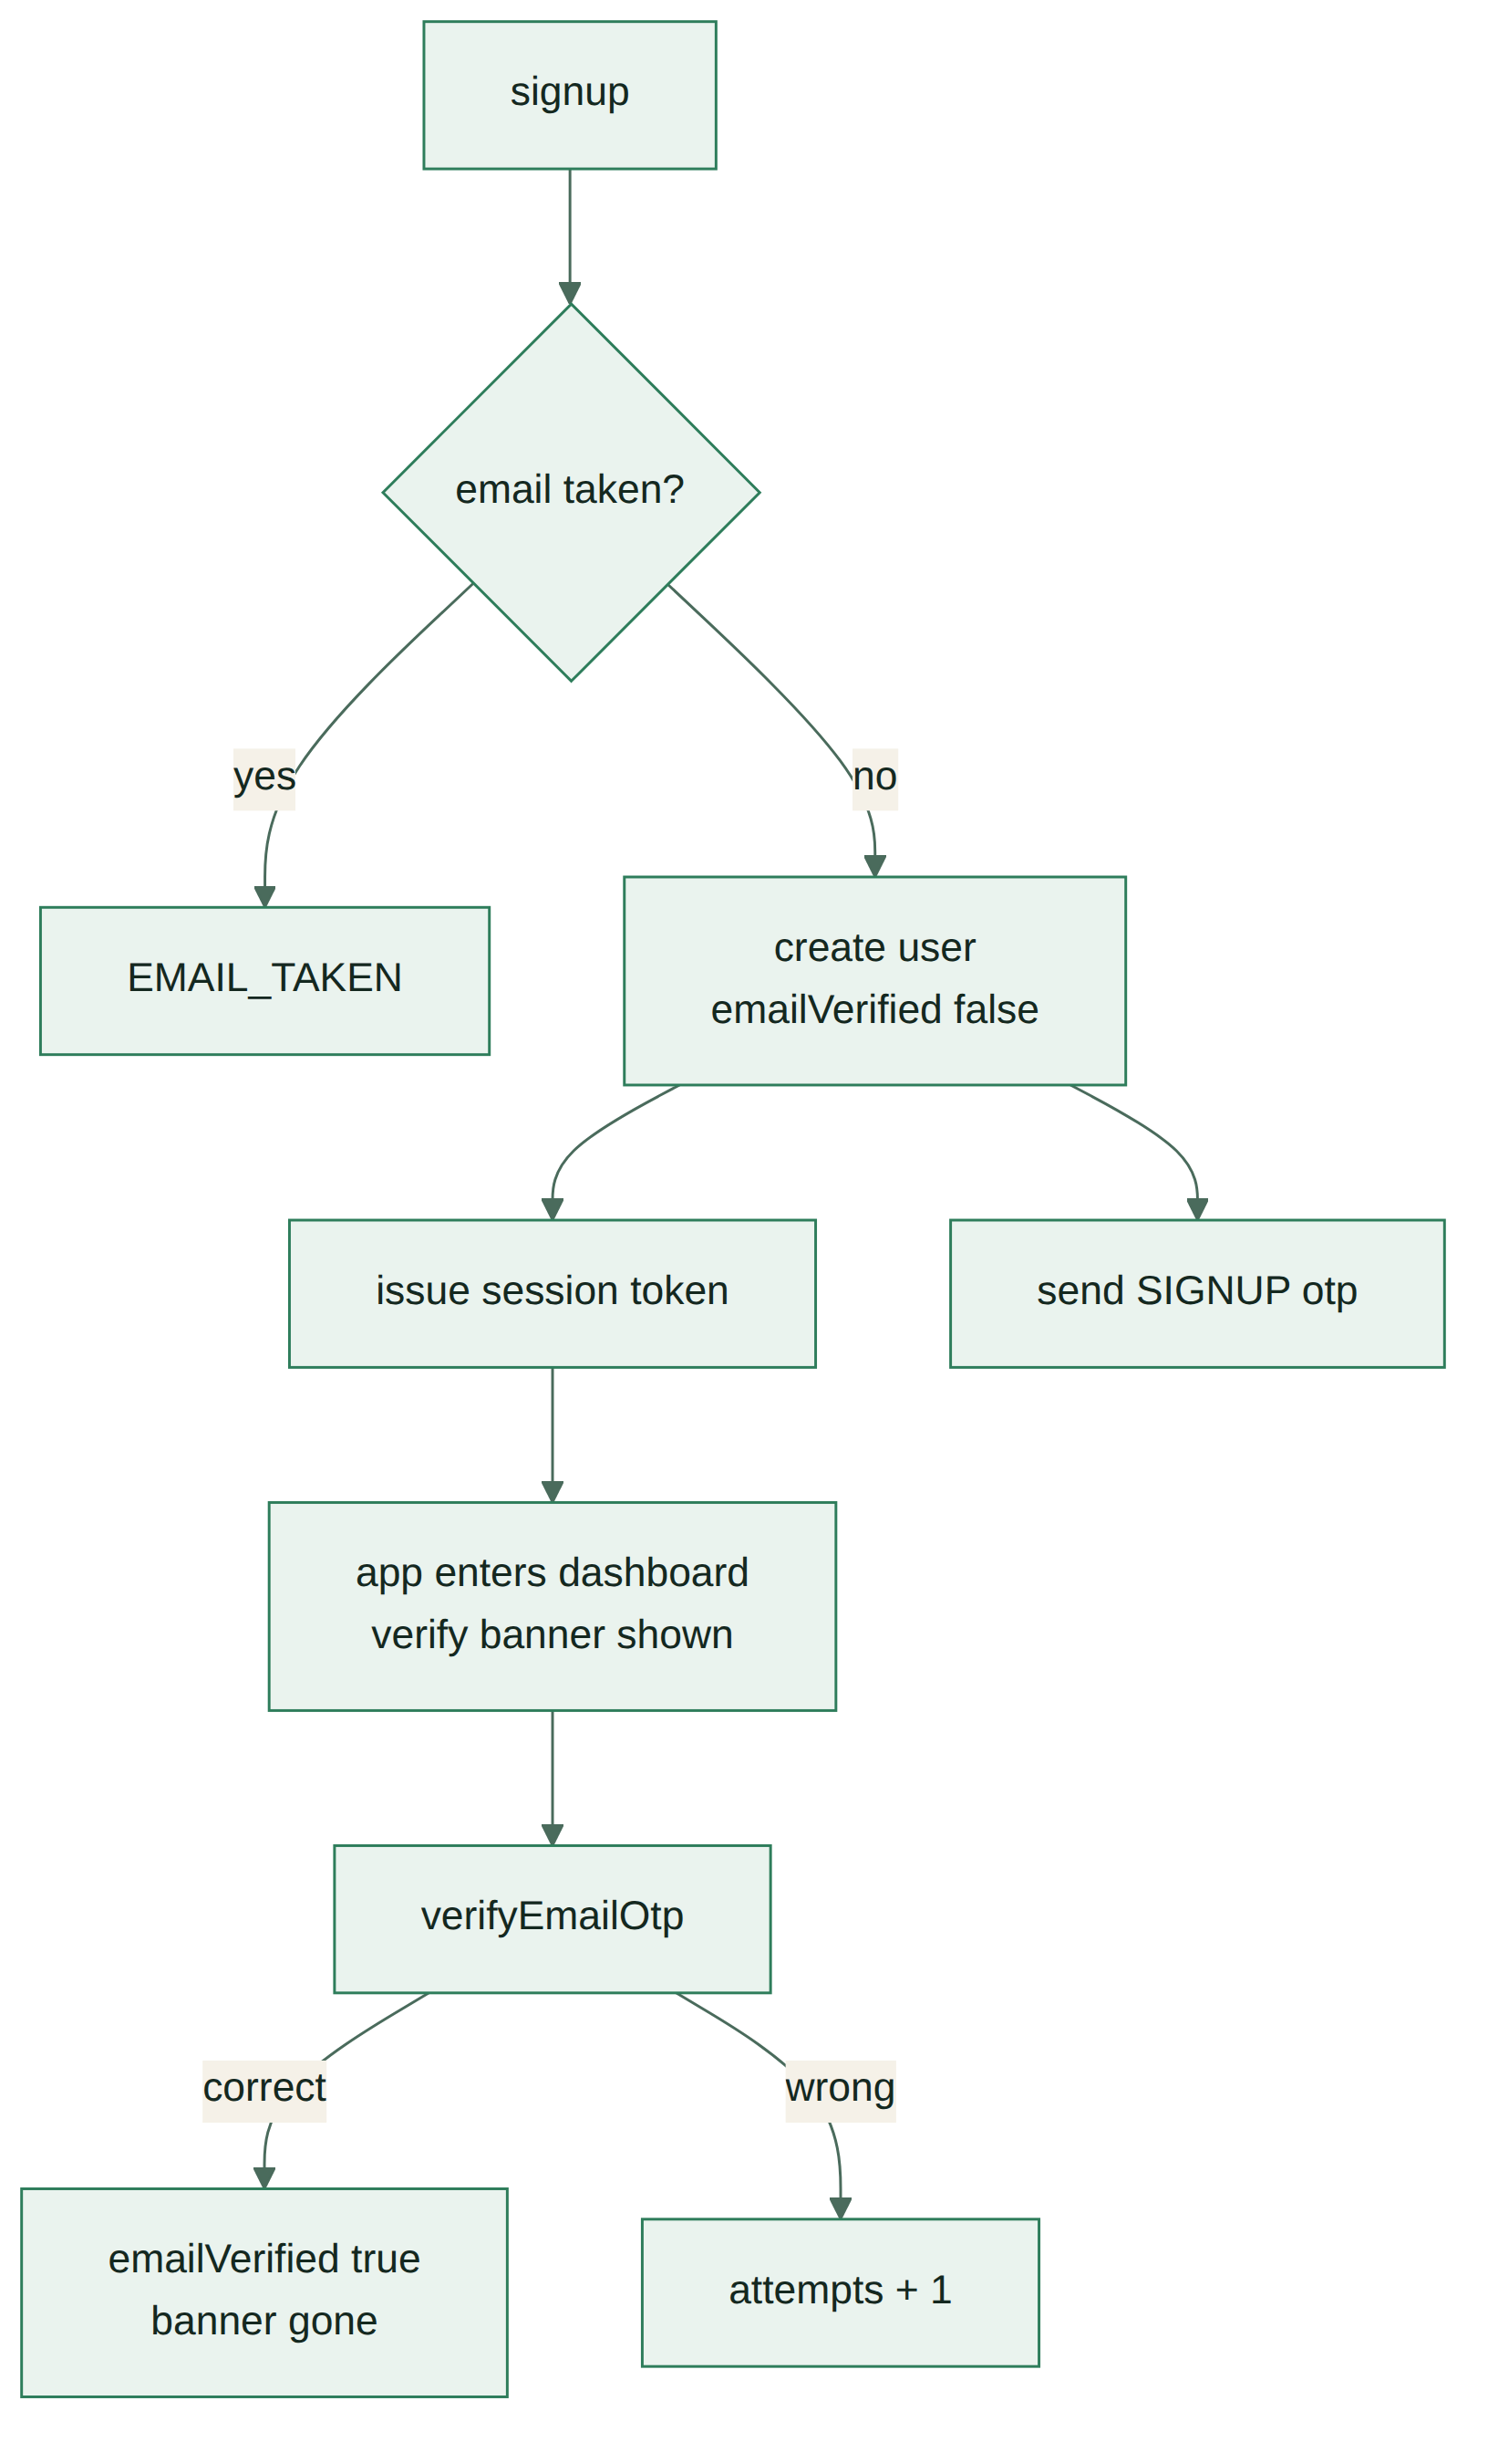
Signup and email verification flow
Signup and email verification flow
The user is inside the app one screen after signup. A dismissible banner asks them to verify, and me carries emailVerified so the app knows whether to show it.

What an unverified account cannot do
Action | Unverified
Log water, steps, sleep, weight, check-in | Allowed
Read own data | Allowed
Request a password reset | Blocked — the address is unproven
Trust a new device | Blocked — must verify first
Change email | Blocked
Tracking works unverified because a user who cannot log water on day one does not come back on day two. Reset is blocked because sending a recovery code to an unproven address is how an account gets handed to a typo.

Rules
- Email is lowercased and trimmed before the uniqueness check.
- Password validated server-side against validation.ts before the user document is created.
- If the OTP email fails to send, signup still succeeds. The failure is logged, the banner offers Resend.
- After 7 days unverified, the banner stops being dismissible. Still not a lockout.

6. Login and device trust
Login takes email, password and deviceId. A trusted device gets a token; anything else gets a code.
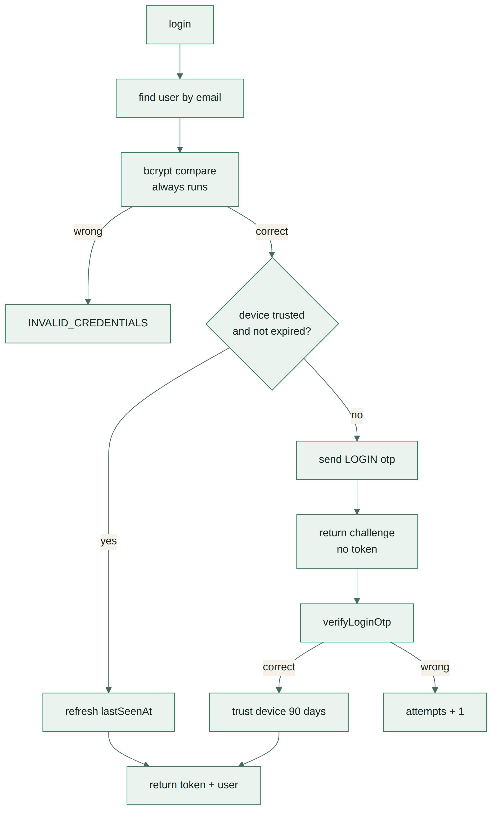
Login and device-trust decision
Login and device-trust decision
login returns a union, not always an AuthPayload. The app branches on which it got.

deviceId
A UUID v4 generated once by the app on first launch and written to secure storage — Keychain on iOS, EncryptedSharedPreferences on Android. Never AsyncStorage, or clearing the cache logs everyone out into an OTP loop.
It is an opaque identifier, not a security boundary. A caller can send any string they like; all it does is decide whether an OTP is required. The password is still the thing being checked.

Timing safety
The existing behaviour stays: bcrypt compare runs against a dummy hash even when no user matches the email, so response time cannot reveal who has an account. INVALID_CREDENTIALS is returned for both a wrong password and an unknown email, with identical wording.

Trust window
90 days from lastSeenAt, refreshed on every successful login. A phone used weekly never sees a code again. A phone left untouched for three months asks once.
Devices are listed in settings with label and last-seen date, and any one can be revoked. Revoking a device does not end its current session — it means the next login from it needs a code. To kill a session, log out or reset the password.

7. Password reset
Three calls: request a code, exchange the code for a reset ticket, set the password.
Password reset flow
Password reset flow
requestPasswordReset always returns true, whether or not the email exists. An endpoint that says “no such account” is a free account-enumeration tool.
An unverified email cannot request a reset — it returns true as well, and sends nothing.
On success the user is logged in directly. Making someone reset a password and then type it again immediately is friction with no security value.

8. Password change
Authenticated, current password required, no OTP. The user already proved possession of the session.
Rule | Behaviour
Wrong current password | failedPasswordAttempts + 1
Five wrong attempts | Change is refused until a reset is done; app offers the email reset
Correct password | Counter cleared to 0
Confirmation mismatch | Caught before an attempt is spent
New password equals old | Refused
On success | tokenVersion bumps, new token returned, other devices logged out
The lockout is per account, not per IP. Someone who cannot remember the password will not remember it on the sixth try, and the reset path is always visible so nobody has to fail five times to find it.
Trusted devices survive a password change. The user is choosing to rotate a password they know, which is not the same signal as a reset.

9. Sequence diagrams
Call-by-call, including what the client stores at each step.

Signup
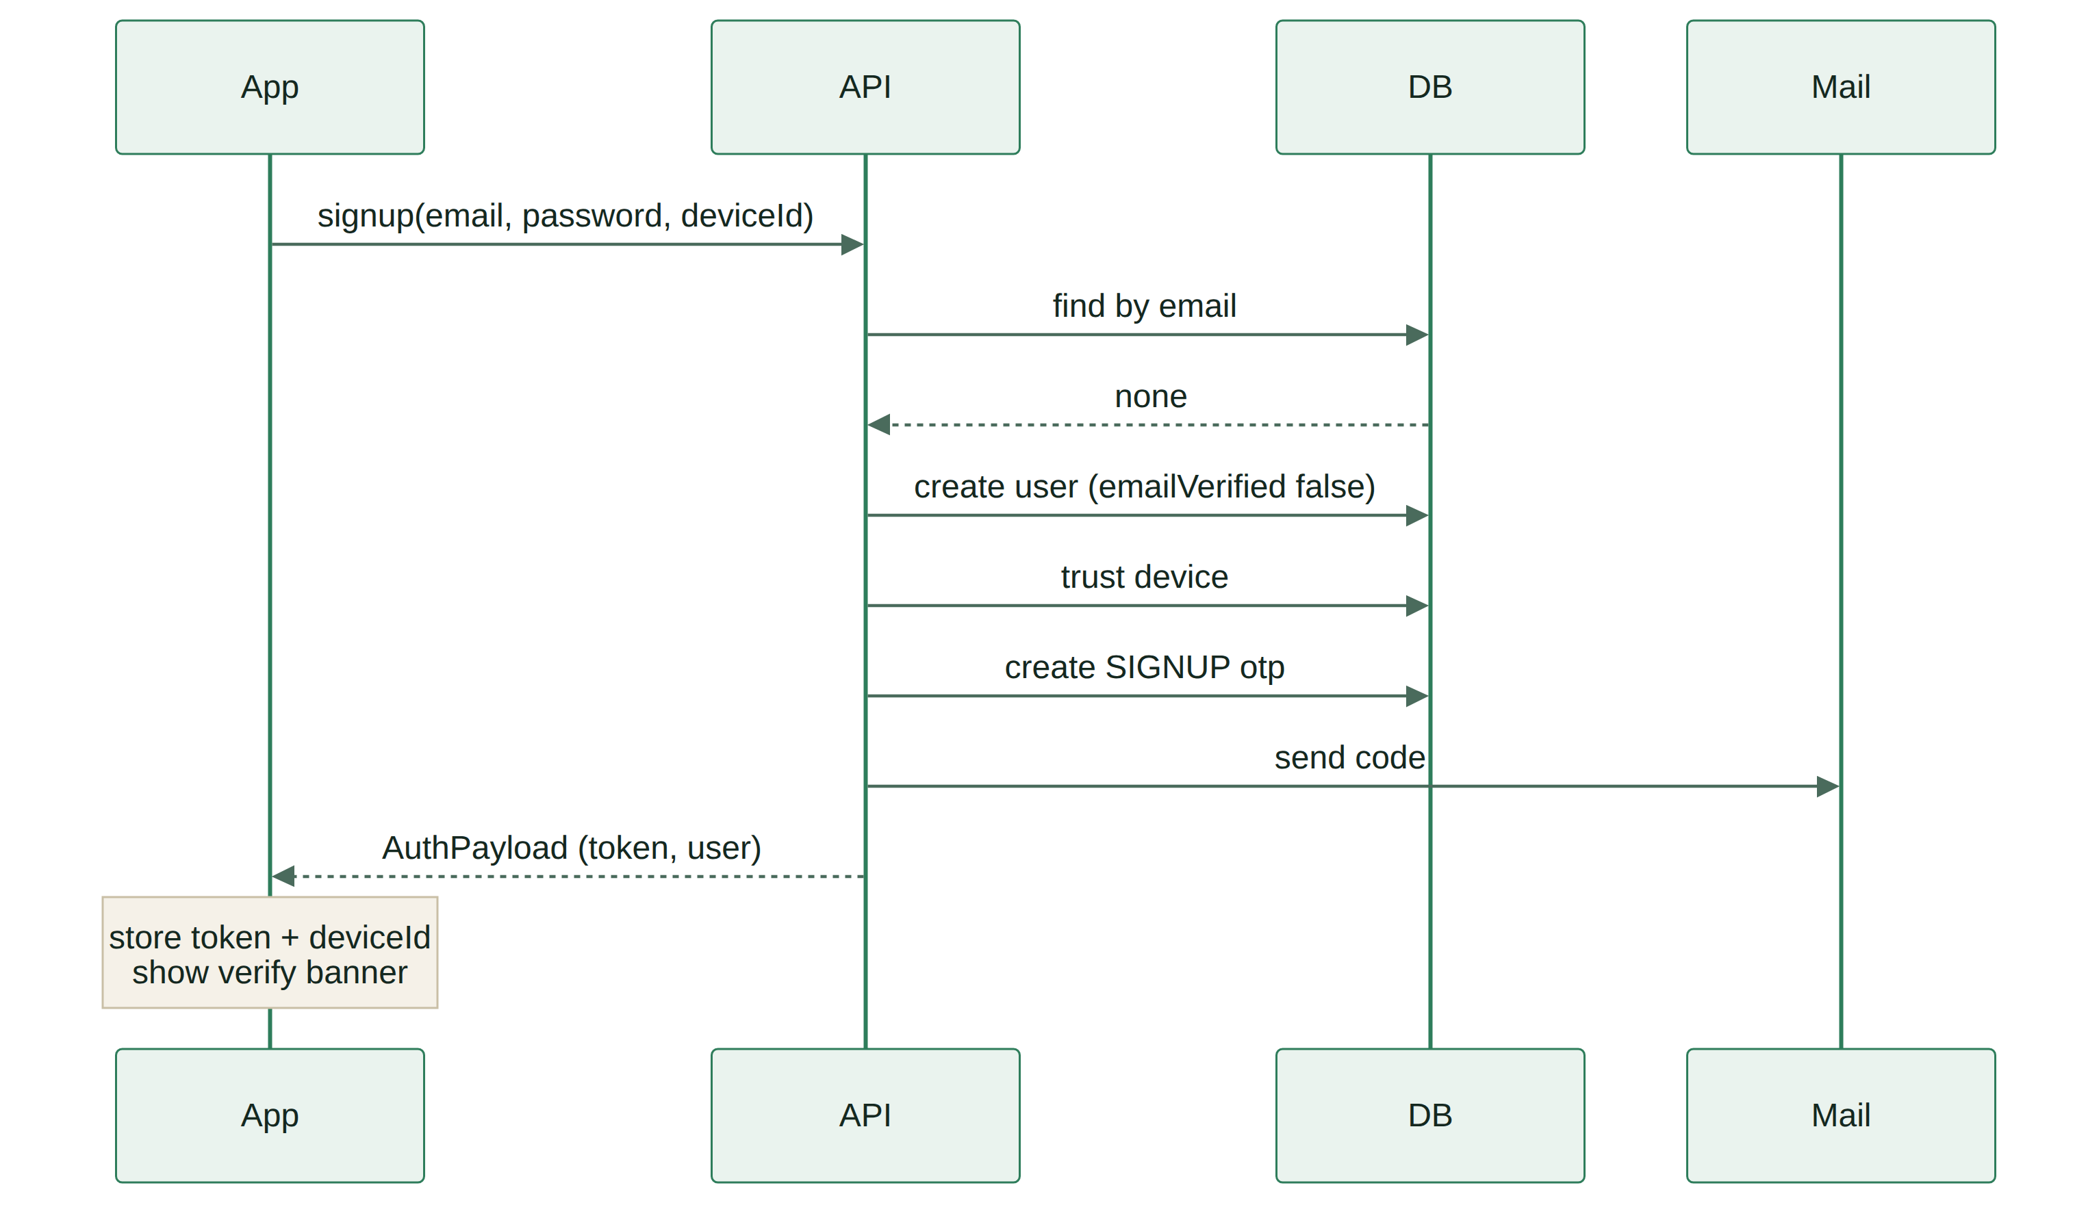
Signup sequence
Signup sequence

Login from a new device
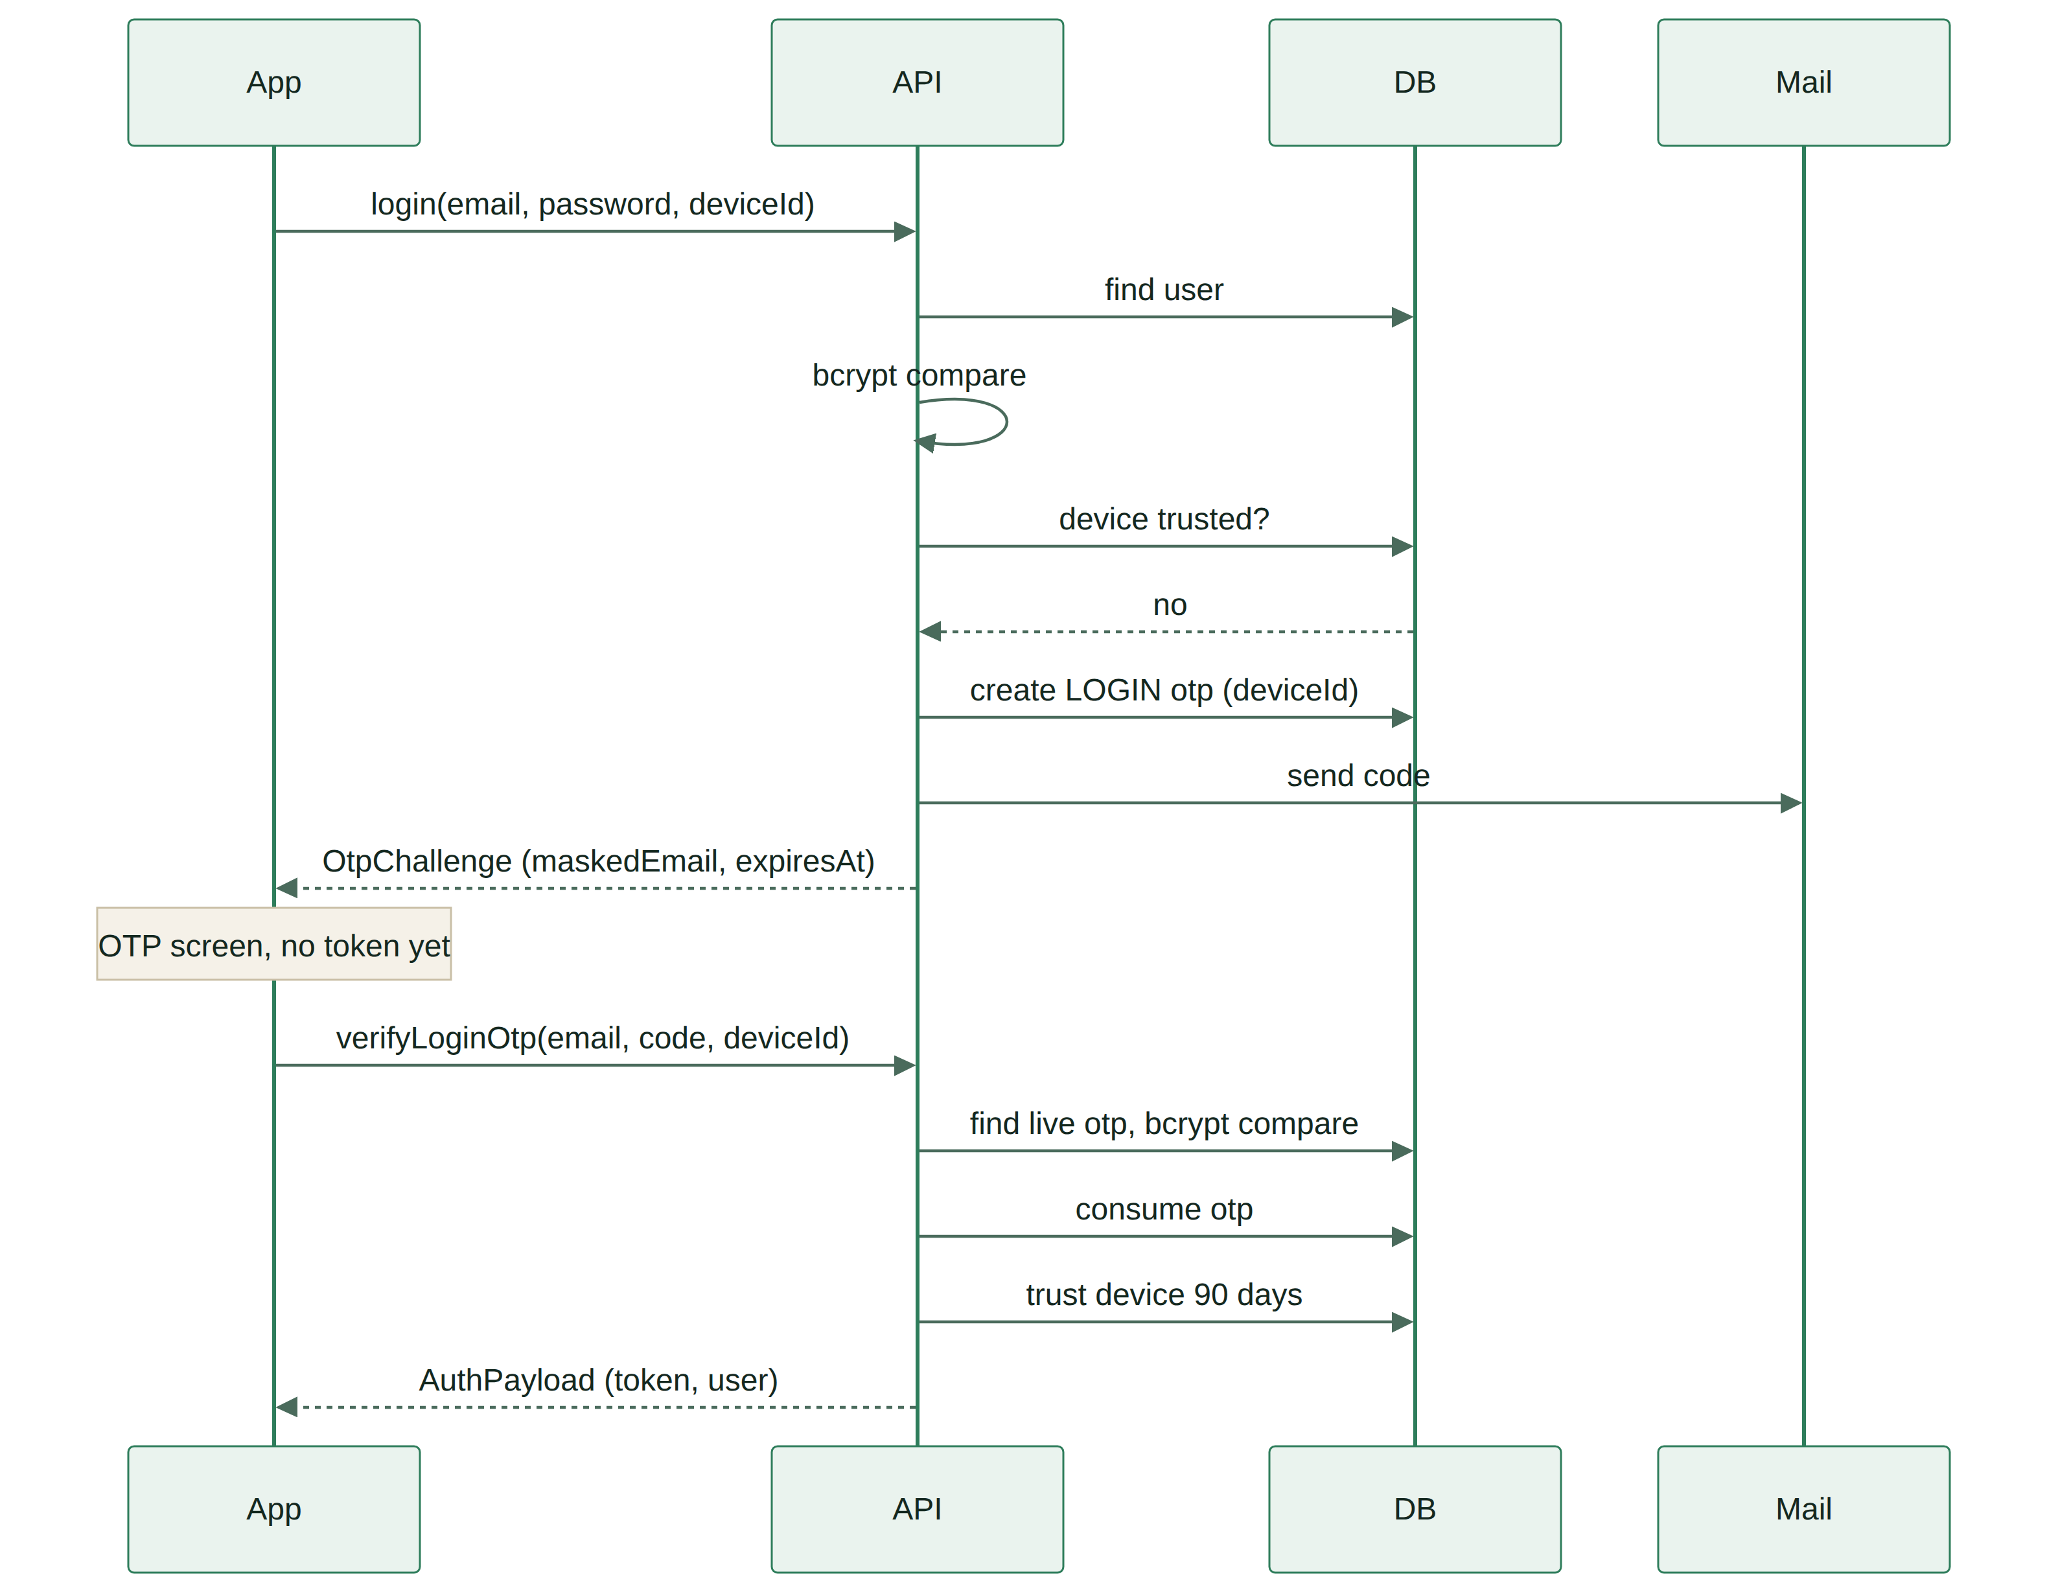
New-device login sequence
New-device login sequence

Password reset
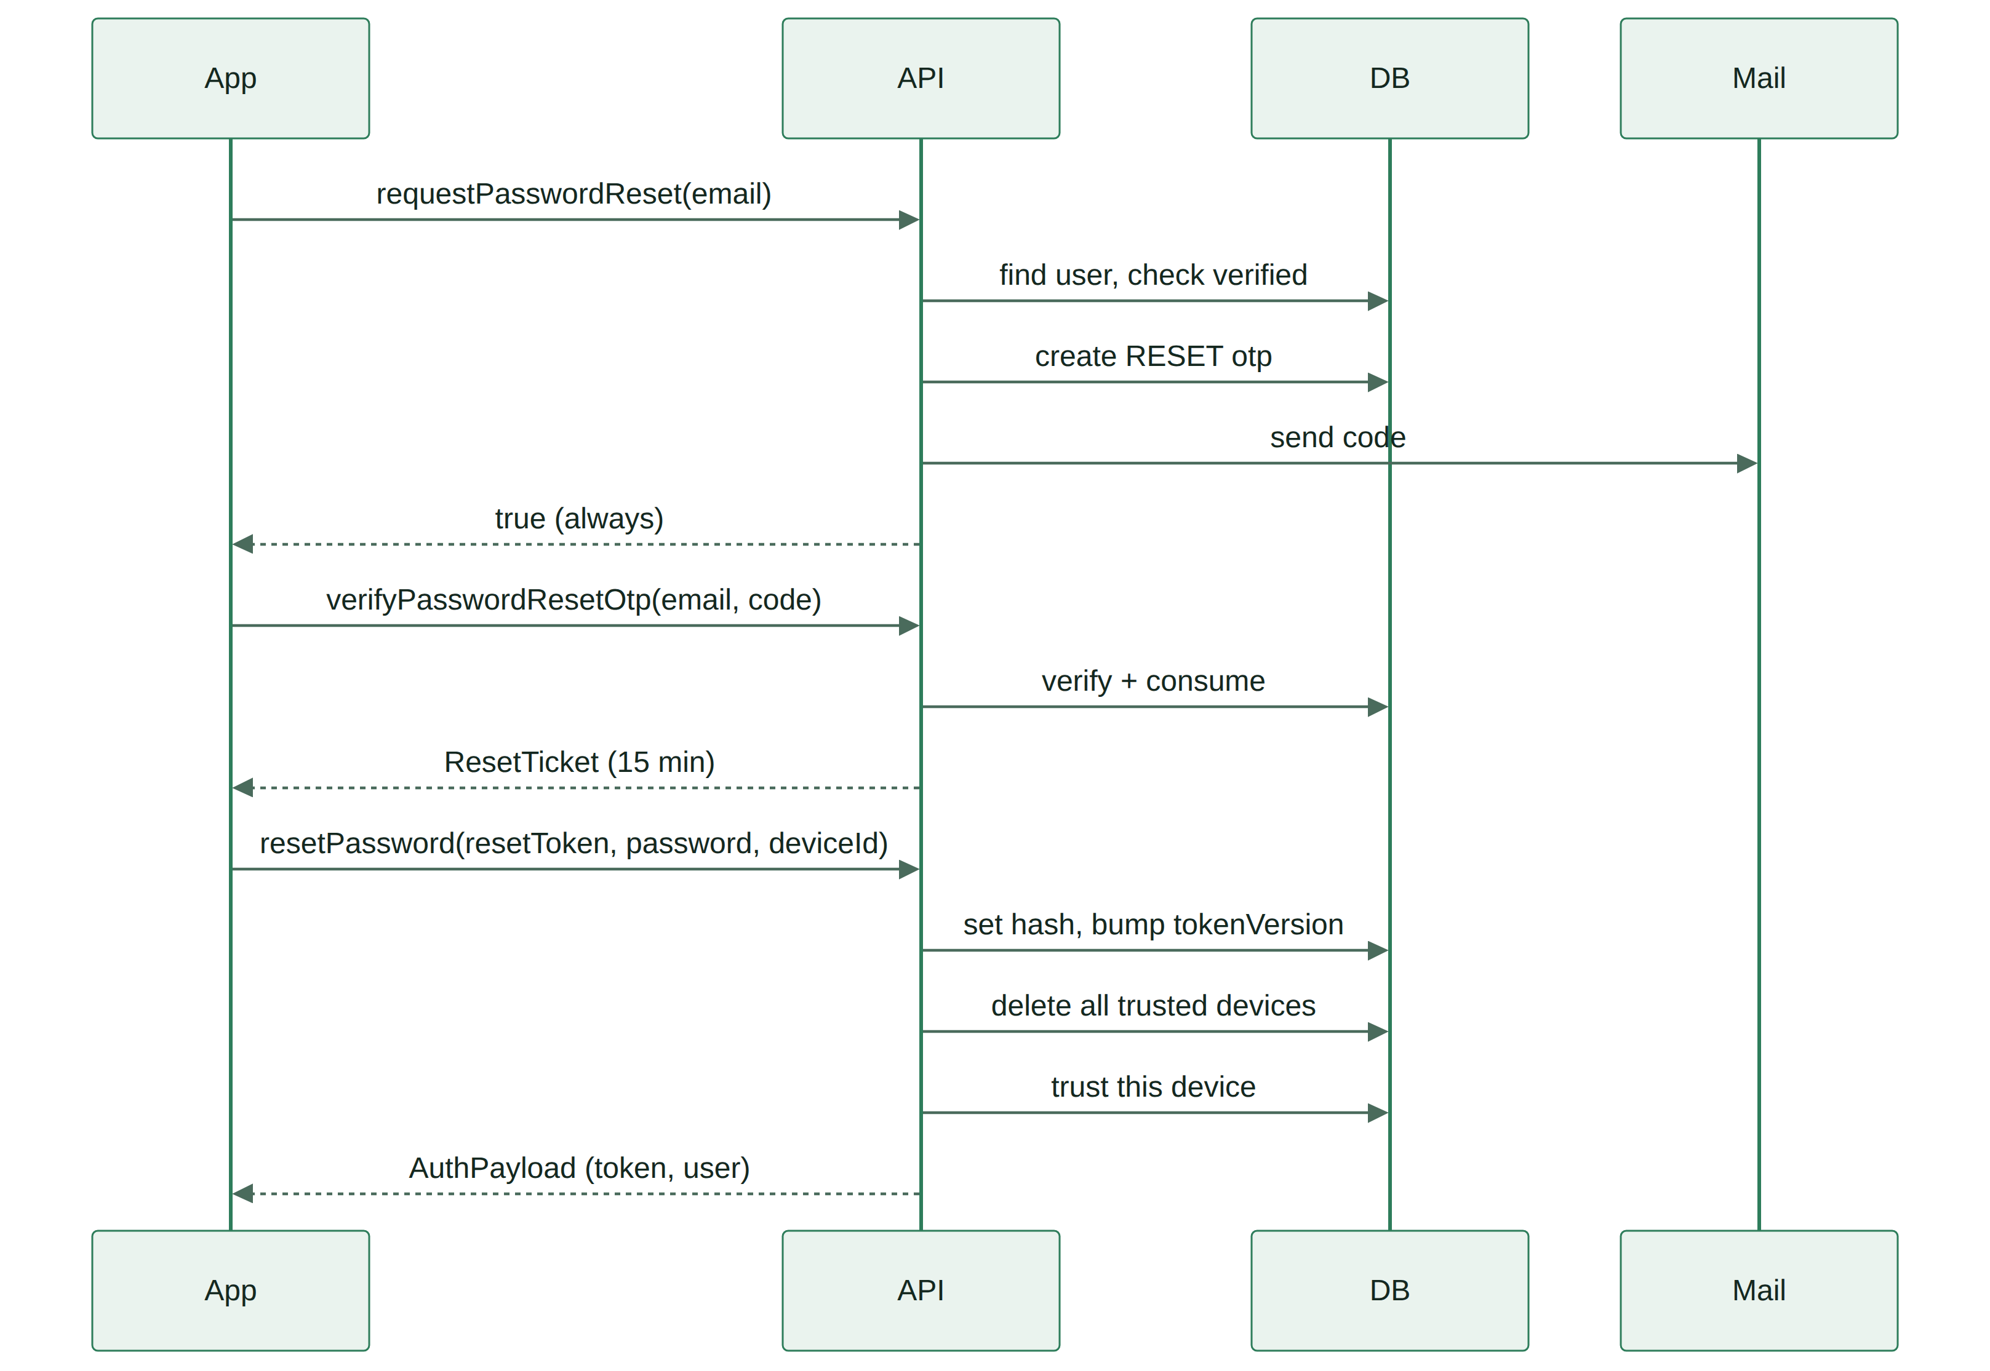
Password reset sequence
Password reset sequence
The reset path ends logged in on the device that did the reset, with every other device required to log in again.

10. OTP rules
One table, and every rule here is enforced server-side.
Rule | Value | Reason
Format | 6 digits, crypto.randomInt | Never Math.random — it is predictable
Lifetime | 10 minutes | Long enough for slow email on 2G, short enough to matter
Storage | bcrypt hash | A leaked database must not contain live codes
Uses | Single | consumedAt set the moment it verifies
Verify attempts | 5, then the code dies | 6 digits is a million guesses; 5 attempts makes brute force useless
Resend cooldown | 60 seconds | Stops a tapped-twice button spending the hourly budget
Resends per hour | 3 per user per purpose | Caps mail cost and abuse
Live codes | One per user per purpose | A new request consumes the old code
Expired rows | TTL index on expiresAt | Self-cleaning, no cron job
Comparison | bcrypt compare | Constant-time by construction
When a code dies from too many attempts, the error says so explicitly and the app offers Resend. Silently rejecting a correct code the user typed on the sixth try is how a support ticket gets written.
The email body carries the code in the subject line as well. On a feature phone or a notification preview, that is often all the user will see.

11. Rate limiting
New entries for the RULES table in operationLimit.ts. Unlisted fields fall through to the default read/write budget, which is far too generous for these.
Field | Burst | Sustained | Key
signup | 3 / 10 min | 10 / day | IP
login | 5 / 1 min | 30 / hour | IP + email
verifyEmailOtp | 5 / 1 min | 20 / hour | user
verifyLoginOtp | 5 / 1 min | 20 / hour | IP + email
verifyPasswordResetOtp | 5 / 1 min | 20 / hour | IP + email
resendEmailOtp | 1 / 1 min | 3 / hour | user
resendLoginOtp | 1 / 1 min | 3 / hour | IP + email
requestPasswordReset | 1 / 1 min | 3 / hour | IP + email
resetPassword | 5 / 10 min | 10 / hour | IP
changePassword | 5 / 10 min | 20 / hour | user
The email key is the important addition. Every current budget keys on req.ip or user id, but an unauthenticated attacker walking a list of addresses has no user id and can rotate IPs. Keying on the submitted email as well caps the attempt count per target account regardless of where it comes from.
Hash the email before using it as a bucket key, so the in-memory map does not hold plaintext addresses.
Both limiters still share the in-memory buckets in rateLimit.ts. That means counts reset on restart and are not shared across instances — a known, deliberate limitation while one instance runs. Swap hit() for Redis before a second instance, not before.

12. GraphQL API surface
Follows the repo’s four-file split: types/user.ts, queries/user.ts, mutation/user.ts, resolvers/userResolver.ts, plus arg types in utils/types.ts and both barrel files.

Types
type AuthPayload {
token: String!
user: User!
}
type OtpChallenge {
challenge: Boolean!
purpose: String!
expiresAt: String!
maskedEmail: String!
}
union LoginResult = AuthPayload | OtpChallenge
type ResetTicket {
resetToken: String!
expiresAt: String!
}
type TrustedDevice {
id: ID!
label: String!
lastSeenAt: String!
expiresAt: String!
current: Boolean!
}
maskedEmail is i****s@gmail.com — enough for the user to confirm which address to check, not enough to harvest.

Inputs
input SignUpInput {
email: String!
password: String!
deviceId: String!
deviceLabel: String
}
input LoginInput {
email: String!
password: String!
deviceId: String!
deviceLabel: String
}
input VerifyOtpInput {
code: String!
deviceId: String
}
input VerifyResetOtpInput {
email: String!
code: String!
}
input ResetPasswordInput {
resetToken: String!
password: String!
deviceId: String!
}
input ChangePasswordInput {
currentPassword: String!
newPassword: String!
}
input DeleteAccountInput {
password: String!
}

Queries
me: User!
myTrustedDevices: [TrustedDevice!]!

Mutations
signup(input: SignUpInput!): AuthPayload!
login(input: LoginInput!): LoginResult!
verifyEmailOtp(input: VerifyOtpInput!): User!
resendEmailOtp: Boolean!
verifyLoginOtp(email: String!, input: VerifyOtpInput!): AuthPayload!
resendLoginOtp(email: String!): Boolean!
requestPasswordReset(email: String!): Boolean!
verifyPasswordResetOtp(input: VerifyResetOtpInput!): ResetTicket!
resendPasswordResetOtp(email: String!): Boolean!
resetPassword(input: ResetPasswordInput!): AuthPayload!
changePassword(input: ChangePasswordInput!): AuthPayload!
refreshSession: AuthPayload!
logout: Boolean!
revokeTrustedDevice(id: ID!): Boolean!
deleteAccount(input: DeleteAccountInput!): Boolean!
15 mutations, 2 queries. verifyEmailOtp and resendEmailOtp are authenticated; everything in the login and reset paths is not.
The union on login is the one schema change the app must handle carefully — it needs an inline fragment on both members and a branch on which came back.

13. Error codes
Every failure is a GraphQLError with extensions: { code }. The app branches on the code, never on the message.
Code | Raised by | Meaning for the user
EMAIL_TAKEN | signup | That address already has an account
INVALID_EMAIL | signup, reset | Not a valid address
WEAK_PASSWORD | signup, reset, change | Fails the password rules
INVALID_CREDENTIALS | login | Wrong email or password — deliberately ambiguous
EMAIL_NOT_VERIFIED | requestPasswordReset, verifyLoginOtp | Verify the address first
OTP_NOT_FOUND | every verify | No live code — request a new one
OTP_EXPIRED | every verify | Past 10 minutes
OTP_INCORRECT | every verify | Wrong digits, attempts remain
OTP_ATTEMPTS_EXCEEDED | every verify | Code is dead, request a new one
OTP_COOLDOWN | every resend | Wait before asking again
OTP_RESEND_LIMIT | every resend | Hourly cap hit
OTP_SEND_FAILED | signup, resend, reset | Mail provider refused — the only honest response
INVALID_RESET_TOKEN | resetPassword | Expired or wrong-purpose ticket
WRONG_PASSWORD | changePassword, deleteAccount | Current password incorrect
PASSWORD_ATTEMPTS_EXCEEDED | changePassword | Five failures — use the email reset
PASSWORD_UNCHANGED | changePassword, reset | New password equals the old one
SESSION_EXPIRED | refreshSession | 30-day origin cap reached — log in again
TOKEN_REVOKED | any authenticated field | tokenVersion behind — log in again
DEVICE_NOT_FOUND | revokeTrustedDevice | Already gone
RATE_LIMITED | any | Too many attempts
OTP_NOT_FOUND, OTP_EXPIRED and OTP_ATTEMPTS_EXCEEDED all resolve to the same user action — request a new code — but are separate codes so the app can word the message correctly and so the logs distinguish a slow user from an attacker.
Every resolver’s catch block ends with rethrow(error, message, code, invalidMessage?) as the last line, per the existing convention.

14. Email templates
Three templates, one per purpose, in the user’s language. The code goes in the subject line as well as the body — on a notification preview that is often all the user sees.

Subject lines
Purpose | English | Français | Kiswahili
SIGNUP | 123456 is your Imara Afya code | 123456 est votre code Imara Afya | 123456 ni namba yako ya Imara Afya
LOGIN | 123456 — new sign-in to Imara Afya | 123456 — nouvelle connexion Imara Afya | 123456 — kuingia kupya Imara Afya
RESET | 123456 — reset your Imara Afya password | 123456 — réinitialiser votre mot de passe | 123456 — badilisha nywila yako

Body rules
- The code appears once, large, on its own line. No other number anywhere in the email.
- State the expiry in minutes, not as a timestamp — timezones confuse, “10 minutes” does not.
- LOGIN and RESET emails carry one line: If this wasn’t you, change your password. SIGNUP does not, because nothing has been compromised yet.
- No tracking pixels, no marketing footer, no unsubscribe link. These are transactional; a recovery code that lands in Promotions is a failed recovery.
- Plain text alternative always sent alongside the HTML. Entry-level Android mail clients handle it better, and it renders on 2G.
Kirundi is not included. The strings are machine-drafted and unreviewed; a mistranslated security email is worse than an English one the user can puzzle out.

15. Client integration
What the React Native app must do, in the order it must do it.

On first launch, before any auth call
Generate a UUID v4, write it to secure storage, read it on every subsequent launch. expo-secure-store, not AsyncStorage. If the read fails, generate a new one — the cost is one OTP, not a broken app.

The login branch
mutation Login($input: LoginInput!) {
login(input: $input) {
__typename
... on AuthPayload { token user { id emailVerified } }
... on OtpChallenge { challenge purpose expiresAt maskedEmail }
}
}
The app switches on __typename. AuthPayload means store the token and go to the dashboard; OtpChallenge means push the OTP screen with maskedEmail and a countdown to expiresAt.

OTP screen behaviour
Element | Requirement
Input | Six single-digit boxes, numeric keyboard, auto-advance
Autofill | textContentType="oneTimeCode" on iOS, autoComplete="sms-otp" on Android
Paste | Pasting six digits fills all boxes at once
Submit | Automatic once the sixth digit lands — no Verify button tap
Resend | Disabled with a 60-second countdown, then enabled
Expiry | Countdown to expiresAt; at zero, the input greys and Resend is the only action
Errors | OTP_INCORRECT clears the boxes and keeps focus; OTP_ATTEMPTS_EXCEEDED clears and switches to Resend

Offline
Auth is the one part of the app that cannot work offline. Every other screen reads local state first. The auth screens must say plainly that a connection is needed rather than showing a spinner that never resolves — on 2G a request can hang for 30 seconds before anything happens, so set an explicit timeout and a retry.

Token storage
Session token in secure storage, never AsyncStorage. Cleared on logout, on TOKEN_REVOKED, and on SESSION_EXPIRED. The deviceId is not cleared on logout — that is the whole point of it.

16. Implementation map
Every file the change touches, in build order. The repo’s feature split means a new field is invisible unless both barrels are edited.
# | File | Change
1 | models/otp.ts | New — schema, TTL index, compound index
2 | models/trustedDevice.ts | New — schema, unique index, TTL index
3 | models/user.ts | Add emailVerified, emailVerifiedAt, failedPasswordAttempts
4 | services/accountService.ts | Add both models to USER_OWNED
5 | utils/validation.ts | Add isValidOtpCode, isValidDeviceId
6 | services/otpService.ts | New — issue, verify, consume, resend guard
7 | services/deviceService.ts | New — isTrusted, trust, revoke, list
8 | services/mailService.ts | Add sendOtpEmail template
9 | services/authServices.ts | Add signResetToken, verifyResetToken
10 | graphql/schemas/types/user.ts | Add OtpChallenge, LoginResult, ResetTicket, TrustedDevice, new inputs
11 | graphql/schemas/queries/user.ts | Add myTrustedDevices
12 | graphql/schemas/mutation/user.ts | Add the 8 new mutations
13 | utils/types.ts | Add arg types for every new field
14 | graphql/resolvers/userResolver.ts | Implement all of it, plus the union resolver
15 | middleware/operationLimit.ts | Add the 10 new RULES entries
16 | graphql/schemas/index.ts | Confirm the union type string is interpolated
17 | config/envConf.ts | Add OTP_TTL_MINUTES, DEVICE_TRUST_DAYS, RESET_TOKEN_MINUTES
The union needs a __resolveType on LoginResult in the resolver barrel — it is not a Query or Mutation key, so spreading alone will not pick it up. This is the one place the existing barrel pattern does not cover the new code.

Environment variables
Var | Default | Notes
OTP_TTL_MINUTES | 10
OTP_MAX_ATTEMPTS | 5
OTP_RESEND_COOLDOWN_SECONDS | 60
OTP_RESENDS_PER_HOUR | 3
DEVICE_TRUST_DAYS | 90
RESET_TOKEN_MINUTES | 15
RESEND_API_KEY | — | Existing
RESEND_FROM | — | Must be a verified domain before launch
envConf.ts throws on a missing required value at boot, which is the right behaviour here too — a server running without RESEND_FROM in production is a server that cannot sign anyone up.

17. Migration from the current auth
The app is unreleased, so there are no production users to migrate. That removes the hard part and leaves one decision: what happens to accounts already in the development database.
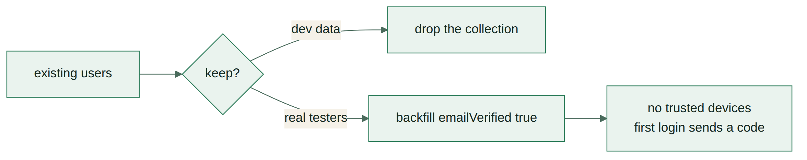
Migration of existing accounts
Migration of existing accounts
Backfilling emailVerified: true for existing accounts is correct — they were created before verification existed, and forcing a verification they never agreed to would lock testers out of their own data. Nobody gets a trusted device, so everyone’s next login sends one code. That is the intended behaviour, not a migration bug.

Order of deployment
- Ship the models and services with no schema changes. Nothing is reachable yet.
- Verify the Resend domain and send a test OTP to a real address.
- Ship the schema and resolvers. login now returns a union — this is a breaking change and the app must ship at the same time or first.
- Add the RULES entries.
- Backfill emailVerified.
Step 3 is the only one that cannot be rolled back independently. An old app build against the new schema will fail to parse the login response. Since nothing is published yet this costs nothing — after launch it would need a versioned field.

18. Test checklist
There is no test runner configured in package.json. Until there is, this is the manual pass — every row is a case that has broken a real OTP implementation somewhere.

Happy paths
- ☐ Signup returns a token and the dashboard loads before verification
- ☐ Signup OTP verifies and the banner disappears
- ☐ Login from the signup device returns a token with no OTP
- ☐ Login from a fresh deviceId returns a challenge, not a token
- ☐ Login OTP verifies and the device is trusted
- ☐ Second login from that device skips the OTP
- ☐ Reset produces a ticket, then a new password, then a session

Failure paths
- ☐ Wrong code increments attempts and leaves the code alive
- ☐ Sixth wrong attempt kills the code and says so
- ☐ Expired code is rejected after 10 minutes
- ☐ A consumed code cannot be replayed
- ☐ Resend within 60 seconds is refused
- ☐ Fourth resend in an hour is refused
- ☐ Requesting a new code kills the previous one
- ☐ A reset token cannot be used as a session token
- ☐ A session token cannot be used as a reset token
- ☐ Reset clears every trusted device
- ☐ Password change bumps tokenVersion and old tokens stop working

Security
- ☐ requestPasswordReset returns true for an address that does not exist
- ☐ Login response time is the same for unknown email and wrong password
- ☐ Codes are stored hashed — check the collection directly
- ☐ Rate limits key on email, verified by rotating IP with the same address
- ☐ Introspection is off with NODE_ENV=production
- ☐ A second account cannot verify the first account’s code
- ☐ Account deletion removes rows from otp and trustedDevice

Field conditions
- ☐ Full flow on 2G with the network throttled
- ☐ OTP autofill works on Android from the SMS-style notification
- ☐ Airplane mode mid-flow shows a connection error, not a hung spinner
- ☐ App killed on the OTP screen, reopened — the code still works

19. Open items and risks

Blocks launch
Resend delivers only to the account owner’s address. Until a domain is verified with Resend, every OTP to a real user silently fails. This was a minor gap when only password reset used email. With OTP on signup and new-device login it is the single thing that makes the auth system work or not work. Buy the domain, verify it, then build.
Password reset deep link is unfixed. Already on the open blockers list. With an OTP flow the link matters less — the user types six digits rather than following a URL — which is an argument for OTP-only reset and dropping the deep link entirely.

Watch
Email is not the primary channel in Burundi. SMS is. The channel column on otp exists so adding SMS is a provider integration, not a migration. Worth revisiting after the first hundred users: if signup verification completion sits below roughly 60%, email is the reason.
SMS needs a second provider. Resend is email only. Twilio supports Burundi but has no two-way SMS and no long or short codes, and since 1 August 2026 the Lumitel network blocks unregistered alphanumeric sender IDs — registration takes about three weeks. Africa’s Talking is the regional alternative. Either way it needs a phone number field, which the MVP does not have.
In-memory rate limit buckets reset on restart. A deploy clears every counter, including a brute-force attempt in progress. Acceptable at one instance; it is the first thing to move to Redis if abuse appears.
Device trust is not a security boundary. deviceId is caller-supplied. Someone who has a valid password and a stolen deviceId skips the OTP. The mitigation is that they need both, and the password is still checked — device trust reduces friction, it does not add a factor.

Deferred to v2
- SMS as an OTP channel
- TOTP authenticator support
- Change email address
- Login alerts by email on a new device
- Account recovery without email access

Imara Afya — Imara Company · Bujumbura, Burundi

