Yaşar University
Spring, 2024 - 2025
SE 2232 - Software System Analysis
Final Project Report: Software Requirements Specifications Document (SRS)

Student Name: | Mert Aydul
Student No: | 22070006010
Department Name: | Software Engineering
Course Section No: | Section 2

This template is prepared based on the IEEE Recommended Practice for Software Requirements Specifications (IEEE Std 830-1998).
Table of Contents (Do not change the Section Names!)
1 Introduction 3
1.1 Purpose 3
1.2 Scope 3
1.3 Definitions, acronyms, and abbreviations 3
1.4 References 3
1.5 Overview 3
2 Design and Implementation Constraints 3
3 Specific Requirements 3
3.1 Functional Requirements 4
3.2 Performance Requirements 4
3.3 Software System Attributes 4
3.4 Use Case Analysis 4
3.4.1 Actors 4
3.4.2 Scenarios 4
3.4.3 Use Case Forms 4
3.4.4 Relationships among Actors and Use Cases 5
3.4.5 Use Case Diagram 5
4 Behavioral Models 5
4.1 Sequence Diagram 5
5 Structural Models 5
5.1 Class Diagram 5
6 Process Modeling 5
6.1 Data Flow Diagram (DFD) 5
7 Graphical User Interface(s) (GUIs) 5
8 Conclusion and Future Work 5

Introduction
No explanation is needed here. Only complete the subsections.

Purpose
The purpose of this Software Requirements Specification (SRS) document is to clearly outline the features, functionalities, and requirements of the “MyLibrary” desktop application. It serves as a comprehensive guide for both developers and stakeholders throughout the system's development lifecycle.

Scope
a) Product Name: MyLibrary
b) What it does: It allows readers to track books they have read, want to read, and manage personal comments, ratings, and favorite items.
c) Goal: To help readers organize their personal libraries, access book/author information, and receive upcoming book release notifications.

Definitions, acronyms, and abbreviations
GUI: Graphical reader Interface
SRS: Software Requirements Specification
JFrame: A Swing container for building GUI in Java
JDBC: Java Database Connectivity
CRUD: Create, Read, Update, Delete

References
SE2232 Final Project PDF (Spring 2025)
IEEE Std 830-1998 (Software Requirements Specification)
Java 17 Documentation
MySQL 8.0 Documentation

Overview
This SRS includes functional and nonfunctional requirements, use cases, system diagrams, reader interface plans, and process models. It is structured according to IEEE 830-1998 format.

Design and Implementation Constraints
Programming Language: Java (JDK 21)
GUI Framework: Java Swing
IDE: Apache NetBeans 20
Database: MySQL 8.0
Modeling Tool: Visual Paradigm (Community Edition)
Platform: Desktop (Windows)

Specific Requirements
No explanation is needed here. Only complete the subsections.

Functional Requirements
1. Login and Reader Authentication
The system shall allow readers to log in using their readername and password. There are two types of readers: Type-1 (full access) and Type-2 (limited access).
2. Add Book
The system shall allow readers to add a new book to the database by entering details such as book title, author, year, number of pages, cover image, description, reading status, rating, and comments. The system shall check if the author exists in the database and link the book to the correct author ID. If the author does not exist, the system shall create a new author entry.
3. Delete Book
The system shall allow readers to delete a book from the database by entering the book’s ID. The system shall automatically delete the book and check if the author has any other books in the reader's library. If not, the corresponding author record will be deleted from the database.
4. Display Book Information
The system shall allow readers to retrieve and display information about a book by entering its book ID. The displayed information shall include the book’s attributes like title, author, year, etc.
5. Search Author by Name
The system shall allow readers to search for an author by name and display the author’s information.
6. Display-Edit-Update Book Information
The system shall allow readers to display detailed information of a book by entering the book ID. After retrieving the book's information, readers shall be able to edit the book’s details, such as title, author, year, pages, rating, and comments. The system shall save the changes and update the book’s information in the database.
7. Display Favorite Books
The system shall display the list of books that the reader has rated 4 or 5 stars (favorite books).
8. Display Favorite Authors
The system shall display a list of authors whose books are marked as favorites by the reader, with at least 3 books from the same author in the library.
9. Display Unread Books
The system shall display a list of books that the reader has not read yet, with details such as the title, author, and rating.
10. Wishlist Notifications
The system shall notify the reader about books in their wishlist (marked with 'read=3') that will be released within the next 7 days.
11. Display Book Cover Image
The system shall display the cover image of a book by retrieving the image path stored in the database for the specific book.

Performance Requirements
1. Number of Readers
The system shall support at least 1000 simultaneous readers logging in at the same time without performance degradation.
2. Data Handling Capacity
The system shall handle up to 10,000 books in the database, each with up to 50 associated comments.
3. Response Time
The system shall retrieve and display book details within 2 seconds for 95% of queries.

Software System Attributes
1. Reliability
The system shall be reliable, ensuring that it runs without failure for at least 95% of the time.
2. Availability
The system shall be available 24/7 with minimal interruptions.
3. Security
The system shall ensure that only authorized readers shall be allowed to access their accounts and personal data.
4. Maintainability
The system shall be easy to maintain, with a clear and organized structure. Features should be easy to add or update without affecting the rest of the system.
5. Usability
The system shall provide a reader interface that allows readers to perform tasks such as adding books, searching for books, and viewing their library.

Use Case Analysis
No explanation is needed here. Only complete the subsections.

Actors
The system will have the following actors:
- Reader: A person who uses the MyLibrary application to manage their book collection.
- Admin: A reader with higher privileges who can manage both readers and books.

Scenarios
Scenario 1: “Adding a Book to the Library”
Admin logs into the system and selects the 'Add Book' option. The admin fills in the book’s details (title, author, rating, and comments), and the system successfully adds the book to the library.
Scenario 2: “Searching for a Book”
The reader enters the title, author, or a keyword of a book in the search bar. The system searches the database for books that match the query and returns a list of results. The reader can click on a book to view its details or refine their search further.

Use Case Forms
Use Case 1: Display Book Information
Actors: Reader or Admin
Description: Reader or Admin retrieves and views detailed information of a book.
Trigger: Reader or Admin enters a book ID and requests to see the details.
Preconditions: Reader or Admin is logged in.
Normal Course:
1. Reader or Admin enters the book’s ID.
2. The system retrieves and displays the book’s details.
Exceptions: If no book is found, the system shows an error message.
Use Case 2: Search Author by Name
Actors: Reader or Admin
Description: Reader or Admin searches for a specific author by name.
Trigger: Reader or Admin enters the author’s name in the search bar.
Preconditions: Reader or Admin is logged in.
Normal Course:
1. Reader or Admin types the author’s name in the search bar.
2. The system retrieves and displays information about the author.
Exceptions: If no author matches, the system shows 'No results found'.
Use Case 3: Display Favorite Books
Actors: Reader or Admin
Description: Reader or Admin views a list of their favorite books (rated 4 or 5 stars).
Trigger: Reader clicks on 'Favorite Books' in the menu.
Preconditions: Reader or Admin is logged in.
Normal Course:
1. The system displays a list of books that Reader or Admin has rated 4 or 5 stars.
Exceptions: If no books are rated 4 or 5 stars, the system shows a message.

Basic Use Case Forms

Use Case 4: Add Book to Wishlist
Actors: Reader or Admin
Description: Reader or Admin updates book status to wishlist.
Trigger: Reader or Admin clicks on 'Add to Wishlist' for a book.
Preconditions: Reader or Admin is logged in.
Use Case 5: Add Book
Actors: Admin
Description: Admin adds a new book to the library by entering all necessary details (title, author, rating, comments).
Trigger: Admin clicks on 'Add Book'.
Preconditions: Admin is logged in.
Use Case 6: Delete Book
Actors: Admin
Description: Admin deletes a book from their library by entering the book ID. If an author has no books in database, author is deleted.
Trigger: Admin clicks on 'Delete Book'.
Preconditions: Admin is logged in.
Use Case 7: Search for a Book
Actors: Reader or Admin
Description: Reader or Admin searches for a book by title, author, or keyword.
Trigger: Reader or Admin enters a search query in the search bar.
Preconditions: Reader or Admin is logged in.
Use Case 8: Rate Book
Actors: Reader or Admin
Description: Reader or Admin rates a book they have read with a score between 1 and 5 stars.
Trigger: Reader or Admin selects a book they have read and provides a rating.
Preconditions: Reader or Admin is logged in and has selected a book to rate.
Use Case 9: Edit Book Info
Actors: Admin
Description: Admin displays information of a book and edits book Info.
Trigger: Admin clicks on ‘Edit Book Info’ button.
Preconditions: Admin is logged in and book info is displayed.

Use Case 10: Display Favorite Authors
Actors: Reader or Admin
Description: Reader or Admin displays information of the authors which has 3 books in the library.
Trigger: Reader or Admin clicks ‘Display Favorite Authors’ button.
Preconditions: Reader or Admin is logged in.

Use Case 11: Login
Actors: Reader or Admin
Description: Reader or Admin logs in to the system.
Trigger: Reader or Admin clicks ‘Login’ button
Preconditions: No preconditions.

Use Case 12: Logout
Actors: Reader or Admin
Description: Reader or Admin logs out from the system.
Trigger: Reader or Admin clicks ‘Logout’ button
Preconditions: Reader or Admin must be logged in.

Use Case 13: Display Unread Books
Actors: Reader or Admin
Description: Reader or Admin views book which have unread status.
Trigger: Reader or Admin clicks ‘Display Unread Books’ button
Preconditions: Reader or Admin must be logged in.
Use Case 14: Show Book Cover
Actors: Reader or Admin
Description: Reader or Admin views cover of the book.
Trigger: Reader or Admin clicks ‘Show Book Cover’ button.
Preconditions: Book info is displayed.

Relationships among Actors and Use Cases
- Search for a Book: The reader can search for books by title, author, or keyword.
- Display Book Information: The reader can view the details of a specific book by entering its book ID.
- Search Author by Name: The reader can search for books by a specific author.
- Display Favorite Books: The reader can view the list of books that they have rated 4 or 5 stars.
- Add Book to Wishlist: The reader can add books they wish to read in the future.
- Update reader Profile: The reader can update personal details in their profile.
- Rate Book: The reader can rate a book they have read with a score between 1 and 5 stars.
- Display Favorite Authors: The reader views a list of authors who have at least three books in their library.
- Login: The reader logs into the system by entering their username and password.
- Logout: The reader securely logs out of the system.
- Display Unread Books: The reader views a list of books they have not read yet.
- Show Book Cover: The reader displays cover of the book.

- Search for a Book: Admin can search for books by title, author, or keyword.
- Display Book Information: Admin can view the details of a specific book by entering its book ID.
- Search Author by Name: Admin can search for books by a specific author.
- Display Favorite Books: Admin can view the list of books that they have rated 4 or 5 stars.
- Add Book to Wishlist: Admin can add books they wish to read in the future.
- Update reader Profile: Admin can update personal details in their profile.
- Delete Book: Admin can delete books from the library.
- Add Book: Admin can add new books to the library by providing details like title, author, rating, and comments.
- Update Reader Profile: Admin can modify reader profiles as needed.
- Rate Book: Admin can rate a book they have read with a score between 1 and 5 stars.
- Edit Book Info: Admin displays information of a book and updates book info.
- Display Favorite Authors: Admin views a list of authors who have at least three books in their library.
- Login: Admin logs into the system by entering their username and password.
- Logout: Admin securely logs out of the system.
- Display Unread Books: Admin views a list of books they have not read yet.
- Show Book Cover: Admin displays cover of the book.
Relationships Overview:
- Reader → Search for a Book
- Reader → Display Book Information
- Reader → Search Author by Name
- Reader → Display Favorite Books
- Reader → Add Book to Wishlist
- Reader → Update Reader Profile
- Reader → Rate Book
- Reader → Display Favorite Authors
- Reader → Login
- Reader → Logout
- Reader → Display Unread Books
- Reader → Show Book Cover
- Admin → Add Book
- Admin → Search for a Book
- Admin → Delete Book
- Admin → Display Book Information
- Admin → Search Author by Name
- Admin → Display Favorite Books
- Admin → Add Book to Wishlist
- Admin → Update reader Profile
- Admin → Rate Book
- Admin → Edit Book Info
- Admin → Display Favorite Authors
- Admin → Login
- Admin → Logout
- Admin → Display Unread Books
- Admin → Show Book Cover

Use Case Diagram
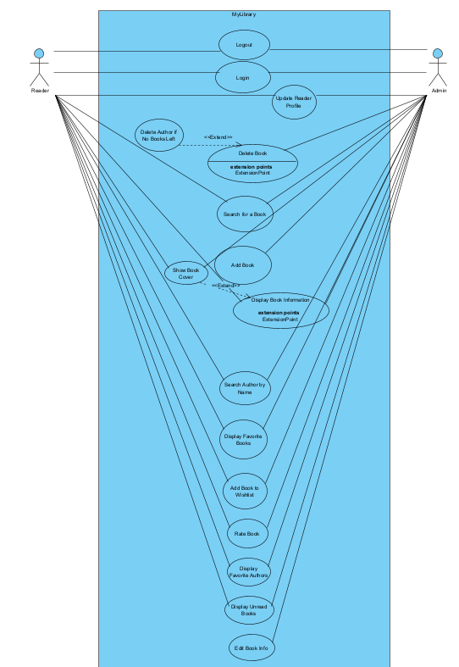

Behavioral Models
No explanation is needed here. Only complete the subsection.

Sequence Diagram
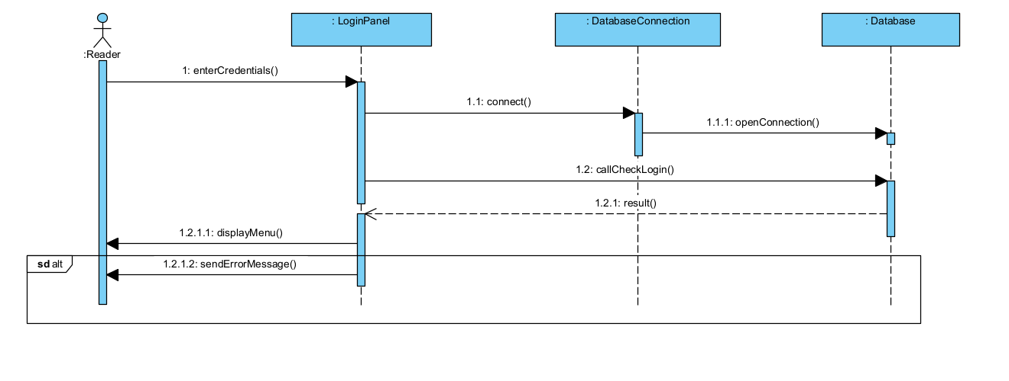

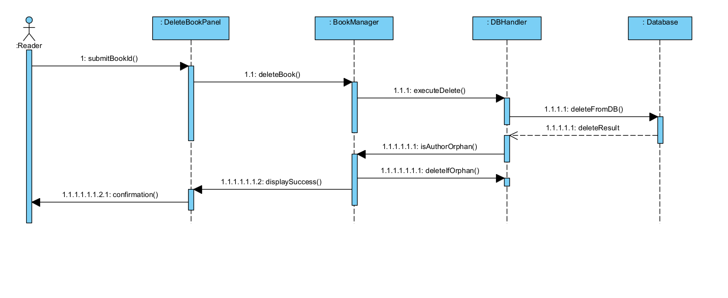
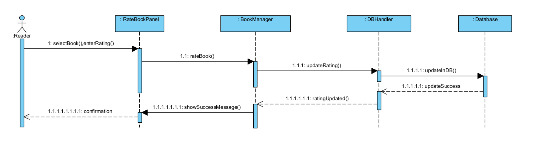

Structural Models

Class Diagram
Put the image and explanation of your class diagram.

Process Modeling

Data Flow Diagram (DFD)
Put the images and the explanations of your Context Diagram and Level 0 DFD.

Graphical User Interface(s) (GUIs)
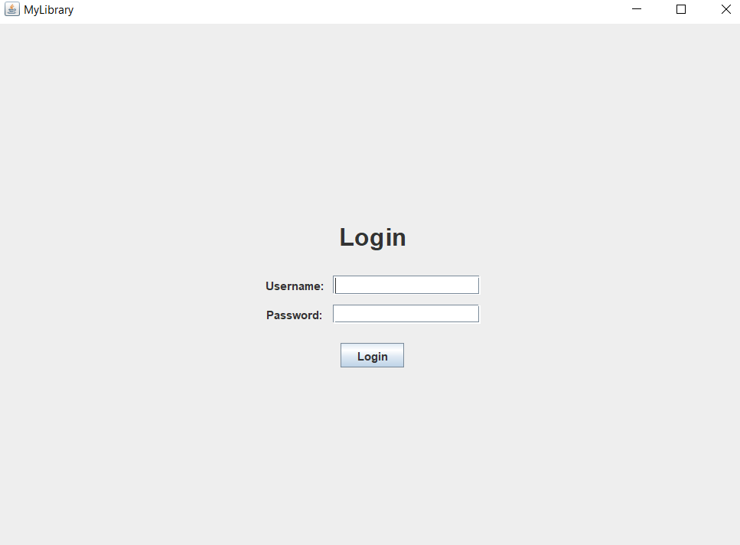

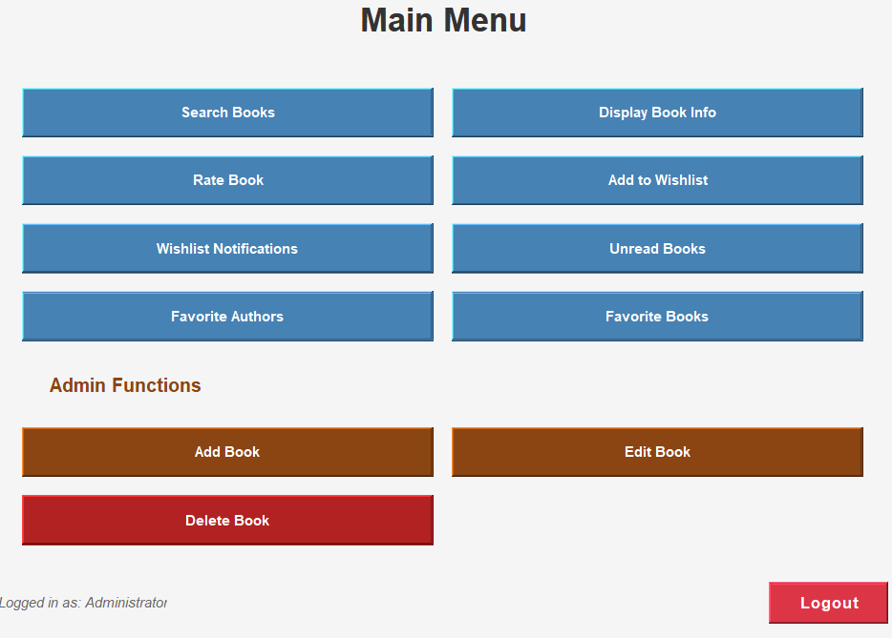

Conclusion and Future Work
Write a conclusion for your project and summarize your work. Also write what kind of features/functions can be added to your project as a future work.

