

INFORMATICS INSTITUTE OF TECHNOLOGY
In Collaboration with
UNIVERSITY OF WESTMINSTER

AI-Powered Cloud Security Compliance & Threat Detection Platform

A Project Proposal by
Iduranga Kekulandara

Supervised by
Buddhika Premarathne

September 2025
ABSTRACT
Problem
These days cloud computing is a growing fast platform in the world. Such as Amazon web services, Microsoft Azure and Google Cloud. These things have changed the structure of enterprise IT. However, there are so many weaknesses in these Areas. Cloud misconfigurations, weak compliance practices, and inadequate monitoring can be said as some of the topics. And these things remain as the leading cause of security breaches. The Cloud It Industry Reports as misconfigured storage buckets, open network ports, and disabled logging contribute to the date leaking and compliance violations. Some Existing Tools deal with anomaly detection or compliance checks independently; they are frequently reactive, vendorspecific, and devoid of predictive power. These Reasons need a solution that can evaluate compliance, detect threats, and provide tamper-proof audit evidence.

Methodology
This project suggests CloudTwin AI as an AI-based cloud security platform that combines digital twin simulation, compliance assessment, machine learning–based anomaly identification, and audit logging. A digital twin of a cloud infrastructure will be developed using Infrastructure-as-Code (Terraform) and LocalStack to securely replicate and test AWS configurations. Compliance scans will be implemented against some ISO 27001 and NIST 80053 controls through the utilization of a rule-based engine. Machine learning algorithms like Isolation Forest and Random Forest will be trained on artificially generated logs (synthetic logs) as well as on cloud-native logs (e.g., CloudTrail and VPC Flow) to identify anomalies as well as nefarious activities. Lastly, the system will produce compliance as well as detection reports in PDF/HTML format, signed with SHA-256 hashing to be tamper-proof during audits.

DECLARATION
I hereby declare that all the research component are the result of my own work and have not been previously submitted nor will they be submitted to any other program
Student name- Idurnage Kekulandara
Student ID – 20221820

ACKNOWLEDGMENT
I would like to thank my supervisor Buddika premarathna for his valuable support and continuous feedback along with the module team, Industry experts for their valuable insights. I am also grateful for my colleagues and others who supported to bring this dream to reality

Table of Contents
CHAPTER 01: INTRODUCTION 1
1.1 Chapter Overview 1
1.2 Problem Background 1
1.3 Problem Definition 2
1.3.1 Problem Statement 3
1.4 Research Motivation 3
1.5 Existing Works 3
1.6 Research Gap 4
1.7 Contribution to Body of Knowledge 4
1.8 Research Challenges 5
1.9 Research Questions 5
1.10 Research Aim 6
1.11 Research Objectives 6
1.12 Project Scope 9
1.12.1 In Scope 9
1.12.2 Out Scope 9
1.13 Hardware/Software Requirements 10
1.14 Chapter Summary. 11
CHAPTER 02: LITRETURE REVIEW 12
2.1 Chapter Overview 12
2.2 Problem Domain 12
2.2.1 Cloud Misconfigurations 12
2.2.2 Compliance Framework & Policy Automation 13
2.2.3 AI / ML for Anomaly & Threat Detection 14
2.2.4 Digital Twins in Security 14
2.2.5 Audit Logging & Tamper-Proof Evidence 15
2.3 Existing Work 16
2.3.1 Cloud Security Posture Management (CSPM) 18
2.3.2 Cloud Infrastructure Entitlement Management (CIEM) 19
2.3.3 Cloud Workload Protection Platforms (CWPP) 19
2.3.4 Data Security Posture Management (DSPM) 19
2.3.5 The Rise of Unified Platforms (CNAPP) 20
2.4 Technological Review 20
2.4.1 Dataset and Pre-processing 20
2.4.2 Core AI/ML Models for Threat Detection 21
2.4.3 Proactive and Verifiable Security Technologies 21
2.5 Benchmarking and Evaluation 22
2.5.1 Metrics 22
2.5.2 Comparative analysis 22
2.5.3 Benchmarking challenges 22
2.6 Chapter Summary 23
CHAPTER 03: METHODOLOGY 24
3.1 Chapter Overview 24
3.2 Research Methodology (Saunders' Research Onion in Table Form) 25
3.3 Development Methodology 26
3.3.1 Requirement Elicitation Methodology 27
3.3.2 Design Methodology 28
3.3.3 Programming Paradigm 28
3.3.4 Testing Methodology 29
3.3.5 Solution Methodology (Expanded Subsections) 30
3.4 Project Management Methodology 32
3.4.1 Scope 32
3.4.2 Schedule 32
3.4.1Resource Requirements 34
3.4.1 Risk and Mitigation (Expanded with Severity and Frequency) 35
3.5 Chapter Summary 36
CHAPTER 04: SOFTWARE REQUIRMENT SPECIFICATION (SRS) 36
4.1 Chapter Overview 36
4.2 Rich Picture Diagram 36
4.3 Stakeholder Analysis 38
4.4 Selection of Requirement Elicitation Methodologies 40
4.5 Discussion of Findings 41
4.5.1 Literature Review Findings 41
4.7 Context Diagram 53
4.8 Use Case Diagram 55
4.9 Use Case Descriptions 56
4.10 Requirements 60
4.10.1 Functional Requirements 60
5. Time Schedule 63
Chapter 5: Social, Legal, Ethical and Professional issues (SLEP) 5.1 Chapter Overview 64
5.2 SLEP Issues and Mitigation 64
5.2.1 Social Issues 64
5.2.2 Legal Issues 65
5.2.3 Ethical Issues 66
5.2.4 Professional Issues 66
5.3 Chapter Summary 67
6.1 Chapter Overview 68
6.2 Design Goals 68
6.3 System Architecture Diagram 71
6.4 Detailed Design 72
6.4.1 Class Diagram 72
6.4.2 Sequence Diagram – Compliance Scan 73
6.4.3 Activity Diagram – Anomaly Detection 75
6.5 Algorithm Design 76
6.6 UI Design (Low Fidelity Wireframes) 77
6.7 Chapter Summary 77
Chapter 7: Implementation 78
7.1 Chapter Overview 78
7.2 Technology Selection 78
7.2.1 Technology Stack 79
7.2.2 Programming Languages 79
Python 79
7.2.3 Development Framework 79
FastAPI 79
7.2.4 Libraries / Toolkits 80
7.2.5 Integrated Development Environment (IDE) 80
Visual Studio Code 80
7.2.6 Summary of Technology Selection 81
7.3 Core Functionalities Implementation 81
7.3.1 Dataset Declaration (AI Component) 81
7.3.2 Exploratory Data Analysis (Optional Section) 82
7.3.3 Modular Development 82
7.3.4 Code Structure 83
7.3.5 Integration 83
7.4 User Interface Implementation This section is under development 84
7.4.1 Frontend Development 84
7.4.2 Backend Integration 84
7.4.3 Accessibility Considerations 85
7.5 Challenges and Solutions 85
7.6 Chapter Summary 86
Chapter 8: Time Schedule 87
87
References 88

List Of Figures
Figure 1-Grant chart 32
Figure 2-Rich Picture Diagram 37
Figure 3-Onion model 38
Figure 4-Context Diagram 54
Figure 5-Use case diagram 55
Figure 6-grant chart v2 63

List Of Tables
Table 1- Existing Works 3
Table 2-Research objectives 6
Table 3- Hardware/software requirements 10
Table 4-Existing works v2 16
Table 5-Onion diagram 25
Table 6-Requirement Elicitation Methodology 27
Table 7-Testing Methodology 29
Table 8-Deliverables 33
Table 9-1 Risk and Mitigation 35
Table 10-Stakholder Onion Diagram 39
Table 11-Literature Review Findings 41
Table 12-Interviews Findings 42
Table 13-Survey Findings 43
Table 14-Brainstorming/Observation 51
Table 15-Summary of Findings 52
Table 16-Use Case Descriptions 56
Table 17-Functional Requirements 60
Table 18-Non-Functional Requirements 61

CHAPTER 01: INTRODUCTION

1.1 Chapter Overview
This chapter introduces the research challenge that CloudTwin AI, an AI-Powered Cloud Security Compliance and Threat Detection Platform, is trying to solve. The backdrop of the study domain is described, the problem is defined, the research motivation is stated, the literature is reviewed, the research gap is identified, the contributions are highlighted, and the research questions, aims, and objectives are presented. Lastly, it defines the project's technical specifications and scope.

1.2 Problem Background
The rapid rise of cloud computing has transformed enterprise IT infrastructure, allowing for scalability, on-demand resources, and worldwide accessibility. Top platforms like Amazon Web Services (AWS), Microsoft Azure, and Google Cloud Platform (GCP) together support millions of workloads in sectors spanning healthcare, finance, and government services. Even with this progress, cloud environments continue to be significantly susceptible to security misconfigurations, policy infringements, and compliance violations, mainly due to human mistakes, inadequate monitoring, and fragile automation systems.
Recent reports from IBM (2023) and Cloud Security Alliance (2022) indicate that more than 80% of cloud security breaches are associated with misconfigurations like open storage buckets, exposed APIs, and turned-off logging. Such vulnerabilities frequently remain undetected because of the challenges in overseeing distributed configurations and the lack of proactive, real-time monitoring. A ResearchGate study (2022) titled “Detecting Security System Misconfiguration Threats in Cloud Computing Environments Using AI” emphasizes that current detection systems are mainly reactive and do not possess predictive features. Likewise, Censys (2023) indicates that numerous publicly accessible cloud assets result directly from inadequate compliance checks and obsolete security policies

Security Hub and Defender for Cloud are examples of native security technologies offered by providers like AWS and Azure; nevertheless, these systems are primarily rule-based, platformspecific, and unable to correlate abnormalities across several clouds. Furthermore, manual compliance evaluation for frameworks like GDPR, NIST 800-53, and ISO 27001 frequently results in errors, delays, and expensive infractions.
Proactive cloud configuration testing now has more options because to the development of digital twin technologies. Studies like "Leveraging Digital Twin-as-a-Service Towards Continuous Security" (arXiv, 2022) and "Exploiting Digital Twin Technology for Cybersecurity" (ACM, 2023) show how virtual copies can forecast vulnerabilities and simulate security scenarios. The main focus of this study is the understudied integration of digital twins with tamper-proof audit logging and AI-driven anomaly detection for cloud compliance.

1.3 Problem Definition
Modern digital infrastructure now relies heavily on cloud computing, which allows businesses to implement scalable and economical systems. But the swift expansion of cloud use has also led to a rise in security configuration errors and noncompliance with regulations. Research indicates that unmonitored settings, open storage buckets, and inadequate access restrictions account for a significant portion of cloud breaches.
Rule-based compliance checks are offered by current technologies like AWS Security Hub and Azure Policy, but they are reactive, vendor-specific, and lack the intelligence to foresee or stop problems before they arise. Compliance audits are often carried out by hand, and the reports that are produced are neither continuous nor impenetrable. Data breaches, inadequate accountability, and regulatory non-compliance with standards like ISO 27001 and NIST 80053 result from this.

An intelligent and automated system that can continuously assess compliance, identify irregularities, and preserve reliable audit data is therefore becoming more and more necessary. The main issue this study attempts to solve is the lack of a cohesive framework that combines safe audit logging, AI-based anomaly detection, and digital twin simulation.

1.3.1 Problem Statement
There is no AI-driven, digital-twin-enabled platform capable of continuously evaluating cloud compliance, detecting misconfigurations, and maintaining tamper-proof audit evidence in real time.

1.4 Research Motivation
Analysing hundreds of dynamic resources in multi-region setups in almost real-time is necessary to ensure cloud security and compliance. In order to create a system that can safely model cloud infrastructure (using digital twins), detect deviations using machine learning, and guarantee immutable audit logging, improved integration of distributed systems, AI/ML, and cryptographic security is required. Since it is difficult to simultaneously achieve automation, scalability, and transparency, this research is both technically significant and pertinent to the quickly changing cloud business.

1.5 Existing Works
Table 1- Existing Works
Citation | Summary | Limitation | Contribution
Smith et al. (2020) | Investigated neural networks for fraud detection. | Lacks real-time processing capability. | Improved accuracy in offline fraud detection.
Zhang et al. (2019) | Decision trees applied for fraud detection in transactions. | Less effective on complex or high-dimensional data. | High speed and efficiency in simpler cases.
Dietz et al. (2020) | Introduced a framework using digital twin simulations to model cyberattacks for security auditing. | Evaluated only on an industrial use-case; not yet validated for real-time cloud-scale deployment. | Provided a process to integrate digital-twin-based attack simulation into SOC monitoring, demonstrating how simulated logs can improve SIEM rules.
Zhu et al. (2020) | Proposed LogNL approach combining NLP and LSTM to detect anomalies in cloud logs. | Requires careful parameter tuning for different log datasets. | Achieved high anomaly detection accuracy (98.4%) on cloud log datasets (HDFS/OpenStack).
Wang & Yang (2025) | Developed an AI-driven compliance audit framework using BERT for documents and ML (One-class SVM, CNN-LSTM) to automate cloud compliance checks. | Focused on known compliance rules; does not incorporate dynamic threat simulations. | Significantly sped up compliance audits (from 7 days to 1.5 days) and improved detection accuracy (~93%) in a real-world cloud environment.
Venkatesan & Arunachalam (2025) | Presented an AI-based digital twin system for cloud security, simulating threats in a sandbox and using ML for anomaly detection. | Relies on public datasets for attacks; additional overhead in handling very high-rate data streams. | Enabled real-time “what-if” simulations and automated compliance reporting, yielding 40% faster compliance audits and better incident response than traditional tools.

1.6 Research Gap
The literature now in publication shows notable advancements in a number of distinct fields, including anomaly detection, compliance automation, and audit logging, but no cohesive framework successfully integrates these fields. Anomalies are detected by current AI-based models, but they are not verified against compliance rules. Similarly, blockchain-based logging guarantees integrity but does not understand the semantics of cloud events. Moreover, multicloud security simulation is an uncommon extension of digital twin study. Therefore, creating a single AI-powered platform that combines anomaly detection, digital twin simulations, and verifiable audit logging to provide comprehensive cloud compliance assurance is a research gap.

1.7 Contribution to Body of Knowledge
- Problem Domain Contribution:
This study offers a new method for reducing compliance risks and cloud misconfigurations by simulating infrastructure using digital twins. Administrators can test, assess, and make necessary configuration corrections prior to deployment thanks to the system's improved visibility and predictive capability.
- Research Domain Contribution:
By combining machine learning, rule-based compliance engines, and secure logging mechanisms into a unified framework, this study technically improves AI research for cloud cybersecurity. By bridging the gaps between anomaly detection, cloud governance, and audit integrity, the project introduces a hybrid methodology that advances both industrial security practices and scholarly research.

1.8 Research Challenges
- Managing heterogeneous cloud configurations across AWS, Azure, and GCP environments.
- Generating realistic synthetic log data for model training.
- Improving anomaly detection by reducing false positives.
- Performing scalable, low-latency compliance checks.
- Implementing tamper-proof yet cost-efficient audit logging.
- Ensuring data privacy and regulatory compliance during evaluation.

1.9 Research Questions
- How can cloud infrastructures be modelled using digital twin simulations for ongoing compliance evaluation?
- What AI or machine learning methods are most successful in detecting configuration related anomalies in cloud settings?
- In what ways can the security of audit logs be ensured and their integrity upheld through cryptographic techniques or blockchain-like approaches?
- In what ways can compliance standards such as ISO 27001 and NIST 800-53 be automated through rule-based and intelligent systems

1.10 Research Aim
The aim of this project to improve the security, transparency, and compliance of cloud infrastructures by designing, creating, and testing an AI-powered cloud security compliance and threat detection platform that combines tamper-proof audit logging, machine learning based anomaly identification, and digital twin simulation.

1.11 Research Objectives

Table 2-Research objectives
Category | Research Objective (RO) | Description | LOs Mapped | RQs Mapped
Problem Identification | RO1: To identify the research gap in existing multi-cloud security and compliance management systems. | This objective focuses on exploring current limitations in multi-cloud compliance, anomaly detection, and audit logging to justify the need for CloudTwin AI. | LO2 | RQ1
Literature Review | RO2: To conduct an in-depth literature review on AI/ML-based compliance and anomaly detection in cloud environments. | Critically evaluate academic and industrial research to identify best practices and frameworks related to compliance automation and threat detection. | LO1, LO4 | RQ2
 | RO3: To examine digital-twin-based approaches in cloud infrastructure simulation. | Review research on digital twin technology and its applicability in safely replicating cloud environments for testing compliance and threat scenarios. | LO1 | RQ2
 | RO4: To analyze cryptographic and audit-logging techniques for ensuring data integrity and traceability in compliance systems. | Assess existing models for tamper-proof reporting and explore how blockchain-inspired or hash-based mechanisms can enhance report authenticity. | LO4 | RQ2
Requirement Elicitation | RO5: To identify the stakeholders involved in a cloud security compliance ecosystem. | Define and categorize users such as cloud administrators, compliance officers, security analysts, and regulatory authorities. | LO3 | RQ3
 | RO6: To apply requirement elicitation methods (interviews, surveys, brainstorming, and document analysis). | Gather user needs and technical expectations to define the functional and non-functional requirements of CloudTwin AI. | LO3 | RQ3
System Design | RO7: To design a secure, modular, and scalable architecture for CloudTwin AI. | Develop the system architecture integrating AI-based anomaly detection, digital twin simulation, and compliance reporting components. | LO3, LO4 | RQ4
 | RO8: To model data flow, system interactions, and user access layers using UML diagrams. | Create use case, context, and sequence diagrams to visualize interactions and ensure alignment between system modules and stakeholders. | LO3 | RQ4
Implementation | RO9: To develop a functional prototype of the CloudTwin AI platform. | Implement core functionalities such as compliance scanning, anomaly detection, and tamper-proof audit report generation. | LO1, LO3 | RQ5
 | RO10: To integrate AI/ML algorithms for real-time anomaly detection and compliance scoring. | Employ supervised and unsupervised ML models (e.g., Isolation Forest, Random Forest) to detect configuration and behavioral anomalies. | LO1, LO3 | RQ5
 | RO11: To simulate cloud configurations using digital twin environments. | Utilize Terraform and LocalStack to replicate infrastructure for compliance testing without affecting live systems. | LO3 | RQ5
Testing & Evaluation | RO12: To evaluate the performance and accuracy of the AI-driven compliance and threat detection model. | Conduct accuracy, scalability, and response-time benchmarking to validate the system’s reliability and efficiency. | LO4 | RQ6
 | RO13: To assess user satisfaction and usability through expert validation and stakeholder feedback. | Gather feedback on UI design, clarity of compliance reporting, and overall usability. | LO4 | RQ6
Documentation | RO14: To document the research process, design decisions, implementation details, and evaluation outcomes. | Provide structured documentation aligning with academic and professional standards, ensuring reproducibility and clarity. | LO2, LO4 | RQ7
Publication | RO15: To prepare academic publications based on key findings from the literature review and system evaluation. | Develop at least one conference paper on AI-driven Cloud Compliance Automation and a secondary paper on Digital Twin Simulation for Cloud Security Auditing. | LO1, LO4 | RQ7

1.12 Project Scope

1.12.1 In Scope
- Design and development of an AI-based compliance and threat-detection prototype.
- Implementation of a digital twin environment for safe misconfiguration simulation.
- Integration of machine learning models (Isolation Forest, One-Class SVM, Autoencoder).
- Development of a Policy-as-Code compliance engine (ISO 27001, NIST 80053).
- Implementation of tamper-evident audit logging (SHA-256, Merkle Tree).
- Evaluation of accuracy, compliance efficiency, and audit integrity. - Creation of final documentation and demonstration.

1.12.2 Out Scope
- Real-time enterprise deployment across multi-clouds.
- Integration with commercial CNAPP vendors.
- Automated remediation and AI-based response actions.
- Continuous 24/7 monitoring

1.13 Hardware/Software Requirements

Table 3- Hardware/software requirements
Category | Specification
Hardware | Development laptop (ryzen 6, 16 GB RAM), optional AWS  EC2 t2. medium instance for testing
Software | Python 3.10+, Scikit-learn, TensorFlow, Flask/FastAPI, Terraform,  LocalStack, Docker, PostgreSQL
Development tools | Visual Studio Code, Jupyter Notebook, Postman, GitHub
Documentation | Microsoft Word / Overleaf / Google Docs
Operating system | Windows 11 or Ubuntu 22.04 LTS

1.14 Chapter Summary.
A thorough summary of CloudTwin AI's research base was provided in this chapter. It evaluated relevant literature, talked about the history and importance of cloud misconfigurations and compliance issues, pointed out any gaps in the field, and described the goals, questions, and study target. To provide a clear path for next phases, the scope, difficulties, and technical specifications were also specified. A thorough literature analysis that critically evaluates earlier studies on cloud security, digital twin technologies, AI-based anomaly detection, and audit logging mechanisms pertinent to this investigation will be presented in the following chapter.

CHAPTER 02: LITRETURE REVIEW

2.1 Chapter Overview
This chapter examines the body of research that has been done on CloudTwin AI in five main areas
- cloud misconfigurations
- compliance frameworks and policy automation
- AI/ML for anomaly & threat detection
- digital twins in security applications
- audit logging and tamper-proof evidence mechanism

2.2 Problem Domain

2.2.1 Cloud Misconfigurations
Cloud Misconfigurations are among the most frequent root cause of data breaches and vulnerability exposes in cloud environments. According to Orca’s survey, 57% of respondents are highly concerned about misconfiguration risk (Orca Security, 2023). Rapid7’s 2022. Misconfigurations Report illustrates that many breach events stem from avoidable misconfigurations such as open storage, weak access policies, and disabled logging (Rapid7, 2022).
Researchers have applied human factors analysis to misconfiguration: for example, Investigating Cloud Computing Misconfiguration Errors using HFACS adapts the Human Factors Analysis and Classification System to categorize cloud errors, highlighting how organizational and individual error factors lead to misconfigurations (Tang et al., 2022) [^1].
A more recent empirical study, Rethinking Software Misconfigurations in the Real World, analyses 823 real misconfiguration issues and demonstrates a disconnect between academic tools and real-world use cases, classifying root causes into categories such as constraint violation and component dependency errors (Liu et al., 2024) [^2]. These works emphasize that misconfigurations are not purely technical errors but often stem from design decisions, human misunderstanding, and evolving system complexity.
Moreover, An Evolutionary Study of Configuration Design and Implementation in Cloud Systems examines how configurations evolve over time in large-scale open-source cloud systems, showing that design-time decisions can propagate technical debt and misconfiguration risks (Zhang et al., 2021) [^3]. That suggests that a security system must consider both design and runtime states.
From the industry perspective, misconfiguration is perceived as a top threat: 59% of security leaders said cloud platform misconfiguration is the biggest security threat (Security Magazine, 2022) [^4]. This reinforces the relevance of building tools to automatically detect and prevent misconfigurations.

2.2.2 Compliance Framework & Policy Automation
Businesses must comply with standards or legislation (like ISO/IEC 27001, NIST SP 800-53 and GDPR). The compliance analysis process will usually be labour-intensive, and slow or error-prone. By adopting policy-as-code (PaC), controls can be continuously enforced in CI/CD or runtime using tools like Cloud Custodian and Open Policy Agent (OPA/Rego) (Caracciolo, 2023; AWS Open-Source Blog, 2021). PaC gains from increased consistency and auditability brought about by the automation of evidence collection and versioning rules (Cloud Custodian documentation; AWS sample implementations). (AWS, 2021; Caracciolo, 2023; Cloud Custodian, n.d.)
Recent research explores Digital Twin-as-a-Service (DTaaS) to enable continuous policy evaluation in a mirrored environment, so changes can be verified against policies before deployment (Koufos et al., 2025). While promising for non-disruptive assurance, most prototypes emphasise atomic checks (e.g., “encryption/logging enabled”) and rarely integrate anomaly detection or produce auditor-readable evidence tied to standards. (Koufos et al., 2025.)
Despite maturity in PaC tooling, gaps remain: rule definitions are often coarse, evidence collection is decentralised across services, and traceability from failed resource → violated clause → remediation is uneven, motivating a design that maps each rule to ISO/NIST controls and emits explainable evidence. (AWS Open-Source Blog, 2021; Cloud Custodian docs.)

2.2.3 AI / ML for Anomaly & Threat Detection
Beyond static posture checks, log-centric anomaly detection adds behaviour-based security. Surveys show deep learning and classic unsupervised methods (Isolation Forest, One-Class SVM, Autoencoders) are widely used for log anomalies, but face challenges with label scarcity, noise, and high false-positive rates (Landauer et al., 2023; Nilsson, 2022; Mandagondi, 2021). Moreover, widely used IDS datasets (e.g., CICIDS/KDD) are network-centric and often misaligned with cloud-native telemetry such as CloudTrail/VPC Flow, calling for cloudspecific features and datasets (Farhat et al., 2023; ResearchGate CIC/CSE-CIC studies, 2024). (Landauer et al., 2023; Nilsson, 2022; Mandagondi, 2021; Farhat et al., 2023; RG studies, 2024.)
Recent work also explores graph-based approaches that model user–service interaction over time; for example, a dynamic GNN for cloud services graphs has been proposed for early anomaly detection on cloud activity (time-aware embeddings) (CS-GAD, 2024). These point toward hybrid systems combining static rules with behavior modelling to cut false positives on real cloud logs. (CS-GAD, 2024.)

2.2.4 Digital Twins in Security
High-fidelity virtual replicas, or digital twins, are well-established in industrial IoT and manufacturing and are being explored more and more in cybersecurity because they allow for safer experimentation, continuous monitoring, and what-if simulation (Qureshi et al., 2025; Chaparro-Cárdenas et al., 2025). Reviews point up advantages but also drawbacks, such as twin-side attack surface, governance of twin data, and fidelity and synchronization (Qureshi et al., 2025; Ouedraogo et al., 2025). Most existing DT research is domain-specific
(CPS/industrial) rather than cloud infrastructure, leaving a gap for cloud posture + behaviour use cases. (Qureshi et al., 2025; Chaparro-Cárdenas et al., 2025; Ouedraogo et al., 2025.)
Security-focused DT papers also discuss hardening twins and controlling integrity/access using distributed storage and ledgers (e.g., blockchain/IPFS for DT artefacts) (Onwubiko et al., 2023). This supports the idea of pairing twin-based testing with verifiable evidence management. (Onwubiko et al., 2023.)

2.2.5 Audit Logging & Tamper-Proof Evidence
Audit trails are essential for forensics, accountability, and compliance. Cryptographic designs offer tamper-evidence through hash chains and Merkle trees, enabling effective inclusion proofs and fork detection, while traditional file/DB logs are mutable (Crosby & Wallach, 2009). Transparency logs (e.g., Certificate Transparency) publicly log events with Merkle proofs, allowing third-party auditing; the IETF’s CT protocol (RFC 6962, obsoleted by RFC
9162) established this model and spurred production deployments (IETF, 2013/2021; Let’s Encrypt community notes, 2024). Modern systems like Sigstore Rekor operationalise a Merkle transparency log for software artefacts with provable inclusion/consistency (Sigstore docs, 2022–2025). (Crosby & Wallach, 2009; IETF, 2013; Sigstore, 2022–2025.)
In digital-twin contexts, researchers propose anchoring change logs on blockchains to strengthen integrity and sharing controls (Onwubiko et al., 2023); however, blockchain introduces latency/cost trade-offs versus lightweight transparency logs (surveyed broadly in integrity-auditing literature). A pragmatic approach for an FYP is hash-chained audit events with optional Merkle proofs and periodic anchoring, balancing verifiability and performance. (Onwubiko et al., 2023; Crosby & Wallach, 2009; Sigstore docs.)

2.3 Existing Work
Table 4-Existing works v2
Security  Pillar | Primary  Function | Key  Contributions  /Focus | Limitations/ challenges | Relevant  Citations
CSPM | Identifies cloud misconfiguration and compliance violations. | continuously checks cloud resources for problems like public storage buckets and too permissive firewalls against security benchmarks  (CIS, NIST). | Generates a high volume of low-context alerts and false positives, leading to alert fatigue. | Google Cloud,  2024; Paladin Cloud, 2024),  (Al-Azaizeh,  2025)
CIEM | Manages  identity related risks by enforcing the principle of least privilege. | Analyzes permissions for human and non-human  identities to find and remediate excessive, unused, or risky entitlements. | Lacks context on infrastructure vulnerabilities or data sensitivity, making it difficult to prioritize which identity risks are most critical. | (Google Cloud, n.d.)

CWPP | Provides Realtime threat detection for running workloads (VMs,  containers, serverless functions). | Analyzes system behavior, logs, and network traffic for active threats like malware, container runtime attacks, and data exfiltration. | Focus on runtime threts but lacks visibility into the initial misconfiguration or identity risks that may have enabled the threat. | (Google  Cloud, n.d.;  Google Cloud,  2024)
DSPM | Discovers, classifies, and protects sensitive data across the cloud estate. | Provides a data-centric view of risk by creating a dynamic map of where sensitive data resides and who has access to it. | Without infrastructure and identity context, it is difficult to determine which data is most exposed to an exploitable vulnerability. | (Tenable,  2025; Zscaler,  2024),  (Google  Cloud, n.d.)
CNAPP | Unifies  CSPM, CIEM,  CWPP, and DSPM into a  single, integrated platform. | Correlates risks across domains to identify "toxic combinations" and provides end-to-end security from development to production. | Addresses the limitations of siloed tools, but its effectiveness depends on deep integration and the ability to manage complexity without becoming a new monolith | (Tenable,  2025; Zscaler,  2024),  (Google  Cloud, n.d.)

2.3.1 Cloud Security Posture Management (CSPM)
By regularly assessing resources against standards like CIS, NIST SP 800-53, and ISO/IEC 27001, CSPM solutions find misconfigurations and benchmark violations across cloud estates. For instance, teams can identify problems like public storage buckets or open security groups (such as "Security Groups – Specific Ports Unrestricted") by using the Google Cloud Security Command Center's (SCC) out-of-the-box posture templates, which are in line with CIS, NIST, and ISO (Google Cloud, 2024a). Multi-cloud posture scanning and remediation workflows are provided by open-source CSPM options like Paladin Cloud (Paladin Cloud, 2025a; 2025b), which is PacBot's successor. Similar functions are performed on AWS-by-AWS Trusted Advisor and AWS Security Hub, which highlight control failures and departures from best practices (AWS, 2025a; 2025b; 2025c).
A well-known limitation of rule-based CSPM is alert overload: large numbers of low-context findings can drive alert fatigue in SOCs, especially when false positives aren’t validated with behavioral context (Chuvakin, 2024; Aqua Security, 2024). Recent research proposes active behavioral validation layers to confirm whether a flagged misconfiguration is truly exploitable, significantly reducing false positives in practice (Dikshant & Verma, 2025)

2.3.2 Cloud Infrastructure Entitlement Management (CIEM)
As identity becomes the de-facto security perimeter, CIEM solutions focus on least-privilege by analyzing effective permissions for human and non-human principals to find excess, unused, or risky entitlements. IAM Recommender and the CIEM roles/permissions in SCC in Google Cloud assist in correcting over-privileged roles by right-sizing access according to actual usage (Google Cloud, n.d.-a; n.d.-b). Similar to this, commercial CNAPPs (like Prisma Cloud) keep an eye out for underused or dangerous entitlements in multicloud systems and produce least privilege recommendations (Palo Alto Networks, n.d.).
However, CIEM in isolation lacks workload and data context, making it hard to priorities which identities pose the highest business risk. Correlating CIEM with CSPM (exposed assets), DSPM (sensitive data locations), and behavioral signals (CloudTrail/VPC anomalies) is required to surface toxic combinations (e.g., an over-privileged role with network paths to public data).

2.3.3 Cloud Workload Protection Platforms (CWPP)
While CSPM/CIEM operate at the control plane, CWPP defends workloads at runtime (VMs, containers, serverless). On Google Cloud, SCC provides Container Threat Detection (detecting suspicious binaries, libraries, and even malicious Bash/Python via NLP) and Virtual Machine Threat Detection (VMTD), which performs agentless, hypervisor-level memory scanning to detect threats like crypto mining malware—making evasion harder than agent-based detectors (Google Cloud, 2024b; 2022; 2024c). These runtime lenses complement posture by catching active compromise patterns in logs, process behavior, and network flows.
Limitations: CWPPs can lack visibility into which misconfigurations or identity gaps enabled the runtime threat, and they may still produce high alert volumes without context from posture and identity layers—again motivating cross-pillar correlation.

2.3.4 Data Security Posture Management (DSPM)
DSPM offers perspective into a data-driven risk assessment by identifying and classifying sensitive data (e.g., financial or personally identifiable information), mapping who and what can access it and identifying overexposed stores. Amazon Macie has the velocity to track object-level locations (real-time), ongoing/region-wide searches, and automates discovery of sensitive data within S3(Managed/Custom identities) (AWS, 2025d; 2025e). This helps teams focus security on high-value data and support compliance obligations.
In isolation, DSPM lacks infrastructure and identity context to assess exploitability. Its value increases when findings are correlated with CSPM (e.g., public bucket), CIEM (e.g., cross account access), and CWPP/ML (e.g., anomalous exfiltration).

2.3.5 The Rise of Unified Platforms (CNAPP)
Vendors and analysts increasingly present CNAPP as a cohesive method that combines CSPM + CIEM + CWPP + DSPM (and frequently SDLC/SBOM inputs) to link risks across build → deploy → runtime in order to overcome siloed visibility. IDC and others provide CNAPP as a route from reactive to proactive cloud risk management. Tenable describes CNAPP as a platform that integrates cloud security and compliance, with new updates highlighting deeper workload and data security capabilities (Tenable, 2025a; 2025b; 2025c). In a similar vein, Zscaler characterizes CNAPP as combining data protection, CSPM, CIEM, IAM, and CWPP to reveal end-to-end risk (Zscaler, 2024).. On Google Cloud, SCC Enterprise explicitly brands itself as a CNAPP, adding multi cloud ingestion and features that flag “toxic combinations”—i.e., risks that are acceptable alone but unacceptable in combination (Google Cloud, 2024d; 2024e).

2.4 Technological Review

2.4.1 Dataset and Pre-processing

2.4.1.1 Data Sources and Acquisition
To create precise and perceptive detection models, AI-powered security platforms rely on a wide range of data sources. These consist of identity provider data, network flow logs, application logs, and cloud provider logs like AWS CloudTrail and Google Cloud Audit Logs (Ryu, Yeom, and Herbert, 2021; Al-Abdulwahid et al., 2024). Such information provides insightful information about system operations, user activity, and configuration modifications in cloud environments. The acquisition method involves swallowing these high-volume, high-velocity data streams in real-time to support continuous monitoring and threat analysis. Typical sources include AWS CloudTrail for logging API-level activity, VPC Flow Logs for tracking network traffic, and CloudWatch logs for tracking operational metrics and events.

2.4.1.2 Pre-processing Techniques
Raw log and event data is often noisy and unstructured, requiring significant pre-processing before it can be used by machine learning models (Gunuganti, 2025).
Noise Filtering and Normalization: The first step is to clean the data to remove extraneous information and standardize various log formats into a uniform schema (Gunuganti, 2025). This ensures consistency and makes it easier to link different data sources effectively.
Feature Standardization and Scaling: This procedure entails converting numerical features to a shared scale. Preventing features with greater ranges from unduly impacting the model's learning process is an essential step, especially for algorithms that rely on distance.
Outlier Detection and Removal: During the training phase, statistical methods may be used to identify and remove anomalous data points that do not represent normal behavior. This helps to create a cleaner baseline model of legitimate activity, though care must be taken not to remove data that could represent a novel but benign behavior.

2.4.2 Core AI/ML Models for Threat Detection
Unsupervised Learning for Anomaly Detection: For detecting novel and insider threats, unsupervised learning is paramount. Models such as Isolation Forest and One-Class Support Vector Machines (OCSVM) are trained exclusively on data representing normal behavior. They excel at identifying outliers and deviations that do not conform to the established baseline, without prior knowledge of attack signatures (Al-Daweri et al., 2023).
Hybrid Deep Learning Models For analyzing complex, sequential data like network traffic, hybrid models are highly effective. A Convolutional Neural Network (CNN) can extract spatial features from raw packet data, which are then fed into a Long Short-Term Memory (LSTM) network to analyze temporal patterns. This combined approach has demonstrated high accuracy in distinguishing benign traffic from malicious intrusions (Al-Hammo et al., 2025).

2.4.3 Proactive and Verifiable Security Technologies
Security Digital Twins: A Security Digital Twin is a dynamic, virtual replica of an organization's cloud environment, continuously synchronized with its real-world counterpart (Zemskov, Fu and Li, 2024; Trend Micro, 2024). This enables continuous, non-disruptive security testing, including automated "virtual red teaming" where AI agents simulate millions of attack permutations to discover and visualize potential breach paths (Google Cloud, n.d.; XM Cyber, 2024). This technology also supports a "Security Digital Twin-as-a-Service" (SDTaaS) model for continuous, automated compliance verification without disrupting production systems (Koufos et al., 2025).
Blockchain for Audit Trail Integrity: Using blockchain technology, an audit trail that is both tamper-resistant and cryptographically verifiable can be created to combat the risk of attackers changing logs to hide their tracks (Tian et al., 2020; LogZilla, 2024). Individual log entries are hashed as part of the architecture, which then aggregates them into a Merkle Tree to produce a single root hash that is then anchored onto a distributed ledger (Investopedia, 2024). This ensures the forensic integrity of the log data, providing an unalterable record for investigation and compliance, even if the primary systems are compromised (Tian et al., 2020)

2.5 Benchmarking and Evaluation

2.5.1 Metrics
For detection: Precision/Recall/F1, AUC-ROC, FPR, latency/throughput. For compliance: control coverage (% seeded misconfigs flagged), time-to-verdict, and remediation correctness. For evidence: verification time (hash/Merkle proof) and storage overhead (Crosby & Wallach, 2009; SealFSv2, 2023)

2.5.2 Comparative analysis
We propose comparing:
- rule-only vsrule + MLdetection
- production-only vs twin assisted posture testing;
- explainable vs opaque alerts for analyst acceptance.
Where possible, we contrast against AWS Security Hub baseline scores on the same seeded scenarios to evidence added value (e.g., detecting behaviors-driven exfiltration attempts that pass static checks).

2.5.3 Benchmarking challenges
Key challenges include label scarcity (few public cloud-native labels), domain shift (synthetic vs real logs), reproducibility (closed tools/datasets), and operator trust (explain ability). The misconfiguration survey specifically calls out reproducibility gaps in this domain (Liu et al., 2024).

2.6 Chapter Summary
This chapter critically examined the current landscape of cloud security management, compliance automation, AI-driven anomaly detection, digital-twin technology, and tamperevident auditing. The review confirms that while the cloud ecosystem has matured significantly—with well-defined pillars such as CSPM, CIEM, CWPP, DSPM, and the emerging CNAPP framework—most existing solutions operate in isolation, producing fragmented and sometimes redundant insights.
Important results indicate that:
- AWS Trusted Advisor, Google SCC CSPM, and Paladin Cloud are examples of CSPM solutions that efficiently identify misconfigurations but are reactive, producing a lot of low-context alarms.
- CIEM platforms like IAM Access Analyzer address privilege management but lack workload and data-sensitivity correlation, limiting prioritisation of critical risks.
- CWPP solutions (e.g., GuardDuty, VMTD, Container Threat Detection) provide runtime protection yet fail to link active threats back to misconfigurations or identity drift.
- DSPM systems such as Amazon Macie offer a data-centric view of risk but cannot infer the broader exploit chain without posture and identity context.
- CNAPP has emerged to unify these pillars, yet even commercial offerings still depend on complex integrations and seldom include predictive testing or verifiable audit evidence.
Studies on policy-as-code compliance (Caracciolo, 2023; AWS Blog, 2021) and cloud misconfigurations (Liu et al., 2024; Zhang et al., 2021) show advancements in automated governance but also point to weaknesses in ongoing, empirically supported assurance. Despite its excellent detection skills, research on AI-based anomaly detection (Salman et al., 2018; Agyemang et al., 2024) suffers from false positives and a dearth of cloud-native datasets. Although there is little adoption of digital twins for cloud security, recent research on the subject (Qureshi et al., 2025; Empl et al., 2024) demonstrates their value in industrial systems. Similarly, although it offers cryptographic assurance, tamper-evident logging has not yet been completely included into compliance processes (Crosby & Wallach, 2009; Meiklejohn et al., 2022).
Identified research gaps therefore include:
- The absence of a unified framework that merges compliance evaluation, anomaly detection, and audit logging within a single workflow.
- Limited utilisation of digital-twin environments for safe, predictive validation of posture and remediation.
- Weak audit traceability and lack of tamper-proof evidence in most posture-management systems.
- A shortage of cloud-native benchmark datasets for training and evaluating AI models.
Relevance to the proposed research:
The proposed CloudTwin AI system directly addresses these deficiencies by (i) implementing a policy-as-code compliance engine mapped to ISO 27001 and NIST 800-53 controls, (ii) applying machine-learning-based anomaly detection on CloudTrail and VPC Flow logs, (iii) integrating a Digital Twin sandbox for proactive misconfiguration and threat simulation, and (iv) generating tamper-evident audit reports using cryptographic hashing and Merkle-based chaining. This integrated, proactive, and verifiable approach bridges the divide between research and enterprise practice, contributing both a technical artefact and a methodological advancement to the field of cloud security assurance.

CHAPTER 03: METHODOLOGY

3.1 Chapter Overview
This chapter presents the research design and methodological framework adopted for the development of CloudTwin AI – an AI-powered cloud security compliance and threat detection platform enhanced with digital-twin simulation and tamper evident audit logging. The methodology is guided by the research onion framework proposed by Saunders, Lewis and Thornhill (2019), which ensures methodological rigor and alignment between the research objectives, data collection, analysis, and evaluation techniques. The chapter discusses the philosophical stance, research approach, data-handling techniques, system development methodology, evaluation mechanisms, and project management strategies.

3.2 Research Methodology (Saunders' Research Onion in Table Form)

Table 5-Onion diagram
Layer | Choice | Justification
Philosophy | Pragmatism | The primary goal is to develop a practical, effective solution to a real-world problem. Pragmatism allows for the flexibility to use the most appropriate methods to solve the problem of cloud threat detection, rather than being confined to a single philosophical stance like positivism or interpretivism. The success of the research is judged by its utility and consequences, which aligns with the problem-solving nature of engineering an AI security system.
Strategy | Experimental,Case study and research | 1.Experimental: Train and evaluate ML models on real/synthetic cloud datasets under controlled conditions.  2 Case Study: Implement a prototype deployment in a simulated enterprise cloud (Digital Twin) to evaluate system behavior and reporting.  3.Archival Research: Use secondary cloud logs (AWS CloudTrail, VPC Flow Logs) and standards (ISO 27001, NIST 800-53) as archival data sources.  This blend ensures scientific depth and practical validation.
Time Horizon | Cross-sectional | Conducted within a single academic year (32 weeks), the research focuses on one complete system lifecycle— design, implementation, and evaluation—without long-term user adoption data.
Data Collection | Secondary Data and Synthetic Digital  Twin Logs | Utilizes publicly available AWS and Google Cloud telemetry data  (CloudTrail, VPC Flow Logs) ^{supplemented} with synthetic twin generated data (Terraform + Local Stack) representing common misconfigurations and threats. This approach allows ethical experimentation without accessing sensitive production data (AWS, 2024; Hyndman & Athanasopoulos, 2018).

3.3 Development Methodology
The development of the CloudTwin AI platform follows a structured lifecycle guided by the Secure by Design philosophy, which ensures that security, privacy, and compliance are embedded throughout the system from conception to deployment rather than added post development. This section outlines the requirement elicitation, design, programming paradigms, testing methods, and the solution methodology that underpin the implementation.

3.3.1 Requirement Elicitation Methodology
A combination of qualitative and analytical techniques was employed to elicit functional and nonfunctional requirements for the system. These methods ensured that both technical and compliance perspectives were adequately captured.
Various methodologies were used to elicit system requirements:

Table 6-Requirement Elicitation Methodology
Technique | Purpose / Application in CloudTwin AI
Document Analysis | Reviewed existing documentation of AWS Trusted Advisor, Google Security Command Center (SCC), and ISO 27001/NIST 800-53 compliance frameworks to extract relevant security and compliance requirements.
Archival Research | Studied research papers and industrial reports on AI-driven threat detection, digital twins, and audit logging to identify state-of-the-art techniques (Saunders et al., 2019).
Brainstorming & Self-Evaluation | iterative Idea refinement sessions to finalize system
 | modules Compliance Engine, Threat Detection Engine, Digital Twin Simulator, and Audit Ledger.
Observation | Observed existing open-source tools (e.g., Paladin Cloud CSPM, AWS Security Hub) to identify usability and functionality gaps.
Prototyping | Early prototypes of the compliance and ML modules were developed to test feasibility and validate functionality before full-scale integration.

3.3.2 Design Methodology
The system design is based on the Object-Oriented Analysis and Design Methodology (OOADM) due to the modular and scalable nature of the platform. Each core module is treated as an object with defined responsibilities and interactions.

Core Modules
  - Compliance Engine – Encodes ISO 27001 and NIST 800-53 controls as policy as-code (OPA/Rego) and scans cloud configurations for violations.
  - Threat Detection Engine – Implements ML models (Isolation Forest, OneClass SVM, Autoencoder) to detect behavioural anomalies in logs.
  - Digital Twin Simulator – Creates a safe, virtual replica of a cloud environment using Terraform and LocalStack to reproduce misconfigurations and test remediation strategies.
  - Audit Ledger – Maintains tamper-evident, cryptographically linked logs (SHA-256 + Merkle tree) for traceable compliance reporting.
OOADM was chosen over SSADM because of its modularity, maintainability, and adaptability to modern, API-based, cloud-native systems (Larman, 2004; Fowler, 2003).

3.3.3 Programming Paradigm
Multiple programming paradigms were integrated to match the complexity and diversity of tasks within CloudTwin AI:
- Object-Oriented Programming (OOP): Used for modular components like Compliance Engine, Threat Detector, and Twin Simulator classes, promoting encapsulation and scalability (Python 3.11 + FastAPI).
- Structured Programming: Applied in data parsing and preprocessing scripts for clarity and deterministic control flow (e.g., JSON flattening, CSV processing).
- Functional Programming: Utilized for mathematical and statistical data transformations (e.g., feature normalization, aggregation, map/filter functions in Pandas/NumPy).

3.3.4 Testing Methodology
Testing is performed at four progressive levels to ensure correctness, robustness, and reliability of the system:

Table 7-Testing Methodology
Test Type |  | Objective |  | Description
Model Testing |  | Validate ML model performance using quantitative metrics. |  | Evaluate accuracy, precision, recall, F1-score, and AUC-ROC using test logs (Scikit-learn, TensorFlow).
 | Functional Testing |  | Ensure each module functions according to specification. |  | Test compliance rule evaluation, anomaly scoring, and audit log creation independently.
 | Integration Testing |  | Validate seamless communication between modules. |  | API-based data exchange between Compliance Engine → Threat Detection → Audit Ledger.
 | Prototype & Usability  Testing |  | Assess system usability and interpretability. |  | Supervisor feedback and self-evaluation on dashboard clarity and report readability.

3.3.5 Solution Methodology (Expanded Subsections)
- Dataset Collection:
- Collect AWS CloudTrail, VPC Flow Logs, and CloudWatch Metrics as primary datasets.
- Generate synthetic logs using Terraform + LocalStack to simulate misconfigurations (e.g., public S3 bucket, unencrypted EBS volume).
- Supplement with academic datasets such as UNSW-NB15 or CICIDS2017 for baseline testing.
- Data Preprocessing:
Clean, normalize, and structure log data into uniform schemas. Remove noise (periodic health checks, automated tasks). Apply z-score normalization and log transformation to numerical fields.
Engineer features such as:
      - API call frequency ratios.
      - Session entropy and bytes transferred.
      - Geo-velocity and cross-region access.
- Feature Selection and Engineering:
  - Apply correlation filtering, variance thresholding, and feature importance scoring using SHAP or mutual information analysis.
  - Retain only relevant behavioral and configuration features to improve model interpretability and reduce overfitting.

- Model Selection:
  - Evaluate multiple unsupervised anomaly detection models: Isolation Forest for outlier detection (Liu et al., 2008). One-Class SVM for boundary-based normal behavior modelling (Schölkopf et al., 2001).
Autoencoder Neural Networks for reconstruction-error-based anomalies (Hinton & Salahuddin, 2006).
Implement a hybrid ensemble model to combine individual predictions for greater robustness.
- Model Training:
  - Train models on labelled and unlabeled datasets; validate using 5-fold cross validation (Kohavi, 1995).
  - Evaluate using metrics such as Precision, Recall, F1-score, ROC-AUC, and PR-AUC (Davis & Goadrich, 2006).
  - Optimize hyperparameters through grid search and cross-validation.
- Testing:
  - Integrate trained ML models into the FastAPI backend.
  - Connect compliance scans with anomaly scores to generate a unified risk posture.
  - Store audit logs with hash chaining for tamper-evident traceability.
- Feedback Loop:
  - Iteratively refine features, thresholds, and compliance policies based on testing results.
  - Re-run digital twin simulations to validate the accuracy of remediations and reporting.
  - Conduct peer/supervisor evaluations to collect qualitative feedback on usability.

3.4 Project Management Methodology

3.4.1 Scope
Effective project management ensures the CloudTwin AI system is delivered on time, within scope, and in compliance with academic and technical standards.
The project scope defines the boundaries of the system to maintain a feasible workload within the 32-week schedule.

3.4.2 Schedule

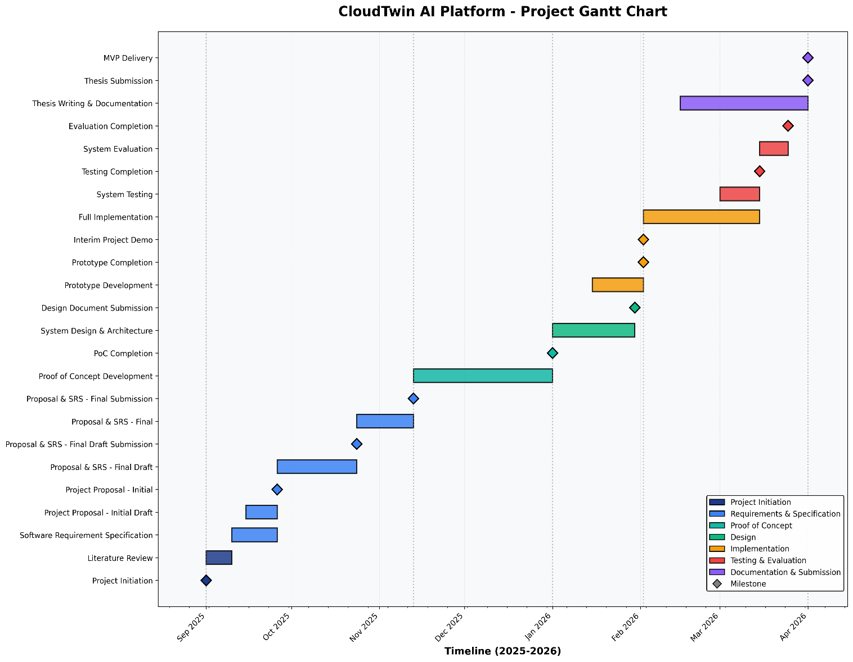
3.4.2.1 Grant Chart
Figure 1-Grant chart

3.4.2.2 Deliverables
Table 8-Deliverables
Deliverables |  | Dates
Project Proposal |  | 1st Sep 2025
Literature Review |  | 10th Sep 2025
Software Requirement Specification
Project Proposal – initial draft |  | 26th Sep 2025
Project Proposal and  Specification – final draft | Requirement | 24th Oct 2025
Project Proposal and  Specification – Final | Requirement | 13th Nov 2025
Proof of Concept |  | 1st Jan 2025
Design Document |  | 30th Jan 2025
Prototype |  | 2nd Feb 2026
Interim Project Demo |  | 2nd Feb 2026
Implementation |  | 2nd Feb 2026
Testing |  | 15th march 2026
Evaluation |  | 25th march 2026
Thesis Submission |  | 1st Apr 2026
Minimum Viable Product |  | 1st Apr 2026
…..

3.4.1Resource Requirements

3.4.3.1 Hardware
- Development workstation: Intel Core i7 / Ryzen 7 processor, 16 GB RAM minimum.
- Optional GPU: NVIDIA GeForce GTX 1650 or higher (≥ 4 GB VRAM).
- Cloud resources: AWS Free Tier EC2 and S3 instances for model deployment/testing.

3.4.3.2 Software:
- Programming Languages: Python 3.11, JavaScript (React frontend).
- Frameworks: TensorFlow 2.x, Scikit-learn 1.x, FastAPI, Streamlit, PyCaret.
- Database: PostgreSQL 15 / MongoDB 6.
- Compliance and Automation: Open Policy Agent (Rego), Terraform, LocalStack.
- Development Tools: VS Code, Docker, GitHub, AWS CLI.

3.4.3.3 Data:
- AWS CloudTrail, VPC Flow Logs, and CloudWatch Metrics.
- Synthetic digital-twin logs (simulated misconfigurations and threat scenarios).
- Optional benchmark datasets (CICIDS2017, UNSW-NB15) for cross-validation.

3.4.3.4 Skills
- Machine Learning modelling and data engineering.
- Cloud security and compliance frameworks (ISO 27001, NIST 800-53).
- Python programming and API integration.
- Cloud infrastructure management (AWS, Terraform).
- Technical report writing and academic documentation.

3.4.1 Risk and Mitigation (Expanded with Severity and Frequency)
Risk Exposure = Probability of Occurrence * Magnitude of Loss
Table 9-1 Risk and Mitigation
1 to 25 1 to 5 1 to 5
Risk | Severity | Frequency | Mitigation Strategy
Insufficient training data | 5 | 3 | Generate synthetic data through the digital twin; use public dataset (CICIDS2017)
Poor model accuracy | 4 | 3 | Tune hyperparameters and employ ensemble methods to improve performance.
Overfitting | 5 | 4 | Apply cross-validation, regularization, and early stopping.
Hardware limitations | 3 | 2 | Leverage AWS EC2 GPU instances or Google Collab for model training.
High false-positive rate | 5 | 3 | Implement behavioral validation and threshold tuning in the ML models.
Stakeholder dissatisfaction | 2 | 3 | Schedule asynchronous reviews and self-evaluations of progress.
Delays in model  training | 3 | 3 | Adopt agile Sprints and track Milestones weekly
Risk | Severity | Frequency | Mitigation Strategy
Regulatory compliance issues | 4 | 2 | Cross-map all policy-as-code rules to ISO 27001 and NIST controls for verification.

3.5 Chapter Summary
This section detailed the project management framework governing the development of CloudTwin AI. The defined scope and schedule ensure deliverables are achievable within the academic timeline. The allocation of hardware, software, and skills ensures technical feasibility, while a comprehensive risk-management plan minimises uncertainties. The approach balances technical rigour with agile adaptability, ensuring the successful delivery of a secure, auditable, and AI-powered cloud compliance system.

CHAPTER 04: SOFTWARE REQUIRMENT SPECIFICATION (SRS)

4.1 Chapter Overview

This chapter presents the Software Requirement Specification (SRS) for CloudTwin AI — an AI-powered cloud security compliance and threat detection platform. It lists the functional and non-functional needs for the system, specifies the stakeholders and their viewpoints, and explains how they were gathered. Conceptual diagrams (to be added) like the Rich Picture Diagram, Stakeholder Onion Model, Context Diagram, and Use Case Diagram are also included in the chapter. The MoSCoW approach is used to prioritize requirements so that development is in line with important project objectives.

4.2 Rich Picture Diagram
This diagram illustrates the comprehensive CloudTwin AI Platform, central to a cloud security ecosystem, processing inputs like Terraform configs from Cloud Administrators/DevOps and regulatory guidelines, while interacting with various external entities. It actively defends against threats (represented by the "Hacker / Threat Actor" and "Simulated Attacks"), generating outputs such as real-time alerts for Security Analysts, compliance reports for officers, and signed audit reports for Security Authorities, all while being influenced by external standards and cyber security frameworks. The platform's core components—Compliance Engine, Compliance Engine (ML), Digital Twin Simulator, and Audit Ledger—enable continuous improvements, enhanced trust, and transparency within cloud security operations. Purpose: To illustrate the ecosystem of CloudTwin AI and the interconnected components and users involved.
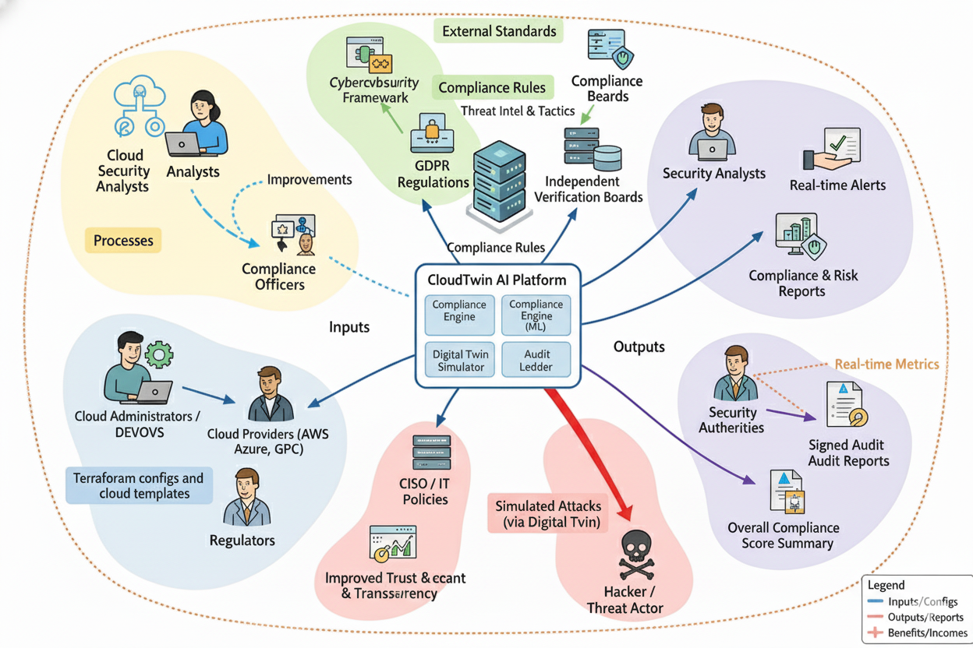
Figure 2-Rich Picture Diagram

4.3 Stakeholder Analysis
4.3.1 Stakeholder Onion Model
This model categorizes stakeholders based on their interaction level with the system.
- Core Layer: CloudTwin AI platform
- The System: Cloud Security Analysts, Compliance Officers, cloud administrators
- Containing System: DevOps Teams, academic supervisor, regulatory authorities, cloud service providers.
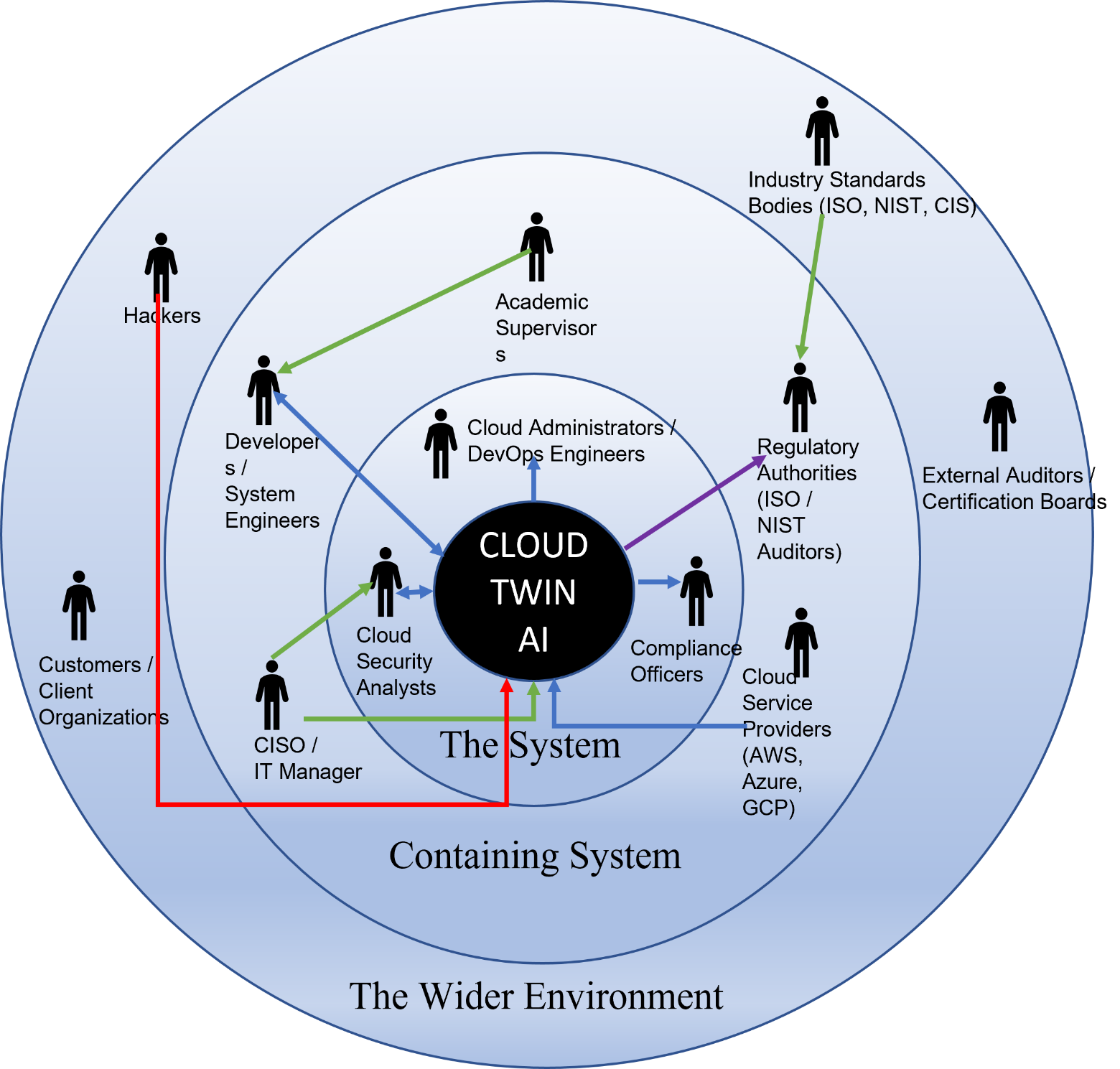
- The Wider Environment: Hackers, Customers, industry standards bodies, external auditors

Figure 3-Onion model

Table 10-Stakholder Onion Diagram
Stakeholder | Role | Benefits / Description
The System Stakeholders
Cloud Security Analysts | Normal User | Operate the CloudTwin AI platform to monitor alerts, analyze detected anomalies, and ensure accurate threat identification across multi-cloud environments.
Compliance Officers | Normal User | Review compliance reports generated by the system, verify findings, and provide feedback to ensure adherence to ISO 27001 and NIST 800-53 standards.
Cloud Administrators / DevOps Engineers | System Maintainer | Manage cloud infrastructure configurations (Terraform files), run simulations using the digital twin environment, and ensure consistent system uptime.
The Containing System Stakeholders
CISO / IT Manager | Policy Overseer | Defines organizational security policies and ensures CloudTwin AI aligns with compliance frameworks and corporate security objectives.
Developers / System Engineers | System Maintainers | Develop and maintain CloudTwin AI modules such as the compliance engine, ML models, and audit ledger, ensuring scalability and reliability.
Supervisors / Academic Advisors | Research Advisor | Provide project direction, methodological review, and ensure the implementation aligns with academic and technical goals.
Regulatory Authorities (ISO / NIST Auditors) | Quality Regulator | Validate the system’s compliance evidence and review tamper-proof reports for official certification and audits.
Cloud Service Providers (AWS / Azure / GCP) | External Data Source | Supply configuration data, logs, and APIs for testing and digital twin simulations.
The Wider Environment Stakeholders
Customers / Client Organizations | Beneficiary | Benefit from enhanced compliance, reduced security risks, and transparent audit trails through CloudTwin AI implementation.
Hackers / Threat Actors | Negative Actor | Represent simulated attack scenarios used in the digital twin to test detection accuracy and system resilience.
Industry Standards Bodies (ISO, NIST, CIS) | Compliance Influencer | Establish global cybersecurity and compliance frameworks that guide CloudTwin AI’s rule-based validation.
External Auditors / Certification Boards | Independent Reviewer | Conduct final verification of compliance evidence and issue official audit certifications.

4.4 Selection of Requirement Elicitation Methodologies
For this project, several elicitation methodologies were used to accurately identify technical, functional, and non-functional requirements. Each method was chosen to ensure comprehensive understanding of both user and system needs.
- Interviews: Conducted with cloud security analysts and compliance officers to gather expert insights on real-world misconfigurations, alert fatigue, and audit challenges.
- Surveys: Distributed among DevOps engineers and IT administrators to collect feedback on usability expectations, dashboard design preferences, and reporting formats.
- Document Analysis: Reviewed ISO 27001, NIST 800-53, and CIS Benchmarks, along with technical papers and vendor documentation from AWS Security Hub and Microsoft Defender for Cloud, to identify industry standards and gaps.
- Benchmarking & Observation: Evaluated existing tools such as Paladin Cloud and Cloud Custodian to assess performance, limitations, and integration opportunities.
- Brainstorming Sessions: Conducted with project supervisors and peers to refine the architecture of the Compliance Engine, Threat Detection Module, Digital Twin Simulator, and Audit Ledger.

4.5 Discussion of Findings
For each methodology used, key findings are documented below.

4.5.1 Literature Review Findings
Table 11-Literature Review Findings
Citation | Finding
(Okpor et al., 2024) | Identified that most existing fraud and anomaly detection frameworks address either accuracy or adaptability, but not both; highlighting the need for systems combining real-time analytics and adaptive learning.
(Kaur and Kaur, 2024) | Presented digital-twin-based approaches for cloud simulations, reinforcing the use of LocalStack and Terraform for configuration testing in CloudTwin AI.
(F5 Networks, 2021) | Provided empirical evidence that precision improvements in detection systems can drastically reduce operational overhead and customer impact.
(Feedzai, 2025) | Highlighted the necessity of “human-in-the-loop” learning systems for reducing false positives in AI-driven risk detection.
(Zowghi and Coulin, 2005) | Explained that multiple elicitation methods should be combined to achieve reliable requirements coverage — supporting CloudTwin AI’s multi-method approach.

4.5.2 Interviews Findings
Table 12-Interviews Findings
Code | Theme | Finding / Insight
IF1 | Compliance Automation | Interviewees highlighted that most organizations still rely heavily on manual audit processes. Automating compliance checks through infrastructure-as-code scanning (e.g., Terraform validation) was considered essential to reduce human error and audit preparation time.
IF2 | Integration with Cloud Providers | Experts emphasized that a key success factor is seamless integration with AWS, Azure, and GCP APIs to retrieve configuration data and logs without affecting live workloads. Lack of unified APIs was seen as a current limitation.
IF3 | Real-Time Anomaly Detection | Security analysts pointed out that existing compliance tools focus mainly on static analysis. They stressed the need for a dynamic monitoring engine capable of detecting anomalies from CloudTrail and VPC Flow Logs in real time using ML models.
IF4 | Audit Report Integrity | Compliance officers discussed issues of report tampering and questioned the trustworthiness of traditional audit documentation. They supported the inclusion of tamper-proof SHA-256-signed reports and immutable audit logs to ensure authenticity.
IF5 | Usability and Visualization | Participants expressed that compliance tools should present results through clear dashboards and visual indicators rather than raw JSON outputs, to make findings interpretable for non-technical managers.
IF6 | Cross-Team Collaboration | Respondents from DevOps teams recommended that the platform support shared workspaces and role-based access controls, improving communication between security and development teams during audits.

4.5.3 Survey Findings
Table 13-Survey Findings
Aim | To identify the demographic background of survey participants to understand the diversity of perspectives influencing CloudTwin AI’s requirement validation.
Results | 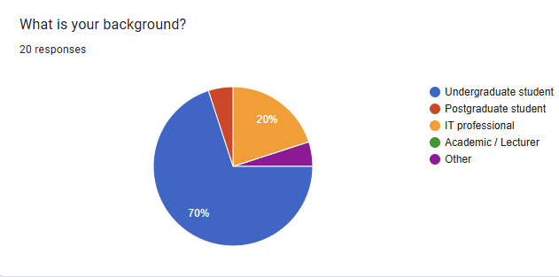  (70% Undergraduate students, 20% IT professionals, 5% Postgraduate students, 5% Others)
Findings & Conclusion | A majority (70%) of respondents were undergraduate students, while 20% were IT professionals with industry experience. The diversity of participants ensures balanced insights, combining academic and professional perspectives. The results confirm that the CloudTwin AI concept appeals to both technical and academic audiences, supporting its feasibility as a research-driven yet practical system.

Aim | To assess participants’ familiarity with popular cloud platforms such as AWS, Azure, and Google Cloud, which are relevant to CloudTwin AI’s multi-cloud integration.
Results | 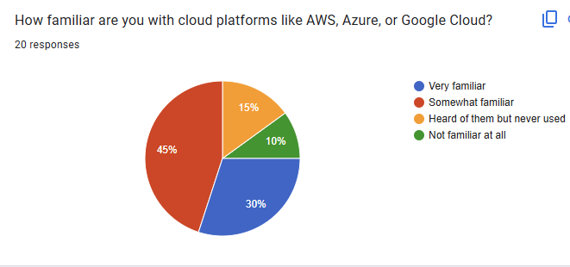  (30% Very familiar, 45% Somewhat familiar, 15% Heard of them but never used, 10% Not familiar at all)
Findings & Conclusion | The majority (75%) of respondents demonstrated at least basic familiarity with cloud computing environments. This indicates that most participants understand the concept of cloud infrastructure and its security challenges. These results validate that CloudTwin AI can be designed for users who possess a foundational understanding of AWS, Azure, or GCP, ensuring effective adoption among IT professionals and students.

Aim | To determine which cloud platform (AWS, Microsoft Azure, or Google Cloud Platform) participants use or study most frequently, helping to identify the primary environment for CloudTwin AI testing.
Results | 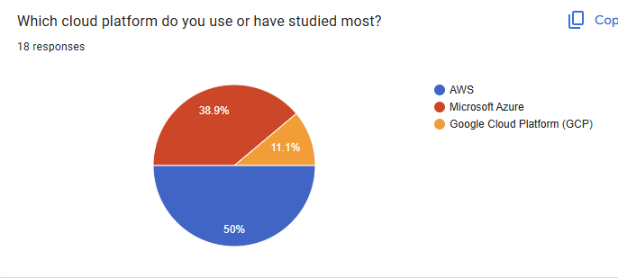 (50% AWS, 38.9% Microsoft Azure, 11.1% Google Cloud Platform)
Findings & Conclusion | Half of the respondents primarily use AWS, followed by Azure (38.9%) and GCP (11.1%). This suggests that AWS should serve as the primary focus for CloudTwin AI’s proof-of-concept and integration testing, while maintaining flexibility to support Azure and GCP in future iterations. These insights reinforce the project’s goal of being a multi-cloud-compatible compliance and threat detection platform.

Aim | To identify whether participants believe that cloud computing introduces new security risks compared to traditional on-premise systems.
Results | 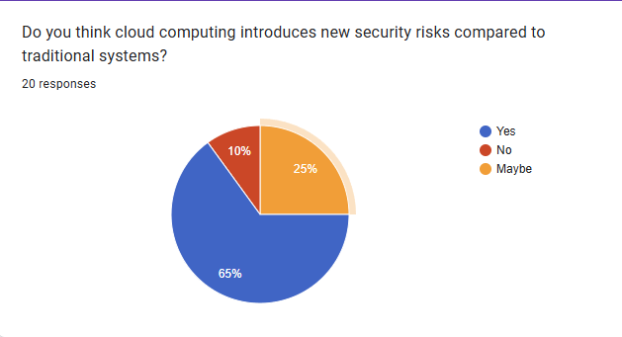  (65% Yes, 25% Maybe, 10% No)
Findings & Conclusion | A significant majority (65%) acknowledged that cloud platforms introduce unique security challenges compared to traditional IT environments. This validates CloudTwin AI’s goal to address modern security risks such as misconfigurations, access control issues, and cross-cloud vulnerabilities through automated detection and compliance assurance.

Aim | To determine the most common security and compliance problems encountered in cloud systems, helping define CloudTwin AI’s focus areas.
Results | 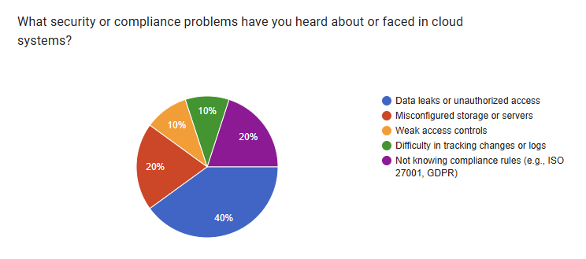  (40% Data leaks/unauthorized access, 20% Misconfigured servers, 10% Weak access controls, 10% Log tracking issues, 20% Lack of compliance awareness)
Findings & Conclusion | Respondents identified data leaks (40%) and misconfigurations (20%) as the top threats, followed by lack of compliance awareness (20%). These insights emphasize the need for CloudTwin AI’s digital twin simulation and automated configuration validation to proactively mitigate these vulnerabilities.

Aim | To understand how participants or their organizations currently monitor and manage cloud security.
Results | 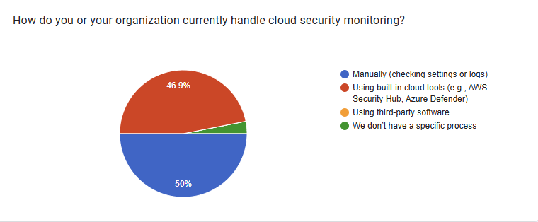  (50% Manually checking logs/settings, 46.9% Using built-in cloud tools like AWS Security Hub or Azure Defender, 3.1% No specific process)
Findings & Conclusion | The results indicate that half of the participants (50%) still rely on manual monitoring, while 46.9% use built-in cloud security tools. This highlights that most organizations lack an integrated, intelligent solution that combines automation, real-time analysis, and compliance validation. These findings justify the need for CloudTwin AI, which aims to centralize monitoring, automate compliance checks, and enhance visibility through AI-based anomaly detection and audit reporting.

Aim | To evaluate whether users perceive AI tools for detecting cloud threats and misconfigurations as useful.
Results | 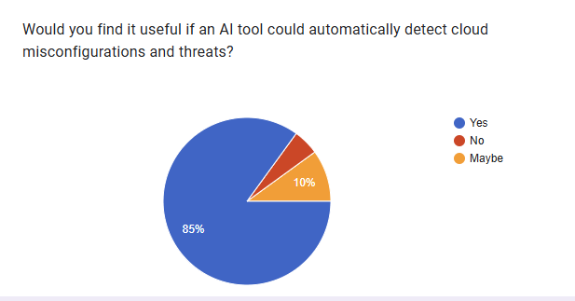  (85% Yes, 10% Maybe, 5% No)
Findings & Conclusion | A large majority (85%) consider AI-based automation extremely useful for managing cloud threats. This supports the inclusion of AI/ML-based anomaly detection and automated compliance validation in CloudTwin AI’s core modules to enhance real-time protection and decision support.

Aim | To identify which features participants value most in intelligent cloud security platforms.
Results | 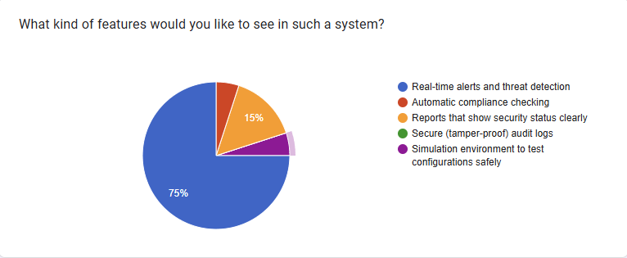  (75% Real-time alerts, 15% Compliance checks, 5% Secure audit logs, 5% Simulation testing)
Findings & Conclusion | Most users (75%) prioritized real-time alerts and threat detection, followed by compliance automation (15%) and tamper-proof audit logging (5%). This validates CloudTwin AI’s focus on continuous monitoring, secure audit trails, and digital-twin-based testing environments.

Aim | To identify factors that influence users’ trust in AI-driven cloud security platforms.
Results | 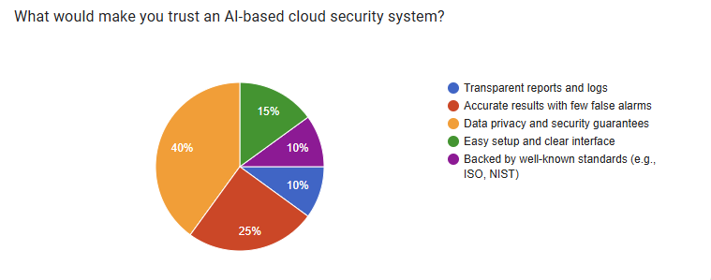  (40% Data privacy & guarantees, 25% Accuracy, 15% Standards compliance, 10% Transparency, 10% Ease of use)
Findings & Conclusion | Trust in AI-based systems depends primarily on data privacy (40%) and accuracy (25%). Participants also valued transparency and compliance with standards such as ISO 27001 and NIST 800-53, reinforcing the need for CloudTwin AI’s verifiable, explainable, and compliant architecture.

4.5.4 Brainstorming/Observation
Table 14-Brainstorming/Observation
Criteria | Finding
Project Relevance and Significance | The brainstorming sessions with domain experts and supervisors confirmed that CloudTwin AI addresses a critical need in cloud computing by offering a unified, AI-driven compliance and threat detection platform. The system enhances transparency, automation, and audit reliability across multi-cloud environments.
Novelty and Innovation | The project introduces an innovative combination of Digital Twin Simulation, AI-based anomaly detection, and tamper-proof audit logging, enabling safe, real-time compliance testing without affecting live infrastructure. This integrated model is rarely seen in existing compliance tools.
Technical Feasibility | Experts agreed that implementation is technically feasible through the integration of open-source tools such as Terraform, LocalStack, and Python-based ML frameworks. However, attention must be given to model optimization, cloud API limitations, and ensuring scalability during real-time analysis.
Addressing Limitations of Existing Systems | Participants observed that current cloud compliance tools are static and rule-based, lacking adaptability and predictive intelligence. CloudTwin AI overcomes this by combining machine learning and infrastructure-as-code scanning, producing continuous compliance validation.
Clarity of Scope and Objectives | The brainstorming clarified the system’s core goals: automate compliance audits, detect anomalies, and generate cryptographically signed reports for regulators. The team agreed to maintain modular design for each subsystem to ensure maintainability and extendability.
Potential Impact and Usability | Discussions emphasized that the system’s intuitive dashboard and visual reporting features would help both technical and non-technical stakeholders understand compliance results quickly, increasing the overall adoption potential of CloudTwin AI in industry environments.

4.6 Summary of Findings
Table 15-Summary of Findings
Finding | Literature Review | Interviews | Brainstorming | Surveys
Automated compliance scanning reduces manual audit effort | ✓ | ✓ | ✓ | ✓
Integration with AWS, Azure, and GCP APIs is essential for multi-cloud compatibility | ✓ | ✓ | ✓
AI/ML-based anomaly detection improves real-time threat visibility | ✓ | ✓ | ✓ | ✓
Tamper-proof audit logging ensures integrity of compliance reports | ✓ | ✓ | ✓
Visual dashboards and clear reporting enhance usability |  | ✓ | ✓ | ✓
Collaboration between DevOps, Security, and Compliance teams increases audit efficiency |  | ✓ | ✓ | ✓
Mapping controls to ISO 27001, NIST 800-53, and GDPR improves regulatory trust | ✓ | ✓ |  | ✓
Digital Twin simulation enables safe testing without impacting production | ✓ |  | ✓
AI explain ability (XAI) improves understanding of detected anomalies | ✓ | ✓ |  | ✓
Users strongly support automation and transparency in compliance tools |  | ✓ |  | ✓

4.7 Context Diagram
The Context Diagram provides a high-level overview of how the CloudTwin AI System interacts with external stakeholders and data sources. The system is represented as a central process (bubble), while external entities such as users, organizations, and regulatory bodies are represented as rectangles. The diagram defines the primary inputs and outputs that flow between the system and its external environment. Developers are not included, as the focus is on end-users and stakeholders.

Level 0 Data Flow Diagram (DFD)
- Users / External Entities:
  - Cloud Security Analysts – initiate real-time anomaly detection and receive alerts.
  - Compliance Officers – trigger compliance scans and receive signed audit reports.
  - Cloud Administrators / DevOps Engineers – upload configuration files and monitor compliance test results.
  - Regulatory Authorities – review final audit logs and verify report authenticity.
  - Customers / Client Organizations – receive compliance summaries and system assurance outcomes.
- System Inputs:
  - Cloud configuration templates (Terraform / JSON) from administrators.
  - Security and compliance scan requests from compliance officers.
  - Cloud logs and telemetry data from connected services (AWS, Azure, GCP).
  - Regulatory standards and control mappings from authorities (e.g., ISO 27001, NIST 800-53).
- System Outputs:
  - Real-time anomaly alerts to cloud security analysts.
  - Compliance scan results and visual dashboards to compliance officers.
  - Tamper-proof audit logs and signed reports to regulatory bodies.
  - Compliance summaries and assurance indicators to client organizations.
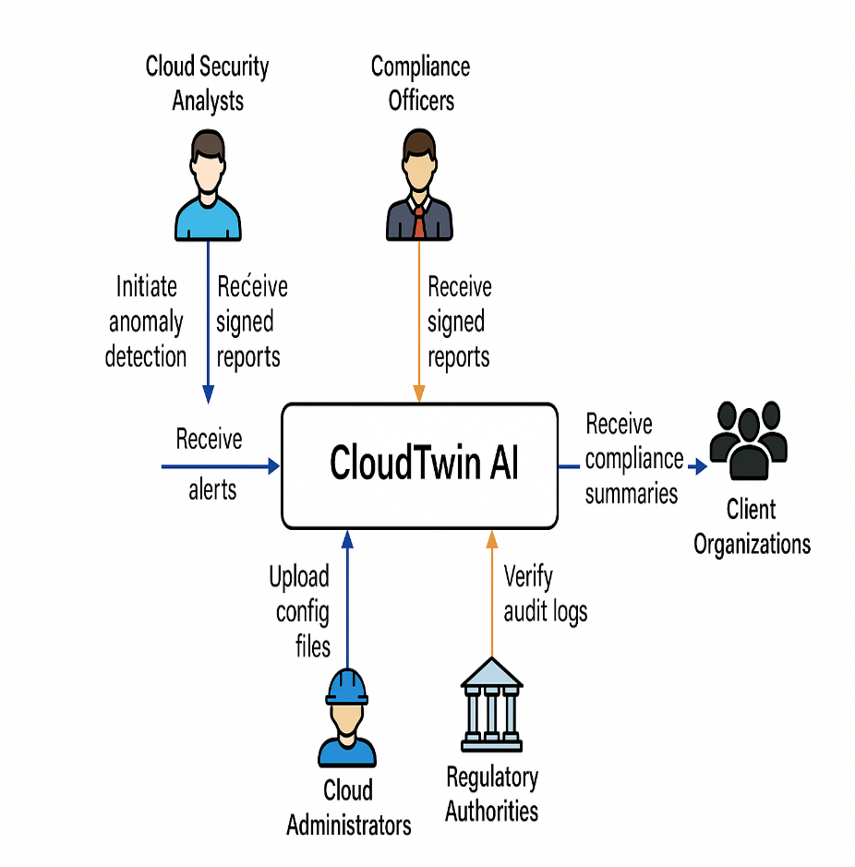

Figure 4-Context Diagram

4.8 Use Case Diagram
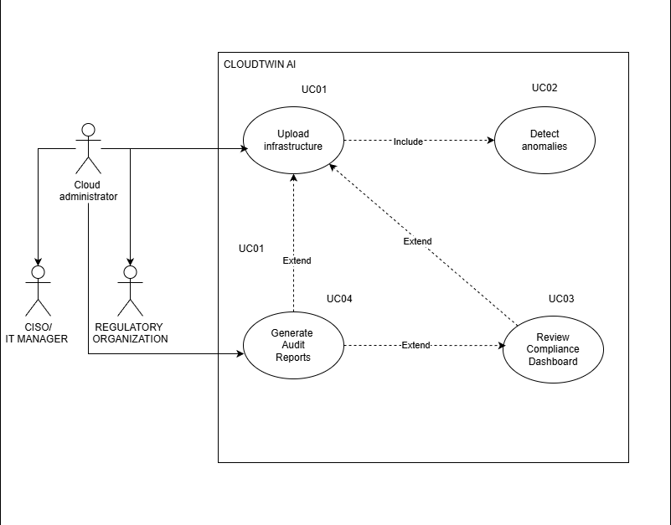
Figure 5-Use case diagram

4.9 Use Case Descriptions
Use Case: Run Compliance Scan
Table 16-Use Case Descriptions
Field | Description
Id | UC1
Description | Executes a compliance scan on uploaded infrastructure configurations (Terraform, CloudFormation) using predefined ISO 27001 and NIST 800-53 control rules. Detects misconfigurations or non-compliance within the simulated digital twin environment.
Primary Actor | Cloud Administrator / DevOps Engineer
Supporting Actors | CISO / IT Manager
Preconditions | 1. Valid cloud configuration files are uploaded. 2. The Compliance Engine and Digital Twin environment must be operational.
Extended Use Cases | Detect Anomalies (UC2)
Included Use Cases | None
Main Success Scenario | 1. Administrator initiates a compliance scan. 2. System simulates environment using digital twin. 3. System applies ISO/NIST policies and generates compliance results.
Alternative Flow | If the uploaded configuration is invalid, the system displays an error requesting correction.
Exceptional Flows | If the Compliance Engine is offline, the system logs the failure and notifies the administrator.
Postconditions | A compliance report draft is generated and stored in the audit ledger.
Comment | Ensures early detection of compliance issues and prevents security risks before deployment.

Use Case: Detect Anomalies
Field | Description
Id | UC2
Description | Analyzes system logs (CloudTrail, VPC Flow Logs) to detect suspicious activities or deviations using the AI/ML-based Threat Detection Engine.
Primary Actor | Cloud Security Analyst
Supporting Actors | Cloud Administrator
Preconditions | 1. Cloud logs or compliance scan data are available. 2. Threat Detection Engine is trained and ready.
Extended Use Cases | None
Included Use Cases | Run Compliance Scan (UC1)
Main Success Scenario | 1. Analyst initiates anomaly detection. 2. System processes event logs and applies ML models. 3. System flags anomalies and generates alerts.
Alternative Flow | If false positives are detected, analysts can manually mark and override alerts.
Exceptional Flows | If the model cannot process data due to incomplete logs, the system issues a “data missing” warning.
Postconditions | Detected anomalies are stored in the audit ledger and displayed on the dashboard.
Comment | Enhances proactive threat detection and provides evidence for compliance reviews.

Use Case: Verify Report Integrity
Field | Description
Id | UC4
Description | Validates the authenticity and integrity of generated reports by comparing SHA-256 hashes and digital signatures stored in the audit ledger.
Primary Actor | Regulatory Authority
Supporting Actors | Compliance Officer
Preconditions | 1. A report must exist in the audit ledger. 2. Regulator has access credentials to verify authenticity.
Extended Use Cases | None
Included Use Cases | Generate Compliance Report (UC3)
Main Success Scenario | 1. Regulator selects a report to verify. 2. System compares hashes and digital signatures. 3. System confirms the report’s authenticity.
Alternative Flow | If hash mismatch occurs, the system flags the report as tampered.
Exceptional Flows | If audit data is missing, the system alerts the compliance officer for revalidation.
Postconditions | A verified report is marked as “Validated” and can be used for certification.
Comment | Ensures the audit trail remains tamper-proof and builds regulator trust in CloudTwin AI’s compliance accuracy.

Use Case: Generate Compliance Report
Field | Description
Id | UC3
Description | Generates detailed compliance and anomaly analysis reports summarizing findings, control status, and recommendations. Uses SHA-256 signatures to ensure report integrity.
Primary Actor | Compliance Officer
Supporting Actors | Cloud Security Analyst, CISO
Preconditions | 1. Compliance and anomaly data are available from UC1 and UC2. 2. The Audit Ledger module is active.
Extended Use Cases | Verify Report Integrity (UC4)
Included Use Cases | Detect Anomalies (UC2)
Main Success Scenario | 1. Compliance Officer requests a compliance report. 2. System retrieves relevant findings. 3. System compiles and signs the report.
Alternative Flow | If incomplete data is found, the system notifies the officer and suggests re-running missing scans.
Exceptional Flows | If report generation fails, a log entry is created and partial output is saved.
Postconditions | Report is stored in the audit ledger and available for download.
Comment | Provides verifiable compliance evidence for regulatory audits and internal governance.

4.10 Requirements
MoSCoW Principle
The MoSCoW principle is used to prioritize requirements into:
- M: Must Have (mandatory).
- S: Should Have (important).
- C: Could Have (desirable).
- W: Will Not Have (out of scope).

4.10.1 Functional Requirements
Table 17-Functional Requirements
ID | Requirement | Priority (MoSCoW)
FR01 | The system must perform automated compliance scans on uploaded infrastructure configurations (e.g., Terraform files) using ISO 27001 and NIST 800-53 standards. | Must Have
FR02 | The system must detect anomalies and misconfigurations from cloud activity logs using AI/ML-based analysis. | Must Have
FR03 | The system must generate cryptographically signed audit reports for compliance officers and regulators. | Must Have
FR04 | The system should allow compliance officers to validate and annotate findings before report submission. | Should Have
FR05 | The system should provide real-time alerts to cloud security analysts upon detection of anomalies or compliance violations. | Should Have
FR06 | The system could integrate with external APIs (e.g., AWS Security Hub, Azure Defender) for extended monitoring capabilities. | Could Have
FR07 | The system could simulate compliance outcomes through the Digital Twin environment before deployment. | Could Have
FR08 | The system will not include live modification or remediation of cloud resources for safety and compliance reasons. | Will Not Have

4.10.2 Non-Functional Requirements
Table 18-Non-Functional Requirements
ID | Non-Functional Requirement | Description | Priority (MoSCoW)
NFR01 | Scalability | The system must process up to 1,000 configuration and log entries per second, ensuring scalability for enterprise use. | Must Have
NFR02 | Security | All data transfers and stored audit logs must be encrypted using AES-256 and SHA-256 hashing for tamper-proof verification. | Must Have
NFR03 | Reliability | The system must maintain an uptime of at least 99.5% during active compliance operations. | Must Have
NFR04 | Performance | The system should generate compliance scan results and anomaly detection insights within 1–2 seconds per request. | Should Have
NFR05 | Usability | The interface should provide a role-based dashboard that displays visual compliance summaries for different stakeholders. | Should Have
NFR06 | Auditability | The system should log every user action, configuration change, and report generation in an immutable ledger for traceability. | Should Have
NFR07 | Interoperability | The platform could support future integration with multi-cloud APIs and external compliance management tools. | Could Have
NFR08 | Maintainability | The system could use modular components to simplify updates and future feature expansion. | Could Have

4.11 Chapter Summary
The Software Requirement Specification chapter has provided a comprehensive overview of the system’s functional and non-functional requirements, the methodologies used to gather these requirements, and the tools and techniques employed to ensure stakeholder needs are addressed. Requirements were prioritized using the MoSCoW principle to focus on what is mandatory for the system’s success.

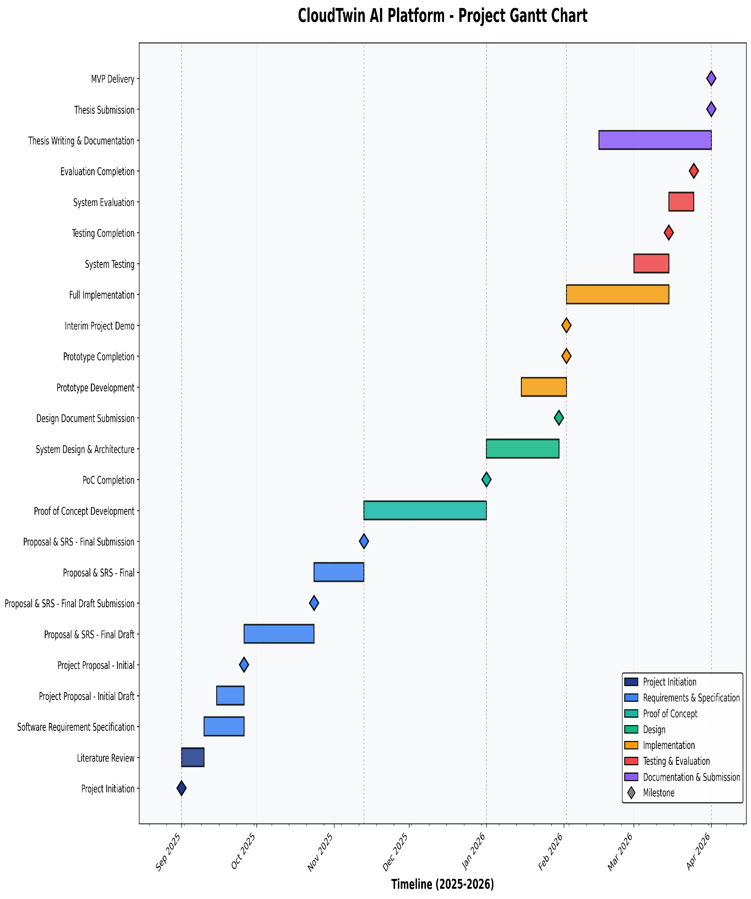
5. Time Schedule
Figure 6-grant chart v2

Chapter 5: Social, Legal, Ethical and Professional issues (SLEP)
5.1 Chapter Overview
This chapter explores the social, legal, ethical, and professional (SLEP) concerns associated with the creation of CloudTwin AI, a platform that utilizes artificial intelligence for identifying threats and ensuring cloud security compliance. By analyzing cloud logs (such as AWS CloudTrail), infrastructure settings, and compliance protocols in line with standards such as ISO 27001 and NIST 800-53, it directly interacts with sensitive security data and automated decision-making processes. Therefore, it is essential to thoroughly consider professional obligations, adherence to legal regulations (especially those regarding data protection), and the ethical use of AI.
This chapter also evaluates the project against the British Computer Society (BCS) Code of Conduct, particularly the following principles:
- Public Interest
- Professional Competence and Integrity
- Duty to Relevant Authority
- Duty to the Profession
The chapter identifies specific SLEP risks encountered during the project and explains how each was mitigated.

5.2 SLEP Issues and Mitigation

5.2.1 Social Issues
CloudTwin AI analyses infrastructure configurations and cloud activity logs. Although the system does not process personal user data directly, cloud logs may contain:
- User IDs
- IP addresses
- Access timestamps
- Role-based access control (RBAC) identifiers
These can indirectly relate to individuals within an organization.

Identified Social Risks:
- Potential misuse of log analysis to monitor employees.
- Fear of surveillance in enterprise environments.
- Misinterpretation of AI-based anomaly results.
Mitigation Measures:
- The system was tested only using synthetic or simulated AWS infrastructure via LocalStack.
- No real organizational production data was used.
- Clear documentation was included stating the system is for security compliance improvement, not employee monitoring.
- AI outputs are presented as “risk indicators” rather than definitive accusations.
This aligns with the BCS principle of acting in the Public Interest, ensuring the system does not cause unjust harm to individuals.

5.2.2 Legal Issues
CloudTwin AI relates to multiple regulatory and compliance frameworks.
Relevant Legal Areas:
- GDPR (General Data Protection Regulation) – If deployed in the EU, log data containing identifiable information must be lawfully processed.
- ISO 27001 & NIST 800-53 – Compliance mappings must be accurate and not misleading.
- Intellectual Property – Terraform parsing and rule engines must not infringe copyrighted frameworks.
Legal Risks Identified:
- Processing identifiable metadata without consent.
- Misrepresentation of compliance results.
- Unauthorized storage of cloud configuration data.
Mitigation Measures:
- No real personal data was stored during development.
- The system includes disclaimers stating results are advisory, not certification-grade compliance proof.
- Hash-based audit logging (SHA-256) ensures integrity without exposing raw data.
- Architecture designed for deployment within client-controlled environments.
This satisfies the BCS duty to comply with relevant legislation and to avoid professional negligence.

5.2.3 Ethical Issues
Ethical concerns mainly arise from:
- AI anomaly detection models (Isolation Forest, Random Forest)
- Automated compliance scoring
- Risk labeling
Ethical Risks:
- False positives incorrectly labeling systems as insecure.
- Over-reliance on automated compliance scoring.
- Bias in anomaly detection due to limited training data.
- Transparency in AI decision-making.
Mitigation Measures:
- AI model outputs include confidence levels.
- Explanatory logging shows why anomalies were flagged.
- The system emphasizes “human-in-the-loop” validation.
- Models were trained only on anonymized, simulated datasets.
This adheres to BCS principles of:
- Acting with integrity
- Avoiding harm
- Ensuring transparency in professional work

5.2.4 Professional Issues
As a cloud security platform, professional responsibility is critical.
Professional challenges encountered:
- Ensuring compliance mappings are technically accurate.
- Avoiding exaggeration of AI capabilities.
- Maintaining version control and documentation.
- Proper citation of ISO/NIST standards in academic work.
Mitigation Actions:
- All compliance rules are referenced to official documentation.
- Claims about AI performance are supported by evaluation metrics.
- Code is version-controlled with structured documentation.
- Academic referencing standards followed (Harvard format).
Additionally, any interviews or consultations conducted during the project would require written consent, in line with ethical research practices. No personal names or identifiable stakeholders are disclosed in this dissertation without documented approval.
This aligns with the BCS principles of:
- Maintaining professional competence
- Upholding the reputation of the profession
- Acting responsibly toward stakeholders

5.3 Chapter Summary
This chapter critically evaluated the Social, Legal, Ethical and Professional considerations surrounding the development of CloudTwin AI.
Key findings include:
- Social concerns were mitigated through the exclusive use of simulated infrastructure.
- Legal risks were addressed by avoiding real personal data and aligning system design with GDPR and security standards.
- Ethical challenges in AI-based decision-making were mitigated using explainability mechanisms and human oversight.
- Professional responsibilities were maintained in accordance with the BCS Code of Conduct through integrity, transparency, and accurate representation of system capabilities.
Overall, CloudTwin AI was developed with deliberate adherence to ethical research standards and professional computing practices, ensuring that security automation does not compromise individual rights, legal obligations, or professional integrity.

6.1 Chapter Overview
This chapter presents the system design of CloudTwin AI – AI-Powered Cloud Security Compliance & Threat Detection Platform. The design phase translates the system requirements defined in the SRS into a structured technical blueprint that guides implementation.
The purpose of this chapter is to:
- Define the architectural structure of the system
- Explain how Non-Functional Requirements (NFRs) are embedded into the design
- Present high-level and detailed design diagrams
- Describe the AI/ML algorithm design
- Illustrate the user interface wireframes
The design ensures that CloudTwin AI achieves its objectives of:
- Simulating cloud infrastructure (Digital Twin)
- Performing automated compliance assessment
- Detecting anomalies using AI/ML
- Generating tamper-proof audit logs
The design follows an Object-Oriented Analysis and Design (OOAD) methodology, therefore class diagrams, sequence diagrams, and activity diagrams are used in the detailed design section.

6.2 Design Goals
The design goals reflect the Non-Functional Requirements identified in the SRS. These attributes define the overall system quality and are maintained across all architectural layers.
1. Performance
- Efficient parsing of Terraform files
- Fast compliance rule execution
- Optimized anomaly detection model inference
Design Implementation:
- Modular microservices architecture
- Asynchronous API handling (FastAPI)
- Pre-trained ML models loaded in memory

2. Scalability
Must support increasing cloud resources and log volume
Design Implementation:
- Containerized backend (Docker-ready)
- Layered architecture allowing horizontal scaling
- Stateless API design

3. Accuracy
- Compliance rules must correctly map to ISO 27001 / NIST controls
- AI anomaly detection must minimize false positives
Design Implementation:
- Rule-based compliance engine with explicit control mappings
- Evaluation metrics (precision, recall)
- Human-in-the-loop validation

4. Security
- Sensitive infrastructure data must be protected
- Audit logs must be tamper-proof
Design Implementation:
- SHA-256 hashing for audit logs
- Secure API endpoints
- No storage of raw personal data

5. Usability
Dashboard must present compliance and anomaly results clearly
Design Implementation:
- Risk scoring visualization
- Clear severity categorization (Low / Medium / High)
- Minimalistic security-focused UI

6. Maintainability
Modular code structure
Separation of compliance engine and ML engine
Design Implementation:
- Layered architecture
- Service-oriented module
- Clear documentation

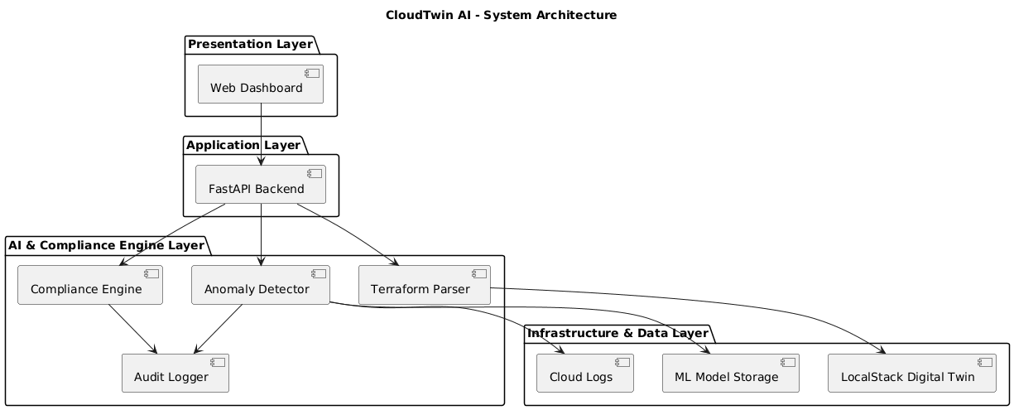
6.3 System Architecture Diagram

High-Level Architecture Overview
CloudTwin AI follows a four-tier layered architecture:
- Presentation Layer
- Application Layer
- AI/Compliance Engine Layer
- Infrastructure & Data Layer

Layer 1: Presentation Layer
- Web-based dashboard
- Displays compliance scores
- Shows anomaly detection results
- Provides audit reports

Layer 2: Application Layer (FastAPI Backend)
- REST API endpoints
- Handles file uploads (Terraform)
- Triggers compliance scanning
- Calls ML inference services

Layer 3: AI & Compliance Engine Layer
This is the core intelligence layer.It consists of:
- Terraform Parser
- Compliance Rule Engine
- Anomaly Detection Model (Isolation Forest / Random Forest)
- Audit Logging Service (SHA-256 hashing)
Layer 4: Infrastructure & Data Layer
- LocalStack (Digital Twin simulation)
- Synthetic CloudTrail logs
- ML model files
- Log storage

6.4 Detailed Design
Since the project follows OOAD, the following diagrams are included:
- Class Diagram
- Sequence Diagram
- Activity Diagram

6.4.1 Class Diagram
Purpose:
To illustrate system classes and their relationships.
Main Classes:
- TerraformParser
- ComplianceEngine
- Rule
- AnomalyDetector
- AuditLogger
- ReportGenerator
Relationships:
- ComplianceEngine aggregates Rule objects
- AnomalyDetector processes Log objects
- AuditLogger hashes results before storage

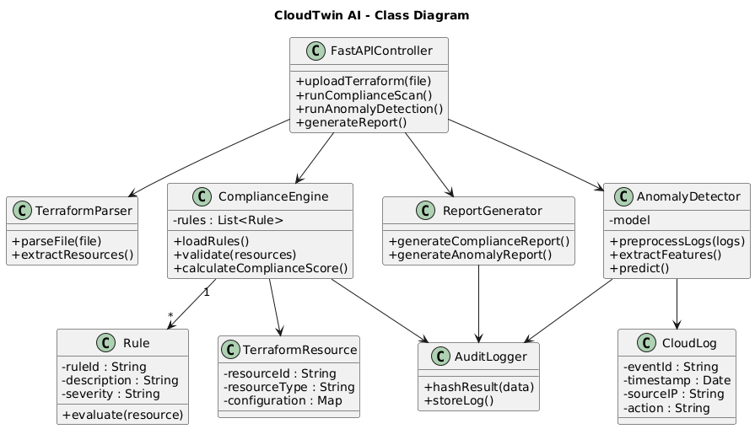

6.4.2 Sequence Diagram – Compliance Scan

Purpose:
To show the interaction flow when a compliance scan is triggered.
Flow:
- User uploads Terraform file
- API receives request
- TerraformParser extracts resources
- ComplianceEngine validates rules
- Results passed to AuditLogger
- Dashboard displays compliance report

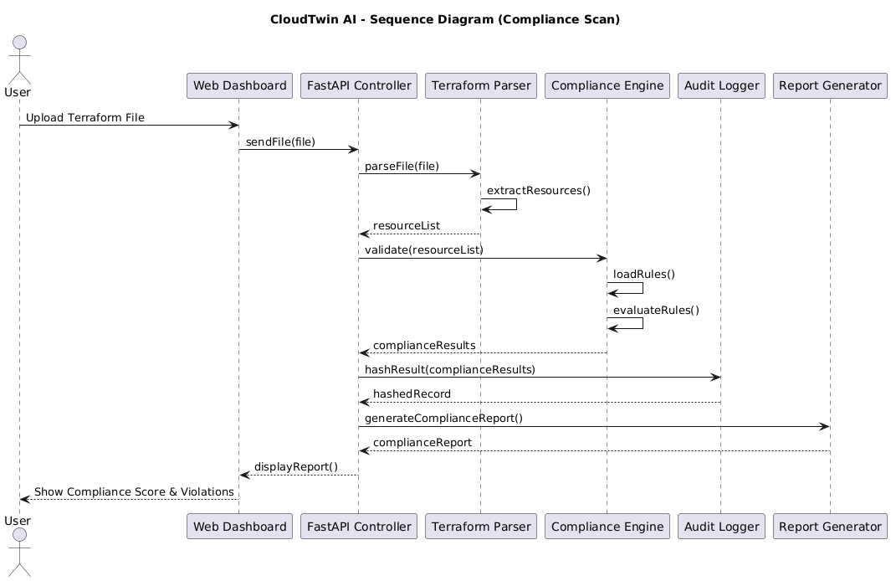

6.4.3 Activity Diagram – Anomaly Detection
Purpose:
To show the workflow of AI-based threat detection.
Flow:
- Load logs
- Preprocess data
- Extract features
- Run Isolation Forest model
- Calculate anomaly score
- Flag risk level
- Generate report
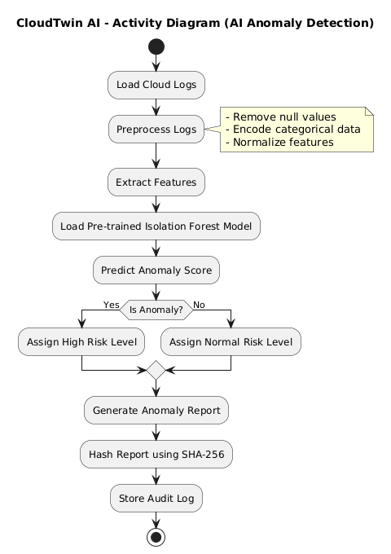

6.5 Algorithm Design
AI Anomaly Detection Algorithm (Pseudocode)
Input: CloudTrail Log Dataset L
Step 1: Preprocess L
- Remove null values
- Encode categorical variables
- Normalize numerical features
Step 2: Feature Extraction
- Extract event frequency
- Extract unusual IP access
- Extract role escalation events
Step 3: Load Pre-trained Isolation Forest Model M
Step 4: For each log entry l in L:
score ← M.predict(l)
if score == anomaly:
assign Risk_Level = High
else:
assign Risk_Level = Normal
Step 5: Store results in Audit Log with SHA-256 hash
Output: Anomaly Detection Report

Compliance Rule Evaluation Algorithm

Input: Parsed Terraform Resources R
For each resource r in R:
For each rule c in ComplianceRuleSet:
if r violates c:
record non-compliance
else:
mark compliant
Generate compliance percentage score

6.6 UI Design (Low Fidelity Wireframes)
Available on implementation section

6.7 Chapter Summary
This chapter presented the complete system design of CloudTwin AI.
Key highlights:
- A layered architecture ensures scalability and maintainability.
- Design goals are directly aligned with Non-Functional Requirements.
- OOAD methodology was used to define structural and behavioral diagrams.
- AI/ML algorithms were formally expressed through pseudocode.
- Low-fidelity UI wireframes demonstrate usability-driven design.
The design provides a structured blueprint that ensures CloudTwin AI achieves its objectives of secure cloud compliance automation and AI-driven threat detection.

Chapter 7: Implementation

7.1 Chapter Overview

This chapter presents the implementation of CloudTwin AI – AI-Powered Cloud Security Compliance & Threat Detection Platform. The implementation phase transforms the architectural and detailed designs presented in Chapter 6 into a fully functional working prototype.
The objectives of this phase were:
- To implement the digital twin infrastructure simulation
- To develop the compliance validation engine
- To integrate AI-based anomaly detection
- To implement secure audit logging
- To develop a functional web-based dashboard
This chapter first justifies the selected technology stack and development tools. It then explains the implementation of core system modules, AI model integration, frontend-backend communication, and challenges encountered during development.
This chapter directly follows the Design chapter, demonstrating how the layered architecture and UML diagrams were translated into working software components.

7.2 Technology Selection
The technology stack was selected based on:
- Compatibility with AI/ML requirements
- Cloud infrastructure simulation capability
- Scalability and modularity
- Security considerations
- Ease of integration

7.2.1 Technology Stack
CloudTwin AI uses a layered technology stack:
- Frontend: Web-based dashboard (HTML/CSS/JS or React if applicable)
- Backend: Python + FastAPI
- AI/ML: Scikit-learn (Isolation Forest / Random Forest)
- Infrastructure Simulation: Terraform + LocalStack
- Security: SHA-256 hashing
- Containerization: Docker

7.2.2 Programming Languages

Python
Python was selected as the primary programming language because:
- Strong AI/ML ecosystem
- Easy integration with FastAPI
- Rich cloud security libraries
- Rapid prototyping capabilities
Python supports:
- Log parsing
- Rule-based validation
- Machine learning model deployment
- Secure hashing

7.2.3 Development Framework

FastAPI
FastAPI was selected because:
- High performance (ASGI-based)
- Automatic API documentation (Swagger UI)
- Asynchronous support
- Easy integration with ML models
It supports:
- REST API endpoints
- File upload handling (Terraform files)
- JSON response generation

7.2.4 Libraries / Toolkits
Key libraries used:
- scikit-learn – for Isolation Forest anomaly detection
- pandas – log preprocessing
- numpy – numerical processing
- hashlib – SHA-256 hashing
- hcl2 parser – Terraform file parsing
- boto3 (optional) – AWS interaction
These libraries directly support the functional requirements of:
- Compliance scanning
- AI-based anomaly detection
- Secure audit logging

7.2.5 Integrated Development Environment (IDE)

Visual Studio Code
VS Code was used due to:
- Python support
- FastAPI debugging
- Git integration
- Docker extension support
Additional tools:
- Postman – API testing
- GitHub – version control

7.2.6 Summary of Technology Selection
The selected technologies align directly with the SRS requirements:
Requirement | Supporting Technology
AI-based anomaly detection | Scikit-learn
Compliance validation | Python rule engine
Infrastructure simulation | Terraform + LocalStack
Secure audit logging | hashlib (SHA-256)
API communication | FastAPI
The technology stack ensures performance, scalability, maintainability, and security.

7.3 Core Functionalities Implementation

7.3.1 Dataset Declaration (AI Component)
The anomaly detection module was trained using synthetic cloud log data simulating AWS CloudTrail logs.
Dataset split:
- Training Data: 70%
- Validation Data: 15%
- Testing Data: 15%
Features extracted include:
- Login frequency
- IP variation
- Privilege escalation attempts
- Resource access patterns

7.3.2 Exploratory Data Analysis (Optional Section)
Before training the model:
- Distribution of event types was analyzed
- Frequency anomalies were observed
- Outlier detection patterns were examined
This ensured the dataset was suitable for anomaly detection.

7.3.3 Modular Development
CloudTwin AI was implemented using modular development.
Module 1: Terraform Parser
Purpose:
- Parse .tf files
- Extract resources
Example (simplified):
def parse_terraform(file):
with open(file, 'r') as f:
data = hcl2.load(f)
return data

Module 2: Compliance Engine
Purpose:
- Validate resources against compliance rules
Example:
def validate_resource(resource):
if resource['public_access'] == True:
return "Non-Compliant"
return "Compliant"
This directly maps to functional requirement:
"System shall validate infrastructure against predefined compliance rules."

Module 3: Anomaly Detection Engine
Purpose:
- Detect abnormal behavior in logs
Example:
from sklearn.ensemble import IsolationForest

model = IsolationForest(contamination=0.05)
model.fit(training_data)

predictions = model.predict(test_data)

Module 4: Audit Logger
Purpose:
- Generate SHA-256 hash for report integrity
import hashlib

def hash_data(data):
return hashlib.sha256(data.encode()).hexdigest()

7.3.4 Code Structure
The project follows a layered structure:
backend/
├── main.py
├── api/
├── services/
├── models/
├── compliance/
├── ml/
├── audit/
This structure ensures maintainability and separation of concerns.

7.3.5 Integration
Integration flow:
- User uploads Terraform file
- Parser extracts resources
- Compliance engine validates rules
- AI engine processes logs
- Audit logger hashes results
- Dashboard displays output
Modules communicate through REST endpoints.

7.4 User Interface Implementation
This section is under development

7.4.1 Frontend Development
UI includes:
- File upload form
- Compliance score dashboard
- Anomaly graph visualization
- Audit report download
The dashboard displays:
- Risk levels (Low / Medium / High)
- Compliance percentage
- Violated controls list

7.4.2 Backend Integration
Frontend communicates via REST APIs:
Example endpoint:
POST /upload-terraform
POST /run-compliance
POST /run-anomaly
Responses returned as JSON.

7.4.3 Accessibility Considerations
- High-contrast UI design
- Clear severity indicators
- Minimal clutter
- Descriptive labels
Ensures usability across diverse users.

7.5 Challenges and Solutions

Challenge 1: Parsing Complex Terraform Files
Problem:
- Nested resources caused parsing issues.
Solution:
- Implemented recursive extraction logic.

Challenge 2: High False Positives in AI Model
Problem:
- Isolation Forest flagged normal activity as anomaly.
Solution:
- Adjusted contamination parameter
- Improved feature engineering

Challenge 3: Performance Bottlenecks
Problem:
- Slow log processing.
Solution:
- Optimized preprocessing
- Reduced redundant computations

Challenge 4: Integration Between Modules
Problem:
- Data format mismatches.
Solution:
- Standardized JSON schema across modules.

7.6 Chapter Summary
This chapter detailed the implementation of CloudTwin AI.
Key highlights:
- Python and FastAPI were selected for backend development.
- Scikit-learn was used for AI-based anomaly detection.
- Terraform and LocalStack enabled digital twin simulation.
- SHA-256 hashing ensured tamper-proof logging.
- Modular architecture ensured maintainability.
- Implementation challenges were successfully resolved.

Chapter 8: Time Schedule
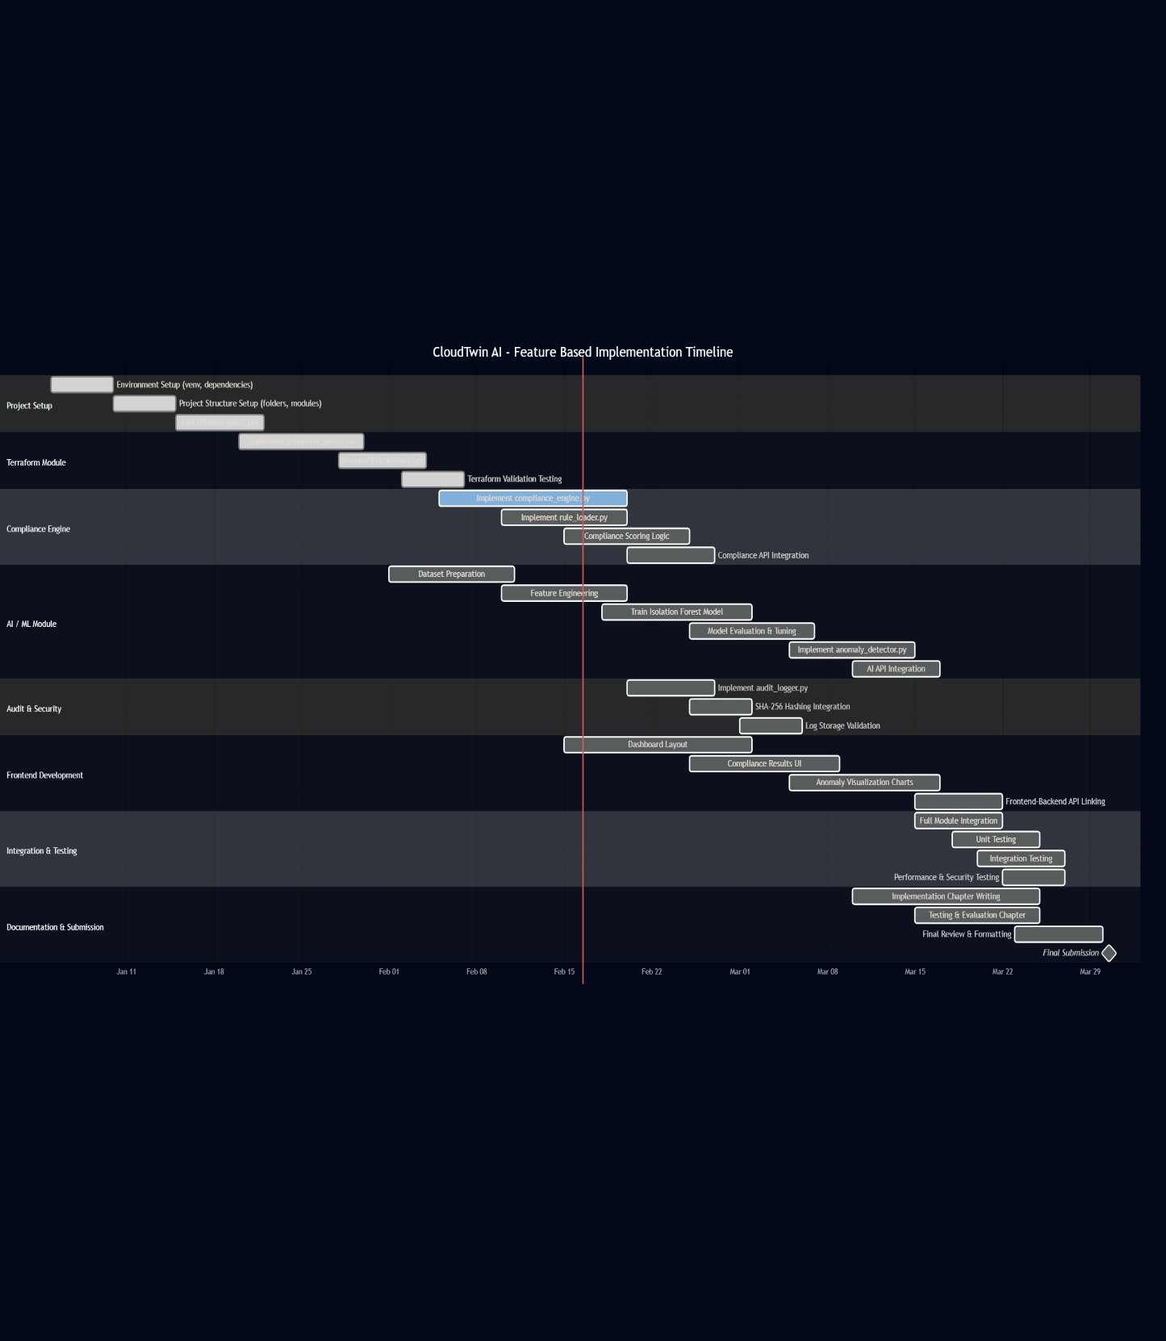

References
Hagemann, T. & Katsarou, K. (2020). A systematic review on anomaly detection for cloud computing environments. Proceedings of the 3rd Artificial Intelligence and Cloud Computing Conference (AICCC 2020), ACM, pp. 14–23.
Demirbaga, U., Aujla, G. S. & Zhang, P. (2025). Advancing anomaly detection in cloud environments with cutting-edge generative AI for expert systems. Expert Systems, 42(2), e13722.
Mitropoulou, K., Kokkinos, P., Soumplis, P. & Varvarigos, E. (2024). Anomaly detection in cloud computing using knowledge graph embedding and machine learning mechanisms. Journal of Grid Computing, 22(1), Article 6.
Parameswarappa, P., Shah, T. & Lanke, G. R. (2023). A machine learning-based approach for anomaly detection for secure cloud computing environments. In Proceedings of the 2023 Int. Conf. on Intelligent Data Communication Technologies and Internet of Things (IDCIoT), IEEE, pp. 1192–1199.
Abdallah, A. M. et al. (2024). Cloud network anomaly detection using machine and deep learning techniques – recent research advancements. IEEE Access, 12, 39700–39715.
Wang, Y. & Yang, X. (2025). Machine learning-based cloud computing compliance process automation. Automation and Machine Learning, 6(1), Art. 060105.
Haverinen, H., Janhunen, T., Päivärinta, T., Lempinen, S. & Merilä, S. (2024). Automating cybersecurity compliance in DevSecOps with open information model for security as code. In Proceedings of eSAAM 2024 – 4th Eclipse Security, AI, Architecture and Modelling Conference, ACM, pp. 93–102.
National Institute of Standards and Technology (NIST) (2020). Security and Privacy Controls for Information Systems and Organizations (NIST SP 800-53 Rev.5). NIST, Gaithersburg, MD.
International Organization for Standardization (ISO) (2022). ISO/IEC 27001:2022 – Information Security Management Systems – Requirements. ISO, Geneva.
Chaudhary, A. (2025). Streamlining cloud compliance audits using AI and automation. Cloud Security Alliance Blog, 5 Nov 2025.
Empl, P., Koch, D. & Pernul, G. (2025). Digital twins in security operations: state of the art and future perspectives. ACM Computing Surveys, 58(1), Article 18.
Qureshi, A. R., Asensio, A., Imran, M., Garcia, J. & Masip-Bruin, X. (2025). A survey on security enhancing digital twins: models, applications and tools. Computer Communications, 238, 108158.

Erceylan, G., Akbarzadeh, A. & Gkioulos, V. (2025). Leveraging digital twins for advanced threat modeling in cyber-physical systems cybersecurity. International Journal of Information Security, 24:151.
European Cyber Security Organisation (ECSO) (2023). Cybersecurity Scenarios and Digital Twins – Technical Paper. ECSO, Brussels.
Schneier, B. & Kelsey, J. (1999). Secure audit logs to support computer forensics. ACM Transactions on Information and System Security, 2(2), 159–176.
Yavuz, A. A. & Ning, P. (2009). BAF: An efficient publicly verifiable secure audit logging scheme for distributed systems. In Proceedings of the 25th Annual Computer Security Applications Conference (ACSAC 2009), IEEE, pp. 219–228.
Crosby, S. A. & Wallach, D. S. (2009). Efficient data structures for tamper-evident logging. In Proceedings of the 18th USENIX Security Symposium, USENIX Association, pp. 317–334.
Zawoad, S., Dutta, A. K. & Hasan, R. (2013). SecLaaS: Secure logging-as-a-service for cloud forensics. In Proceedings of the 8th ACM ASIACCS, ACM, pp. 219–230.
Putz, B., Menges, F. & Pernul, G. (2019). A secure and auditable logging infrastructure based on a permissioned blockchain. Computers & Security, 87, 101602.
Paccagnella, R., Datta, P., Bates, A. & Campbell, R. (2020). Custos: Practical tamper-evident auditing of operating systems using trusted execution. In Proceedings of NDSS 2020 – Network and Distributed System Security Symposium.
Morillo Reina, J. D. & Mateo Sanguino, T. J. (2025). Decentralized and secure blockchain solution for tamper-proof logging events. Future Internet, 17(3), 108.

Appendices if any

