

Name: Idwah Sajjad

Roll Number: 221440716

Assignment 1

COMP 421 – B

Submitted on: 15th April 2022

**SQL Injection Attack with SQL Map using Kali Linux**

1. Checking the ip address in kali Linux.

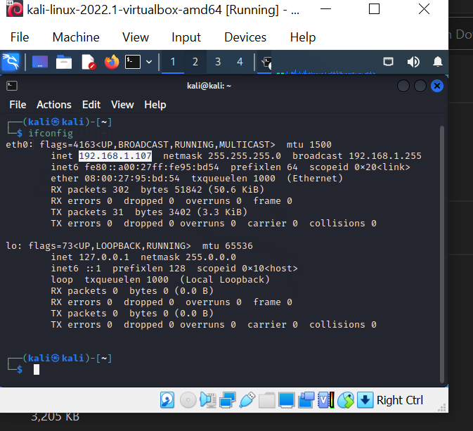

1. Assign the ip address of Metasploitable 2 within the same subnet.

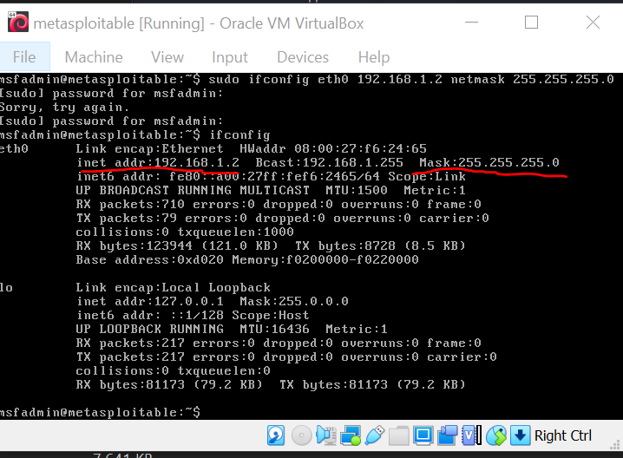

1. Ping the Metasploitable 2.

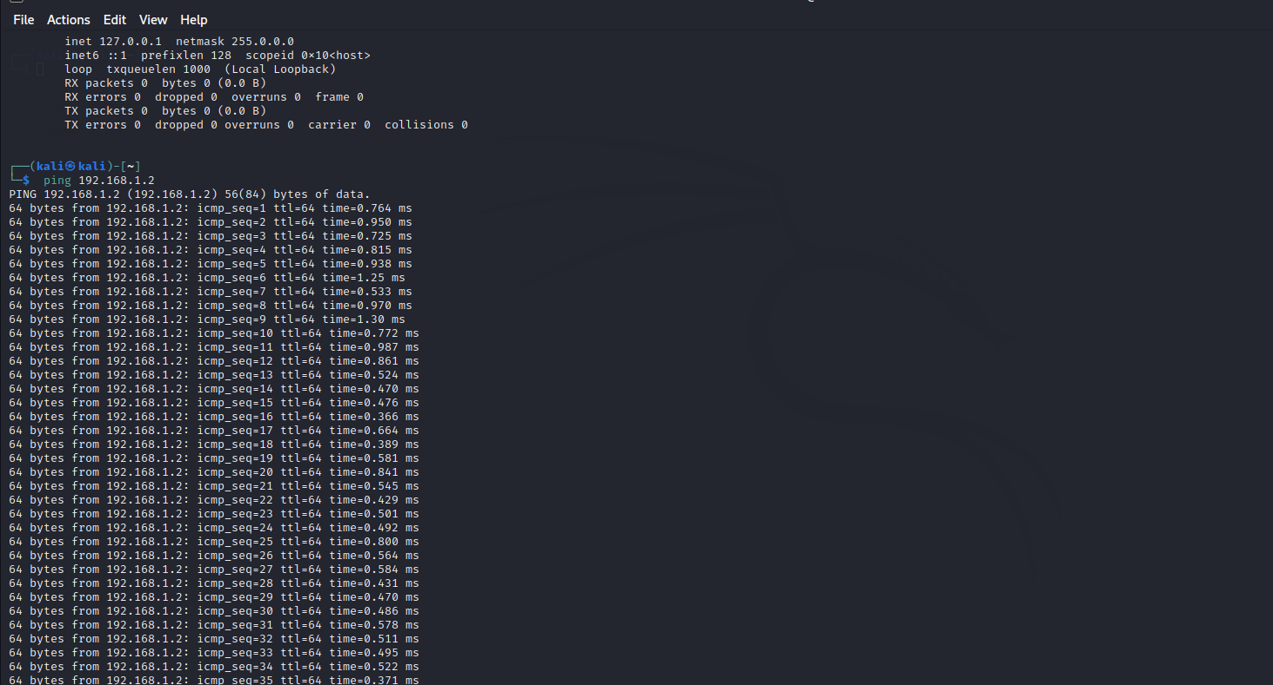

1. Open the assigned ip address to metaspoilatable 2 in Mozilla Firefox

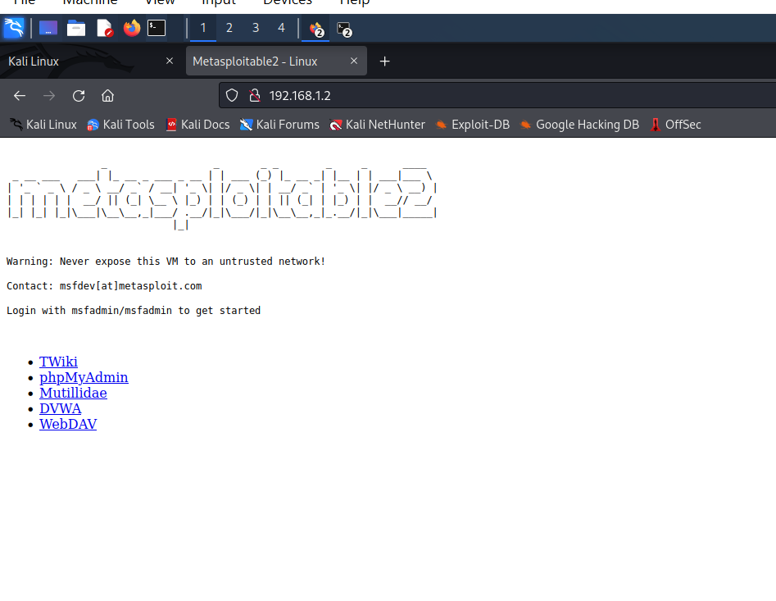

1. Open OWASP top 10 -> A1-Injection -> Extract Data -> user info

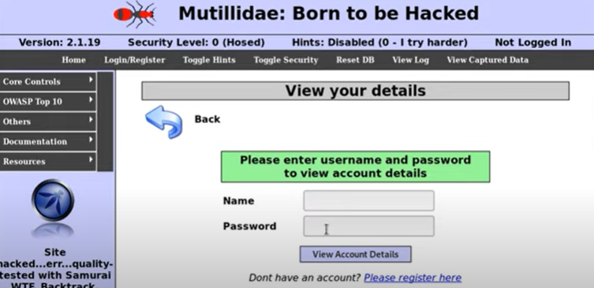

1. Use the tool Burp suite.

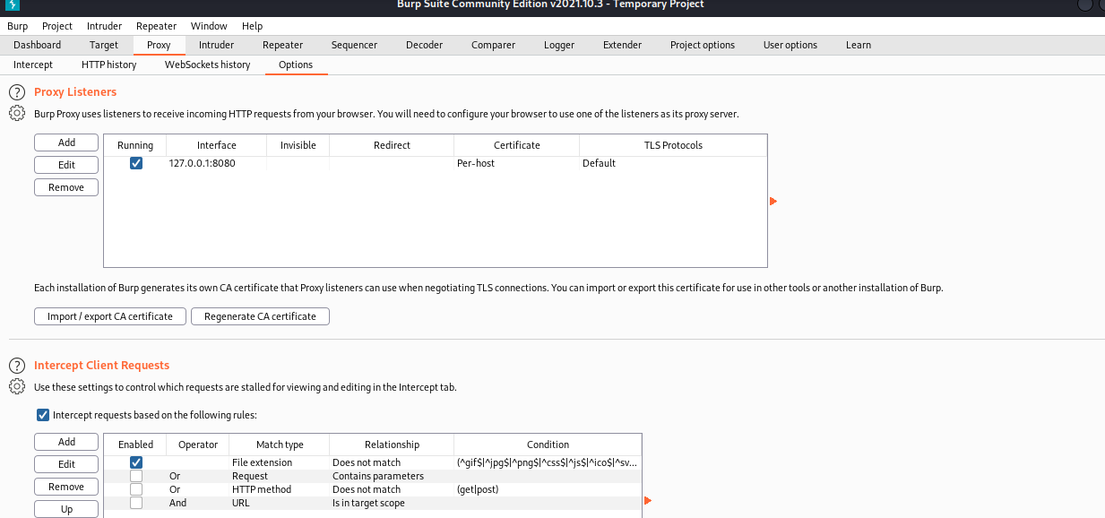

1. Set the network settings to manual proxy configuration and make sure the ip address and port number are the same as in the burp suite proxy settings. Make sure the intercept is on and then enter a random user name and password here:



Save when a request is captured:

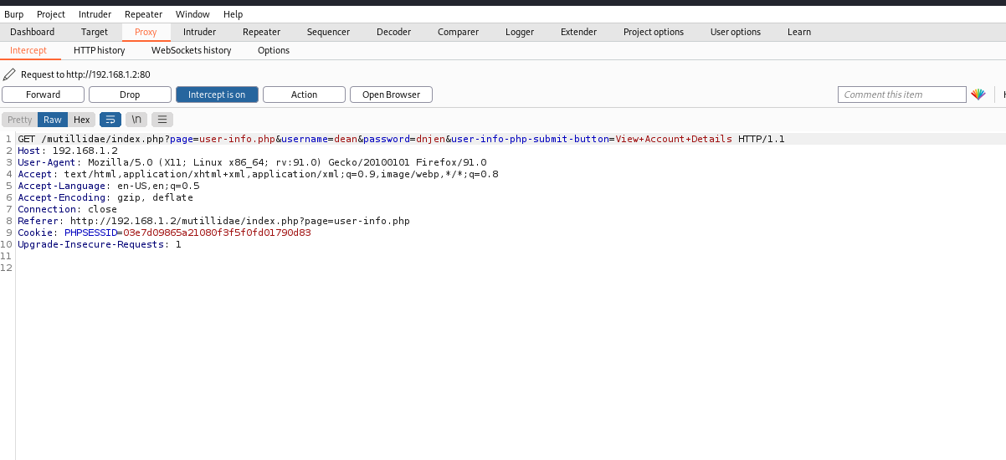

1. Save the file.

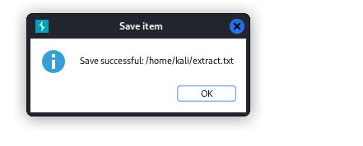

1. Using Sql Map, write a request to check if the database has any vulnerabilities.

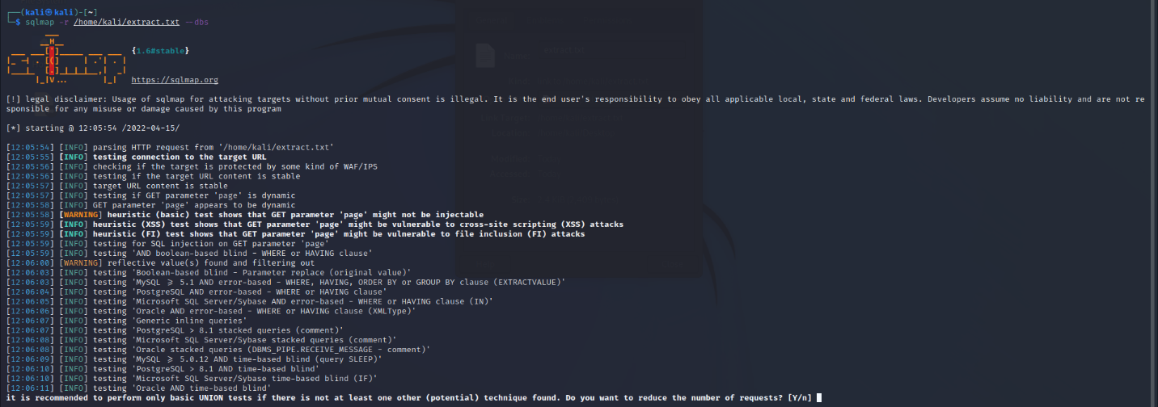

1. No Injectable parameters were found.

