|  |
| --- |
| The University of hull |
| LoRaWAN Public/Private Gateway |
| [Document subtitle] |

|  |
| --- |
| Ieaun Roberts  [Date] |

# Abstract

Original Project Description

“This project aims to produce a LoRaWAN gateway that is able to secure private data whilst still allowing the gateway to route public data to The Things Network.

Public users commonly utilise 'The Things Network' (TTN) to connect endpoints and gateways. The more of these that are available, the more useful and usable LoRaWAN is for all. However, private companies are often uncomfortable with their data being shared with third parties. This drives them to create their own LoRaWAN infrastructure and not connect their gateways to TTN.  
  
This project seeks to offer public connection to TTN but gateway-level private filtering for registered endpoints. Data from unregistered/unknown endpoints is still sent to TTN as usual. Private data is filtered out and not sent to the TTN servers - instead the data would be sent to privately owned servers for storage/use. This means that protected data is secured whilst ensuring that the gateway is still useful to the public.”

Contents

Abstract 1

Introduction 3

What is LoRa 3

What is LoRaWan 3

Aims and Objectives 4

Background 5

Hardware systems 6

LoRaWan gateways and end nodes 7

Small scale projects 7

Technical background 7

Development 8

Project management 8

Critical evaluation 9

Definition of done 9

Technical achievements 9

Problems faced; lessons learnt 9

Conclusion 10

Appendix 11

# Introduction

## What is LoRa

“LoRa (Long Range) is a low-power wide-area network protocol developed by Semtech. It is based on spread spectrum modulation techniques derived from [chirp spread spectrum](https://en.wikipedia.org/wiki/Chirp_spread_spectrum) (CSS) technology.

LoRa uses license-free sub-gigahertz [radio frequency](https://en.wikipedia.org/wiki/Radio_frequency) bands like 433 MHz, [868 MHz (Europe)](https://en.wikipedia.org/wiki/Short-range_device#SRD860), 915 MHz (Australia and North America) and 923 MHz ([Asia](https://en.wikipedia.org/wiki/Asia)). LoRa enables long-range transmissions (more than 10 km in rural areas) with low power consumption.

The technology covers the [physical layer](https://en.wikipedia.org/wiki/Physical_layer), while other technologies and protocols such as LoRaWAN (Long Range Wide Area Network) cover the upper layers.”

-Wikipedia (Wiki, 2020)

LoRa spread spectreum is a patented modulation technique developed by semtech based on spread spectrum modulation. LoRa provides long-range and low power consumtion, a low data rate and secure data transitions. LoRa can be used with public/private and hybrid networks to achieve a greater range thjan cellular networks

## What is LoRaWan

“Since LoRa defines the lower physical layer, the upper networking layers were lacking. LoRaWAN is one of several protocols that were developed to define the upper layers of the network. LoRaWAN is a cloud-based [medium access control](https://en.wikipedia.org/wiki/Medium_access_control) (MAC) layer protocol but acts mainly as a network layer protocol for managing communication between [LPWAN](https://en.wikipedia.org/wiki/LPWAN) [gateways](https://en.wikipedia.org/wiki/Gateway_(telecommunications)) and end-node devices as a routing protocol, maintained by the LoRa Alliance.

LoRaWAN defines the communication protocol and system architecture for the network, while the LoRa physical layer enables the long-range communication link. LoRaWAN is also responsible for managing the communication frequencies, [data rate](https://en.wikipedia.org/wiki/Data-rate_units), and power for all devices.

Devices in the network are asynchronous and transmit when they have data available to send. Data transmitted by an end-node device is received by multiple gateways, which forward the data packets to a centralized network server.[[11]](https://en.wikipedia.org/wiki/LoRa#cite_note-:0-11) The network server filters duplicate packets, performs security checks, and manages the network.

Data is then forwarded to application servers.[[12]](https://en.wikipedia.org/wiki/LoRa#cite_note-12) The technology shows high reliability for the moderate load, however, it has some performance issues related to sending acknowledgements.”

-Wikipedia (Wiki, 2020)

# Aims and Objectives

1. Initial system set up phase:
   1. Conduct extensive research into the topic
   2. Produce a LoraWan gateway that is capable of receiving communications from an end node.
   3. Add functionality:
      1. Enable it to forward packets received to:
         1. The TTN
         2. Private servers
      2. Differentiate between public and private packets.
      3. Option to encrypt packets.
   4. Produce a LoRaWan gateway that is able to secure private data whilst still allowing the gateway to route public data to the things network.
2. Exploration of use cases / experiments phase:
   1. Examine each of the outlined use cases and produce several experiment results on selected use cases.
      1. Outline short comings.
      2. Research possible improvements.
      3. Security concerns.
3. Further development phase:

# Background

#### LoRa Applications

Off grid mobile phone messaging (Skrypt, 2019)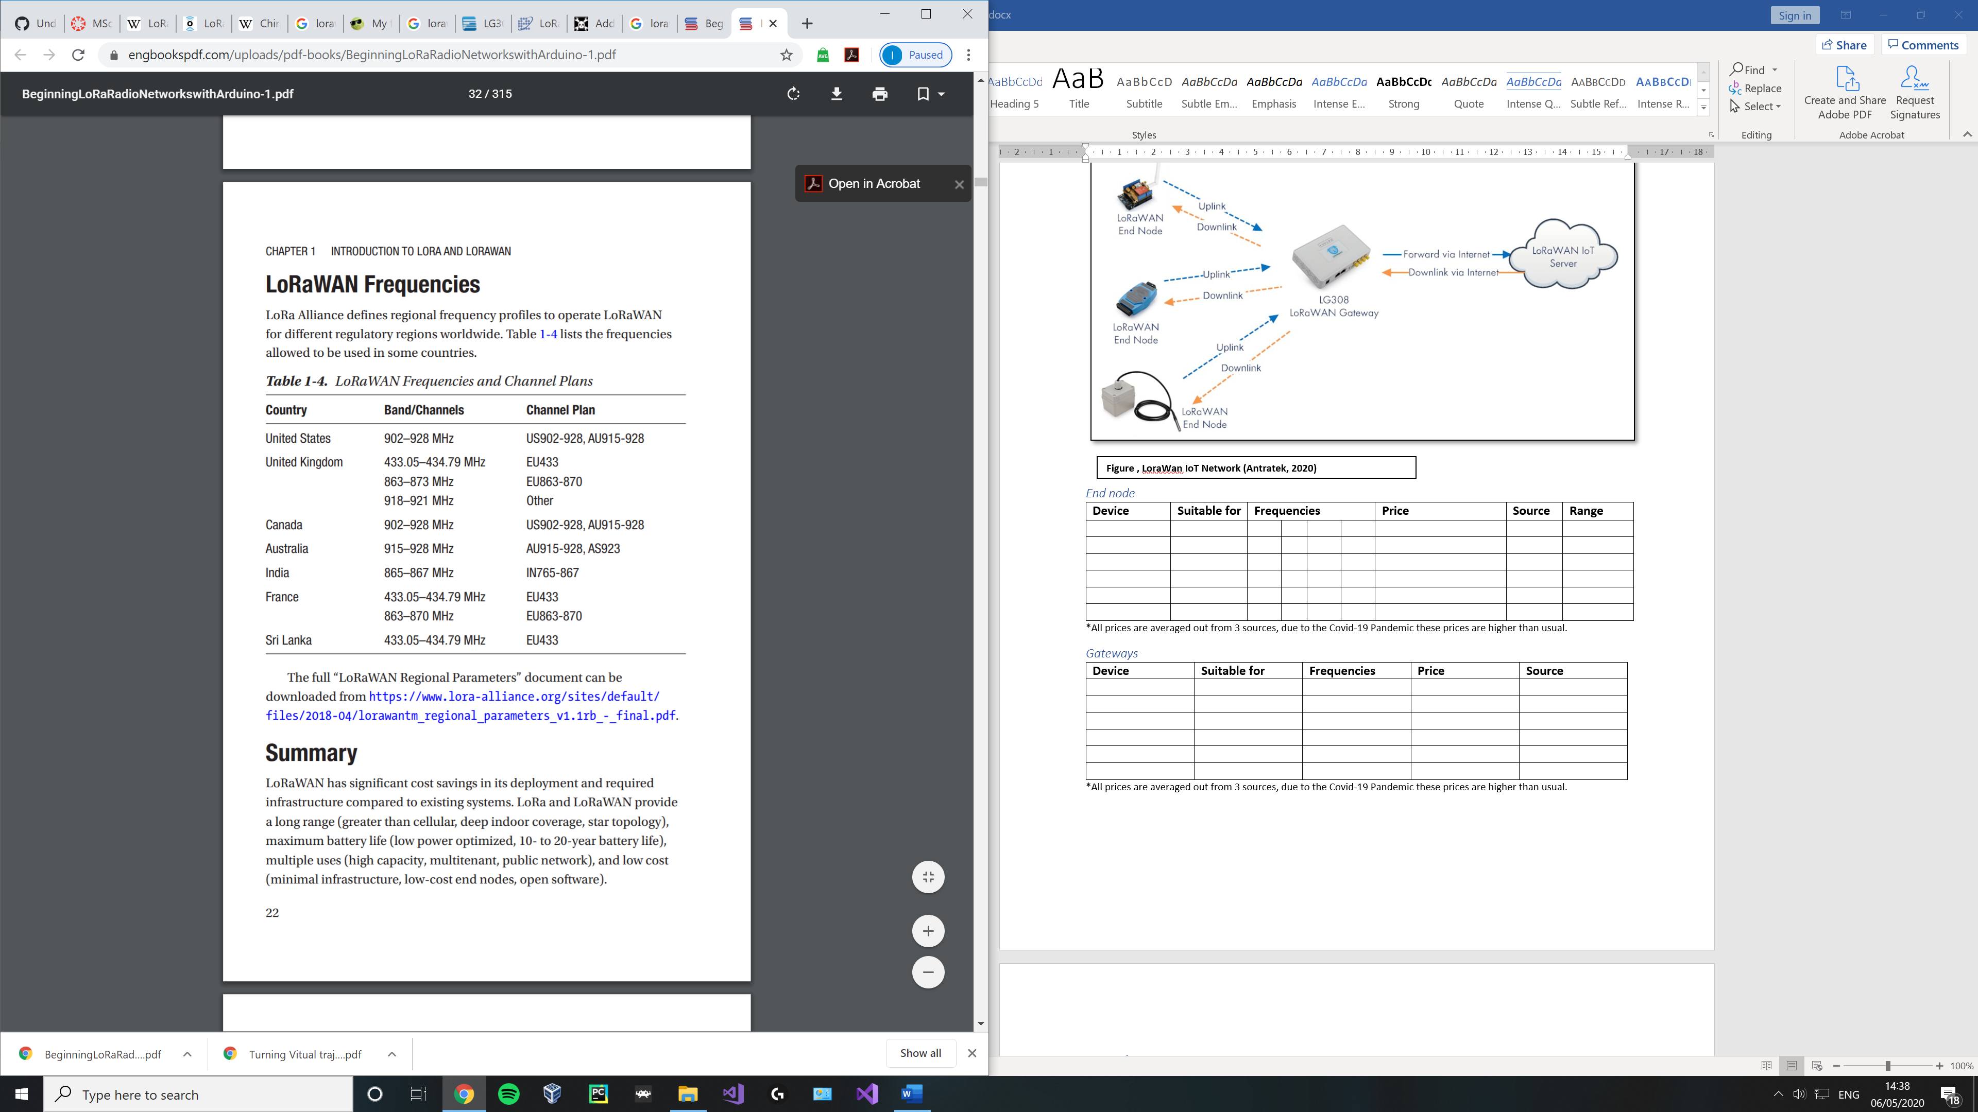

**Figure , LoraWan IoT Network** (Seneviratne, 2019)

## Hardware systems

**Figure , LoraWan IoT Network (Antratek, 2020)**

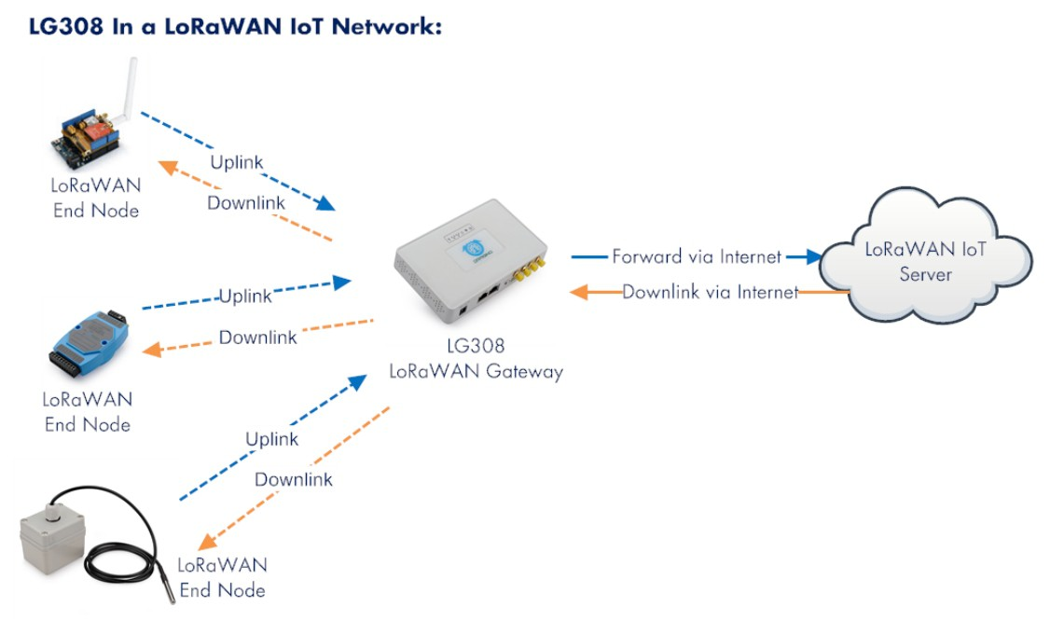

## LoRaWan gateways and end nodes

Due to the cost of particular devices, some may only be feasibility in certain use cases. In this section end nodes and gateways are split into 2 sub sections, being either for use in small scale projects (with a price cap of x amount **overall\***) or industry use (with no price cap).

*This includes the price of the microcontroller / board needed to use the device

#### Chipsets

|  |  |  |  |  |
| --- | --- | --- | --- | --- |
| **Manufacturer** | **Chipset** | **Sensitivity (dBm)** | **Interface** | **Type** |
| Microchip | RN2483 | -139 / +20 | UART | Transceiver |
| Semtech | SX1276/77/78/79 | -148 / +168 | FSK, GFSK, MSK, GMSK, LoRa and OOK | Transceiver |
|  |  |  |  |  |
|  |  |  |  |  |

## Small scale projects

#### End node

|  |  |  |  |
| --- | --- | --- | --- |
| **Device** | **Chipset** | **Notes** | **Price** |
| Dorji (DRF1276DM) | SX1276 |  | £9.10 |
| DM164138 | RN2483 | All in one device with built in sensors / LCD. | £56.14 |
|  |  |  |  |
|  |  |  |  |
|  |  |  |  |

*All prices are averaged out from 3 sources, due to the Covid-19 Pandemic these prices are higher than usual.

#### Gateways

|  |  |  |  |  |
| --- | --- | --- | --- | --- |
| **Device** | **Suitable for** | **Frequencies** | **Price** | **Source** |
|  |  |  |  |  |
|  |  |  |  |  |
|  |  |  |  |  |
|  |  |  |  |  |
|  |  |  |  |  |
|  |  |  |  |  |

*All prices are averaged out from 3 sources, due to the Covid-19 Pandemic these prices are higher than usual.

#### Transceivers

|  |  |  |  |
| --- | --- | --- | --- |
| **Device** | **Chipset** | **Notes** | **Price** |
| Dragino LoRa Shield | SX1276 / SX1278 (RFM95W) |  | £20.27 |
| LORA CLICK | RN2483 | Can swap between 433/868 frequencies |  |
|  |  |  |  |
|  |  |  |  |
|  |  |  |  |

*All prices are averaged out from 3 sources, due to the Covid-19 Pandemic these prices are higher than usual.

## Technical background

Chirp spread spectrum

# Development

## Project management

# Critical evaluation

## Definition of done

## Technical achievements

## Problems faced; lessons learnt

# Conclusion

# Appendix

