Functional Design Specification
English Learning and IELTS Preparation Support System Based on Personalized Learning Pathways for IELTS Space
- Report 3.2 -

Document Title | English Learning and IELTS Preparation Support System Based on Personalized Learning Pathways for IELTS Space (IELTSPath)
Version | v0.7
Date | 12/10/2026
Status | In Review
Author(s) | SonLH
Reviewer(s) | LinhNDM
SRS Reference | IELTSPath SRS v1.0.1 (09/10/2026) — Report 3.0_SRS_IELTSPath_IeltsPath_v1.docx
Backend Reference | IELTSPath backend, branch main, commit eedc6cd (package com.ieltspath)
Frontend Reference | IeltsPath Platform Frontend (React 19 + Vite 8), branch main, commit 6525a6d
TDS Reference | IELTSPath TDS v1.0.0 (In Review) — Report 4_TDS_IELTSPath_IeltsPath_v1.docx
RTW Reference | IELTSPath_RTW v1.0.1 (09/10/2026) — Report 3.1_RTW_IELTSPath_v1.xlsx — Sheet 2 Use Case List (UC ids), Sheet 4 Permission Matrix (role policy), Sheet 6 Business Rules (BR ids). The RTW has no screen or API sheet: Section 1.1 Screen Index, Appendix A and Appendix D hold those lists.

Version History
Version | Date | Author | Description
v0.1 | 05/10/2026 | SonLH | Initial draft from SRS v0.9.6: Part 1 screen navigation flow, screen index and job schedule; Part 2 common conventions and 43 screen specifications covering FT-01 to FT-54; Part 3 background jobs JOB-01 to JOB-07; Appendix A API catalog; Appendix B open questions.
v0.2 | 05/10/2026 | SonLH | Aligned with the frontend (IeltsPath Platform Frontend (React 19 + Vite 8), branch feat/ui-learning, commit bdac878): real routes, guards, Vietnamese UI copy, API calls and error handling for the built screens; added Home, OAuth Callback, Overview, Practice Test Catalog, Practice Workspaces, Classroom and Classroom Lesson Workspace; every screen states its frontend status; screenshots embedded where the screen exists; Appendix C lists frontend–SRS gaps.
v0.3 | 06/10/2026 | SonLH | Cross-checked with IELTSPath_TDS v0.9.16 (Draft) — Report 4_TDS_IELTSPath_IeltsPath_v1.docx: TDS reference filled; backend session, error body, paging and correlation conventions added to Section 2.0; Appendix A marks the endpoints detailed in TDS 2.4, uses the admin vocabulary write paths and flags the internal access endpoints; JOB-01 payload uses the wire field names of the event contract; Lesson Player and Test Attempt cover PAYMENT_UNAVAILABLE, stale revision and ATTEMPT_EXPIRED; new open questions OQ-18 – OQ-20 and frontend gap FG-13.
v0.4 | 07/10/2026 | SonLH | Traced to IELTSPath_RTW v1.0.1 (09/10/2026) — Report 3.1_RTW_IELTSPath_v1.xlsx: every screen names its use cases by RTW id; use cases missing from screens were added (UC-009 Send reset link, UC-043 Grade essay, UC-061 Submit Speaking recording, UC-063–UC-064 Request AI grading, UC-080 Request examiner grading); Plans & Key Products cites BR-08 for key product limits instead of BR-31; Test Result cites BR-31; Section 2.0 points to the RTW Permission Matrix for role policy; new Appendix D maps each use case and business rule to its screens and jobs. Full review against the backend controllers: six endpoints missing from Appendix A were added (admin delete learner profile, get and delete one video progress, get one flashcard, get one deck, expire an attempt) and the /api/content/admin path aliases are explained; User Detail can delete a learner profile; Media Assets also traces UC-162–UC-185, UC-187–UC-192; Login cites FG-11; each screen and job lists the open questions that affect it, and OQ-20 names the right screens. Aligned with SRS v0.9.15 (Part 6 NFRs): SRS reference updated; Login and Forgot Password add the sign-in and reset rate limits (NFR-SEC11) and the same-response rule for unknown emails (NFR-SEC12); Register and Reset Password cite the 72-byte password limit (NFR-SEC04); Lesson Player cites the 45-second grading limit (NFR-P03); Test Result and JOB-01 cite the 5-second result delivery (NFR-P05) and new frontend gap FG-14; Section 2.0 and Appendix A cite NFR-P04, NFR-U01 and NFR-U02.
v0.5 | 09/10/2026 | SonLH | Aligned with SRS v1.0.1, the backend at bf7db56 and the frontend at bdac878 (feat/ui-learning): new screens Course List, Placement Test and Placement Report; Learning Path becomes Course Path (/learn/courses/:courseId) with the course final test; Topic Detail, Lesson Player, Practice Set, Review Session, Test Attempt, Test Result, Overview and Mock Tests follow the new frontend; staff screens add courses, PLACEMENT questions, COURSE_TEST packages and essays handed to examiners; twelve new endpoints in Appendix A; use cases UC-035 to UC-162–UC-164 and rules BR-35 to BR-41 from the SRS; JOB-03 is now the running test essay grading worker and JOB-02 handles COURSE_GATE and PLACEMENT; resolved open questions marked, OQ-21 and OQ-22 added; new frontend gaps FG-15 to FG-19; Part 1 figures redrawn in draw.io; screenshots retaken from the running application.
v0.6 | 09/10/2026 | SonLH | Aligned with SRS v1.0.1, RTW v1.0.1 and V&S v1.1.0: use cases cited by RTW Sheet 2 ids; BR-40 (every ACTIVE course open) and OQ-18, OQ-21, OQ-22 resolved; prototype and marketing screens marked outside the scope (OQ-17, FG-20); frontend gaps renamed FG-xx; Report 3.2 numbering.
v0.7 | 12/10/2026 | SonLH | Aligned with the frontend at 6525a6d (main) and the backend at eedc6cd (no code change since bf7db56; the capstone documents moved to the docs repository): Overview follows the refreshed dashboard — Dashboard hover menu, hero with the current course and IELTS Journey, five study stats, the activity calendar with day and week selection, My Learning Orbit, Study Plan, SPACE Autonomy, AI suggestions and the Dữ liệu chi tiết tab; Placement Test waits for GET placement-result instead of the course list, so FG-17 is resolved; every Part 2 UI figure is now exported from the draw.io wireframes in docs/wireframes/screens (one file per P-ID, shared with the Screen Design Spec; clickable prototype docs/wireframes/IELTSPath_Prototype.drawio) in place of the application screenshots, with new drawings for Overview (P-11), Writing Feedback (P-32), Classroom (P-20, P-20a), Classroom Lesson Workspace (P-21) and Vocabulary (P-50) and figures added to every built screen; design-target wireframes added for Mock Tests (P-46 catalog, P-47 computer-based runner), Speaking Practice (P-45), the 3-column Writing Practice (P-44), Profile & Account and Subscription & Points (P-80); Submission History (P-54) is specified in Section 2.54. The Dashboard menu replaces its left sidebar; personal information is reached through Thông tin cá nhân in the user menu. The account tab is named Lịch sử kích hoạt gói and the dictionary remains Tra Anh-Việt.

PART 1 – OVERVIEW

1.1 Screen Navigation Flow
The web client is the IELTS Space frontend (IeltsPath Platform Frontend (React 19 + Vite 8), branch main, commit 6525a6d), a React single-page app in front of the API Gateway (VITE_API_BASE_URL, default http://localhost:8080). Its UI language is Vietnamese. "/" opens /overview for a signed-in user and /home otherwise. Public routes are /home, /vocabulary, /login, /register, /forgot-password, /reset-password and /auth/oauth/callback; every other route is wrapped in RequireAuth.
The top bar (SiteNavbar) has two rows: the brand logo and account area, then the menu. Guests see Trang chủ, Khóa học (sub-menu Test đầu vào 4 kỹ năng FREE · Khóa học), Luyện tập 4 kỹ năng (Listening · Reading · Writing · Speaking, each /practice-tests?skill=…), Bài mẫu Writing 8.0+ and Kết quả học viên. Signed in, Trang chủ opens a sub-menu Dashboard (/overview) · Lịch sử nộp bài · Khóa học của tôi (/learn), Sổ từ vựng (Flashcard của tôi · Kho từ vựng · Bài mẫu 8đ) is added, and the user dropdown shows the point balance and Đăng xuất. After sign-in the app returns to the route the user came from, otherwise to /learn; it does not route by role yet (FG-02).
Learners move along the course loop /learn (course list) → /learn/courses/:courseId (the topic path of one course, ending with the course final test) → /learn/topics/:topicId → /learn/lessons/:lessonId → /learn/lessons/:lessonId/practice → /learn/reviews/:reviewId → /learn/tests/:attemptId (topic or course final test) → /learn/tests/:attemptId/result. The optional placement test at /learn/placement runs a survey, a four-skill test and a report that recommends a course. These screens call the real backend. Overview, Classroom (no longer in the menu), Luyện đề and Từ điển are built on mock data. /practice, /submission-history, /flashcards, /writing-samples, /student-results, /classes/:classCode/join, /mentors/:mentorSlug, /terms, /privacy and /copyright show a placeholder page (RouteStatusPage); unknown routes show NotFoundPage.
Screens marked "FE: not built" in the index — the account, library, games, community, notification and every staff screen — are specified here as the design target. Figure 1.1 shows the navigation in five areas: the public screens, then the top menu with one arrow into each signed-in area — courses, dashboard & practice, account & self-study — and the staff screens opened by role. It draws only the main paths; the build status of each screen is in the Screen Index, and placeholder routes are not drawn.
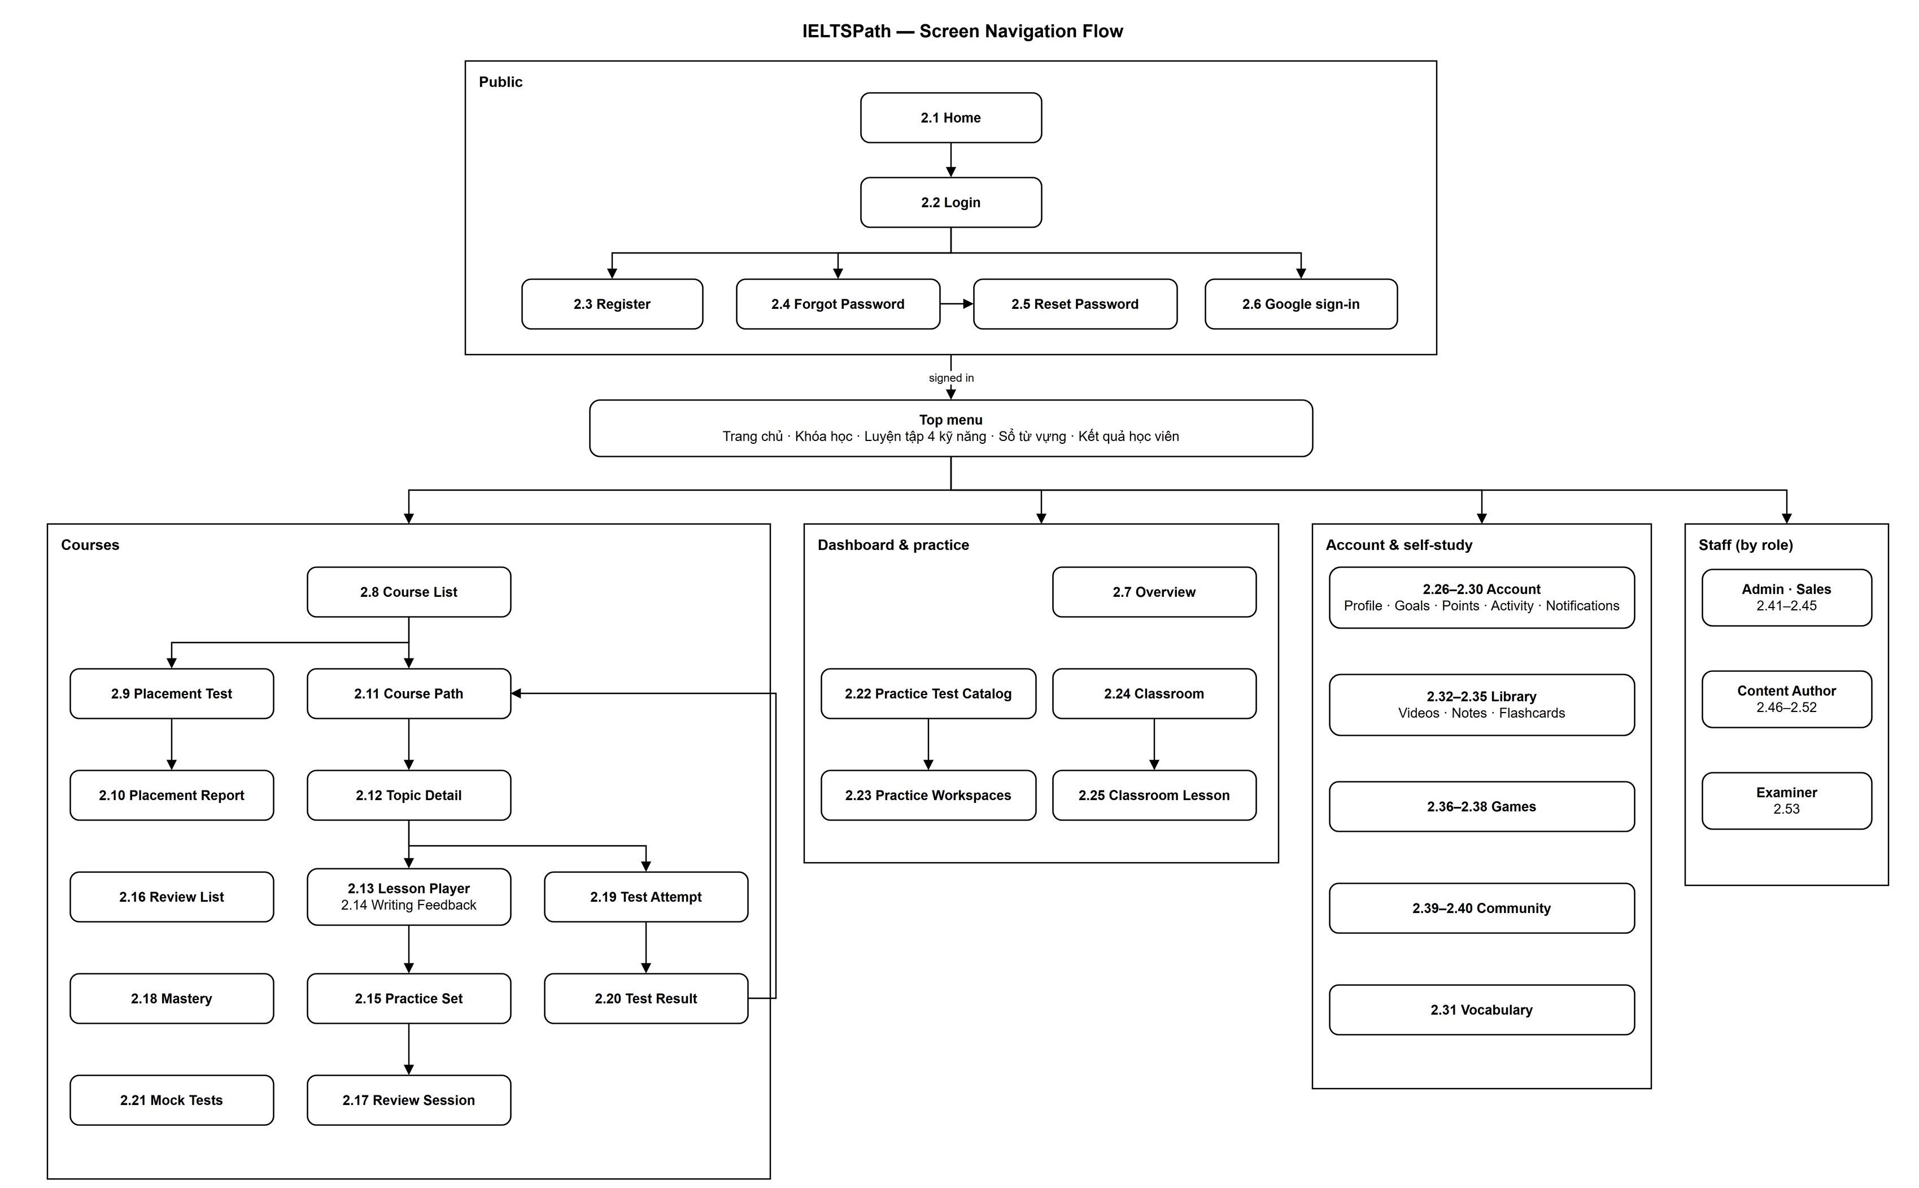
Figure 1.1 — Screen Navigation Flow, read top to bottom: public screens → top menu → courses, dashboard & practice, account & self-study, and staff screens by role. Source: part1-diagrams/IELTSPath_ScreenNavigationFlow.drawio

Screen Index
Section | Screen | Route | Role(s) | Status
2.1 | Home | /home · Public page (default route for guests) | Guest and any signed-in user | Specified (key activation not wired in the frontend: FG-03)  FE: partly built
2.2 | Login | /login · Public page (GuestOnly) | Guest | Specified (OAuth button: Draft; role-based home: FG-02)  FE: built, real API
2.3 | Register | /register · Public page (GuestOnly) | Guest | Specified  FE: built, real API
2.4 | Forgot Password | /forgot-password · Public page (GuestOnly) | Guest | Specified (email delivery: Draft, FG-06)  FE: built, real API
2.5 | Reset Password | /reset-password?token=… · Public page (GuestOnly) | Guest | Specified (link delivery: Draft, FG-06)  FE: built, real API
2.6 | OAuth Callback | /auth/oauth/callback · Public page (GuestOnly) | Guest | Draft  FE: placeholder route
2.7 | Overview | /overview · RequireAuth (default route when signed in) | Any signed-in user | Draft (UI on mock data, OQ-17)  FE: built on mock data
2.8 | Course List | /learn · RequireAuth (index of the learning area) | Signed-in learner | Specified (placement card link: FG-15)  FE: built, real API
2.9 | Placement Test | /learn/placement · RequireAuth (survey, test and grading steps) | Signed-in learner | Specified (Speaking recordings not uploaded: FG-19)  FE: built, real API
2.10 | Placement Report | /learn/placement · result step | Signed-in learner | Specified  FE: built, real API
2.11 | Course Path | /learn/courses/:courseId · RequireAuth | Signed-in learner | Specified (course test error codes: FG-16; Premium lock: Draft)  FE: built, real API
2.12 | Topic Detail | /learn/topics/:topicId · RequireAuth | Signed-in learner | Specified  FE: built, real API
2.13 | Lesson Player | /learn/lessons/:lessonId · RequireAuth | Signed-in learner | Specified  FE: built, real API
2.14 | Writing Feedback | Inline panel in /learn/lessons/:lessonId (EssayBlock) | Signed-in learner | Specified (separate page and re-reading a submission: FG-08)  FE: partly built
2.15 | Practice Set | /learn/lessons/:lessonId/practice · RequireAuth | Signed-in learner | Specified (Premium sets disabled: FG-05; Writing questions not answerable: FG-18)  FE: built, real API
2.16 | Review List | /learn/reviews (proposed) | CUSTOMER | Specified (backend); screen not built (FG-07)  FE: not built
2.17 | Review Session | /learn/reviews/:reviewId · RequireAuth | Signed-in learner | Specified (empty quick-check: FG-12)  FE: built, real API
2.18 | Mastery | /learn/mastery (proposed) | CUSTOMER | Specified (backend); screen not built (FG-07)  FE: not built
2.19 | Test Attempt | /learn/tests/:attemptId?topic=… | ?course=… · RequireAuth | Signed-in learner | Specified (no timer: FG-09)  FE: built, real API
2.20 | Test Result | /learn/tests/:attemptId/result?topic=… | ?course=… · RequireAuth | Signed-in learner | Specified (examiner and AI grading requests: Draft)  FE: built, real API
2.21 | Mock Tests | /tests (proposed) | CUSTOMER | Draft  FE: not built
2.22 | Practice Test Catalog | /practice-tests?skill=listening|reading|writing|speaking · RequireAuth | Any signed-in user | Prototype outside the SRS scope (V&S LI-02, LI-05; OQ-17) / FE: built on mock data
2.23 | Practice Workspaces (Reading, Listening, Writing, Speaking) | /practice/test/:testId · /practice/listening/:testId · /practice/writing/:taskId · /practice/speaking/:cueId · RequireAuth | Any signed-in user | Prototype outside the SRS scope (V&S LI-02, LI-05; OQ-17) / FE: built on mock data
2.24 | Classroom | /classroom · RequireAuth | Any signed-in user | Prototype outside the SRS scope (V&S LI-02, LI-05; OQ-17) / FE: built on mock data
2.25 | Classroom Lesson Workspace | /lessons/:lessonId · RequireAuth | Any signed-in user | Prototype outside the SRS scope (V&S LI-02, LI-05; OQ-17) / FE: built on mock data
2.26 | Profile & Account | /account/profile | Any signed-in role | Specified (OAuth linking: Draft)  FE: not built
2.27 | Learning Goals | /account/goals | CUSTOMER | Specified (edit of the active goal: Draft; the placement survey also saves a goal)  FE: not built
2.28 | Subscription & Points | /account/subscription | CUSTOMER | Specified  FE: partly built
2.29 | Activity & Streak | /account/activity | Any signed-in role | Specified (server-side streak: Draft)  FE: not built
2.30 | Notification Centre | /notifications | CUSTOMER | Draft  FE: not built
2.31 | Vocabulary | /vocabulary · Public page | Guest and any signed-in user | Specified (backend); frontend on mock data (FG-10)  FE: built on mock data
2.32 | Video Library | /library/videos | CUSTOMER, EXAMINER, CONTENT_AUTHOR, ADMIN | Specified  FE: not built
2.33 | Video Player | /library/videos/:videoId | CUSTOMER | Specified (shadowing / dictation scoring: Draft)  FE: not built
2.34 | My Notes | /library/notes | Any signed-in role | Specified  FE: not built
2.35 | Flashcards & Decks | /library/flashcards | Any signed-in role | Specified  FE: not built
2.36 | Game Lobby | /games | Any signed-in role | Specified (matchmaking: Draft)  FE: not built
2.37 | Single-player Game | /games/sessions/:sessionId | Any signed-in role | Specified  FE: not built
2.38 | Game Room | /games/rooms/:roomId | Any signed-in role | Specified  FE: not built
2.39 | Community Feed | /community | Any signed-in role | Specified  FE: not built
2.40 | Post Detail | /community/posts/:postId | Any signed-in role | Specified  FE: not built
2.41 | User Management | /admin/users · ADMIN home | ADMIN | Specified (paging and search: Draft)  FE: not built
2.42 | User Detail | /admin/users/:userId | ADMIN | Specified  FE: not built
2.43 | Plans & Key Products | /admin/access/plans | ADMIN | Specified  FE: not built
2.44 | Activation Keys | /admin/access/keys · SALES_STAFF home | ADMIN, SALES_STAFF | Specified for ADMIN (SALES_STAFF access and key list: Draft)  FE: not built
2.45 | Points & Subscriptions | /admin/access/accounts | ADMIN | Specified  FE: not built
2.46 | Courses & Topics | /author/topics · CONTENT_AUTHOR home | ADMIN, CONTENT_AUTHOR | Specified  FE: not built
2.47 | Question Bank | /author/questions | ADMIN, CONTENT_AUTHOR | Specified  FE: not built
2.48 | Packages | /author/packages | ADMIN, CONTENT_AUTHOR | Specified (TOPIC_TEST and COURSE_TEST are created by seed only)  FE: not built
2.49 | Media Assets | /author/assets | ADMIN, CONTENT_AUTHOR | Specified (upload: Draft)  FE: not built
2.50 | Lesson Builder | /author/lessons/:lessonId | ADMIN, CONTENT_AUTHOR | Draft  FE: not built
2.51 | Vocabulary Management | /author/vocabulary | ADMIN, CONTENT_AUTHOR | Specified  FE: not built
2.52 | Video Management | /author/videos | ADMIN, CONTENT_AUTHOR | Specified  FE: not built
2.53 | Grading Workspace | /examiner/grading · EXAMINER home | ADMIN, EXAMINER | Specified (work queue and response view: Draft)  FE: not built
2.54 | Submission History | /submission-history · RequireAuth · P-54 | Signed-in learner | Design target (history list APIs not implemented)  FE: placeholder route

1.2 Job Schedule & Dependencies
Three jobs run in the current release: JOB-01 relays assessment outbox rows to RabbitMQ every 2 seconds, JOB-02 consumes AssessmentCompleted.v2 in the learning service, with a 30-second retry queue and a dead-letter queue, and JOB-03 grades the essays of topic, course and placement tests with the LLM every 5 seconds. JOB-04 to JOB-07 are required by Draft features (notifications, matchmaking) and are specified here so the TDS can design them; AI grading that a learner requests for other attempts (FT-33) still has no worker.
No other service runs a scheduler. access-service (PointCredited, PointDebited, SubscriptionGranted, SubscriptionChanged) and game-service (GameRoomCreated, GameMatchCompleted) write outbox rows but have no relay, so those events reach no consumer (TDS 2.5); this is a known gap, not a job.
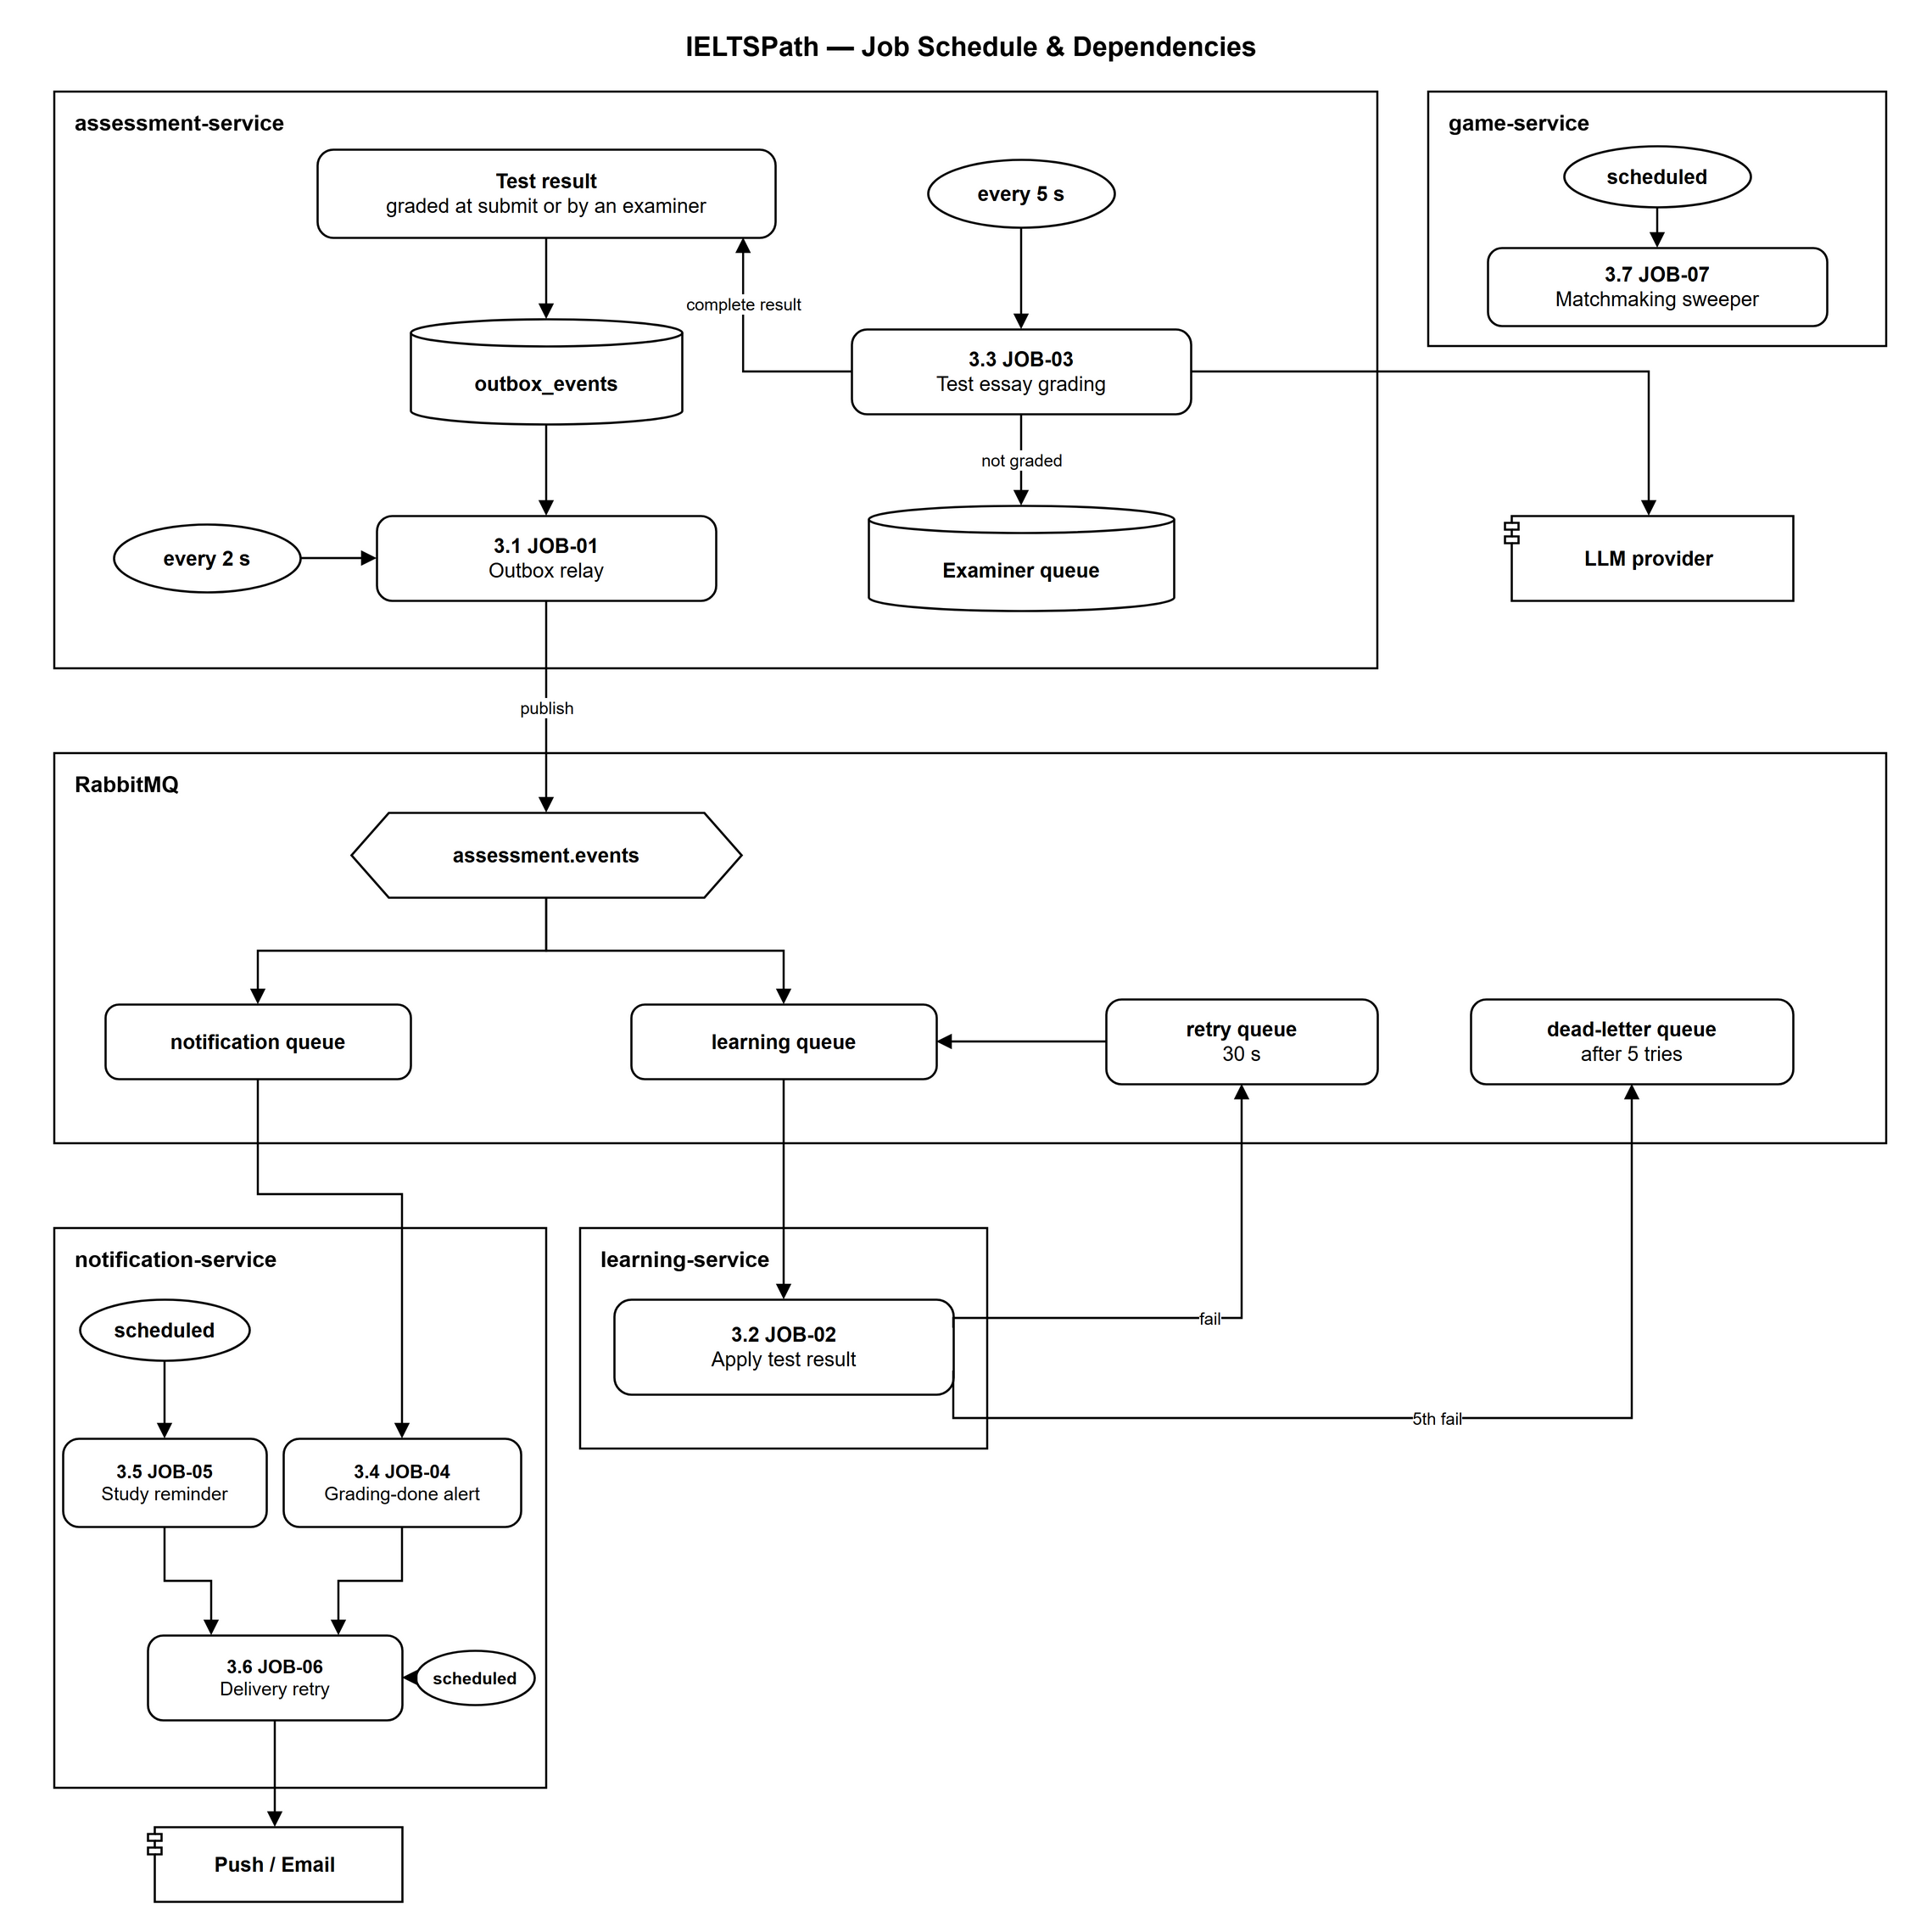
Figure 1.2 — Job Schedule & Dependencies: the triggers, services, queues and external systems of JOB-01 (outbox relay), JOB-02 (applies test results, with retry and dead-letter queues), JOB-03 (test essay grading with the LLM, hand-over to the examiner queue) and JOB-04 to JOB-07 (notifications and matchmaking). Source: part1-diagrams/IELTSPath_JobSchedule.drawio
┌──────────────────────────────────────────────────────────────────────────┐
│ JOB-01 Assessment outbox relay ←── every 2 s (fixed delay) │
│ JOB-02 AssessmentCompleted consumer ←── RabbitMQ event (retry 30 s) │
│ JOB-03 Test essay grading worker ←── every 5 s (fixed delay) │
│ JOB-04 Grading-done alert dispatcher ←── RabbitMQ event [Draft] │
│ JOB-05 Study reminder scheduler ←── every [TBC] min [Draft] │
│ JOB-06 Notification delivery retry ←── every [TBC] s [Draft] │
│ JOB-07 Matchmaking queue sweeper ←── every [TBC] s [Draft] │
└──────────────────────────────────────────────────────────────────────────┘
Dependencies: JOB-03 → result complete → outbox → JOB-01 → (assessment.events / assessment.completed.v2)
→ JOB-02, JOB-04; JOB-04, JOB-05 → JOB-06 → FCM / Email.

PART 2 – SCREEN SPECIFICATIONS
One section per screen, in the order of the Screen Index (Section 1.1). Component codes follow [ScreenKey]-[TYPE]-[NN]; types are TXT (text input), TXA (text area), NUM (number), DAT (date), SEL (select), CHK (checkbox / toggle), RAD (radio group), BTN (button), LNK (link), TBL (table / list), CRD (card), BDG (badge), TAB (tab bar), MDL (modal / dialog), PNL (panel), AUD (audio player), VID (video player), PRG (progress indicator).
Every General Information table has a Frontend row. For a built screen it names the React page, and the route, components, UI copy, API calls and messages describe what the code does today; UI copy is the exact Vietnamese text of the app. For a screen that is not built, the section is the design target and its UI copy is an English proposal to be translated when the screen is built. API ids refer to Appendix A; gaps between the frontend and the SRS are listed in Appendix C.

2.0 Common Screen Conventions
Session (src/lib/httpClient.ts, features/auth/authSession.ts): the access token is kept in memory only; the refresh token stays in the HttpOnly cookie set by the backend, and every request is sent with credentials. On start-up AuthProvider calls auth.refresh with an empty body and then user.me while showing "Đang khôi phục phiên đăng nhập…". On an HTTP 401 the client refreshes once (single-flight: parallel requests share one refresh) and repeats the request; if the refresh fails the session is cleared and RequireAuth sends the user to /login, keeping the original route in router state (GG-01).
Requests time out after 30 s (60 s for Writing grading). Buttons that submit are disabled and show a spinner while the request runs, and an in-flight guard stops double clicks. Exercise, practice, review and Writing submissions send a new requestId (UUID) per submission (lib/requestId.ts); key activation keeps the same idempotencyKey while the same key is retried (BR-30).
Feedback is shown inline (role=status / role=alert text next to the action), not as toasts. Learning pages use shared states from components/PageState.tsx: a loading line, an error panel with "Thử lại", a not-found panel and lock redirects (GLB table). A pending review is shown on every /learn page by ReviewGateBanner.
Backend contract the screens rely on (TDS 2.2 and 2.4): the access token lives 1 hour and the refresh token 7 days; a refresh consumes the refresh token and returns a new pair (BR-04), and an access token stays valid until it expires because there is no blacklist. Sign-in and refresh also set HttpOnly cookies access_token (path /) and refresh_token (path /auth), SameSite=Lax, but the Gateway reads the access token only from the Authorization: Bearer header, which is why the client keeps it in memory and sends it on every call. The Gateway adds X-Correlation-Id when the client sends none and returns it in the response; support asks the user for it when a request fails. Lists are paged with ?page=0&size=20 (size 1–100) or ?limit=20 (NFR-P04); times are ISO 8601 and are shown in the browser's local time.
Roles: the Role(s) row of each screen and the role column of Appendix A follow the RTW Permission Matrix (IELTSPath_RTW v1.0.1 (09/10/2026) — Report 3.1_RTW_IELTSPath_v1.xlsx, Sheet 4), which states the required policy per role and notes where the current release differs. Learner self-service endpoints check only sign-in and ownership today, so any signed-in role can use them on its own data; those screens say "Any signed-in role".
Scope: this FDS covers the web client only; a mobile app is out of scope (V&S LI-09).

Global Messages
Code | Type | Trigger condition | Content (UI copy) | Action / Duration
GLB-01 | Redirect | Session expired and the silent refresh failed (401), or no session on a protected route | Login page; httpClient error "Phiên đăng nhập đã hết hạn, vui lòng đăng nhập lại." | Immediate; original route kept in router state
GLB-02 | Inline Error | HTTP 403 without a specific code | Server message; Home access calls use "Tài khoản của bạn chưa được phép thực hiện thao tác này." | Until the next action
GLB-03 | Not Found Panel | HTTP 404 / NOT_FOUND for the main resource, or an unknown /learn route | Title "Không tìm thấy trang" · "Nội dung này không tồn tại hoặc đã bị gỡ." · Button "Về lộ trình" | Persistent
GLB-04 | Error Panel | HTTP 500 / 502 on page load | Title "Chưa tải được nội dung" · "Máy chủ đang gặp sự cố hoặc mất kết nối. Hãy thử lại." · Button "Thử lại" | Persistent; Thử lại reloads
GLB-05 | Error Panel | HTTP 503 (a dependent service is unavailable) | Same panel as GLB-04 | Persistent; Thử lại reloads
GLB-06 | Inline Error | HTTP 400 with field errors | Field message from the server (details), else the screen's own message | Below the form, role=alert
GLB-07 | Confirm Modal | Leaving a screen with unsaved edits | Design target, not built: Title "Bỏ thay đổi?" · Body "Các thay đổi chưa được lưu." | Buttons "Bỏ thay đổi" (Danger) + "Tiếp tục sửa"
GLB-08 | Inline Error | Network error or timeout (status 0) | "Không kết nối được máy chủ. Kiểm tra mạng hoặc địa chỉ API." (fallback "Có lỗi xảy ra, vui lòng thử lại.") | Until the next action
GLB-09 | Redirect + Notice | 403 TOPIC_LOCKED / LESSON_LOCKED / TEST_LOCKED when a learning page loads | → /learn "Topic đó chưa mở. Hãy hoàn thành chặng trước." · → topic "Bài học đó chưa mở. Hãy học theo thứ tự." · → topic "Bài kiểm tra chưa mở. Hoàn thành mọi bài học trước." | Notice banner on the target page
GLB-10 | Review Panel / Banner | 403 REVIEW_REQUIRED on load, or pending reviews exist | Panel "Cần ôn lại trước khi học tiếp" · "Hoàn thành bài ôn "{KP}" để mở nội dung này." · Banner "Bạn còn {n} bài ôn bắt buộc. Bắt đầu với "{KP}" để mở bài kế tiếp." · Button "Làm bài ôn" | Persistent until the review ends

Global Guard Redirects
# | Condition check | If met | If not met → Action
GG-01 | Route is wrapped in RequireAuth and no session exists | Continue rendering | Redirect → /login (state.from = current location); after sign-in return to it
GG-02 | Route requires a staff role | Continue rendering | Design target: redirect → 403 page. Not built: the frontend has no role-based routes yet (Appendix C)
GG-03 | Signed-in user opens /login, /register, /forgot-password, /reset-password or /auth/oauth/callback (GuestOnly) | Continue rendering (guest) | Redirect → /learn

2.1 Home

2.1.1 General Information
Screen Name | Home
Purpose | Introduces IELTS Space, shows the FREE / Premium plans and point cards, and lets a signed-in learner redeem an activation key for Premium days or points.
Route / Type | /home · Public page (default route for guests)
Role(s) | Guest and any signed-in user
Related FT / UC | FT-10, FT-11, FT-12  UC-088 Activate key; UC-084–UC-085 View subscription
Status | Specified (key activation not wired in the frontend: FG-03)
Frontend | Partly built — features/home/HomePage.tsx with PricingCards and KeyActivationDialog. Landing sections use static content; the pricing area calls access-service only when an access client is passed in, which the route does not do yet (FG-03).
Mockup / Wireframe | Figure 2.1-1 to 2.1-3 below — draw.io wireframes in docs/wireframes/screens (P-10_Home.drawio, P-10c_KeyActivation.drawio), one tab per state; clickable prototype: docs/wireframes/IELTSPath_Prototype.drawio

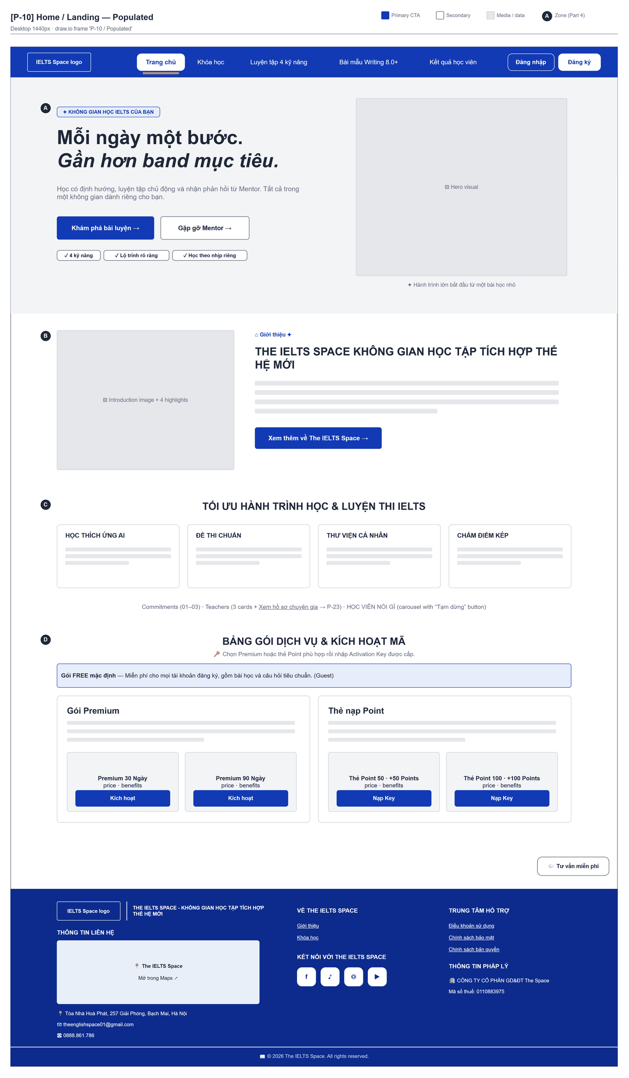
Figure 2.1-1 — Home — Populated. Source: wireframes/screens/P-10_Home.drawio, tab “P-10 / Populated”
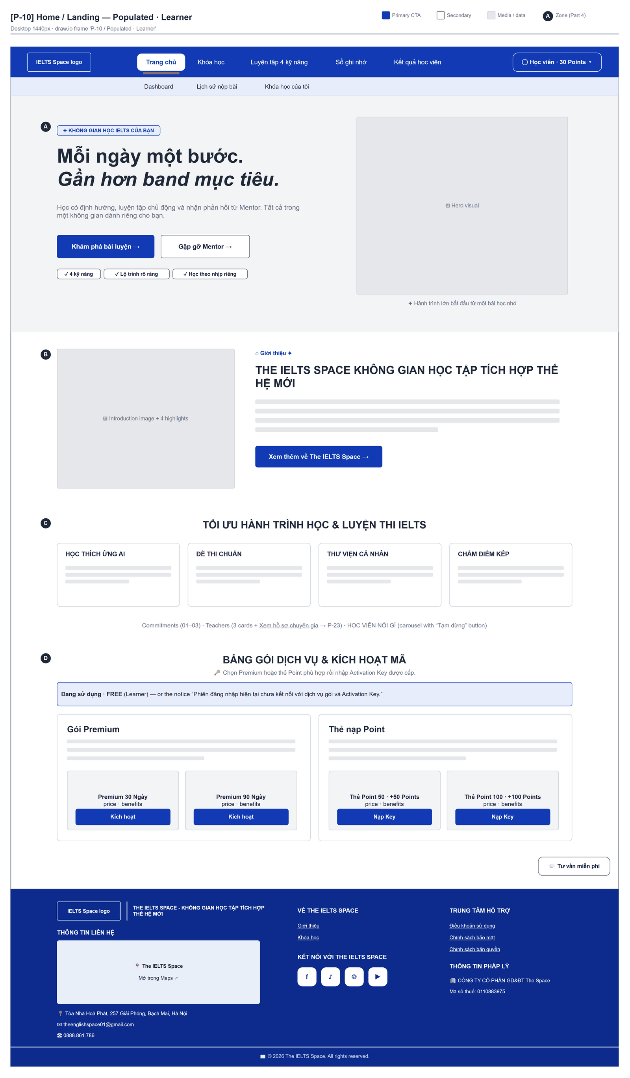
Figure 2.1-2 — Home — Populated · Learner. Source: wireframes/screens/P-10_Home.drawio, tab “P-10 / Populated · Learner”
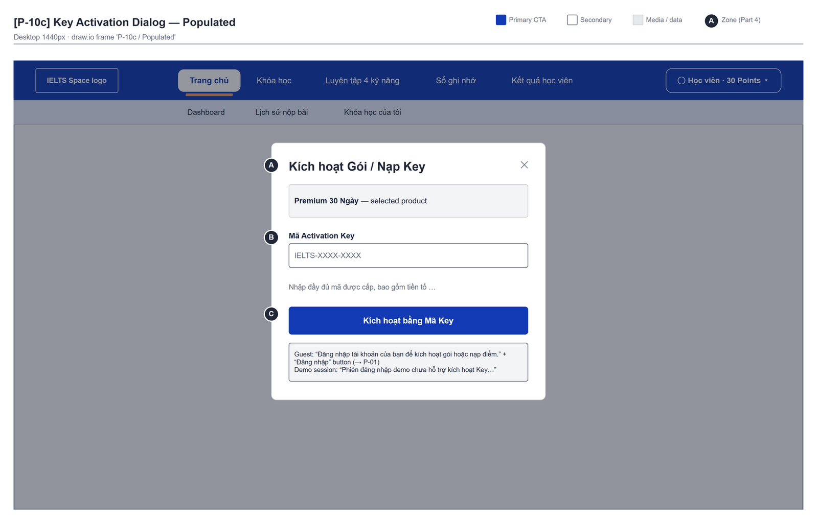
Figure 2.1-3 — Home — Key Activation Dialog · Populated. Source: wireframes/screens/P-10c_KeyActivation.drawio, tab “P-10c / Populated”

Navigation Context
Navigates from | Condition / Trigger
Browser | User opens "/" without a session, or /home
Top bar | User clicks "Trang chủ" or the logo

Navigates to | Condition / Trigger
Login / Register | Guest clicks "Đăng nhập" / "Đăng ký" in the top bar or in the key dialog
Practice Test Catalog | User clicks "Khám phá bài luyện" (signed in)

2.1.2 Entry & Exit Conditions

Preconditions & Guard Redirects
# | Condition check | If met | If not met → Action
PC-01 | None — public page | Render | —

Entry Triggers
# | Trigger | From screen / Source | Parameters passed
ET-01 | Open the site | Browser | Path / → /home for guests
ET-02 | Top bar | Any page | —

Exit Points
# | Event | Condition | Navigates to | Notes
EX-01 | User clicks Đăng nhập / Đăng ký | Guest | Login / Register | —
EX-02 | User completes key activation | Signed in, client available | Stay | Pricing reloads
EX-03 | User picks an item in the top bar (SiteNavbar) | Any | Selected route | No unsaved-change prompt

2.1.3 UI Components
Code | Component name | Type | Validation / Constraint | Notes
Home-PNL-01 | Hero | Section | — | "Mỗi ngày một bước. Gần hơn band mục tiêu." · CTA "Khám phá bài luyện", "Gặp gỡ Mentor"
Home-PNL-02 | Introduction, learning orbit, quality, teachers, learner feedback | Sections | — | Static content
Home-CRD-01 | Gói FREE mặc định | Card | — | Badge "Đang sử dụng" when no Premium is active
Home-CRD-02 | Gói Premium | Card | Duration choice: Premium 30 Ngày / Premium 90 Ngày | Shows days and examiner credits; "Còn {n} ngày · hết hạn {date}" when active
Home-CRD-03 | Thẻ nạp Point | Card | Choice: Thẻ Point 50 / Thẻ Point 100 | —
Home-BTN-01 | Kích hoạt bằng Mã Key — {product} | Button (Primary) | — | Opens MDL-01 for the chosen product
Home-MDL-01 | Kích hoạt Gói / Nạp Key | Dialog | — | Holds TXT-01 and BTN-02
Home-TXT-01 | Mã Activation Key | Text Input | Required; trimmed and upper-cased | Placeholder "IP-XXXX-XXXX-XXXX"
Home-BTN-02 | Kích hoạt bằng Mã Key | Button (Primary) | Disabled while pending or not signed in | Shows "Đang kích hoạt…" while pending

2.1.4 API Calls & Data Flow
# | Trigger (UI event) | API ID | Method + Path | Request | Success → UI action | Error → UI action
1 | Pricing area mounts (signed in, client present) | API-42 | GET /api/access/me/subscription | — | Mark the active plan · loading: "Đang tải thông tin gói hiện tại…" | Error → "Chưa thể tải thông tin gói hiện tại." + "Thử tải lại"
2 | User clicks Kích hoạt bằng Mã Key | API-45 | POST /api/access/me/keys/activate | {rawKey, idempotencyKey} (UUID kept while the same key is retried) | Dialog shows MSG-01 or MSG-02; pricing reloads | Mapped messages MSG-03…MSG-07

2.1.5 Interaction Specifications

Dialog state
IF the user is not signed in
THEN show "Đăng nhập tài khoản của bạn để kích hoạt gói hoặc nạp điểm." + button "Đăng nhập"
ELSE IF no access client (current /home route, FG-03)
THEN show "Phiên đăng nhập demo chưa hỗ trợ kích hoạt Key. Mã của bạn chưa được gửi hoặc sử dụng."
ELSE show the submit button
END IF

Premium check
A plan is shown as active when planCode = PREMIUM, status = ACTIVE and endsAt is empty or in the future.

2.1.6 Messages & Display Content
Code | Type | Trigger condition | Content (UI copy) | Action / Duration
MSG-01 | Success Panel | POINTS key redeemed | "Kích hoạt thành công" · "Đã nạp {n} Points vào ví điểm. Điểm không hết hạn và không cấp quyền Premium hay lượt chấm giáo viên." | Button "Hoàn tất"
MSG-02 | Success Panel | PREMIUM key redeemed | "Kích hoạt thành công" · "Đã cộng {d} ngày Premium và {c} lượt chấm giáo viên. Gói không cộng thêm AI Points." | Button "Hoàn tất"
MSG-03 | Inline Error | Key already redeemed | "Mã này đã được sử dụng." | Below the field
MSG-04 | Inline Error | Key expired / revoked | "Mã kích hoạt đã hết hạn." / "Mã kích hoạt đã bị thu hồi." | Below the field
MSG-05 | Inline Error | Unknown key or other 4xx | "Mã kích hoạt không hợp lệ. Vui lòng kiểm tra lại mã." / "Chưa thể kích hoạt mã. Vui lòng kiểm tra mã và thử lại." | Below the field
MSG-06 | Inline Error | 401 / 403 / 429 | "Phiên đăng nhập đã hết hạn hoặc chưa hợp lệ. Vui lòng đăng nhập lại." / "Tài khoản của bạn chưa được phép thực hiện thao tác này." / "Bạn thao tác quá nhanh. Vui lòng chờ một chút rồi thử lại." | Below the field
MSG-07 | Inline Error | 5xx or network | "Dịch vụ tạm thời gián đoạn. Vui lòng thử lại sau." / "Chưa xác nhận được kết quả kích hoạt. Hãy giữ nguyên mã và thử lại khi kết nối ổn định." | Below the field
MSG-08 | Inline Error | Empty key | "Vui lòng nhập mã kích hoạt." | Below the field; focus returns

2.1.7 Business Rules
BR/BV Code | Short description | UI behaviour when violated
BR-07 | A key is redeemed at most once | MSG-03 / MSG-04
BR-08 | Premium days extend the subscription | MSG-02 and the new end date on the Premium card
BR-30 | Same idempotencyKey grants once | Key id kept while the same key is retried

2.2 Login

2.2.1 General Information
Screen Name | Login
Purpose | Lets a registered user sign in with email and password, so the app can return to the page the user wanted or open the learning path.
Route / Type | /login · Public page (GuestOnly)
Role(s) | Guest
Related FT / UC | FT-02, FT-03, FT-05, FT-07  UC-002–UC-004 Sign in; UC-005–UC-007 Sign in with OAuth
Status | Specified (OAuth button: Draft; role-based home: FG-02)
Frontend | Built — features/auth/pages/AuthPage.tsx (mode sign-in) with AuthForm (route /login); calls the real backend.
Mockup / Wireframe | Figure 2.2-1 to 2.2-3 below — draw.io wireframes in docs/wireframes/screens (P-01_SignIn.drawio), one tab per state; clickable prototype: docs/wireframes/IELTSPath_Prototype.drawio
Open Questions | OQ-02, OQ-19 (Appendix B)

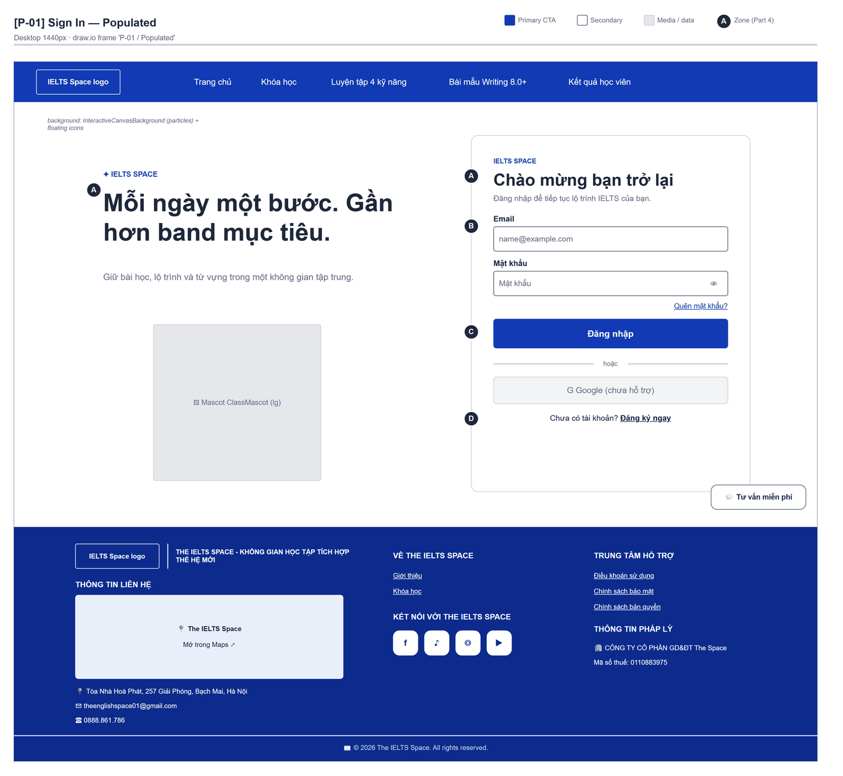
Figure 2.2-1 — Login — Populated. Source: wireframes/screens/P-01_SignIn.drawio, tab “P-01 / Populated”
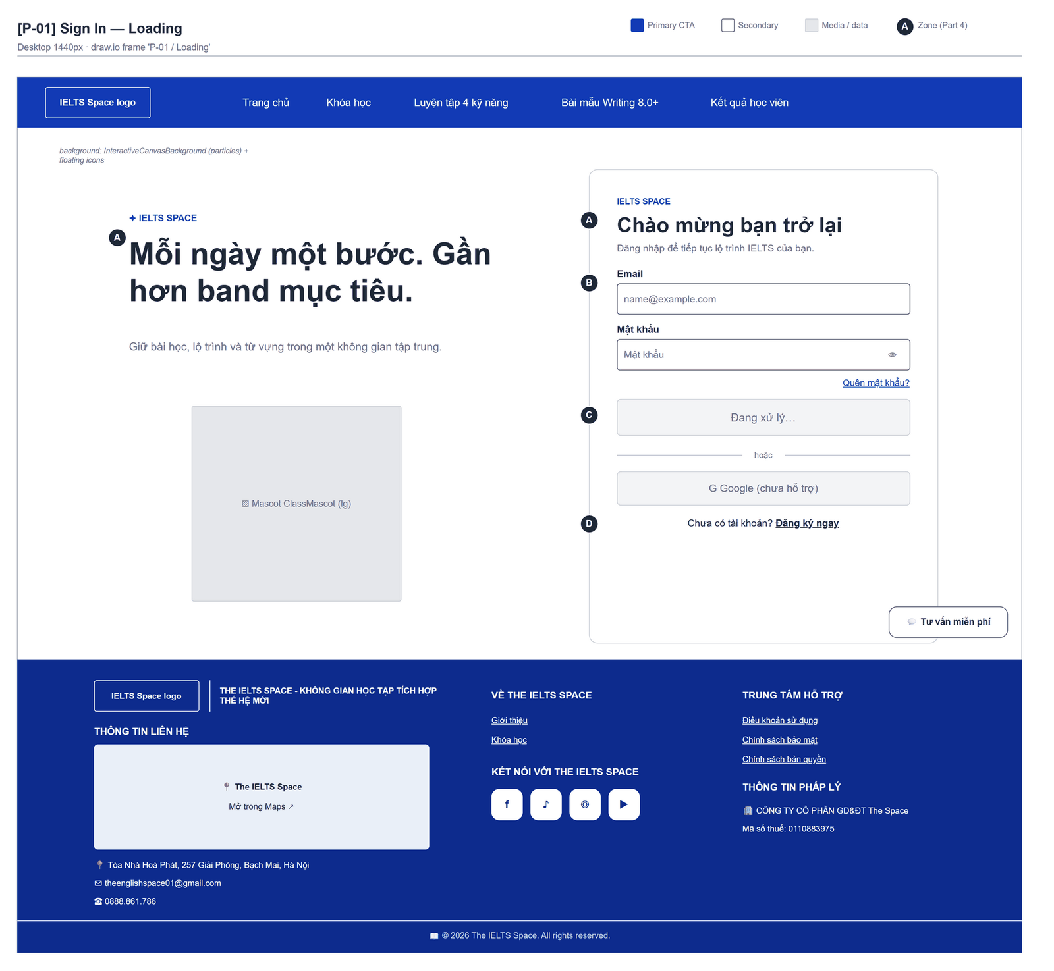
Figure 2.2-2 — Login — Loading. Source: wireframes/screens/P-01_SignIn.drawio, tab “P-01 / Loading”
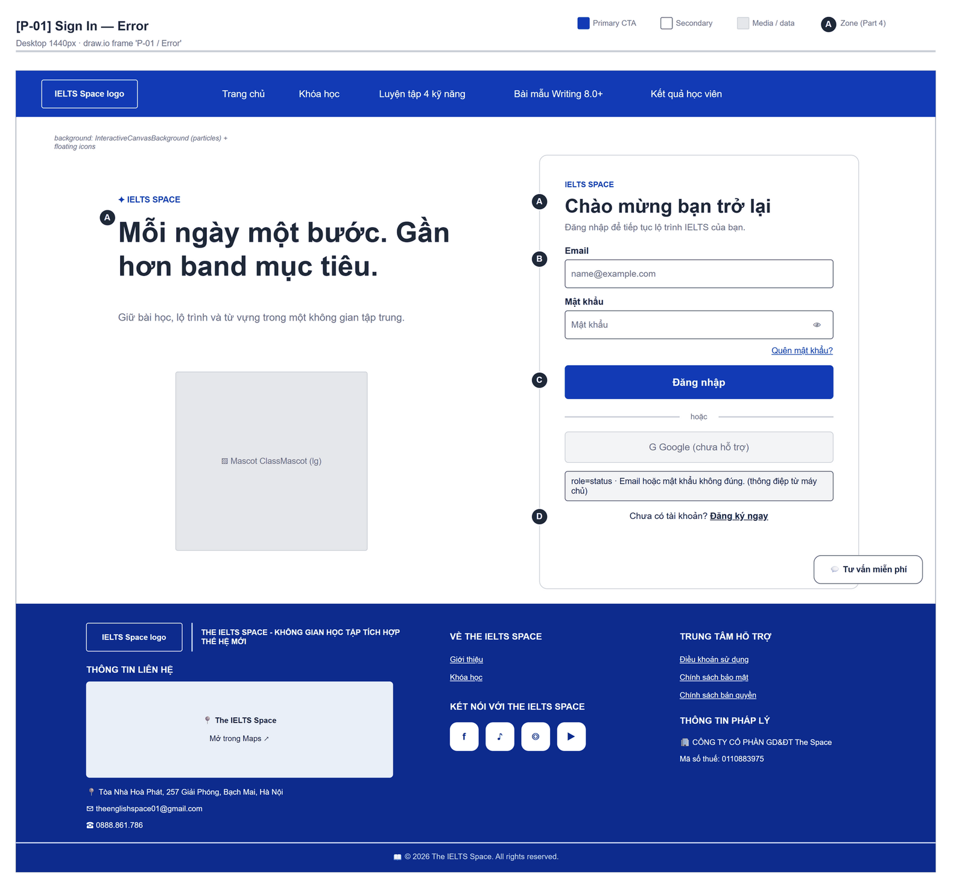
Figure 2.2-3 — Login — Error. Source: wireframes/screens/P-01_SignIn.drawio, tab “P-01 / Error”

Navigation Context
Navigates from | Condition / Trigger
Any protected route | No session (RequireAuth); the original location is kept
Register | User clicks "Đăng nhập"
Reset Password | Reset succeeded (redirect after 0.9 s)
User menu | User clicks "Đăng xuất"

Navigates to | Condition / Trigger
Original route, else Course List (/learn) | Sign-in succeeds
Register | User clicks "Đăng ký ngay"
Forgot Password | User clicks "Quên mật khẩu?"

2.2.2 Entry & Exit Conditions

Preconditions & Guard Redirects
# | Condition check | If met | If not met → Action
PC-01 | No signed-in session (GuestOnly, GG-03) | Render the form | Redirect → /learn

Entry Triggers
# | Trigger | From screen / Source | Parameters passed
ET-01 | Protected route without session | Any | Router state from
ET-02 | Top bar "Đăng nhập" | Home, Vocabulary | —
ET-03 | Sign-out | User menu | —

Exit Points
# | Event | Condition | Navigates to | Notes
EX-01 | User clicks Đăng nhập | Credentials accepted | state.from or /learn | No message
EX-02 | User clicks Đăng ký ngay | Any | Register | —
EX-03 | User clicks Quên mật khẩu? | Any | Forgot Password | —
EX-04 | Sign-in rejected | HTTP 401 / 400 | Stay | MSG-01

2.2.3 UI Components
Code | Component name | Type | Validation / Constraint | Notes
Login-TXT-01 | Email | Email Input | Required (HTML) | Placeholder "name@example.com"
Login-TXT-02 | Mật khẩu | Password Input | Required | Placeholder "Mật khẩu"; show/hide toggle
Login-LNK-01 | Quên mật khẩu? | Link | — | Opens /forgot-password
Login-BTN-01 | Đăng nhập | Button (Primary) | Disabled while submitting | Label "Đang xử lý…" while pending
Login-BTN-02 | Google (chưa hỗ trợ) | Button (Outline) | Disabled while VITE_OAUTH_ENABLED = false | Label "Continue with Google" when enabled
Login-LNK-02 | Đăng ký ngay | Link | — | Opens /register
Login-PNL-01 | Status line | Text (role=status) | — | Shows MSG-01 / MSG-02

2.2.4 API Calls & Data Flow
# | Trigger (UI event) | API ID | Method + Path | Request | Success → UI action | Error → UI action
1 | User clicks Đăng nhập | API-02 | POST /auth/login | {email, password} | Keep the access token in memory · loading: "Đang xử lý…" | Server message → MSG-01
2 | Login succeeded | API-09 | GET /api/users/me | Bearer access token | Fill name and email of the session (the app reads /api/users/me, not /auth/me: FG-11) | Error → MSG-01
3 | Login succeeded | API-43 | GET /api/access/me/points | — | Point balance in the user menu | Error ignored (points stay 0)
4 | User clicks the Google button (OAuth enabled) | API-08 | GET /auth/oauth/{provider}/authorize?redirect_uri=… | Query: redirect_uri=<origin>/auth/oauth/callback | Browser goes to the provider | Not enabled → MSG-02

2.2.5 Interaction Specifications

After sign-in
navigate(location.state.from.pathname ?? '/learn', replace)
The app does not read roles yet: every user lands on /learn (FG-02).

Failure message
The status line shows the server message of the 401. The backend returns the same message for every failure (FT-02/NAC-01).

2.2.6 Messages & Display Content
Code | Type | Trigger condition | Content (UI copy) | Action / Duration
MSG-01 | Inline Error | API returns 401 / 400 | Server message, else "Không thể xác thực. Vui lòng thử lại." | Status line until the next submit
MSG-02 | Inline Error | User clicks Google while OAuth is off | "Đăng nhập với Google chưa được hỗ trợ." | Status line
MSG-03 | Inline Error | Network error | GLB-08 | Status line
MSG-04 | Inline Error | Design target: HTTP 429 after 5 failed sign-ins in 15 minutes (NFR-SEC11) | "Bạn đã đăng nhập sai quá nhiều lần. Vui lòng thử lại sau 15 phút." | Status line; button stays enabled

2.2.7 Business Rules
BR/BV Code | Short description | UI behaviour when violated
BR-04 | Access token 3,600 s; refresh token 7 days, single use | Silent refresh (Section 2.0)
FT-02/NAC-01 | Same message for every sign-in failure | Server message shown as is
NFR-SEC11 | At most 5 failed sign-ins per account and IP in 15 minutes, then HTTP 429 [not built] | MSG-04
BR-06 | Five canonical roles | Design target: open the role home (FG-02)

2.3 Register

2.3.1 General Information
Screen Name | Register
Purpose | Lets a guest create a learner account and signs the guest in straight away, so learning can start.
Route / Type | /register · Public page (GuestOnly)
Role(s) | Guest
Related FT / UC | FT-01, FT-02  UC-001 Register
Status | Specified
Frontend | Built — features/auth/pages/AuthPage.tsx (mode sign-up) with AuthForm (route /register); calls the real backend.
Mockup / Wireframe | Figure 2.3-1 to 2.3-2 below — draw.io wireframes in docs/wireframes/screens (P-02_SignUp.drawio), one tab per state; clickable prototype: docs/wireframes/IELTSPath_Prototype.drawio

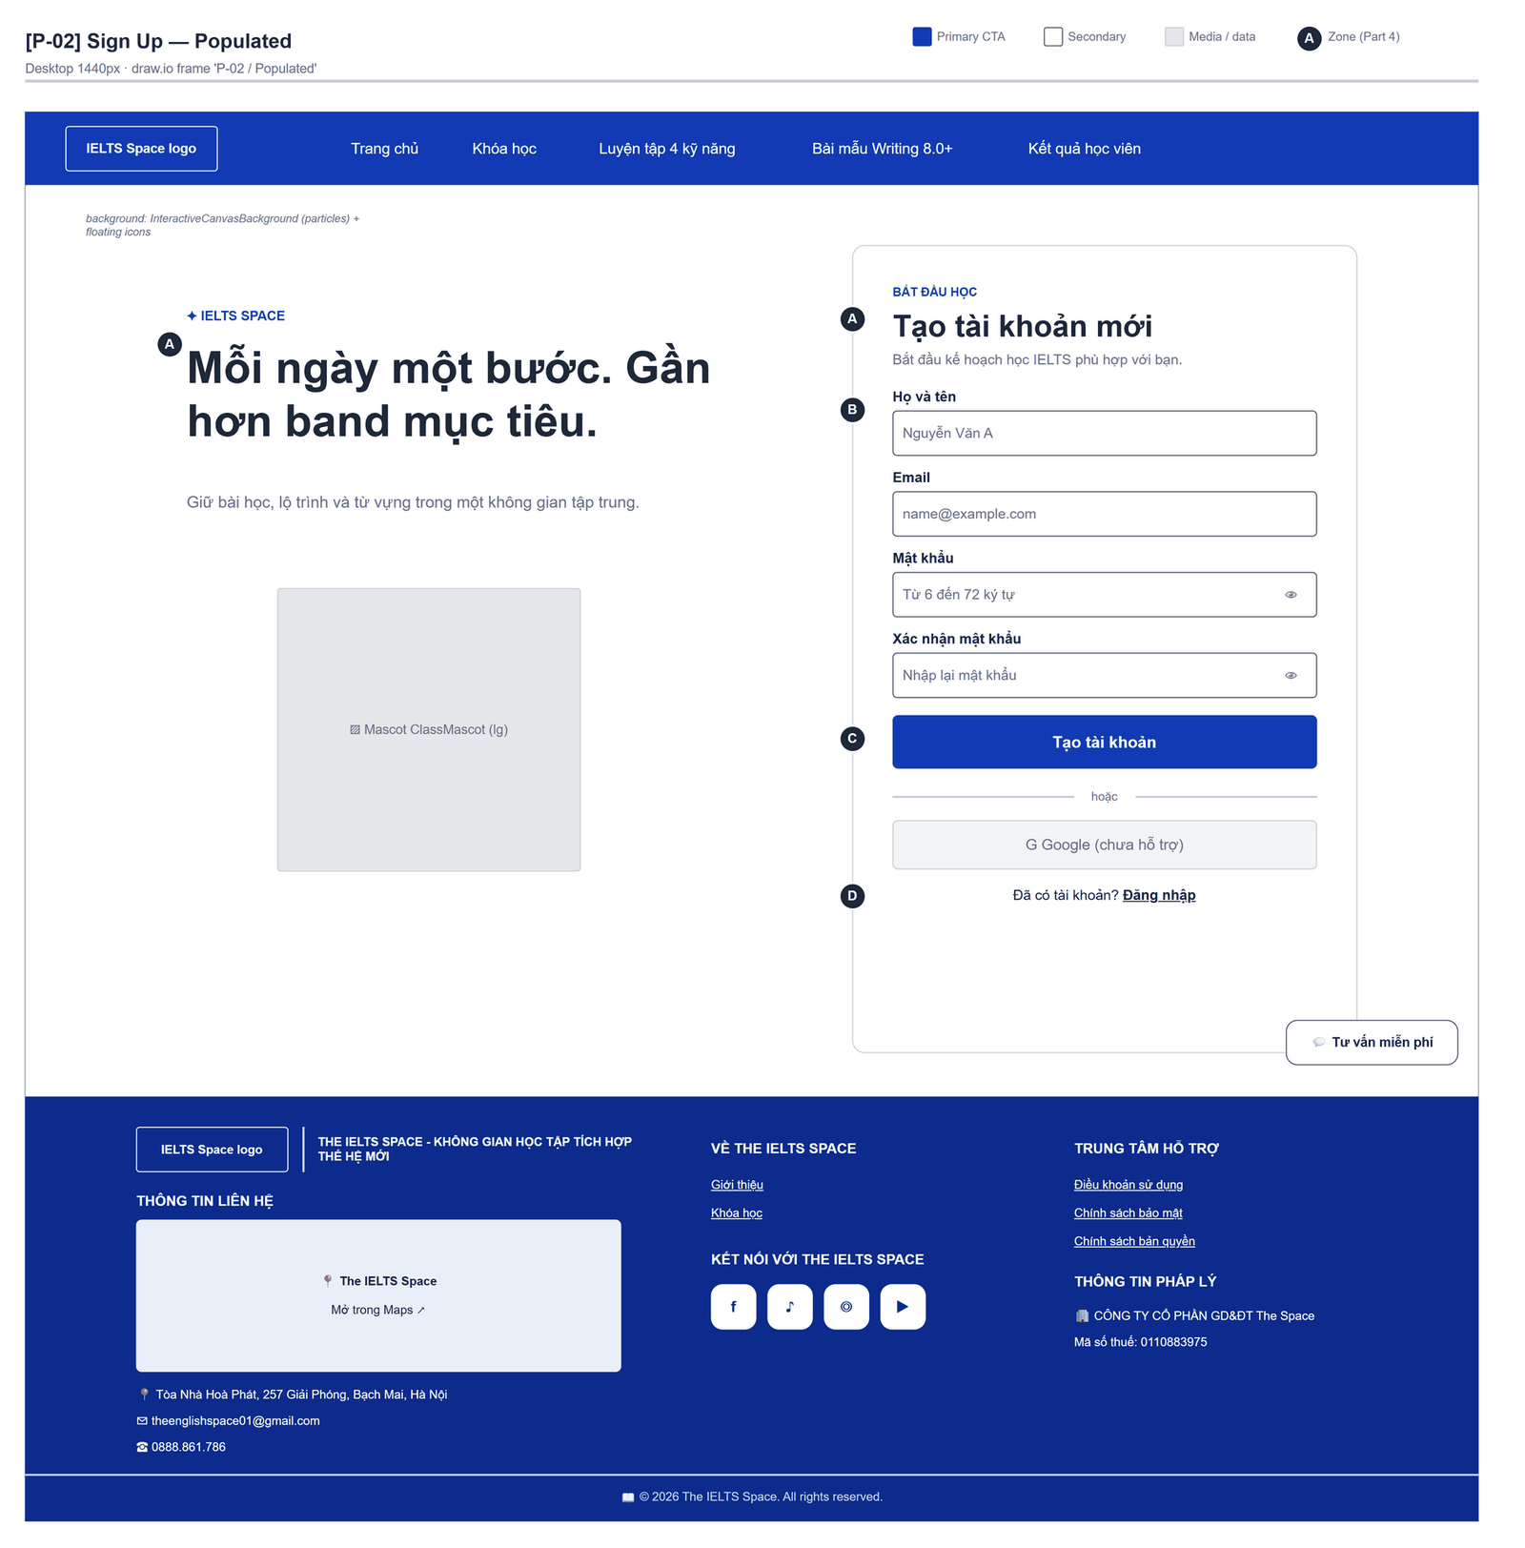
Figure 2.3-1 — Register — Populated. Source: wireframes/screens/P-02_SignUp.drawio, tab “P-02 / Populated”
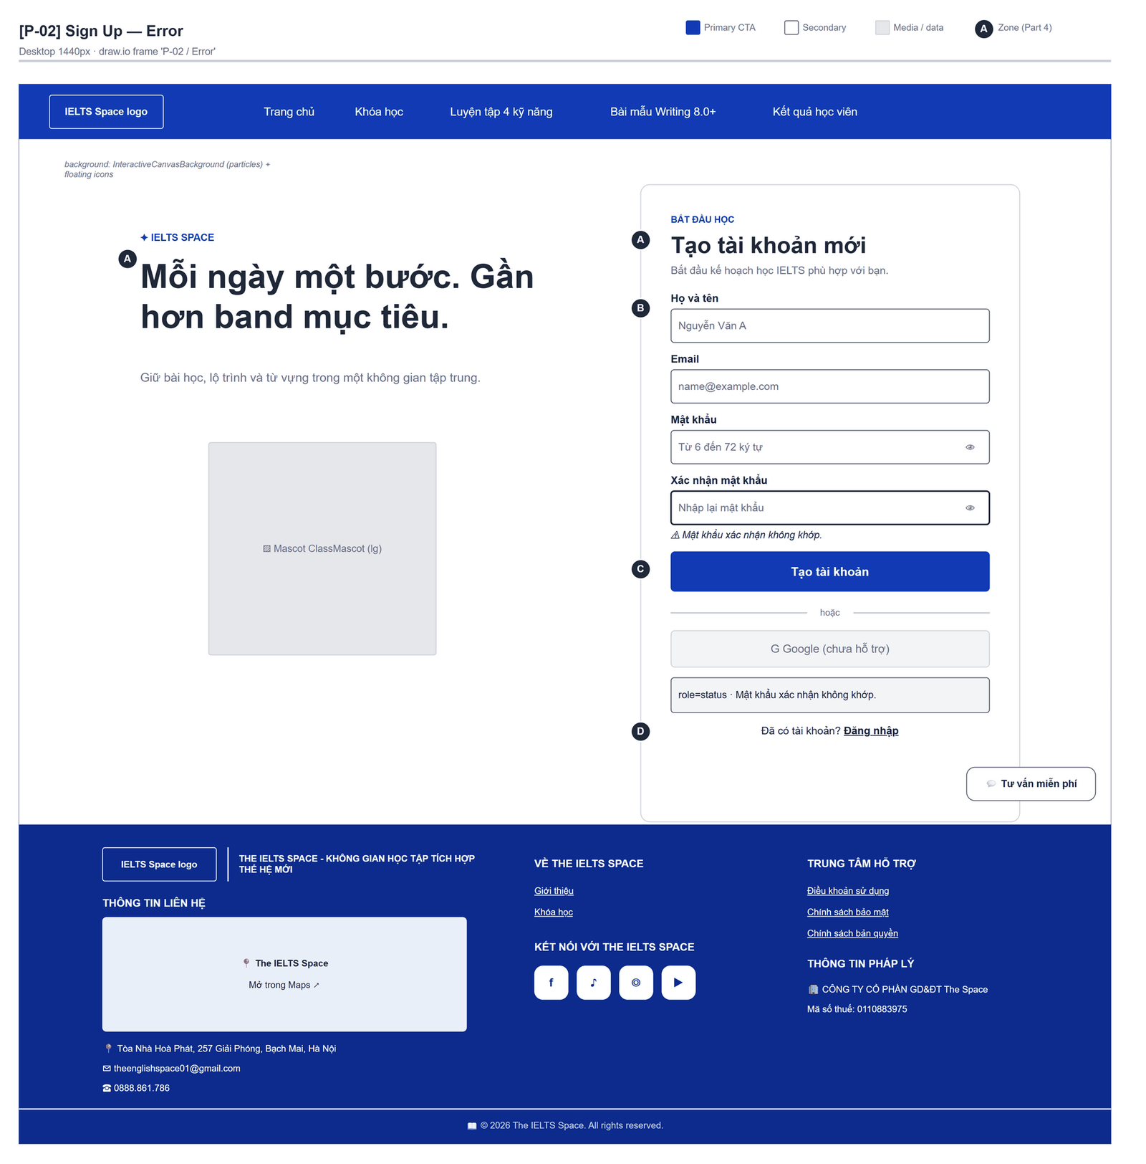
Figure 2.3-2 — Register — Error. Source: wireframes/screens/P-02_SignUp.drawio, tab “P-02 / Error”

Navigation Context
Navigates from | Condition / Trigger
Login | User clicks "Đăng ký ngay"
Top bar | Guest clicks "Đăng ký"

Navigates to | Condition / Trigger
Course List (/learn) | Registration and the automatic sign-in succeed
Login | User clicks "Đăng nhập"

2.3.2 Entry & Exit Conditions

Preconditions & Guard Redirects
# | Condition check | If met | If not met → Action
PC-01 | No signed-in session (GuestOnly, GG-03) | Render the form | Redirect → /learn

Entry Triggers
# | Trigger | From screen / Source | Parameters passed
ET-01 | Đăng ký ngay | Login | —
ET-02 | Top bar | Home, Vocabulary | —

Exit Points
# | Event | Condition | Navigates to | Notes
EX-01 | User clicks Tạo tài khoản | Register 201 and login 200 | state.from or /learn | No message
EX-02 | Rejected | 409 / 400 | Stay | MSG-01
EX-03 | User clicks Đăng nhập | Any | Login | —

2.3.3 UI Components
Code | Component name | Type | Validation / Constraint | Notes
Register-TXT-01 | Họ và tên | Text Input | Required; trimmed not blank | Placeholder "Nguyễn Văn A"
Register-TXT-02 | Email | Email Input | Required | Placeholder "name@example.com"
Register-TXT-03 | Mật khẩu | Password Input | 6–72 characters (BV-01); MSG-02 | Hint "Từ 6 đến 72 ký tự."
Register-TXT-04 | Xác nhận mật khẩu | Password Input | Must equal Mật khẩu; MSG-03 | Placeholder "Nhập lại mật khẩu"
Register-BTN-01 | Tạo tài khoản | Button (Primary) | Disabled while submitting | "Đang xử lý…" while pending
Register-BTN-02 | Google (chưa hỗ trợ) | Button (Outline) | Disabled (OAuth off) | —
Register-LNK-01 | Đăng nhập | Link | — | Opens /login

2.3.4 API Calls & Data Flow
# | Trigger (UI event) | API ID | Method + Path | Request | Success → UI action | Error → UI action
1 | User clicks Tạo tài khoản | API-01 | POST /api/users/register | {email, password, fullName} | Then API 2 | 409 / 400 → MSG-01
2 | Registration succeeded | API-02 | POST /auth/login | {email, password} | Then user.me and access.myPoints; navigate | Error → MSG-01

2.3.5 Interaction Specifications

Client checks
IF full name blank OR email/password empty → do nothing (HTML required)
IF password length outside 6–72 → MSG-02
IF confirmation differs → MSG-03
ELSE submit

2.3.6 Messages & Display Content
Code | Type | Trigger condition | Content (UI copy) | Action / Duration
MSG-01 | Inline Error | API error | Field message from the server, else server message, else "Không thể đăng ký. Vui lòng thử lại." | Status line
MSG-02 | Inline Error | Password outside 6–72 | "Mật khẩu phải có từ 6 đến 72 ký tự." | Status line
MSG-03 | Inline Error | Confirmation differs | "Mật khẩu xác nhận không khớp." | Status line

2.3.7 Business Rules
BR/BV Code | Short description | UI behaviour when violated
BR-01 | Public registration creates a CUSTOMER account; one account per email | 409 → MSG-01
BR-02 / FT-01 BV-01 | Password 6–72 characters | MSG-02 before any request
NFR-SEC04 | Password at most 72 bytes (BCrypt limit); the current release counts characters | Accented characters take 2–3 bytes: a 72-character Vietnamese password can be rejected later

2.4 Forgot Password

2.4.1 General Information
Screen Name | Forgot Password
Purpose | Lets a user who forgot the password ask for a reset code, so a new password can be set.
Route / Type | /forgot-password · Public page (GuestOnly)
Role(s) | Guest
Related FT / UC | FT-04  UC-008, UC-010 Reset password; UC-009 Send reset link
Status | Specified (email delivery: Draft, FG-06)
Frontend | Built — features/auth/pages/ForgotPasswordPage.tsx (route /forgot-password); calls the real backend.
Mockup / Wireframe | Figure 2.4-1 to 2.4-2 below — draw.io wireframes in docs/wireframes/screens (P-03_ForgotPassword.drawio), one tab per state; clickable prototype: docs/wireframes/IELTSPath_Prototype.drawio
Open Questions | OQ-03 (Appendix B)

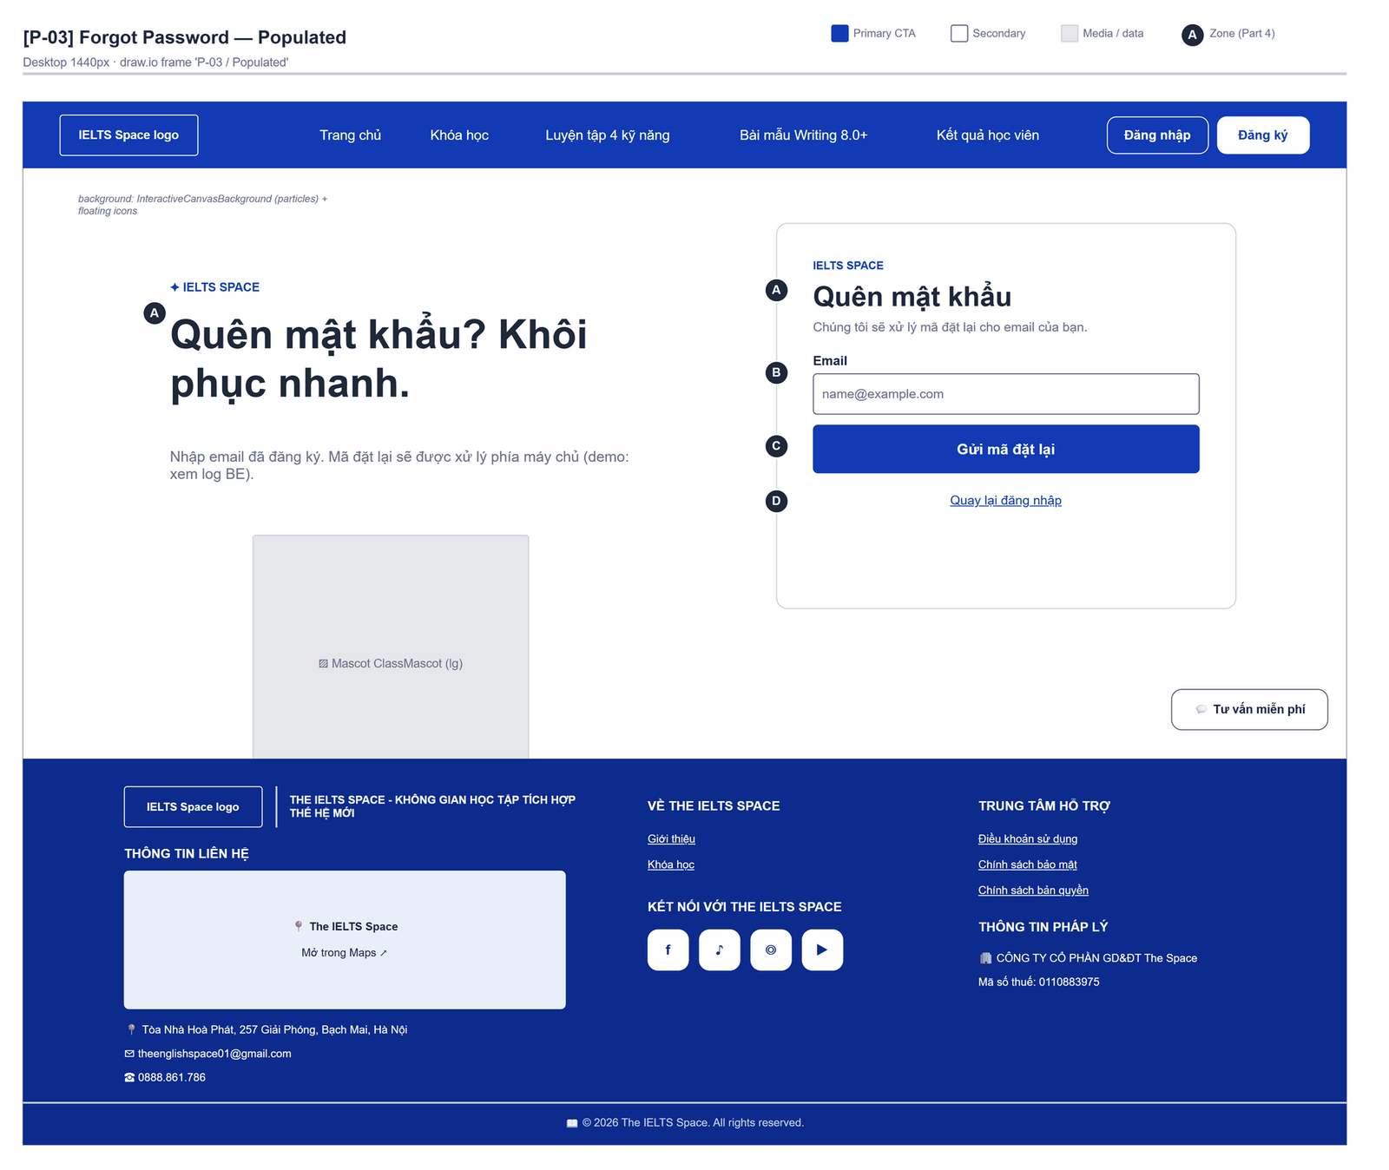
Figure 2.4-1 — Forgot Password — Populated. Source: wireframes/screens/P-03_ForgotPassword.drawio, tab “P-03 / Populated”
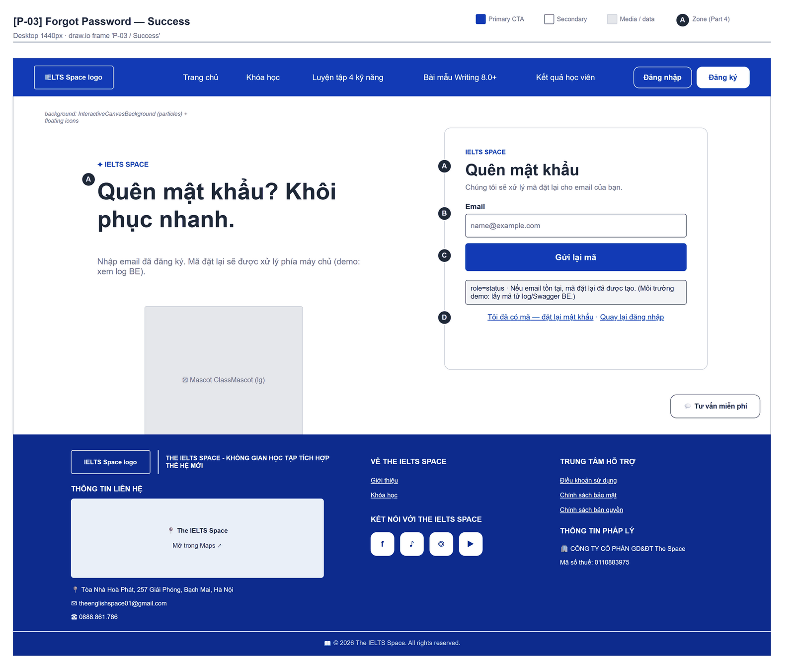
Figure 2.4-2 — Forgot Password — Success. Source: wireframes/screens/P-03_ForgotPassword.drawio, tab “P-03 / Success”

Navigation Context
Navigates from | Condition / Trigger
Login | User clicks "Quên mật khẩu?"
Reset Password | User clicks "Yêu cầu lại"

Navigates to | Condition / Trigger
Reset Password | User clicks "Tôi đã có mã — đặt lại mật khẩu" (after sending)
Login | User clicks "Quay lại đăng nhập"

2.4.2 Entry & Exit Conditions

Preconditions & Guard Redirects
# | Condition check | If met | If not met → Action
PC-01 | No signed-in session (GuestOnly, GG-03) | Render the form | Redirect → /learn

Entry Triggers
# | Trigger | From screen / Source | Parameters passed
ET-01 | Quên mật khẩu? | Login | —

Exit Points
# | Event | Condition | Navigates to | Notes
EX-01 | User clicks Gửi mã đặt lại | API 200 | Stay | MSG-01; button becomes "Gửi lại mã"
EX-02 | User clicks Tôi đã có mã | After sending | Reset Password | —
EX-03 | User clicks Quay lại đăng nhập | Any | Login | —

2.4.3 UI Components
Code | Component name | Type | Validation / Constraint | Notes
ForgotPassword-TXT-01 | Email | Email Input | Required; trimmed | Disabled while sending
ForgotPassword-BTN-01 | Gửi mã đặt lại / Gửi lại mã | Button (Primary) | Disabled while sending | "Đang gửi…" while pending
ForgotPassword-PNL-01 | Status line | Text (role=status) | — | MSG-01 / MSG-02
ForgotPassword-LNK-01 | Tôi đã có mã — đặt lại mật khẩu | Link | Visible after a success | Opens /reset-password
ForgotPassword-LNK-02 | Quay lại đăng nhập | Link | — | Opens /login

2.4.4 API Calls & Data Flow
# | Trigger (UI event) | API ID | Method + Path | Request | Success → UI action | Error → UI action
1 | User clicks Gửi mã đặt lại | API-06 | POST /auth/forgot-password | {email} | Show MSG-01 | 404 / 400 → MSG-02

2.4.5 Interaction Specifications

No email yet
The backend stores the token but sends no email (Email Service not integrated); in the demo the code is read from the backend log and pasted on Reset Password.

2.4.6 Messages & Display Content
Code | Type | Trigger condition | Content (UI copy) | Action / Duration
MSG-01 | Info Text | API returns 200 | Server message, else "Nếu email tồn tại, mã đặt lại đã được tạo. (Môi trường demo: lấy mã từ log/Swagger BE.)" | Status line
MSG-02 | Inline Error | API error | Server message, else "Không gửi được yêu cầu. Thử lại." | Status line
MSG-03 | Inline Error | Design target: HTTP 429 after 3 requests for one email in an hour (NFR-SEC11) | "Bạn đã yêu cầu quá nhiều lần. Vui lòng thử lại sau." | Status line

2.4.7 Business Rules
BR/BV Code | Short description | UI behaviour when violated
BR-03 | Reset token single-use, valid 15 minutes | Not stated on the screen (design target: MSG-01)
FT-04/NAC-01 | Unknown email → 404 (current release) | Server message shown (reveals unknown emails; OQ-03)
NFR-SEC12 | Same response whether or not the email is registered [open issue in the backend] | Design target: always MSG-01; the 404 branch goes away
NFR-SEC11 | At most 3 reset requests per email per hour, then HTTP 429 [not built] | MSG-03

2.5 Reset Password

2.5.1 General Information
Screen Name | Reset Password
Purpose | Lets the user set a new password with the reset code, so the user can sign in again.
Route / Type | /reset-password?token=… · Public page (GuestOnly)
Role(s) | Guest
Related FT / UC | FT-04  UC-008, UC-010 Reset password
Status | Specified (link delivery: Draft, FG-06)
Frontend | Built — features/auth/pages/ResetPasswordPage.tsx (route /reset-password); calls the real backend.
Mockup / Wireframe | Figure 2.5-1 to 2.5-3 below — draw.io wireframes in docs/wireframes/screens (P-04_ResetPassword.drawio), one tab per state; clickable prototype: docs/wireframes/IELTSPath_Prototype.drawio
Open Questions | OQ-03 (Appendix B)

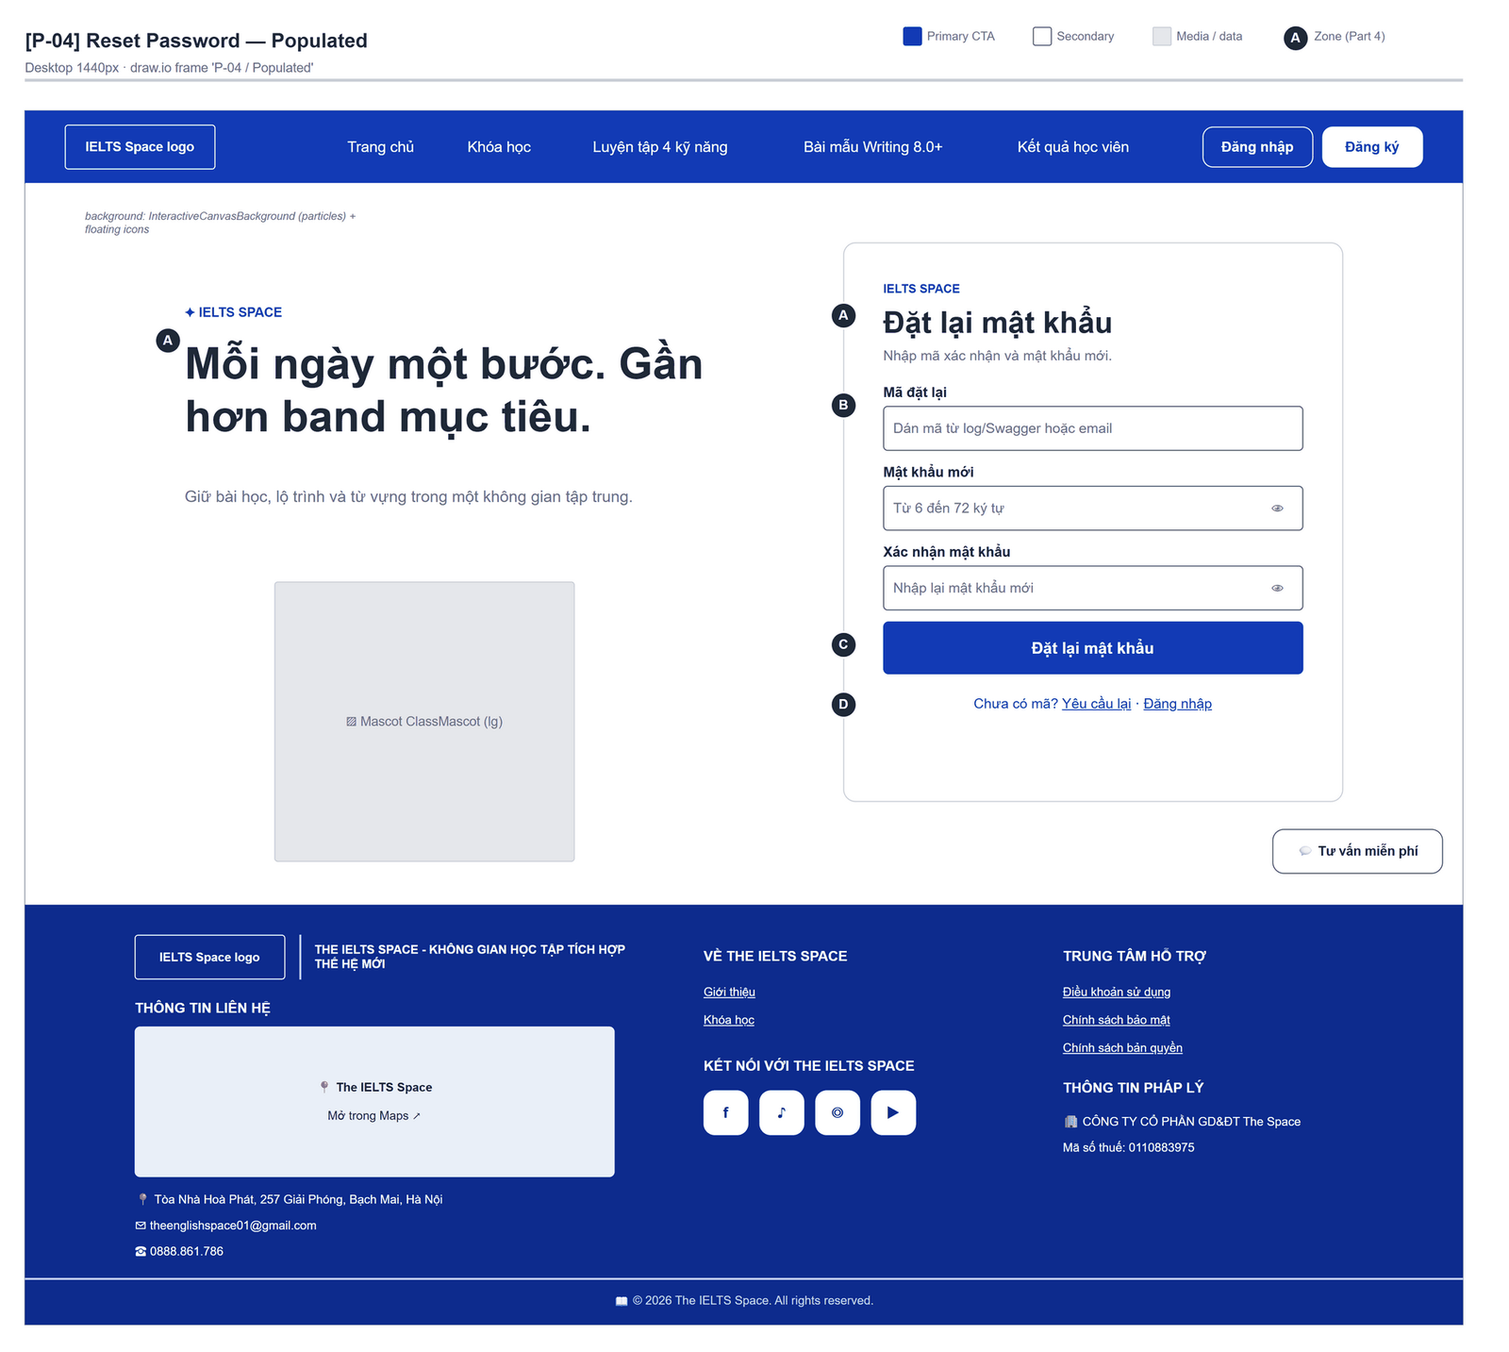
Figure 2.5-1 — Reset Password — Populated. Source: wireframes/screens/P-04_ResetPassword.drawio, tab “P-04 / Populated”
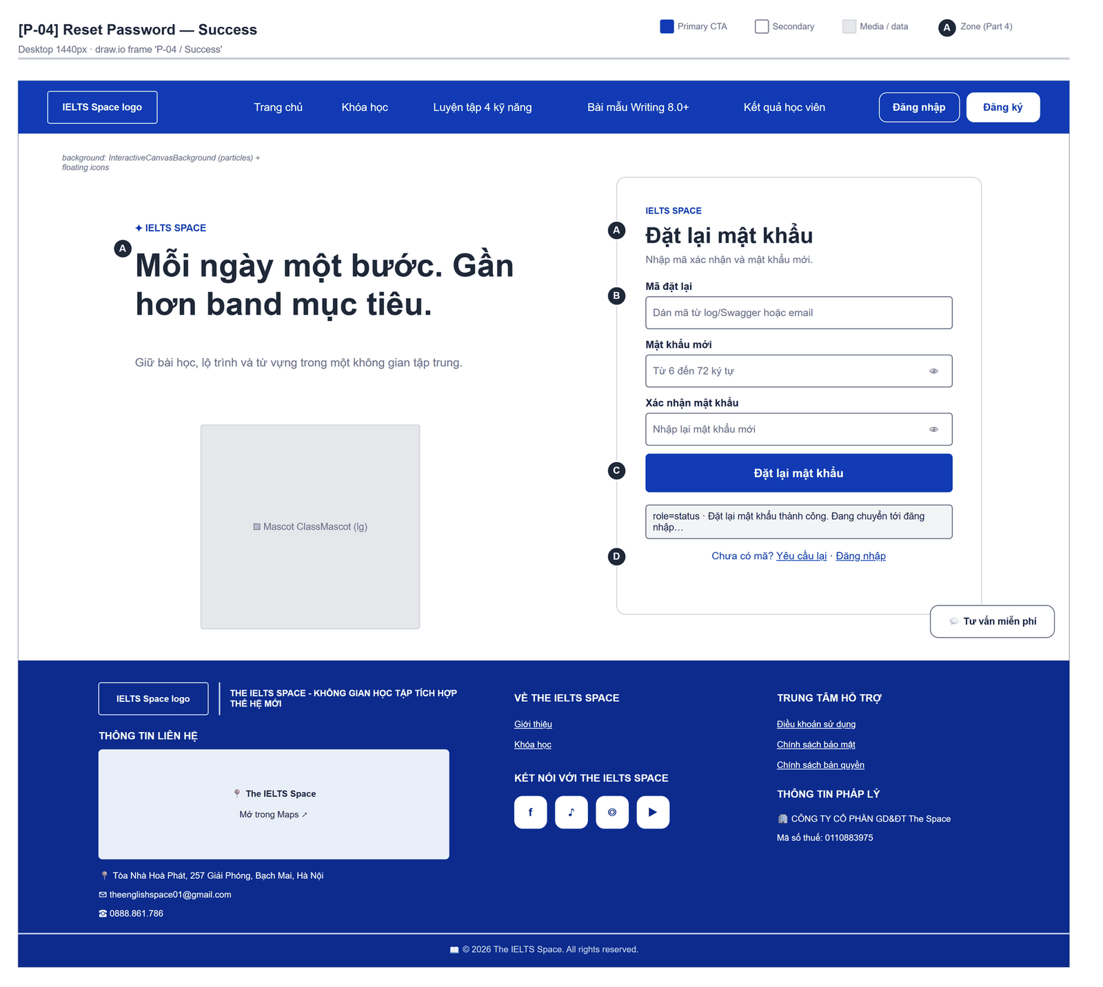
Figure 2.5-2 — Reset Password — Success. Source: wireframes/screens/P-04_ResetPassword.drawio, tab “P-04 / Success”
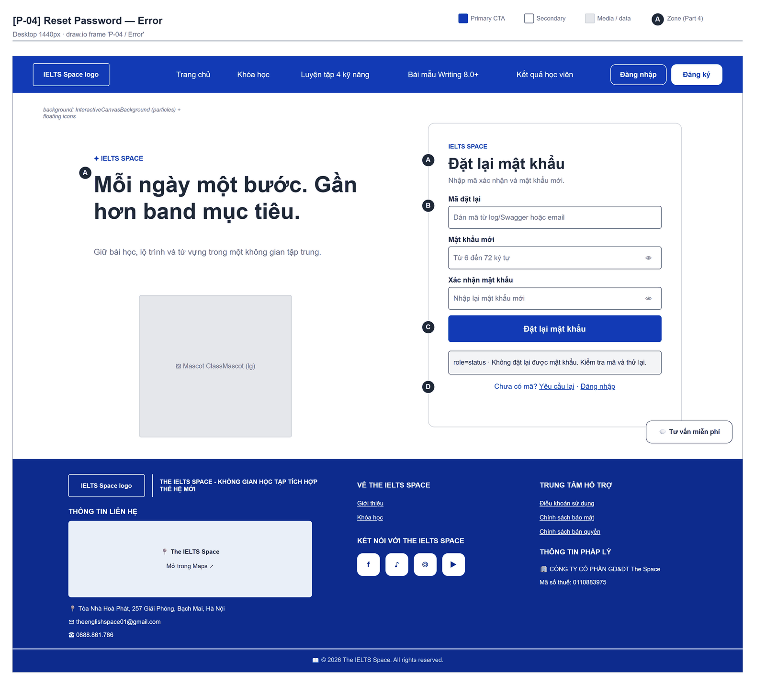
Figure 2.5-3 — Reset Password — Error. Source: wireframes/screens/P-04_ResetPassword.drawio, tab “P-04 / Error”

Navigation Context
Navigates from | Condition / Trigger
Forgot Password | User clicks "Tôi đã có mã — đặt lại mật khẩu"
Reset link | Opened with ?token=

Navigates to | Condition / Trigger
Login | Reset succeeded (after 0.9 s) or user clicks "Đăng nhập"
Forgot Password | User clicks "Yêu cầu lại"

2.5.2 Entry & Exit Conditions

Preconditions & Guard Redirects
# | Condition check | If met | If not met → Action
PC-01 | No signed-in session (GuestOnly, GG-03) | Render the form | Redirect → /learn

Entry Triggers
# | Trigger | From screen / Source | Parameters passed
ET-01 | Link from Forgot Password | Forgot Password | —
ET-02 | Reset link | Email (Draft) | Query: ?token=

Exit Points
# | Event | Condition | Navigates to | Notes
EX-01 | User clicks Đặt lại mật khẩu | API 200 | Login | MSG-01, redirect after 900 ms
EX-02 | Rejected | API 400 | Stay | MSG-02

2.5.3 UI Components
Code | Component name | Type | Validation / Constraint | Notes
ResetPassword-TXT-01 | Mã đặt lại | Text Input | Required; prefilled from ?token= | Hint "Demo: BE ghi mã vào log khi gọi forgot-password."
ResetPassword-TXT-02 | Mật khẩu mới | Password Input | 6–72 characters; MSG-03 | Hint "Từ 6 đến 72 ký tự."
ResetPassword-TXT-03 | Xác nhận mật khẩu | Password Input | Must match; MSG-04 | Placeholder "Nhập lại mật khẩu mới"
ResetPassword-BTN-01 | Đặt lại mật khẩu | Button (Primary) | Disabled while submitting | "Đang xử lý…" while pending
ResetPassword-LNK-01 | Yêu cầu lại · Đăng nhập | Links | — | —

2.5.4 API Calls & Data Flow
# | Trigger (UI event) | API ID | Method + Path | Request | Success → UI action | Error → UI action
1 | User clicks Đặt lại mật khẩu | API-07 | POST /auth/reset-password | {token, newPassword} | MSG-01; navigate /login after 900 ms | 400 → MSG-02

2.5.5 Interaction Specifications

Token source
The code field is prefilled from ?token= and can be edited, because the demo has no email: the user pastes the code from the backend log.

2.5.6 Messages & Display Content
Code | Type | Trigger condition | Content (UI copy) | Action / Duration
MSG-01 | Info Text | API returns 200 | Server message, else "Đặt lại mật khẩu thành công. Đang chuyển tới đăng nhập…" | Status line; redirect after 0.9 s
MSG-02 | Inline Error | API error | Field message from the server, else "Không đặt lại được mật khẩu. Kiểm tra mã và thử lại." | Status line
MSG-03 | Inline Error | Password outside 6–72 | "Mật khẩu phải có từ 6 đến 72 ký tự." | Status line
MSG-04 | Inline Error | Confirmation differs | "Mật khẩu xác nhận không khớp." | Status line

2.5.7 Business Rules
BR/BV Code | Short description | UI behaviour when violated
BR-03 | Token single-use, 15 minutes | Expired or used code → MSG-02
BR-02 | New password 6–72 characters (frontend check) | MSG-03; the backend accepts ≥ 6
NFR-SEC04 | Reset must also enforce at most 72 bytes [open issue in the backend] | Frontend check stays until the backend enforces it

2.6 OAuth Callback
Draft: OAuth sign-in is not built in the backend; the frontend route only shows a message while VITE_OAUTH_ENABLED = false.

2.6.1 General Information
Screen Name | OAuth Callback
Purpose | Finishes a sign-in with the OAuth identity provider and opens the learning path.
Route / Type | /auth/oauth/callback · Public page (GuestOnly)
Role(s) | Guest
Related FT / UC | FT-05  UC-005–UC-007 Sign in with OAuth
Status | Draft
Frontend | Placeholder — features/auth/pages/OAuthCallbackPage.tsx; exchanges nothing until the backend endpoint exists (authApi.handleOAuthCallback throws).
Mockup / Wireframe | TBD — no frontend screen yet
Open Questions | OQ-02 (Appendix B)

Navigation Context
Navigates from | Condition / Trigger
OAuth Identity Provider | Provider redirects back with code/state

Navigates to | Condition / Trigger
Course List (/learn) | Tokens received and user.me succeeds
Login | User clicks "Quay lại đăng nhập"

2.6.2 Entry & Exit Conditions

Preconditions & Guard Redirects
# | Condition check | If met | If not met → Action
PC-01 | No signed-in session (GuestOnly, GG-03) | Render the form | Redirect → /learn

Entry Triggers
# | Trigger | From screen / Source | Parameters passed
ET-01 | Provider redirect | OAuth Identity Provider | Query: code, state [TBC]

Exit Points
# | Event | Condition | Navigates to | Notes
EX-01 | Sign-in completes | OAuth enabled and exchange succeeds | /learn | —
EX-02 | User clicks Quay lại đăng nhập | Any | Login | —

2.6.3 UI Components
Code | Component name | Type | Validation / Constraint | Notes
OAuthCallback-PNL-01 | Message | Heading + text | — | "Đang hoàn tất đăng nhập…" or MSG-01 / MSG-02
OAuthCallback-LNK-01 | Quay lại đăng nhập | Link | — | Opens /login

2.6.4 API Calls & Data Flow
# | Trigger (UI event) | API ID | Method + Path | Request | Success → UI action | Error → UI action
1 | Page load (OAuth enabled) [Draft] | API-08 | GET /auth/oauth/{provider}/authorize?redirect_uri=… | Code exchange endpoint [TBC] | loginWithAccessToken → user.me → /learn | Error → MSG-02

2.6.5 Interaction Specifications

Never invents a session
Without a backend exchange the page shows a message only; it never creates tokens on the client.

2.6.6 Messages & Display Content
Code | Type | Trigger condition | Content (UI copy) | Action / Duration
MSG-01 | Info Text | OAuth disabled | "Đăng nhập mạng xã hội chưa được hỗ trợ." | Persistent
MSG-02 | Inline Error | Exchange fails | Error message, else "OAuth thất bại." | Persistent

2.6.7 Business Rules
BR/BV Code | Short description | UI behaviour when violated
FT-05 | OAuth sign-in issues tokens as in FT-02 [TBC] | Not built (OQ-02)

2.7 Overview

2.7.1 General Information
Design target: hover over Dashboard to open a popup directly below it with Tổng quát, Dữ liệu chi tiết, Lịch sử ôn luyện and Xếp hạng. The Dashboard has no left sidebar. The draw.io prototype simulates hover by clicking Dashboard to open P-11 / Menu Dashboard. Personal information is reached through the user menu: Thông tin cá nhân → P-80 / Hồ sơ của bạn.
Screen Name | Overview
Purpose | Gives the learner a dashboard of the current band against the target, the current course, study statistics, a study-activity calendar with the streak, four-skill progress, a daily study plan and AI study suggestions; a second tab holds the study-time chart, skill progress, words to review, mentor feedback and the learner's courses.
Route / Type | /overview · RequireAuth (default route when signed in)
Role(s) | Any signed-in user
Related FT / UC | FT-26, FT-44, FT-45 (intended)  UC-053 View mastery; UC-054–UC-058 View activity and streak
Status | Draft (UI on mock data, OQ-17)
Frontend | Built on mock data — features/overview/pages/OverviewPage.tsx with components/Overview*.tsx and mocks/overviewData.ts; no API call.
Mockup / Wireframe | Figure 2.7-1 to 2.7-4 below — draw.io wireframes in docs/wireframes/screens (P-11_OverviewDashboard.drawio), one tab per state; clickable prototype: docs/wireframes/IELTSPath_Prototype.drawio
Open Questions | OQ-17 (Appendix B)

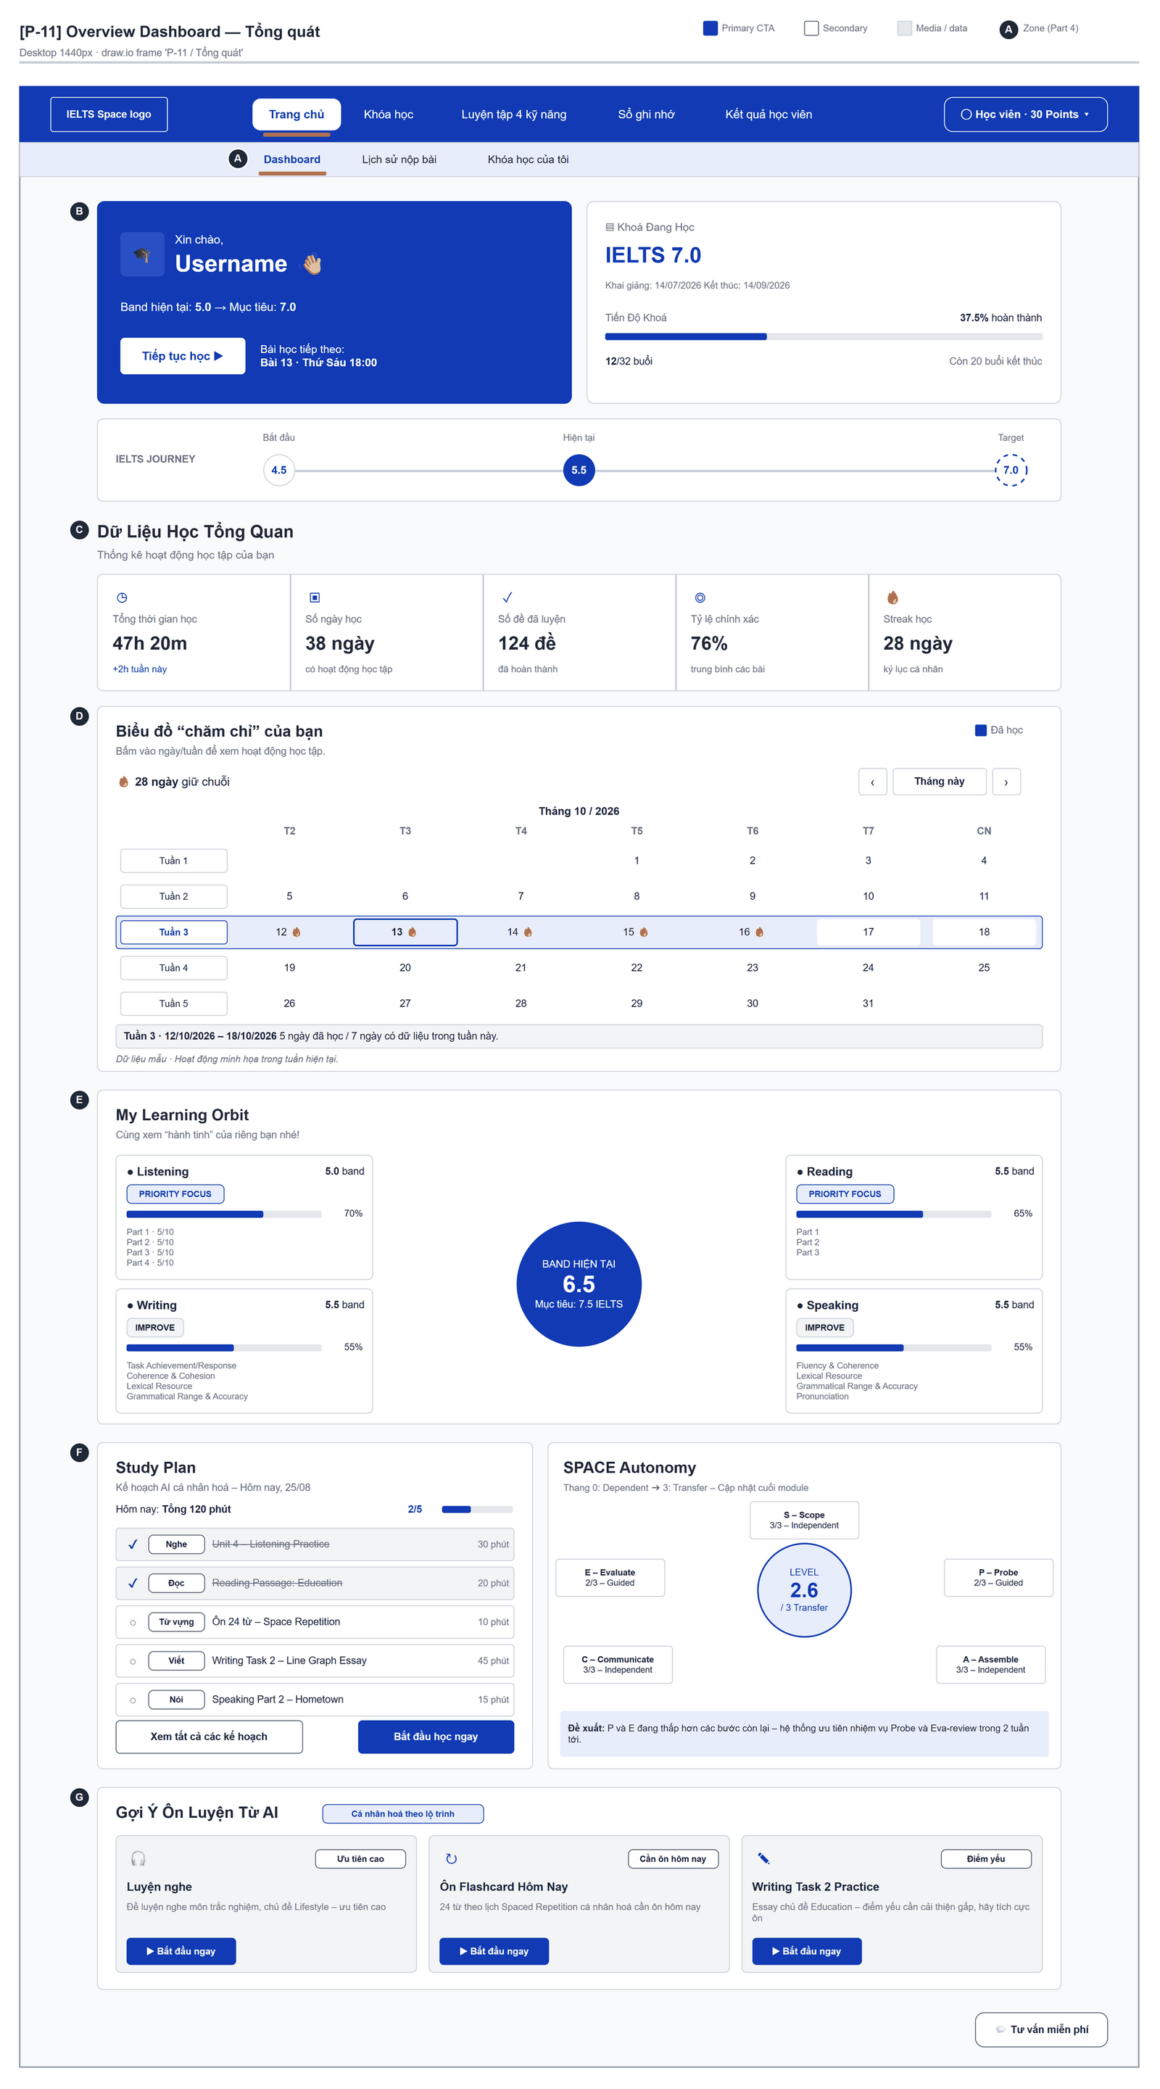
Figure 2.7-1 — Overview — Tổng quát. Source: wireframes/screens/P-11_OverviewDashboard.drawio, tab “P-11 / Tổng quát”
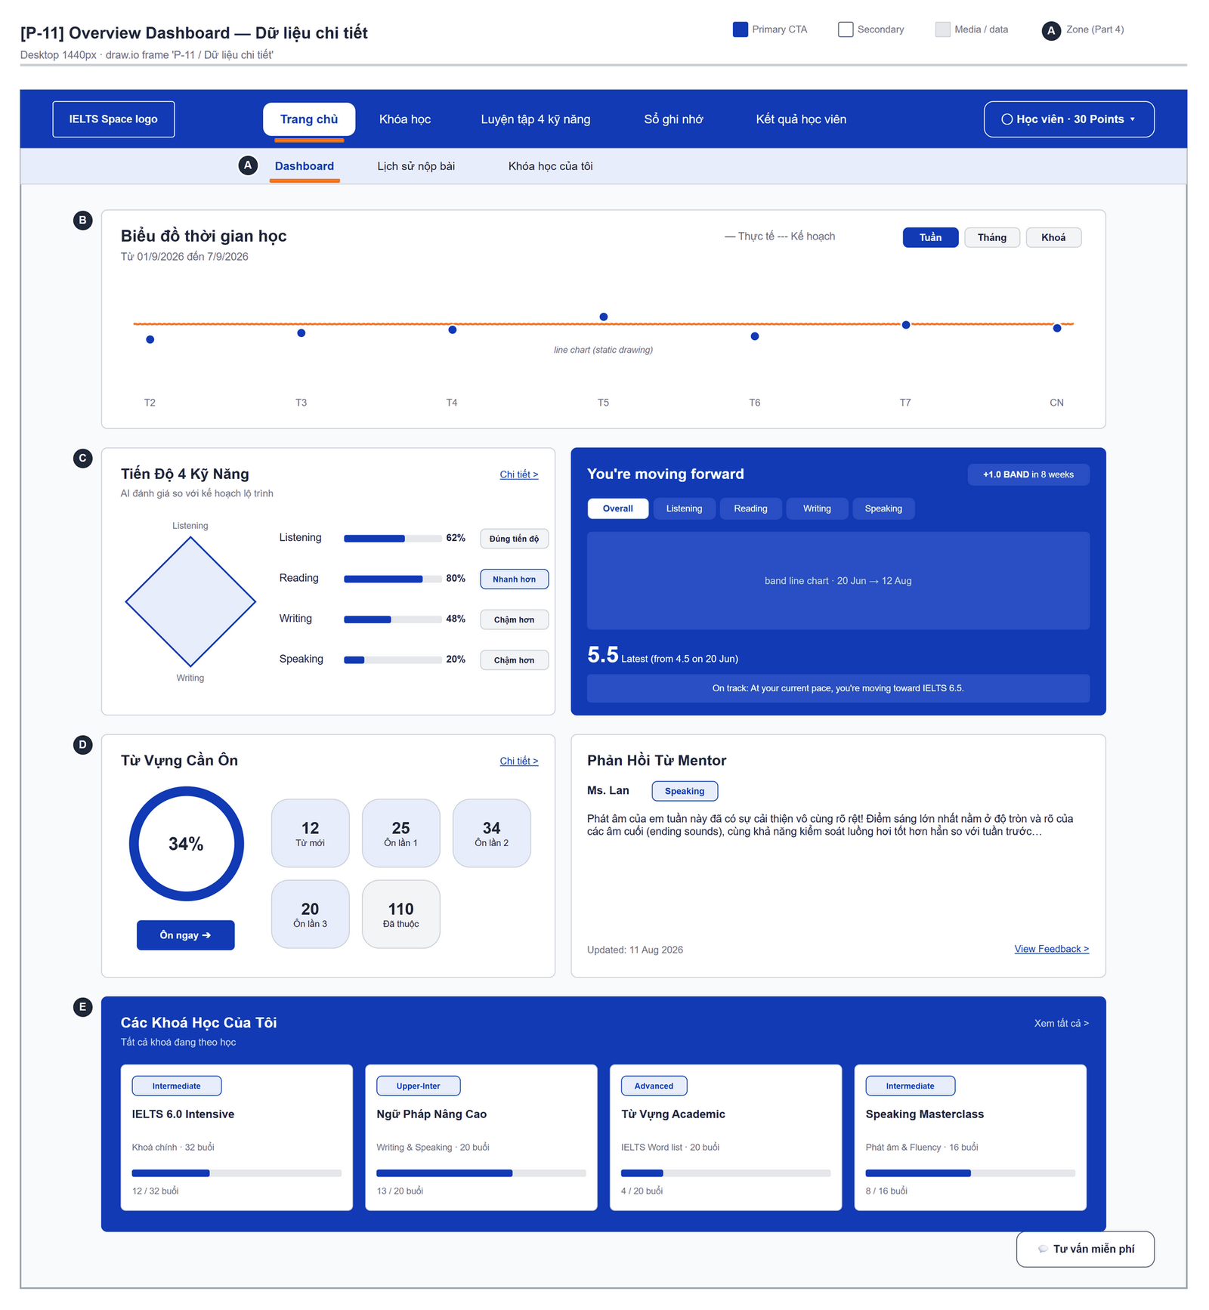
Figure 2.7-2 — Overview — Dữ liệu chi tiết. Source: wireframes/screens/P-11_OverviewDashboard.drawio, tab “P-11 / Dữ liệu chi tiết”
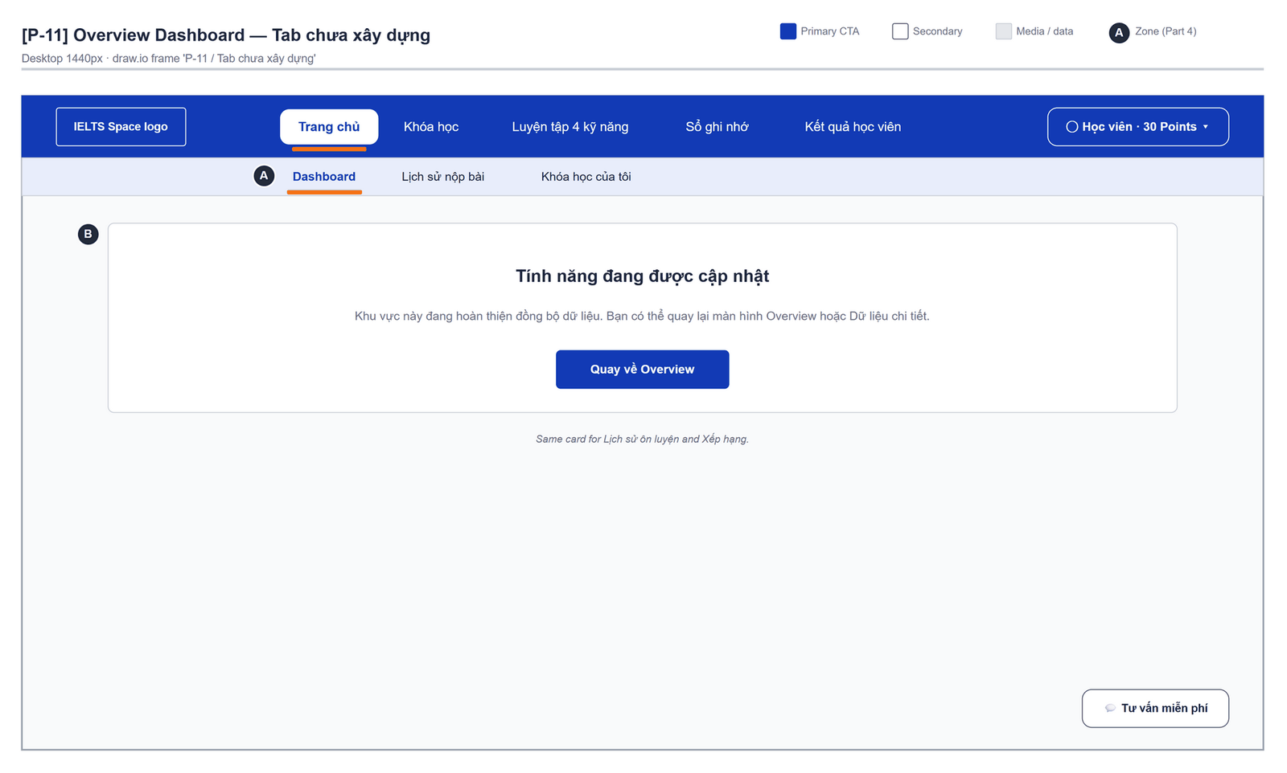
Figure 2.7-3 — Overview — Tab chưa xây dựng. Source: wireframes/screens/P-11_OverviewDashboard.drawio, tab “P-11 / Tab chưa xây dựng”
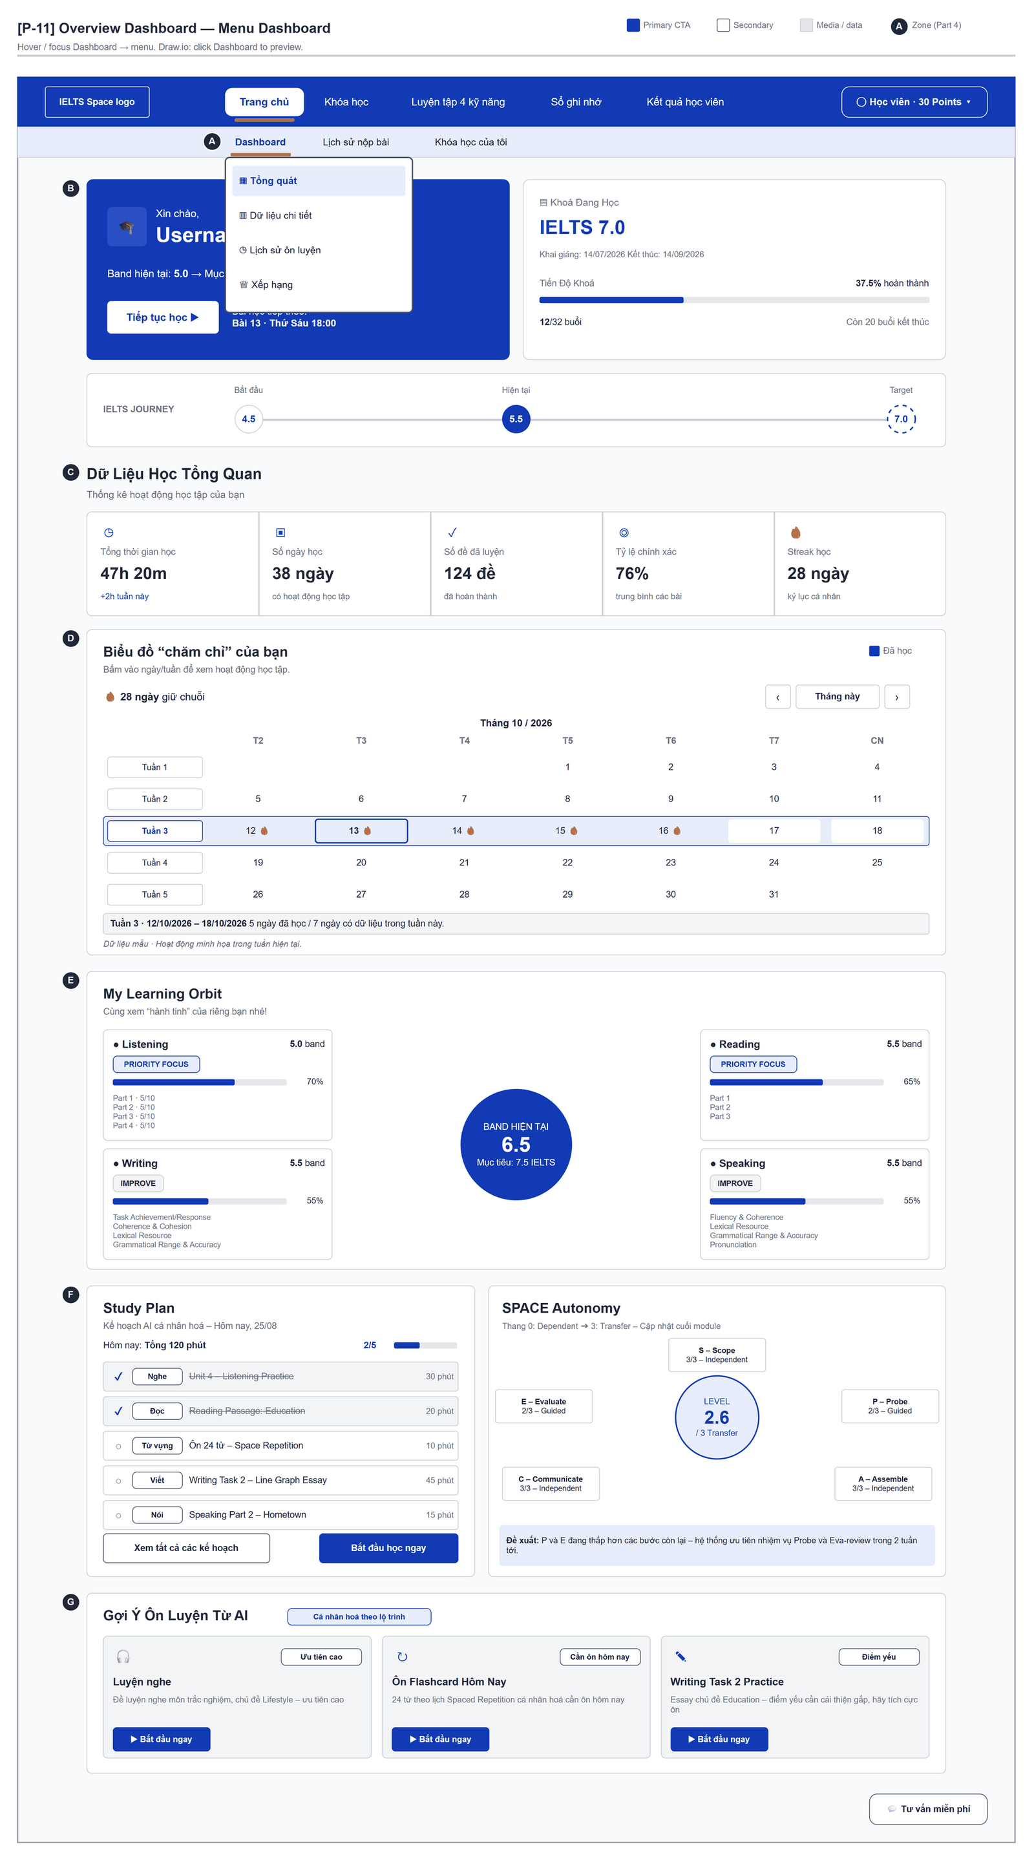
Figure 2.7-4 — Overview — Menu Dashboard. Source: wireframes/screens/P-11_OverviewDashboard.drawio, tab “P-11 / Menu Dashboard”

Navigation Context
Navigates from | Condition / Trigger
Browser | Signed-in user opens "/"
Top bar | User opens "Trang chủ" → "Dashboard"

Navigates to | Condition / Trigger
Practice Test Catalog | User clicks "Tiếp tục học", "Bắt đầu học ngay" or "Bắt đầu ngay"
Selected route | User picks an item in the top bar

2.7.2 Entry & Exit Conditions

Preconditions & Guard Redirects
# | Condition check | If met | If not met → Action
PC-01 | Session exists (RequireAuth, GG-01) | Continue rendering | Redirect → /login (state.from kept); GLB-01

Entry Triggers
# | Trigger | From screen / Source | Parameters passed
ET-01 | Default route | Browser | —
ET-02 | Top bar | Any page | —

Exit Points
# | Event | Condition | Navigates to | Notes
EX-01 | User clicks "Tiếp tục học", "Bắt đầu học ngay" or "Bắt đầu ngay" | Any | Practice Test Catalog | /practice-tests
EX-02 | User picks an item in the top bar (SiteNavbar) | Any | Selected route | No unsaved-change prompt
EX-03 | Session expires, silent refresh fails | Refresh token used, expired or revoked | Login | GLB-01; returnUrl kept

2.7.3 UI Components
Code | Component name | Type | Validation / Constraint | Notes
Overview-TAB-01 | Dashboard menu | Hover popup directly below Dashboard | One active section, default Tổng quát | "Tổng quát" · "Dữ liệu chi tiết" · "Lịch sử ôn luyện" · "Xếp hạng"
Overview-PNL-01 | Hero banner | Banner | Tab Tổng quát | "Xin chào," {username} 👋 · "Band hiện tại: {band} → Mục tiêu: {target}" · "Bài học tiếp theo:" {next lesson}
Overview-BTN-01 | Tiếp tục học | Primary button | — | Opens /practice-tests
Overview-CRD-01 | Khoá Đang Học | Card + progress bar | — | {course} · "Khai giảng: {date}" · "Kết thúc: {date}" · "Tiến Độ Khoá {p}% hoàn thành" · "{n}/{total} buổi" · "Còn {r} buổi kết thúc"
Overview-PRG-01 | IELTS JOURNEY | Band timeline | — | Nodes "Bắt đầu" {start band} → "Hiện tại" {band} → "Target" {target band}
Overview-CRD-02 | Dữ Liệu Học Tổng Quan | Five stat cards | — | "Tổng thời gian học" (+ change this week), "Số ngày học", "Số đề đã luyện", "Tỷ lệ chính xác", "Streak học" ({n} ngày)
Overview-PNL-02 | Biểu đồ “chăm chỉ” của bạn | Month calendar (Mon–Sun, week rows) | Opens on the current month | "Bấm vào ngày/tuần để xem hoạt động học tập." · legend "Đã học" · "{n} ngày giữ chuỗi" · caption "Tháng {m} / {yyyy}"; a studied day shows a flame, today is highlighted
Overview-BTN-02 | Tháng trước · Tháng này · Tháng sau | Icon / text buttons | — | Change the month shown and clear the selection
Overview-BTN-03 | Day cell · "Tuần {n}" | Toggle buttons | — | Select one day or the whole week; the detail line below the calendar explains it
Overview-TXT-01 | Calendar detail | Text (aria-live) | — | "Chọn một ngày hoặc tuần để xem chi tiết." · "Dữ liệu mẫu · Hoạt động minh họa trong tuần hiện tại."
Overview-PNL-03 | My Learning Orbit | Band centre + four skill cards | — | "BAND HIỆN TẠI"; per skill: band, tag PRIORITY FOCUS / IMPROVE, progress %, IELTS parts or criteria
Overview-PNL-04 | Study Plan | Task list | — | "Kế hoạch AI cá nhân hoá – Hôm nay, {dd/MM}" · "Hôm nay: Tổng {n} phút" · {done}/{total}; each task: skill tag, title, minutes; buttons "Xem tất cả các kế hoạch", "Bắt đầu học ngay"
Overview-PNL-05 | SPACE Autonomy | Level badge + five nodes | — | "Thang 0: Dependent ➔ 3: Transfer" · "LEVEL {x} / 3 Transfer" · nodes S, P, A, C, E · "Đề xuất:" text
Overview-PNL-06 | Gợi Ý Ôn Luyện Từ AI | Three suggestion cards | — | "Cá nhân hoá theo lộ trình"; each card: badge, title, description, "Bắt đầu ngay"
Overview-PNL-07 | Biểu đồ thời gian học | Line chart | Tab Dữ liệu chi tiết | "Thực tế" vs "Kế hoạch" per day T2–CN; filter pills "Tuần" / "Tháng" / "Khoá"
Overview-PNL-08 | Tiến Độ 4 Kỹ Năng | Radar + skill bars | Tab Dữ liệu chi tiết | "AI đánh giá so với kế hoạch lộ trình"; per skill: % and status tag; "Chi tiết >"
Overview-PNL-09 | You're moving forward | Band line chart | Tab Dữ liệu chi tiết | "+{x} BAND in {n} weeks" · pills Overall / Listening / Reading / Writing / Speaking · latest band · "On track: …"
Overview-PNL-10 | Từ Vựng Cần Ôn | Donut + five counters | Tab Dữ liệu chi tiết | % learned · "Ôn ngay ➔" · Từ mới, Ôn lần 1, Ôn lần 2, Ôn lần 3, Đã thuộc
Overview-PNL-11 | Phản Hồi Từ Mentor · Các Khoá Học Của Tôi | Comment card · course cards | Tab Dữ liệu chi tiết | Mentor, skill tag, comment, "Updated: {date}", "View Feedback >" · "Tất cả khoá đang theo học", "Xem tất cả >"
Overview-PNL-12 | Other tabs | Placeholder card | Lịch sử ôn luyện, Xếp hạng | "Tính năng đang được cập nhật" · button "Quay về Overview"

2.7.4 API Calls & Data Flow
# | Trigger (UI event) | API ID | Method + Path | Request | Success → UI action | Error → UI action
1 | Page load | — | No API (mock data) | mocks/overviewData.ts | Render cards | —

2.7.5 Interaction Specifications

Data source
All numbers are mock data. When wired, study time and streak come from user-service (activity.list, streak.get), skill progress from learn.mastery, and the current band and course from the placement result and learn.courses (OQ-17).

Activity calendar
The fixture only has a status per weekday, so only the current week (Monday to Sunday) has data; other days read "Chưa có dữ liệu cho ngày này."
One day selected: "Đã học — có trong chuỗi tuần này." / "Chưa học." / "Ngày học sắp tới."
A week selected: "{x} ngày đã học / {y} ngày có dữ liệu trong tuần này.", or "Chưa có dữ liệu cho tuần này."
Changing the month clears the selection.

Study Plan
Clicking a task ticks or unticks it in the page only; nothing is saved and a reload restores the fixture.
"Xem tất cả các kế hoạch" has no action yet.

Tab Dữ liệu chi tiết
The Tuần / Tháng / Khoá pills and the skill pills only change the active pill; the charts are fixed drawings.
"Chi tiết >", "Ôn ngay ➔", "View Feedback >" and "Xem tất cả >" have no action yet.

Tabs
Lịch sử ôn luyện and Xếp hạng show the placeholder; "Quay về Overview" returns to Tổng quát. The tab is kept in page state, not in the URL.

2.7.6 Messages & Display Content
Code | Type | Trigger condition | Content (UI copy) | Action / Duration
MSG-01 | Info Text | Calendar | "Dữ liệu mẫu · Hoạt động minh họa trong tuần hiện tại." | Below the calendar
MSG-02 | Info Panel | Tab not built | "Tính năng đang được cập nhật" · "Khu vực này đang hoàn thiện đồng bộ dữ liệu. Bạn có thể quay lại màn hình Overview hoặc Dữ liệu chi tiết." | Main area
MSG-03 | Empty State | Design target: no activity | "Chưa có dữ liệu học tập." | —

2.7.7 Business Rules
BR/BV Code | Short description | UI behaviour when violated
BR-27 | Personal data visible only to its owner | Design target when the APIs are wired

2.8 Course List

2.8.1 General Information
Screen Name | Course List
Purpose | Shows every band-level course with the learner's progress, puts forward the course to continue or the one the placement recommends, and leads to a course's topic path or to the placement test.
Route / Type | /learn · RequireAuth (index of the learning area)
Role(s) | Signed-in learner
Related FT / UC | FT-20, FT-35, FT-55  UC-036–UC-037 View learning path; UC-035 View and choose courses
Status | Specified (placement card link: FG-15)
Frontend | Built — features/learning-path/pages/CourseListPage.tsx inside LearnLayout (route /learn); calls the real backend.
Mockup / Wireframe | Figure 2.8-1 to 2.8-4 below — draw.io wireframes in docs/wireframes/screens (P-30_CourseList.drawio), one tab per state; clickable prototype: docs/wireframes/IELTSPath_Prototype.drawio
Open Questions | OQ-21, OQ-22 (Appendix B)

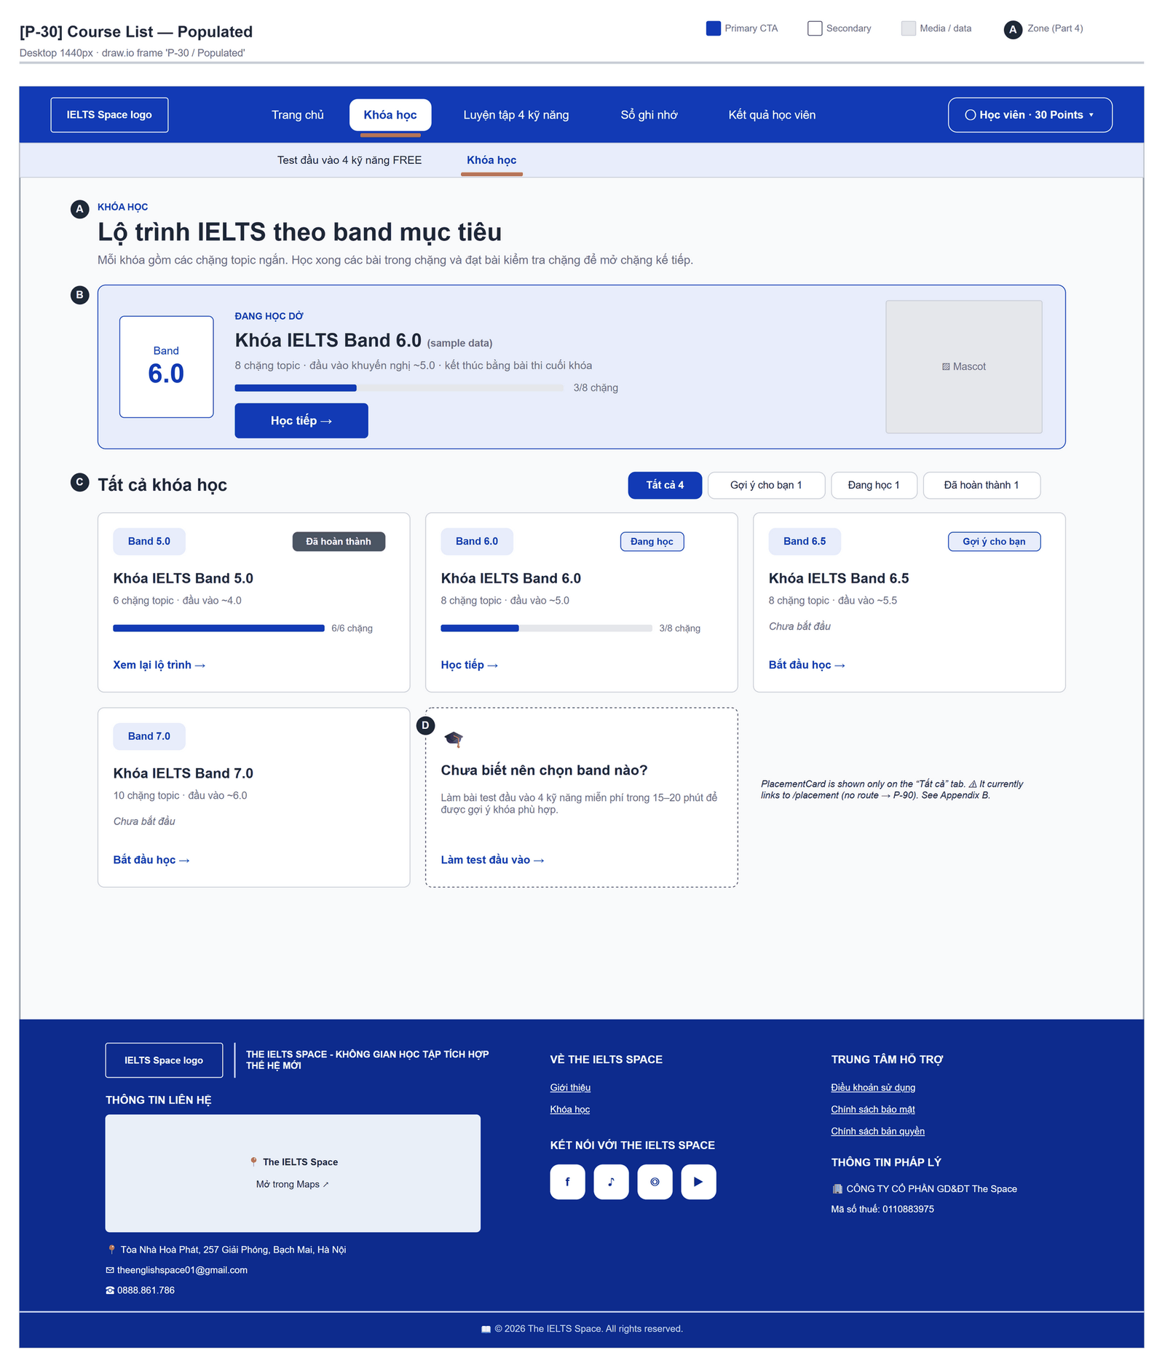
Figure 2.8-1 — Course List — Populated. Source: wireframes/screens/P-30_CourseList.drawio, tab “P-30 / Populated”
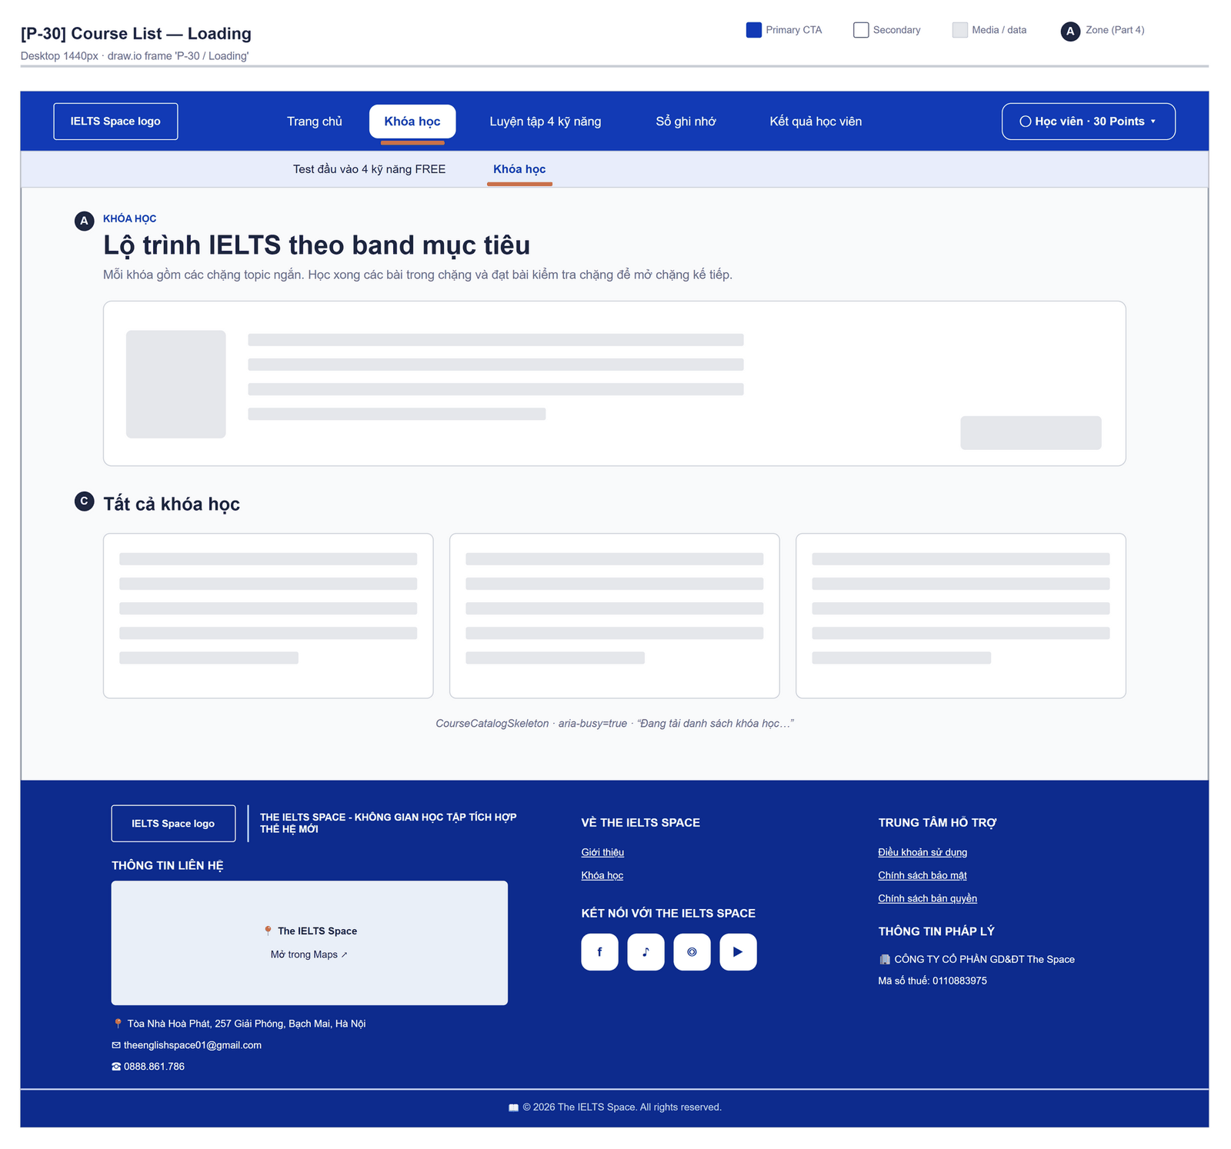
Figure 2.8-2 — Course List — Loading. Source: wireframes/screens/P-30_CourseList.drawio, tab “P-30 / Loading”
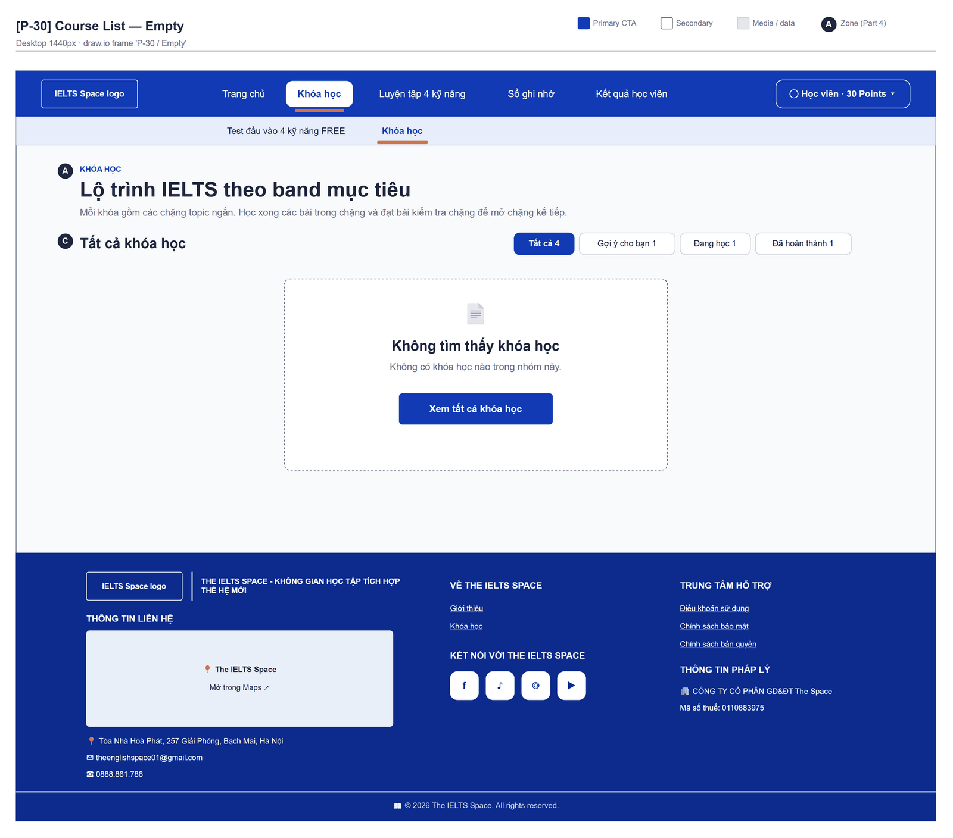
Figure 2.8-3 — Course List — Empty. Source: wireframes/screens/P-30_CourseList.drawio, tab “P-30 / Empty”
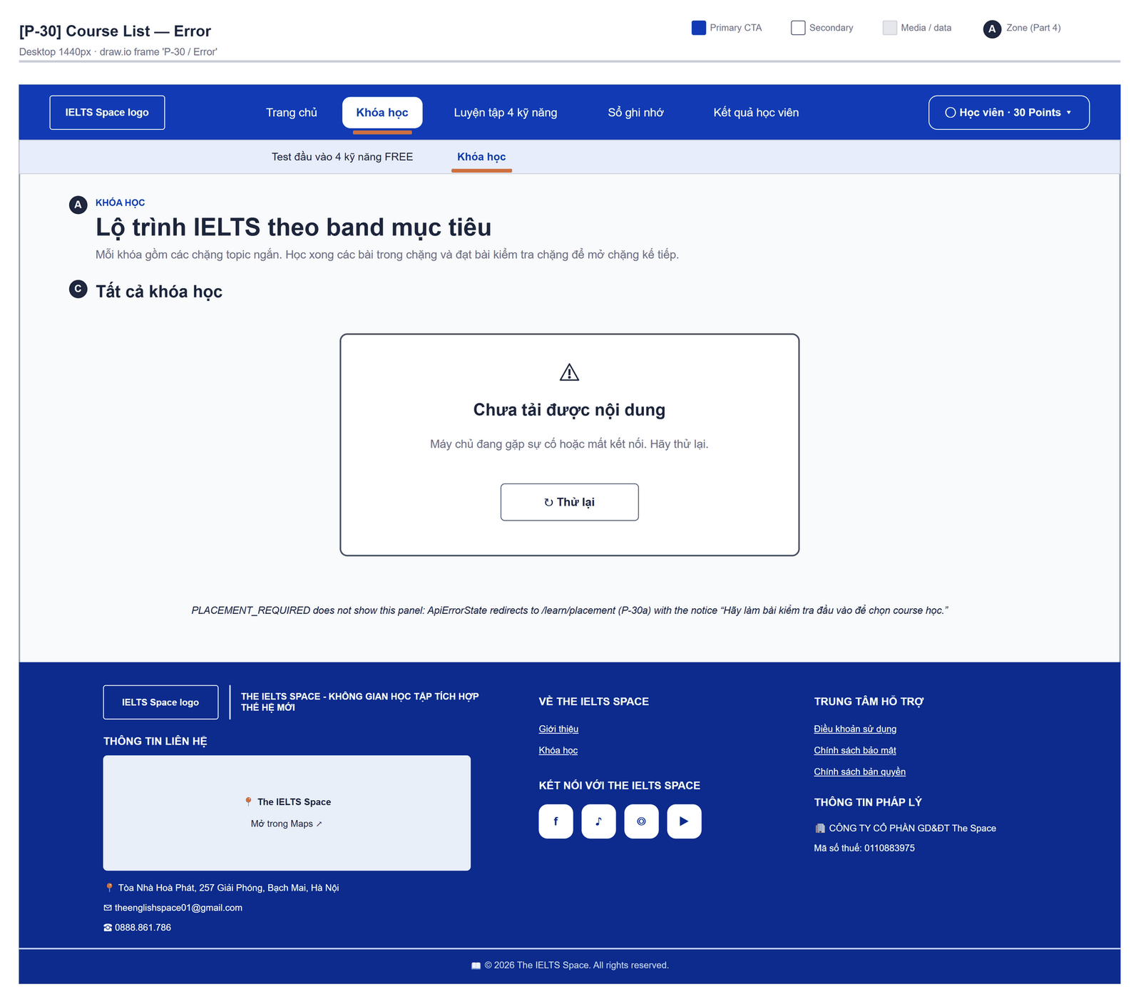
Figure 2.8-4 — Course List — Error. Source: wireframes/screens/P-30_CourseList.drawio, tab “P-30 / Error”

Navigation Context
Navigates from | Condition / Trigger
Login / Register | Sign-in without a stored route
Top bar | User clicks "Khóa học" or "Khóa học của tôi"
Course Path, Test Result | User clicks "Tất cả khóa học" / "Xem danh sách khóa"
Placement Test | Placement already taken (PLACEMENT_ALREADY_DONE)

Navigates to | Condition / Trigger
Course Path | User clicks the spotlight button or a course card
Placement Test | User clicks the card "Chưa biết nên chọn band nào?" (wrong link today: FG-15)

2.8.2 Entry & Exit Conditions

Preconditions & Guard Redirects
# | Condition check | If met | If not met → Action
PC-01 | Session exists (RequireAuth, GG-01) | Continue rendering | Redirect → /login (state.from kept); GLB-01

Entry Triggers
# | Trigger | From screen / Source | Parameters passed
ET-01 | Sign-in | Login | —
ET-02 | Top bar | Any page | —
ET-03 | Lock redirect | Learning pages | Router state notice (GLB-09)

Exit Points
# | Event | Condition | Navigates to | Notes
EX-01 | User clicks a course | Any course (all are open) | Course Path | /learn/courses/{courseId}
EX-02 | User clicks the placement card | Filter Tất cả | NotFoundPage today; design target Placement Test | FG-15
EX-03 | User picks an item in the top bar (SiteNavbar) | Any | Selected route | No unsaved-change prompt
EX-04 | Session expires, silent refresh fails | Refresh token used, expired or revoked | Login | GLB-01; returnUrl kept

2.8.3 UI Components
Code | Component name | Type | Validation / Constraint | Notes
CourseList-PNL-01 | Page header | Header | — | Eyebrow "Khóa học" · "Lộ trình IELTS theo band mục tiêu" · "Mỗi khóa gồm các chặng topic ngắn. Học xong các bài trong chặng và đạt bài kiểm tra chặng để mở chặng kế tiếp."
CourseList-CRD-01 | Spotlight | Card | Course in progress, else the recommended course, else the lowest band | Band ticket; label "Đang học dở" / "Gợi ý cho bạn" / "Gợi ý bắt đầu"; "{n} chặng topic · đầu vào khuyến nghị ~{band} · kết thúc bằng bài thi cuối khóa"; progress "{passed}/{n} chặng"
CourseList-BTN-01 | Spotlight action | Button (Accent) | — | "Bắt đầu học" / "Học tiếp" / "Làm bài thi cuối khóa" / "Xem lại lộ trình" by course state
CourseList-TAB-01 | Lọc khóa học | Segmented buttons | Filters with no course are hidden | "Tất cả", "Gợi ý cho bạn", "Đang học", "Đã hoàn thành", each with a count
CourseList-CRD-02 | Course card | Card grid | Sorted by band level | "Band {x.x}", title, "{n} chặng topic · đầu vào ~{band}", progress or "Chưa bắt đầu", chip "Đã hoàn thành" / "Sẵn sàng thi cuối" / "Đang học" / "Gợi ý cho bạn", action label
CourseList-CRD-03 | Placement card | Card | Shown with the Tất cả filter | "Chưa biết nên chọn band nào?" · "Làm bài test đầu vào 4 kỹ năng miễn phí trong 15–20 phút để được gợi ý khóa phù hợp." · "Làm test đầu vào"
CourseList-PNL-02 | Notice banner | Banner | — | Redirect notice (GLB-09)

2.8.4 API Calls & Data Flow
# | Trigger (UI event) | API ID | Method + Path | Request | Success → UI action | Error → UI action
1 | Page load | API-117 | GET /api/learning/courses | — | Render spotlight and cards · loading: course skeleton | GLB-04 / GLB-05 panel with "Thử lại"

2.8.5 Interaction Specifications

Course state
In progress = passedTopicCount > 0 AND testStatus ≠ PASSED
Action label = PASSED → "Xem lại lộ trình"; AVAILABLE → "Làm bài thi cuối khóa";
in progress → "Học tiếp"; else "Bắt đầu học"
Entry band = max(bandLevel − 1, 3.5)

Recommendation
recommended comes from the latest placement band (BR-36): the lowest course at or above it,
else the highest course. Without a placement nothing is recommended; every course stays open.

2.8.6 Messages & Display Content
Code | Type | Trigger condition | Content (UI copy) | Action / Duration
MSG-01 | Empty State | A filter has no course | Title "Không tìm thấy khóa học" · "Không có khóa học nào trong nhóm này." | Button "Xem tất cả khóa học"
MSG-02 | Loading | Page load | Skeleton "Đang tải danh sách khóa học…" | —

2.8.7 Business Rules
BR/BV Code | Short description | UI behaviour when violated
BR-35 | Courses are band levels shared by all skills, ordered by band | Cards sorted by band level
BR-36 | Placement only recommends a course | Chip "Gợi ý cho bạn"; no course is locked
BR-40 | Every ACTIVE course is open, with or without a placement result | All courses open; the placement card only suggests a course

2.9 Placement Test

2.9.1 General Information
Screen Name | Placement Test
Purpose | Lets a learner take the optional four-skill placement test once: three survey questions that save a learning goal, then the Listening, Reading, Writing and Speaking sections handed in one by one, then the wait while the essays are graded.
Route / Type | /learn/placement · RequireAuth (survey, test and grading steps)
Role(s) | Signed-in learner
Related FT / UC | FT-09, FT-35, FT-39  UC-011–UC-018 Manage profile and learning goal; UC-075–UC-078 Take placement test
Status | Specified (Speaking recordings not uploaded: FG-19)
Frontend | Built — features/learning-path/pages/PlacementPage.tsx with placement/ (PlacementSurvey, PlacementDashboard, ObjectiveSectionRunner, WritingSectionRunner, SpeakingSectionRunner) inside LearnLayout (route /learn/placement); calls the real backend.
Mockup / Wireframe | Figure 2.9-1 to 2.9-7 below — draw.io wireframes in docs/wireframes/screens (P-30a_Placement.drawio), one tab per state; clickable prototype: docs/wireframes/IELTSPath_Prototype.drawio
Open Questions | OQ-08 (Appendix B)

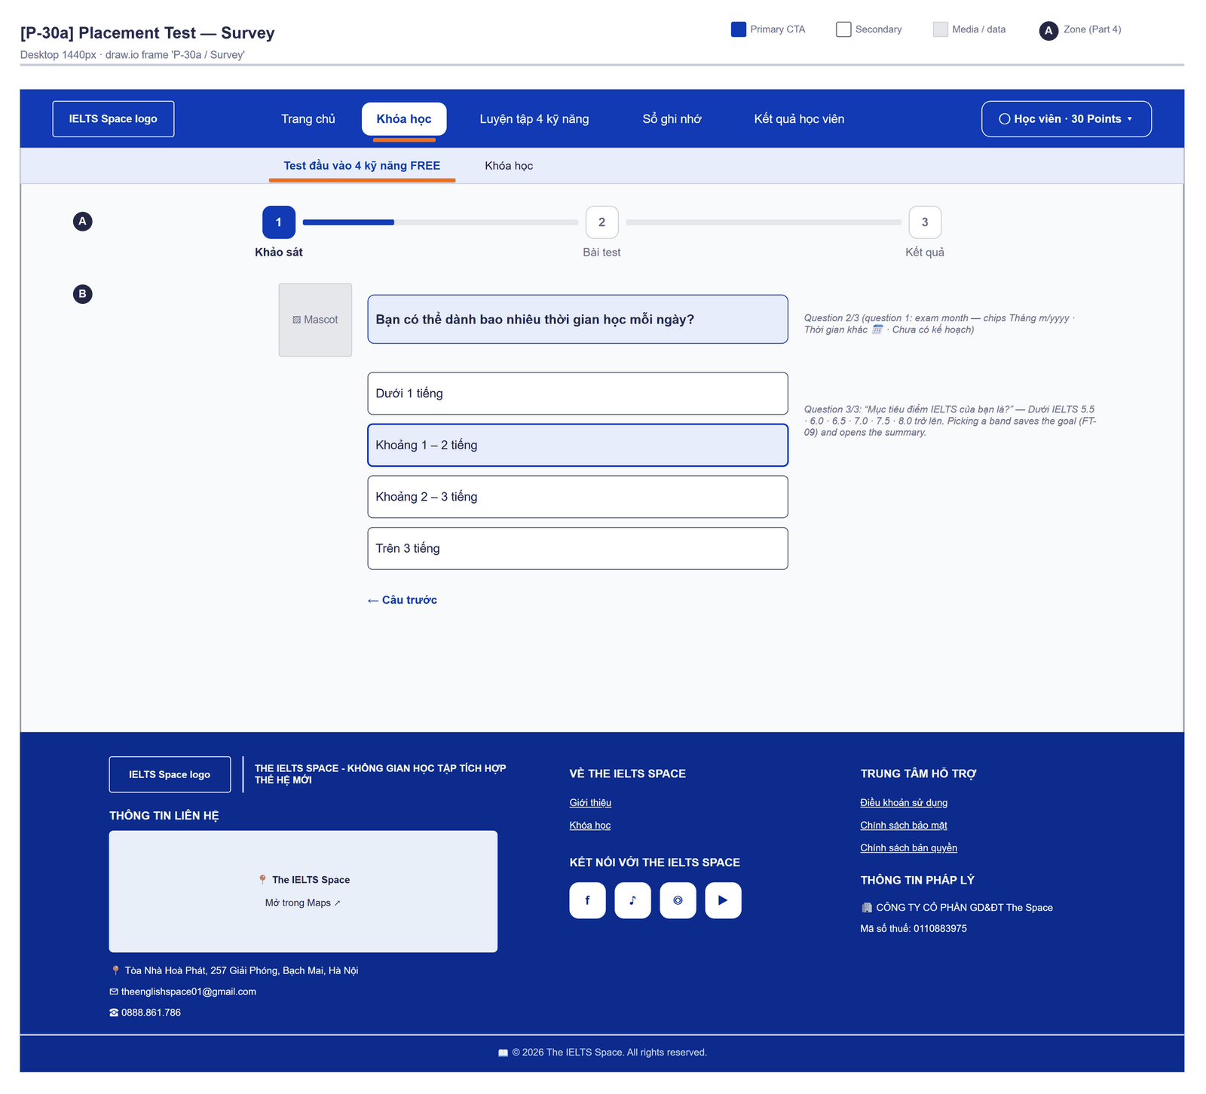
Figure 2.9-1 — Placement Test — Survey. Source: wireframes/screens/P-30a_Placement.drawio, tab “P-30a / Survey”
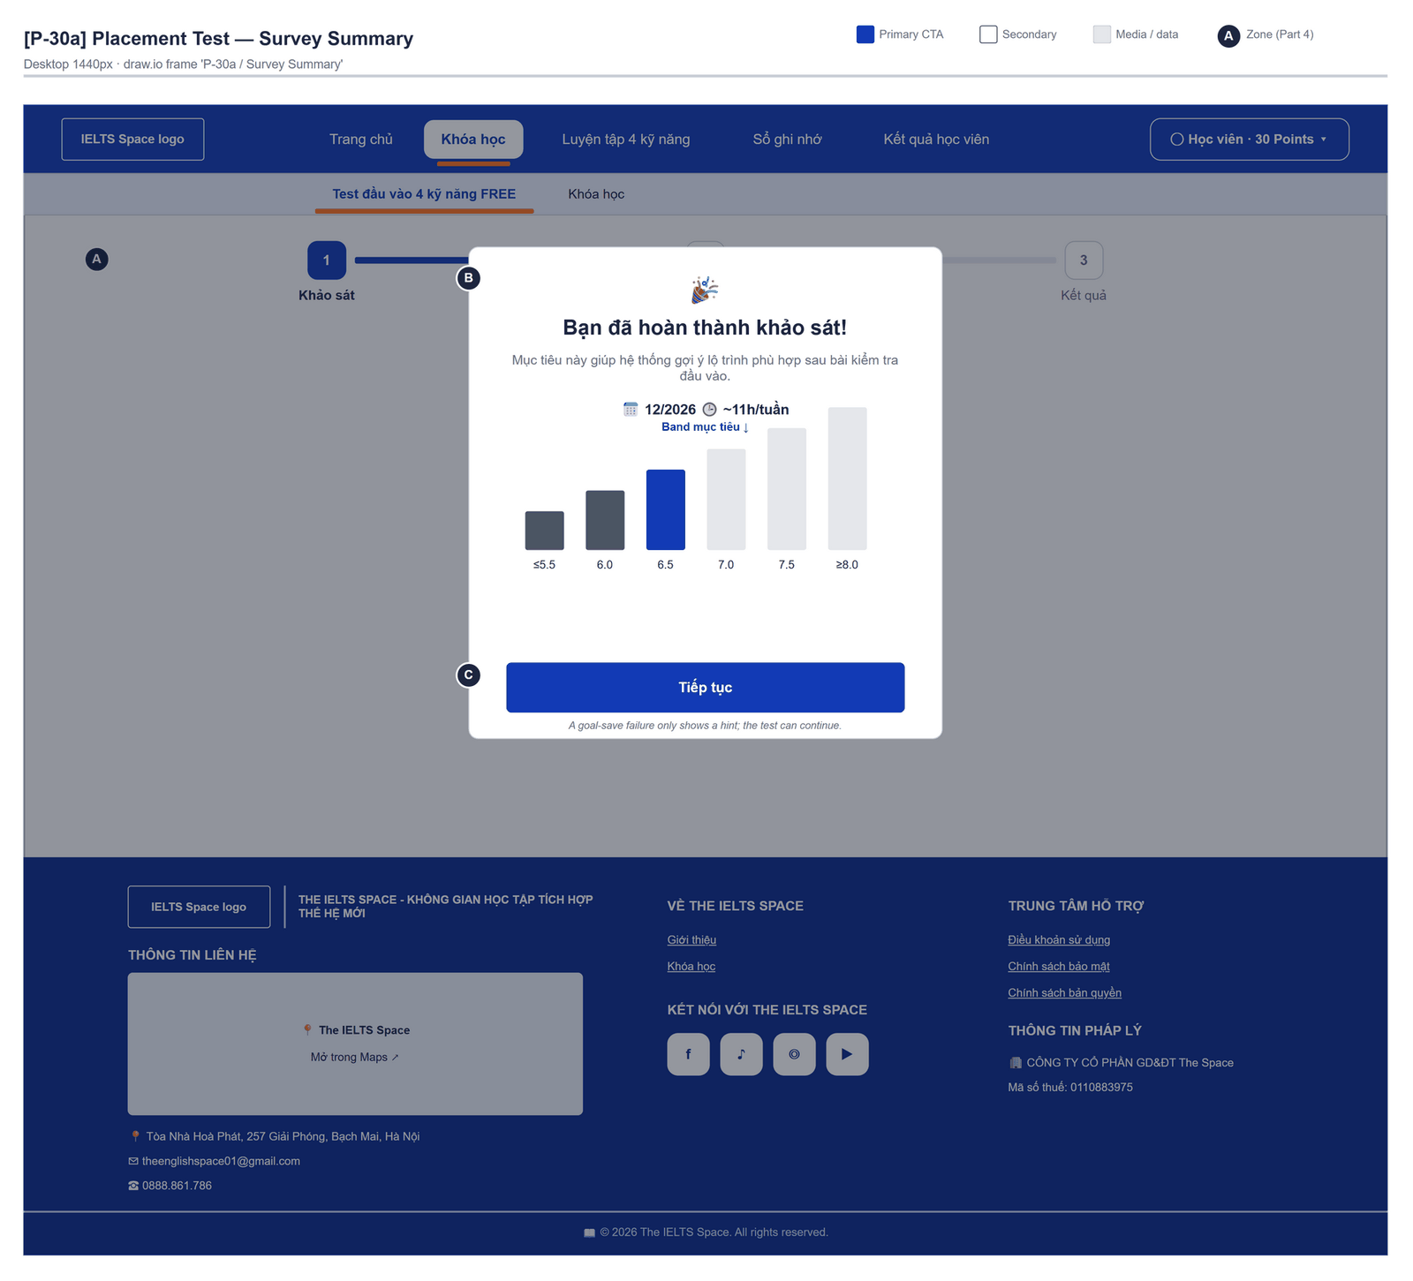
Figure 2.9-2 — Placement Test — Survey Summary. Source: wireframes/screens/P-30a_Placement.drawio, tab “P-30a / Survey Summary”
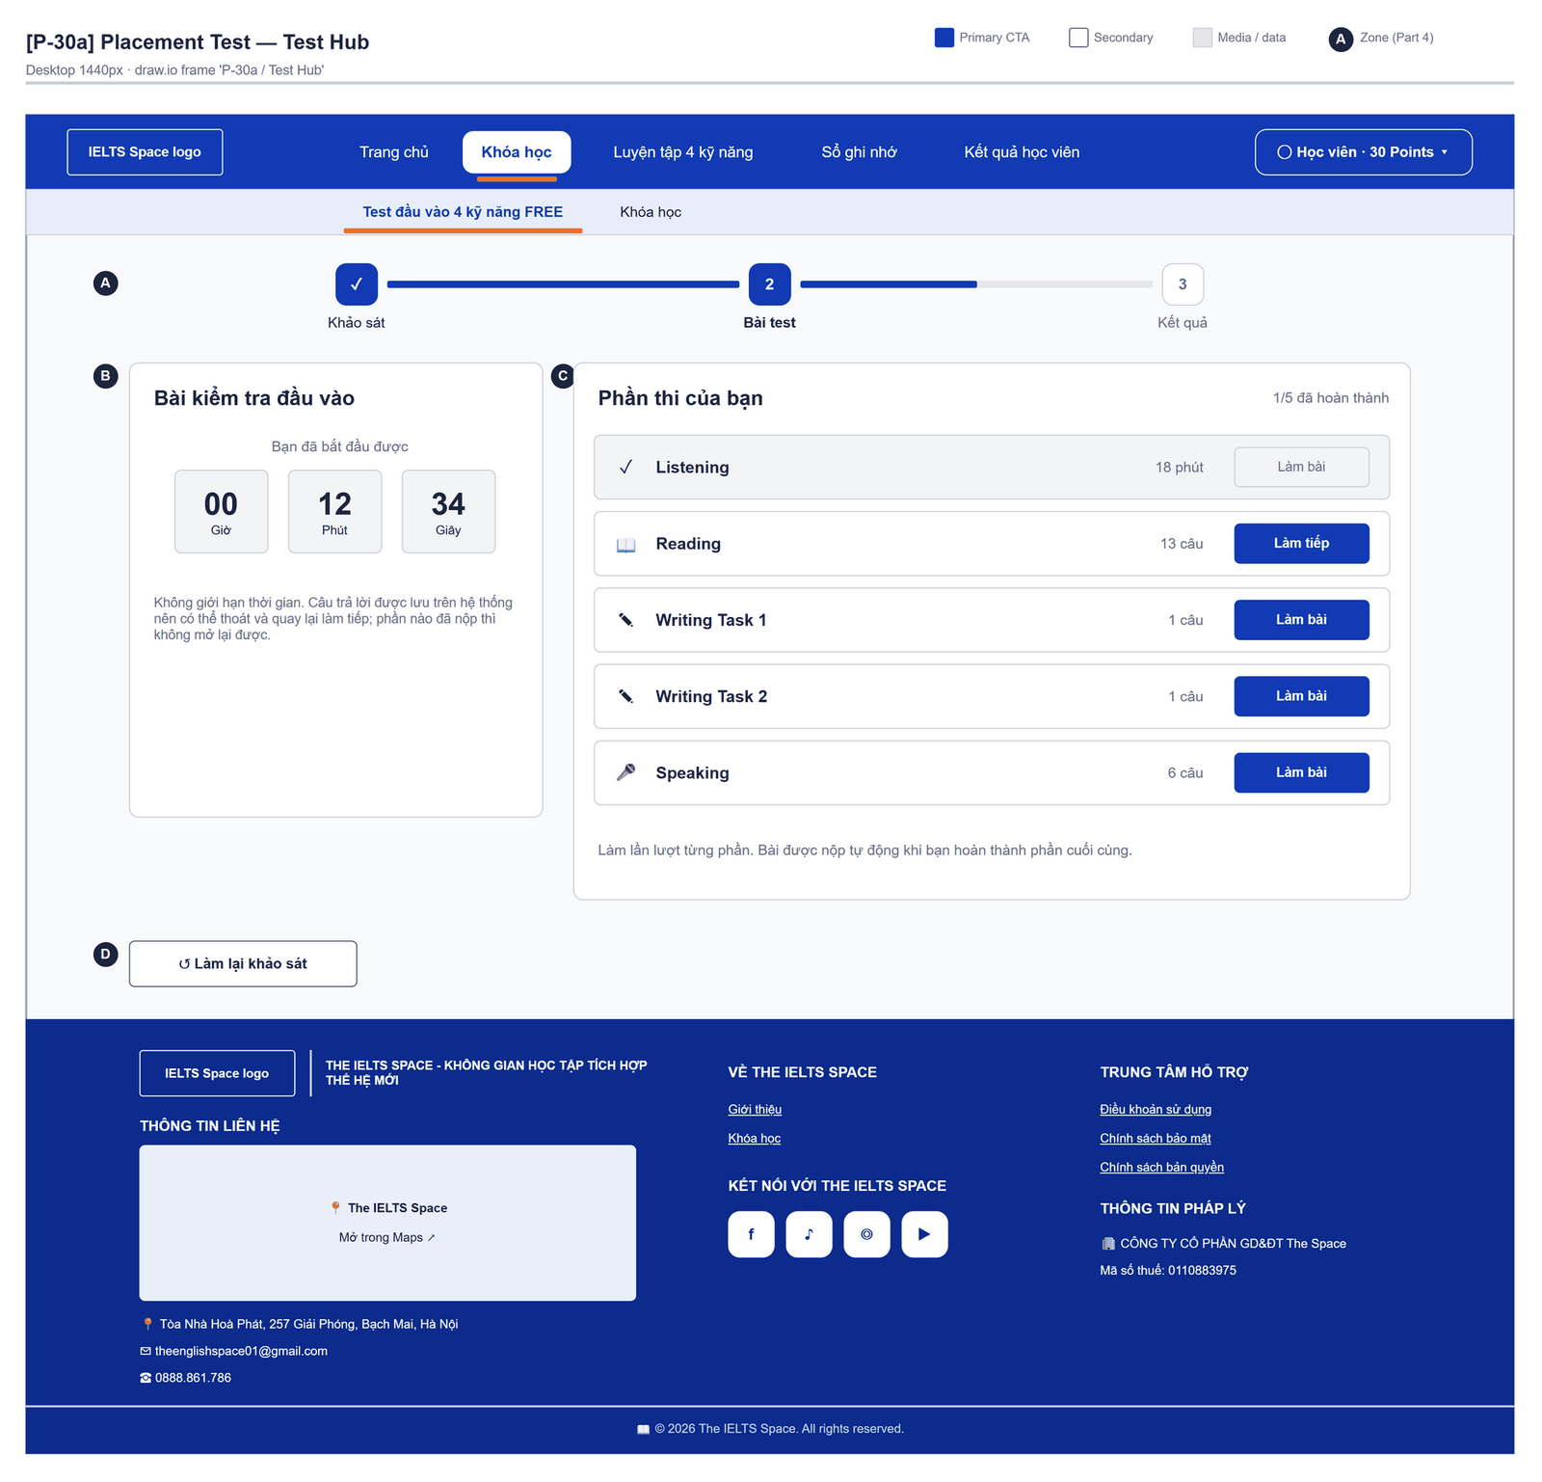
Figure 2.9-3 — Placement Test — Test Hub. Source: wireframes/screens/P-30a_Placement.drawio, tab “P-30a / Test Hub”
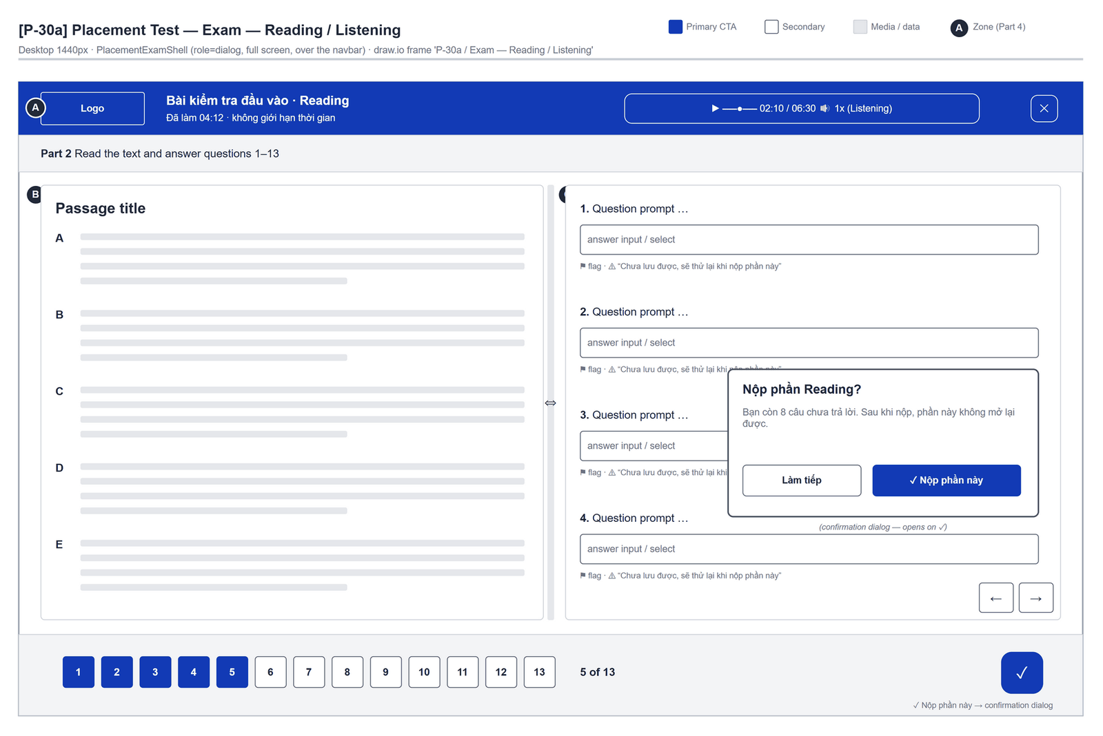
Figure 2.9-4 — Placement Test — Exam — Reading / Listening. Source: wireframes/screens/P-30a_Placement.drawio, tab “P-30a / Exam — Reading / Listening”
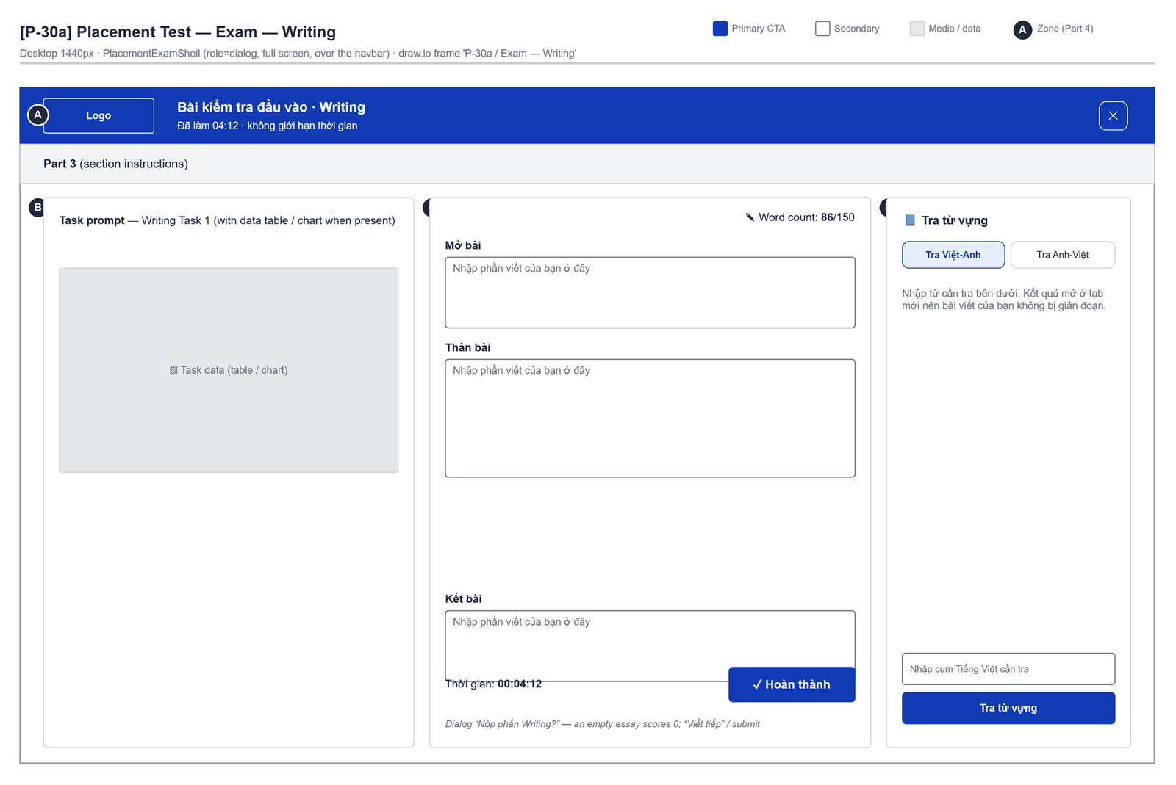
Figure 2.9-5 — Placement Test — Exam — Writing. Source: wireframes/screens/P-30a_Placement.drawio, tab “P-30a / Exam — Writing”
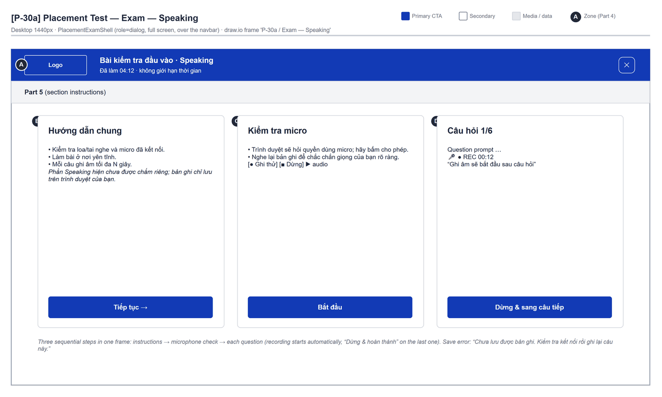
Figure 2.9-6 — Placement Test — Exam — Speaking. Source: wireframes/screens/P-30a_Placement.drawio, tab “P-30a / Exam — Speaking”
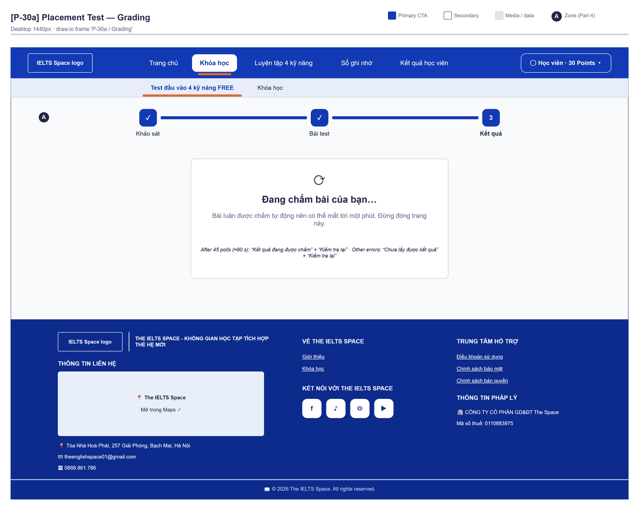
Figure 2.9-7 — Placement Test — Grading. Source: wireframes/screens/P-30a_Placement.drawio, tab “P-30a / Grading”

Navigation Context
Navigates from | Condition / Trigger
Top bar | User clicks "Test đầu vào 4 kỹ năng FREE"
Course List | Placement card (wrong link today: FG-15)

Navigates to | Condition / Trigger
Placement Report | Grading finished
Course List | Placement already taken and no attempt of the learner's own (PLACEMENT_ALREADY_DONE)

2.9.2 Entry & Exit Conditions

Preconditions & Guard Redirects
# | Condition check | If met | If not met → Action
PC-01 | Session exists (RequireAuth, GG-01) | Continue rendering | Redirect → /login (state.from kept); GLB-01
PC-02 | The learner has not finished a placement | Survey, or the open attempt | 409 PLACEMENT_ALREADY_DONE → redirect /learn
PC-03 | A PLACEMENT_TEST package is published | Continue | 404 NO_PLACEMENT_TEST → MSG-01

Entry Triggers
# | Trigger | From screen / Source | Parameters passed
ET-01 | Top bar | Any page | —
ET-02 | Resume | Learner comes back later | Open attempt from as.placementCurrent: IN_PROGRESS → test step; submitted → grading step

Exit Points
# | Event | Condition | Navigates to | Notes
EX-01 | User clicks Tiếp tục in the survey dialog | Attempt created or resumed | Test step (same route) | —
EX-02 | Last section handed in | Attempt submitted automatically | Grading step | —
EX-03 | Grading finished | Result available | Placement Report (same route) | —
EX-04 | User clicks Lưu và quay lại | Inside a section | Section list | Answers already saved
EX-05 | User picks an item in the top bar (SiteNavbar) | Any | Selected route | No unsaved-change prompt
EX-06 | Session expires, silent refresh fails | Refresh token used, expired or revoked | Login | GLB-01; returnUrl kept

2.9.3 UI Components
Code | Component name | Type | Validation / Constraint | Notes
PlacementTest-PRG-01 | Stepper | Steps | — | "Khảo sát" · "Bài test" · "Kết quả" with the progress of the current step
PlacementTest-PNL-01 | Survey question | Chat bubble with mascot | One question at a time | "Bạn dự định thi IELTS khi nào?" · "Bạn có thể dành bao nhiêu thời gian học mỗi ngày?" · "Mục tiêu điểm IELTS của bạn là?"; "Câu trước"
PlacementTest-BTN-01 | Exam month | Chips | Next six months, "Thời gian khác" (month input), "Chưa có kế hoạch" | Exam date = last day of the month; "Chưa có kế hoạch" sends no date
PlacementTest-BTN-02 | Study time | Option list | "Dưới 1 tiếng" 45, "Khoảng 1 – 2 tiếng" 90, "Khoảng 2 – 3 tiếng" 150, "Trên 3 tiếng" 210 minutes a day | —
PlacementTest-BTN-03 | Target band | Option list | "Dưới IELTS 5.5" (5.5) … "IELTS 8.0 trở lên" (8.0) | Saves the goal
PlacementTest-MDL-01 | Bạn đã hoàn thành khảo sát! | Dialog | — | Exam month, "~{h}h/tuần", band chart, button "Tiếp tục" ("Đang mở bài test…")
PlacementTest-PNL-02 | Bài kiểm tra đầu vào | Dashboard | — | "Bạn đã bắt đầu được {h} giờ {m} phút {s} giây"; "Không giới hạn thời gian. Câu trả lời được lưu trên hệ thống nên có thể thoát và quay lại làm tiếp; phần nào đã nộp thì không mở lại được."
PlacementTest-TBL-01 | Phần thi của bạn | Section list | Section order of the package (Reading, Listening, Writing Task 1, Writing Task 2, Speaking in the seed) | "{done}/{n} đã hoàn thành"; per section "{n} câu", time "{m} phút" or "Đã hoàn thành" once handed in, button "Làm bài" / "Làm tiếp"; "Làm lần lượt từng phần. Bài được nộp tự động khi bạn hoàn thành phần cuối cùng."
PlacementTest-BTN-04 | Làm lại khảo sát | Button (Outline) | Test step | Back to the survey; the attempt is kept
PlacementTest-PNL-03 | Listening / Reading section | Split view (passage or audio + questions) | — | "Chuyển nhanh tới câu hỏi", flag, "Câu trước" / "Câu tiếp theo", "Nộp phần này", "Lưu và quay lại"
PlacementTest-TXA-01 | Bài viết | Text Area per Writing task | Saved as the learner types | Placeholder "Nhập phần viết của bạn ở đây"; panel "Tra từ vựng" (opens a dictionary in a new tab, ≤ 50 characters)
PlacementTest-PNL-04 | Speaking | Recorder | Needs microphone permission | "Hướng dẫn chung", "Kiểm tra micro", recording starts after each question, "Dừng & sang câu tiếp" / "Dừng & hoàn thành"
PlacementTest-MDL-02 | Hand in a section | Confirm dialog | — | "Sau khi nộp, phần này không mở lại được." (+ unanswered count, or "Bài viết đang để trống nên sẽ tính 0 điểm.")
PlacementTest-PNL-05 | Grading | Status panel (aria-live) | — | MSG-07 / MSG-08 / "Chưa lấy được kết quả" + "Kiểm tra lại"

2.9.4 API Calls & Data Flow
# | Trigger (UI event) | API ID | Method + Path | Request | Success → UI action | Error → UI action
1 | Page load | API-140 | GET /api/assessments/attempts/placement/current | — (204 when none) | Choose the step | GLB-04 panel
2 | Page load | API-118 | GET /api/learning/placement-test | — | Keep packageVersionId | 409 PLACEMENT_ALREADY_DONE → /learn; 404 NO_PLACEMENT_TEST → MSG-01
3 | User picks a target band | API-17 | POST /api/users/me/learning-goals | {targetBand, examDate | null, availableMinutesPerDay} | Summary dialog | MSG-02 (the test can still start)
4 | User clicks Tiếp tục (no attempt yet) | API-138 | POST /api/assessments/attempts | {packageVersionId, mode: STANDARD, channel: WEB} | Test step (attempt type PLACEMENT) | MSG-03
5 | Test step load | API-144 | GET /api/assessments/attempts/{id}/structure | Path: attemptId | Sections and items | GLB-04 panel
6 | Test step load (parallel) | API-141 | GET /api/assessments/attempts/{id}/responses | Path: attemptId | Restore saved answers | GLB-04 panel
7 | User opens a section the first time | API-142 | POST /api/assessments/attempts/{id}/sections/{sectionId}/start | Path: attemptId, sectionId | Section clock starts | Ignored (the clock is only shown)
8 | Answer picked, essay typed, recording stopped | API-145 | PUT /api/assessments/attempts/{id}/items/{itemId}/response | {payload, schemaVersion, expectedRevision} | Save state | MSG-04
9 | Writing or Speaking section handed in | API-155 | POST /api/assessments/submissions | {attemptItemId, skill, textPayload | audioReference, promptSnapshot, submissionKey} | Essay queued for JOB-03 | MSG-05
10 | User hands in a section | API-143 | POST /api/assessments/attempts/{id}/sections/{sectionId}/complete | Path: attemptId, sectionId | Section closed | MSG-05
11 | Last section handed in | API-147 | POST /api/assessments/attempts/{id}/submit | Path: attemptId | Grading step | MSG-06
12 | Grading step, every 2 s, up to 45 times | API-149 | GET /api/assessments/attempts/{attemptId}/placement-result | Path: attemptId | 200 → Placement Report; 404 NOT_FOUND → keep waiting | Other error → "Chưa lấy được kết quả"

2.9.5 Interaction Specifications

Step on load
No attempt, or attempt EXPIRED / CANCELLED → survey
Attempt IN_PROGRESS → test step
Attempt submitted → grading step
No attempt of the learner's own AND PLACEMENT_ALREADY_DONE → redirect /learn

Sections
Each section is handed in on its own and is not reopened.
When the last section is handed in, the attempt is submitted automatically.
Speaking saves the recording length; the audio stays in the browser and only
local-recording:{attemptId}:{itemId} is sent (FG-19).

Grading wait
The result does not exist until every essay is graded and the attempt completes, so the placement result answers 404 NOT_FOUND meanwhile; the page polls it every 2 s and opens the report on the first 200.
After 45 checks (about 90 s) the slow panel shows; "Kiểm tra lại" starts polling again.

2.9.6 Messages & Display Content
Code | Type | Trigger condition | Content (UI copy) | Action / Duration
MSG-01 | Empty State | 404 NO_PLACEMENT_TEST | "Chưa có bài kiểm tra đầu vào nào được mở. Hãy quay lại sau." | —
MSG-02 | Info Text | Goal not saved | "Chưa lưu được mục tiêu lên hệ thống ({message}). Bạn vẫn có thể làm bài." | In the survey dialog
MSG-03 | Inline Error | Attempt not started | Server message + " Hãy thử lại." | In the survey dialog
MSG-04 | Inline Error | Answer, essay or recording not saved | "Chưa lưu được một số câu trả lời. Kiểm tra kết nối rồi nộp lại." / "Chưa lưu được bài viết. Kiểm tra kết nối rồi nộp lại." / "Chưa lưu được bản ghi. Kiểm tra kết nối rồi ghi lại câu này." | In the section
MSG-05 | Inline Error | Section not handed in | Server message + " Hãy nộp lại." | In the section
MSG-06 | Inline Error | Submit failed | Server message + " Hãy thử nộp lại." · "Bạn đã hoàn thành tất cả các phần nhưng bài chưa được nộp." | Buttons "Thử nộp lại" / "Nộp bài"
MSG-07 | Info Panel | Grading | "Đang chấm bài của bạn…" · "Bài luận được chấm tự động nên có thể mất tới một phút. Đừng đóng trang này." | Until graded
MSG-08 | Info Panel | Grading slow (after 45 checks) | "Kết quả đang được chấm" · "Việc chấm đang lâu hơn bình thường. Bài của bạn đã được nộp, hãy kiểm tra lại sau ít phút." | Button "Kiểm tra lại"

2.9.7 Business Rules
BR/BV Code | Short description | UI behaviour when violated
BR-36 | Optional, taken once; only recommends a course | Redirect when already taken; nothing locks
BR-41 | Per-skill bands; Writing by the LLM or 5.5; Speaking 5.5 for now; overall rounded to 0.5 | Shown on the Placement Report
BR-39 | Essays graded by the LLM (JOB-03) | Grading step (MSG-07)
BR-05 | At most one ACTIVE learning goal | A refused goal only shows MSG-02
BR-14 | Placement questions have purpose PLACEMENT | Authoring rule; no UI effect

2.10 Placement Report

2.10.1 General Information
Screen Name | Placement Report
Purpose | Reports the placement result — overall and skill bands against the learner's target band, how reachable the target is and the detail of every skill with the Writing feedback — and recommends a course.
Route / Type | /learn/placement · result step
Role(s) | Signed-in learner
Related FT / UC | FT-20, FT-35  UC-075–UC-078 Take placement test; UC-035 View and choose courses
Status | Specified
Frontend | Built — features/learning-path/pages/placement/PlacementResultView.tsx with ReportSkillPanels inside LearnLayout (route /learn/placement); calls the real backend.
Mockup / Wireframe | Figure 2.10-1 below — draw.io wireframes in docs/wireframes/screens (P-30a_Placement.drawio), one tab per state; clickable prototype: docs/wireframes/IELTSPath_Prototype.drawio

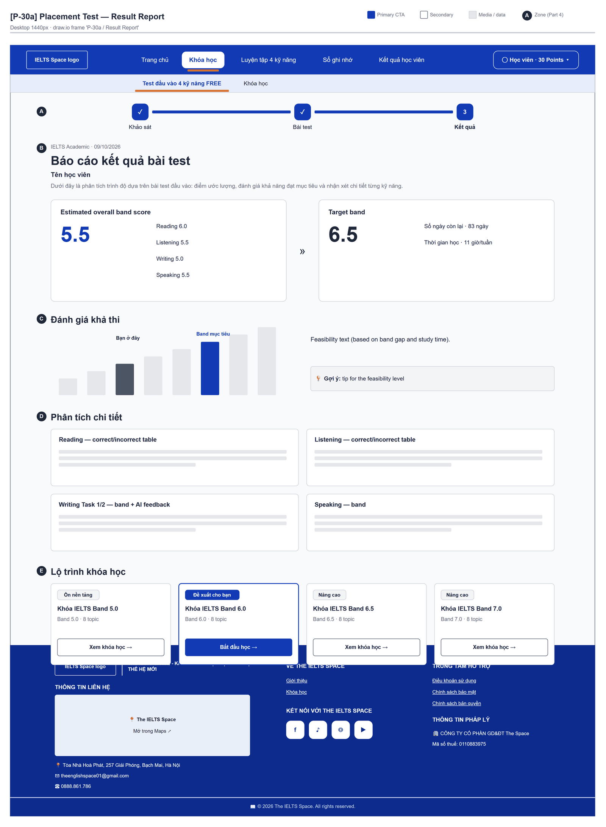
Figure 2.10-1 — Placement Report — Result Report. Source: wireframes/screens/P-30a_Placement.drawio, tab “P-30a / Result Report”

Navigation Context
Navigates from | Condition / Trigger
Placement Test | Grading finished, or the learner comes back after grading

Navigates to | Condition / Trigger
Course Path | User clicks "Bắt đầu học" (recommended course) or "Xem khóa học"

2.10.2 Entry & Exit Conditions

Preconditions & Guard Redirects
# | Condition check | If met | If not met → Action
PC-01 | Session exists (RequireAuth, GG-01) | Continue rendering | Redirect → /login (state.from kept); GLB-01
PC-02 | The placement attempt in the URL belongs to the signed-in user | Continue rendering | API returns 404 → redirect to previous screen; GLB-03

Entry Triggers
# | Trigger | From screen / Source | Parameters passed
ET-01 | Grading finished | Placement Test | attemptId

Exit Points
# | Event | Condition | Navigates to | Notes
EX-01 | User clicks a course | Any | Course Path | —
EX-02 | User picks an item in the top bar (SiteNavbar) | Any | Selected route | No unsaved-change prompt
EX-03 | Session expires, silent refresh fails | Refresh token used, expired or revoked | Login | GLB-01; returnUrl kept

2.10.3 UI Components
Code | Component name | Type | Validation / Constraint | Notes
PlacementReport-PNL-01 | Report header | Header | — | "IELTS Academic · {date}" · "Báo cáo kết quả bài test" · learner name · "Dưới đây là phân tích trình độ dựa trên bài test đầu vào…"
PlacementReport-CRD-01 | Estimated overall band score | Card | — | Overall band and one band per skill
PlacementReport-CRD-02 | Target band | Card | Needs a learning goal | Target band, "Số ngày còn lại" (or "Chưa chọn"), "Thời gian học {h} giờ/tuần"
PlacementReport-PNL-02 | Đánh giá khả thi | Band steps + advice | — | Tags "Bạn ở đây" and "Band mục tiêu"; advice text and "Gợi ý:" tip
PlacementReport-PNL-03 | Phân tích chi tiết | Skill panels | One per section | Reading / Listening: right and wrong questions; Writing Task 1 / Task 2: band and LLM feedback; Speaking: interim band
PlacementReport-CRD-03 | Lộ trình khóa học | Course cards | Sorted by band | "Đề xuất cho bạn" / "Ôn nền tảng" / "Nâng cao", "Band {x}", "{n} topic · đã qua {p}/{n}", "Bắt đầu học" / "Xem khóa học"

2.10.4 API Calls & Data Flow
# | Trigger (UI event) | API ID | Method + Path | Request | Success → UI action | Error → UI action
1 | Report load | API-149 | GET /api/assessments/attempts/{attemptId}/placement-result | Path: attemptId | Bands, sections and essays · loading: "Đang tải báo cáo…" | Error panel with "Thử lại"
2 | Report load (parallel) | API-117 | GET /api/learning/courses | — | Recommended course and course cards | Error panel
3 | Report load (parallel) | API-15 | GET /api/users/me/learning-goals/active | — | Target side of the report | 404 → report without a target

2.10.5 Interaction Specifications

Feasibility
The advice compares the overall band with the target band, the days left to the exam month and the weekly study hours of the goal; without a goal only the bands are shown.

Course badge
Recommended → "Đề xuất cho bạn"; lower band → "Ôn nền tảng"; higher band → "Nâng cao"; no recommendation → "Khóa học".

2.10.6 Messages & Display Content
Code | Type | Trigger condition | Content (UI copy) | Action / Duration
MSG-01 | Info Text | No section detail | "Chưa có dữ liệu chi tiết cho bài làm này." | —
MSG-02 | Loading | Report load | "Đang tải báo cáo…" | —

2.10.7 Business Rules
BR/BV Code | Short description | UI behaviour when violated
BR-36 | The placement band only recommends a course | Badge "Đề xuất cho bạn"; every course stays open
BR-41 | Overall band = mean of the skill bands rounded to 0.5 | Overall card

2.11 Course Path

2.11.1 General Information
Screen Name | Course Path
Purpose | Shows the topics of one course as an ordered route with each topic's status and lesson progress, ending with the course final test, so the learner knows which topic to study next.
Route / Type | /learn/courses/:courseId · RequireAuth
Role(s) | Signed-in learner
Related FT / UC | FT-13, FT-20, FT-28, FT-55  UC-036–UC-037 View learning path; UC-060 Take course test
Status | Specified (course test error codes: FG-16; Premium lock: Draft)
Frontend | Built — features/learning-path/pages/TopicListPage.tsx inside LearnLayout (route /learn/courses/:courseId); calls the real backend.
Mockup / Wireframe | Figure 2.11-1 to 2.11-3 below — draw.io wireframes in docs/wireframes/screens (P-30b_TopicList.drawio), one tab per state; clickable prototype: docs/wireframes/IELTSPath_Prototype.drawio
Open Questions | OQ-04, OQ-21, OQ-22 (Appendix B)

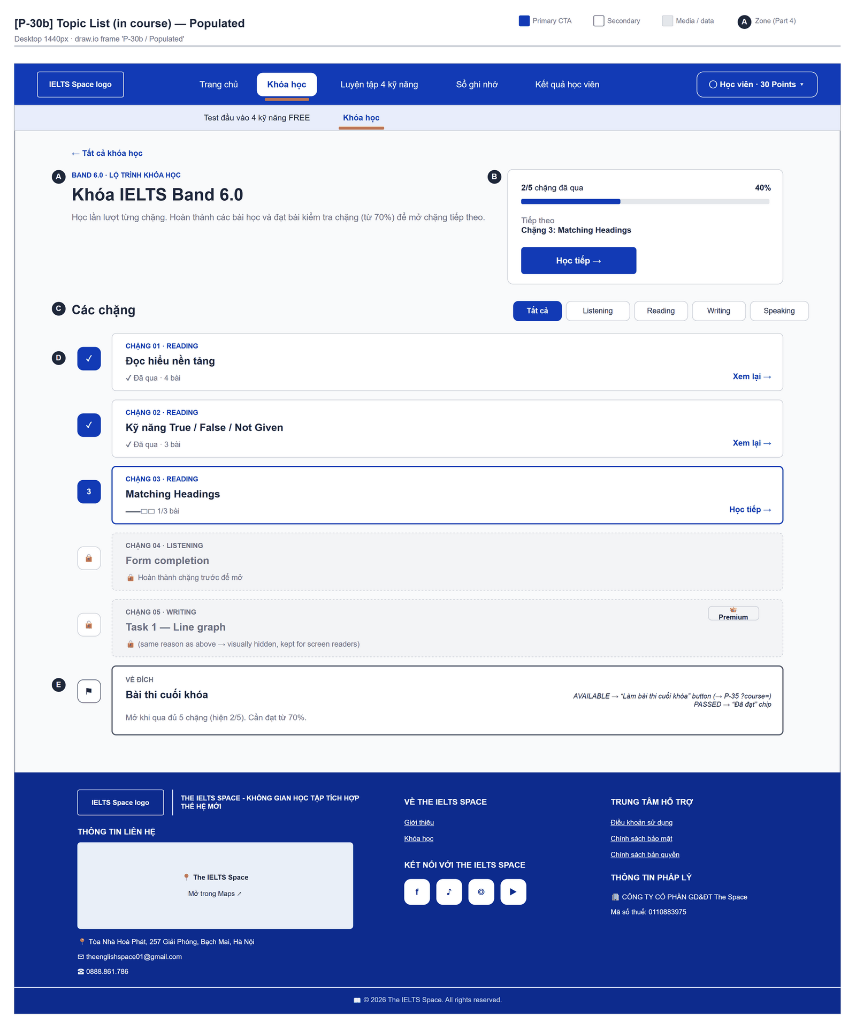
Figure 2.11-1 — Course Path — Populated. Source: wireframes/screens/P-30b_TopicList.drawio, tab “P-30b / Populated”
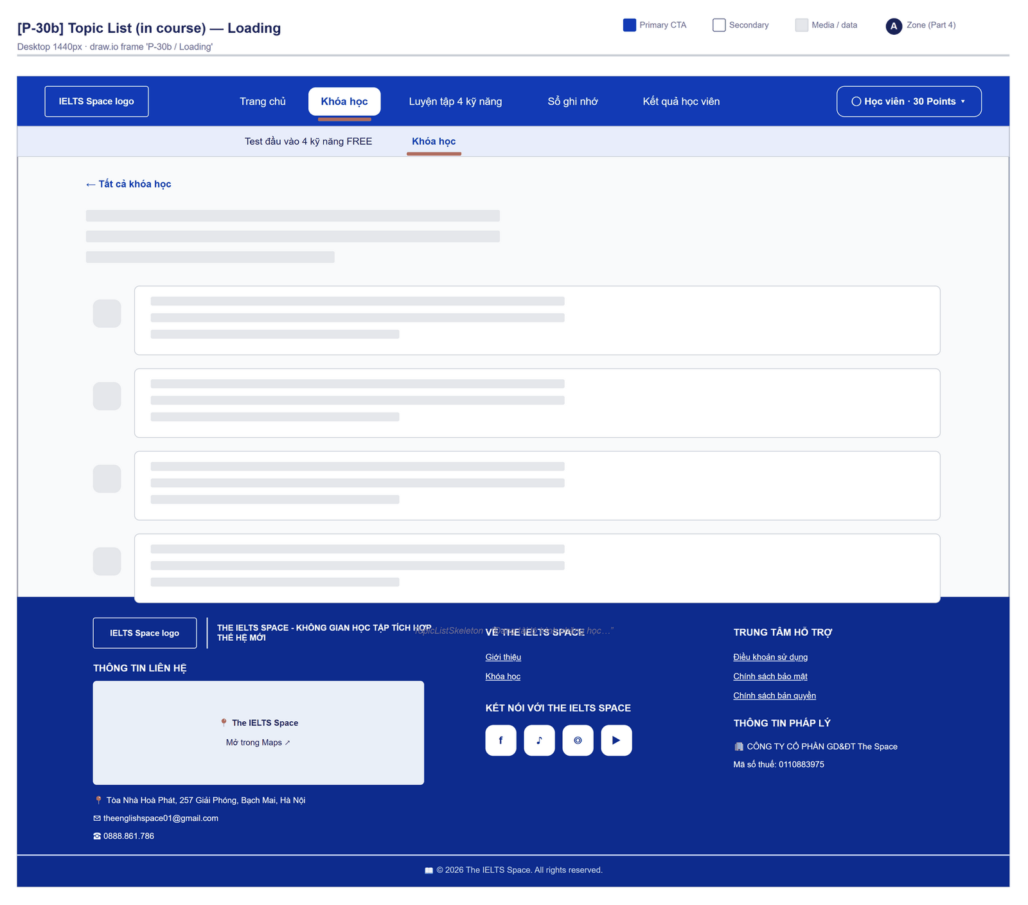
Figure 2.11-2 — Course Path — Loading. Source: wireframes/screens/P-30b_TopicList.drawio, tab “P-30b / Loading”
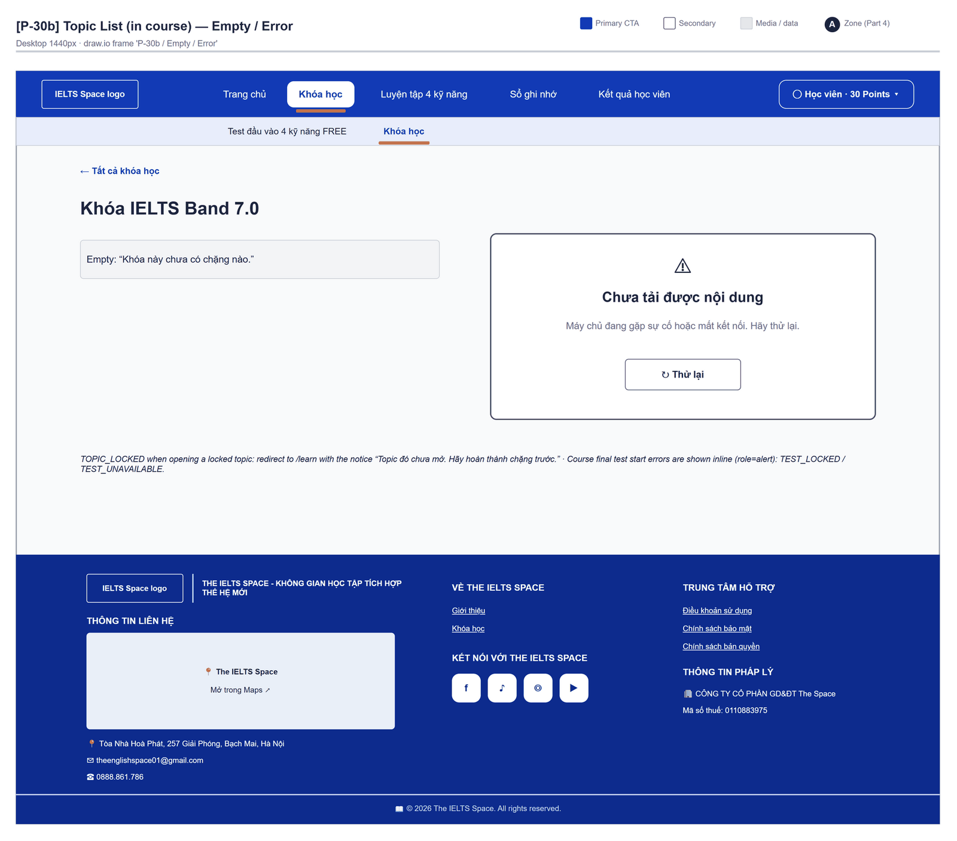
Figure 2.11-3 — Course Path — Empty / Error. Source: wireframes/screens/P-30b_TopicList.drawio, tab “P-30b / Empty / Error”

Navigation Context
Navigates from | Condition / Trigger
Course List | User clicks a course
Topic Detail | User clicks the course back link
Test Result | Course test: user clicks "Về khóa học" / "Về khóa để làm lại"

Navigates to | Condition / Trigger
Topic Detail | User clicks a PASSED or IN_PROGRESS station, or "Bắt đầu chặng" / "Học tiếp"
Test Attempt | User clicks "Làm bài thi cuối khóa" and the attempt is created
Course List | User clicks "Tất cả khóa học"

2.11.2 Entry & Exit Conditions

Preconditions & Guard Redirects
# | Condition check | If met | If not met → Action
PC-01 | Session exists (RequireAuth, GG-01) | Continue rendering | Redirect → /login (state.from kept); GLB-01

Entry Triggers
# | Trigger | From screen / Source | Parameters passed
ET-01 | Course card | Course List | courseId
ET-02 | Back link | Topic Detail | courseId

Exit Points
# | Event | Condition | Navigates to | Notes
EX-01 | User clicks a station | Not LOCKED | Topic Detail | —
EX-02 | LOCKED station | — | Not clickable | Lock reason under the card
EX-03 | User clicks Làm bài thi cuối khóa | testStatus AVAILABLE; APIs 3–4 succeed | Test Attempt | /learn/tests/{attemptId}?course={courseId}
EX-04 | Course test refused | 403 / 409 | Stay | MSG-03…MSG-05
EX-05 | User picks an item in the top bar (SiteNavbar) | Any | Selected route | No unsaved-change prompt
EX-06 | Session expires, silent refresh fails | Refresh token used, expired or revoked | Login | GLB-01; returnUrl kept

2.11.3 UI Components
Code | Component name | Type | Validation / Constraint | Notes
CoursePath-LNK-01 | Tất cả khóa học | Back link | — | To /learn
CoursePath-PNL-01 | Course header | Header | — | "Band {x.x} · Lộ trình khóa học", course title, "Học lần lượt từng chặng. Hoàn thành các bài học và đạt bài kiểm tra chặng (từ 70%) để mở chặng tiếp theo."
CoursePath-PRG-01 | Course progress | Meter | — | "{passed}/{total} chặng đã qua" and percent
CoursePath-BTN-01 | Next topic | Button (Accent) | When a topic is IN_PROGRESS | "Tiếp theo · Chặng {n}: {title}" + "Bắt đầu chặng" / "Học tiếp"
CoursePath-TAB-01 | Lọc theo kỹ năng | Segmented buttons | When the course has topics of more than one skill | "Tất cả" + Listening, Reading, Writing, Speaking, and "Khác" for topics without a skill
CoursePath-TBL-01 | Các chặng | Ordered route | Sorted by sequenceOrder | "Chặng {nn} · {skill}", title, description, "{done}/{total} bài" or "Đã qua · {n} bài", action "Vào chặng" / "Học tiếp" / "Xem lại"
CoursePath-BDG-01 | Premium | Chip | Topic accessLevel PREMIUM | "Premium"
CoursePath-PNL-02 | Lock reason | Inline text | LOCKED stations | Server lockedReason, else "Hoàn thành chặng trước để mở"; a reason repeated on the next station is hidden
CoursePath-CRD-01 | Bài thi cuối khóa | Final station | Hidden when the course has no final test (testStatus NONE) | "Về đích" and a status text (see Interactions)
CoursePath-BTN-02 | Làm bài thi cuối khóa | Button (Accent) | Only when testStatus = AVAILABLE | "Đang giao đề…" while pending; chip "Đã đạt" when PASSED

2.11.4 API Calls & Data Flow
# | Trigger (UI event) | API ID | Method + Path | Request | Success → UI action | Error → UI action
1 | Page load | API-120 | GET /api/learning/topics | — | Keep the topics of this course · loading: topic skeleton | GLB-04 / GLB-05 panel with "Thử lại"
2 | Page load (parallel) | API-117 | GET /api/learning/courses | — | Course title, band, testStatus and counts | Same panel
3 | User clicks Làm bài thi cuối khóa | API-119 | POST /api/learning/courses/{id}/test-assignments | Path: courseId | Then API 4 | MSG-03…MSG-05
4 | Assignment received | API-138 | POST /api/assessments/attempts | {packageVersionId, mode: STANDARD, channel: WEB} (COURSE_GATE) | Navigate Test Attempt with ?course= | Server message + " Hãy thử lại."

2.11.5 Interaction Specifications

Final station text
PASSED → "Bạn đã đạt bài thi cuối khóa."
AVAILABLE → "Bạn đã qua mọi chặng. Đề tổng hợp theo band mục tiêu, cần đạt từ 70%."
LOCKED → "Mở khi qua đủ {n} chặng (hiện {passed}/{n}). Cần đạt từ 70%."

Station state
IF status = LOCKED THEN a disabled card with the lock reason
ELSE a link to /learn/topics/{id}; the next IN_PROGRESS topic is marked as the current step

2.11.6 Messages & Display Content
Code | Type | Trigger condition | Content (UI copy) | Action / Duration
MSG-01 | Empty State | Course has no topic | "Khóa này chưa có chặng nào." | —
MSG-02 | Success Text | All topics passed | "Bạn đã qua tất cả các chặng." | Header panel
MSG-03 | Inline Error | 403 TEST_LOCKED (the backend sends COURSE_TEST_LOCKED, which falls back to MSG-05: FG-16) | "Bài thi cuối khóa chưa mở. Hoàn thành mọi chặng trong khóa trước." | On the final station; page reloads
MSG-04 | Inline Error | 409 TEST_UNAVAILABLE | "Chưa có đề thi cuối cho khóa này. Hãy quay lại sau." | On the final station
MSG-05 | Inline Error | Other error (incl. NO_COURSE_TEST, COURSE_ALREADY_PASSED, COURSE_NOT_FOUND) | Server message + " Hãy thử lại." | On the final station

2.11.7 Business Rules
BR/BV Code | Short description | UI behaviour when violated
BR-16 | One topic sequence per course; first unpassed topic IN_PROGRESS, later ones LOCKED | Badges; LOCKED stations disabled
BR-37 | Course test opens when every topic is PASSED; 70% passes the course | Final station by testStatus
BR-22 | Course test code single-use | A new assignment for each try
BR-34 | Premium content needs an entitlement | Only a Premium chip (OQ-04)

2.12 Topic Detail

2.12.1 General Information
Screen Name | Topic Detail
Purpose | Lists the ordered lessons of a topic, points to the next step — a pending review, the next lesson, the practice a lesson still needs or the final test — and starts the topic final test.
Route / Type | /learn/topics/:topicId · RequireAuth
Role(s) | Signed-in learner
Related FT / UC | FT-20, FT-21, FT-27, FT-29  UC-036–UC-037 View learning path; UC-059, UC-066–UC-073 Take test attempt
Status | Specified
Frontend | Built — features/learning-path/pages/TopicDetailPage.tsx inside LearnLayout (route /learn/topics/:topicId); calls the real backend.
Mockup / Wireframe | Figure 2.12-1 to 2.12-2 below — draw.io wireframes in docs/wireframes/screens (P-31_TopicDetail.drawio), one tab per state; clickable prototype: docs/wireframes/IELTSPath_Prototype.drawio
Open Questions | OQ-22 (Appendix B)

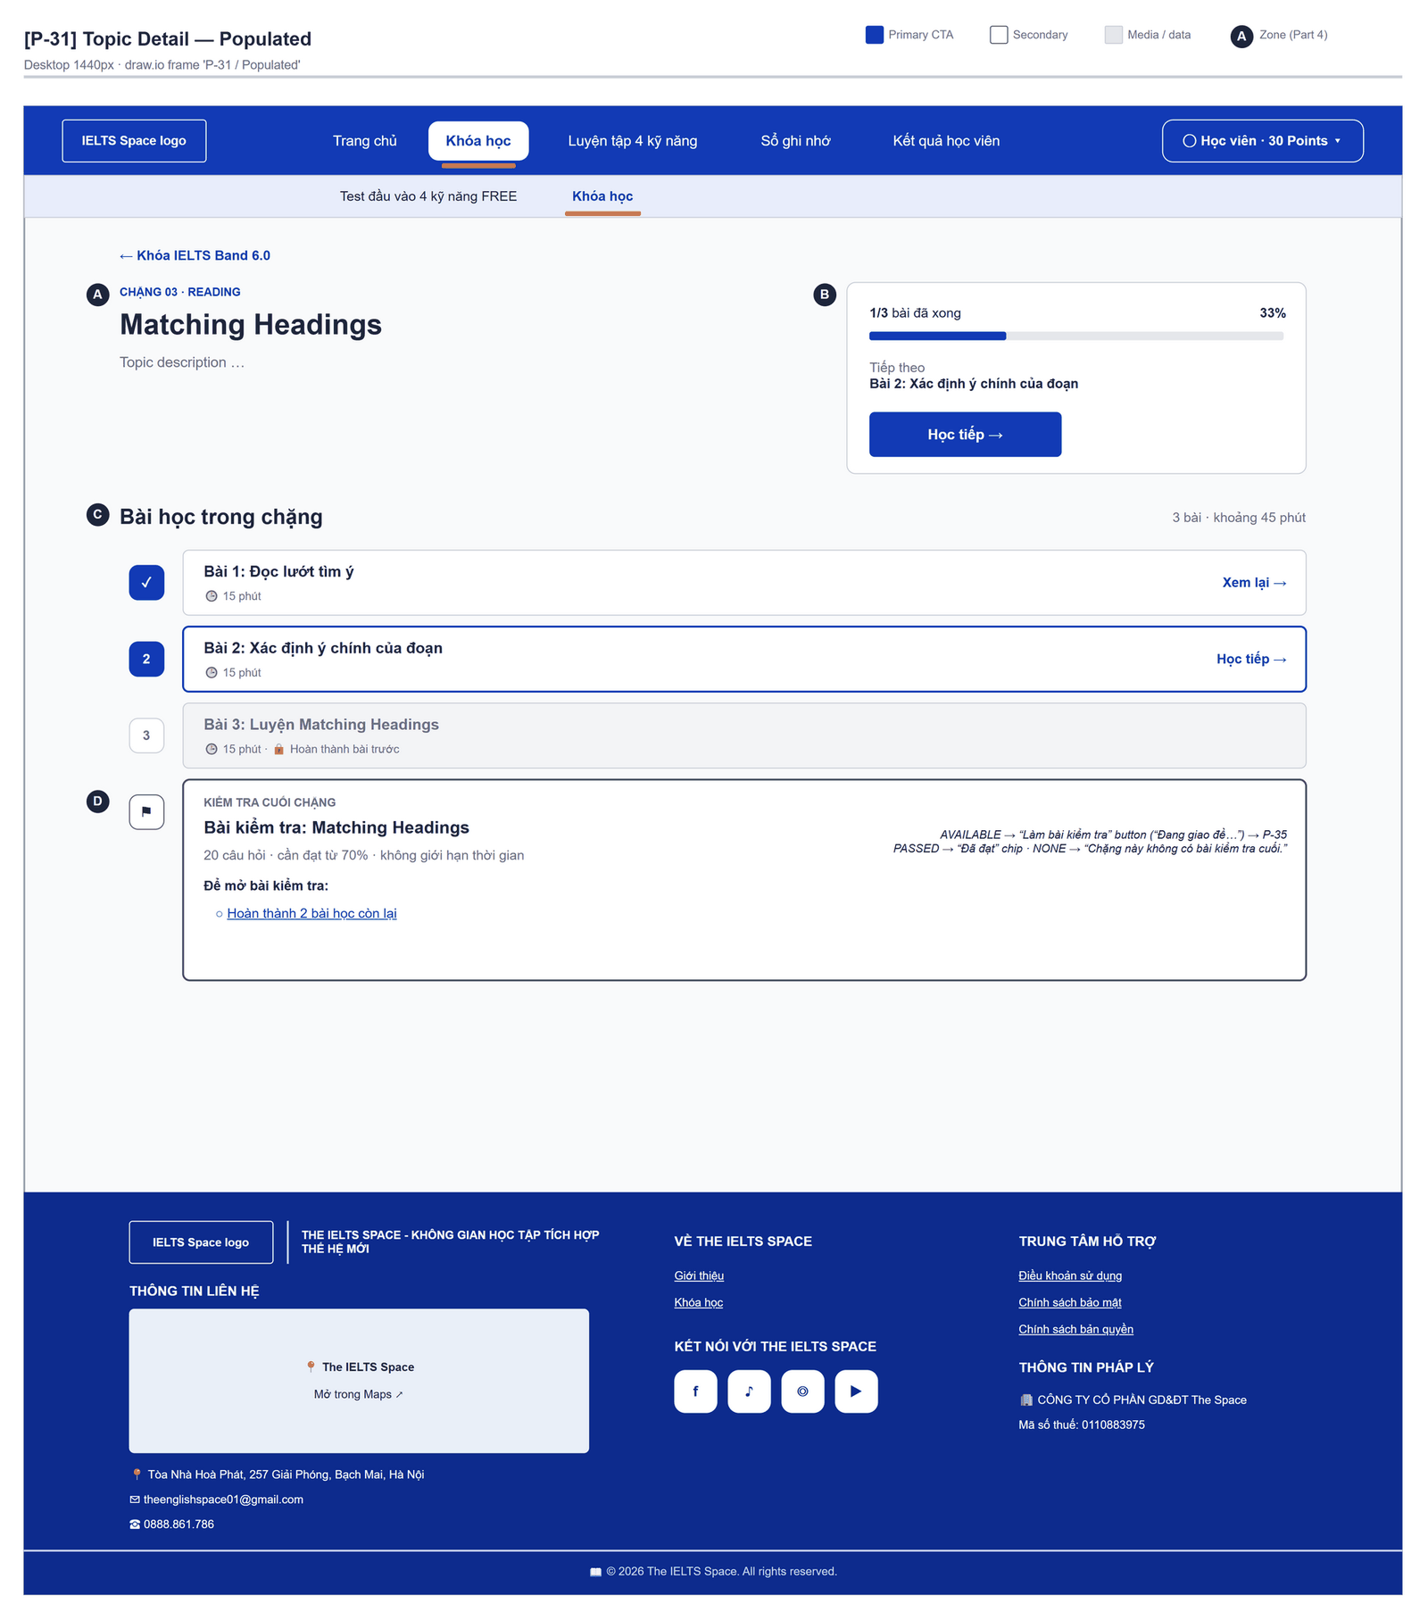
Figure 2.12-1 — Topic Detail — Populated. Source: wireframes/screens/P-31_TopicDetail.drawio, tab “P-31 / Populated”
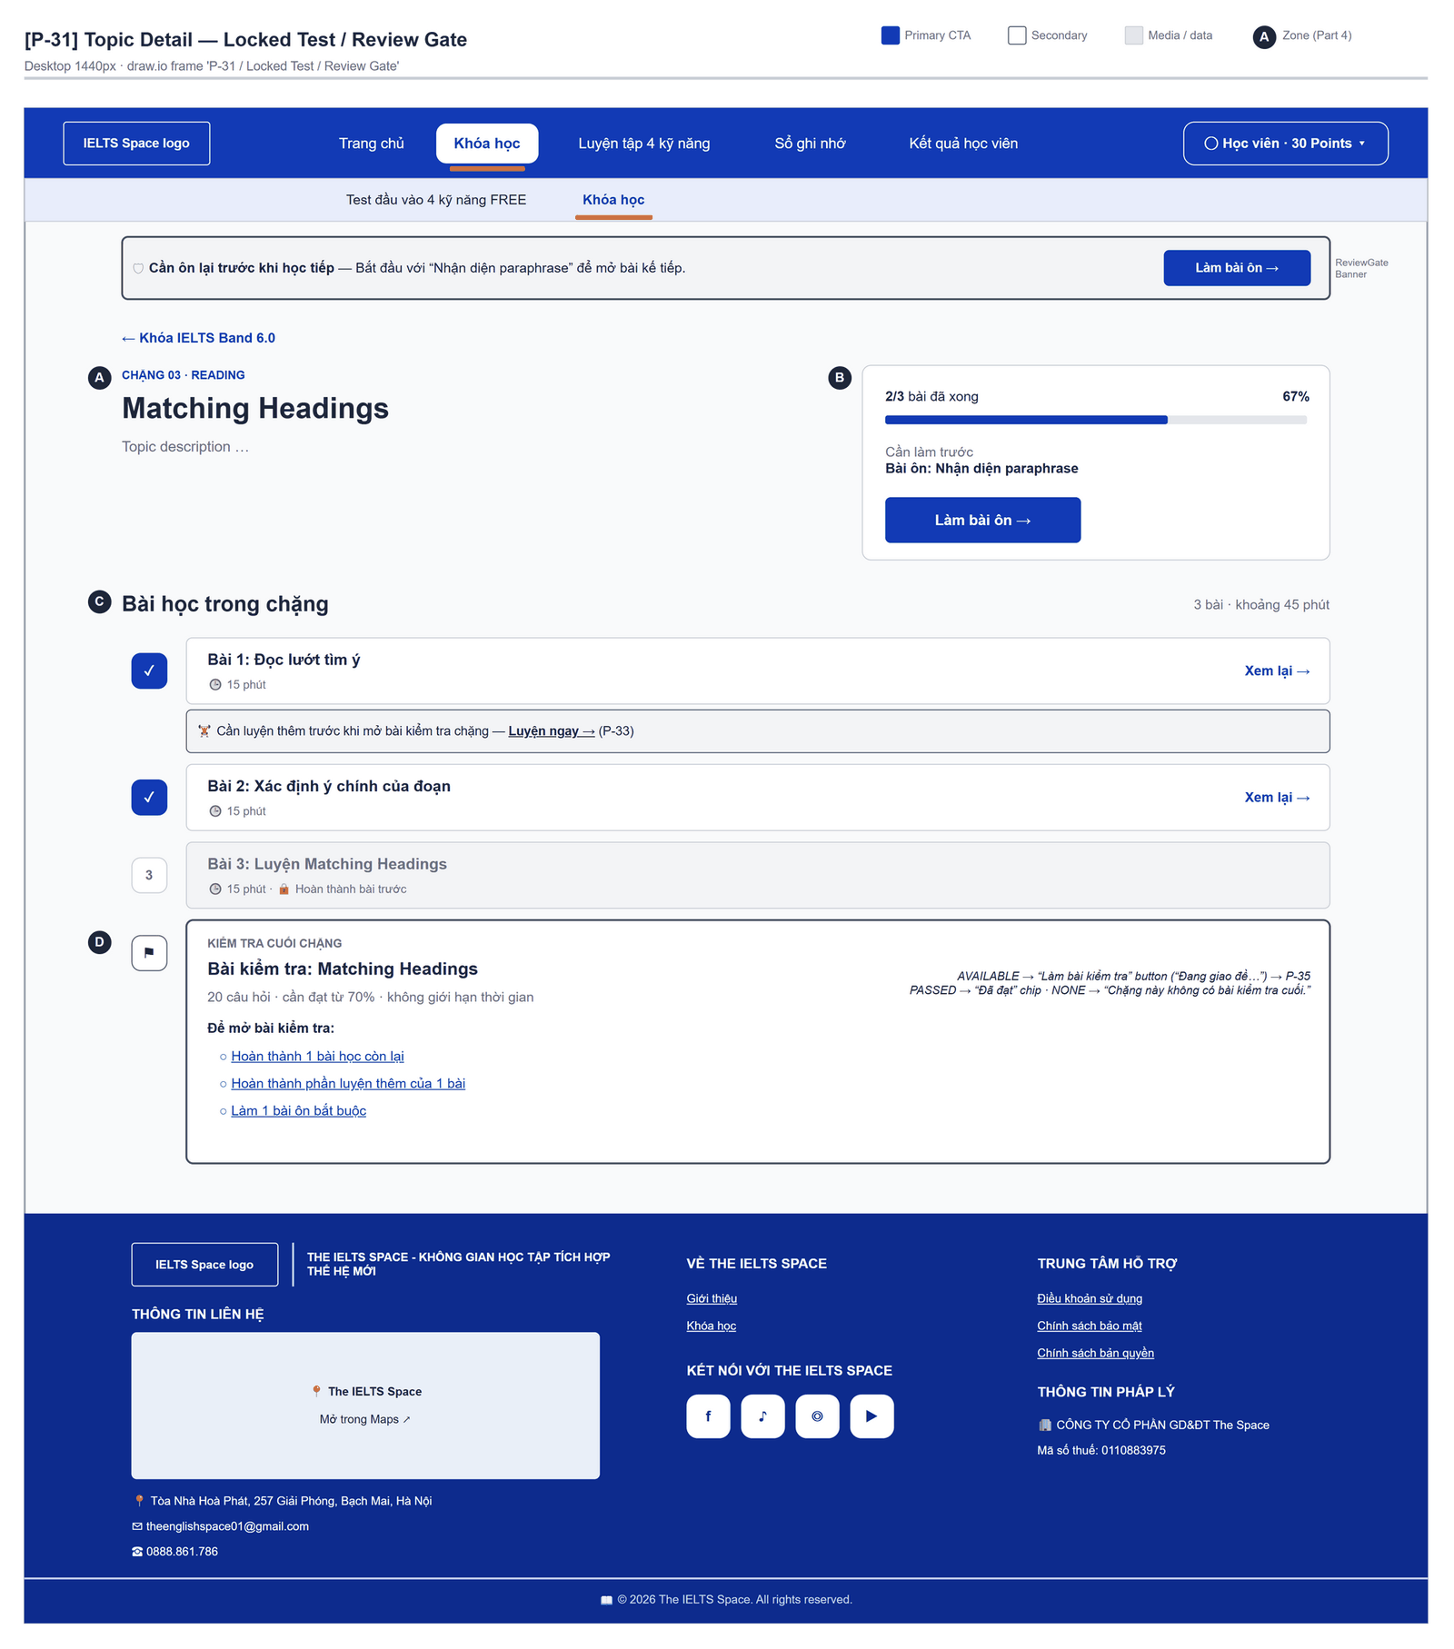
Figure 2.12-2 — Topic Detail — Locked Test / Review Gate. Source: wireframes/screens/P-31_TopicDetail.drawio, tab “P-31 / Locked Test / Review Gate”

Navigation Context
Navigates from | Condition / Trigger
Course Path | User clicks a station
Lesson Player, Practice Set, Test Result | User goes back to the topic

Navigates to | Condition / Trigger
Lesson Player | User clicks an AVAILABLE or COMPLETED lesson, or the next-step button
Practice Set | User clicks "Luyện ngay" or the next-step button "Luyện thêm"
Review Session | User clicks "Làm bài ôn" in the header or the unlock checklist
Test Attempt | User clicks "Làm bài kiểm tra" and the attempt is created
Course Path | User clicks the course back link

2.12.2 Entry & Exit Conditions

Preconditions & Guard Redirects
# | Condition check | If met | If not met → Action
PC-01 | Session exists (RequireAuth, GG-01) | Continue rendering | Redirect → /login (state.from kept); GLB-01
PC-02 | Topic exists and is not LOCKED | Continue | TOPIC_LOCKED → /learn with notice (GLB-09); 404 → GLB-03

Entry Triggers
# | Trigger | From screen / Source | Parameters passed
ET-01 | Station click | Course Path | topicId
ET-02 | Back link | Lesson Player | topicId

Exit Points
# | Event | Condition | Navigates to | Notes
EX-01 | User clicks a lesson | Not LOCKED | Lesson Player | —
EX-02 | User clicks Làm bài kiểm tra | testStatus AVAILABLE; APIs 4–5 succeed | Test Attempt | /learn/tests/{attemptId}?topic={topicId}
EX-03 | Final test refused | 403 / 409 | Stay | MSG-02…MSG-06
EX-04 | User clicks the course link | Any | Course Path | —
EX-05 | Session expires, silent refresh fails | Refresh token used, expired or revoked | Login | GLB-01; returnUrl kept

2.12.3 UI Components
Code | Component name | Type | Validation / Constraint | Notes
TopicDetail-LNK-01 | {course title} | Back link | — | To /learn/courses/{courseId}; "Lộ trình khóa học" → /learn when the topic has no course
TopicDetail-PNL-01 | Topic header | Header | — | "Chặng {nn} · {skill}", title, description
TopicDetail-PRG-01 | Topic progress | Meter | — | "{done}/{total} bài đã xong" and percent
TopicDetail-BTN-01 | Next step | Button (Accent) | First match: pending review → next lesson → lesson needing practice | "Cần làm trước · Bài ôn: {KP}" + "Làm bài ôn"; "Bắt đầu với" / "Tiếp theo · Bài {n}: {title}" + "Bắt đầu học" / "Học tiếp"; "Cần luyện thêm" + "Luyện thêm"; else "Đã học xong các bài. Làm bài kiểm tra chặng" (jump) or "Bạn đã qua chặng này · {p}%"
TopicDetail-TBL-01 | Bài học trong chặng | Ordered route | Sorted by sortOrder | "{n} bài · khoảng {m} phút"; lesson title, "{min} phút", lock reason, action "Học tiếp" / "Xem lại" / "Mở bài"
TopicDetail-LNK-02 | Luyện ngay | Link | Lesson COMPLETED and practice REQUIRED | "Cần luyện thêm trước khi mở bài kiểm tra chặng"
TopicDetail-CRD-01 | Kiểm tra cuối chặng | Final station | — | Test title and "{n} câu hỏi · cần đạt từ 70% · không giới hạn thời gian · lần gần nhất {p}%"; "Chặng này không có bài kiểm tra cuối." when NONE
TopicDetail-PNL-02 | Để mở bài kiểm tra | Checklist | Visible when testStatus = LOCKED | Items with links (see Interactions)
TopicDetail-BTN-02 | Làm bài kiểm tra | Button (Accent) | Only when AVAILABLE | "Đang giao đề…" while pending; chip "Đã đạt" when PASSED

2.12.4 API Calls & Data Flow
# | Trigger (UI event) | API ID | Method + Path | Request | Success → UI action | Error → UI action
1 | Page load | API-121 | GET /api/learning/topics/{id}/lessons | Path: topicId | Render lessons and the final station · loading: "Đang tải chặng học…" | GLB-03/04/09/10
2 | Page load (parallel) | API-120 | GET /api/learning/topics | — (cached) | Topic title, skill, description and course | Fallback title
3 | Page load (parallel) | API-131 | GET /api/learning/reviews | Query: status=PENDING&limit=50 | Next step and review banner | Error → empty list
4 | User clicks Làm bài kiểm tra | API-135 | POST /api/learning/topics/{id}/test-assignments | Path: topicId | Then API 5 | MSG-02…MSG-06
5 | Assignment received | API-138 | POST /api/assessments/attempts | {packageVersionId, mode: STANDARD, channel: WEB} (TOPIC_GATE) | Navigate Test Attempt | Server message + " Hãy thử lại."

2.12.5 Interaction Specifications

Unlock checklist (testStatus = LOCKED)
"Hoàn thành {n} bài học còn lại" (done: "Hoàn thành tất cả bài học") → first unfinished lesson
IF lessons need practice → "Hoàn thành phần luyện thêm của {n} bài" → its practice
IF pending reviews → "Làm {n} bài ôn bắt buộc" → first review
IF every item is done → "Hoàn tất phần luyện thêm và bài ôn còn treo (nếu có)"

Final test start
An in-flight guard stops a second click. learn.assignTest returns the open assignment when one exists, so a retry reuses the same test version (FT-29/AC-01).

2.12.6 Messages & Display Content
Code | Type | Trigger condition | Content (UI copy) | Action / Duration
MSG-01 | Empty State | Topic has no lesson | "Chặng này chưa có bài học." | —
MSG-02 | Inline Error | 409 TEST_UNAVAILABLE / NO_TOPIC_TEST | "Chưa có đề cho chặng này. Hãy quay lại sau." | On the final station
MSG-03 | Inline Error | 409 PRACTICE_REQUIRED | "Cần luyện thêm trước khi mở đề: Bài {n}, … Mở bài học tương ứng và hoàn thành phần luyện thêm." | On the station; page reloads
MSG-04 | Inline Error | 403 REVIEW_REQUIRED | "Cần làm bài ôn “{KP}” trước khi làm bài kiểm tra." | On the station; page reloads
MSG-05 | Inline Error | 403 TEST_LOCKED | "Bài kiểm tra chưa mở. Hoàn thành bài học, luyện thêm và bài ôn (nếu có)." | On the station; page reloads
MSG-06 | Inline Error | Other error | Server message + " Hãy thử lại." | On the station

2.12.7 Business Rules
BR/BV Code | Short description | UI behaviour when violated
BR-17 | Lessons open in order | LOCKED lessons are not links; the lock reason is shown
BR-17 | A pending review blocks the lessons that teach its skill, their practice and the final test of a topic that teaches it | 403 REVIEW_REQUIRED → review panel / banner GLB-10 with "Làm bài ôn"
BR-22 | Topic test needs every lesson completed and practice-cleared; codes rotate | Checklist; the open assignment is reused
BR-38 | Practice is cleared skill by skill; essays never block | "Luyện ngay" only while practice is REQUIRED
BR-15 | Topic pass mark 70% | "cần đạt từ 70%"

2.13 Lesson Player

2.13.1 General Information
Screen Name | Lesson Player
Purpose | Presents a lesson's blocks in order — text, passage, audio, exercises and essays — grades each exercise block, so the learner can pass the lesson and move on.
Route / Type | /learn/lessons/:lessonId · RequireAuth
Role(s) | Signed-in learner
Related FT / UC | FT-21, FT-22, FT-23, FT-24, FT-25  UC-038–UC-040, UC-089 Study lesson; UC-041–UC-042 Submit Writing task; UC-043 Grade essay
Status | Specified
Frontend | Built — features/learning-path/pages/LessonPage.tsx with components/blocks (BlockList, TextBlock, PassageBlock, AudioBlock, ExerciseBlock, EssayBlock) inside LearnLayout (route /learn/lessons/:lessonId); calls the real backend.
Mockup / Wireframe | Figure 2.13-1 to 2.13-3 below — draw.io wireframes in docs/wireframes/screens (P-32_LessonPlayer.drawio), one tab per state; clickable prototype: docs/wireframes/IELTSPath_Prototype.drawio
Open Questions | OQ-22 (Appendix B)

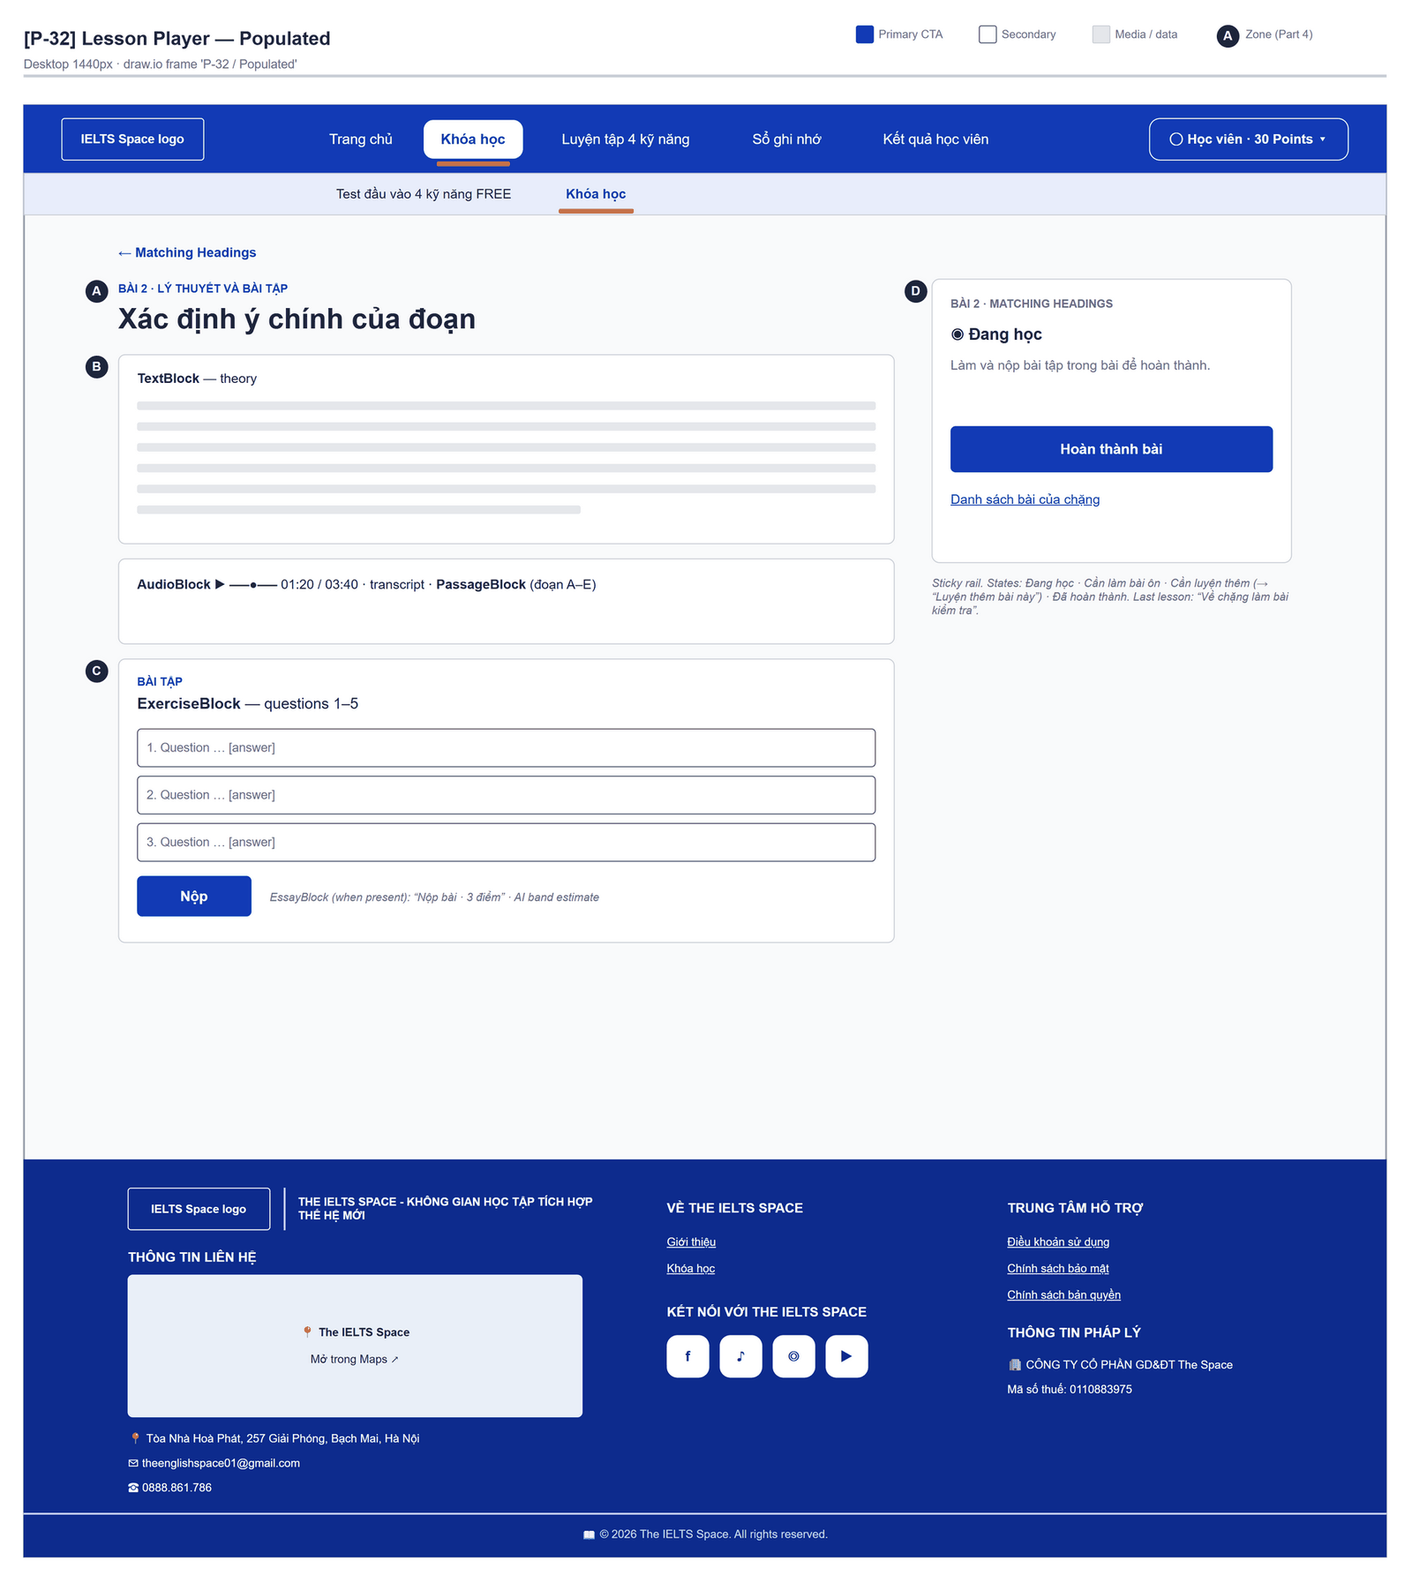
Figure 2.13-1 — Lesson Player — Populated. Source: wireframes/screens/P-32_LessonPlayer.drawio, tab “P-32 / Populated”
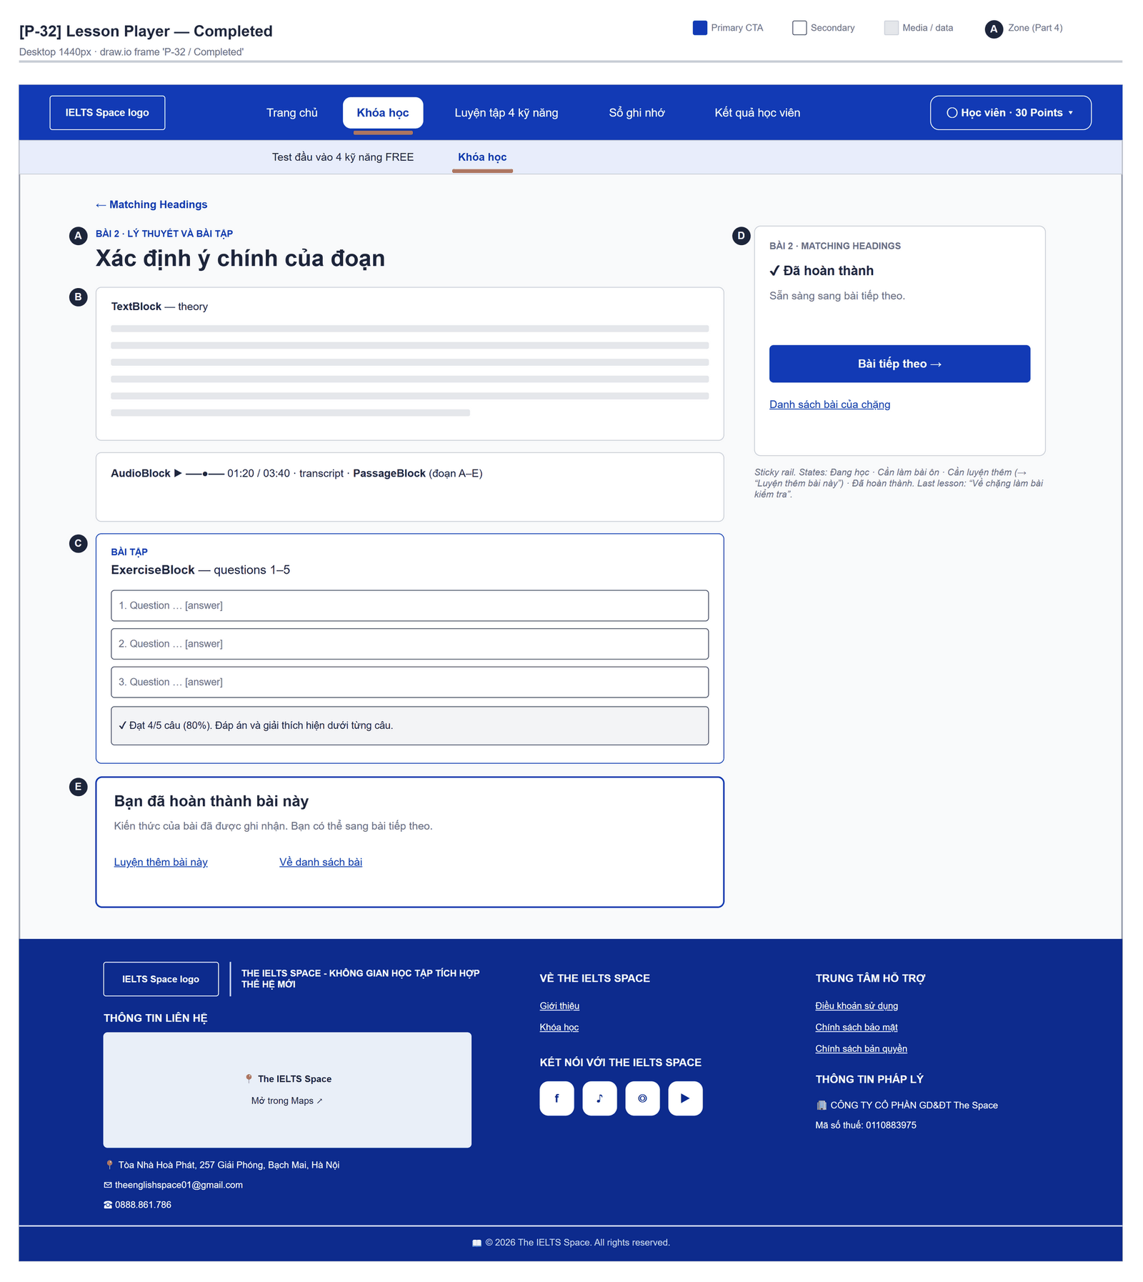
Figure 2.13-2 — Lesson Player — Completed. Source: wireframes/screens/P-32_LessonPlayer.drawio, tab “P-32 / Completed”
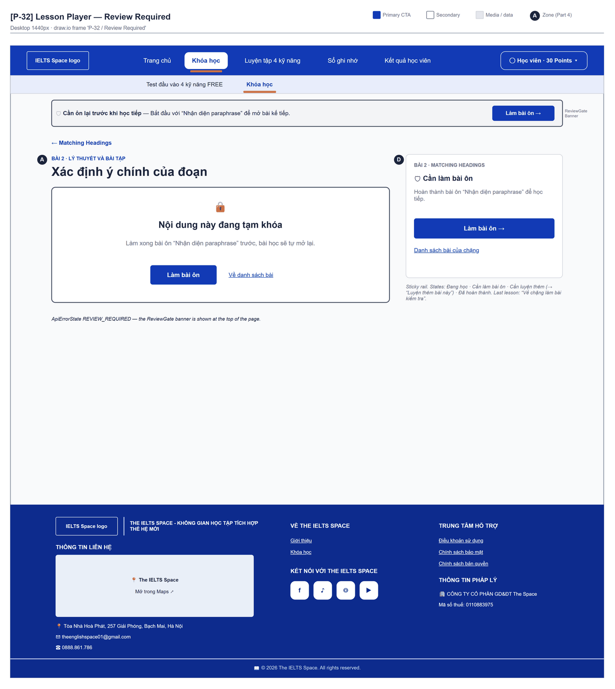
Figure 2.13-3 — Lesson Player — Review Required. Source: wireframes/screens/P-32_LessonPlayer.drawio, tab “P-32 / Review Required”

Navigation Context
Navigates from | Condition / Trigger
Topic Detail | User clicks a lesson or the next-step button
Lesson Player | User clicks "Bài tiếp theo"
Review Session | User clicks "Học tiếp" after the review

Navigates to | Condition / Trigger
Practice Set | User clicks "Luyện thêm bài này"
Review Session | A review is pending; user clicks "Làm bài ôn"
Lesson Player (next) | User clicks "Bài tiếp theo"
Topic Detail | User clicks the topic link, "Danh sách bài của chặng", "Về danh sách bài" or "Về chặng làm bài kiểm tra"

2.13.2 Entry & Exit Conditions

Preconditions & Guard Redirects
# | Condition check | If met | If not met → Action
PC-01 | Session exists (RequireAuth, GG-01) | Continue rendering | Redirect → /login (state.from kept); GLB-01
PC-02 | No pending review in the lesson's skill | Continue | 403 REVIEW_REQUIRED → review panel (GLB-10)
PC-03 | Topic not LOCKED and earlier lessons completed | Continue | TOPIC_LOCKED → /learn; LESSON_LOCKED → topic (GLB-09)

Entry Triggers
# | Trigger | From screen / Source | Parameters passed
ET-01 | Lesson row | Topic Detail | lessonId
ET-02 | Bài tiếp theo | Lesson Player | nextLessonId

Exit Points
# | Event | Condition | Navigates to | Notes
EX-01 | Last exercise block passes | lessonCompleted = true | Stay; completion panel | MSG-04
EX-02 | User clicks Luyện thêm / Bài tiếp theo / Về topic | Completion panel | Practice Set / next lesson / Topic Detail | —
EX-03 | Gate refused on load | 403 | Redirect or review panel | GLB-09 / GLB-10
EX-04 | Session expires, silent refresh fails | Refresh token used, expired or revoked | Login | GLB-01; returnUrl kept

2.13.3 UI Components
Code | Component name | Type | Validation / Constraint | Notes
LessonPlayer-LNK-01 | {topic title} | Back link | — | To the topic
LessonPlayer-PNL-01 | Text block | Rich text | — | —
LessonPlayer-PNL-02 | Passage block | Panel | — | "Bài đọc", paragraphs "Đoạn {label}"
LessonPlayer-AUD-01 | Audio block | Native audio player | — | Title "Bài nghe", duration, no download; "Transcript" collapsible only when the API sends it
LessonPlayer-RAD-01 | Choice question | Radio group | One answer per question | "Câu {n}"
LessonPlayer-TXT-01 | Fill / short answer | Text Input | — | Placeholder "Nhập câu trả lời"
LessonPlayer-BTN-01 | Nộp / Nộp lại | Button (Primary) | Disabled while submitting | Shows "Còn {n} câu chưa trả lời"
LessonPlayer-BTN-02 | Làm lại từ đầu | Button (Outline) | Visible after a graded try | Clears the answers
LessonPlayer-PNL-03 | Per-question feedback | Inline | — | "Đúng" / "Sai"; "Gợi ý:" when hint is not null; "Đáp án:" + explanation after the block passes
LessonPlayer-TXA-01 | Bài làm của bạn (essay) | Text Area | Word count ≥ max(minWords, 50) and ≤ 1,000 | Placeholder "Viết bài luận tại đây…"; live "{n} từ"
LessonPlayer-BTN-03 | Nộp bài · 3 điểm | Button (Primary) | Disabled outside the word limits or when passed | "Đang chấm (có thể 10–45 giây)…" while grading
LessonPlayer-PNL-04 | Lesson header | Header | — | "Bài {n} · Lý thuyết và bài tập" or "Bài {n} · Lý thuyết", title
LessonPlayer-PNL-05 | Tiến độ bài học | Side rail (bottom bar on mobile) | — | "Bài {n} · {topic}", state with a hint (see Interactions), primary action, link "Danh sách bài của chặng"
LessonPlayer-BTN-04 | Primary action | Button (Accent) | By lesson state | "Làm bài ôn" / "Luyện thêm bài này" / "Bài tiếp theo" or "Về chặng làm bài kiểm tra" / "Hoàn thành bài" ("Đang ghi nhận…") / "Đến phần bài tập"
LessonPlayer-PNL-06 | Completion panel | Panel (role=status) | Lesson COMPLETED | "Bạn đã hoàn thành bài này" / "Bài này đã hoàn thành", message, links "Luyện thêm bài này" and "Về danh sách bài"

2.13.4 API Calls & Data Flow
# | Trigger (UI event) | API ID | Method + Path | Request | Success → UI action | Error → UI action
1 | Page load | API-122 | GET /api/learning/lessons/{id} | Path: lessonId | Render blocks · loading: "Đang tải nội dung bài học…" | GLB-03/04/09/10
2 | Page load (after the lesson) | API-120 | GET /api/learning/topics | — (cached) | Topic title for the back link | —
3 | Page load (after the lesson) | API-121 | GET /api/learning/topics/{id}/lessons | Path: topicId | Next lesson and practice status for the rail; reloaded after completion | Rail without the next lesson
4 | User clicks Nộp | API-123 | POST /api/learning/lessons/{id}/exercises/{blockId}/submissions | {requestId, answers:[{questionVersionId, answer}]} | Mark answers, hints, solutions on pass; completion panel when lessonCompleted | Server message + " Hãy thử nộp lại."
5 | User clicks Hoàn thành bài | API-124 | POST /api/learning/lessons/{id}/complete | Path: lessonId | Completion panel | Server message + " Hãy thử lại."
6 | User clicks Nộp bài · 3 điểm | API-136 | POST /api/learning/lessons/{lessonId}/essays/{blockId}/submissions | {requestId, essayText} (timeout 60 s) | Inline result (see Writing Feedback); then access.myPoints | MSG-06…MSG-10
7 | Essay graded | API-43 | GET /api/access/me/points | — | Update the balance in the user menu | Ignored

2.13.5 Interaction Specifications

Exercise result
IF the block passed
THEN "Đạt {c}/{t} câu ({p}%). Đáp án và giải thích hiện dưới từng câu."; answers locked
ELSE "Đúng {c}/{t} câu ({p}%). Cần từ 70% để đạt. Sửa các câu sai rồi nộp lại."; hints shown
END IF
Each try sends a new requestId (no reuse after a network error).

Essay pre-check
IF balance < 3 THEN "Không đủ điểm. Cần 3 điểm để chấm bài (hiện có {n})." and no request
The balance comes from the session (access.myPoints).

Rail state
Review pending → "Cần làm bài ôn": "Hoàn thành bài ôn “{KP}” để học tiếp."
Done, practice due → "Cần luyện thêm": "Luyện thêm bài này để mở bài kiểm tra chặng."
Done → "Đã hoàn thành": "Sẵn sàng sang bài tiếp theo." or, for the last
lesson, "Đây là bài cuối của chặng. Tiếp theo là bài kiểm tra chặng."
Has exercises → "Đang học": "Làm và nộp bài tập trong bài để hoàn thành."
Reading only → "Đang học": "Đọc hết nội dung rồi bấm hoàn thành để ghi nhận tiến độ."

2.13.6 Messages & Display Content
Code | Type | Trigger condition | Content (UI copy) | Action / Duration
MSG-01 | Inline Result | Block passed | "Đạt {c}/{t} câu ({p}%). Đáp án và giải thích hiện dưới từng câu." | Persistent
MSG-02 | Inline Result | Block not passed | "Đúng {c}/{t} câu ({p}%). Cần từ 70% để đạt. Sửa các câu sai rồi nộp lại." | Persistent
MSG-03 | Info Text | Lesson without exercises | "Hết nội dung bài học. Bấm Hoàn thành bài để ghi nhận tiến độ." | Under the content
MSG-04 | Completion Panel | Lesson completed | "Bạn đã hoàn thành bài này" · "Kiến thức của bài đã được ghi nhận. Bạn có thể sang bài tiếp theo." (last lesson: "Bạn đã học xong bài cuối của chặng. Quay về chặng để làm bài kiểm tra."; practice due: "Bài này yêu cầu luyện thêm trước khi mở bài kiểm tra chặng.") | Persistent
MSG-05 | Completion Panel | Review pending | "Bạn cần củng cố lại “{KP}” trước khi học tiếp. Bài ôn gồm tóm tắt lý thuyết và vài câu hỏi ngắn." | Rail button "Làm bài ôn"
MSG-06 | Inline Error | Balance below 3 (client) / 402 INSUFFICIENT_POINTS | "Không đủ điểm. Cần 3 điểm để chấm bài (hiện có {n})." / "Không đủ điểm để chấm bài luận." | Below the editor
MSG-07 | Inline Error | 503 GRADING_UNAVAILABLE | "Hệ thống chấm bài tạm thời không khả dụng. Thử lại sau." | Below the editor
MSG-08 | Inline Error | 429 DAILY_LIMIT_REACHED | "Bạn đã hết hạn mức chấm bài trong ngày." | Below the editor
MSG-09 | Inline Error | Other essay error (422 ESSAY_EMPTY / ESSAY_TOO_SHORT / ESSAY_TOO_LONG, 409 GRADING_IN_PROGRESS / REQUEST_CONFLICT) | Server message + " Hãy thử lại." | Below the editor
MSG-10 | Inline Error | 503 PAYMENT_UNAVAILABLE (graded, point debit failed) | Today: server message + " Hãy thử lại." Design target: "Bài đã chấm xong nhưng chưa trừ được điểm. Bấm Nộp lại để hoàn tất (không chấm lại)." and resend the same requestId (FG-13) | Below the editor

2.13.7 Business Rules
BR/BV Code | Short description | UI behaviour when violated
BR-15 | Pass mark 70% | MSG-01 / MSG-02 show the score and the threshold
BR-18 | Only the first submission records evidence | Not stated on the screen
BR-19 | Answers hidden until the block passes; hints after a wrong answer | Solutions rendered only for a passed block
BR-17 | A pending review blocks the lessons that teach its skill, their practice and the final test of a topic that teaches it | 403 REVIEW_REQUIRED → review panel / banner GLB-10 with "Làm bài ôn"
BR-10, BR-11 | 3 points per essay; 10 gradings per day | MSG-06 / MSG-08
NFR-P03 | Grade or 503 GRADING_UNAVAILABLE within 45 s; each LLM call stops after 20 s | Client timeout 60 s (Section 2.0) covers it; MSG-07
BR-38 | A lesson is completed by its objective blocks; Writing essays never block it | Completion panel after the last objective block

2.14 Writing Feedback

2.14.1 General Information
Screen Name | Writing Feedback
Purpose | Shows the AI grading of a Writing essay — estimated band, pass or not, criteria, corrections and the sample answer — so the learner can improve the next essay.
Route / Type | Inline panel in /learn/lessons/:lessonId (EssayBlock)
Role(s) | Signed-in learner
Related FT / UC | FT-12, FT-25  UC-041–UC-042 Submit Writing task; UC-043 Grade essay; UC-086–UC-087 View points
Status | Specified (separate page and re-reading a submission: FG-08)
Frontend | Partly built — feedback is rendered inside EssayBlock.tsx on the Lesson Player; there is no separate route and learn.essay is not called (FG-08).
Mockup / Wireframe | Figure 2.14-1 to 2.14-2 below — draw.io wireframes in docs/wireframes/screens (P-32_LessonPlayer.drawio), one tab per state; clickable prototype: docs/wireframes/IELTSPath_Prototype.drawio

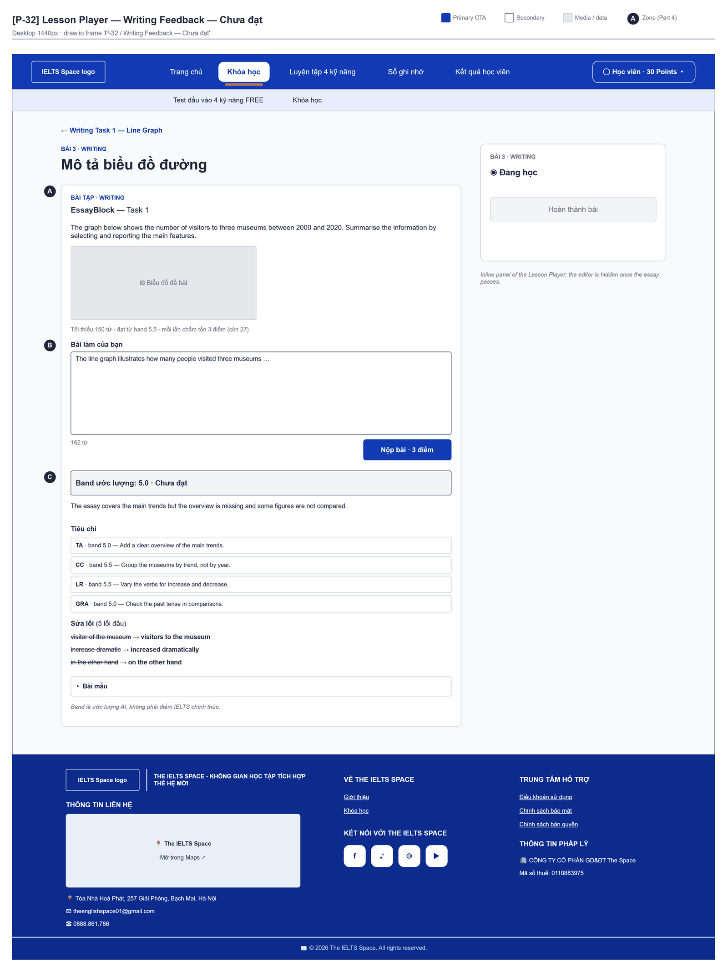
Figure 2.14-1 — Writing Feedback — Chưa đạt. Source: wireframes/screens/P-32_LessonPlayer.drawio, tab “P-32 / Writing Feedback — Chưa đạt”
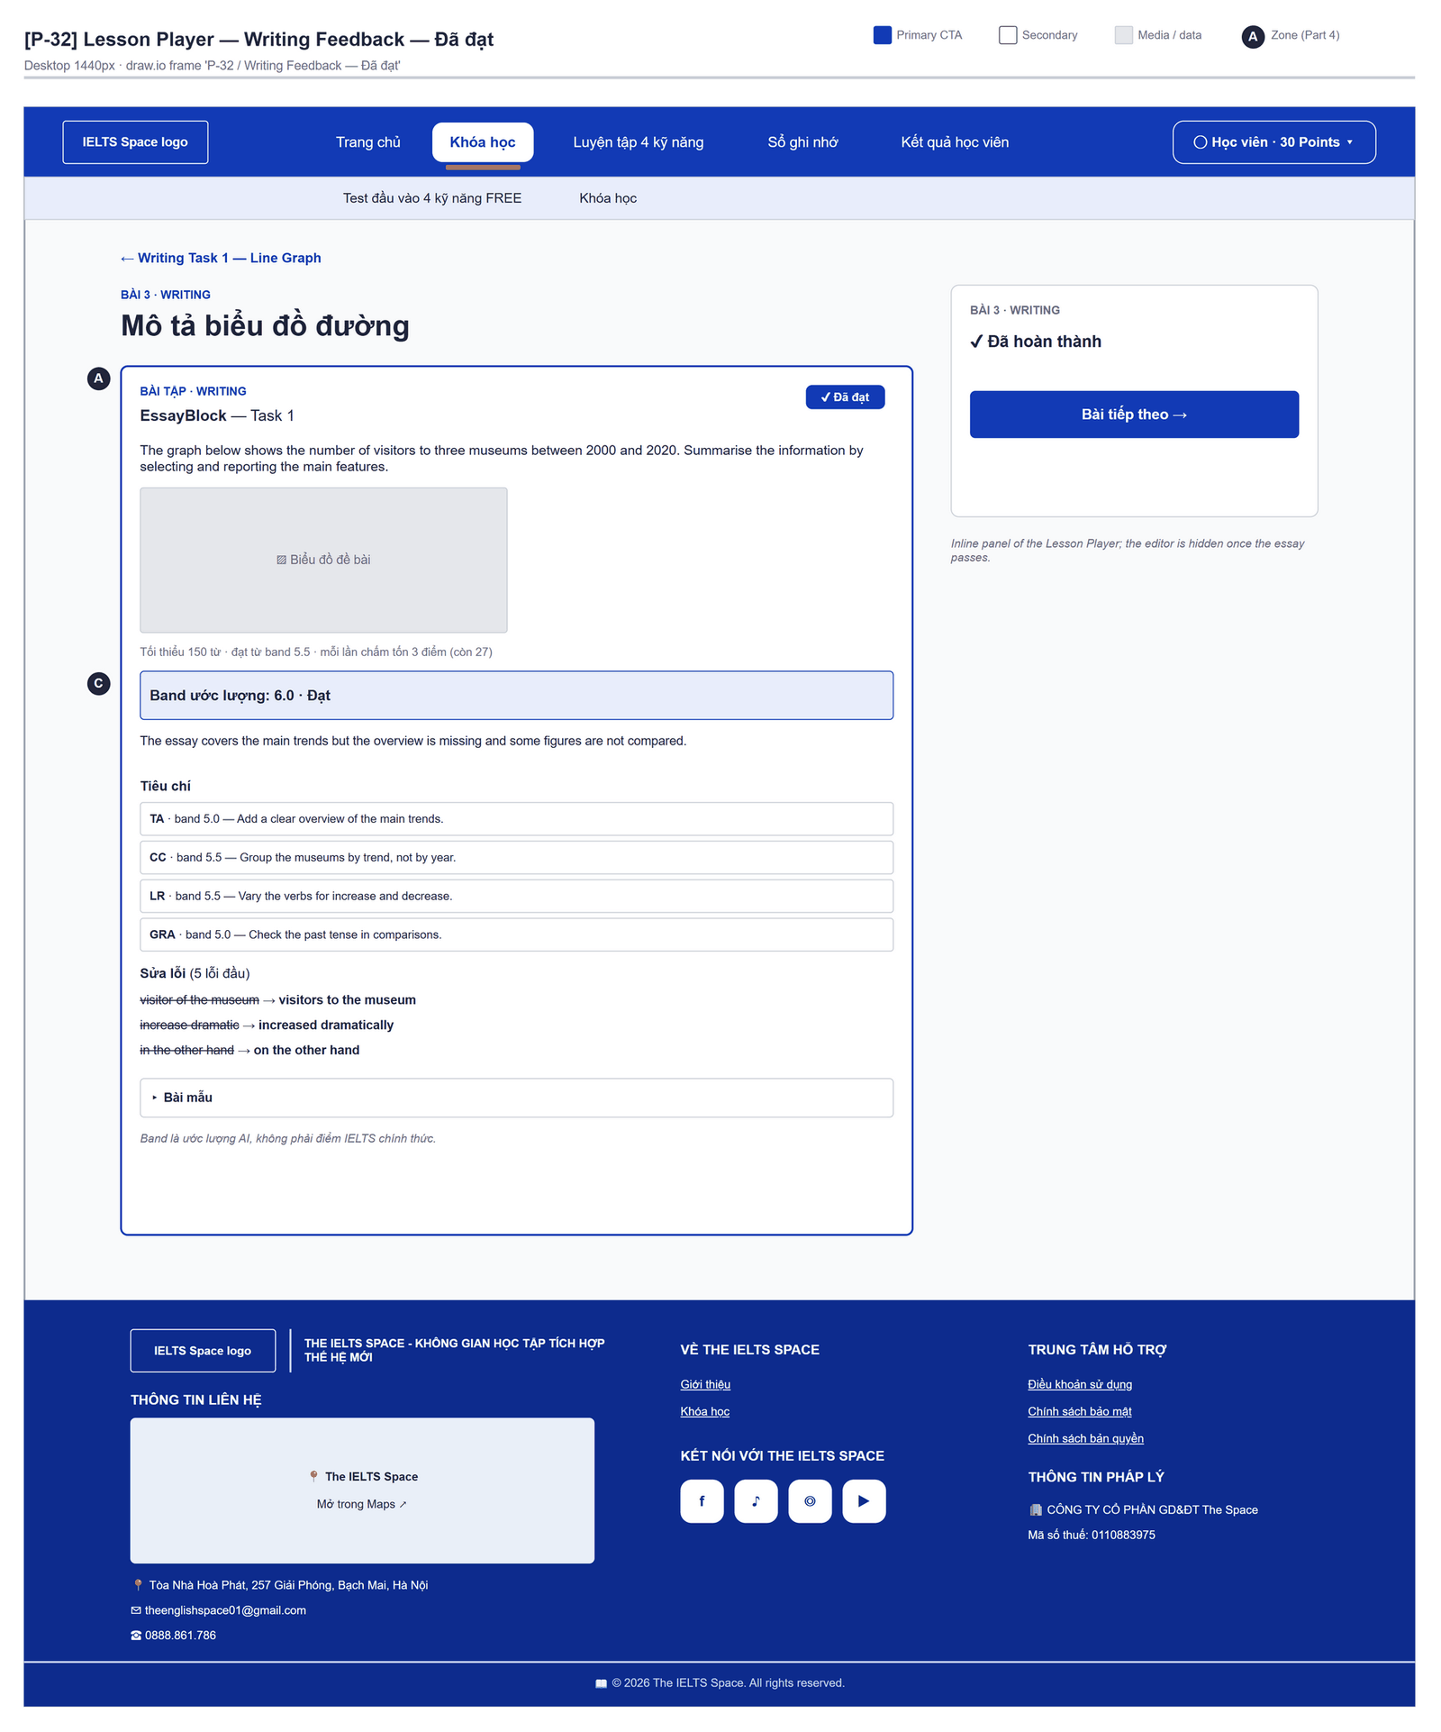
Figure 2.14-2 — Writing Feedback — Đã đạt. Source: wireframes/screens/P-32_LessonPlayer.drawio, tab “P-32 / Writing Feedback — Đã đạt”

Navigation Context
Navigates from | Condition / Trigger
Lesson Player | Essay graded, or the block's latest submission is GRADED on load

Navigates to | Condition / Trigger
Lesson Player | Same page — the learner keeps studying

2.14.2 Entry & Exit Conditions

Preconditions & Guard Redirects
# | Condition check | If met | If not met → Action
PC-01 | Session exists (RequireAuth, GG-01) | Continue rendering | Redirect → /login (state.from kept); GLB-01

Entry Triggers
# | Trigger | From screen / Source | Parameters passed
ET-01 | Essay graded | Lesson Player | Submission response
ET-02 | Lesson load | Lesson Player | latestSubmission with status GRADED (band and pass only)

Exit Points
# | Event | Condition | Navigates to | Notes
EX-01 | User edits and submits again | Not passed | Same panel | Next grading

2.14.3 UI Components
Code | Component name | Type | Validation / Constraint | Notes
WritingFeedback-BDG-01 | Đã đạt | Badge | Shown when passed | Editor hidden once passed
WritingFeedback-PNL-01 | Band ước lượng | Text | — | "Band ước lượng: {band} · Đạt / Chưa đạt"
WritingFeedback-PNL-02 | Summary | Text | — | —
WritingFeedback-TBL-01 | Criteria | List | TA/TR, CC, LR, GRA | Band + first improvement
WritingFeedback-TBL-02 | Corrections | List | First 5 shown | ~~excerpt~~ → suggestion
WritingFeedback-PNL-03 | Bài mẫu | Collapsible | Only when sampleAnswer is sent | —
WritingFeedback-PNL-04 | Disclaimer | Text | — | "Band là ước lượng AI, không phải điểm IELTS chính thức."

2.14.4 API Calls & Data Flow
# | Trigger (UI event) | API ID | Method + Path | Request | Success → UI action | Error → UI action
1 | Essay submitted (Lesson Player) | API-136 | POST /api/learning/lessons/{lessonId}/essays/{blockId}/submissions | {requestId, essayText} | Render the panel from the response | See Lesson Player MSG-06…MSG-10
2 | Design target: reopen a result | API-137 | GET /api/learning/writing-submissions/{id} | Path: submissionId | Show FAILED / grading states after reload | Not called today (FG-08)

2.14.5 Interaction Specifications

Result display
IF status = GRADED THEN show band, summary, criteria, corrections, sample answer
Other statuses (FAILED, PAYMENT_PENDING) show only the error message of the request (FG-08).

2.14.6 Messages & Display Content
Code | Type | Trigger condition | Content (UI copy) | Action / Duration
MSG-01 | Info Text | Always under the editor | "Band là ước lượng AI, không phải điểm IELTS chính thức." | —
MSG-02 | Info Text | Essay header | "Tối thiểu {min} từ · đạt từ band {pass} · mỗi lần chấm tốn 3 điểm (còn {n})" | —

2.14.7 Business Rules
BR/BV Code | Short description | UI behaviour when violated
BR-10 | 3 points per grading, after success | Cost shown on the button and the header
BR-11 | 10 gradings per day | Lesson Player MSG-08

2.15 Practice Set

2.15.1 General Information
Screen Name | Practice Set
Purpose | Lists the practice sets of a completed lesson and lets the learner answer one set, see every solution and start the review it creates.
Route / Type | /learn/lessons/:lessonId/practice · RequireAuth
Role(s) | Signed-in learner
Related FT / UC | FT-23, FT-24, FT-26, FT-27  UC-044–UC-048 Do lesson practice
Status | Specified (Premium sets disabled: FG-05; Writing questions not answerable: FG-18)
Frontend | Built — features/learning-path/pages/PracticePage.tsx (list and attempt on the same route) inside LearnLayout (route /learn/lessons/:lessonId/practice); calls the real backend.
Mockup / Wireframe | Figure 2.15-1 to 2.15-3 below — draw.io wireframes in docs/wireframes/screens (P-33_LessonPractice.drawio), one tab per state; clickable prototype: docs/wireframes/IELTSPath_Prototype.drawio
Open Questions | OQ-04 (Appendix B)

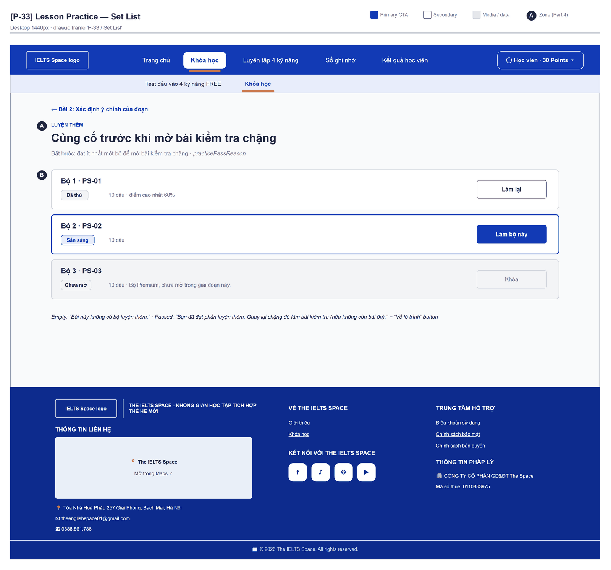
Figure 2.15-1 — Practice Set — Set List. Source: wireframes/screens/P-33_LessonPractice.drawio, tab “P-33 / Set List”
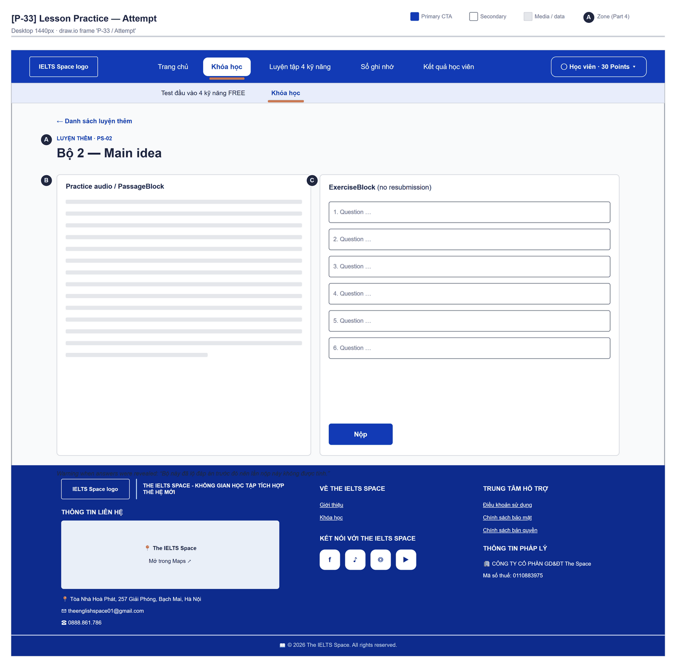
Figure 2.15-2 — Practice Set — Attempt. Source: wireframes/screens/P-33_LessonPractice.drawio, tab “P-33 / Attempt”
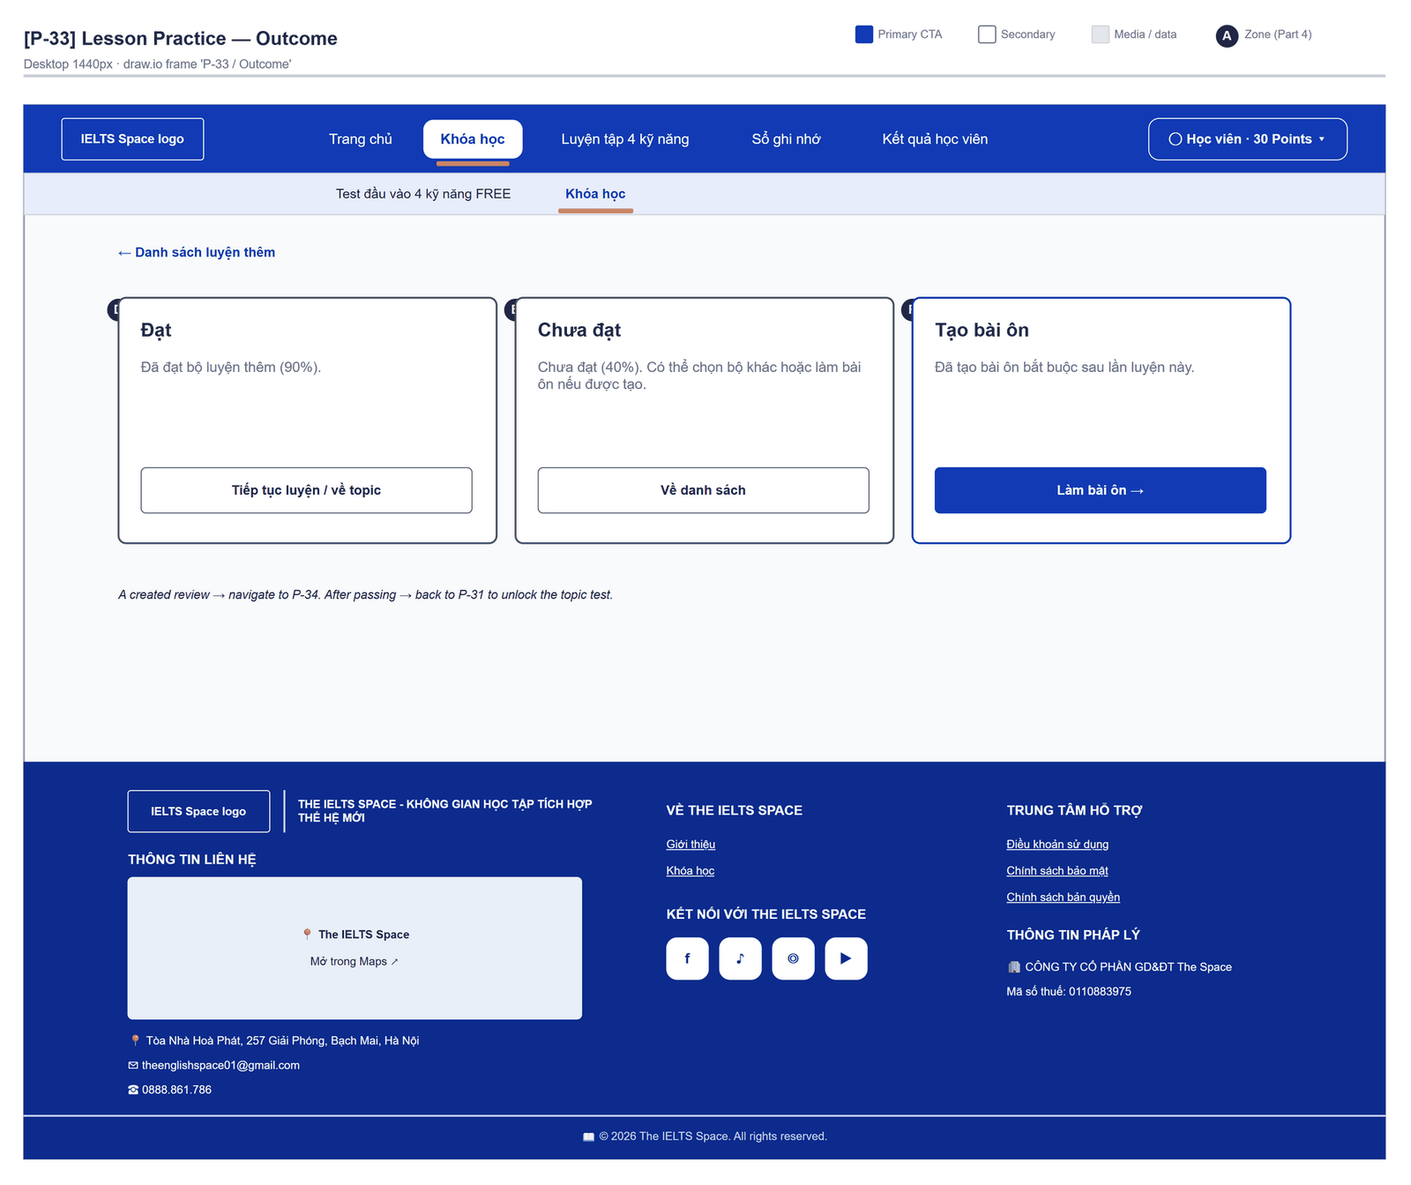
Figure 2.15-3 — Practice Set — Outcome. Source: wireframes/screens/P-33_LessonPractice.drawio, tab “P-33 / Outcome”

Navigation Context
Navigates from | Condition / Trigger
Lesson Player | User clicks "Luyện thêm"
Topic Detail | User clicks "Mở luyện thêm" or an unlock hint

Navigates to | Condition / Trigger
Review Session | A review was created; user clicks "Làm bài ôn"
Course List | Practice PASSED; user clicks "Về lộ trình"
Lesson Player | User clicks "Về bài học"

2.15.2 Entry & Exit Conditions

Preconditions & Guard Redirects
# | Condition check | If met | If not met → Action
PC-01 | Session exists (RequireAuth, GG-01) | Continue rendering | Redirect → /login (state.from kept); GLB-01
PC-02 | No pending review in the skill | Continue | 403 REVIEW_REQUIRED → review panel (GLB-10)

Entry Triggers
# | Trigger | From screen / Source | Parameters passed
ET-01 | Luyện thêm | Lesson Player | lessonId
ET-02 | Mở luyện thêm | Topic Detail | lessonId

Exit Points
# | Event | Condition | Navigates to | Notes
EX-01 | User clicks Làm bộ này / Làm lại | Set not LOCKED or PREMIUM | Same route, attempt view | —
EX-02 | Submission done | API 200 | Same route, result view | MSG-02…MSG-05
EX-03 | User clicks Danh sách luyện thêm / Về danh sách | Any | Same route, list view | List reloads
EX-04 | Session expires, silent refresh fails | Refresh token used, expired or revoked | Login | GLB-01; returnUrl kept

2.15.3 UI Components
Code | Component name | Type | Validation / Constraint | Notes
PracticeSet-PNL-01 | Header | Header | — | "Luyện thêm" · "Củng cố trước khi mở bài kiểm tra chặng" · REQUIRED "Bắt buộc: đạt ít nhất một bộ để mở bài kiểm tra chặng", PASSED "Đã đạt phần luyện thêm", LOCKED "Chưa mở" (+ " · Hoàn thành bài học trước khi luyện.")
PracticeSet-CRD-01 | Practice set card | Card list | — | Title, "{n} câu · điểm cao nhất {p}%", "Đã lộ đáp án nên không được tính." when revealed
PracticeSet-BDG-01 | Set status | Badge | AVAILABLE "Sẵn sàng", IN_PROGRESS "Đang làm", PASSED "Đã đạt", ATTEMPTED "Đã thử", LOCKED "Chưa mở" | —
PracticeSet-BTN-01 | Làm bộ này / Làm tiếp / Làm lại | Button | Hidden on LOCKED sets; disabled on PREMIUM sets | The set in progress (else the first open set) is the accent button; "Đang mở…" while starting
PracticeSet-PNL-02 | Passage / audio | Split view | — | Left side of the attempt view
PracticeSet-PNL-03 | Questions | ExerciseBlock (no resubmit) | One answer per question | Instructions "Trả lời hết câu. Đạt mới được tính evidence cho practice của bài."
PracticeSet-PNL-04 | Result | Panel | — | Solutions under each question; review link or success panel

2.15.4 API Calls & Data Flow
# | Trigger (UI event) | API ID | Method + Path | Request | Success → UI action | Error → UI action
1 | Page load | API-126 | GET /api/learning/lessons/{id}/practice-sets | Path: lessonId | Render the list · loading: "Đang tải luyện thêm…" | GLB-03/04/10
2 | User clicks Làm bộ này | API-127 | POST /api/learning/lessons/{id}/practice-attempts | {packageId} | Show the attempt (open attempt reused) | Server message (409 PRACTICE_LOCKED, 403 REVIEW_REQUIRED)
3 | User clicks Nộp | API-129 | POST /api/learning/practice-attempts/{id}/submissions | {requestId, answers} | Show score, solutions, transcript; store created reviews for the banner | Server message + " Hãy thử nộp lại."

2.15.5 Interaction Specifications

Result outcome
IF passed → "Đã đạt bộ luyện thêm ({p}%)." + "Tiếp tục luyện / về topic"
ELSE → "Chưa đạt ({p}%). Có thể chọn bộ khác hoặc làm bài ôn nếu được tạo." + "Về danh sách"
IF reviewsCreated not empty → "Đã tạo bài ôn bắt buộc sau lần luyện này." + "Làm bài ôn"

2.15.6 Messages & Display Content
Code | Type | Trigger condition | Content (UI copy) | Action / Duration
MSG-01 | Empty State | No practice set | "Bài này không có bộ luyện thêm." | —
MSG-02 | Success Panel | Set passed | "Đã đạt bộ luyện thêm ({p}%)." | Button "Tiếp tục luyện / về topic"
MSG-03 | Inline Result | Set not passed | "Chưa đạt ({p}%). Có thể chọn bộ khác hoặc làm bài ôn nếu được tạo." | Button "Về danh sách"
MSG-04 | Review Panel | Review created | "Đã tạo bài ôn bắt buộc sau lần luyện này." | Button "Làm bài ôn"
MSG-05 | Info Text | Set already revealed | "Bộ này đã lộ đáp án trước đó nên lần nộp này không được tính." | Attempt header
MSG-06 | Success Panel | Practice PASSED for the lesson | "Bạn đã đạt phần luyện thêm. Quay lại chặng để làm bài kiểm tra (nếu không còn bài ôn)." | Button "Về lộ trình"
MSG-07 | Info Text | Premium set | "Bộ Premium, chưa mở trong giai đoạn này." | On the card

2.15.7 Business Rules
BR/BV Code | Short description | UI behaviour when violated
BR-15 | Pass mark 70% | MSG-02 / MSG-03
BR-18 | Only the first submission of an unrevealed set records evidence | MSG-05
BR-20 | A revealed set is never reused as a review set | "Đã lộ đáp án" note
BR-21 | Reviews open for knowledge points below 70% | MSG-04
BR-17 | A pending review blocks the lessons that teach its skill, their practice and the final test of a topic that teaches it | 403 REVIEW_REQUIRED → review panel / banner GLB-10 with "Làm bài ôn"
BR-34 | Premium sets need an entitlement | Always disabled today (FG-05)
BR-38 | Practice is cleared skill by skill for Reading and Listening; essays never block | Writing questions of a set have no essay box yet (FG-18)

2.16 Review List

2.16.1 General Information
Screen Name | Review List
Purpose | Lists the learner's reviews, oldest first, so the learner can finish the ones that block a skill.
Route / Type | /learn/reviews (proposed)
Role(s) | CUSTOMER
Related FT / UC | FT-28  UC-049–UC-052 Complete review
Status | Specified (backend); screen not built (FG-07)
Frontend | Not built in the frontend yet — this section is the design target for the frontend team.
Mockup / Wireframe | TBD — no frontend screen yet

Navigation Context
Navigates from | Condition / Trigger
Course Path / Topic Detail / Lesson Player | User clicks the pending-review banner or link
Main menu | User clicks "Reviews"

Navigates to | Condition / Trigger
Review Session | User clicks a review

2.16.2 Entry & Exit Conditions

Preconditions & Guard Redirects
# | Condition check | If met | If not met → Action
PC-01 | Valid session: access token, or a successful silent refresh (GG-01) | Continue rendering | Redirect → Login?returnUrl=…; GLB-01
PC-02 | User holds role CUSTOMER (GG-02) | Continue rendering | Redirect → /403; GLB-02

Entry Triggers
# | Trigger | From screen / Source | Parameters passed
ET-01 | Pending-review banner | Course Path, Topic Detail, Lesson Player | Query: ?skill=
ET-02 | Main menu | Any learner screen | —

Exit Points
# | Event | Condition | Navigates to | Notes
EX-01 | User clicks a review | Any | Review Session | —
EX-02 | User picks another item in the main menu | Any | Selected screen | —
EX-03 | Session expires, silent refresh fails | Refresh token used, expired or revoked | Login | GLB-01; returnUrl kept

2.16.3 UI Components
Code | Component name | Type | Validation / Constraint | Notes
ReviewList-SEL-01 | Status filter | Select | PENDING (default), DONE, SKIPPED | —
ReviewList-SEL-02 | Skill filter | Select | All, LISTENING, READING, WRITING, SPEAKING | —
ReviewList-TBL-01 | Reviews | Table | Oldest first; 20 per page (limit 1–100) | Columns: knowledge point, skill, stage (PRACTICE / THEORY), created
ReviewList-BTN-01 | Load more | Button (Secondary) | — | Raises limit by 20 up to 100

2.16.4 API Calls & Data Flow
# | Trigger (UI event) | API ID | Method + Path | Request | Success → UI action | Error → UI action
1 | Page load / filter change | API-131 | GET /api/learning/reviews | Query: status, skill, limit | Render rows · loading: skeleton | 400 INVALID_LIMIT → reset to 20
2 | Page load (parallel) | API-63 | GET /api/content/knowledge-points | — | Map knowledgePointId → name | Error → show id

2.16.5 Interaction Specifications

Knowledge point names
Names come from one content.kps call and are joined in memory by id;
the screen never calls one request per row.

2.16.6 Messages & Display Content
Code | Type | Trigger condition | Content (UI copy) | Action / Duration
MSG-01 | Empty State | No PENDING review | Title: "No reviews to do" · Description: "Reviews appear when a practice set or test shows a weak point." | CTA: "Back to learning path"
MSG-02 | Info Banner | PENDING reviews exist | "Each pending review blocks the lessons, practice and final test of its own skill." | Persistent

2.16.7 Business Rules
BR/BV Code | Short description | UI behaviour when violated
BR-17 | Pending review blocks only its own skill | MSG-02
FT-28 BV-04 | List limit 1–100, default 20 | Load more stops at 100

2.17 Review Session

2.17.1 General Information
Screen Name | Review Session
Purpose | Guides the learner through one review — theory with a quick check, then a set of questions — so a weak knowledge point is repaired and the skill is unblocked.
Route / Type | /learn/reviews/:reviewId · RequireAuth
Role(s) | Signed-in learner
Related FT / UC | FT-23, FT-24, FT-26, FT-28  UC-049–UC-052 Complete review
Status | Specified (empty quick-check: FG-12)
Frontend | Built — features/learning-path/pages/ReviewPage.tsx inside LearnLayout (route /learn/reviews/:reviewId); calls the real backend.
Mockup / Wireframe | Figure 2.17-1 to 2.17-3 below — draw.io wireframes in docs/wireframes/screens (P-34_ReviewSession.drawio), one tab per state; clickable prototype: docs/wireframes/IELTSPath_Prototype.drawio

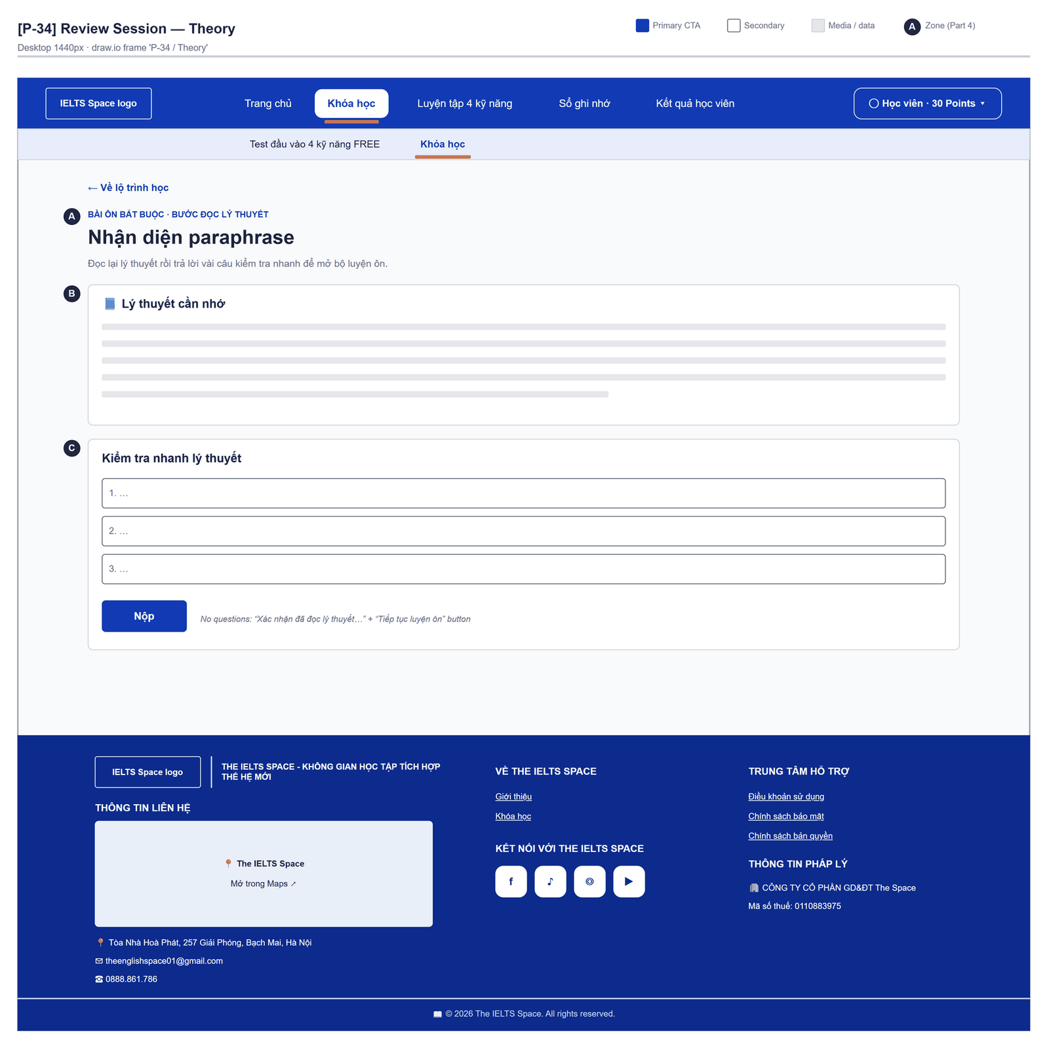
Figure 2.17-1 — Review Session — Theory. Source: wireframes/screens/P-34_ReviewSession.drawio, tab “P-34 / Theory”
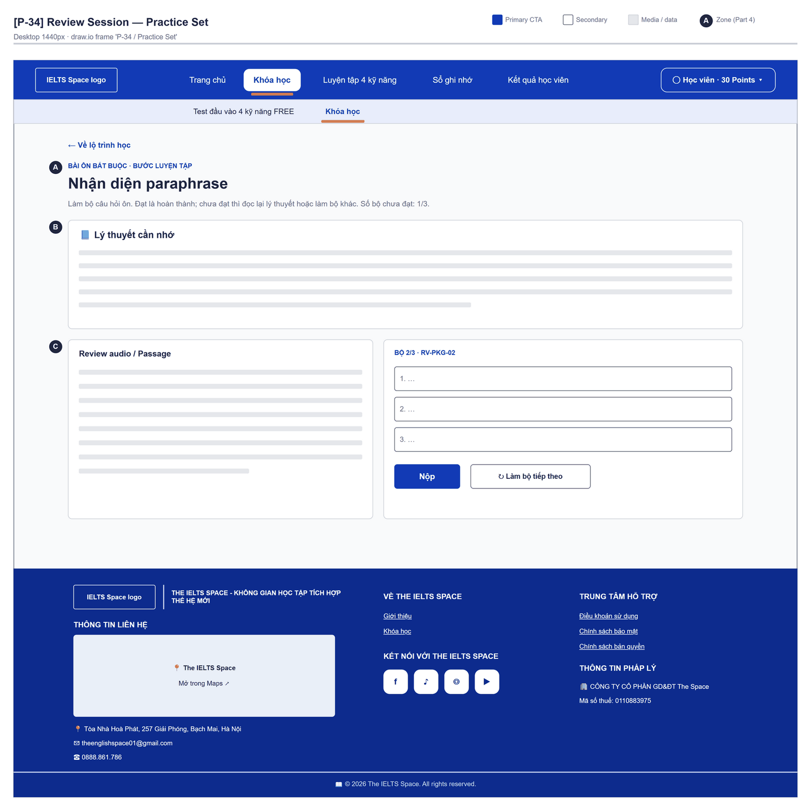
Figure 2.17-2 — Review Session — Practice Set. Source: wireframes/screens/P-34_ReviewSession.drawio, tab “P-34 / Practice Set”
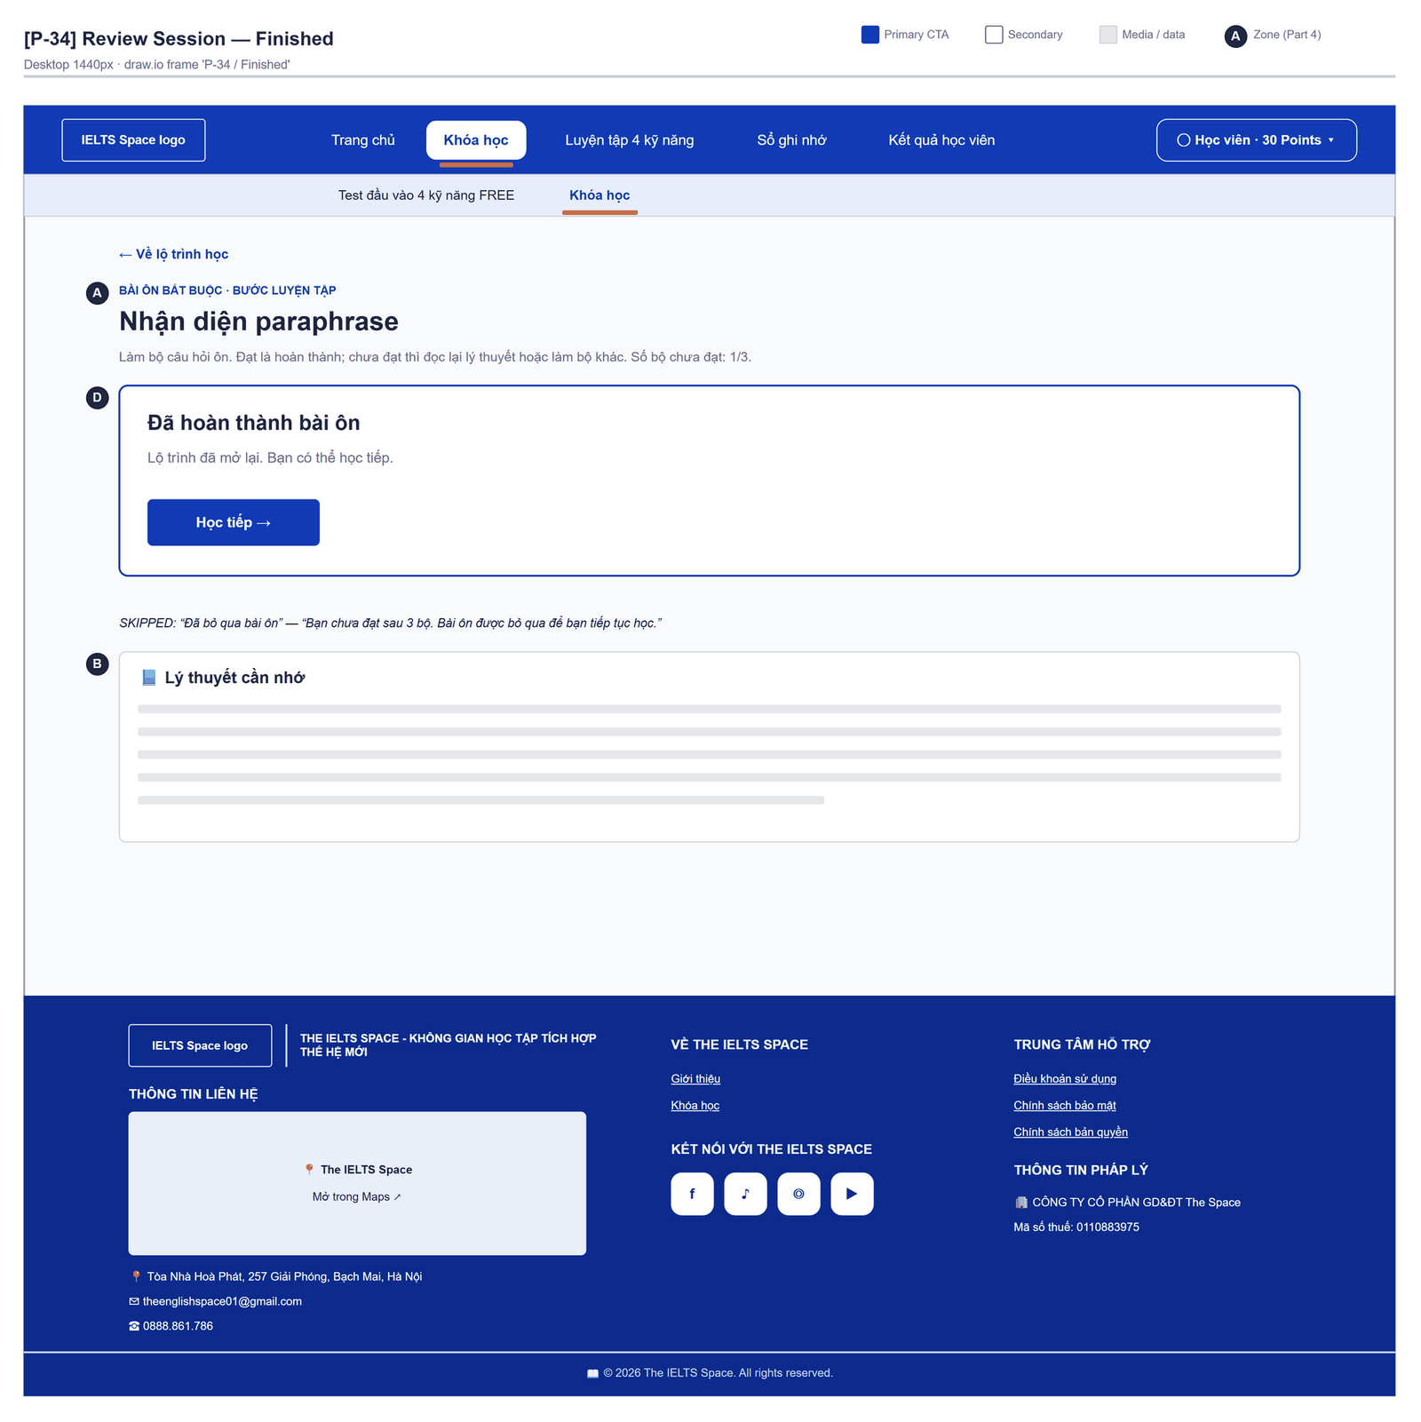
Figure 2.17-3 — Review Session — Finished. Source: wireframes/screens/P-34_ReviewSession.drawio, tab “P-34 / Finished”

Navigation Context
Navigates from | Condition / Trigger
Review banner / panel | User clicks "Làm bài ôn"
Lesson Player, Practice Set, Topic Detail | A review was created

Navigates to | Condition / Trigger
Lesson Player or Topic Detail | Review DONE or SKIPPED; user clicks "Học tiếp"

2.17.2 Entry & Exit Conditions

Preconditions & Guard Redirects
# | Condition check | If met | If not met → Action
PC-01 | Session exists (RequireAuth, GG-01) | Continue rendering | Redirect → /login (state.from kept); GLB-01
PC-02 | The review in the URL belongs to the signed-in user | Continue rendering | API returns 404 → redirect to previous screen; GLB-03

Entry Triggers
# | Trigger | From screen / Source | Parameters passed
ET-01 | Làm bài ôn | Banner, Lesson Player, Practice Set | reviewId

Exit Points
# | Event | Condition | Navigates to | Notes
EX-01 | Set passed | reviewStatus DONE | Stay; done panel | MSG-03
EX-02 | Second failure / no set left | reviewStatus SKIPPED | Stay; skipped panel | MSG-02
EX-03 | User clicks Học tiếp | DONE or SKIPPED | resumeLessonId lesson, else the topic, else /learn | —
EX-04 | Session expires, silent refresh fails | Refresh token used, expired or revoked | Login | GLB-01; returnUrl kept

2.17.3 UI Components
Code | Component name | Type | Validation / Constraint | Notes
ReviewSession-LNK-01 | Về lộ trình học | Back link | — | To the lesson to resume, else the topic, else /learn
ReviewSession-PNL-01 | Header | Header | — | "Bài ôn bắt buộc · Bước đọc lý thuyết" or "· Bước luyện tập"; "Số bộ chưa đạt: {n}/{max}." after a failed set
ReviewSession-PNL-02 | Lý thuyết cần nhớ | Rich text | — | Theory blocks of the knowledge point
ReviewSession-PNL-03 | Kiểm tra nhanh lý thuyết | Questions | THEORY stage | "Đọc lại lý thuyết rồi trả lời vài câu kiểm tra nhanh để mở bộ luyện ôn."
ReviewSession-BTN-01 | Confirm read | Button | Only when there is no quick-check | "Không có câu kiểm tra nhanh. Xác nhận đã đọc lý thuyết để sang bước luyện tập." (FG-12)
ReviewSession-PNL-04 | Bộ câu hỏi ôn | Questions + passage / "Audio ôn" | PRACTICE stage | "Làm bộ câu hỏi ôn. Đạt là hoàn thành; chưa đạt thì đọc lại lý thuyết hoặc làm bộ khác."
ReviewSession-BTN-02 | Làm bộ tiếp theo | Button (Secondary) | After a failed set | Reloads the review
ReviewSession-BTN-03 | Học tiếp | Button (Primary) | DONE or SKIPPED | —

2.17.4 API Calls & Data Flow
# | Trigger (UI event) | API ID | Method + Path | Request | Success → UI action | Error → UI action
1 | Page load | API-132 | GET /api/learning/reviews/{reviewId} | Path: reviewId | Render the stage · loading: "Đang tải bài ôn…" | GLB-03/04
2 | User submits the set | API-132 | GET /api/learning/reviews/{reviewId} | Path: reviewId (re-read for lessonId) | Then API 3 | —
3 | User submits the set | API-133 | POST /api/learning/reviews/{reviewId}/submissions | {reviewSetId, requestId, answers} | Show results; follow stage / status | 409 REVIEW_SET_CLOSED (set already submitted) / THEORY_REQUIRED (theory first), BR-21 → server message + " Hãy thử nộp lại."
4 | User submits the quick check | API-134 | POST /api/learning/reviews/{reviewId}/theory-check | {requestId, answers} | Show results; reload for the new set | 422 INVALID_ANSWERS when there is no quick-check (FG-12)

2.17.5 Interaction Specifications

Ladder
THEORY: quick check (no evidence) → PRACTICE with a new set
PRACTICE: set ≥ 70% → DONE (MSG-03)
PRACTICE: set < 70% → "Chưa đạt ({n}/{max} bộ). Thử bộ tiếp theo."
Second failed set or no unseen set → SKIPPED (MSG-02)

2.17.6 Messages & Display Content
Code | Type | Trigger condition | Content (UI copy) | Action / Duration
MSG-01 | Inline Result | Set below 70% | "Chưa đạt ({n}/{max} bộ). Thử bộ tiếp theo." | Button "Làm bộ tiếp theo"
MSG-02 | Info Panel | Review SKIPPED | "Đã bỏ qua bài ôn" · "Bạn chưa đạt sau {max} bộ. Bài ôn được bỏ qua để bạn tiếp tục học." | Button "Học tiếp"
MSG-03 | Success Panel | Review DONE | "Đã hoàn thành bài ôn" · "Lộ trình đã mở lại. Bạn có thể học tiếp." | Button "Học tiếp"

2.17.7 Business Rules
BR/BV Code | Short description | UI behaviour when violated
BR-21 | Set → theory (≤ 3 quick checks, no evidence) → set; 70% DONE; second fail SKIPPED | Stage header and panels
BR-20 | Revealed packages are never reused | SKIPPED panel when no set remains
FT-28/NAC-02 | A review with no quick-check → 422 | The confirm button fails today (FG-12)

2.18 Mastery

2.18.1 General Information
Screen Name | Mastery
Purpose | Shows the learner's mastery from 0 to 1 for every knowledge point, grouped by skill and topic, so the learner can see strong and weak points.
Route / Type | /learn/mastery (proposed)
Role(s) | CUSTOMER
Related FT / UC | FT-26  UC-053 View mastery
Status | Specified (backend); screen not built (FG-07)
Frontend | Not built in the frontend yet — this section is the design target for the frontend team.
Mockup / Wireframe | TBD — no frontend screen yet

Navigation Context
Navigates from | Condition / Trigger
Course Path | User clicks "View mastery"
Main menu | User clicks "Mastery"

Navigates to | Condition / Trigger
Topic Detail | User clicks a topic group header

2.18.2 Entry & Exit Conditions

Preconditions & Guard Redirects
# | Condition check | If met | If not met → Action
PC-01 | Valid session: access token, or a successful silent refresh (GG-01) | Continue rendering | Redirect → Login?returnUrl=…; GLB-01
PC-02 | User holds role CUSTOMER (GG-02) | Continue rendering | Redirect → /403; GLB-02

Entry Triggers
# | Trigger | From screen / Source | Parameters passed
ET-01 | View mastery link | Course Path | —
ET-02 | Main menu | Any learner screen | Query: ?skill=

Exit Points
# | Event | Condition | Navigates to | Notes
EX-01 | User clicks a topic | Topic not LOCKED | Topic Detail | —
EX-02 | User picks another item in the main menu | Any | Selected screen | —
EX-03 | Session expires, silent refresh fails | Refresh token used, expired or revoked | Login | GLB-01; returnUrl kept

2.18.3 UI Components
Code | Component name | Type | Validation / Constraint | Notes
Mastery-TAB-01 | Skill tabs | Tab bar | LISTENING, READING, WRITING, SPEAKING | —
Mastery-TBL-01 | Knowledge points | Table grouped by topic | Sortable: mastery, evidence count | Name, mastery bar, evidence count
Mastery-BDG-01 | Mastery level | Badge | < 0.6→red "Needs work", 0.6–0.8→amber, ≥ 0.8→green | 0 evidence→grey "Not started"

2.18.4 API Calls & Data Flow
# | Trigger (UI event) | API ID | Method + Path | Request | Success → UI action | Error → UI action
1 | Page load (mount) | API-125 | GET /api/learning/mastery | — | Render table · loading: skeleton | 503 → GLB-05
2 | Page load (parallel) | API-63 | GET /api/content/knowledge-points | — | Join names by id in memory | Error → show ids

2.18.5 Interaction Specifications

Display rule
Mastery is shown as a percentage bar (mastery × 100). With one or two pieces of
evidence the value is capped (0.5 / 0.8); the tooltip says "More practice gives a more reliable score".

2.18.6 Messages & Display Content
Code | Type | Trigger condition | Content (UI copy) | Action / Duration
MSG-01 | Empty State | No knowledge points | Title: "Nothing measured yet" · Description: "Finish an exercise block to see your mastery." | CTA: "Go to learning path"

2.18.7 Business Rules
BR/BV Code | Short description | UI behaviour when violated
BR-23 | Latest 5 outcomes weighted; caps 0.5 / 0.8 | Tooltip on low-evidence rows
BR-23 | Mastery < 0.6 opens a review after an assessment | Red badge "Needs work"

2.19 Test Attempt

2.19.1 General Information
Screen Name | Test Attempt
Purpose | Lets the learner sit a topic final test or a course final test section by section, with answers saved as they go, and submit it for grading.
Route / Type | /learn/tests/:attemptId?topic=… | ?course=… · RequireAuth
Role(s) | Signed-in learner
Related FT / UC | FT-24, FT-30, FT-31, FT-55  UC-059, UC-066–UC-073 Take test attempt; UC-060 Take course test
Status | Specified (no timer: FG-09)
Frontend | Built — features/learning-path/pages/TopicTestPage.tsx inside LearnLayout (route /learn/tests/:attemptId); calls the real backend.
Mockup / Wireframe | Figure 2.19-1 to 2.19-2 below — draw.io wireframes in docs/wireframes/screens (P-35_TopicTest.drawio), one tab per state; clickable prototype: docs/wireframes/IELTSPath_Prototype.drawio
Open Questions | OQ-21 (Appendix B)

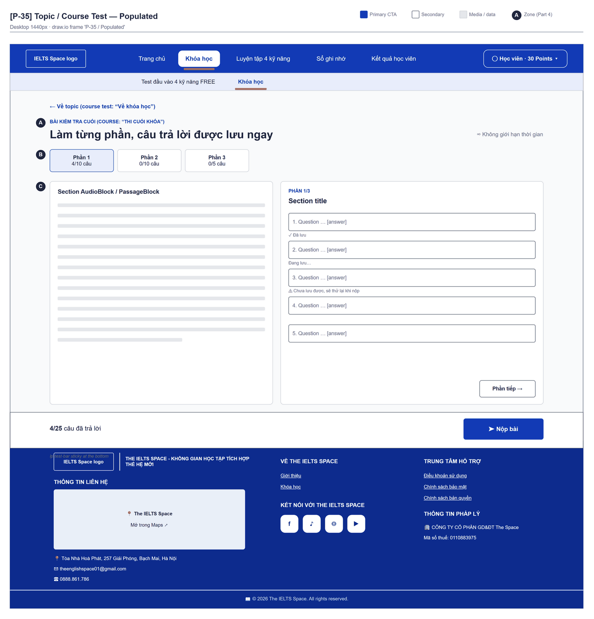
Figure 2.19-1 — Test Attempt — Populated. Source: wireframes/screens/P-35_TopicTest.drawio, tab “P-35 / Populated”
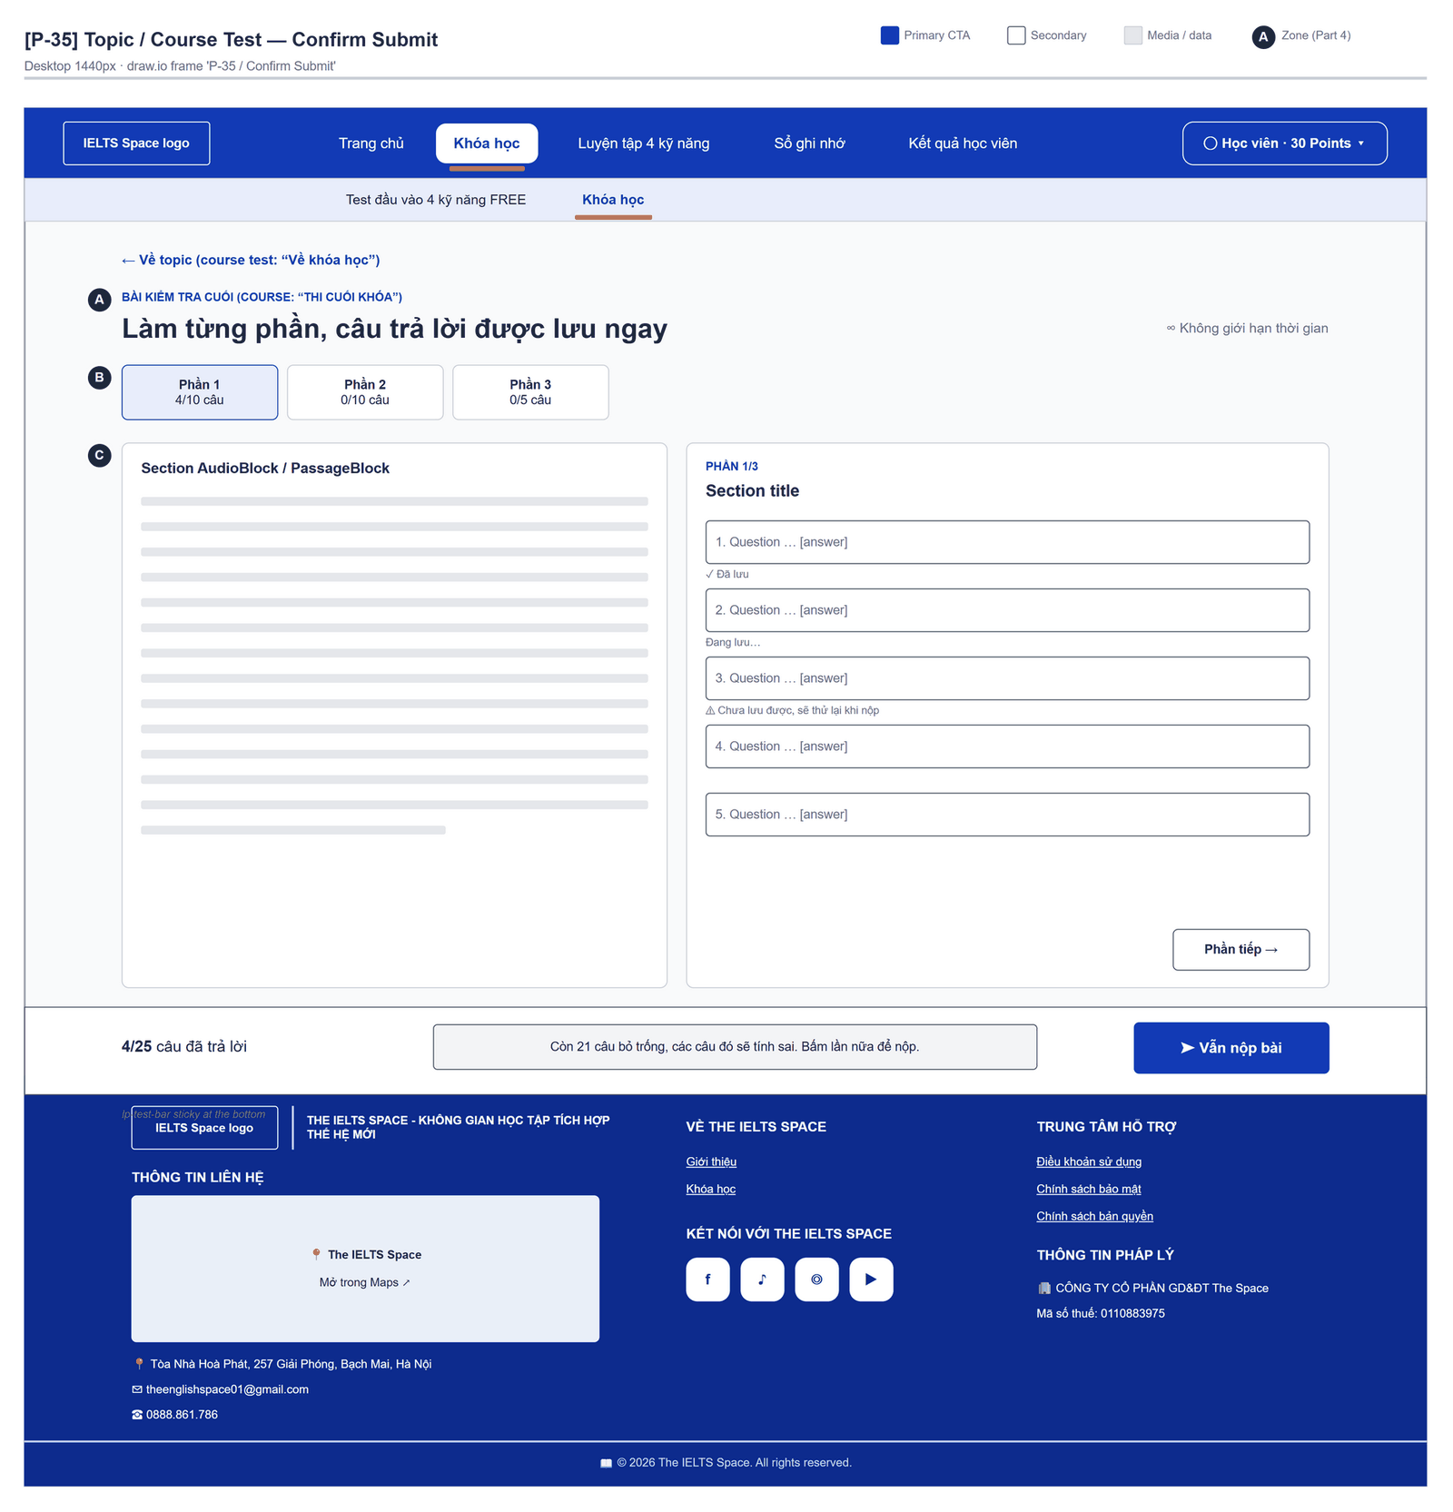
Figure 2.19-2 — Test Attempt — Confirm Submit. Source: wireframes/screens/P-35_TopicTest.drawio, tab “P-35 / Confirm Submit”

Navigation Context
Navigates from | Condition / Trigger
Topic Detail | Topic final test assigned and attempt created
Course Path | Course final test assigned and attempt created

Navigates to | Condition / Trigger
Test Result | Submit succeeds
Topic Detail | User clicks "Về topic"
Course Path | User clicks "Về khóa học"

2.19.2 Entry & Exit Conditions

Preconditions & Guard Redirects
# | Condition check | If met | If not met → Action
PC-01 | Session exists (RequireAuth, GG-01) | Continue rendering | Redirect → /login (state.from kept); GLB-01
PC-02 | Attempt belongs to the user | Continue | 403 → error panel

Entry Triggers
# | Trigger | From screen / Source | Parameters passed
ET-01 | Làm bài kiểm tra | Topic Detail | attemptId, Query topic
ET-02 | Làm bài thi cuối khóa | Course Path | attemptId, Query course

Exit Points
# | Event | Condition | Navigates to | Notes
EX-01 | User clicks Nộp bài (all saved) | API 200 | Test Result | /learn/tests/{id}/result?topic=…, replace
EX-02 | Save failed for some answer | — | Stay | MSG-02
EX-03 | User clicks Về topic | Any | Topic Detail | Saved answers stay on the server
EX-04 | Session expires, silent refresh fails | Refresh token used, expired or revoked | Login | GLB-01; returnUrl kept

2.19.3 UI Components
Code | Component name | Type | Validation / Constraint | Notes
TestAttempt-LNK-01 | Về topic / Về khóa học | Back link | — | To the topic or the course
TestAttempt-PNL-01 | Header | Header | — | "Bài kiểm tra cuối" (course: "Thi cuối khóa") · "Làm từng phần, câu trả lời được lưu ngay" · "Không giới hạn thời gian"
TestAttempt-TAB-01 | Các phần của đề | Section list | — | "Phần {n}" with "{done}/{total} câu"
TestAttempt-PNL-02 | Section content | Passage / audio | — | No transcript during the test
TestAttempt-RAD-01 | Answer | Radio (choices) / Text Input | — | Choice answers save on change
TestAttempt-BDG-01 | Save state | Inline text | "Đang lưu…" / "Đã lưu" / "Chưa lưu được, sẽ thử lại khi nộp" | Per item
TestAttempt-BTN-01 | Phần trước / Phần tiếp | Buttons | — | "Phần {k}/{n}"
TestAttempt-BTN-02 | Nộp bài / Vẫn nộp | Button (Primary) | Second click needed when answers are missing | "Đang nộp…" while pending

2.19.4 API Calls & Data Flow
# | Trigger (UI event) | API ID | Method + Path | Request | Success → UI action | Error → UI action
1 | Page load | API-144 | GET /api/assessments/attempts/{id}/structure | Path: attemptId | Render sections · loading: "Đang tải đề…" | GLB-03/04
2 | Choice picked, text field left, and every answer at submit | API-145 | PUT /api/assessments/attempts/{id}/items/{itemId}/response | {payload: {answer}, schemaVersion: 1, expectedRevision} | Badge "Đã lưu"; keep the new revision | Badge "Chưa lưu được, sẽ thử lại khi nộp"
3 | User confirms Nộp bài | API-147 | POST /api/assessments/attempts/{id}/submit | Path: attemptId | Navigate Test Result | 409 ATTEMPT_ALREADY_SUBMITTED / ATTEMPT_EXPIRED → server message + " Hãy thử nộp lại."

2.19.5 Interaction Specifications

Submit
IF unanswered > 0 AND not confirmed → show MSG-01, button becomes "Vẫn nộp bài"
Save every answered item (queued per item); IF any save fails → MSG-02 and stop
ELSE submit and open the result

Saves per item
Saves of one item run one after another; each sends the last revision so a stale save is refused by the server.

2.19.6 Messages & Display Content
Code | Type | Trigger condition | Content (UI copy) | Action / Duration
MSG-01 | Warning Text | Unanswered items on first submit | "Còn {n} câu bỏ trống, các câu đó sẽ tính sai. Bấm lần nữa để nộp." | Until the next change
MSG-02 | Inline Error | A save failed at submit | "Chưa lưu được một số câu trả lời. Kiểm tra các câu có cảnh báo rồi nộp lại." | Persistent
MSG-03 | Empty State | Structure has no question | "Đề này chưa có câu hỏi." | —
MSG-04 | Item Badge | 409 on save: stale revision (another tab or device saved first) or ATTEMPT_EXPIRED | Today: "Chưa lưu được, sẽ thử lại khi nộp". Design target: stale → reload the item answer and revision from as.attempt; expired → "Bài làm đã hết thời gian. Các câu đã lưu được giữ lại." and open Test Result (FG-09) | Per item
MSG-05 | Inline Error | 409 ATTEMPT_EXPIRED on submit | Today: server message + " Hãy thử nộp lại." Design target: same text as MSG-04 | Persistent

2.19.7 Business Rules
BR/BV Code | Short description | UI behaviour when violated
FT-30 | Frozen snapshot; no answers, hints or transcripts in the structure | Nothing to hide client-side
FT-30 BV-01 | Save needs the current revision | Revision kept per item
BR-39 | Essays of topic and course tests are graded by the LLM after submit (JOB-03) | No essay box in the test runner yet; an essay never sent scores 0

2.20 Test Result

2.20.1 General Information
Screen Name | Test Result
Purpose | Shows the score of the submitted topic or course test, per-question correctness and — at 70% or more — the correct answers, and tells the learner whether the topic or the course is passed.
Route / Type | /learn/tests/:attemptId/result?topic=… | ?course=… · RequireAuth
Role(s) | Signed-in learner
Related FT / UC | FT-14, FT-24, FT-29, FT-31, FT-33, FT-55  UC-063–UC-064 Request AI grading; UC-074 View result; UC-080 Request examiner grading; UC-060 Take course test
Status | Specified (examiner and AI grading requests: Draft)
Frontend | Built — features/learning-path/pages/TopicTestResultPage.tsx inside LearnLayout (route /learn/tests/:attemptId/result); calls the real backend.
Mockup / Wireframe | Figure 2.20-1 to 2.20-2 below — draw.io wireframes in docs/wireframes/screens (P-36_TestResult.drawio), one tab per state; clickable prototype: docs/wireframes/IELTSPath_Prototype.drawio
Open Questions | OQ-07 (Appendix B)

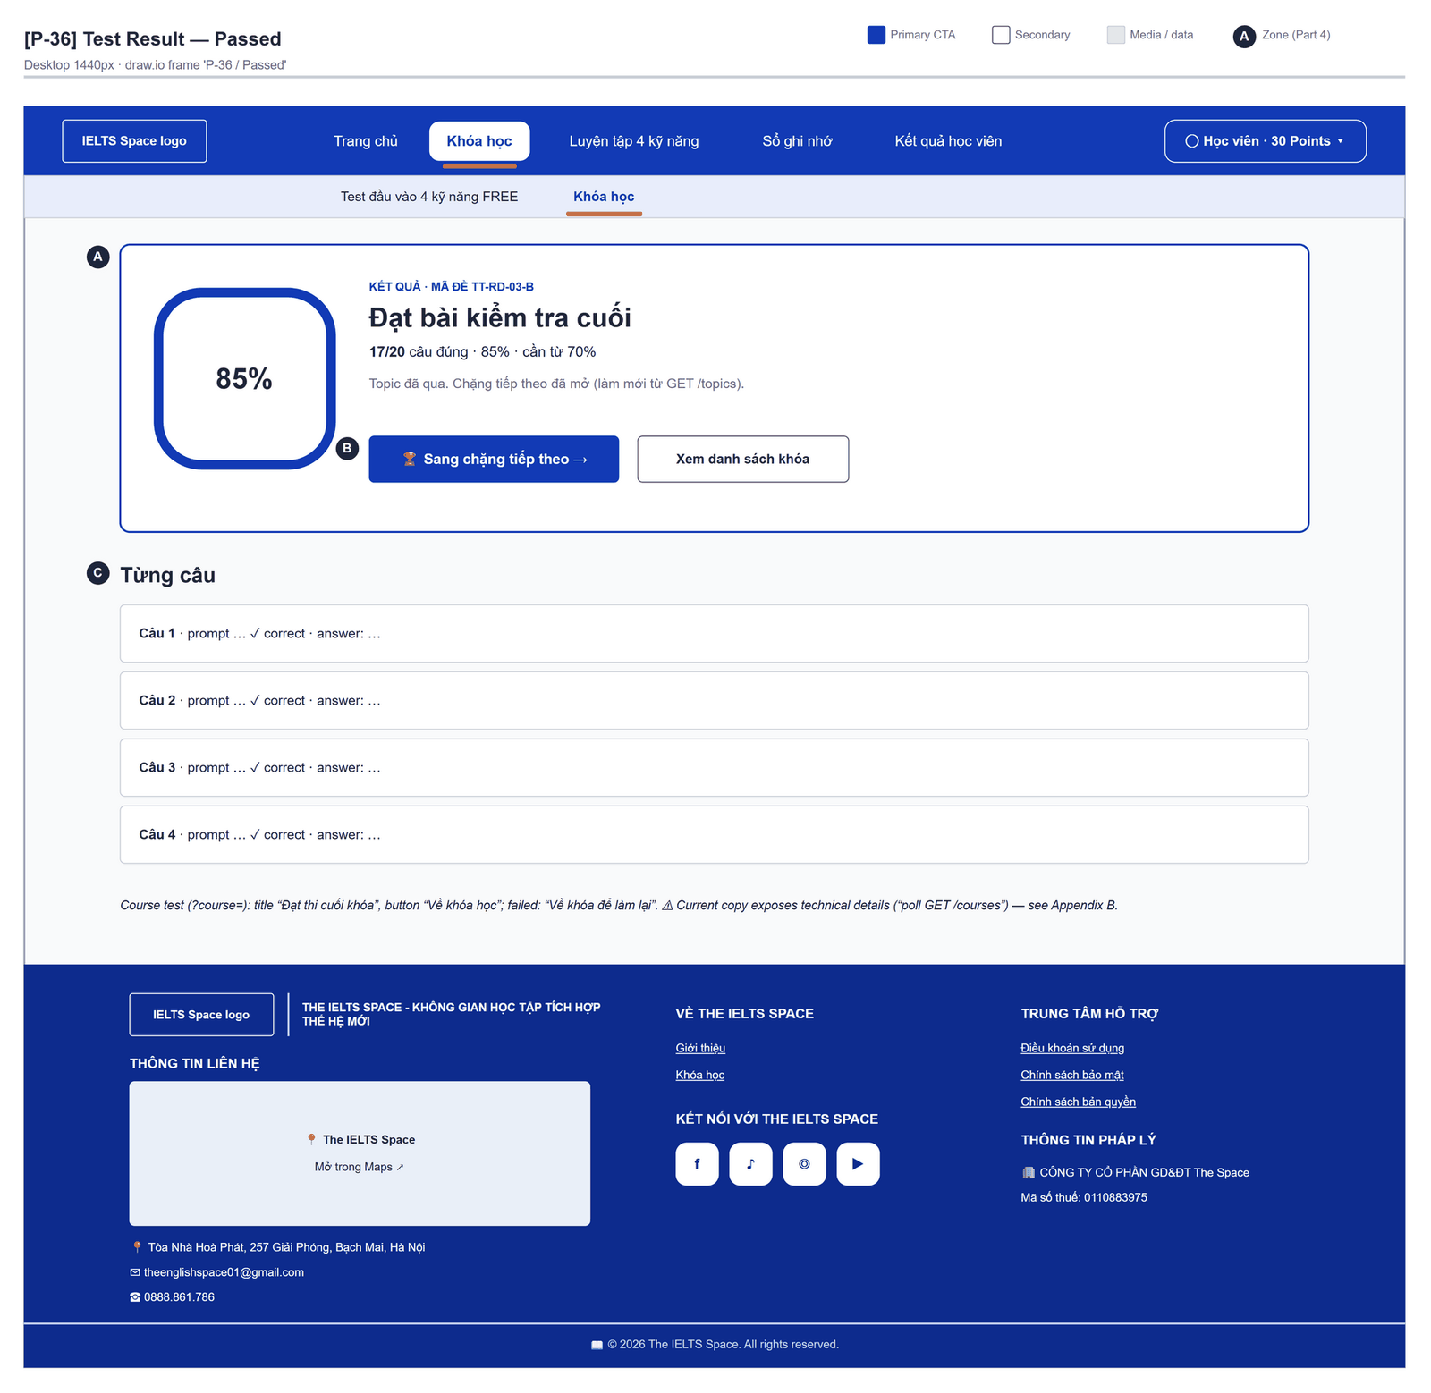
Figure 2.20-1 — Test Result — Passed. Source: wireframes/screens/P-36_TestResult.drawio, tab “P-36 / Passed”
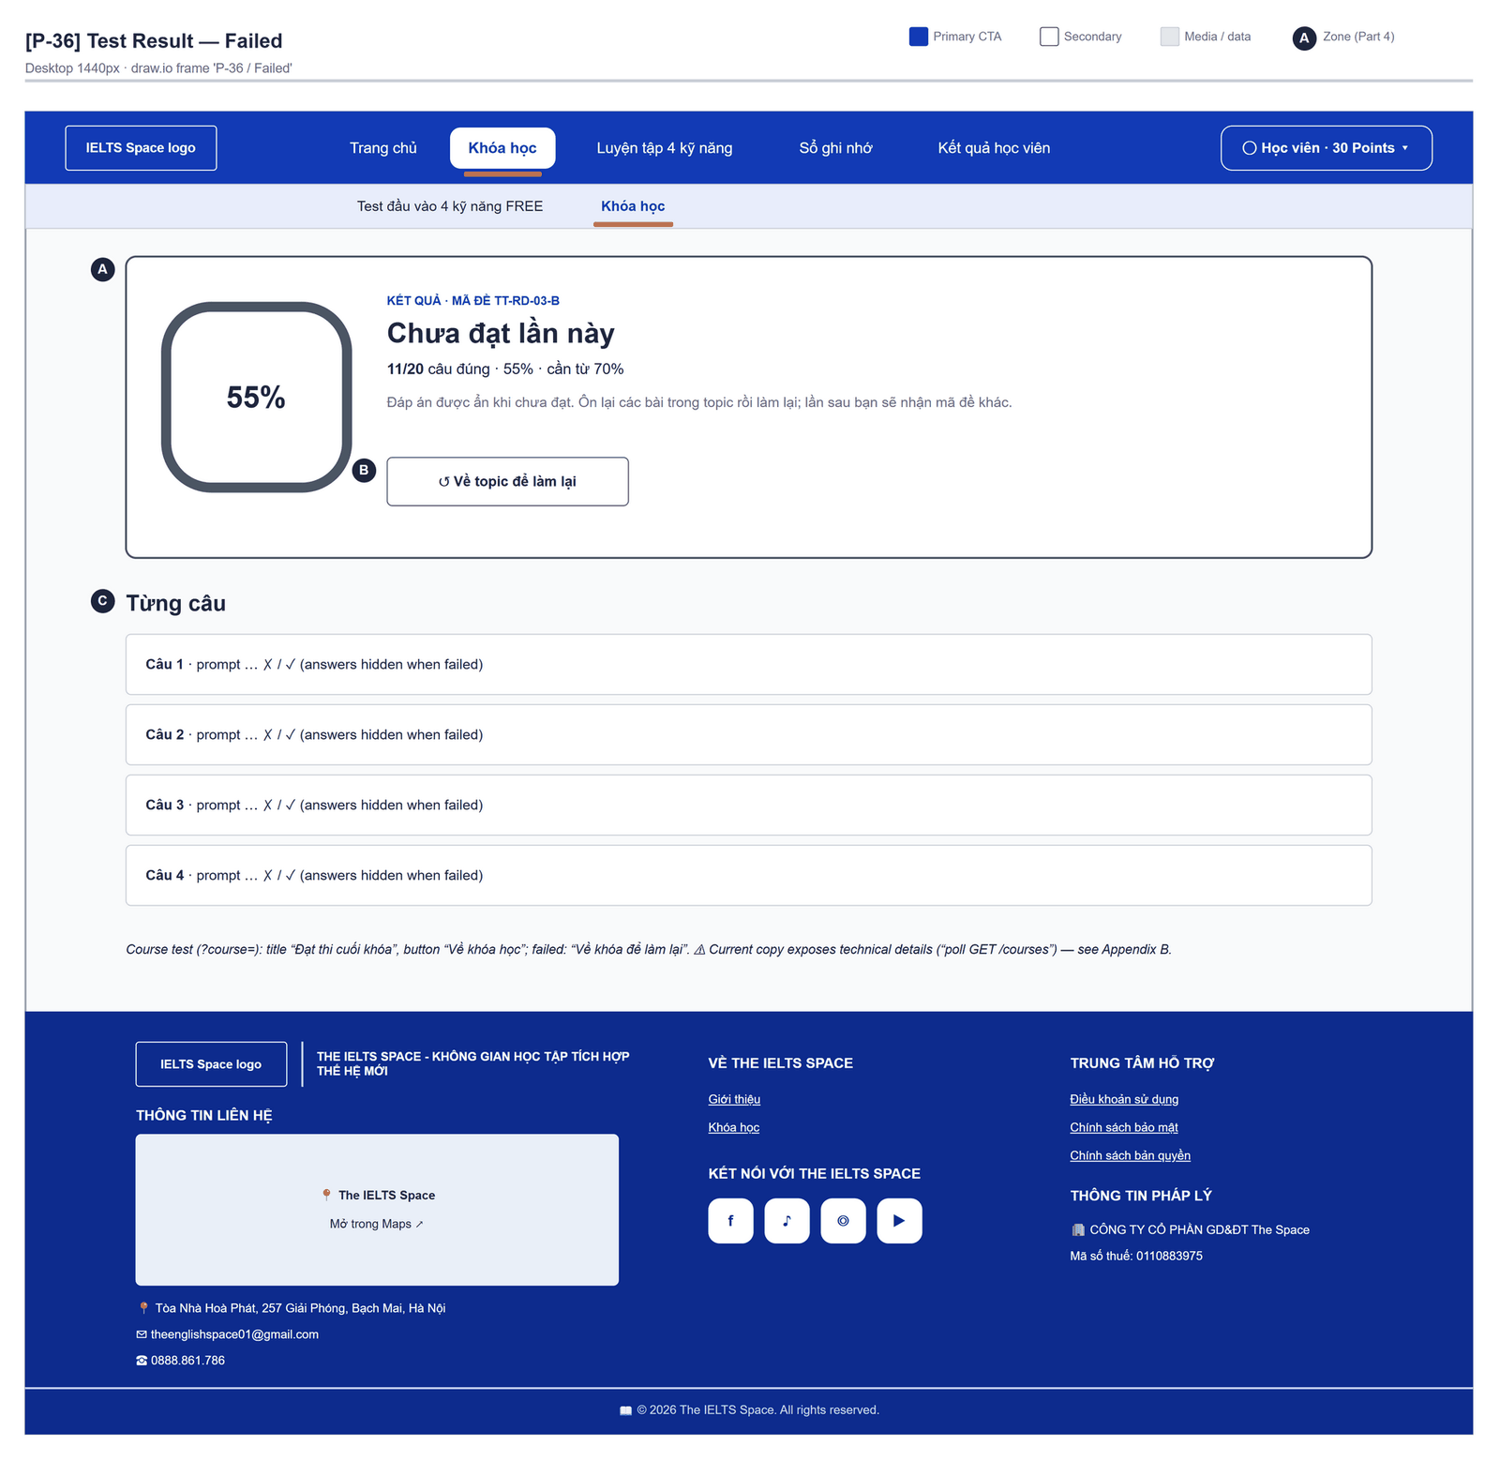
Figure 2.20-2 — Test Result — Failed. Source: wireframes/screens/P-36_TestResult.drawio, tab “P-36 / Failed”

Navigation Context
Navigates from | Condition / Trigger
Test Attempt | Submit succeeded

Navigates to | Condition / Trigger
Topic Detail (next topic) | Topic passed; user clicks "Sang chặng tiếp theo"
Course Path | Course passed: "Về khóa học"; failed: "Về khóa để làm lại"
Course List | User clicks "Xem danh sách khóa"
Topic Detail | Topic failed; user clicks "Về topic để làm lại"

2.20.2 Entry & Exit Conditions

Preconditions & Guard Redirects
# | Condition check | If met | If not met → Action
PC-01 | Session exists (RequireAuth, GG-01) | Continue rendering | Redirect → /login (state.from kept); GLB-01
PC-02 | Attempt belongs to the user | Continue | 403 → error panel

Entry Triggers
# | Trigger | From screen / Source | Parameters passed
ET-01 | Submit | Test Attempt | attemptId, Query topic or course

Exit Points
# | Event | Condition | Navigates to | Notes
EX-01 | User clicks a navigation button | Any | Topic Detail, Course Path or Course List | —
EX-02 | Session expires, silent refresh fails | Refresh token used, expired or revoked | Login | GLB-01; returnUrl kept

2.20.3 UI Components
Code | Component name | Type | Validation / Constraint | Notes
TestResult-PRG-01 | Score dial | Ring | — | Percent
TestResult-PNL-01 | Outcome | Header | — | "Kết quả · mã đề {code}" · "Đạt bài kiểm tra cuối" (course: "Đạt thi cuối khóa") / "Chưa đạt lần này"
TestResult-PNL-02 | Score line | Text | — | "{score}/{max} câu đúng · {p}% · cần từ 70%"
TestResult-TBL-01 | Từng câu | List | — | "Câu {n}" ✓/✗; "Đáp án: {answer}" only when passed
TestResult-BTN-01 | Sang chặng tiếp theo / Về khóa học / Xem danh sách khóa / Về topic (khóa) để làm lại | Buttons | — | By outcome and test kind

2.20.4 API Calls & Data Flow
# | Trigger (UI event) | API ID | Method + Path | Request | Success → UI action | Error → UI action
1 | Page load | API-148 | GET /api/assessments/attempts/{attemptId}/result | Path: attemptId | Render score and items · loading: "Đang chấm bài…" | 404 / 403 → error panel
2 | Topic passed: re-read the topics up to 4 times, 400 ms apart | API-120 | GET /api/learning/topics | — | Find the PASSED topic and the next IN_PROGRESS topic | Error → panel
3 | Course passed: re-read the courses up to 4 times, 400 ms apart | API-117 | GET /api/learning/courses | — | Find the course with testStatus PASSED | Error → panel
4 | Design target: user clicks "Chấm bằng AI" on a Writing/Speaking item [Draft] | API-155 | POST /api/assessments/submissions | {attemptItemId, skill, textPayload | audioReference, submissionKey} | Then API 4 | 400 → GLB-06
5 | Design target: submission created [Draft] | API-156 | POST /api/assessments/grading-jobs | {submissionId, skill, gradingMode, idempotencyKey} | Show the job status | 402 → "Bạn không đủ điểm để chấm bằng AI."
6 | Design target: every 5 s until final [Draft] | API-157 | GET /api/assessments/grading-jobs/{id} | Path: id | GRADED → reload API 1 | 403 → GLB-02
7 | Design target: user clicks "Gửi giáo viên chấm" [Draft] | API-55 | POST /api/access/users/{userId}/consume-human-grading | Path: userId (learner flow [TBC]) | Credits left shown | 402 → "Bạn đã hết lượt chấm giáo viên."

2.20.5 Interaction Specifications

Outcome text
IF passed AND a next topic is IN_PROGRESS → "Topic đã qua. Chặng tiếp theo đã mở (làm mới từ GET /topics)."
ELSE IF passed → "Topic đã qua. Bạn đã hoàn thành toàn bộ lộ trình hiện có."
ELSE → "Đáp án được ẩn khi chưa đạt. Ôn lại các bài trong topic rồi làm lại; lần sau bạn sẽ nhận mã đề khác."
Course test: passed and course PASSED → "Khóa đã đánh dấu PASSED (poll GET /courses). Bạn có thể chọn khóa
khác hoặc xem lại lộ trình."; passed, not yet PASSED → "Đã đạt điểm. Hệ thống đang cập nhật trạng
thái khóa — làm mới danh sách khóa nếu chưa thấy PASSED."; failed → "Đáp án được ẩn khi chưa đạt.
Ôn lại các topic rồi làm lại; lần sau bạn sẽ nhận mã đề khác."

Why it re-reads topics
The topic is passed asynchronously by JOB-02 after JOB-01 relays the event (relay every 2 s; NFR-P05 allows up to 5 s), so the page re-reads /topics before showing the next topic.
Today it re-reads 4 times, 400 ms apart (about 1.6 s), which is often too short (FG-14).

2.20.6 Messages & Display Content
Code | Type | Trigger condition | Content (UI copy) | Action / Duration
MSG-01 | Success Header | Passed | "Đạt bài kiểm tra cuối" | Persistent
MSG-02 | Info Header | Not passed | "Chưa đạt lần này" | Persistent
MSG-03 | Info Text | Not passed | "Đáp án được ẩn khi chưa đạt. Ôn lại các bài trong topic rồi làm lại; lần sau bạn sẽ nhận mã đề khác." | Persistent

2.20.7 Business Rules
BR/BV Code | Short description | UI behaviour when violated
BR-24 | Answers and transcripts only at ≥ 70% | "Đáp án" lines only when passed
BR-22 | Test code consumed even on failure; the next code rotates | MSG-03
BR-15 | Topic and course pass mark 70% | "cần từ 70%" in the score line
BR-37 | A course passes permanently at 70%; topics never relock | Course outcome text
NFR-P05 | A result reaches Learning Service within 5 s (95%) | Re-read /topics long enough to see the next topic (FG-14)
BR-31 | Examiner grading consumes one credit of an ACTIVE subscription [Draft] | 402 → "Bạn đã hết lượt chấm giáo viên."; nothing is consumed

2.21 Mock Tests
Draft: no mock test content exists and learners cannot list mock tests in the current release; an attempt of type MOCK can already be started by package version id. The placement test is built separately (Placement Test). The frontend's Luyện tập 4 kỹ năng area is a separate prototype (Practice Test Catalog).

2.21.1 General Information
Screen Name | Mock Tests
Purpose | Lists the published mock tests so the learner can practise under exam conditions and get an estimated band per skill.
Route / Type | /tests (proposed)
Role(s) | CUSTOMER
Related FT / UC | FT-34  UC-079 Take mock test
Status | Draft
Frontend | Not built in the frontend yet — this section is the design target for the frontend team.
Mockup / Wireframe | Figure 2.21-1 to 2.21-5 below — draw.io wireframes in docs/wireframes/screens (P-46_MockTestCatalog.drawio, P-47_MockTestRunner.drawio), one tab per state; clickable prototype: docs/wireframes/IELTSPath_Prototype.drawio

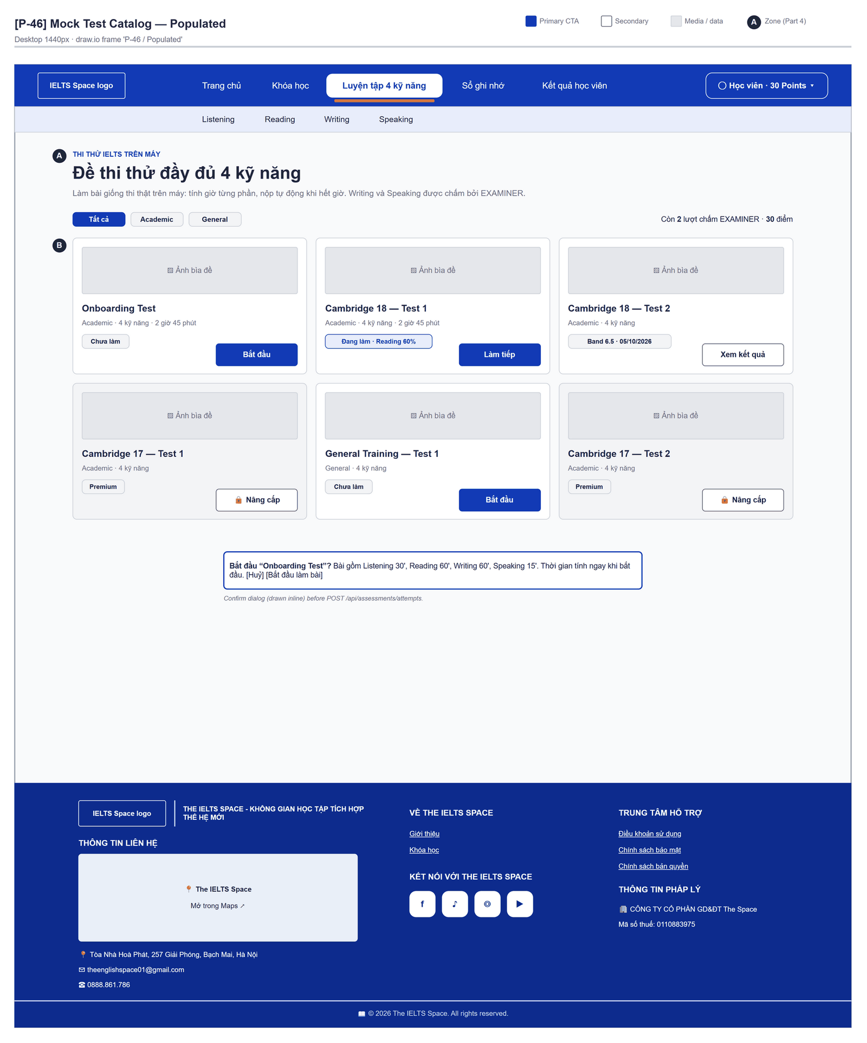
Figure 2.21-1 — Mock Tests — Populated. Source: wireframes/screens/P-46_MockTestCatalog.drawio, tab “P-46 / Populated”
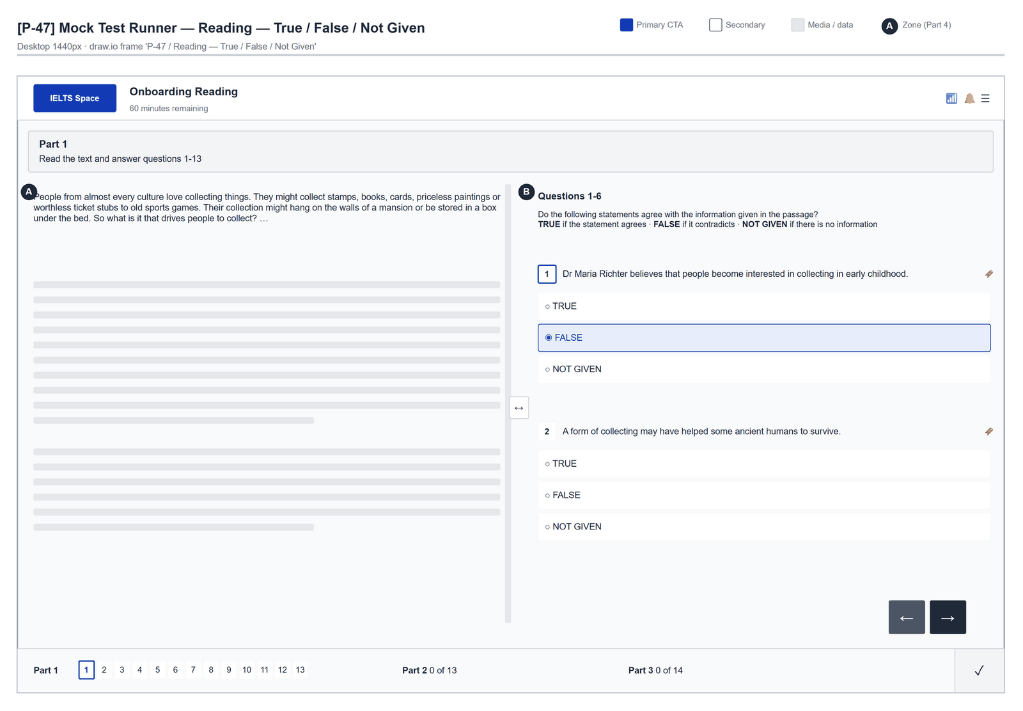
Figure 2.21-2 — Mock Tests — Mock Test Runner · Reading — True / False / Not Given. Source: wireframes/screens/P-47_MockTestRunner.drawio, tab “P-47 / Reading — True / False / Not Given”
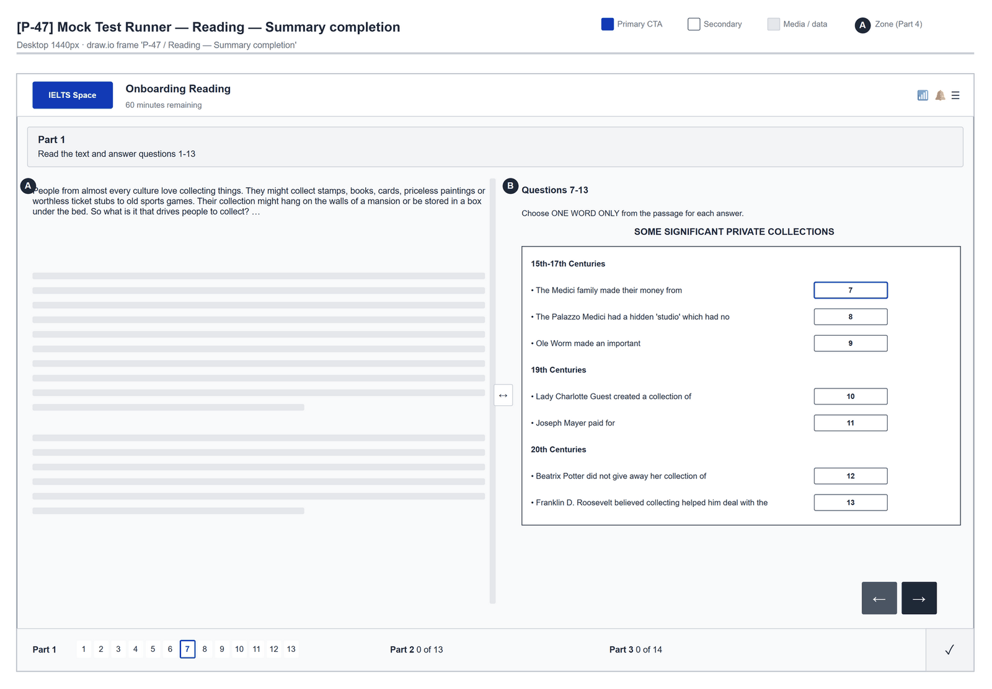
Figure 2.21-3 — Mock Tests — Mock Test Runner · Reading — Summary completion. Source: wireframes/screens/P-47_MockTestRunner.drawio, tab “P-47 / Reading — Summary completion”
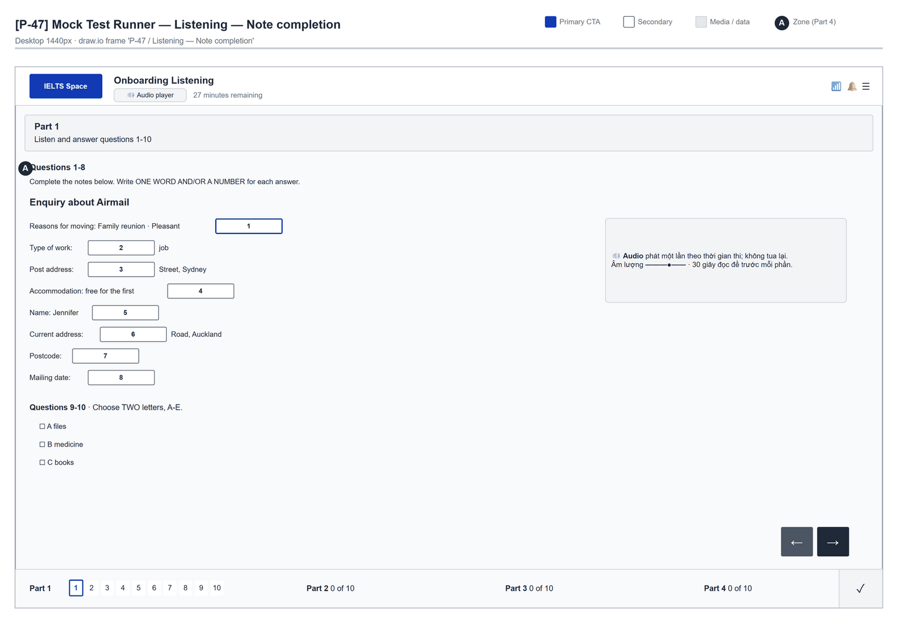
Figure 2.21-4 — Mock Tests — Mock Test Runner · Listening — Note completion. Source: wireframes/screens/P-47_MockTestRunner.drawio, tab “P-47 / Listening — Note completion”
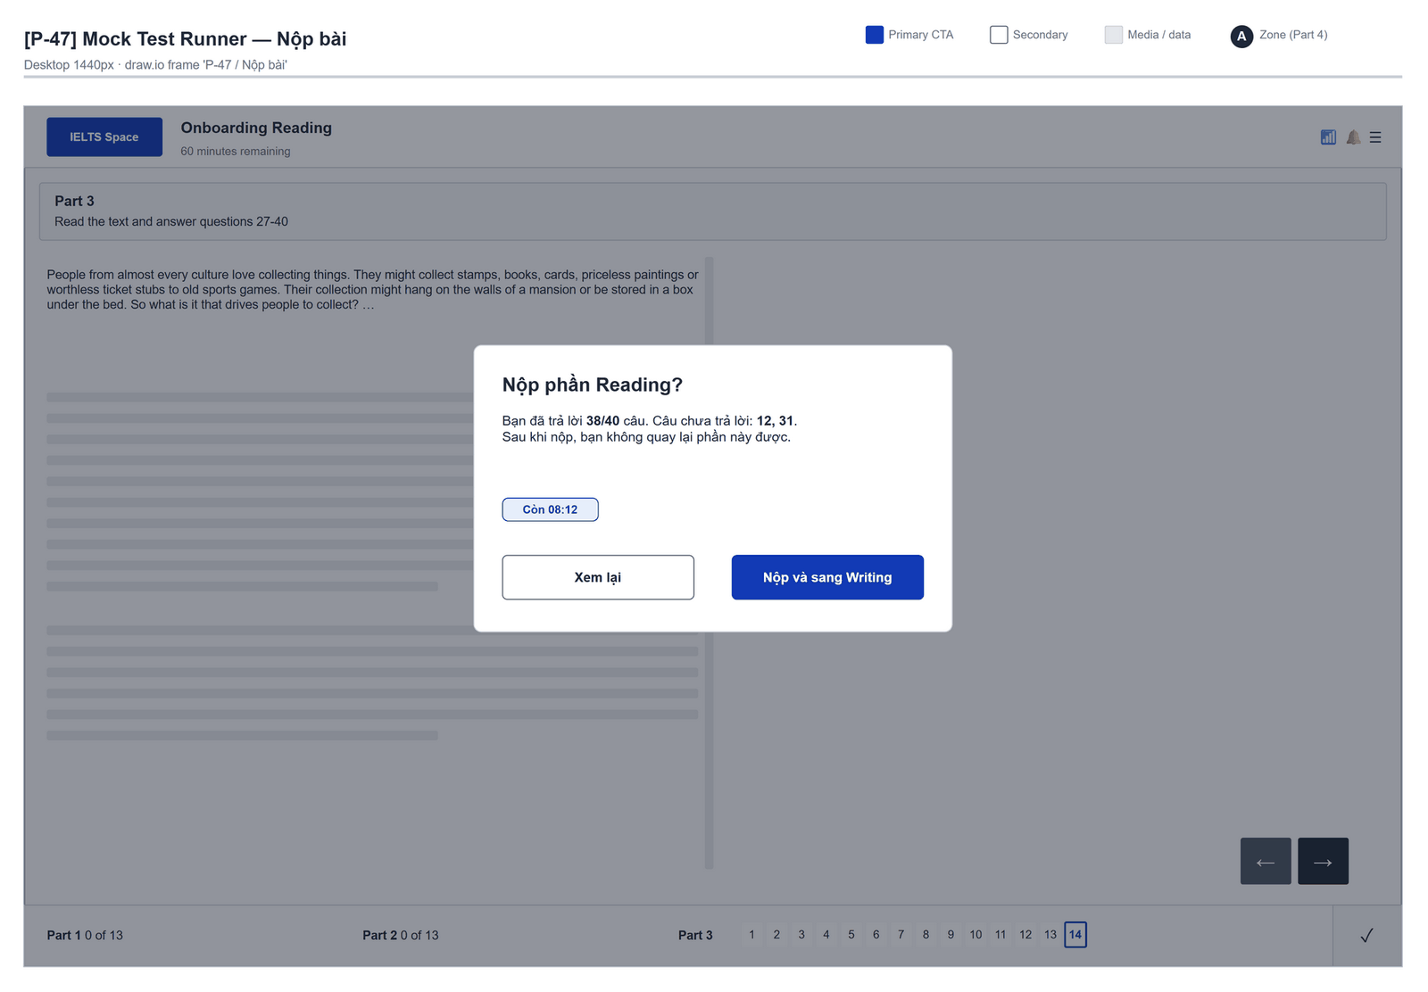
Figure 2.21-5 — Mock Tests — Mock Test Runner · Nộp bài. Source: wireframes/screens/P-47_MockTestRunner.drawio, tab “P-47 / Nộp bài”

Navigation Context
Navigates from | Condition / Trigger
Main menu | User clicks "Tests"

Navigates to | Condition / Trigger
Test Attempt | User starts a test
Test Result | User opens a past attempt

2.21.2 Entry & Exit Conditions

Preconditions & Guard Redirects
# | Condition check | If met | If not met → Action
PC-01 | Valid session: access token, or a successful silent refresh (GG-01) | Continue rendering | Redirect → Login?returnUrl=…; GLB-01
PC-02 | User holds role CUSTOMER (GG-02) | Continue rendering | Redirect → /403; GLB-02

Entry Triggers
# | Trigger | From screen / Source | Parameters passed
ET-01 | Main menu | Any learner screen | —

Exit Points
# | Event | Condition | Navigates to | Notes
EX-01 | User clicks Start | Test available | Test Attempt | Confirm modal MSG-02
EX-02 | User clicks a past attempt | Any | Test Result | —
EX-03 | User picks another item in the main menu | Any | Selected screen | —
EX-04 | Session expires, silent refresh fails | Refresh token used, expired or revoked | Login | GLB-01; returnUrl kept

2.21.3 UI Components
Code | Component name | Type | Validation / Constraint | Notes
MockTests-CRD-01 | Test card | Card list | — | Title, skills covered, estimated duration [TBC]
MockTests-BTN-01 | Start | Button (Primary) | — | Triggers API 2
MockTests-TBL-01 | Past attempts | Table | Newest first | Date, overall band (mock), status

2.21.4 API Calls & Data Flow
# | Trigger (UI event) | API ID | Method + Path | Request | Success → UI action | Error → UI action
1 | Page load (mount) | API-150 | GET /api/assessments/catalog?type=MOCK | Query: type | Render cards · loading: skeleton | Error → GLB-04
2 | User confirms Start | API-138 | POST /api/assessments/attempts | {packageVersionId, mode: STANDARD, channel: WEB} | Navigate Test Attempt | 422 PACKAGE_NOT_ATTEMPTABLE / 404 → MSG-03; 503 → GLB-05

2.21.5 Interaction Specifications

Grading
Objective sections are graded at submit; Writing and Speaking of a mock test are graded by an Examiner (SRS v0.9.20) and the bands use the official IELTS Academic tables (BR-33).

2.21.6 Messages & Display Content
Code | Type | Trigger condition | Content (UI copy) | Action / Duration
MSG-01 | Empty State | No published test | Title: "No tests yet" · Description: "Mock tests will appear here when they are published." | —
MSG-02 | Confirm Modal | User clicks Start | Title: "Start {test}?" · Body: "Find a quiet place. Your answers are saved as you go." | Buttons: "Start" + "Cancel"
MSG-03 | Error Toast | Start fails | "This test cannot be started right now. Please try again later." | Auto-dismiss 5s

2.21.7 Business Rules
BR/BV Code | Short description | UI behaviour when violated
BR-14 | Mock tests contain EXAM questions only | Authoring rule; no UI effect
BR-33 | Mock bands from the official tables; overall = mean rounded to 0.5 | Shown on Test Result

2.22 Practice Test Catalog

2.22.1 General Information
Screen Name | Practice Test Catalog
Purpose | Lets the learner browse practice tests by skill and open one in practice or exam mode.
Route / Type | /practice-tests?skill=listening|reading|writing|speaking · RequireAuth
Role(s) | Any signed-in user
Related FT / UC | — (no SRS feature; closest FT-34 Mock test)  —
Status | Prototype (mock data, OQ-17)
Frontend | Built on mock data — features/practice/pages/PracticeCatalogPage.tsx with mocks/practiceData.ts; no API call.
Mockup / Wireframe | Figure 2.22-1 to 2.22-2 below — draw.io wireframes in docs/wireframes/screens (P-41_PracticeCatalog.drawio, P-41a_PracticeModeSelect.drawio), one tab per state; clickable prototype: docs/wireframes/IELTSPath_Prototype.drawio
Open Questions | OQ-17 (Appendix B)

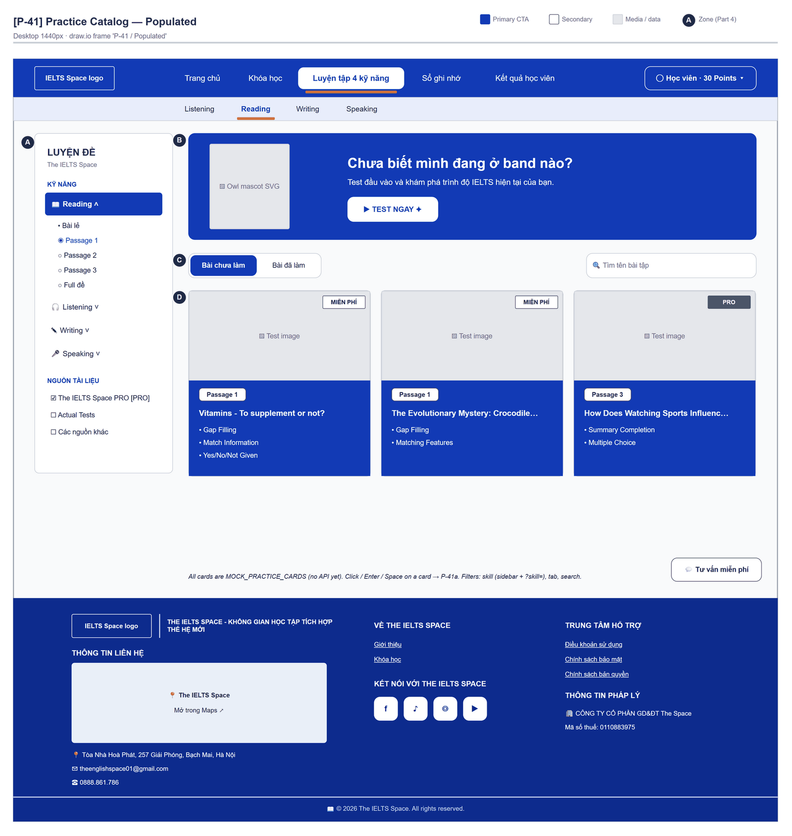
Figure 2.22-1 — Practice Test Catalog — Populated. Source: wireframes/screens/P-41_PracticeCatalog.drawio, tab “P-41 / Populated”
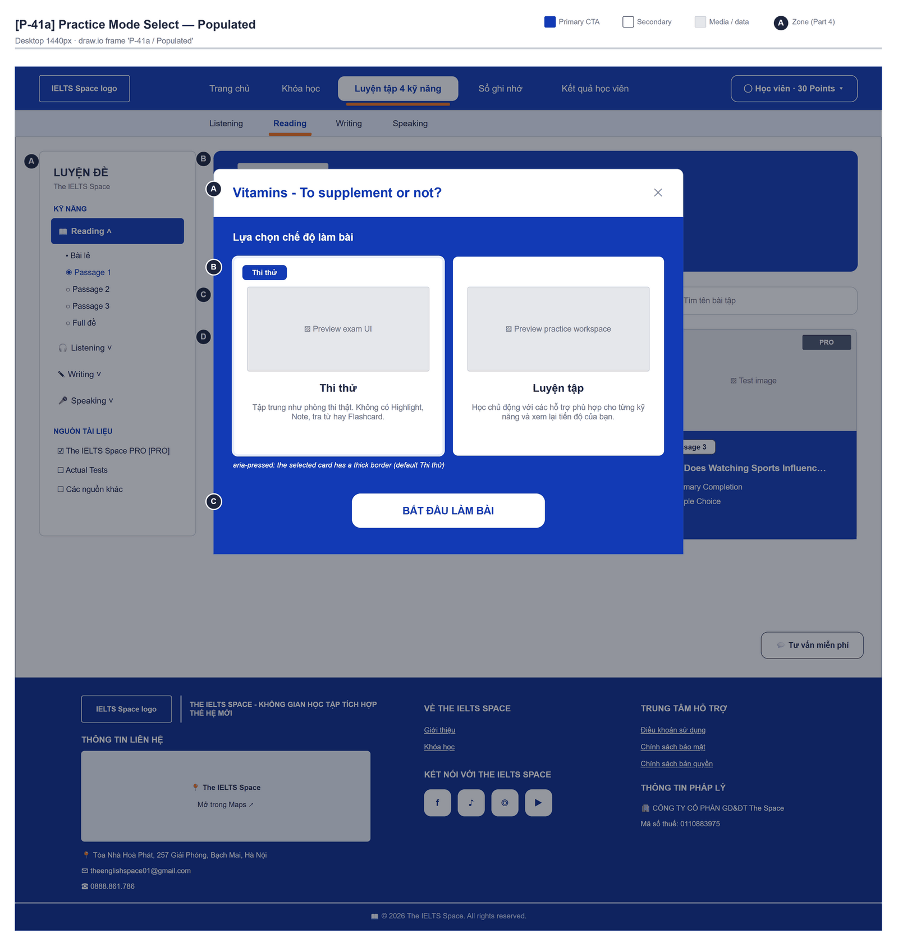
Figure 2.22-2 — Practice Test Catalog — Practice Mode Select · Populated. Source: wireframes/screens/P-41a_PracticeModeSelect.drawio, tab “P-41a / Populated”

Navigation Context
Navigates from | Condition / Trigger
Top bar | User clicks "Luyện tập 4 kỹ năng" or its sub-item Listening / Reading / Writing / Speaking, which opens the matching skill tab (?skill=…)
Footer | User clicks "Khóa học"
Practice Workspaces | User clicks "Thoát"

Navigates to | Condition / Trigger
Practice Workspaces | User picks a test and a mode

2.22.2 Entry & Exit Conditions

Preconditions & Guard Redirects
# | Condition check | If met | If not met → Action
PC-01 | Session exists (RequireAuth, GG-01) | Continue rendering | Redirect → /login (state.from kept); GLB-01

Entry Triggers
# | Trigger | From screen / Source | Parameters passed
ET-01 | Top bar | Any page | —

Exit Points
# | Event | Condition | Navigates to | Notes
EX-01 | User confirms a mode | Any | /practice/test/:id (Reading) or /practice/{skill}/:id | Query ?mode=
EX-02 | User picks an item in the top bar (SiteNavbar) | Any | Selected route | Typed answers are lost
EX-03 | Session expires, silent refresh fails | Refresh token used, expired or revoked | Login | GLB-01; returnUrl kept

2.22.3 UI Components
Code | Component name | Type | Validation / Constraint | Notes
PracticeCatalog-PNL-01 | Sidebar | Panel | — | "LUYỆN ĐỀ", "KỸ NĂNG" (Reading, Listening, Writing, Speaking), "Bài lẻ" / "Full đề", "NGUỒN TÀI LIỆU"
PracticeCatalog-TAB-01 | Bài chưa làm / Bài đã làm | Segmented tabs | — | Filters the cards
PracticeCatalog-TXT-01 | Tìm tên bài tập | Search Input | Case-insensitive title match | Client-side filter
PracticeCatalog-CRD-01 | Practice test card | Card grid | — | Title and meta; opens MDL-01
PracticeCatalog-MDL-01 | Lựa chọn chế độ làm bài | Dialog | — | Options "Luyện tập" and "Thi thử"

2.22.4 API Calls & Data Flow
# | Trigger (UI event) | API ID | Method + Path | Request | Success → UI action | Error → UI action
1 | Page load / filters | — | No API (mock data) | mocks/practiceData.ts | Filter cards in memory | —

2.22.5 Interaction Specifications

Open a test
Reading → /practice/test/{id}?mode={mode}
Listening / Writing / Speaking → /practice/{skill}/{id}?mode={mode}

2.22.6 Messages & Display Content
Code | Type | Trigger condition | Content (UI copy) | Action / Duration
MSG-01 | Empty State | No card matches | Design target: "Không có bài phù hợp." | —

2.22.7 Business Rules
BR/BV Code | Short description | UI behaviour when violated
OQ-17 | Prototype on mock data | No business rule is enforced; data resets on reload

2.23 Practice Workspaces (Reading, Listening, Writing, Speaking)

2.23.1 General Information
Dictionary lookup in scope is English to Vietnamese only (Tra Anh-Việt, API-82). The Reading glossary and the Writing Practice design (P-44) show only Tra Anh-Việt. The built Placement dictionary still has a Tra Việt-Anh tab: Vietnamese-to-English lookup is out of scope and has no API, so that tab is to be removed.
Screen Name | Practice Workspaces (Reading, Listening, Writing, Speaking)
Purpose | Gives a full-screen workspace for one practice test per skill, with tools for highlighting, notes, a small dictionary and flashcards.
Route / Type | /practice/test/:testId · /practice/listening/:testId · /practice/writing/:taskId · /practice/speaking/:cueId · RequireAuth
Role(s) | Any signed-in user
Related FT / UC | — (closest FT-25, FT-39, FT-42, FT-43)  —
Status | Prototype (mock data and browser storage, OQ-17)
Frontend | Built on mock data — features/practice/pages/PracticeTestPage.tsx, ListeningPage.tsx, WritingPage.tsx and SpeakingPage.tsx; notes, highlights and flashcards stay in the browser (FG-10); recordings are not sent anywhere.
Mockup / Wireframe | Figure 2.23-1 to 2.23-13 below — draw.io wireframes in docs/wireframes/screens (P-42_ReadingPracticeTest.drawio, P-42a_CreateFlashcard.drawio, P-42b_DictionaryLookup.drawio, P-42c_SavedFlashcards.drawio, P-42d_FloatingNotes.drawio, P-43_ListeningPractice.drawio, P-44_WritingPractice.drawio, P-44a_WritingChartZoom.drawio, P-45_SpeakingPractice.drawio), one tab per state; clickable prototype: docs/wireframes/IELTSPath_Prototype.drawio
Open Questions | OQ-17 (Appendix B)

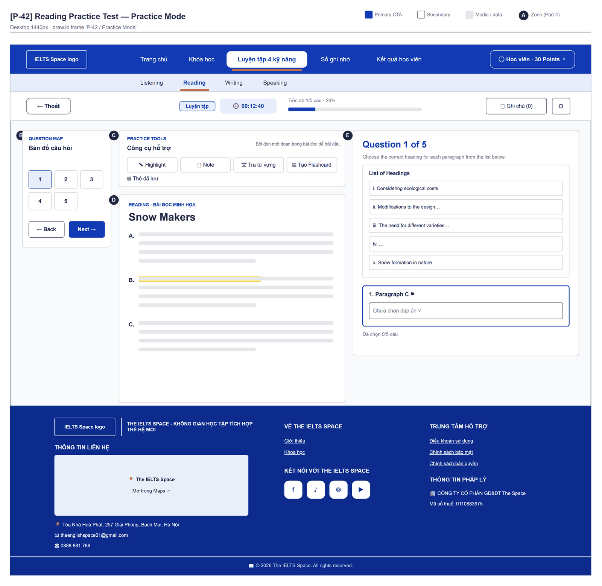
Figure 2.23-1 — Practice Workspaces — Practice Mode. Source: wireframes/screens/P-42_ReadingPracticeTest.drawio, tab “P-42 / Practice Mode”
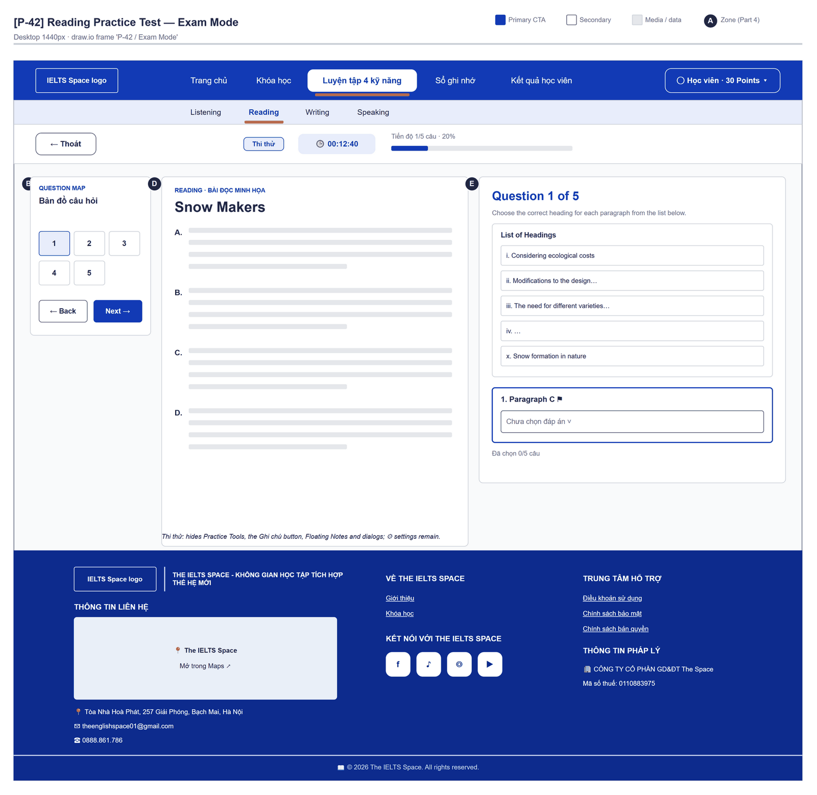
Figure 2.23-2 — Practice Workspaces — Exam Mode. Source: wireframes/screens/P-42_ReadingPracticeTest.drawio, tab “P-42 / Exam Mode”
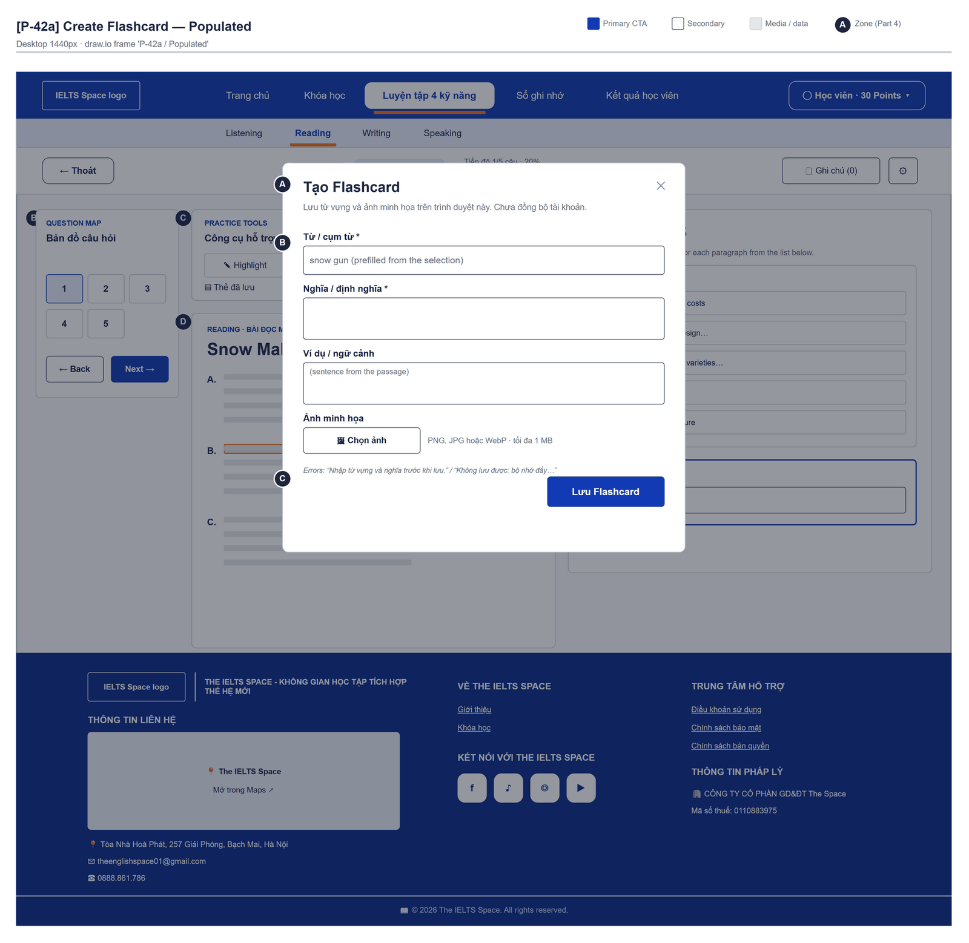
Figure 2.23-3 — Practice Workspaces — Create Flashcard · Populated. Source: wireframes/screens/P-42a_CreateFlashcard.drawio, tab “P-42a / Populated”
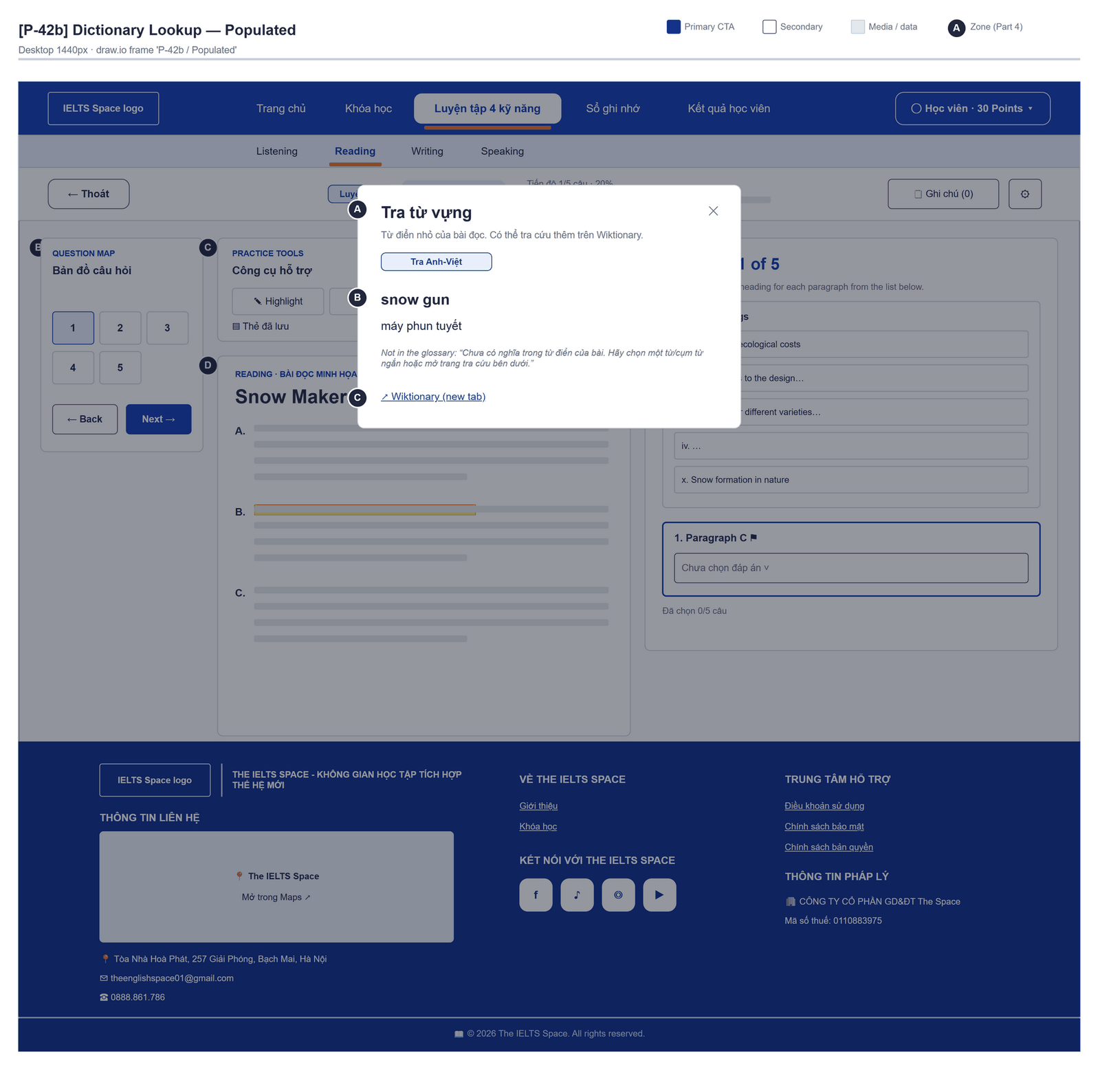
Figure 2.23-4 — Practice Workspaces — Dictionary Lookup · Populated. Source: wireframes/screens/P-42b_DictionaryLookup.drawio, tab “P-42b / Populated”
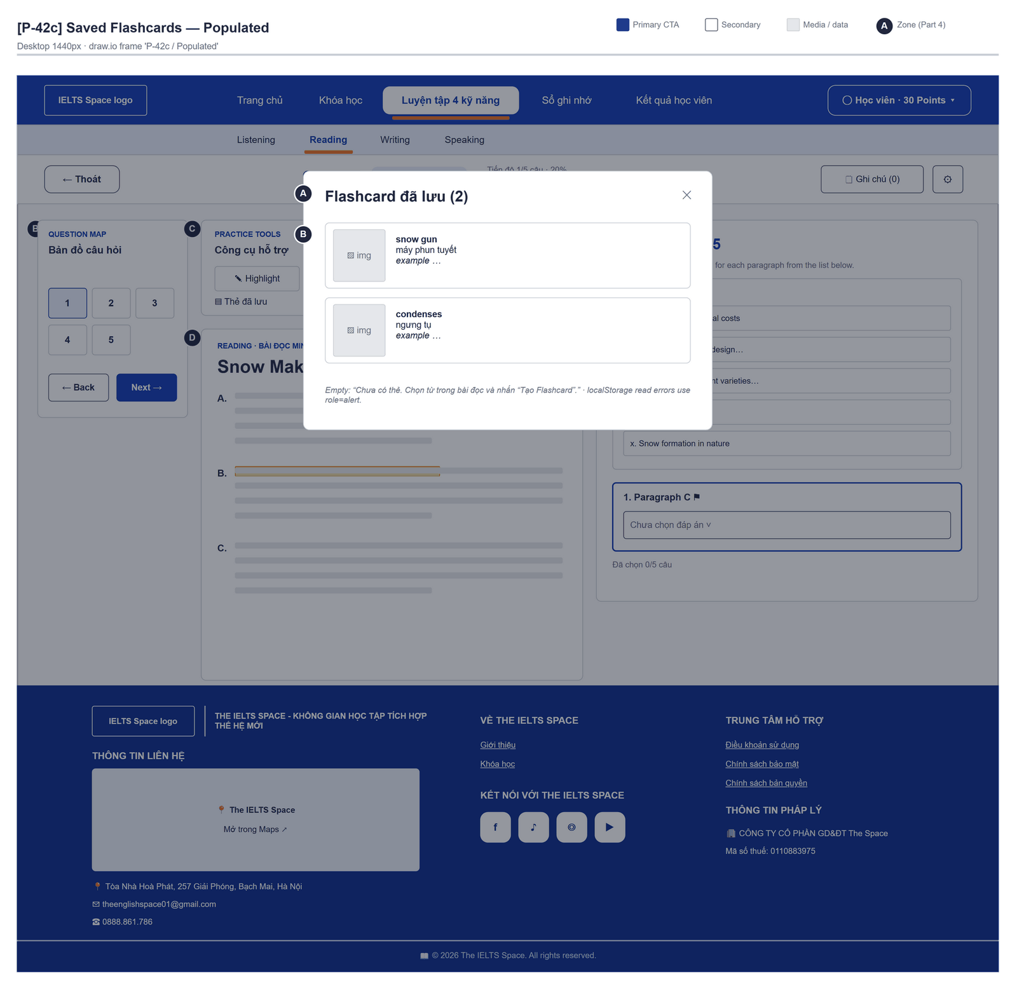
Figure 2.23-5 — Practice Workspaces — Saved Flashcards · Populated. Source: wireframes/screens/P-42c_SavedFlashcards.drawio, tab “P-42c / Populated”
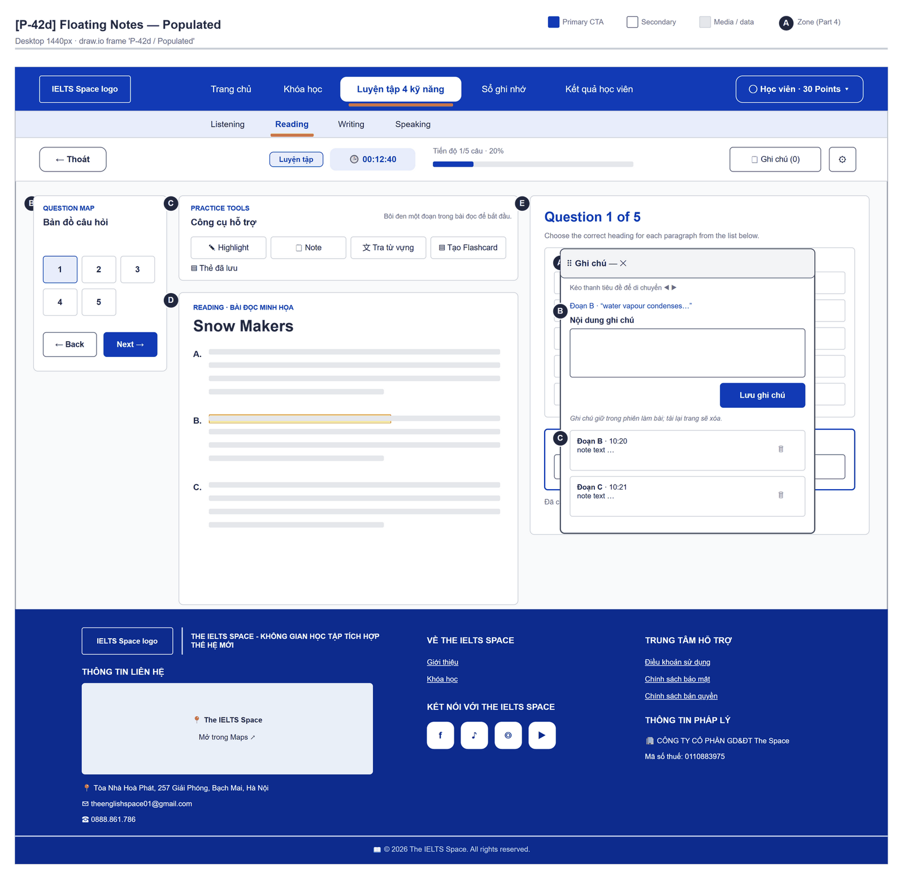
Figure 2.23-6 — Practice Workspaces — Floating Notes · Populated. Source: wireframes/screens/P-42d_FloatingNotes.drawio, tab “P-42d / Populated”
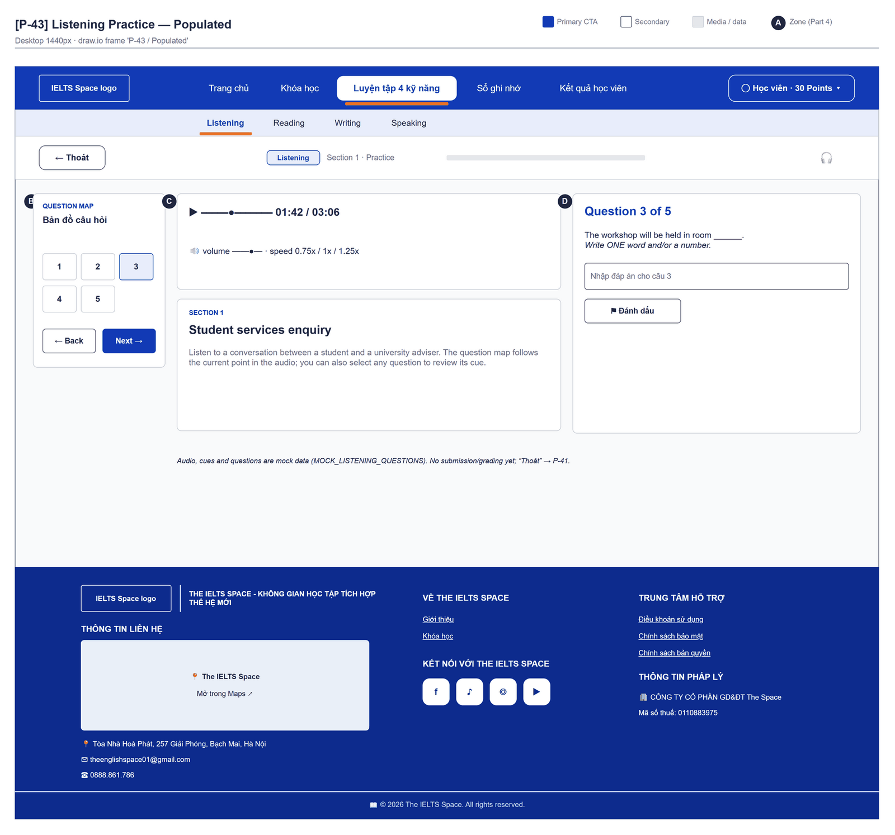
Figure 2.23-7 — Practice Workspaces — Listening Practice · Populated. Source: wireframes/screens/P-43_ListeningPractice.drawio, tab “P-43 / Populated”
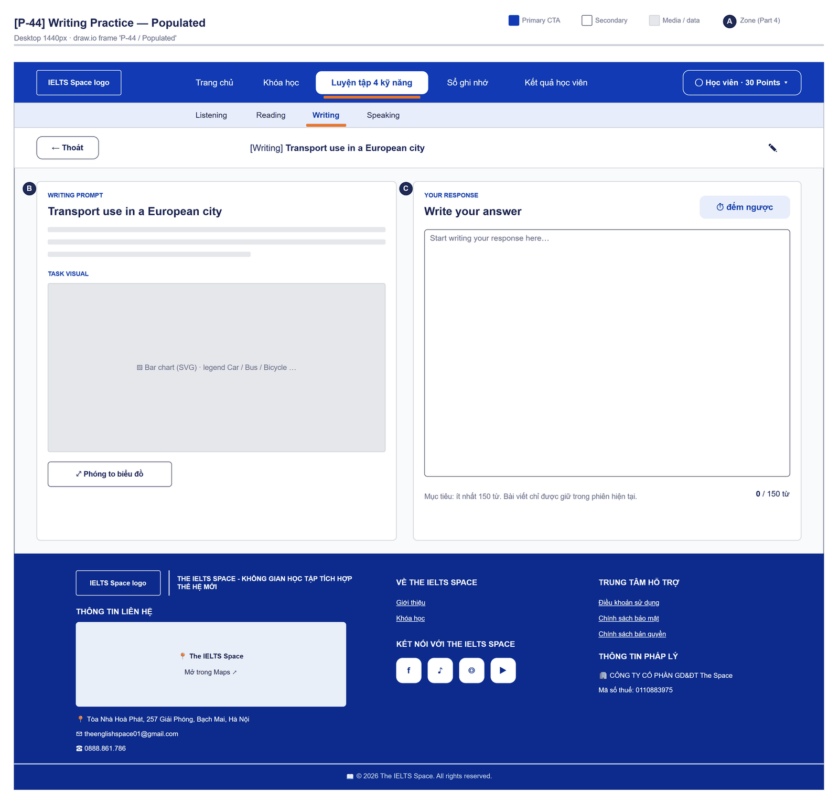
Figure 2.23-8 — Practice Workspaces — Writing Practice · Populated. Source: wireframes/screens/P-44_WritingPractice.drawio, tab “P-44 / Populated”
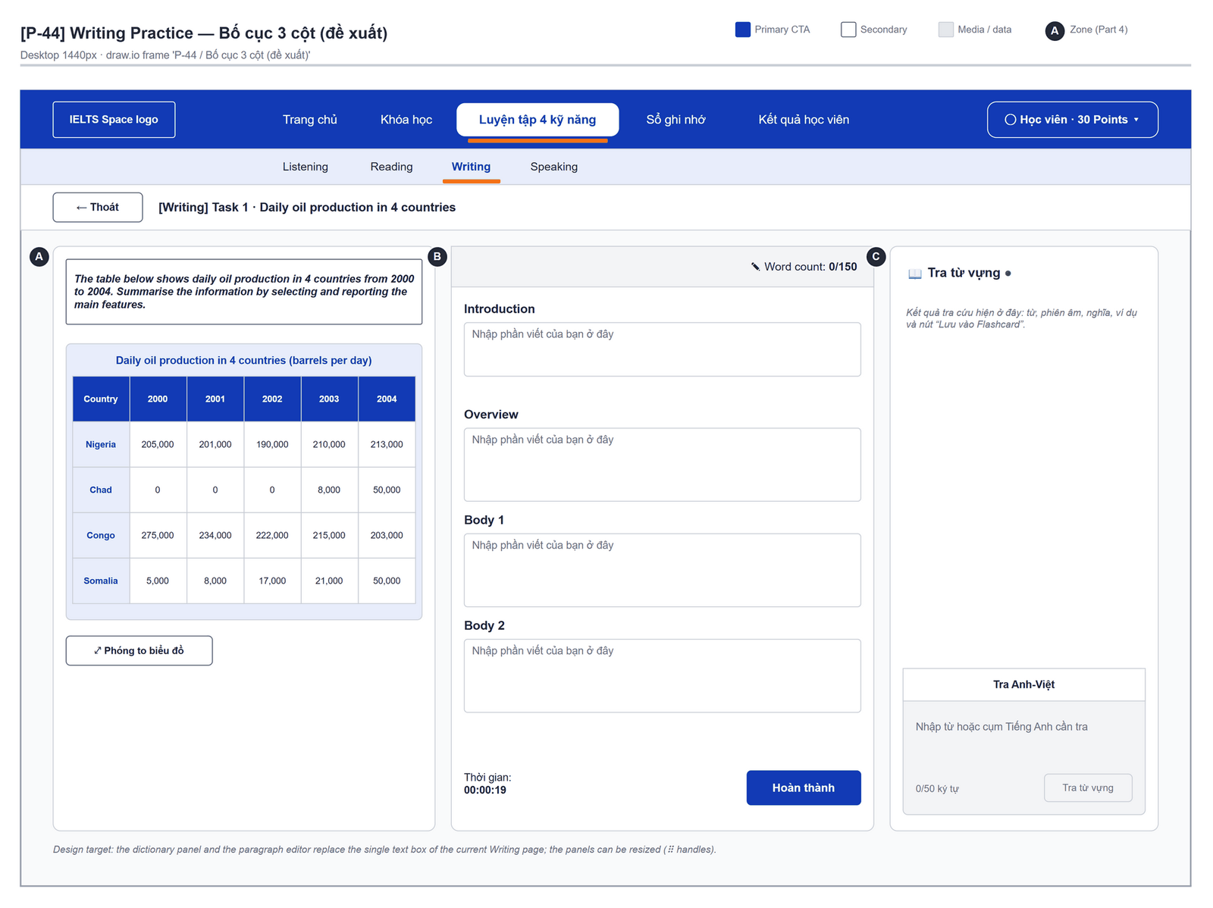
Figure 2.23-9 — Practice Workspaces — Writing Practice · Bố cục 3 cột (đề xuất). Source: wireframes/screens/P-44_WritingPractice.drawio, tab “P-44 / Bố cục 3 cột (đề xuất)”
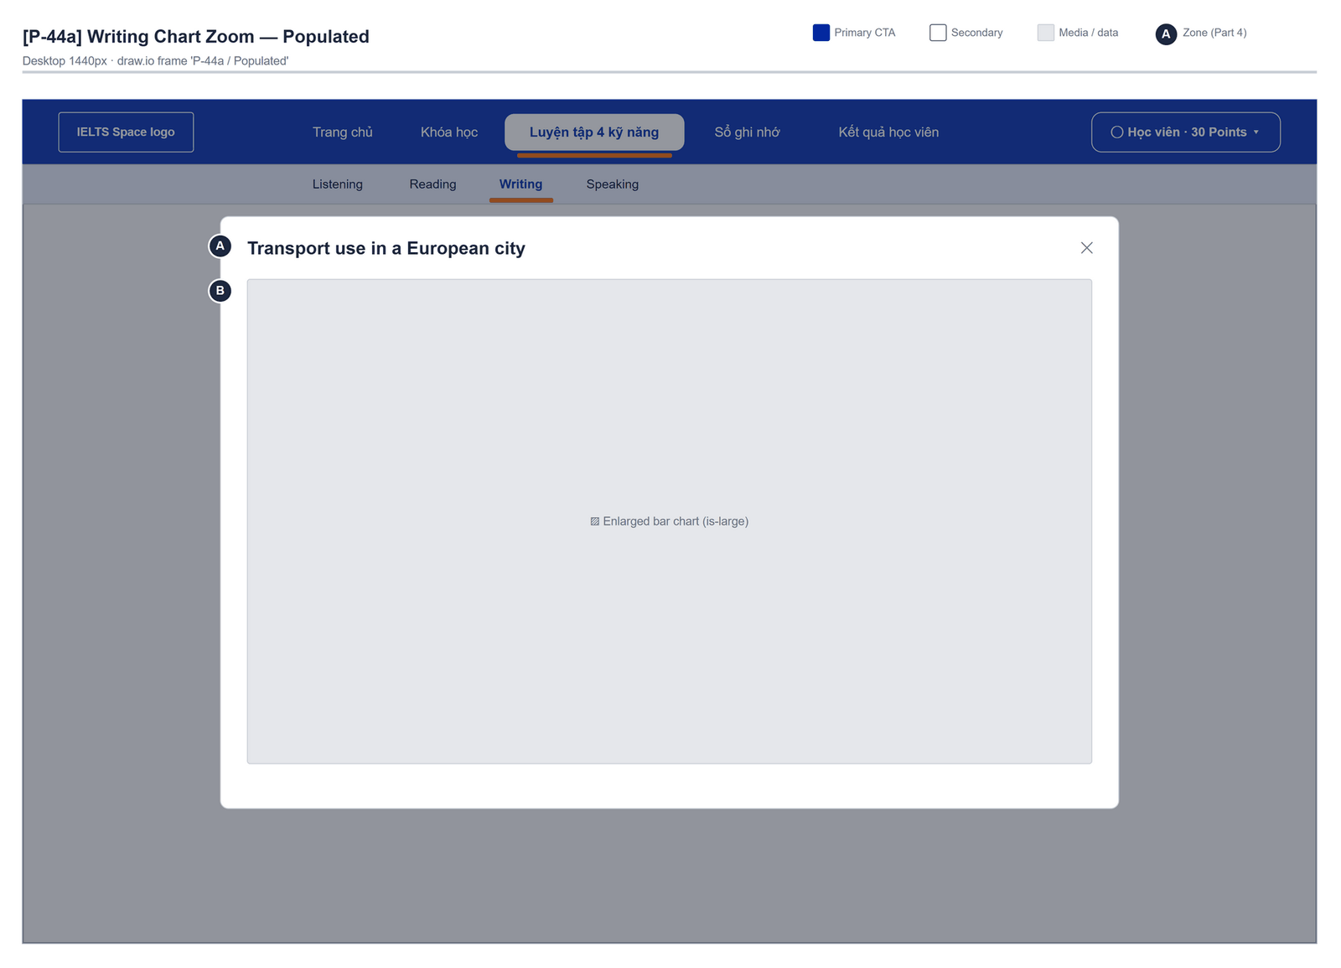
Figure 2.23-10 — Practice Workspaces — Writing Chart Zoom · Populated. Source: wireframes/screens/P-44a_WritingChartZoom.drawio, tab “P-44a / Populated”
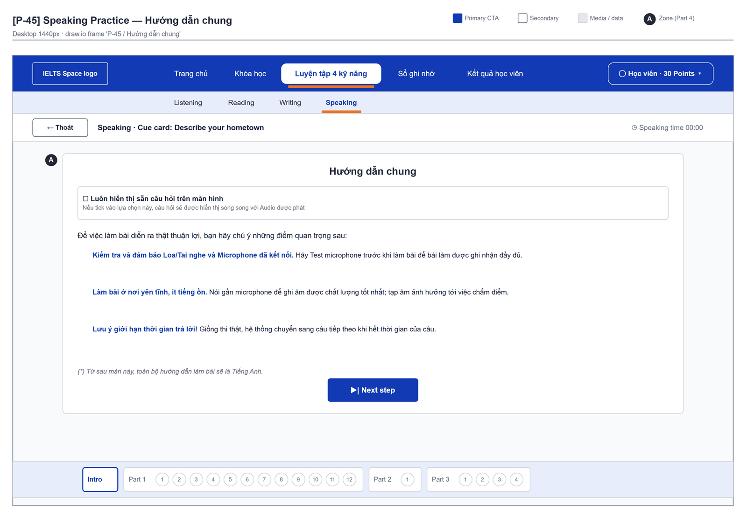
Figure 2.23-11 — Practice Workspaces — Speaking Practice · Hướng dẫn chung. Source: wireframes/screens/P-45_SpeakingPractice.drawio, tab “P-45 / Hướng dẫn chung”
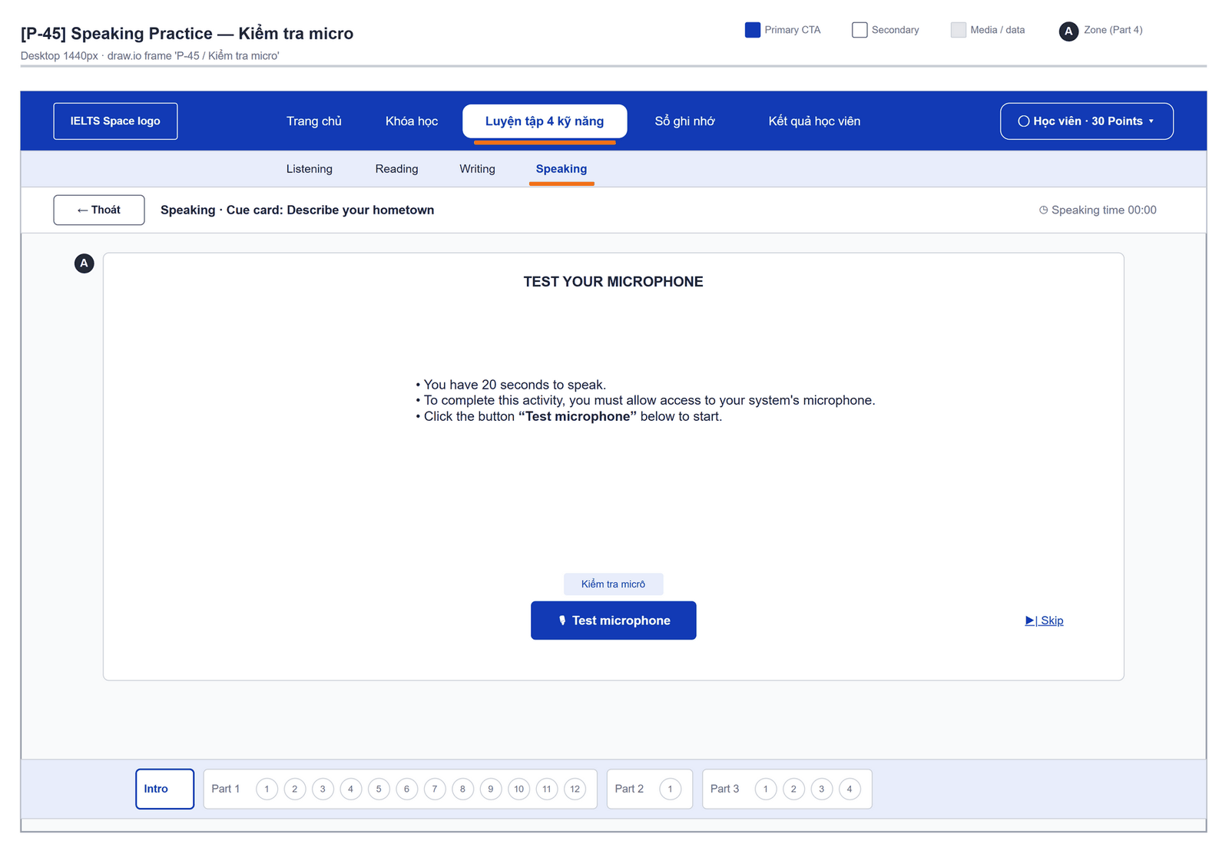
Figure 2.23-12 — Practice Workspaces — Speaking Practice · Kiểm tra micro. Source: wireframes/screens/P-45_SpeakingPractice.drawio, tab “P-45 / Kiểm tra micro”
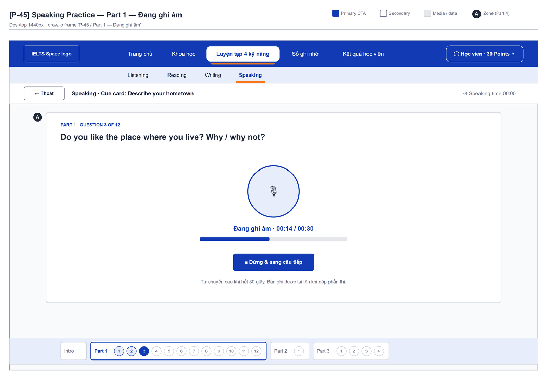
Figure 2.23-13 — Practice Workspaces — Speaking Practice · Part 1 — Đang ghi âm. Source: wireframes/screens/P-45_SpeakingPractice.drawio, tab “P-45 / Part 1 — Đang ghi âm”

Navigation Context
Navigates from | Condition / Trigger
Practice Test Catalog | User confirms a mode

Navigates to | Condition / Trigger
Practice Test Catalog | User clicks "Thoát"

2.23.2 Entry & Exit Conditions

Preconditions & Guard Redirects
# | Condition check | If met | If not met → Action
PC-01 | Session exists (RequireAuth, GG-01) | Continue rendering | Redirect → /login (state.from kept); GLB-01

Entry Triggers
# | Trigger | From screen / Source | Parameters passed
ET-01 | Mode dialog | Practice Test Catalog | Path id, Query mode (Luyện tập / Thi thử)

Exit Points
# | Event | Condition | Navigates to | Notes
EX-01 | User clicks Thoát | Any | Practice Test Catalog | Work is not saved
EX-02 | Session expires, silent refresh fails | Refresh token used, expired or revoked | Login | GLB-01; returnUrl kept

2.23.3 UI Components
Code | Component name | Type | Validation / Constraint | Notes
PracticeWorkspace-PNL-01 | Reading: passage + questions | Split view | — | Question map, navigation, timer "Thời gian làm bài"
PracticeWorkspace-PNL-02 | Passage tools | Context menu | Text must be selected first | "Tra từ vựng", "Tạo Flashcard", Highlight / "Bỏ Highlight"
PracticeWorkspace-MDL-01 | Tạo Flashcard | Dialog | Word and meaning required; image PNG/JPG/WebP ≤ 1 MB | "Lưu từ vựng và ảnh minh họa trên trình duyệt này. Chưa đồng bộ tài khoản."
PracticeWorkspace-PNL-03 | Ghi chú | Floating notes | — | "Ghi chú ({n})"; kept in the page
PracticeWorkspace-AUD-01 | Listening player | Audio player | Playback rate | "Section 1 · Practice"
PracticeWorkspace-TXA-01 | Writing editor | Text Area | Minimum words shown | Countdown timer; word counter; "Bài viết chỉ được giữ trong phiên hiện tại."
PracticeWorkspace-BTN-01 | Speaking recorder | Button | Microphone permission | "Thời gian nói {mm:ss}"; "Bản ghi chỉ ở trong trình duyệt hiện tại và chưa được gửi cho Mentor."

2.23.4 API Calls & Data Flow
# | Trigger (UI event) | API ID | Method + Path | Request | Success → UI action | Error → UI action
1 | Page load | — | No API (mock data) | mocks/practiceData.ts | Render the test | —
2 | Save flashcard | — | No API (mock data) | localStorage (practice/lib/flashcardStorage.ts) | "Đã lưu Flashcard trên trình duyệt này. Mở “Thẻ đã lưu” để xem." | Storage full → MSG-02

2.23.5 Interaction Specifications

Design target
When these workspaces are wired: Writing uses FT-25 grading, Speaking uses FT-39, notes and flashcards use library-service (FT-42, FT-43) instead of the browser.

2.23.6 Messages & Display Content
Code | Type | Trigger condition | Content (UI copy) | Action / Duration
MSG-01 | Info Text | Tool used without a selection | "Hãy bôi đen một đoạn trong bài đọc trước khi chọn công cụ." | Inline
MSG-02 | Inline Error | Flashcard not stored | "Không lưu được: bộ nhớ đầy, bị chặn hoặc dữ liệu cũ không hợp lệ. Thử bỏ ảnh hoặc bật bộ nhớ trình duyệt; dữ liệu đã lưu không bị ghi đè." | In the dialog
MSG-03 | Inline Error | Word or meaning empty | "Nhập từ vựng và nghĩa trước khi lưu." | In the dialog

2.23.7 Business Rules
BR/BV Code | Short description | UI behaviour when violated
OQ-17 | Prototype on mock data | No business rule is enforced; data resets on reload
FG-10 | Personal data in the browser, not in library-service | Lost on another device

2.24 Classroom

2.24.1 General Information
Screen Name | Classroom
Purpose | Shows the learner's class, teacher and a calendar of class sessions with a link to join or open each session.
Route / Type | /classroom · RequireAuth
Role(s) | Any signed-in user
Related FT / UC | — (mentor classes are not in the SRS)  —
Status | Prototype (mock data, OQ-17)
Frontend | Built on mock data — features/classroom/ClassroomPage.tsx with mocks/classroomData.ts; no API call.
Mockup / Wireframe | Figure 2.24-1 to 2.24-2 below — draw.io wireframes in docs/wireframes/screens (P-20_MyClassroom.drawio, P-20a_LessonDetail.drawio), one tab per state; clickable prototype: docs/wireframes/IELTSPath_Prototype.drawio
Open Questions | OQ-17 (Appendix B)

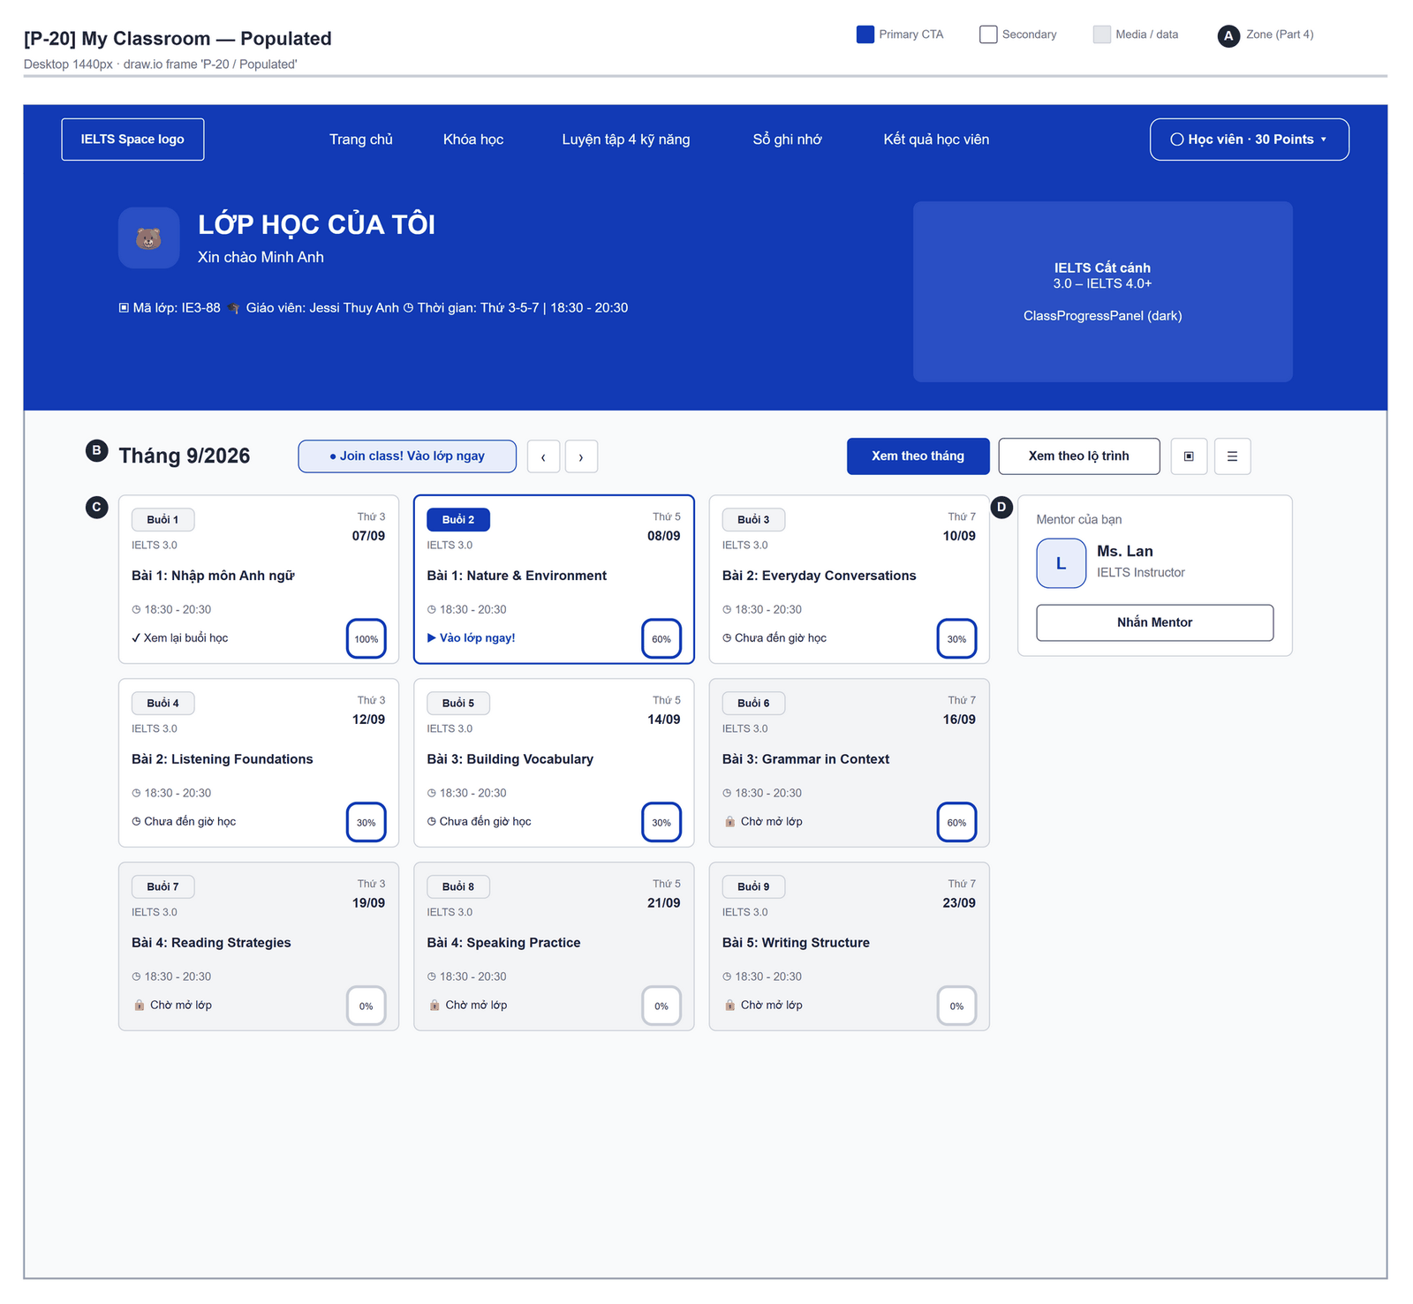
Figure 2.24-1 — Classroom — Populated. Source: wireframes/screens/P-20_MyClassroom.drawio, tab “P-20 / Populated”
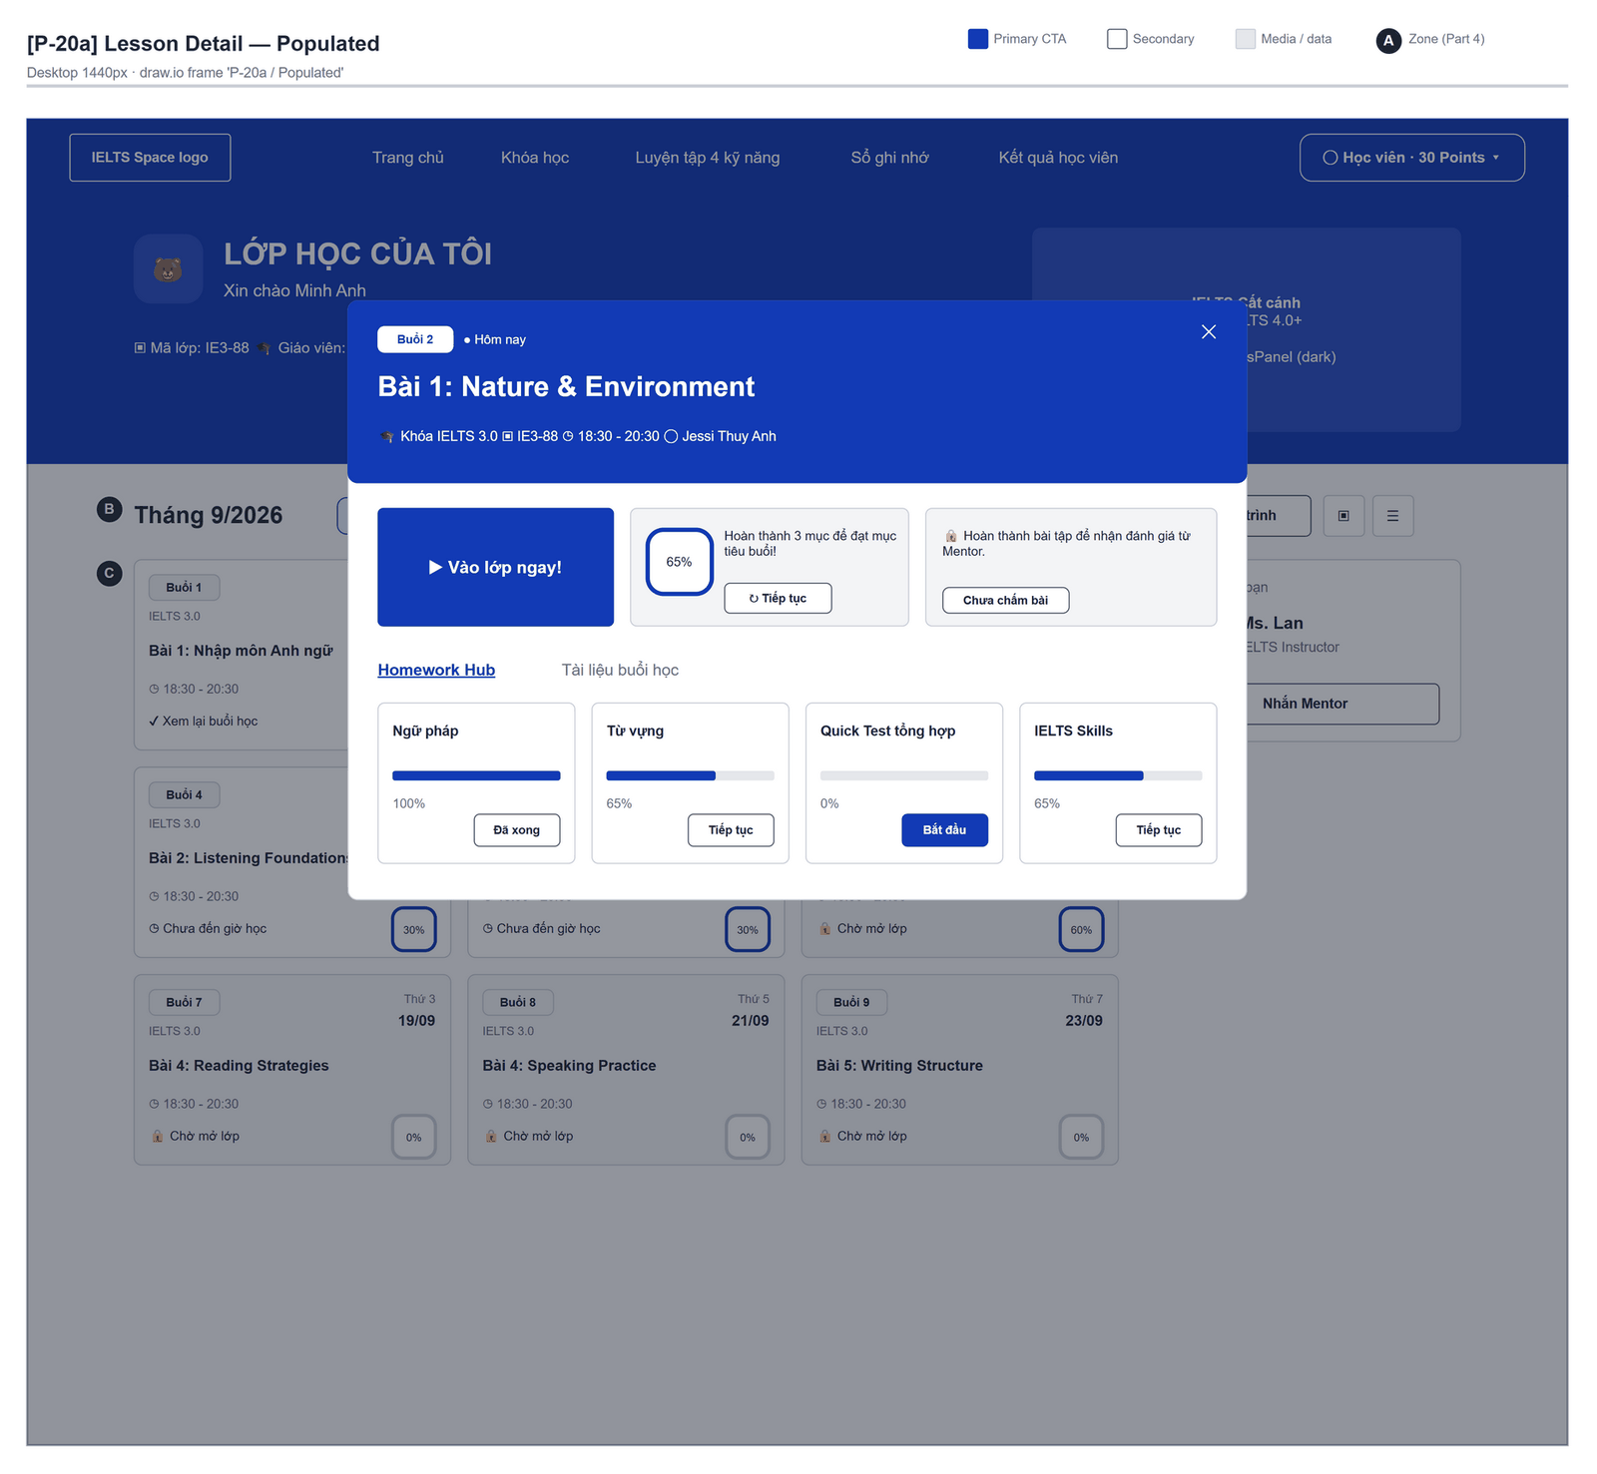
Figure 2.24-2 — Classroom — Lesson Detail · Populated. Source: wireframes/screens/P-20a_LessonDetail.drawio, tab “P-20a / Populated”

Navigation Context
Navigates from | Condition / Trigger
Direct link | User opens /classroom (no longer in the top menu)

Navigates to | Condition / Trigger
Classroom Lesson Workspace | User opens a session's lesson
Placeholder /classes/:classCode/join | User clicks "Join class! Vào lớp ngay"

2.24.2 Entry & Exit Conditions

Preconditions & Guard Redirects
# | Condition check | If met | If not met → Action
PC-01 | Session exists (RequireAuth, GG-01) | Continue rendering | Redirect → /login (state.from kept); GLB-01

Entry Triggers
# | Trigger | From screen / Source | Parameters passed
ET-01 | Top bar | Any page | —

Exit Points
# | Event | Condition | Navigates to | Notes
EX-01 | User opens a session | Any | Classroom Lesson Workspace or detail modal | —
EX-02 | User picks an item in the top bar (SiteNavbar) | Any | Selected route | Typed answers are lost
EX-03 | Session expires, silent refresh fails | Refresh token used, expired or revoked | Login | GLB-01; returnUrl kept

2.24.3 UI Components
Code | Component name | Type | Validation / Constraint | Notes
Classroom-PNL-01 | Class header | Header | — | "LỚP HỌC CỦA TÔI", "Xin chào {name}", "Mã lớp", "Giáo viên", "Thời gian"
Classroom-PNL-02 | Calendar controls | Toolbar | — | "Tháng trước" / "Tháng sau", "Xem theo tháng" / "Xem theo lộ trình", "Xem dạng danh sách"
Classroom-CRD-01 | Schedule card | Card | — | One per session
Classroom-MDL-01 | Lesson detail | Dialog | — | Session details
Classroom-PNL-03 | Class progress | Panel + mascot | — | Progress of the course

2.24.4 API Calls & Data Flow
# | Trigger (UI event) | API ID | Method + Path | Request | Success → UI action | Error → UI action
1 | Page load | — | No API (mock data) | mocks/classroomData.ts | Render the calendar | —

2.24.5 Interaction Specifications

Open question
Mentor-led classes are not specified in the SRS; decide whether they become a new feature or are removed (OQ-17).

2.24.6 Messages & Display Content
Code | Type | Trigger condition | Content (UI copy) | Action / Duration
MSG-01 | Info Text | Join link | "● Join class! Vào lớp ngay" | Opens a placeholder page

2.24.7 Business Rules
BR/BV Code | Short description | UI behaviour when violated
OQ-17 | Prototype on mock data | No business rule is enforced; data resets on reload

2.25 Classroom Lesson Workspace

2.25.1 General Information
Screen Name | Classroom Lesson Workspace
Purpose | Shows one class session with its materials, a short quiz and the topic vocabulary to review.
Route / Type | /lessons/:lessonId · RequireAuth
Role(s) | Any signed-in user
Related FT / UC | — (closest FT-36, FT-43)  —
Status | Prototype (mock data, OQ-17)
Frontend | Built on mock data — features/classroom/pages/LessonWorkspacePage.tsx with mocks/lessonData.ts; no API call. Not to be confused with the Lesson Player (/learn/lessons/:lessonId).
Mockup / Wireframe | Figure 2.25-1 to 2.25-4 below — draw.io wireframes in docs/wireframes/screens (P-21_LessonWorkspace.drawio), one tab per state; clickable prototype: docs/wireframes/IELTSPath_Prototype.drawio

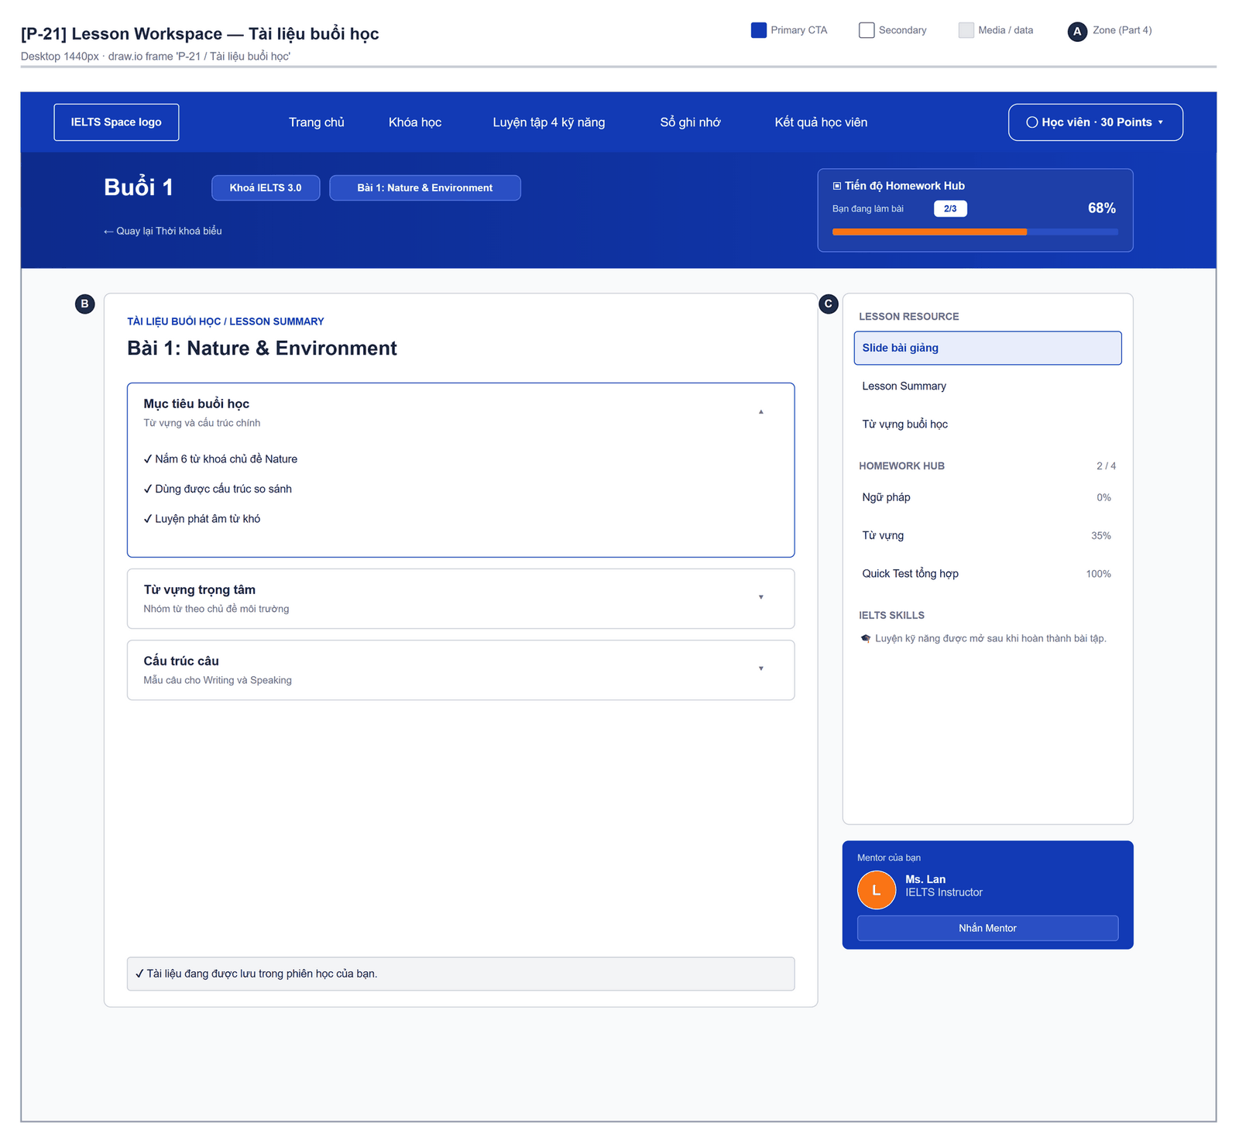
Figure 2.25-1 — Classroom Lesson Workspace — Tài liệu buổi học. Source: wireframes/screens/P-21_LessonWorkspace.drawio, tab “P-21 / Tài liệu buổi học”
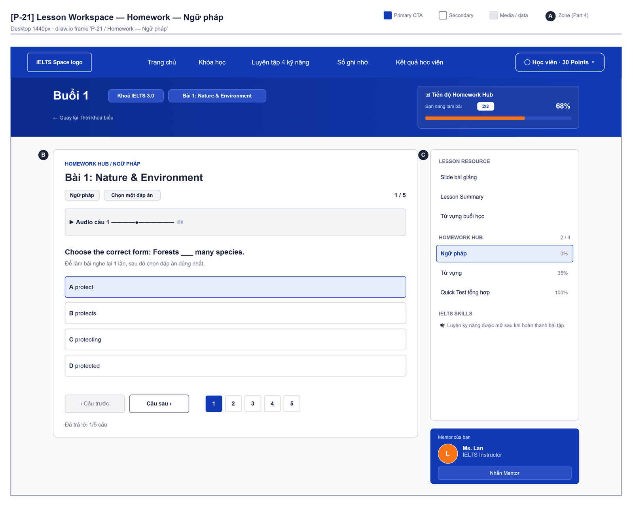
Figure 2.25-2 — Classroom Lesson Workspace — Homework — Ngữ pháp. Source: wireframes/screens/P-21_LessonWorkspace.drawio, tab “P-21 / Homework — Ngữ pháp”
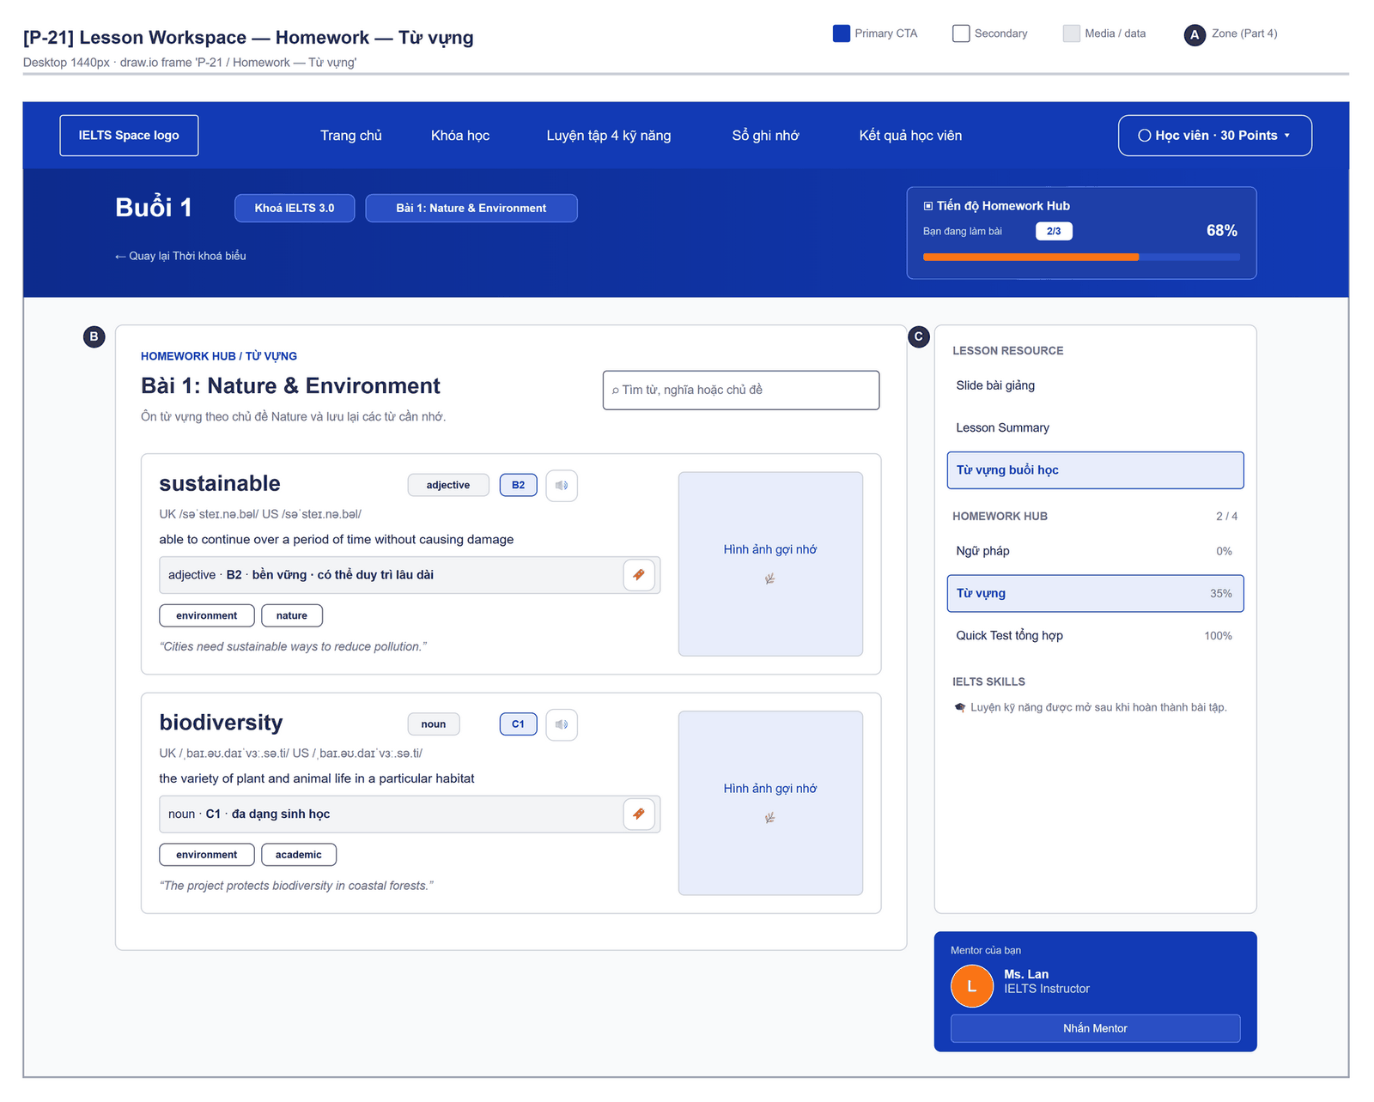
Figure 2.25-3 — Classroom Lesson Workspace — Homework — Từ vựng. Source: wireframes/screens/P-21_LessonWorkspace.drawio, tab “P-21 / Homework — Từ vựng”
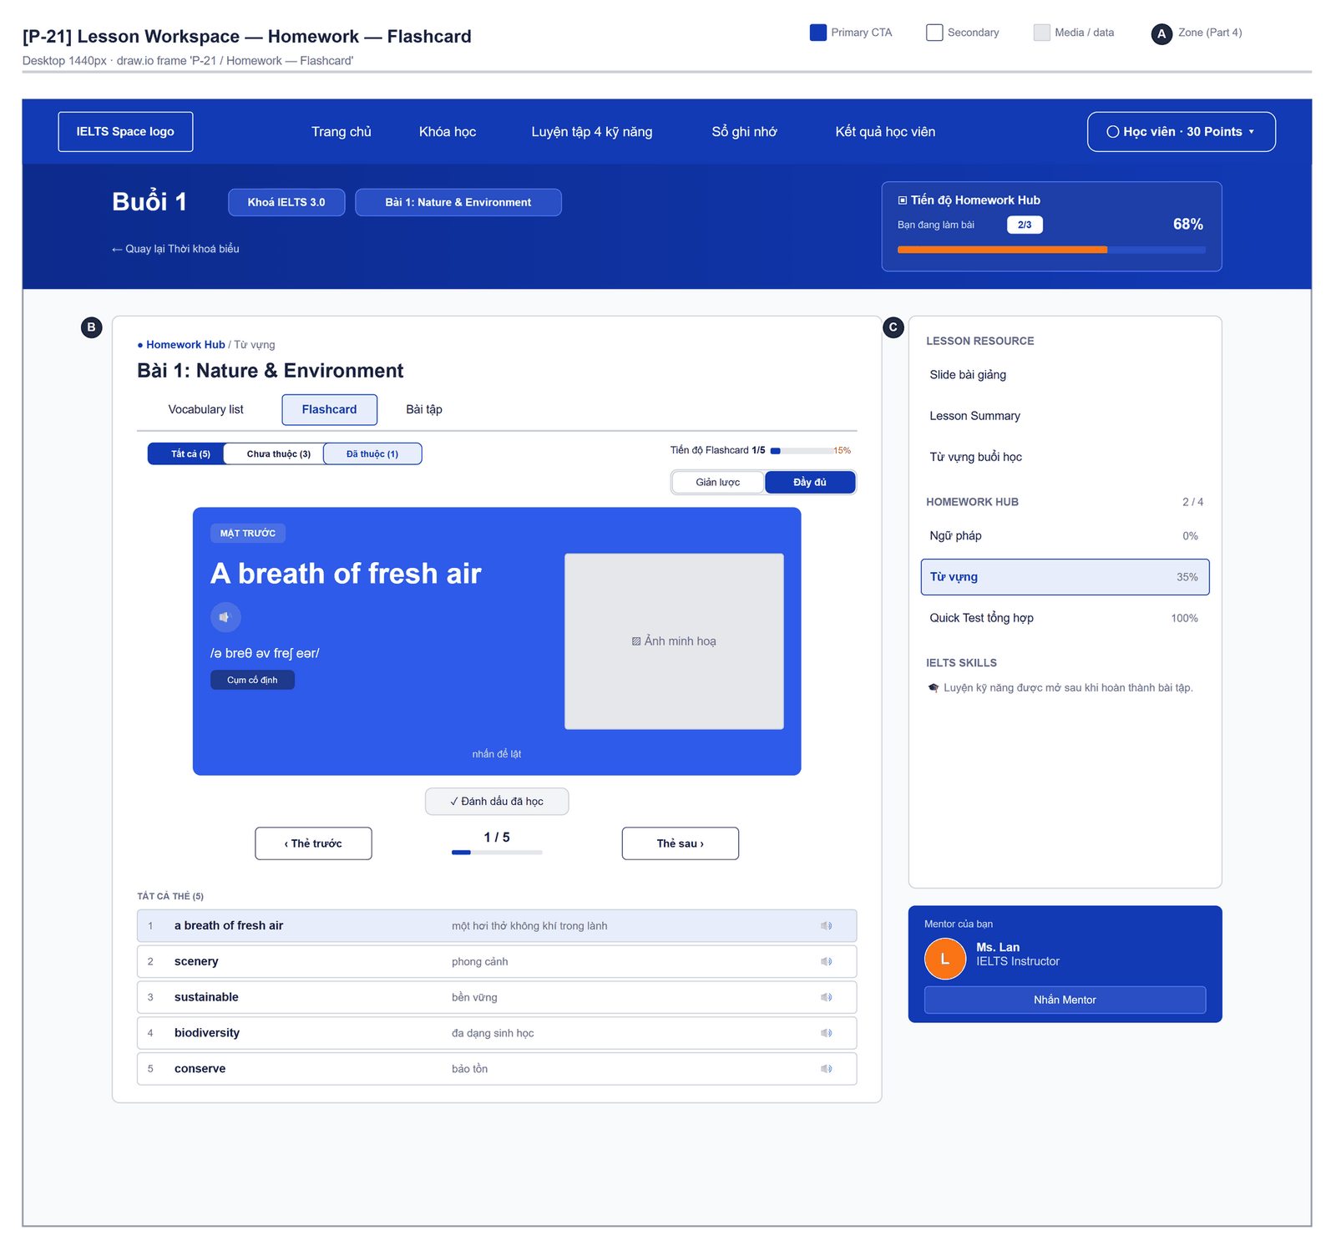
Figure 2.25-4 — Classroom Lesson Workspace — Homework — Flashcard. Source: wireframes/screens/P-21_LessonWorkspace.drawio, tab “P-21 / Homework — Flashcard”

Navigation Context
Navigates from | Condition / Trigger
Classroom | User opens a session

Navigates to | Condition / Trigger
Classroom | User goes back

2.25.2 Entry & Exit Conditions

Preconditions & Guard Redirects
# | Condition check | If met | If not met → Action
PC-01 | Session exists (RequireAuth, GG-01) | Continue rendering | Redirect → /login (state.from kept); GLB-01

Entry Triggers
# | Trigger | From screen / Source | Parameters passed
ET-01 | Session link | Classroom | lessonId

Exit Points
# | Event | Condition | Navigates to | Notes
EX-01 | User picks an item in the top bar (SiteNavbar) | Any | Selected route | Typed answers are lost
EX-02 | Session expires, silent refresh fails | Refresh token used, expired or revoked | Login | GLB-01; returnUrl kept

2.25.3 UI Components
Code | Component name | Type | Validation / Constraint | Notes
ClassLesson-PNL-01 | Sidebar | Panel | — | "Buổi {n}", "Tiến độ khoá học", "Tiến độ Homework Hub"
ClassLesson-PNL-02 | Lesson materials | Panel | — | Session documents
ClassLesson-PNL-03 | Lesson quiz | Questions | — | Short quiz
ClassLesson-TBL-01 | Homework Hub / Từ vựng | Vocabulary collection | — | Same component as the Vocabulary screen

2.25.4 API Calls & Data Flow
# | Trigger (UI event) | API ID | Method + Path | Request | Success → UI action | Error → UI action
1 | Page load | — | No API (mock data) | mocks/lessonData.ts | Render the session | —

2.25.5 Interaction Specifications

Data source
All content is mock data (OQ-17).

2.25.6 Messages & Display Content
Code | Type | Trigger condition | Content (UI copy) | Action / Duration
MSG-01 | Info Text | Progress | "Hoàn thành 8 / 12 bài tập" (mock) | —

2.25.7 Business Rules
BR/BV Code | Short description | UI behaviour when violated
OQ-17 | Prototype on mock data | No business rule is enforced; data resets on reload

2.26 Profile & Account

2.26.1 General Information
Screen Name | Profile & Account
Purpose | Lets a user keep account details and the learner profile up to date and manage linked sign-in providers.
Route / Type | /account/profile
Role(s) | Any signed-in role
Related FT / UC | FT-05, FT-06  UC-011–UC-018 Manage profile and learning goal
Status | Specified (OAuth linking: Draft)
Frontend | Not built in the frontend yet — this section is the design target for the frontend team.
Mockup / Wireframe | Figure 2.26-1 to 2.26-3 below — draw.io wireframes in docs/wireframes/screens (P-80_Account.drawio, SHELL_SharedLayout.drawio), one tab per state; clickable prototype: docs/wireframes/IELTSPath_Prototype.drawio
Open Questions | OQ-20 (Appendix B)

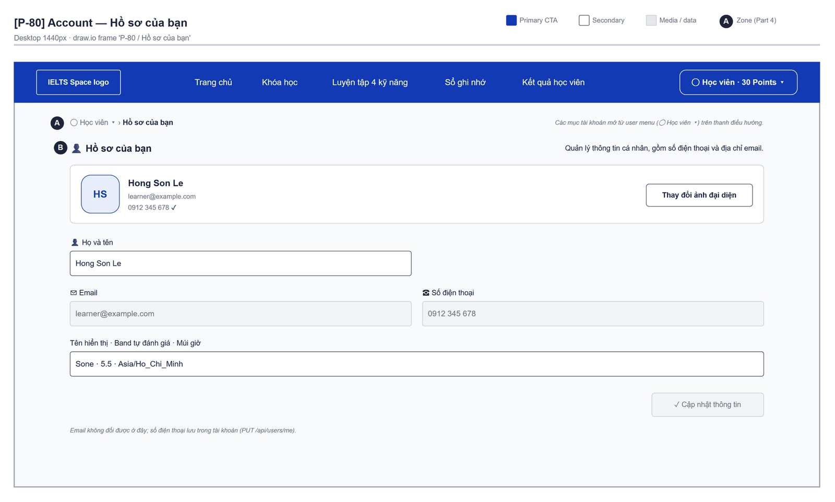
Figure 2.26-1 — Profile & Account — Hồ sơ của bạn. Source: wireframes/screens/P-80_Account.drawio, tab “P-80 / Hồ sơ của bạn”
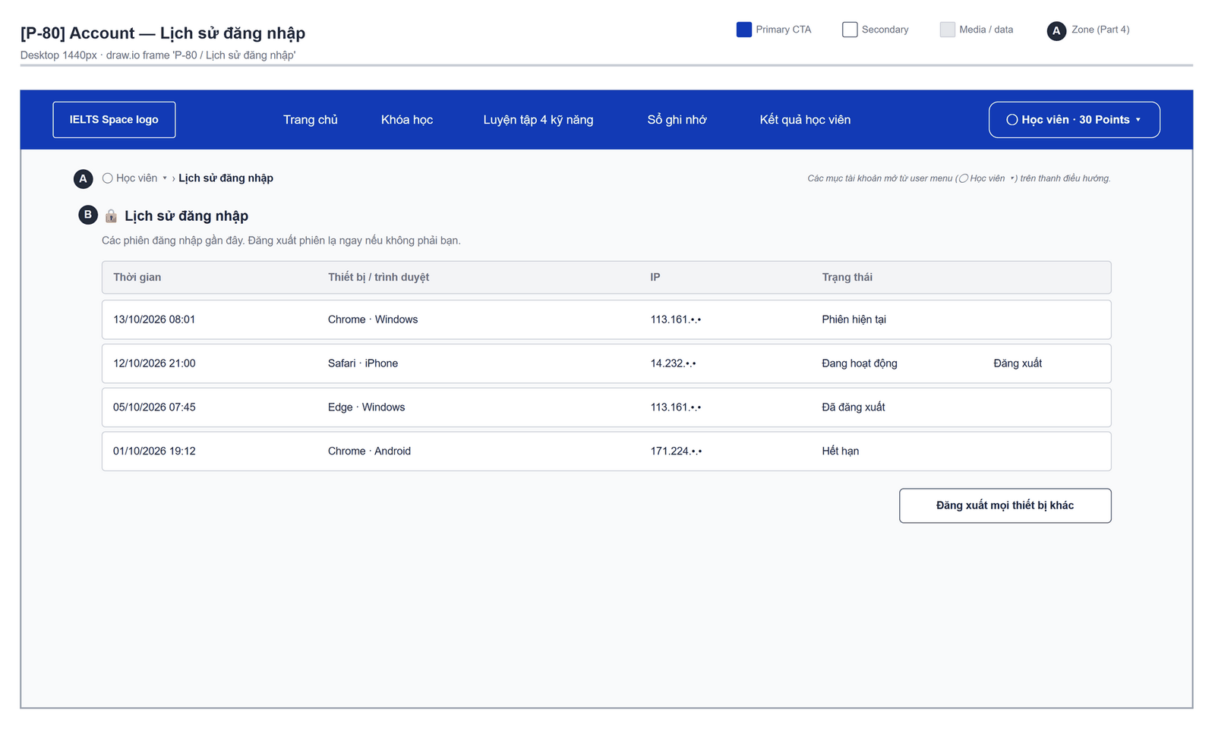
Figure 2.26-2 — Profile & Account — Lịch sử đăng nhập. Source: wireframes/screens/P-80_Account.drawio, tab “P-80 / Lịch sử đăng nhập”
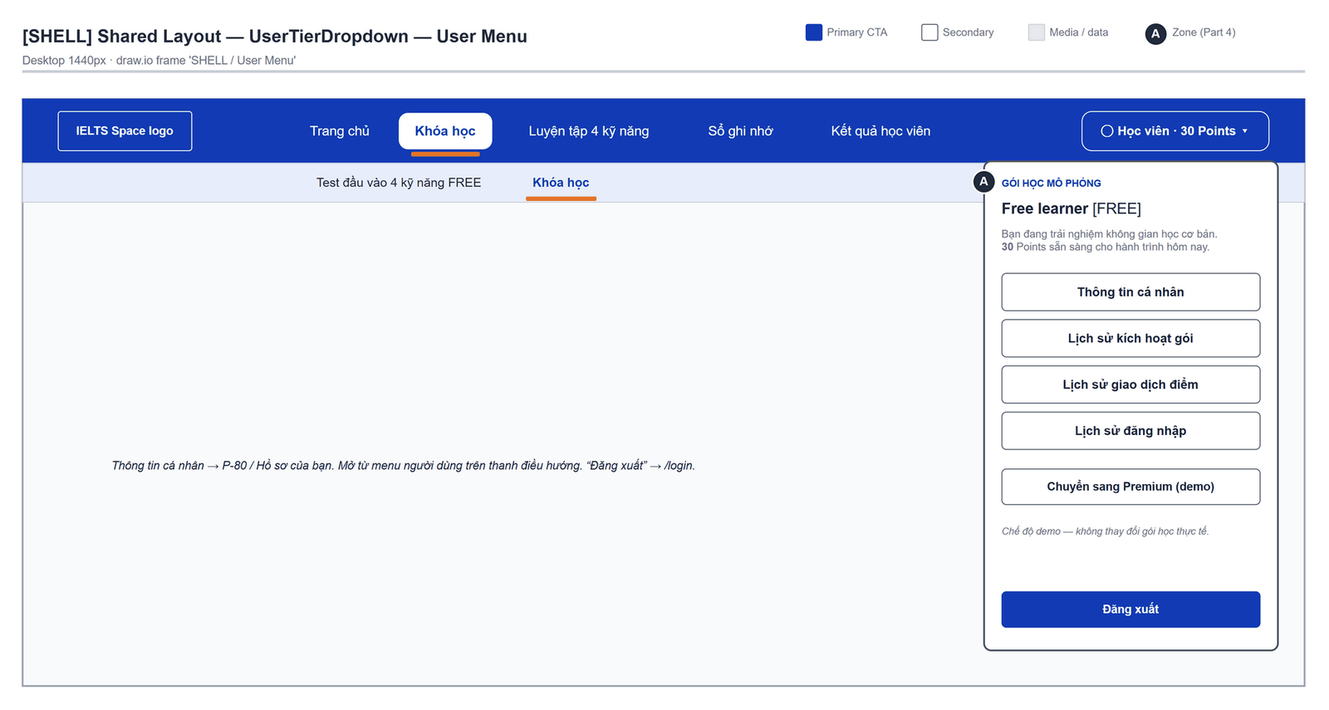
Figure 2.26-3 — Profile & Account — Shared layout · User Menu. Source: wireframes/screens/SHELL_SharedLayout.drawio, tab “SHELL / User Menu”

Navigation Context
Navigates from | Condition / Trigger
Top bar avatar menu | User clicks "Thông tin cá nhân" → P-80 / Hồ sơ của bạn

Navigates to | Condition / Trigger
Learning Goals | User clicks the "Goals" tab
Login | User signs out

2.26.2 Entry & Exit Conditions

Preconditions & Guard Redirects
# | Condition check | If met | If not met → Action
PC-01 | Valid session: access token, or a successful silent refresh (GG-01) | Continue rendering | Redirect → Login?returnUrl=…; GLB-01
PC-02 | User is signed in with any canonical role | Continue rendering | Redirect → Login; GLB-01

Entry Triggers
# | Trigger | From screen / Source | Parameters passed
ET-01 | Avatar menu | Any screen | —

Exit Points
# | Event | Condition | Navigates to | Notes
EX-01 | User clicks Save account / Save profile | API returns 200 | Stay | MSG-01
EX-02 | User clicks Unlink | Confirmed | Stay | Identity removed from the list
EX-03 | User picks another item in the main menu | Any | Selected screen | GLB-07 if a form has unsaved edits
EX-04 | Session expires, silent refresh fails | Refresh token used, expired or revoked | Login | GLB-01; returnUrl kept

2.26.3 UI Components
Code | Component name | Type | Validation / Constraint | Notes
Profile-TXT-01 | Full name | Text Input | Required; not blank; MSG-04 | Account section
Profile-TXT-02 | Phone number | Text Input | Optional; unique across accounts; MSG-03 | Account section
Profile-TXT-03 | Email | Text (read-only) | — | Cannot be changed
Profile-BTN-01 | Save account | Button (Primary) | — | Triggers API 3
Profile-TXT-04 | Display name | Text Input | Required; 1–100 chars (BV-01); MSG-05 | Profile section
Profile-TXT-05 | Avatar URL | Text Input | Optional; ≤ 500 chars | Preview thumbnail
Profile-TXA-01 | Bio | Text Area | ≤ 1,000 chars (BV-03); counter | —
Profile-NUM-01 | Current band | Number (step 0.5) | 0.0–9.0 (BV-02); MSG-06 | —
Profile-SEL-01 | Timezone | Select | IANA names, ≤ 50 chars | Default: Asia/Ho_Chi_Minh
Profile-RAD-01 | Profile visibility | Radio group | PUBLIC or PRIVATE | Default: PRIVATE
Profile-BTN-02 | Save profile | Button (Primary) | — | Triggers API 4
Profile-TBL-01 | Linked sign-in providers | List | — | Provider, linked date; "Unlink" per row
Profile-BTN-03 | Unlink | Button (Danger) | Requires confirm MSG-07 | Per provider

2.26.4 API Calls & Data Flow
# | Trigger (UI event) | API ID | Method + Path | Request | Success → UI action | Error → UI action
1 | Page load (mount) | API-09 | GET /api/users/me | — | Fill account section · loading: skeleton | 401 → GLB-01
2 | Page load (parallel) | API-11 | GET /api/users/me/profile | — | Fill profile section | 404 → empty profile form
3 | User clicks Save account | API-10 | PUT /api/users/me | {fullName, phoneNumber} | Toast MSG-01 | 409 → MSG-03; 400 → MSG-04
4 | User clicks Save profile | API-12 | PUT /api/users/me/profile | {displayName, avatarReference, bio, selfReportedBand, timezone, visibility} | Toast MSG-01 | 400 → MSG-05 / MSG-06
5 | Page load (parallel) | API-13 | GET /api/users/me/oauth | — | Render providers | Error → hide section
6 | User confirms Unlink | API-14 | DELETE /api/users/me/oauth/{provider} | Path: provider | Remove row; toast MSG-02 | 404 → reload list

2.26.5 Interaction Specifications

Unlink guard
IF the user has no password sign-in and this is the only provider [TBC, OQ-02]
THEN disable Unlink with tooltip "Set a password before unlinking"
END IF

2.26.6 Messages & Display Content
Code | Type | Trigger condition | Content (UI copy) | Action / Duration
MSG-01 | Success Toast | Save succeeded | "Your changes have been saved." | Auto-dismiss 3s
MSG-02 | Success Toast | Provider unlinked | "The sign-in provider has been unlinked." | Auto-dismiss 3s
MSG-03 | Inline Error | 409 phone in use | "This phone number is already used by another account." | Below field, red colour
MSG-04 | Inline Error | Full name blank | "Enter your full name." | Below field, red colour
MSG-05 | Inline Error | Display name invalid | "Enter a display name of up to 100 characters." | Below field, red colour
MSG-06 | Inline Error | Band outside 0–9 | "Enter a band from 0.0 to 9.0." | Below field, red colour
MSG-07 | Confirm Modal | User clicks Unlink | Title: "Unlink {provider}?" · Body: "You will no longer be able to sign in with {provider}." | Buttons: "Unlink" (Danger) + "Cancel"

2.26.7 Business Rules
BR/BV Code | Short description | UI behaviour when violated
BR-27 | Personal data is visible only to its owner | Another user's id returns 404 → GLB-03; lists show only the user's own records
FT-06 BV-01…03 | Display name ≤ 100, band 0–9, bio ≤ 1,000 | Inline errors MSG-05/06

2.27 Learning Goals

2.27.1 General Information
Screen Name | Learning Goals
Purpose | Lets the learner set one active goal — target band, exam date and daily study minutes — and pause, resume or close it, so progress can be tracked against a target.
Route / Type | /account/goals
Role(s) | CUSTOMER
Related FT / UC | FT-09, FT-35  UC-011–UC-018 Manage profile and learning goal; UC-075–UC-078 Take placement test
Status | Specified (edit of the active goal: Draft; the placement survey also saves a goal)
Frontend | Not built in the frontend yet — this section is the design target for the frontend team.
Mockup / Wireframe | TBD — no frontend screen yet

Navigation Context
Navigates from | Condition / Trigger
Course List | User clicks "Set a goal" or the goal summary
Profile & Account | User clicks the "Goals" tab

Navigates to | Condition / Trigger
Placement Test | User clicks "Take the placement test"
Course List | Goal saved; user clicks "Back to learning"

2.27.2 Entry & Exit Conditions

Preconditions & Guard Redirects
# | Condition check | If met | If not met → Action
PC-01 | Valid session: access token, or a successful silent refresh (GG-01) | Continue rendering | Redirect → Login?returnUrl=…; GLB-01
PC-02 | User holds role CUSTOMER (GG-02) | Continue rendering | Redirect → /403; GLB-02

Entry Triggers
# | Trigger | From screen / Source | Parameters passed
ET-01 | Set a goal | Course List | —
ET-02 | Goals tab | Profile & Account | —

Exit Points
# | Event | Condition | Navigates to | Notes
EX-01 | User clicks Save goal | API returns 201/200 | Stay | MSG-01
EX-02 | User changes status | Confirmed | Stay | MSG-02
EX-03 | User picks another item in the main menu | Any | Selected screen | GLB-07 if unsaved
EX-04 | Session expires, silent refresh fails | Refresh token used, expired or revoked | Login | GLB-01; returnUrl kept

2.27.3 UI Components
Code | Component name | Type | Validation / Constraint | Notes
Goals-CRD-01 | Active goal | Card | — | Target band, exam date, minutes/day, days left; status badge
Goals-NUM-01 | Target band | Number (step 0.5) | Required; 1.0–9.0 (BV-01); MSG-04 | —
Goals-DAT-01 | Exam date | Date picker | Optional; after today (BV-03); MSG-05 | —
Goals-NUM-02 | Study minutes per day | Number | Required; ≥ 5 (BV-02); MSG-06 | Default: 30
Goals-BTN-01 | Save goal | Button (Primary) | — | Triggers API 3
Goals-BTN-02 | Pause / Resume | Button (Secondary) | Pause when ACTIVE; Resume when PAUSED | Triggers API 4
Goals-BTN-03 | Mark achieved / Abandon | Button (Secondary / Danger) | Confirm MSG-07 | Triggers API 4
Goals-TBL-01 | Goal history | Table | Newest first | Band, exam date, status, created
Goals-LNK-01 | Take the placement test | Link | Hidden once the placement is taken | Opens /learn/placement

2.27.4 API Calls & Data Flow
# | Trigger (UI event) | API ID | Method + Path | Request | Success → UI action | Error → UI action
1 | Page load (mount) | API-15 | GET /api/users/me/learning-goals/active | — | Fill active card · loading: skeleton | 404 → empty state MSG-03
2 | Page load (parallel) | API-16 | GET /api/users/me/learning-goals | — | Render history | Error → GLB-04
3 | User clicks Save goal | API-17 | POST /api/users/me/learning-goals | {targetBand, examDate, availableMinutesPerDay} | Toast MSG-01; reload API 1 and 2 | 400 → MSG-04…06; 409 (concurrent) → reload
4 | User changes status | API-18 | PUT /api/users/me/learning-goals/{goalId}/status | Path: goalId; {status} (ACTIVE, PAUSED, ACHIEVED, ABANDONED) | Toast MSG-02; reload | 400 → MSG-08

2.27.5 Interaction Specifications

Saving while a goal is ACTIVE
Target (FT-09): saving updates the ACTIVE goal (same id).
Current release: a goal cannot be edited; saving creates a new ACTIVE goal and moves the
previous one to PAUSED. The form explains this with an info line until the edit API exists.

2.27.6 Messages & Display Content
Code | Type | Trigger condition | Content (UI copy) | Action / Duration
MSG-01 | Success Toast | Goal saved | "Your goal has been saved." | Auto-dismiss 3s
MSG-02 | Success Toast | Status changed | "Goal status updated." | Auto-dismiss 3s
MSG-03 | Empty State | No active goal | Title: "Set your IELTS goal" · Description: "Choose a target band and how long you can study each day." | CTA: "Set a goal"
MSG-04 | Inline Error | Band outside 1.0–9.0 | "Choose a target band from 1.0 to 9.0." | Below field
MSG-05 | Inline Error | Exam date today or past | "Choose an exam date after today." | Below field
MSG-06 | Inline Error | Minutes below 5 | "Plan at least 5 minutes a day." | Below field
MSG-07 | Confirm Modal | Mark achieved / Abandon | Title: "Close this goal?" · Body: "You can set a new goal afterwards." | Buttons: "Confirm" + "Cancel"
MSG-08 | Error Toast | Invalid status change | "This goal cannot be changed that way." | Auto-dismiss 5s

2.27.7 Business Rules
BR/BV Code | Short description | UI behaviour when violated
BR-05 | At most one ACTIVE goal | Server enforces; screen shows a single active card
FT-09 BV-01…03 | Band 1–9, minutes ≥ 5, exam date after today | Inline errors MSG-04…06

2.28 Subscription & Points

2.28.1 General Information
Lịch sử kích hoạt gói shows activation-key history, not payment transactions. The history list is a design target: its listing API is not implemented. Existing subscription and key-activation APIs remain unchanged.
Screen Name | Subscription & Points
Purpose | Shows the learner's subscription, examiner credits, point balance and history, and lets the learner redeem an activation key for Premium days or points.
Route / Type | /account/subscription
Role(s) | CUSTOMER
Related FT / UC | FT-10, FT-11, FT-12, FT-14  UC-088 Activate key; UC-086–UC-087 View points; UC-084–UC-085 View subscription
Status | Specified
Frontend | Partly built — no account page. The point balance is shown in the user menu (UserTierDropdown, from access.myPoints after sign-in and after each essay); the Premium/Free badge there is a demo toggle (FG-04); keys are redeemed only from the Home dialog (FG-03). The rest is the design target.
Mockup / Wireframe | Figure 2.28-1 to 2.28-2 below — draw.io wireframes in docs/wireframes/screens (P-80_Account.drawio), one tab per state; clickable prototype: docs/wireframes/IELTSPath_Prototype.drawio

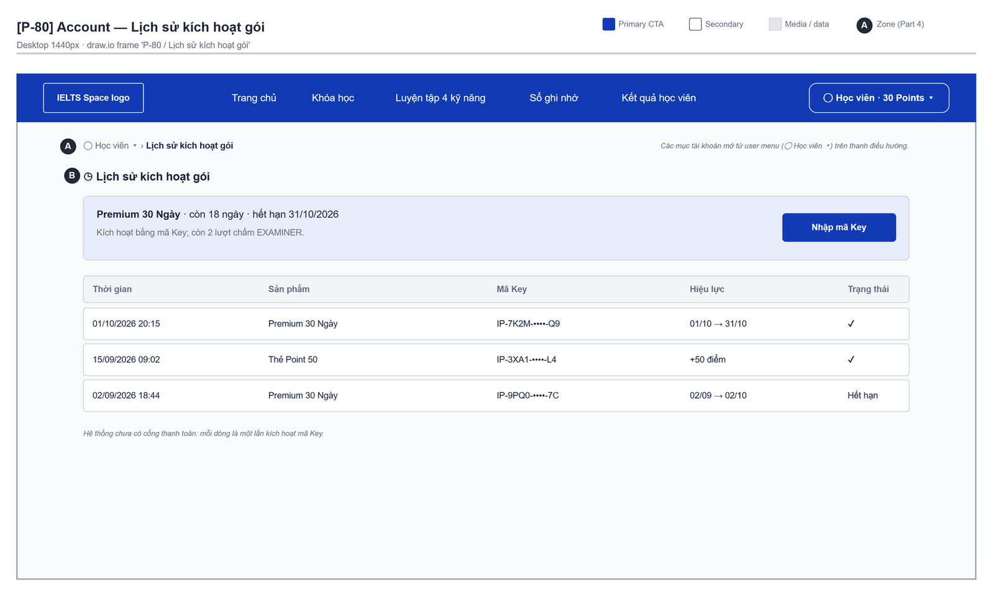
Figure 2.28-1 — Subscription & Points — Lịch sử kích hoạt gói. Source: wireframes/screens/P-80_Account.drawio, tab “P-80 / Lịch sử kích hoạt gói”
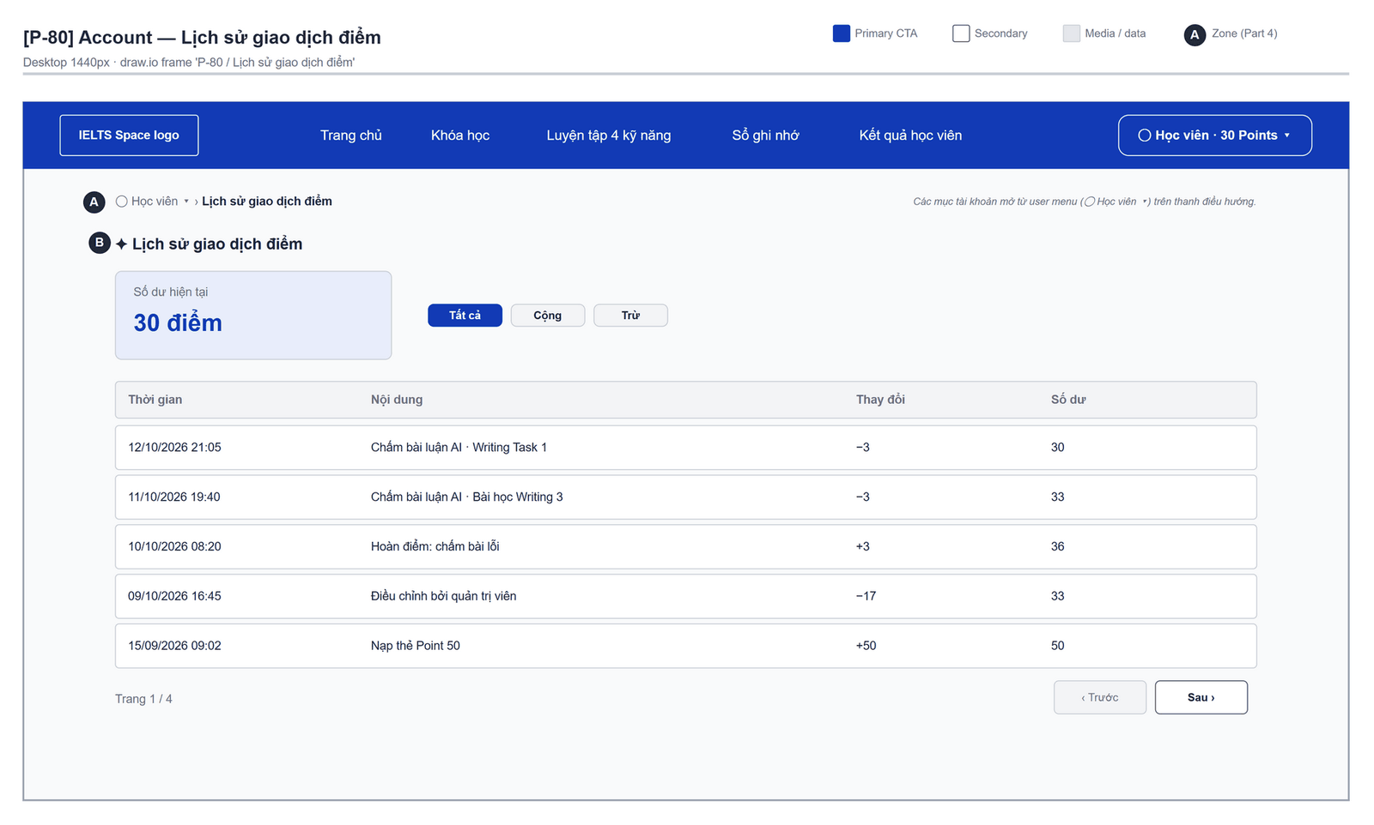
Figure 2.28-2 — Subscription & Points — Lịch sử giao dịch điểm. Source: wireframes/screens/P-80_Account.drawio, tab “P-80 / Lịch sử giao dịch điểm”

Navigation Context
Navigates from | Condition / Trigger
Top bar points badge | User clicks the balance
Writing Feedback | User clicks "Top up points"
Course Path | User clicks "Unlock with Premium" [Draft]

Navigates to | Condition / Trigger
Previous screen | User clicks "Back" after redeeming

2.28.2 Entry & Exit Conditions

Preconditions & Guard Redirects
# | Condition check | If met | If not met → Action
PC-01 | Valid session: access token, or a successful silent refresh (GG-01) | Continue rendering | Redirect → Login?returnUrl=…; GLB-01
PC-02 | User holds role CUSTOMER (GG-02) | Continue rendering | Redirect → /403; GLB-02

Entry Triggers
# | Trigger | From screen / Source | Parameters passed
ET-01 | Points badge | Top bar | —
ET-02 | Top up link | Writing Feedback | Query: ?activate=1 (opens MDL-01)

Exit Points
# | Event | Condition | Navigates to | Notes
EX-01 | User redeems a key | API returns 200 | Stay | MSG-01 / MSG-02
EX-02 | User picks another item in the main menu | Any | Selected screen | —
EX-03 | Session expires, silent refresh fails | Refresh token used, expired or revoked | Login | GLB-01; returnUrl kept

2.28.3 UI Components
Code | Component name | Type | Validation / Constraint | Notes
Wallet-CRD-01 | Subscription | Card | — | Plan, status ACTIVE / EXPIRED / CANCELLED, end date, examiner credits left; "No subscription" state
Wallet-CRD-02 | Point balance | Card | — | Whole number ≥ 0
Wallet-TBL-01 | Points history | Table | 20 per page (offset/limit) | Date, type (KEY_CREDIT, AI_GRADING_DEBIT, AI_GRADING_REFUND, ADMIN_ADJUSTMENT), amount ±, balance after
Wallet-BTN-01 | Activate a key | Button (Primary) | — | Opens MDL-01
Wallet-MDL-01 | Activate key | Modal | — | Holds TXT-01 and BTN-02
Wallet-TXT-01 | Activation key | Text Input | Required; trimmed; upper-cased; MSG-05 | Placeholder: "XXXX-XXXX-XXXX"
Wallet-BTN-02 | Redeem | Button (Primary) | Disabled while empty or pending | Triggers API 4

2.28.4 API Calls & Data Flow
# | Trigger (UI event) | API ID | Method + Path | Request | Success → UI action | Error → UI action
1 | Page load (mount) | API-42 | GET /api/access/me/subscription | — | Fill subscription card · loading: skeleton | 404 → "No subscription"
2 | Page load (parallel) | API-43 | GET /api/access/me/points | — | Fill balance | 404 → balance 0
3 | Page load / page change | API-44 | GET /api/access/me/points/history | Query: offset, limit=20 | Render rows | Error → GLB-04
4 | User clicks Redeem | API-45 | POST /api/access/me/keys/activate | {rawKey, idempotencyKey} (idempotencyKey generated when the modal opens, reused on retry) | Close modal; toast MSG-01 or MSG-02; reload API 1–3 | 400 → MSG-03; 404 → MSG-04

2.28.5 Interaction Specifications

Redeem result
IF product type = PREMIUM → MSG-01 with the new end date (+ credits added)
ELSE (POINTS) → MSG-02 with the points added
END IF
A repeat with the same idempotencyKey returns the first result; the screen shows it the same way.

2.28.6 Messages & Display Content
Code | Type | Trigger condition | Content (UI copy) | Action / Duration
MSG-01 | Success Toast | Premium key redeemed | "Premium is active until {endDate}." | Auto-dismiss 3s
MSG-02 | Success Toast | Points key redeemed | "{points} points have been added to your balance." | Auto-dismiss 3s
MSG-03 | Inline Error | 400 (redeemed, revoked, expired) | "This key has already been used, was cancelled or has expired. Ask your centre for a new key." | Below field, red colour
MSG-04 | Inline Error | 404 | "We could not find this key. Check it and try again." | Below field, red colour
MSG-05 | Inline Error | Blank key | "Enter your activation key." | Below field, red colour
MSG-06 | Empty State | No ledger entries | Title: "No points activity yet" · Description: "Redeem a points key to get started." | CTA: "Activate a key"

2.28.7 Business Rules
BR/BV Code | Short description | UI behaviour when violated
BR-07 | A key is redeemed at most once | MSG-03
BR-08 | Premium days extend the active subscription | MSG-01 shows the new end date
BR-09 | Balance never below 0; every change in the ledger | History table
BR-30 | Same idempotencyKey grants once | Key reused on network retry

2.29 Activity & Streak

2.29.1 General Information
Screen Name | Activity & Streak
Purpose | Shows the learner's study activities and current and longest streak, so the learner can keep a daily study habit.
Route / Type | /account/activity
Role(s) | Any signed-in role
Related FT / UC | FT-44, FT-45  UC-054–UC-058 View activity and streak
Status | Specified (server-side streak: Draft)
Frontend | Not built in the frontend yet — this section is the design target for the frontend team.
Mockup / Wireframe | TBD — no frontend screen yet

Navigation Context
Navigates from | Condition / Trigger
Top bar streak badge | User clicks the flame badge
Main menu | User clicks "Activity"

Navigates to | Condition / Trigger
Course List | User clicks "Study now"

2.29.2 Entry & Exit Conditions

Preconditions & Guard Redirects
# | Condition check | If met | If not met → Action
PC-01 | Valid session: access token, or a successful silent refresh (GG-01) | Continue rendering | Redirect → Login?returnUrl=…; GLB-01
PC-02 | User is signed in with any canonical role | Continue rendering | Redirect → Login; GLB-01

Entry Triggers
# | Trigger | From screen / Source | Parameters passed
ET-01 | Streak badge | Top bar | —
ET-02 | Main menu | Any screen | —

Exit Points
# | Event | Condition | Navigates to | Notes
EX-01 | User deletes an activity | Confirmed | Stay | MSG-02
EX-02 | User picks another item in the main menu | Any | Selected screen | —
EX-03 | Session expires, silent refresh fails | Refresh token used, expired or revoked | Login | GLB-01; returnUrl kept

2.29.3 UI Components
Code | Component name | Type | Validation / Constraint | Notes
Activity-CRD-01 | Current streak | Card | ≥ 0 days | Flame icon; last qualifying date
Activity-CRD-02 | Longest streak | Card | ≥ 0 days | —
Activity-TBL-01 | Activities | Table | 20 per page | Type, source, date, duration (min)
Activity-BTN-01 | Delete | Button (Danger) | Confirm MSG-03 | Per row

2.29.4 API Calls & Data Flow
# | Trigger (UI event) | API ID | Method + Path | Request | Success → UI action | Error → UI action
1 | Page load (mount) | API-38 | GET /api/learning-support/streak | — | Fill cards | 404 → zeros
2 | Page load / page change | API-36 | GET /api/learning-support/activities | Query: page, size=20 | Render table · loading: skeleton | Error → GLB-04
3 | Learner finishes a study action on another screen | API-35 | POST /api/learning-support/activities | {activityType, sourceType, sourceId, occurredAt, durationSeconds} | Silent; no UI on this screen | 400 → ignored, logged
4 | Activity recorded (client-side streak, current release) | API-39 | PUT /api/learning-support/streak | {currentDays, longestDays, lastQualifiedDate, timezone} | Silent | 400 → ignored
5 | User confirms Delete | API-37 | DELETE /api/learning-support/activities/{id} | Path: id | Remove row; toast MSG-02 | 404 → reload

2.29.5 Interaction Specifications

Client-side streak (current release)
On the first qualifying activity of a local day (profile timezone):
IF lastQualifiedDate = yesterday THEN currentDays + 1
ELSE IF lastQualifiedDate = today THEN no change
ELSE currentDays = 1
END IF; longestDays = max(longestDays, currentDays); then streak.put.
Target: the server calculates the streak (FT-45 Draft) and this logic is removed.

2.29.6 Messages & Display Content
Code | Type | Trigger condition | Content (UI copy) | Action / Duration
MSG-01 | Empty State | No activity | Title: "No study activity yet" · Description: "Finish a lesson or practice set to start your streak." | CTA: "Study now"
MSG-02 | Success Toast | Activity deleted | "Activity removed." | Auto-dismiss 3s
MSG-03 | Confirm Modal | User clicks Delete | Title: "Remove this activity?" · Body: "Your streak is not recalculated." | Buttons: "Remove" (Danger) + "Cancel"

2.29.7 Business Rules
BR/BV Code | Short description | UI behaviour when violated
BR-27 | Personal data is visible only to its owner | Another user's id returns 404 → GLB-03; lists show only the user's own records
FT-45 BV-01 | Day counts ≥ 0 | Client never sends negative values

2.30 Notification Centre
Draft: notification-service is a skeleton with a reserved route and no API; every API row below is [TBC] (OQ-10).

2.30.1 General Information
Screen Name | Notification Centre
Purpose | Lists the learner's in-app notifications and lets the learner choose channels, reminder time and registered devices.
Route / Type | /notifications
Role(s) | CUSTOMER
Related FT / UC | FT-51, FT-52, FT-53, FT-54  UC-100–UC-102 Receive study reminders and grading-done alerts; UC-098–UC-099 Manage notification preferences
Status | Draft
Frontend | Not built in the frontend yet — this section is the design target for the frontend team.
Mockup / Wireframe | TBD — no frontend screen yet
Open Questions | OQ-10 (Appendix B)

Navigation Context
Navigates from | Condition / Trigger
Top bar bell | User clicks the bell
Push notification | User taps a push message

Navigates to | Condition / Trigger
Test Result | User opens a grading-done notification
Course List | User opens a study reminder

2.30.2 Entry & Exit Conditions

Preconditions & Guard Redirects
# | Condition check | If met | If not met → Action
PC-01 | Valid session: access token, or a successful silent refresh (GG-01) | Continue rendering | Redirect → Login?returnUrl=…; GLB-01
PC-02 | User holds role CUSTOMER (GG-02) | Continue rendering | Redirect → /403; GLB-02

Entry Triggers
# | Trigger | From screen / Source | Parameters passed
ET-01 | Bell icon | Top bar | —
ET-02 | Push tap | Device | Query: ?notificationId=

Exit Points
# | Event | Condition | Navigates to | Notes
EX-01 | User clicks a notification | Has a target | Target screen | Marked read
EX-02 | User picks another item in the main menu | Any | Selected screen | —
EX-03 | Session expires, silent refresh fails | Refresh token used, expired or revoked | Login | GLB-01; returnUrl kept

2.30.3 UI Components
Code | Component name | Type | Validation / Constraint | Notes
Notifications-TAB-01 | Tabs | Tab bar | Notifications, Preferences, Devices | —
Notifications-TBL-01 | Notifications | List | Newest first; 20 per page | Unread in bold; time; link
Notifications-BTN-01 | Mark as read | Button (Tertiary) | — | Per item
Notifications-CHK-01 | Channel toggles | Toggle | One per channel [TBC: PUSH, EMAIL, IN_APP] | —
Notifications-SEL-01 | Reminder time | Time picker | Local time | Uses profile timezone
Notifications-TBL-02 | Devices | List | — | Platform, last seen; "Revoke" per row
Notifications-BTN-02 | Revoke device | Button (Danger) | Confirm MSG-03 | —

2.30.4 API Calls & Data Flow
# | Trigger (UI event) | API ID | Method + Path | Request | Success → UI action | Error → UI action
1 | Notifications tab load | API-191 | GET /api/notifications | Query: page, size | Render list | Error → GLB-04
2 | User clicks a notification / Mark as read | API-192 | POST /api/notifications/{id}/read | Path: id | Bold removed; badge count - 1 | 404 → reload
3 | Preferences tab load | API-193 | GET /api/notifications/preferences | — | Fill toggles | Error → GLB-04
4 | Toggle or time changed | API-194 | PUT /api/notifications/preferences/{channel} | Path: channel; {enabled, preferredTime, timezone} | Toast MSG-01 | 400 → GLB-06
5 | App start with push permission | API-196 | PUT /api/notifications/devices/{installationId} | Path: installationId; {platform, pushToken} | Silent (same installation updates its token) | Error → retry next start
6 | Devices tab load | API-195 | GET /api/notifications/devices | — | Render devices | Error → GLB-04
7 | User confirms Revoke | API-197 | DELETE /api/notifications/devices/{installationId} | Path: installationId | Remove row; MSG-02 | 404 → reload

2.30.5 Interaction Specifications

Unread badge
Bell badge = unread count from notif.list; refreshed on page focus [TBC: push or polling].

2.30.6 Messages & Display Content
Code | Type | Trigger condition | Content (UI copy) | Action / Duration
MSG-01 | Success Toast | Preference saved | "Notification settings saved." | Auto-dismiss 3s
MSG-02 | Success Toast | Device revoked | "This device will no longer receive notifications." | Auto-dismiss 3s
MSG-03 | Confirm Modal | User clicks Revoke | Title: "Stop notifications on this device?" | Buttons: "Revoke" (Danger) + "Cancel"
MSG-04 | Empty State | No notifications | Title: "You're all caught up" | —

2.30.7 Business Rules
BR/BV Code | Short description | UI behaviour when violated
BR-32 | One preference per channel; at most one reminder a day | Toggles, not a list
BR-27 | Personal data is visible only to its owner | Another user's id returns 404 → GLB-03; lists show only the user's own records

2.31 Vocabulary

2.31.1 General Information
Screen Name | Vocabulary
Purpose | Lets the learner look up topic vocabulary, hear the pronunciation and save words to review later.
Route / Type | /vocabulary · Public page
Role(s) | Guest and any signed-in user
Related FT / UC | FT-36, FT-43  UC-115–UC-132 Manage notes and flashcards; UC-103–UC-106 Browse vocabulary and videos
Status | Specified (backend); frontend on mock data (FG-10)
Frontend | Built on mock data — features/vocabulary/pages/VocabularyPage.tsx with VocabularyCollection and mocks/lessonData.ts (LESSON_VOCABULARY); search, pronunciation and save work in the page only. The design target calls library-service (rows below).
Mockup / Wireframe | Figure 2.31-1 to 2.31-28 below — draw.io wireframes in docs/wireframes/screens (P-50_Vocabulary.drawio, P-56_DictionaryHome.drawio, P-57_WordDetail.drawio, P-58_VocabularyMap.drawio, P-59_VocabularySet.drawio, P-59a_SetStudy.drawio, P-59b_TopicLessonPath.drawio, P-59c_VocabularyLesson.drawio, P-59d_Flashcard.drawio), one tab per state; clickable prototype: docs/wireframes/IELTSPath_Prototype.drawio
Open Questions | OQ-17 (Appendix B)

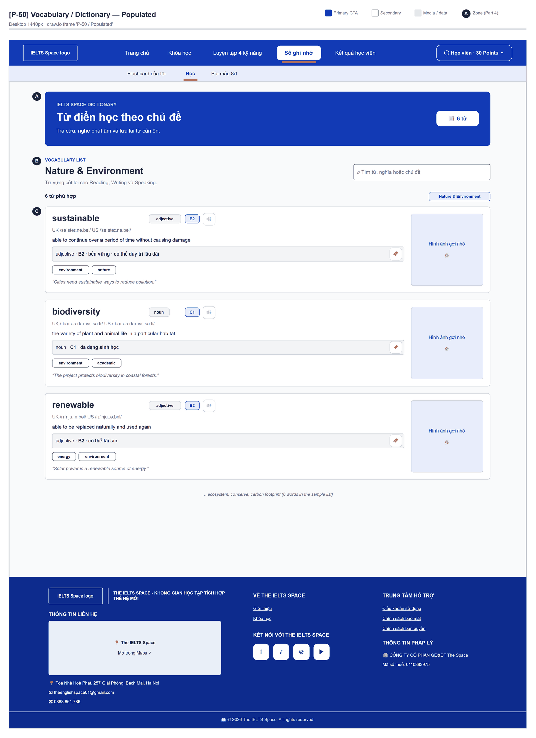
Figure 2.31-1 — Vocabulary — Populated. Source: wireframes/screens/P-50_Vocabulary.drawio, tab “P-50 / Populated”
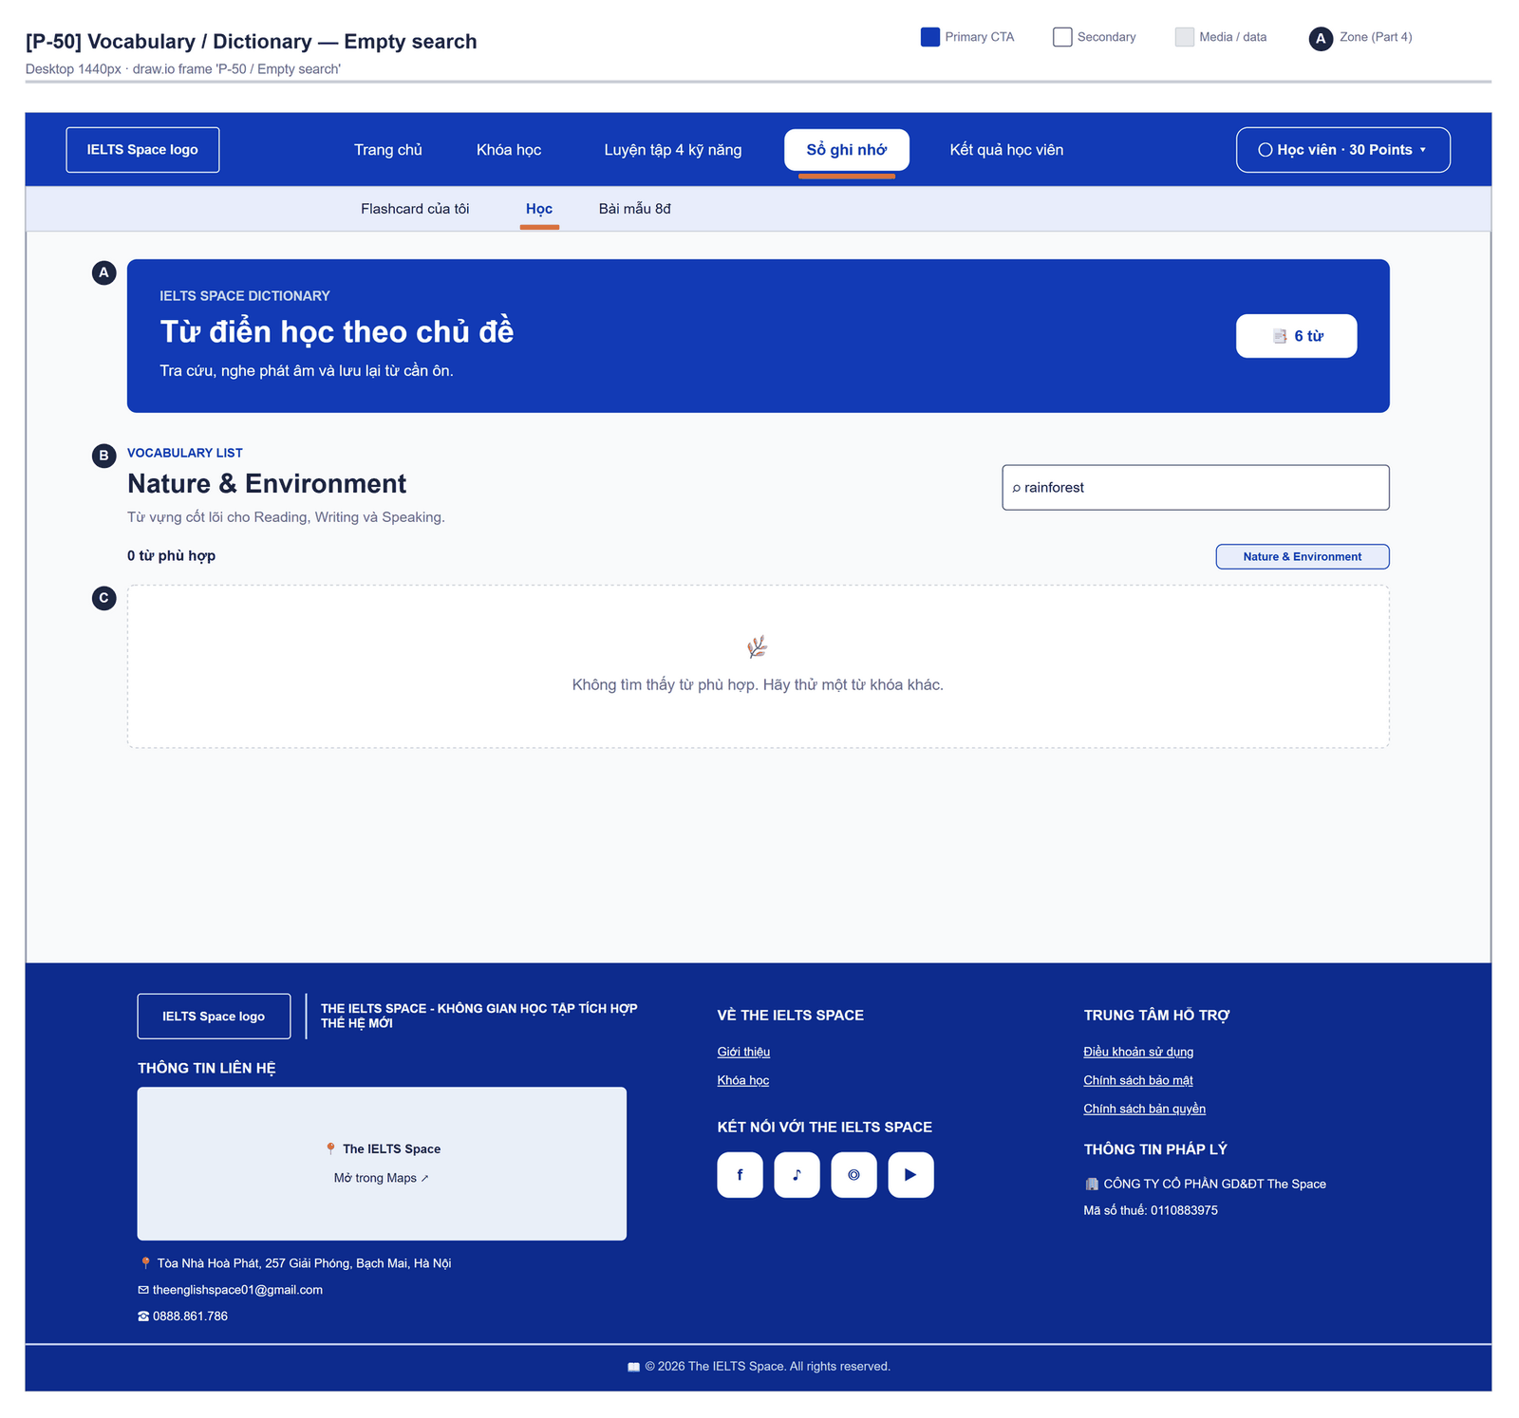
Figure 2.31-2 — Vocabulary — Empty search. Source: wireframes/screens/P-50_Vocabulary.drawio, tab “P-50 / Empty search”
Figure 2.31-3 — Vocabulary — Dictionary Home · Trang chủ từ điển. Source: wireframes/screens/P-56_DictionaryHome.drawio, tab “P-56 / Trang chủ từ điển”
Figure 2.31-4 — Vocabulary — Word Detail · Định nghĩa. Source: wireframes/screens/P-57_WordDetail.drawio, tab “P-57 / Định nghĩa”
Figure 2.31-5 — Vocabulary — Word Detail · Thesaurus. Source: wireframes/screens/P-57_WordDetail.drawio, tab “P-57 / Thesaurus”
Figure 2.31-6 — Vocabulary — Vocabulary Map · Populated. Source: wireframes/screens/P-58_VocabularyMap.drawio, tab “P-58 / Populated”
Figure 2.31-7 — Vocabulary — Vocabulary Set · Tổng quan. Source: wireframes/screens/P-59_VocabularySet.drawio, tab “P-59 / Tổng quan”
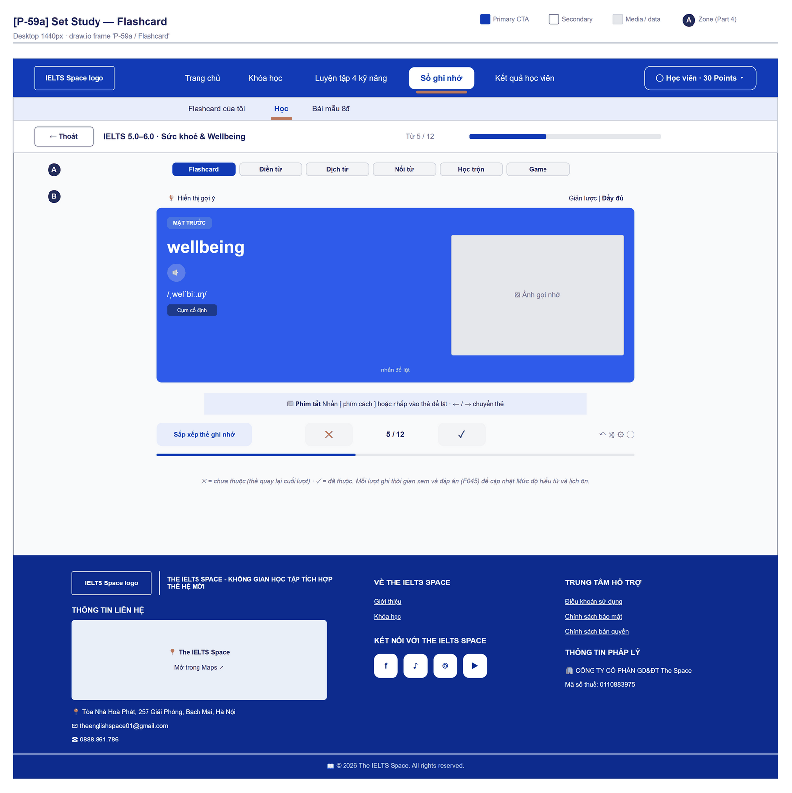
Figure 2.31-8 — Vocabulary — Set Study · Flashcard. Source: wireframes/screens/P-59a_SetStudy.drawio, tab “P-59a / Flashcard”
Figure 2.31-9 — Vocabulary — Set Study · Học trộn — Điền từ. Source: wireframes/screens/P-59a_SetStudy.drawio, tab “P-59a / Học trộn — Điền từ”
Figure 2.31-10 — Vocabulary — Set Study · Dịch từ. Source: wireframes/screens/P-59a_SetStudy.drawio, tab “P-59a / Dịch từ”
Figure 2.31-11 — Vocabulary — Set Study · Nối từ. Source: wireframes/screens/P-59a_SetStudy.drawio, tab “P-59a / Nối từ”
Figure 2.31-12 — Vocabulary — Set Study · Game. Source: wireframes/screens/P-59a_SetStudy.drawio, tab “P-59a / Game”
Figure 2.31-13 — Vocabulary — Topic Lesson Path · Lộ trình bài học. Source: wireframes/screens/P-59b_TopicLessonPath.drawio, tab “P-59b / Lộ trình bài học”
Figure 2.31-14 — Vocabulary — Vocabulary Lesson (SPACE) · S — Khám phá bộ từ. Source: wireframes/screens/P-59c_VocabularyLesson.drawio, tab “P-59c / S — Khám phá bộ từ”
Figure 2.31-15 — Vocabulary — Vocabulary Lesson (SPACE) · P — Đoán nghĩa. Source: wireframes/screens/P-59c_VocabularyLesson.drawio, tab “P-59c / P — Đoán nghĩa”
Figure 2.31-16 — Vocabulary — Vocabulary Lesson (SPACE) · P — Đoán nghĩa · sai. Source: wireframes/screens/P-59c_VocabularyLesson.drawio, tab “P-59c / P — Đoán nghĩa · sai”
Figure 2.31-17 — Vocabulary — Vocabulary Lesson (SPACE) · P — Đoán nghĩa · đúng. Source: wireframes/screens/P-59c_VocabularyLesson.drawio, tab “P-59c / P — Đoán nghĩa · đúng”
Figure 2.31-18 — Vocabulary — Vocabulary Lesson (SPACE) · Hộp thoại bỏ qua. Source: wireframes/screens/P-59c_VocabularyLesson.drawio, tab “P-59c / Hộp thoại bỏ qua”
Figure 2.31-19 — Vocabulary — Vocabulary Lesson (SPACE) · A — Điền từ vào câu. Source: wireframes/screens/P-59c_VocabularyLesson.drawio, tab “P-59c / A — Điền từ vào câu”
Figure 2.31-20 — Vocabulary — Vocabulary Lesson (SPACE) · C — Đặt câu. Source: wireframes/screens/P-59c_VocabularyLesson.drawio, tab “P-59c / C — Đặt câu”
Figure 2.31-21 — Vocabulary — Vocabulary Lesson (SPACE) · Thông báo trước khi nhìn lại. Source: wireframes/screens/P-59c_VocabularyLesson.drawio, tab “P-59c / Thông báo trước khi nhìn lại”
Figure 2.31-22 — Vocabulary — Vocabulary Lesson (SPACE) · E — Nhìn lại bài vừa học. Source: wireframes/screens/P-59c_VocabularyLesson.drawio, tab “P-59c / E — Nhìn lại bài vừa học”
Figure 2.31-23 — Vocabulary — Flashcard Effects (F045) · Mặt trước · hover. Source: wireframes/screens/P-59d_Flashcard.drawio, tab “P-59d / Mặt trước · hover”
Figure 2.31-24 — Vocabulary — Flashcard Effects (F045) · Đang lật. Source: wireframes/screens/P-59d_Flashcard.drawio, tab “P-59d / Đang lật”
Figure 2.31-25 — Vocabulary — Flashcard Effects (F045) · Mặt sau. Source: wireframes/screens/P-59d_Flashcard.drawio, tab “P-59d / Mặt sau”
Figure 2.31-26 — Vocabulary — Flashcard Effects (F045) · Mặt sau · nhấn giữ. Source: wireframes/screens/P-59d_Flashcard.drawio, tab “P-59d / Mặt sau · nhấn giữ”
Figure 2.31-27 — Vocabulary — Flashcard Effects (F045) · Chế độ giản lược. Source: wireframes/screens/P-59d_Flashcard.drawio, tab “P-59d / Chế độ giản lược”
Figure 2.31-28 — Vocabulary — Flashcard Effects (F045) · Giản lược · mặt sau. Source: wireframes/screens/P-59d_Flashcard.drawio, tab “P-59d / Giản lược · mặt sau”

Navigation Context
Navigates from | Condition / Trigger
Top bar | User opens "Sổ từ vựng" → "Kho từ vựng"
Classroom Lesson Workspace | Homework Hub / Từ vựng

Navigates to | Condition / Trigger
Flashcards & Decks | Design target: user opens saved words

2.31.2 Entry & Exit Conditions

Preconditions & Guard Redirects
# | Condition check | If met | If not met → Action
PC-01 | None — public page | Render | —

Entry Triggers
# | Trigger | From screen / Source | Parameters passed
ET-01 | Top bar | Any page | —

Exit Points
# | Event | Condition | Navigates to | Notes
EX-01 | User picks another top bar item | Any | Selected route | Saved words are lost (page state)

2.31.3 UI Components
Code | Component name | Type | Validation / Constraint | Notes
Vocabulary-PNL-01 | Header | Banner | — | "IELTS SPACE DICTIONARY" · "Từ điển học theo chủ đề" · "Tra cứu, nghe phát âm và lưu lại từ cần ôn." · "{n} từ"
Vocabulary-TXT-01 | Tìm từ vựng | Search Input | Matches word, meaning or topic | Placeholder "Tìm từ, nghĩa hoặc chủ đề"; "{n} từ phù hợp"
Vocabulary-CRD-01 | Word card | Card list | — | Word, part of speech, CEFR level, UK/US IPA, definition, Vietnamese meaning, tags, example, "Hình ảnh gợi nhớ"
Vocabulary-BTN-01 | Nghe phát âm từ {word} | Icon button | Browser speech synthesis | —
Vocabulary-BTN-02 | Lưu / Bỏ lưu | Toggle button | — | Page state only (FG-10)

2.31.4 API Calls & Data Flow
# | Trigger (UI event) | API ID | Method + Path | Request | Success → UI action | Error → UI action
1 | Page load / search | — | No API (mock data) | mocks/lessonData.ts | Filter words in memory | —
2 | Design target: search typed | API-82 | GET /api/content/vocabulary/search | Query: query | Render results | Error → GLB-04
3 | Design target: user opens a word | API-83 | GET /api/content/vocabulary/{id} | Path: id | Render senses | 404 → GLB-03
4 | Design target: user clicks Lưu | API-104 | POST /api/learning-support/flashcards | {sourceType: VOCABULARY_SENSE, vocabularySenseId, front, back} | Saved state | 400 → GLB-06

2.31.5 Interaction Specifications

Pronunciation
IF the browser has speech synthesis THEN speak the word and announce "Đang phát cách đọc: {word}." then "Đã phát cách đọc: {word}."
ELSE show MSG-02

2.31.6 Messages & Display Content
Code | Type | Trigger condition | Content (UI copy) | Action / Duration
MSG-01 | Empty State | No word matches | "Không tìm thấy từ phù hợp. Hãy thử một từ khóa khác." | —
MSG-02 | Inline Error | No speech support | "Thiết bị này chưa hỗ trợ phát âm thanh." / "Không thể phát âm thanh trên thiết bị này." | Live region

2.31.7 Business Rules
BR/BV Code | Short description | UI behaviour when violated
BR-27 | Catalog writes need ADMIN or CONTENT_AUTHOR | No edit controls on this screen
FG-10 | Saved words are not stored in library-service | Lost on reload

2.32 Video Library

2.32.1 General Information
Screen Name | Video Library
Purpose | Lists the published learning videos with the learner's progress, so the learner can pick one to watch.
Route / Type | /library/videos
Role(s) | CUSTOMER, EXAMINER, CONTENT_AUTHOR, ADMIN
Related FT / UC | FT-37, FT-38  UC-103–UC-106 Browse vocabulary and videos
Status | Specified
Frontend | Not built in the frontend yet — this section is the design target for the frontend team.
Mockup / Wireframe | TBD — no frontend screen yet

Navigation Context
Navigates from | Condition / Trigger
Main menu | User clicks "Videos"

Navigates to | Condition / Trigger
Video Player | User clicks a video

2.32.2 Entry & Exit Conditions

Preconditions & Guard Redirects
# | Condition check | If met | If not met → Action
PC-01 | Valid session: access token, or a successful silent refresh (GG-01) | Continue rendering | Redirect → Login?returnUrl=…; GLB-01
PC-02 | User holds role ADMIN, CONTENT_AUTHOR, CUSTOMER or EXAMINER (GG-02) | Continue rendering | Redirect → /403; GLB-02

Entry Triggers
# | Trigger | From screen / Source | Parameters passed
ET-01 | Main menu | Any learner screen | Query: ?level=B1

Exit Points
# | Event | Condition | Navigates to | Notes
EX-01 | User clicks a video | Any | Video Player | —
EX-02 | User picks another item in the main menu | Any | Selected screen | —
EX-03 | Session expires, silent refresh fails | Refresh token used, expired or revoked | Login | GLB-01; returnUrl kept

2.32.3 UI Components
Code | Component name | Type | Validation / Constraint | Notes
VideoLibrary-SEL-01 | Level filter | Select | All, A2, B1, B2, C1, C2 | Client-side filter on the loaded page
VideoLibrary-SEL-02 | Access filter | Select | All, FREE, PREMIUM | Sent as accessLevel
VideoLibrary-CRD-01 | Video card | Card grid | — | Thumbnail, title, duration, level
VideoLibrary-PRG-01 | Watch progress | Progress bar | 0–100% | From the learner's video progress

2.32.4 API Calls & Data Flow
# | Trigger (UI event) | API ID | Method + Path | Request | Success → UI action | Error → UI action
1 | Page load / filter change | API-86 | GET /api/content/videos | Query: accessLevel, status=PUBLISHED | Render cards · loading: skeleton | Error → GLB-04
2 | Page load (parallel) | API-93 | GET /api/learning-support/video-progress | Query: page, size=100 | Join progress by videoId in memory | Error → hide bars

2.32.5 Interaction Specifications

Progress join
Progress records are loaded once and joined by videoId; no request per card.

2.32.6 Messages & Display Content
Code | Type | Trigger condition | Content (UI copy) | Action / Duration
MSG-01 | Empty State | No video | Title: "No videos yet" · Description: "New videos are added regularly." | —

2.32.7 Business Rules
BR/BV Code | Short description | UI behaviour when violated
BR-27 | Progress visible only to its owner | Bars use the learner's own records

2.33 Video Player

2.33.1 General Information
Screen Name | Video Player
Purpose | Plays a learning video with its segment transcript, remembers progress, saves segments and lets the learner practise shadowing and dictation on a segment.
Route / Type | /library/videos/:videoId
Role(s) | CUSTOMER
Related FT / UC | FT-37, FT-38, FT-39, FT-40, FT-41  UC-061 Submit Speaking recording; UC-062 Assess speech; UC-065 Practise shadowing; UC-107–UC-113 Track video progress and saved segments; UC-114 Practise dictation
Status | Specified (shadowing / dictation scoring: Draft)
Frontend | Not built in the frontend yet — this section is the design target for the frontend team.
Mockup / Wireframe | TBD — no frontend screen yet
Open Questions | OQ-08 (Appendix B)

Navigation Context
Navigates from | Condition / Trigger
Video Library | User clicks a video

Navigates to | Condition / Trigger
Video Library | User clicks "Back"
Flashcards & Decks | User opens saved words

2.33.2 Entry & Exit Conditions

Preconditions & Guard Redirects
# | Condition check | If met | If not met → Action
PC-01 | Valid session: access token, or a successful silent refresh (GG-01) | Continue rendering | Redirect → Login?returnUrl=…; GLB-01
PC-02 | User holds role CUSTOMER (GG-02) | Continue rendering | Redirect → /403; GLB-02
PC-03 | Video exists and is published | Continue | 404 → Video Library; GLB-03

Entry Triggers
# | Trigger | From screen / Source | Parameters passed
ET-01 | Video card | Video Library | videoId

Exit Points
# | Event | Condition | Navigates to | Notes
EX-01 | User clicks Back | Any | Video Library | Progress saved first
EX-02 | Session expires, silent refresh fails | Refresh token used, expired or revoked | Login | GLB-01; returnUrl kept

2.33.3 UI Components
Code | Component name | Type | Validation / Constraint | Notes
VideoPlayer-VID-01 | Player | YouTube embed | — | Resumes at lastPositionMs
VideoPlayer-TBL-01 | Segments | Transcript list | Ordered by sequenceNo | Click → seek to startMs; highlighted words open the sense
VideoPlayer-BTN-01 | Save segment | Button (Secondary) | Note ≤ 2,000 chars; MSG-04 | Per segment; opens note field
VideoPlayer-TBL-02 | Saved segments | List | — | Delete per row
VideoPlayer-BTN-02 | Shadow this segment | Button (Secondary) | Draft: recording | Creates a SHADOWING attempt
VideoPlayer-BTN-03 | Record / Stop | Button (Primary) | Duration [TBC]; MSG-05 | Draft
VideoPlayer-TXA-01 | Dictation answer | Text Area | Required [TBC] | DICTATION attempt; audio replay allowed
VideoPlayer-CRD-01 | Speech scores | Card | Draft | Transcript, pronunciation, fluency (FT-39)

2.33.4 API Calls & Data Flow
# | Trigger (UI event) | API ID | Method + Path | Request | Success → UI action | Error → UI action
1 | Page load (mount) | API-87 | GET /api/content/videos/{id} | Path: videoId | Render player and segments · loading: skeleton | 404 → GLB-03
2 | Every 15 s while playing, on pause and on leave | API-92 | PUT /api/learning-support/video-progress | {videoId, lastPositionMs, watchedDurationSeconds, progressPercent, status} | Silent | 400 → ignored, logged
3 | User clicks Save segment | API-96 | POST /api/learning-support/saved-segments | {videoId, segmentId, transcriptSnapshot, note} | Add to saved list; toast MSG-01 | 400 → MSG-04
4 | Page load (parallel) | API-97 | GET /api/learning-support/saved-segments | Query: page, size | Saved list (filtered to this video) | —
5 | User deletes a saved segment | API-98 | DELETE /api/learning-support/saved-segments/{id} | Path: id | Remove row | 404 → reload
6 | User starts shadowing / dictation | API-158 | POST /api/assessments/video-practice | {videoId, segmentId, practiceType, referenceTextSnapshot} | Attempt created | 400 → GLB-06
7 | User stops recording [Draft] | API-159 | POST /api/assessments/recordings | audio file + attempt id [TBC] | Show scores MSG-02 (within [TBC] s) | Provider failure → MSG-03
8 | User submits dictation [Draft] | API-160 | POST /api/assessments/video-practice/{id}/dictation | {text} [TBC] | Show % correct and missed words | Empty → MSG-06

2.33.5 Interaction Specifications

Progress status
progressPercent ≥ 95 → status COMPLETED; > 0 → IN_PROGRESS [TBC: threshold].

Snapshot
The practice attempt stores the segment's text at start, so later edits of the video
do not change the attempt (FT-40).

2.33.6 Messages & Display Content
Code | Type | Trigger condition | Content (UI copy) | Action / Duration
MSG-01 | Success Toast | Segment saved | "Segment saved to your library." | Auto-dismiss 3s
MSG-02 | Info Toast | Scores ready [Draft] | "Your recording has been scored." | Auto-dismiss 3s
MSG-03 | Error Toast | Provider failure [Draft] | "We could not score this recording. Please try again." | Auto-dismiss 5s
MSG-04 | Inline Error | Note over 2,000 chars | "Keep your note under 2,000 characters." | Below field
MSG-05 | Inline Error | Recording too long/short [Draft] | "Recordings must be {min}–{max} seconds." | Below recorder
MSG-06 | Inline Error | Empty dictation [Draft] | "Type what you heard before checking." | Below field

2.33.7 Business Rules
BR/BV Code | Short description | UI behaviour when violated
BR-27 | Personal data is visible only to its owner | Another user's id returns 404 → GLB-03; lists show only the user's own records
FT-38 BV-01 | Progress 0–100% | Client clamps before sending
BR-30 | Speech scoring resend does not duplicate [Draft] | Same attempt id on retry

2.34 My Notes

2.34.1 General Information
Screen Name | My Notes
Purpose | Lets the learner write private notes, optionally linked to a knowledge point or a Reading section.
Route / Type | /library/notes
Role(s) | Any signed-in role
Related FT / UC | FT-42  UC-115–UC-132 Manage notes and flashcards
Status | Specified
Frontend | Not built in the frontend yet — this section is the design target for the frontend team.
Mockup / Wireframe | TBD — no frontend screen yet

Navigation Context
Navigates from | Condition / Trigger
Main menu | User clicks "Notes"
Lesson Player / Review Session | User clicks "Add note" (source prefilled)

Navigates to | Condition / Trigger
Lesson Player | User clicks the note's source link [TBC: resolve lesson from KP]

2.34.2 Entry & Exit Conditions

Preconditions & Guard Redirects
# | Condition check | If met | If not met → Action
PC-01 | Valid session: access token, or a successful silent refresh (GG-01) | Continue rendering | Redirect → Login?returnUrl=…; GLB-01
PC-02 | User is signed in with any canonical role | Continue rendering | Redirect → Login; GLB-01

Entry Triggers
# | Trigger | From screen / Source | Parameters passed
ET-01 | Main menu | Any screen | —
ET-02 | Add note | Lesson Player | Query: ?sourceType=KNOWLEDGE_POINT&sourceReferenceId=

Exit Points
# | Event | Condition | Navigates to | Notes
EX-01 | Save | API 2xx | Stay | MSG-01
EX-02 | User picks another item in the main menu | Any | Selected screen | GLB-07 if the editor has unsaved text
EX-03 | Session expires, silent refresh fails | Refresh token used, expired or revoked | Login | GLB-01; returnUrl kept

2.34.3 UI Components
Code | Component name | Type | Validation / Constraint | Notes
Notes-TBL-01 | Notes list | List | 20 per page; filter by source | Title, updated, source tag
Notes-TXT-01 | Title | Text Input | Required; ≤ 255 chars; MSG-03 | —
Notes-TXA-01 | Body | Text Area | Required; ≤ 20,000 chars; MSG-04 | Counter
Notes-SEL-01 | Source type | Select | None, KNOWLEDGE_POINT, READING, TUTOR_SESSION | Requires a source id when set (MSG-05)
Notes-BTN-01 | Save | Button (Primary) | — | Create or update
Notes-BTN-02 | Delete | Button (Danger) | Confirm MSG-06 | —

2.34.4 API Calls & Data Flow
# | Trigger (UI event) | API ID | Method + Path | Request | Success → UI action | Error → UI action
1 | Page load / filter | API-100 | GET /api/learning-support/notes | Query: status=ACTIVE, page, size, sourceType, sourceReferenceId | Render list | Error → GLB-04
2 | User opens a note | API-101 | GET /api/learning-support/notes/{id} | Path: id | Fill editor | 404 → GLB-03
3 | User clicks Save (new) | API-99 | POST /api/learning-support/notes | {title, body, sourceType, sourceReferenceId} | Toast MSG-01 | 400 → MSG-03…05
4 | User clicks Save (existing) | API-102 | PUT /api/learning-support/notes/{id} | Path: id; {title, body, status} | Toast MSG-01 | 400 → MSG-03/04
5 | User confirms Delete | API-103 | DELETE /api/learning-support/notes/{id} | Path: id | Remove from list; toast MSG-02 | 404 → reload
6 | Note linked to READING | API-80 | GET /api/content/reading/sections/{sectionId} | Path: sectionId | Show the passage title as source | Error → show "Reading section"

2.34.5 Interaction Specifications

Source pair
sourceType and sourceReferenceId are sent together or not at all (FT-42/NAC-01).

2.34.6 Messages & Display Content
Code | Type | Trigger condition | Content (UI copy) | Action / Duration
MSG-01 | Success Toast | Saved | "Note saved." | Auto-dismiss 3s
MSG-02 | Success Toast | Deleted | "Note deleted." | Auto-dismiss 3s
MSG-03 | Inline Error | Title invalid | "Enter a title of up to 255 characters." | Below field
MSG-04 | Inline Error | Body invalid | "Write your note (up to 20,000 characters)." | Below field
MSG-05 | Inline Error | Source incomplete | "Choose what this note is about, or remove the link." | Below field
MSG-06 | Confirm Modal | Delete | Title: "Delete this note?" | Buttons: "Delete" (Danger) + "Cancel"

2.34.7 Business Rules
BR/BV Code | Short description | UI behaviour when violated
BR-27 | Personal data is visible only to its owner | Another user's id returns 404 → GLB-03; lists show only the user's own records
FT-42 BV-01/02 | Title ≤ 255, body ≤ 20,000 | Inline errors

2.35 Flashcards & Decks

2.35.1 General Information
Screen Name | Flashcards & Decks
Purpose | Lets the learner create flashcards, group them into decks and study a deck card by card.
Route / Type | /library/flashcards
Role(s) | Any signed-in role
Related FT / UC | FT-43  UC-115–UC-132 Manage notes and flashcards
Status | Specified
Frontend | Not built in the frontend yet — this section is the design target for the frontend team.
Mockup / Wireframe | Figure 2.35-1 to 2.35-3 below — draw.io wireframes in docs/wireframes/screens (P-51_MyFlashcards.drawio, P-51a_CreateSet.drawio, P-51b_SetDetail.drawio), one tab per state; clickable prototype: docs/wireframes/IELTSPath_Prototype.drawio

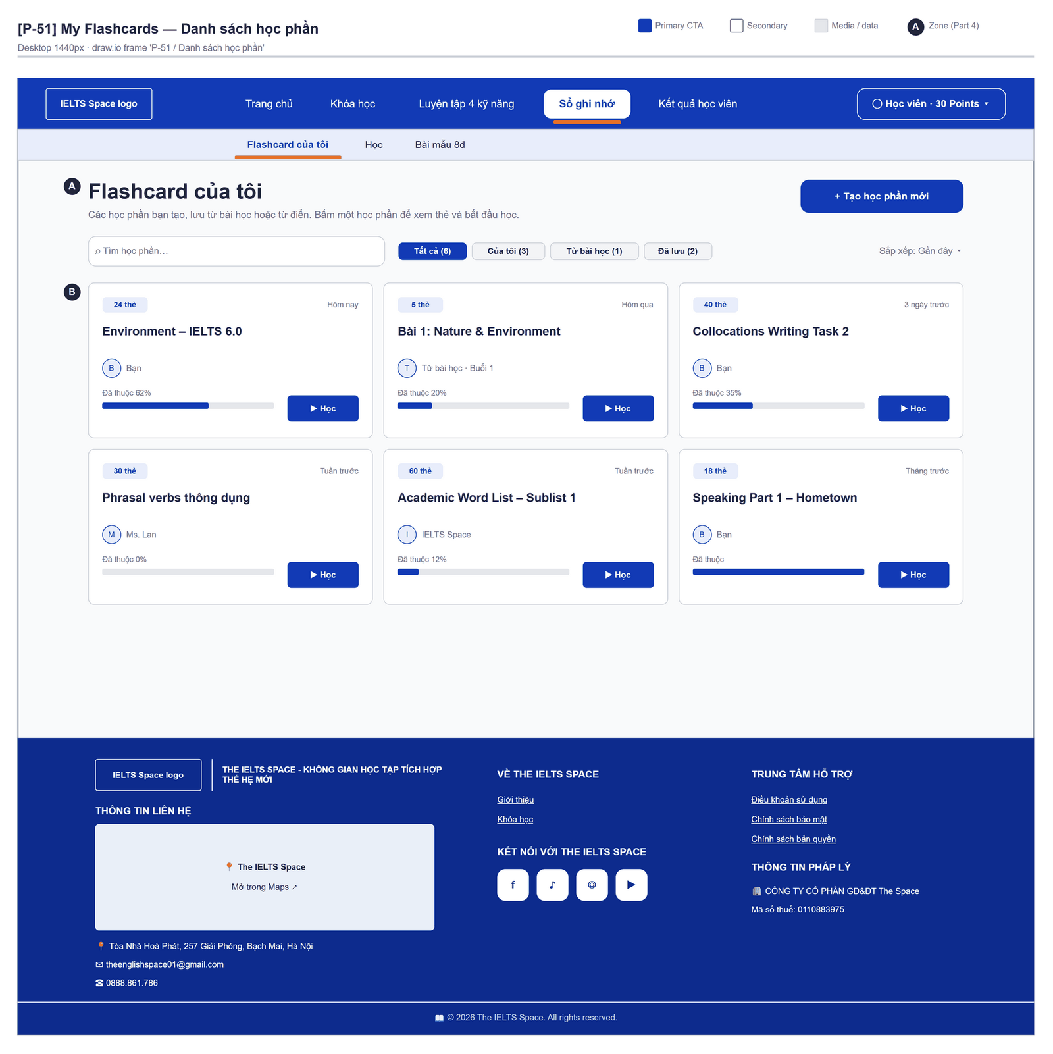
Figure 2.35-1 — Flashcards & Decks — Danh sách học phần. Source: wireframes/screens/P-51_MyFlashcards.drawio, tab “P-51 / Danh sách học phần”
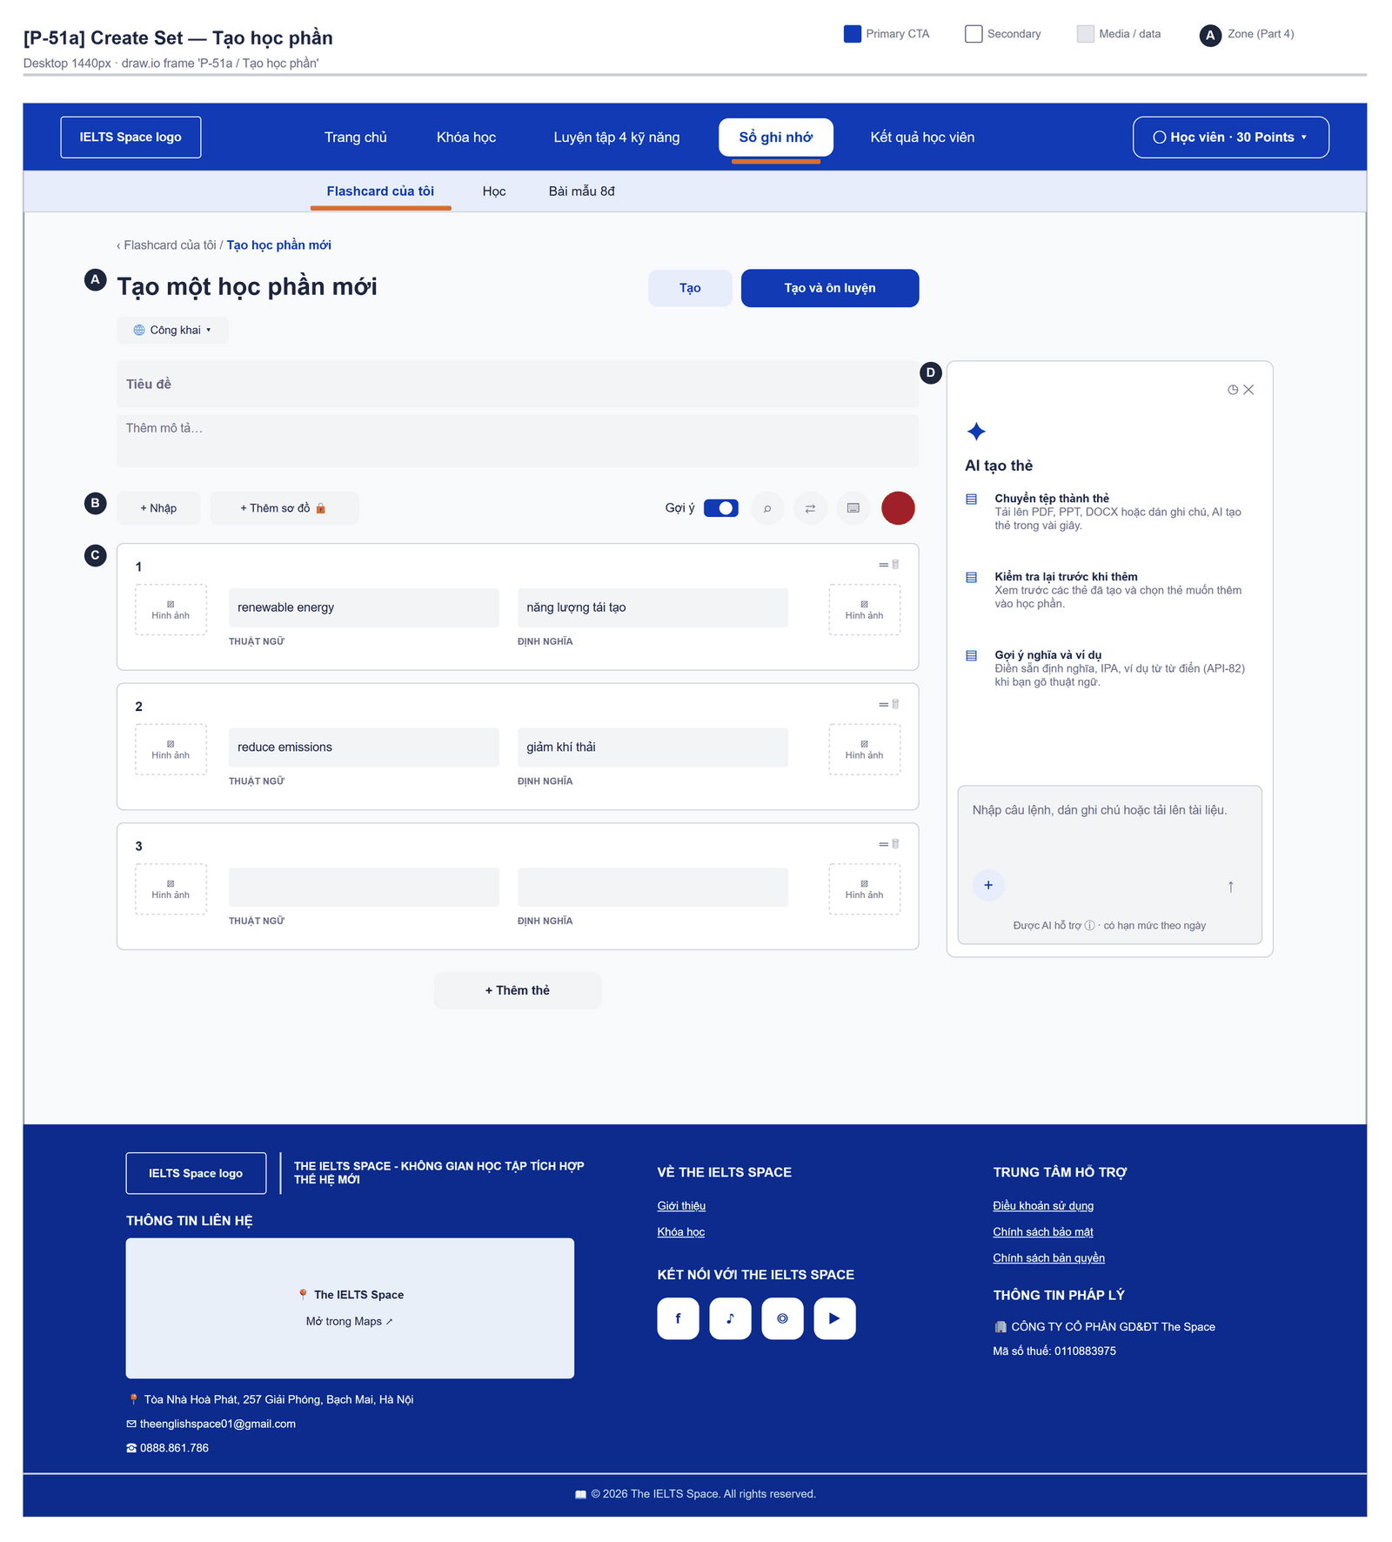
Figure 2.35-2 — Flashcards & Decks — Create Set · Tạo học phần. Source: wireframes/screens/P-51a_CreateSet.drawio, tab “P-51a / Tạo học phần”
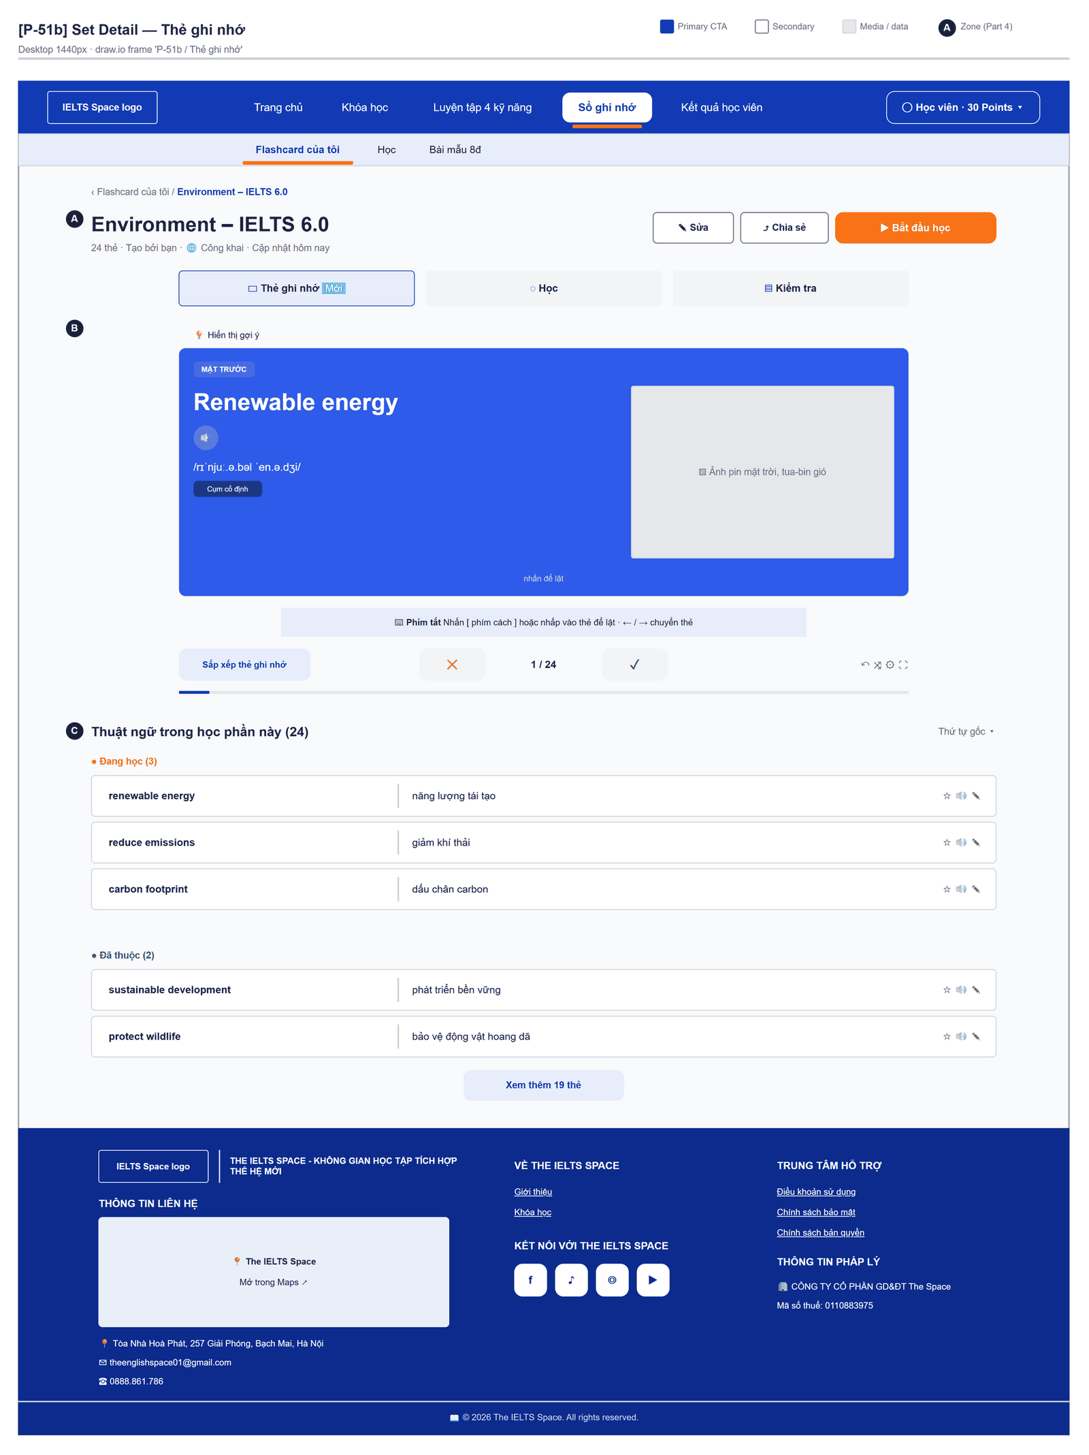
Figure 2.35-3 — Flashcards & Decks — Set Detail · Thẻ ghi nhớ. Source: wireframes/screens/P-51b_SetDetail.drawio, tab “P-51b / Thẻ ghi nhớ”

Navigation Context
Navigates from | Condition / Trigger
Top bar | User opens "Sổ từ vựng" → "Flashcard của tôi" (/flashcards shows a placeholder page today)
Vocabulary / Practice Set | Card saved; user opens the library

Navigates to | Condition / Trigger
Vocabulary | User clicks a VOCABULARY_SENSE card's source

2.35.2 Entry & Exit Conditions

Preconditions & Guard Redirects
# | Condition check | If met | If not met → Action
PC-01 | Valid session: access token, or a successful silent refresh (GG-01) | Continue rendering | Redirect → Login?returnUrl=…; GLB-01
PC-02 | User is signed in with any canonical role | Continue rendering | Redirect → Login; GLB-01

Entry Triggers
# | Trigger | From screen / Source | Parameters passed
ET-01 | Main menu | Any screen | Query: ?deckId=

Exit Points
# | Event | Condition | Navigates to | Notes
EX-01 | Save / add / remove | API 2xx | Stay | MSG-01
EX-02 | User picks another item in the main menu | Any | Selected screen | —
EX-03 | Session expires, silent refresh fails | Refresh token used, expired or revoked | Login | GLB-01; returnUrl kept

2.35.3 UI Components
Code | Component name | Type | Validation / Constraint | Notes
Flashcards-TAB-01 | Tabs | Tab bar | Cards, Decks, Study | —
Flashcards-TBL-01 | Cards | List | 20 per page; status ACTIVE | Front, back preview, source type
Flashcards-TXA-01 | Front | Text Area | Required; ≤ 4,000 chars; MSG-03 | —
Flashcards-TXA-02 | Back | Text Area | Required; ≤ 4,000 chars; MSG-03 | —
Flashcards-TXT-01 | Highlighted text | Text Input | Optional; ≤ 2,000 chars | —
Flashcards-TBL-02 | Decks | List | 20 per page | Name, card count
Flashcards-TXT-02 | Deck name | Text Input | Required; ≤ 150 chars; MSG-04 | —
Flashcards-TXA-03 | Deck description | Text Area | ≤ 2,000 chars | —
Flashcards-SEL-01 | Add to deck | Select | Learner's decks | Per card
Flashcards-CRD-01 | Study card | Flip card | — | Click to flip; next / previous

2.35.4 API Calls & Data Flow
# | Trigger (UI event) | API ID | Method + Path | Request | Success → UI action | Error → UI action
1 | Cards tab | API-105 | GET /api/learning-support/flashcards | Query: status=ACTIVE, page, size | Render cards | Error → GLB-04
2 | Save card | API-104 | POST /api/learning-support/flashcards | {sourceType: MANUAL, front, back, highlightedText} | Toast MSG-01 | 400 → MSG-03
3 | Edit card | API-107 | PUT /api/learning-support/flashcards/{id} | Path: id; same fields + status | Toast MSG-01 | 404 → reload
4 | Delete card | API-108 | DELETE /api/learning-support/flashcards/{id} | Path: id | Toast MSG-02 | 404 → reload
5 | Decks tab | API-110 | GET /api/learning-support/decks | Query: status=ACTIVE, page, size | Render decks | Error → GLB-04
6 | Save deck | API-109 | POST /api/learning-support/decks | {name, description} | Toast MSG-01 | 400 → MSG-04
7 | Rename / archive deck | API-112 | PUT /api/learning-support/decks/{id} | Path: id; {name, description, status} | Toast MSG-01 | 404 → reload
8 | Delete deck | API-113 | DELETE /api/learning-support/decks/{id} | Path: id | Toast MSG-02 | 404 → reload
9 | Add card to deck | API-114 | POST /api/learning-support/decks/{deckId}/items | Path: deckId; {flashcardId, sortOrder} | Toast MSG-05 | 404 → reload
10 | Open deck / Study | API-115 | GET /api/learning-support/decks/{deckId}/items | Path: deckId; Query: page, size | Render cards | 404 → GLB-03
11 | Remove card from deck | API-116 | DELETE /api/learning-support/decks/{deckId}/items/{flashcardId} | Path: deckId, flashcardId | Card stays in Cards tab | 404 → reload

2.35.5 Interaction Specifications

Remove vs delete
Removing from a deck keeps the card (FT-43/AC-02); deleting a card removes it everywhere and needs confirm MSG-06.

2.35.6 Messages & Display Content
Code | Type | Trigger condition | Content (UI copy) | Action / Duration
MSG-01 | Success Toast | Saved | "Saved." | Auto-dismiss 3s
MSG-02 | Success Toast | Deleted | "Deleted." | Auto-dismiss 3s
MSG-03 | Inline Error | Front/back invalid | "Fill in both sides (up to 4,000 characters each)." | Below field
MSG-04 | Inline Error | Deck name invalid | "Enter a deck name of up to 150 characters." | Below field
MSG-05 | Success Toast | Added to deck | "Card added to {deck}." | Auto-dismiss 3s
MSG-06 | Confirm Modal | Delete card or deck | Title: "Delete this {card|deck}?" · Body: "This cannot be undone." | Buttons: "Delete" (Danger) + "Cancel"

2.35.7 Business Rules
BR/BV Code | Short description | UI behaviour when violated
BR-27 | Personal data is visible only to its owner | Another user's id returns 404 → GLB-03; lists show only the user's own records
FT-43 BV-01/02 | Sides ≤ 4,000; deck name ≤ 150 | Inline errors

2.36 Game Lobby

2.36.1 General Information
Screen Name | Game Lobby
Purpose | Lets the learner start a single-player game, create or join a multiplayer room, and see past sessions.
Route / Type | /games
Role(s) | Any signed-in role
Related FT / UC | FT-46, FT-47, FT-48  UC-133–UC-148 Play game
Status | Specified (matchmaking: Draft)
Frontend | Not built in the frontend yet — this section is the design target for the frontend team.
Mockup / Wireframe | TBD — no frontend screen yet
Open Questions | OQ-11 (Appendix B)

Navigation Context
Navigates from | Condition / Trigger
Main menu | User clicks "Games"

Navigates to | Condition / Trigger
Single-player Game | Session started
Game Room | Room created or joined

2.36.2 Entry & Exit Conditions

Preconditions & Guard Redirects
# | Condition check | If met | If not met → Action
PC-01 | Valid session: access token, or a successful silent refresh (GG-01) | Continue rendering | Redirect → Login?returnUrl=…; GLB-01
PC-02 | User is signed in with any canonical role | Continue rendering | Redirect → Login; GLB-01

Entry Triggers
# | Trigger | From screen / Source | Parameters passed
ET-01 | Main menu | Any screen | Query: ?code=ABC123 (join link)

Exit Points
# | Event | Condition | Navigates to | Notes
EX-01 | User clicks Play | Session created | Single-player Game | —
EX-02 | User creates / joins a room | API 2xx | Game Room | —
EX-03 | User clicks Find a match [Draft] | Queue joined | Stay (waiting state) | MSG-05
EX-04 | User picks another item in the main menu | Any | Selected screen | —
EX-05 | Session expires, silent refresh fails | Refresh token used, expired or revoked | Login | GLB-01; returnUrl kept

2.36.3 UI Components
Code | Component name | Type | Validation / Constraint | Notes
GameLobby-SEL-01 | Game type | Select | WORD_MEANING_MATCH, SPELLING (VOCABULARY); SENTENCE_COMPLETION, ERROR_CORRECTION, WORD_ORDER (GRAMMAR) | Domain is set from the type
GameLobby-SEL-02 | Content source | Select | Topic, deck or vocabulary list → 1–20 content ids | MSG-03
GameLobby-BTN-01 | Play | Button (Primary) | — | Triggers API 1
GameLobby-NUM-01 | Max players | Number | 2–32 (BV-01); MSG-04 | Default: 8
GameLobby-BTN-02 | Create room | Button (Secondary) | — | Triggers API 2
GameLobby-TXT-01 | Room code | Text Input | Required for join | —
GameLobby-BTN-03 | Join | Button (Secondary) | — | Triggers API 3
GameLobby-BTN-04 | Find a match | Button (Secondary) | Draft | Joins the matchmaking queue
GameLobby-TBL-01 | History | Table | 20 per page | Game type, score, status COMPLETED / ABANDONED, date

2.36.4 API Calls & Data Flow
# | Trigger (UI event) | API ID | Method + Path | Request | Success → UI action | Error → UI action
1 | User clicks Play | API-161 | POST /api/games/sessions | {gameType, learningDomain, mode: PRACTICE, topicId, contentIds} | Navigate Single-player Game | 400 → MSG-02/03; 503 → GLB-05
2 | User clicks Create room | API-166 | POST /api/games/rooms | {gameType, learningDomain, mode, maxPlayers, contentIds} | Navigate Game Room | 400 → MSG-04
3 | User clicks Join | API-170 | POST /api/games/rooms/code/{roomCode}/join | Path: roomCode | Navigate Game Room | 400 (full / not WAITING) → MSG-01; 404 → MSG-06
4 | Lobby opened with ?code= (join link) | API-168 | GET /api/games/rooms/code/{roomCode} | Path: roomCode | Show room preview (game type, players, status) with a Join button | 404 → MSG-06
5 | User clicks Join on the preview | API-169 | POST /api/games/rooms/{roomId}/join | Path: roomId | Navigate Game Room | 400 (full / not WAITING) → MSG-01
6 | Page load | API-164 | GET /api/games/sessions | Query: page, size=20 | Render history | Error → GLB-04
7 | User clicks Find a match [Draft] | API-177 | POST /api/games/matchmaking | {gameType, learningDomain} [TBC] | Waiting state; match found → Game Room | Timeout → MSG-05

2.36.5 Interaction Specifications

Domain from type
VOCABULARY types fetch content from library, GRAMMAR types from content;
the screen sets learningDomain from the chosen type so they never mismatch.

2.36.6 Messages & Display Content
Code | Type | Trigger condition | Content (UI copy) | Action / Duration
MSG-01 | Error Toast | Room full or already started | "This room is full or the match has already started." | Auto-dismiss 5s
MSG-02 | Error Toast | Type/domain not supported | "This game cannot use that content. Choose another source." | Auto-dismiss 5s
MSG-03 | Inline Error | 0 or > 20 items | "Choose between 1 and 20 items to play." | Below field
MSG-04 | Inline Error | Players outside 2–32 | "A room holds 2 to 32 players." | Below field
MSG-05 | Info Banner | Matchmaking waiting / timeout [Draft] | "Looking for players…" / "No match found. Please try again." | Persistent while waiting
MSG-06 | Error Toast | Room code not found | "We could not find a room with this code." | Auto-dismiss 5s

2.36.7 Business Rules
BR/BV Code | Short description | UI behaviour when violated
BR-29 | 1 point per correct answer; room 2–32 players | MSG-04
FT-46 BV-01 | 1–20 content ids per session | MSG-03

2.37 Single-player Game

2.37.1 General Information
Screen Name | Single-player Game
Purpose | Plays a single-player vocabulary or grammar game item by item on a frozen content snapshot and shows the final score.
Route / Type | /games/sessions/:sessionId
Role(s) | Any signed-in role
Related FT / UC | FT-46  UC-133–UC-148 Play game
Status | Specified
Frontend | Not built in the frontend yet — this section is the design target for the frontend team.
Mockup / Wireframe | TBD — no frontend screen yet

Navigation Context
Navigates from | Condition / Trigger
Game Lobby | Session started

Navigates to | Condition / Trigger
Game Lobby | Game finished or abandoned

2.37.2 Entry & Exit Conditions

Preconditions & Guard Redirects
# | Condition check | If met | If not met → Action
PC-01 | Valid session: access token, or a successful silent refresh (GG-01) | Continue rendering | Redirect → Login?returnUrl=…; GLB-01
PC-02 | User is signed in with any canonical role | Continue rendering | Redirect → Login; GLB-01
PC-03 | The game session in the URL belongs to the signed-in user | Continue rendering | API returns 404 → redirect to previous screen; GLB-03

Entry Triggers
# | Trigger | From screen / Source | Parameters passed
ET-01 | Play | Game Lobby | sessionId

Exit Points
# | Event | Condition | Navigates to | Notes
EX-01 | Last item answered | Session COMPLETED | Stay (score panel) | MSG-01
EX-02 | User clicks Quit | Confirmed | Game Lobby | Session ABANDONED (MSG-02)
EX-03 | Session expires, silent refresh fails | Refresh token used, expired or revoked | Login | GLB-01; returnUrl kept

2.37.3 UI Components
Code | Component name | Type | Validation / Constraint | Notes
SoloGame-PRG-01 | Item progress | Progress | item n of N | —
SoloGame-PNL-01 | Prompt | Panel | — | From the snapshot item
SoloGame-RAD-01 | Answer | Choice / Text / Drag order | Per game type | Timer measures durationMilliseconds
SoloGame-BTN-01 | Submit answer | Button (Primary) | Once per item | Triggers API 2
SoloGame-CRD-01 | Score | Card | — | Live score; final score panel
SoloGame-BTN-02 | Quit | Button (Secondary) | Confirm MSG-02 | Triggers API 3

2.37.4 API Calls & Data Flow
# | Trigger (UI event) | API ID | Method + Path | Request | Success → UI action | Error → UI action
1 | Page load (mount) | API-163 | GET /api/games/sessions/{sessionId} | Path: sessionId | Render current item | 404 → GLB-03
2 | User submits an answer | API-162 | POST /api/games/sessions/{sessionId}/answers/{itemSequence} | Path: sessionId, itemSequence; {responsePayload, durationMilliseconds} | Show correct/incorrect, +1 when correct; next item | 400 (answered twice, ended) → reload session
3 | User confirms Quit / leaves the page | API-165 | POST /api/games/sessions/{sessionId}/abandon | Path: sessionId | Navigate Game Lobby | Error → navigate anyway

2.37.5 Interaction Specifications

Leaving
Closing the tab or navigating away sends game.abandon (sendBeacon) so the session ends ABANDONED and is not counted as completed.

2.37.6 Messages & Display Content
Code | Type | Trigger condition | Content (UI copy) | Action / Duration
MSG-01 | Success Toast | Session COMPLETED | "Game over — you scored {score} of {total}!" | Auto-dismiss 3s
MSG-02 | Confirm Modal | User clicks Quit | Title: "Quit this game?" · Body: "Your progress will not count as a completed game." | Buttons: "Quit" (Danger) + "Keep playing"

2.37.7 Business Rules
BR/BV Code | Short description | UI behaviour when violated
BR-29 | 1 point per correct answer | Score card
FT-46/NAC-03 | Each item answered once | Submit disabled after answering

2.38 Game Room

2.38.1 General Information
Screen Name | Game Room
Purpose | Gathers players in a multiplayer room, lets the host start the match and plays it in real time over WebSocket, ending with a ranking.
Route / Type | /games/rooms/:roomId
Role(s) | Any signed-in role
Related FT / UC | FT-47  UC-133–UC-148 Play game
Status | Specified
Frontend | Not built in the frontend yet — this section is the design target for the frontend team.
Mockup / Wireframe | TBD — no frontend screen yet

Navigation Context
Navigates from | Condition / Trigger
Game Lobby | Room created or joined
Join link | Lobby opened with a room code

Navigates to | Condition / Trigger
Game Lobby | User leaves, host closes the room, or match ends

2.38.2 Entry & Exit Conditions

Preconditions & Guard Redirects
# | Condition check | If met | If not met → Action
PC-01 | Valid session: access token, or a successful silent refresh (GG-01) | Continue rendering | Redirect → Login?returnUrl=…; GLB-01
PC-02 | User is signed in with any canonical role | Continue rendering | Redirect → Login; GLB-01
PC-03 | User is a member of the room | Continue | Redirect → Game Lobby; GLB-03

Entry Triggers
# | Trigger | From screen / Source | Parameters passed
ET-01 | Create / join | Game Lobby | roomId

Exit Points
# | Event | Condition | Navigates to | Notes
EX-01 | User clicks Leave | Any | Game Lobby | room.leave; MEMBER_LEFT broadcast
EX-02 | Host clicks Close room | Host only | Game Lobby (all members) | MSG-03
EX-03 | Match ends | All items played | Stay (ranking) | MSG-04
EX-04 | Session expires, silent refresh fails | Refresh token used, expired or revoked | Login | GLB-01; returnUrl kept

2.38.3 UI Components
Code | Component name | Type | Validation / Constraint | Notes
GameRoom-TBL-01 | Members | List | 2–32 | Name, ready ✓, host crown
GameRoom-CHK-01 | Ready | Toggle | — | Sends READY over WebSocket (or API 3)
GameRoom-BTN-01 | Start match | Button (Primary) | Host only; enabled when ≥ 2 active members are all ready | Sends START_MATCH
GameRoom-BTN-02 | Close room | Button (Danger) | Host only; confirm MSG-05 | Triggers API 5
GameRoom-TXT-01 | Room code | Text (copy) | — | Copy button + share link
GameRoom-PNL-01 | Match item | Panel | — | Prompt + answer input
GameRoom-TBL-02 | Ranking | Table | Score desc, then total answer time asc | Rank, player, score, time
GameRoom-BDG-01 | Connection | Badge | Connected / Reconnecting… | —

2.38.4 API Calls & Data Flow
# | Trigger (UI event) | API ID | Method + Path | Request | Success → UI action | Error → UI action
1 | Page load (mount) | API-167 | GET /api/games/rooms/{roomId} | Path: roomId | Render members | 404 → GLB-03
2 | After load | API-174 | POST /api/games/rooms/{roomId}/websocket-ticket | Path: roomId | Ticket valid 30 s → API 7 immediately | Error → GLB-05
3 | Ready toggled (fallback) | API-171 | POST /api/games/rooms/{roomId}/ready | {ready} | Member list updates | 400 → reload
4 | User clicks Leave | API-172 | POST /api/games/rooms/{roomId}/leave | Path: roomId | Navigate Game Lobby | —
5 | Host confirms Close | API-173 | POST /api/games/rooms/{roomId}/close | Path: roomId | All members return to lobby | 400 (not host) → GLB-02
6 | Match ended | API-176 | GET /api/games/matches/{matchId} | Path: matchId | Render ranking | —
7 | Ticket received | API-175 | WS /ws/games (subprotocols game.v1, ticket.{ticket}) | Subprotocols game.v1, ticket.{ticket}; messages PING, ROOM_STATE, READY, START_MATCH, ANSWER, LEAVE, RECONNECT | CONNECTED, ROOM_STATE, MEMBER_LEFT, match events | Handshake refused → new ticket, retry ×3 → MSG-06

2.38.5 Interaction Specifications

Reconnect
IF the socket closes during a match
THEN request a new ticket (room.ticket), reconnect, send RECONNECT {matchId}
show badge "Reconnecting…"; after 3 failures show MSG-06
END IF

Start rule
Start is enabled only for the host and only when at least 2 active members are ready;
the server re-checks and replies ERROR otherwise (FT-47/NAC-01).

2.38.6 Messages & Display Content
Code | Type | Trigger condition | Content (UI copy) | Action / Duration
MSG-01 | Info Toast | Member joined / left | "{name} joined the room." / "{name} left the room." | Auto-dismiss 3s
MSG-02 | Warning Toast | Start refused | "Everyone must be ready, with at least 2 players, to start." | Auto-dismiss 5s
MSG-03 | Info Banner | Room closed by host | "The host closed this room." | Redirect after 3 s
MSG-04 | Success Toast | Match ended | "Match over! You finished #{rank}." | Auto-dismiss 3s
MSG-05 | Confirm Modal | Host clicks Close room | Title: "Close this room?" · Body: "All players will be removed." | Buttons: "Close room" (Danger) + "Cancel"
MSG-06 | Alert Banner | Cannot connect | "Connection lost. Check your internet and rejoin the room." | Persistent; button "Rejoin"

2.38.7 Business Rules
BR/BV Code | Short description | UI behaviour when violated
BR-29 | Room 2–32 players; host starts once ≥ 2 members are ready | Start disabled; MSG-02
FT-47 BV-02 | WebSocket ticket valid 30 s | Ticket requested right before connecting

2.39 Community Feed

2.39.1 General Information
Screen Name | Community Feed
Purpose | Lists active community posts newest first and lets users write a post, react, and — for Administrators — hide posts that break the rules.
Route / Type | /community
Role(s) | Any signed-in role
Related FT / UC | FT-49, FT-50  UC-149–UC-159 Post and comment; UC-160–UC-161 Moderate community
Status | Specified
Frontend | Not built in the frontend yet — this section is the design target for the frontend team.
Mockup / Wireframe | TBD — no frontend screen yet

Navigation Context
Navigates from | Condition / Trigger
Main menu | User clicks "Community"

Navigates to | Condition / Trigger
Post Detail | User clicks a post

2.39.2 Entry & Exit Conditions

Preconditions & Guard Redirects
# | Condition check | If met | If not met → Action
PC-01 | Valid session: access token, or a successful silent refresh (GG-01) | Continue rendering | Redirect → Login?returnUrl=…; GLB-01
PC-02 | User is signed in with any canonical role | Continue rendering | Redirect → Login; GLB-01

Entry Triggers
# | Trigger | From screen / Source | Parameters passed
ET-01 | Main menu | Any screen | Query: ?page=

Exit Points
# | Event | Condition | Navigates to | Notes
EX-01 | User publishes a post | API 201 | Stay (post on top) | MSG-01
EX-02 | User clicks a post | Any | Post Detail | —
EX-03 | User picks another item in the main menu | Any | Selected screen | GLB-07 if the composer has text
EX-04 | Session expires, silent refresh fails | Refresh token used, expired or revoked | Login | GLB-01; returnUrl kept

2.39.3 UI Components
Code | Component name | Type | Validation / Constraint | Notes
Feed-SEL-01 | Category | Select | GENERAL, QUESTION, DISCUSSION | Default: GENERAL
Feed-TXT-01 | Title | Text Input | Optional; ≤ 200 chars | —
Feed-TXA-01 | Body | Text Area | Required; 1–20,000 chars; MSG-03 | Counter
Feed-BTN-01 | Publish | Button (Primary) | Disabled while body empty | Triggers API 2
Feed-CRD-01 | Post card | Card list | 20 per page (1–100) | Author id/name [TBC], category, excerpt, reaction counts, comment count
Feed-BTN-02 | Like / Love | Toggle button | — | Adds or removes the user's reaction
Feed-BTN-03 | Hide | Button (Danger) | ADMIN only; confirm MSG-04 | Moderation
Feed-BTN-04 | Load more | Button (Secondary) | — | Next page

2.39.4 API Calls & Data Flow
# | Trigger (UI event) | API ID | Method + Path | Request | Success → UI action | Error → UI action
1 | Page load / Load more | API-179 | GET /api/community/posts | Query: page, size=20 | Append cards · loading: skeleton | 400 (size) → reset; error → GLB-04
2 | User clicks Publish | API-178 | POST /api/community/posts | {category, title, body} | Prepend card; toast MSG-01 | 400 → MSG-03
3 | User toggles a reaction on | API-189 | PUT /api/community/posts/{postId}/reactions/{type} | Path: postId, type | Optimistic +1 | Error → revert
4 | User toggles a reaction off | API-190 | DELETE /api/community/posts/{postId}/reactions/{type} | Path: postId, type | Optimistic −1 | Error → revert
5 | Admin confirms Hide | API-183 | PUT /api/community/posts/{id}/status | Path: id; {status: HIDDEN} | Remove card; toast MSG-02 | 403 → GLB-02; 400 (DELETED) → reload

2.39.5 Interaction Specifications

Reactions
Adding the same reaction twice has no effect on the server, so the optimistic update is safe to repeat.

2.39.6 Messages & Display Content
Code | Type | Trigger condition | Content (UI copy) | Action / Duration
MSG-01 | Success Toast | Post published | "Your post is live." | Auto-dismiss 3s
MSG-02 | Success Toast | Post hidden | "The post has been hidden." | Auto-dismiss 3s
MSG-03 | Inline Error | Body empty or too long | "Write your post (up to 20,000 characters)." | Below field
MSG-04 | Confirm Modal | Admin clicks Hide | Title: "Hide this post?" · Body: "It will disappear from the feed until you restore it." | Buttons: "Hide" (Danger) + "Cancel"
MSG-05 | Empty State | No posts | Title: "No posts yet" · Description: "Be the first to share a tip." | —

2.39.7 Business Rules
BR/BV Code | Short description | UI behaviour when violated
BR-28 | Own content only; soft delete; ADMIN hides/restores | Edit/delete only on own cards; Hide only for ADMIN
FT-49 BV-03 | Page size 1–100, default 20 | Client always sends 20

2.40 Post Detail

2.40.1 General Information
Screen Name | Post Detail
Purpose | Shows one post with its comments and lets users comment, reply, edit or delete their own content, and Administrators hide or restore it.
Route / Type | /community/posts/:postId
Role(s) | Any signed-in role
Related FT / UC | FT-49, FT-50  UC-149–UC-159 Post and comment; UC-160–UC-161 Moderate community
Status | Specified
Frontend | Not built in the frontend yet — this section is the design target for the frontend team.
Mockup / Wireframe | TBD — no frontend screen yet

Navigation Context
Navigates from | Condition / Trigger
Community Feed | User clicks a post

Navigates to | Condition / Trigger
Community Feed | Back, or the post was deleted / hidden

2.40.2 Entry & Exit Conditions

Preconditions & Guard Redirects
# | Condition check | If met | If not met → Action
PC-01 | Valid session: access token, or a successful silent refresh (GG-01) | Continue rendering | Redirect → Login?returnUrl=…; GLB-01
PC-02 | User is signed in with any canonical role | Continue rendering | Redirect → Login; GLB-01
PC-03 | Post is ACTIVE (or user is ADMIN) | Continue | 404 → Community Feed; GLB-03

Entry Triggers
# | Trigger | From screen / Source | Parameters passed
ET-01 | Post card | Community Feed | postId

Exit Points
# | Event | Condition | Navigates to | Notes
EX-01 | Author deletes the post | Confirmed | Community Feed | MSG-02
EX-02 | Session expires, silent refresh fails | Refresh token used, expired or revoked | Login | GLB-01; returnUrl kept

2.40.3 UI Components
Code | Component name | Type | Validation / Constraint | Notes
Post-PNL-01 | Post | Panel | — | Full body, category, reactions
Post-BTN-01 | Edit / Delete post | Button | Author only, ACTIVE only; delete confirm MSG-04 | —
Post-TBL-01 | Comments | Flat list | Oldest first; reply shows parent | —
Post-TXA-01 | Comment | Text Area | Required; 1–5,000 chars; MSG-03 | Reply sets parentCommentId
Post-BTN-02 | Send | Button (Primary) | Disabled while empty | Triggers API 3
Post-BTN-03 | Edit / Delete comment | Button | Author only | —
Post-BTN-04 | Hide / Restore | Button (Danger) | ADMIN only; not for DELETED | Post or comment

2.40.4 API Calls & Data Flow
# | Trigger (UI event) | API ID | Method + Path | Request | Success → UI action | Error → UI action
1 | Page load (mount) | API-180 | GET /api/community/posts/{id} | Path: postId | Render post · loading: skeleton | 404 → GLB-03
2 | Page load (parallel) | API-185 | GET /api/community/posts/{postId}/comments | Path: postId; Query: page, size | Render comments | —
3 | User clicks Send | API-184 | POST /api/community/posts/{postId}/comments | Path: postId; {parentCommentId, body} | Append comment | 400 → MSG-03
4 | Author saves an edit | API-181 | PUT /api/community/posts/{id} | Path: id; {category, title, body} | Toast MSG-01 | 403 → GLB-02; 409 (concurrent edit) → MSG-05
5 | Author confirms Delete post | API-182 | DELETE /api/community/posts/{id} | Path: id | Navigate Feed; MSG-02 | 403 → GLB-02
6 | Author edits a comment | API-186 | PUT /api/community/comments/{id} | Path: id; {body} | Update | 403 → GLB-02
7 | Author deletes a comment | API-187 | DELETE /api/community/comments/{id} | Path: id | Remove | 403 → GLB-02
8 | Admin hides / restores the post | API-183 | PUT /api/community/posts/{id}/status | {status: HIDDEN | ACTIVE} | Badge update | 400 (DELETED) → MSG-06
9 | Admin hides / restores a comment | API-188 | PUT /api/community/comments/{id}/status | {status: HIDDEN | ACTIVE} | Update | 400 → MSG-06

2.40.5 Interaction Specifications

Control visibility
IF current user = author AND status = ACTIVE THEN show Edit/Delete
IF user has ADMIN THEN show Hide (ACTIVE) or Restore (HIDDEN)
END IF

2.40.6 Messages & Display Content
Code | Type | Trigger condition | Content (UI copy) | Action / Duration
MSG-01 | Success Toast | Saved | "Your changes have been saved." | Auto-dismiss 3s
MSG-02 | Success Toast | Deleted | "Deleted." | Auto-dismiss 3s
MSG-03 | Inline Error | Comment invalid | "Write a comment (up to 5,000 characters)." | Below field
MSG-04 | Confirm Modal | Delete | Title: "Delete this post?" · Body: "It will be removed from the community." | Buttons: "Delete" (Danger) + "Cancel"
MSG-05 | Error Toast | 409 concurrent edit | "This post was changed by someone else. Reload to see the latest version." | Auto-dismiss 5s
MSG-06 | Error Toast | Moderating DELETED content | "Deleted content cannot be hidden or restored." | Auto-dismiss 5s

2.40.7 Business Rules
BR/BV Code | Short description | UI behaviour when violated
BR-28 | Own content only; soft delete; ADMIN hides/restores non-deleted content | Controls per role
FT-49 BV-02 | Comment 1–5,000 chars | MSG-03

2.41 User Management

2.41.1 General Information
Screen Name | User Management
Purpose | Lets an Administrator find accounts, create staff or learner accounts with roles, and open an account to manage it.
Route / Type | /admin/users · ADMIN home
Role(s) | ADMIN
Related FT / UC | FT-07, FT-08  UC-019–UC-034 Manage users and roles
Status | Specified (paging and search: Draft)
Frontend | Not built in the frontend yet — this section is the design target for the frontend team.
Mockup / Wireframe | TBD — no frontend screen yet
Open Questions | OQ-16, OQ-20 (Appendix B)

Navigation Context
Navigates from | Condition / Trigger
Login | Administrator signs in (ADMIN home)
Main menu | User clicks "Users"

Navigates to | Condition / Trigger
User Detail | User clicks a row or creates a user

2.41.2 Entry & Exit Conditions

Preconditions & Guard Redirects
# | Condition check | If met | If not met → Action
PC-01 | Valid session: access token, or a successful silent refresh (GG-01) | Continue rendering | Redirect → Login?returnUrl=…; GLB-01
PC-02 | User holds role ADMIN (GG-02) | Continue rendering | Redirect → /403; GLB-02

Entry Triggers
# | Trigger | From screen / Source | Parameters passed
ET-01 | Sign-in as ADMIN | Login | —
ET-02 | Main menu | Any admin screen | Query: ?role=&status=&q=

Exit Points
# | Event | Condition | Navigates to | Notes
EX-01 | User clicks a row | Any | User Detail | —
EX-02 | User saves a new user | API 201 | User Detail | MSG-01
EX-03 | User picks another item in the main menu | Any | Selected screen | —
EX-04 | Session expires, silent refresh fails | Refresh token used, expired or revoked | Login | GLB-01; returnUrl kept

2.41.3 UI Components
Code | Component name | Type | Validation / Constraint | Notes
AdminUsers-TXT-01 | Search | Search Input | Email, name or phone | Client-side filter until server search exists (OQ-16)
AdminUsers-SEL-01 | Role filter | Select | All + five canonical roles | —
AdminUsers-SEL-02 | Status filter | Select | All, ACTIVE, INACTIVE, LOCKED, PENDING_VERIFY | —
AdminUsers-TBL-01 | Users | Table | Sortable: email, created; 20 rows per page (client paging) | Email, full name, roles, status
AdminUsers-BTN-01 | Create user | Button (Primary) | — | Opens MDL-01
AdminUsers-MDL-01 | Create user | Modal | — | Fields below
AdminUsers-TXT-02 | Email | Email Input | Required; valid; unique (409 → MSG-02) | —
AdminUsers-TXT-03 | Temporary password | Password Input | Required; 6–72 chars; MSG-03 | Generate button
AdminUsers-TXT-04 | Full name | Text Input | Required | —
AdminUsers-CHK-01 | Roles | Checkbox group | At least one of the five roles; MSG-04 | Default: CUSTOMER
AdminUsers-BTN-02 | Save | Button (Primary) | — | Triggers API 2

2.41.4 API Calls & Data Flow
# | Trigger (UI event) | API ID | Method + Path | Request | Success → UI action | Error → UI action
1 | Page load (mount) | API-19 | GET /api/users | — | Render table · loading: skeleton | 403 → GLB-02
2 | User clicks Save | API-20 | POST /api/users | {email, password, fullName, phoneNumber, roles} | Toast MSG-01 · navigate User Detail | 409 → MSG-02; 400 → MSG-03/04

2.41.5 Interaction Specifications

List size
GET /api/users returns every user (no paging, FT-08 baseline). The table pages and
filters in the browser; replace with server paging before the user count grows (OQ-16).

2.41.6 Messages & Display Content
Code | Type | Trigger condition | Content (UI copy) | Action / Duration
MSG-01 | Success Toast | User created | "User {email} has been created." | Auto-dismiss 3s
MSG-02 | Inline Error | 409 email in use | "This email already belongs to an account." | Below field
MSG-03 | Inline Error | Password length | "Use 6 to 72 characters." | Below field
MSG-04 | Inline Error | No role / unknown role | "Choose at least one role." | Below field
MSG-05 | Empty State | No match | Title: "No users match these filters" | CTA: "Clear filters"

2.41.7 Business Rules
BR/BV Code | Short description | UI behaviour when violated
BR-06 | Only ADMIN manages users and roles; five canonical roles | Route guarded; checkboxes limited to the five roles
FT-08 BV-01 | 1–5 distinct roles | MSG-04

2.42 User Detail

2.42.1 General Information
Screen Name | User Detail
Purpose | Lets an Administrator change one account's details, roles and status, and review its profile, goals, linked providers and account action tokens.
Route / Type | /admin/users/:userId
Role(s) | ADMIN
Related FT / UC | FT-04, FT-05, FT-08, FT-09, FT-10, FT-12, FT-13  UC-019–UC-034 Manage users and roles
Status | Specified
Frontend | Not built in the frontend yet — this section is the design target for the frontend team.
Mockup / Wireframe | TBD — no frontend screen yet
Open Questions | OQ-20 (Appendix B)

Navigation Context
Navigates from | Condition / Trigger
User Management | User clicks a row or created a user

Navigates to | Condition / Trigger
User Management | User clicks "Back" or deletes the account
Points & Subscriptions | User clicks "Manage points & subscription"

2.42.2 Entry & Exit Conditions

Preconditions & Guard Redirects
# | Condition check | If met | If not met → Action
PC-01 | Valid session: access token, or a successful silent refresh (GG-01) | Continue rendering | Redirect → Login?returnUrl=…; GLB-01
PC-02 | User holds role ADMIN (GG-02) | Continue rendering | Redirect → /403; GLB-02
PC-03 | User id exists | Continue | 404 → User Management; GLB-03

Entry Triggers
# | Trigger | From screen / Source | Parameters passed
ET-01 | Row click / create | User Management | userId

Exit Points
# | Event | Condition | Navigates to | Notes
EX-01 | Save details / roles / status | API 200 | Stay | MSG-01
EX-02 | Delete account | Confirmed | User Management | MSG-02
EX-03 | User picks another item in the main menu | Any | Selected screen | GLB-07 if unsaved
EX-04 | Session expires, silent refresh fails | Refresh token used, expired or revoked | Login | GLB-01; returnUrl kept

2.42.3 UI Components
Code | Component name | Type | Validation / Constraint | Notes
AdminUser-TAB-01 | Sections | Tab bar | Account, Profile, Goals, Sign-in, Access | —
AdminUser-TXT-01 | Full name / Phone | Text Input | Full name required; phone unique (409) | —
AdminUser-CHK-01 | Roles | Checkbox group | 1–5 canonical roles | Note: "Takes effect at the user's next sign-in or refresh"
AdminUser-SEL-01 | Status | Select | ACTIVE, INACTIVE, LOCKED, PENDING_VERIFY | Confirm MSG-03 when not ACTIVE
AdminUser-BTN-01 | Save | Button (Primary) | — | Per section
AdminUser-BTN-02 | Delete account | Button (Danger) | Confirm MSG-04 | —
AdminUser-PNL-01 | Profile | Form | Same rules as Profile & Account | Editable by ADMIN
AdminUser-TBL-01 | Goals | Table | — | Status change per row
AdminUser-TBL-02 | Linked providers | List | — | Unlink per row
AdminUser-TBL-03 | Account action tokens | Table | — | Purpose, created, expiry, used; "Revoke all"
AdminUser-CRD-01 | Entitlement | Card | — | Feature keys of the active plan (Access tab)

2.42.4 API Calls & Data Flow
# | Trigger (UI event) | API ID | Method + Path | Request | Success → UI action | Error → UI action
1 | Page load (mount) | API-21 | GET /api/users/{id} | Path: userId | Fill Account tab · loading: skeleton | 404 → GLB-03
2 | Save account | API-22 | PUT /api/users/{id} | {fullName, phoneNumber} | Toast MSG-01 | 409 → MSG-05
3 | Save roles | API-23 | PUT /api/users/{id}/roles | {roles} | Toast MSG-01 | 400 → MSG-06
4 | Save status | API-24 | PUT /api/users/{id}/status | {status} | Toast MSG-01 | 400 → GLB-06
5 | Confirm delete | API-25 | DELETE /api/users/{id} | Path: userId | Navigate list; MSG-02 | 404 → list
6 | Profile tab | API-26 | GET /api/users/{id}/profile | — | Fill form | 404 → empty
7 | Save profile | API-27 | PUT /api/users/{id}/profile | Profile fields | Toast MSG-01 | 400 → GLB-06
8 | Confirm delete profile | API-28 | DELETE /api/users/{id}/profile | Path: userId | Empty profile form; toast "Learner profile deleted" | 404 → empty
9 | Goals tab | API-29 | GET /api/users/{id}/learning-goals | — | Render goals | —
10 | Goal status change | API-30 | PUT /api/users/{id}/learning-goals/{goalId}/status | Path: goalId; {status} | Reload goals | 400 → GLB-06
11 | Sign-in tab | API-31 | GET /api/users/{id}/oauth | — | Render providers | —
12 | Unlink provider | API-32 | DELETE /api/users/{id}/oauth/{provider} | Path: provider | Remove row | 404 → reload
13 | Sign-in tab | API-33 | GET /api/users/{id}/action-tokens | — | Render tokens | —
14 | Revoke all tokens | API-34 | DELETE /api/users/{id}/action-tokens | — | Reload tokens | —
15 | Access tab | API-53 | GET /api/access/users/{userId}/entitlement | Path: userId | Render feature keys | 404 → "No active plan"

2.42.5 Interaction Specifications

Status effect
A status other than ACTIVE blocks the next sign-in and refresh; tokens already issued
stay valid up to 3,600 s. The confirm modal says so (MSG-03).

2.42.6 Messages & Display Content
Code | Type | Trigger condition | Content (UI copy) | Action / Duration
MSG-01 | Success Toast | Saved | "Changes saved." | Auto-dismiss 3s
MSG-02 | Success Toast | Deleted | "The account has been deleted." | Auto-dismiss 3s
MSG-03 | Confirm Modal | Status → INACTIVE / LOCKED / PENDING_VERIFY | Title: "Change status to {status}?" · Body: "The user cannot sign in or refresh. A session already open ends within one hour." | Buttons: "Change status" (Danger) + "Cancel"
MSG-04 | Confirm Modal | Delete account | Title: "Delete this account?" · Body: "This cannot be undone." | Buttons: "Delete" (Danger) + "Cancel"
MSG-05 | Inline Error | 409 phone | "This phone number is used by another account." | Below field
MSG-06 | Inline Error | Roles invalid | "Choose at least one role." | Below field

2.42.7 Business Rules
BR/BV Code | Short description | UI behaviour when violated
BR-06 | ADMIN only | Route guarded
FT-08 | New roles/status apply at next token | Note under Roles; MSG-03

2.43 Plans & Key Products

2.43.1 General Information
Screen Name | Plans & Key Products
Purpose | Lets an Administrator define plans and the key products that activation keys grant (Premium days with examiner credits, or points).
Route / Type | /admin/access/plans
Role(s) | ADMIN
Related FT / UC | FT-10, FT-14  UC-094–UC-097 Manage plans and point adjustments
Status | Specified
Frontend | Not built in the frontend yet — this section is the design target for the frontend team.
Mockup / Wireframe | TBD — no frontend screen yet

Navigation Context
Navigates from | Condition / Trigger
Main menu | User clicks "Plans"

Navigates to | Condition / Trigger
Activation Keys | User clicks "Generate keys" on a product

2.43.2 Entry & Exit Conditions

Preconditions & Guard Redirects
# | Condition check | If met | If not met → Action
PC-01 | Valid session: access token, or a successful silent refresh (GG-01) | Continue rendering | Redirect → Login?returnUrl=…; GLB-01
PC-02 | User holds role ADMIN (GG-02) | Continue rendering | Redirect → /403; GLB-02

Entry Triggers
# | Trigger | From screen / Source | Parameters passed
ET-01 | Main menu | Any admin screen | —

Exit Points
# | Event | Condition | Navigates to | Notes
EX-01 | Save plan / product | API 201 | Stay | MSG-01
EX-02 | Generate keys | Any | Activation Keys | Product preselected
EX-03 | User picks another item in the main menu | Any | Selected screen | —
EX-04 | Session expires, silent refresh fails | Refresh token used, expired or revoked | Login | GLB-01; returnUrl kept

2.43.3 UI Components
Code | Component name | Type | Validation / Constraint | Notes
Plans-TBL-01 | Plans | Table | — | Code, name
Plans-BTN-01 | New plan | Button (Primary) | — | Opens form: code, name (required)
Plans-TBL-02 | Key products | Table | — | Code, name, type, points / days, plan, credits
Plans-BTN-02 | New key product | Button (Primary) | — | Opens form below
Plans-RAD-01 | Type | Radio group | POINTS or PREMIUM | Shows the matching fields
Plans-NUM-01 | Points amount | Number | POINTS: ≥ 1 (BV-02); MSG-03 | —
Plans-SEL-01 | Plan | Select | PREMIUM: required | —
Plans-NUM-02 | Premium days | Number | PREMIUM: ≥ 1; MSG-03 | —
Plans-NUM-03 | Examiner credits | Number | PREMIUM: ≥ 1 (FT-14 BV-01); MSG-04 | —

2.43.4 API Calls & Data Flow
# | Trigger (UI event) | API ID | Method + Path | Request | Success → UI action | Error → UI action
1 | Page load | API-40 | GET /api/access/plans | — | Render plans | Error → GLB-04
2 | Page load | API-41 | GET /api/access/key-products | — | Render products | Error → GLB-04
3 | Save plan | API-49 | POST /api/access/admin/plans | {code, name} | Toast MSG-01; reload | 400 → GLB-06; 409 → MSG-02
4 | Save product | API-50 | POST /api/access/admin/key-products | {code, name, keyType, pointsAmount | planId, premiumDays, humanGradingCredits} | Toast MSG-01; reload | 400 → MSG-03/04; 409 → MSG-02

2.43.5 Interaction Specifications

Type-dependent fields
IF type = POINTS THEN show Points amount ELSE show Plan, Premium days, Examiner credits
END IF

2.43.6 Messages & Display Content
Code | Type | Trigger condition | Content (UI copy) | Action / Duration
MSG-01 | Success Toast | Saved | "Saved." | Auto-dismiss 3s
MSG-02 | Inline Error | Code already used | "This code is already used." | Below field
MSG-03 | Inline Error | Amount/days < 1 | "Enter a value of 1 or more." | Below field
MSG-04 | Inline Error | Credits < 1 | "A Premium product needs at least 1 examiner grading." | Below field

2.43.7 Business Rules
BR/BV Code | Short description | UI behaviour when violated
BR-08 / FT-10 BV-02 | Points and days ≥ 1 | MSG-03
BR-08 / FT-14 BV-01 | Premium credits ≥ 1 | MSG-04

2.44 Activation Keys

2.44.1 General Information
Screen Name | Activation Keys
Purpose | Lets staff generate a batch of activation keys for a key product, copy them once, and revoke keys that were lost before use.
Route / Type | /admin/access/keys · SALES_STAFF home
Role(s) | ADMIN, SALES_STAFF
Related FT / UC | FT-11  UC-090–UC-093 Generate and revoke activation keys
Status | Specified for ADMIN (SALES_STAFF access and key list: Draft)
Frontend | Not built in the frontend yet — this section is the design target for the frontend team.
Mockup / Wireframe | TBD — no frontend screen yet
Open Questions | OQ-14 (Appendix B)

Navigation Context
Navigates from | Condition / Trigger
Login | SALES_STAFF signs in (home)
Plans & Key Products | User clicks "Generate keys"

Navigates to | Condition / Trigger
Plans & Key Products | ADMIN clicks "Back to products"

2.44.2 Entry & Exit Conditions

Preconditions & Guard Redirects
# | Condition check | If met | If not met → Action
PC-01 | Valid session: access token, or a successful silent refresh (GG-01) | Continue rendering | Redirect → Login?returnUrl=…; GLB-01
PC-02 | User holds role ADMIN or SALES_STAFF (GG-02) | Continue rendering | Redirect → /403; GLB-02
PC-03 | SALES_STAFF access enabled on the API | Continue | Current release: show MSG-06 to SALES_STAFF

Entry Triggers
# | Trigger | From screen / Source | Parameters passed
ET-01 | Generate keys | Plans & Key Products | Query: ?productId=
ET-02 | Home | Login | —

Exit Points
# | Event | Condition | Navigates to | Notes
EX-01 | Generate | API 201 | Stay (result panel) | MSG-01
EX-02 | User leaves while the result panel is open | Keys not copied | Selected screen | Confirm MSG-02
EX-03 | User picks another item in the main menu | Any | Selected screen | —
EX-04 | Session expires, silent refresh fails | Refresh token used, expired or revoked | Login | GLB-01; returnUrl kept

2.44.3 UI Components
Code | Component name | Type | Validation / Constraint | Notes
Keys-SEL-01 | Key product | Select | Required | From access.products
Keys-NUM-01 | Number of keys | Number | Required; 1–1,000 (BV-01); MSG-03 | Default: 10
Keys-DAT-01 | Expires at | Date-time picker | Optional; future | Empty = no expiry
Keys-BTN-01 | Generate | Button (Primary) | — | Triggers API 2
Keys-PNL-01 | Generated keys | Panel | Shown once | Raw keys list; "Copy all" and "Download CSV"
Keys-TBL-01 | Issued keys | Table | Draft (OQ-14) | Hint (last 4), product, status ACTIVE / REDEEMED / REVOKED, expiry
Keys-BTN-02 | Revoke | Button (Danger) | Only ACTIVE keys; confirm MSG-04 | Triggers API 3

2.44.4 API Calls & Data Flow
# | Trigger (UI event) | API ID | Method + Path | Request | Success → UI action | Error → UI action
1 | Page load | API-41 | GET /api/access/key-products | — | Fill product select | Error → GLB-04
2 | User clicks Generate | API-46 | POST /api/access/admin/keys/generate | {productId, count, expiresAt} | Show raw keys once · loading: button spinner | 400 → MSG-03; 403 → MSG-06
3 | User confirms Revoke | API-47 | POST /api/access/admin/keys/{id}/revoke | Path: id | Row status REVOKED; toast MSG-05 | 400 (REDEEMED) → MSG-07
4 | Page load [Draft] | API-48 | GET /api/access/admin/keys | Query: productId, status, page | Render issued keys | Draft

2.44.5 Interaction Specifications

Show once
The raw keys exist only in the generate response. The panel stays until the user copies or downloads them; leaving earlier asks for confirmation (MSG-02). The client never stores raw keys.

2.44.6 Messages & Display Content
Code | Type | Trigger condition | Content (UI copy) | Action / Duration
MSG-01 | Success Toast | Keys generated | "{n} keys generated. Copy them now — they will not be shown again." | Auto-dismiss 5s
MSG-02 | Confirm Modal | Leaving with keys not copied | Title: "Leave without copying the keys?" · Body: "You will not be able to see these keys again." | Buttons: "Leave" (Danger) + "Stay"
MSG-03 | Inline Error | Count outside 1–1,000 | "Generate between 1 and 1,000 keys at a time." | Below field
MSG-04 | Confirm Modal | User clicks Revoke | Title: "Revoke this key?" · Body: "It can no longer be redeemed." | Buttons: "Revoke" (Danger) + "Cancel"
MSG-05 | Success Toast | Revoked | "The key has been revoked." | Auto-dismiss 3s
MSG-06 | Alert Banner | SALES_STAFF in current release / 403 | "Key management for Sales is not enabled yet. Please ask an administrator." | Persistent
MSG-07 | Error Toast | Revoke a REDEEMED key | "This key has already been redeemed and cannot be revoked." | Auto-dismiss 5s

2.44.7 Business Rules
BR/BV Code | Short description | UI behaviour when violated
BR-07 | Redeemed keys cannot be revoked | Revoke hidden for REDEEMED; MSG-07
FT-11 BV-01 | 1–1,000 keys per request | MSG-03

2.45 Points & Subscriptions

2.45.1 General Information
Screen Name | Points & Subscriptions
Purpose | Lets an Administrator grant subscription days and examiner credits, adjust or refund a learner's points with a reason, and consume an examiner credit.
Route / Type | /admin/access/accounts
Role(s) | ADMIN
Related FT / UC | FT-10, FT-12, FT-14  UC-094–UC-097 Manage plans and point adjustments
Status | Specified
Frontend | Not built in the frontend yet — this section is the design target for the frontend team.
Mockup / Wireframe | TBD — no frontend screen yet

Navigation Context
Navigates from | Condition / Trigger
User Detail | User clicks "Manage points & subscription"
Main menu | User clicks "Points & subscriptions"

Navigates to | Condition / Trigger
User Detail | User clicks the learner's name

2.45.2 Entry & Exit Conditions

Preconditions & Guard Redirects
# | Condition check | If met | If not met → Action
PC-01 | Valid session: access token, or a successful silent refresh (GG-01) | Continue rendering | Redirect → Login?returnUrl=…; GLB-01
PC-02 | User holds role ADMIN (GG-02) | Continue rendering | Redirect → /403; GLB-02

Entry Triggers
# | Trigger | From screen / Source | Parameters passed
ET-01 | From user | User Detail | Query: ?userId=
ET-02 | Main menu | Any admin screen | —

Exit Points
# | Event | Condition | Navigates to | Notes
EX-01 | Any action succeeds | API 2xx | Stay | MSG-01
EX-02 | User picks another item in the main menu | Any | Selected screen | —
EX-03 | Session expires, silent refresh fails | Refresh token used, expired or revoked | Login | GLB-01; returnUrl kept

2.45.3 UI Components
Code | Component name | Type | Validation / Constraint | Notes
AdminAccounts-TXT-01 | Learner | User picker | Required | Search by email (from admin.users)
AdminAccounts-SEL-01 | Plan | Select | Required for grant | —
AdminAccounts-NUM-01 | Days | Number | ≥ 1 (FT-10 BV-01); MSG-02 | —
AdminAccounts-NUM-02 | Examiner credits | Number | ≥ 0 | —
AdminAccounts-BTN-01 | Grant subscription | Button (Primary) | — | Triggers API 1
AdminAccounts-NUM-03 | Point change | Number | Non-zero integer (+ credit / − debit) | —
AdminAccounts-TXT-02 | Reason | Text Input | Required; MSG-03 | Stored in the ledger
AdminAccounts-BTN-02 | Adjust points | Button (Primary) | Confirm MSG-04 | Triggers API 2
AdminAccounts-BTN-03 | Refund | Button (Secondary) | Amount ≥ 1; reference of the debit | Triggers API 3
AdminAccounts-BTN-04 | Consume examiner credit | Button (Secondary) | — | Triggers API 4

2.45.4 API Calls & Data Flow
# | Trigger (UI event) | API ID | Method + Path | Request | Success → UI action | Error → UI action
1 | User clicks Grant subscription | API-52 | POST /api/access/admin/subscriptions/grant | {userId, planId, durationDays, humanGradingCredits} | Toast MSG-01 | 400 → MSG-02
2 | User confirms Adjust points | API-51 | POST /api/access/admin/points/adjust | {userId, delta, reason, idempotencyKey} | Toast MSG-01 | 400 → MSG-03; 402 → MSG-05; 409 → MSG-06
3 | User clicks Refund | API-54 | POST /api/access/points/refund | {userId, amount, referenceType, referenceId, idempotencyKey, description} | Toast MSG-01 | 409 → MSG-06
4 | User clicks Consume examiner credit | API-55 | POST /api/access/users/{userId}/consume-human-grading | Path: userId | Credits left shown | 402 → MSG-07

2.45.5 Interaction Specifications

Idempotency
Each form generates an idempotencyKey when opened and reuses it on retry, so a double submit changes the balance once (BR-30).

2.45.6 Messages & Display Content
Code | Type | Trigger condition | Content (UI copy) | Action / Duration
MSG-01 | Success Toast | Action succeeded | "Done. The learner's balance and subscription are updated." | Auto-dismiss 3s
MSG-02 | Inline Error | Days < 1 | "Grant at least 1 day." | Below field
MSG-03 | Inline Error | Reason missing | "Enter a reason for this change." | Below field
MSG-04 | Confirm Modal | Adjust points | Title: "Change balance by {delta}?" | Buttons: "Confirm" + "Cancel"
MSG-05 | Error Toast | 402 balance too low | "The learner does not have enough points for this debit." | Auto-dismiss 5s
MSG-06 | Error Toast | 409 idempotency conflict | "This change conflicts with an earlier request. Reload and try again." | Auto-dismiss 5s
MSG-07 | Error Toast | 402 no credit | "The learner has no examiner credits left." | Auto-dismiss 5s

2.45.7 Business Rules
BR/BV Code | Short description | UI behaviour when violated
BR-09 | Balance never below 0 | MSG-05
BR-30 | Idempotency key | Reused on retry; 409 → MSG-06
BR-31 | Credit consumption needs a credit | MSG-07

2.46 Courses & Topics

2.46.1 General Information
Screen Name | Courses & Topics
Purpose | Lets an author maintain the band-level courses, the topics of each course and the knowledge points each topic teaches.
Route / Type | /author/topics · CONTENT_AUTHOR home
Role(s) | ADMIN, CONTENT_AUTHOR
Related FT / UC | FT-15  UC-162–UC-185, UC-187–UC-192 Manage topics, knowledge points, questions, packages, vocabulary and videos; UC-162–UC-164 Manage courses
Status | Specified
Frontend | Not built in the frontend yet — this section is the design target for the frontend team.
Mockup / Wireframe | TBD — no frontend screen yet
Open Questions | OQ-21 (Appendix B)

Navigation Context
Navigates from | Condition / Trigger
Login | CONTENT_AUTHOR signs in (home)
Main menu | User clicks "Topics"

Navigates to | Condition / Trigger
Question Bank | User clicks "Questions" on a knowledge point
Packages | User clicks "Packages" on a topic
Lesson Builder | User clicks a lesson [Draft]

2.46.2 Entry & Exit Conditions

Preconditions & Guard Redirects
# | Condition check | If met | If not met → Action
PC-01 | Valid session: access token, or a successful silent refresh (GG-01) | Continue rendering | Redirect → Login?returnUrl=…; GLB-01
PC-02 | User holds role ADMIN or CONTENT_AUTHOR (GG-02) | Continue rendering | Redirect → /403; GLB-02

Entry Triggers
# | Trigger | From screen / Source | Parameters passed
ET-01 | Home | Login | —
ET-02 | Main menu | Any author screen | Query: ?skill=

Exit Points
# | Event | Condition | Navigates to | Notes
EX-01 | Save topic / KP | API 2xx | Stay | MSG-01
EX-02 | User picks another item in the main menu | Any | Selected screen | GLB-07 if unsaved
EX-03 | Session expires, silent refresh fails | Refresh token used, expired or revoked | Login | GLB-01; returnUrl kept

2.46.3 UI Components
Code | Component name | Type | Validation / Constraint | Notes
AuthorTopics-TBL-01 | Courses | Table | Ordered by band level | Code, name, band level, status
AuthorTopics-BTN-01 | New course | Button (Secondary) | Code ≤ 100 (fixed after create), name ≤ 255, band level 0.0–9.0 | Update changes name, band level and status
AuthorTopics-TBL-02 | Topic tree | Tree | Grouped by course, then by sortOrder | Code, name, skill, band range, status
AuthorTopics-TXT-01 | Code | Text Input | Required; ≤ 100 chars; read-only after create | —
AuthorTopics-TXT-02 | Name | Text Input | Required; ≤ 255 chars | —
AuthorTopics-SEL-01 | Skill | Select | LISTENING, READING, WRITING, SPEAKING | Disabled once the topic has published lessons (MSG-03)
AuthorTopics-SEL-02 | Course | Select | ACTIVE courses | Places the topic in a course path (BR-35)
AuthorTopics-SEL-03 | Parent topic | Select | Optional | —
AuthorTopics-NUM-01 | Band min / max | Number (0.5) | 0.0–9.0; min ≤ max; MSG-04 | —
AuthorTopics-NUM-02 | Sort order | Number | Integer | —
AuthorTopics-SEL-04 | Status | Select | Topic status (update only) | —
AuthorTopics-BTN-02 | Save topic | Button (Primary) | — | Create or update
AuthorTopics-TBL-03 | Knowledge points | Table | Filtered by topic | Code, name, kind, skill
AuthorTopics-BTN-03 | New knowledge point | Button (Secondary) | Code ≤ 100, name ≤ 255 | Fields: code, name, kind, learning type, skill, description

2.46.4 API Calls & Data Flow
# | Trigger (UI event) | API ID | Method + Path | Request | Success → UI action | Error → UI action
1 | Page load | API-56 | GET /api/content/courses | — | Render courses | 403 → GLB-02
2 | Save new course | API-57 | POST /api/content/admin/courses | {code, name, bandLevel} | Toast MSG-01; reload courses | 400 → MSG-04; 409 → MSG-02
3 | Save existing course | API-58 | PUT /api/content/admin/courses/{id} | Path: id; {name, bandLevel, status} | Toast MSG-01 | 400 → MSG-04
4 | Page load (parallel) | API-59 | GET /api/content/topics | — | Render tree · loading: skeleton | 403 → GLB-02
5 | User selects a topic | API-60 | GET /api/content/topics/{id} | Path: id | Fill form | 404 → GLB-03
6 | Save new topic | API-61 | POST /api/content/topics | {courseId, parentTopicId, code, name, sortOrder, bandMin, bandMax, skill} | Toast MSG-01; reload tree | 400 → MSG-04; 409 → MSG-02
7 | Save existing topic | API-62 | PUT /api/content/topics/{id} | {courseId, parentTopicId, name, sortOrder, status, bandMin, bandMax, skill} (skill omitted when unchanged) | Toast MSG-01 | 409 TOPIC_SKILL_LOCKED → MSG-03
8 | Topic selected | API-63 | GET /api/content/knowledge-points | Query: topicId | Render KPs | —
9 | Save KP | API-64 | POST /api/content/knowledge-points | {topicId, code, name, kind, learningType, skill, description} | Toast MSG-01 | 400 → GLB-06

2.46.5 Interaction Specifications

Skill lock
IF the topic has published lessons THEN disable Skill with tooltip MSG-03
Sending no skill on update keeps the current skill (FT-15/AC-02).
END IF

2.46.6 Messages & Display Content
Code | Type | Trigger condition | Content (UI copy) | Action / Duration
MSG-01 | Success Toast | Saved | "Saved." | Auto-dismiss 3s
MSG-02 | Inline Error | Duplicate code | "This code is already used." | Below field
MSG-03 | Inline Error | 409 TOPIC_SKILL_LOCKED | "The skill cannot change because this topic has published lessons." | Below field
MSG-04 | Inline Error | Band outside 0–9 or min > max | "Use a band range between 0.0 and 9.0." | Below field

2.46.7 Business Rules
BR/BV Code | Short description | UI behaviour when violated
BR-12 | A topic declares at most one skill, locked once lessons are published | MSG-03
BR-35 | Courses are band levels shared by all skills; one course per band level; only ACTIVE courses are in the learning path | Course form; inactive courses vanish from Course List
BR-27 / FT-07 | Catalog writes need ADMIN or CONTENT_AUTHOR | Route guarded (GG-02); API 403 → GLB-02

2.47 Question Bank

2.47.1 General Information
Screen Name | Question Bank
Purpose | Lets an author create versioned questions with answer, explanation, hint, purpose and knowledge points, and filter the bank by purpose and skill.
Route / Type | /author/questions
Role(s) | ADMIN, CONTENT_AUTHOR
Related FT / UC | FT-16  UC-162–UC-185, UC-187–UC-192 Manage topics, knowledge points, questions, packages, vocabulary and videos
Status | Specified
Frontend | Not built in the frontend yet — this section is the design target for the frontend team.
Mockup / Wireframe | TBD — no frontend screen yet

Navigation Context
Navigates from | Condition / Trigger
Courses & Topics | User clicks "Questions"
Main menu | User clicks "Questions"

Navigates to | Condition / Trigger
Packages | User adds selected questions to a package

2.47.2 Entry & Exit Conditions

Preconditions & Guard Redirects
# | Condition check | If met | If not met → Action
PC-01 | Valid session: access token, or a successful silent refresh (GG-01) | Continue rendering | Redirect → Login?returnUrl=…; GLB-01
PC-02 | User holds role ADMIN or CONTENT_AUTHOR (GG-02) | Continue rendering | Redirect → /403; GLB-02

Entry Triggers
# | Trigger | From screen / Source | Parameters passed
ET-01 | Main menu | Any author screen | Query: ?purpose=&skill=

Exit Points
# | Event | Condition | Navigates to | Notes
EX-01 | Save | API 2xx | Stay | MSG-01
EX-02 | User picks another item in the main menu | Any | Selected screen | GLB-07 if the editor has unsaved changes
EX-03 | Session expires, silent refresh fails | Refresh token used, expired or revoked | Login | GLB-01; returnUrl kept

2.47.3 UI Components
Code | Component name | Type | Validation / Constraint | Notes
QuestionBank-SEL-01 | Purpose filter | Select | All, LEARNING, EXAM, PLACEMENT | Sent to the API (database filter)
QuestionBank-SEL-02 | Skill filter | Select | All + four skills | Sent to the API
QuestionBank-TBL-01 | Questions | Table | — | Type, stem excerpt, purpose, skill, current version, status
QuestionBank-BTN-01 | New question | Button (Primary) | — | Type, skill, access level, purpose (default LEARNING)
QuestionBank-SEL-03 | Question type | Select | MULTIPLE_CHOICE, FILL_IN_BLANK, MATCHING, TRUE_FALSE_NOT_GIVEN, SHORT_ANSWER, ESSAY, SPEAKING | Fixed after create
QuestionBank-RAD-01 | Purpose | Radio group | LEARNING / EXAM / PLACEMENT; fixed after create | —
QuestionBank-TXA-01 | Stem | Rich text | Required | Version editor
QuestionBank-TBL-02 | Options | Editable list | Choice types only | Key, content, order
QuestionBank-TXA-02 | Answer specification | JSON / form | Required | Hidden from learners
QuestionBank-TXA-03 | Explanation | Text Area | — | —
QuestionBank-TXT-01 | Hint | Text Input | ≤ 500 chars (BV-01); MSG-03 | Shown after a wrong answer
QuestionBank-SEL-04 | Difficulty | Select | Question difficulty | —
QuestionBank-SEL-05 | Knowledge points | Multi-select | ≥ 1 recommended | With weight / primary flag
QuestionBank-BTN-02 | Save version | Button (Primary) | Version number ≥ 1 (next number suggested) | —
QuestionBank-BTN-03 | Archive | Button (Danger) | Confirm MSG-04 | —

2.47.4 API Calls & Data Flow
# | Trigger (UI event) | API ID | Method + Path | Request | Success → UI action | Error → UI action
1 | Page load / filter change | API-65 | GET /api/content/questions | Query: skill, purpose | Render table | 403 → GLB-02
2 | Row selected | API-66 | GET /api/content/questions/{id} | Path: id | Fill editor with versions | 404 → GLB-03
3 | New question | API-67 | POST /api/content/questions | {questionType, skill, accessLevel, purpose} | Open version editor | 400 → MSG-02
4 | Save version | API-68 | POST /api/content/questions/{id}/versions | {versionNumber, stem, options, answerSpecJson, explanation, hint, difficulty, knowledgePoints} | Toast MSG-01 | 400 → MSG-03 / GLB-06
5 | Confirm Archive | API-69 | POST /api/content/questions/{id}/archive | Path: id | Row status ARCHIVED | —
6 | Editor open | API-63 | GET /api/content/knowledge-points | — | Fill KP selector | —

2.47.5 Interaction Specifications

Purpose
Purpose is chosen once at creation; new versions keep it (FT-16/AC-02). The editor shows it read-only after creation.

2.47.6 Messages & Display Content
Code | Type | Trigger condition | Content (UI copy) | Action / Duration
MSG-01 | Success Toast | Saved | "Question saved." | Auto-dismiss 3s
MSG-02 | Inline Error | Invalid purpose / type | "Choose a valid purpose and type." | Below field
MSG-03 | Inline Error | Hint too long | "Keep the hint under 500 characters." | Below field
MSG-04 | Confirm Modal | Archive | Title: "Archive this question?" · Body: "It stays in published packages but cannot be added to new ones." | Buttons: "Archive" (Danger) + "Cancel"

2.47.7 Business Rules
BR/BV Code | Short description | UI behaviour when violated
BR-14 | Purpose fixed: LEARNING, EXAM or PLACEMENT | Read-only after create
BR-27 / FT-07 | Catalog writes need ADMIN or CONTENT_AUTHOR | Route guarded (GG-02); API 403 → GLB-02
FT-16 BV-01 | Hint ≤ 500 chars | MSG-03

2.48 Packages

2.48.1 General Information
Screen Name | Packages
Purpose | Lets an author group questions into versioned packages — practice sets, tests and quizzes — and publish them after the system checks question ownership and purpose.
Route / Type | /author/packages
Role(s) | ADMIN, CONTENT_AUTHOR
Related FT / UC | FT-17, FT-34, FT-35  UC-162–UC-185, UC-187–UC-192 Manage topics, knowledge points, questions, packages, vocabulary and videos
Status | Specified (TOPIC_TEST and COURSE_TEST are created by seed only)
Frontend | Not built in the frontend yet — this section is the design target for the frontend team.
Mockup / Wireframe | TBD — no frontend screen yet

Navigation Context
Navigates from | Condition / Trigger
Courses & Topics | User clicks "Packages"
Question Bank | Add to package

Navigates to | Condition / Trigger
Question Bank | User clicks "Add questions"

2.48.2 Entry & Exit Conditions

Preconditions & Guard Redirects
# | Condition check | If met | If not met → Action
PC-01 | Valid session: access token, or a successful silent refresh (GG-01) | Continue rendering | Redirect → Login?returnUrl=…; GLB-01
PC-02 | User holds role ADMIN or CONTENT_AUTHOR (GG-02) | Continue rendering | Redirect → /403; GLB-02

Entry Triggers
# | Trigger | From screen / Source | Parameters passed
ET-01 | Main menu | Any author screen | Query: ?status=&accessLevel=

Exit Points
# | Event | Condition | Navigates to | Notes
EX-01 | Publish | API 200 | Stay | MSG-01
EX-02 | Publish rejected | 422 | Stay | MSG-02…04
EX-03 | User picks another item in the main menu | Any | Selected screen | —
EX-04 | Session expires, silent refresh fails | Refresh token used, expired or revoked | Login | GLB-01; returnUrl kept

2.48.3 UI Components
Code | Component name | Type | Validation / Constraint | Notes
Packages-SEL-01 | Filters | Select | Access level, status | Sent to the API
Packages-TBL-01 | Packages | Table | — | Code, title, type, access, published version
Packages-BTN-01 | New package | Button (Primary) | — | Code ≤ 100, title ≤ 255, type, access level
Packages-SEL-02 | Package type | Select | PRACTICE_SET, MOCK_TEST, PLACEMENT_TEST, QUIZ, LESSON (TOPIC_TEST and COURSE_TEST: seed only) | —
Packages-SEL-03 | Linked lesson | Select | PRACTICE_SET only | Lesson of the same skill
Packages-BTN-02 | New version | Button (Secondary) | Version number ≥ 1 | Starts DRAFT
Packages-PNL-01 | Sections | Editable list | Title, skill, order, time limit, instructions | Questions per section
Packages-BTN-03 | Publish | Button (Primary) | Confirm MSG-05 | Triggers publish checks

2.48.4 API Calls & Data Flow
# | Trigger (UI event) | API ID | Method + Path | Request | Success → UI action | Error → UI action
1 | Page load / filters | API-70 | GET /api/content/packages | Query: accessLevel, status | Render table | 403 → GLB-02
2 | Row selected | API-71 | GET /api/content/packages/{id} | Path: id | Render versions and sections | 404 → GLB-03
3 | Create package | API-72 | POST /api/content/packages | {code, title, packageType, accessLevel, lessonId} | Toast MSG-06 | 422 INVALID_PACKAGE_LESSON → MSG-04
4 | New version | API-73 | POST /api/content/packages/{id}/versions | {versionNumber, rulesJson} | Version DRAFT | 400 → GLB-06
5 | Add section | API-74 | POST /api/content/packages/versions/{versionId}/sections | {title, skill, sortOrder, timeLimitSeconds, instructions} | Section added | 400 → GLB-06
6 | User confirms Publish | API-75 | POST /api/content/packages/{id}/publish | {versionId} | Status PUBLISHED; toast MSG-01 | 422 QUESTION_ALREADY_USED → MSG-02; 422 QUESTION_PURPOSE_MISMATCH → MSG-03; 422 INVALID_PACKAGE_LESSON → MSG-04

2.48.5 Interaction Specifications

Publish conflicts
QUESTION_ALREADY_USED lists at most 10 conflicting questions; the screen shows them as links to the Question Bank. Nothing is saved or published when any check fails.

2.48.6 Messages & Display Content
Code | Type | Trigger condition | Content (UI copy) | Action / Duration
MSG-01 | Success Toast | Published | "Version {n} is published." | Auto-dismiss 3s
MSG-02 | Alert Banner | 422 QUESTION_ALREADY_USED | "Some questions already belong to another lesson or package: {list}. Remove them or create new questions." | Persistent
MSG-03 | Alert Banner | 422 QUESTION_PURPOSE_MISMATCH | "Mock tests need EXAM questions and the placement test needs PLACEMENT questions; lessons, practice sets, topic tests and course tests need LEARNING questions." | Persistent
MSG-04 | Alert Banner | 422 INVALID_PACKAGE_LESSON | "The linked lesson does not exist or teaches another skill." | Persistent
MSG-05 | Confirm Modal | Publish | Title: "Publish version {n}?" · Body: "Learners will see it. Learners who already started keep their version." | Buttons: "Publish" + "Cancel"
MSG-06 | Success Toast | Package created | "Package created." | Auto-dismiss 3s

2.48.7 Business Rules
BR/BV Code | Short description | UI behaviour when violated
BR-13 | One owner per question | MSG-02
BR-14 | Purpose fits the package type | MSG-03
BR-27 / FT-07 | Catalog writes need ADMIN or CONTENT_AUTHOR | Route guarded (GG-02); API 403 → GLB-02

2.49 Media Assets

2.49.1 General Information
Screen Name | Media Assets
Purpose | Lets an author register passage text, images and Listening audio as assets and link them to sections or question versions.
Route / Type | /author/assets
Role(s) | ADMIN, CONTENT_AUTHOR
Related FT / UC | FT-18, FT-24  UC-162–UC-185, UC-187–UC-192 Manage topics, knowledge points, questions, packages, vocabulary and videos; UC-186 Upload media
Status | Specified (upload: Draft)
Frontend | Not built in the frontend yet — this section is the design target for the frontend team.
Mockup / Wireframe | TBD — no frontend screen yet
Open Questions | OQ-13 (Appendix B)

Navigation Context
Navigates from | Condition / Trigger
Packages | User clicks "Add asset" on a section
Main menu | User clicks "Assets"

Navigates to | Condition / Trigger
Packages | Asset linked; user returns

2.49.2 Entry & Exit Conditions

Preconditions & Guard Redirects
# | Condition check | If met | If not met → Action
PC-01 | Valid session: access token, or a successful silent refresh (GG-01) | Continue rendering | Redirect → Login?returnUrl=…; GLB-01
PC-02 | User holds role ADMIN or CONTENT_AUTHOR (GG-02) | Continue rendering | Redirect → /403; GLB-02

Entry Triggers
# | Trigger | From screen / Source | Parameters passed
ET-01 | Add asset | Packages | Query: ?sectionId= or ?questionVersionId=

Exit Points
# | Event | Condition | Navigates to | Notes
EX-01 | Save / link | API 2xx | Stay or Packages | MSG-01
EX-02 | User picks another item in the main menu | Any | Selected screen | —
EX-03 | Session expires, silent refresh fails | Refresh token used, expired or revoked | Login | GLB-01; returnUrl kept

2.49.3 UI Components
Code | Component name | Type | Validation / Constraint | Notes
Assets-SEL-01 | Asset type | Select | Text, image, audio (AssetType) | —
Assets-TXA-01 | Text content / transcript | Text Area | — | Transcripts are revealed to learners only after they earn them
Assets-TXT-01 | Media reference | Text Input | https:// URL, PNG/JPEG/SVG data URI, or audio key (ASCII, no leading '/', no '..'); MSG-02 | —
Assets-NUM-01 | Duration (s) | Number | Audio only | —
Assets-BTN-01 | Upload file | File picker | Draft; size [TBC] | Uploads to Media Storage, fills the reference
Assets-BTN-02 | Save asset | Button (Primary) | — | Triggers API 1
Assets-BTN-03 | Link | Button (Secondary) | Section or question version + order | Triggers API 2
Assets-PNL-01 | Preview | Panel | — | Image / audio player from the built URL

2.49.4 API Calls & Data Flow
# | Trigger (UI event) | API ID | Method + Path | Request | Success → UI action | Error → UI action
1 | User clicks Save asset | API-77 | POST /api/content/assets | {assetType, textContent, mediaReference, durationSeconds, checksum} | Toast MSG-01 | 400 / INVALID_MEDIA_REFERENCE → MSG-02
2 | User clicks Link | API-78 | POST /api/content/assets/links | {assetId, sectionId | questionVersionId, sortOrder} | Toast MSG-01 | 400 → GLB-06
3 | User opens an asset | API-76 | GET /api/content/assets/{id} | Path: id | Fill form | 404 → GLB-03
4 | User picks a file [Draft] | API-79 | POST /api/content/assets/uploads | multipart file [TBC] | Reference filled | Too large → MSG-03

2.49.5 Interaction Specifications

Reference check
The client applies the same pattern as the server before saving, so an http:// URL or a path with '..' is caught in the form (FT-18/NAC-01).

2.49.6 Messages & Display Content
Code | Type | Trigger condition | Content (UI copy) | Action / Duration
MSG-01 | Success Toast | Saved / linked | "Asset saved." | Auto-dismiss 3s
MSG-02 | Inline Error | Invalid reference | "Use an https:// link, a PNG, JPEG or SVG image, or a valid audio key." | Below field
MSG-03 | Inline Error | File too large [Draft] | "Files must be smaller than {size} MB." | Below field

2.49.7 Business Rules
BR/BV Code | Short description | UI behaviour when violated
BR-19 | Transcripts hidden until earned | Note under the transcript field
BR-27 / FT-07 | Catalog writes need ADMIN or CONTENT_AUTHOR | Route guarded (GG-02); API 403 → GLB-02

2.50 Lesson Builder
Draft: there is no lesson authoring API in the current release; lessons come from seed data and are validated when read. API rows are [TBC] (OQ-13).

2.50.1 General Information
Screen Name | Lesson Builder
Purpose | Lets an author build a topic's ordered lessons from theory, assets, exercise blocks and essay blocks, and publish them to the learning path.
Route / Type | /author/lessons/:lessonId
Role(s) | ADMIN, CONTENT_AUTHOR
Related FT / UC | FT-19  UC-193–UC-195 Author lessons
Status | Draft
Frontend | Not built in the frontend yet — this section is the design target for the frontend team.
Mockup / Wireframe | TBD — no frontend screen yet
Open Questions | OQ-13 (Appendix B)

Navigation Context
Navigates from | Condition / Trigger
Courses & Topics | User clicks a lesson or "New lesson"

Navigates to | Condition / Trigger
Courses & Topics | User clicks "Back"
Media Assets | User adds an asset

2.50.2 Entry & Exit Conditions

Preconditions & Guard Redirects
# | Condition check | If met | If not met → Action
PC-01 | Valid session: access token, or a successful silent refresh (GG-01) | Continue rendering | Redirect → Login?returnUrl=…; GLB-01
PC-02 | User holds role ADMIN or CONTENT_AUTHOR (GG-02) | Continue rendering | Redirect → /403; GLB-02

Entry Triggers
# | Trigger | From screen / Source | Parameters passed
ET-01 | Lesson link | Courses & Topics | lessonId or Query: ?topicId= (new)

Exit Points
# | Event | Condition | Navigates to | Notes
EX-01 | Publish | Valid | Stay | MSG-01
EX-02 | Publish rejected | INVALID_LESSON_BLOCK | Stay | MSG-02
EX-03 | User picks another item in the main menu | Any | Selected screen | GLB-07 if unsaved
EX-04 | Session expires, silent refresh fails | Refresh token used, expired or revoked | Login | GLB-01; returnUrl kept

2.50.3 UI Components
Code | Component name | Type | Validation / Constraint | Notes
LessonBuilder-TXT-01 | Title / code / summary | Text Inputs | Required | Skill inherited from the topic (read-only)
LessonBuilder-TBL-01 | Blocks | Drag-and-drop list | Ordered | Theory, asset, exercise, essay
LessonBuilder-TXA-01 | Theory text | Rich text | — | Tagged with knowledge points
LessonBuilder-SEL-01 | Exercise questions | Question picker | Same skill; LEARNING; unused elsewhere | —
LessonBuilder-SEL-02 | Essay question | Question picker | Exactly one ESSAY question | —
LessonBuilder-TXA-02 | Task 1 chart facts | Text Area | 1–2,000 chars; required with ≥ 1 image for Task 1; MSG-03 | Never shown to learners
LessonBuilder-NUM-01 | Essay pass band | Number (0.5) | 0–9 | —
LessonBuilder-BTN-01 | Publish lesson | Button (Primary) | Topic with a final test needs ≥ 1 practice set | —

2.50.4 API Calls & Data Flow
# | Trigger (UI event) | API ID | Method + Path | Request | Success → UI action | Error → UI action
1 | Page load / save / publish [Draft] | API-81 | GET/POST/PUT /api/content/lessons… | Lesson and blocks [TBC] | Toast MSG-01 | INVALID_LESSON_BLOCK → MSG-02

2.50.5 Interaction Specifications

Block order
Dragging a block updates sortOrder for every block below it; one save sends the whole order [TBC].

2.50.6 Messages & Display Content
Code | Type | Trigger condition | Content (UI copy) | Action / Duration
MSG-01 | Success Toast | Published | "Lesson published. Learners will see it in the topic." | Auto-dismiss 3s
MSG-02 | Alert Banner | INVALID_LESSON_BLOCK | "An essay block needs exactly one essay question; a Task 1 essay also needs chart facts and an image." | Persistent
MSG-03 | Inline Error | Chart facts invalid | "Enter the chart facts (up to 2,000 characters)." | Below field

2.50.7 Business Rules
BR/BV Code | Short description | UI behaviour when violated
BR-12 | Lesson inherits the topic's skill | Skill read-only
BR-13 | A question has one owner | Picker hides used questions

2.51 Vocabulary Management

2.51.1 General Information
Screen Name | Vocabulary Management
Purpose | Lets an author add vocabulary items and their senses to the catalog used by lessons, videos, flashcards and games.
Route / Type | /author/vocabulary
Role(s) | ADMIN, CONTENT_AUTHOR
Related FT / UC | FT-36  UC-162–UC-185, UC-187–UC-192 Manage topics, knowledge points, questions, packages, vocabulary and videos
Status | Specified
Frontend | Not built in the frontend yet — this section is the design target for the frontend team.
Mockup / Wireframe | TBD — no frontend screen yet

Navigation Context
Navigates from | Condition / Trigger
Main menu | User clicks "Vocabulary" (author area)

Navigates to | Condition / Trigger
Video Management | User links a sense to a video segment

2.51.2 Entry & Exit Conditions

Preconditions & Guard Redirects
# | Condition check | If met | If not met → Action
PC-01 | Valid session: access token, or a successful silent refresh (GG-01) | Continue rendering | Redirect → Login?returnUrl=…; GLB-01
PC-02 | User holds role ADMIN or CONTENT_AUTHOR (GG-02) | Continue rendering | Redirect → /403; GLB-02

Entry Triggers
# | Trigger | From screen / Source | Parameters passed
ET-01 | Main menu | Any author screen | —

Exit Points
# | Event | Condition | Navigates to | Notes
EX-01 | Save | API 201 | Stay | MSG-01
EX-02 | User picks another item in the main menu | Any | Selected screen | —
EX-03 | Session expires, silent refresh fails | Refresh token used, expired or revoked | Login | GLB-01; returnUrl kept

2.51.3 UI Components
Code | Component name | Type | Validation / Constraint | Notes
AuthorVocabulary-TXT-01 | Search | Search Input | — | Same search as learners
AuthorVocabulary-TXT-02 | Lemma | Text Input | Required; ≤ 255 chars (BV-01); MSG-02 | —
AuthorVocabulary-TXT-03 | IPA | Text Input | Optional | —
AuthorVocabulary-TXT-04 | Pronunciation audio | Text Input | Media reference | —
AuthorVocabulary-SEL-01 | Part of speech | Select | NOUN, VERB, ADJECTIVE, ADVERB, PREPOSITION, CONJUNCTION, IDIOM, PHRASAL_VERB | Sense form
AuthorVocabulary-TXA-01 | English definition / Vietnamese meaning / example | Text Areas | — | Sense form
AuthorVocabulary-BTN-01 | Save item / Add sense | Button (Primary) | — | —

2.51.4 API Calls & Data Flow
# | Trigger (UI event) | API ID | Method + Path | Request | Success → UI action | Error → UI action
1 | Search | API-82 | GET /api/content/vocabulary/search | Query: query | Render results | —
2 | Select item | API-83 | GET /api/content/vocabulary/{id} | Path: id | Render senses | 404 → GLB-03
3 | Save item | API-84 | POST /api/content/admin/vocabulary | {lemma, ipa, pronunciationAudioReference} | Toast MSG-01 | 400 → MSG-02
4 | Add sense | API-85 | POST /api/content/admin/vocabulary/{id}/senses | {partOfSpeech, englishDefinition, vietnameseMeaning, exampleSentence, imageUrl, sortOrder} | Toast MSG-01 | 400 → GLB-06

2.51.5 Interaction Specifications

Duplicates
Before saving, the screen searches the lemma and warns when it already exists (MSG-03); saving is still allowed for homographs.

2.51.6 Messages & Display Content
Code | Type | Trigger condition | Content (UI copy) | Action / Duration
MSG-01 | Success Toast | Saved | "Saved." | Auto-dismiss 3s
MSG-02 | Inline Error | Lemma invalid | "Enter a word of up to 255 characters." | Below field
MSG-03 | Warning Toast | Lemma exists | "This word is already in the catalog. Add a sense to it instead?" | Auto-dismiss 5s

2.51.7 Business Rules
BR/BV Code | Short description | UI behaviour when violated
BR-27 / FT-07 | Catalog writes need ADMIN or CONTENT_AUTHOR | Route guarded (GG-02); API 403 → GLB-02

2.52 Video Management

2.52.1 General Information
Screen Name | Video Management
Purpose | Lets an author register a YouTube learning video, split it into timed segments with transcripts and linked words, and publish it.
Route / Type | /author/videos
Role(s) | ADMIN, CONTENT_AUTHOR
Related FT / UC | FT-37  UC-162–UC-185, UC-187–UC-192 Manage topics, knowledge points, questions, packages, vocabulary and videos
Status | Specified
Frontend | Not built in the frontend yet — this section is the design target for the frontend team.
Mockup / Wireframe | TBD — no frontend screen yet

Navigation Context
Navigates from | Condition / Trigger
Main menu | User clicks "Videos" (author area)

Navigates to | Condition / Trigger
Vocabulary Management | User creates a missing word

2.52.2 Entry & Exit Conditions

Preconditions & Guard Redirects
# | Condition check | If met | If not met → Action
PC-01 | Valid session: access token, or a successful silent refresh (GG-01) | Continue rendering | Redirect → Login?returnUrl=…; GLB-01
PC-02 | User holds role ADMIN or CONTENT_AUTHOR (GG-02) | Continue rendering | Redirect → /403; GLB-02

Entry Triggers
# | Trigger | From screen / Source | Parameters passed
ET-01 | Main menu | Any author screen | —

Exit Points
# | Event | Condition | Navigates to | Notes
EX-01 | Save / publish | API 2xx | Stay | MSG-01
EX-02 | User picks another item in the main menu | Any | Selected screen | GLB-07 if unsaved
EX-03 | Session expires, silent refresh fails | Refresh token used, expired or revoked | Login | GLB-01; returnUrl kept

2.52.3 UI Components
Code | Component name | Type | Validation / Constraint | Notes
AuthorVideos-TBL-01 | Videos | Table | Filter by access level, status | Title, level, status
AuthorVideos-TXT-01 | YouTube URL / id | Text Input | Required | Thumbnail preview
AuthorVideos-TXT-02 | Title / description | Text Inputs | Title required | —
AuthorVideos-SEL-01 | Topic | Select | Checked with content (2 s connect, 5 s read) | MSG-02 when unreachable
AuthorVideos-SEL-02 | Level | Select | A2, B1, B2, C1, C2 | —
AuthorVideos-SEL-03 | Access level | Select | FREE, PREMIUM | —
AuthorVideos-TBL-02 | Segments | Editable list | Sequence ≥ 1; start/end ≥ 0 ms; MSG-03 | Transcript, Vietnamese translation
AuthorVideos-TBL-03 | Lexical entries | List | Span start/end char | Link to a vocabulary sense
AuthorVideos-BTN-01 | Publish | Button (Primary) | — | —

2.52.4 API Calls & Data Flow
# | Trigger (UI event) | API ID | Method + Path | Request | Success → UI action | Error → UI action
1 | Page load | API-86 | GET /api/content/videos | Query: accessLevel, status | Render table | —
2 | Select video | API-87 | GET /api/content/videos/{id} | Path: id | Fill editor | 404 → GLB-03
3 | Save video | API-88 | POST /api/content/videos | {youtubeVideoId, youtubeUrl, title, description, thumbnailUrl, durationSeconds, topicId, level, accessLevel} | Toast MSG-01 | 503 → MSG-02; 400 → GLB-06
4 | Add segment | API-89 | POST /api/content/videos/{id}/segments | {sequenceNo, startMs, endMs, transcript, translationVi} | Row added | 400 → MSG-03
5 | Add lexical entry | API-90 | POST /api/content/videos/segments/{segmentId}/lexical-entries | {vocabularySenseId, surfaceText, startChar, endChar, sortOrder} | Highlight added | 400 → GLB-06
6 | Publish | API-91 | POST /api/content/videos/{id}/publish | Path: id | Status PUBLISHED; toast MSG-04 | —

2.52.5 Interaction Specifications

Segment timing
The editor sorts segments by sequenceNo and warns when end ≤ start or segments overlap [TBC: server rule].

2.52.6 Messages & Display Content
Code | Type | Trigger condition | Content (UI copy) | Action / Duration
MSG-01 | Success Toast | Saved | "Video saved." | Auto-dismiss 3s
MSG-02 | Alert Banner | 503 topic check failed | "We could not verify the topic right now. Please try again." | Persistent
MSG-03 | Inline Error | Segment invalid | "Sequence starts at 1 and times cannot be negative." | Below row
MSG-04 | Success Toast | Published | "Video published." | Auto-dismiss 3s

2.52.7 Business Rules
BR/BV Code | Short description | UI behaviour when violated
BR-27 / FT-07 | Catalog writes need ADMIN or CONTENT_AUTHOR | Route guarded (GG-02); API 403 → GLB-02
FT-37 BV-01/02 | Sequence ≥ 1; times ≥ 0 ms | MSG-03

2.53 Grading Workspace

2.53.1 General Information
Screen Name | Grading Workspace
Purpose | Lets an Examiner open a submitted attempt, enter item scores, errors and knowledge-point judgments, and finalize the result so it reaches the learner's progress.
Route / Type | /examiner/grading · EXAMINER home
Role(s) | ADMIN, EXAMINER
Related FT / UC | FT-31, FT-32, FT-52  UC-081–UC-083 Grade attempt manually and finalize result
Status | Specified (work queue and response view: Draft)
Frontend | Not built in the frontend yet — this section is the design target for the frontend team.
Mockup / Wireframe | TBD — no frontend screen yet
Open Questions | OQ-12 (Appendix B)

Navigation Context
Navigates from | Condition / Trigger
Login | EXAMINER signs in (home)
Main menu | User clicks "Grading"

Navigates to | Condition / Trigger
Grading Workspace (next attempt) | Result finalized; user clicks "Next"

2.53.2 Entry & Exit Conditions

Preconditions & Guard Redirects
# | Condition check | If met | If not met → Action
PC-01 | Valid session: access token, or a successful silent refresh (GG-01) | Continue rendering | Redirect → Login?returnUrl=…; GLB-01
PC-02 | User holds role ADMIN or EXAMINER (GG-02) | Continue rendering | Redirect → /403; GLB-02

Entry Triggers
# | Trigger | From screen / Source | Parameters passed
ET-01 | Home | Login | —
ET-02 | Attempt link | Shared by staff | Query: ?attemptId=

Exit Points
# | Event | Condition | Navigates to | Notes
EX-01 | Finalize | API 200 | Stay (queue) | MSG-01
EX-02 | User picks another item in the main menu | Any | Selected screen | GLB-07 if details unsaved
EX-03 | Session expires, silent refresh fails | Refresh token used, expired or revoked | Login | GLB-01; returnUrl kept

2.53.3 UI Components
Code | Component name | Type | Validation / Constraint | Notes
Grading-TBL-01 | Waiting attempts | Table | Draft (OQ-12) | Learner, test, submitted at
Grading-TXT-01 | Attempt id | Text Input | UUID | Current release: examiner pastes the attempt id
Grading-PNL-01 | Learner responses | Panel | Draft: read API [TBC] | Per item: prompt, response, max score
Grading-NUM-01 | Item score | Number | 0 to the item's max (BV-02); MSG-03 | Per item
Grading-TBL-02 | Errors | Editable list | Error type ≤ 50 chars (BV-03) | Per item; optional knowledge point
Grading-SEL-01 | Knowledge-point judgment | Select | Only KPs snapshotted on the item | Correct / incorrect
Grading-NUM-02 | Overall band | Number (0.5) | 0.0–9.0 (BV-01); MSG-04 | —
Grading-BTN-01 | Open result version | Button (Primary) | — | Triggers API 1
Grading-BTN-02 | Save details | Button (Secondary) | — | Triggers API 2
Grading-BTN-03 | Finalize | Button (Primary) | Confirm MSG-05 | Triggers API 3

2.53.4 API Calls & Data Flow
# | Trigger (UI event) | API ID | Method + Path | Request | Success → UI action | Error → UI action
1 | User clicks Open result version | API-152 | POST /api/assessments/grading/attempts/{attemptId}/results | Path: attemptId; {overallBand} | Returns the result version id; editor opens | 400 (not submitted / latest DRAFT or PROCESSING) → MSG-02; 403 → GLB-02
2 | User clicks Save details | API-153 | PUT /api/assessments/grading/results/{resultId}/details | {overallBand, skillScores, itemResults, errors, knowledgeJudgments} | Toast MSG-06 | 400 → MSG-03 / MSG-04
3 | User confirms Finalize | API-154 | POST /api/assessments/grading/results/{resultId}/finalize | Path: resultId | Result COMPLETED; event written once; toast MSG-01 | Finalizing again returns the same result (no second event)
4 | Page load [Draft] | API-151 | GET /api/assessments/grading/queue | — | Render waiting attempts | Draft

2.53.5 Interaction Specifications

Re-grade
Opening a version for a COMPLETED attempt creates the next version; once finalized, the learner's evidence is replaced by the new version (BR-25).

Where the work comes from
Writing and Speaking of mock tests.
Essays of topic and course tests that JOB-03 could not grade (LLM not configured, failed, or daily limit reached): a HUMAN grading job and a human_reviews row are created and the result waits for this screen (BR-39). Placement essays never come here (BR-41).

2.53.6 Messages & Display Content
Code | Type | Trigger condition | Content (UI copy) | Action / Duration
MSG-01 | Success Toast | Finalized | "Result finalized. The learner will be notified." | Auto-dismiss 3s
MSG-02 | Error Toast | Cannot open a version | "This attempt is not ready for grading, or another grading is still open." | Auto-dismiss 5s
MSG-03 | Inline Error | Score above max / foreign item / KP | "Enter a score from 0 to {max} for this item." | Below field
MSG-04 | Inline Error | Band outside 0–9 | "Enter a band from 0.0 to 9.0." | Below field
MSG-05 | Confirm Modal | Finalize | Title: "Finalize this result?" · Body: "The learner sees the result and their progress is updated." | Buttons: "Finalize" + "Cancel"
MSG-06 | Success Toast | Details saved | "Grading saved." | Auto-dismiss 3s

2.53.7 Business Rules
BR/BV Code | Short description | UI behaviour when violated
BR-26 | Only EXAMINER and ADMIN grade; finalizing twice has no effect | Route guarded; repeat finalize is harmless
BR-25 | Newer version replaces older evidence | Re-grade note
FT-32 BV-01…03 | Band 0–9; score ≤ max; error type ≤ 50 | Inline errors
BR-39 | Test essays the LLM cannot grade go to an Examiner | They appear in the waiting list [Draft]

2.54 Submission History

2.54.1 General Information
Screen Name | Submission History
Purpose | Lets the learner find submitted work across Writing, Speaking, Reading, Listening and Mock Test, check grading status and open the available result or feedback. UI label: Lịch sử nộp bài.
Route / Type | /submission-history · RequireAuth · P-54
Role(s) | Signed-in learner
Related FT / UC | FT-25, FT-27, FT-31, FT-34, FT-39  —
Status | Design target (history list APIs not implemented)
Frontend | The route currently shows RouteStatusPage. P-54 specifies the populated and empty states; the wireframe does not imply a working history API.
Mockup / Wireframe | Figure 2.54-1 to 2.54-2 below — draw.io wireframes in docs/wireframes/screens (P-54_SubmissionHistory.drawio), one tab per state; clickable prototype: docs/wireframes/IELTSPath_Prototype.drawio

Figure 2.54-1 — Submission History — Populated. Source: wireframes/screens/P-54_SubmissionHistory.drawio, tab “P-54 / Populated”
Figure 2.54-2 — Submission History — Empty. Source: wireframes/screens/P-54_SubmissionHistory.drawio, tab “P-54 / Empty”

Navigation Context
Navigates from | Condition / Trigger
Trang chủ submenu | User selects "Lịch sử nộp bài"

Navigates to | Condition / Trigger
Writing Feedback | User selects "Xem nhận xét" for a lesson Writing submission
Test Result / Placement Report | User selects "Xem bài" or "Xem nhận xét" for an attempt
Original exercise | User selects "Làm lại" when the source permits another submission
Practice Test Catalog | Empty-state CTA "Tiến hành làm bài tập ngay" → /practice-tests

2.54.2 Entry & Exit Conditions

Preconditions & Guard Redirects
# | Condition check | If met | If not met → Action
PC-01 | Valid session: access token, or a successful silent refresh (GG-01) | Continue rendering | Redirect → Login?returnUrl=…; GLB-01

Entry Triggers
# | Trigger | From screen / Source | Parameters passed
ET-01 | History menu | Any signed-in page | No user id accepted from navigation

Exit Points
# | Event | Condition | Navigates to | Notes
EX-01 | Open record | Record belongs to the learner | Source result or feedback | Use the source id
EX-02 | Empty-state CTA | No matching records | Practice Test Catalog | /practice-tests
EX-03 | User picks another item in the main menu | Any | Selected screen | —
EX-04 | Session expires, silent refresh fails | Refresh token used, expired or revoked | Login | GLB-01; returnUrl kept

2.54.3 UI Components
Code | Component name | Type | Validation / Constraint | Notes
SubmissionHistory-TAB-01 | Skill and test type | Tabs | One active tab | Writing · Speaking · Reading · Listening · Mock Test
SubmissionHistory-TXT-01 | Theo tên bài | Search input | Trim input | Filter by exercise name
SubmissionHistory-DAT-01 | Theo ngày nộp | Date filter | Valid date | Filter by submission date
SubmissionHistory-TBL-01 | Submission list | Paginated table | Own records only | Tên bài · Nguồn · Ngày nộp · Trạng thái · Band · Action
SubmissionHistory-BDG-01 | Grading status | Status label | Do not infer a final grade | Đã chấm (AI) · Đang chấm… · Chờ EXAMINER · Chưa đạt · làm lại
SubmissionHistory-BTN-01 | Record action | Button | Depends on source and status | Xem nhận xét · Xem bài · Làm lại
SubmissionHistory-BTN-02 | Pagination | Previous / next | Disable unavailable direction | Trang {page} / {pages} · ‹ Trước · Sau ›
SubmissionHistory-BTN-03 | Empty-state action | Primary button | No matching submissions | Tiến hành làm bài tập ngay

2.54.4 API Calls & Data Flow
# | Trigger (UI event) | API ID | Method + Path | Request | Success → UI action | Error → UI action
1 | Open lesson Writing feedback | API-137 | GET /api/learning/writing-submissions/{id} | Path: submission id | Render Writing Feedback | 404 → unavailable record; 401 → GLB-01
2 | Open assessment result | API-148 | GET /api/assessments/attempts/{attemptId}/result | Path: attemptId | Render source result | 404 / 403 → unavailable record
3 | Open placement result | API-149 | GET /api/assessments/attempts/{attemptId}/placement-result | Path: attemptId | Render Placement Report | Not ready → retain pending status
4 | Open learning Practice detail | API-128 | GET /api/learning/practice-attempts/{id} | Path: id | Render source Practice attempt | 404 → unavailable record

2.54.5 Interaction Specifications

History data availability
History lists for assessment attempts, lesson Writing submissions and learning Practice attempts are missing.
Their pagination, filtering, sorting and combined-list contract remain design work; no new endpoint is asserted here.
Existing detail APIs require known ids and do not provide a history list.
Keep source type and source id with each row; matching names do not identify the same submission.

Filtering and results
Changing skill, exercise name or submission date resets the page to the first page.
A pending grade shows no band. Show an empty state only after a successful response with no matches.
A failed request shows retry and preserves the selected filters; it must not look like an empty history.
Làm lại opens the original exercise and respects its access and retry rules.

2.54.6 Messages & Display Content
Code | Type | Trigger condition | Content (UI copy) | Action / Duration
MSG-01 | Empty State | Successful query with no matching submissions | "Chưa có bài nộp" | CTA: "Tiến hành làm bài tập ngay"
MSG-02 | Error Panel | History request failed | "Không tải được lịch sử nộp bài. Vui lòng thử lại." | Action: "Thử lại"
MSG-03 | Status Text | Grading pending | "Đang chấm…" / "Chờ EXAMINER" | Band shown as —

2.54.7 Business Rules
BR/BV Code | Short description | UI behaviour when violated
BR-27 | History and feedback belong to the signed-in learner | Server enforces ownership
Existing result policy | Opening history does not bypass answer or feedback release rules | Source API decides which details are available
Design target | No grade, payment or progress change occurs merely by viewing history | Read-only list and navigation

PART 3 – BACKGROUND JOB SPECIFICATIONS
One section per background job. JOB-01 to JOB-03 describe the current release (values from code and config-repo). JOB-04 to JOB-07 are Draft: they specify required behaviour for Draft features, and every value marked [TBC] is an open decision listed in Appendix B. The platform has no metrics stack yet; alert rules name the condition to monitor once one is chosen.

3.1 [JOB-01] Assessment outbox relay

3.1.1 General Information
Code / Name | JOB-01 — Assessment outbox relay
Class / Bean | com.ieltspath.assessment.infrastructure.messaging.OutboxRelayScheduler → OutboxRelay (assessment-service)
Purpose | Publishes the AssessmentCompleted.v2 events that grading writes to the outbox table, so a result reaches the learning service only after its database transaction has committed.
Trigger / Schedule | @Scheduled fixed delay 2 s (assessment.outbox.relay.poll-interval = PT2S); enabled by ASSESSMENT_OUTBOX_RELAY_ENABLED (default true)
Related FT / BR | FT-29, FT-31, FT-32 · BR-25, BR-26, BR-30
Status | Specified (implemented)
SLA (max runtime) | < 2 s for a batch of 50 events under normal load; alert when an event stays unpublished > 60 s.
Open Questions | OQ-15 (Appendix B)

Business Context
When a test result becomes final — at submit for auto-graded attempts (FT-31) or when an examiner finalizes it (FT-32) — the assessment service writes the result and an outbox row in one transaction. This job moves committed rows to RabbitMQ (exchange assessment.events, routing key assessment.completed.v2). Without it, no topic is ever passed by a final test, no assessment evidence is recorded and no review opens after a test; learners stay stuck on the topic although their result shows a pass.

3.1.2 Detailed Specification

Processing Flow
STEP 1: Claim a batch (one transaction)
- SELECT * FROM outbox_events WHERE published_at IS NULL AND retry_count < 20
ORDER BY created_at LIMIT 50 FOR UPDATE SKIP LOCKED
- Row locks replace a job lock: two instances never claim the same row.
- Empty result → end the run quietly.

STEP 2: Publish each claimed row
FOR EACH event (in created_at order):
2a: publish to exchange assessment.events, routing key assessment.completed.v2,
persistent, messageId = event id, with publisher confirm and mandatory routing
2b: confirmed → UPDATE outbox_events SET published_at = now()
2c: not confirmed / not routed / broker down → retry_count + 1, last_error = message
(the row stays unpublished and is claimed again on a later run)

STEP 3: Commit the batch transaction (releases the row locks)

STEP 4: Errors outside a single event (database down) are caught by the scheduler,
logged at WARN and retried on the next tick; the scheduler thread never stops.

Input / Output Data
Input:
Source | Data | Filter condition | Notes
Table outbox_events | id, event_type, payload, created_at, retry_count | published_at IS NULL AND retry_count < max-attempts (20) | Batch size 50; FOR UPDATE SKIP LOCKED

Output:
Type | Destination | Content | Condition
Event Publish | Exchange assessment.events → queue learning.assessment-completed.v2 | AssessmentCompleted.v2 envelope {event_id, event_type, occurred_at, source, data}; data {user_id, package_version_id, attempt_id, result_id, result_version, assessment_type, status, completed_at, overall_band, item_results[]} (docs/contracts/assessment-completed-v2.md, TDS 2.5) | After the business transaction committed
DB Update | Table outbox_events | SET published_at = now() | Broker confirmed the message
DB Update | Table outbox_events | SET retry_count = retry_count + 1, last_error = … | Publish failed

Idempotency Guarantee
Pattern B (status guard) + consumer deduplication:
- Only rows with published_at IS NULL are claimed; a published row is never sent again.
- Delivery is at-least-once: a crash after the broker confirm but before the commit
republishes the same event id. JOB-02 ignores a result version it already applied
(BR-25), so the duplicate has no effect.
Verification: Stop the database commit after the confirm (test double) and run the relay twice: the broker receives the same messageId twice and the learning data changes once · L2 ref: [test-id TBC].

Business Rules
Code | Rule | Applied at step | If violated
BR-25 | Each result version is applied once | Step 2 (messageId = event id) | Consumer ignores the duplicate
BR-26 | Finalizing twice has no further effect (no second outbox row) | Upstream of Step 1 | No second event exists to relay

Error Handling & Retry Policy
Type | Exception / Condition | Action | Retry? | Max attempts
Transient | Broker unreachable, no confirm within timeout, message returned as unroutable | Log WARN with event id and type; retry_count + 1; retried on a later run | Yes | 20
Permanent | Event reached retry_count = 20 | Stays unpublished; no longer claimed; needs manual replay after the cause is fixed | No | —
Critical | Database unavailable or batch transaction fails | Log WARN "Outbox relay batch failed"; whole batch retried on the next tick | Yes | Unbounded

Retry policy: Max 20 publish attempts per event · retried every poll (2 s fixed delay); no exponential backoff
DLQ (if event-driven): None for the relay; events that exhausted 20 attempts stay in outbox_events with last_error and must be replayed manually [TBC: replay procedure]

SLA / Performance Expectation
Metric | Target | Alert when | How to measure
Runtime per execution (normal) | < 2 s | > 5 s | Log timing [TBC: tracing not set up]
Runtime per execution (peak) | < 5 s | > 10 s | Load test
Records per execution | ≤ 50 (batch size) | — | Count of published events
Event age before publish | < 5 s end to end for 95% of results (NFR-P05) | > 60 s | now() − created_at of unpublished rows

Required index: idx_outbox_unpublished ON outbox_events(created_at) WHERE published_at IS NULL (assessment migrations); uq_outbox_assessment_completed_result keeps one AssessmentCompleted row per result version
Batch strategy: 50 records per run · ordered by created_at, claimed with SKIP LOCKED (no offset)

Logging & Alerting
Required log events:
Event | Level | Required fields
Batch failed (database / transaction) | WARN | message (no payload)
Event not published | WARN | eventId eventType error
Batch completed | DEBUG [TBC] | published claimed durationMs

Log format: [TIMESTAMP] [LEVEL] [service] [logger] message k=v … (correlationId when a request started it); event payloads are never logged

Alert rules:
Alert | Condition | Severity
OutboxRelayLag | oldest unpublished event older than 60 s | Warning
OutboxRelayExhausted | any row with retry_count ≥ 20 | Critical
OutboxRelayNotRunning | no successful run within 2 × poll interval while rows are pending | Critical

3.2 [JOB-02] AssessmentCompleted.v2 consumer

3.2.1 General Information
Code / Name | JOB-02 — AssessmentCompleted.v2 consumer
Class / Bean | com.ieltspath.learning.infrastructure.messaging.AssessmentCompletedListener → ApplyAssessmentResultUseCase (learning-service)
Purpose | Applies each final assessment result to the learner's progress: knowledge-point evidence, topic and course test assignments, topic and course pass, reviews for weak knowledge points and the placement band used to recommend a course.
Trigger / Schedule | @RabbitListener on queue learning.assessment-completed.v2 (manual ack); learning.messaging.consumer-enabled (default true)
Related FT / BR | FT-26, FT-29, FT-34, FT-35, FT-55 · BR-22, BR-23, BR-25, BR-36, BR-37
Status | Specified (implemented)
SLA (max runtime) | < 1 s per message under normal load; alert on any message in the DLQ.
Open Questions | OQ-15 (Appendix B)

Business Context
The topic final test is graded in the assessment module, but topic progress lives in the learning module, which never calls assessment over HTTP. This consumer turns each AssessmentCompleted.v2 event into evidence, consumes the learner's test code, passes the topic at 70% or more and opens reviews for knowledge points with mastery below 0.6. If it does not run, learners who passed a final test stay IN_PROGRESS, their mastery ignores test results and no review follows a failed test.

3.2.2 Detailed Specification

Processing Flow
STEP 1: Parse the message
- Validate against the AssessmentCompleted.v2 contract (docs/contracts).
- Contract violation → copy to the DLQ with header x-learning-failure, ack, stop.

STEP 2: Apply the result (one transaction)
2a: SELECT pg_advisory_xact_lock(hashtext(userId)) -- serialise per learner
2b: applied version ≥ resultVersion for this attempt → log INFO, commit, ack (no change)
2c: an older version was applied → delete its assessment evidence (BR-25)
2d: record (userId, attemptId, resultVersion) as applied
2e: PLACEMENT → store overall_band in learner_placements (first one gates nothing,
it only marks the recommended course, BR-36) and stop: no evidence, no topic change
2f: append one evidence row per judged knowledge point of every item
2g: TOPIC_GATE → find the latest unused assignment for the package version issued
before completedAt; consume it; percent ≥ 70 → topic PASSED, next topic of the course opens
2h: COURSE_GATE → same rule on course_test_assignments; percent ≥ 70 →
course_progress.passed_at (BR-37); no topic is locked or reopened
2i: TOPIC_GATE / COURSE_GATE / MOCK → re-evaluate reviews: one for each KP with mastery < 0.6

STEP 3: Acknowledge
- Commit succeeded → basicAck.
- Exception → attempt = previous rejections + 1;
attempt < 5 → basicNack (no requeue) → retry queue (TTL 30 s) → main queue
attempt ≥ 5 → copy to DLQ with x-learning-failure, then ack

Input / Output Data
Input:
Source | Data | Filter condition | Notes
Queue learning.assessment-completed.v2 | AssessmentCompleted.v2 | Bound to assessment.events with key assessment.completed.v2 | Parsed by AssessmentCompletedParser; payload never logged
Table assessment_result_versions | user_id, attempt_id, result_version | user_id = ? AND attempt_id = ? | Idempotency check
Table topic_test_assignments | open assignment | user, package version, issued before completedAt | Row locked FOR UPDATE

Output:
Type | Destination | Content | Condition
DB Insert | Table kp_evidence | one row per judged knowledge point (source ASSESSMENT) | Not PLACEMENT
DB Update | Table topic_test_assignments | consumed_attempt_id, score | TOPIC_GATE with an open assignment
DB Update | Table topic_progress | topic PASSED; next topic IN_PROGRESS | TOPIC_GATE and percent ≥ 70
DB Update | Tables course_test_assignments, course_progress | assignment consumed; passed_at | COURSE_GATE (passed_at only at percent ≥ 70)
DB Upsert | Table learner_placements | overall_band, attempt_id, completed_at | PLACEMENT with a non-null overall band
DB Insert | Table review_items | status PENDING per weak knowledge point | TOPIC_GATE, COURSE_GATE or MOCK, mastery < 0.6
Event Publish | Exchange learning.assessment-completed.dlx → …v2.dlq | original message + x-learning-failure | Contract violation or 5th failure

Idempotency Guarantee
Pattern A (idempotency record) + per-learner lock:
- The applied (userId, attemptId, resultVersion) is stored in the same transaction as
the evidence. A redelivery or a JOB-01 duplicate finds version ≥ and changes nothing.
- A newer version (examiner re-grade) replaces the older version's evidence (BR-25).
- The advisory lock serialises two deliveries for the same learner.
Verification: Deliver the same event twice and a lower version after a higher one: evidence count and topic status are identical after each delivery (FT-29/AC-04, FT-26/NAC-03) · L2 ref: [test-id TBC].

Business Rules
Code | Rule | Applied at step | If violated
BR-22 | Test code single-use, consumed even on failure | Step 2g | No open assignment → log INFO, evidence still recorded
BR-15 | Topic pass mark 70% | Step 2g | Below 70% → topic stays IN_PROGRESS
BR-37 | Course passes at 70%; never locks a topic or another course | Step 2h | Below 70% → course stays open, assignment consumed
BR-36 | Placement band only recommends a course | Step 2e | No topic or course status changes
BR-23 | Reviews open for mastery < 0.6 | Step 2i | Mastery ≥ 0.6 → no review
BR-25 | Result version applied once; newer replaces older | Step 2b–2d | Equal/older ignored

Error Handling & Retry Policy
Type | Exception / Condition | Action | Retry? | Max attempts
Transient | Database unavailable, deadlock, lock timeout | Log WARN eventId, attempt, errorType; nack → retry queue (30 s) | Yes | 5 deliveries
Permanent | Payload breaks the v2 contract | Log WARN messageId, reason; park in DLQ at once | No | —
Critical | 5th failed delivery, or DLQ publish not confirmed in 5 s | Park in DLQ with reason; if parking fails → nack and retry | No | —

Retry policy: Max 5 deliveries (learning.messaging.max-delivery-attempts) · fixed 30 s delay via the TTL of queue learning.assessment-completed.v2.retry (learning.messaging.retry-delay-ms = 30000)
DLQ (if event-driven): Queue learning.assessment-completed.v2.dlq (exchange learning.assessment-completed.dlx) · TTL none [TBC: retention] · Alert when depth > 0; replay by moving the message back after the fix

SLA / Performance Expectation
Metric | Target | Alert when | How to measure
Runtime per message (normal) | < 1 s | > 3 s | Log timing [TBC]
Runtime per message (peak) | < 3 s | > 10 s | Load test
Records per execution | 1 message | — | One delivery per invocation
Queue depth | 0 at steady state | > 100 for 5 min | RabbitMQ management UI

Required index: kp_evidence(user_id, kp_id, recorded order); topic_test_assignments(user_id, package_version_id, consumed_attempt_id) — see learning migrations V1–V5
Batch strategy: 1 message per delivery · prefetch per Spring AMQP default [TBC]

Logging & Alerting
Required log events:
Event | Level | Required fields
Result already applied | INFO | eventId attemptId version
Topic gate without package version / open assignment | INFO | eventId
Contract violation | WARN | messageId reason
Event failed | WARN | eventId attempt errorType
Could not park event | ERROR | messageId errorType

Log format: [TIMESTAMP] [LEVEL] [service] [logger] message k=v … (correlationId when a request started it); payloads and answers are never logged

Alert rules:
Alert | Condition | Severity
AssessmentConsumerDlqDepth | dlq_messages > 0 | Warning
AssessmentConsumerRetrying | retry queue depth > 0 for 5 min | Warning
AssessmentConsumerDown | no consumer on learning.assessment-completed.v2 | Critical

3.3 [JOB-03] Test essay grading worker

3.3.1 General Information
Code / Name | JOB-03 — Test essay grading worker
Class / Bean | com.ieltspath.assessment.infrastructure.scheduler.GateEssayGradingScheduler → GradeGateEssayJobUseCase (assessment-service)
Purpose | Grades with the LLM, at no point cost, every essay a learner sent in a topic final test, a course final test or the placement test, and completes the result once all of its essays are graded.
Trigger / Schedule | @Scheduled fixed delay 5 s (assessment.llm-grading.poll-interval = PT5S); enabled by assessment.llm-grading.enabled (default true)
Related FT / BR | FT-31, FT-32, FT-33, FT-35, FT-55 · BR-25, BR-39, BR-41
Status | Specified (implemented for TOPIC_GATE, COURSE_GATE and PLACEMENT; learner-requested AI grading of other attempts, FT-33, is Draft)
SLA (max runtime) | One LLM call per essay (read timeout 45 s); a job stuck in PROCESSING is requeued after 10 min.

Business Context
When a learner submits a topic, course or placement test, every essay sent through POST /api/assessments/submissions becomes one AI grading job (status QUEUED, no charge) and the result waits until all of them are graded. An essay never sent scores 0 and gets no job (BR-39). Without this job those results are never completed, no AssessmentCompleted.v2 event is written and the learner's topic, course or placement never moves on. Lesson and practice essays (FT-25) are graded synchronously by learning-service and do not use it.

3.3.2 Detailed Specification

Processing Flow
STEP 1: Claim a batch (short transaction)
- Requeue AI jobs left in PROCESSING for more than 10 min (stuck-after)
- UPDATE grading_jobs SET status = 'PROCESSING' for up to 10 QUEUED AI jobs of
TOPIC_GATE / COURSE_GATE / PLACEMENT attempts, FOR UPDATE OF gj SKIP LOCKED

STEP 2: FOR EACH claimed job (outside any transaction)
2a: LLM not configured → LLM_UNAVAILABLE
2b: consume the learner's daily quota (Vietnam date, limit 20) → else DAILY_LIMIT_REACHED
2c: build the prompt from the question snapshot (stem, task, minWords, chartFacts)
→ unreadable snapshot: INVALID_PROMPT
2d: call the OpenAI-compatible LLM (connect 3 s, read 45 s) → band + feedback
→ no reply / unusable reply: LLM_REQUEST_FAILED / INVALID_GRADE

STEP 3: Success (new transaction)
- grading_jobs: COMPLETED with llm_band and llm_feedback (only from PROCESSING)
- PLACEMENT → complete the placement result when every skill is graded (BR-41)
- otherwise → assemble the gate result once every AI job of the attempt is done:
full marks when the band reaches the question's pass band, else 0 (BR-39);
result + outbox row → JOB-01

STEP 4: Any error of step 2 (new transaction)
- PLACEMENT → job COMPLETED with the default Writing band 5.5; complete the placement
- otherwise → job FAILED and a HUMAN grading job + human_reviews row (examiner queue,
FT-32); the result is completed by the examiner

STEP 5: An exception outside one job is caught by the scheduler, logged at WARN, retried next tick

Input / Output Data
Input:
Source | Data | Filter condition | Notes
Table grading_jobs | id, submission_id, user_id, skill, grading_mode | grading_mode = 'AI' AND status = 'QUEUED', attempt type TOPIC_GATE / COURSE_GATE / PLACEMENT | Batch 10; FOR UPDATE SKIP LOCKED
Tables learner_submissions, attempt_items | essay text, question and answer snapshots | id = job.submission_id | Essay text and prompt never logged
LLM quota store | count per learner and day | user_id, date (Asia/Ho_Chi_Minh) | Limit ASSESSMENT_LLM_DAILY_LIMIT (default 20)

Output:
Type | Destination | Content | Condition
DB Update | Table grading_jobs | status COMPLETED / FAILED, llm_band, llm_feedback | Each job
DB Insert | Tables grading_jobs (HUMAN), human_reviews | examiner job, status QUEUED | Gate essay the LLM could not grade
DB Insert | Tables assessment_results, item_results, outbox_events | completed result version + AssessmentCompleted.v2 row | All essays of the attempt graded
External call | OpenAI-compatible LLM POST {base}/chat/completions | essay + task prompt | Configured and within quota

Idempotency Guarantee
Pattern B (status guard):
- Jobs move QUEUED → PROCESSING → COMPLETED / FAILED; complete and fail update only rows
still in PROCESSING, so a second worker or a requeued job cannot grade twice.
- The result is assembled only when no AI job of the attempt is left, and once per
attempt; a duplicate event is ignored by JOB-02 (BR-25).
- Gate grading is free, so no point debit can repeat.
Verification: Run two schedulers against one queued essay with a stub LLM: one COMPLETED job, one result version, one outbox row · L2 ref: [test-id TBC].

Business Rules
Code | Rule | Applied at step | If violated
BR-39 | Test essays graded by the LLM for free, 20 per learner per day; full marks at the pass band | Steps 2b, 3 | Limit reached or LLM fails → examiner grades it
BR-41 | Placement Writing takes the default band 5.5 when the LLM cannot grade | Step 4 | Learner is never left waiting for an examiner
BR-25 | Each result version applied once | Step 3 | Duplicate event ignored by JOB-02

Error Handling & Retry Policy
Type | Exception / Condition | Action | Retry? | Max attempts
Transient | LLM timeout, 5xx, network error (LLM_REQUEST_FAILED) | Log WARN jobId, code; examiner job (gate) or default band (placement) | No | 1 call
Permanent | LLM not configured, daily limit reached, INVALID_GRADE, INVALID_PROMPT | Same hand-over as above | No | —
Critical | Database unavailable during claim or record | Batch logged at WARN and retried next tick; PROCESSING jobs requeued after 10 min | Yes | Unbounded

Retry policy: No LLM retry; a failed gate essay goes to an examiner, a failed placement essay takes band 5.5 · stuck PROCESSING jobs are requeued after 10 min
DLQ (if event-driven): Not event-driven; essays the LLM could not grade wait in the examiner queue (human_reviews, Grading Workspace)

SLA / Performance Expectation
Metric | Target | Alert when | How to measure
Runtime per job (normal) | < 45 s (LLM read timeout) | > 45 s | Log timing [TBC]
Records per execution | ≤ 10 jobs | — | Claimed count
Queue wait | < 1 min after submit (FT-35 grading page) | > 10 min | now() − created_at of QUEUED AI jobs
Daily LLM use per learner | ≤ 20 essays | limit reached | Quota store

Required index: grading_jobs(grading_mode, status, created_at) and the claim query of JdbcGateEssayJobStore (assessment migrations V6, V7)
Batch strategy: 10 jobs per run · claimed with SKIP LOCKED, oldest first

Logging & Alerting
Required log events:
Event | Level | Required fields
Gate essay moved to an examiner | WARN | jobId code
Placement essay graded with the default band | WARN | jobId code
Batch failed | WARN | exception class

Log format: [TIMESTAMP] [LEVEL] [service] [logger] message k=v … (correlationId when a request started it); essays, prompts and LLM output are never logged

Alert rules:
Alert | Condition | Severity
GateEssayBacklog | QUEUED AI jobs older than 10 min | Warning
GateEssayHandOverRate | jobs moved to an examiner > 20% in 1 h | Warning
GateEssayNotRunning | no batch within 2 × poll interval while jobs are queued | Critical

3.4 [JOB-04] Grading-done alert dispatcher
Status Draft (FT-52): notification-service is a skeleton; no alert is sent in the current release.

3.4.1 General Information
Code / Name | JOB-04 — Grading-done alert dispatcher
Class / Bean | [TBC] com.ieltspath.notification.infrastructure.messaging.GradingDoneListener (notification-service)
Purpose | Creates one grading-done notification when an examiner finalizes a result and hands it to the delivery channels the learner enabled.
Trigger / Schedule | RabbitMQ: own queue bound to assessment.events / assessment.completed.v2 [TBC: queue name]
Related FT / BR | FT-51, FT-52 · BR-27, BR-32
Status | Draft
SLA (max runtime) | Notification created < [TBC] s after the event; delivered within [TBC] minutes.

Business Context
Results that need an examiner can take days. The learner must learn that grading is done without polling the result screen. If the job does not run, the learner sees the result only on the next visit to Test Result.

3.4.2 Detailed Specification

Processing Flow
STEP 1: Parse AssessmentCompleted.v2; skip unless the result was finalized by an examiner [TBC: field]
STEP 2: In one transaction: INSERT notification (type GRADING_DONE, dedup key = attemptId:version)
ON CONFLICT DO NOTHING; one delivery row per enabled channel (FT-51)
STEP 3: Ack; deliveries are sent by JOB-06
(push to each registered device; email when no device is registered)

Input / Output Data
Input:
Source | Data | Filter condition | Notes
Queue [TBC] | AssessmentCompleted.v2 | Examiner-finalized results | Same contract as JOB-02
Table notification_preferences | channel, enabled | user_id = ?

Output:
Type | Destination | Content | Condition
DB Insert | Table notifications | GRADING_DONE naming the test, never the score | Not a duplicate
DB Insert | Table notification_deliveries | one PENDING row per enabled channel | Channel enabled

Idempotency Guarantee
Pattern D (upsert): unique (user_id, dedup_key); a redelivered event inserts nothing (FT-52/NAC-02).
Verification: Deliver the same event twice: one notification, one delivery per channel · L2 ref: [TBC].

Business Rules
Code | Rule | Applied at step | If violated
BR-32 | One preference per channel; dedup key per notification | Step 2 | Duplicate ignored
BR-27 | Notifications visible only to their owner | Step 2 | —

Error Handling & Retry Policy
Type | Exception / Condition | Action | Retry? | Max attempts
Transient | Database unavailable | Nack → retry [TBC] | Yes | [TBC]
Permanent | Contract violation | Park in DLQ | No | —
Critical | Unhandled exception | Log ERROR; DLQ; alert | No | —

Retry policy: [TBC] (same pattern as JOB-02 recommended: 30 s retry queue, 5 deliveries)
DLQ (if event-driven): [TBC] notification.grading-done.dlq · alert when depth > 0

SLA / Performance Expectation
Metric | Target | Alert when | How to measure
Runtime per message (normal) | < 500 ms | > 2 s | Log timing
Runtime per message (peak) | [TBC] | [TBC] | Load test
Records per execution | 1 message | —
DB query time | < 50 ms | > 200 ms | Slow query log

Required index: notifications(user_id, dedup_key) unique
Batch strategy: 1 message per delivery

Logging & Alerting
Required log events:
Event | Level | Required fields
Notification created | INFO | notificationId userId type
Duplicate skipped | DEBUG | dedupKey
Event failed | WARN | eventId attempt errorType

Log format: [TIMESTAMP] [LEVEL] [service] [logger] message k=v … (correlationId when a request started it)

Alert rules:
Alert | Condition | Severity
GradingAlertDlqDepth | dlq_messages > 0 | Warning
GradingAlertConsumerDown | no consumer on the queue | Critical

3.5 [JOB-05] Study reminder scheduler
Status Draft (FT-53): no reminder is scheduled or sent in the current release; learning activity is reported by the client (FT-44).

3.5.1 General Information
Code / Name | JOB-05 — Study reminder scheduler
Class / Bean | [TBC] com.ieltspath.notification.infrastructure.scheduler.StudyReminderScheduler (notification-service)
Purpose | Creates at most one study reminder per learner per day, at the learner's preferred local time, on days without a qualifying study activity.
Trigger / Schedule | @Scheduled every [TBC] minutes; ShedLock or SKIP LOCKED to run on one instance [TBC]
Related FT / BR | FT-44, FT-51, FT-53 · BR-32
Status | Draft
SLA (max runtime) | < [TBC] s per run for [TBC] learners.

Business Context
Regular study keeps a learner's streak (FT-45). A reminder at the time the learner chose nudges them back on days they have not studied. Without the job, learners receive no reminder; with a faulty job they might receive several, which BR-32 forbids.

3.5.2 Detailed Specification

Processing Flow
STEP 1: Find learners whose preferred reminder time (in their timezone) fell inside the last interval
and whose reminder channel is enabled
STEP 2: FOR EACH learner:
2a: skip if a qualifying activity exists today in the learner's timezone [TBC: data source —
user-service activity API or an activity event]
2b: INSERT notification with dedup key reminder:{userId}:{localDate} ON CONFLICT DO NOTHING
2c: create delivery rows for enabled channels (sent by JOB-06)
STEP 3: Log created / skipped / durationMs

Input / Output Data
Input:
Source | Data | Filter condition | Notes
Table notification_preferences | user_id, channel, preferred_time, timezone | enabled AND preferred time in window | Batch [TBC]

Output:
Type | Destination | Content | Condition
DB Insert | Table notifications | STUDY_REMINDER | No activity today, no reminder yet
DB Insert | Table notification_deliveries | PENDING per channel | Channel enabled

Idempotency Guarantee
Pattern D (upsert): unique dedup key per learner and local date — at most one reminder a day.
Verification: Run the job twice in the same window: one reminder per learner (FT-53/NAC-01) · L2 ref: [TBC].

Business Rules
Code | Rule | Applied at step | If violated
BR-32 | At most one study reminder per learner per day | Step 2b | Insert ignored

Error Handling & Retry Policy
Type | Exception / Condition | Action | Retry? | Max attempts
Transient | Activity source unavailable | Skip learner this run; retried next run | Yes | Next run
Permanent | Invalid timezone | Skip learner; log WARN | No | —
Critical | Unhandled exception | Log ERROR; alert | No | —

Retry policy: Next scheduled run
DLQ (if event-driven): Not event-driven

SLA / Performance Expectation
Metric | Target | Alert when | How to measure
Runtime per execution (normal) | < [TBC] s | > [TBC] s | Log timing
Runtime per execution (peak) | [TBC] | [TBC] | Load test
Records per execution | ≤ [TBC] | — | Log output
DB query time | < 100 ms | > 500 ms | Slow query log

Required index: notification_preferences(channel, preferred_time); notifications(user_id, dedup_key) unique
Batch strategy: [TBC] learners per run · cursor by user_id

Logging & Alerting
Required log events:
Event | Level | Required fields
Job started | INFO | runId window
Job completed | INFO | created skipped failed durationMs
Learner skipped | DEBUG | userId reason

Log format: [TIMESTAMP] [LEVEL] [service] [logger] message k=v … (correlationId when a request started it)

Alert rules:
Alert | Condition | Severity
StudyReminderNotRunning | no run within 2 × interval | Critical
StudyReminderSlow | runtime > [TBC] s | Warning

3.6 [JOB-06] Notification delivery retry
Status Draft (FT-54): no delivery record exists in the current release.

3.6.1 General Information
Code / Name | JOB-06 — Notification delivery retry
Class / Bean | [TBC] com.ieltspath.notification.infrastructure.scheduler.DeliveryDispatcher (notification-service)
Purpose | Sends pending notification deliveries to Firebase Cloud Messaging or the Email Service and retries failed ones without creating a second notification.
Trigger / Schedule | @Scheduled every [TBC] s
Related FT / BR | FT-52, FT-53, FT-54 · BR-32
Status | Draft
SLA (max runtime) | Pending delivery sent within [TBC] s.
Open Questions | OQ-03 (Appendix B)

Business Context
External channels fail transiently. Every attempt is recorded with the provider's result and message id so the learner receives each notification at most once per channel and support can see why one was not delivered.

3.6.2 Detailed Specification

Processing Flow
STEP 1: Claim deliveries WHERE status IN ('PENDING','RETRY') AND next_attempt_at <= now()
FOR UPDATE SKIP LOCKED LIMIT [TBC]
STEP 2: FOR EACH delivery:
2a: skip if the device was revoked or the channel disabled since creation
2b: send (FCM: per device token; Email: learner address)
2c: success → SENT, store provider message id
2d: failure → attempt + 1; RETRY with next_attempt_at = now() + backoff; FAILED after [TBC]
(an invalid FCM token revokes the device [TBC])

Input / Output Data
Input:
Source | Data | Filter condition | Notes
Table notification_deliveries | id, notification_id, channel, target, attempts | status IN (PENDING, RETRY) AND next_attempt_at <= now() | Batch [TBC]

Output:
Type | Destination | Content | Condition
DB Update | Table notification_deliveries | status, attempts, provider_message_id, last_error | Each attempt
Push / Email | Firebase Cloud Messaging / Email Service | title + body, deep link | Channel enabled

Idempotency Guarantee
Pattern B: only PENDING/RETRY rows are sent; SENT and FAILED are final; the notification row is
never re-created by a retry (FT-54/AC-02).
Verification: Stub FCM to time out once then succeed: one notification, two attempts recorded · L2 ref: [TBC].

Business Rules
Code | Rule | Applied at step | If violated
BR-32 | No duplicate notifications | Step 2 | Retry updates the delivery only

Error Handling & Retry Policy
Type | Exception / Condition | Action | Retry? | Max attempts
Transient | Provider timeout, 5xx, rate limit | RETRY with backoff | Yes | [TBC]
Permanent | Invalid token / address | FAILED; device revoked [TBC] | No | —
Critical | Unhandled exception | Log ERROR; alert | No | —

Retry policy: Max [TBC] attempts · backoff [TBC] ms initial, ×2 multiplier, max [TBC] ms
DLQ (if event-driven): Not event-driven; FAILED rows stay for audit [TBC: retention]

SLA / Performance Expectation
Metric | Target | Alert when | How to measure
Runtime per execution (normal) | < [TBC] s | > [TBC] s | Log timing
Runtime per execution (peak) | [TBC] | [TBC] | Load test
Records per execution | ≤ [TBC] | — | Log output
Delivery delay | < [TBC] s | > [TBC] min | sent_at − created_at

Required index: notification_deliveries(status, next_attempt_at)
Batch strategy: [TBC] deliveries per run · SKIP LOCKED claim

Logging & Alerting
Required log events:
Event | Level | Required fields
Delivery sent | INFO | deliveryId channel providerMessageId
Delivery failed | WARN | deliveryId channel attempt errorType

Log format: [TIMESTAMP] [LEVEL] [service] [logger] message k=v … (correlationId when a request started it); push tokens and email addresses are masked

Alert rules:
Alert | Condition | Severity
NotificationDeliveryFailures | FAILED/sent > [TBC]% in 15 min | Warning
NotificationDispatcherNotRunning | no run within 2 × interval | Critical

3.7 [JOB-07] Matchmaking queue sweeper
Status Draft (FT-48): matchmaking is not built; rooms are joined by id or code only.

3.7.1 General Information
Code / Name | JOB-07 — Matchmaking queue sweeper
Class / Bean | [TBC] com.ieltspath.game.infrastructure.scheduler.MatchmakingSweeper (game-service)
Purpose | Groups waiting learners of the same game type into a room and starts the match, and removes learners who waited too long.
Trigger / Schedule | @Scheduled every [TBC] s
Related FT / BR | FT-47, FT-48 · BR-29
Status | Draft
SLA (max runtime) | < 1 s per run.
Open Questions | OQ-11 (Appendix B)

Business Context
Learners who do not have a room code still want to play against others. The sweeper forms rooms from the waiting queue; without it, queued learners wait forever.

3.7.2 Detailed Specification

Processing Flow
STEP 1: Lock the queue per game type (SKIP LOCKED)
STEP 2: Remove entries older than [TBC] s → notify learner "No match found"
STEP 3: While ≥ [TBC] learners wait for the same game type and domain:
create a room (FT-47), add them as members, start the match
STEP 4: Log matched / expired / durationMs

Input / Output Data
Input:
Source | Data | Filter condition | Notes
Table [TBC] matchmaking_queue | user_id, game_type, learning_domain, joined_at | all

Output:
Type | Destination | Content | Condition
DB Insert | Tables game_rooms, room_members, game_matches | new room IN_MATCH | Enough players
WebSocket | /ws/games | MATCH_FOUND [TBC] | Matched

Idempotency Guarantee
Pattern B: a learner leaves the queue in the same transaction that adds them to a room.
Verification: Two sweeper runs in parallel create one room for the same learners · L2 ref: [TBC].

Business Rules
Code | Rule | Applied at step | If violated
BR-29 | Room holds 2–32 players | Step 3 | Group size capped

Error Handling & Retry Policy
Type | Exception / Condition | Action | Retry? | Max attempts
Transient | Database contention | Next run | Yes | Next run
Permanent | Content snapshot unavailable | Return learners to the queue; alert | No | —
Critical | Unhandled exception | Log ERROR; alert | No | —

Retry policy: Next scheduled run
DLQ (if event-driven): Not event-driven

SLA / Performance Expectation
Metric | Target | Alert when | How to measure
Runtime per execution (normal) | < 1 s | > 3 s | Log timing
Runtime per execution (peak) | [TBC] | [TBC] | Load test
Records per execution | ≤ [TBC] | — | Log output
Queue wait | < [TBC] s | > [TBC] s | now() − joined_at

Required index: [TBC] matchmaking_queue(game_type, learning_domain, joined_at)
Batch strategy: All waiting entries per game type

Logging & Alerting
Required log events:
Event | Level | Required fields
Match formed | INFO | roomId players gameType
Entry expired | INFO | userId waitedSeconds

Log format: [TIMESTAMP] [LEVEL] [service] [logger] message k=v … (correlationId when a request started it)

Alert rules:
Alert | Condition | Severity
MatchmakingNotRunning | no run within 2 × interval | Critical
MatchmakingLongWait | p95 wait > [TBC] s | Warning

APPENDIX A – API CATALOG
Every endpoint a screen calls, numbered in catalog order. Paths are those seen through the API Gateway (port 8080); the Gateway replaces the external access token with a short-lived internal token. Endpoints under /internal are service-to-service only and are listed in TDS 2.5, not here. "Draft — path [TBC]" marks an endpoint that the FDS needs but the current release does not provide; TDS 2.1 lists the feature as planned with no endpoint yet, so the path is proposed here and fixed when the TDS designs it. "detail: TDS 2.4" marks an endpoint whose request body, status codes and response body are written out in TDS 2.4; the FDS describes only how a screen uses it.
Path aliases: the topic, question and vocabulary controllers also answer under /api/content/admin/… (for example /api/content/admin/topics, /api/content/admin/questions, GET /api/content/admin/vocabulary/search) with the same roles and behaviour; the catalog lists one path per endpoint. Vocabulary writes use the /api/content/admin/vocabulary paths that the Gateway routes to library-service.
Error bodies (TDS 2.4 API Conventions): every service except learning returns ErrorResponse {timestamp, status, error, message, path, details}, where details maps each invalid field to its message and assessment adds a code; learning-service returns {detail, code}, plus reviews or lessonIds for gate errors (for example 403 REVIEW_REQUIRED). SRS NFR-U01 and NFR-U02 require the ErrorResponse format with a field list everywhere; learning-service is an open issue there. Screens map these codes to the messages in each 2.x.6 table and never show the raw code.
API ID | Method + Path | Service | Role(s) | Screens | FT | Status
API-01 | POST /api/users/register | user | Public | 2.3 | FT-01 | Specified · detail: TDS 2.4
API-02 | POST /auth/login | user | Public | 2.2, 2.3 | FT-02 | Specified · detail: TDS 2.4
API-03 | POST /auth/refresh | user | Public (refresh token) | All (2.0 session) | FT-03 | Specified · detail: TDS 2.4
API-04 | POST /auth/logout | user | Public (refresh token) | Top bar (all) | FT-03 | Specified
API-05 | GET /auth/me | user | Any signed-in role | — (not called by any screen) | FT-02, FT-07 | Specified
API-06 | POST /auth/forgot-password | user | Public | 2.4 | FT-04 | Specified
API-07 | POST /auth/reset-password | user | Public | 2.5 | FT-04 | Specified
API-08 | GET /auth/oauth/{provider}/authorize?redirect_uri=… | user | Public | 2.2, 2.6 | FT-05 | Draft — frontend already builds this URL; backend endpoint missing
API-09 | GET /api/users/me | user | Any signed-in role | 2.2, 2.26 | FT-06 | Specified
API-10 | PUT /api/users/me | user | Any signed-in role | 2.26 | FT-06 | Specified
API-11 | GET /api/users/me/profile | user | Any signed-in role | 2.26 | FT-06 | Specified
API-12 | PUT /api/users/me/profile | user | Any signed-in role | 2.26 | FT-06 | Specified
API-13 | GET /api/users/me/oauth | user | Any signed-in role | 2.26 | FT-05 | Specified
API-14 | DELETE /api/users/me/oauth/{provider} | user | Any signed-in role | 2.26 | FT-05 | Specified
API-15 | GET /api/users/me/learning-goals/active | user | Any signed-in role | 2.10, 2.27 | FT-09 | Specified
API-16 | GET /api/users/me/learning-goals | user | Any signed-in role | 2.27 | FT-09 | Specified
API-17 | POST /api/users/me/learning-goals | user | Any signed-in role | 2.9, 2.27 | FT-09 | Specified
API-18 | PUT /api/users/me/learning-goals/{goalId}/status | user | Any signed-in role | 2.27 | FT-09 | Specified
API-19 | GET /api/users | user | ADMIN | 2.41 | FT-08 | Specified (no paging yet)
API-20 | POST /api/users | user | ADMIN | 2.41 | FT-08 | Specified
API-21 | GET /api/users/{id} | user | ADMIN | 2.42 | FT-08 | Specified
API-22 | PUT /api/users/{id} | user | ADMIN | 2.42 | FT-08 | Specified
API-23 | PUT /api/users/{id}/roles | user | ADMIN | 2.42 | FT-08 | Specified
API-24 | PUT /api/users/{id}/status | user | ADMIN | 2.42 | FT-08 | Specified
API-25 | DELETE /api/users/{id} | user | ADMIN | 2.42 | FT-08 | Specified
API-26 | GET /api/users/{id}/profile | user | ADMIN | 2.42 | FT-08 | Specified
API-27 | PUT /api/users/{id}/profile | user | ADMIN | 2.42 | FT-08 | Specified
API-28 | DELETE /api/users/{id}/profile | user | ADMIN | 2.42 | FT-08 | Specified
API-29 | GET /api/users/{id}/learning-goals | user | ADMIN | 2.42 | FT-08, FT-09 | Specified
API-30 | PUT /api/users/{id}/learning-goals/{goalId}/status | user | ADMIN | 2.42 | FT-08 | Specified
API-31 | GET /api/users/{id}/oauth | user | ADMIN | 2.42 | FT-05, FT-08 | Specified
API-32 | DELETE /api/users/{id}/oauth/{provider} | user | ADMIN | 2.42 | FT-05, FT-08 | Specified
API-33 | GET /api/users/{id}/action-tokens | user | ADMIN | 2.42 | FT-04, FT-08 | Specified
API-34 | DELETE /api/users/{id}/action-tokens | user | ADMIN | 2.42 | FT-04, FT-08 | Specified
API-35 | POST /api/learning-support/activities | user | Any signed-in role | 2.29 | FT-44 | Specified
API-36 | GET /api/learning-support/activities | user | Any signed-in role | 2.29 | FT-44 | Specified
API-37 | DELETE /api/learning-support/activities/{id} | user | Any signed-in role | 2.29 | FT-44 | Specified
API-38 | GET /api/learning-support/streak | user | Any signed-in role | 2.29 | FT-45 | Specified
API-39 | PUT /api/learning-support/streak | user | Any signed-in role | 2.29 | FT-45 | Specified
API-40 | GET /api/access/plans | access | Any signed-in role | 2.43 | FT-10 | Specified
API-41 | GET /api/access/key-products | access | Any signed-in role | 2.43, 2.44 | FT-10 | Specified
API-42 | GET /api/access/me/subscription | access | Any signed-in role | 2.1, 2.28 | FT-10, FT-14 | Specified
API-43 | GET /api/access/me/points | access | Any signed-in role | 2.2, 2.13, 2.28 | FT-12 | Specified
API-44 | GET /api/access/me/points/history | access | Any signed-in role | 2.28 | FT-12 | Specified
API-45 | POST /api/access/me/keys/activate | access | Any signed-in role | 2.1, 2.28 | FT-11 | Specified · detail: TDS 2.4
API-46 | POST /api/access/admin/keys/generate | access | ADMIN (SALES_STAFF: Draft) | 2.44 | FT-11 | Specified
API-47 | POST /api/access/admin/keys/{id}/revoke | access | ADMIN (SALES_STAFF: Draft) | 2.44 | FT-11 | Specified
API-48 | GET /api/access/admin/keys | access | ADMIN, SALES_STAFF | 2.44 | FT-11 | Draft — path [TBC]
API-49 | POST /api/access/admin/plans | access | ADMIN | 2.43 | FT-10 | Specified
API-50 | POST /api/access/admin/key-products | access | ADMIN | 2.43 | FT-10, FT-14 | Specified
API-51 | POST /api/access/admin/points/adjust | access | ADMIN | 2.45 | FT-12 | Specified
API-52 | POST /api/access/admin/subscriptions/grant | access | ADMIN | 2.45 | FT-10, FT-14 | Specified
API-53 | GET /api/access/users/{userId}/entitlement | access | ADMIN token (service-to-service) | 2.42 | FT-13 | Specified (no caller yet, TDS 2.5)
API-54 | POST /api/access/points/refund | access | ADMIN token (service-to-service) | 2.45 | FT-12 | Specified (no caller yet, TDS 2.5)
API-55 | POST /api/access/users/{userId}/consume-human-grading | access | ADMIN token (service-to-service) | 2.20, 2.45 | FT-14 | Specified (no caller yet, TDS 2.5; learner flow: Draft)
API-56 | GET /api/content/courses | content | ADMIN, CONTENT_AUTHOR, CUSTOMER, EXAMINER | 2.46 | FT-15 | Specified
API-57 | POST /api/content/admin/courses | content | ADMIN, CONTENT_AUTHOR | 2.46 | FT-15 | Specified
API-58 | PUT /api/content/admin/courses/{id} | content | ADMIN, CONTENT_AUTHOR | 2.46 | FT-15 | Specified
API-59 | GET /api/content/topics | content | ADMIN, CONTENT_AUTHOR, CUSTOMER, EXAMINER | 2.46 | FT-15 | Specified
API-60 | GET /api/content/topics/{id} | content | ADMIN, CONTENT_AUTHOR, CUSTOMER, EXAMINER | 2.46 | FT-15 | Specified
API-61 | POST /api/content/topics | content | ADMIN, CONTENT_AUTHOR | 2.46 | FT-15 | Specified
API-62 | PUT /api/content/topics/{id} | content | ADMIN, CONTENT_AUTHOR | 2.46 | FT-15 | Specified
API-63 | GET /api/content/knowledge-points | content | Any signed-in role | 2.16, 2.18, 2.46, 2.47 | FT-15 | Specified
API-64 | POST /api/content/knowledge-points | content | ADMIN, CONTENT_AUTHOR | 2.46 | FT-15 | Specified
API-65 | GET /api/content/questions | content | ADMIN, CONTENT_AUTHOR | 2.47 | FT-16 | Specified
API-66 | GET /api/content/questions/{id} | content | ADMIN, CONTENT_AUTHOR | 2.47 | FT-16 | Specified
API-67 | POST /api/content/questions | content | ADMIN, CONTENT_AUTHOR | 2.47 | FT-16 | Specified
API-68 | POST /api/content/questions/{id}/versions | content | ADMIN, CONTENT_AUTHOR | 2.47 | FT-16 | Specified
API-69 | POST /api/content/questions/{id}/archive | content | ADMIN, CONTENT_AUTHOR | 2.47 | FT-16 | Specified
API-70 | GET /api/content/packages | content | ADMIN, CONTENT_AUTHOR | 2.48 | FT-17 | Specified
API-71 | GET /api/content/packages/{id} | content | ADMIN, CONTENT_AUTHOR | 2.48 | FT-17 | Specified
API-72 | POST /api/content/packages | content | ADMIN, CONTENT_AUTHOR | 2.48 | FT-17 | Specified
API-73 | POST /api/content/packages/{id}/versions | content | ADMIN, CONTENT_AUTHOR | 2.48 | FT-17 | Specified
API-74 | POST /api/content/packages/versions/{versionId}/sections | content | ADMIN, CONTENT_AUTHOR | 2.48 | FT-17 | Specified
API-75 | POST /api/content/packages/{id}/publish | content | ADMIN, CONTENT_AUTHOR | 2.48 | FT-17 | Specified
API-76 | GET /api/content/assets/{id} | content | ADMIN, CONTENT_AUTHOR | 2.49 | FT-18 | Specified
API-77 | POST /api/content/assets | content | ADMIN, CONTENT_AUTHOR | 2.49 | FT-18 | Specified
API-78 | POST /api/content/assets/links | content | ADMIN, CONTENT_AUTHOR | 2.49 | FT-18 | Specified
API-79 | POST /api/content/assets/uploads | content | ADMIN, CONTENT_AUTHOR | 2.49 | FT-18 | Draft — path [TBC]
API-80 | GET /api/content/reading/sections/{sectionId} | content | ADMIN, CONTENT_AUTHOR, CUSTOMER, EXAMINER | 2.34 | FT-42 | Specified
API-81 | GET/POST/PUT /api/content/lessons… | content | ADMIN, CONTENT_AUTHOR | 2.50 | FT-19 | Draft — path [TBC]
API-82 | GET /api/content/vocabulary/search | library | ADMIN, CONTENT_AUTHOR, CUSTOMER, EXAMINER | 2.31, 2.51 | FT-36 | Specified
API-83 | GET /api/content/vocabulary/{id} | library | ADMIN, CONTENT_AUTHOR, CUSTOMER, EXAMINER | 2.31, 2.51 | FT-36 | Specified
API-84 | POST /api/content/admin/vocabulary | library | ADMIN, CONTENT_AUTHOR | 2.51 | FT-36 | Specified
API-85 | POST /api/content/admin/vocabulary/{id}/senses | library | ADMIN, CONTENT_AUTHOR | 2.51 | FT-36 | Specified
API-86 | GET /api/content/videos | library | ADMIN, CONTENT_AUTHOR, CUSTOMER, EXAMINER | 2.32, 2.52 | FT-37 | Specified
API-87 | GET /api/content/videos/{id} | library | ADMIN, CONTENT_AUTHOR, CUSTOMER, EXAMINER | 2.33, 2.52 | FT-37 | Specified
API-88 | POST /api/content/videos | library | ADMIN, CONTENT_AUTHOR | 2.52 | FT-37 | Specified
API-89 | POST /api/content/videos/{id}/segments | library | ADMIN, CONTENT_AUTHOR | 2.52 | FT-37 | Specified
API-90 | POST /api/content/videos/segments/{segmentId}/lexical-entries | library | ADMIN, CONTENT_AUTHOR | 2.52 | FT-37 | Specified
API-91 | POST /api/content/videos/{id}/publish | library | ADMIN, CONTENT_AUTHOR | 2.52 | FT-37 | Specified
API-92 | PUT /api/learning-support/video-progress | library | Any signed-in role | 2.33 | FT-38 | Specified
API-93 | GET /api/learning-support/video-progress | library | Any signed-in role | 2.32 | FT-38 | Specified
API-94 | GET /api/learning-support/video-progress/{id} | library | Any signed-in role | — (not called by any screen) | FT-38 | Specified
API-95 | DELETE /api/learning-support/video-progress/{id} | library | Any signed-in role | — (not called by any screen) | FT-38 | Specified
API-96 | POST /api/learning-support/saved-segments | library | Any signed-in role | 2.33 | FT-38 | Specified
API-97 | GET /api/learning-support/saved-segments | library | Any signed-in role | 2.33 | FT-38 | Specified
API-98 | DELETE /api/learning-support/saved-segments/{id} | library | Any signed-in role | 2.33 | FT-38 | Specified
API-99 | POST /api/learning-support/notes | library | Any signed-in role | 2.34 | FT-42 | Specified
API-100 | GET /api/learning-support/notes | library | Any signed-in role | 2.34 | FT-42 | Specified
API-101 | GET /api/learning-support/notes/{id} | library | Any signed-in role | 2.34 | FT-42 | Specified
API-102 | PUT /api/learning-support/notes/{id} | library | Any signed-in role | 2.34 | FT-42 | Specified
API-103 | DELETE /api/learning-support/notes/{id} | library | Any signed-in role | 2.34 | FT-42 | Specified
API-104 | POST /api/learning-support/flashcards | library | Any signed-in role | 2.31, 2.35 | FT-43 | Specified
API-105 | GET /api/learning-support/flashcards | library | Any signed-in role | 2.35 | FT-43 | Specified
API-106 | GET /api/learning-support/flashcards/{id} | library | Any signed-in role | — (not called by any screen) | FT-43 | Specified
API-107 | PUT /api/learning-support/flashcards/{id} | library | Any signed-in role | 2.35 | FT-43 | Specified
API-108 | DELETE /api/learning-support/flashcards/{id} | library | Any signed-in role | 2.35 | FT-43 | Specified
API-109 | POST /api/learning-support/decks | library | Any signed-in role | 2.35 | FT-43 | Specified
API-110 | GET /api/learning-support/decks | library | Any signed-in role | 2.35 | FT-43 | Specified
API-111 | GET /api/learning-support/decks/{id} | library | Any signed-in role | — (not called by any screen) | FT-43 | Specified
API-112 | PUT /api/learning-support/decks/{id} | library | Any signed-in role | 2.35 | FT-43 | Specified
API-113 | DELETE /api/learning-support/decks/{id} | library | Any signed-in role | 2.35 | FT-43 | Specified
API-114 | POST /api/learning-support/decks/{deckId}/items | library | Any signed-in role | 2.35 | FT-43 | Specified
API-115 | GET /api/learning-support/decks/{deckId}/items | library | Any signed-in role | 2.35 | FT-43 | Specified
API-116 | DELETE /api/learning-support/decks/{deckId}/items/{flashcardId} | library | Any signed-in role | 2.35 | FT-43 | Specified
API-117 | GET /api/learning/courses | learning | CUSTOMER | 2.8, 2.9, 2.10, 2.11, 2.20 | FT-20, FT-35, FT-55 | Specified
API-118 | GET /api/learning/placement-test | learning | CUSTOMER | 2.9 | FT-35 | Specified
API-119 | POST /api/learning/courses/{id}/test-assignments | learning | CUSTOMER | 2.11 | FT-55 | Specified
API-120 | GET /api/learning/topics | learning | CUSTOMER | 2.11, 2.12, 2.13, 2.20 | FT-13, FT-20 | Specified · detail: TDS 2.4
API-121 | GET /api/learning/topics/{id}/lessons | learning | CUSTOMER | 2.12, 2.13 | FT-20 | Specified
API-122 | GET /api/learning/lessons/{id} | learning | CUSTOMER | 2.13 | FT-21, FT-23, FT-24 | Specified · detail: TDS 2.4
API-123 | POST /api/learning/lessons/{id}/exercises/{blockId}/submissions | learning | CUSTOMER | 2.13 | FT-22, FT-23 | Specified · detail: TDS 2.4
API-124 | POST /api/learning/lessons/{id}/complete | learning | CUSTOMER | 2.13 | FT-21 | Specified
API-125 | GET /api/learning/mastery | learning | CUSTOMER | 2.18 | FT-26 | Specified
API-126 | GET /api/learning/lessons/{id}/practice-sets | learning | CUSTOMER | 2.15 | FT-27 | Specified
API-127 | POST /api/learning/lessons/{id}/practice-attempts | learning | CUSTOMER | 2.15 | FT-27 | Specified · detail: TDS 2.4
API-128 | GET /api/learning/practice-attempts/{id} | learning | CUSTOMER | — (not called by any screen), 2.54 | FT-27 | Specified
API-129 | POST /api/learning/practice-attempts/{id}/submissions | learning | CUSTOMER | 2.15, 2.54 | FT-27 | Specified · detail: TDS 2.4
API-130 | POST /api/learning/practice-attempts/{id}/essays/{questionVersionId}/submissions | learning | CUSTOMER | — (not called by any screen), 2.54 | FT-25, FT-27 | Specified
API-131 | GET /api/learning/reviews | learning | CUSTOMER | 2.12, 2.16 | FT-28 | Specified
API-132 | GET /api/learning/reviews/{reviewId} | learning | CUSTOMER | 2.17 | FT-28 | Specified
API-133 | POST /api/learning/reviews/{reviewId}/submissions | learning | CUSTOMER | 2.17 | FT-28 | Specified · detail: TDS 2.4
API-134 | POST /api/learning/reviews/{reviewId}/theory-check | learning | CUSTOMER | 2.17 | FT-28 | Specified
API-135 | POST /api/learning/topics/{id}/test-assignments | learning | CUSTOMER | 2.12 | FT-29 | Specified · detail: TDS 2.4
API-136 | POST /api/learning/lessons/{lessonId}/essays/{blockId}/submissions | learning | CUSTOMER | 2.13, 2.14 | FT-25 | Specified · detail: TDS 2.4
API-137 | GET /api/learning/writing-submissions/{id} | learning | CUSTOMER | 2.14, 2.54 | FT-25 | Specified
API-138 | POST /api/assessments/attempts | assessment | CUSTOMER | 2.9, 2.11, 2.12, 2.21 | FT-30, FT-34, FT-35, FT-55 | Specified · detail: TDS 2.4
API-139 | GET /api/assessments/attempts/{id} | assessment | Attempt owner | — (not called by any screen) | FT-30 | Specified
API-140 | GET /api/assessments/attempts/placement/current | assessment | CUSTOMER | 2.9 | FT-35 | Specified
API-141 | GET /api/assessments/attempts/{id}/responses | assessment | Attempt owner | 2.9 | FT-30, FT-35 | Specified
API-142 | POST /api/assessments/attempts/{id}/sections/{sectionId}/start | assessment | Attempt owner | 2.9 | FT-35 | Specified
API-143 | POST /api/assessments/attempts/{id}/sections/{sectionId}/complete | assessment | Attempt owner | 2.9 | FT-35 | Specified
API-144 | GET /api/assessments/attempts/{id}/structure | assessment | Attempt owner | 2.9, 2.19 | FT-24, FT-30 | Specified
API-145 | PUT /api/assessments/attempts/{id}/items/{itemId}/response | assessment | Attempt owner | 2.9, 2.19 | FT-30 | Specified · detail: TDS 2.4
API-146 | POST /api/assessments/attempts/{id}/expire | assessment | Attempt owner | — (not called by any screen) | FT-30 | Specified
API-147 | POST /api/assessments/attempts/{id}/submit | assessment | Attempt owner | 2.9, 2.19 | FT-30, FT-31 | Specified · detail: TDS 2.4
API-148 | GET /api/assessments/attempts/{attemptId}/result | assessment | Attempt owner | 2.20, 2.54 | FT-24, FT-31 | Specified · detail: TDS 2.4
API-149 | GET /api/assessments/attempts/{attemptId}/placement-result | assessment | Attempt owner | 2.10, 2.54 | FT-35 | Specified
API-150 | GET /api/assessments/catalog?type=MOCK | assessment | CUSTOMER | 2.21 | FT-34 | Draft — path [TBC]
API-151 | GET /api/assessments/grading/queue | assessment | ADMIN, EXAMINER | 2.53 | FT-32 | Draft — path [TBC]
API-152 | POST /api/assessments/grading/attempts/{attemptId}/results | assessment | ADMIN, EXAMINER | 2.53, 2.54 | FT-32 | Specified
API-153 | PUT /api/assessments/grading/results/{resultId}/details | assessment | ADMIN, EXAMINER | 2.53 | FT-32 | Specified
API-154 | POST /api/assessments/grading/results/{resultId}/finalize | assessment | ADMIN, EXAMINER | 2.53 | FT-32 | Specified
API-155 | POST /api/assessments/submissions | assessment | CUSTOMER | 2.9, 2.20 | FT-33, FT-39 | Specified
API-156 | POST /api/assessments/grading-jobs | assessment | CUSTOMER | 2.20 | FT-33 | Specified
API-157 | GET /api/assessments/grading-jobs/{id} | assessment | Job owner | 2.20 | FT-33 | Specified
API-158 | POST /api/assessments/video-practice | assessment | CUSTOMER | 2.33 | FT-40, FT-41 | Specified
API-159 | POST /api/assessments/recordings | assessment | CUSTOMER | 2.33 | FT-39, FT-40 | Draft — path [TBC]
API-160 | POST /api/assessments/video-practice/{id}/dictation | assessment | CUSTOMER | 2.33 | FT-41 | Draft — path [TBC]
API-161 | POST /api/games/sessions | game | Any signed-in role | 2.36 | FT-46 | Specified
API-162 | POST /api/games/sessions/{sessionId}/answers/{itemSequence} | game | Session owner | 2.37 | FT-46 | Specified
API-163 | GET /api/games/sessions/{sessionId} | game | Session owner | 2.37 | FT-46 | Specified
API-164 | GET /api/games/sessions | game | Any signed-in role | 2.36 | FT-46 | Specified
API-165 | POST /api/games/sessions/{sessionId}/abandon | game | Session owner | 2.37 | FT-46 | Specified
API-166 | POST /api/games/rooms | game | Any signed-in role | 2.36 | FT-47 | Specified
API-167 | GET /api/games/rooms/{roomId} | game | Room member | 2.38 | FT-47 | Specified
API-168 | GET /api/games/rooms/code/{roomCode} | game | Any signed-in role | 2.36 | FT-47 | Specified
API-169 | POST /api/games/rooms/{roomId}/join | game | Any signed-in role | 2.36 | FT-47 | Specified
API-170 | POST /api/games/rooms/code/{roomCode}/join | game | Any signed-in role | 2.36 | FT-47 | Specified
API-171 | POST /api/games/rooms/{roomId}/ready | game | Room member | 2.38 | FT-47 | Specified
API-172 | POST /api/games/rooms/{roomId}/leave | game | Room member | 2.38 | FT-47 | Specified
API-173 | POST /api/games/rooms/{roomId}/close | game | Room host | 2.38 | FT-47 | Specified
API-174 | POST /api/games/rooms/{roomId}/websocket-ticket | game | Room member | 2.38 | FT-47 | Specified
API-175 | WS /ws/games (subprotocols game.v1, ticket.{ticket}) | game | Ticket holder | 2.38 | FT-47 | Specified
API-176 | GET /api/games/matches/{matchId} | game | Match player | 2.38 | FT-47 | Specified
API-177 | POST /api/games/matchmaking | game | Any signed-in role | 2.36 | FT-48 | Draft — path [TBC]
API-178 | POST /api/community/posts | community | Any signed-in role | 2.39 | FT-49 | Specified
API-179 | GET /api/community/posts | community | Any signed-in role | 2.39 | FT-49 | Specified
API-180 | GET /api/community/posts/{id} | community | Any signed-in role | 2.40 | FT-49 | Specified
API-181 | PUT /api/community/posts/{id} | community | Post author | 2.40 | FT-49 | Specified
API-182 | DELETE /api/community/posts/{id} | community | Post author | 2.40 | FT-49 | Specified
API-183 | PUT /api/community/posts/{id}/status | community | ADMIN | 2.39, 2.40 | FT-50 | Specified
API-184 | POST /api/community/posts/{postId}/comments | community | Any signed-in role | 2.40 | FT-49 | Specified
API-185 | GET /api/community/posts/{postId}/comments | community | Any signed-in role | 2.40 | FT-49 | Specified
API-186 | PUT /api/community/comments/{id} | community | Comment author | 2.40 | FT-49 | Specified
API-187 | DELETE /api/community/comments/{id} | community | Comment author | 2.40 | FT-49 | Specified
API-188 | PUT /api/community/comments/{id}/status | community | ADMIN | 2.40 | FT-50 | Specified
API-189 | PUT /api/community/posts/{postId}/reactions/{type} | community | Any signed-in role | 2.39 | FT-49 | Specified
API-190 | DELETE /api/community/posts/{postId}/reactions/{type} | community | Any signed-in role | 2.39 | FT-49 | Specified
API-191 | GET /api/notifications | notification | CUSTOMER | 2.30 | FT-54 | Draft — path [TBC]
API-192 | POST /api/notifications/{id}/read | notification | CUSTOMER | 2.30 | FT-54 | Draft — path [TBC]
API-193 | GET /api/notifications/preferences | notification | CUSTOMER | 2.30 | FT-51 | Draft — path [TBC]
API-194 | PUT /api/notifications/preferences/{channel} | notification | CUSTOMER | 2.30 | FT-51 | Draft — path [TBC]
API-195 | GET /api/notifications/devices | notification | CUSTOMER | 2.30 | FT-51 | Draft — path [TBC]
API-196 | PUT /api/notifications/devices/{installationId} | notification | CUSTOMER | 2.30 | FT-51 | Draft — path [TBC]
API-197 | DELETE /api/notifications/devices/{installationId} | notification | CUSTOMER | 2.30 | FT-51 | Draft — path [TBC]

APPENDIX B – OPEN QUESTIONS
# | Open question | Affects
OQ-01 | Route names and copy of screens not built yet are proposals; the frontend team decides the final ones. | Screens marked FE: not built
OQ-02 | Resolved (SRS v0.9.20): the first OAuth sign-in links by verified email or creates a CUSTOMER account. Still open: providers and the authorize endpoint the frontend already calls. | Login, OAuth Callback, FT-05
OQ-03 | Email Service integration: until it exists, a tester in local development reads the reset token from the backend log and pastes it by hand; that log line must be removed before deployment (NFR-SEC10, RTW OI-14). | Forgot Password, Reset Password, JOB-06
OQ-04 | Premium enforcement and the learner entitlement read; the frontend disables PREMIUM practice sets. | Course Path, Practice Set, FT-13
OQ-05 | Resolved (SRS v0.9.20): Writing and Speaking of mock tests are graded by an Examiner and bands come from the official IELTS Academic tables (BR-33). | Mock Tests, FT-34
OQ-06 | Resolved (SRS v0.9.22, built): the placement test is optional, taken once (an Administrator can allow a second attempt) and only recommends a course. | Placement Test, FT-35
OQ-07 | Resolved (SRS v0.9.20): learner-requested AI grading costs 3 points for Writing and 5 for Speaking; test essays are free (BR-39). Still open: the worker for learner-requested jobs. | Test Result, FT-33
OQ-08 | Resolved (SRS v0.9.20): recordings of 10 to 120 seconds, scored within 30 seconds; audio upload up to 20 MB. Still open: the recording upload endpoint (placement keeps a local reference). | Video Player, Placement Test, FT-39, FT-40
OQ-09 | Resolved (SRS v0.9.20): dictation score = percentage of words typed correctly. | Video Player, FT-41
OQ-10 | Resolved (SRS v0.9.20): channels PUSH, EMAIL and IN_APP; alerts within 5 minutes; up to 3 delivery retries. Still open: reminder schedule. | Notification Centre, JOB-04 – JOB-06
OQ-11 | Resolved (SRS v0.9.20): matches of 2 learners after at most 60 seconds of waiting. Still open: sweep interval. | Game Lobby, JOB-07
OQ-12 | Examiner work queue and an API for examiners to read learner responses. | Grading Workspace, FT-32
OQ-13 | Lesson authoring API (open). Resolved (SRS v0.9.20): upload limits audio 20 MB, image 5 MB. | Media Assets, Lesson Builder, FT-18, FT-19
OQ-14 | Activation key list for staff and SALES_STAFF access. | Activation Keys, FT-11
OQ-15 | Outbox relay replay procedure and DLQ retention; metrics/alerting stack. | JOB-01, JOB-02
OQ-16 | User list paging and search (GET /api/users returns all users today). | User Management, FT-08
OQ-17 | Decided (V&S v1.1.0): mentor classes, the timed practice-test catalog and the marketing pages for prospective students are outside the SRS scope (V&S LI-02, LI-05). Overview, Classroom, Luyện đề and Từ điển stay prototypes on mock data until they are removed or mapped to SRS features. | Overview, Classroom, Practice Test Catalog, Practice Workspaces, Vocabulary
OQ-18 | Resolved (V&S v1.1.0): the mobile app is out of scope (LI-09); this FDS covers the web client only. | All screens
OQ-19 | TDS 2.2 leaves the client token storage [TBC]; the web client already keeps the access token in memory and the refresh token in the HttpOnly cookie (Section 2.0). The TDS should record this choice, and the Secure cookie flag must be on when deployed. | Section 2.0, Login
OQ-20 | Date-times: user-service returns local date-times without an offset, other services UTC (TDS 2.4, target UTC everywhere [TBC]). Until then screens that show user-service times may be off by the server's time zone. | Profile & Account, User Management, User Detail
OQ-21 | Resolved (RTW v1.0.1): the RTW holds every use case and BR-35 to BR-41; this FDS uses the RTW UC ids. | Appendix D, Course List, Course Path, Test Attempt, Courses & Topics
OQ-22 | Resolved (SRS v1.0.0): there is no current course; every ACTIVE course stays open (BR-40). | Course List, Course Path, Topic Detail, Lesson Player

APPENDIX C – FRONTEND ALIGNMENT GAPS
Frontend gaps (FG-xx, not the V&S GAP ids): differences between the frontend (IeltsPath Platform Frontend (React 19 + Vite 8), branch main, commit 6525a6d) and the SRS / this FDS, found while reading the frontend code. Each gap is also noted in the affected screen section.
# | Gap | Screen | SRS ref | Suggested action
FG-01 | Resolved: the course path (/learn/courses/:courseId) lists the topics of one course in sequence order with skill filter buttons (Tất cả · Listening · Reading · Writing · Speaking). | Course Path | FT-20, BR-16 | —
FG-02 | No role-based home and no staff screens; GuestOnly and sign-in always lead to /learn. | Login, all staff screens | FT-07, FT-08 | Read roles from user.me and add the staff area
FG-03 | /home renders HomePage without an access client, so the key dialog always shows "Phiên đăng nhập demo chưa hỗ trợ kích hoạt Key" and nothing is redeemed. | Home | FT-11 | Pass an access client built from the session token
FG-04 | The Premium/Free badge in the user menu is a demo toggle (setDemoTier), not read from the subscription. | Subscription & Points | FT-10, FT-13 | Read access.mySub after sign-in
FG-05 | PREMIUM practice sets are always disabled ("Premium — chưa mở trong giai đoạn này."). | Practice Set | FT-13, BR-34 | Use the entitlement once FT-13 is enforced
FG-06 | Reset password uses a code typed by hand (read from the backend log in local development); there is no email link yet, and the log line must go before deployment (NFR-SEC10). | Forgot Password, Reset Password | FT-04 | Keep ?token= support; add email delivery
FG-07 | No review list, mastery, mock test, account, library, games, community or notification screens; pending reviews appear only in the review banner and lesson rail. | Several | FT-06, FT-09, FT-26, FT-28, FT-34, FT-36 – FT-54 | Build from the specifications in Part 2
FG-08 | Writing feedback is shown inline in the essay block; writing-submissions/{id} is never called, so a FAILED or still-grading essay is not shown again after leaving the page. | Lesson Player, Writing Feedback | FT-25 | Read the latest submission on load
FG-09 | The topic and course test runner saves a choice answer when it is picked and a text answer when the field loses focus, but has no timer or expiry handling. | Test Attempt | FT-30 | Show remaining time when a test gets a time limit
FG-10 | Vocabulary, flashcards and notes of the practice area live in the browser (localStorage / page state), not in library-service. | Vocabulary, Practice Workspaces | FT-36, FT-42, FT-43 | Call the library APIs
FG-11 | The frontend reads the current user from /api/users/me; /auth/me is unused. | Login | FT-02 | None needed (both return the user)
FG-12 | When a review has no quick-check question the frontend sends an empty theory check, which the backend rejects with 422 INVALID_ANSWERS. | Review Session | FT-28 (NAC-02) | Agree on how a review without quick-check moves to PRACTICE
FG-13 | Every essay try sends a new requestId. After 503 PAYMENT_UNAVAILABLE (graded, but the point debit failed) TDS 2.4 says to resend the same requestId; a new one grades the essay again with the LLM and counts toward the daily limit. | Lesson Player | FT-25, BR-30 | Keep the requestId of a PAYMENT_UNAVAILABLE try and resend it
FG-14 | After a passed test the result page re-reads the topics 4 times, 400 ms apart (about 1.6 s), but the relay polls every 2 s and NFR-P05 allows up to 5 s, so the page often shows no next topic although it opens a moment later. | Test Result | FT-29, NFR-P05 | Re-read for up to 6 s, or show "Đang cập nhật lộ trình…" with a reload button
FG-15 | The placement card on the course list links to /placement, which has no route, so it opens NotFoundPage; the top bar uses the right route /learn/placement. | Course List | FT-35 | Link the card to /learn/placement
FG-16 | The course final test maps only TEST_LOCKED and TEST_UNAVAILABLE; the backend returns 403 COURSE_TEST_LOCKED, 409 NO_COURSE_TEST, 409 COURSE_ALREADY_PASSED and 404 COURSE_NOT_FOUND, which fall back to the raw server message. | Course Path | FT-55, BR-37 | Map the four course codes to their own messages
FG-17 | Resolved (frontend 6525a6d): after the placement test is submitted the grading step polls GET /assessments/attempts/{id}/placement-result every 2 s while it answers 404 and opens the report on the first 200. | Placement Test | FT-35, BR-36 | —
FG-18 | Practice sets with a Writing question cannot be answered: the backend accepts the essay at POST /practice-attempts/{id}/essays/{questionVersionId}/submissions, but the practice page has no essay block. | Practice Set | FT-25, FT-27, BR-38 | Reuse the lesson essay block in the practice page
FG-19 | Speaking recordings of the placement test stay in the browser; the submission only carries the reference local-recording:{attemptId}:{itemId}, so Speaking takes the interim band 5.5 (BR-41). | Placement Test | FT-35, FT-39 | Upload recordings once the recording endpoint exists (OQ-08)
FG-20 | The guest menu and Home show content for prospective students (Test đầu vào 4 kỹ năng FREE, Bài mẫu Writing 8.0+, Kết quả học viên, Gặp gỡ Mentor), which V&S LI-02 excludes. | Home, top bar | V&S LI-02 | Remove these items from the guest menu and Home, or show them to signed-in centre students only

APPENDIX D – TRACEABILITY TO THE RTW
Links every use case (RTW Sheet 2) and business rule (RTW Sheet 6) of IELTSPath_RTW v1.0.1 (09/10/2026) — Report 3.1_RTW_IELTSPath_v1.xlsx to the screens of Part 2 and the jobs of Part 3 that realise it. Each row names the screens and jobs of Part 2 and Part 3 that realise the use case or rule. Status is the status in SRS v1.0.1: Specified / Approved = in effect in the current release; Draft = required but not built yet. UC ids are those of RTW Sheet 2; each row groups the RTW use cases of one use case of the Use Case Diagram (SRS Figure 1.3). "gap" marks an item that no screen or job covers.

D.1 Use Case → Screens
UC ID | Use case | FT | Status | Screen(s)
UC-001 | Register | FT-01 | Specified | 2.3 Register
UC-002–UC-004 | Sign in | FT-02, FT-03, FT-05 | Specified | 2.2 Login
UC-005–UC-007 | Sign in with OAuth | FT-05 | Draft | 2.2 Login  2.6 OAuth Callback
UC-008, UC-010 | Reset password | FT-04 | Specified | 2.4 Forgot Password  2.5 Reset Password
UC-009 | Send reset link | FT-04 | Draft | 2.4 Forgot Password
UC-011–UC-018 | Manage profile and learning goal | FT-06, FT-09 | Specified | 2.9 Placement Test  2.26 Profile & Account  2.27 Learning Goals
UC-019–UC-034 | Manage users and roles | FT-08 | Specified | 2.41 User Management  2.42 User Detail
UC-036–UC-037 | View learning path | FT-13, FT-20, FT-29 | Specified | 2.8 Course List  2.11 Course Path  2.12 Topic Detail
UC-038–UC-040, UC-089 | Study lesson | FT-13, FT-21, FT-22, FT-23, FT-24 | Specified | 2.13 Lesson Player
UC-044–UC-048 | Do lesson practice | FT-27 | Specified | 2.15 Practice Set
UC-049–UC-052 | Complete review | FT-28 | Specified | 2.16 Review List  2.17 Review Session
UC-041–UC-042 | Submit Writing task | FT-25 | Specified | 2.13 Lesson Player  2.14 Writing Feedback
UC-043 | Grade essay | FT-25, FT-33 | Specified | 2.13 Lesson Player  2.14 Writing Feedback
UC-061 | Submit Speaking recording | FT-39 | Draft | 2.33 Video Player
UC-062 | Assess speech | FT-33, FT-39, FT-40 | Draft | 2.33 Video Player
UC-063–UC-064 | Request AI grading | FT-33 | Draft | 2.20 Test Result
UC-065 | Practise shadowing | FT-40 | Draft | 2.33 Video Player
UC-053 | View mastery | FT-26 | Specified | 2.7 Overview  2.18 Mastery
UC-054–UC-058 | View activity and streak | FT-44, FT-45 | Specified | 2.7 Overview  2.29 Activity & Streak
UC-059, UC-066–UC-073 | Take test attempt | FT-24, FT-29, FT-30, FT-31, FT-34, FT-35 | Specified | 2.12 Topic Detail  2.19 Test Attempt
UC-079 | Take mock test | FT-34 | Draft | 2.21 Mock Tests
UC-074 | View result | FT-31, FT-34, FT-35 | Specified | 2.20 Test Result
UC-075–UC-078 | Take placement test | FT-35 | Specified | 2.9 Placement Test  2.10 Placement Report  2.27 Learning Goals
UC-081–UC-083 | Grade attempt manually and finalize result | FT-32 | Specified | 2.53 Grading Workspace
UC-080 | Request examiner grading | FT-14 | Draft | 2.20 Test Result
UC-088 | Activate key | FT-10, FT-11, FT-14 | Specified | 2.1 Home  2.28 Subscription & Points
UC-086–UC-087 | View points | FT-12, FT-25 | Specified | 2.14 Writing Feedback  2.28 Subscription & Points
UC-090–UC-093 | Generate and revoke activation keys | FT-11 | Specified | 2.44 Activation Keys
UC-094–UC-097 | Manage plans and point adjustments | FT-10, FT-12 | Specified | 2.43 Plans & Key Products  2.45 Points & Subscriptions
UC-084–UC-085 | View subscription | FT-10 | Specified | 2.1 Home  2.28 Subscription & Points
UC-100–UC-102 | Receive study reminders and grading-done alerts | FT-52, FT-53, FT-54 | Draft | 2.30 Notification Centre
UC-098–UC-099 | Manage notification preferences | FT-51 | Draft | 2.30 Notification Centre
UC-115–UC-132 | Manage notes and flashcards | FT-42, FT-43 | Specified | 2.31 Vocabulary  2.34 My Notes  2.35 Flashcards & Decks
UC-133–UC-148 | Play game | FT-46, FT-47, FT-48 | Specified | 2.36 Game Lobby  2.37 Single-player Game  2.38 Game Room
UC-149–UC-159 | Post and comment | FT-49 | Specified | 2.39 Community Feed  2.40 Post Detail
UC-160–UC-161 | Moderate community | FT-50 | Specified | 2.39 Community Feed  2.40 Post Detail
UC-103–UC-106 | Browse vocabulary and videos | FT-36, FT-37 | Specified | 2.31 Vocabulary  2.32 Video Library
UC-107–UC-113 | Track video progress and saved segments | FT-38 | Specified | 2.33 Video Player
UC-114 | Practise dictation | FT-41 | Draft | 2.33 Video Player
UC-162–UC-185, UC-187–UC-192 | Manage topics, knowledge points, questions, packages, vocabulary and videos | FT-15, FT-16, FT-17, FT-18, FT-36, FT-37 | Specified | 2.46 Courses & Topics  2.47 Question Bank  2.48 Packages  2.49 Media Assets  2.51 Vocabulary Management  2.52 Video Management
UC-186 | Upload media | FT-18 | Draft | 2.49 Media Assets
UC-193–UC-195 | Author lessons | FT-19 | Draft | 2.50 Lesson Builder
UC-035 | View and choose courses | FT-20, FT-35 | Specified | 2.8 Course List  2.10 Placement Report
UC-060 | Take course test | FT-55 | Specified | 2.11 Course Path  2.19 Test Attempt  2.20 Test Result
UC-162–UC-164 | Manage courses | FT-15 | Specified | 2.46 Courses & Topics

D.2 Business Rule → Screens and Jobs
BR ID | Rule (short) | Status | Owner | Used in
BR-01 | Registration creates one CUSTOMER account per email | Approved | user-service | 2.3
BR-02 | Password length; BCrypt hash only | Approved | user-service | 2.3, 2.5
BR-03 | Reset token hashed, single-use, 15 minutes | Approved | user-service | 2.4, 2.5
BR-04 | Access token 3,600 s; refresh token 7 days, rotated | Approved | user-service | 2.2
BR-05 | At most one ACTIVE learning goal | Approved | user-service | 2.9, 2.27
BR-06 | Five canonical roles; only ADMIN manages users | Approved | user-service, api-gateway | 2.2, 2.41, 2.42
BR-07 | Activation key redeemed once; 1–1,000 keys per request | Approved | access-service | 2.1, 2.28, 2.44
BR-08 | PREMIUM key extends subscription; POINTS key credits wallet | Approved | access-service | 2.1, 2.28, 2.43
BR-09 | Point balance ≥ 0; ledger entry per change | Approved | access-service | 2.28, 2.45
BR-10 | AI Writing grading costs 3 points, charged after success | Approved | learning-service, access-service | 2.13, 2.14
BR-11 | At most 10 AI Writing gradings per day | Approved | learning-service | 2.13, 2.14
BR-12 | A topic declares at most one skill; a lesson teaches the skills of its questions | Approved | content-service | 2.46, 2.50
BR-13 | One owner per question (lesson, practice set, topic, course, mock or placement test) | Approved | content-service | 2.48, 2.50
BR-14 | Question purpose LEARNING, EXAM or PLACEMENT fits the package | Approved | content-service | 2.9, 2.21, 2.47, 2.48
BR-15 | Pass mark 70% (blocks, review sets, topic and course tests, each practice skill) | Approved | learning-service, assessment-service | 2.12, 2.13, 2.15, 2.20, JOB-02
BR-16 | One topic sequence per course; first unpassed topic IN_PROGRESS | Approved | learning-service | 2.11
BR-17 | Lessons in order; a pending review blocks lessons that teach its skill | Approved | learning-service | 2.12, 2.13, 2.15, 2.16
BR-18 | Evidence only from first submissions | Approved | learning-service | 2.13, 2.15
BR-19 | Answers, hints and transcripts hidden until earned | Approved | learning-service, content-service | 2.13, 2.49
BR-20 | Revealed practice set never reused as review set | Approved | learning-service | 2.15, 2.17
BR-21 | Review ladder: set → theory → set | Approved | learning-service | 2.15, 2.17
BR-22 | Topic test prerequisites; topic and course test codes single-use | Approved | learning-service | 2.11, 2.12, 2.20, JOB-02
BR-23 | Mastery from latest 5 outcomes; review below 0.6 | Approved | learning-service | 2.18, JOB-02
BR-24 | Test solutions only at ≥ 70% | Approved | assessment-service | 2.20
BR-25 | Each result version applied once; newer replaces older | Approved | learning-service, assessment-service | 2.53, JOB-01, JOB-02, JOB-03
BR-26 | Only EXAMINER and ADMIN grade and finalize | Approved | assessment-service | 2.53, JOB-01
BR-27 | Personal data owner-only; catalog writes by staff | Approved | All services owning personal data | 2.7, 2.26, 2.29, 2.30, 2.31, 2.32, 2.33, 2.34, 2.35, 2.46, 2.47, 2.48, 2.49, 2.51, 2.52, JOB-04
BR-28 | Own community content only; ADMIN moderates | Approved | community-service | 2.39, 2.40
BR-29 | Game scoring, snapshot size and room rules | Approved | game-service | 2.36, 2.37, 2.38, JOB-07
BR-30 | Same requestId / idempotency key never applied twice | Approved | learning-service, access-service, assessment-service | 2.1, 2.28, 2.33, 2.45, JOB-01
BR-31 | Examiner grading consumes one credit | Draft | access-service, assessment-service | 2.20, 2.45
BR-32 | Notification preferences and reminder limits | Draft | notification-service | 2.30, JOB-04, JOB-05, JOB-06
BR-33 | Mock test band conversion | Draft | assessment-service | 2.21
BR-34 | Premium content needs an entitlement | Draft | learning-service, access-service | 2.11, 2.15
BR-35 | Courses are band levels shared by all skills | Approved | content-service, learning-service | 2.8, 2.46
BR-36 | Optional placement taken once; result only recommends a course | Approved | learning-service, assessment-service | 2.8, 2.9, 2.10, JOB-02
BR-37 | Course final test opens when every topic is PASSED; 70% passes the course | Approved | learning-service | 2.11, 2.20, JOB-02
BR-38 | Lesson done by objective blocks; practice cleared skill by skill; essays never block | Approved | learning-service | 2.12, 2.13, 2.15
BR-39 | Test essays graded by the LLM for free within a daily limit, else by an examiner | Approved | assessment-service | 2.9, 2.19, 2.53, JOB-03
BR-40 | Every ACTIVE course is open, with or without a placement result | Approved | learning-service | 2.8
BR-41 | Placement graded per skill; overall band = mean rounded to 0.5 | Approved | assessment-service | 2.9, 2.10, JOB-03

This document is version-controlled alongside the codebase. Any change to screen logic or job behaviour must update this FDS before (or in parallel with) the code change. The FDS version must stay aligned with the corresponding SRS version.

