Screen Design Specification
IELTS Space (CAPSTONE-FALL26) — Report 3.2
Project Name | IELTS Space (IeltsPath Platform)
Project Code | CAPSTONE-FALL26
SRS Reference | SRS vTBD
TDS Reference | TDS vTBD
Spec Version | v0.3.1
Date Created | 05/10/2026
Last Updated | 07/10/2026
Author(s) | UX / Product (draft from frontend codebase)
Reviewer(s) | Tech Lead, Product Owner — pending
Status | Draft — with Desktop + Mobile mockups
Design File | docs/sds-mockups/ (local FE captures @ http://localhost:5173)

Purpose & Scope
What this document covers
- Design language (colours, typography, grid, icons)
- Information architecture (site map, navigation, role access)
- Screen flows (end-to-end user journeys)
- Screen specifications for MVP screens (layout, states, key interactions, mockup refs)
- Responsive rules (breakpoints and global layout adaptation)

What this document does NOT cover
- Component-level implementation detail, ARIA labels, keyboard navigation → TDS / Frontend Spec
- WCAG contrast ratios, accessibility audit → Accessibility Review
- Motion and animation timing → Frontend Spec
- Detailed acceptance criteria and business rules → SRS (AC-xx, NAC-xx)

Companion documents
- SRS vTBD — requirements, user roles, scenarios, acceptance criteria
- TDS vTBD — technical implementation; Part 2.3 pages map to screens here
- CAPSTONE-FALL26_RTW.xlsx Sheet 2 — Use Case List (TBD)
- CAPSTONE-FALL26_RTW.xlsx Sheet 4 — Permission Matrix (TBD)
- Design file: docs/sds-mockups/ — local FE Desktop/Mobile captures
- Source of tokens: frontend/src/styles/globals.css + feature CSS (classroom, learning-path, practice, auth)

Document Change History
Version | Date | Changes | Author
v0.1.0-phase-A | 05/10/2026 | Phase A: metadata, Part 1 Design Language, Part 2 Information Architecture | Agent draft
v0.2.0-phase-B | 05/10/2026 | Phase B: F-01 Auth, F-02 Learn, F-03 Practice, F-04 Guest→Home→auth gate; Part 4 MVP P-IDs; Part 5; Appendix A | Agent draft
v0.2.1-phase-B | 05/10/2026 | Replace F-04 Classroom journey with Guest Home auth-gate flow; finalize Phase B content | Agent draft
v0.3.0 | 06/10/2026 | Embed Desktop+Mobile FE screenshots for MVP; Design File=docs/sds-mockups; P-35/P-36 blocked (topic test LOCKED on demo) | Agent draft
v0.3.1 | 07/10/2026 | Recapture MVP screens from localhost:5173 (desktop 1440x900, mobile 375x812). P-34 blocked: fresh demo has no review. P-35/P-36 stay blocked: topic test LOCKED. | Agent draft

Part 1 — Design Language
Visual rules applied consistently across screens. Tokens extracted from the current frontend theme (globals.css and feature CSS).

1.1 Design Principles
# | Principle | What It Means in Practice
1 | Progress first | Every learner screen surfaces current topic/lesson status and the next actionable step without an extra click.
2 | Gate honestly | Locked practice, pending reviews, and insufficient points show why progress is blocked and what unlocks it.
3 | Practice over polish | Learning Path and Practice workspaces prioritise answer submission, feedback, and retry over decorative chrome.
4 | One primary action | Each screen emphasises a single primary CTA (Start, Submit, Continue, Join) with secondary actions visually quieter.
5 | Mock vs live clarity | UI that still uses mock or stub routes (Classroom, Overview, Materials) must remain navigable but not imply completed product capability.

1.2 Colour Palette

Brand / Primary Colours
Name | Hex | Usage
Primary | #123AB5 | Primary buttons, active nav, key links (`--classroom-primary` / `--primary`)
Primary Dark | #0D2B8D | Hover / pressed primary; high-emphasis text (`--classroom-primary-strong`)
Primary Light | #EEF3FF | Selected backgrounds, soft panels, active tab fill (`--classroom-soft`)
Primary XLight | #F8F9FC | Page canvas / subtle section background (`--classroom-canvas`)
Hero Start | #061C64 | Hero gradient start (`--classroom-hero-start`)
Hero End | #1647D6 | Hero gradient end (`--classroom-hero-end`)
Accent / Warning | #FF7624 | Join CTAs, accent chips, warning accents (`--classroom-warning`)

Semantic / Feedback Colours
Name | Hex | Usage
Success | #13845A | Passed lesson/practice, positive badges (`--lp-success`)
Success Light | #E6F5EE | Success banner / badge fill (`--lp-success-soft`)
Warning | #FF7624 | At-risk / pending / accent warning
Warning Light | #FFF1E7 | Warning banner fill (`--lp-accent-soft`)
Error | #C2332B | Validation / fetch errors (`--lp-danger`)
Error Light | #FDECEA | Error banner fill (`--lp-danger-soft`)
Info | #388BFF | Informational highlights (`--particle-blue`)
Info Light | #BDD8FF | Soft info / home accent (`--home-hero-accent`)
Focus | #005FCC | Focus-visible outline (`--color-focus`)
Highlight | #FEF08A | Reading passage highlight (`--practice-highlight-bg`)

Neutral / Text / Surface Colours
Name | Hex | Usage
Text Primary | #202633 | Headings, body, labels (`--classroom-text`)
Text Secondary | #77808E | Helper text, muted labels (`--classroom-text-muted`)
Text Disabled / Locked | #7A8291 | Locked nodes, disabled labels (`--lp-locked`)
Border | #E3E7EF | Cards, inputs, dividers (`--classroom-border`)
Border Strong | #D0D7E4 | Stronger section separators (derived)
Surface 1 | #F8F9FC | Page background
Surface 2 | #FFFFFF | Cards / panels (`--classroom-surface`)
Surface 3 | #EEF3FF | Sidebar soft / selected rows
Locked Soft | #EFF1F5 | Locked lesson/practice chip fill
White | #FFFFFF | Button labels on dark fills; card inner
Shadow: 0 8px 22px rgb(32 55 115 / 8%) (`--classroom-shadow`). Radius base: 0.625rem (~10px) with feature radii up to ~14–18px.

1.3 Typography
Font family — Primary: Inter (CSS stack; system fallbacks)
Fallback: ui-sans-serif, system-ui, -apple-system, BlinkMacSystemFont, "Segoe UI", sans-serif
Monospace (IDs, codes, timers): ui-monospace, SFMono-Regular, Menlo, monospace
Default line-height: 1.5 on :root.
Style | Size | Weight | Line Height | Used For
heading-1 | 32px (clamp ~32–51px heroes) | 800 | 1.1–1.2 | Page / hero titles
heading-2 | 24px | 700–800 | 1.3 | Section headings, modal titles
heading-3 | 20px | 600–700 | 1.35 | Card titles, subsection headings
heading-4 | 16px | 600 | 1.4 | Form section labels
body-lg | 16px | 400 | 1.5–1.6 | Primary descriptive copy
body-md | 14px | 400 | 1.5 | Default body, table cells, inputs
body-sm | 12px | 400 | 1.5 | Helper text, captions, timestamps
label | 12px | 500–700 | 1.4 | Field labels, nav meta, column headers
code | 13px | 400–600 | 1.5 | IDs, timers, station codes (ui-monospace)
button | 14px | 600–700 | 1.0 | Button labels
badge | 11–12px | 600–800 | 1.2 | Status badges, chips

1.4 Layout Grid & Spacing
Spacing base unit: 4px (tokens --space-1…4 in globals.css).
Token | Value | Primary Usage
xs | 4px | Icon-to-label gap (`--space-1`)
sm | 8px | Tight related elements (`--space-2`)
md | 16px | Default card/panel padding (`--space-3`)
lg | 24px | Form groups / section gaps (`--space-4`)
xl | 32px | Card-to-card / major separation
2xl | 48px | Page section gap / empty-state padding

Breakpoint | Width Range | Columns | Gutter | Page Margin
Mobile | < 768px (CSS also uses 680px for classroom) | 4 | 16px | 16px
Tablet | 768–1024px (CSS nav collapse ~1100px) | 8 | 24px | 24px
Desktop | 1025–1440px | 12 | 24px | 24–32px
Wide | > 1440px | 12 | 32px | auto (content max ~1440px)

Layout Zone | Width
Top navbar (desktop) | Full width; shell max ~1440px
Main content area | Remaining width; classroom/home shell max 1440px
Narrow forms (auth) | Centred auth card (~400–480px)
Modal — small | ~400px (confirm / mode pick)
Modal — medium | ~600–724px (lesson detail ~45.25rem)
Modal — large | ~800px+ (practice settings / chart zoom)
Left sidebar (Overview) | ~240–280px fixed on desktop (Overview/Practice shells)

1.5 Iconography
Icon library: Lucide React (frontend dependency)
Sizes: 16px (inline/small) · 18–20px (default/button) · 24px (standalone/brand)
Icon | Meaning | Must NOT be used for
X / close | Close, dismiss overlay | Delete permanently
Trash | Delete permanently | Remove from temporary list
Pencil / edit | Edit content | Create new
Plus | Create / add flashcard | Expand / collapse
Chevron down | Expand / dropdown | Navigate back
Arrow left | Navigate back / exit practice | Expand / collapse
Menu / hamburger | Open mobile nav drawer | Submit / confirm
GraduationCap | Brand / learning identity | Error state
BookOpen / BookMarked | Learning materials / vocabulary | Destructive action
Mic / Headphones | Speaking / Listening skills | General navigation
Settings gear | Practice display settings | Account settings (not yet)
Warning | Caution / side-effect | Blocking hard error
Check | Completed / success | Selectable radio (use control)

Part 2 — Information Architecture
Product structure: pages, organisation, and navigation between them.

2.1 User Roles & Navigation Access
Role | Visible Navigation Sections | Landing Page After Login
Guest | Home, Vocabulary; auth entry (Sign in / Sign up) | Home (P-10) or Sign In (P-01)
Learner (authenticated CUSTOMER) | Home, Overview, Classroom, Learning Path, Practice hub, Practice Catalog, Vocabulary, Materials | Learning Path Topic List (P-30) after auth
Notes: FE guards distinguish Guest vs authenticated Learner only (`GuestOnly` / `RequireAuth`). Backend role CUSTOMER maps to Learner. Admin/Teacher FE surfaces are out of scope for this web Site Map.
Public nav when logged out: Home, Vocabulary. Logged-in adds Overview, Classroom, Learning Path, Practice, Practice Catalog, Materials.

2.2 Site Map
Format: [P-ID] Page Name (Roles) [PRIMARY | SUB | DEEP | MODAL | AUTH]. MVP vs Later marked. Later* = UI exists with mock data.

[Root] IELTS Space web app
│
├── Auth
│ ├── [P-01] Sign In (Guest) [AUTH] — MVP — /login
│ ├── [P-02] Sign Up (Guest) [AUTH] — MVP — /register
│ ├── [P-03] Forgot Password (Guest) [AUTH] — MVP — /forgot-password
│ ├── [P-04] Reset Password (Guest) [AUTH] — MVP — /reset-password
│ └── [P-05] OAuth Callback (Guest) [AUTH] — Later — /auth/oauth/callback
│
├── Home / Overview
│ ├── [P-10] Home / Landing (Guest, Learner) [PRIMARY] — MVP — /home
│ ├── [P-10a] Mentor Detail (Guest, Learner) [MODAL] — Later — Home
│ ├── [P-10b] Plan Detail (Guest, Learner) [MODAL] — Later — Home
│ └── [P-11] Overview Dashboard (Learner) [PRIMARY] — Later* — /overview
│
├── Classroom
│ ├── [P-20] My Classroom (Learner) [PRIMARY] — Later* — /classroom
│ ├── [P-20a] Lesson Detail (Learner) [MODAL] — Later — Classroom
│ ├── [P-21] Lesson Workspace (Learner) [DEEP] — Later* — /lessons/:lessonId
│ ├── [P-22] Join Live Class (Guest, Learner) [SUB] — Later — /classes/:classCode/join
│ └── [P-23] Contact Mentor (Guest, Learner) [SUB] — Later — /mentors/:mentorSlug
│
├── Learning Path
│ ├── [P-30] Topic List (Learner) [PRIMARY] — MVP — /learn
│ ├── [P-31] Topic Detail (Learner) [SUB] — MVP — /learn/topics/:topicId
│ ├── [P-32] Lesson Player (Learner) [DEEP] — MVP — /learn/lessons/:lessonId
│ ├── [P-33] Lesson Practice (Learner) [DEEP] — MVP — /learn/lessons/:lessonId/practice
│ ├── [P-34] Review Session (Learner) [DEEP] — MVP — /learn/reviews/:reviewId
│ ├── [P-35] Topic Test (Learner) [DEEP] — MVP — /learn/tests/:attemptId
│ └── [P-36] Topic Test Result (Learner) [DEEP] — MVP — /learn/tests/:attemptId/result
│
├── Practice
│ ├── [P-40] Practice Hub (Learner) [PRIMARY] — Later — /practice (stub)
│ ├── [P-41] Practice Catalog (Learner) [PRIMARY] — MVP — /practice-tests
│ ├── [P-41a] Practice Mode Select (Learner) [MODAL] — MVP
│ ├── [P-42] Reading Practice Test (Learner) [DEEP] — MVP — /practice/test/:testId
│ ├── [P-42a] Create Flashcard (Learner) [MODAL] — MVP
│ ├── [P-42b] Dictionary Lookup (Learner) [MODAL] — MVP
│ ├── [P-42c] Saved Flashcards (Learner) [MODAL] — Later
│ ├── [P-43] Listening Practice (Learner) [DEEP] — MVP — /practice/listening/:testId
│ ├── [P-44] Writing Practice (Learner) [DEEP] — MVP — /practice/writing/:taskId
│ ├── [P-44a] Writing Chart Zoom (Learner) [MODAL] — MVP
│ └── [P-45] Speaking Practice (Learner) [DEEP] — Later* — /practice/speaking/:cueId
│
├── Vocabulary
│ └── [P-50] Vocabulary / Dictionary (Guest, Learner) [PRIMARY] — Later* — /vocabulary
│
└── System / Related
├── [P-60] Materials (Learner) [PRIMARY] — Later — /materials (stub)
└── [P-90] Not Found (Guest, Learner) [DEEP] — MVP — *

2.3 Navigation Patterns

Primary Navigation
Attribute | Specification
Pattern | Fixed top navbar (SiteNavbar / PracticeNavbar) with brand left, links centre-left, auth actions right
Desktop width | Full viewport; content shell max ~1440px
Tablet behaviour | Link row collapses ~≤1100px; hamburger opens nav panel
Mobile behaviour | Hamburger opens full nav overlay; secondary auth buttons may hide
Active state | Pill / highlighted link (white translucent on dark hero nav; primary accent on light nav)
Badge / count | Not used on primary nav today; tier/points shown in user dropdown when logged in

In-Page Navigation (Tabs)
Used on: Lesson Workspace (materials / quiz / vocabulary); Classroom lesson modal tabs; Overview sidebar sections.
Attribute | Specification
Style | Underline / bottom-border tabs — Primary colour + soft fill on active
Position | Below page heading or inside modal content
Mobile | Horizontal scroll if tabs overflow

Breadcrumbs
Used on: Learning Path deep screens (topic → lesson → practice / review / test) via LearnLayout trail / back affordances rather than classic Home > Section crumbs.
Attribute | Specification
Format | Back / trail to parent topic or catalog (not multi-level text crumbs everywhere)
Current page | Page title as plain text (Text Primary)
Mobile | Show previous level control + current title

Part 3 — Screen Flows
MVP flows only. Later / Later* pages appear in Site Map (§2.2) and Appendix A.1 index — they do not receive Part 4 specs in this revision.
MVP Part 4 coverage: P-01, P-02, P-03, P-04, P-10, P-30–P-36, P-41, P-41a, P-42, P-42a, P-42b, P-43, P-44, P-44a, P-90.

Flow [F-01] — Authentication & Account Recovery
Related SRS Scenario | SC-AUTH-01…04 (TBD)
Primary Actor | Guest → Learner
Entry Point | P-10 CTA or direct /login
Success End State | Authenticated session; land on P-30
Design File | TBD — frame '[F-01] Authentication'

Flow Diagram
[Entry: Home P-10 or deep link]
│
▼
[P-01 Sign In] ──link──► [P-02 Sign Up] ──after register──► [P-01]
│
├── invalid credentials → inline error on P-01
├── Forgot password → [P-03] → email sent status → [P-01]
│ └── reset link → [P-04] → success → [P-01]
▼
[Session established]
▼
[P-30 Topic List] (GuestOnly redirect target)

Key Decision Points
Branch | Condition | Outcome
B1 | Invalid email/password | Stay on P-01 with error; preserve email
B2 | Already authenticated hits auth route | GuestOnly redirect → P-30
B3 | Reset token invalid/expired | P-04 error; offer P-03
B4 | OAuth enabled (Later) | Optional social path via P-05 — deferred

Flow [F-02] — Learning Path Ladder
Related SRS Scenario | SC-LEARN-01…07 (TBD)
Primary Actor | Learner
Entry Point | Nav → P-30 after login
Success End State | Topic PASSED (via lessons+practice+test) and next topic unlocked
Design File | TBD — frame '[F-02] Learning Path'

Flow Diagram
[P-30 Topic List]
│ select IN_PROGRESS/PASSED
▼
[P-31 Topic Detail]
│
├── REVIEW_REQUIRED ──► [P-34 Review] ──► P-31
│
▼ open lesson
[P-32 Lesson Player] ──complete──► [P-33 Lesson Practice]
│ │
│ ├── pass → P-31
│ └── reviewsCreated → P-34 → P-31
▼ when testStatus=AVAILABLE
[P-35 Topic Test] ──submit──► [P-36 Result]
│ ├── pass → poll topics → P-30
│ └── fail → retry policy / return P-31

Key Decision Points
Branch | Condition | Outcome
B1 | Topic LOCKED / PREMIUM gated | No enter; show locked/premium cue
B2 | Lesson blocked by pending review | Gate banner → P-34
B3 | Practice creates reviews | Navigate P-34 before continuing
B4 | Essay grading insufficient points | Error on P-32; keep draft
B5 | Topic test below pass mark | P-36 failed state; answers may hide

Flow [F-03] — Practice Catalog to Skill Workspace
Related SRS Scenario | SC-PRACTICE-01…04 (TBD)
Primary Actor | Learner
Entry Point | Nav Practice Catalog / Home CTA → P-41
Success End State | Learner completes or exits a skill practice session back to P-41
Design File | TBD — frame '[F-03] Practice'

Flow Diagram
[P-41 Practice Catalog]
│ select card
▼
[P-41a Mode Select]
│ confirm mode
├── reading → [P-42] ──modals──► [P-42a]/[P-42b]
├── listening → [P-43]
├── writing → [P-44] ──zoom──► [P-44a]
└── speaking → [P-45] (Later*)
│
▼ Exit
[P-41]

Note: Nav item /practice (P-40) is a stub Later hub — catalog is P-41.

Key Decision Points
Branch | Condition | Outcome
B1 | User cancels mode modal | Remain on P-41
B2 | Skill = speaking | P-45 Later* — out of MVP Part 4
B3 | Exit mid-session | Return P-41; persist policy per SRS

Flow [F-04] — Guest Home to Auth Gate
Related SRS Scenario | SC-HOME-01 / SC-AUTH-01 (TBD)
Primary Actor | Guest
Entry Point | Open app → P-10 Home (or / → redirect /home)
Success End State | Guest reaches auth (P-01/P-02) or is redirected there when hitting a RequireAuth route; after login continues on learner flow (F-01 → P-30)
Design File | TBD — frame '[F-04] Guest Home Auth Gate'

Flow Diagram
[Entry: / or bookmark]
│
▼
[P-10 Home / Landing] (public)
│
├── Sign in / Sign up (nav) ──────────────► [P-01] / [P-02] → F-01
├── CTA Practice Catalog ──(RequireAuth)─► if Guest: [P-01] (from=target)
│ if Learner: [P-41]
├── Feature links Overview / Classroom ──► RequireAuth → [P-01] if Guest
└── Browse Vocabulary (public Later*) ───► no auth gate

After successful auth (F-01): default land [P-30]; optional return to original from= route.

Key Decision Points
Branch | Condition | Outcome
B1 | Guest opens RequireAuth route | Redirect to P-01 with from= state
B2 | Guest uses public Home CTA to catalog | Auth gate then continue to P-41
B3 | Guest stays on P-10 only | No auth required; marketing browse
B4 | Learner already signed in visits P-10 | Full nav visible; CTAs go direct

Part 4 — Screen Specifications
One section per MVP screen. Shared chrome documented once in 4.0. Mobile behaviour defaults to Part 5; screen-specific exceptions appear under each section.

4.0 — Shared Layout (Authenticated Shell)
Design file: TBD — frame 'Shared Layout — Authenticated Shell'
┌───────────────────────────────────────────────────────────┐
│ Top navbar: brand | primary links | user tier | logout │
├───────────────────────────────────────────────────────────┤
│ Page content area (feature-specific) │
│ LearnLayout may add trail/header under navbar │
└───────────────────────────────────────────────────────────┘
Nav Item | Icon | Visible to Roles | Shows Badge?
Home | GraduationCap/brand | Guest, Learner | No
Overview | — | Learner | No
Classroom | — | Learner | No
Learning Path (Lộ trình) | — | Learner | No
Practice (hub stub) | — | Learner | No
Practice Catalog (Luyện đề) | — | Learner | No
Vocabulary | BookMarked | Guest, Learner | No
Materials | — | Learner | No
Auth screens (P-01–P-04) use AuthShell (centred card + canvas) without the authenticated nav links.

4.1 — Sign In (P-01)
Page ID | P-01
Screen name | Sign In
Design file | docs/sds-mockups/ (P-01__*.png)
SRS Feature | FT-AUTH (TBD)
SRS Scenario | SC-AUTH-01 (TBD)
Roles with access | Guest
Route | /login
Nav level | AUTH
Capture status | Captured (Desktop + Mobile)

Screen States
State | When It Appears | Design File Frame
Loading | Submit in flight | [P-01] — Loading
Empty | N/A (form always shown) | N/A
Populated — default | Guest form ready | Desktop: P-01__populated__desktop.png · Mobile: P-01__populated__mobile.png
Error | Invalid credentials / network | [P-01] — Error

Layout Description
┌──────────────────────────────────────┐
│ Brand / canvas background │
│ ┌────────────────────────────────┐ │
│ │ Auth card: title, email, pwd │ │
│ │ Primary CTA Sign in │ │
│ │ Links: Forgot / Sign up │ │
│ │ Optional OAuth (if enabled) │ │
│ └────────────────────────────────┘ │
└──────────────────────────────────────┘
Zone descriptions:
Zone | Description
A | Page title + short supporting line
B | Email + password fields; show/hide password
C | Primary Sign in; status/error message
D | Forgot password → P-03; Sign up → P-02

Key Interactions
User Action | What Happens | Notes
Submit valid credentials | Session created; navigate to P-30 | GuestOnly
Submit invalid | Inline error; keep fields | Do not clear password blindly
Forgot password | Navigate to P-03
Sign up link | Navigate to P-02

Mobile exception (this screen)
Auth card full-width with 16px page margin; OAuth row stacks vertically if enabled.

Mockup
Mockup / Wireframe — local FE captures
Folder: docs/sds-mockups/ · Base URL: http://localhost:5173
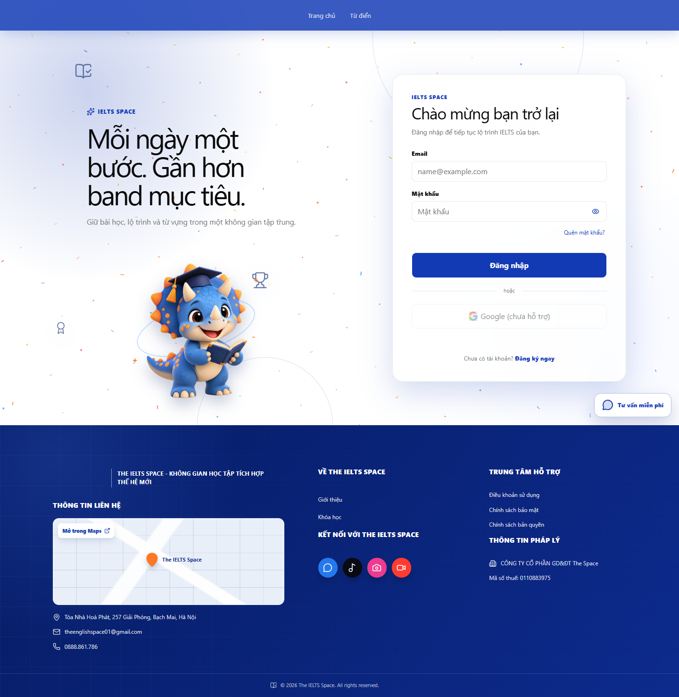
[P-01] — Populated (Desktop)
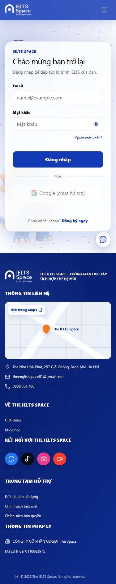
[P-01] — Populated (Mobile)

4.2 — Sign Up (P-02)
Page ID | P-02
Screen name | Sign Up
Design file | docs/sds-mockups/ (P-02__*.png)
SRS Feature | FT-AUTH (TBD)
SRS Scenario | SC-AUTH-02 (TBD)
Roles with access | Guest
Route | /register
Nav level | AUTH
Capture status | Captured (Desktop + Mobile)

Screen States
State | When It Appears | Design File Frame
Loading | Register request in flight | [P-02] — Loading
Empty | N/A | N/A
Populated — default | Registration form | Desktop: P-02__populated__desktop.png · Mobile: P-02__populated__mobile.png
Error | Validation / duplicate email | [P-02] — Error

Layout Description
┌──────────────────────────────────────┐
│ Auth card: fullName, email, password │
│ optional phone; CTA Create account │
│ Link: already have account → Sign in │
└──────────────────────────────────────┘
Zone descriptions:
Zone | Description
A | Title + helper copy
B | Registration fields
C | Primary Create account + status
D | Link to P-01

Key Interactions
User Action | What Happens | Notes
Submit valid | Account created; proceed to login / session per product rule | SRS TBD
Validation fail | Inline field errors
Sign in link | Navigate to P-01

Mobile exception (this screen)
Same as P-01 — single-column full-width card.

Mockup
Mockup / Wireframe — local FE captures
Folder: docs/sds-mockups/ · Base URL: http://localhost:5173
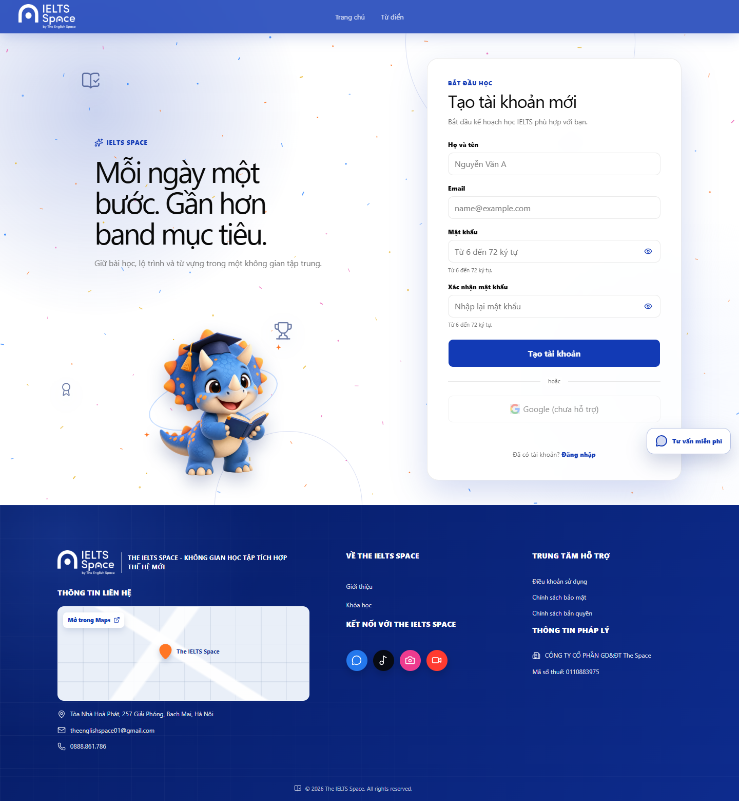
[P-02] — Populated (Desktop)
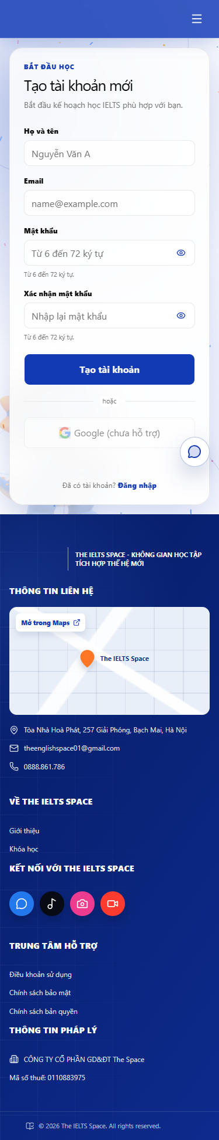
[P-02] — Populated (Mobile)

4.3 — Forgot Password (P-03)
Page ID | P-03
Screen name | Forgot Password
Design file | docs/sds-mockups/ (P-03__*.png)
SRS Feature | FT-AUTH (TBD)
SRS Scenario | SC-AUTH-03 (TBD)
Roles with access | Guest
Route | /forgot-password
Nav level | AUTH
Capture status | Captured (Desktop + Mobile)

Screen States
State | When It Appears | Design File Frame
Loading | Request submit in flight | [P-03] — Loading
Empty | N/A | N/A
Populated — default | Email request form | Desktop: P-03__populated__desktop.png · Mobile: P-03__populated__mobile.png
Error | Request failed | [P-03] — Error
Success | Generic confirmation shown | [P-03] — Success

Layout Description
┌──────────────────────────────────────┐
│ Title + email field + Submit │
│ Back to Sign in │
└──────────────────────────────────────┘
Zone descriptions:
Zone | Description
A | Heading + privacy-safe helper text
B | Email field + submit
C | Status message; link to P-01

Key Interactions
User Action | What Happens | Notes
Submit email | Show success/status (no account enumeration)
Back to Sign in | Navigate to P-01

Mockup
Mockup / Wireframe — local FE captures
Folder: docs/sds-mockups/ · Base URL: http://localhost:5173
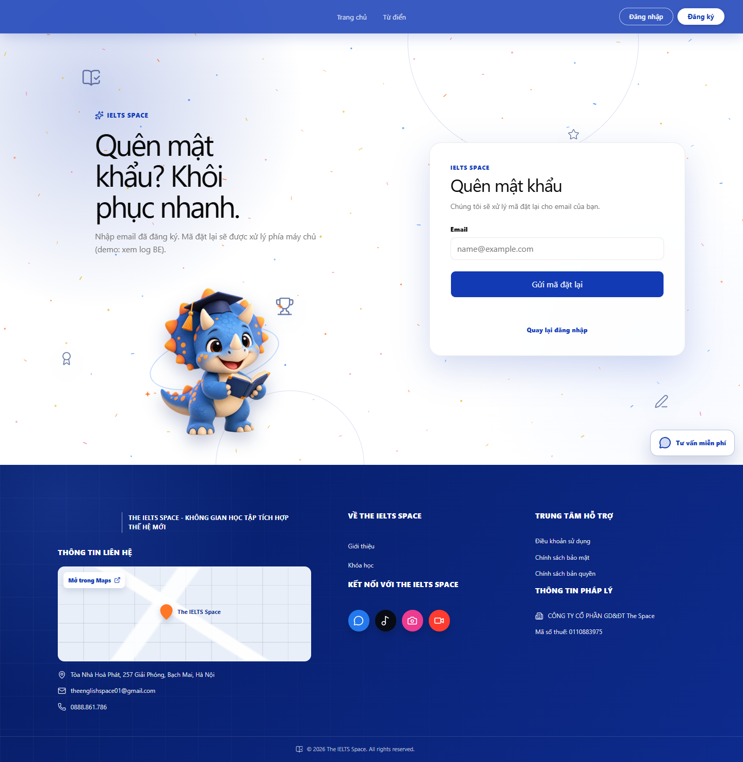
[P-03] — Populated (Desktop)
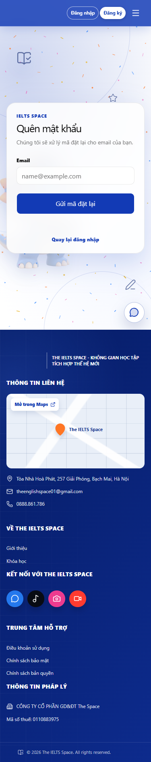
[P-03] — Populated (Mobile)

4.4 — Reset Password (P-04)
Page ID | P-04
Screen name | Reset Password
Design file | docs/sds-mockups/ (P-04__*.png)
SRS Feature | FT-AUTH (TBD)
SRS Scenario | SC-AUTH-04 (TBD)
Roles with access | Guest
Route | /reset-password
Nav level | AUTH
Capture status | Captured (Desktop + Mobile)

Screen States
State | When It Appears | Design File Frame
Loading | Token validate / submit | [P-04] — Loading
Empty | Missing/invalid token message | [P-04] — Invalid token
Populated — default | New password form | Desktop: P-04__populated__desktop.png · Mobile: P-04__populated__mobile.png
Error | Weak password / expired token | [P-04] — Error
Success | Password updated; prompt sign in | [P-04] — Success

Layout Description
┌──────────────────────────────────────┐
│ New password + confirm + Submit │
└──────────────────────────────────────┘
Zone descriptions:
Zone | Description
A | Heading
B | Password fields
C | Submit + status + link to P-01

Key Interactions
User Action | What Happens | Notes
Submit new password | On success → guide to P-01
Invalid token | Show recovery path to P-03

Mockup
Mockup / Wireframe — local FE captures
Folder: docs/sds-mockups/ · Base URL: http://localhost:5173
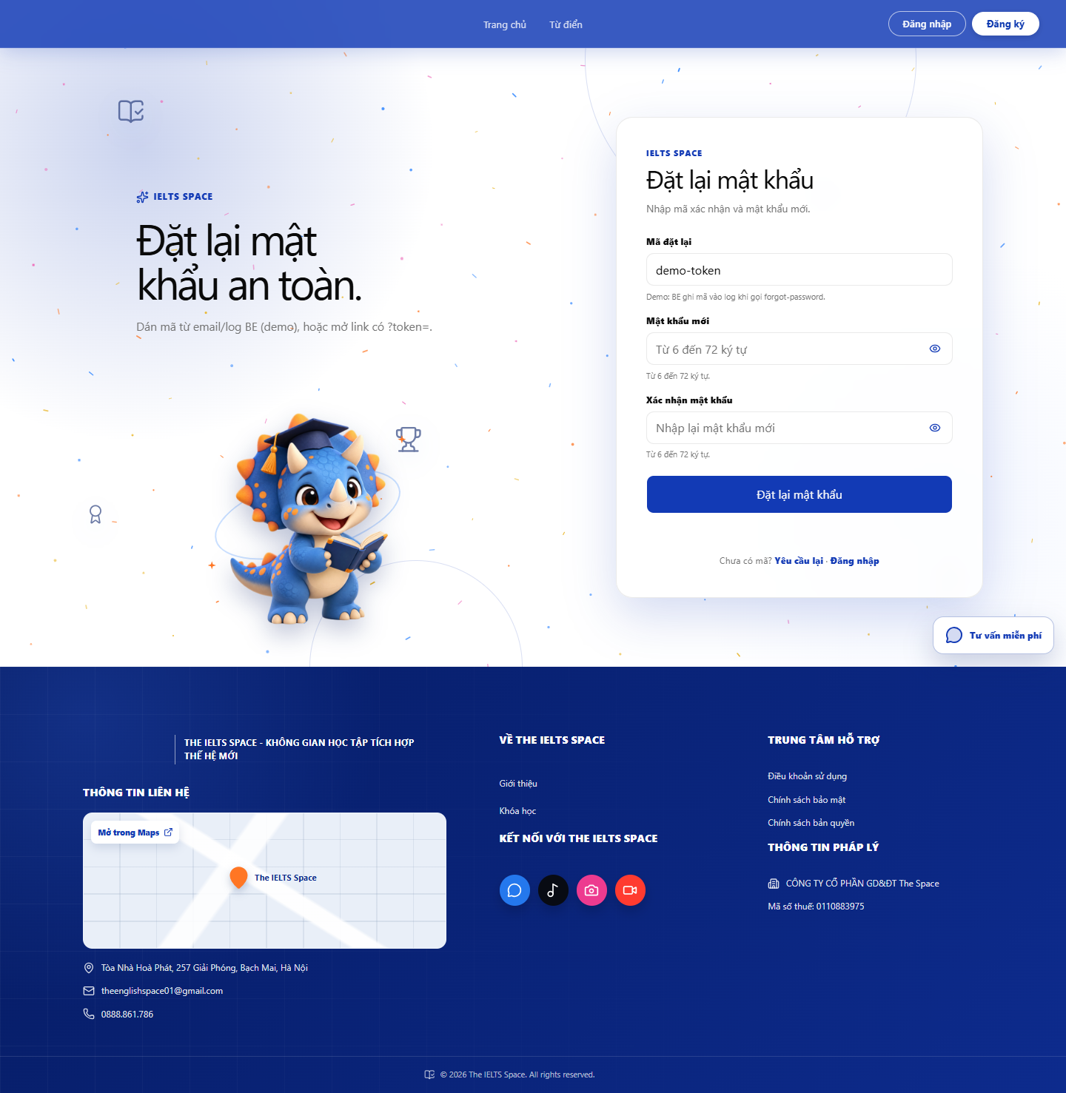
[P-04] — Populated (Desktop)
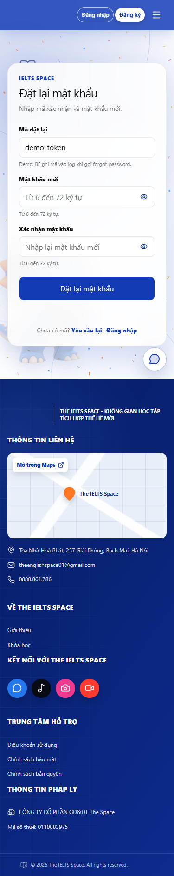
[P-04] — Populated (Mobile)

4.5 — Home / Landing (P-10)
Page ID | P-10
Screen name | Home / Landing
Design file | docs/sds-mockups/ (P-10__*.png)
SRS Feature | FT-HOME (TBD)
SRS Scenario | SC-HOME-01 (TBD)
Roles with access | Guest, Learner
Route | /home
Nav level | PRIMARY
Capture status | Captured (Desktop + Mobile)

Screen States
State | When It Appears | Design File Frame
Loading | N/A (static + local mock sections) | N/A
Empty | N/A | N/A
Populated — default | Hero + features + mentors + pricing | Desktop: P-10__populated__desktop.png · Mobile: P-10__populated__mobile.png
Error | N/A for MVP static home | N/A

Layout Description
┌──────────────────────────────────────┐
│ SiteNavbar │
├──────────────────────────────────────┤
│ Hero: headline + CTAs + skill icons │
│ Features grid │
│ Mentors (demo) + Pricing (demo) │
│ Footer │
└──────────────────────────────────────┘
Zone descriptions:
Zone | Description
A | Hero brand message + CTA to practice catalog / mentors
B | Feature cards linking Overview / Practice / Classroom
C | Mentor & pricing demo sections (Later modals P-10a/b)

Key Interactions
User Action | What Happens | Notes
Primary CTA | Navigate to P-41 Practice Catalog | May require auth downstream
Nav Sign in / Sign up | P-01 / P-02 | Guest
Feature card Practice | Navigate to P-41

Mobile exception (this screen)
Hero stacks single column; feature/mentor/pricing grids → 1 column; secondary hero CTA full-width.

Mockup
Mockup / Wireframe — local FE captures
Folder: docs/sds-mockups/ · Base URL: http://localhost:5173
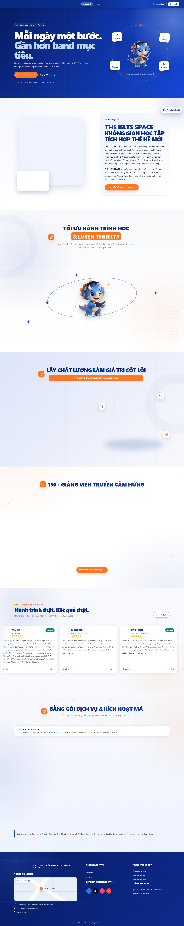
[P-10] — Populated (Desktop)
[P-10] — Populated (Mobile)

4.6 — Topic List (P-30)
Page ID | P-30
Screen name | Topic List
Design file | docs/sds-mockups/ (P-30__*.png)
SRS Feature | FT-LEARN (TBD)
SRS Scenario | SC-LEARN-01 (TBD)
Roles with access | Learner
Route | /learn
Nav level | PRIMARY
Capture status | Captured (Desktop + Mobile)

Screen States
State | When It Appears | Design File Frame
Loading | Fetching topics | [P-30] — Loading
Empty | No topics returned | [P-30] — Empty
Populated — default | Ordered topic trail/list | Desktop: P-30__populated__desktop.png · Mobile: P-30__populated__mobile.png
Error | Fetch failed | [P-30] — Error

Layout Description
┌──────────────────────────────────────┐
│ LearnLayout header / trail │
├──────────────────────────────────────┤
│ Topic nodes: status, name, progress │
│ LOCKED / IN_PROGRESS / PASSED │
└──────────────────────────────────────┘
Zone descriptions:
Zone | Description
A | Section title + points/status if shown
B | Topic list/trail with lock & premium cues
C | Retry on error

Key Interactions
User Action | What Happens | Notes
Open IN_PROGRESS/PASSED topic | Navigate to P-31
Tap LOCKED topic | No navigation; show locked affordance
Retry on error | Reload topics

Mockup
Mockup / Wireframe — local FE captures
Folder: docs/sds-mockups/ · Base URL: http://localhost:5173
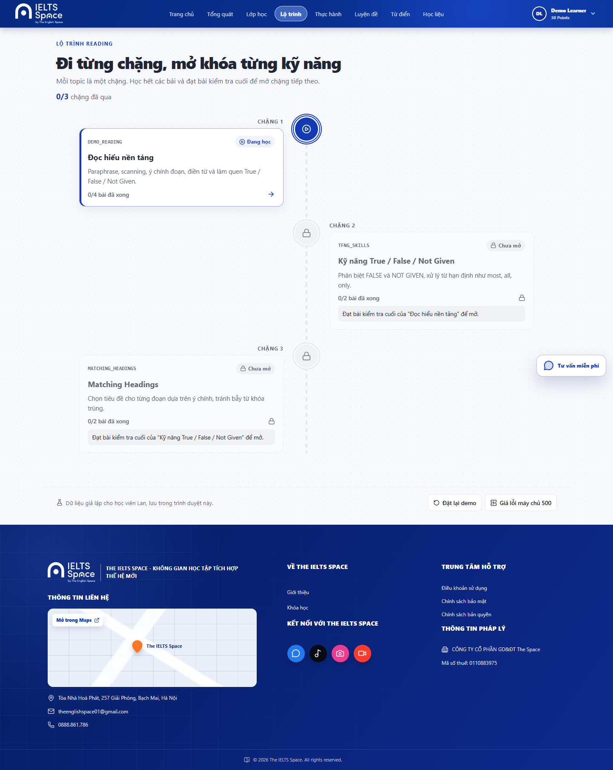
[P-30] — Populated (Desktop)
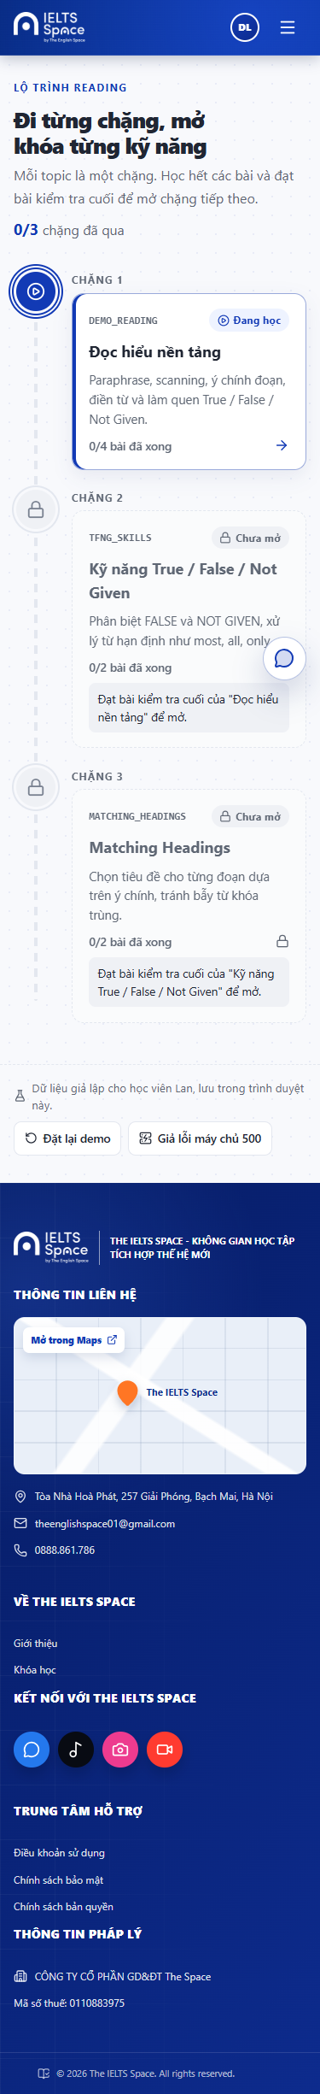
[P-30] — Populated (Mobile)

4.7 — Topic Detail (P-31)
Page ID | P-31
Screen name | Topic Detail
Design file | docs/sds-mockups/ (P-31__*.png)
SRS Feature | FT-LEARN (TBD)
SRS Scenario | SC-LEARN-02 (TBD)
Roles with access | Learner
Route | /learn/topics/:topicId
Nav level | SUB
Capture status | Captured (Desktop + Mobile)

Screen States
State | When It Appears | Design File Frame
Loading | Fetching lessons | [P-31] — Loading
Empty | Topic with no lessons | [P-31] — Empty
Populated — default | Lesson list + test gate | Desktop: P-31__populated__desktop.png · Mobile: P-31__populated__mobile.png
Error | TOPIC_LOCKED / fetch fail | [P-31] — Error
Gate | Review required banner | [P-31] — Review gate

Layout Description
┌──────────────────────────────────────┐
│ Topic title + back │
│ Optional ReviewGate banner │
│ Lessons: LOCKED/AVAILABLE/COMPLETED │
│ Final test CTA when AVAILABLE │
└──────────────────────────────────────┘
Zone descriptions:
Zone | Description
A | Topic header + back to P-30
B | Lesson rows with practice status
C | Topic test unlock / start

Key Interactions
User Action | What Happens | Notes
Open AVAILABLE/COMPLETED lesson | Navigate to P-32
Start topic test | Create attempt → P-35 | When testStatus=AVAILABLE
Open pending review | Navigate to P-34 | From gate banner

Mockup
Mockup / Wireframe — local FE captures
Folder: docs/sds-mockups/ · Base URL: http://localhost:5173
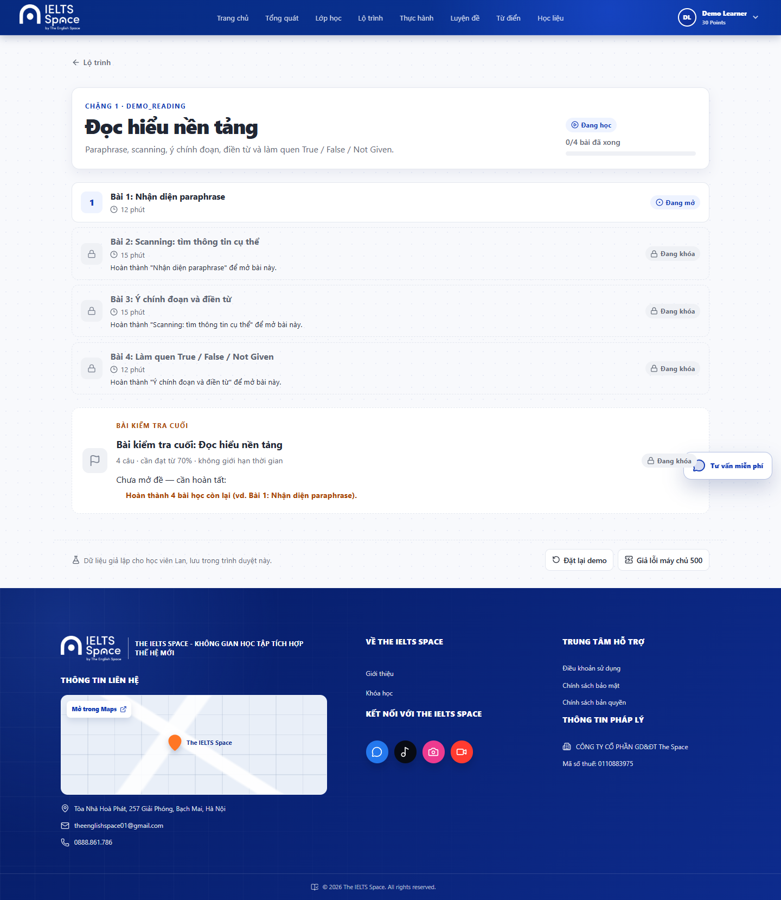
[P-31] — Populated (Desktop)
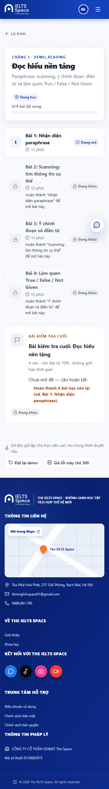
[P-31] — Populated (Mobile)

4.8 — Lesson Player (P-32)
Page ID | P-32
Screen name | Lesson Player
Design file | docs/sds-mockups/ (P-32__*.png)
SRS Feature | FT-LEARN (TBD)
SRS Scenario | SC-LEARN-03 (TBD)
Roles with access | Learner
Route | /learn/lessons/:lessonId
Nav level | DEEP
Capture status | Captured (Desktop + Mobile)

Screen States
State | When It Appears | Design File Frame
Loading | Fetching lesson blocks | [P-32] — Loading
Empty | N/A | N/A
Populated — default | Theory + exercises + essay blocks | Desktop: P-32__populated__desktop.png · Mobile: P-32__populated__mobile.png
Error | Fetch/submit fail; REVIEW_REQUIRED | [P-32] — Error
Completed | Lesson done → continue practice | [P-32] — Completed

Layout Description
┌──────────────────────────────────────┐
│ Lesson title + progress │
│ Content blocks (text/audio/questions)│
│ Exercise submit / Essay submit │
│ Footer: continue / practice CTA │
└──────────────────────────────────────┘
Zone descriptions:
Zone | Description
A | Header + back to topic
B | Scrollable lesson blocks
C | Block-level submit feedback
D | Post-complete CTA to P-33

Key Interactions
User Action | What Happens | Notes
Submit exercise block | Show correct/incorrect + hints
Submit essay | Spend points; show grading result | INSUFFICIENT_POINTS
Continue to practice | Navigate to P-33 | When lesson complete

Mobile exception (this screen)
Blocks stack full-width; audio controls sticky optional; long essay field expands vertically.

Mockup
Mockup / Wireframe — local FE captures
Folder: docs/sds-mockups/ · Base URL: http://localhost:5173
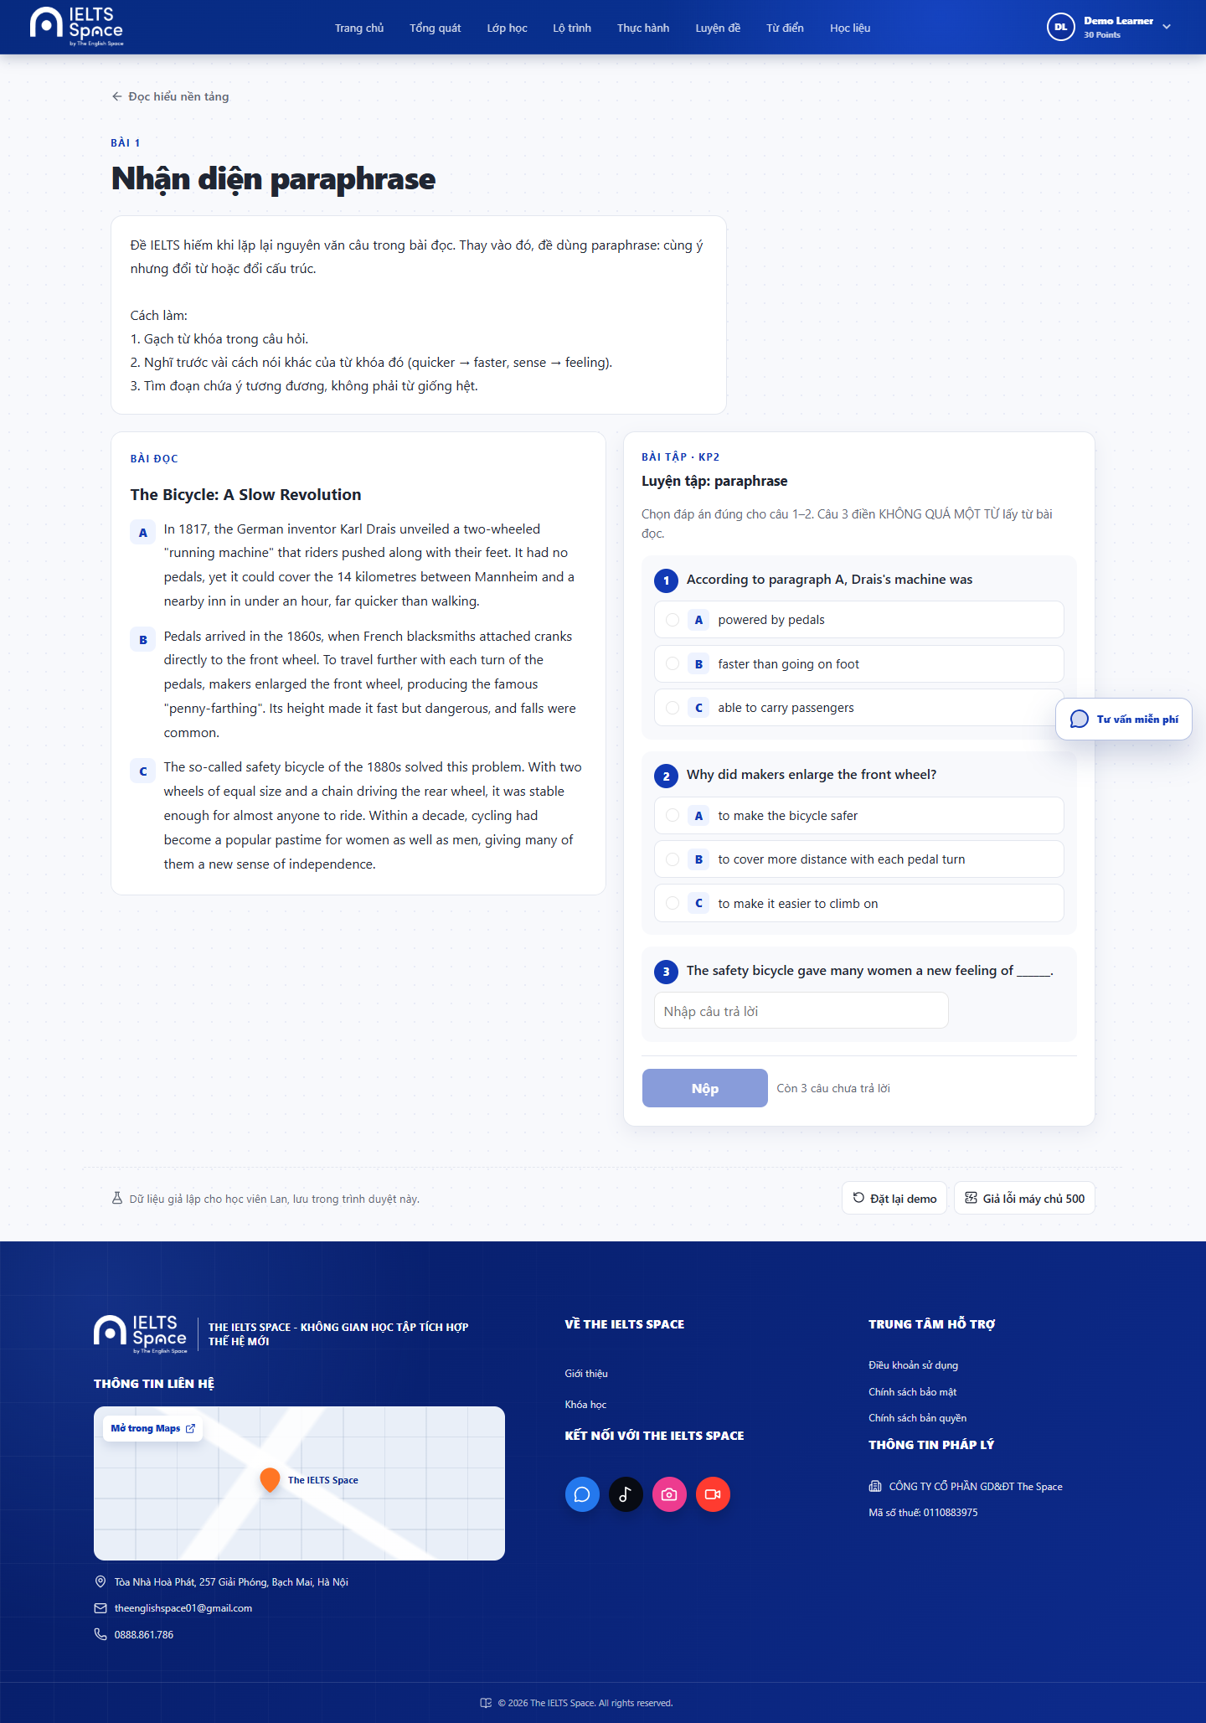
[P-32] — Populated (Desktop)
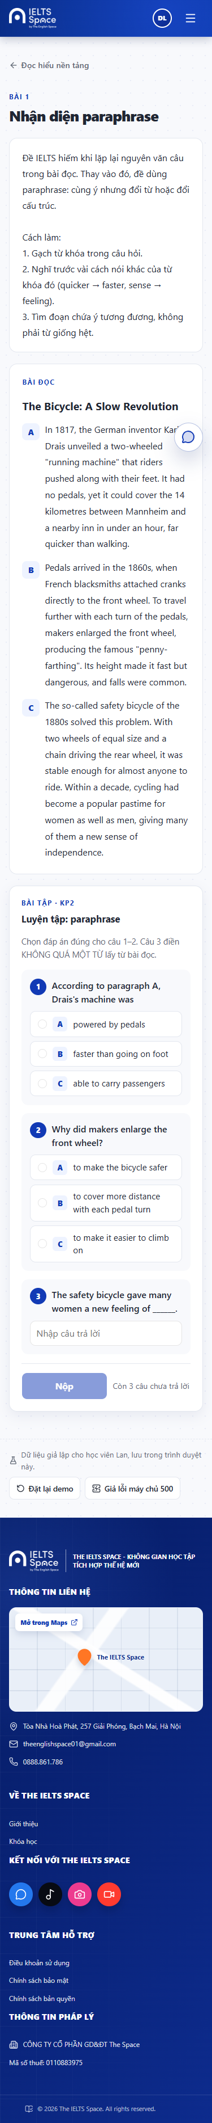
[P-32] — Populated (Mobile)

4.9 — Lesson Practice (P-33)
Page ID | P-33
Screen name | Lesson Practice
Design file | docs/sds-mockups/ (P-33__*.png)
SRS Feature | FT-LEARN (TBD)
SRS Scenario | SC-LEARN-04 (TBD)
Roles with access | Learner
Route | /learn/lessons/:lessonId/practice
Nav level | DEEP
Capture status | Captured (Desktop + Mobile)

Screen States
State | When It Appears | Design File Frame
Loading | Load practice sets / attempt | [P-33] — Loading
Empty | NO_PRACTICE / nothing required | [P-33] — Empty
Populated — default | Active attempt questions | Desktop: P-33__populated__desktop.png · Mobile: P-33__populated__mobile.png
Error | Submit/start fail | [P-33] — Error
Passed / Review created | Outcome + next step | [P-33] — Outcome

Layout Description
┌──────────────────────────────────────┐
│ Practice set selector / progress │
│ Question list + submit │
│ Result panel + continue to topic │
└──────────────────────────────────────┘
Zone descriptions:
Zone | Description
A | Header + set status
B | Questions + answers
C | Submit + outcome (pass reason / review link)

Key Interactions
User Action | What Happens | Notes
Start / continue attempt | Load questions
Submit answers | Score + reveal per rules; may create review → P-34
Back to topic | Navigate to P-31

Mockup
Mockup / Wireframe — local FE captures
Folder: docs/sds-mockups/ · Base URL: http://localhost:5173
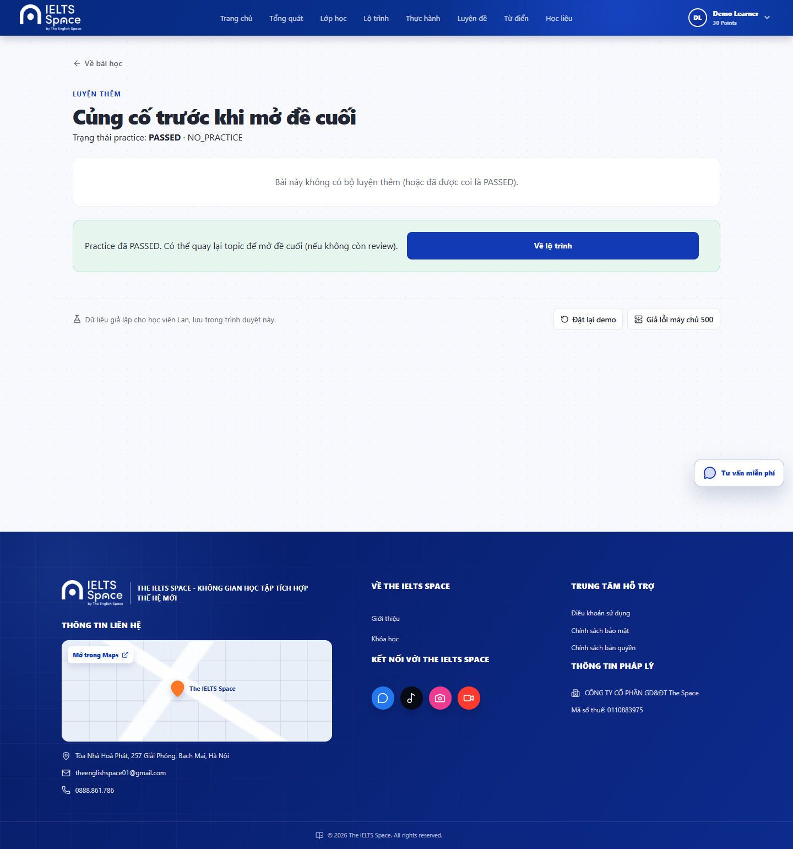
[P-33] — Populated (Desktop)
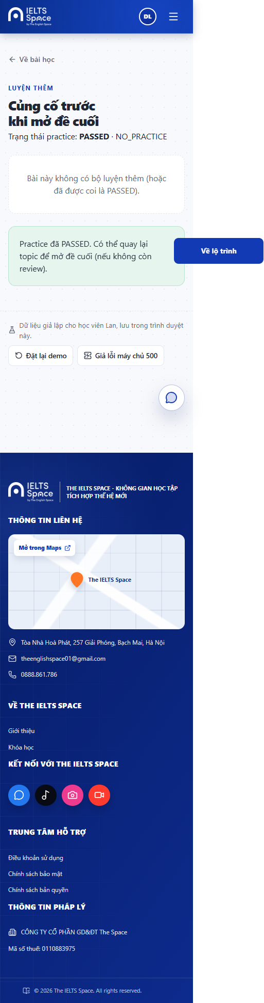
[P-33] — Populated (Mobile)

4.10 — Review Session (P-34)
Page ID | P-34
Screen name | Review Session
Design file | docs/sds-mockups/ (P-34__*.png)
SRS Feature | FT-LEARN (TBD)
SRS Scenario | SC-LEARN-05 (TBD)
Roles with access | Learner
Route | /learn/reviews/:reviewId
Nav level | DEEP
Capture status | Blocked — see Mockup

Screen States
State | When It Appears | Design File Frame
Loading | Load review pack | [P-34] — Loading
Empty | N/A | N/A
Populated — default | Practice-set review or theory+quick-check | Desktop: Blocked — not captured · Mobile: Blocked — not captured
Error | Fetch/submit fail | [P-34] — Error
Finished | Review cleared; return to topic | [P-34] — Finished

Layout Description
┌──────────────────────────────────────┐
│ Review stage banner │
│ Questions / theory + quick check │
│ Submit / finish │
└──────────────────────────────────────┘
Zone descriptions:
Zone | Description
A | Stage indicator (THEORY vs PRACTICE_SET)
B | Review content
C | Submit + return CTA to P-31

Key Interactions
User Action | What Happens | Notes
Submit review set | Update mastery gate; unlock lesson path
Finish / return | Navigate to P-31

Mockup
Mockup / Wireframe — local FE captures
Folder: docs/sds-mockups/ · Base URL: http://localhost:5173
Blocked — fresh demo has no reviewId. Mock learning starts with an empty review list; opening P-34 would require completing lessons first. No screenshot was invented.

4.11 — Topic Test (P-35)
Page ID | P-35
Screen name | Topic Test
Design file | docs/sds-mockups/ (P-35__*.png)
SRS Feature | FT-LEARN (TBD)
SRS Scenario | SC-LEARN-06 (TBD)
Roles with access | Learner
Route | /learn/tests/:attemptId
Nav level | DEEP
Capture status | Partial / Blocked — see Mockup

Screen States
State | When It Appears | Design File Frame
Loading | Load attempt structure | [P-35] — Loading
Empty | N/A | N/A
Populated — default | Timed/untimed question run | Desktop: Blocked — not captured · Mobile: Blocked — not captured
Error | Save/submit fail | [P-35] — Error
Confirm submit | Unanswered warning | [P-35] — Confirm

Layout Description
┌──────────────────────────────────────┐
│ Progress / unanswered count │
│ Question stem + options/inputs │
│ Nav prev/next + Submit │
└──────────────────────────────────────┘
Zone descriptions:
Zone | Description
A | Attempt header
B | Current question workspace
C | Navigation + submit with confirm

Key Interactions
User Action | What Happens | Notes
Answer + navigate | Persist answer locally/API
First submit with blanks | Confirm warning
Confirm submit | Grade → navigate to P-36

Mobile exception (this screen)
Question nav collapses to compact pager; submit bar sticky bottom.

Mockup
Mockup / Wireframe — local FE captures
Folder: docs/sds-mockups/ · Base URL: http://localhost:5173
Blocked — topic test LOCKED on the fresh demo. Topic DEMO_READING still needs 4 lessons before the final test opens, so P-35 was not captured.

4.12 — Topic Test Result (P-36)
Page ID | P-36
Screen name | Topic Test Result
Design file | docs/sds-mockups/ (P-36__*.png)
SRS Feature | FT-LEARN (TBD)
SRS Scenario | SC-LEARN-07 (TBD)
Roles with access | Learner
Route | /learn/tests/:attemptId/result
Nav level | DEEP
Capture status | Partial / Blocked — see Mockup

Screen States
State | When It Appears | Design File Frame
Loading | Load result / topics for next | [P-36] — Loading
Empty | N/A | N/A
Populated — passed | Score ≥ pass threshold | Desktop: Blocked — not captured · Mobile: Blocked — not captured
Populated — failed | Score below threshold; answers may hide | Desktop: Blocked — not captured · Mobile: Blocked — not captured
Error | Result fetch fail | [P-36] — Error

Layout Description
┌──────────────────────────────────────┐
│ Score dial + pass/fail │
│ Per-question summary │
│ CTA: back to topics / retry policy │
└──────────────────────────────────────┘
Zone descriptions:
Zone | Description
A | Score + outcome
B | Item review (correct answers gated if failed)
C | Navigation to P-30 / P-31

Key Interactions
User Action | What Happens | Notes
Return to topics | Navigate to P-30
Open next topic if unlocked | Navigate to P-31 | Derived from topic list
Retry per policy | New attempt flow if allowed | SRS TBD

Mockup
Mockup / Wireframe — local FE captures
Folder: docs/sds-mockups/ · Base URL: http://localhost:5173
Blocked — topic test LOCKED on the fresh demo. No attempt was started and no result screen exists, so P-36 was not captured.

4.13 — Practice Catalog (P-41)
Page ID | P-41
Screen name | Practice Catalog
Design file | docs/sds-mockups/ (P-41__*.png)
SRS Feature | FT-PRACTICE (TBD)
SRS Scenario | SC-PRACTICE-01 (TBD)
Roles with access | Learner
Route | /practice-tests
Nav level | PRIMARY
Capture status | Captured (Desktop + Mobile)

Screen States
State | When It Appears | Design File Frame
Loading | Catalog load | [P-41] — Loading
Empty | No tests available | [P-41] — Empty
Populated — default | Skill cards grid | Desktop: P-41__populated__desktop.png · Mobile: P-41__populated__mobile.png
Error | Fetch fail | [P-41] — Error

Layout Description
┌──────────────────────────────────────┐
│ PracticeNavbar │
│ Filters / skill tabs (if any) │
│ Test cards grid │
└──────────────────────────────────────┘
Zone descriptions:
Zone | Description
A | Page heading
B | Catalog cards (skill, title, meta)
C | Opens P-41a on card select

Key Interactions
User Action | What Happens | Notes
Select a test card | Open P-41a mode modal
Retry on error | Reload catalog

Mobile exception (this screen)
Card grid → 1 column; navbar compact.

Mockup
Mockup / Wireframe — local FE captures
Folder: docs/sds-mockups/ · Base URL: http://localhost:5173
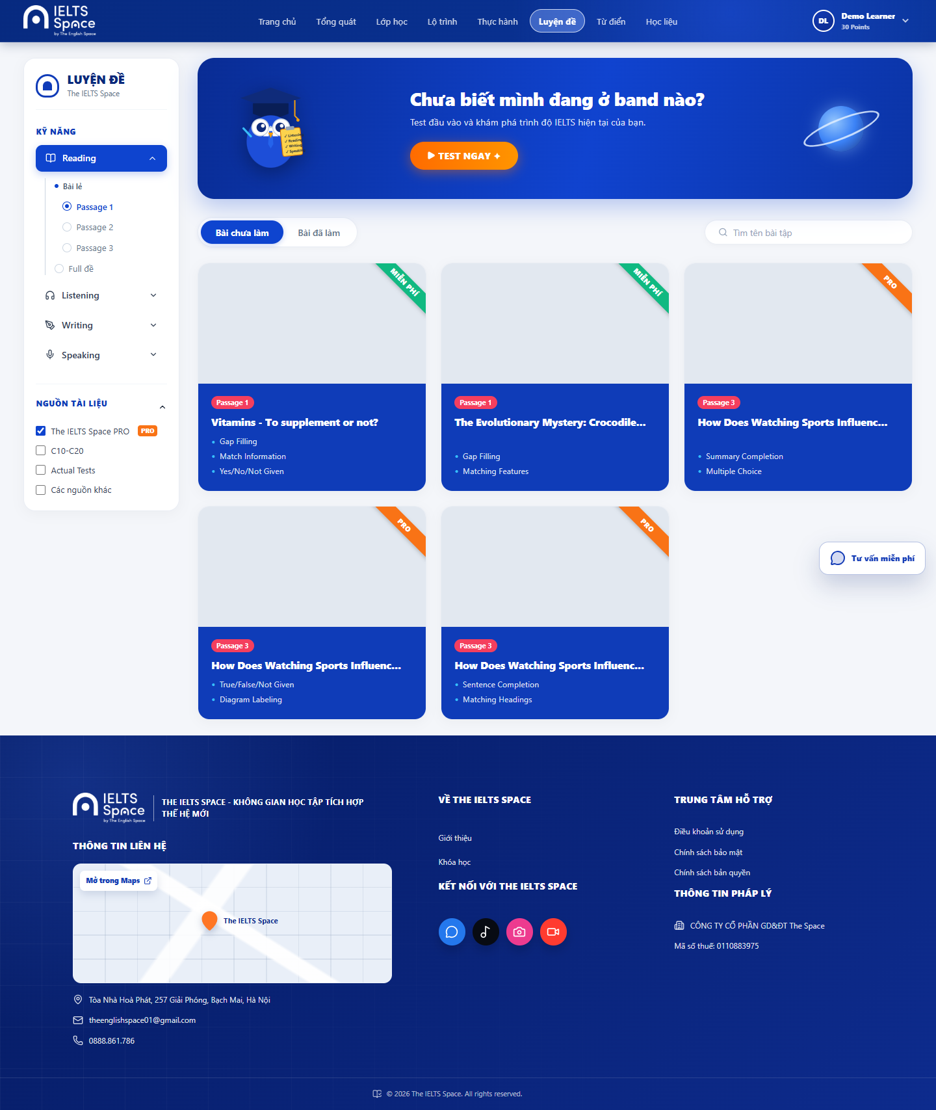
[P-41] — Populated (Desktop)
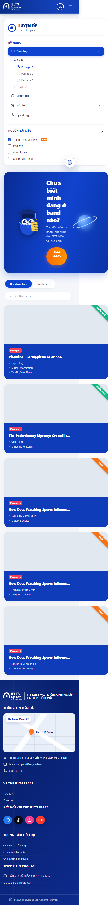
[P-41] — Populated (Mobile)

4.14 — Practice Mode Select (P-41a)
Page ID | P-41a
Screen name | Practice Mode Select
Design file | docs/sds-mockups/ (P-41a__*.png)
SRS Feature | FT-PRACTICE (TBD)
SRS Scenario | SC-PRACTICE-01 (TBD)
Roles with access | Learner
Route | Modal on P-41
Nav level | MODAL
Capture status | Captured (Desktop + Mobile)

Screen States
State | When It Appears | Design File Frame
Loading | N/A | N/A
Empty | N/A | N/A
Populated — default | Mode choices for selected card | Desktop: P-41a__populated__desktop.png · Mobile: P-41a__populated__mobile.png
Error | N/A | N/A

Layout Description
┌──────────────────────────────────────┐
│ Dialog: test title │
│ Mode options (e.g. practice/exam) │
│ Confirm → skill workspace │
└──────────────────────────────────────┘
Zone descriptions:
Zone | Description
A | Title + short description
B | Mode radio/cards
C | Start / Cancel

Key Interactions
User Action | What Happens | Notes
Choose mode + Start | Navigate to P-42 / P-43 / P-44 / P-45 by skill | Reading→P-42
Cancel / close | Stay on P-41

Mockup
Mockup / Wireframe — local FE captures
Folder: docs/sds-mockups/ · Base URL: http://localhost:5173
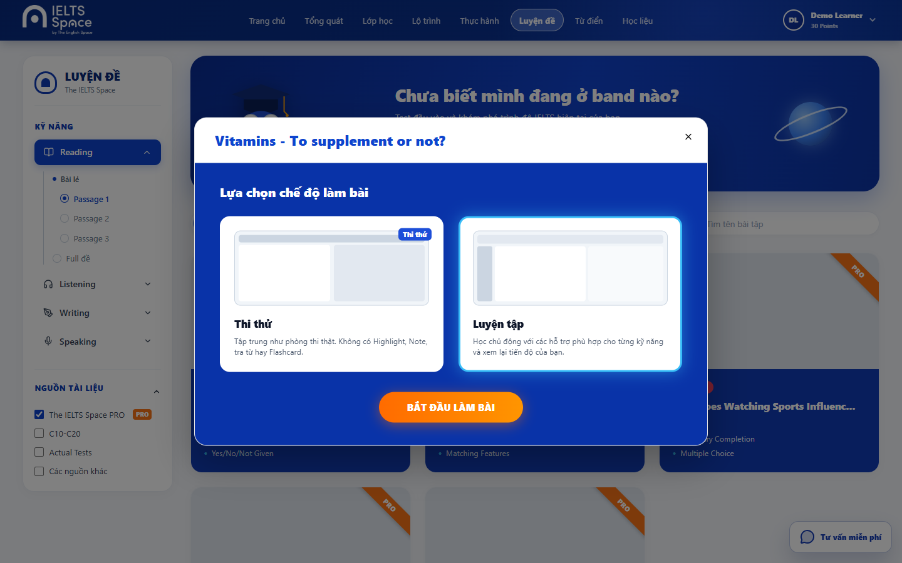
[P-41a] — Populated (Desktop)
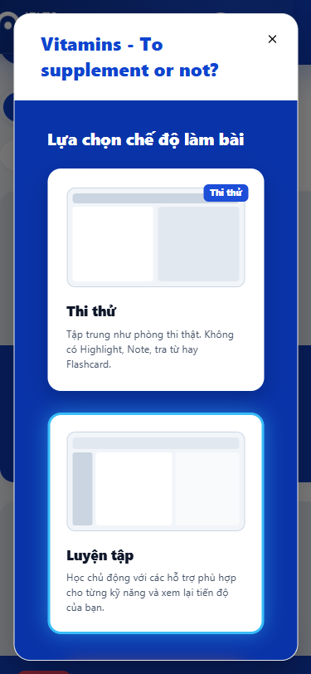
[P-41a] — Populated (Mobile)

4.15 — Reading Practice Test (P-42)
Page ID | P-42
Screen name | Reading Practice Test
Design file | docs/sds-mockups/ (P-42__*.png)
SRS Feature | FT-PRACTICE (TBD)
SRS Scenario | SC-PRACTICE-02 (TBD)
Roles with access | Learner
Route | /practice/test/:testId
Nav level | DEEP
Capture status | Captured (Desktop + Mobile)

Screen States
State | When It Appears | Design File Frame
Loading | Load passage/questions | [P-42] — Loading
Empty | N/A | N/A
Populated — default | Split passage + answers | Desktop: P-42__populated__desktop.png · Mobile: P-42__populated__mobile.png
Error | Submit/load fail | [P-42] — Error

Layout Description
┌──────────────────────────────────────┐
│ Practice subbar (timer/settings/exit)│
├───────────────┬──────────────────────┤
│ Passage │ Questions / answers │
│ highlight │ │
└───────────────┴──────────────────────┘
Zone descriptions:
Zone | Description
A | Subbar: exit → P-41, settings, timer
B | Passage with selection tools
C | Question panel
D | Modals P-42a / P-42b

Key Interactions
User Action | What Happens | Notes
Answer questions | Update local answer map
Select text → Flashcard | Open P-42a
Dictionary lookup | Open P-42b
Exit | Return to P-41

Mobile exception (this screen)
Passage and questions stack vertically (tabs or accordion); no persistent side-by-side split.

Mockup
Mockup / Wireframe — local FE captures
Folder: docs/sds-mockups/ · Base URL: http://localhost:5173
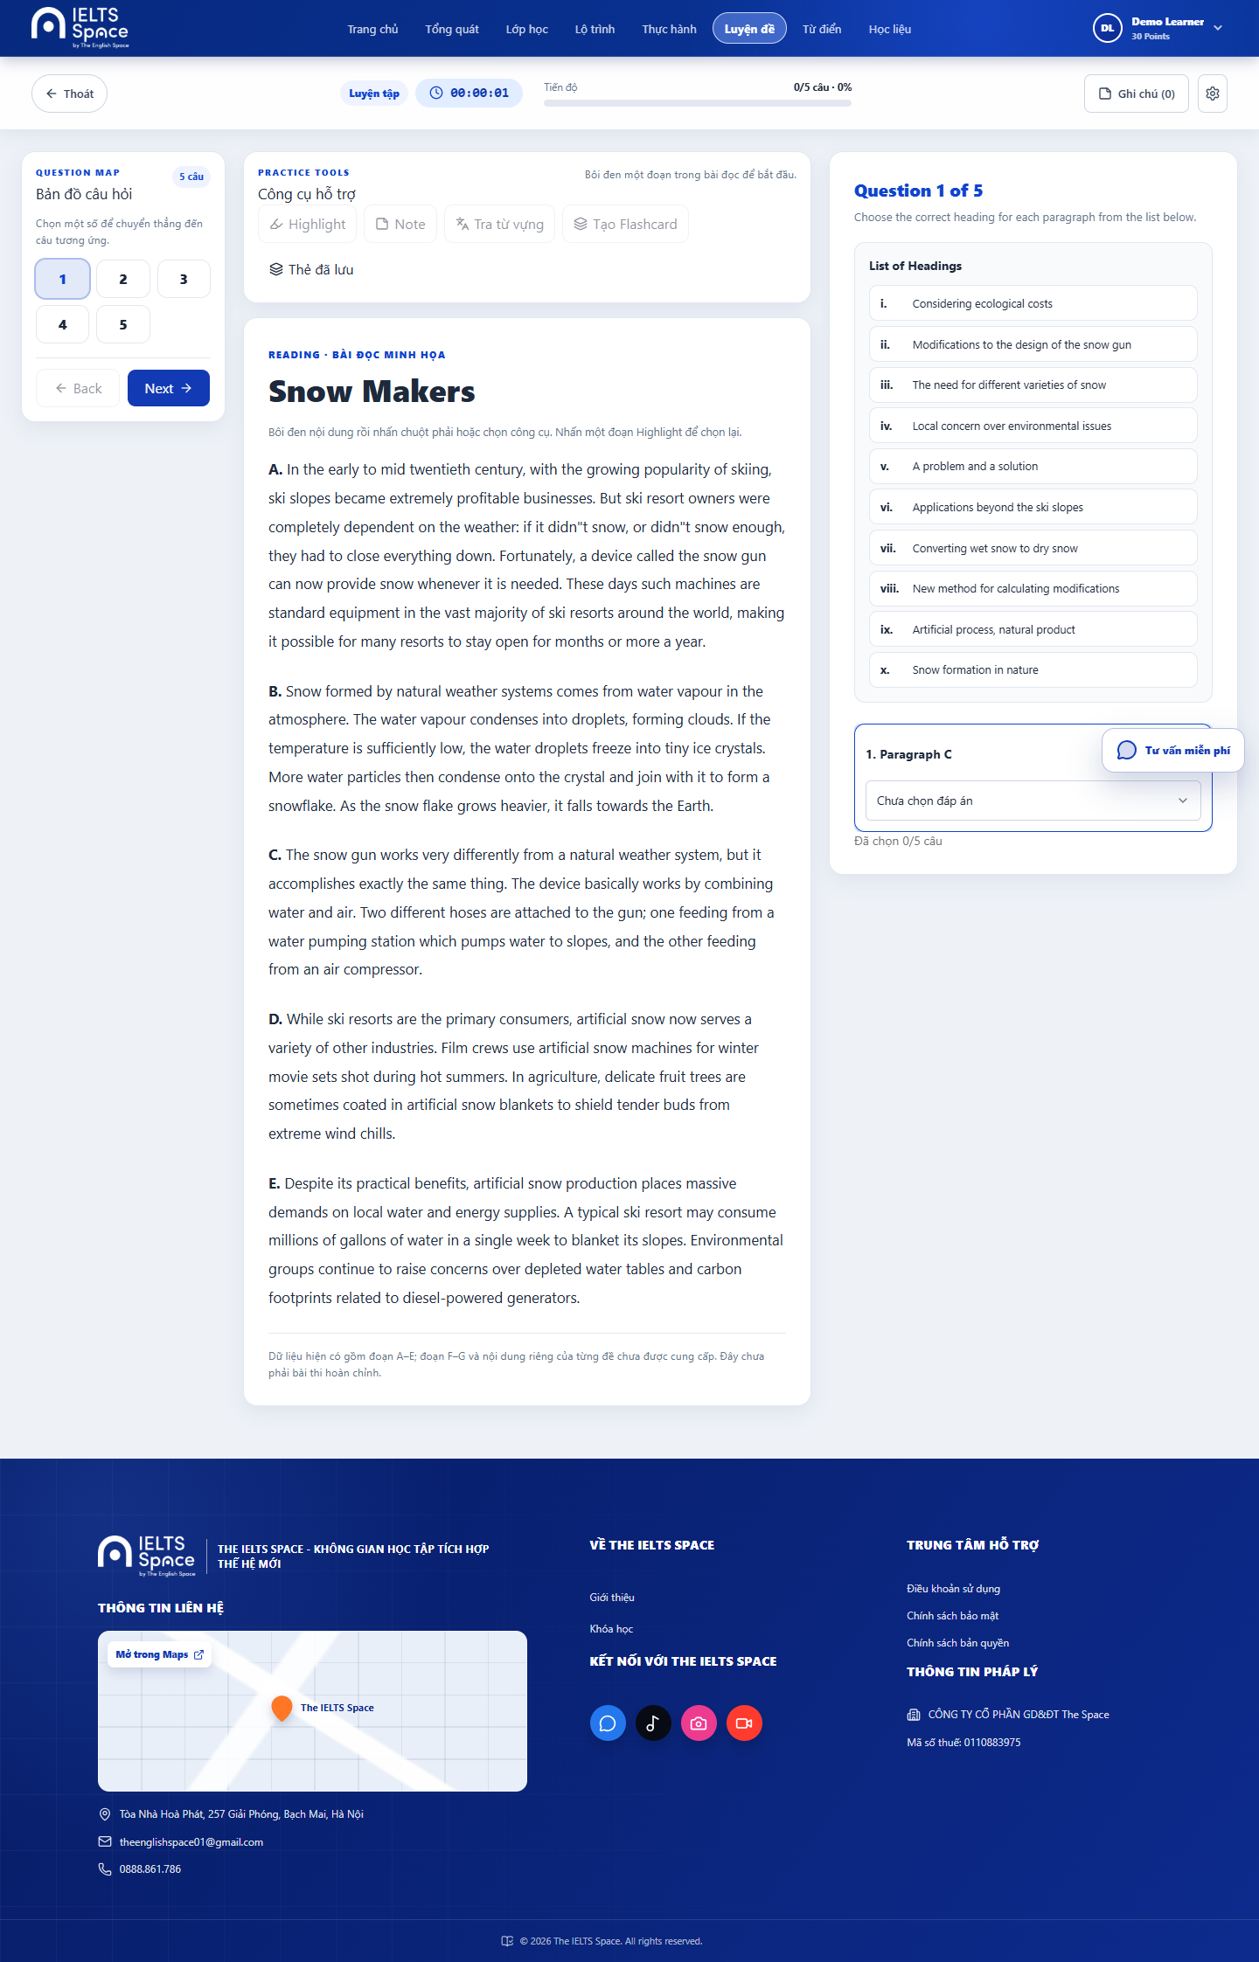
[P-42] — Populated (Desktop)
[P-42] — Populated (Mobile)

4.16 — Create Flashcard (P-42a)
Page ID | P-42a
Screen name | Create Flashcard
Design file | docs/sds-mockups/ (P-42a__*.png)
SRS Feature | FT-PRACTICE (TBD)
SRS Scenario | SC-PRACTICE-02 (TBD)
Roles with access | Learner
Route | Modal on P-42
Nav level | MODAL
Capture status | Captured (Desktop + Mobile)

Screen States
State | When It Appears | Design File Frame
Loading | Saving card | [P-42a] — Loading
Empty | N/A | N/A
Populated — default | Word/meaning/example form | Desktop: P-42a__populated__desktop.png · Mobile: P-42a__populated__mobile.png
Error | Validation / save fail | [P-42a] — Error

Layout Description
Dialog: word, meaning, example, optional image, Save / Cancel
Zone descriptions:
Zone | Description
A | Prefilled selected text
B | Editable fields
C | Save (local) / Close

Key Interactions
User Action | What Happens | Notes
Save | Persist locally; toast on P-42 | Not account-synced
Close | Dismiss modal

Mockup
Mockup / Wireframe — local FE captures
Folder: docs/sds-mockups/ · Base URL: http://localhost:5173
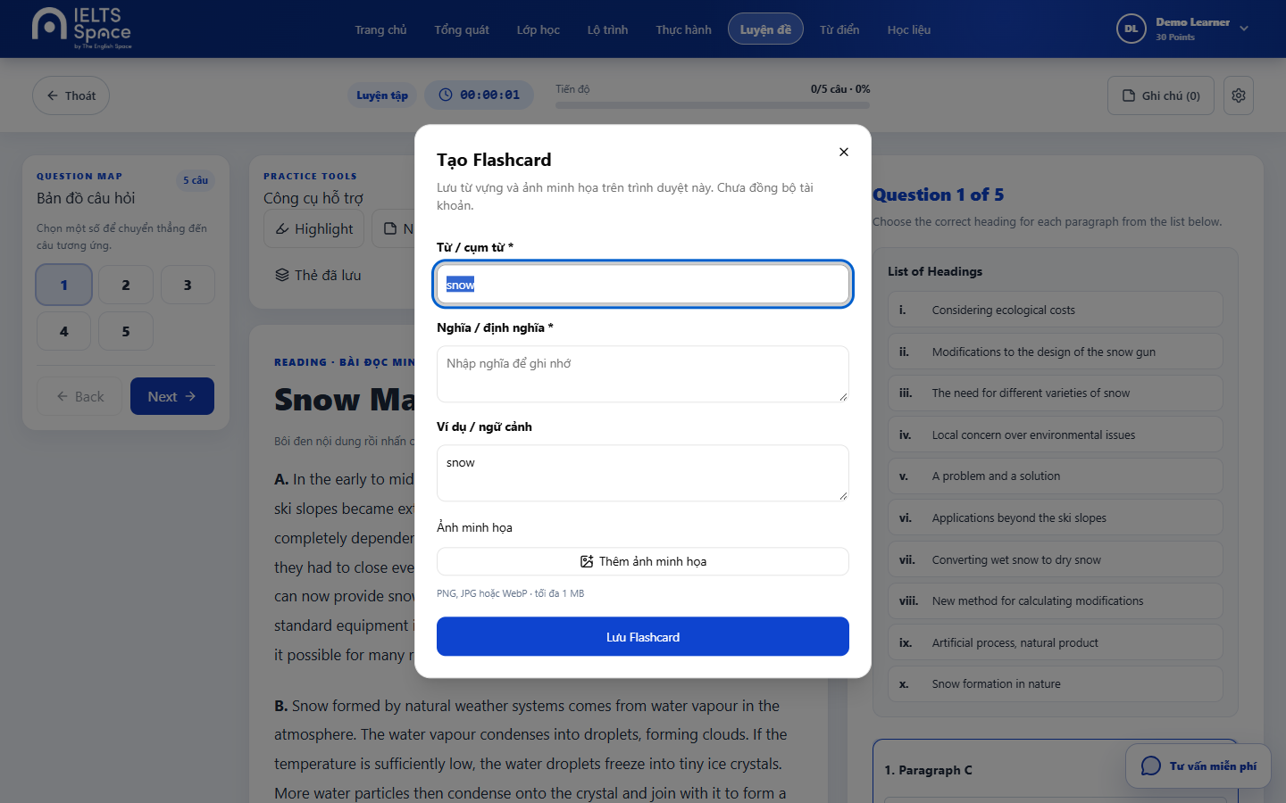
[P-42a] — Populated (Desktop)
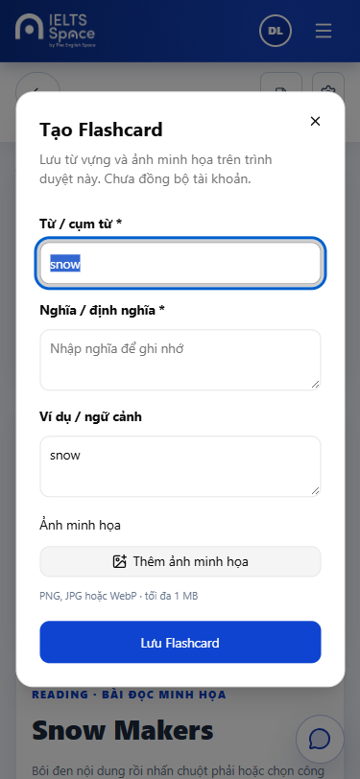
[P-42a] — Populated (Mobile)

4.17 — Dictionary Lookup (P-42b)
Page ID | P-42b
Screen name | Dictionary Lookup
Design file | docs/sds-mockups/ (P-42b__*.png)
SRS Feature | FT-PRACTICE (TBD)
SRS Scenario | SC-PRACTICE-02 (TBD)
Roles with access | Learner
Route | Modal on P-42
Nav level | MODAL
Capture status | Captured (Desktop + Mobile)

Screen States
State | When It Appears | Design File Frame
Loading | Lookup in progress | [P-42b] — Loading
Empty | No definition found | [P-42b] — Empty
Populated — default | Definition shown | Desktop: P-42b__populated__desktop.png · Mobile: P-42b__populated__mobile.png
Error | Lookup fail | [P-42b] — Error

Layout Description
Dialog: selected term + definition / close
Zone descriptions:
Zone | Description
A | Term
B | Definition body
C | Close

Key Interactions
User Action | What Happens | Notes
Close | Return to P-42

Mockup
Mockup / Wireframe — local FE captures
Folder: docs/sds-mockups/ · Base URL: http://localhost:5173
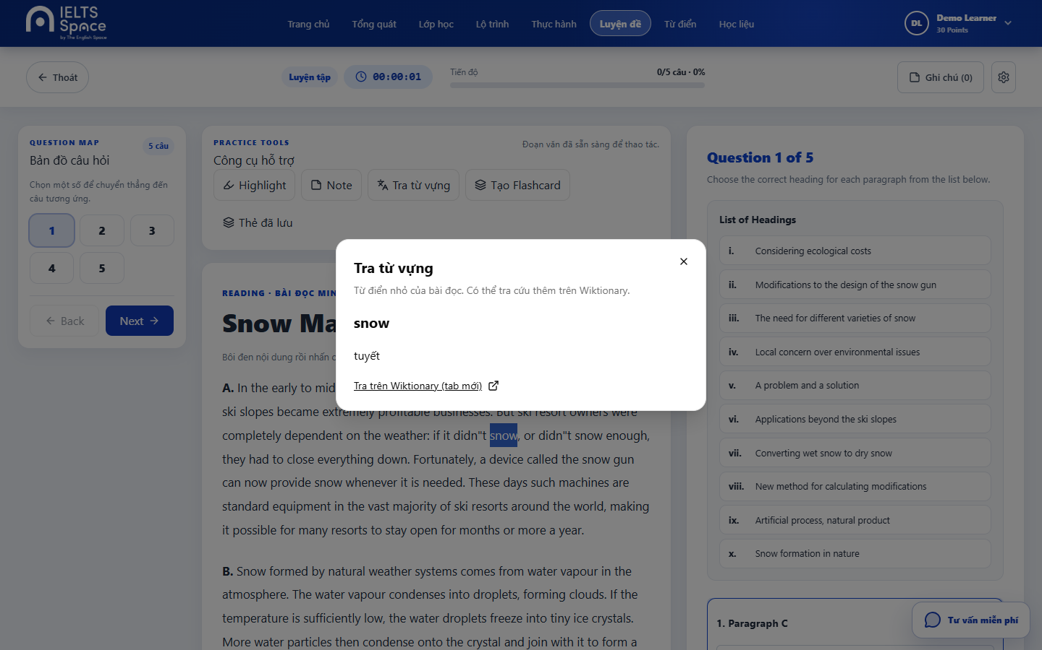
[P-42b] — Populated (Desktop)
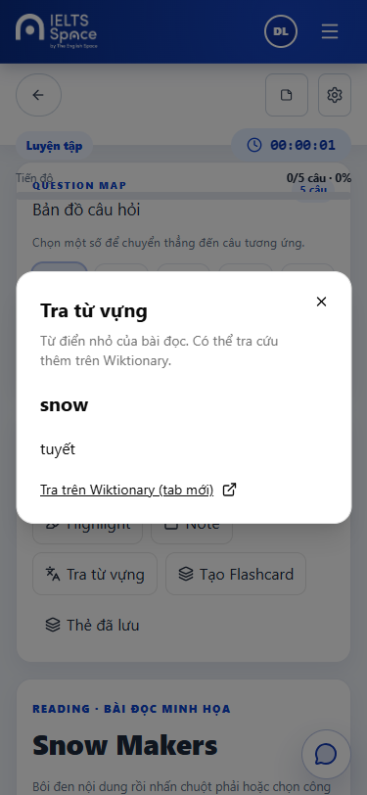
[P-42b] — Populated (Mobile)

4.18 — Listening Practice (P-43)
Page ID | P-43
Screen name | Listening Practice
Design file | docs/sds-mockups/ (P-43__*.png)
SRS Feature | FT-PRACTICE (TBD)
SRS Scenario | SC-PRACTICE-03 (TBD)
Roles with access | Learner
Route | /practice/listening/:testId
Nav level | DEEP
Capture status | Captured (Desktop + Mobile)

Screen States
State | When It Appears | Design File Frame
Loading | Load audio + questions | [P-43] — Loading
Empty | N/A | N/A
Populated — default | Player + question map | Desktop: P-43__populated__desktop.png · Mobile: P-43__populated__mobile.png
Error | Audio/load fail | [P-43] — Error

Layout Description
┌──────────────────────────────────────┐
│ Instruction + audio player │
│ Question map synced to cues │
│ Answer inputs + exit │
└──────────────────────────────────────┘
Zone descriptions:
Zone | Description
A | Audio controls + time
B | Question list / map
C | Exit → P-41

Key Interactions
User Action | What Happens | Notes
Play/seek audio | Update active cue/question
Answer question | Store response
Exit | Return to P-41

Mobile exception (this screen)
Player sticky top; question map scrolls below.

Mockup
Mockup / Wireframe — local FE captures
Folder: docs/sds-mockups/ · Base URL: http://localhost:5173
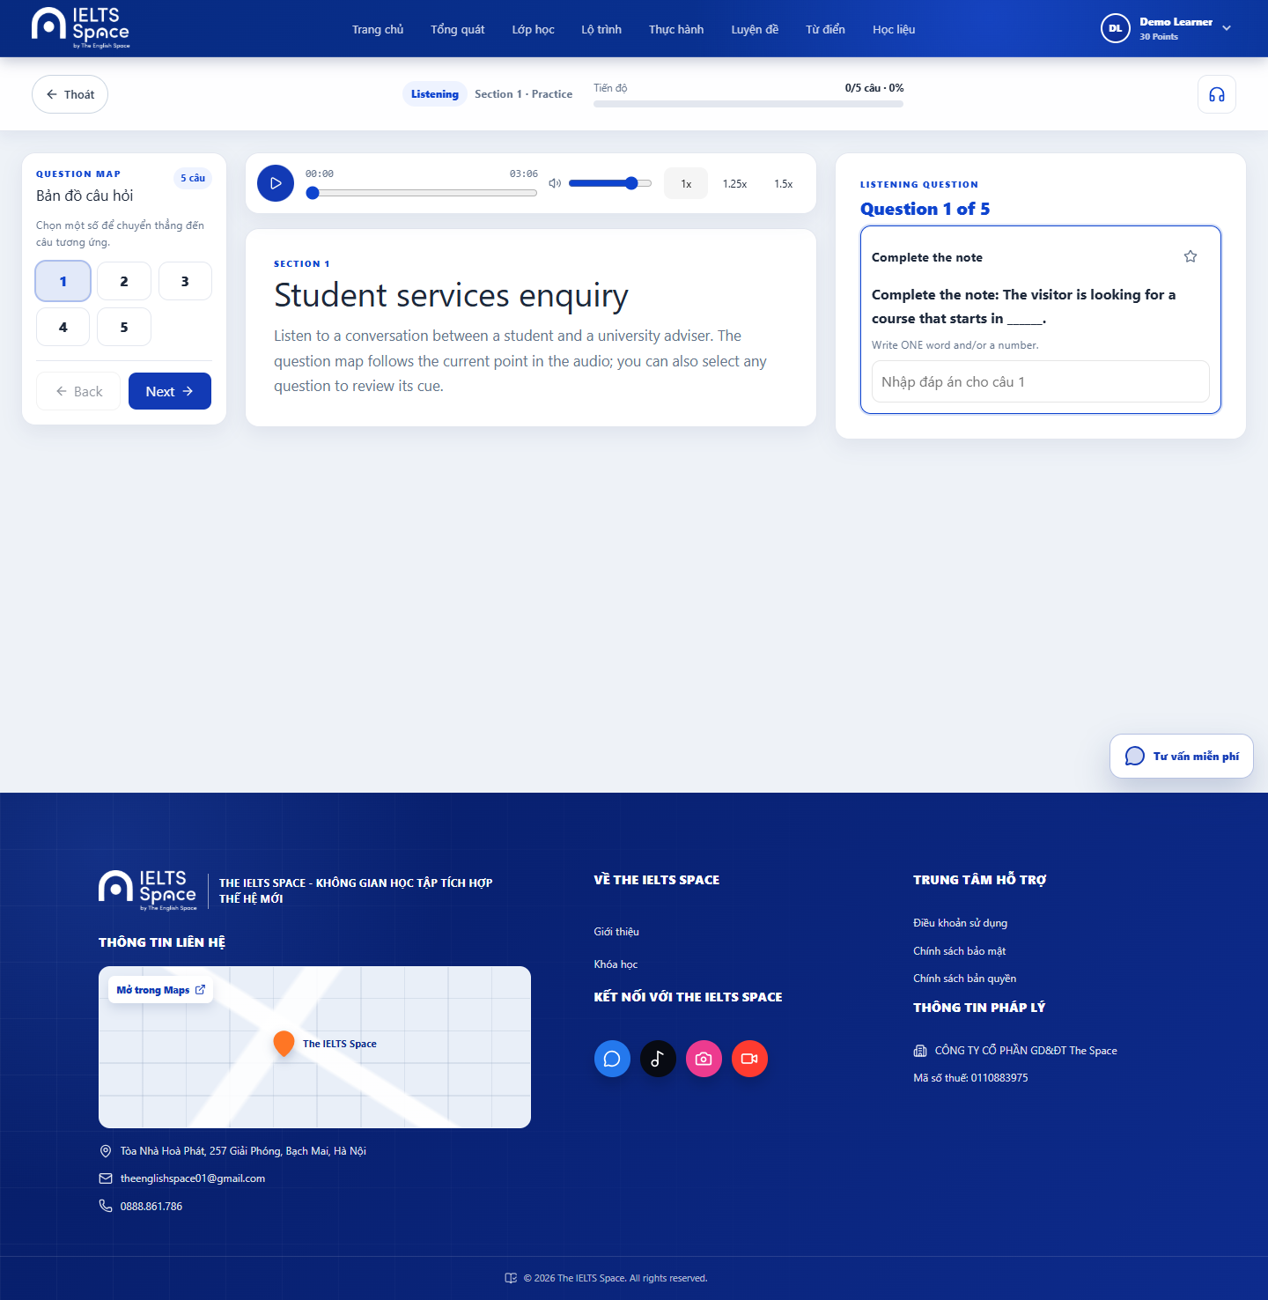
[P-43] — Populated (Desktop)
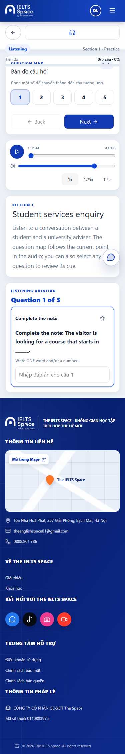
[P-43] — Populated (Mobile)

4.19 — Writing Practice (P-44)
Page ID | P-44
Screen name | Writing Practice
Design file | docs/sds-mockups/ (P-44__*.png)
SRS Feature | FT-PRACTICE (TBD)
SRS Scenario | SC-PRACTICE-04 (TBD)
Roles with access | Learner
Route | /practice/writing/:taskId
Nav level | DEEP
Capture status | Captured (Desktop + Mobile)

Screen States
State | When It Appears | Design File Frame
Loading | Load task | [P-44] — Loading
Empty | N/A | N/A
Populated — default | Prompt + editor + word count | Desktop: P-44__populated__desktop.png · Mobile: P-44__populated__mobile.png
Error | Submit/load fail | [P-44] — Error

Layout Description
┌──────────────────────────────────────┐
│ Task prompt + chart thumbnail │
│ Essay textarea + word counter │
│ Submit / Exit │
└──────────────────────────────────────┘
Zone descriptions:
Zone | Description
A | Prompt + visual (opens P-44a)
B | Writing surface + counter
C | Actions → P-41 on exit

Key Interactions
User Action | What Happens | Notes
Zoom chart | Open P-44a
Type essay | Update word count
Exit | Return to P-41

Mobile exception (this screen)
Prompt above editor (no split); chart zoom opens full-screen dialog.

Mockup
Mockup / Wireframe — local FE captures
Folder: docs/sds-mockups/ · Base URL: http://localhost:5173
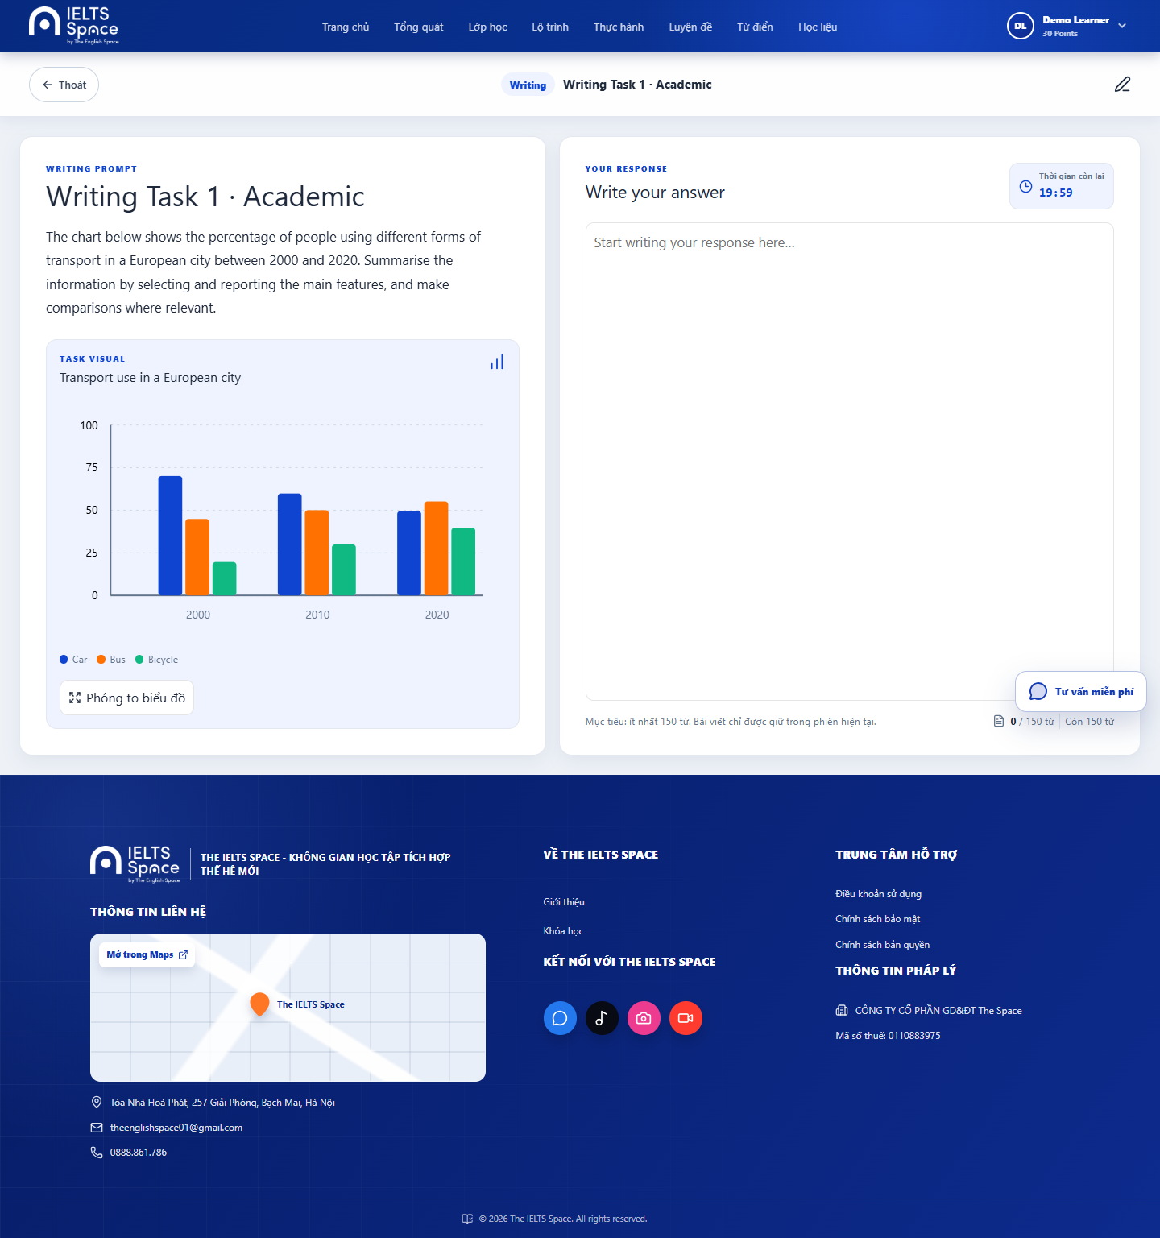
[P-44] — Populated (Desktop)
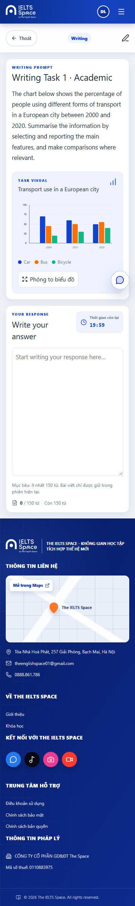
[P-44] — Populated (Mobile)

4.20 — Writing Chart Zoom (P-44a)
Page ID | P-44a
Screen name | Writing Chart Zoom
Design file | docs/sds-mockups/ (P-44a__*.png)
SRS Feature | FT-PRACTICE (TBD)
SRS Scenario | SC-PRACTICE-04 (TBD)
Roles with access | Learner
Route | Modal on P-44
Nav level | MODAL
Capture status | Captured (Desktop + Mobile)

Screen States
State | When It Appears | Design File Frame
Loading | N/A | N/A
Empty | N/A | N/A
Populated — default | Enlarged chart | Desktop: P-44a__populated__desktop.png · Mobile: P-44a__populated__mobile.png
Error | N/A | N/A

Layout Description
Dialog: large chart + close
Zone descriptions:
Zone | Description
A | Chart visual
B | Close control

Key Interactions
User Action | What Happens | Notes
Close | Return to P-44

Mockup
Mockup / Wireframe — local FE captures
Folder: docs/sds-mockups/ · Base URL: http://localhost:5173
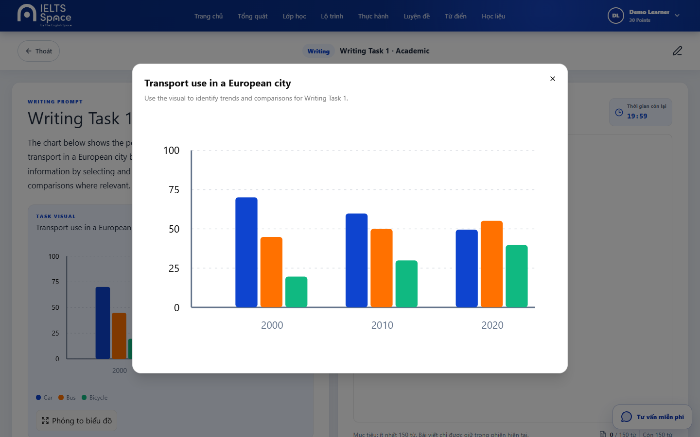
[P-44a] — Populated (Desktop)
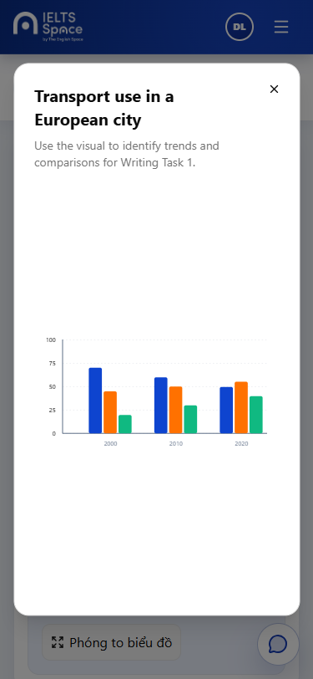
[P-44a] — Populated (Mobile)

4.21 — Not Found (P-90)
Page ID | P-90
Screen name | Not Found
Design file | docs/sds-mockups/ (P-90__*.png)
SRS Feature | —
SRS Scenario | —
Roles with access | Guest, Learner
Route | *
Nav level | DEEP
Capture status | Captured (Desktop + Mobile)

Screen States
State | When It Appears | Design File Frame
Loading | N/A | N/A
Empty | N/A | N/A
Populated — default | 404 message + path | Desktop: P-90__populated__desktop.png · Mobile: P-90__populated__mobile.png
Error | N/A | N/A

Layout Description
Centered panel: 404 title, pathname, CTA to Overview/Home
Zone descriptions:
Zone | Description
A | Message
B | Primary recovery link

Key Interactions
User Action | What Happens | Notes
Go to Overview | Navigate /overview (auth) or /home

Mockup
Mockup / Wireframe — local FE captures
Folder: docs/sds-mockups/ · Base URL: http://localhost:5173
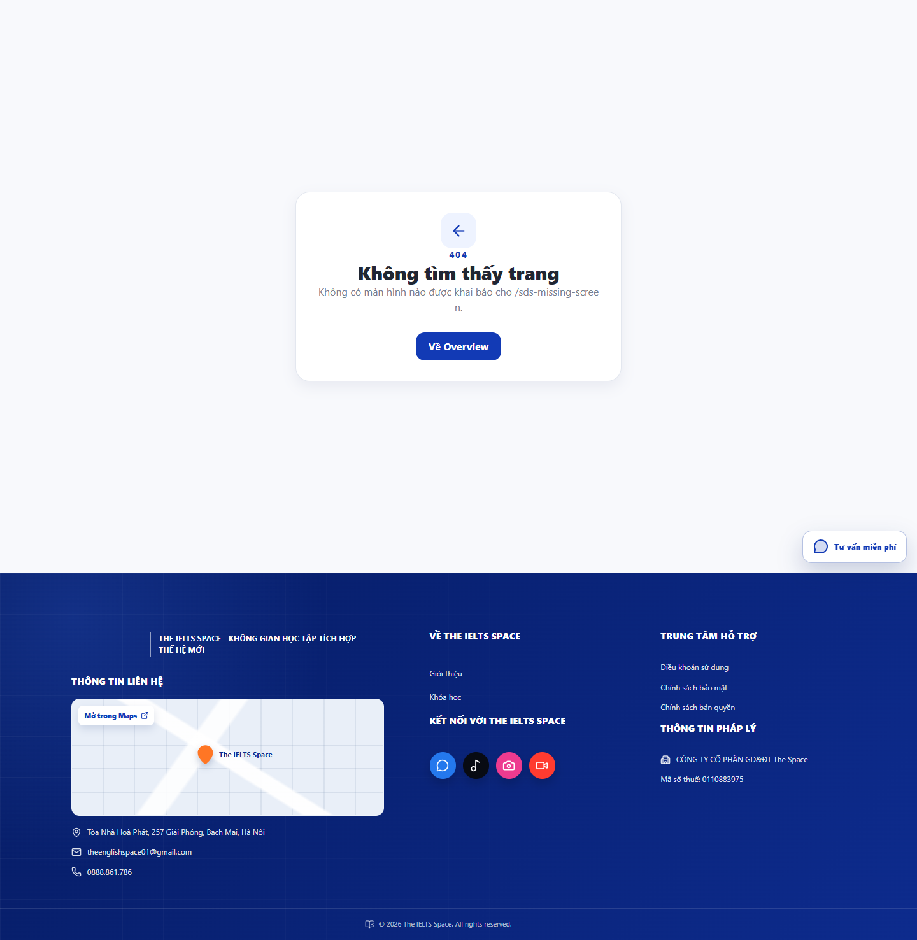
[P-90] — Populated (Desktop)
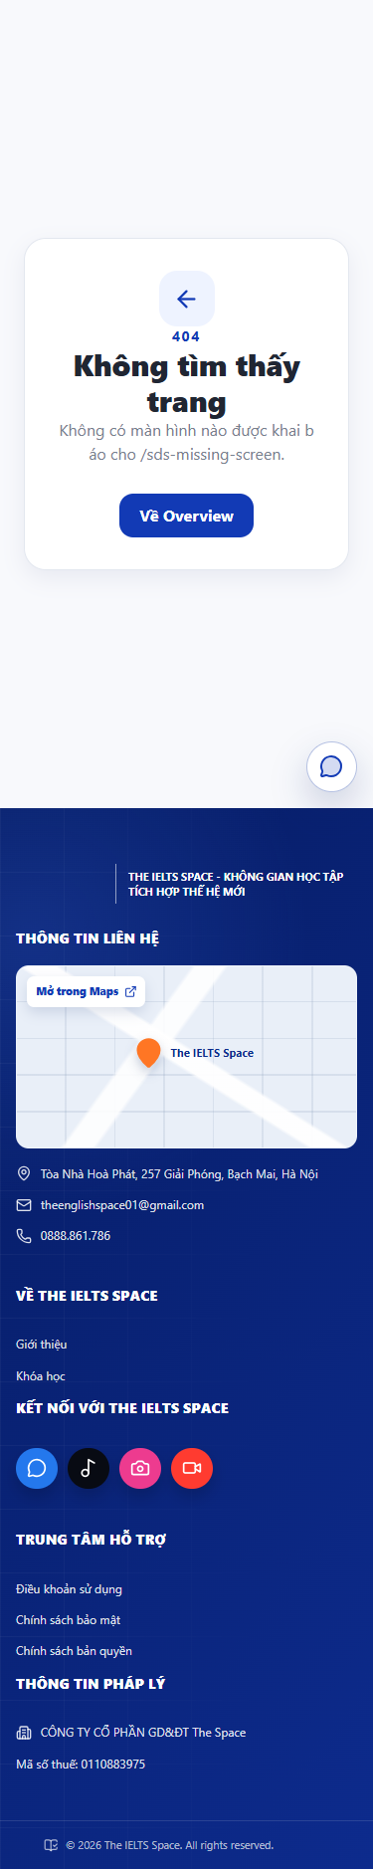
[P-90] — Populated (Mobile)

Part 5 — Responsive Rules
Global rules for all screens. Screen-specific mobile exceptions are recorded in Part 4 only.

5.1 Navigation
Breakpoint | Behaviour
Desktop (≥ 1025px) | Full top navbar; all labels visible; shell max ~1440px
Tablet (768–1024px) | Nav links may collapse (~≤1100px CSS); hamburger opens panel
Mobile (< 768px) | Hamburger overlay drawer; compact auth actions

5.2 Content Layout
Breakpoint | Layout Behaviour
Desktop | Multi-column grids (practice catalog 2–3 col; reading split pane); side-by-side forms where designed
Tablet | 2-column grids; reading may retain split or soften; tables/cards reduce columns
Mobile | Single column throughout; auth card full width; practice workspaces stack

5.3 Data Tables
Pattern A — Horizontal scroll: keep columns; sticky first column when 5+ columns. Use for dense score/item review tables.
Pattern B — Card reflow: each row becomes a card showing 3–4 key fields. Prefer for entity lists (topics, catalog cards already use cards).
MVP screens primarily use cards/lists rather than wide data tables; choose Pattern B for any future tabular topic/test history.

5.4 Typography Scaling
Breakpoint | Heading Adjustment
Desktop | Full type scale as Part 1.3
Tablet | heading-1 may reduce toward heading-2 size; body unchanged
Mobile | heading-1 → ~24px; heading-2 → ~20px; body sizes unchanged

5.5 Touch Targets (Mobile)
Element | Visual Size | Minimum Touch Target
Primary buttons | Design spec | 44px height minimum
Icon-only buttons | ~24px icon | 44×44px tap area via padding
Checkboxes / radio | ~18px | 44×44px tap area
Navigation items (drawer) | variable | 48px height minimum
List/card row | variable | Full row tappable; 48px min height

Appendix A — Screen Index & Design File

A.1 Screen Index
1:1 with Site Map §2.2. Spec Section = Part 4 heading for MVP; Deferred = Later / not in this Phase B pass.
Page ID | Screen Name | SRS Feature | Flow(s) | Spec Section | Design Frame | Status
P-01 | Sign In | FT-AUTH | F-01, F-04 | 4.1 | P-01__populated__desktop.png / P-01__populated__mobile.png | Captured
P-02 | Sign Up | FT-AUTH | F-01, F-04 | 4.2 | P-02__populated__desktop.png / P-02__populated__mobile.png | Captured
P-03 | Forgot Password | FT-AUTH | F-01 | 4.3 | P-03__populated__desktop.png / P-03__populated__mobile.png | Captured
P-04 | Reset Password | FT-AUTH | F-01 | 4.4 | P-04__populated__desktop.png / P-04__populated__mobile.png | Captured
P-05 | OAuth Callback | FT-AUTH | F-01 | Deferred | [P-05] OAuth Callback | Later
P-10 | Home / Landing | FT-HOME | F-04, F-01 | 4.5 | P-10__populated__desktop.png / P-10__populated__mobile.png | Captured
P-10a | Mentor Detail | FT-HOME | — | Deferred | [P-10a] Mentor Detail | Later
P-10b | Plan Detail | FT-HOME | — | Deferred | [P-10b] Plan Detail | Later
P-11 | Overview Dashboard | FT-OVERVIEW | — | Deferred | [P-11] Overview | Later*
P-20 | My Classroom | FT-CLASS | — | Deferred | [P-20] Classroom | Later*
P-20a | Lesson Detail | FT-CLASS | — | Deferred | [P-20a] Lesson Detail | Later
P-21 | Lesson Workspace | FT-CLASS | — | Deferred | [P-21] Lesson Workspace | Later*
P-22 | Join Live Class | FT-CLASS | — | Deferred | [P-22] Join Class | Later
P-23 | Contact Mentor | FT-CLASS | — | Deferred | [P-23] Mentor | Later
P-30 | Topic List | FT-LEARN | F-02 | 4.6 | P-30__populated__desktop.png / P-30__populated__mobile.png | Captured
P-31 | Topic Detail | FT-LEARN | F-02 | 4.7 | P-31__populated__desktop.png / P-31__populated__mobile.png | Captured
P-32 | Lesson Player | FT-LEARN | F-02 | 4.8 | P-32__populated__desktop.png / P-32__populated__mobile.png | Captured
P-33 | Lesson Practice | FT-LEARN | F-02 | 4.9 | P-33__populated__desktop.png / P-33__populated__mobile.png | Captured
P-34 | Review Session | FT-LEARN | F-02 | 4.10 | P-34__populated__desktop.png / P-34__populated__mobile.png | Blocked — no review in fresh demo
P-35 | Topic Test | FT-LEARN | F-02 | 4.11 | P-35__populated__desktop.png / P-35__populated__mobile.png | Blocked — topic test LOCKED
P-36 | Topic Test Result | FT-LEARN | F-02 | 4.12 | P-36__populated__desktop.png / P-36__populated__mobile.png | Blocked — topic test LOCKED
P-40 | Practice Hub | FT-PRACTICE | F-03 | Deferred | [P-40] Practice Hub | Later
P-41 | Practice Catalog | FT-PRACTICE | F-03 | 4.13 | P-41__populated__desktop.png / P-41__populated__mobile.png | Captured
P-41a | Practice Mode Select | FT-PRACTICE | F-03 | 4.14 | P-41a__populated__desktop.png / P-41a__populated__mobile.png | Captured
P-42 | Reading Practice Test | FT-PRACTICE | F-03 | 4.15 | P-42__populated__desktop.png / P-42__populated__mobile.png | Captured
P-42a | Create Flashcard | FT-PRACTICE | F-03 | 4.16 | P-42a__populated__desktop.png / P-42a__populated__mobile.png | Captured
P-42b | Dictionary Lookup | FT-PRACTICE | F-03 | 4.17 | P-42b__populated__desktop.png / P-42b__populated__mobile.png | Captured
P-42c | Saved Flashcards | FT-PRACTICE | F-03 | Deferred | [P-42c] Saved Flashcards | Later
P-43 | Listening Practice | FT-PRACTICE | F-03 | 4.18 | P-43__populated__desktop.png / P-43__populated__mobile.png | Captured
P-44 | Writing Practice | FT-PRACTICE | F-03 | 4.19 | P-44__populated__desktop.png / P-44__populated__mobile.png | Captured
P-44a | Writing Chart Zoom | FT-PRACTICE | F-03 | 4.20 | P-44a__populated__desktop.png / P-44a__populated__mobile.png | Captured
P-45 | Speaking Practice | FT-PRACTICE | F-03 | Deferred | [P-45] Speaking | Later*
P-50 | Vocabulary | FT-VOCAB | — | Deferred | [P-50] Vocabulary | Later*
P-60 | Materials | FT-MATERIALS | — | Deferred | [P-60] Materials | Later
P-90 | Not Found | — | — | 4.21 | P-90__populated__desktop.png / P-90__populated__mobile.png | Captured

A.2 Design File Structure
docs/sds-mockups/ (local FE captures — Design File for this SDS)
│
├── Desktop populated: P-xx__populated__desktop.png
├── Mobile populated: P-xx__populated__mobile.png
├── Optional states: P-xx__loading|empty|error__{desktop|mobile}.png
└── _manifest.json capture metadata

Mirror folders (logical):
├── Screens — Desktop / {Auth, Home, Learning Path, Practice, System}
└── Screens — Mobile / (same P-ID filenames with __mobile suffix)

Flows F-01…F-04 documented in Part 3 (no separate flow PNGs required).
Placeholder frame names map 1:1 to PNG filenames under docs/sds-mockups/.

A.3 Glossary
Term | Definition
P-xx | Page ID — Site Map and Part 4 traceability
F-xx | Flow ID — Part 3 screen flow
FT-xx | SRS Feature ID (TBD until SRS published)
SC-xx | SRS Scenario ID (TBD)
AC-xx / NAC-xx | SRS acceptance criteria — not duplicated here
Later* | UI exists with mock data; not MVP-wired
Screen state | Loading / Empty / Populated / Error (and extras)
Design file | Figma / draw.io source of mockups (TBD)
— End of Report 3.2 Screen Design Specification (Phase B) —

