Screen Design Specification
IELTS Space (CAPSTONE-FALL26) — Report 3.2
Project Name | IELTS Space (IeltsPath Platform)
Project Code | CAPSTONE-FALL26
SRS Reference | IELTSPath SRS v1.0.0 — Report 3.0_SRS_IELTSPath_IeltsPath_v1.docx (FT-01…FT-55, SC-01…SC-08)
TDS Reference | IELTSPath TDS v1.0.0 (Draft) — Report 4_TDS_IELTSPath_IeltsPath_v1.docx
Spec Version | v0.4.0
Date Created | 05/10/2026
Last Updated | 09/10/2026
Author(s) | UX / Product — IELTS Space capstone team (derived from the frontend codebase)
Reviewer(s) | Tech Lead, Product Owner — pending
Status | Draft for review — desktop web wireframes complete for every MVP screen (draw.io)
Design File | draw.io — frontend/docs/report-3.2-sds/diagrams/ (wireframes/*.drawio · flows/IELTSSpace_SDS_Flows.drawio · IELTSSpace_SDS_InformationArchitecture.drawio). Every figure in this document is exported from these files (diagrams/exports/).

Purpose & Scope
What this document covers
Design language (colours, typography, grid, icons) — tokens taken from the current CSS
Information architecture (site map covering every App.tsx route, Guest vs Learner navigation)
Screen flows F-01…F-05 (draw.io diagrams), including the course-based learning path and placement test
Screen specifications for every MVP screen on desktop web: layout, states, zones, interactions, UI copy, draw.io wireframes
Responsive rules for desktop and narrow desktop / tablet widths

What this document does NOT cover
Mobile layouts (< 640px) — deferred to a later revision; this revision focuses on the desktop web frontend
Component-level implementation, detailed ARIA, keyboard maps → TDS / Frontend Spec
WCAG contrast audit → Accessibility Review
Motion / animation timing → Frontend Spec
Business rules, API contracts and acceptance criteria → SRS (BR-xx, AC-xx) and FDS (Report 3.2 Functional Design)
Staff / Admin / Content Author screens — not part of the current web frontend

Companion documents
SRS v1.0.0 — Report 3.0_SRS_IELTSPath_IeltsPath_v1.docx — features, scenarios, business rules
FDS v0.4 — Report 3.2_FDS_IELTSPath_v1.docx — backend functional design (a different document)
RTW v1.0 — Report 3.1_RTW_IELTSPath_v1.xlsx — Sheet 2 Use Case List · Sheet 4 Permission Matrix
TDS v1.0.0 — Report 4_TDS_IELTSPath_IeltsPath_v1.docx — technical architecture
Design file: frontend/docs/report-3.2-sds/diagrams/ (draw.io) — see README.md and APPENDIX_INDEX.md in the same folder
UI source of truth: frontend/src/app/App.tsx · frontend/src/features/** · frontend/src/styles/globals.css

Document Change History
Version | Date | Changes | Author
v0.1.0-phase-A | 05/10/2026 | Metadata, Part 1 Design Language, Part 2 Information Architecture | Agent draft
v0.2.0-phase-B | 05/10/2026 | F-01…F-04, Part 4 MVP, Part 5, Appendix A | Agent draft
v0.2.1-phase-B | 05/10/2026 | F-04 replaced by Guest Home → auth gate | Agent draft
v0.3.0 | 06/10/2026 | Embedded FE desktop + mobile screenshots (docs/sds-mockups) | Agent draft
v0.4.0 | 09/10/2026 | Rewritten against the current UI: course-based learning path (P-30 Course List, P-30a Placement, P-30b Topic List); new navigation (Khóa học / Luyện tập 4 kỹ năng / Sổ từ vựng); added P-10c, P-42c, P-42d, P-51…P-54, P-70…P-72, P-91, P-92; retired P-10a, P-10b, P-60; F-02 rewritten, F-05 Placement added; Design File = draw.io; real SRS IDs (FT/SC); Appendix B FE gaps; scope limited to desktop web (mobile deferred); document language English. | UX / Product

Part 1 — Design Language
Visual rules applied consistently across every screen. Tokens are taken from the current CSS: globals.css, learning-path.css, placement.css, practice.css.

1.1 Design Principles
# | Principle | What It Means in Practice
1 | Progress first | Every learning screen shows progress (topics / lessons / test sections) and one clear next step — e.g. the “Tiếp theo” card with the “Học tiếp →” CTA on P-30b and P-31.
2 | Gate honestly | Locked content always states the reason and how to unlock it: “🔒 Hoàn thành chặng trước để mở”, the “Để mở bài kiểm tra” checklist, the “Cần ôn lại trước khi học tiếp” banner.
3 | Course before topic | Learners pick a course by band (P-30); without a placement result they are sent to P-30a. Topics are only shown inside a course (P-30b).
4 | One primary action | Each screen has a single prominent CTA (Học tiếp, Nộp bài, BẮT ĐẦU LÀM BÀI); secondary actions use outline buttons or links.
5 | Mock vs live clarity | Screens backed by mock data (Practice, Overview, Classroom) stay navigable but are labelled MVP·mock / Later*; unbuilt routes use P-92 with the copy “nội dung vẫn đang được hoàn thiện”.

1.2 Colour Palette

Brand / Primary Colours
Name | Hex | Usage
Primary | #123AB5 | Primary buttons, links, active state (--classroom-primary, --primary, --lp-primary)
Primary Dark | #0D2B8D | Hover / pressed (--classroom-primary-strong)
Primary Light | #EEF3FF | Selected backgrounds, soft panels, subnav (--classroom-soft, --lp-soft)
Canvas | #F8F9FC | Learn / classroom page background (--classroom-canvas, --lp-canvas)
Navbar Navy | #072A80 → #0A359C | SiteNavbar gradient (.site-main-header)
Hero Start / End | #061C64 / #1647D6 | Hero gradient (--classroom-hero-start/end)
Accent / CTA | #FF7624 | Learning path accent CTA (.lp-btn--accent), consultation button, suggestion chip (--classroom-warning, --lp-accent)
Placement Blue | #0E44CF / #0A359C | Placement exam shell and stepper (--pl-blue, --pl-blue-navy)

Semantic / Feedback Colours
Name | Hex | Usage
Success | #13845A | Passed / achieved (--lp-success)
Success Light | #E6F5EE | Success chip background (--lp-success-soft)
Warning | #FF7624 | Practice required, pending (--lp-accent)
Warning Ink / Light | #A94300 / #FFF1E7 | Warning text and background (--lp-accent-ink, --lp-accent-soft)
Error | #C2332B | Load / submit errors (--lp-danger)
Error Light | #FDECEA | Error background (--lp-danger-soft)
Info | #388BFF | Informational highlight (--particle-blue)
Focus | #005FCC | Focus-visible outline (--color-focus)
Highlight | #FEF08A | Reading passage highlight (--practice-highlight-bg)

Neutral / Text / Surface Colours
Name | Hex | Usage
Text Primary | #202633 | Headings, body (--classroom-text, --lp-ink)
Text Secondary | #5F6774 / #77808E | Descriptions, meta (--lp-muted, --classroom-text-muted)
Locked | #7A8291 | Locked topic / lesson (--lp-locked)
Locked Soft | #EFF1F5 | Locked card background (--lp-locked-soft)
Border | #E3E7EF | Cards, inputs, dividers (--classroom-border, --lp-line)
Surface | #FFFFFF | Cards / panels (--classroom-surface)
Text (global) | #111827 / #4B5563 | Default text outside feature scopes (--color-text, --color-text-muted)
Footer | #061C64 → #0D2B8D | SiteFooter gradient (hero-start → primary-strong)

Shadow: 0 8px 22px rgb(32 55 115 / 8%) (--classroom-shadow); learn card hover 0 16px 36px rgb(18 58 181 / 13%). Radius: --radius 0.625rem (10px, shadcn), --lp-radius 16px for learning path cards; 999px pills for chips and segments.

1.3 Typography
Font family: Primary: Inter (Google Fonts, weights 400–800; imported in learning-path.css) — body and UI.
Display: “Be Vietnam Pro” 600–800 (--lp-display) — learning path and placement headings.
Fallback: ui-sans-serif, system-ui, -apple-system, BlinkMacSystemFont, "Segoe UI", sans-serif
Monospace: ui-monospace, SFMono-Regular, Menlo, monospace — clocks, test codes, timers.
Default line-height 1.5 (:root).
Style | Size | Weight | Line Height | Used For
heading-1 | 32px (hero clamp up to ~51px) | 800 | 1.1–1.2 | Page titles (lp-pagehead h1), Home hero
heading-2 | 22–24px | 700–800 | 1.3 | Section titles (“Tất cả khóa học”, “Các chặng”), dialogs
heading-3 | 18–20px | 700 | 1.35 | Card titles (course, topic, lesson)
heading-4 | 16px | 600 | 1.4 | Form group labels
body-lg | 16px | 400 | 1.5–1.6 | Lead text, descriptions
body-md | 14–15px | 400 | 1.5 | Default body, inputs
body-sm | 12–13px | 400 | 1.5 | Meta, helper text, timestamps
eyebrow / label | 12px UPPERCASE | 700 | 1.4 | lp-eyebrow (“KHÓA HỌC”, “CHẶNG 03 · READING”)
button | 14–16px | 700 | 1.0 | Button labels
badge / chip | 11–13px | 600–800 | 1.2 | Status chips, band pill
timer | 26–34px mono | 800 | 1.0 | Placement clock, workspace timer

1.4 Layout Grid & Spacing
Spacing base unit: 4px (--space-1…4 in globals.css; Tailwind spacing 0.25rem).
Token | Value | Primary Usage
xs | 4px | Icon ↔ label (--space-1)
sm | 8px | Closely related elements (--space-2)
md | 16px | Card padding (--space-3)
lg | 24px | Form groups, section spacing (--space-4)
xl | 28–32px | Between large cards; lp-main padding-top 1.75rem
2xl | 48–56px | Large section gaps; lp-main padding-bottom 3.5rem

Breakpoint | Width Range | Columns | Gutter | Page Margin
Narrow desktop / tablet | 1024–1240px (navbar ☰ ≤ 1240px) | 8–12 | 20–24px | 24–32px (clamp(1rem,3.5vw,2rem))
Desktop | 1025–1440px | 12 | 24px | 32px
Wide | > 1440px | 12 | 24–32px | auto; shell 1240px (learn) / 1440px (navbar, practice)

Layout Zone | Width
Top navbar | Sticky, full width; shell max 1440px; ~72px high + 44px subnav
Learn content (.lp-shell) | max 1240px, padding-inline clamp(1rem, 3.5vw, 2rem)
Lesson rail (P-32) | Sticky right column ≥ 1025px; at ≤ 1024px replaced by a fixed bottom bar (lp-lesson-mobile-bar)
Practice sidebar (P-41) | ~260px left column; stacks above content at ≤ 960px
Auth card | ~480–500px, right aligned; at ≤ 1024px the ambient copy is hidden and the card is centred
Modal small / medium | ~420–520px (confirmations, Key Activation, survey summary)
Modal large | ~780px (P-41a Mode Select), ~1000px (P-44a chart)
Exam shell (P-30a) | Full screen (role=dialog) over the navbar

1.5 Iconography
Icon library: Lucide React (lucide-react) — the only icon dependency for UI icons; logo and mascot are brand images.
Sizes: 14–16px (inline, chips) · 18–20px (buttons, default) · 22–28px (standalone, status)
Icon | Meaning | Must NOT be used for
X | Close dialog / leave exam (“Lưu và quay lại”) | Permanent delete
ArrowLeft / ArrowRight | Back link (“← Tất cả khóa học”), forward CTA | Form submit
Lock | Locked topic / lesson / test | System error
Check / CheckCircle2 | Passed / saved / completed | Answer radio
Flag / Trophy | Topic final test / achieved | Question bookmark (⚑ in question map)
ShieldAlert | Review gate (ReviewGateBanner) | Security warning
Crown | Premium content | Passed state
Loader2 (spin) | Loading / submitting | Empty state
Menu | Open navigation at ≤ 1240px | Open user dropdown
Headphones / BookOpenText / NotebookPen / MicVocal | Listening / Reading / Writing / Speaking | General navigation

Part 2 — Information Architecture
Product structure: pages, how they are organised and how users move between them. Sources: frontend/src/app/App.tsx, SiteNavbar.tsx, AuthGuards.tsx. Design file: diagrams/IELTSSpace_SDS_InformationArchitecture.drawio.

2.1 User Roles & Navigation Access
Role | Visible Navigation Sections | Landing Page After Login
Guest | Trang chủ · Khóa học🔒 · Luyện tập 4 kỹ năng🔒 · Bài mẫu Writing 8.0+🔒 · Kết quả học viên🔒 · [Đăng nhập] [Đăng ký] | P-10 Home (/ → /home). 🔒 items lead to P-01.
Learner (CUSTOMER) | Trang chủ (Dashboard, Lịch sử nộp bài, Khóa học của tôi) · Khóa học (Test đầu vào 4 kỹ năng FREE, Khóa học) · Luyện tập 4 kỹ năng (Listening/Reading/Writing/Speaking) · Sổ từ vựng (Flashcard của tôi, Kho từ vựng, Bài mẫu 8đ) · Kết quả học viên · user menu | After sign-in: the originally requested route (state.from) or P-30 Course List (/learn). Opening / → P-11 /overview.

- The FE only distinguishes Guest and Learner through RequireAuth / GuestOnly; backend role CUSTOMER = Learner. There are no Staff/Admin screens in the web FE.
- Learner without a placement result: the learning API returns PLACEMENT_REQUIRED and the FE redirects to P-30a with a notice (BR-36, BR-40).

2.2 Site Map
Format: [P-ID] Page Name (Roles: G = Guest, L = Learner) [PRIMARY | SUB | DEEP | MODAL | AUTH] Status · Route. Status: MVP, MVP·mock, Later*, Stub, Later, Retired (Glossary A.3). Every App.tsx route is cross-checked in Appendix A.4.
Site Map — IELTS Space web (from App.tsx, 09/10/2026)
[Root] IELTS Space web app / → /home (Guest) · /overview (Learner)
│
├── Auth
│ ├── [P-01] Sign In (G) [AUTH] MVP · /login
│ ├── [P-02] Sign Up (G) [AUTH] MVP · /register
│ ├── [P-03] Forgot Password (G) [AUTH] MVP · /forgot-password
│ ├── [P-04] Reset Password (G) [AUTH] MVP · /reset-password
│ └── [P-05] OAuth Callback (G) [AUTH] Later · /auth/oauth/callback
│
├── Home
│ ├── [P-10] Home / Landing (G+L) [PRIMARY] MVP · /home (/ → /home for Guest)
│ ├── [P-10a] Mentor Detail (G+L) [MODAL] Retired · — (former modal)
│ ├── [P-10b] Plan Detail (G+L) [MODAL] Retired · — (former modal)
│ └── [P-10c] Key Activation Dialog (G+L) [MODAL] MVP · Modal on P-10
│
├── Overview & Classroom
│ ├── [P-11] Overview Dashboard (L) [PRIMARY] Later* · /overview (/ → /overview for …
│ ├── [P-20] My Classroom (L) [PRIMARY] Later* · /classroom
│ ├── [P-20a] Lesson Detail (L) [MODAL] Later* · Modal on P-20
│ ├── [P-21] Lesson Workspace (L) [DEEP] Later* · /lessons/:lessonId
│ ├── [P-22] Join Live Class (G+L) [SUB] Stub · /classes/:classCode/join
│ └── [P-23] Contact Mentor (G+L) [SUB] Stub · /mentors/:mentorSlug
│
├── Learning Path
│ ├── [P-30] Course List (L) [PRIMARY] MVP · /learn
│ ├── [P-30a] Placement Test (L) [SUB] MVP · /learn/placement
│ ├── [P-30b] Topic List (in course) (L) [SUB] MVP · /learn/courses/:courseId
│ ├── [P-31] Topic Detail (L) [SUB] MVP · /learn/topics/:topicId
│ ├── [P-32] Lesson Player (L) [DEEP] MVP · /learn/lessons/:lessonId
│ ├── [P-33] Lesson Practice (L) [DEEP] MVP · /learn/lessons/:lessonId/practice
│ ├── [P-34] Review Session (L) [DEEP] MVP · /learn/reviews/:reviewId
│ ├── [P-35] Topic / Course Test (L) [DEEP] MVP · /learn/tests/:attemptId (?topic= | …
│ └── [P-36] Test Result (L) [DEEP] MVP · /learn/tests/:attemptId/result
│
├── Practice
│ ├── [P-40] Practice Hub (“Thực hành”) (L) [PRIMARY] Stub · /practice
│ ├── [P-41] Practice Catalog (L) [PRIMARY] MVP·mock · /practice-tests (?skill=)
│ ├── [P-41a] Practice Mode Select (L) [MODAL] MVP·mock · Modal on P-41
│ ├── [P-42] Reading Practice Test (L) [DEEP] MVP·mock · /practice/test/:testId?mode=…
│ ├── [P-42a] Create Flashcard (L) [MODAL] MVP·mock · Modal on P-42
│ ├── [P-42b] Dictionary Lookup (L) [MODAL] MVP·mock · Modal on P-42
│ ├── [P-42c] Saved Flashcards (L) [MODAL] MVP·mock · Modal on P-42
│ ├── [P-42d] Floating Notes (L) [MODAL] MVP·mock · Floating panel on P-42
│ ├── [P-43] Listening Practice (L) [DEEP] MVP·mock · /practice/listening/:testId
│ ├── [P-44] Writing Practice (L) [DEEP] MVP·mock · /practice/writing/:taskId
│ ├── [P-44a] Writing Chart Zoom (L) [MODAL] MVP·mock · Modal on P-44
│ └── [P-45] Speaking Practice (L) [DEEP] Later* · /practice/speaking/:cueId
│
├── Vocabulary & Personal
│ ├── [P-50] Vocabulary / Dictionary (G+L) [PRIMARY] Later* · /vocabulary
│ ├── [P-51] My Flashcards (L) [SUB] Stub · /flashcards
│ ├── [P-52] Writing 8.0+ Samples (L) [PRIMARY] Stub · /writing-samples
│ ├── [P-53] Student Results (L) [PRIMARY] Stub · /student-results
│ ├── [P-54] Submission History (L) [SUB] Stub · /submission-history
│ └── [P-60] Materials (L) [PRIMARY] Retired · /materials (removed)
│
├── Info & Legal
│ ├── [P-70] Terms of Use (G+L) [SUB] Stub · /terms
│ ├── [P-71] Privacy Policy (G+L) [SUB] Stub · /privacy
│ └── [P-72] Copyright Policy (G+L) [SUB] Stub · /copyright
│
└── System
├── [P-90] Not Found (G+L) [DEEP] MVP · *
├── [P-91] Learning Path Not Found (L) [DEEP] MVP · /learn/*
└── [P-92] Route Status (stub template) (G+L) [SUB] MVP · shared by 10 stub routes

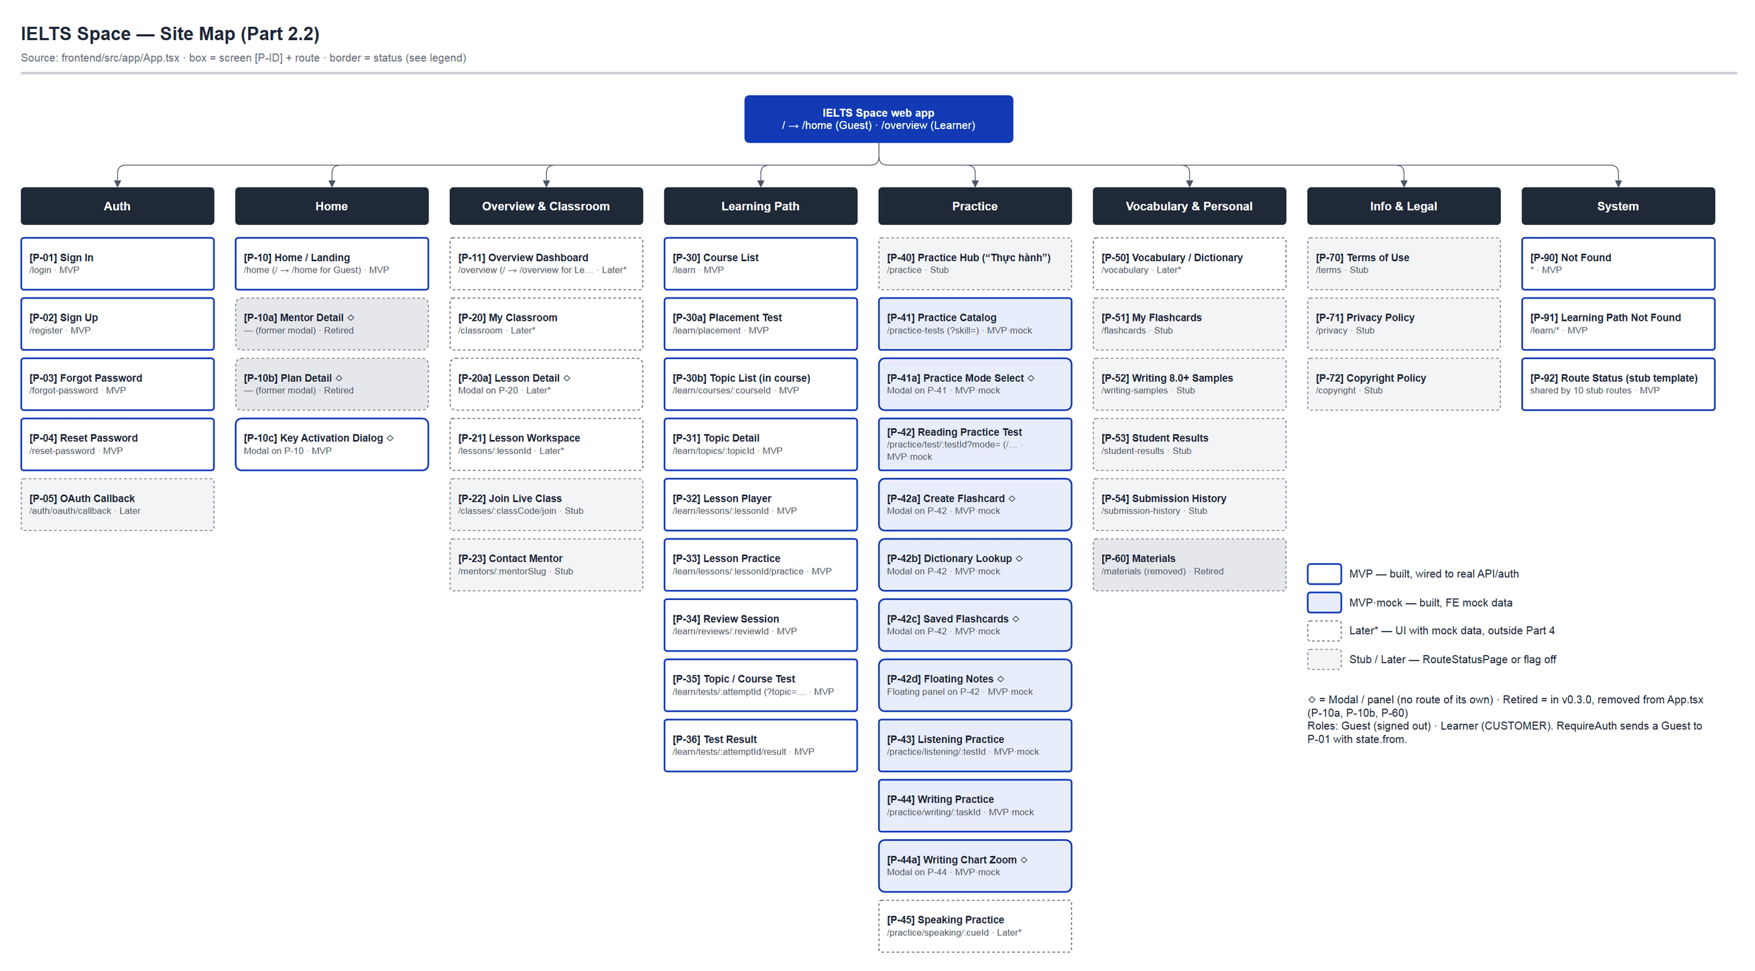
Figure 1 — Site Map — draw.io: diagrams/IELTSSpace_SDS_InformationArchitecture.drawio › 'IA-01 / Site Map'
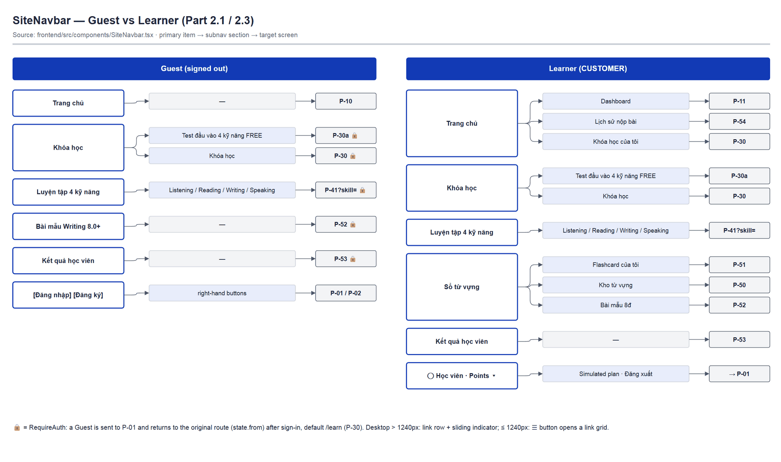
Figure 2 — Navigation Guest vs Learner (2.1 / 2.3) — draw.io: IELTSSpace_SDS_InformationArchitecture.drawio › 'IA-02 / Navigation'

2.3 Navigation Patterns

Primary Navigation
Attribute | Specification
Pattern | Sticky top navbar (SiteNavbar) — logo left, primary items centre, account right; second subnav row for items with sections
Desktop width | Full viewport; shell max 1440px; sliding indicator under the active item (> 1240px)
Narrow desktop | ≤ 1240px: link row hidden, ☰ button (44×44) opens a link grid below the navbar; Esc closes it
Active state | White pill with Primary text for the main item; active subnav item underlined + aria-current=page (matches path and ?skill= query)
Badge / count | No badges; Points and tier are shown in the UserTierDropdown

In-Page Navigation (Tabs)
Used on: Segment filters: P-30 (Tất cả / Gợi ý cho bạn / Đang học / Đã hoàn thành), P-30b (Tất cả / Listening / Reading / Writing / Speaking), P-41 (Bài chưa làm / Bài đã làm); section tabs on P-35 (Phần 1…N); DictionaryPanel (Tra Việt-Anh / Tra Anh-Việt).
Attribute | Specification
Style | Pill segment — aria-pressed buttons; active = Primary fill with white text; optional count (lp-segment__count)
Position | Right of the section title
Overflow | Only tabs with data are shown (‘Tất cả’ is always shown); the row wraps when it does not fit

Breadcrumbs
Used on: No multi-level breadcrumbs. The learning path uses a single back link (lp-back): P-30b “← Tất cả khóa học”, P-31 “← {course title}”, P-32 “← {topic title}”, P-33 “← {lesson title}”, P-34 “← Về lộ trình học”, P-35 “← Về topic / Về khóa học”.
Attribute | Specification
Format | ← {Parent title} (Primary bold link, ArrowLeft icon 16px)
Current page | Eyebrow + H1 directly below the back link

Part 3 — Screen Flows
Main MVP journeys. Each flow has a diagram in diagrams/flows/IELTSSpace_SDS_Flows.drawio (one tab per flow). Box = screen (P-ID), diamond = condition, arrow = action / route; dashed = secondary branch or Later.

Flow [F-01] — Authentication & Account Recovery
Related SRS Scenario | SC-01 Join IELTSPath and set a learning goal
Primary Actor | Guest → Learner
Entry Point | Navbar [Đăng nhập]/[Đăng ký], or RequireAuth redirect to /login with state.from
Success End State | Session created; user lands on the original route (from) or P-30 /learn
Design File | flows/IELTSSpace_SDS_Flows.drawio — frame 'F-01 / Authentication'

Key Decision Points
Branch | Condition | Outcome
B1 | Wrong email/password (HttpError) | Stay on P-01; server message shown in the role=status area
B2 | state.from present (blocked by RequireAuth) | Return to the original route after sign-in; otherwise → /learn
B3 | Sign-up succeeds | User is signed in automatically and routed as in B2 (no return to P-01)
B4 | Signed-in Learner opens an auth route | GuestOnly → P-30
B5 | Password reset succeeds | Success message, then automatic redirect to P-01 after ~0.9 s
B6 | Google OAuth (OAUTH_ENABLED = false) | “Google (chưa hỗ trợ)” button disabled; P-05 is Later

Flow Diagram — [F-01]
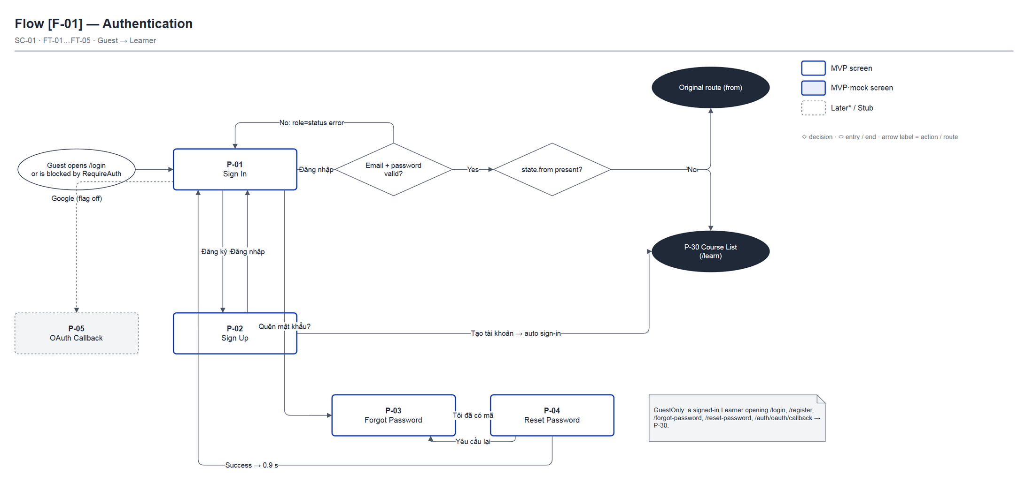
Figure 3 — Flow [F-01] Authentication & Account Recovery — draw.io: diagrams/flows/IELTSSpace_SDS_Flows.drawio — frame 'F-01 / Authentication'

Flow [F-02] — Course-based Learning Path
Related SRS Scenario | SC-01, SC-02, SC-03, SC-05
Primary Actor | Learner
Entry Point | Navbar “Khóa học” / “Khóa học của tôi”, or after sign-in (/learn)
Success End State | Topic PASSED → next topic unlocked; all topics passed → course final test PASSED
Design File | flows/IELTSSpace_SDS_Flows.drawio — frame 'F-02 / Course-based Learning Path'

Key Decision Points
Branch | Condition | Outcome
B1 | API returns PLACEMENT_REQUIRED | Redirect to P-30a with the notice “Hãy làm bài kiểm tra đầu vào để chọn course học.”
B2 | Topic LOCKED / Premium | Topic card is not a link; lock reason and Premium chip shown
B3 | Lesson still has practiceStatus REQUIRED | Rail shows “Cần luyện thêm” → P-33; topic test stays locked
B4 | Mandatory review pending (REVIEW_REQUIRED) | ReviewGateBanner + content temporarily locked → P-34
B5 | Topic test AVAILABLE | “Làm bài kiểm tra” → create assignment + attempt → P-35
B6 | Score < 70% | P-36 “Chưa đạt lần này”, answers hidden; a retry gets a different test code
B7 | All topics passed (course AVAILABLE) | P-30b shows “Làm bài thi cuối khóa” → P-35 ?course= → P-36

Flow Diagram — [F-02]
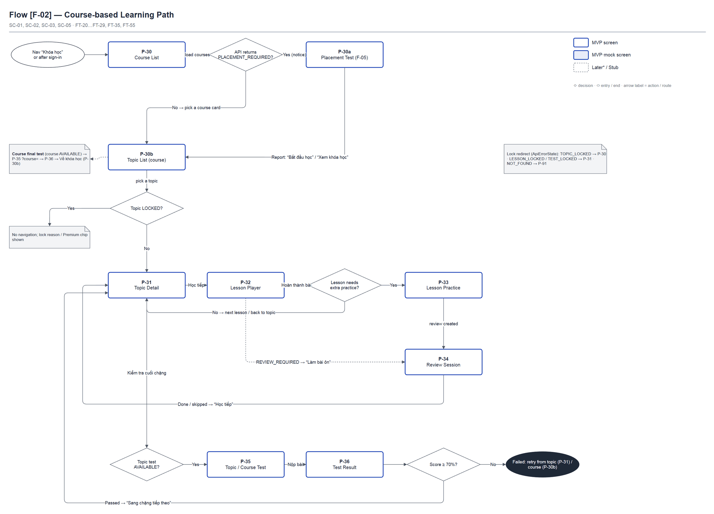
Figure 4 — Flow [F-02] Course-based Learning Path — draw.io: diagrams/flows/IELTSSpace_SDS_Flows.drawio — frame 'F-02 / Course-based Learning Path'

Flow [F-03] — Practice Catalog to Skill Workspace
Related SRS Scenario | — (FT-34 Mock test, FT-42 Notes, FT-43 Flashcards; FE mock data)
Primary Actor | Learner
Entry Point | Navbar “Luyện tập 4 kỹ năng” (?skill=), Home “Khám phá bài luyện”
Success End State | Learner works in a skill workspace and exits back to P-41
Design File | flows/IELTSSpace_SDS_Flows.drawio — frame 'F-03 / Practice Catalog to Skill Workspace'

Key Decision Points
Branch | Condition | Outcome
B1 | Mode dialog closed | Stay on P-41
B2 | mode=exam (Thi thử) | P-42 hides Highlight / Note / dictionary / Flashcard tools
B3 | Skill = speaking | P-45 Later* (recording UI, not in Part 4)
B4 | “Thoát” button | Back to /practice-tests; attempt state is not saved

Flow Diagram — [F-03]
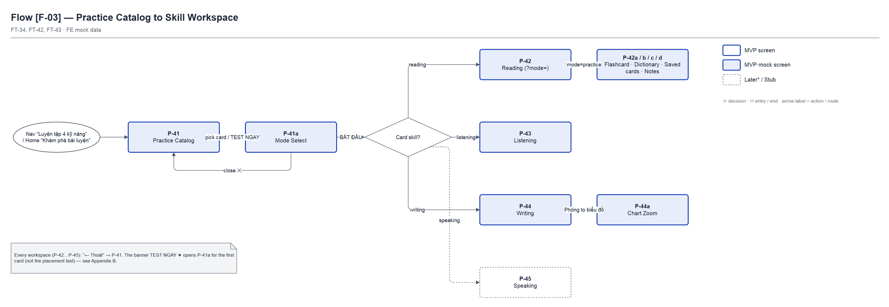
Figure 5 — Flow [F-03] Practice Catalog to Skill Workspace — draw.io: diagrams/flows/IELTSSpace_SDS_Flows.drawio — frame 'F-03 / Practice Catalog to Skill Workspace'

Flow [F-04] — Guest Home to Auth Gate
Related SRS Scenario | SC-01, SC-06
Primary Actor | Guest
Entry Point | Open / or /home
Success End State | Guest signs in and reaches the selected screen (state.from), or keeps browsing Home
Design File | flows/IELTSSpace_SDS_Flows.drawio — frame 'F-04 / Guest Home to Auth Gate'

Key Decision Points
Branch | Condition | Outcome
B1 | Already signed in when opening / | Redirect to /overview (P-11)
B2 | Guest opens a RequireAuth route | Navigate /login (replace) with state.from = original route
B3 | Guest clicks Kích hoạt / Nạp Key | P-10c shows a sign-in prompt with an “Đăng nhập” button
B4 | Guest only browses Home | No authentication required

Flow Diagram — [F-04]
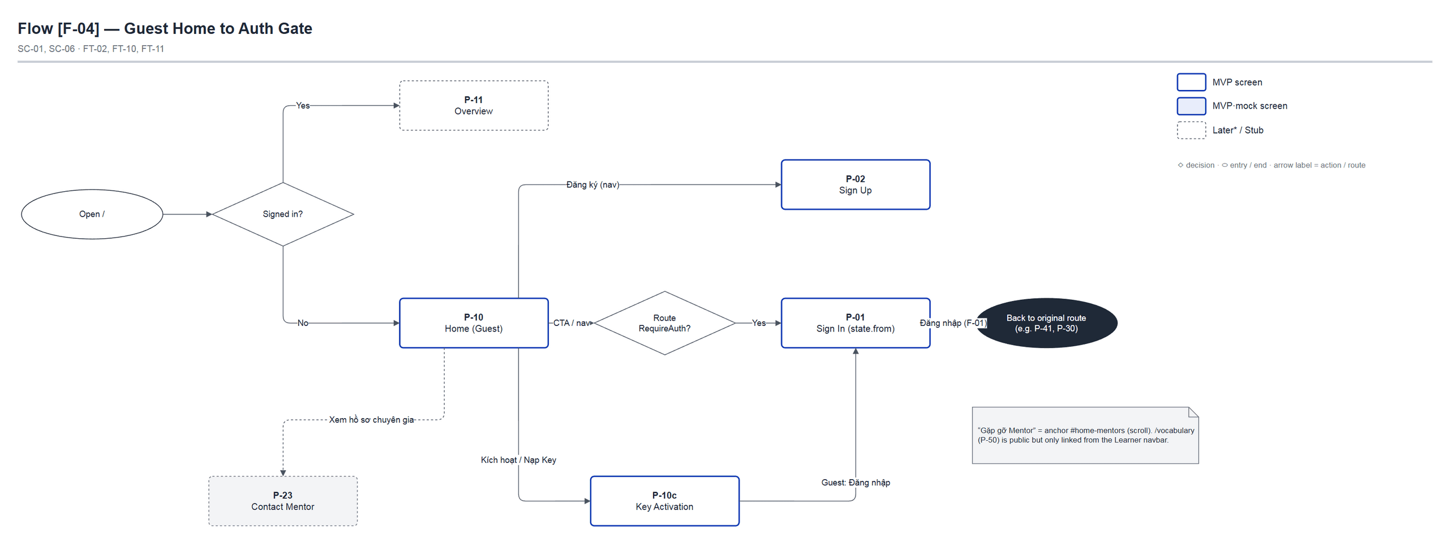
Figure 6 — Flow [F-04] Guest Home to Auth Gate — draw.io: diagrams/flows/IELTSSpace_SDS_Flows.drawio — frame 'F-04 / Guest Home to Auth Gate'

Flow [F-05] — Placement Test
Related SRS Scenario | SC-01 · FT-09, FT-35 · BR-36 (placement taken once)
Primary Actor | Learner
Entry Point | /learn/placement — subnav “Test đầu vào 4 kỹ năng FREE” or PLACEMENT_REQUIRED redirect
Success End State | Result report shown; Learner opens the recommended course → P-30b
Design File | flows/IELTSSpace_SDS_Flows.drawio — frame 'F-05 / Placement Test'

Key Decision Points
Branch | Condition | Outcome
B1 | No attempt / EXPIRED / CANCELLED | Start with the 3-question survey
B2 | Attempt IN_PROGRESS | Go straight to the Test Hub (answers are saved on the server)
B3 | Attempt already submitted | Grading screen (polling), then the report
B4 | PLACEMENT_ALREADY_DONE | Redirect to /learn (P-30)
B5 | NO_PLACEMENT_TEST | “Chưa có bài kiểm tra đầu vào nào được mở. Hãy quay lại sau.”
B6 | Grading takes > 90 s | “Kết quả đang được chấm” + “Kiểm tra lại” button

Flow Diagram — [F-05]
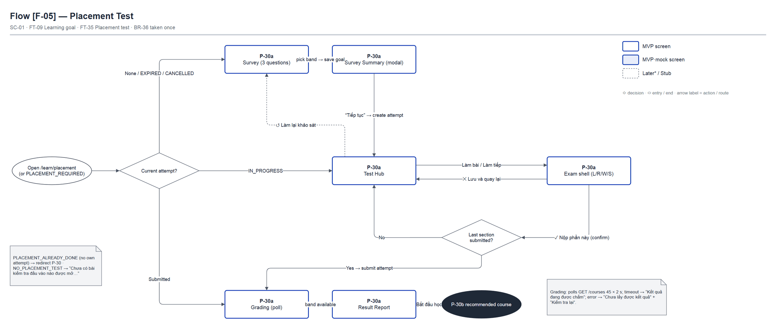
Figure 7 — Flow [F-05] Placement Test — draw.io: diagrams/flows/IELTSSpace_SDS_Flows.drawio — frame 'F-05 / Placement Test'

Part 4 — Screen Specifications
One section per MVP / MVP·mock screen (from Site Map 2.2), desktop web only. The shared shell is described once in 4.0. Each screen points to its draw.io Design File (path + frame name) and embeds images exported from those frames. Later* / Stub screens appear only in the Site Map and Appendix A.

4.0 — Shared Layout (Authenticated Shell)
Design file: draw.io — diagrams/wireframes/SHELL_SharedLayout.drawio — frames 'SHELL / Learner Desktop', 'SHELL / User Menu', 'SHELL / Guest Desktop', 'SHELL / Auth Shell', 'SHELL / Exam Shell', 'SHELL / Mobile Nav'
Shell layout structure
┌──────────────────────────────────────────────────────────────┐
│ [A] SiteNavbar: logo | primary items | user menu (Points) │
│ [B] Subnav: sections of the active item │
├──────────────────────────────────────────────────────────────┤
│ [C] ReviewGateBanner / NoticeBanner (/learn/* only) │
│ [D] main#main-content (ErrorBoundary theo route) │
│ [E] DemoControls (mock learning) │
├──────────────────────────────────────────────────────────────┤
│ [F] SiteFooter (Tư vấn miễn phí) │
└──────────────────────────────────────────────────────────────┘
AuthShell (P-01…P-05): navbar + ambient copy/mascot + form card.
PlacementExamShell (P-30a): full-screen dialog over the navbar.

Nav Item | Icon | Visible to Roles | Shows Badge?
Trang chủ | — (text) | Guest, Learner | No — Learner subnav: Dashboard / Lịch sử nộp bài / Khóa học của tôi
Khóa học | — | Guest🔒, Learner | No — subnav: Test đầu vào 4 kỹ năng FREE / Khóa học
Luyện tập 4 kỹ năng | — | Guest🔒, Learner | No — subnav: Listening / Reading / Writing / Speaking
Sổ từ vựng | — | Learner | No — subnav: Flashcard của tôi / Kho từ vựng / Bài mẫu 8đ
Bài mẫu Writing 8.0+ | — | Guest🔒 | No
Kết quả học viên | — | Guest🔒, Learner | No
User menu | ◯ avatar + Points ▾ | Learner | Points / tier shown in the trigger
☰ Menu | Menu / X | Guest, Learner | ≤ 1240px only

Zone descriptions:
- Zone A: SiteNavbar: logo (→ /home), primary items, user menu or [Đăng nhập][Đăng ký]; skip link “Chuyển đến nội dung chính”.
- Zone B: Subnav: sections of the active item; hovering another item previews its sections (reverts after 200 ms). For a Guest on Trang chủ the subnav floats over the page.
- Zone C: Banners inside /learn/*: ReviewGateBanner (“Cần ôn lại trước khi học tiếp” + “Làm bài ôn”) and NoticeBanner (redirect notices, ✕ to dismiss).
- Zone D: main#main-content — per-route ErrorBoundary (“Không thể hiển thị lộ trình học”).
- Zone E: DemoControls (only when VITE_USE_MOCK_LEARNING): “Đặt lại demo”, “Giả lỗi máy chủ 500”.
- Zone F: SiteFooter (every route, rendered after <Routes>): contact info + map, about, social links, support centre (/terms, /privacy, /copyright), legal info; floating “Tư vấn miễn phí” (tel) button.
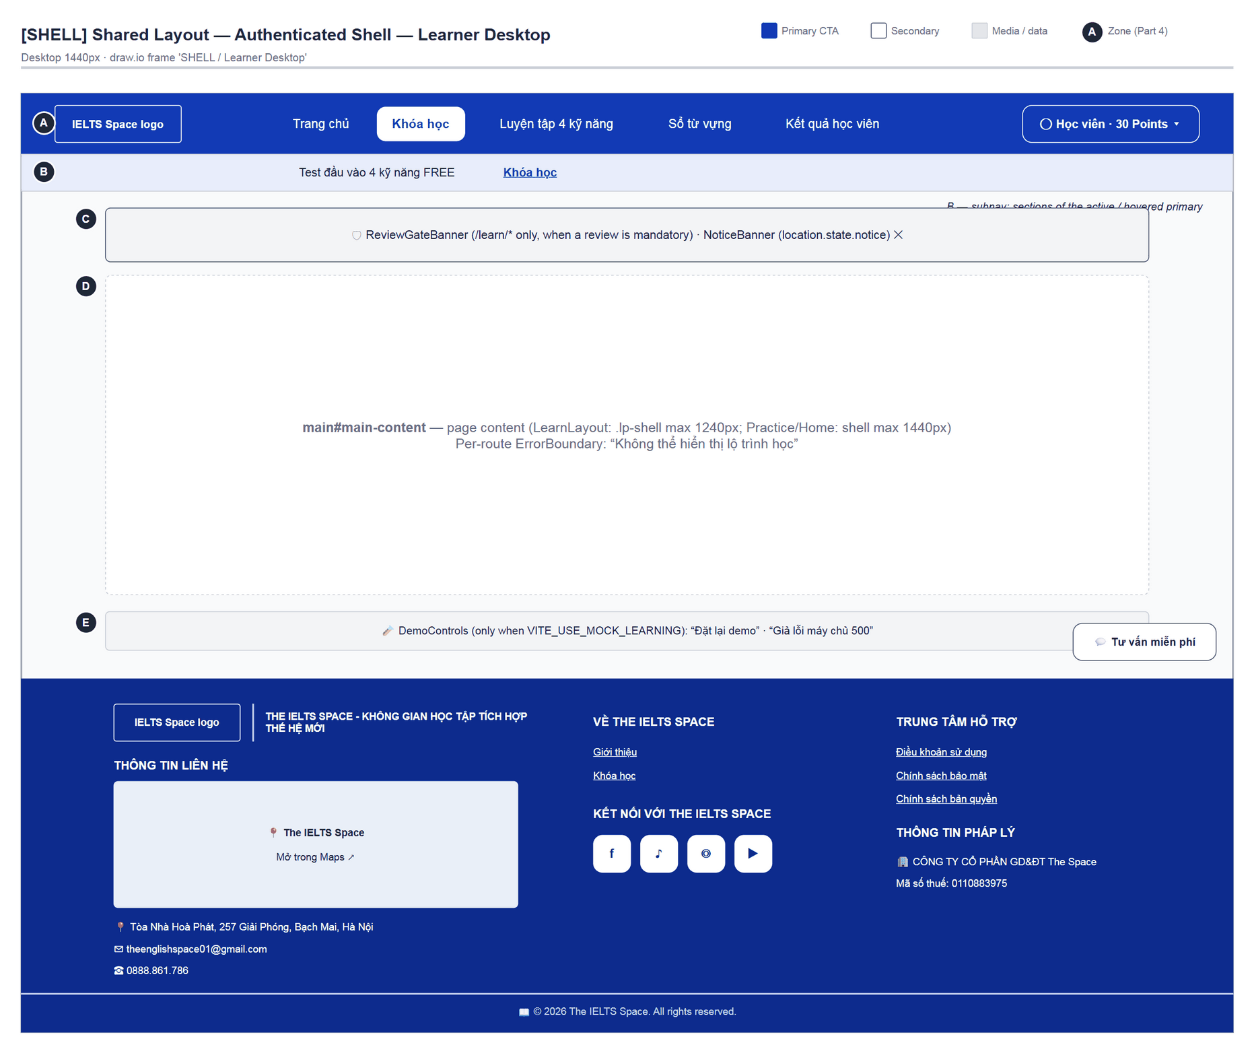
Figure 8 — Authenticated shell (LearnLayout) — draw.io: diagrams/wireframes/SHELL_SharedLayout.drawio › 'SHELL / Learner Desktop'
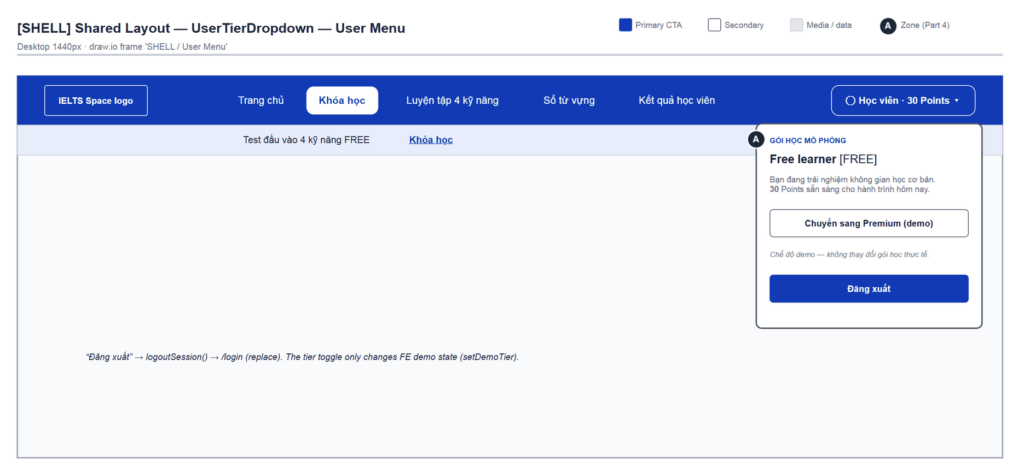
Figure 9 — UserTierDropdown — draw.io: diagrams/wireframes/SHELL_SharedLayout.drawio › 'SHELL / User Menu'
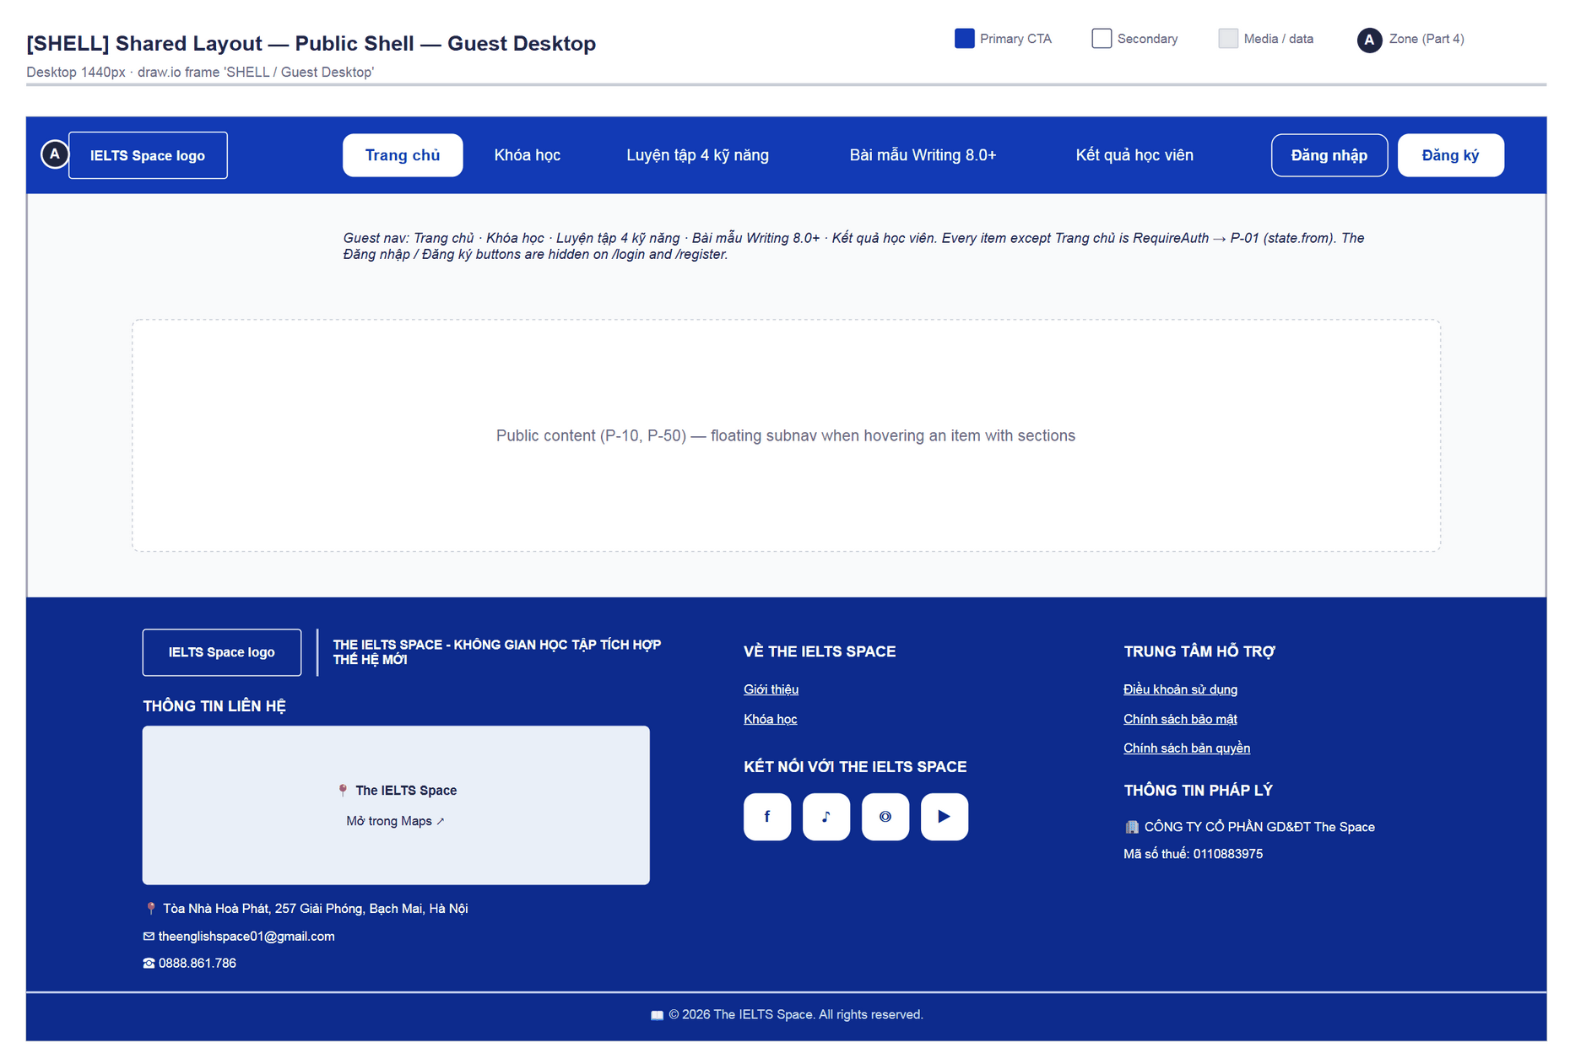
Figure 10 — Public shell — draw.io: diagrams/wireframes/SHELL_SharedLayout.drawio › 'SHELL / Guest Desktop'
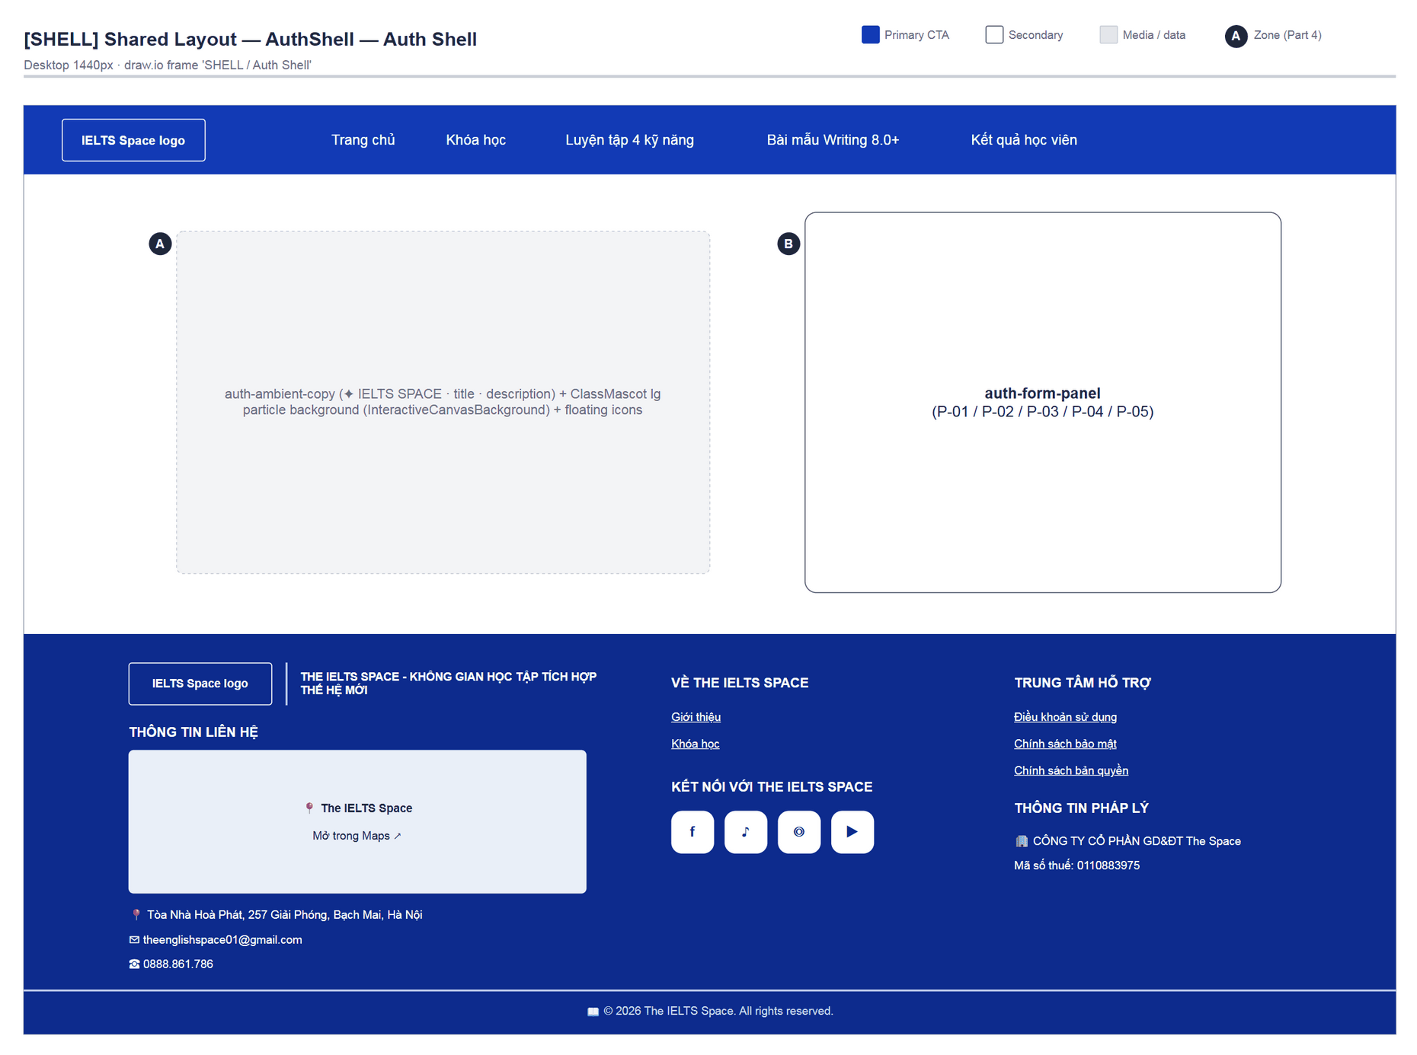
Figure 11 — AuthShell (P-01…P-05) — draw.io: diagrams/wireframes/SHELL_SharedLayout.drawio › 'SHELL / Auth Shell'
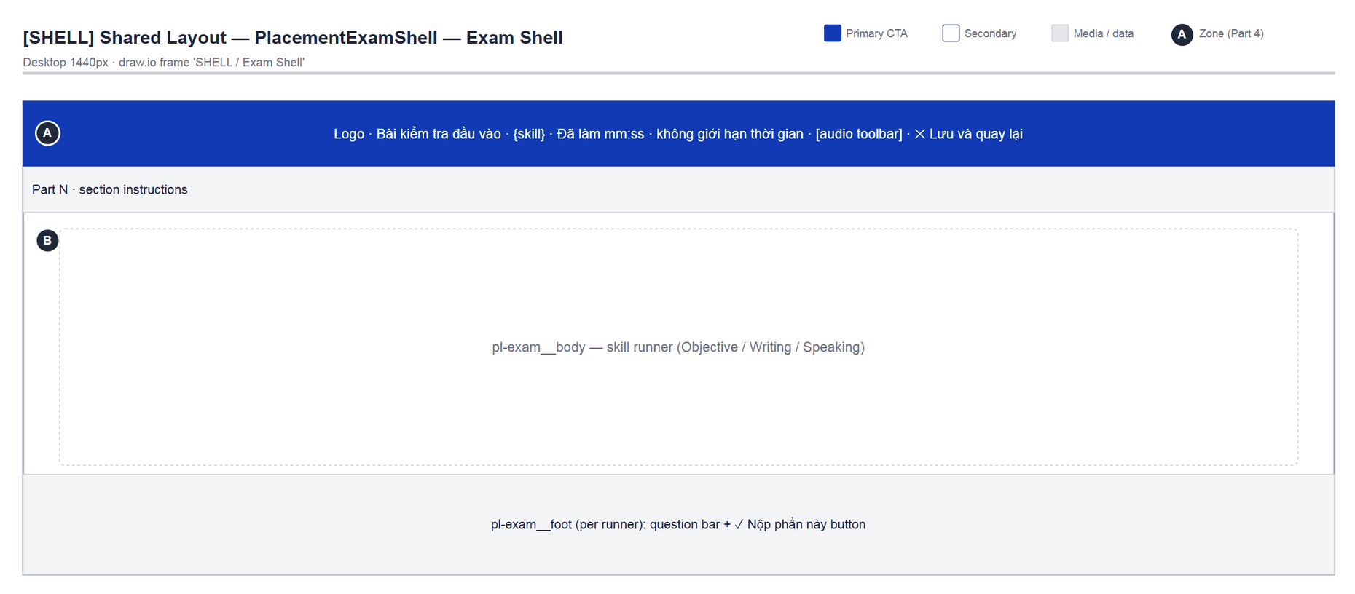
Figure 12 — PlacementExamShell (P-30a) — draw.io: diagrams/wireframes/SHELL_SharedLayout.drawio › 'SHELL / Exam Shell'

4.1 — Sign In (P-01)
Page ID | P-01
Screen name | Sign In
Design file | draw.io — diagrams/wireframes/P-01_SignIn.drawio — frames 'P-01 / Populated', 'P-01 / Loading', 'P-01 / Error'
SRS Feature | FT-02, FT-05
SRS Scenario | SC-01
Roles with access | Guest
Route | /login
Nav level | AUTH
Status | MVP
Flow(s) | F-01, F-04

Email + password sign-in for Guests. After sign-in the user goes to the route that was blocked before (state.from) or to /learn.

Screen States
State | When It Appears | Design File Frame
Loading | Request in flight (button “Đang xử lý…”, disabled) | P-01 / Loading
Empty | N/A — the form is always shown | N/A
Populated — default | Form ready | P-01 / Populated
Error | Wrong credentials / network error — HttpError message or “Không thể xác thực. Vui lòng thử lại.” | P-01 / Error

Layout Description
Layout zones — P-01 Sign In
┌───────────────────────────────────────────────────────────┐
│ SiteNavbar (Guest, [Đăng nhập][Đăng ký] hidden) │
├───────────────────────────┬───────────────────────────────┤
│ [A] IELTS SPACE │ [A] IELTS SPACE │
│ Mỗi ngày một bước. Gần │ Chào mừng bạn trở lại │
│ hơn band mục tiêu. │ [B] Email / Mật khẩu │
│ mascot + particles │ Quên mật khẩu? │
│ │ [C] [ Đăng nhập ] · hoặc · │
│ │ [Google (chưa hỗ trợ)] │
│ │ [D] Chưa có tài khoản? Đăng ký│
├───────────────────────────┴───────────────────────────────┤
│ SiteFooter (Tư vấn miễn phí) │
└───────────────────────────────────────────────────────────┘

Zone descriptions:
- Zone A: Ambient copy on the left (“Mỗi ngày một bước. Gần hơn band mục tiêu.” / “Giữ bài học, lộ trình và từ vựng trong một không gian tập trung.”) and the form header: “IELTS SPACE”, “Chào mừng bạn trở lại”, “Đăng nhập để tiếp tục lộ trình IELTS của bạn.”
- Zone B: Email (placeholder name@example.com) and Mật khẩu (placeholder “Mật khẩu”, show/hide toggle); right-aligned link “Quên mật khẩu?”.
- Zone C: Primary button “Đăng nhập” (loading “Đang xử lý…”), “hoặc” divider, disabled “Google (chưa hỗ trợ)” button, role=status message area.
- Zone D: “Chưa có tài khoản? Đăng ký ngay” → P-02.

Key Interactions
User Action | What Happens | Notes
Submit valid credentials | Session created; navigate (replace) to state.from or /learn (P-30) | FT-02; GuestOnly
Submit wrong email/password | role=status message; email kept | Form is not cleared
Click “Quên mật khẩu?” | → P-03
Click Google | Disabled; with the flag on it would start the provider flow (P-05) | FT-05 Draft

Mockup
Mockup / Wireframe — draw.io
Design file: diagrams/wireframes/P-01_SignIn.drawio
Frames: 'P-01 / Populated', 'P-01 / Loading', 'P-01 / Error'
Images below are exported from draw.io (scripts/export_diagrams.py); edit the .drawio file, then rebuild this document.

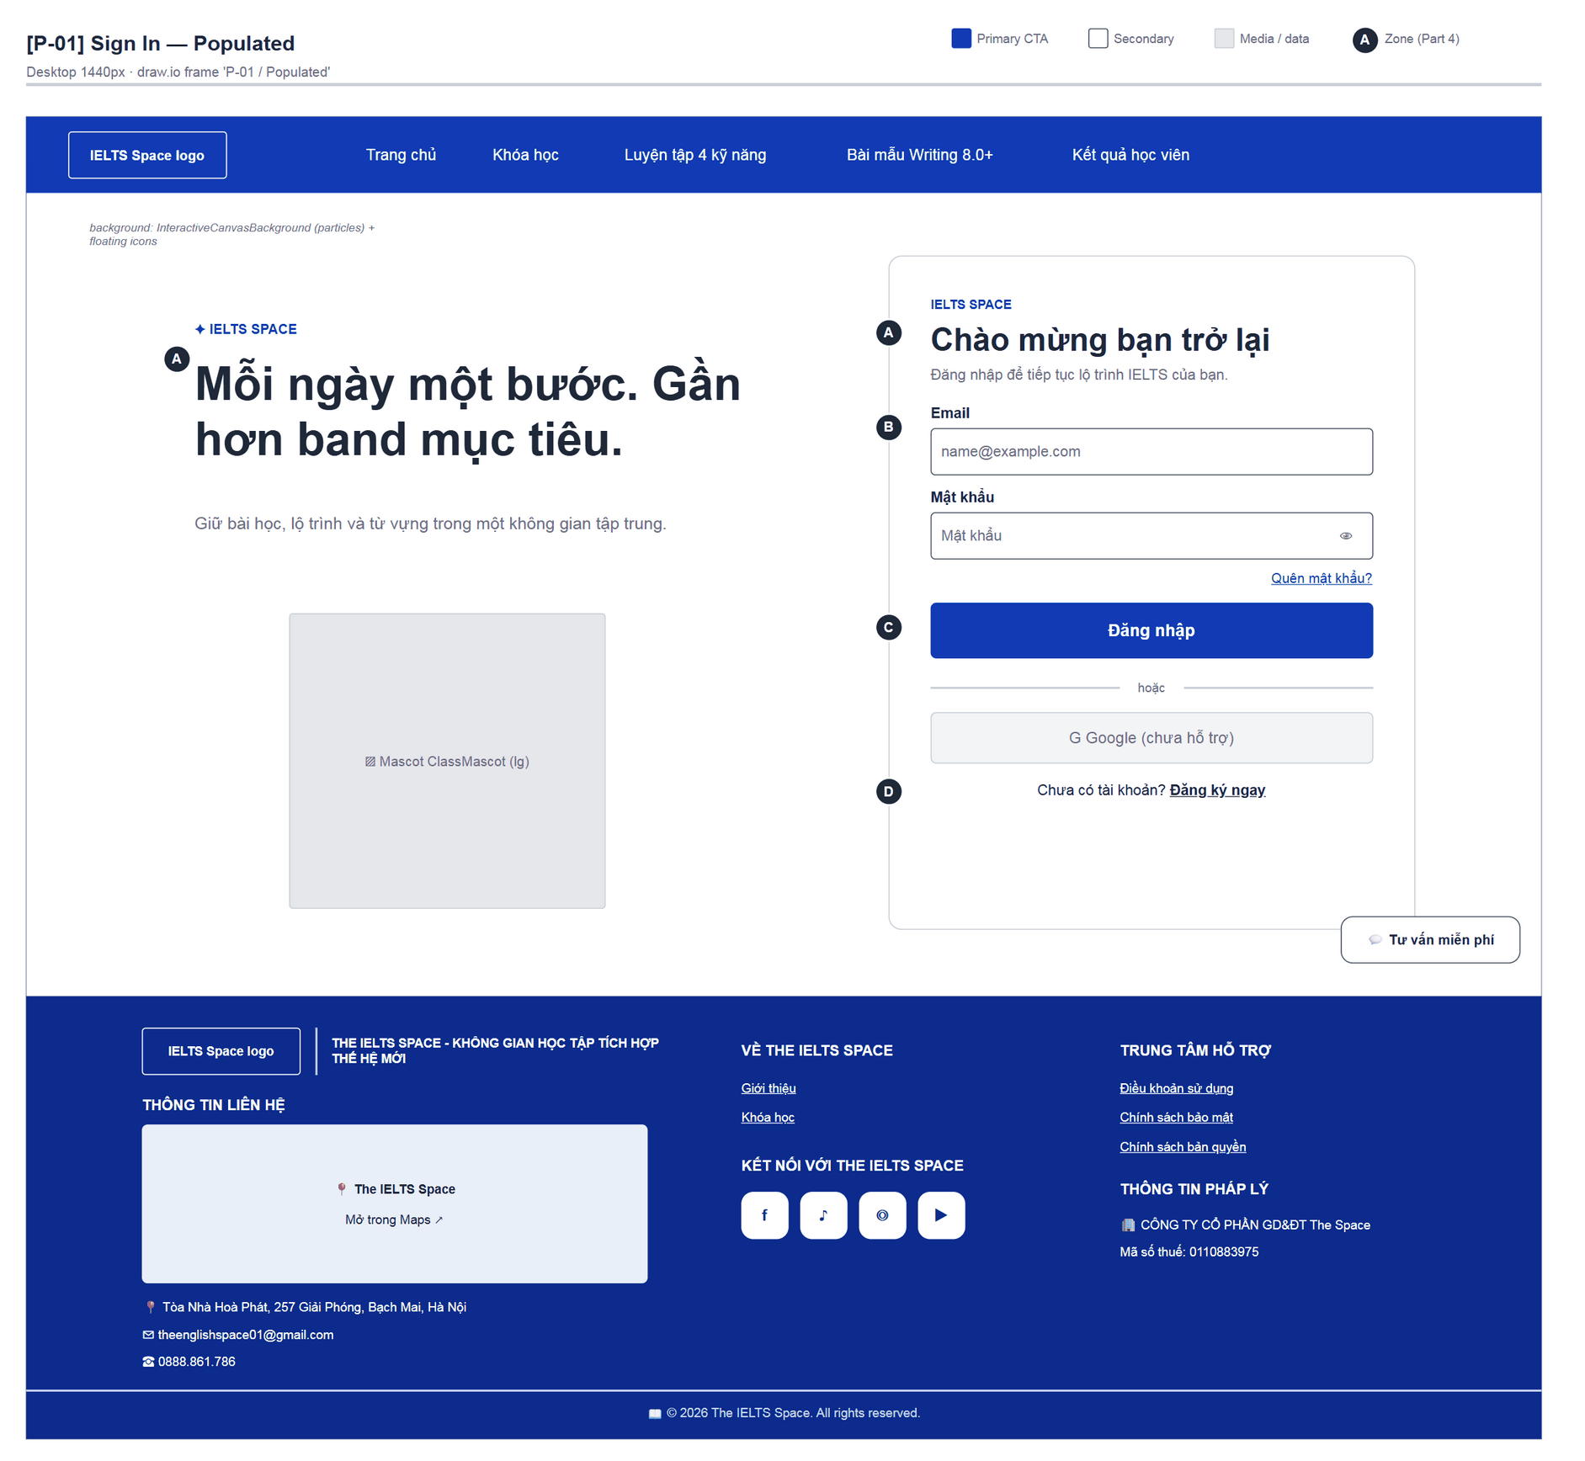
Figure 13 — [P-01] Sign In — Populated · draw.io frame 'P-01 / Populated'
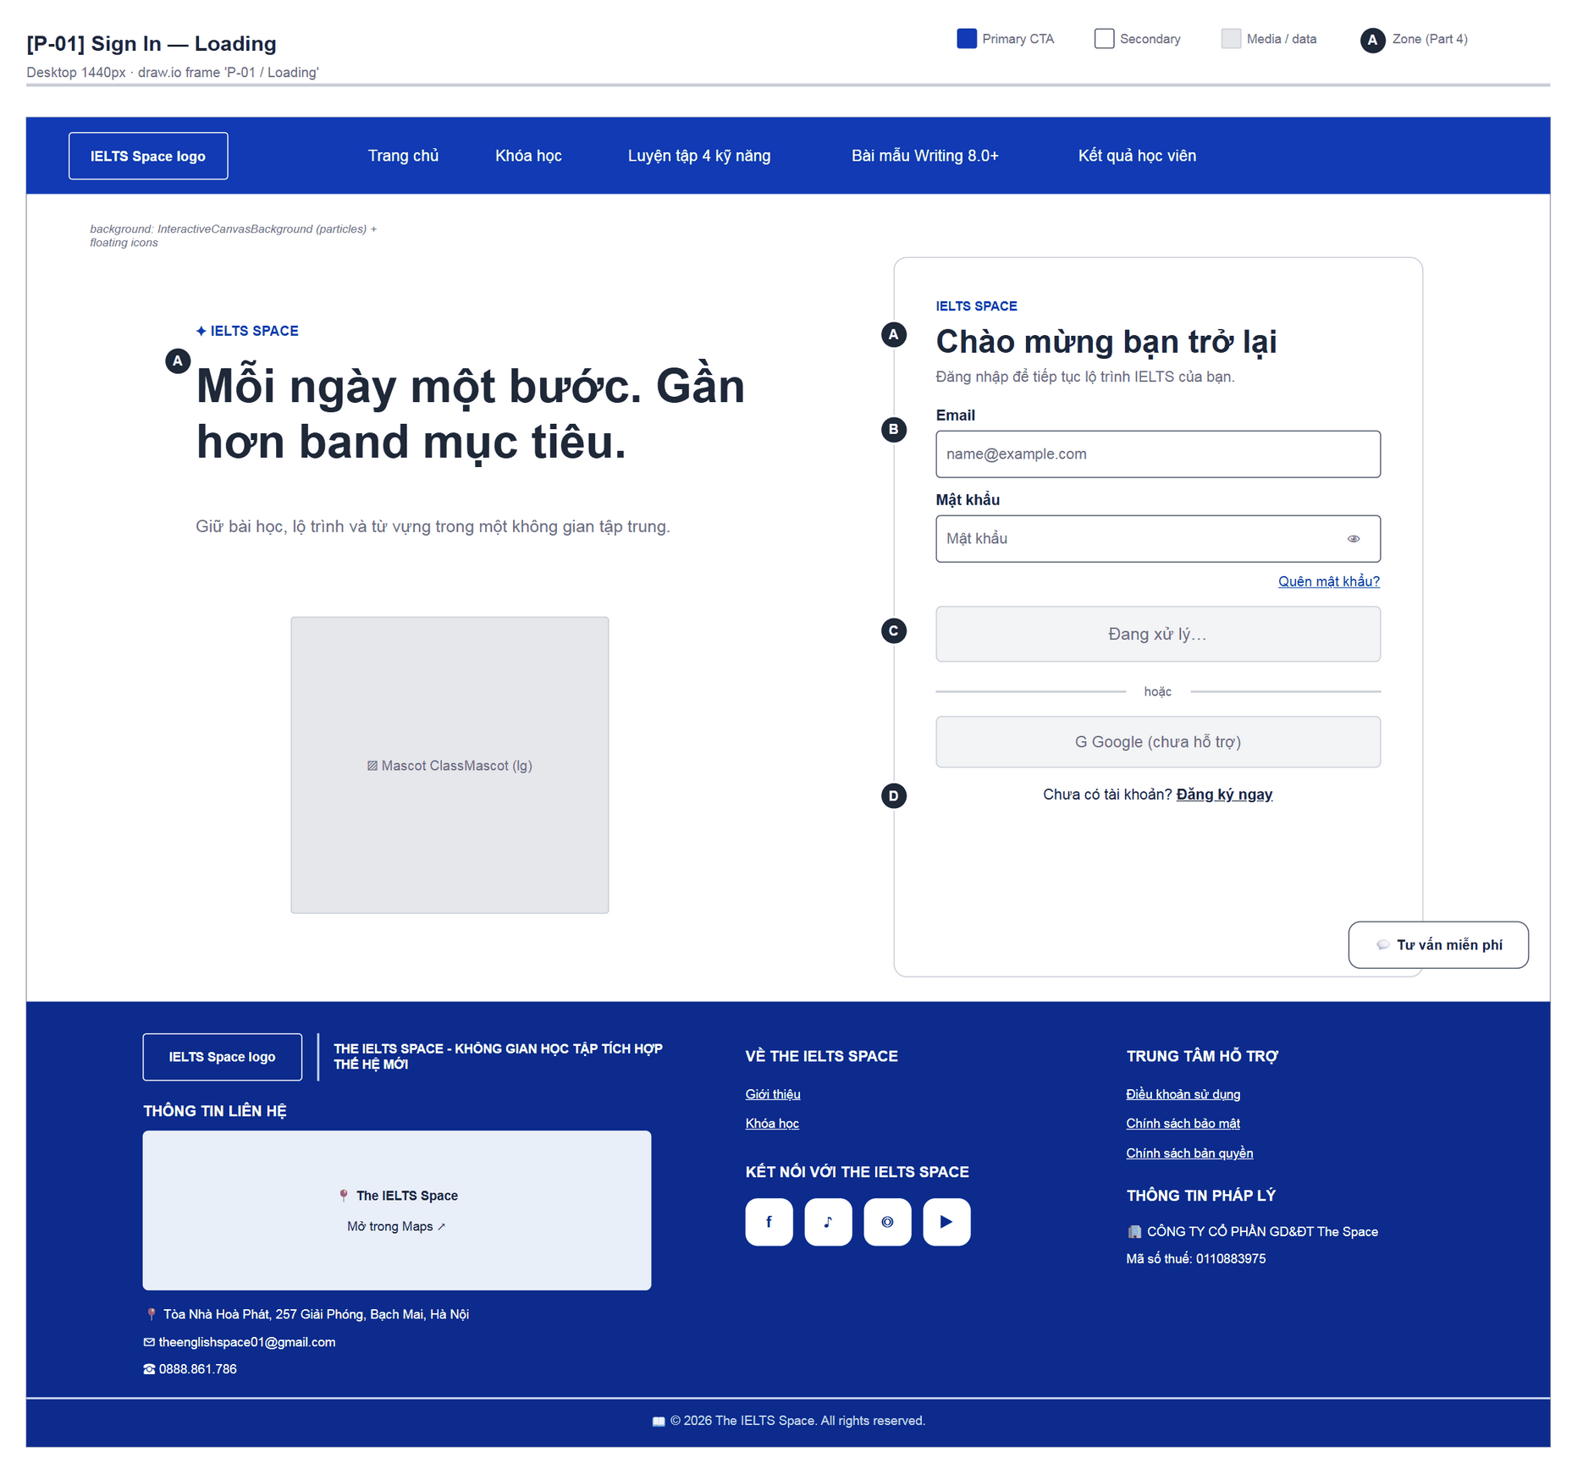
Figure 14 — [P-01] Sign In — Loading · draw.io frame 'P-01 / Loading'
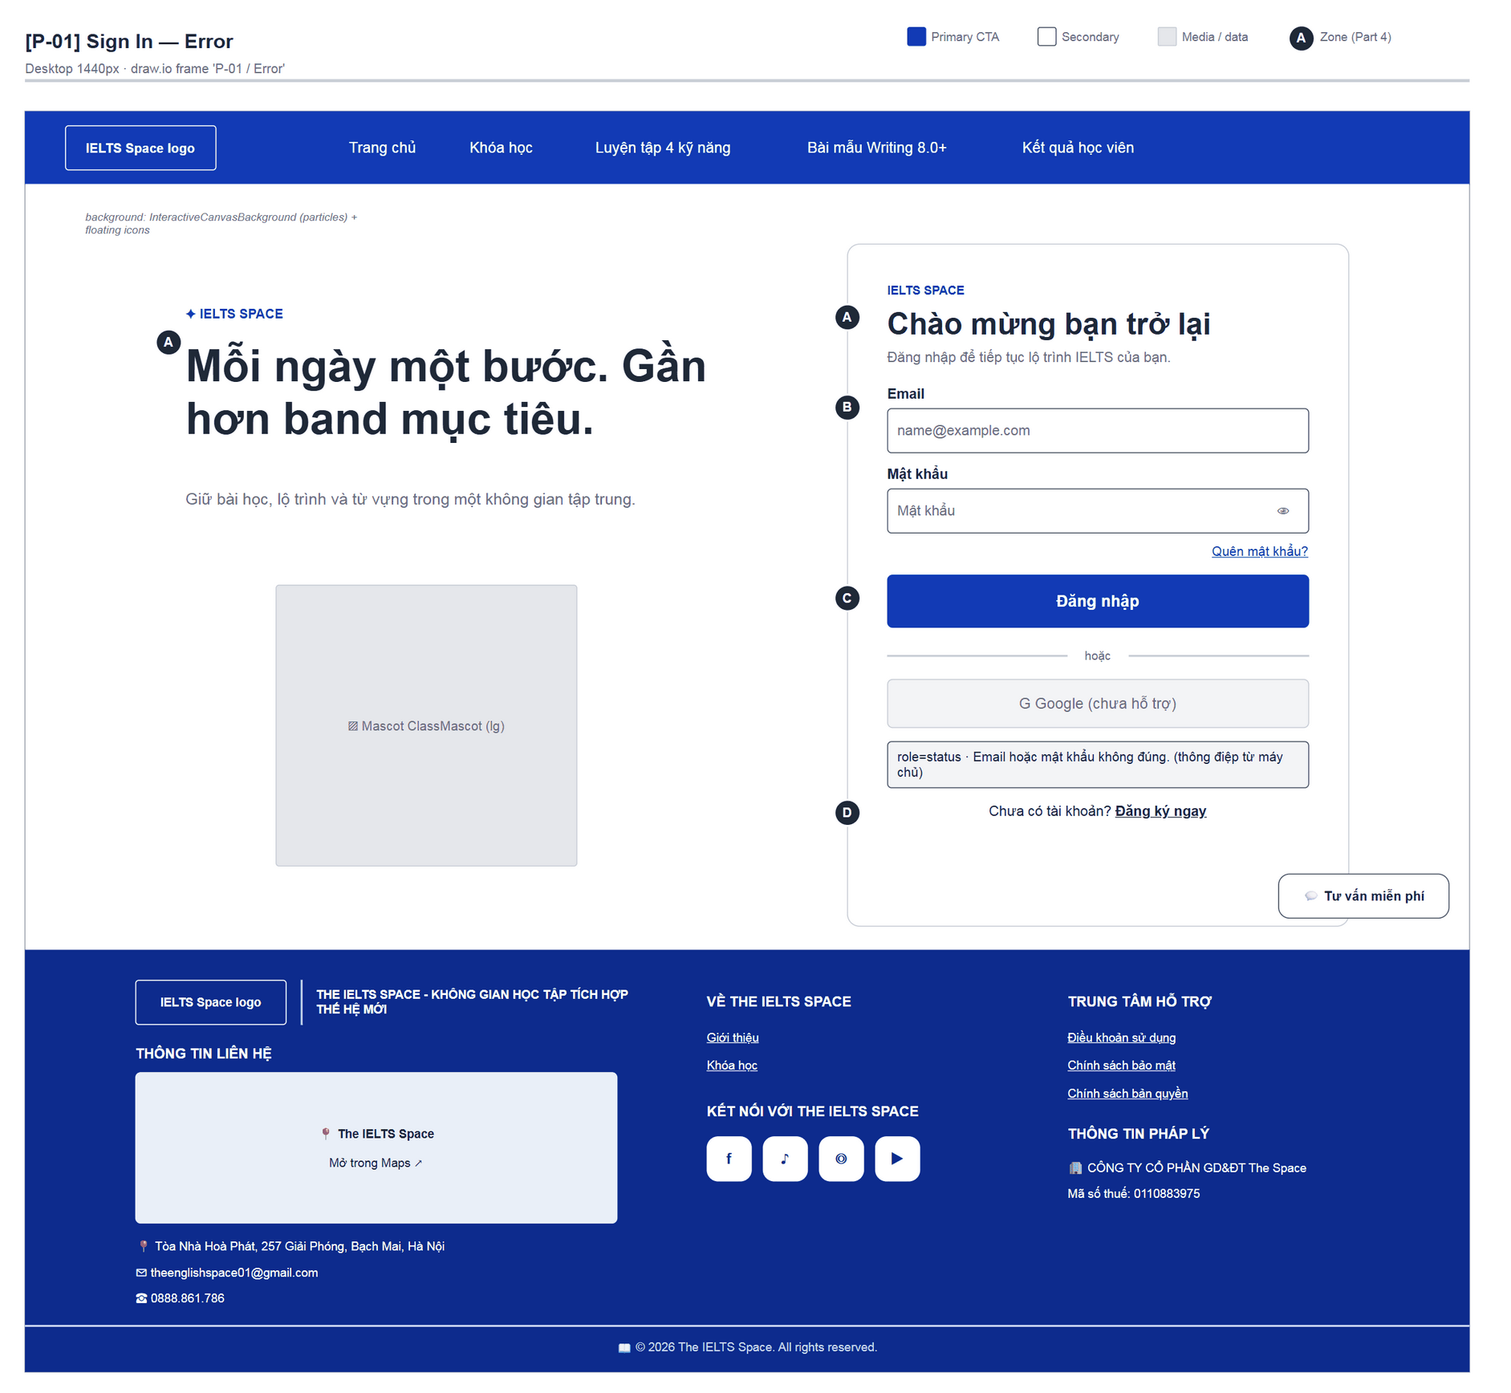
Figure 15 — [P-01] Sign In — Error · draw.io frame 'P-01 / Error'

4.2 — Sign Up (P-02)
Page ID | P-02
Screen name | Sign Up
Design file | draw.io — diagrams/wireframes/P-02_SignUp.drawio — frames 'P-02 / Populated', 'P-02 / Error'
SRS Feature | FT-01
SRS Scenario | SC-01
Roles with access | Guest
Route | /register
Nav level | AUTH
Status | MVP
Flow(s) | F-01, F-04

Create a Learner account (full name, email, 6–72 character password). On success the user is signed in automatically.

Screen States
State | When It Appears | Design File Frame
Loading | Registering (“Đang xử lý…”) | Same layout as P-01 / Loading
Empty | N/A | N/A
Populated — default | Registration form | P-02 / Populated
Error | Mismatch “Mật khẩu xác nhận không khớp.” / length “Mật khẩu phải có từ 6 đến 72 ký tự.” / email already used (server message) | P-02 / Error

Layout Description
Layout zones — P-02 Sign Up
┌───────────────────────────────┐
│ [A] BẮT ĐẦU HỌC │
│ Tạo tài khoản mới │
│ [B] Họ và tên · Email │
│ Mật khẩu · Xác nhận │
│ [C] [ Tạo tài khoản ] │
│ hoặc · [Google] │
│ [D] Đã có tài khoản? Đăng nhập│
└───────────────────────────────┘
(inside AuthShell, same as P-01)

Zone descriptions:
- Zone A: “BẮT ĐẦU HỌC” · “Tạo tài khoản mới” · “Bắt đầu kế hoạch học IELTS phù hợp với bạn.”
- Zone B: Họ và tên (Nguyễn Văn A), Email, Mật khẩu + hint “Từ 6 đến 72 ký tự.”, Xác nhận mật khẩu (“Nhập lại mật khẩu”).
- Zone C: “Tạo tài khoản” button, disabled Google button, status area.
- Zone D: “Đã có tài khoản? Đăng nhập” → P-01.

Key Interactions
User Action | What Happens | Notes
Submit valid form | registerWithPassword → session → navigate to state.from or /learn | FT-01
Confirmation differs | Blocked client-side, message shown
Email already exists | Message mapped from the HTTP error | mapAuthPasswordHttpError

Mockup
Mockup / Wireframe — draw.io
Design file: diagrams/wireframes/P-02_SignUp.drawio
Frames: 'P-02 / Populated', 'P-02 / Error'
Images below are exported from draw.io (scripts/export_diagrams.py); edit the .drawio file, then rebuild this document.

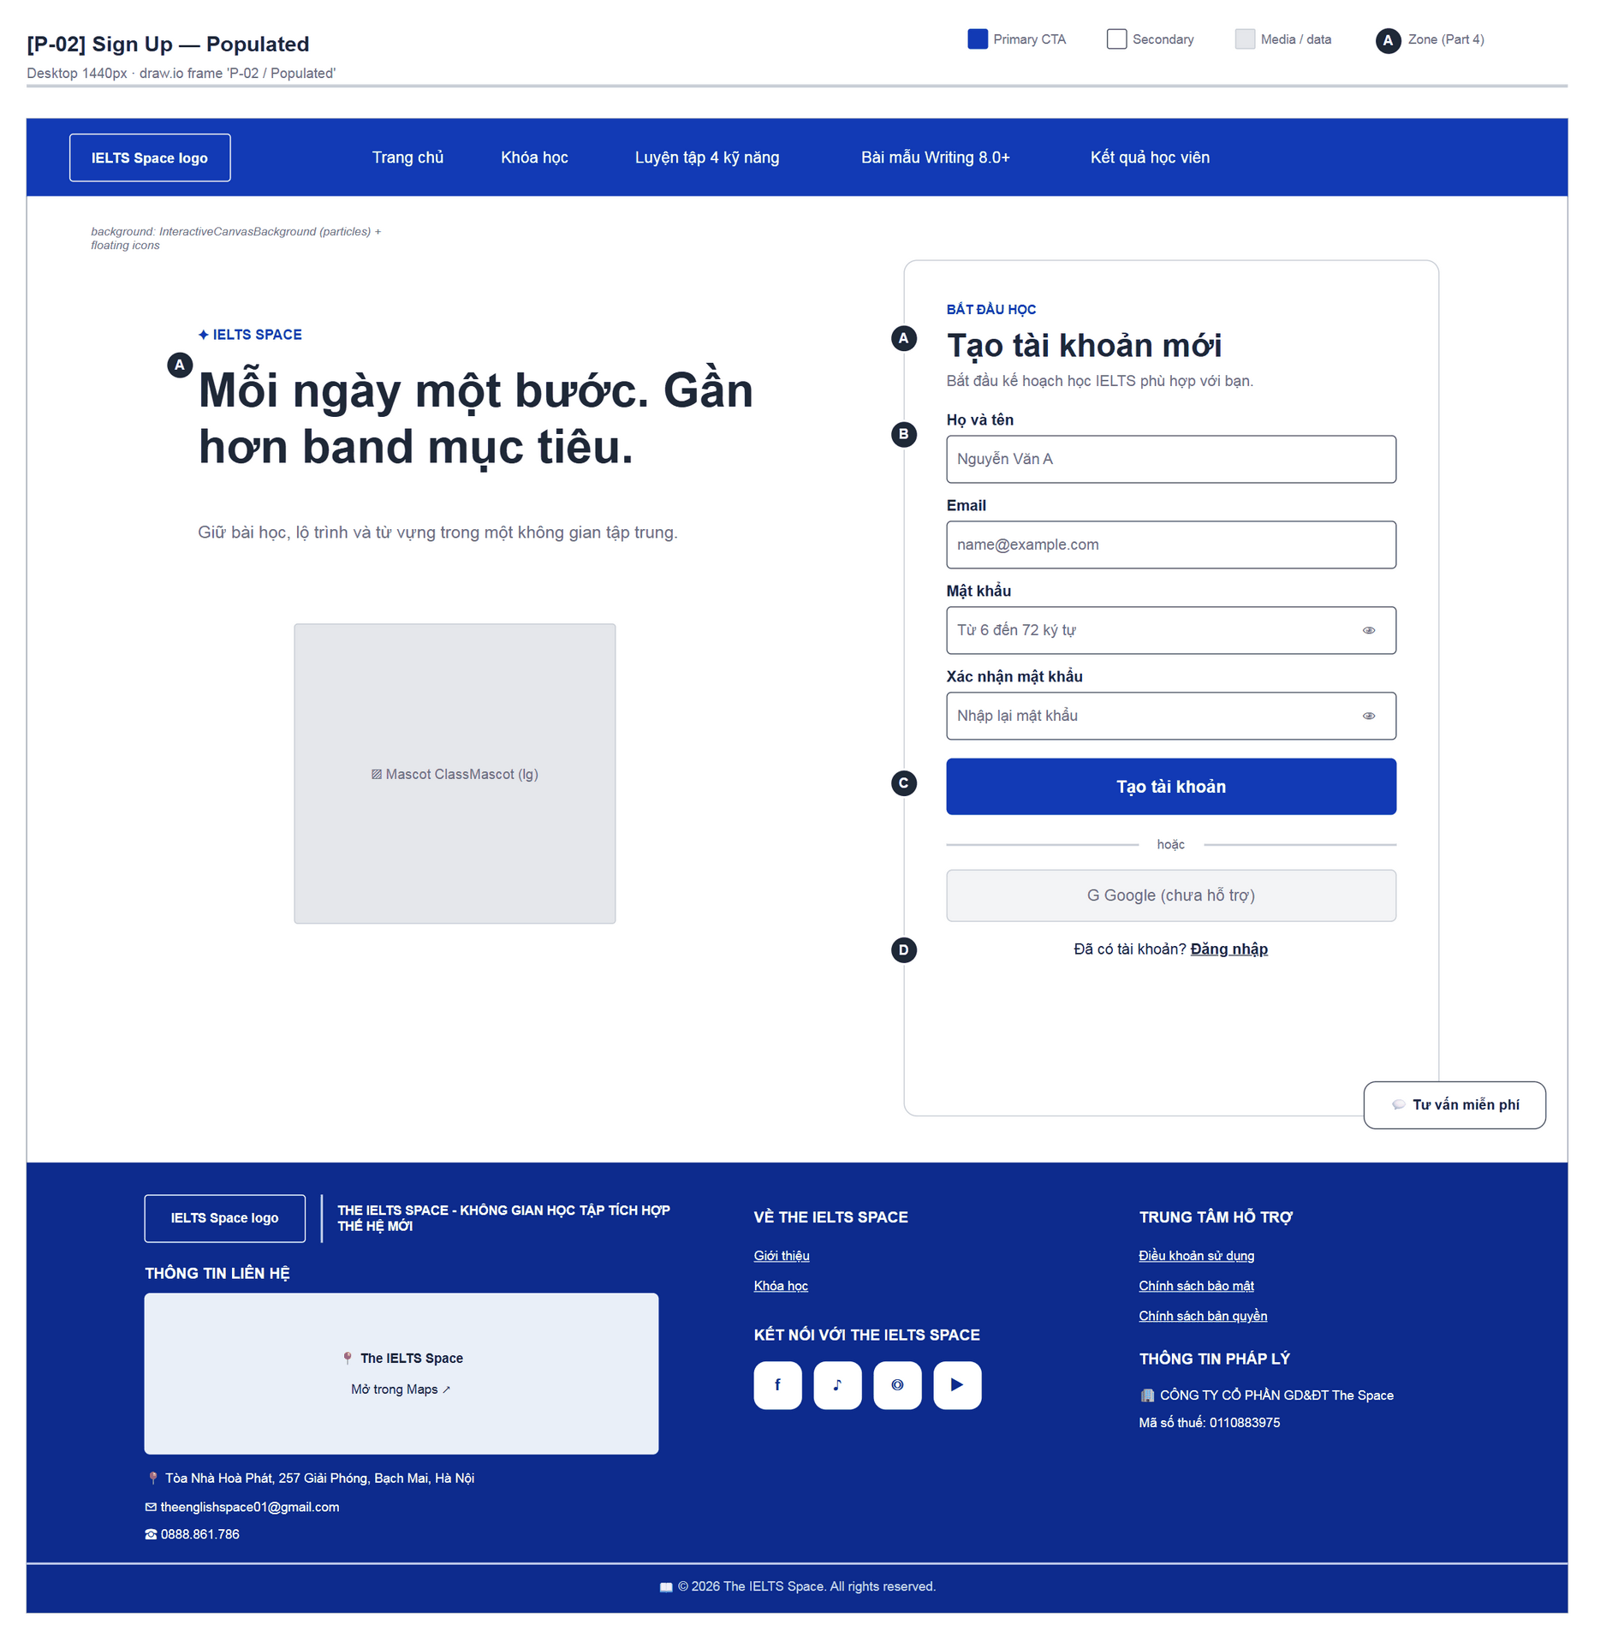
Figure 16 — [P-02] Sign Up — Populated · draw.io frame 'P-02 / Populated'
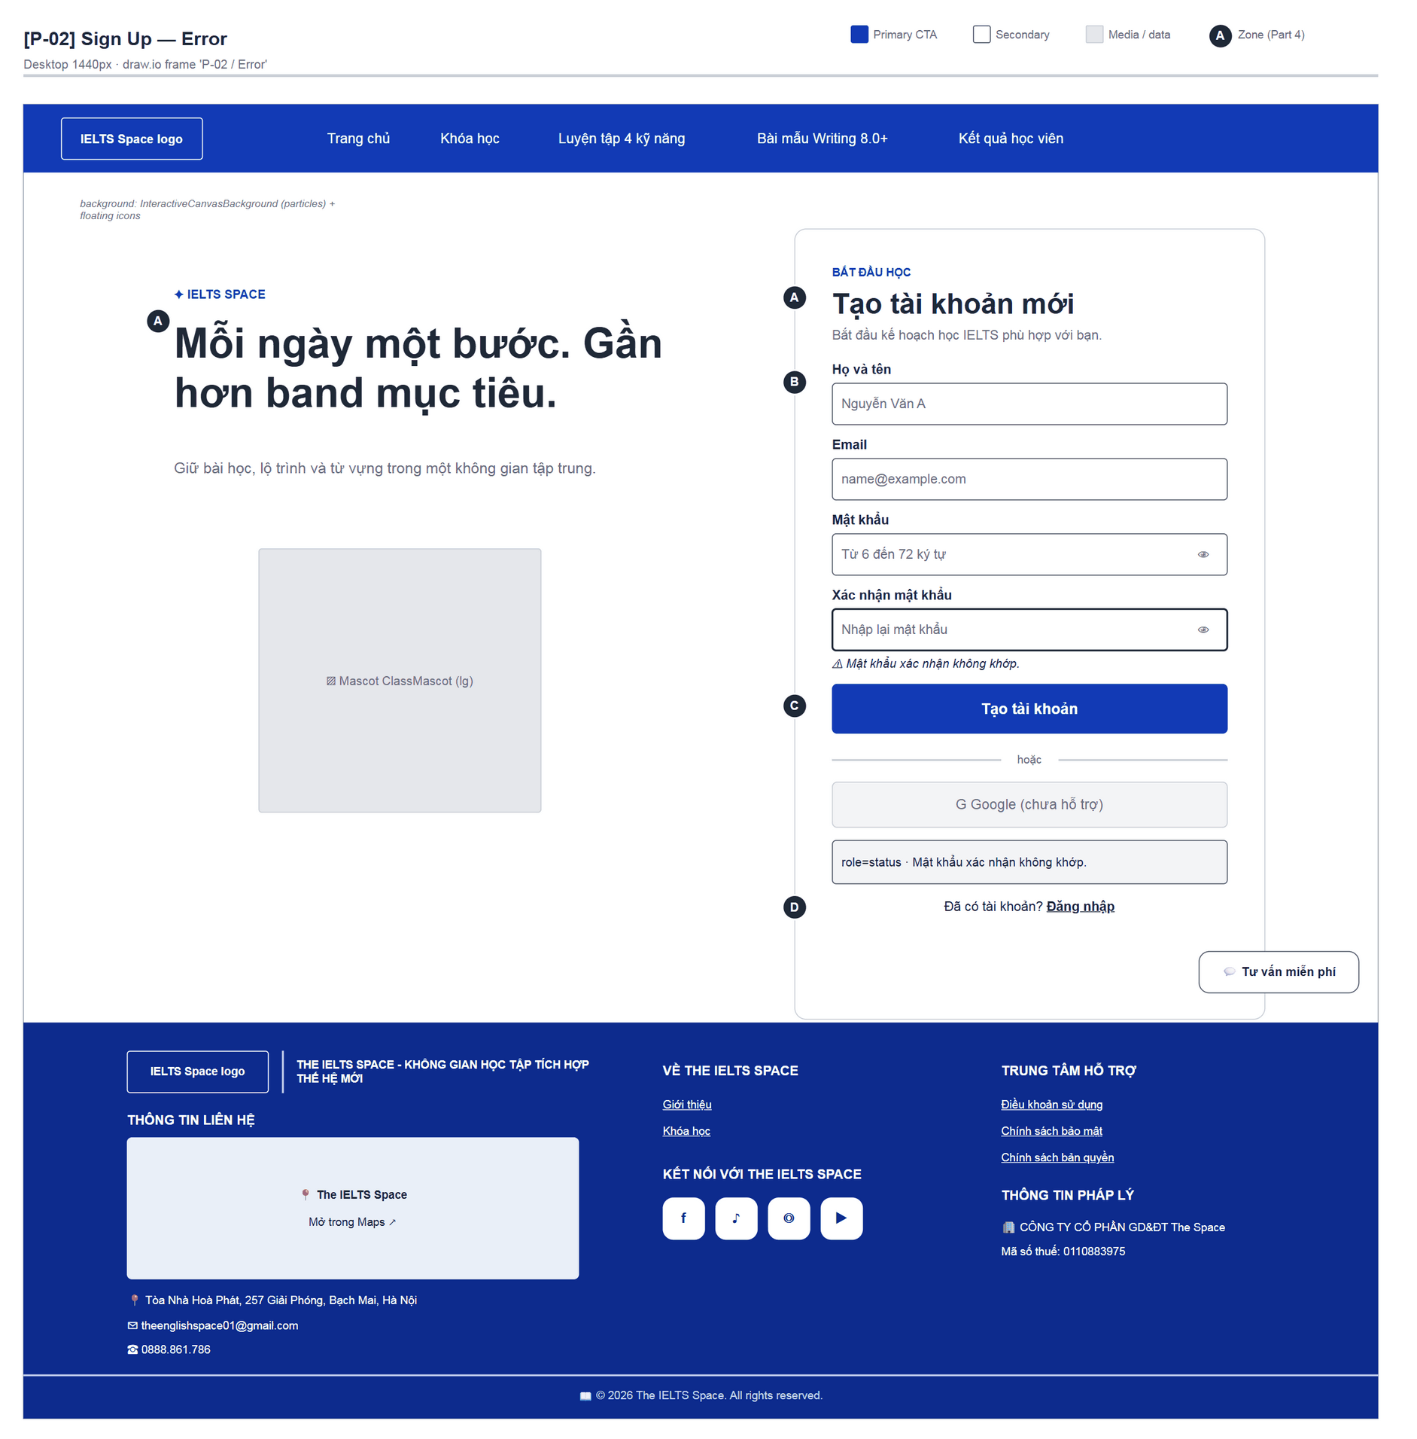
Figure 17 — [P-02] Sign Up — Error · draw.io frame 'P-02 / Error'

4.3 — Forgot Password (P-03)
Page ID | P-03
Screen name | Forgot Password
Design file | draw.io — diagrams/wireframes/P-03_ForgotPassword.drawio — frames 'P-03 / Populated', 'P-03 / Success'
SRS Feature | FT-04
SRS Scenario | SC-01
Roles with access | Guest
Route | /forgot-password
Nav level | AUTH
Status | MVP
Flow(s) | F-01

Request a password reset code by email without revealing whether the email exists.

Screen States
State | When It Appears | Design File Frame
Loading | “Đang gửi…” | N/A (button disabled)
Populated — default | Single email field | P-03 / Populated
Success | Sent: “Nếu email tồn tại, mã đặt lại đã được tạo. (Môi trường demo: lấy mã từ log/Swagger BE.)”; button becomes “Gửi lại mã” | P-03 / Success
Error | “Không gửi được yêu cầu. Thử lại.” | Status area as in P-03 / Success

Layout Description
Layout zones — P-03 Forgot Password
┌────────────────────────────────┐
│ [A] IELTS SPACE · Quên mật khẩu│
│ [B] Email │
│ [C] [ Gửi mã đặt lại ] status │
│ [D] Tôi đã có mã … · Quay lại │
└────────────────────────────────┘

Zone descriptions:
- Zone A: Ambient “Quên mật khẩu? Khôi phục nhanh.”; header “Quên mật khẩu” / “Chúng tôi sẽ xử lý mã đặt lại cho email của bạn.”
- Zone B: Email (name@example.com).
- Zone C: “Gửi mã đặt lại” → “Gửi lại mã”; role=status message.
- Zone D: After sending: “Tôi đã có mã — đặt lại mật khẩu” (→ P-04) · “Quay lại đăng nhập” (→ P-01).

Key Interactions
User Action | What Happens | Notes
Submit email | Generic message, stays on the page | FT-04; no account enumeration
“Tôi đã có mã” | → P-04
“Quay lại đăng nhập” | → P-01

Mockup
Mockup / Wireframe — draw.io
Design file: diagrams/wireframes/P-03_ForgotPassword.drawio
Frames: 'P-03 / Populated', 'P-03 / Success'
Images below are exported from draw.io (scripts/export_diagrams.py); edit the .drawio file, then rebuild this document.

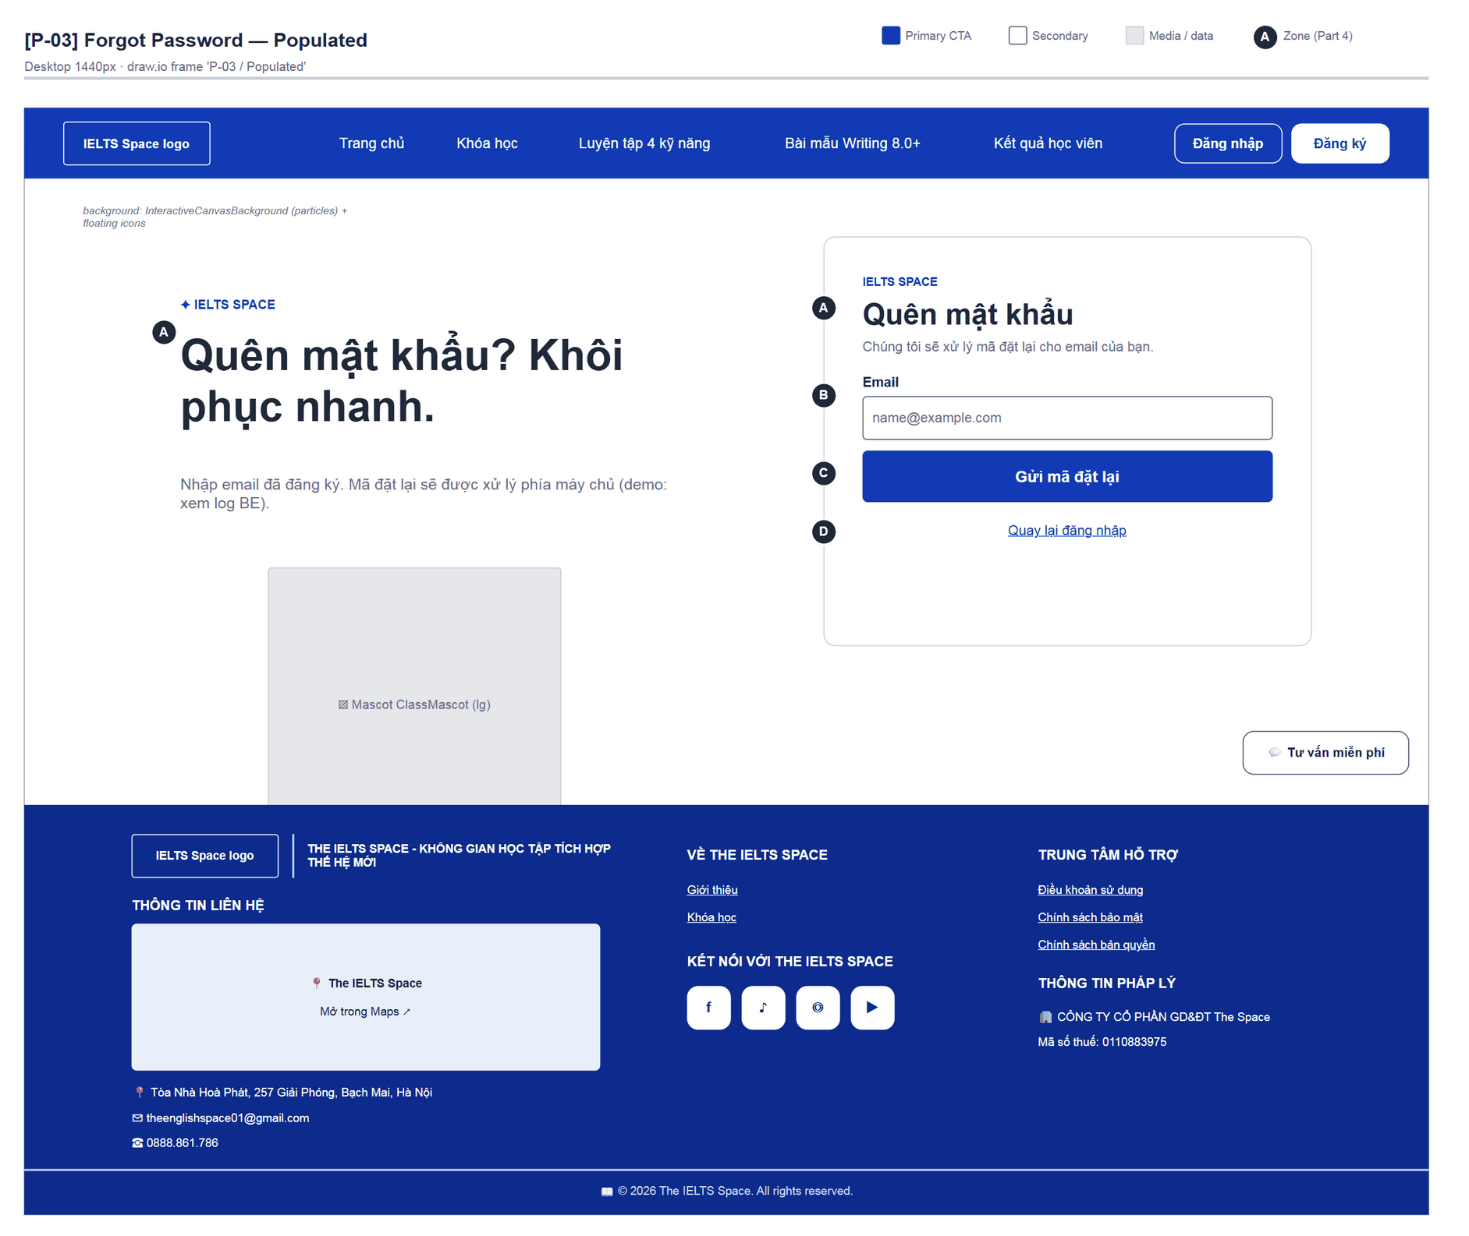
Figure 18 — [P-03] Forgot Password — Populated · draw.io frame 'P-03 / Populated'
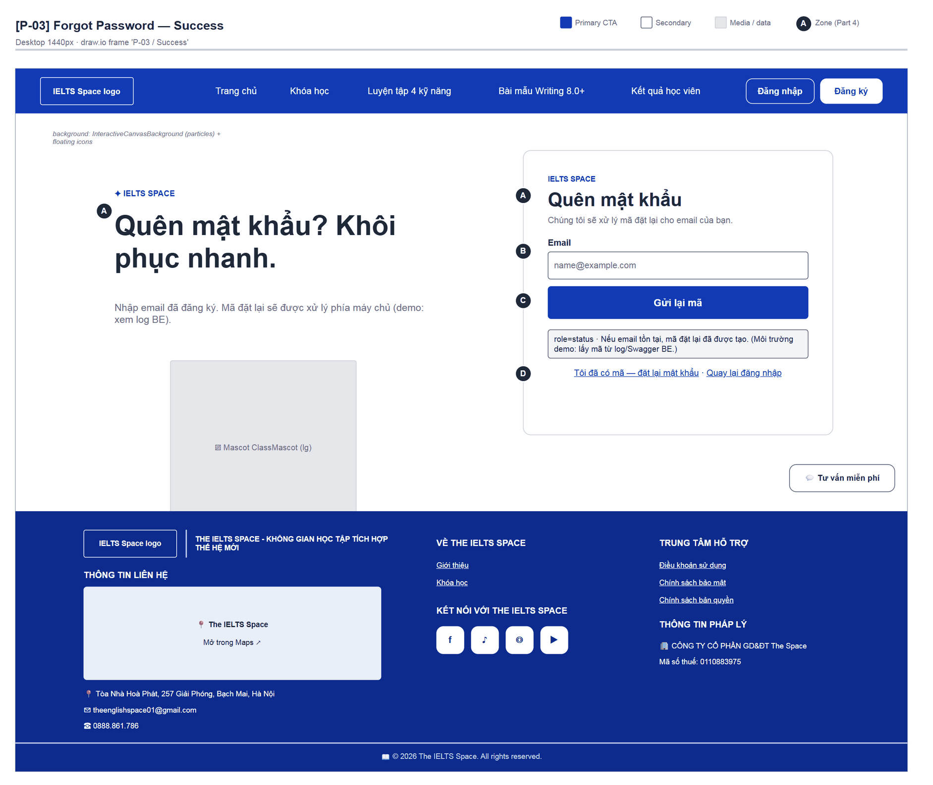
Figure 19 — [P-03] Forgot Password — Success · draw.io frame 'P-03 / Success'

4.4 — Reset Password (P-04)
Page ID | P-04
Screen name | Reset Password
Design file | draw.io — diagrams/wireframes/P-04_ResetPassword.drawio — frames 'P-04 / Populated', 'P-04 / Success', 'P-04 / Error'
SRS Feature | FT-04
SRS Scenario | SC-01
Roles with access | Guest
Route | /reset-password
Nav level | AUTH
Status | MVP
Flow(s) | F-01

Set a new password with a reset code (typed in, not read from the URL).

Screen States
State | When It Appears | Design File Frame
Loading | “Đang xử lý…” | N/A
Populated — default | Code + password form | P-04 / Populated
Success | “Đặt lại mật khẩu thành công. Đang chuyển tới đăng nhập…”, then automatic redirect to P-01 after ~0.9 s | P-04 / Success
Error | “Không đặt lại được mật khẩu. Kiểm tra mã và thử lại.” or length / mismatch errors | P-04 / Error

Layout Description
Layout zones — P-04 Reset Password
┌────────────────────────────────┐
│ [A] Đặt lại mật khẩu │
│ [B] Mã đặt lại · Mật khẩu mới │
│ Xác nhận mật khẩu │
│ [C] [ Đặt lại mật khẩu ] │
│ [D] Chưa có mã? Yêu cầu lại · │
│ Đăng nhập │
└────────────────────────────────┘

Zone descriptions:
- Zone A: “Đặt lại mật khẩu” · “Nhập mã xác nhận và mật khẩu mới.”
- Zone B: Mã đặt lại (“Dán mã từ log/Swagger hoặc email”), Mật khẩu mới (6–72), Xác nhận (“Nhập lại mật khẩu mới”).
- Zone C: “Đặt lại mật khẩu” button, status.
- Zone D: “Chưa có mã? Yêu cầu lại” (→ P-03) · “Đăng nhập” (→ P-01).

Key Interactions
User Action | What Happens | Notes
Submit valid form | Success message → P-01 | FT-04
Wrong / expired code | Error message; input kept
“Yêu cầu lại” | → P-03

Mockup
Mockup / Wireframe — draw.io
Design file: diagrams/wireframes/P-04_ResetPassword.drawio
Frames: 'P-04 / Populated', 'P-04 / Success', 'P-04 / Error'
Images below are exported from draw.io (scripts/export_diagrams.py); edit the .drawio file, then rebuild this document.

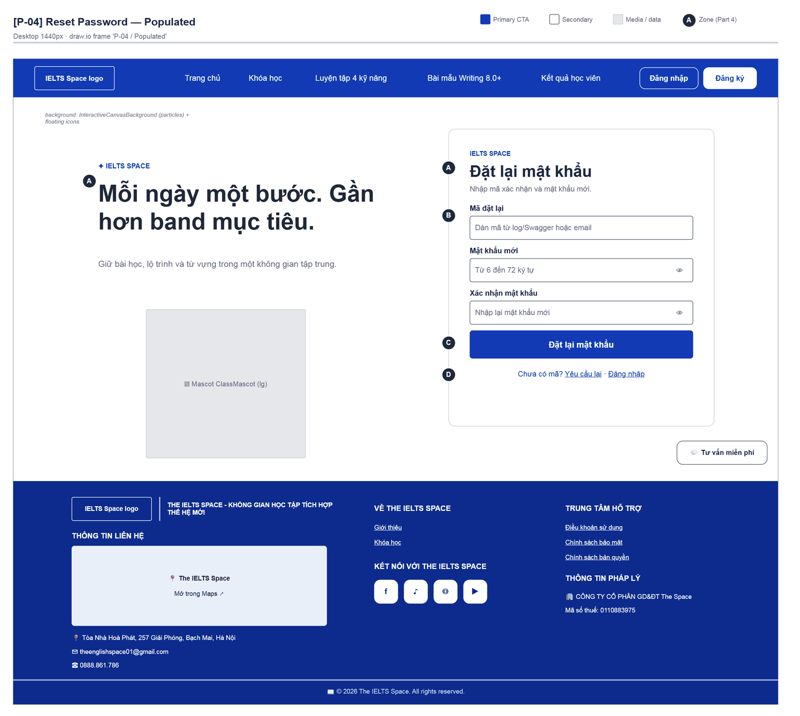
Figure 20 — [P-04] Reset Password — Populated · draw.io frame 'P-04 / Populated'
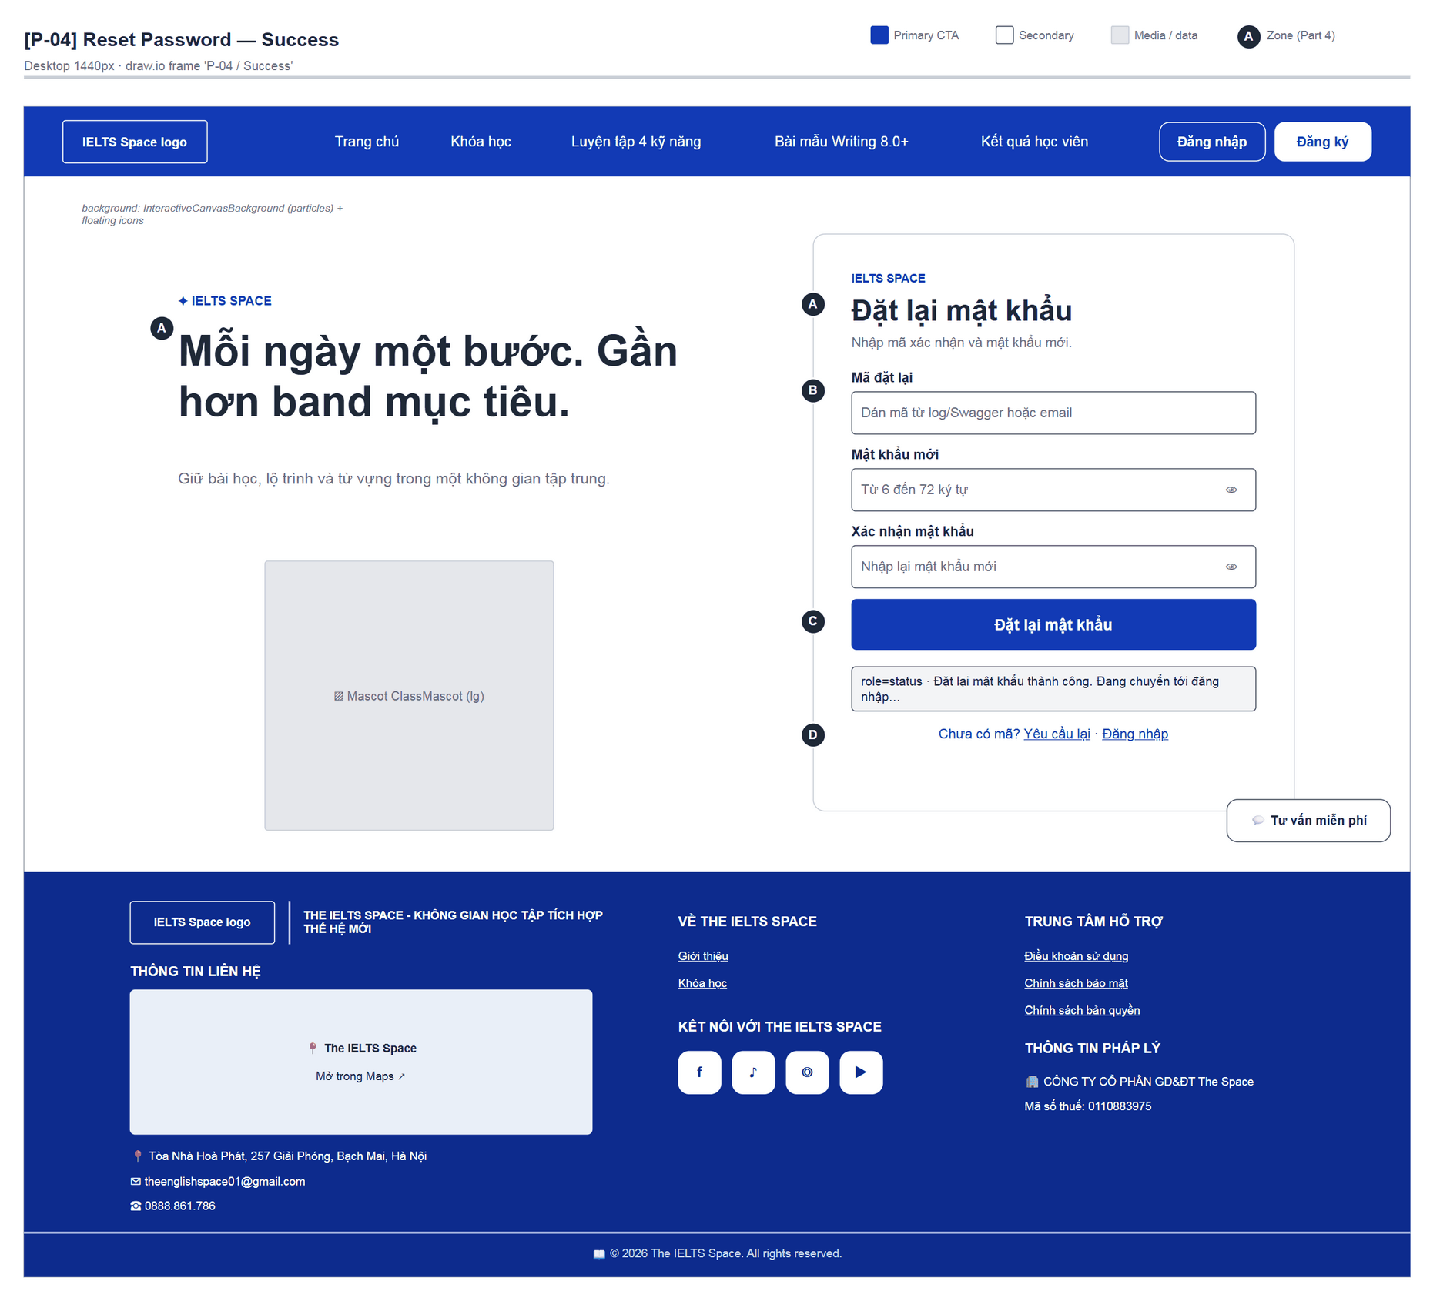
Figure 21 — [P-04] Reset Password — Success · draw.io frame 'P-04 / Success'
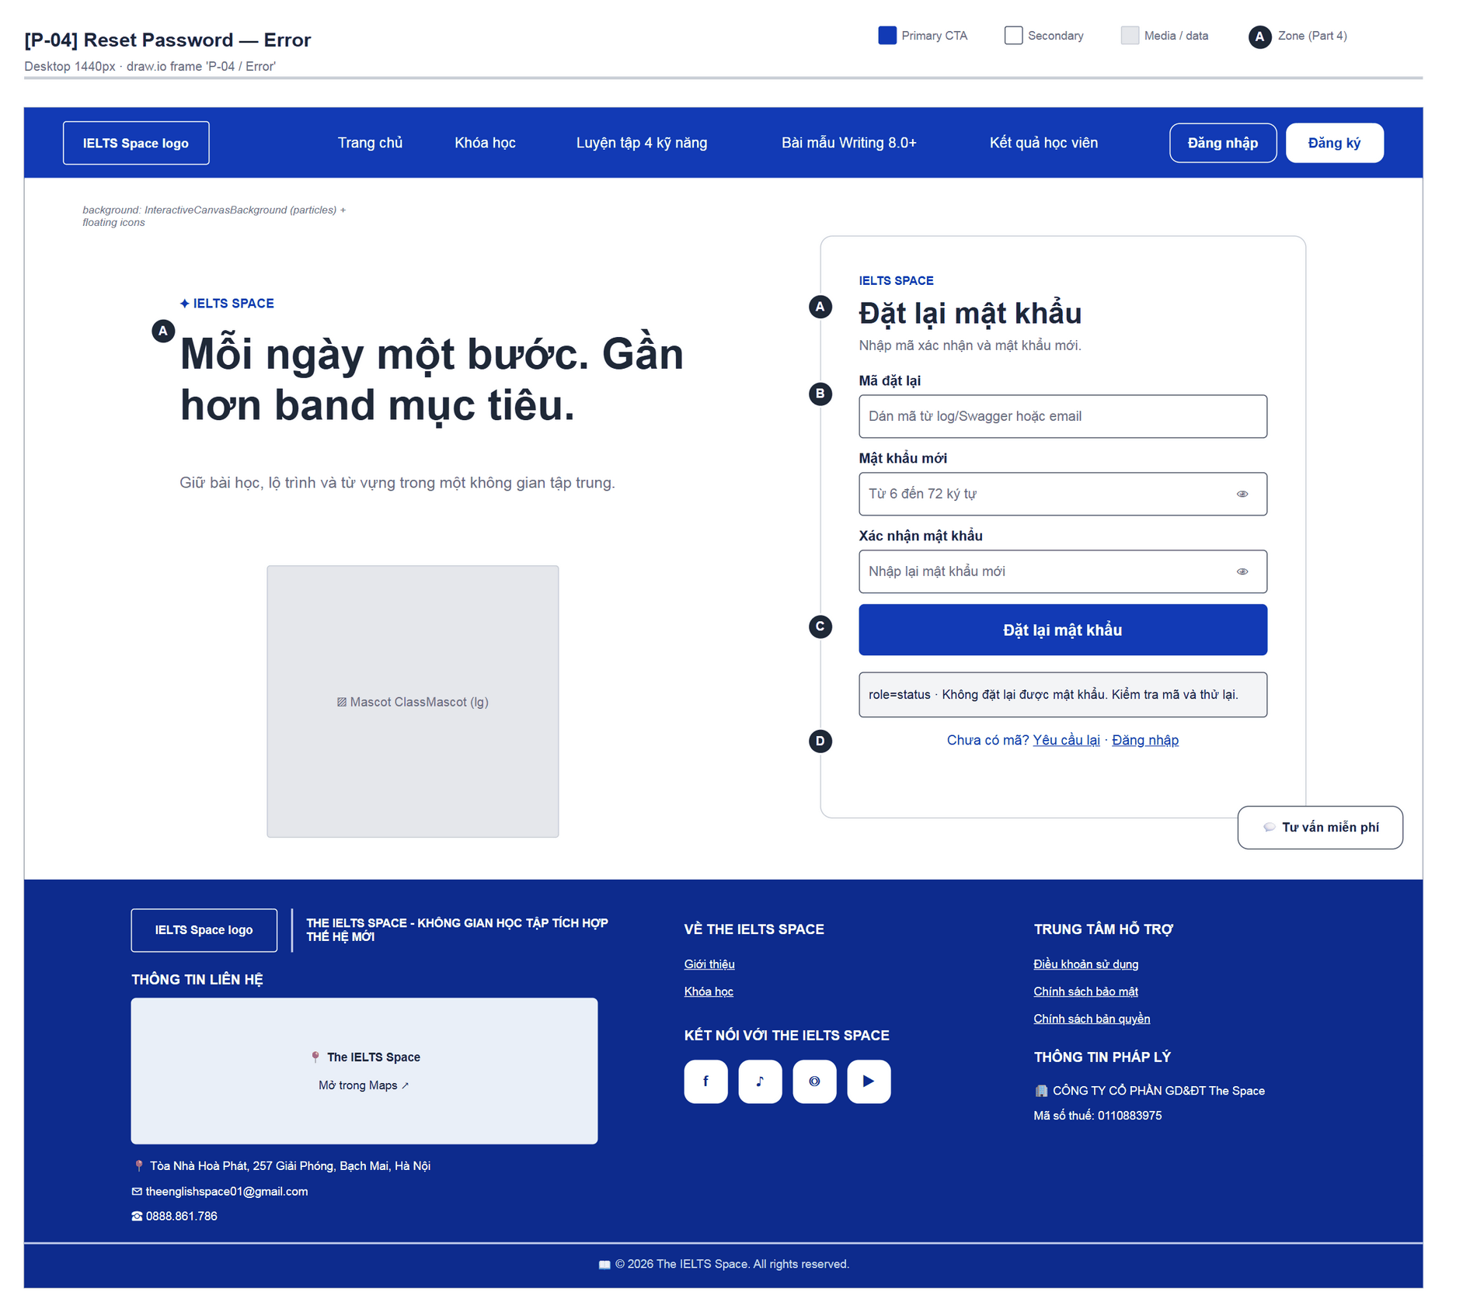
Figure 22 — [P-04] Reset Password — Error · draw.io frame 'P-04 / Error'

4.5 — Home / Landing (P-10)
Page ID | P-10
Screen name | Home / Landing
Design file | draw.io — diagrams/wireframes/P-10_Home.drawio — frames 'P-10 / Populated', 'P-10 / Populated · Learner'
SRS Feature | FT-10, FT-11
SRS Scenario | SC-06
Roles with access | Guest, Learner
Route | /home (/ → /home for Guest)
Nav level | PRIMARY
Status | MVP
Flow(s) | F-04, F-01

Public landing page for The IELTS Space; leads to practice tests, mentors and the plans / activation key table.

Screen States
State | When It Appears | Design File Frame
Loading | Learner: “Đang tải thông tin gói hiện tại…” in the plans block | Inside P-10 / Populated · Learner
Empty | N/A (static content) | N/A
Populated — Guest | Hero + introduction + features + commitments + teachers + feedback + plans | P-10 / Populated
Populated — Learner | Learner navbar; “Đang sử dụng · FREE” block or the not-connected notice | P-10 / Populated · Learner
Error | “Chưa thể tải thông tin gói hiện tại.” + “Thử tải lại” | Zone D

Layout Description
Layout zones — P-10 Home / Landing
┌─────────────────────────────────────────────┐
│ SiteNavbar (Trang chủ active) │
├─────────────────────────────────────────────┤
│ [A] Hero: tag · H1 · lead · 2 CTAs · 3 chips│
│ [B] Introduction: image | THE IELTS SPACE … │
│ [C] 4 features · commitments · teachers │
│ · learner feedback carousel │
│ [D] BẢNG GÓI DỊCH VỤ & KÍCH HOẠT MÃ │
│ FREE · Premium (30/90 days) · Points │
├─────────────────────────────────────────────┤
│ SiteFooter │
└─────────────────────────────────────────────┘

Zone descriptions:
- Zone A: Tag “KHÔNG GIAN HỌC IELTS CỦA BẠN”; H1 “Mỗi ngày một bước. Gần hơn band mục tiêu.”; CTAs “Khám phá bài luyện →” (/practice-tests) and “Gặp gỡ Mentor →” (#home-mentors); chips ✓ 4 kỹ năng · Lộ trình rõ ràng · Học theo nhịp riêng.
- Zone B: Introduction “THE IELTS SPACE KHÔNG GIAN HỌC TẬP TÍCH HỢP THẾ HỆ MỚI” + “Xem thêm về The IELTS Space →” (#home-features).
- Zone C: “TỐI ƯU HÀNH TRÌNH HỌC & LUYỆN THI IELTS” (4 cards), commitments 01–03, teachers + “Xem hồ sơ chuyên gia” (→ P-23), feedback carousel with “Tạm dừng / Tiếp tục chạy”.
- Zone D: Plans: Gói FREE mặc định, Gói Premium (Premium 30 Ngày / 90 Ngày), Thẻ nạp Point (50 / 100); each product opens P-10c.

Key Interactions
User Action | What Happens | Notes
“Khám phá bài luyện” | → /practice-tests; a Guest is redirected to P-01 (from) | F-04
“Gặp gỡ Mentor” | Scrolls to #home-mentors
“Kích hoạt” / “Nạp Key” | Opens P-10c with the chosen product; focus returns to the button on close | FT-11
“Thử tải lại” (plans error) | Reloads the subscription | Learner

Mockup
Mockup / Wireframe — draw.io
Design file: diagrams/wireframes/P-10_Home.drawio
Frames: 'P-10 / Populated', 'P-10 / Populated · Learner'
Images below are exported from draw.io (scripts/export_diagrams.py); edit the .drawio file, then rebuild this document.

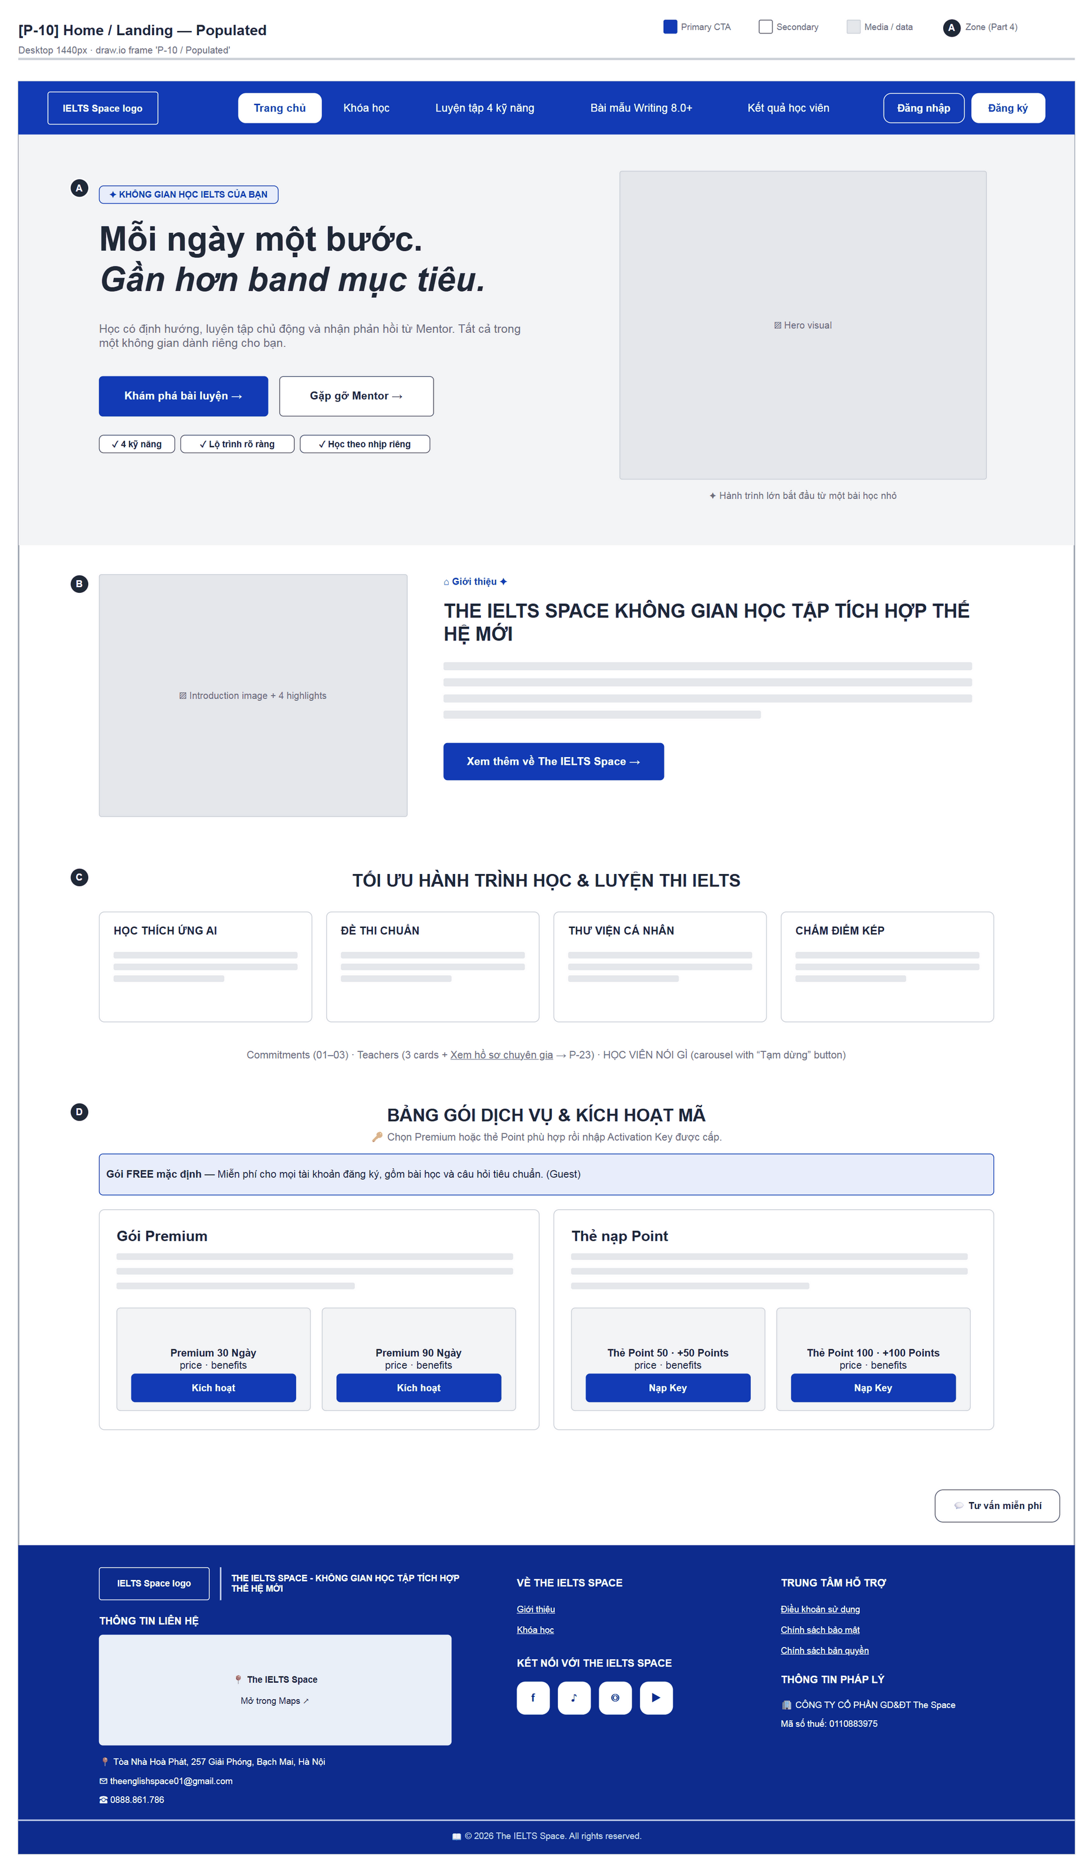
Figure 23 — [P-10] Home / Landing — Populated · draw.io frame 'P-10 / Populated'
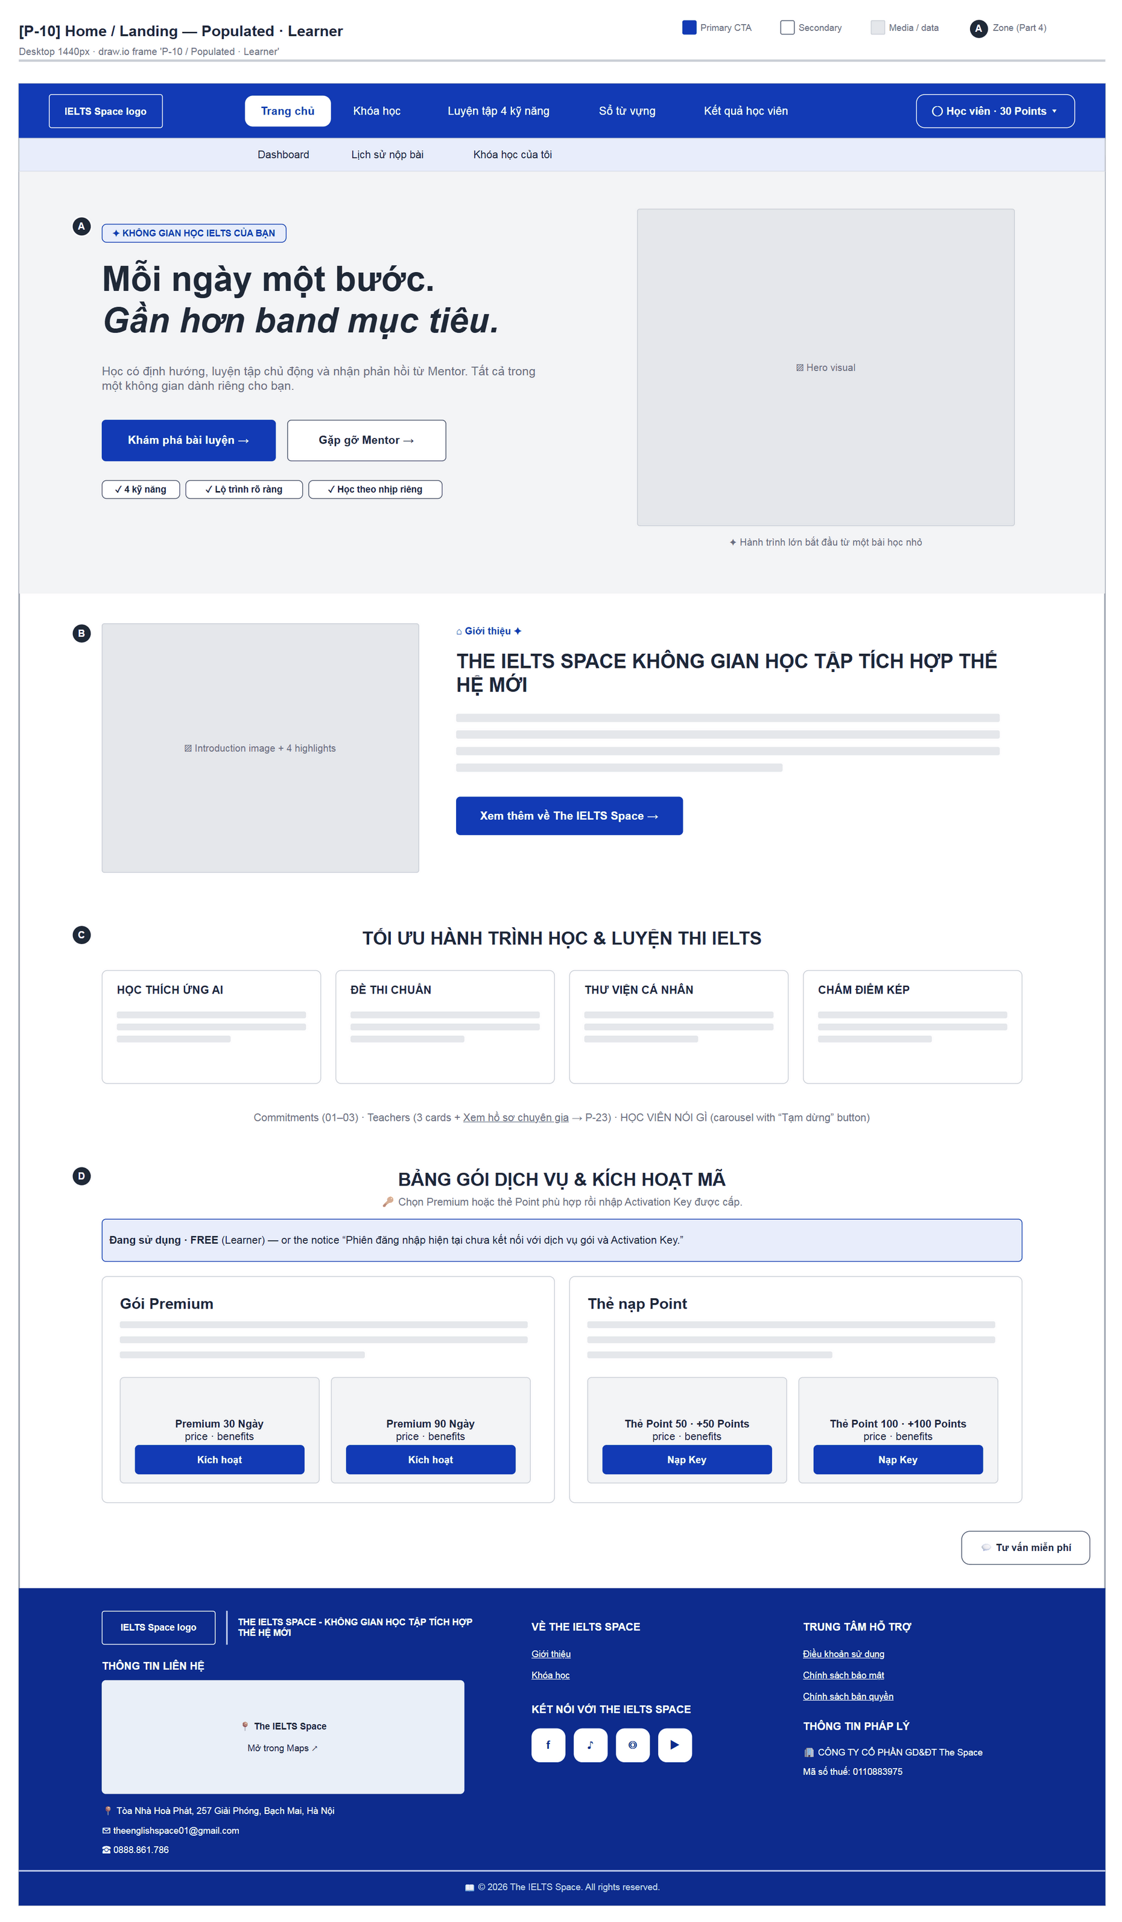
Figure 24 — [P-10] Home / Landing — Populated · Learner · draw.io frame 'P-10 / Populated · Learner'

4.6 — Key Activation Dialog (P-10c)
Page ID | P-10c
Screen name | Key Activation Dialog
Design file | draw.io — diagrams/wireframes/P-10c_KeyActivation.drawio — frames 'P-10c / Populated'
SRS Feature | FT-11, FT-12
SRS Scenario | SC-06
Roles with access | Guest, Learner
Route | Modal on P-10
Nav level | MODAL
Status | MVP
Flow(s) | F-04

Dialog to activate a Premium plan or top up Points with an Activation Key.

Screen States
State | When It Appears | Design File Frame
Populated — default | A product is selected | P-10c / Populated
Loading | “Đang kích hoạt…” | Zone C button disabled
Success | “Kích hoạt thành công” + “Hoàn tất” button | Replaces zones B/C
Error | “Vui lòng nhập mã kích hoạt.” / “Chưa xác nhận được kết quả kích hoạt. Hãy giữ nguyên mã và thử lại khi kết nối ổn định.” | Below the key field
Guest | “Đăng nhập tài khoản của bạn để kích hoạt gói hoặc nạp điểm.” + “Đăng nhập” | P-10c / Populated (note)
Unavailable | Demo Learner session: “Phiên đăng nhập demo chưa hỗ trợ kích hoạt Key…” (see Appendix B G-04) | P-10c / Populated (note)

Layout Description
Layout zones — P-10c Key Activation Dialog
┌──────────────────────────────┐
│ [A] Kích hoạt Gói / Nạp Key x│
│ selected product │
│ [B] Mã Activation Key │
│ [C] [Kích hoạt bằng Mã Key] │
└──────────────────────────────┘

Zone descriptions:
- Zone A: Title “Kích hoạt Gói / Nạp Key”, close button, selected product.
- Zone B: Field “Mã Activation Key” + description “Nhập đầy đủ mã được cấp, bao gồm tiền tố …”.
- Zone C: “Kích hoạt bằng Mã Key” button; or the sign-in block (Guest) / demo notice.

Key Interactions
User Action | What Happens | Notes
Enter a key and activate | Calls the access API; on success the plans block on P-10 refreshes | FT-11, FT-12
Guest clicks “Đăng nhập” | → P-01
Close | Dialog closes, focus restored

Mockup
Mockup / Wireframe — draw.io
Design file: diagrams/wireframes/P-10c_KeyActivation.drawio
Frames: 'P-10c / Populated'
Images below are exported from draw.io (scripts/export_diagrams.py); edit the .drawio file, then rebuild this document.

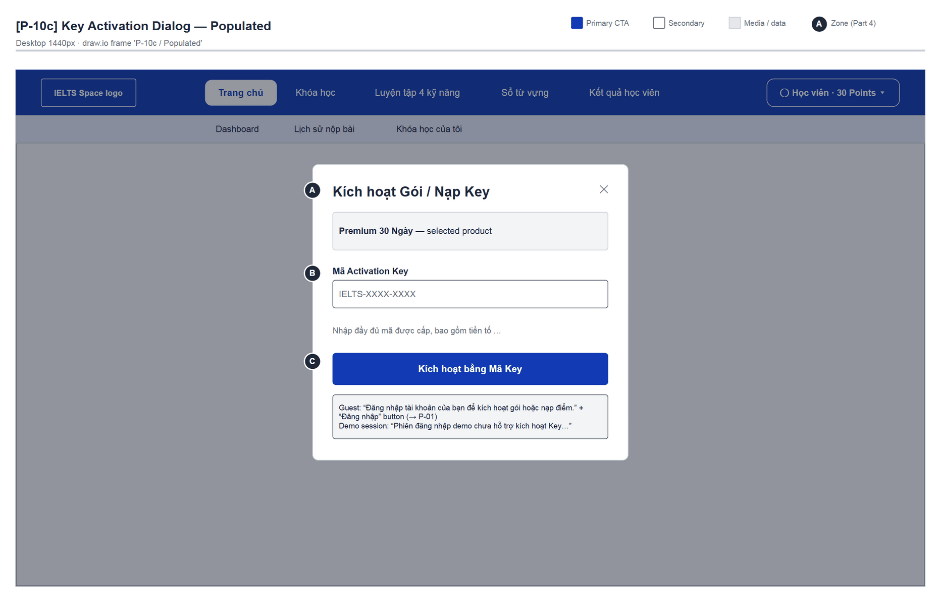
Figure 25 — [P-10c] Key Activation Dialog — Populated · draw.io frame 'P-10c / Populated'

4.7 — Course List (P-30)
Page ID | P-30
Screen name | Course List
Design file | draw.io — diagrams/wireframes/P-30_CourseList.drawio — frames 'P-30 / Populated', 'P-30 / Loading', 'P-30 / Empty', 'P-30 / Error'
SRS Feature | FT-20, FT-55
SRS Scenario | SC-01, SC-02
Roles with access | Learner
Route | /learn
Nav level | PRIMARY
Status | MVP
Flow(s) | F-02

Course catalogue by band (index of /learn). Highlights the course in progress or the course recommended by the placement test.

Screen States
State | When It Appears | Design File Frame
Loading | CourseCatalogSkeleton (“Đang tải danh sách khóa học…”) | P-30 / Loading
Empty | Filter has no course: “Không tìm thấy khóa học” / “Không có khóa học nào trong nhóm này.” + “Xem tất cả khóa học” | P-30 / Empty
Populated — default | Spotlight + course grid + placement card | P-30 / Populated
Error | “Chưa tải được nội dung” + “Thử lại”; PLACEMENT_REQUIRED redirects to P-30a instead | P-30 / Error

Layout Description
Layout zones — P-30 Course List
┌───────────────────────────────────────────────────┐
│ SiteNavbar · subnav (Test đầu vào … | Khóa học) │
├───────────────────────────────────────────────────┤
│ [A] KHÓA HỌC · Lộ trình IELTS theo band mục tiêu │
│ [B] Spotlight: Band 6.0 | Đang học dở | 3/8 chặng │
│ [ Học tiếp → ] mascot │
│ [C] Tất cả khóa học (Tất cả|Gợi ý|Đang học|…) │
│ [card] [card] [card] (3-column grid) │
│ [card] [D] [Chưa biết nên chọn band nào?] │
└───────────────────────────────────────────────────┘

Zone descriptions:
- Zone A: Eyebrow “Khóa học”, H1 “Lộ trình IELTS theo band mục tiêu”, lead “Mỗi khóa gồm các chặng topic ngắn…”.
- Zone B: Spotlight: the course in progress (label “Đang học dở”) or the suggested course (“Gợi ý cho bạn” / “Gợi ý bắt đầu”); band ticket; meta “{n} chặng topic · đầu vào khuyến nghị ~{band-1} · kết thúc bằng bài thi cuối khóa”; progress “x/y chặng”; CTA depends on status.
- Zone C: Section “Tất cả khóa học” + segment filter (only tabs with data, with counts); course cards: band pill, chip (Đã hoàn thành / Sẵn sàng thi cuối / Đang học / Gợi ý cho bạn), title, meta, progress or “Chưa bắt đầu”, CTA (“Xem lại lộ trình”, “Làm bài thi cuối khóa”, “Học tiếp”, “Bắt đầu học”). Sorted by bandLevel.
- Zone D: PlacementCard (only on the Tất cả tab): “Chưa biết nên chọn band nào?” · “Làm bài test đầu vào 4 kỹ năng miễn phí trong 15–20 phút…” · “Làm test đầu vào →”.

Key Interactions
User Action | What Happens | Notes
Click a card / spotlight | → P-30b /learn/courses/:courseId | FT-20
Choose a segment | Client-side filter; no match → Empty state
Click the PlacementCard | Currently → /placement (404); should be P-30a | Appendix B G-01
API returns PLACEMENT_REQUIRED | Redirect to /learn/placement with a notice | BR-36, BR-40

Mockup
Mockup / Wireframe — draw.io
Design file: diagrams/wireframes/P-30_CourseList.drawio
Frames: 'P-30 / Populated', 'P-30 / Loading', 'P-30 / Empty', 'P-30 / Error'
Images below are exported from draw.io (scripts/export_diagrams.py); edit the .drawio file, then rebuild this document.

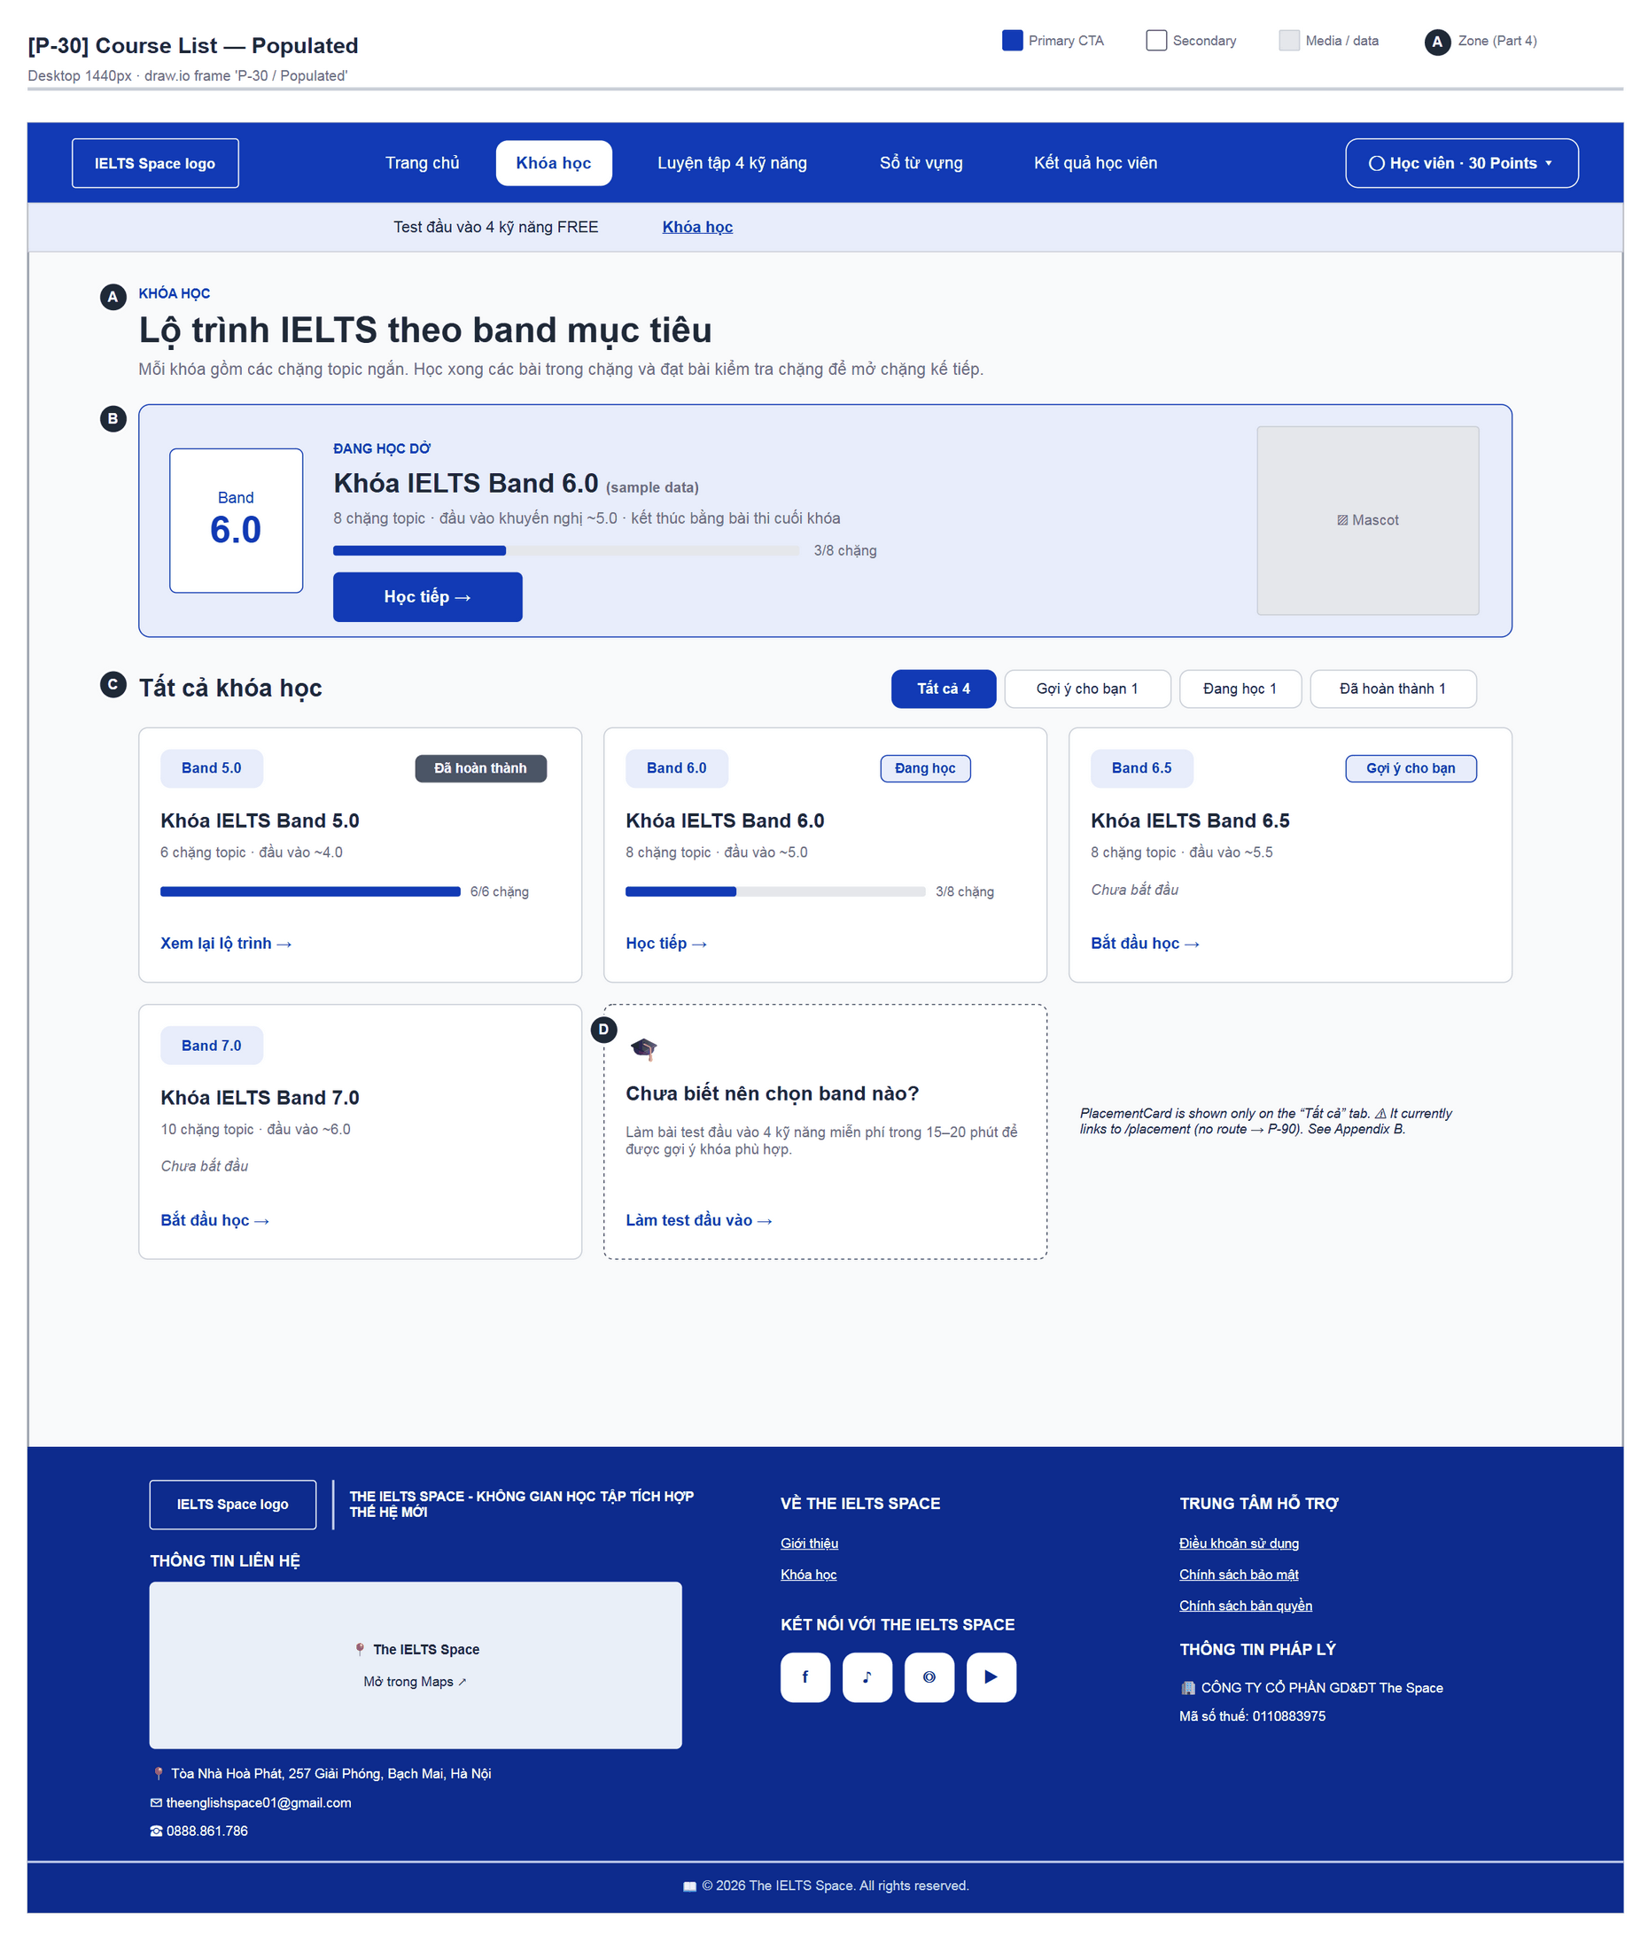
Figure 26 — [P-30] Course List — Populated · draw.io frame 'P-30 / Populated'
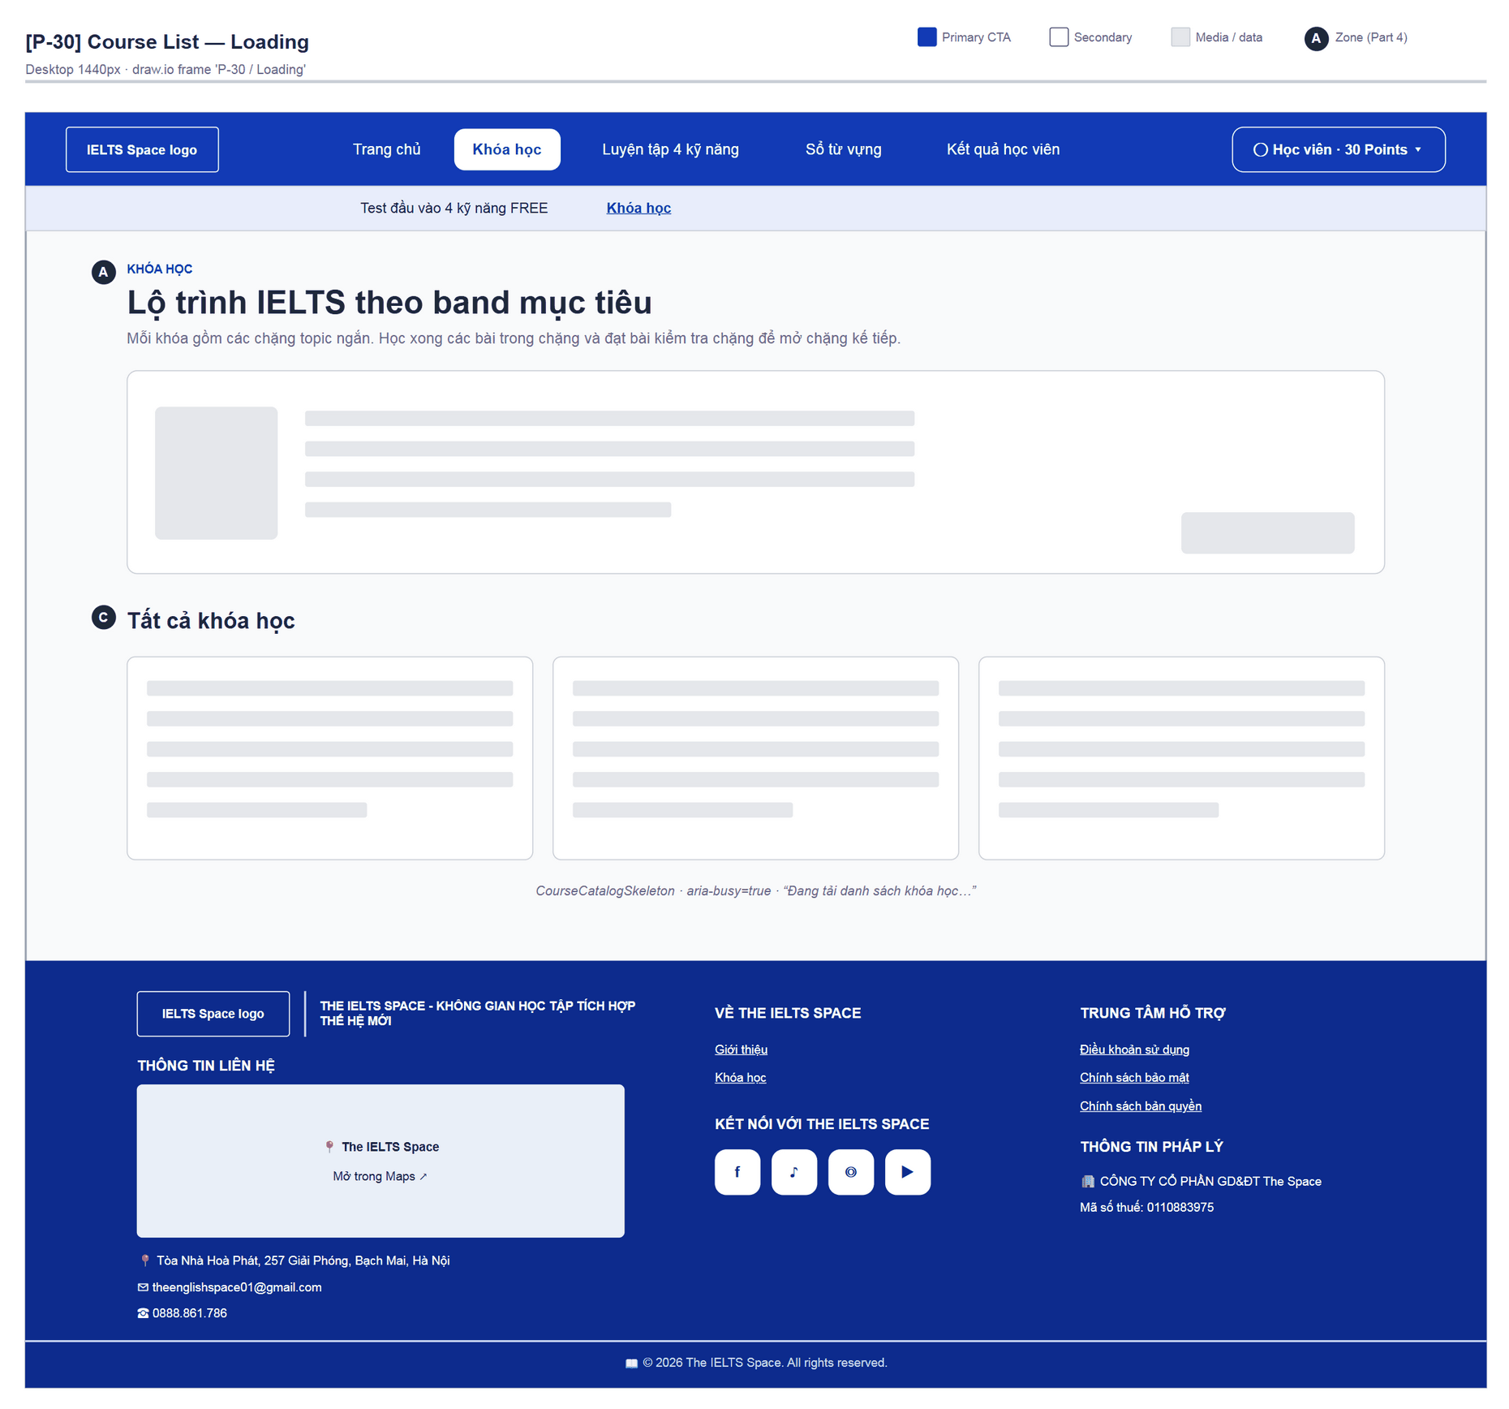
Figure 27 — [P-30] Course List — Loading · draw.io frame 'P-30 / Loading'
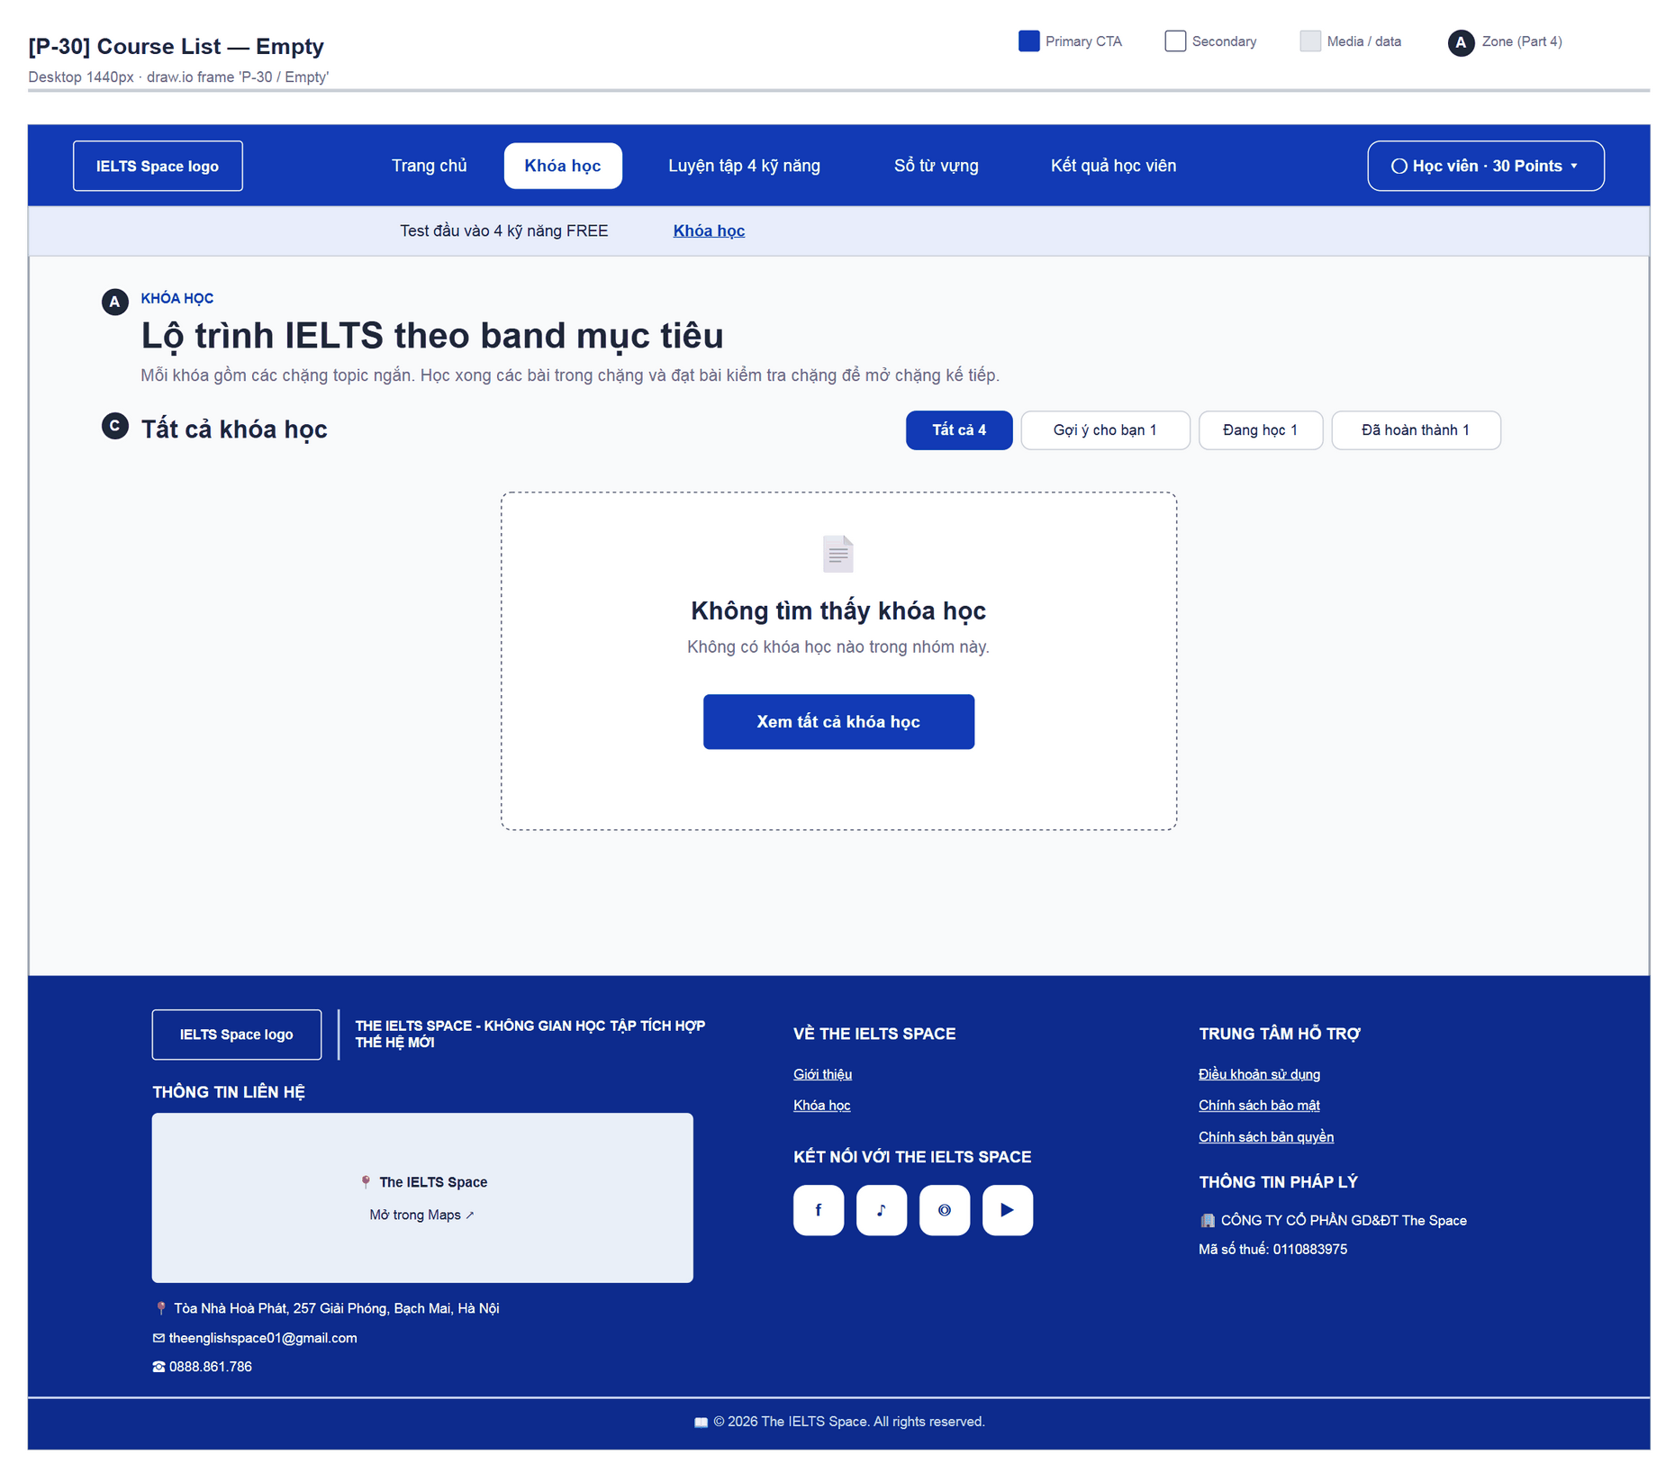
Figure 28 — [P-30] Course List — Empty · draw.io frame 'P-30 / Empty'
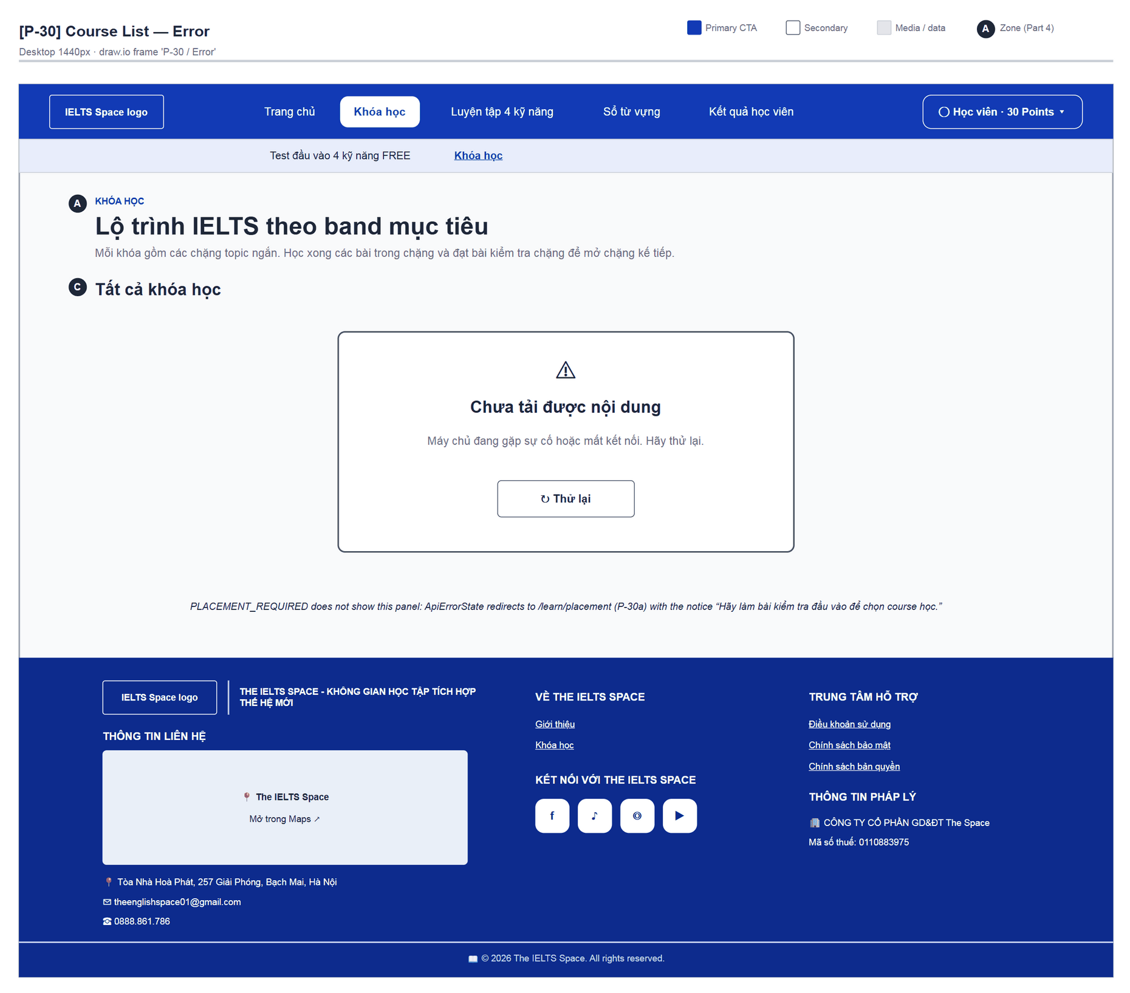
Figure 29 — [P-30] Course List — Error · draw.io frame 'P-30 / Error'

4.8 — Placement Test (P-30a)
Page ID | P-30a
Screen name | Placement Test
Design file | draw.io — diagrams/wireframes/P-30a_Placement.drawio — frames 'P-30a / Survey', 'P-30a / Survey Summary', 'P-30a / Test Hub', 'P-30a / Exam — Reading / Listening', 'P-30a / Exam — Writing', 'P-30a / Exam — Speaking', 'P-30a / Grading', 'P-30a / Result Report'
SRS Feature | FT-09, FT-35
SRS Scenario | SC-01
Roles with access | Learner
Route | /learn/placement
Nav level | SUB
Status | MVP
Flow(s) | F-02, F-05

One-time four-skill placement test: goal survey → test (hub + exam shell) → grading → report and course recommendation.

Screen States
State | When It Appears | Design File Frame
Loading | “Đang tải bài kiểm tra đầu vào…” / “Đang tải đề…” / “Đang tải báo cáo…” | LoadingState (as the P-91 panel)
Survey | No usable attempt — 3 chat-style questions | P-30a / Survey
Survey Summary | Target band chosen | P-30a / Survey Summary
Test Hub | Attempt IN_PROGRESS | P-30a / Test Hub
Exam — Reading / Listening | An objective section is open | P-30a / Exam — Reading / Listening
Exam — Writing | Writing Task 1/2 section is open | P-30a / Exam — Writing
Exam — Speaking | Speaking section is open | P-30a / Exam — Speaking
Grading | Submitted; polling until a band exists | P-30a / Grading
Result Report | Result available | P-30a / Result Report
Empty | “Chưa có bài kiểm tra đầu vào nào được mở. Hãy quay lại sau.” / “Đề này chưa có câu hỏi.” | lp-empty text
Error | ApiErrorState; submit failure “… Hãy thử nộp lại.” + “Thử nộp lại” | Test Hub footer

Layout Description
Layout zones — P-30a Placement Test
┌──────────────────────────────────────────────────┐
│ [A] Stepper: Khảo sát - Bài test - Kết quả │
├──────────────────────────────────────────────────┤
│ Survey: mascot + question bubble; chips/options │
│ Hub: [B] elapsed clock | [C] sections (5 rows) │
│ [D] Làm lại khảo sát │
│ Exam shell (full screen): top bar · part · body │
│ · question bar + [v] Nộp phần này │
│ Report: [B] current band > target [C] feasibility│
│ [D] per-skill analysis [E] course list │
└──────────────────────────────────────────────────┘

Zone descriptions:
- Zone A: PlacementStepper “Khảo sát / Bài test / Kết quả”; connectors fill with progress (survey answers, sections submitted).
- Zone B: Survey: 3 questions “Bạn dự định thi IELTS khi nào?” (Tháng m/yyyy ×6, “Thời gian khác 📅”, “Chưa có kế hoạch”) · “Bạn có thể dành bao nhiêu thời gian học mỗi ngày?” (Dưới 1 tiếng … Trên 3 tiếng) · “Mục tiêu điểm IELTS của bạn là?” (Dưới IELTS 5.5 … 8.0 trở lên); “← Câu trước”. Hub: card “Bài kiểm tra đầu vào” — “Bạn đã bắt đầu được” Giờ/Phút/Giây + no-time-limit note.
- Zone C: Summary dialog: “Bạn đã hoàn thành khảo sát!”, exam month, ~h/week, target band chart, “Tiếp tục”. Hub: “Phần thi của bạn” — Listening, Reading, Writing Task 1, Writing Task 2, Speaking; each row shows question count or minutes spent, button “Làm bài” / “Làm tiếp” (disabled once submitted); footer “Làm lần lượt từng phần. Bài được nộp tự động khi bạn hoàn thành phần cuối cùng.”
- Zone D: Hub: “Làm lại khảo sát”. Exam: question bar (numbered, answered in Primary, “x of n”) + ✓ “Nộp phần này” → dialog “Nộp phần Reading?” (“Bạn còn N câu chưa trả lời…”, “Làm tiếp” / “Nộp phần này”). Writing: Word count x/150, Mở bài / Thân bài / Kết bài, “Hoàn thành”, “Tra từ vựng” panel (Tra Việt-Anh / Tra Anh-Việt). Speaking: Hướng dẫn chung → Kiểm tra micro → each question (“Dừng & sang câu tiếp”). Report: per-skill analysis.
- Zone E: Report: “Lộ trình khóa học” — one card per course with badge “Đề xuất cho bạn” / “Ôn nền tảng” / “Nâng cao”, CTA “Bắt đầu học” / “Xem khóa học” → P-30b.

Key Interactions
User Action | What Happens | Notes
Pick a survey answer | Next question; question 3 saves the Learning Goal (failure only warns) | FT-09
“Tiếp tục” (summary) | Creates a PLACEMENT_TEST attempt (or resumes the existing one) → Hub | FT-35
Open a section | Opens the exam shell and records the section start (startAttemptSection) | Answers saved on blur
✕ in the exam shell | Save and return to the Hub; unsubmitted sections can be reopened
Submit the last section | completeSection → automatic submitAttempt → Grading | Submitted sections cannot be reopened
Grading | Polls GET /courses every 2 s, up to 45 times; success → Report | “Đang chấm bài của bạn…”
“Bắt đầu học” (recommended course) | → P-30b | BR-36

Mockup
Mockup / Wireframe — draw.io
Design file: diagrams/wireframes/P-30a_Placement.drawio
Frames: 'P-30a / Survey', 'P-30a / Survey Summary', 'P-30a / Test Hub', 'P-30a / Exam — Reading / Listening', 'P-30a / Exam — Writing', 'P-30a / Exam — Speaking', 'P-30a / Grading', 'P-30a / Result Report'
Images below are exported from draw.io (scripts/export_diagrams.py); edit the .drawio file, then rebuild this document.

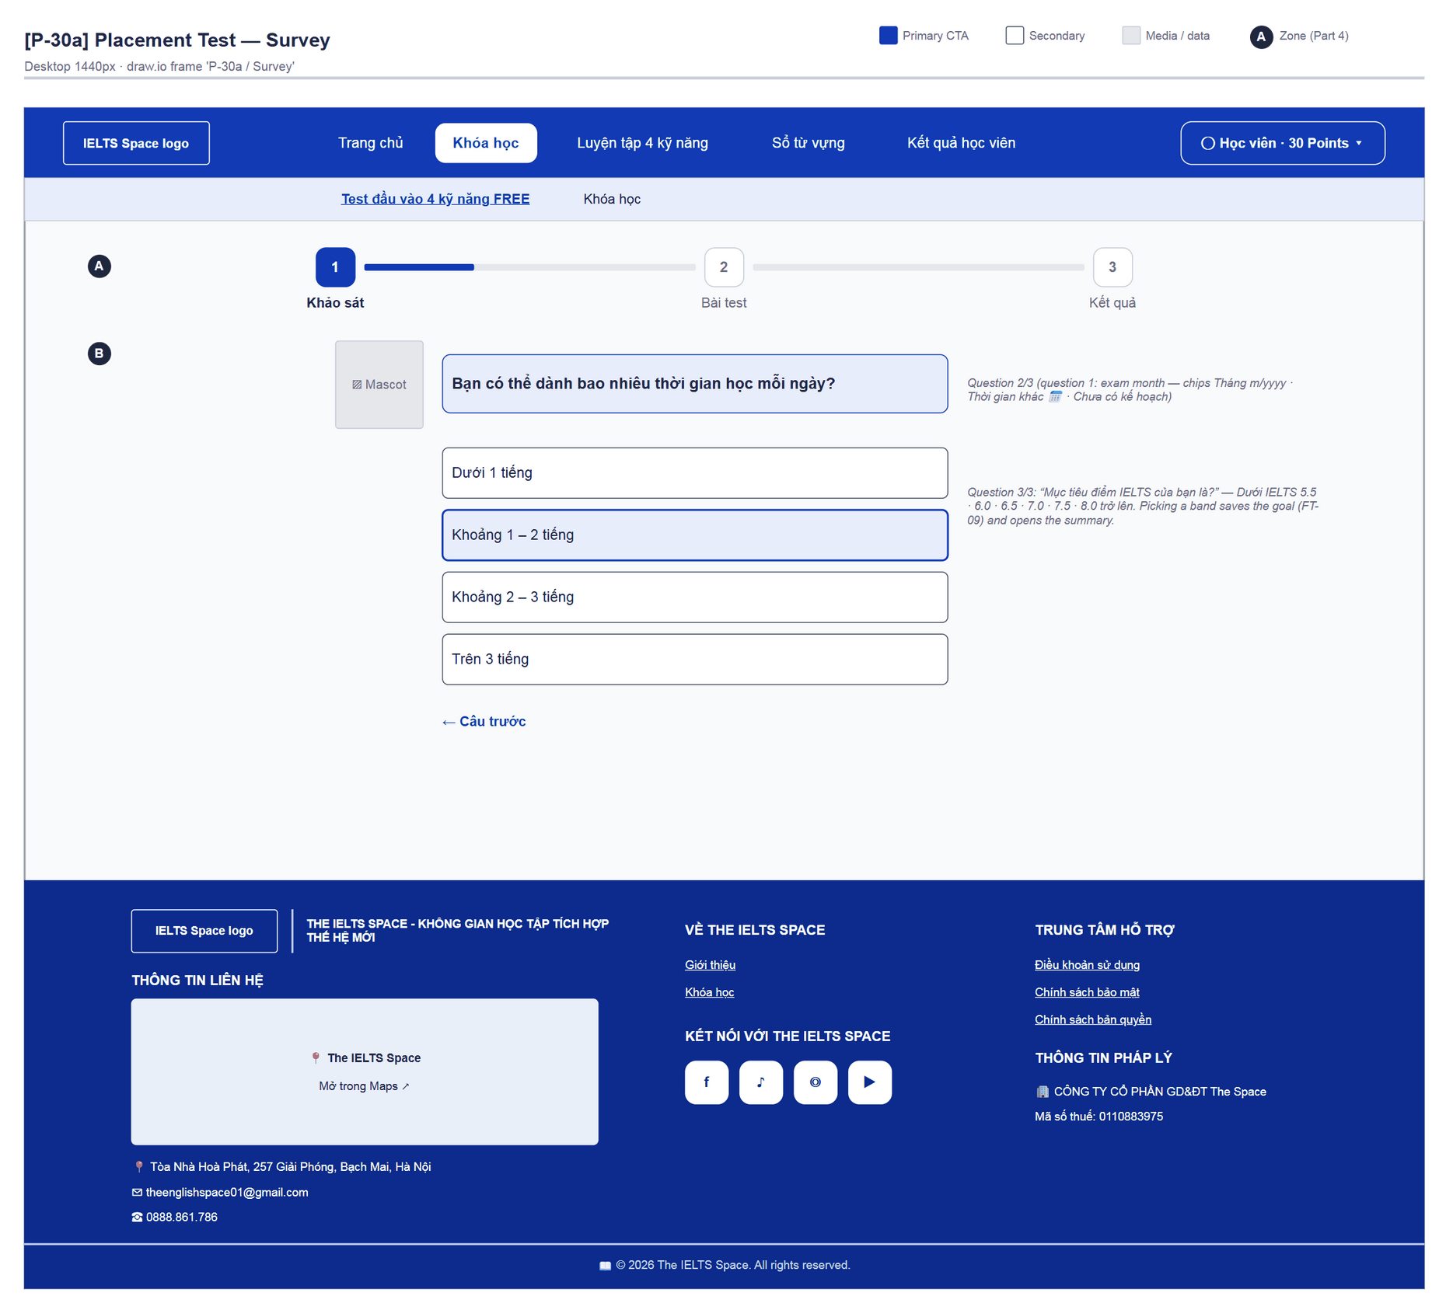
Figure 30 — [P-30a] Placement Test — Survey · draw.io frame 'P-30a / Survey'
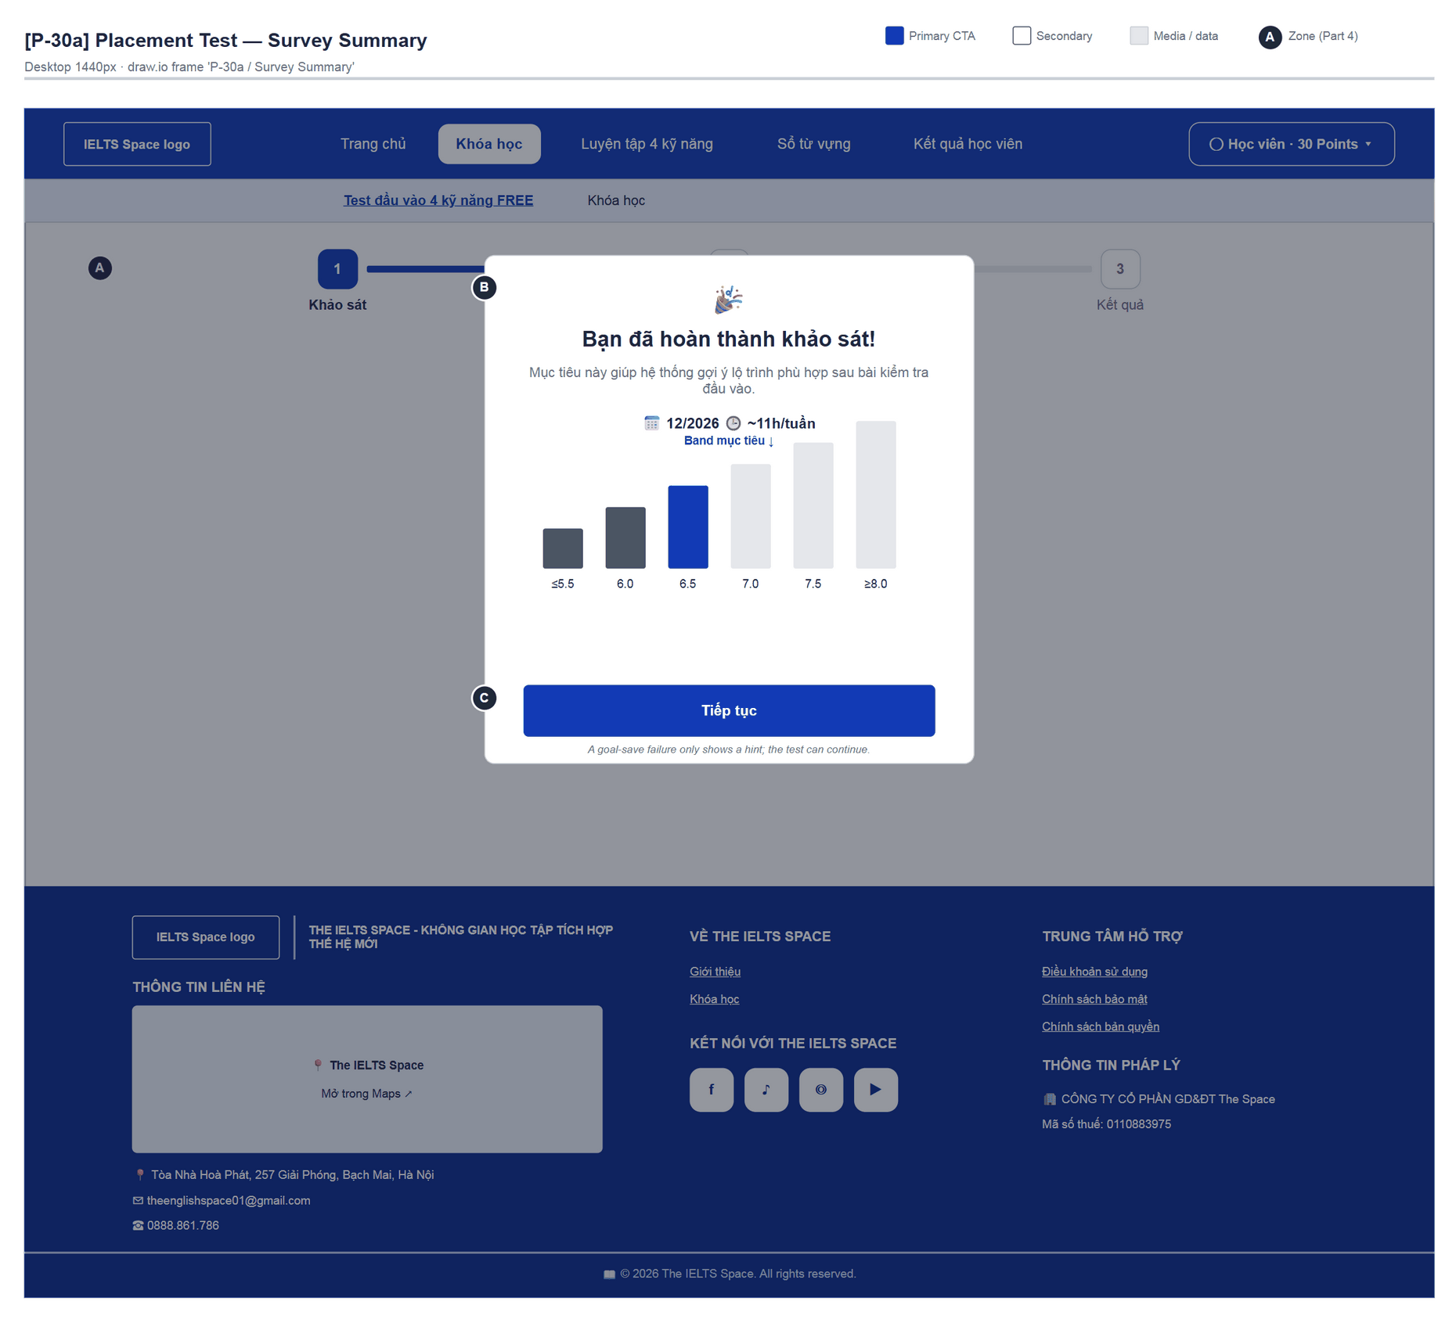
Figure 31 — [P-30a] Placement Test — Survey Summary · draw.io frame 'P-30a / Survey Summary'
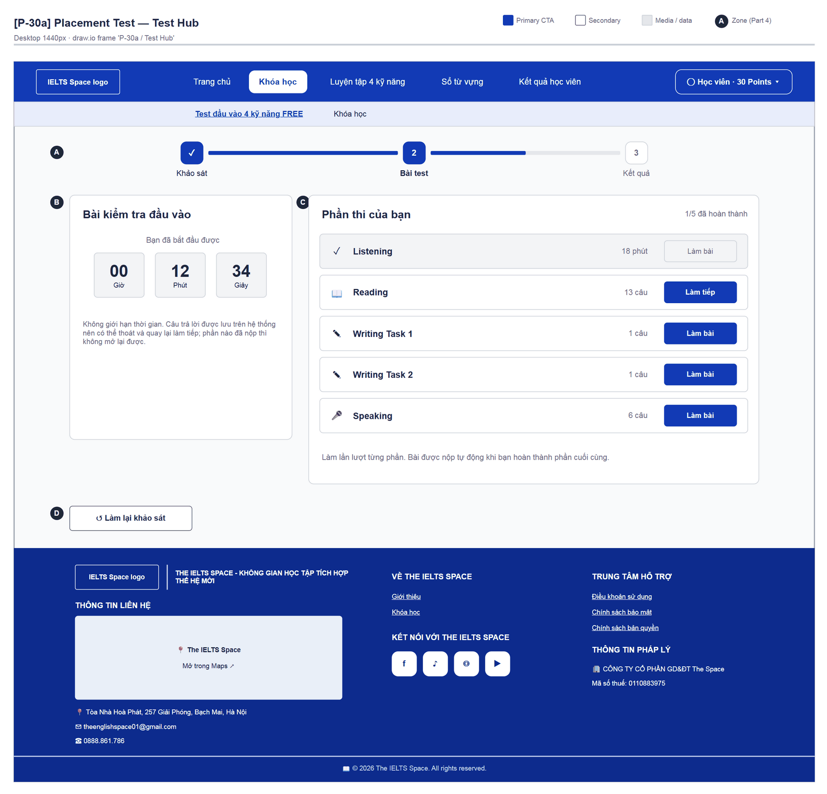
Figure 32 — [P-30a] Placement Test — Test Hub · draw.io frame 'P-30a / Test Hub'
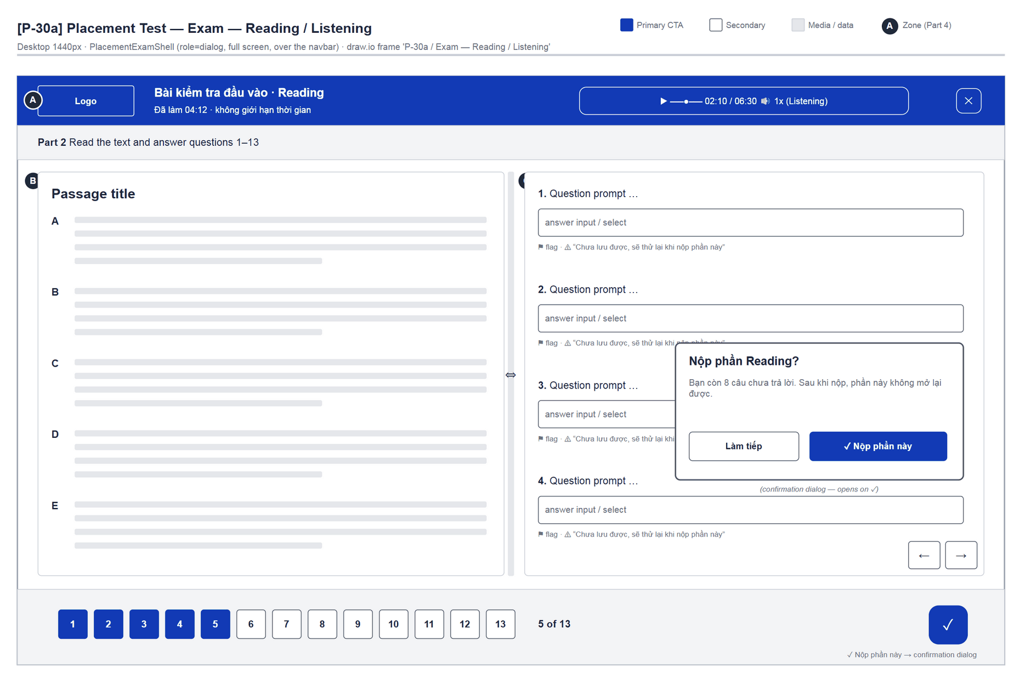
Figure 33 — [P-30a] Placement Test — Exam — Reading / Listening · draw.io frame 'P-30a / Exam — Reading / Listening'
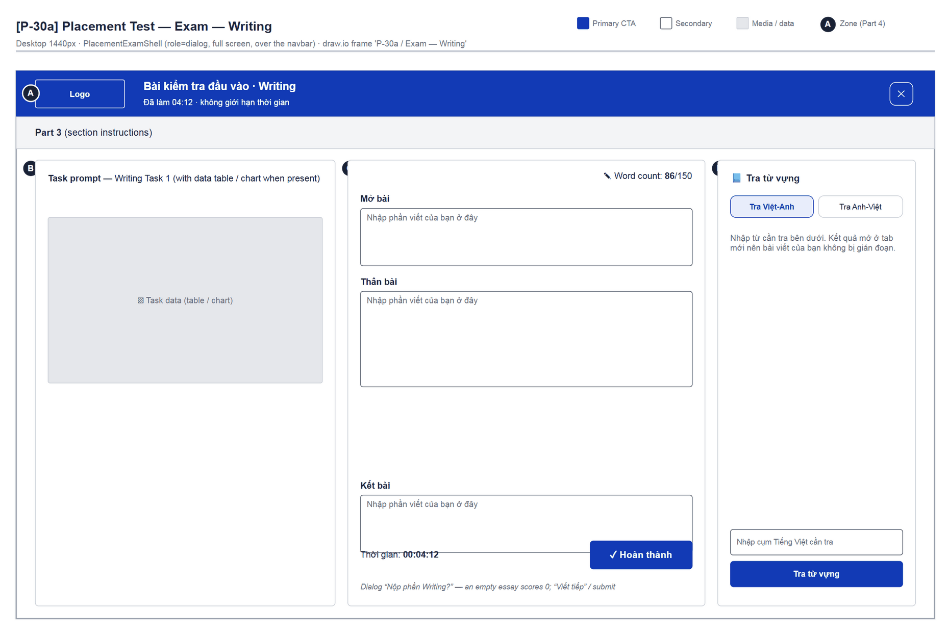
Figure 34 — [P-30a] Placement Test — Exam — Writing · draw.io frame 'P-30a / Exam — Writing'
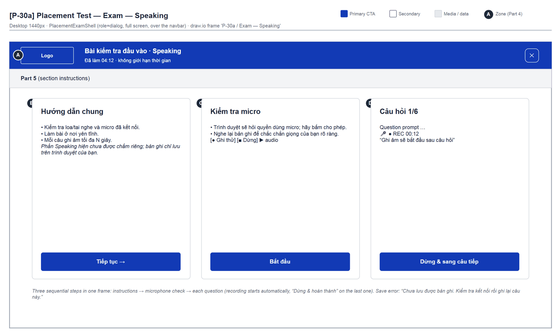
Figure 35 — [P-30a] Placement Test — Exam — Speaking · draw.io frame 'P-30a / Exam — Speaking'
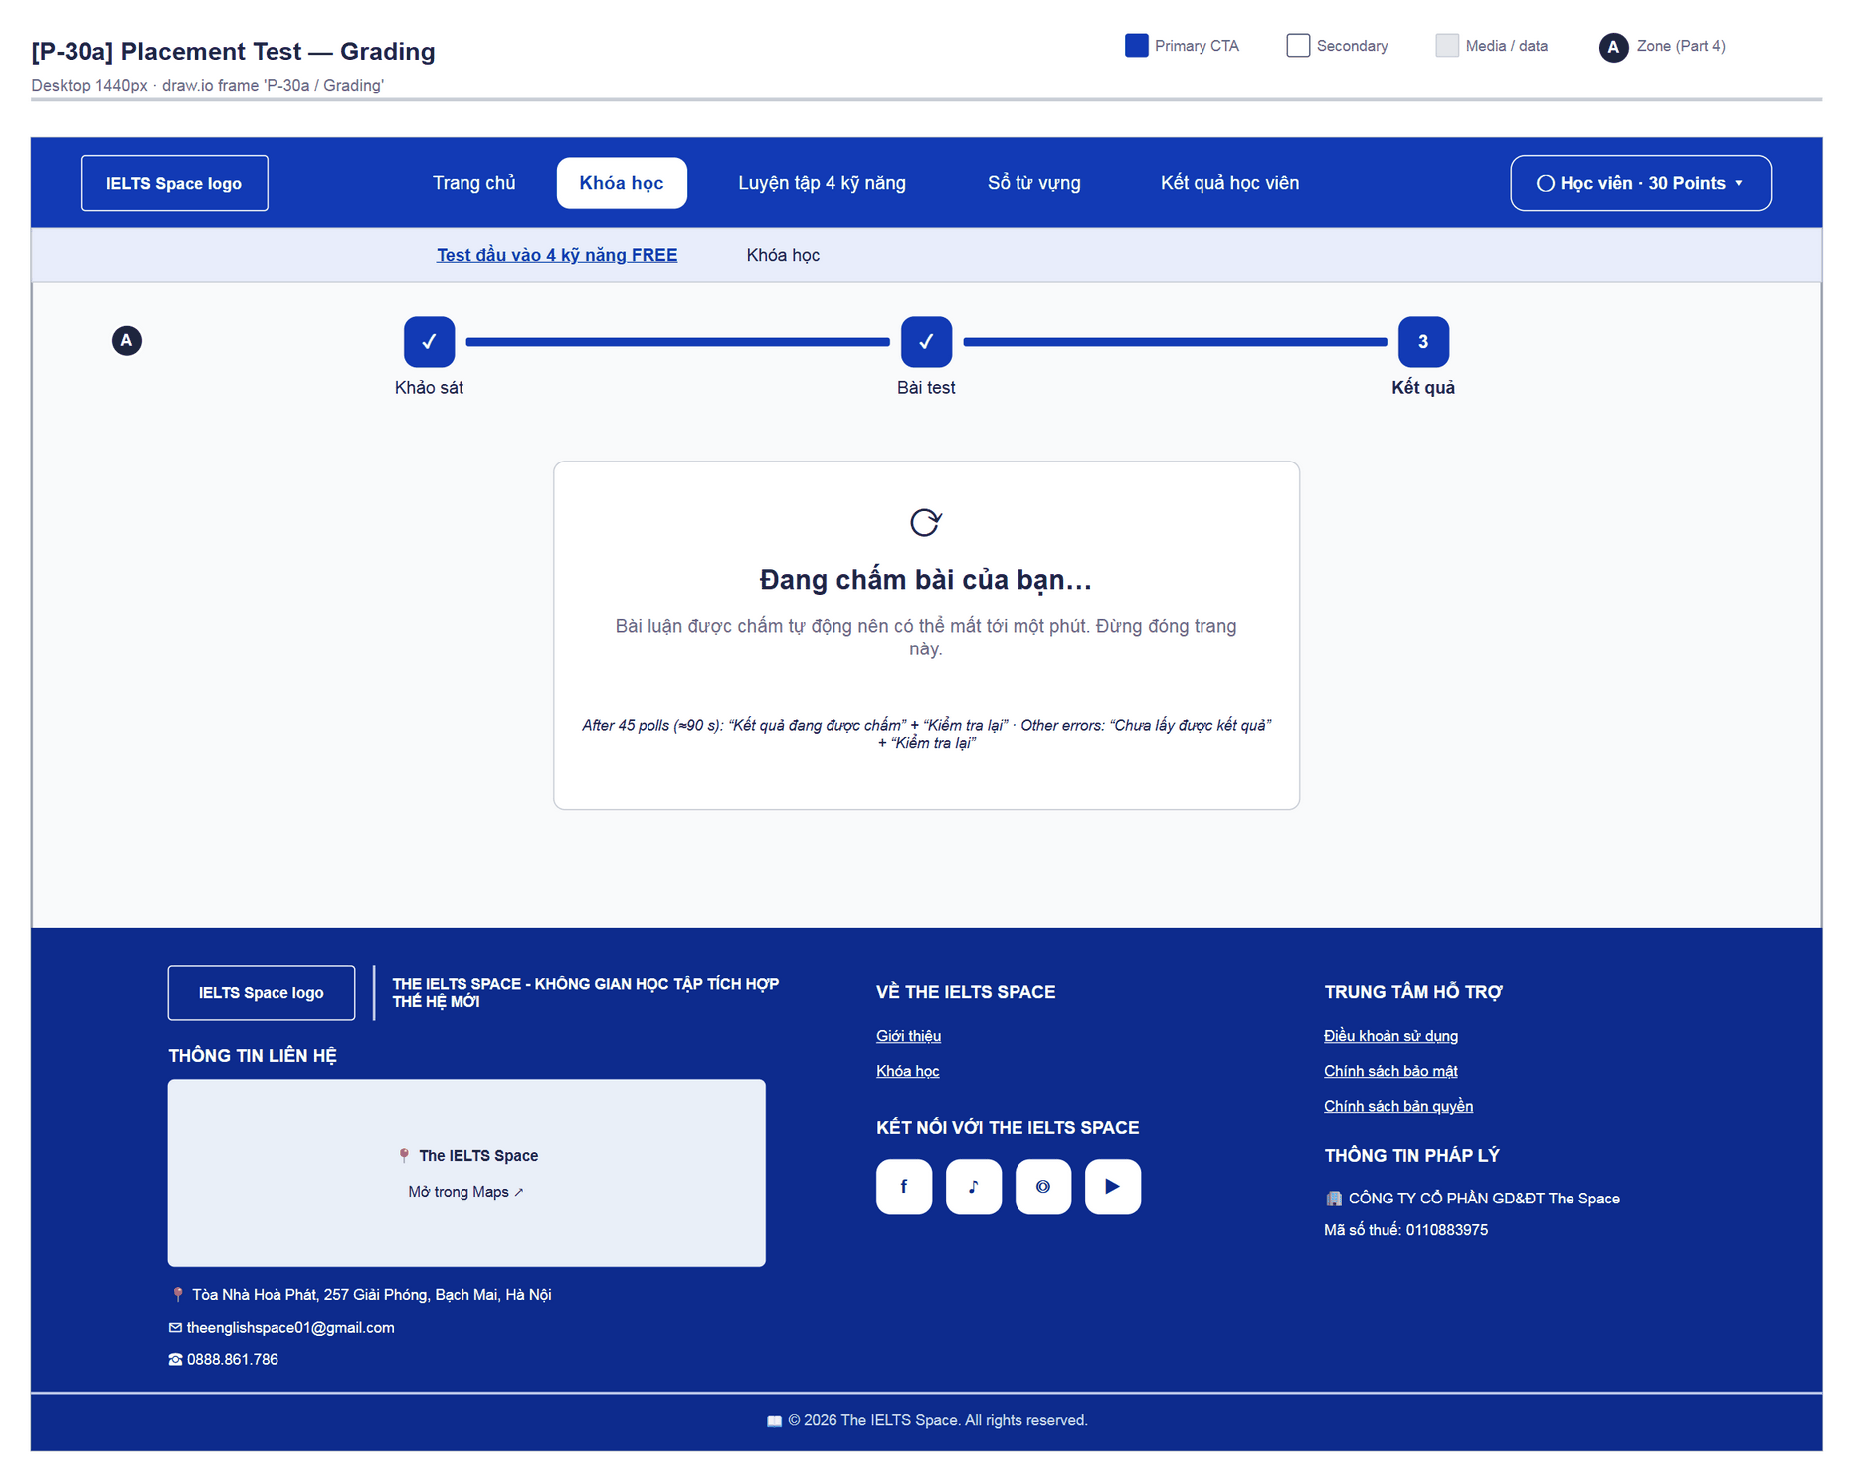
Figure 36 — [P-30a] Placement Test — Grading · draw.io frame 'P-30a / Grading'
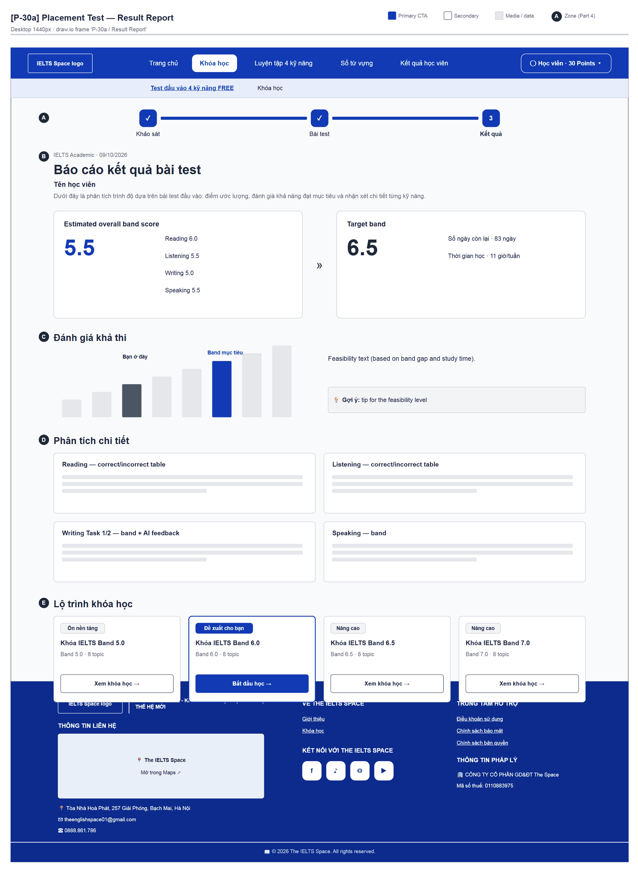
Figure 37 — [P-30a] Placement Test — Result Report · draw.io frame 'P-30a / Result Report'

4.9 — Topic List (in course) (P-30b)
Page ID | P-30b
Screen name | Topic List (in course)
Design file | draw.io — diagrams/wireframes/P-30b_TopicList.drawio — frames 'P-30b / Populated', 'P-30b / Loading', 'P-30b / Empty / Error'
SRS Feature | FT-20, FT-29, FT-55
SRS Scenario | SC-02, SC-05
Roles with access | Learner
Route | /learn/courses/:courseId
Nav level | SUB
Status | MVP
Flow(s) | F-02

Topic route inside one course; opens the next topic and the course final test.

Screen States
State | When It Appears | Design File Frame
Loading | TopicListSkeleton (“Đang tải lộ trình chặng học…”) | P-30b / Loading
Empty | “Khóa này chưa có chặng nào.” | P-30b / Empty / Error
Populated — default | Progress header + topic list + finish line | P-30b / Populated
Locked | LOCKED topic: card is not a link, “🔒 {reason}”; a reason identical to the previous topic is visually hidden | P-30b / Populated
Error | ApiErrorState + “Thử lại”; course-test start errors shown inline | P-30b / Empty / Error

Layout Description
Layout zones — P-30b Topic List (in course)
┌──────────────────────────────────────────────────┐
│ ← Tất cả khóa học │
│ [A] Band 6.0 · Lộ trình khóa học │ [B] 2/5 chặng│
│ Khóa IELTS Band 6.0 │ ==- 40% │
│ lead │ Tiếp theo… │
│ │ [Học tiếp →] │
│ [C] Các chặng (Tất cả|Listening|Reading|…) │
│ [D] o Chặng 01 … v o Chặng 03 (is-next) # … │
│ [E] F Về đích — Bài thi cuối khóa │
└──────────────────────────────────────────────────┘

Zone descriptions:
- Zone A: Back “← Tất cả khóa học”; eyebrow “Band x.x · Lộ trình khóa học”; H1 course title; lead “Học lần lượt từng chặng. Hoàn thành các bài học và đạt bài kiểm tra chặng (từ 70%) để mở chặng tiếp theo.”
- Zone B: Progress panel “x/y chặng đã qua” + %; “Tiếp theo — Chặng n: {title}” + CTA “Học tiếp” / “Bắt đầu chặng”; or “Bạn đã qua tất cả các chặng.”
- Zone C: “Các chặng” + skill filter (Tất cả / Listening / Reading / Writing / Speaking — only when there is more than one skill).
- Zone D: Vertical route: node (number / ✓ / 🔒), kicker “Chặng 0n · Skill”, “👑 Premium” chip, title, description, footer (“Đã qua · n bài”, progress “x/y bài”, or lock reason), CTA “Vào chặng” / “Học tiếp” / “Xem lại”.
- Zone E: “Về đích — Bài thi cuối khóa”: LOCKED “Mở khi qua đủ n chặng (hiện x/n). Cần đạt từ 70%.”; AVAILABLE “Bạn đã qua mọi chặng…” + “Làm bài thi cuối khóa” (“Đang giao đề…”); PASSED chip “Đã đạt”. Errors: “Bài thi cuối khóa chưa mở…” / “Chưa có đề thi cuối cho khóa này…”.

Key Interactions
User Action | What Happens | Notes
Click an open topic | → P-31 | FT-20
Click a locked topic | No navigation (aria-disabled, aria-describedby reason)
“Làm bài thi cuối khóa” | createCourseTestAssignment + createAttempt COURSE_TEST → P-35 ?course= | FT-55
Filter by skill | Client-side filter, keeps sequenceOrder

Mockup
Mockup / Wireframe — draw.io
Design file: diagrams/wireframes/P-30b_TopicList.drawio
Frames: 'P-30b / Populated', 'P-30b / Loading', 'P-30b / Empty / Error'
Images below are exported from draw.io (scripts/export_diagrams.py); edit the .drawio file, then rebuild this document.

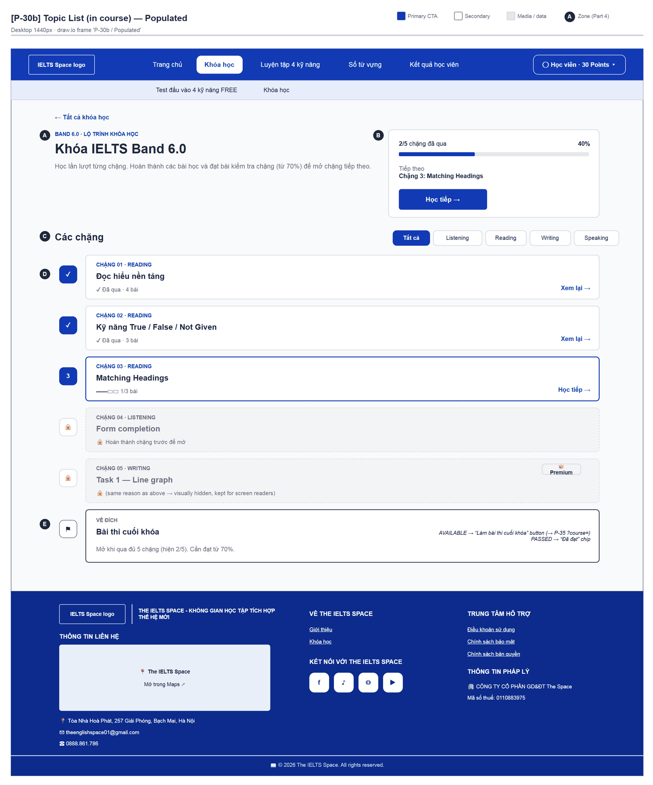
Figure 38 — [P-30b] Topic List (in course) — Populated · draw.io frame 'P-30b / Populated'
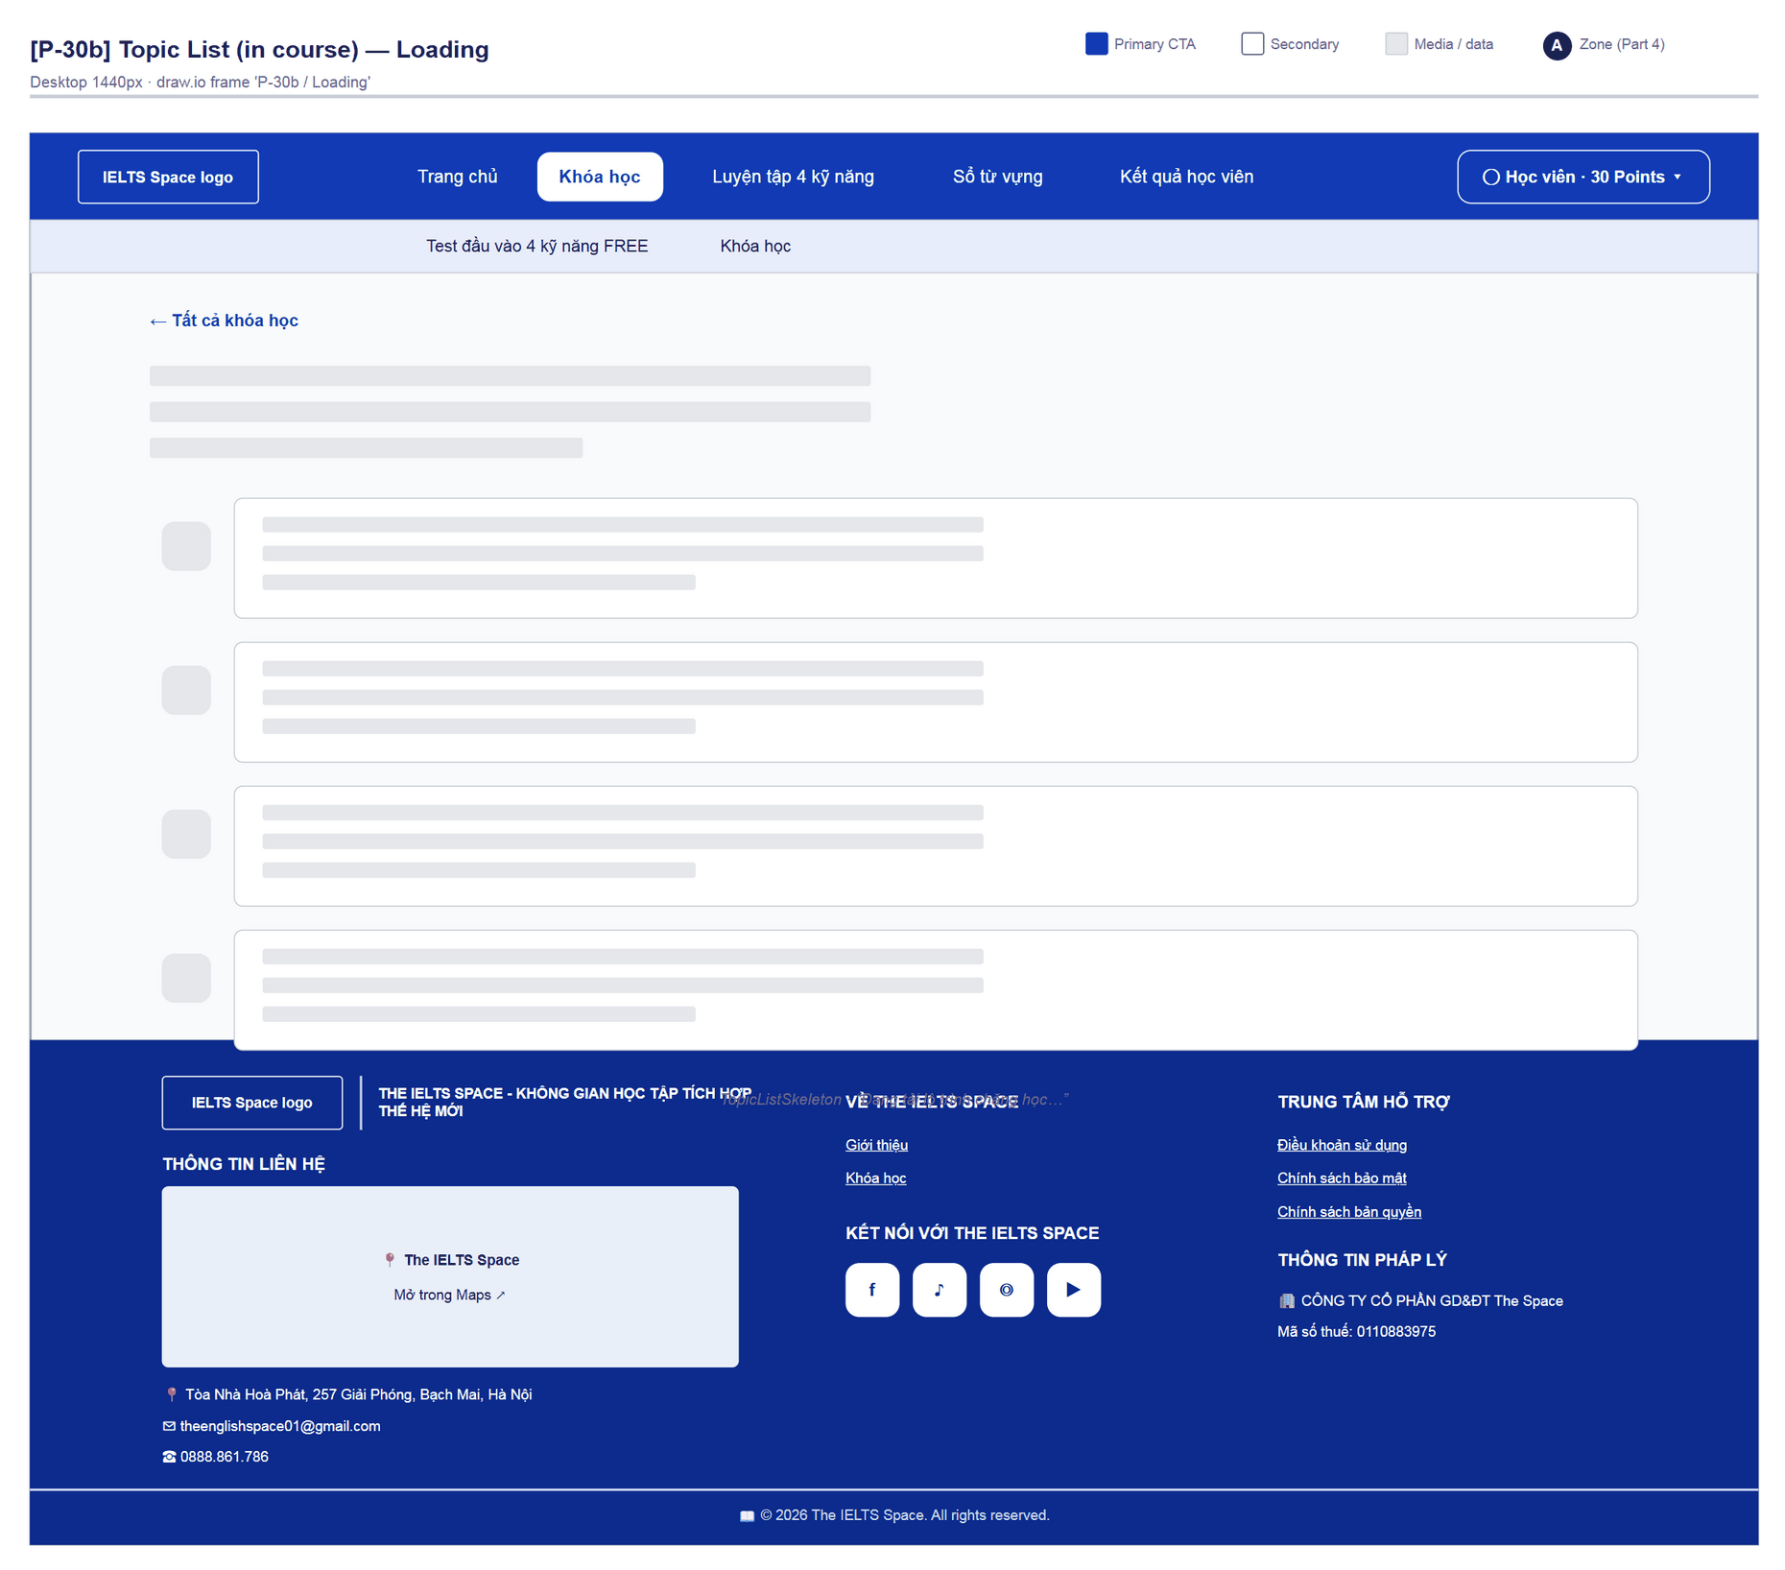
Figure 39 — [P-30b] Topic List (in course) — Loading · draw.io frame 'P-30b / Loading'
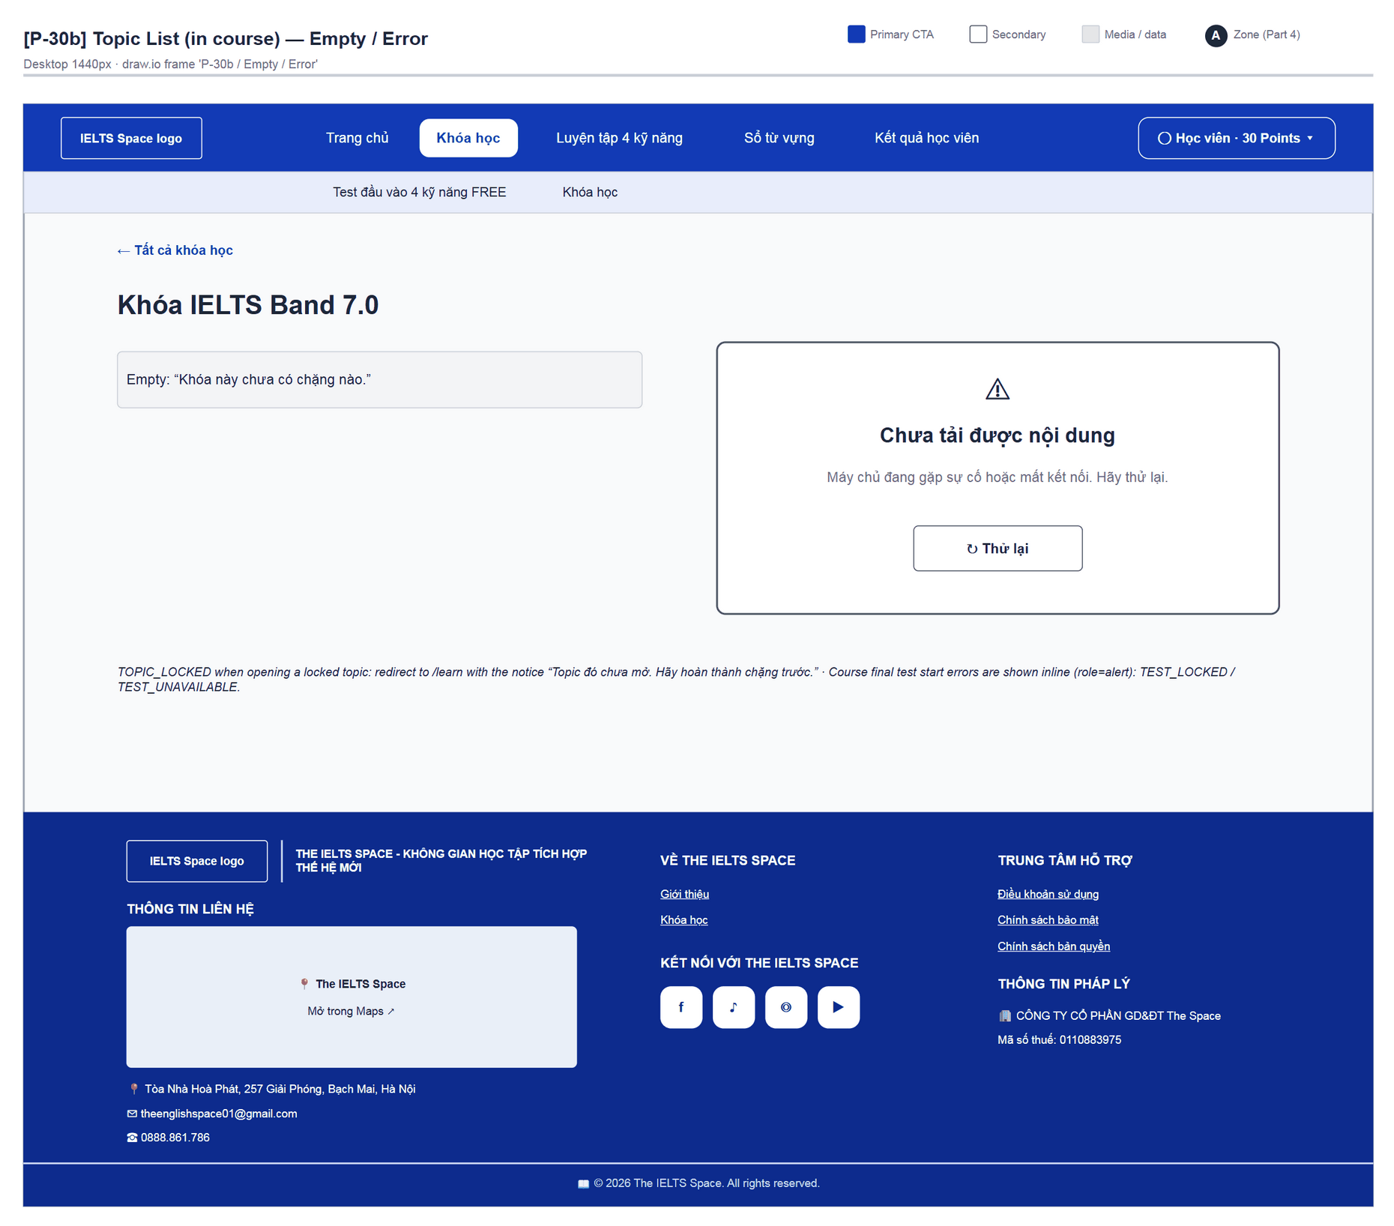
Figure 40 — [P-30b] Topic List (in course) — Empty / Error · draw.io frame 'P-30b / Empty / Error'

4.10 — Topic Detail (P-31)
Page ID | P-31
Screen name | Topic Detail
Design file | draw.io — diagrams/wireframes/P-31_TopicDetail.drawio — frames 'P-31 / Populated', 'P-31 / Locked Test / Review Gate'
SRS Feature | FT-21, FT-29
SRS Scenario | SC-02, SC-05
Roles with access | Learner
Route | /learn/topics/:topicId
Nav level | SUB
Status | MVP
Flow(s) | F-02

Topic detail: lesson list, next step, unlock conditions and the start of the topic final test.

Screen States
State | When It Appears | Design File Frame
Loading | “Đang tải chặng học…” | LoadingState
Empty | “Chặng này chưa có bài học.” | Text inside the section
Populated — default | An AVAILABLE lesson is next | P-31 / Populated
Locked test / Review gate | Test LOCKED with checklist; a mandatory review turns the CTA into “Làm bài ôn” | P-31 / Locked Test / Review Gate
Error | TOPIC_LOCKED → back to /learn with a notice; otherwise ApiErrorState | —

Layout Description
Layout zones — P-31 Topic Detail
┌──────────────────────────────────────────────────┐
│ (ReviewGateBanner) ← {course title} │
│ [A] Chặng 03 · Reading — Matching Headings │ [B] │
│ [C] Bài học trong chặng 3 bài · ~45 phút │
│ v Bài 1 … o Bài 2 (next) … # Bài 3 … │
│ └ Cần luyện thêm … Luyện ngay → │
│ [D] F Kiểm tra cuối chặng — checklist / CTA │
└──────────────────────────────────────────────────┘

Zone descriptions:
- Zone A: Back “← {course title}”; eyebrow “Chặng 0n · Skill”; H1 topic title; description.
- Zone B: Panel: “x/y bài đã xong” + %; one of: “Cần làm trước — Bài ôn: …” + “Làm bài ôn”; “Bắt đầu với / Tiếp theo / Cần luyện thêm — Bài n: …” + “Bắt đầu học / Học tiếp / Luyện thêm”; “Đã học xong các bài. Làm bài kiểm tra chặng ↓”; “Bạn đã qua chặng này · x%”.
- Zone C: “Bài học trong chặng” + “n bài · khoảng m phút”; each lesson: node, title, “🕒 m phút”, lock reason, CTA “Mở bài” / “Học tiếp” / “Xem lại”; extra row “Cần luyện thêm trước khi mở bài kiểm tra chặng — Luyện ngay” (→ P-33).
- Zone D: “Kiểm tra cuối chặng” — test title, meta “n câu hỏi · cần đạt từ 70% · không giới hạn thời gian · lần gần nhất x%”; LOCKED: “Để mở bài kiểm tra:” checklist with links; AVAILABLE: “Làm bài kiểm tra”; PASSED: “Đã đạt”; NONE: “Chặng này không có bài kiểm tra cuối.”

Key Interactions
User Action | What Happens | Notes
Open a lesson | → P-32 | FT-21
“Luyện ngay” | → P-33 | FT-27
“Làm bài ôn” | → P-34 | FT-28
“Làm bài kiểm tra” | createTestAssignment + createAttempt TOPIC_TEST → P-35 ?topic= | FT-29
Test start fails | PRACTICE_REQUIRED: “Cần luyện thêm trước khi mở đề: Bài n…”; REVIEW_REQUIRED; TEST_LOCKED; TEST_UNAVAILABLE “Chưa có đề cho chặng này…” | role=alert

Mockup
Mockup / Wireframe — draw.io
Design file: diagrams/wireframes/P-31_TopicDetail.drawio
Frames: 'P-31 / Populated', 'P-31 / Locked Test / Review Gate'
Images below are exported from draw.io (scripts/export_diagrams.py); edit the .drawio file, then rebuild this document.

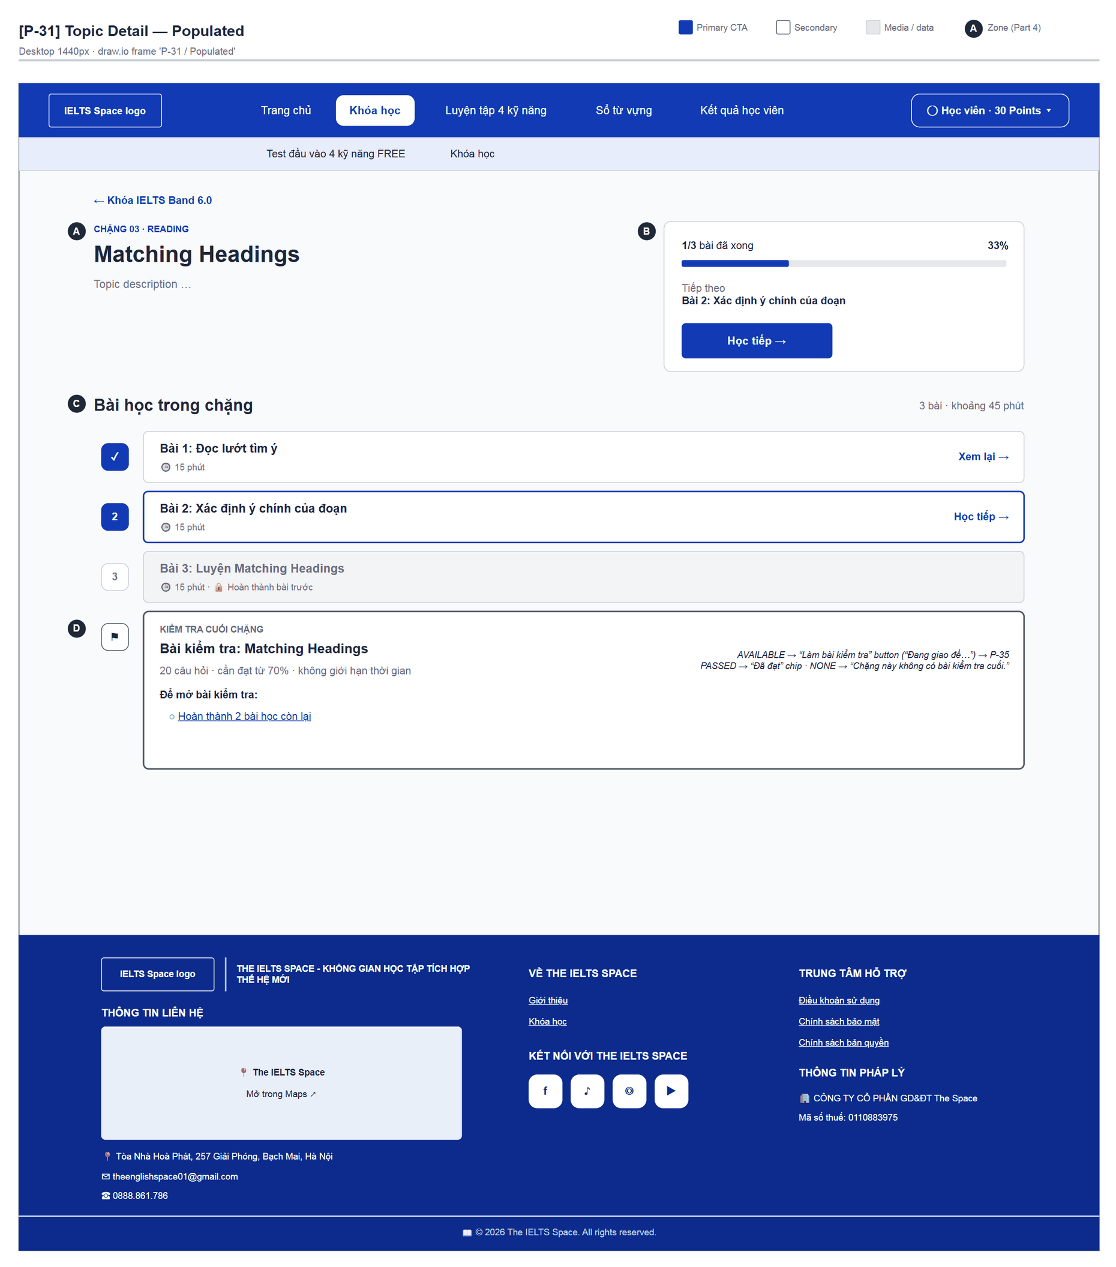
Figure 41 — [P-31] Topic Detail — Populated · draw.io frame 'P-31 / Populated'
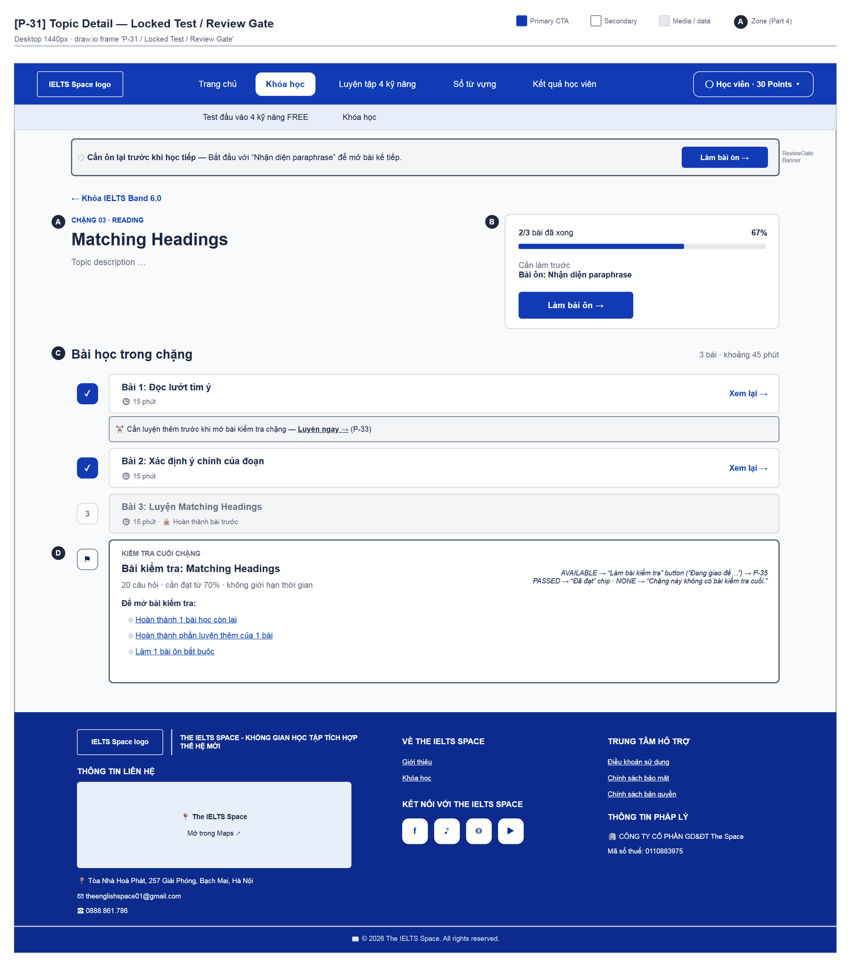
Figure 42 — [P-31] Topic Detail — Locked Test / Review Gate · draw.io frame 'P-31 / Locked Test / Review Gate'

4.11 — Lesson Player (P-32)
Page ID | P-32
Screen name | Lesson Player
Design file | draw.io — diagrams/wireframes/P-32_LessonPlayer.drawio — frames 'P-32 / Populated', 'P-32 / Completed', 'P-32 / Review Required'
SRS Feature | FT-21, FT-22, FT-23, FT-25
SRS Scenario | SC-02, SC-04
Roles with access | Learner
Route | /learn/lessons/:lessonId
Nav level | DEEP
Status | MVP
Flow(s) | F-02

Study one lesson: content blocks (text, audio, passage, exercises, essay) and record completion.

Screen States
State | When It Appears | Design File Frame
Loading | “Đang tải nội dung bài học…” | LoadingState
Populated — default | Studying | P-32 / Populated
Completed | Panel “Bạn đã hoàn thành bài này” / “Bài này đã hoàn thành” | P-32 / Completed
Review required | REVIEW_REQUIRED: “Nội dung này đang tạm khóa” + “Làm bài ôn” / “Về danh sách bài” | P-32 / Review Required
Error | Submit failure “… Hãy thử lại.”; essay: “Không đủ điểm…”, “Hệ thống chấm bài tạm thời không khả dụng…”, “Bạn đã hết hạn mức chấm bài trong ngày.” | Inline in the block / rail

Layout Description
Layout zones — P-32 Lesson Player
┌───────────────────────────────────────┬──────────────┐
│ ← {Topic} │ [D] Rail │
│ [A] Bài 2 · Lý thuyết và bài tập │ Bài 2 · … │
│ H1 lesson title │ o Đang học │
│ [B] TextBlock / AudioBlock / Passage │ hint │
│ [C] ExerciseBlock · EssayBlock │ [Hoàn thành] │
│ [E] Completion panel │ Danh sách bài│
└───────────────────────────────────────┴──────────────┘

Zone descriptions:
- Zone A: Back to the topic; eyebrow “Bài n · Lý thuyết và bài tập” (or “Lý thuyết”); H1.
- Zone B: BlockList: TextBlock, AudioBlock (player + transcript), PassageBlock; unsupported blocks render UnsupportedBlock.
- Zone C: ExerciseBlock: questions + “Nộp” / “Nộp lại” / “Làm lại từ đầu”; result “Đạt x/y câu (z%)…” or “Đúng x/y câu… Cần từ 70% để đạt.”. EssayBlock: “Bài làm của bạn”, “Nộp bài · 3 điểm”, “Đang chấm (có thể 10–45 giây)…”, “Band ước lượng”, “Bài mẫu”, disclaimer “Band là ước lượng AI, không phải điểm IELTS chính thức.”
- Zone D: Sticky rail: status (Đang học / Cần làm bài ôn / Cần luyện thêm / Đã hoàn thành) + hint + CTA (“Hoàn thành bài” / “Đang ghi nhận…”, “Làm bài ôn”, “Luyện thêm bài này”, “Bài tiếp theo”, “Về chặng làm bài kiểm tra”) + link “Danh sách bài của chặng”.
- Zone E: Completion panel: “Kiến thức của bài đã được ghi nhận…” / “Bài này yêu cầu luyện thêm…” / “Bạn đã học xong bài cuối của chặng…” + links “Luyện thêm bài này”, “Về danh sách bài”. Theory-only lessons: “Hết nội dung bài học. Bấm Hoàn thành bài để ghi nhận tiến độ.”

Key Interactions
User Action | What Happens | Notes
Submit an exercise | Graded; answers/explanations shown on pass | FT-22, FT-23
Submit an essay | Deducts 3 points, AI grading, band shown | FT-25; INSUFFICIENT_POINTS
“Hoàn thành bài” | completeLesson → Completed; may require extra practice | FT-21
“Bài tiếp theo” / back to topic | → next P-32 / P-31
REVIEW_REQUIRED | Content locked → P-34 | FT-28

Mockup
Mockup / Wireframe — draw.io
Design file: diagrams/wireframes/P-32_LessonPlayer.drawio
Frames: 'P-32 / Populated', 'P-32 / Completed', 'P-32 / Review Required'
Images below are exported from draw.io (scripts/export_diagrams.py); edit the .drawio file, then rebuild this document.

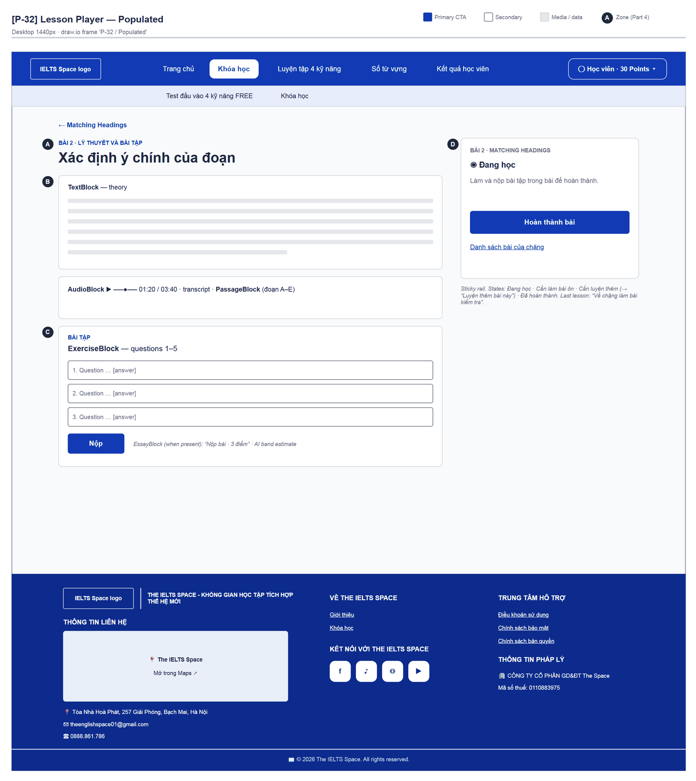
Figure 43 — [P-32] Lesson Player — Populated · draw.io frame 'P-32 / Populated'
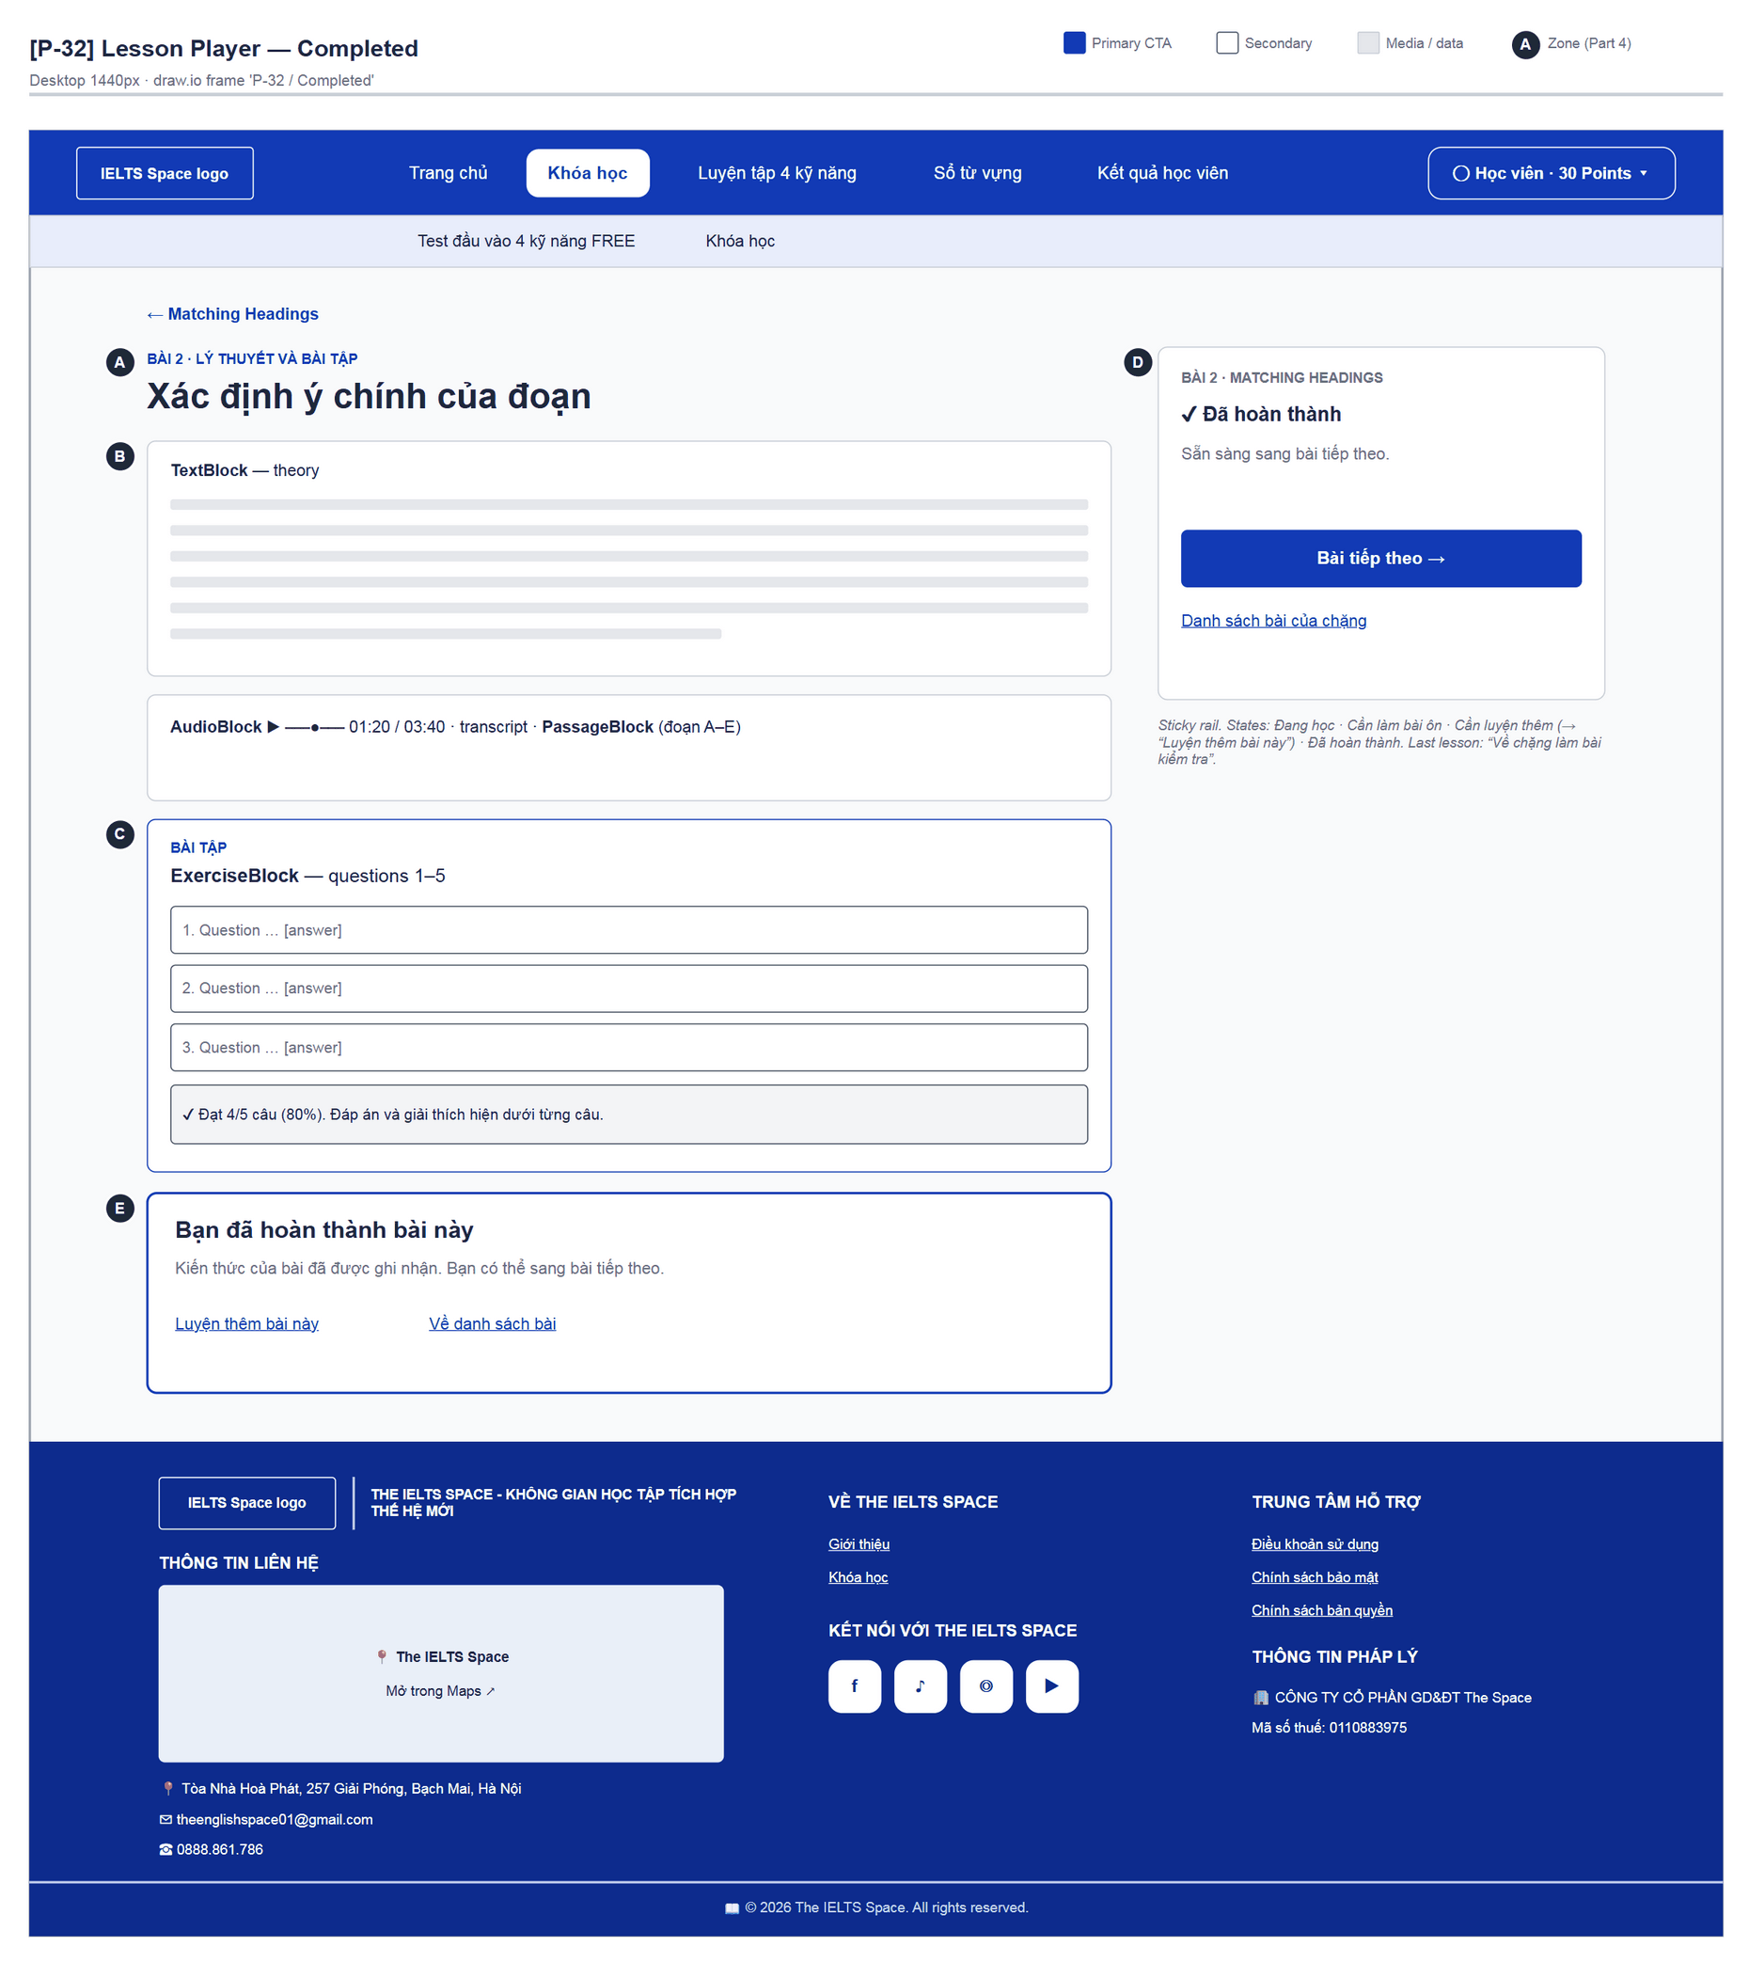
Figure 44 — [P-32] Lesson Player — Completed · draw.io frame 'P-32 / Completed'
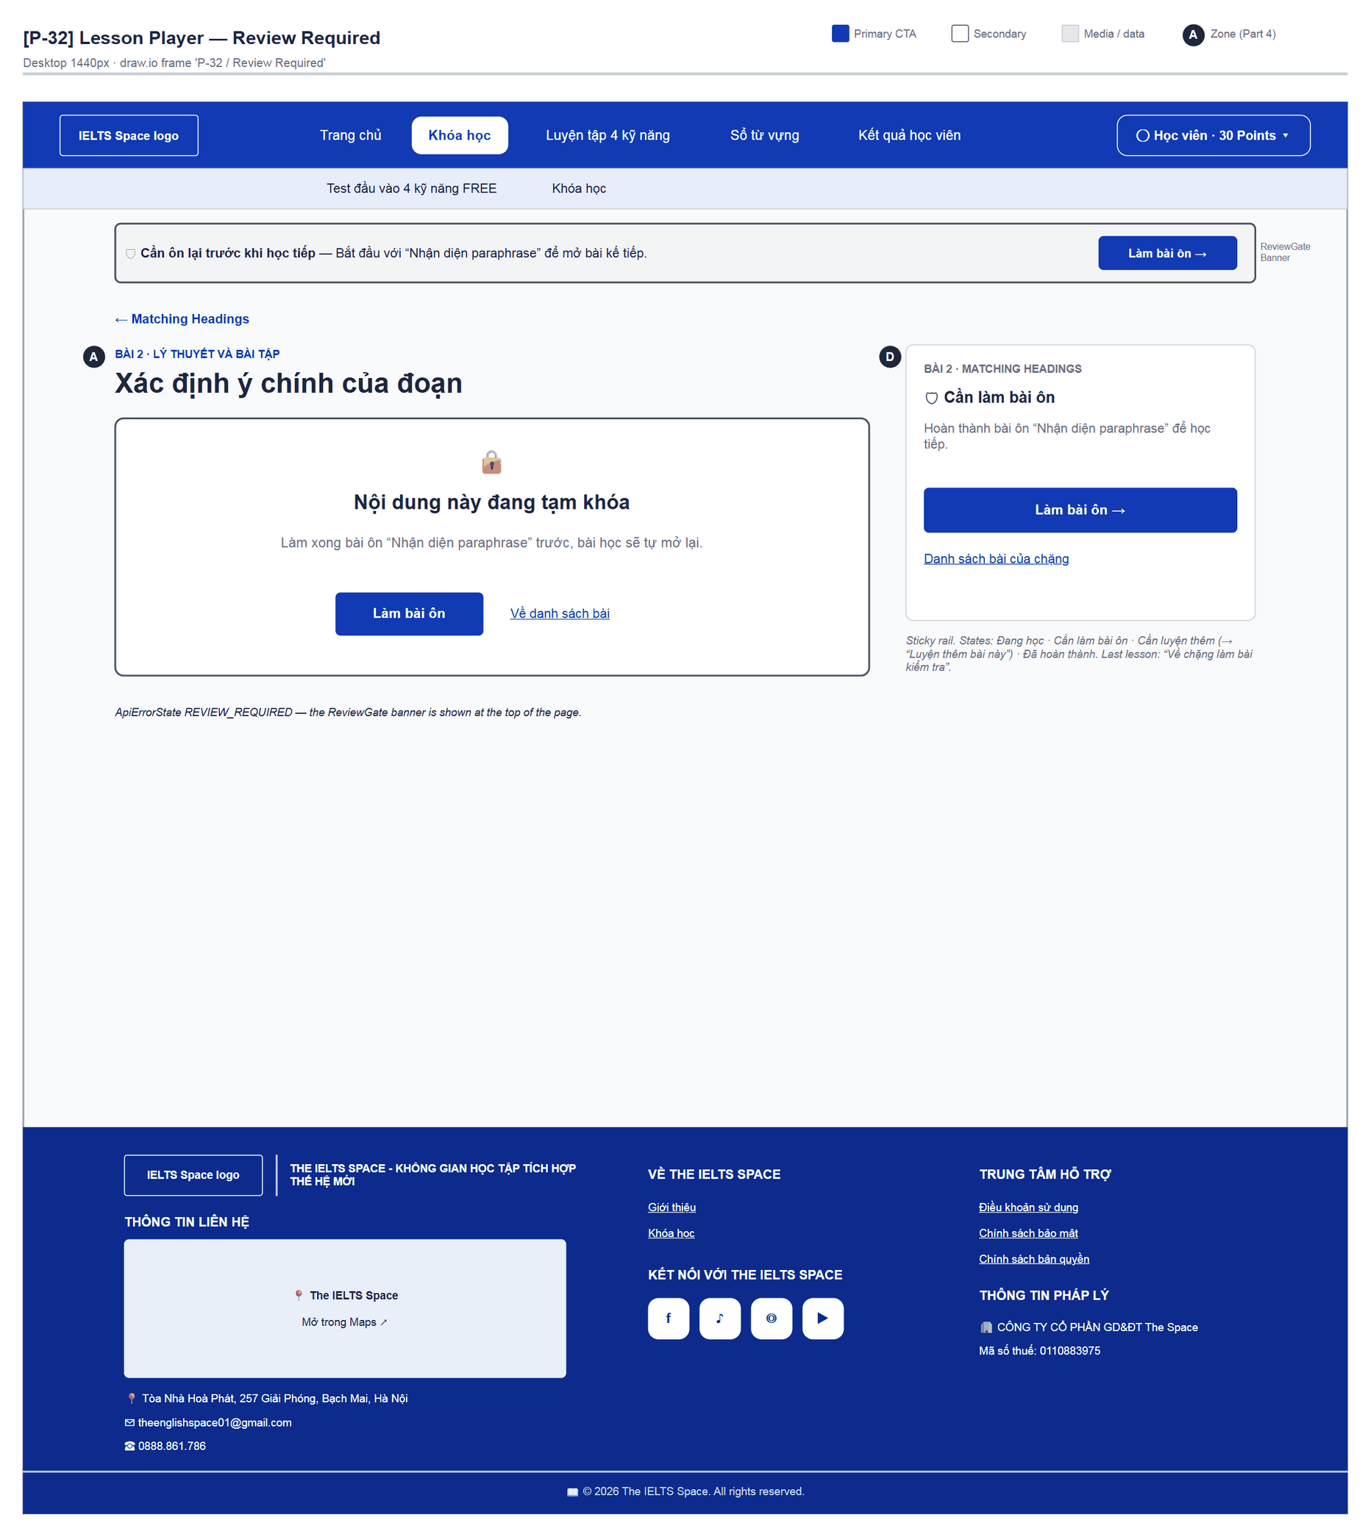
Figure 45 — [P-32] Lesson Player — Review Required · draw.io frame 'P-32 / Review Required'

4.12 — Lesson Practice (P-33)
Page ID | P-33
Screen name | Lesson Practice
Design file | draw.io — diagrams/wireframes/P-33_LessonPractice.drawio — frames 'P-33 / Set List', 'P-33 / Attempt', 'P-33 / Outcome'
SRS Feature | FT-27
SRS Scenario | SC-03, SC-04
Roles with access | Learner
Route | /learn/lessons/:lessonId/practice
Nav level | DEEP
Status | MVP
Flow(s) | F-02

Extra practice after a lesson: pick a practice set, answer and submit; passing at least one set unlocks the topic test.

Screen States
State | When It Appears | Design File Frame
Loading | “Đang tải luyện thêm…” | LoadingState
Empty | “Bài này không có bộ luyện thêm.” | P-33 / Set List (note)
Populated — Set list | List of sets | P-33 / Set List
Attempt | Working on one set | P-33 / Attempt
Outcome | Passed / Not passed / Review created | P-33 / Outcome
Passed (overall) | “Bạn đã đạt phần luyện thêm. Quay lại chặng để làm bài kiểm tra (nếu không còn bài ôn).” + “Về lộ trình” | P-33 / Set List (note)

Layout Description
Layout zones — P-33 Lesson Practice
┌──────────────────────────────────────────────────┐
│ ← {Lesson} │
│ [A] LUYỆN THÊM · Củng cố trước khi mở bài KT │
│ [B] Bộ 1 [Đã thử] 10 câu · cao nhất 60% [Làm lại]│
│ Bộ 2 [Sẵn sàng] [Làm bộ này] │
│ Bộ 3 [Chưa mở] Premium [Khóa] │
│ Attempt: [B] passage/audio | [C] ExerciseBlock │
│ Outcome: [D] passed [E] not passed [F] review │
└──────────────────────────────────────────────────┘

Zone descriptions:
- Zone A: Back to the lesson; eyebrow “Luyện thêm”; H1 “Củng cố trước khi mở bài kiểm tra chặng”; meta “Bắt buộc: đạt ít nhất một bộ để mở bài kiểm tra chặng” / “Đã đạt phần luyện thêm” + practicePassReason; “Hoàn thành bài học trước khi luyện.”
- Zone B: Set list: title, status chip (Sẵn sàng / Đang làm / Đã đạt / Đã thử / Chưa mở), “n câu · điểm cao nhất x%”, warnings “Đã lộ đáp án nên không được tính.” and “Bộ Premium, chưa mở trong giai đoạn này.”, CTA “Làm bộ này / Làm tiếp / Làm lại / Đang mở… / Khóa”. Attempt: “← Danh sách luyện thêm”, eyebrow “Luyện thêm · {code}”, audio/passage.
- Zone C: ExerciseBlock without resubmission; instructions “Trả lời hết câu. Đạt mới được tính evidence cho practice của bài.”
- Zone D: “Đã đạt bộ luyện thêm (x%).” + “Tiếp tục luyện / về topic”.
- Zone E: “Chưa đạt (x%). Có thể chọn bộ khác hoặc làm bài ôn nếu được tạo.” + “Về danh sách”.
- Zone F: “Đã tạo bài ôn bắt buộc sau lần luyện này.” + “Làm bài ôn →” (P-34).

Key Interactions
User Action | What Happens | Notes
“Làm bộ này” | startPractice → Attempt | FT-27
“Nộp” | Graded; may create a review | FT-26, FT-28
“Làm bài ôn” | → P-34
“Về danh sách” | Reloads the catalogue

Mockup
Mockup / Wireframe — draw.io
Design file: diagrams/wireframes/P-33_LessonPractice.drawio
Frames: 'P-33 / Set List', 'P-33 / Attempt', 'P-33 / Outcome'
Images below are exported from draw.io (scripts/export_diagrams.py); edit the .drawio file, then rebuild this document.

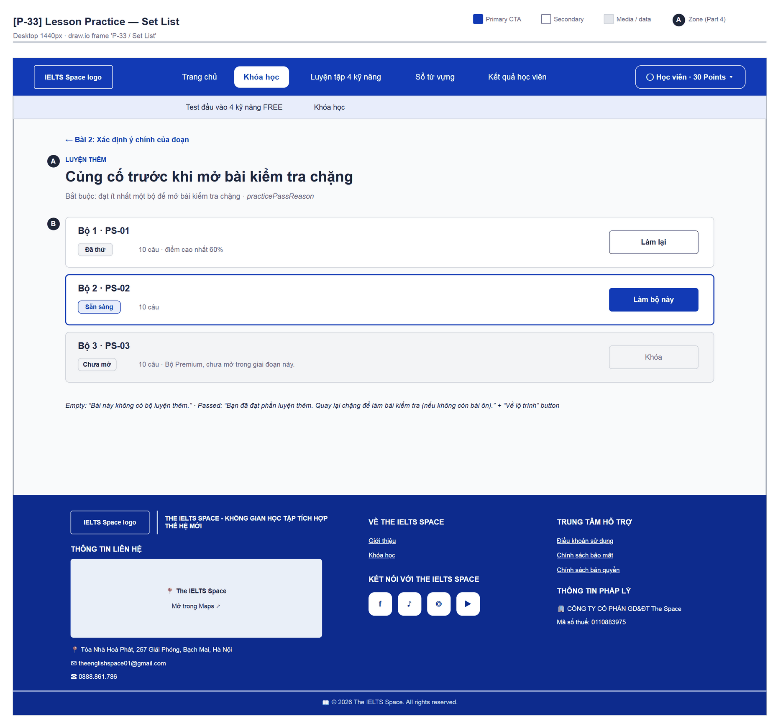
Figure 46 — [P-33] Lesson Practice — Set List · draw.io frame 'P-33 / Set List'
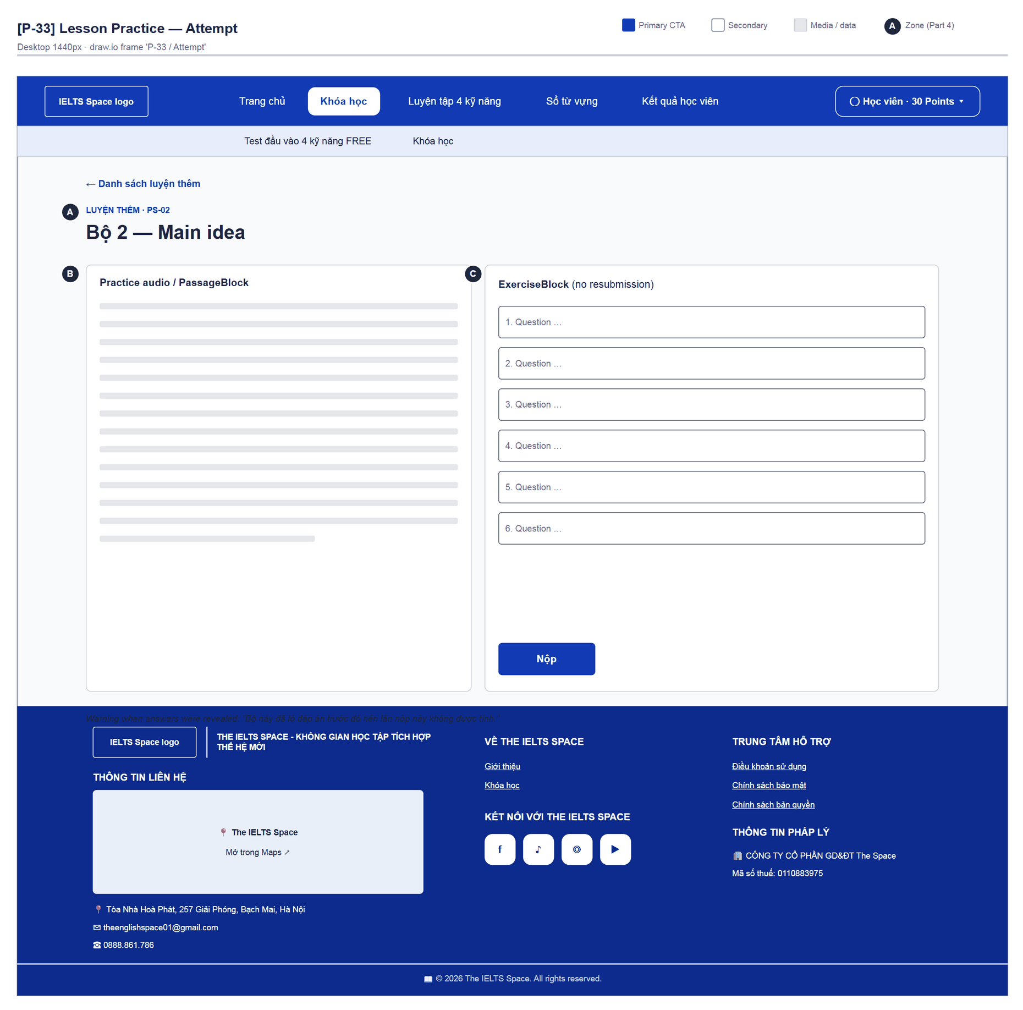
Figure 47 — [P-33] Lesson Practice — Attempt · draw.io frame 'P-33 / Attempt'
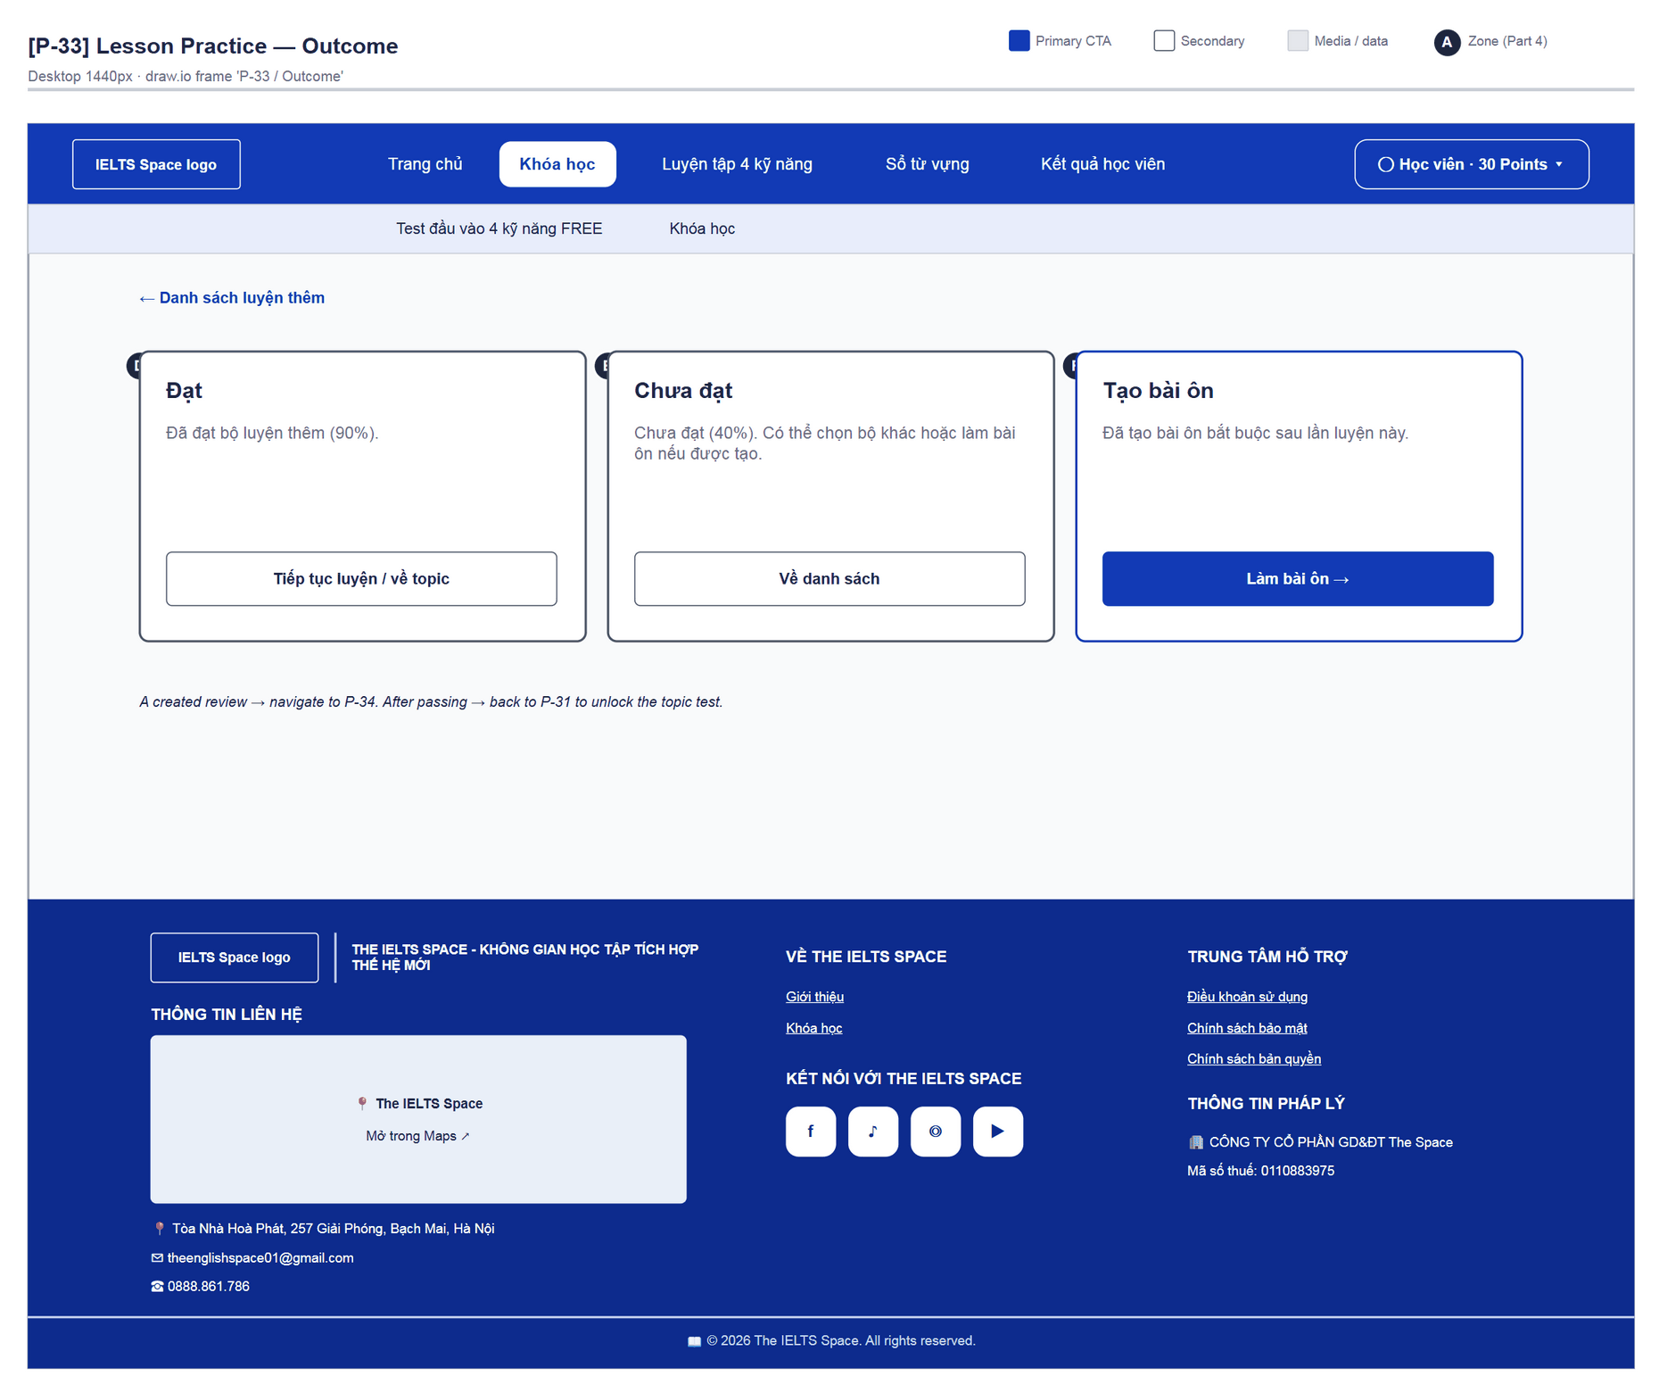
Figure 48 — [P-33] Lesson Practice — Outcome · draw.io frame 'P-33 / Outcome'

4.13 — Review Session (P-34)
Page ID | P-34
Screen name | Review Session
Design file | draw.io — diagrams/wireframes/P-34_ReviewSession.drawio — frames 'P-34 / Theory', 'P-34 / Practice Set', 'P-34 / Finished'
SRS Feature | FT-26, FT-28
SRS Scenario | SC-03
Roles with access | Learner
Route | /learn/reviews/:reviewId
Nav level | DEEP
Status | MVP
Flow(s) | F-02

Mandatory review for a knowledge point: theory + quick check, then review sets until passed or attempts run out.

Screen States
State | When It Appears | Design File Frame
Loading | “Đang tải bài ôn…” | LoadingState
Theory | Stage THEORY — theory + quick check | P-34 / Theory
Practice set | Stage PRACTICE_SET — review question set, “Số bộ chưa đạt: x/y” | P-34 / Practice Set
Finished | DONE “Đã hoàn thành bài ôn” / SKIPPED “Đã bỏ qua bài ôn” | P-34 / Finished
Error | Submit failure — inline | —

Layout Description
Layout zones — P-34 Review Session
┌──────────────────────────────────────────────────┐
│ ← Về lộ trình học │
│ [A] BÀI ÔN BẮT BUỘC · Bước … — {knowledge point} │
│ [D] Outcome panel (when finished) │
│ [B] Lý thuyết cần nhớ │
│ [C] Kiểm tra nhanh lý thuyết | review set (split)│
└──────────────────────────────────────────────────┘

Zone descriptions:
- Zone A: Back “Về lộ trình học”; eyebrow “Bài ôn bắt buộc · Bước đọc lý thuyết / luyện tập”; H1 knowledge point; lead depends on the stage.
- Zone B: “Lý thuyết cần nhớ” — theory BlockList.
- Zone C: THEORY: ExerciseBlock “Kiểm tra nhanh lý thuyết” (no questions → “Xác nhận đã đọc lý thuyết để sang bước luyện tập.” + “Tiếp tục luyện ôn”). PRACTICE_SET: audio/passage + set “Bộ x/y · {code}”; not passed → “Làm bộ tiếp theo”.
- Zone D: DONE: “Lộ trình đã mở lại. Bạn có thể học tiếp.”; SKIPPED: “Bạn chưa đạt sau n bộ. Bài ôn được bỏ qua để bạn tiếp tục học.”; CTA “Học tiếp →”.

Key Interactions
User Action | What Happens | Notes
Submit the quick check | Moves to stage PRACTICE_SET | FT-28
Submit a review set | Passed → DONE; not passed → next set | FT-26
“Học tiếp” | Back to the interrupted lesson/topic; the gate banner disappears

Mockup
Mockup / Wireframe — draw.io
Design file: diagrams/wireframes/P-34_ReviewSession.drawio
Frames: 'P-34 / Theory', 'P-34 / Practice Set', 'P-34 / Finished'
Images below are exported from draw.io (scripts/export_diagrams.py); edit the .drawio file, then rebuild this document.

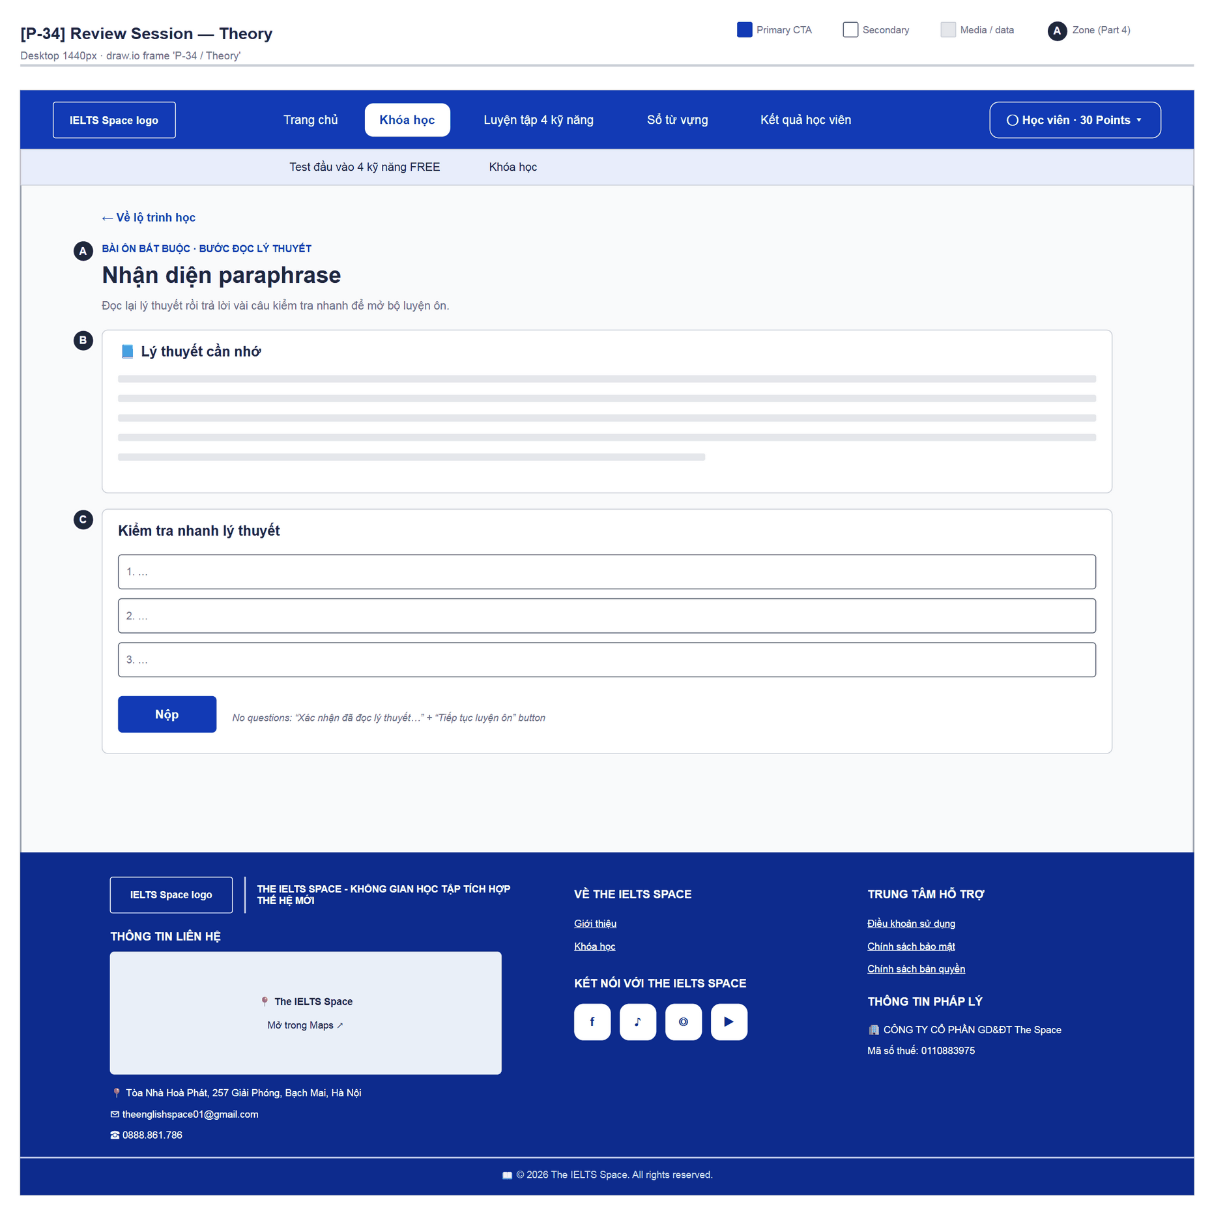
Figure 49 — [P-34] Review Session — Theory · draw.io frame 'P-34 / Theory'
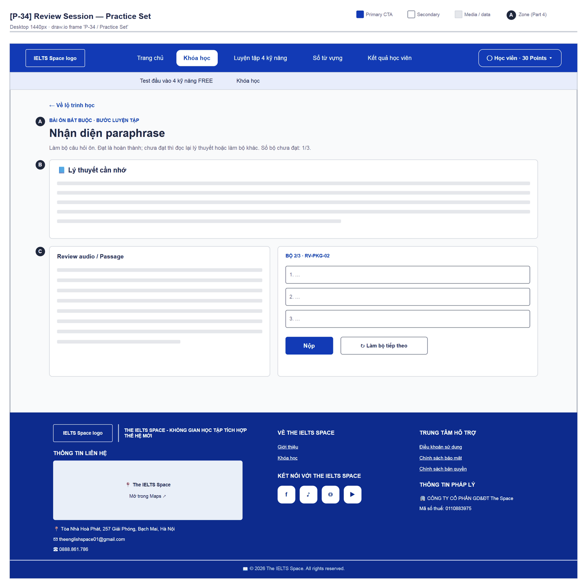
Figure 50 — [P-34] Review Session — Practice Set · draw.io frame 'P-34 / Practice Set'
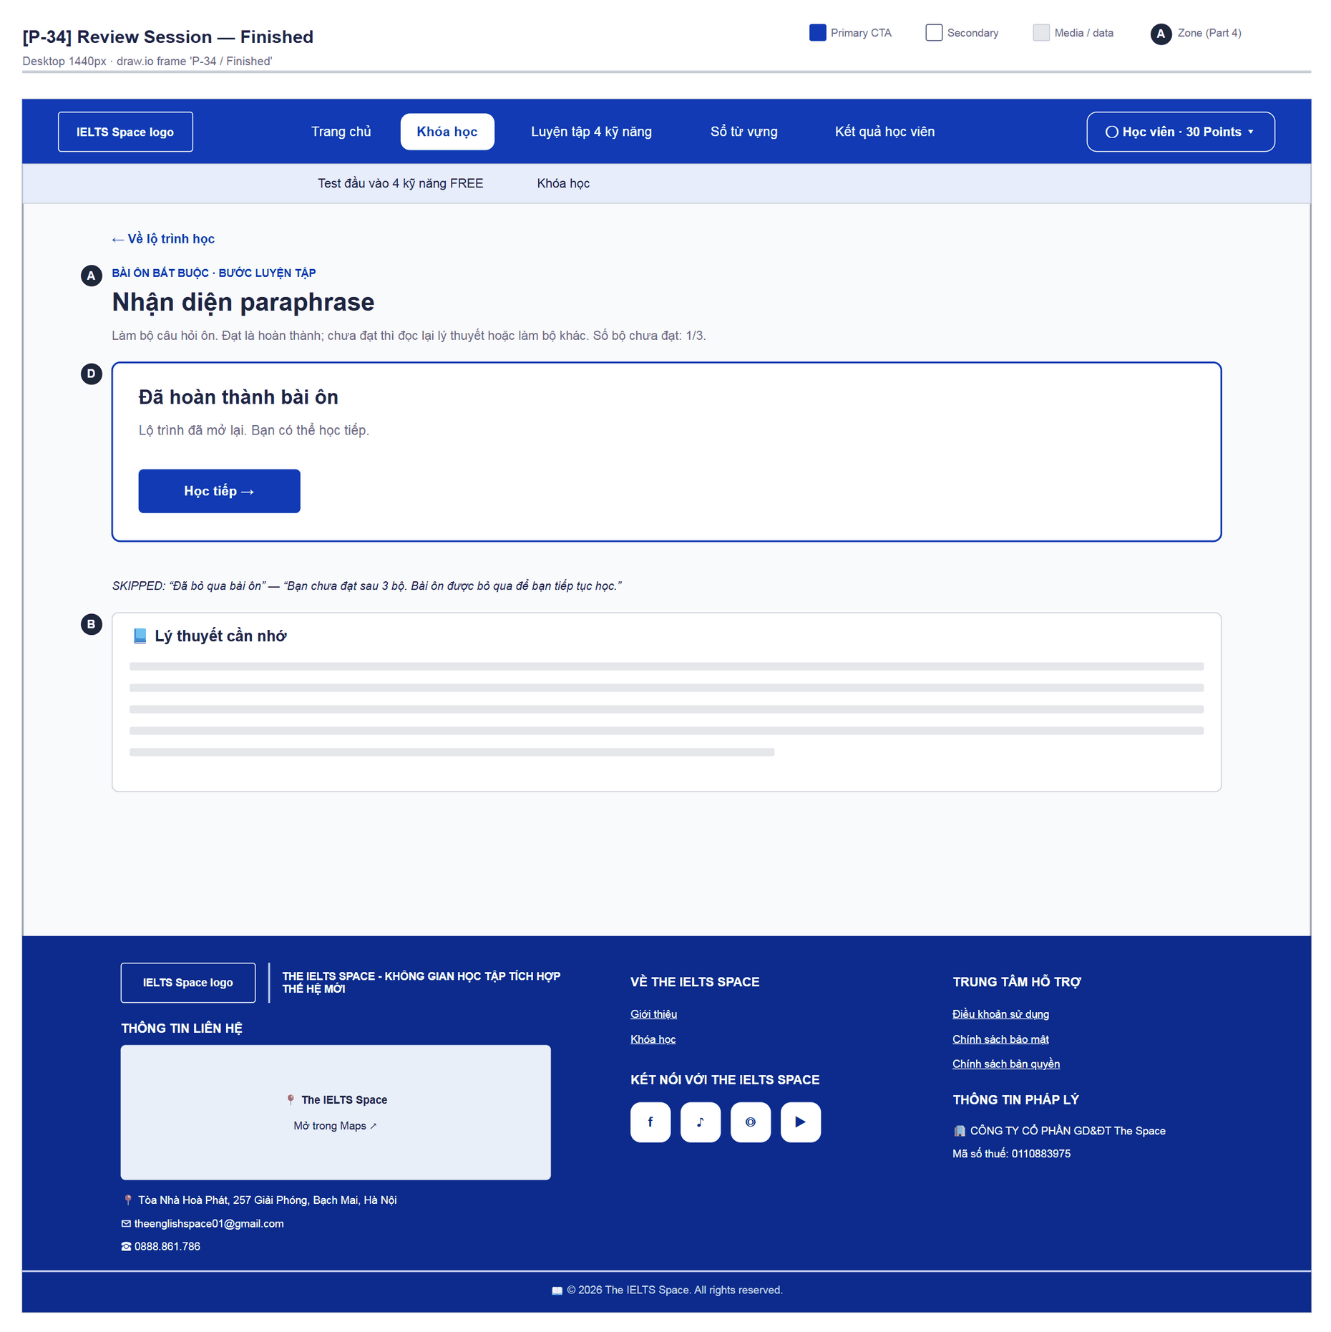
Figure 51 — [P-34] Review Session — Finished · draw.io frame 'P-34 / Finished'

4.14 — Topic / Course Test (P-35)
Page ID | P-35
Screen name | Topic / Course Test
Design file | draw.io — diagrams/wireframes/P-35_TopicTest.drawio — frames 'P-35 / Populated', 'P-35 / Confirm Submit'
SRS Feature | FT-29, FT-30, FT-55
SRS Scenario | SC-05
Roles with access | Learner
Route | /learn/tests/:attemptId (?topic= | ?course=)
Nav level | DEEP
Status | MVP
Flow(s) | F-02

Take the topic final test (?topic=) or the course final test (?course=); answers are saved immediately; no time limit.

Screen States
State | When It Appears | Design File Frame
Loading | “Đang tải đề…” | LoadingState
Empty | “Đề này chưa có câu hỏi.” | Text
Populated — default | Answering | P-35 / Populated
Confirm submit | Blank answers on first submit: “Còn n câu bỏ trống, các câu đó sẽ tính sai. Bấm lần nữa để nộp.” | P-35 / Confirm Submit
Error | “Chưa lưu được một số câu trả lời…” / “… Hãy thử nộp lại.” | Footer bar

Layout Description
Layout zones — P-35 Topic / Course Test
┌──────────────────────────────────────────────────┐
│ ← Về topic │
│ [A] BÀI KIỂM TRA CUỐI · Làm từng phần… ∞ │
│ [B] [Phần 1 4/10] [Phần 2 0/10] [Phần 3 0/5] │
│ [C] audio / passage | Phần 1/3 · questions │
│ | Đã lưu / Đang lưu… │
│ [D] 4/25 câu đã trả lời [ > Nộp bài ] │
└──────────────────────────────────────────────────┘

Zone descriptions:
- Zone A: Back “Về topic” / “Về khóa học”; eyebrow “Bài kiểm tra cuối” / “Thi cuối khóa”; H1 “Làm từng phần, câu trả lời được lưu ngay”; “Không giới hạn thời gian”.
- Zone B: Section tabs (aria-current=step): “Phần n” + “x/y câu”.
- Zone C: Split: section audio/passage | questions (QuestionField) + SaveIndicator “Đang lưu…”, “Đã lưu”, “Chưa lưu được, sẽ thử lại khi nộp”; “Phần trước / Phần tiếp”.
- Zone D: Sticky bottom bar: “x/y câu đã trả lời”, warning, button “Nộp bài” → “Vẫn nộp bài” → “Đang nộp…”.

Key Interactions
User Action | What Happens | Notes
Answer / blur | Saves the response per question | FT-30
“Nộp bài” with blanks | First click warns, second click submits
Submit succeeds | Navigate (replace) → P-36 (keeps ?topic / ?course) | FT-31
“Về topic” | → P-31 / P-30b

Mockup
Mockup / Wireframe — draw.io
Design file: diagrams/wireframes/P-35_TopicTest.drawio
Frames: 'P-35 / Populated', 'P-35 / Confirm Submit'
Images below are exported from draw.io (scripts/export_diagrams.py); edit the .drawio file, then rebuild this document.

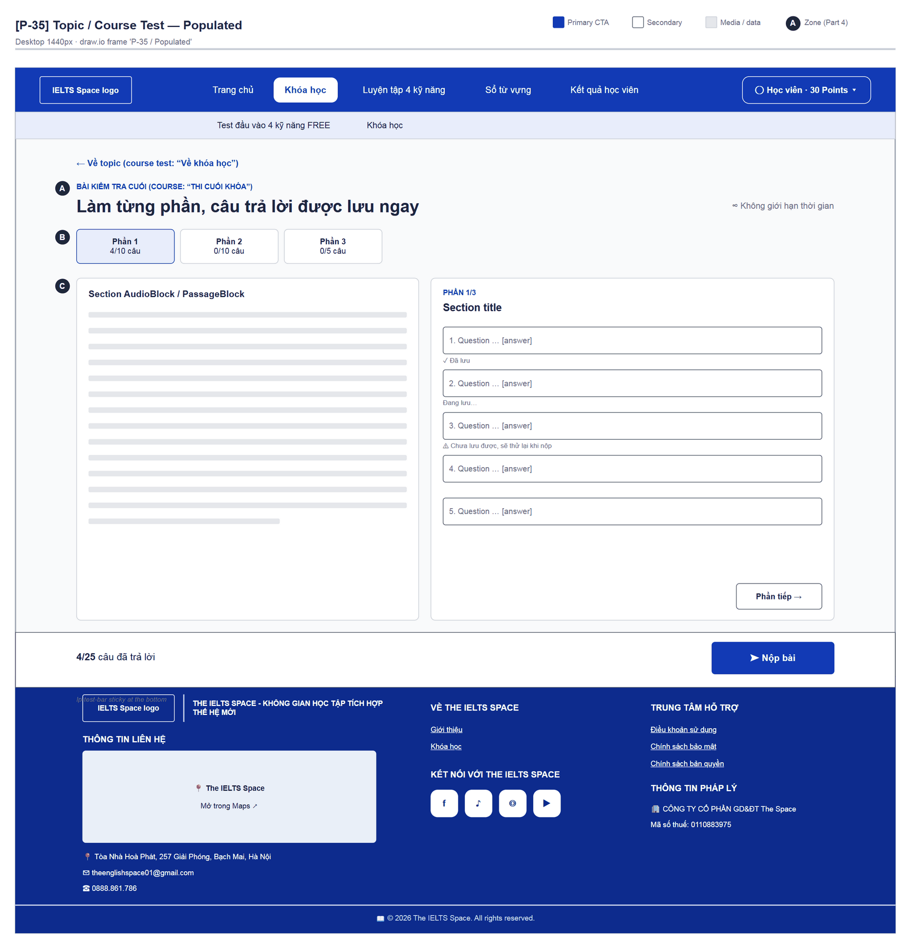
Figure 52 — [P-35] Topic / Course Test — Populated · draw.io frame 'P-35 / Populated'
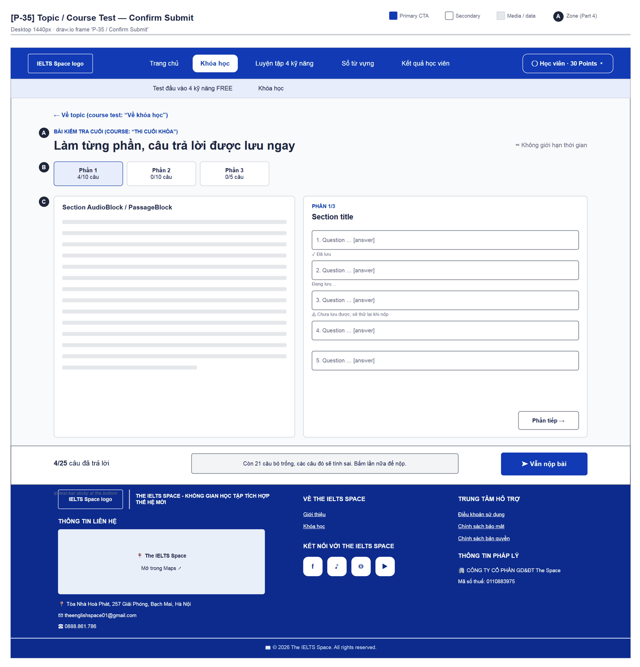
Figure 53 — [P-35] Topic / Course Test — Confirm Submit · draw.io frame 'P-35 / Confirm Submit'

4.15 — Test Result (P-36)
Page ID | P-36
Screen name | Test Result
Design file | draw.io — diagrams/wireframes/P-36_TestResult.drawio — frames 'P-36 / Passed', 'P-36 / Failed'
SRS Feature | FT-31, FT-29, FT-55
SRS Scenario | SC-05
Roles with access | Learner
Route | /learn/tests/:attemptId/result
Nav level | DEEP
Status | MVP
Flow(s) | F-02

Result of the topic / course final test: score, pass or fail, next step, per-question list.

Screen States
State | When It Appears | Design File Frame
Loading | “Đang chấm bài…” | LoadingState
Passed | ≥ 70% | P-36 / Passed
Failed | < 70% — answers hidden | P-36 / Failed
Error | ApiErrorState + Thử lại | —

Layout Description
Layout zones — P-36 Test Result
┌──────────────────────────────────────────────────┐
│ [A] (85%) KẾT QUẢ · mã đề … — Đạt bài kiểm tra… │
│ 17/20 câu đúng · 85% · cần từ 70% │
│ [B] [Sang chặng tiếp theo] [Xem danh sách khóa] │
│ [C] Từng câu: Câu 1 · prompt · correct/wrong … │
└──────────────────────────────────────────────────┘

Zone descriptions:
- Zone A: Score dial %, eyebrow “Kết quả · mã đề {code}”, H1 “Đạt bài kiểm tra cuối” / “Đạt thi cuối khóa” / “Chưa đạt lần này”, score line, message (see Appendix B G-02 about technical copy).
- Zone B: Passed: “Sang chặng tiếp theo” (when nextTopicId exists) or “Về khóa học” (course) + “Xem danh sách khóa”; failed: “Về topic để làm lại” / “Về khóa để làm lại”.
- Zone C: “Từng câu” — number, prompt, status; correct answers only when passed.

Key Interactions
User Action | What Happens | Notes
“Sang chặng tiếp theo” | → P-31 of the new topic | FT-29
“Về khóa học” | → P-30b | FT-55
Retry | → P-31 / P-30b; the next attempt gets a different test code
“Xem danh sách khóa” | → P-30

Mockup
Mockup / Wireframe — draw.io
Design file: diagrams/wireframes/P-36_TestResult.drawio
Frames: 'P-36 / Passed', 'P-36 / Failed'
Images below are exported from draw.io (scripts/export_diagrams.py); edit the .drawio file, then rebuild this document.

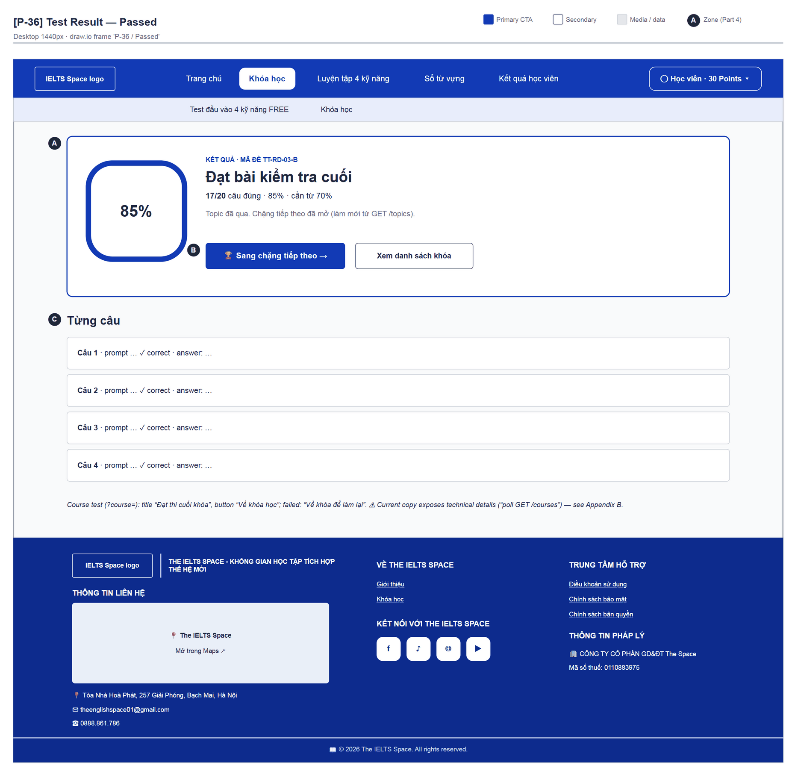
Figure 54 — [P-36] Test Result — Passed · draw.io frame 'P-36 / Passed'
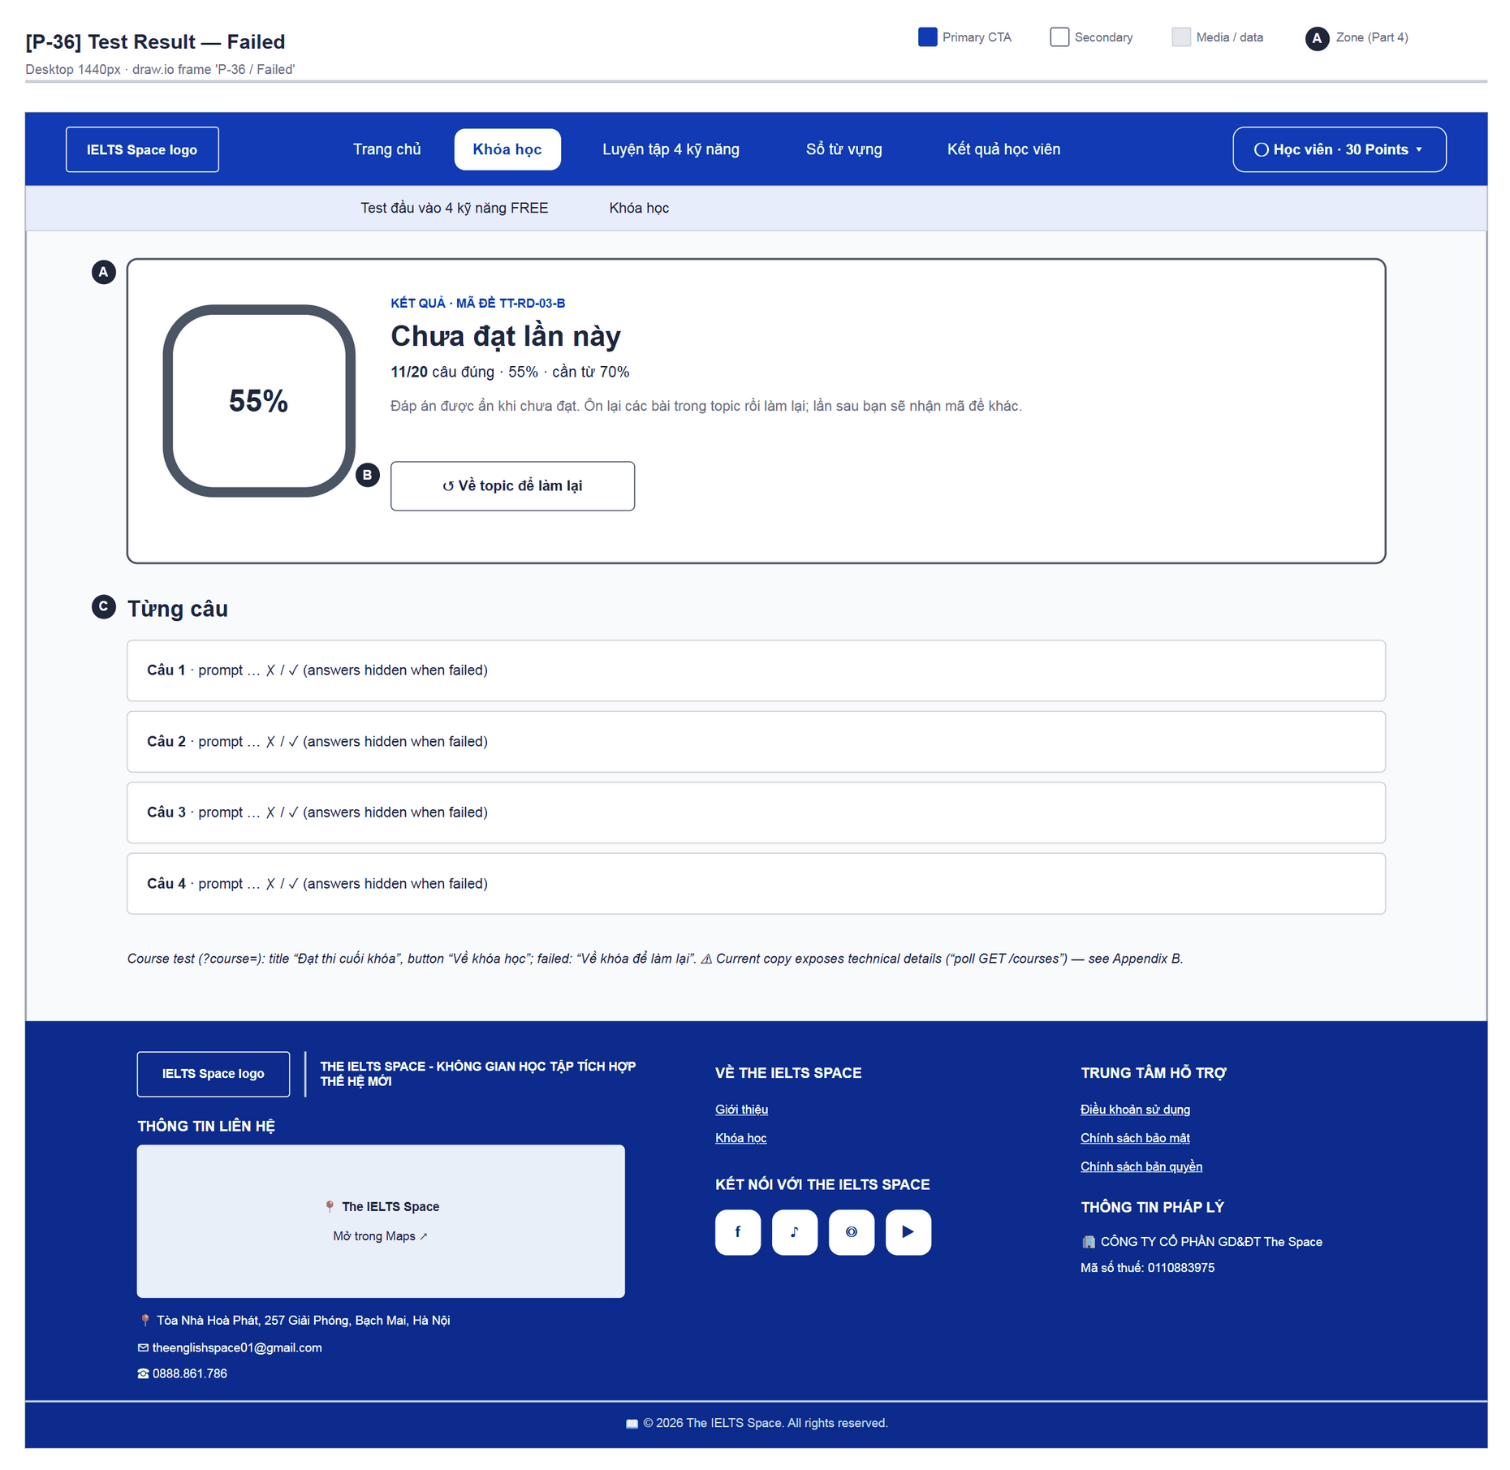
Figure 55 — [P-36] Test Result — Failed · draw.io frame 'P-36 / Failed'

4.16 — Practice Catalog (P-41)
Page ID | P-41
Screen name | Practice Catalog
Design file | draw.io — diagrams/wireframes/P-41_PracticeCatalog.drawio — frames 'P-41 / Populated'
SRS Feature | FT-34
SRS Scenario | —
Roles with access | Learner
Route | /practice-tests (?skill=)
Nav level | PRIMARY
Status | MVP·mock
Flow(s) | F-03

Catalogue of four-skill practice tests (mock data): filter by skill, source, status and search.

Screen States
State | When It Appears | Design File Frame
Loading | N/A — static mock data | N/A
Empty | No card matches the filters — empty grid (no dedicated copy yet) | N/A
Populated — default | Sidebar + banner + tabs + card grid | P-41 / Populated
Error | N/A (no API call yet) | N/A

Layout Description
Layout zones — P-41 Practice Catalog
┌──────────┬───────────────────────────────────────┐
│ [A] LUYỆN│ [B] Chưa biết mình đang ở band nào? │
│ ĐỀ │ > TEST NGAY │
│ KỸ NĂNG │ [C] (Bài chưa làm|Bài đã làm) Tìm │
│ Reading^ │ [D] [card] [card] [card] (3 columns) │
│ NGUỒN … │ [card] [card] │
└──────────┴───────────────────────────────────────┘

Zone descriptions:
- Zone A: PracticeSidebar “LUYỆN ĐỀ · The IELTS Space”; “KỸ NĂNG”: Reading (Bài lẻ: Passage 1/2/3, Full đề), Listening, Writing, Speaking; “NGUỒN TÀI LIỆU”: The IELTS Space PRO [PRO], Actual Tests, Các nguồn khác.
- Zone B: PracticeCosmicBanner “Chưa biết mình đang ở band nào?” / “Test đầu vào và khám phá trình độ IELTS hiện tại của bạn.” + “TEST NGAY ✦” (see G-03).
- Zone C: Tabs “Bài chưa làm” / “Bài đã làm”; search box “Tìm tên bài tập”.
- Zone D: PracticeTestCard: image, ribbon MIỄN PHÍ / PRO, passage pill, title, question-type bullets; click / Enter / Space opens P-41a.

Key Interactions
User Action | What Happens | Notes
Choose a skill (sidebar or ?skill=) | Filters the cards | The Luyện tập subnav keeps ?skill= in sync
Choose a card | Opens P-41a
Search | Filters by title | Client-side

Mockup
Mockup / Wireframe — draw.io
Design file: diagrams/wireframes/P-41_PracticeCatalog.drawio
Frames: 'P-41 / Populated'
Images below are exported from draw.io (scripts/export_diagrams.py); edit the .drawio file, then rebuild this document.

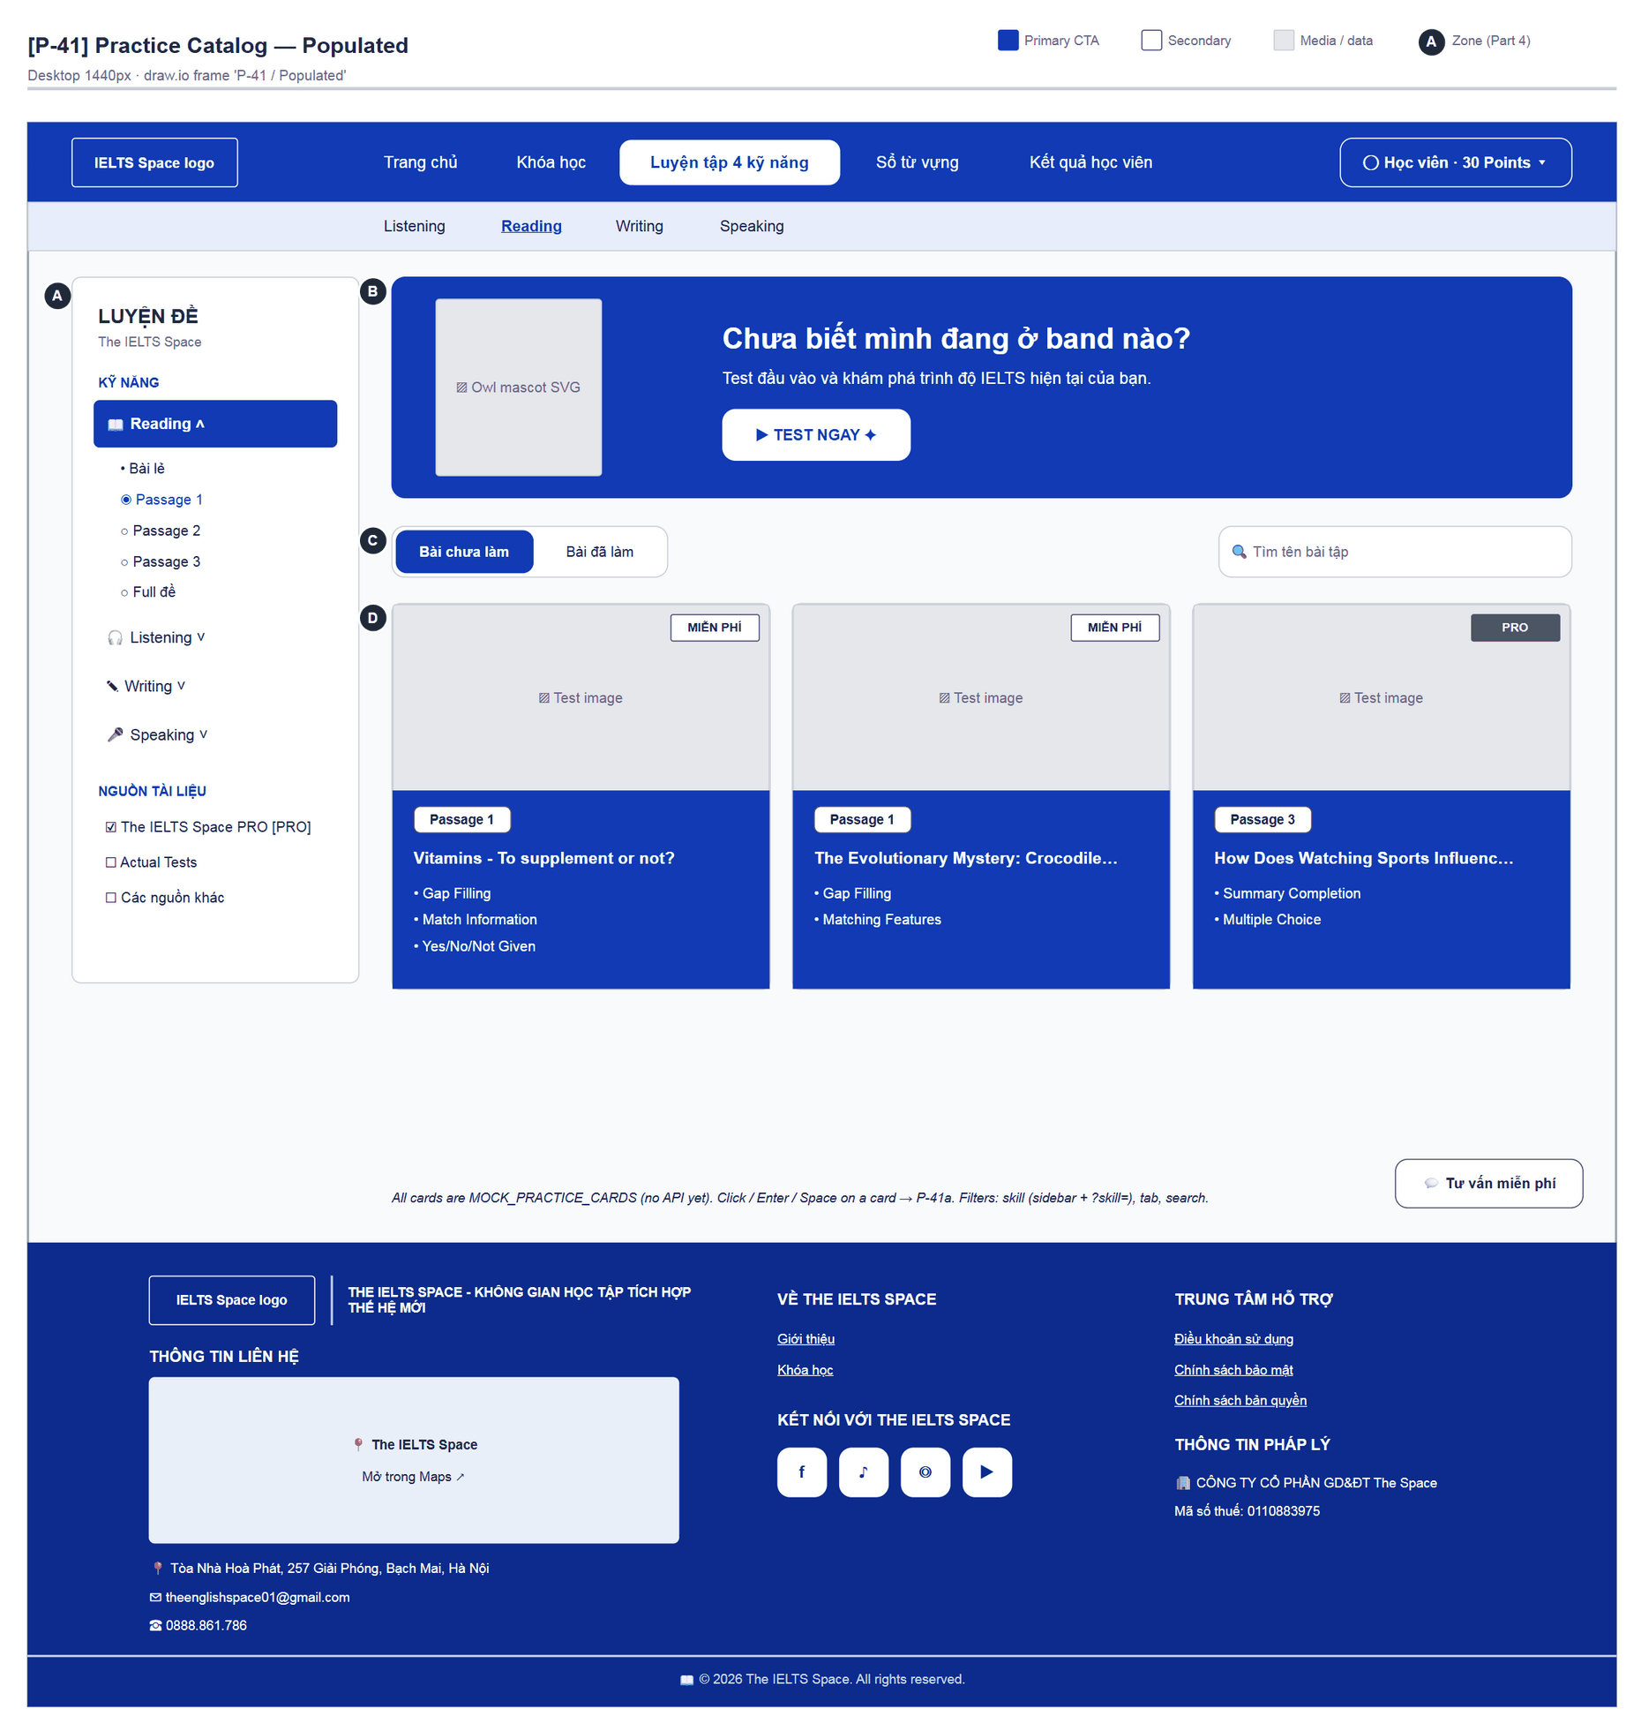
Figure 56 — [P-41] Practice Catalog — Populated · draw.io frame 'P-41 / Populated'

4.17 — Practice Mode Select (P-41a)
Page ID | P-41a
Screen name | Practice Mode Select
Design file | draw.io — diagrams/wireframes/P-41a_PracticeModeSelect.drawio — frames 'P-41a / Populated'
SRS Feature | FT-34
SRS Scenario | —
Roles with access | Learner
Route | Modal on P-41
Nav level | MODAL
Status | MVP·mock
Flow(s) | F-03

Choose the attempt mode for the selected card: exam simulation or practice.

Screen States
State | When It Appears | Design File Frame
Populated — default | Thi thử selected by default | P-41a / Populated

Layout Description
Layout zones — P-41a Practice Mode Select
┌────────────────────────────────────┐
│ [A] {Test title} x │
│ Lựa chọn chế độ làm bài │
│ [B] [Thi thử] [Luyện tập] │
│ [C] [ BẮT ĐẦU LÀM BÀI ] │
└────────────────────────────────────┘

Zone descriptions:
- Zone A: Test title (DialogTitle).
- Zone B: Two aria-pressed cards: “Thi thử” — “Tập trung như phòng thi thật. Không có Highlight, Note, tra từ hay Flashcard.”; “Luyện tập” — “Học chủ động với các hỗ trợ phù hợp cho từng kỹ năng và xem lại tiến độ của bạn.”
- Zone C: Button “BẮT ĐẦU LÀM BÀI”.

Key Interactions
User Action | What Happens | Notes
Choose a mode | Selected card changes
“BẮT ĐẦU LÀM BÀI” | reading → /practice/test/:id?mode=; others → /practice/{skill}/:id?mode= | F-03
Close / Esc | Back to P-41

Mockup
Mockup / Wireframe — draw.io
Design file: diagrams/wireframes/P-41a_PracticeModeSelect.drawio
Frames: 'P-41a / Populated'
Images below are exported from draw.io (scripts/export_diagrams.py); edit the .drawio file, then rebuild this document.

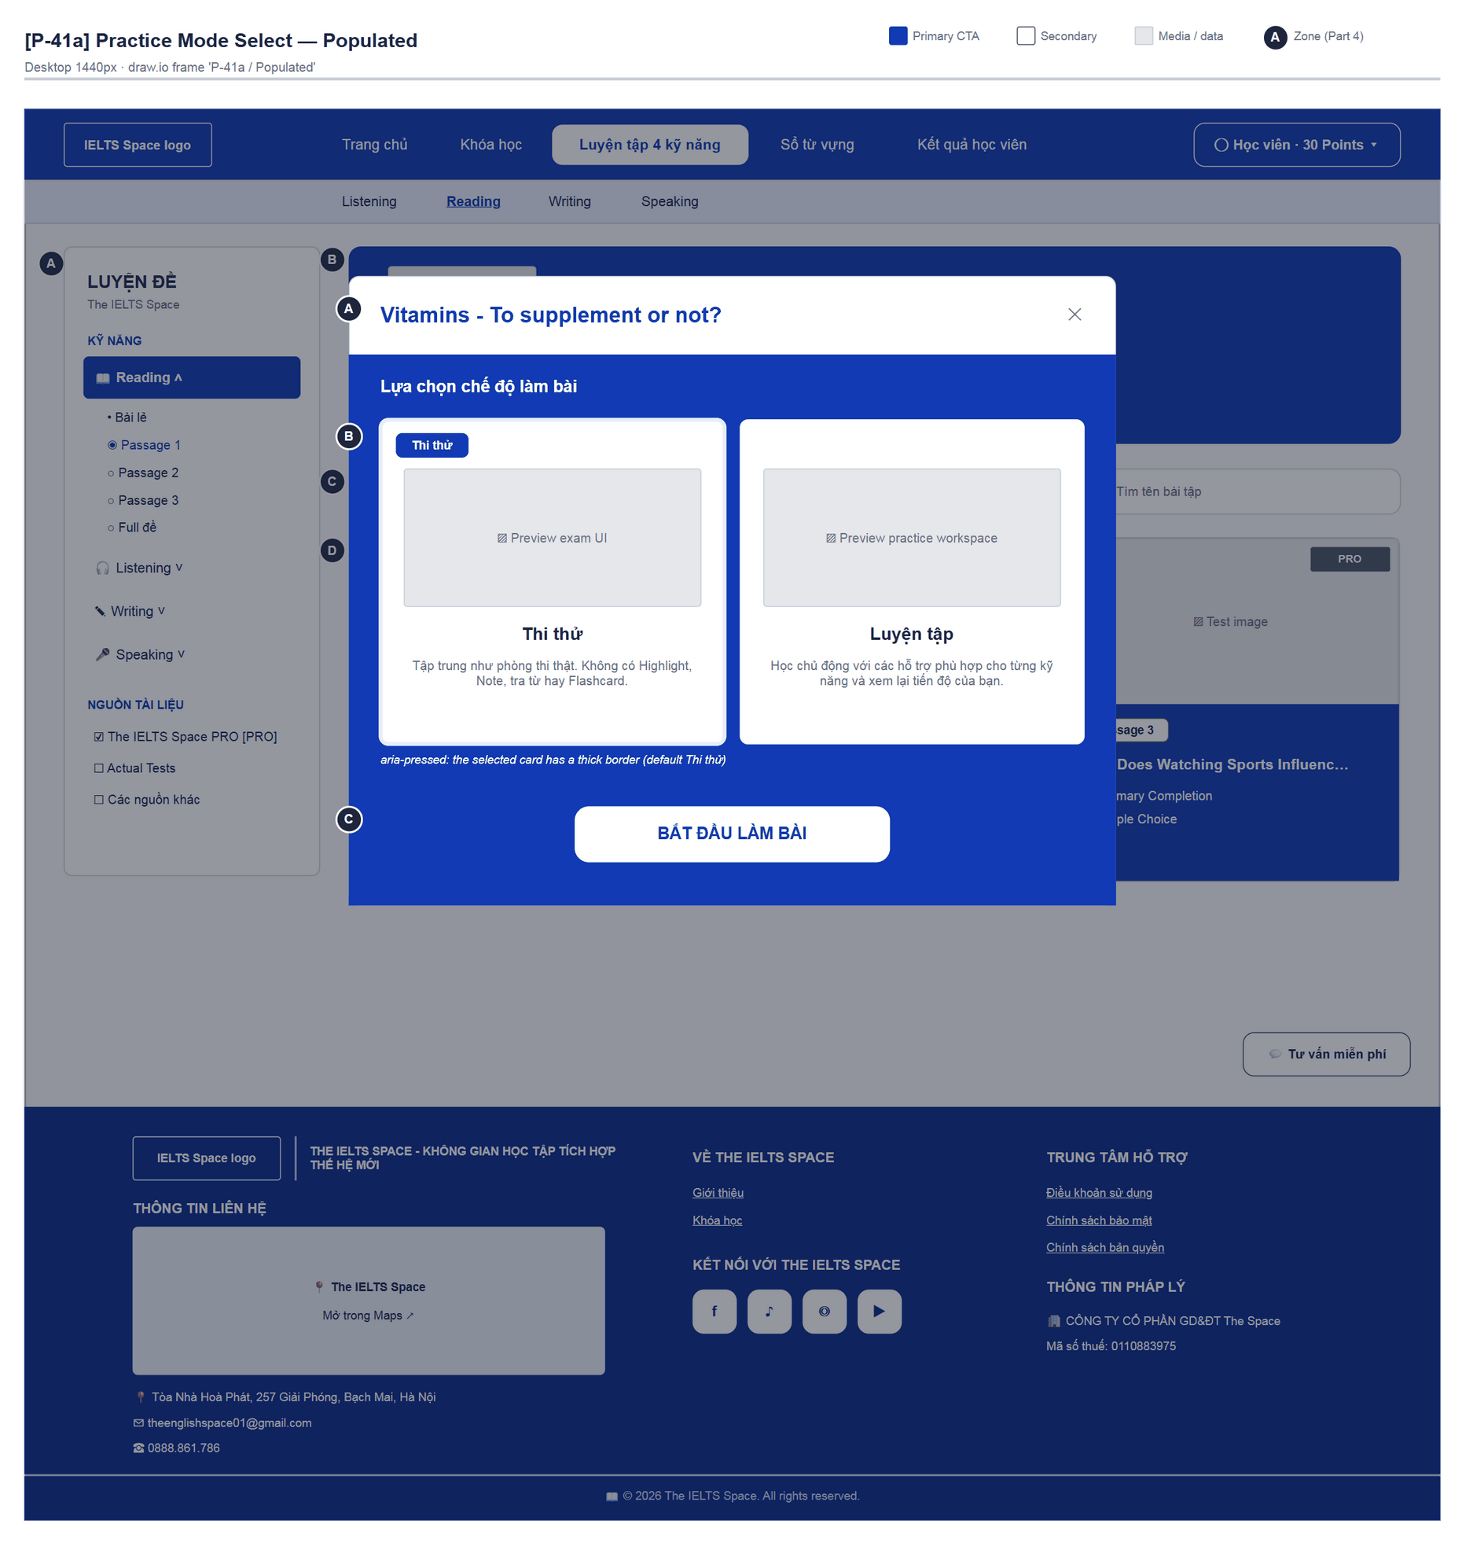
Figure 57 — [P-41a] Practice Mode Select — Populated · draw.io frame 'P-41a / Populated'

4.18 — Reading Practice Test (P-42)
Page ID | P-42
Screen name | Reading Practice Test
Design file | draw.io — diagrams/wireframes/P-42_ReadingPracticeTest.drawio — frames 'P-42 / Practice Mode', 'P-42 / Exam Mode'
SRS Feature | FT-34, FT-42, FT-43
SRS Scenario | SC-08
Roles with access | Learner
Route | /practice/test/:testId?mode= (/practice/test)
Nav level | DEEP
Status | MVP·mock
Flow(s) | F-03

Reading workspace: passage, question map and answers; practice mode adds Highlight / Note / dictionary / Flashcard tools.

Screen States
State | When It Appears | Design File Frame
Populated — Practice | mode=practice | P-42 / Practice Mode
Populated — Exam | mode=exam (Thi thử) | P-42 / Exam Mode
Feedback | aria-live messages: “Hãy bôi đen một đoạn trong bài đọc trước khi chọn công cụ.”, “Đã Highlight đoạn được chọn.”, “Đã bỏ Highlight.” | Inside the frame

Layout Description
Layout zones — P-42 Reading Practice Test
┌────────────────────────────────────────────────────┐
│ [A] ← Thoát | Luyện tập 00:12:40 | Tiến độ | Ghi chú│
├──────────┬───────────────────────┬─────────────────┤
│ [B] Map │ [C] Công cụ hỗ trợ │ [E] Question 1/5│
│ 1 2 3 │ [D] Snow Makers A–E │ List of Headings│
│ Back Next│ (highlight) │ 1. Paragraph C │
└──────────┴───────────────────────┴─────────────────┘

Zone descriptions:
- Zone A: Sub-topbar: “← Thoát”, badge “Luyện tập / Thi thử”, timer, “Tiến độ x/5 câu” bar, “Ghi chú (n)” (practice), ⚙ “Cài đặt giao diện” (Chế độ bảo vệ mắt, Kích cỡ chữ).
- Zone B: QUESTION MAP “Bản đồ câu hỏi” 1–5 + Back / Next.
- Zone C: PRACTICE TOOLS “Công cụ hỗ trợ”: Highlight, Note, Tra từ vựng, Tạo Flashcard, “Thẻ đã lưu”, “Bỏ Highlight” (practice mode only).
- Zone D: Passage “Snow Makers” paragraphs A–E; select text to act on it, right-click context menu.
- Zone E: Matching Headings questions (List of Headings i–x, answer for Paragraph C…), ⚑ flag, “Đã chọn x/5 câu”.

Key Interactions
User Action | What Happens | Notes
Select text + tool | Highlight / open P-42d / P-42b / P-42a | FT-42, FT-43
“Thẻ đã lưu” | Opens P-42c
Answer / ⚑ | Updates map and progress | Not saved to the server
“Thoát” | → P-41

Mockup
Mockup / Wireframe — draw.io
Design file: diagrams/wireframes/P-42_ReadingPracticeTest.drawio
Frames: 'P-42 / Practice Mode', 'P-42 / Exam Mode'
Images below are exported from draw.io (scripts/export_diagrams.py); edit the .drawio file, then rebuild this document.

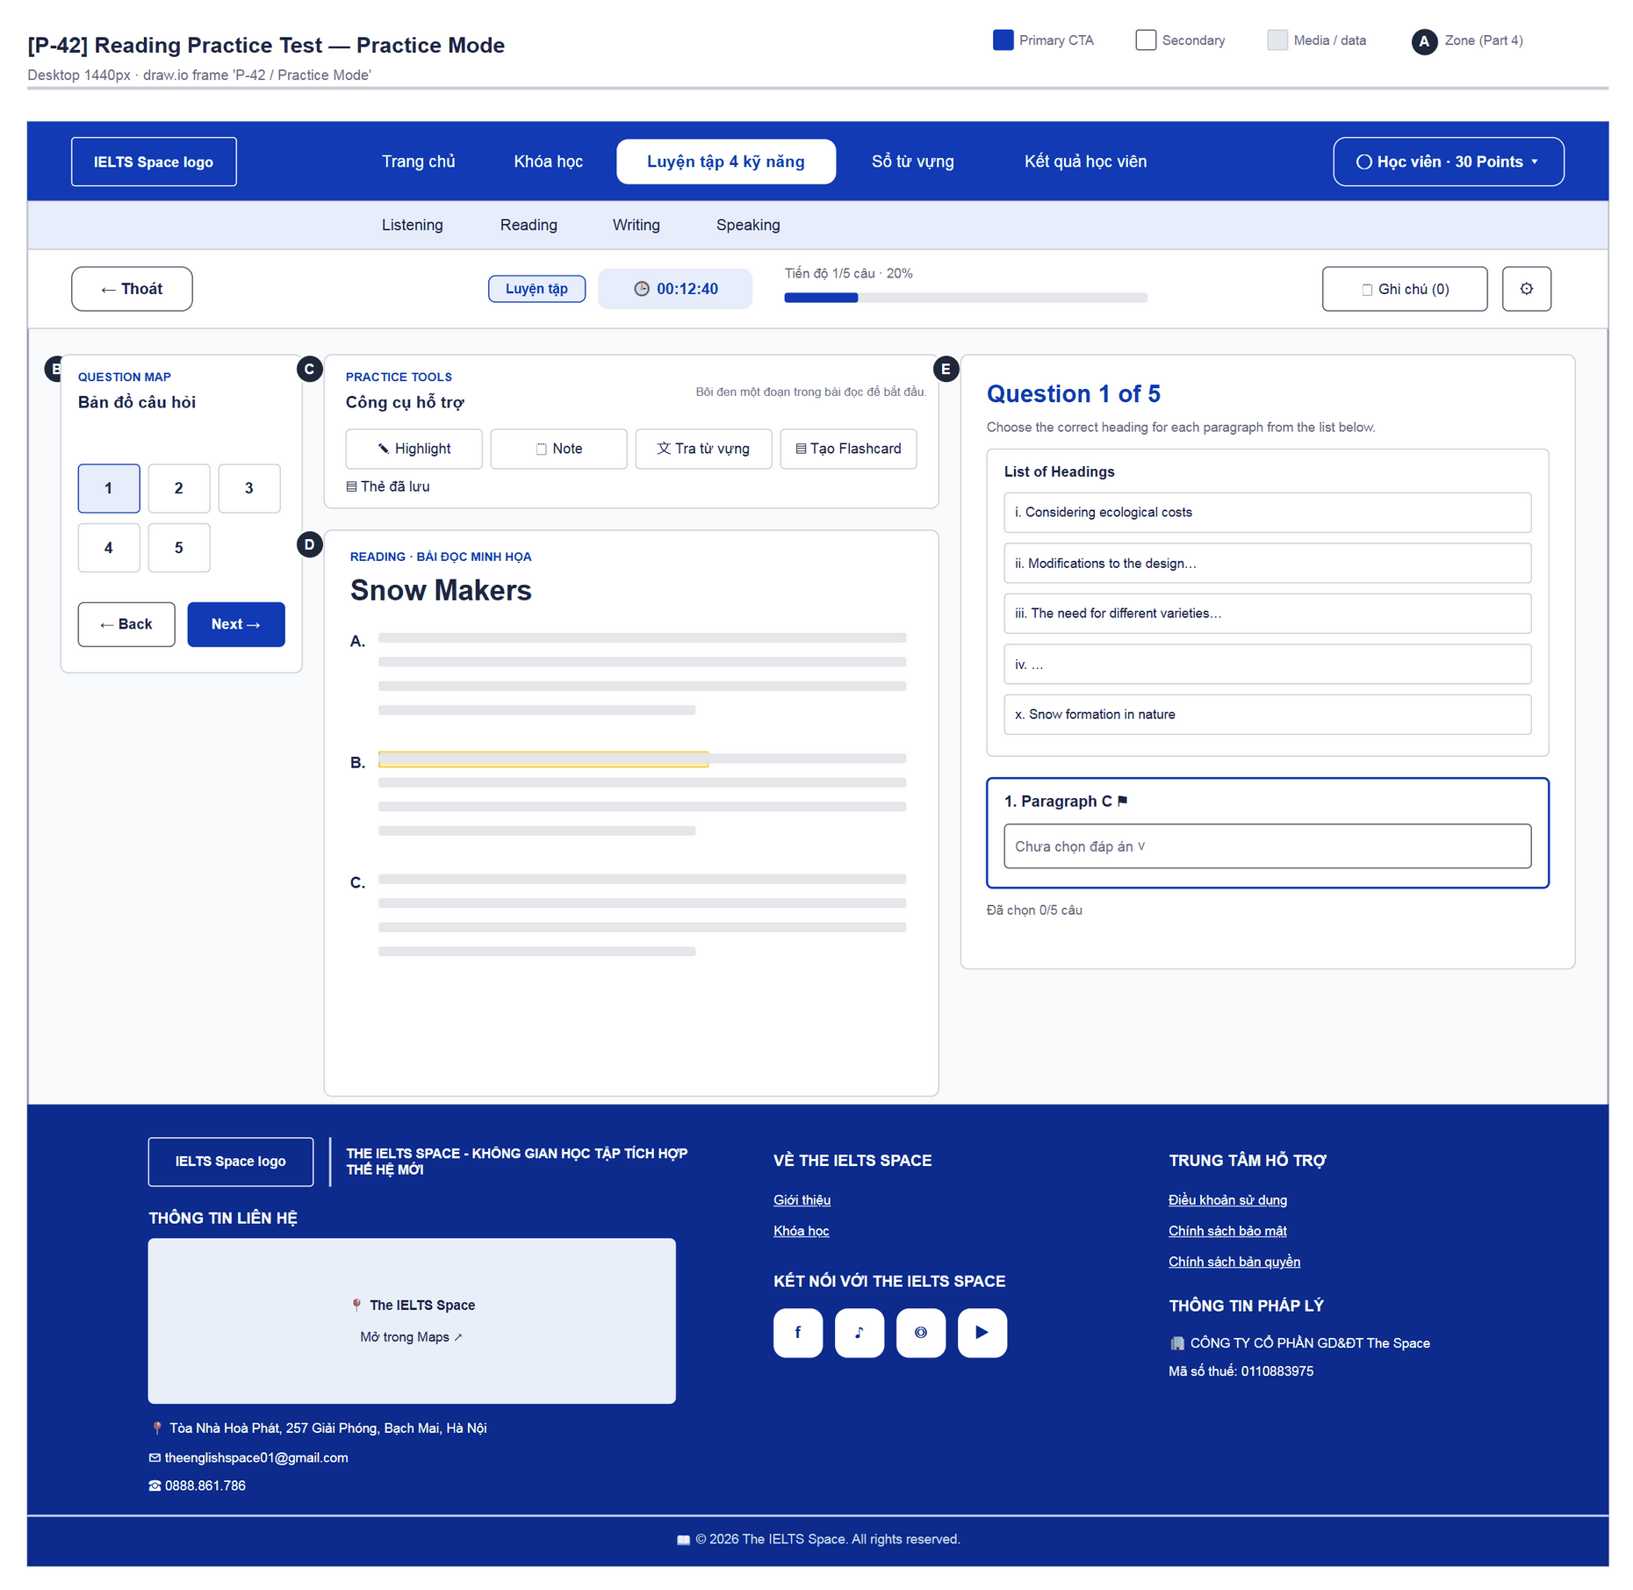
Figure 58 — [P-42] Reading Practice Test — Practice Mode · draw.io frame 'P-42 / Practice Mode'
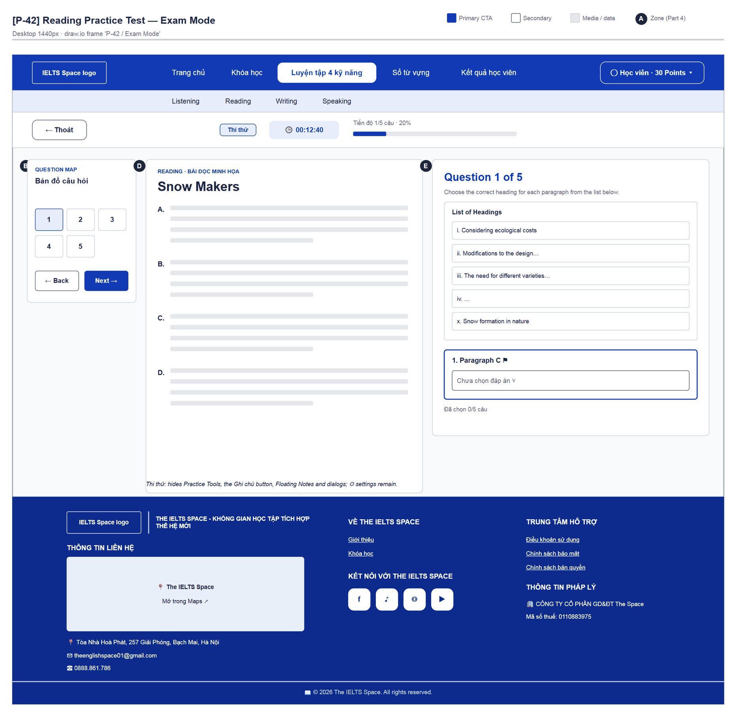
Figure 59 — [P-42] Reading Practice Test — Exam Mode · draw.io frame 'P-42 / Exam Mode'

4.19 — Create Flashcard (P-42a)
Page ID | P-42a
Screen name | Create Flashcard
Design file | draw.io — diagrams/wireframes/P-42a_CreateFlashcard.drawio — frames 'P-42a / Populated'
SRS Feature | FT-43
SRS Scenario | SC-08
Roles with access | Learner
Route | Modal on P-42
Nav level | MODAL
Status | MVP·mock
Flow(s) | F-03

Save the selected word/phrase as a flashcard (localStorage, not synced to the account).

Screen States
State | When It Appears | Design File Frame
Populated — default | Opened from P-42 (practice mode) | P-42a / Populated

Layout Description
Layout: see frame 'P-42a / Populated' (figure below); zone badges A/B/C match the list that follows.
Zone descriptions:
- Zone A: “Tạo Flashcard” · “Lưu từ vựng và ảnh minh họa trên trình duyệt này. Chưa đồng bộ tài khoản.”
- Zone B: “Từ / cụm từ *” (prefilled), “Nghĩa / định nghĩa *”, “Ví dụ / ngữ cảnh”, “Ảnh minh họa” (PNG, JPG hoặc WebP · tối đa 1 MB).
- Zone C: Errors “Nhập từ vựng và nghĩa trước khi lưu.” / “Không lưu được: bộ nhớ đầy…”; button “Lưu Flashcard”.

Key Interactions
User Action | What Happens | Notes
“Lưu Flashcard” | Writes to localStorage; P-42 shows “Đã lưu Flashcard trên trình duyệt này. Mở “Thẻ đã lưu” để xem.” | FT-43
Close | Back to P-42

Mockup
Mockup / Wireframe — draw.io
Design file: diagrams/wireframes/P-42a_CreateFlashcard.drawio
Frames: 'P-42a / Populated'
Images below are exported from draw.io (scripts/export_diagrams.py); edit the .drawio file, then rebuild this document.

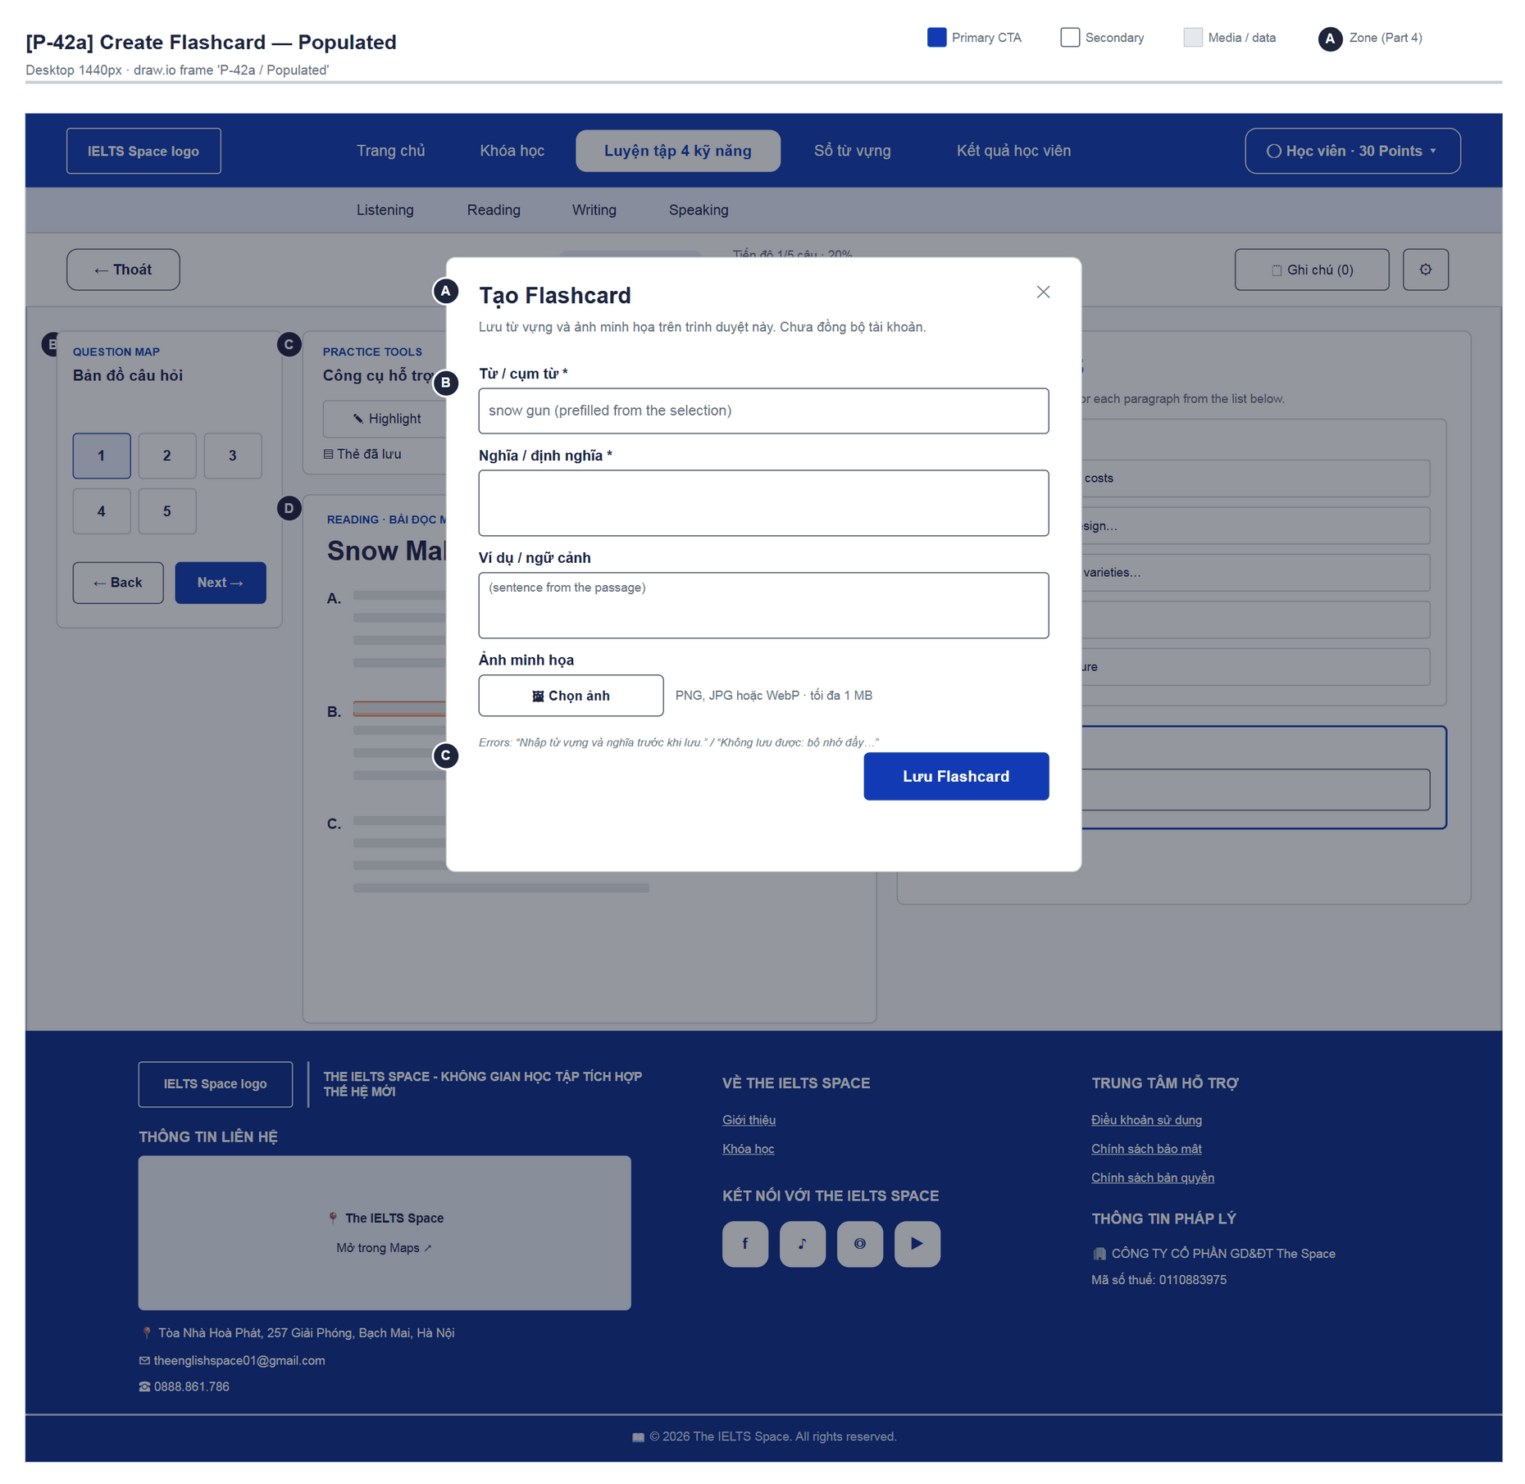
Figure 60 — [P-42a] Create Flashcard — Populated · draw.io frame 'P-42a / Populated'

4.20 — Dictionary Lookup (P-42b)
Page ID | P-42b
Screen name | Dictionary Lookup
Design file | draw.io — diagrams/wireframes/P-42b_DictionaryLookup.drawio — frames 'P-42b / Populated'
SRS Feature | FT-36
SRS Scenario | SC-08
Roles with access | Learner
Route | Modal on P-42
Nav level | MODAL
Status | MVP·mock
Flow(s) | F-03

Look up the selected word in the passage glossary; Wiktionary link.

Screen States
State | When It Appears | Design File Frame
Populated — default | Opened from P-42 (practice mode) | P-42b / Populated

Layout Description
Layout: see frame 'P-42b / Populated' (figure below); zone badges A/B/C match the list that follows.
Zone descriptions:
- Zone A: “Tra từ vựng” · “Từ điển nhỏ của bài đọc. Có thể tra cứu thêm trên Wiktionary.”
- Zone B: Selected word + meaning; not found: “Chưa có nghĩa trong từ điển của bài…”
- Zone C: Wiktionary link (new tab).

Key Interactions
User Action | What Happens | Notes
Open Wiktionary | New tab | noopener
Close | Back to P-42

Mockup
Mockup / Wireframe — draw.io
Design file: diagrams/wireframes/P-42b_DictionaryLookup.drawio
Frames: 'P-42b / Populated'
Images below are exported from draw.io (scripts/export_diagrams.py); edit the .drawio file, then rebuild this document.

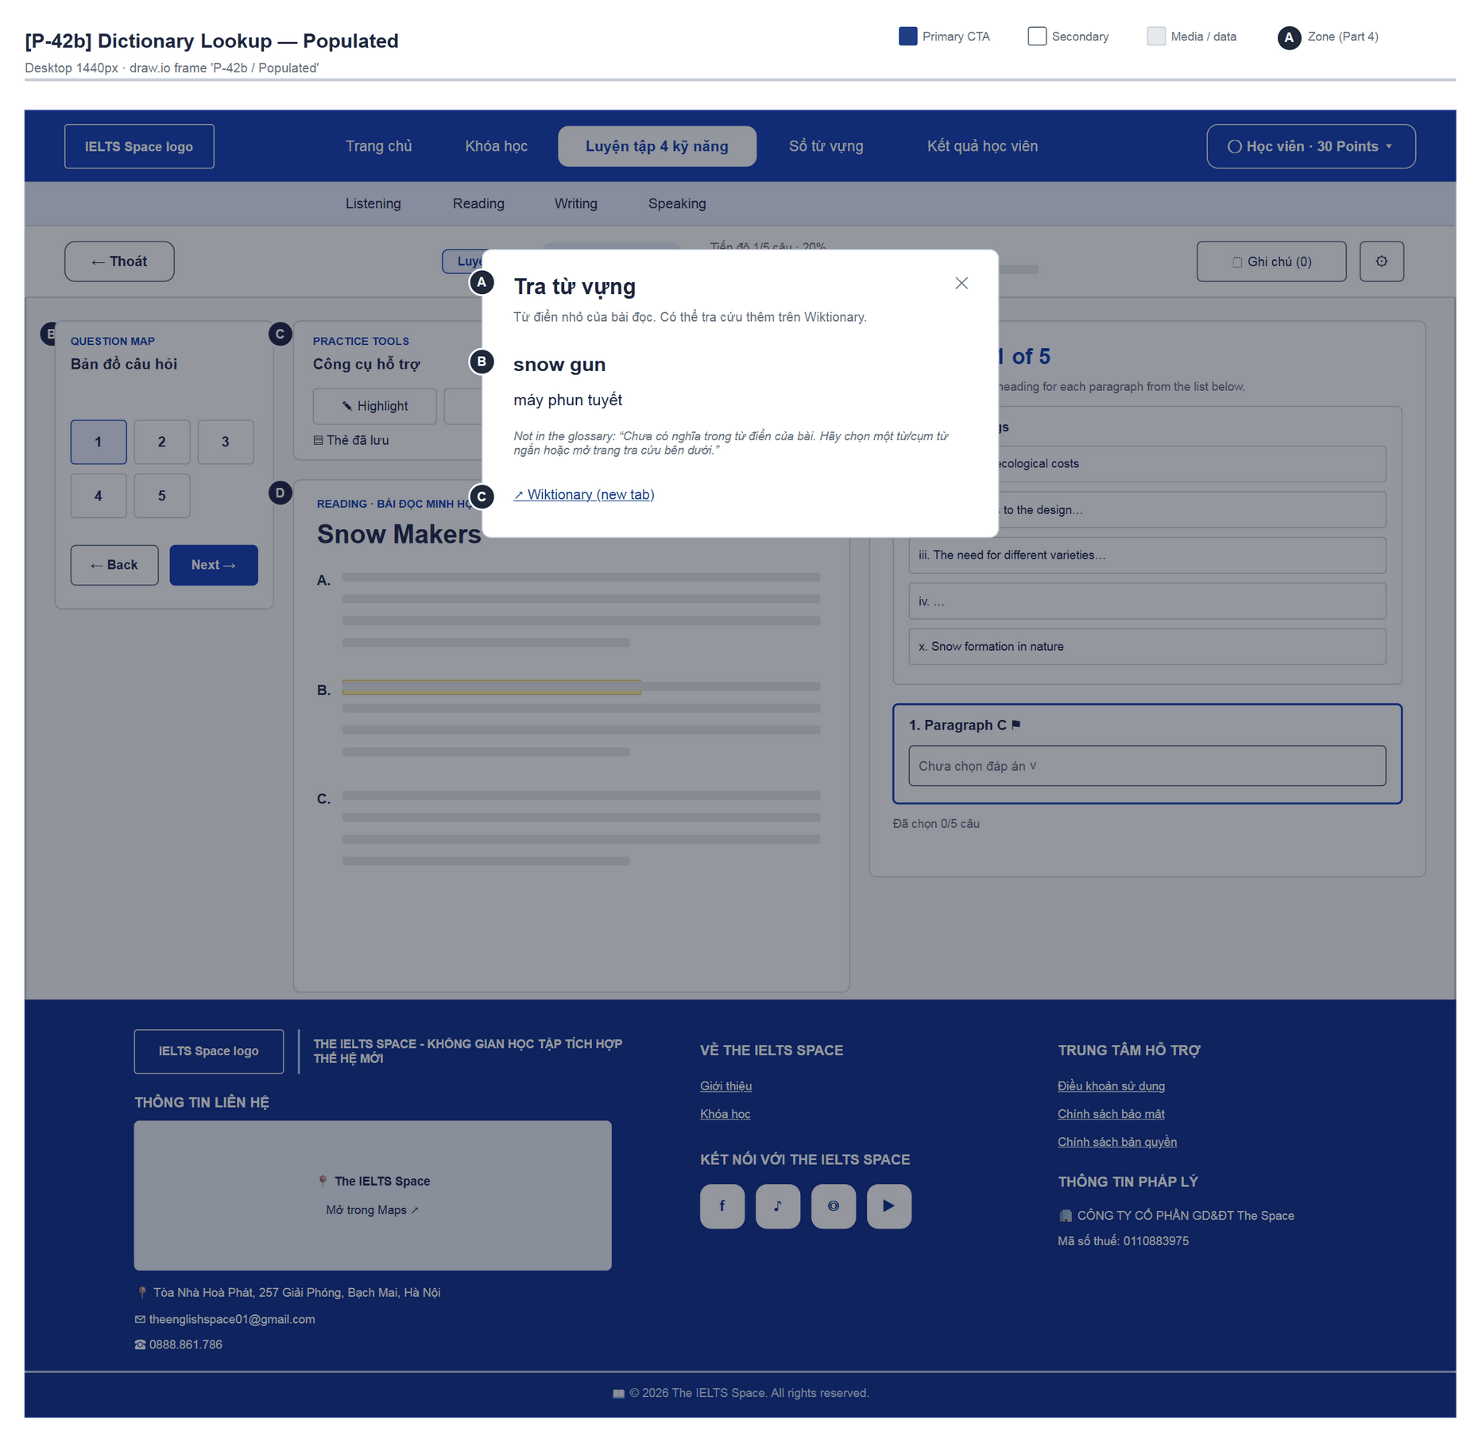
Figure 61 — [P-42b] Dictionary Lookup — Populated · draw.io frame 'P-42b / Populated'

4.21 — Saved Flashcards (P-42c)
Page ID | P-42c
Screen name | Saved Flashcards
Design file | draw.io — diagrams/wireframes/P-42c_SavedFlashcards.drawio — frames 'P-42c / Populated'
SRS Feature | FT-43
SRS Scenario | SC-08
Roles with access | Learner
Route | Modal on P-42
Nav level | MODAL
Status | MVP·mock
Flow(s) | F-03

View flashcards saved in this browser.

Screen States
State | When It Appears | Design File Frame
Populated — default | Opened from P-42 (practice mode) | P-42c / Populated

Layout Description
Layout: see frame 'P-42c / Populated' (figure below); zone badges A/B/C match the list that follows.
Zone descriptions:
- Zone A: “Flashcard đã lưu (n)”.
- Zone B: Card list (image, word, meaning, example); empty: “Chưa có thẻ. Chọn từ trong bài đọc và nhấn “Tạo Flashcard”.”; storage read errors use role=alert.

Key Interactions
User Action | What Happens | Notes
Close | Back to P-42

Mockup
Mockup / Wireframe — draw.io
Design file: diagrams/wireframes/P-42c_SavedFlashcards.drawio
Frames: 'P-42c / Populated'
Images below are exported from draw.io (scripts/export_diagrams.py); edit the .drawio file, then rebuild this document.

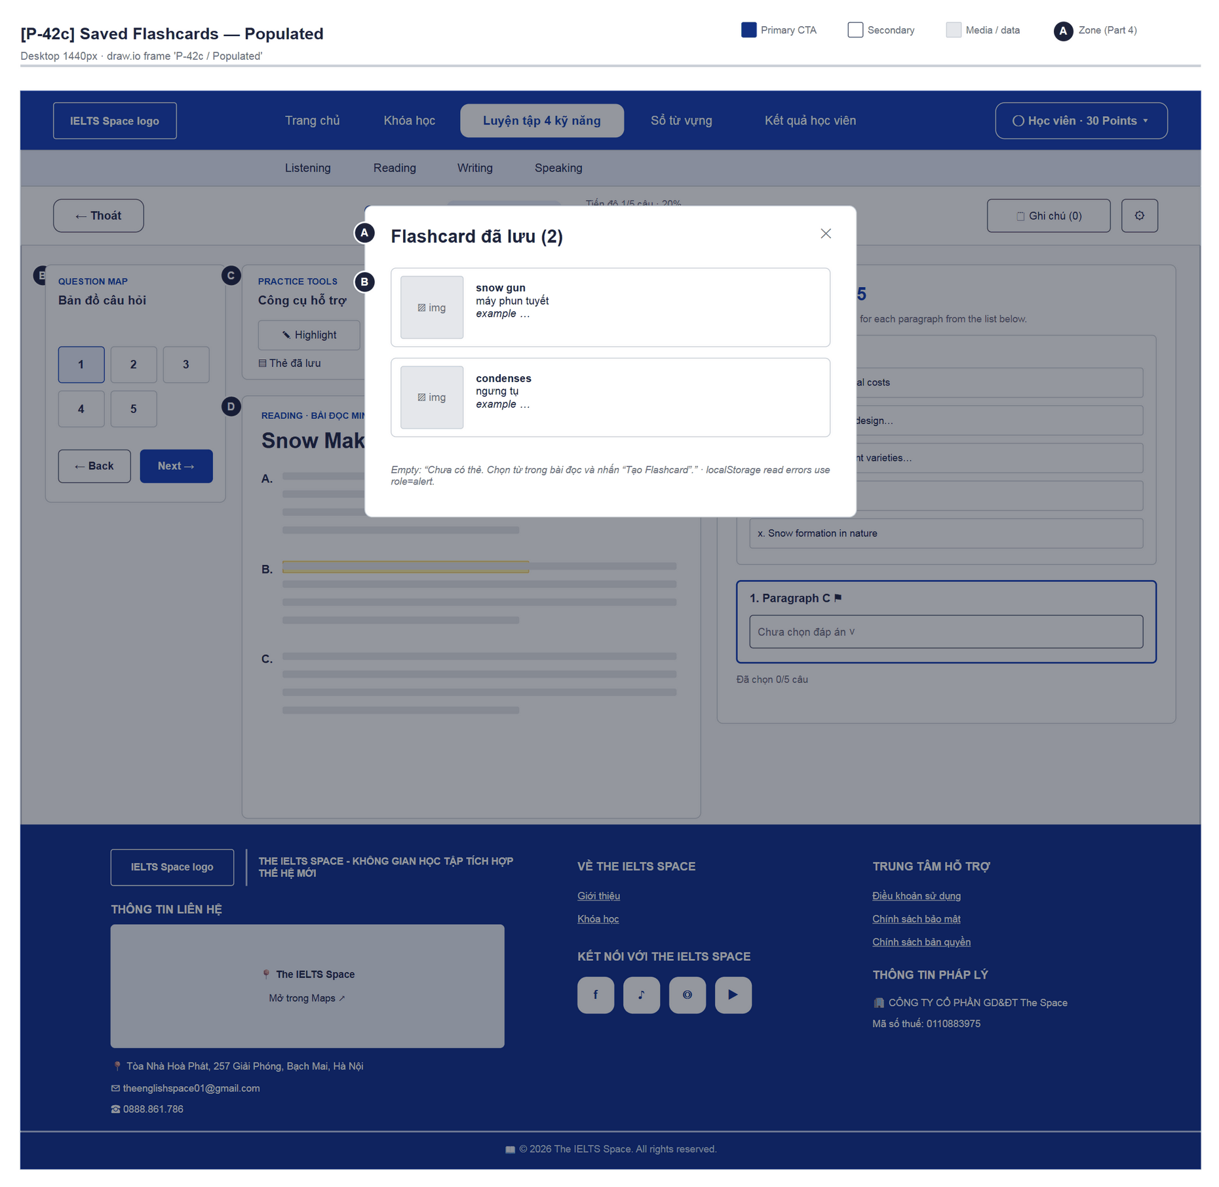
Figure 62 — [P-42c] Saved Flashcards — Populated · draw.io frame 'P-42c / Populated'

4.22 — Floating Notes (P-42d)
Page ID | P-42d
Screen name | Floating Notes
Design file | draw.io — diagrams/wireframes/P-42d_FloatingNotes.drawio — frames 'P-42d / Populated'
SRS Feature | FT-42
SRS Scenario | SC-08
Roles with access | Learner
Route | Floating panel on P-42
Nav level | MODAL
Status | MVP·mock
Flow(s) | F-03

Draggable floating notes panel tied to the selected paragraph; kept for the session only.

Screen States
State | When It Appears | Design File Frame
Populated — default | Opened from P-42 (practice mode) | P-42d / Populated

Layout Description
Layout: see frame 'P-42d / Populated' (figure below); zone badges A/B/C match the list that follows.
Zone descriptions:
- Zone A: Draggable title bar (⠿), minimise —, hide ✕; “Kéo thanh tiêu đề để di chuyển”, move left/right buttons.
- Zone B: Selected paragraph, “Nội dung ghi chú”, “Lưu ghi chú”, “Ghi chú giữ trong phiên làm bài; tải lại trang sẽ xóa.”
- Zone C: Note list (Đoạn n · time) + delete; empty: “Chưa có ghi chú. Chọn một đoạn văn và viết điều cần nhớ.”

Key Interactions
User Action | What Happens | Notes
“Lưu ghi chú” | Added at the top of the list; “Đã lưu ghi chú trong phiên làm bài này.” | FT-42
Drag / arrow keys | Moves the panel | a11y
Hide | Closes the panel, focus returns to the Ghi chú button

Mockup
Mockup / Wireframe — draw.io
Design file: diagrams/wireframes/P-42d_FloatingNotes.drawio
Frames: 'P-42d / Populated'
Images below are exported from draw.io (scripts/export_diagrams.py); edit the .drawio file, then rebuild this document.

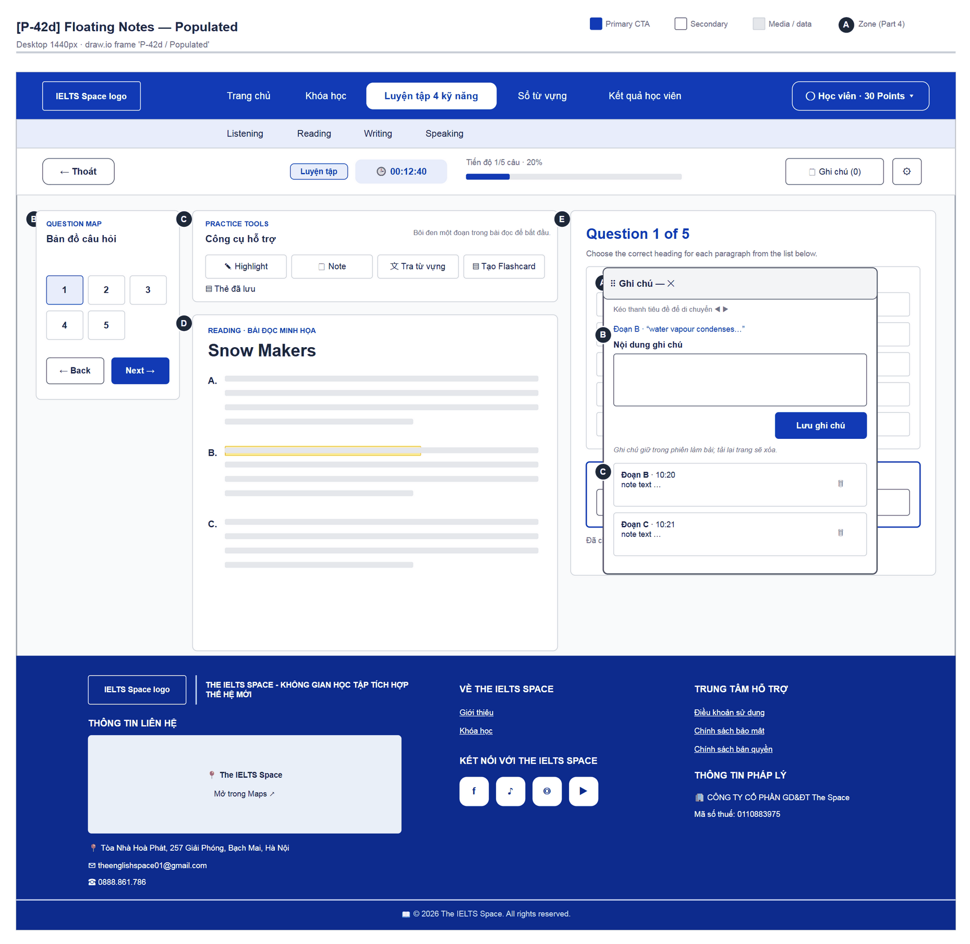
Figure 63 — [P-42d] Floating Notes — Populated · draw.io frame 'P-42d / Populated'

4.23 — Listening Practice (P-43)
Page ID | P-43
Screen name | Listening Practice
Design file | draw.io — diagrams/wireframes/P-43_ListeningPractice.drawio — frames 'P-43 / Populated'
SRS Feature | FT-24, FT-34
SRS Scenario | —
Roles with access | Learner
Route | /practice/listening/:testId
Nav level | DEEP
Status | MVP·mock
Flow(s) | F-03

Listening workspace (mock): audio player, question map that follows audio cues, answer per question.

Screen States
State | When It Appears | Design File Frame
Populated — default | Audio 03:06, 5 questions | P-43 / Populated

Layout Description
Layout zones — P-43 Listening Practice
┌───────────────────────────────────────────────────────┐
│ [A] ← Thoát | Listening · Section 1 · Practice │
│ [B] Map │ [C] player · SECTION 1 │ [D] Question 3 of 5│
└───────────────────────────────────────────────────────┘

Zone descriptions:
- Zone A: “← Thoát”, Listening badge, “Section 1 · Practice”, progress.
- Zone B: Question map 1–5 + Back/Next; follows the audio cue automatically.
- Zone C: AudioPlayer (play/pause, seek, volume, speed) + “SECTION 1 · Student services enquiry” + instructions.
- Zone D: Current question: prompt, helper “Write ONE word and/or a number.”, field “Nhập đáp án cho câu n”, ⚑.

Key Interactions
User Action | What Happens | Notes
Play / seek | Active question follows the cue
Select a question | Seeks to that question's cue
“Thoát” | → P-41

Mockup
Mockup / Wireframe — draw.io
Design file: diagrams/wireframes/P-43_ListeningPractice.drawio
Frames: 'P-43 / Populated'
Images below are exported from draw.io (scripts/export_diagrams.py); edit the .drawio file, then rebuild this document.

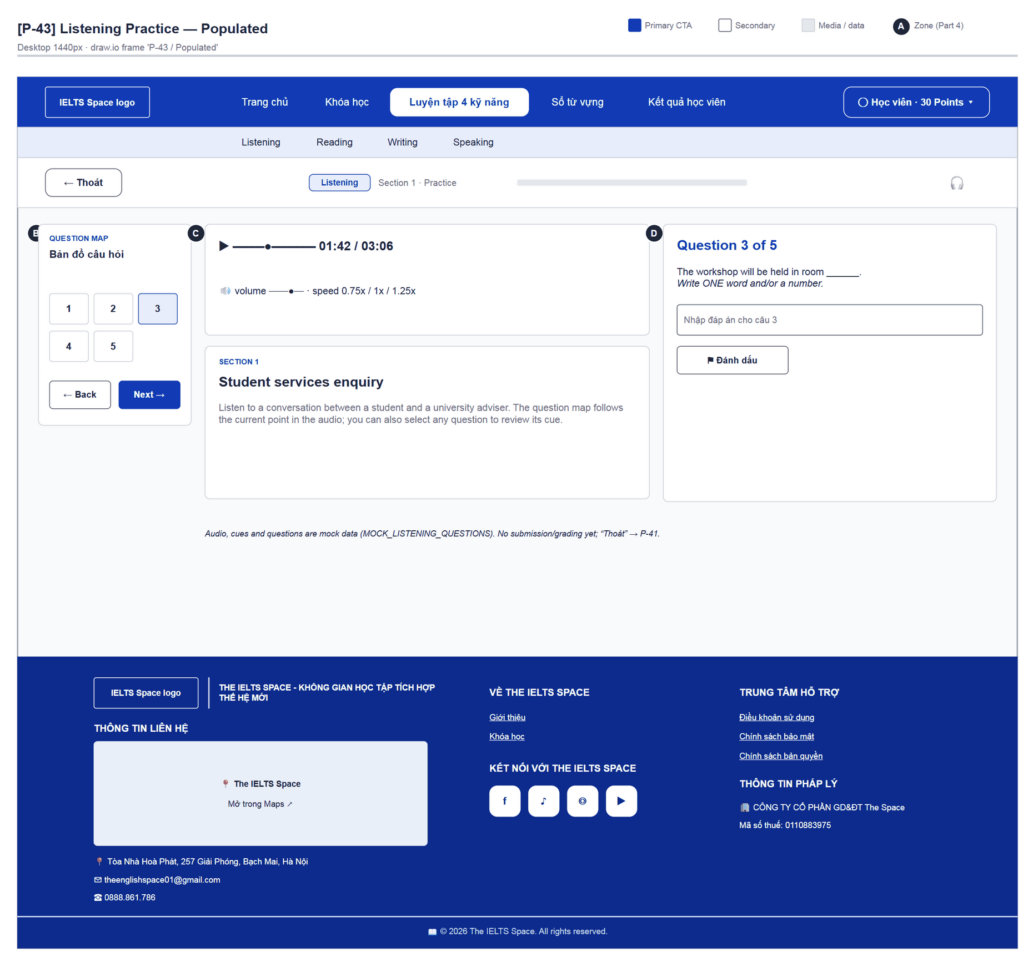
Figure 64 — [P-43] Listening Practice — Populated · draw.io frame 'P-43 / Populated'

4.24 — Writing Practice (P-44)
Page ID | P-44
Screen name | Writing Practice
Design file | draw.io — diagrams/wireframes/P-44_WritingPractice.drawio — frames 'P-44 / Populated'
SRS Feature | FT-34
SRS Scenario | —
Roles with access | Learner
Route | /practice/writing/:taskId
Nav level | DEEP
Status | MVP·mock
Flow(s) | F-03

Writing Task 1 workspace (mock): prompt + chart, essay editor with word count and countdown.

Screen States
State | When It Appears | Design File Frame
Populated — default | Empty response | P-44 / Populated

Layout Description
Layout zones — P-44 Writing Practice
┌───────────────────────────┬──────────────────────┐
│ [A] ← Thoát · Writing · {title} │
│ [B] WRITING PROMPT │ [C] YOUR RESPONSE │
│ TASK VISUAL (chart) │ textarea │
│ [Phóng to biểu đồ] │ ≥150 từ · 0/150 │
└───────────────────────────┴──────────────────────┘

Zone descriptions:
- Zone A: Topbar “← Thoát”, Writing badge, task title.
- Zone B: Prompt + chart “Transport use in a European city” (Car / Bus / Bicycle) + “Phóng to biểu đồ” (P-44a).
- Zone C: “Write your answer”, CountdownTimer, textarea “Start writing your response here…”, “Mục tiêu: ít nhất 150 từ. Bài viết chỉ được giữ trong phiên hiện tại.”, WordCounter.

Key Interactions
User Action | What Happens | Notes
Type | Word count updates | Not saved, not graded
“Phóng to biểu đồ” | Opens P-44a
“Thoát” | → P-41

Mockup
Mockup / Wireframe — draw.io
Design file: diagrams/wireframes/P-44_WritingPractice.drawio
Frames: 'P-44 / Populated'
Images below are exported from draw.io (scripts/export_diagrams.py); edit the .drawio file, then rebuild this document.

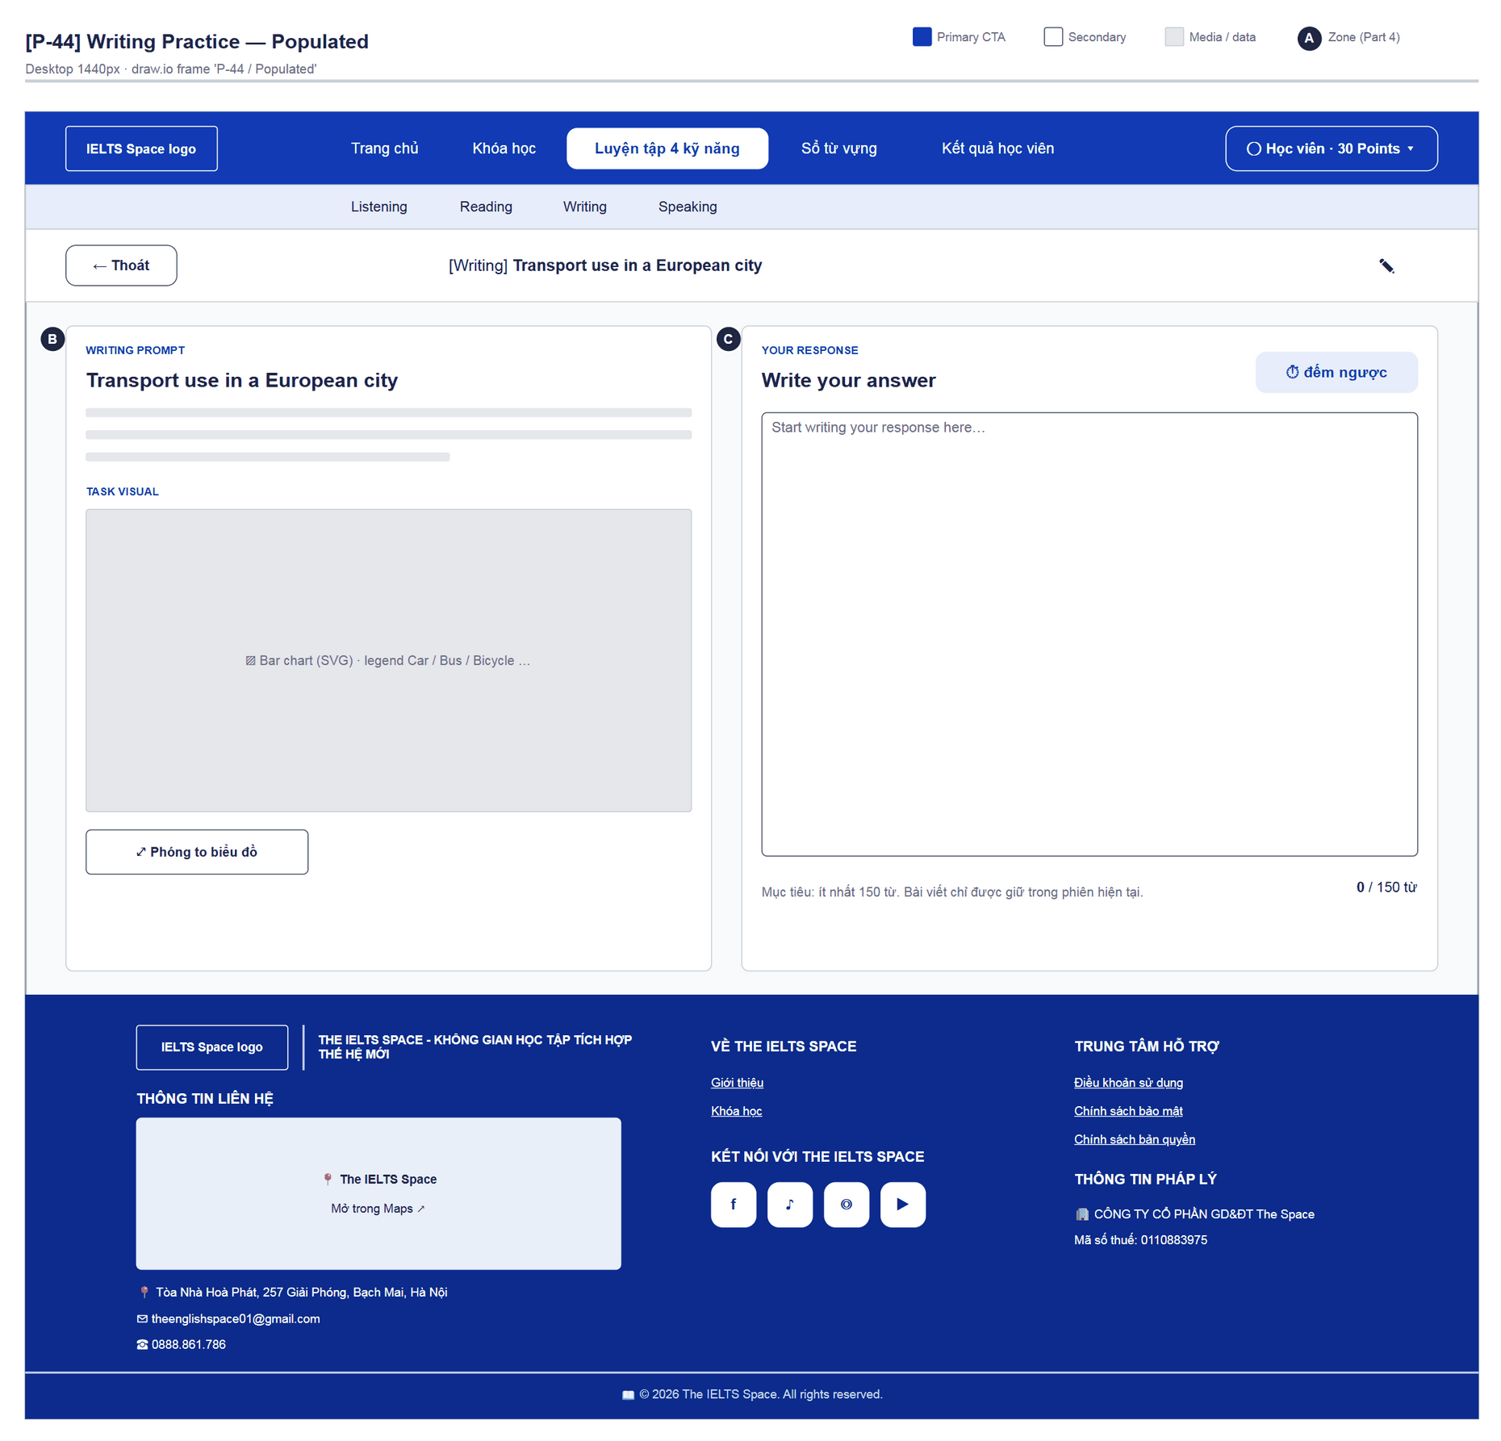
Figure 65 — [P-44] Writing Practice — Populated · draw.io frame 'P-44 / Populated'

4.25 — Writing Chart Zoom (P-44a)
Page ID | P-44a
Screen name | Writing Chart Zoom
Design file | draw.io — diagrams/wireframes/P-44a_WritingChartZoom.drawio — frames 'P-44a / Populated'
SRS Feature | FT-34
SRS Scenario | —
Roles with access | Learner
Route | Modal on P-44
Nav level | MODAL
Status | MVP·mock
Flow(s) | F-03

View the Writing task chart at a large size.

Screen States
State | When It Appears | Design File Frame
Populated — default | Opened from P-44 | P-44a / Populated

Layout Description
Layout: see frame 'P-44a / Populated' (figure below); zone badges A/B/C match the list that follows.
Zone descriptions:
- Zone A: Chart title + close.
- Zone B: Enlarged SVG chart (is-large).

Key Interactions
User Action | What Happens | Notes
Close / Esc | Back to P-44

Mockup
Mockup / Wireframe — draw.io
Design file: diagrams/wireframes/P-44a_WritingChartZoom.drawio
Frames: 'P-44a / Populated'
Images below are exported from draw.io (scripts/export_diagrams.py); edit the .drawio file, then rebuild this document.

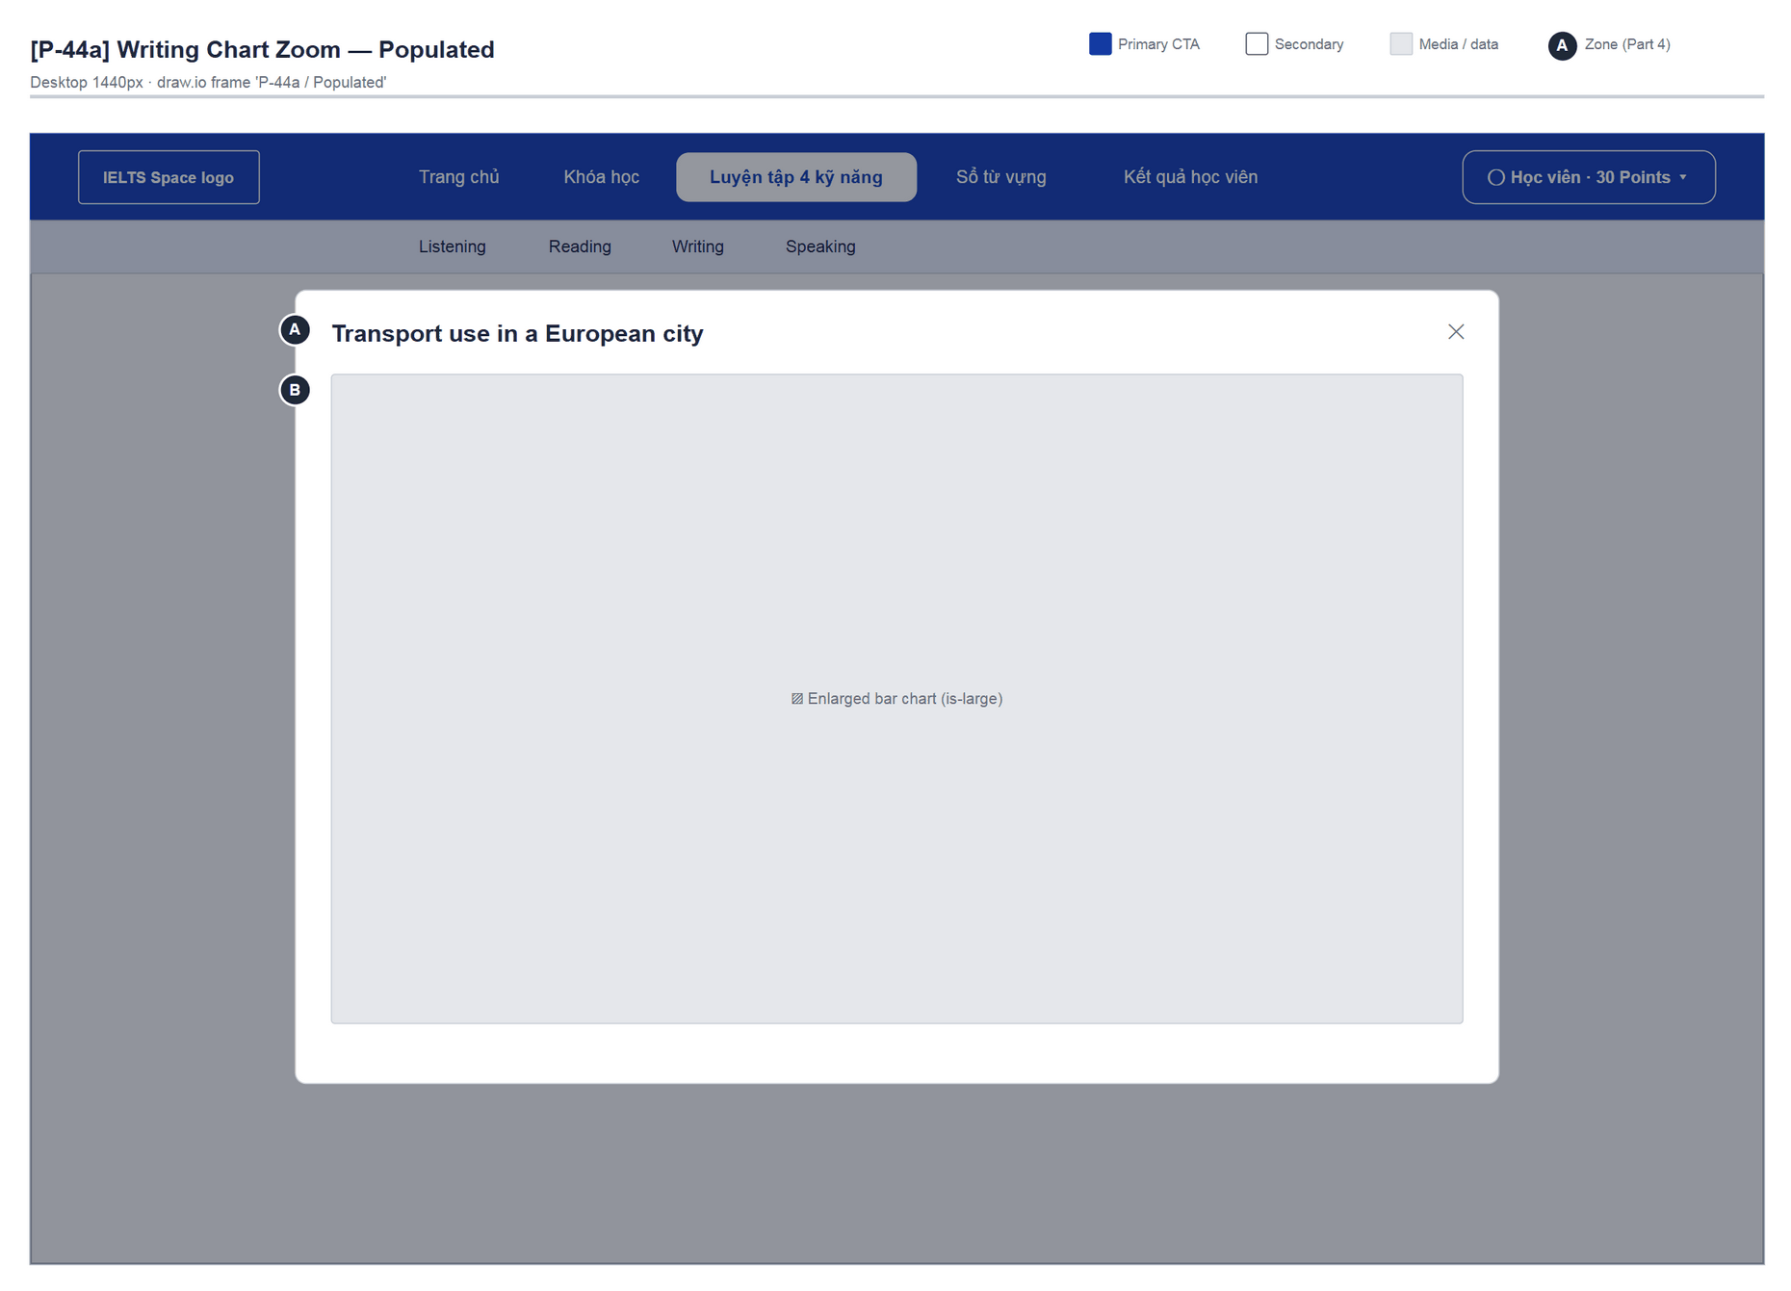
Figure 66 — [P-44a] Writing Chart Zoom — Populated · draw.io frame 'P-44a / Populated'

4.26 — Not Found (P-90)
Page ID | P-90
Screen name | Not Found
Design file | draw.io — diagrams/wireframes/P-90_NotFound.drawio — frames 'P-90 / Populated'
SRS Feature | —
SRS Scenario | —
Roles with access | Guest, Learner
Route | *
Nav level | DEEP
Status | MVP
Flow(s) | —

Global 404 for undeclared routes.

Screen States
State | When It Appears | Design File Frame
Populated — default | Any unmatched path | P-90 / Populated

Layout Description
Layout: see frame 'P-90 / Populated' (figure below); zone badges A/B/C match the list that follows.
Zone descriptions:
- Zone A: Icon, “404”, “Không tìm thấy trang”, “Không có màn hình nào được khai báo cho {pathname}.”
- Zone B: “Về Overview” (→ /overview; a Guest is sent to P-01 — G-05).

Key Interactions
User Action | What Happens | Notes
“Về Overview” | → /overview

Mockup
Mockup / Wireframe — draw.io
Design file: diagrams/wireframes/P-90_NotFound.drawio
Frames: 'P-90 / Populated'
Images below are exported from draw.io (scripts/export_diagrams.py); edit the .drawio file, then rebuild this document.

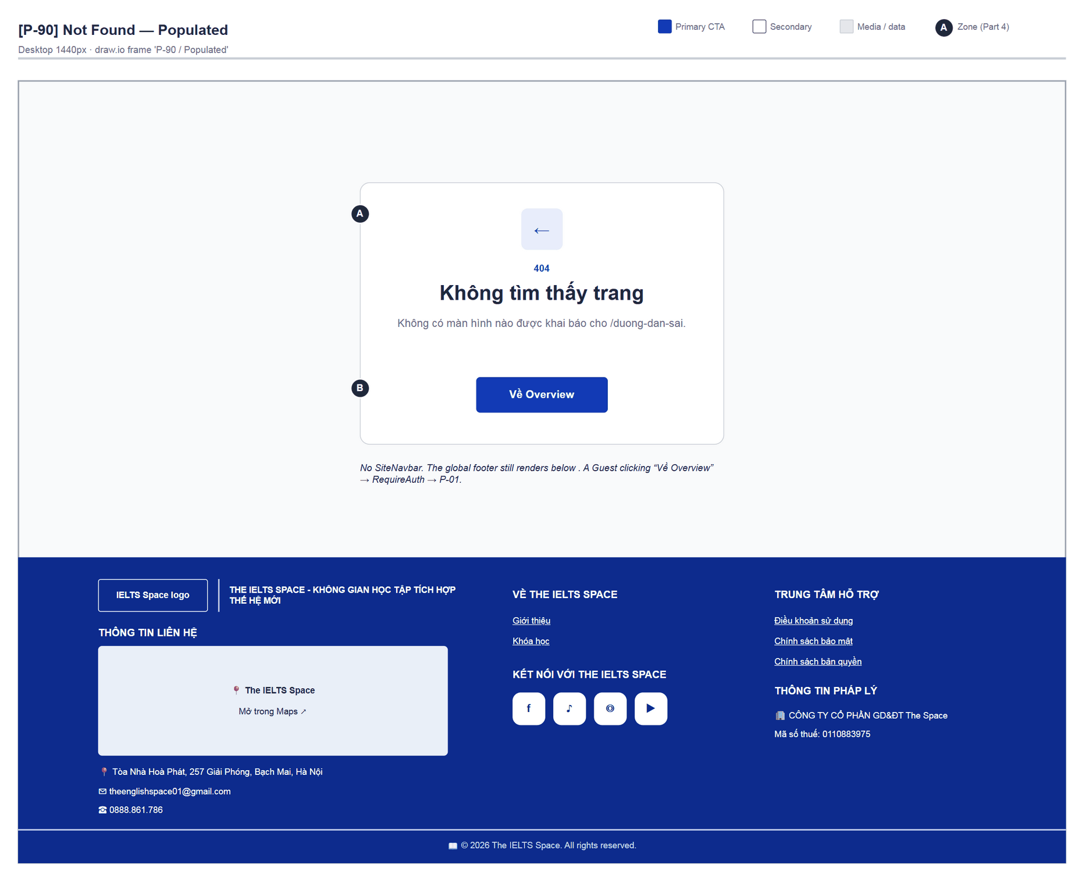
Figure 67 — [P-90] Not Found — Populated · draw.io frame 'P-90 / Populated'

4.27 — Learning Path Not Found (P-91)
Page ID | P-91
Screen name | Learning Path Not Found
Design file | draw.io — diagrams/wireframes/P-91_LearnNotFound.drawio — frames 'P-91 / Populated'
SRS Feature | —
SRS Scenario | —
Roles with access | Learner
Route | /learn/*
Nav level | DEEP
Status | MVP
Flow(s) | F-02

Not-found state inside /learn (unmatched child route or API NOT_FOUND); keeps the navbar and learn layout.

Screen States
State | When It Appears | Design File Frame
Populated — default | Unmatched /learn/* / NOT_FOUND | P-91 / Populated

Layout Description
Layout: see frame 'P-91 / Populated' (figure below); zone badges A/B/C match the list that follows.
Zone descriptions:
- Zone A: “Không tìm thấy trang” / “Nội dung này không tồn tại hoặc đã bị gỡ.”
- Zone B: “Về lộ trình” → /learn.

Key Interactions
User Action | What Happens | Notes
“Về lộ trình” | → P-30

Mockup
Mockup / Wireframe — draw.io
Design file: diagrams/wireframes/P-91_LearnNotFound.drawio
Frames: 'P-91 / Populated'
Images below are exported from draw.io (scripts/export_diagrams.py); edit the .drawio file, then rebuild this document.

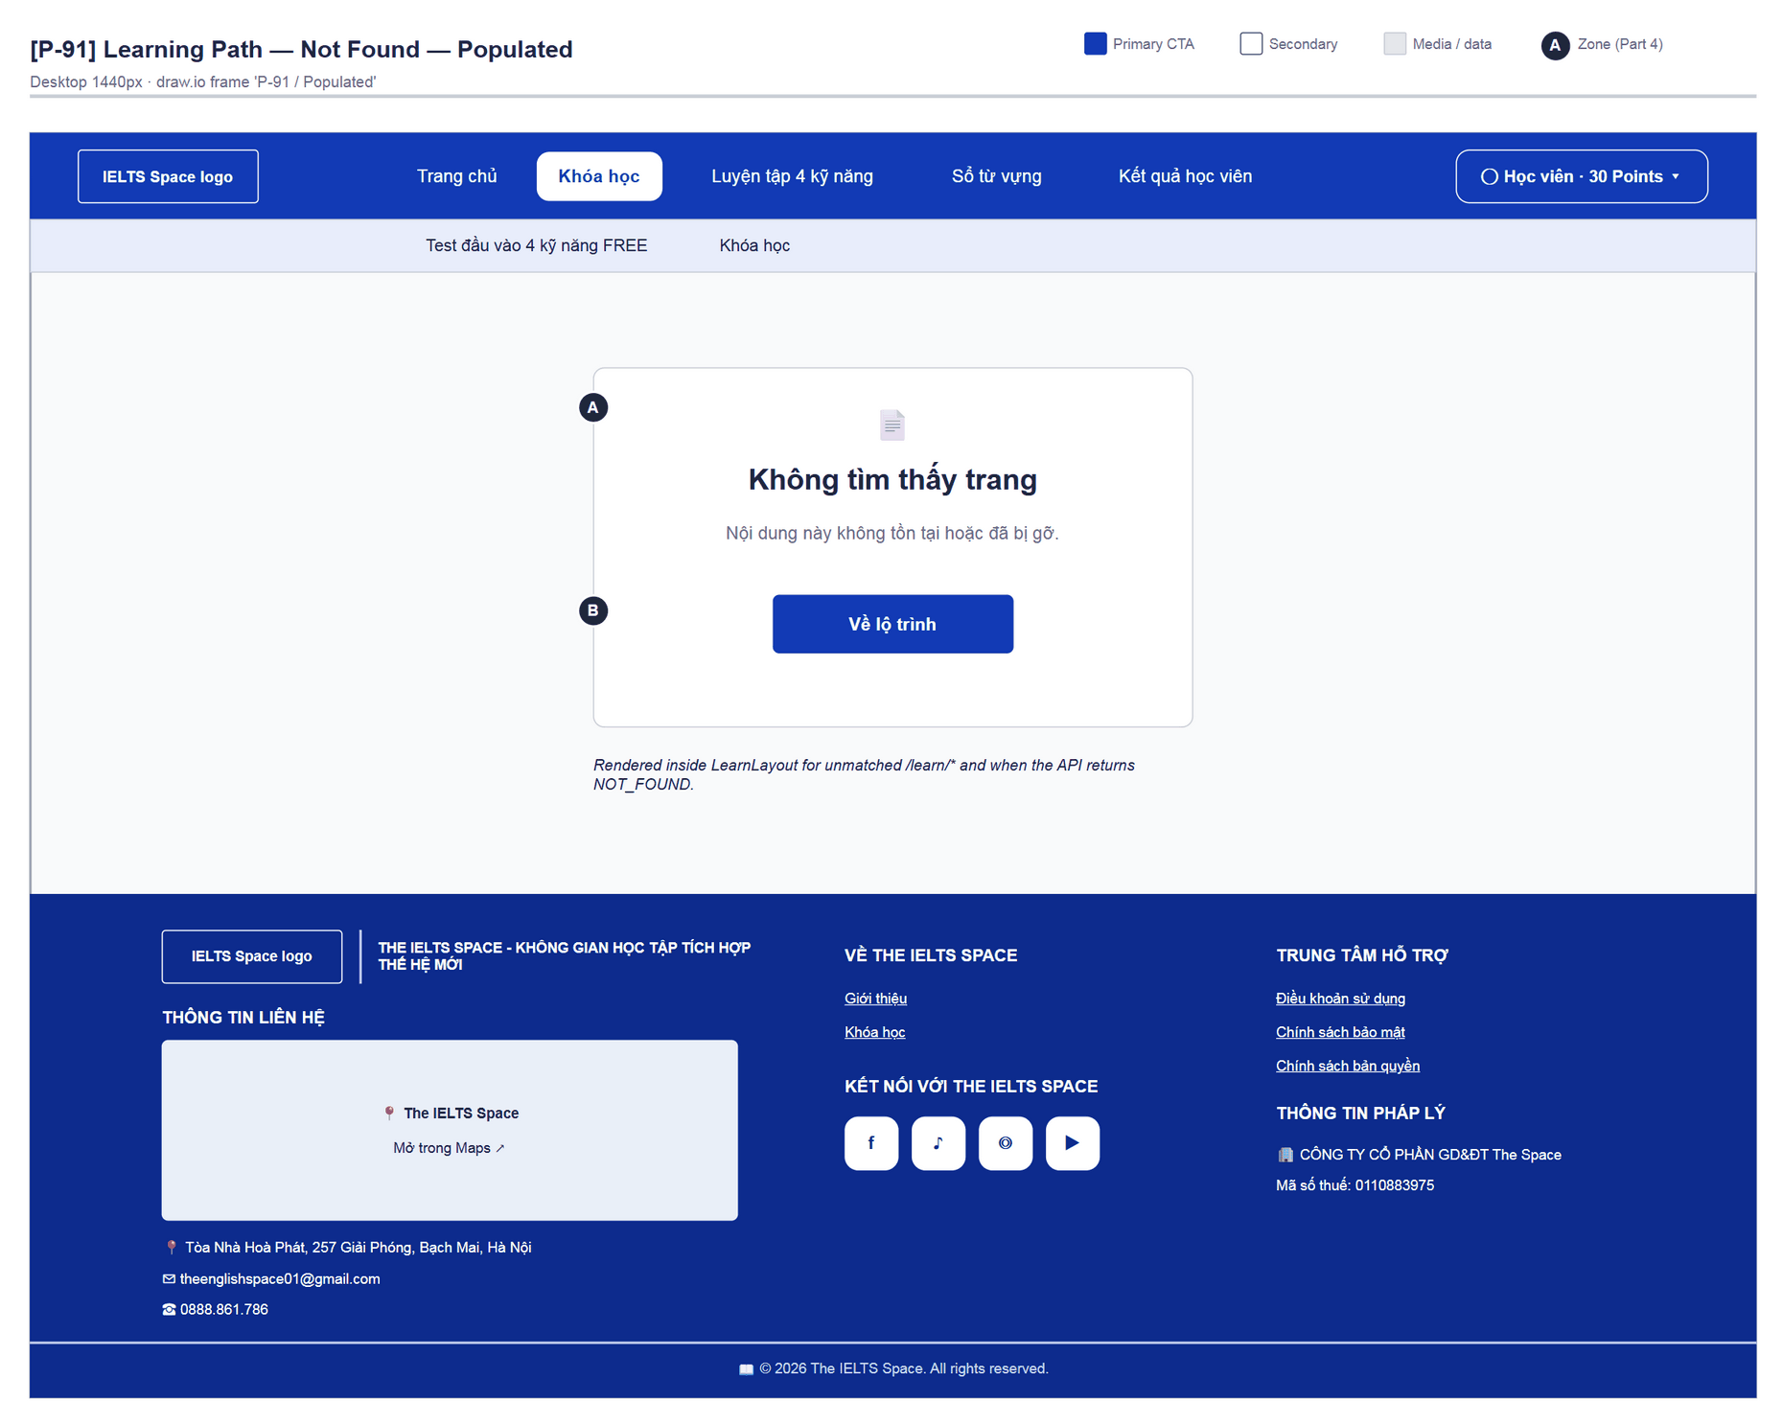
Figure 68 — [P-91] Learning Path Not Found — Populated · draw.io frame 'P-91 / Populated'

4.28 — Route Status (stub template) (P-92)
Page ID | P-92
Screen name | Route Status (stub template)
Design file | draw.io — diagrams/wireframes/P-92_RouteStatus.drawio — frames 'P-92 / Populated'
SRS Feature | —
SRS Scenario | —
Roles with access | Guest, Learner
Route | shared by 10 stub routes
Nav level | SUB
Status | MVP
Flow(s) | —

Shared template for routes that exist but have no content yet (Stub).

Screen States
State | When It Appears | Design File Frame
Populated — default | Every Stub route (P-22, P-23, P-40, P-51…P-54, P-70…P-72) | P-92 / Populated

Layout Description
Layout: see frame 'P-92 / Populated' (figure below); zone badges A/B/C match the list that follows.
Zone descriptions:
- Zone A: 🚧 icon, “IELTSPATH”, route title (e.g. “Thực hành”, “Lịch sử nộp bài”), “Trang này đã có đường dẫn riêng nhưng nội dung vẫn đang được hoàn thiện.”
- Zone B: “Về Overview” (Primary) · “Đến lớp học” (outline).

Key Interactions
User Action | What Happens | Notes
“Về Overview” | → /overview | RequireAuth
“Đến lớp học” | → /classroom (P-20)

Mockup
Mockup / Wireframe — draw.io
Design file: diagrams/wireframes/P-92_RouteStatus.drawio
Frames: 'P-92 / Populated'
Images below are exported from draw.io (scripts/export_diagrams.py); edit the .drawio file, then rebuild this document.

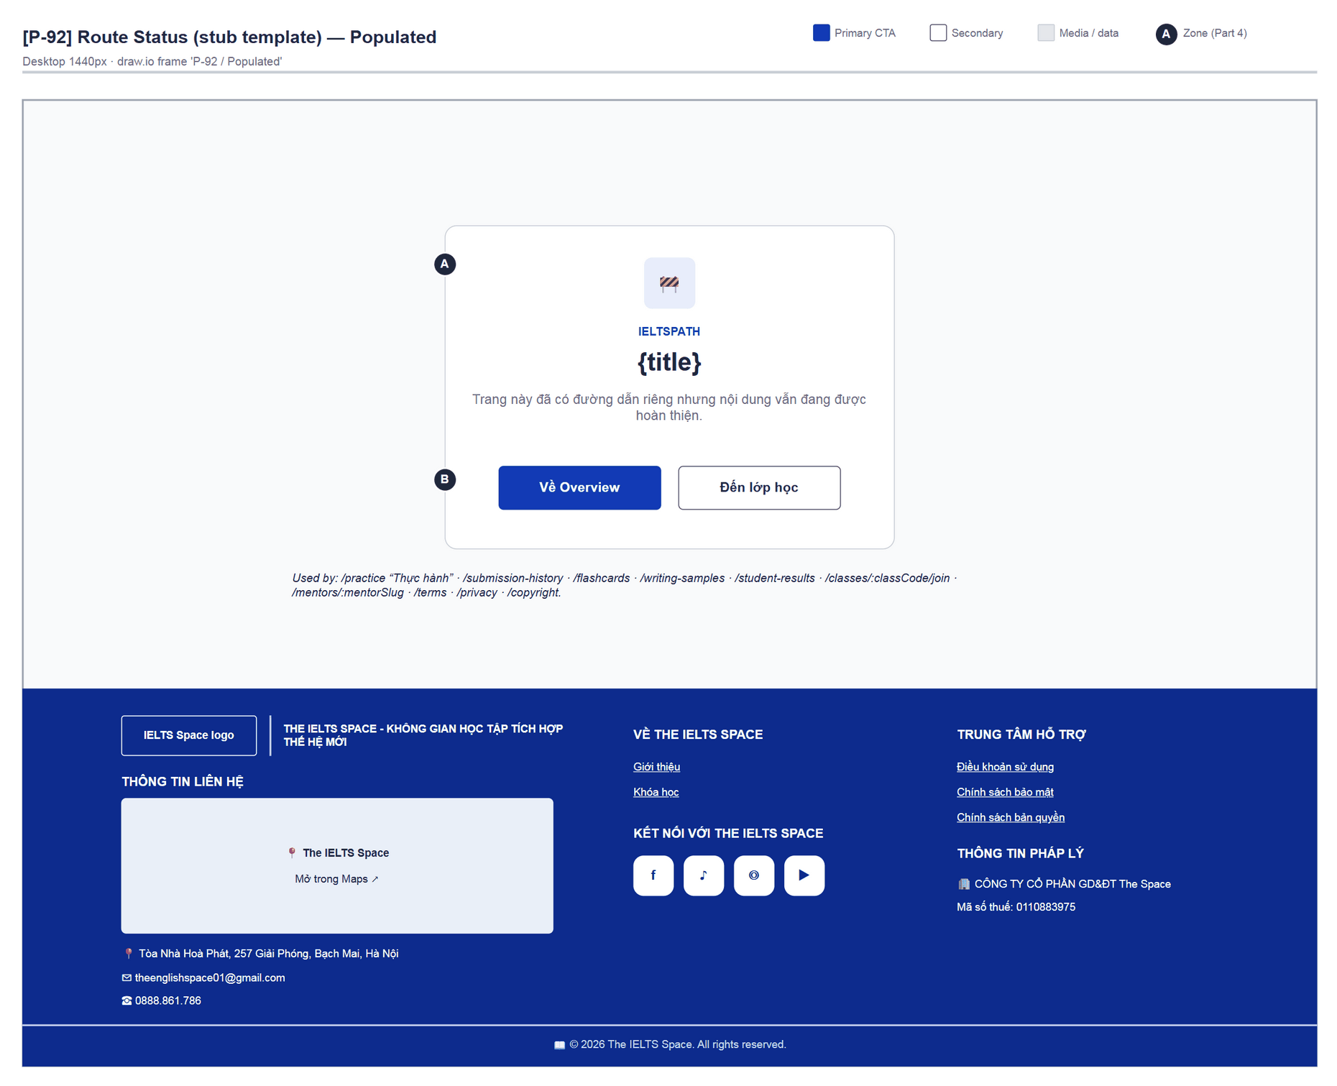
Figure 69 — [P-92] Route Status (stub template) — Populated · draw.io frame 'P-92 / Populated'

Part 5 — Responsive Rules
Global rules for desktop web, taken from the CSS media queries. Mobile layouts (< 640px) are out of scope for this revision.

5.1 Navigation
Breakpoint | Behaviour
Desktop (> 1240px) | Full link row with sliding indicator; subnav on the second row; user menu as dropdown
Narrow desktop / tablet (1024–1240px) | Links hidden; ☰ button (44×44) opens a link grid (min-height 44px); subnav still visible

5.2 Content Layout
Breakpoint | Layout Behaviour
Desktop (≥ 1025px) | Course grid auto-fit min 280px (3 columns at 1240px); overview header 2 columns (text | progress panel); lesson with sticky right rail; passage | questions split; practice 3 columns (map | passage | questions)
Narrow desktop / tablet (≤ 1024px) | Overview header stacks; lesson rail becomes a fixed bottom bar; practice sidebar moves above content (≤ 960px); card grids drop to 2 columns

5.3 Data Tables
Pattern used per surface
Pattern B — Card reflow (default): courses, topics, lessons, practice sets and per-question results are cards/lists that reflow with the container.
Pattern A — Horizontal scroll: only for the correct/incorrect tables in the placement report (ReportSkillPanels) when columns overflow.

5.4 Typography Scaling
Breakpoint | Heading Adjustment
Desktop | Full type scale as defined in Part 1.3
Narrow desktop / tablet | heading-1 ~28px; body unchanged

5.5 Touch Targets (Mobile)
Not applicable in this revision
Mobile layouts are out of scope for this revision. Interactive controls already use a 44px minimum height (min-h-11); icon-only buttons (☰, ✕, ⚙) keep a 44 × 44px hit area. Full touch-target rules will be specified with the mobile revision.

Appendix A — Screen Index & Design File

A.1 Screen Index
1:1 with Site Map 2.2. Design Frame = draw.io file + default frame (number of additional frames in brackets). Stub screens share the 'P-92 / Populated' frame.
Page ID | Screen Name | SRS Feature | Flow(s) | Spec Section | Design Frame | Status
P-01 | Sign In | FT-02, FT-05 | F-01, F-04 | 4.1 | P-01_SignIn.drawio  'P-01 / Populated' (+2) | MVP
P-02 | Sign Up | FT-01 | F-01, F-04 | 4.2 | P-02_SignUp.drawio  'P-02 / Populated' (+1) | MVP
P-03 | Forgot Password | FT-04 | F-01 | 4.3 | P-03_ForgotPassword.drawio  'P-03 / Populated' (+1) | MVP
P-04 | Reset Password | FT-04 | F-01 | 4.4 | P-04_ResetPassword.drawio  'P-04 / Populated' (+2) | MVP
P-05 | OAuth Callback | FT-05 | F-01 | Deferred | — (not drawn: Later) | Later
P-10 | Home / Landing | FT-10, FT-11 | F-04, F-01 | 4.5 | P-10_Home.drawio  'P-10 / Populated' (+1) | MVP
P-10a | Mentor Detail | — | — | Deferred | — (not drawn: Retired) | Retired
P-10b | Plan Detail | — | — | Deferred | — (not drawn: Retired) | Retired
P-10c | Key Activation Dialog | FT-11, FT-12 | F-04 | 4.6 | P-10c_KeyActivation.drawio  'P-10c / Populated' | MVP
P-11 | Overview Dashboard | FT-44, FT-45 | — | Deferred | — (not drawn: Later*) | Later*
P-20 | My Classroom | — | — | Deferred | — (not drawn: Later*) | Later*
P-20a | Lesson Detail | — | — | Deferred | — (not drawn: Later*) | Later*
P-21 | Lesson Workspace | — | — | Deferred | — (not drawn: Later*) | Later*
P-22 | Join Live Class | — | — | Deferred | P-92_RouteStatus.drawio  'P-92 / Populated' | Stub
P-23 | Contact Mentor | — | — | Deferred | P-92_RouteStatus.drawio  'P-92 / Populated' | Stub
P-30 | Course List | FT-20, FT-55 | F-02 | 4.7 | P-30_CourseList.drawio  'P-30 / Populated' (+3) | MVP
P-30a | Placement Test | FT-09, FT-35 | F-02, F-05 | 4.8 | P-30a_Placement.drawio  'P-30a / Survey' (+7) | MVP
P-30b | Topic List (in course) | FT-20, FT-29, FT-55 | F-02 | 4.9 | P-30b_TopicList.drawio  'P-30b / Populated' (+2) | MVP
P-31 | Topic Detail | FT-21, FT-29 | F-02 | 4.10 | P-31_TopicDetail.drawio  'P-31 / Populated' (+1) | MVP
P-32 | Lesson Player | FT-21, FT-22, FT-23, FT-25 | F-02 | 4.11 | P-32_LessonPlayer.drawio  'P-32 / Populated' (+2) | MVP
P-33 | Lesson Practice | FT-27 | F-02 | 4.12 | P-33_LessonPractice.drawio  'P-33 / Set List' (+2) | MVP
P-34 | Review Session | FT-26, FT-28 | F-02 | 4.13 | P-34_ReviewSession.drawio  'P-34 / Theory' (+2) | MVP
P-35 | Topic / Course Test | FT-29, FT-30, FT-55 | F-02 | 4.14 | P-35_TopicTest.drawio  'P-35 / Populated' (+1) | MVP
P-36 | Test Result | FT-31, FT-29, FT-55 | F-02 | 4.15 | P-36_TestResult.drawio  'P-36 / Passed' (+1) | MVP
P-40 | Practice Hub (“Thực hành”) | — | — | Deferred | P-92_RouteStatus.drawio  'P-92 / Populated' | Stub
P-41 | Practice Catalog | FT-34 | F-03 | 4.16 | P-41_PracticeCatalog.drawio  'P-41 / Populated' | MVP·mock
P-41a | Practice Mode Select | FT-34 | F-03 | 4.17 | P-41a_PracticeModeSelect.drawio  'P-41a / Populated' | MVP·mock
P-42 | Reading Practice Test | FT-34, FT-42, FT-43 | F-03 | 4.18 | P-42_ReadingPracticeTest.drawio  'P-42 / Practice Mode' (+1) | MVP·mock
P-42a | Create Flashcard | FT-43 | F-03 | 4.19 | P-42a_CreateFlashcard.drawio  'P-42a / Populated' | MVP·mock
P-42b | Dictionary Lookup | FT-36 | F-03 | 4.20 | P-42b_DictionaryLookup.drawio  'P-42b / Populated' | MVP·mock
P-42c | Saved Flashcards | FT-43 | F-03 | 4.21 | P-42c_SavedFlashcards.drawio  'P-42c / Populated' | MVP·mock
P-42d | Floating Notes | FT-42 | F-03 | 4.22 | P-42d_FloatingNotes.drawio  'P-42d / Populated' | MVP·mock
P-43 | Listening Practice | FT-24, FT-34 | F-03 | 4.23 | P-43_ListeningPractice.drawio  'P-43 / Populated' | MVP·mock
P-44 | Writing Practice | FT-34 | F-03 | 4.24 | P-44_WritingPractice.drawio  'P-44 / Populated' | MVP·mock
P-44a | Writing Chart Zoom | FT-34 | F-03 | 4.25 | P-44a_WritingChartZoom.drawio  'P-44a / Populated' | MVP·mock
P-45 | Speaking Practice | FT-39 | F-03 | Deferred | — (not drawn: Later*) | Later*
P-50 | Vocabulary / Dictionary | FT-36 | — | Deferred | — (not drawn: Later*) | Later*
P-51 | My Flashcards | FT-43 | — | Deferred | P-92_RouteStatus.drawio  'P-92 / Populated' | Stub
P-52 | Writing 8.0+ Samples | — | — | Deferred | P-92_RouteStatus.drawio  'P-92 / Populated' | Stub
P-53 | Student Results | — | — | Deferred | P-92_RouteStatus.drawio  'P-92 / Populated' | Stub
P-54 | Submission History | FT-30 | — | Deferred | P-92_RouteStatus.drawio  'P-92 / Populated' | Stub
P-60 | Materials | — | — | Deferred | — (not drawn: Retired) | Retired
P-70 | Terms of Use | — | — | Deferred | P-92_RouteStatus.drawio  'P-92 / Populated' | Stub
P-71 | Privacy Policy | — | — | Deferred | P-92_RouteStatus.drawio  'P-92 / Populated' | Stub
P-72 | Copyright Policy | — | — | Deferred | P-92_RouteStatus.drawio  'P-92 / Populated' | Stub
P-90 | Not Found | — | — | 4.26 | P-90_NotFound.drawio  'P-90 / Populated' | MVP
P-91 | Learning Path Not Found | — | F-02 | 4.27 | P-91_LearnNotFound.drawio  'P-91 / Populated' | MVP
P-92 | Route Status (stub template) | — | — | 4.28 | P-92_RouteStatus.drawio  'P-92 / Populated' | MVP

A.2 Design File Structure
Design file structure (draw.io)
frontend/docs/report-3.2-sds/ (Design File = draw.io)
├── diagrams/
│ ├── IELTSSpace_SDS_InformationArchitecture.drawio tabs: IA-01 Site Map · IA-02 Navigation
│ ├── flows/IELTSSpace_SDS_Flows.drawio tabs: F-01 … F-05
│ ├── IELTSSpace_SDS_Prototype.drawio clickable prototype: every frame, buttons linked
│ ├── wireframes/ one file per P-ID, one tab per frame
│ │ ├── SHELL_SharedLayout.drawio (Learner / Guest / Auth / Exam shells, User Menu)
│ │ ├── P-01_SignIn.drawio tabs 'P-01 / Populated' 'P-01 / Loading' …
│ │ ├── P-30_CourseList.drawio … P-36_TestResult.drawio
│ │ ├── P-41_PracticeCatalog.drawio … P-44a_WritingChartZoom.drawio
│ │ └── P-90_NotFound.drawio · P-91_LearnNotFound.drawio · P-92_RouteStatus.drawio
│ └── exports/ PNG export: <ID>__<frame-slug>.png
├── scripts/ build_diagrams.py → export_diagrams.py (draw.io CLI) → build_sds_docx.py
├── Report_3.2_ScreenDesignSpec_v0.4.0.docx
├── README.md · CHANGELOG.md · APPENDIX_INDEX.md

Frame naming: '<P-ID> / <State>' — State ∈ Populated, Loading, Empty, Error, Success, Locked …
Grayscale wireframes + #123AB5 accent; zone badges A/B/C… match the Zone lists in Part 4.
Open: double-click a .drawio file (draw.io Desktop) or app.diagrams.net → Open Existing Diagram.
Prototype: open IELTSSpace_SDS_Prototype.drawio, start from the INDEX tab and click buttons to move between screens.

The old screenshot set frontend/docs/sds-mockups/ (v0.3.0) is evidence only; it is not the Design File.

A.3 Glossary
Term | Definition
P-xx | Page ID — used in the Site Map, Part 4, draw.io file names and frame names
F-xx | Flow ID — Screen Flow in Part 3 (F-01…F-05)
FT-xx | SRS Feature ID (SRS v1.0.0, FT-01…FT-55)
SC-xx | SRS Scenario ID (SC-01…SC-08)
AC-xx / NAC-xx | SRS acceptance criteria — not repeated here
BR-xx | SRS business rule (e.g. BR-36 placement taken once)
MVP | Built and wired to the real API / auth
MVP·mock | Built and navigable; content comes from FE mock data
Later* | UI exists with mock data; outside Part 4 in this revision
Stub | Route exists but renders P-92 Route Status
Screen state | A visual variant of a screen: Loading / Empty / Populated / Error / Locked / Success …
Design file | draw.io source of the wireframes (frontend/docs/report-3.2-sds/diagrams/) — the source of truth for every figure in this document (completed)
Design frame | One tab in a .drawio file, named '<P-ID> / <State>'
Wireframe | Lo-fi structural drawing; colours and fonts follow Part 1
Evidence screenshot | FE captures (docs/sds-mockups, v0.3.0) — reference only, not the Design File

A.4 Route Coverage (App.tsx)
Every <Route> in frontend/src/app/App.tsx and its P-ID. 🔒 = RequireAuth.
Route | Element | P-ID
/ | Redirect → /home (Guest) · /overview (Learner) | —
/home | HomePage | P-10
/overview | OverviewPage 🔒 | P-11
/classroom | ClassroomPage 🔒 | P-20
/learn (index) | LearnLayout › CourseListPage 🔒 | P-30
/learn/placement | PlacementPage | P-30a
/learn/courses/:courseId | TopicListPage | P-30b
/learn/topics/:topicId | TopicDetailPage | P-31
/learn/lessons/:lessonId | LessonPage | P-32
/learn/lessons/:lessonId/practice | PracticePage | P-33
/learn/reviews/:reviewId | ReviewPage | P-34
/learn/tests/:attemptId | TopicTestPage | P-35
/learn/tests/:attemptId/result | TopicTestResultPage | P-36
/learn/* | NotFoundState | P-91
/practice | RouteStatusPage “Thực hành” 🔒 | P-40 (P-92)
/practice-tests | PracticeCatalogPage 🔒 | P-41
/practice/test/:testId | PracticeTestPage 🔒 | P-42
/practice/test | PracticeTestPage (default test) 🔒 | P-42
/practice/listening/:testId | ListeningPage 🔒 | P-43
/practice/writing/:taskId | WritingPage 🔒 | P-44
/practice/speaking/:cueId | SpeakingPage 🔒 | P-45
/vocabulary | VocabularyPage | P-50
/submission-history | RouteStatusPage 🔒 | P-54 (P-92)
/flashcards | RouteStatusPage 🔒 | P-51 (P-92)
/writing-samples | RouteStatusPage 🔒 | P-52 (P-92)
/student-results | RouteStatusPage 🔒 | P-53 (P-92)
/login | AuthPage sign-in (GuestOnly) | P-01
/register | AuthPage sign-up (GuestOnly) | P-02
/forgot-password | ForgotPasswordPage (GuestOnly) | P-03
/reset-password | ResetPasswordPage (GuestOnly) | P-04
/auth/oauth/callback | OAuthCallbackPage (GuestOnly) | P-05
/classes/:classCode/join | RouteStatusPage | P-22 (P-92)
/lessons/:lessonId | LessonWorkspacePage 🔒 | P-21
/mentors/:mentorSlug | RouteStatusPage | P-23 (P-92)
/terms | RouteStatusPage | P-70 (P-92)
/privacy | RouteStatusPage | P-71 (P-92)
/copyright | RouteStatusPage | P-72 (P-92)
* | NotFoundPage | P-90

Appendix B — FE ↔ Spec Gaps & Open Questions

B.1 Gaps found in the UI audit
ID | Screen | Observation (current code) | Suggested resolution
G-01 | P-30 | PlacementCard links to /placement — no such route, so it falls through to P-90. | Change to /learn/placement (CourseListPage.tsx).
G-02 | P-36 | Result copy exposes technical details: “poll GET /courses”, “làm mới từ GET /topics”. | Rewrite as learner-facing copy (e.g. “Chặng tiếp theo đã mở.”).
G-03 | P-41 | The “TEST NGAY ✦” button on the “Chưa biết mình đang ở band nào?” banner opens P-41a for the first card instead of the placement test. | Link to /learn/placement (P-30a) to match the message.
G-04 | P-10 / P-10c | App.tsx does not pass accessClient to HomePage, so a signed-in Learner always sees “Phiên đăng nhập hiện tại chưa kết nối với dịch vụ gói và Activation Key.” | Wire the access API (FT-10/FT-11) or mark it Later for the demo.
G-05 | P-90 / P-92 | The “Về Overview” CTA points to /overview (RequireAuth), so a Guest is pushed to P-01. | Choose the target by session: Guest → /home.
G-06 | P-41…P-44 | Catalog and workspaces use mock data (MOCK_PRACTICE_CARDS…); results are not saved or graded. | Wire FT-34 Mock test when the backend is ready.
G-07 | Guest navbar | “Khóa học”, “Luyện tập”, “Bài mẫu”, “Kết quả học viên” are shown to Guests but are all RequireAuth. | Accept (auth gate F-04) or add public landing pages.
G-08 | P-30a Speaking | Placement Speaking is “chưa được chấm riêng; bản ghi chỉ lưu trên trình duyệt”. | Per FT-39 (Draft) — keep the warning copy.
G-09 | P-11, P-20, P-21, P-45, P-50 | UI exists but uses mock data — not in Part 4. | Specify in a later revision once APIs exist.

B.2 Open questions (SRS ↔ FE)
- Switching the current course (SRS FT-20 course choice: Draft) — the FE has no “change course” UI; P-30 lets the learner open any course. The flow needs to be agreed.
- Course final test with AI-graded essays (BR-39) — P-35 currently supports objective questions only.
- Multi-skill lessons (BR-38): P-32 shows only the topic skill; the list of lesson skills is not displayed.
- Mobile layouts (< 640px) — to be specified in the next revision.

— End of Report 3.2 Screen Design Specification v0.4.0 —

