MRFS v1.0 — Volume 6: Sample Audit Report (Reference Demonstration)
Marketplace Ranking Fairness Audit-Synthetic Dataset

1. Executive Summary
This report presents the results of a demonstration audit conducted on a synthetic dataset using the evaluation methodology defined in the Audit Protocol v1 (MRFS Volume 3). The purpose is to validate the protocol’s feasibility and demonstrate that the methodology produces clear, standardized outputs.
The synthetic dataset simulates a generic marketplace-style ranking environment with 5,000 sellers and 250,000 ranking events over a 12-week period. Sellers are segmented into Small and Large cohorts based on listing volume quartiles. This dataset does not represent any specific commercial platform. It is intentionally constructed as a controlled test case with cohort exposure differences to validate that the protocol detects, reports, and governs disparities when they occur.
Key Findings:
- Small sellers’ ExposureShare@10 = 0.62, indicating they receive only 62% of the visibility they would receive under proportional allocation. This falls below the 0.80 Review Required threshold.
- Both CTR and CVR Disparate Impact ratios fall below the 0.80 four-fifths threshold (CTR DI = 0.72, CVR DI = 0.68), triggering Review Required status for outcome metrics. These thresholds are operational governance triggers used for audit triage and do not constitute legal conclusions.
- ExposureShare@10 for Small sellers declined steadily from 0.71 to 0.50 over the 12-week audit window, indicating progressive drift toward greater disparity.
- The Exposure Gini coefficient for Small sellers (0.72) is substantially higher than for Large sellers (0.41), indicating that the limited visibility Small sellers do receive is concentrated among a few sellers rather than distributed equitably.
Status: REVIEW REQUIRED- ExposureShare below 0.80 and CTR/CVR DI ratios below four-fifths threshold. Diagnostic drilldown and mitigation workflow recommended per Audit Protocol Section 6.4-6.5.

2. Data Summary
The following synthetic dataset was generated to demonstrate the audit protocol:
Parameter | Value
Dataset type | Synthetic (generated for demonstration purposes)
Total ranking events | 250,000
Audit window | 12 weeks (W1-W12)
Total sellers | 5,000
Small sellers (bottom quartile) | 1,250 (25%)
Large sellers (top quartile) | 1,250 (25%)
Product categories | 10
Top-K evaluated | K = 10 (primary), K = 20 (robustness)
Click data available | Yes (simulated)
Conversion data available | Yes (simulated)
Model versions | 2 (v1.0, v1.1 ; deployed at W7)

Data quality checks:
- Zero null values in seller_id, rank_position, or event_timestamp.
- Rank positions contiguous (1-100) within each event.
- Seller attribute coverage: 100% of seller_ids matched.
- Minimum event threshold (10,000) exceeded: 250,000 events.

3. Exposure Analysis

3.1 ExposureShare@K
ExposureShare@K measures the ratio of a cohort’s observed top-K exposure to its proportional share under a proportional-allocation baseline.
A value of 1.0 indicates proportional representation; values < 1.0 indicate underexposure; and values > 1.0 indicate overexposure.
The governance threshold is applied directly to ExposureShare: values below 0.80 trigger Review Required.
Metric | Small Sellers | Large Sellers | Status
ExposureShare@10 | 0.62 | 1.41 | REVIEW REQ.
ExposureShare@20 | 0.65 | 1.37 | REVIEW REQ.

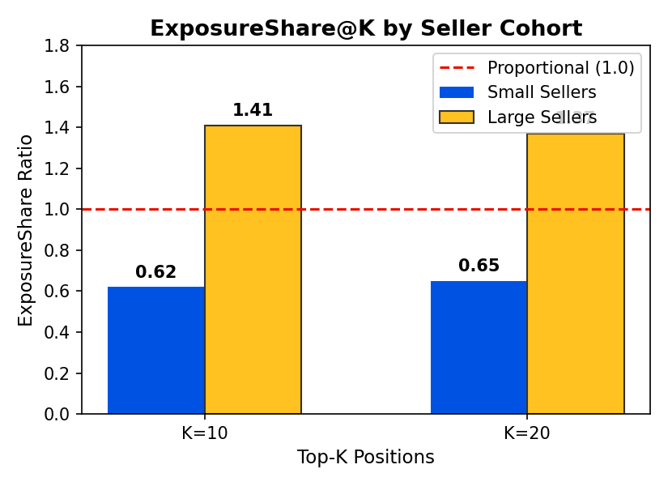
At K=10, Small sellers receive only 62% of the visibility they would receive under proportional allocation, while Large sellers receive 141%. The disparity narrows slightly at K=20 but remains well below the 0.80 Review Required threshold.

3.2 Mean Rank Position
Cohort | Mean Rank (Top 100) | 95% CI
Small Sellers | 58.3 | [56.8, 59.7]
Large Sellers | 34.1 | [32.9, 35.4]

Small sellers’ mean rank position is 24.2 positions worse than Large sellers, exceeding the ≥10 position Review Required threshold defined in the Audit Protocol (Section 6.2).

3.3 Exposure Gini Coefficient
The Gini coefficient measures how evenly visibility is distributed within each cohort. Higher values indicate that a few sellers capture most of the visibility.
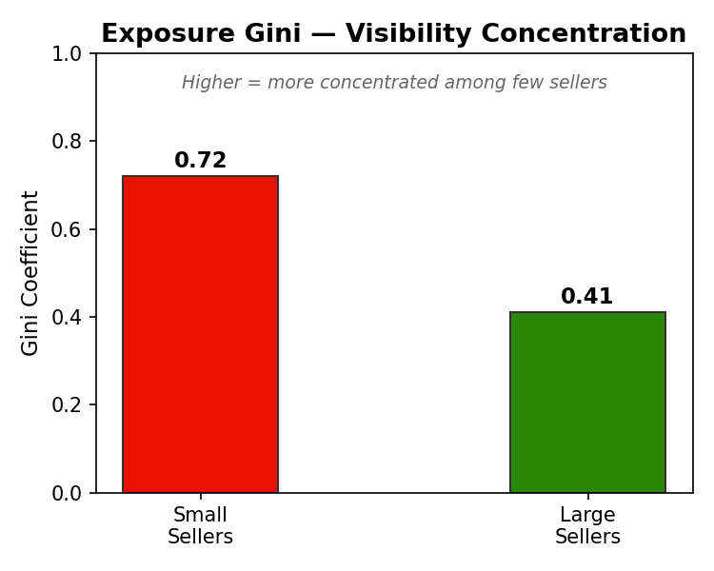
The Small seller Gini (0.72) indicates that the limited top-10 exposure they do receive is heavily concentrated among a small number of sellers. The Large seller Gini (0.41) shows more equitable distribution within that cohort.

4. Outcome Analysis
Outcome metrics assess whether position-driven exposure disparities translate into click-through rate (CTR) and conversion rate (CVR) disparities. Disparate Impact (DI) ratios are computed for these outcome metrics using the four-fifths rule.
Metric | Small Sellers | Large Sellers | Parity Ratio | DI Ratio | Status
CTR @10 | 3.2% | 4.5% | 0.71 | 0.72 | REVIEW REQ.
CVR @10 | 1.8% | 2.6% | 0.69 | 0.68 | REVIEW REQ.

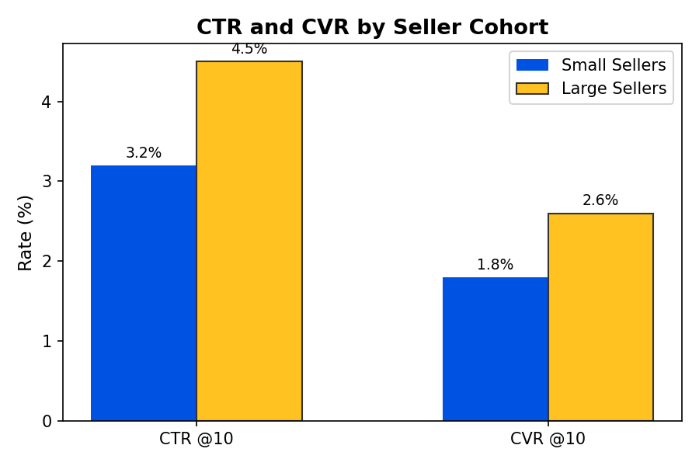
Both CTR and CVR parity ratios fall below the 0.80 four-fifths threshold. Small sellers’ click-through rate is 71% of Large sellers’, and their conversion rate is 69% of Large sellers’. This indicates that exposure disparity is translating into measurable outcome disparity.

4.1 Disparate Impact Summary
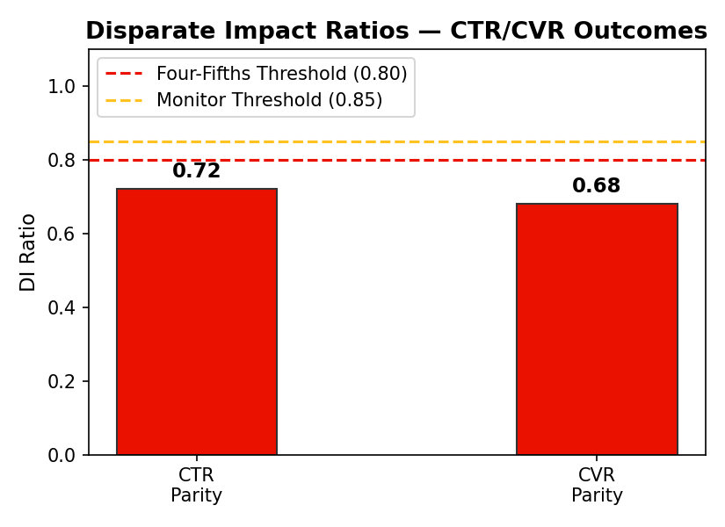
Both CTR and CVR DI ratios fall below the 0.80 four-fifths threshold. Exposure disparity is measured directly by ExposureShare@K (Section 3.1), which shows Small sellers at 0.62, well below the 0.80 governance threshold. Together, these metrics indicate that the ranking system’s position allocation is driving both visibility and outcome disparities. These thresholds are operational governance triggers and do not constitute legal conclusions.

5. Drift and Regression
Weekly ExposureShare@10 was monitored across the 12-week audit window to assess stability. A new model version (v1.1) was deployed at Week 7.
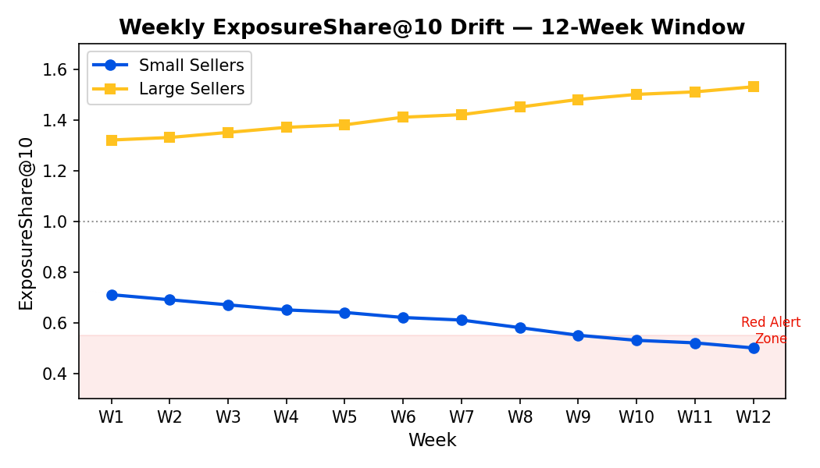
Period | Small ES@10 | Large ES@10 | Change
W1-W6 (v1.0) | 0.66 avg | 1.36 avg | Baseline
W7-W12 (v1.1) | 0.55 avg | 1.48 avg | −17% Small / +9% Large
W12 (latest) | 0.50 | 1.53 | Review Required: >20% decline

Small seller ExposureShare@10 declined steadily from 0.71 (W1) to 0.50 (W12), a 30% relative decline. The decline accelerated after the v1.1 model deployment at Week 7. Per Audit Protocol Section 6.2, the >20% decline sustained over multiple weeks constitutes a Review Required trigger.
Model version regression finding: The v1.1 deployment correlates with accelerated exposure loss for Small sellers. Diagnostic drilldown recommended to determine whether the model change is causal.

6. Quality Guardrails
Quality metrics are monitored to ensure that any future fairness interventions do not degrade overall marketplace performance.
Guardrail | Baseline (W1-W6) | Current (W12) | Threshold | Status
Overall CTR | 4.1% | 4.0% | ≤2% relative decline | PASS
Overall CVR | 2.3% | 2.2% | ≤2% relative decline | PASS
NDCG@10 (relevance) | 0.81 | 0.79 | ≤5% relative decline | PASS

All quality guardrails are within acceptable bounds. This indicates that the current ranking system is maintaining buyer-side relevance and conversion quality, but is doing so while systematically underexposing Small sellers.

7. Limitations
- This audit was conducted on synthetic data generated for demonstration purposes. Results validate methodological feasibility but do not represent findings from a live marketplace.
- Synthetic click and conversion data may not capture the full complexity of real user behavior patterns.
- Category-level stratification was applied across 10 simulated categories; live marketplace audits may involve hundreds of categories.
- Ownership attributes (minority-owned, women-owned) were not included in this synthetic dataset. Live audits would incorporate these dimensions where lawful, voluntary, and available.

8. Recommendations
Based on the findings of this demonstration audit, the following actions would be recommended if these results were observed in a live marketplace environment:
Immediate (Review Required response):
- Initiate diagnostic drilldown per Audit Protocol Section 6.4 to determine whether exposure disparity is concentrated in specific categories or systemic.
- Investigate the v1.1 model deployment as a potential cause of accelerated drift.
- Document a “Review Required” decision record per Mitigation Workflow (Section 6.5, Step 1).
Short-term mitigation options:
- Evaluate fairness-constrained re-ranking (e.g., proportional representation constraints at K=10) and simulate impact on ExposureShare and quality guardrails.
- Consider score calibration adjustments to reduce position bias against lower-volume sellers.
Ongoing monitoring:
- Continue weekly drift monitoring with heightened attention to ExposureShare@10 for Small sellers.
- Schedule full monthly audit to track mitigation effectiveness if interventions are applied.

9. Conclusion
This demonstration audit validates the feasibility and output format of the Audit Protocol v1. Using synthetic data, the protocol successfully identified systematic underexposure of Small sellers (ExposureShare@10 = 0.62), quantified outcome disparities using CTR/CVR DI ratios, detected progressive drift over a 12-week window, and produced actionable recommendations aligned with the governance framework.
The results demonstrate that the proposed evaluation methodology can produce clear, interpretable, and actionable audit outputs suitable for platform operators, seller organizations, and governance review, directly supporting the proposed endeavor’s goal of creating practical accountability infrastructure for U.S. digital marketplaces.

This report is based entirely on synthetic data and is provided as a methodological demonstration. It does not reflect findings from any specific marketplace platform.

