# Report on fairness of sailing scoring

## Problem

In this coursework I am investigating the fairness of a scoring system used in a series of sailor races. In the current system the racer to finish in first is awarded 1 point, second is awarded 2 and so on, with the worst result from each racer being discarded at the end of the series. My investigation will look at whether the scoring system rewards skill and consistency, and how the discarding of a racers worst placement(s) effects the overall score of a racer and therefore the final standings. I expect that the scoring system used is fair, as the discarding of a racers lowest placing removes the possibility of the outcome being effected by an anomalous result.

## Method

My method for solving this problem will be to create a python program (Python 3.6.5) with a series of functions that allow me to create models of races, I will use these models and data provided to evaluate the fairness of the scoring system. Firstly I will create a function that reads data on the given races (mean performance and standard deviation) from a csv file. The data read from the csv file will then be passed into a function that will generate a performance using the normal distribution for each sailor (based on mean performance and standard deviation). This performance data generated will then be passed into a function that will calculate the finishing order of the race - the higher the performance score, the higher the finishing place. Next, in a series of races, each racers worst finish(s) will be removed and a final sum of the remaining performances is calculated, this will be done with a function for calculating series score. Finally, I will create a function which will sort the final standings of the series based on the score of each racer.

## Assumptions

* All sailors will complete all races.
* No races will have any anomalous results (outside of their mean and standard deviation).
* No disqualification will occur.
* All races are completed fairly according to the set out guideline.

## Results

To test the hypothesis that I put forward in my ‘problem’ section that the scoring system is fair I ran a set of simulations to compare how consistency effects the final data, below are 3 figures that show the average placing, and overall winner of the series when 1 race, 6 races and 100 races are run in a series:

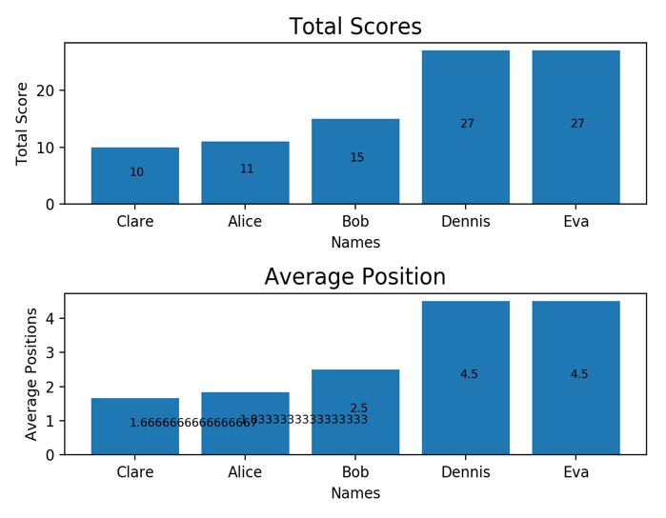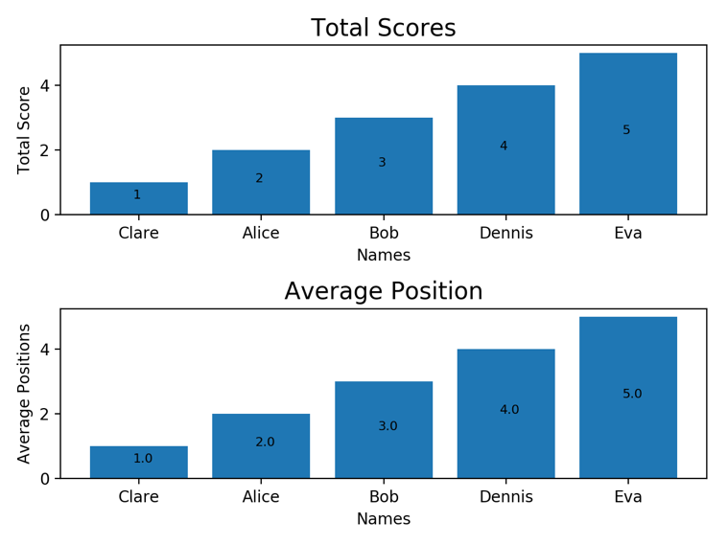

< Figure 1 – 1 race

Figure 2 – 10 races >

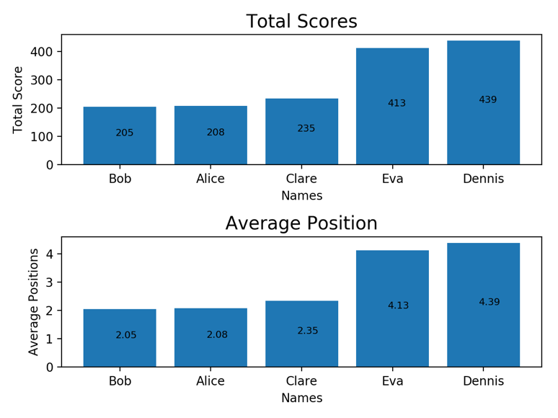As you can see in the first race 2 simulations Claire is the winner, whilst in the final simulation Bob is the winner. What this shows is that with a standard number of races being ran each time being a skilled, yet inconsistent sailor is advantageous to a sailor within this scoring system.

Figure 3 – 100 races

## Conclusions

In brief, I believe my code allowed me to run a reliable and further usable test on the scoring system, allowing me to surmise that although the scoring system may seem to be fair, that it gives more of a reward to races who are inconsistent, but who do have a good mean performance score.

There are a few changes I would make if I was able to complete this project again. Firstly, something I was unable to test was the effect the removal of the worst score had on the standings; If I was to complete this investigation again I would put more of a focus on testing that, allowing me to get a more evidence supported understanding of the scoring system and the effects created by the stipulations. Something else I would like to improve upon in the future would be including doctests within my code, as testing throughout this project was something that I found fairly difficult, but could’ve been solved by adding doctests to each function. Finally, next time I would improve the figures and graphs used within my simulations, as I believe with more time I could make figures that better represent the investigation, and my findings as a whole.

Overall, I believe that I have complete this project well, allowing me to come to the initial conclusion that although the system does reward skilled racers, the system does not effectively reward consistency – meaning that the scoring system has a bias towards racers who are skilled but inconsistent.