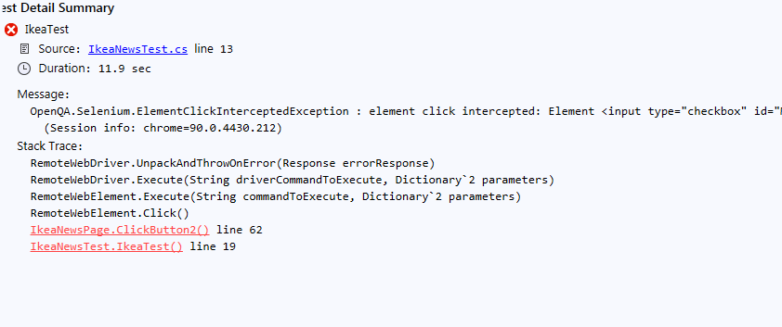
TA PATI KLAIDA COPY-PASTE:

IkeaTest
Source: IkeaNewsTest.cs line 13
Duration: 11.9 sec

Message:
OpenQA.Selenium.ElementClickInterceptedException : element click intercepted: Element <input type="checkbox" id="Mažiau-nei-50-€" class="" name="pmin" value="0&amp;pmax=50" data-text="Mažiau nei 50 €" style="position: absolute; top: -20%; left: -20%; display: block; width: 140%; height: 140%; margin: 0px; padding: 0px; background: rgb(255, 255, 255); border: 0px; opacity: 0;"> is not clickable at point (67, 610). Other element would receive the click: <ins class="iCheck-helper" style="position: absolute; top: -20%; left: -20%; display: block; width: 140%; height: 140%; margin: 0px; padding: 0px; background: rgb(255, 255, 255); border: 0px; opacity: 0;"></ins>
(Session info: chrome=90.0.4430.212)
Stack Trace:
RemoteWebDriver.UnpackAndThrowOnError(Response errorResponse)
RemoteWebDriver.Execute(String driverCommandToExecute, Dictionary`2 parameters)
RemoteWebElement.Execute(String commandToExecute, Dictionary`2 parameters)
RemoteWebElement.Click()
IkeaNewsPage.ClickButton2() line 62
IkeaNewsTest.IkeaTest() line 19

