SE 3002 - Software Quality Engineering
FAST School of Computing - Department of Software Engineering - FAST NUCES Islamabad
ASSIGNMENT 3 - Student Submission
Black-Box Testing: Equivalence Partitioning & Boundary Value Analysis on Testfolio (testfol.io)

Student Name | Muhammad Bilal Tahir
Roll Number | 24i-3166
Section / Batch | SE-B
Instructors | Dr. Nigar Azhar Butt | Dr. Atif Aftab Jilani | Miss Anum Kaleem
Test Account Used | i243166@isb.nu.edu.pk
Browser & Version | Google Chrome 142.0.0.0 on Ubuntu Linux

Summary of this submission: 11 forms, 51 input fields, 159 equivalence classes, 48 boundaries, 165 EP + Strong EP test cases and 106 BVA test cases (271 executed with screenshots, 0 marked Not Executed); 14 defect observations.

D1 - Test Plan [20 marks]

TP-1 Test Plan Metadata
Test Plan ID | TP-A3-24I-3166
Version | 1.0
Author (Roll No.) | 24i-3166 (Muhammad Bilal Tahir)
Status | Final

TP-2 Introduction
Testfolio (testfol.io) is a web-based portfolio back-testing and analysis platform. Users build portfolios from tickers and allocation percentages, run historical back-tests over chosen dates with a starting amount, configure rebalancing, cashflows and benchmarks, and view charts and statistics. It also offers Monte Carlo simulation, safe-withdrawal-rate analysis, an optimizer, an efficient-frontier tool, a Lump Sum vs DCA tool, a time-value-of-money calculator and a rebalancing-sensitivity tool. This plan describes black-box testing of the input validation of eleven forms using Equivalence Partitioning (EP) and Boundary Value Analysis (BVA), with every test case executed against the live system on my own account and backed by screenshots.

TP-3 Scope
In-scope features (all 11 forms and their input fields):
- 1 Sign Up (testfol.io/start): Email, Password
- 2 Sign In (testfol.io/login): Email, Password
- 3 Portfolio Backtester (testfol.io/): Start Date, End Date, Starting Value, Rolling Window, Annual cashflow growth, Cashflow, Drag, Ticker, Allocation %, Rebalance frequency (critical form)
- 4 Monte Carlo Simulator: Start/End Date, Number of years, Starting Value, Min block, Max block, Random seed, Allocation %
- 5 Safe Withdrawal Rate Calculator: Retirement horizon, Phase 1 end year, Phase 1 and Phase 2 withdrawal %, Start/End Date, Allocation %
- 6 Backtest Optimizer: Tickers, Start/End Date, Starting Value, Rolling Window, Max holdings, Min weight to include, Max vol
- 7 Efficient Frontier: Tickers, Start/End Date, Max holdings, Min weight to include
- 8 Contact Form: Name, Email, Subject, Message (and topic selector)
- 9 Lump Sum vs DCA: Starting Value, DCA horizon, Ticker, Allocation % (premium tool on the Free plan)
- 10 Time Value of Money Calculator: Starting Value, Monthly contribution
- 11 Rebalancing Sensitivity: Start/End Date, Drag, Allocation % (premium tool on the Free plan)

TP-4 Test Objectives
- Identify the valid and invalid equivalence classes of every input field and verify that each class behaves consistently (valid input accepted, invalid input rejected with a clear message).
- Locate and probe every numeric, length and date boundary with 2-point BVA on all forms and 3-point BVA (below/at/above) on the critical form (Portfolio Backtester).
- Reveal defects such as silent acceptance of invalid values, silent value rewriting, inconsistent messages and validation that is bypassed by plan gating.
- Produce an evidence-backed traceability matrix: every executed test case has an ID, expected result, actual result, pass/fail verdict and screenshot(s).

TP-5 Test Approach
Probe strategy: before designing any test case I explored each form with a probe log (Appendix A): empty values, zero, negative, decimal, very large, very long strings, special characters (apostrophes, spaces, unicode, SQL fragment), reversed/equal/future/ancient dates and allocations that do not sum to 100. I recorded the complete input set of every probe, the exact message shown and the inference. Different messages for different violations were treated as different equivalence classes.
Equivalence classes: for every input field I split the input domain into valid classes (VEC) and invalid classes (IEC) using the rules inferred from the probes, gave each a sequential EC ID (EC-001...), a representative value and the type. Weak EP with robustness (one test case per EC, including every IEC) was applied to all eleven forms; each TC-EP cites the EC it exercises.
Critical form: I designated the Portfolio Backtester as the critical form because it has the most inputs (dates, amounts, windows, percentages, cashflows, drag, tickers and allocations), the richest validation rules and the highest risk (money values and date logic). It receives Strong EP (TC-EP-S1..S6 combine several classes in one test) and 3-point BVA (below/at/above for every boundary).
Boundaries: boundaries were found by binary search on the live system (for example Starting Value accepted at 999,999,999,999 and rejected at 1,000,000,000,000; Rolling Window accepted at 11999 and rejected at 12000). Fields excluded from BVA: Ticker, Email and Password format, selects and the Rebalance option (symbolic data with no numeric boundary; a very long ticker is rejected as an unknown symbol, not by a length rule), Start/End Date on forms without a minimum span (only the ordering boundary is meaningful and is tested on the critical form), and Cashflow amount (no limit found by probing).
Execution: each test case was run on a fresh page load, the inputs were applied, the action button was clicked and the observed response (toast, browser validation message, run result, plan-limit dialog or pricing redirect) was recorded and screenshotted with the roll-number note visible.
Designated critical form: Portfolio Backtester (testfol.io/). Justification: it has the largest number of inputs, the most validation rules, cross-field rules (date order, allocation total) and the highest risk (money values and date logic). It receives Strong EP and 3-point BVA.

TP-6 Test Environment
Browser & Version | Google Chrome 142.0.0.0
Operating System | Ubuntu Linux (GNOME, Wayland)
Screen Resolution | 1920 x 1080 screen; browser viewport 1854 x 875
Test Account (email) | i243166@isb.nu.edu.pk
Network / VPN | No VPN; standard home network connection
Plan | Testfolio Free plan (all testing on my own account)

TP-7 Entry & Exit Criteria
Entry criteria:
- Testfolio account created and signed in on the Free plan; all 11 in-scope forms reachable.
- Chrome set up with a consistent viewport/zoom and the roll-number note visible on screen.
- Handout and template read; probe log of at least 15 probes completed before test design.
Exit criteria:
- All EP partition tables and all BVA boundary tables completed with unique EC and BC IDs.
- Every test case executed (or marked Blocked with the reason) with screenshot evidence; at least 35 EP and 25 BVA test cases executed.
- Traceability matrix complete and consistent with the execution log; defect observations recorded.

TP-8 Test Schedule
Activity | Notes / Dates | Est. Hours | Done?
Probe / explore all 11 Testfolio forms | Exploration with probe log; binary search of boundaries | 5.0 | Yes
Complete EP partition tables (Layer 1) | Classes inferred from probes | 2.0 | Yes
Design EP test cases (Layer 2) | Weak EP + robustness; Strong EP on Backtester | 2.5 | Yes
Complete BVA boundary tables (Layer 1) | Boundaries bracketed by probes | 1.5 | Yes
Design BVA test cases (Layer 2) | 2-point all forms, 3-point on Backtester | 2.0 | Yes
Execute test cases & capture screenshots | One fresh page load per test case | 8.0 | Yes
Complete traceability matrix | Cross-checked against execution log | 1.0 | Yes
Compile PDF and submit | Template sections, roll number in header | 1.0 | Yes

TP-9 Risks & Mitigations
Risk | Likelihood / Impact | Mitigation
Testfolio goes offline or returns intermittent server errors during testing (seen: 'Backtest failed', 'An error occurred while running Monte Carlo') | Medium / High | Run each case on a fresh page, repeat a case once if a transient error appears and record both attempts.
Free-plan limits and premium gating hide validation rules (Lump Sum vs DCA, Rebalancing Sensitivity, Monte Carlo years > 15, Efficient Frontier > 2 tickers) | High / Medium | Record the gate behaviour itself as the observed result, mark such cases Blocked and test the field-level browser validation separately.
Validation rules are undocumented, so inferred boundaries may be wrong | Medium / High | Bracket every boundary by binary search with values below, at and above and re-run the boundary cases on fresh pages.
Live data and results change over time (market data refresh) so actual numbers may differ on re-run | Medium / Low | Verdicts depend on acceptance/rejection behaviour and messages, not on exact result numbers; numbers are recorded as supporting evidence only.
Forms with CAPTCHA/bot protection or real side effects (Contact, Sign Up) cannot be fully automated | High / Medium | Run those cases manually where required and avoid sending real messages or creating extra accounts.

TP-10 Probe Log - Appendix A
Every probe lists all inputs entered (context fields included). Probes were run on my own account before any test case was designed.
Probe ID | Form | Test Inputs (field: value, ...) | System Response | Inference / Note
PR-001 | Backtester | Starting Value: 0; tickers SPY 60 / AGG 40; dates empty; other fields default | Browser bubble: "Value must be greater than or equal to 1." | Minimum Starting Value is 1; zero is an invalid class.
PR-002 | Backtester | Starting Value: empty; SPY 60 / AGG 40 | Toast: "Invalid starting value" | Empty is a separate invalid class (app message, not browser).
PR-003 | Backtester | Starting Value: 1000000000; SPY 60 / AGG 40 | Runs; Ending Value $6,222,004,217.23 | Large values are accepted; an upper limit may exist.
PR-004 | Backtester | Starting Value: 1000000000000 (1e12); SPY 60 / AGG 40 | Toast: "Starting value is too high" | Upper limit lies below 1e12.
PR-005 | Backtester | Starting Value: 999999999999; SPY 60 / AGG 40 | Runs; Ending Value $6,222,004,217,219.58 | Maximum accepted Starting Value is 999,999,999,999.
PR-006 | Backtester | SPY 60 / AGG 60 (total 120); defaults | Toast: "Portfolio 1: Allocation percentages must sum to 100"; total box red | Total is validated; upper bound 100.
PR-007 | Backtester | SPY 60 / AGG 39.99 (total 99.99) | Same sum-to-100 toast | Exact equality to 100 is required, no tolerance.
PR-008 | Backtester | SPY -10 / AGG 110 (total 100) | Runs; Ending Value $15,590.61 | Negative weight silently accepted - possible defect.
PR-009 | Backtester | Start Date 2020-01-01, End Date 2019-01-01 | Toast: "Start date must be before end date" | Date order is validated.
PR-010 | Backtester | Start Date 2020-01-01, End Date 2020-01-01 | Same toast | Start must be strictly before End.
PR-011 | Backtester | Start Date 1990-01-01, End Date 2020-01-01 | Runs; header shows 2003-09-26 - 2019-12-31 | Start earlier than data is silently clamped; also dates shown one day earlier than entered.
PR-012 | Backtester | Start Date 2099-01-01, End Date 2100-01-01 | Toast: "No overlapping time period found for the specified tickers and start/end dates" | Future ranges are a distinct invalid class.
PR-013 | Backtester | Ticker ZZZZZZ (60%), AGG 40 | Toast: "Invalid ticker ZZZZZZ" | Unknown symbols rejected server-side.
PR-014 | Backtester | Ticker " OR 1=1 --" style SQL fragment (60%), AGG 40 | Toast: "Invalid ticker ' OR 1=1 --" | Special characters are rejected safely; no error leakage.
PR-015 | Backtester | Rolling Window: 12000; SPY 60 / AGG 40 | Toast: "Rolling window is too large" | Upper limit exists; 11999 is accepted.
PR-016 | Backtester | Annual cashflow growth: -100 / 100.01 | Bubble ">= -99.99" / "<= 100" | Range is -99.99 to 100.
PR-017 | Backtester | Drag: 101 and 1000 | Runs (up to 16 s), Ending Value $0.00, no message | No upper validation on drag - defect candidate.
PR-018 | Monte Carlo | Number of years: 0 / 101 (others default) | Bubble + toast "Number of years must be positive" / "must be <= 100" | Range 1 to 100 in the form.
PR-019 | Monte Carlo | Number of years: 16 | Dialog "Upgrade for higher Monte Carlo limits - Free supports up to 15 years and 500 simulations" | Free-plan limit is a separate class.
PR-020 | Monte Carlo | Min block: 0.04 | Run completes ("Ran 500 simulations") although the field minimum is 0.05 | Min block minimum is not enforced - defect candidate.
PR-021 | Monte Carlo | Random seed: -1 and 1.5 | Field silently rewritten to 0 and 2; run completes | Seed is silently corrected, not rejected.
PR-022 | Safe Withdrawal Rate | Retirement horizon 0 and 51 (defaults otherwise) | Toast "Retirement horizon must be greater than 0 and at most 50 years" | Range 1 to 50.
PR-023 | Safe Withdrawal Rate | Phase 1 end year 30 with horizon 30 | Toast "Phase 2 must end after the previous phase" | Phase 1 end must be below the horizon.
PR-024 | Safe Withdrawal Rate | Phase 1 withdrawal 101 and -5 | Toast "Phase 1 withdrawal rate must be between 0% and 100%" | Range 0 to 100 percent.
PR-025 | Backtest Optimizer | Tickers "SPY,AGG,GLD" (comma separated) | Toast "You must specify at least two tickers" | Tickers must be space-separated; minimum two tickers.
PR-026 | Backtest Optimizer | Min weight to include 101 | Bubble "Value must be less than or equal to 100." | Range 0 to 100.
PR-027 | Efficient Frontier | Tickers "SPY AGG GLD" (three) | Redirect to /pricing "You've hit the max tickers limit ... current limit is 2 tickers" | Free plan allows 2 tickers.
PR-028 | Lump Sum vs DCA | Valid inputs, click Analyze | Redirect to /pricing "Premium tool - Requires Pro or higher" | Premium gate; validation order must be checked.
PR-029 | Lump Sum vs DCA | Starting Value 50 (bubble) then Analyze | Bubble "Value must be greater than or equal to 100." but click redirects to pricing | Premium gate fires before validation.
PR-030 | Rebalancing Sensitivity | Valid inputs / reversed dates / allocation 90, click Analyze | Always redirected to /pricing (premium tool) | No validation feedback is observable on the Free plan.
PR-031 | Time Value of Money | Starting Value -1 and 5000001 | Toast "Starting Value must be between $0 and $5,000,000." | Range 0 to 5,000,000.
PR-032 | Time Value of Money | Monthly contribution -1 and 100001 | Toast "Contribution must be between $0 and $100,000." | Range 0 to 100,000.

D2 - Equivalence Partitioning [25 marks]

Layer 1 - EP Partition Tables (one per input field)

Sign Up - Email
EC ID | Equivalence Class Description | Representative Value | Type (VEC / IEC)
EC-001 | Valid, unregistered email address format | newuser@example.com | VEC
EC-002 | Empty email | (empty) | IEC
EC-003 | Email without @ symbol | notanemail | IEC
EC-004 | Email without domain suffix | a@b | IEC
EC-005 | Email already registered | (your registered email) | IEC

Sign Up - Password
EC ID | Equivalence Class Description | Representative Value | Type (VEC / IEC)
EC-006 | Password of valid length | Test@1234 | VEC
EC-007 | Empty password | (empty) | IEC
EC-008 | Password shorter than minimum length | abcde | IEC
EC-009 | Password longer than maximum length | 73 x a | IEC

Sign In - Email
EC ID | Equivalence Class Description | Representative Value | Type (VEC / IEC)
EC-010 | Registered email | (your registered email) | VEC
EC-011 | Empty email | (empty) | IEC
EC-012 | Malformed email | notanemail | IEC
EC-013 | Unregistered email | nobody@x.com | IEC

Sign In - Password
EC ID | Equivalence Class Description | Representative Value | Type (VEC / IEC)
EC-014 | Correct password for the account | (correct password) | VEC
EC-015 | Empty password | (empty) | IEC
EC-016 | Wrong password | wrongpass1234 | IEC

Portfolio Backtester - Start Date
EC ID | Equivalence Class Description | Representative Value | Type (VEC / IEC)
EC-017 | Valid start date inside data range, before end date | 2020-01-01 (end 2021-01-01) | VEC
EC-018 | Start date left empty (full history) | (empty) | VEC
EC-019 | Start date after end date | 2020-01-01 (end 2019-01-01) | IEC
EC-020 | Start date equal to end date | 2020-01-01 (end 2020-01-01) | IEC
EC-021 | Start date earlier than first available data | 1990-01-01 (end 2020-01-01) | IEC
EC-022 | Start date in the far future (no data) | 2099-01-01 (end 2100-01-01) | IEC

Portfolio Backtester - End Date
EC ID | Equivalence Class Description | Representative Value | Type (VEC / IEC)
EC-023 | Valid end date with start empty | 2020-01-01 (start empty) | VEC
EC-024 | Start only, end date empty (runs to latest data) | 2020-01-01 (end empty) | VEC
EC-025 | End date later than last available data | 2020-01-01 to 2030-01-01 | IEC

Portfolio Backtester - Starting Value
EC ID | Equivalence Class Description | Representative Value | Type (VEC / IEC)
EC-026 | Valid starting value (>=1, below upper limit) | 10000 | VEC
EC-027 | Zero starting value | 0 | IEC
EC-028 | Negative starting value | -5 | IEC
EC-029 | Fractional value below minimum | 0.5 | IEC
EC-030 | Empty starting value | (empty) | IEC
EC-031 | Starting value above the upper limit | 5000000000000 | IEC

Portfolio Backtester - Rolling Window
EC ID | Equivalence Class Description | Representative Value | Type (VEC / IEC)
EC-032 | Valid rolling window in months | 60 | VEC
EC-033 | Zero rolling window | 0 | IEC
EC-034 | Negative rolling window | -1 | IEC
EC-035 | Non-integer rolling window | 1.5 | IEC
EC-036 | Rolling window above upper limit | 20000 | IEC

Portfolio Backtester - Annual cashflow growth
EC ID | Equivalence Class Description | Representative Value | Type (VEC / IEC)
EC-037 | Valid growth percentage | 2 | VEC
EC-038 | Growth below minimum | -100 | IEC
EC-039 | Growth above maximum | 101 | IEC

Portfolio Backtester - Cashflow amount
EC ID | Equivalence Class Description | Representative Value | Type (VEC / IEC)
EC-040 | Positive cashflow (contribution) | 1000 | VEC
EC-041 | Negative cashflow (withdrawal) | -500 | VEC
EC-042 | Zero cashflow (no cashflow) | 0 | VEC

Portfolio Backtester - Drag (annual fee %)
EC ID | Equivalence Class Description | Representative Value | Type (VEC / IEC)
EC-043 | Valid drag between 0 and 100 | 0.5 | VEC
EC-044 | Negative drag | -1 | IEC
EC-045 | Drag above 100% | 150 | IEC

Portfolio Backtester - Ticker
EC ID | Equivalence Class Description | Representative Value | Type (VEC / IEC)
EC-046 | Valid ticker (upper case) | SPY | VEC
EC-047 | Valid ticker in lower case | spy | VEC
EC-048 | Unknown ticker | ZZZZZZ | IEC
EC-049 | Empty ticker with non-zero allocation | (empty) | IEC
EC-050 | SQL fragment as ticker | ' OR 1=1 -- | IEC
EC-051 | Non-ASCII (unicode) ticker | ÄÖÜ | IEC
EC-052 | Ticker containing a space | S PY | IEC
EC-053 | Very long ticker (50 characters) | ABCDEFGHIJ x5 | IEC

Portfolio Backtester - Allocation % (portfolio total)
EC ID | Equivalence Class Description | Representative Value | Type (VEC / IEC)
EC-054 | Allocations sum to exactly 100 across 2 assets | SPY 60 / AGG 40 | VEC
EC-055 | Single asset at 100% | SPY 100 / AGG 0 | VEC
EC-056 | Allocations sum below 100 | SPY 60 / AGG 30 (90) | IEC
EC-057 | Allocations sum above 100 | SPY 60 / AGG 60 (120) | IEC
EC-058 | Negative allocation with offsetting excess | SPY -10 / AGG 110 | IEC

Portfolio Backtester - Rebalance frequency
EC ID | Equivalence Class Description | Representative Value | Type (VEC / IEC)
EC-059 | Valid rebalance option (Yearly, default) | Yearly | VEC

Monte Carlo Simulator - Start / End Date
EC ID | Equivalence Class Description | Representative Value | Type (VEC / IEC)
EC-060 | Dates empty (full history) | (empty) | VEC
EC-061 | Start date after end date | 2020-01-01 / 2019-01-01 | IEC

Monte Carlo Simulator - Number of years
EC ID | Equivalence Class Description | Representative Value | Type (VEC / IEC)
EC-062 | Valid horizon within free limit | 10 | VEC
EC-063 | Horizon below minimum | 0 | IEC
EC-064 | Horizon above free-plan limit but within 100 | 50 | IEC
EC-065 | Horizon above absolute maximum | 150 | IEC
EC-066 | Decimal horizon | 2.5 | VEC

Monte Carlo Simulator - Starting Value
EC ID | Equivalence Class Description | Representative Value | Type (VEC / IEC)
EC-067 | Valid starting value | 10000 | VEC
EC-068 | Zero starting value | 0 | IEC

Monte Carlo Simulator - Min block (years)
EC ID | Equivalence Class Description | Representative Value | Type (VEC / IEC)
EC-069 | Valid minimum block length | 1 | VEC
EC-070 | Minimum block below allowed minimum | 0.01 | IEC

Monte Carlo Simulator - Max block (years)
EC ID | Equivalence Class Description | Representative Value | Type (VEC / IEC)
EC-071 | Valid maximum block length | 5 | VEC
EC-072 | Maximum block above allowed maximum | 25 | IEC
EC-073 | Maximum block below allowed minimum | 0.01 | IEC

Monte Carlo Simulator - Random seed
EC ID | Equivalence Class Description | Representative Value | Type (VEC / IEC)
EC-074 | Seed left empty (random) | (empty) | VEC
EC-075 | Valid whole-number seed | 42 | VEC
EC-076 | Negative seed | -1 | IEC
EC-077 | Non-integer seed | 1.5 | IEC

Monte Carlo Simulator - Allocation % (portfolio total)
EC ID | Equivalence Class Description | Representative Value | Type (VEC / IEC)
EC-078 | Allocations sum to 100 (50/25/25) | 50/25/25 | VEC
EC-079 | Allocations sum below 100 | 50/25/20 (95) | IEC

Safe Withdrawal Rate Calculator - Retirement horizon (years)
EC ID | Equivalence Class Description | Representative Value | Type (VEC / IEC)
EC-080 | Valid horizon | 30 | VEC
EC-081 | Zero horizon | 0 | IEC
EC-082 | Horizon above maximum | 60 | IEC

Safe Withdrawal Rate Calculator - Phase 1 end year
EC ID | Equivalence Class Description | Representative Value | Type (VEC / IEC)
EC-083 | Valid end year before horizon | 10 | VEC
EC-084 | End year zero | 0 | IEC
EC-085 | End year after the horizon | 40 (horizon 30) | IEC

Safe Withdrawal Rate Calculator - Phase 1 annual withdrawal %
EC ID | Equivalence Class Description | Representative Value | Type (VEC / IEC)
EC-086 | Valid withdrawal rate | 4 | VEC
EC-087 | Withdrawal rate negative | -5 | IEC
EC-088 | Withdrawal rate above 100 | 150 | IEC

Safe Withdrawal Rate Calculator - Phase 2 annual withdrawal %
EC ID | Equivalence Class Description | Representative Value | Type (VEC / IEC)
EC-089 | Valid withdrawal rate | 6 | VEC
EC-090 | Withdrawal rate negative | -5 | IEC
EC-091 | Withdrawal rate above 100 | 150 | IEC

Safe Withdrawal Rate Calculator - Start / End Date
EC ID | Equivalence Class Description | Representative Value | Type (VEC / IEC)
EC-092 | Dates empty (full history) | (empty) | VEC
EC-093 | Start date after end date | 2020-01-01 / 2019-01-01 | IEC

Safe Withdrawal Rate Calculator - Allocation % (portfolio total)
EC ID | Equivalence Class Description | Representative Value | Type (VEC / IEC)
EC-094 | Allocations sum to 100 (50/30/20) | 50/30/20 | VEC
EC-095 | Allocations sum below 100 | 50/30/10 (90) | IEC

Backtest Optimizer - Tickers
EC ID | Equivalence Class Description | Representative Value | Type (VEC / IEC)
EC-096 | Three valid tickers separated by spaces | SPY AGG GLD | VEC
EC-097 | Exactly two valid tickers | SPY AGG | VEC
EC-098 | Only one ticker | SPY | IEC
EC-099 | Empty tickers | (empty) | IEC
EC-100 | Contains an unknown ticker | SPY ZZZZZZ | IEC
EC-101 | Comma-separated tickers | SPY,AGG,GLD | IEC

Backtest Optimizer - Start / End Date
EC ID | Equivalence Class Description | Representative Value | Type (VEC / IEC)
EC-102 | Dates empty (full history) | (empty) | VEC
EC-103 | Start date after end date | 2020-01-01 / 2019-01-01 | IEC

Backtest Optimizer - Starting Value
EC ID | Equivalence Class Description | Representative Value | Type (VEC / IEC)
EC-104 | Valid starting value | 10000 | VEC
EC-105 | Zero starting value | 0 | IEC

Backtest Optimizer - Rolling Window
EC ID | Equivalence Class Description | Representative Value | Type (VEC / IEC)
EC-106 | Valid rolling window | 60 | VEC
EC-107 | Zero rolling window | 0 | IEC

Backtest Optimizer - Max holdings
EC ID | Equivalence Class Description | Representative Value | Type (VEC / IEC)
EC-108 | Valid max holdings | 2 | VEC
EC-109 | Zero max holdings | 0 | IEC

Backtest Optimizer - Min weight to include (%)
EC ID | Equivalence Class Description | Representative Value | Type (VEC / IEC)
EC-110 | Valid minimum weight | 10 | VEC
EC-111 | Negative minimum weight | -5 | IEC
EC-112 | Minimum weight above 100 | 150 | IEC

Backtest Optimizer - Max vol (%)
EC ID | Equivalence Class Description | Representative Value | Type (VEC / IEC)
EC-113 | Valid maximum volatility | 20 | VEC
EC-114 | Negative maximum volatility | -5 | IEC

Efficient Frontier - Tickers
EC ID | Equivalence Class Description | Representative Value | Type (VEC / IEC)
EC-115 | Two valid tickers | SPY AGG | VEC
EC-116 | Only one ticker | SPY | IEC
EC-117 | Empty tickers | (empty) | IEC
EC-118 | Three tickers (above free-plan limit) | SPY AGG GLD | IEC

Efficient Frontier - Start / End Date
EC ID | Equivalence Class Description | Representative Value | Type (VEC / IEC)
EC-119 | Dates empty (full history) | (empty) | VEC
EC-120 | Start date after end date | 2020-01-01 / 2019-01-01 | IEC

Efficient Frontier - Max holdings
EC ID | Equivalence Class Description | Representative Value | Type (VEC / IEC)
EC-121 | Valid max holdings | 2 | VEC
EC-122 | Zero max holdings | 0 | IEC

Efficient Frontier - Min weight to include (%)
EC ID | Equivalence Class Description | Representative Value | Type (VEC / IEC)
EC-123 | Valid minimum weight | 10 | VEC
EC-124 | Negative minimum weight | -5 | IEC
EC-125 | Minimum weight above 100 | 150 | IEC

Contact Form - Name
EC ID | Equivalence Class Description | Representative Value | Type (VEC / IEC)
EC-126 | Valid name (1-120 chars) | Muhammad Bilal Tahir | VEC
EC-127 | Empty name | (empty) | IEC
EC-128 | Name longer than 120 characters | 121 x a | IEC

Contact Form - Email
EC ID | Equivalence Class Description | Representative Value | Type (VEC / IEC)
EC-129 | Valid email format | student@example.com | VEC
EC-130 | Empty email | (empty) | IEC
EC-131 | Malformed email | notanemail | IEC

Contact Form - Subject
EC ID | Equivalence Class Description | Representative Value | Type (VEC / IEC)
EC-132 | Valid subject (1-120 chars) | Question about backtests | VEC
EC-133 | Empty subject | (empty) | IEC
EC-134 | Subject longer than 120 characters | 121 x a | IEC

Contact Form - Message
EC ID | Equivalence Class Description | Representative Value | Type (VEC / IEC)
EC-135 | Valid message (1-5000 chars) | Hello, test message | VEC
EC-136 | Empty message | (empty) | IEC
EC-137 | Message longer than 5000 characters | 5001 x a | IEC

Lump Sum vs DCA - Starting Value
EC ID | Equivalence Class Description | Representative Value | Type (VEC / IEC)
EC-138 | Valid starting value (>=100) | 10000 | VEC
EC-139 | Starting value below minimum | 50 | IEC

Lump Sum vs DCA - DCA horizon (months)
EC ID | Equivalence Class Description | Representative Value | Type (VEC / IEC)
EC-140 | Valid horizon | 12 | VEC
EC-141 | Horizon below minimum | 0 | IEC
EC-142 | Horizon above maximum | 200 | IEC

Lump Sum vs DCA - Ticker
EC ID | Equivalence Class Description | Representative Value | Type (VEC / IEC)
EC-143 | Valid ticker | SPY | VEC
EC-144 | Unknown ticker | ZZZZZZ | IEC

Lump Sum vs DCA - Allocation % (portfolio total)
EC ID | Equivalence Class Description | Representative Value | Type (VEC / IEC)
EC-145 | Allocations sum to 100 | 60/40 | VEC
EC-146 | Allocations sum below 100 | 60/30 (90) | IEC

Time Value of Money Calculator - Starting Value
EC ID | Equivalence Class Description | Representative Value | Type (VEC / IEC)
EC-147 | Valid starting value | 10000 | VEC
EC-148 | Negative starting value | -500 | IEC
EC-149 | Starting value above maximum | 9000000 | IEC
EC-150 | Empty starting value | (empty) | IEC

Time Value of Money Calculator - Monthly contribution
EC ID | Equivalence Class Description | Representative Value | Type (VEC / IEC)
EC-151 | Valid monthly contribution | 1000 | VEC
EC-152 | Negative contribution | -50 | IEC
EC-153 | Contribution above maximum | 500000 | IEC

Rebalancing Sensitivity - Start / End Date
EC ID | Equivalence Class Description | Representative Value | Type (VEC / IEC)
EC-154 | Dates empty (full history) | (empty) | VEC
EC-155 | Start date after end date | 2020-01-01 / 2019-01-01 | IEC

Rebalancing Sensitivity - Drag (annual fee %)
EC ID | Equivalence Class Description | Representative Value | Type (VEC / IEC)
EC-156 | Valid drag | 0.5 | VEC
EC-157 | Negative drag | -2 | IEC

Rebalancing Sensitivity - Allocation % (portfolio total)
EC ID | Equivalence Class Description | Representative Value | Type (VEC / IEC)
EC-158 | Allocations sum to 100 | 60/40 | VEC
EC-159 | Allocations sum below 100 | 60/30 (90) | IEC

Layer 2 - EP Test Case Table (Weak EP with robustness: one TC per EC)
TC-EP ID | EC IDs Covered | Feature / Form | Input Field(s) | Test Value(s) | Expected Result | Actual Result | P/F
TC-EP-001 | EC-001 | Sign Up | Email | newuser@example.com | Account created / verification step shown | ACCEPTED | Valid unregistered email newuser@example.com accepted: toast 'Code sent' and the verification step 'Enter the verification code sent to newuser@example.com' appears (account is only created after the code is verified, which was not done) | Pass
TC-EP-002 | EC-002 | Sign Up | Email | (empty) | Rejected; email required | REJECTED (no submission) | Empty email: Confirm my email click does nothing; no message, no account request | Pass
TC-EP-003 | EC-003 | Sign Up | Email | notanemail | Rejected; invalid email format | Rejected (browser validation message) | Please include an '@' in the email address. 'notanemail' is missing an '@'. | Pass
TC-EP-004 | EC-004 | Sign Up | Email | a@b | Rejected; invalid email format | ACCEPTED | 'a@b' passes the browser email check (no domain suffix needed); submit then stops silently because the password is empty | Fail
TC-EP-005 | EC-005 | Sign Up | Email | (your registered email) | Rejected; account exists | RAN | Already-registered email was not rejected: toast 'Code sent' and the dialog moved to 'Enter the verification code sent to ... to create your account' (no 'account exists' message; consistent with anti-enumeration design) | Fail
TC-EP-006 | EC-006 | Sign Up | Password | Test@1234 | Accepted | ACCEPTED | Password of valid length (Test@1234, 9 chars) accepted: 'Code sent' toast and verification step shown | Pass
TC-EP-007 | EC-007 | Sign Up | Password | (empty) | Rejected; password required | REJECTED (no submission) | Valid email with empty password: Confirm my email click does nothing; no message shown | Pass
TC-EP-008 | EC-008 | Sign Up | Password | abcde | Rejected; too short | REJECTED (no submission) | 5-character password with matching confirmation: Confirm my email click does nothing and no message explains why | Pass
TC-EP-009 | EC-009 | Sign Up | Password | 73 x a | Rejected or truncated; too long | RAN | 73-character password was NOT rejected or truncated: 'Code sent' toast and the verification-code step appeared (no maximum length enforced at this step) | Fail
TC-EP-010 | EC-010 | Sign In | Email | (your registered email) | Accepted | ACCEPTED | Registered email accepted in the Sign in dialog | Pass
TC-EP-011 | EC-011 | Sign In | Email | (empty) | Rejected; email required | REJECTED (no submission) | Empty email and password: Sign in click does nothing, no request is made | Pass
TC-EP-012 | EC-012 | Sign In | Email | notanemail | Rejected; invalid email format | Rejected (browser validation message) | Please include an '@' in the email address. 'notanemail' is missing an '@'. | Pass
TC-EP-013 | EC-013 | Sign In | Email | nobody@x.com | Rejected; invalid credentials | Rejected (toast) | toast: Email or password wasn't recognized. Try again, use a one-time code, or create/reset your password. (generic message, does not reveal whether the email exists) | Pass
TC-EP-014 | EC-014 | Sign In | Password | (correct password) | Signed in | RAN | Correct password: signed in, 'Finish setup' dialog appears and the account shows Free plan | Pass
TC-EP-015 | EC-015 | Sign In | Password | (empty) | Rejected; password required | REJECTED (no submission) | Registered email with empty password: Sign in click does nothing, no message shown | Pass
TC-EP-016 | EC-016 | Sign In | Password | wrongpass1234 | Rejected; invalid credentials | Rejected (toast) | toast: Email or password wasn't recognized. Try again, use a one-time code, or create/reset your password. | Pass
TC-EP-017 | EC-017 | Portfolio Backtester | Start Date | 2020-01-01 (end 2021-01-01) | Backtest runs for the entered period | RAN | EV $11,401.48, CAGR 13.98% | 1.00 years: 2019-12-31 - 2020-12-31 | Pass
TC-EP-018 | EC-018 | Portfolio Backtester | Start Date | (empty) | Backtest runs from earliest common date | RAN | EV $62,220.04, CAGR 8.25% | 23.06 years: 2003-09-26 - 2026-10-19 | Pass
TC-EP-019 | EC-019 | Portfolio Backtester | Start Date | 2020-01-01 (end 2019-01-01) | Rejected with a validation message; no calculation is run | Rejected (toast) | toast: Start date must be before end date | Pass
TC-EP-020 | EC-020 | Portfolio Backtester | Start Date | 2020-01-01 (end 2020-01-01) | Rejected with a validation message; no calculation is run | Rejected (toast) | toast: Start date must be before end date | Pass
TC-EP-021 | EC-021 | Portfolio Backtester | Start Date | 1990-01-01 (end 2020-01-01) | Rejected, or user told the start is adjusted | RAN | EV $33,672.37, CAGR 7.75% | 16.26 years: 2003-09-26 - 2019-12-31 | Fail
TC-EP-022 | EC-022 | Portfolio Backtester | Start Date | 2099-01-01 (end 2100-01-01) | Rejected with a validation message; no calculation is run | Rejected (toast) | toast: No overlapping time period found for the specified tickers and start/end dates | Pass
TC-EP-023 | EC-023 | Portfolio Backtester | End Date | 2020-01-01 (start empty) | Backtest runs up to the entered date | RAN | EV $33,672.37, CAGR 7.75% | 16.26 years: 2003-09-26 - 2019-12-31 | Pass
TC-EP-024 | EC-024 | Portfolio Backtester | End Date | 2020-01-01 (end empty) | Backtest runs to latest data | RAN | EV $18,478.07, CAGR 9.45% | 6.80 years: 2019-12-31 - 2026-10-19 | Pass
TC-EP-025 | EC-025 | Portfolio Backtester | End Date | 2020-01-01 to 2030-01-01 | Rejected, or user told the end is adjusted | RAN | EV $18,478.07, CAGR 9.45% | 6.80 years: 2019-12-31 - 2026-10-19 | Fail
TC-EP-026 | EC-026 | Portfolio Backtester | Starting Value | 10000 | Accepted; calculation/analysis completes and results are shown | RAN | EV $62,220.04, CAGR 8.25% | 23.06 years: 2003-09-26 - 2026-10-19 | Pass
TC-EP-027 | EC-027 | Portfolio Backtester | Starting Value | 0 | Rejected with a validation message; no calculation is run | Rejected (browser validation message) | Starting Value: Value must be greater than or equal to 1. | Pass
TC-EP-028 | EC-028 | Portfolio Backtester | Starting Value | -5 | Rejected with a validation message; no calculation is run | Rejected (browser validation message) | Starting Value: Value must be greater than or equal to 1. | Pass
TC-EP-029 | EC-029 | Portfolio Backtester | Starting Value | 0.5 | Rejected with a validation message; no calculation is run | Rejected (browser validation message) | Starting Value: Value must be greater than or equal to 1. | Pass
TC-EP-030 | EC-030 | Portfolio Backtester | Starting Value | (empty) | Rejected with a validation message; no calculation is run | Rejected (toast) | toast: Invalid starting value | Pass
TC-EP-031 | EC-031 | Portfolio Backtester | Starting Value | 5000000000000 | Rejected with a validation message; no calculation is run | Rejected (toast) | toast: Starting value is too high | Pass
TC-EP-032 | EC-032 | Portfolio Backtester | Rolling Window | 60 | Accepted; calculation/analysis completes and results are shown | RAN | EV $62,220.04, CAGR 8.25% | 23.06 years: 2003-09-26 - 2026-10-19 | Pass
TC-EP-033 | EC-033 | Portfolio Backtester | Rolling Window | 0 | Rejected with a validation message; no calculation is run | Rejected (browser validation message) | Rolling Window: Value must be greater than or equal to 1. | Pass
TC-EP-034 | EC-034 | Portfolio Backtester | Rolling Window | -1 | Rejected with a validation message; no calculation is run | Rejected (browser validation message) | Rolling Window: Value must be greater than or equal to 1. | Pass
TC-EP-035 | EC-035 | Portfolio Backtester | Rolling Window | 1.5 | Rejected with a validation message; no calculation is run | Rejected (browser validation message) | Rolling Window: Please enter a valid value. The two nearest valid values are 1 and 2. | Pass
TC-EP-036 | EC-036 | Portfolio Backtester | Rolling Window | 20000 | Rejected with a validation message; no calculation is run | Rejected (toast) | toast: Rolling window is too large | Pass
TC-EP-037 | EC-037 | Portfolio Backtester | Annual cashflow growth | 2 | Accepted; calculation/analysis completes and results are shown | RAN | EV $62,220.04, CAGR 8.25% | 23.06 years: 2003-09-26 - 2026-10-19 | Pass
TC-EP-038 | EC-038 | Portfolio Backtester | Annual cashflow growth | -100 | Rejected with a validation message; no calculation is run | Rejected (browser validation message) | Annual cashflow growth: Value must be greater than or equal to -99.99. | Pass
TC-EP-039 | EC-039 | Portfolio Backtester | Annual cashflow growth | 101 | Rejected with a validation message; no calculation is run | Rejected (browser validation message) | Annual cashflow growth: Value must be less than or equal to 100. | Pass
TC-EP-040 | EC-040 | Portfolio Backtester | Cashflow amount | 1000 | Accepted; calculation/analysis completes and results are shown | RAN | EV $135,115.00, CAGR 8.25% | 23.06 years: 2003-09-26 - 2026-10-19 | Pass
TC-EP-041 | EC-041 | Portfolio Backtester | Cashflow amount | -500 | Accepted; calculation/analysis completes and results are shown | RAN | EV $25,772.56 (total contributions -$1,500.00), CAGR 8.25% | 23.06 years: 2003-09-26 - 2026-10-19 | Pass
TC-EP-042 | EC-042 | Portfolio Backtester | Cashflow amount | 0 | Accepted; calculation/analysis completes and results are shown | RAN | EV $62,220.04, CAGR 8.25% | 23.06 years: 2003-09-26 - 2026-10-19 | Pass
TC-EP-043 | EC-043 | Portfolio Backtester | Drag (annual fee %) | 0.5 | Accepted; calculation/analysis completes and results are shown | RAN | EV $55,457.11, CAGR 7.71% | 23.06 years: 2003-09-26 - 2026-10-19 | Pass
TC-EP-044 | EC-044 | Portfolio Backtester | Drag (annual fee %) | -1 | Rejected with a validation message; no calculation is run | RAN | EV $78,320.13, CAGR 9.33% | 23.06 years: 2003-09-26 - 2026-10-19 | Fail
TC-EP-045 | EC-045 | Portfolio Backtester | Drag (annual fee %) | 150 | Rejected with a validation message; no calculation is run | RAN | EV $0.00, CAGR -75.88% | 23.06 years: 2003-09-26 - 2026-10-19 | Fail
TC-EP-046 | EC-046 | Portfolio Backtester | Ticker | SPY | Accepted; calculation/analysis completes and results are shown | RAN | EV $62,220.04, CAGR 8.25% | 23.06 years: 2003-09-26 - 2026-10-19 | Pass
TC-EP-047 | EC-047 | Portfolio Backtester | Ticker | spy | Accepted; calculation/analysis completes and results are shown | RAN | EV $62,220.04, CAGR 8.25% | 23.06 years: 2003-09-26 - 2026-10-19 | Pass
TC-EP-048 | EC-048 | Portfolio Backtester | Ticker | ZZZZZZ | Rejected with a validation message; no calculation is run | Rejected (toast) | toast: Invalid ticker ZZZZZZ | Pass
TC-EP-049 | EC-049 | Portfolio Backtester | Ticker | (empty) | Rejected with a validation message; no calculation is run | Rejected (toast) | toast: Portfolio 1: Non-zero allocation has empty ticker | Pass
TC-EP-050 | EC-050 | Portfolio Backtester | Ticker | ' OR 1=1 -- | Rejected with a validation message; no calculation is run | Rejected (toast) | toast: Invalid ticker ' OR 1=1 -- | Pass
TC-EP-051 | EC-051 | Portfolio Backtester | Ticker | ÄÖÜ | Rejected with a validation message; no calculation is run | Rejected (toast) | toast: Invalid ticker ÄÖÜ | Pass
TC-EP-052 | EC-052 | Portfolio Backtester | Ticker | S PY | Rejected with a validation message; no calculation is run | Rejected (toast) | toast: Invalid ticker S PY | Pass
TC-EP-053 | EC-053 | Portfolio Backtester | Ticker | ABCDEFGHIJ x5 | Rejected with a validation message; no calculation is run | Rejected (toast) | toast: Invalid ticker ABCDEFGHIJABCDEFGHIJABCDEFGHIJABCDEFGHIJABCDEFGHIJ | Pass
TC-EP-054 | EC-054 | Portfolio Backtester | Allocation % (portfolio total) | SPY 60 / AGG 40 | Accepted; calculation/analysis completes and results are shown | RAN | EV $62,220.04, CAGR 8.25% | 23.06 years: 2003-09-26 - 2026-10-19 | Pass
TC-EP-055 | EC-055 | Portfolio Backtester | Allocation % (portfolio total) | SPY 100 / AGG 0 | Accepted; calculation/analysis completes and results are shown | RAN | single asset SPY EV $318,820.13, CAGR 10.81% | 33.72 years: 1993-01-29 - 2026-10-19 | Pass
TC-EP-056 | EC-056 | Portfolio Backtester | Allocation % (portfolio total) | SPY 60 / AGG 30 (90) | Rejected with a validation message; no calculation is run | Rejected (toast) | toast: Portfolio 1: Allocation percentages must sum to 100 | Pass
TC-EP-057 | EC-057 | Portfolio Backtester | Allocation % (portfolio total) | SPY 60 / AGG 60 (120) | Rejected with a validation message; no calculation is run | Rejected (toast) | toast: Portfolio 1: Allocation percentages must sum to 100 | Pass
TC-EP-058 | EC-058 | Portfolio Backtester | Allocation % (portfolio total) | SPY -10 / AGG 110 | Rejected with a validation message; no calculation is run | RAN | EV $15,590.61, CAGR 1.94% | 23.06 years: 2003-09-26 - 2026-10-19 | Fail
TC-EP-059 | EC-059 | Portfolio Backtester | Rebalance frequency | Yearly | Accepted; calculation/analysis completes and results are shown | RAN | EV $62,220.04, CAGR 8.25% | 23.06 years: 2003-09-26 - 2026-10-19 | Pass
TC-EP-060 | EC-060 | Monte Carlo Simulator | Start / End Date | (empty) | Simulation runs | RAN | | 500 simulations of 15 years | Pass
TC-EP-061 | EC-061 | Monte Carlo Simulator | Start / End Date | 2020-01-01 / 2019-01-01 | Rejected with a validation message; no calculation is run | Rejected (toast) | toast: Start date must be before end date | Pass
TC-EP-062 | EC-062 | Monte Carlo Simulator | Number of years | 10 | Accepted; calculation/analysis completes and results are shown | RAN | | 500 simulations of 10 years | Pass
TC-EP-063 | EC-063 | Monte Carlo Simulator | Number of years | 0 | Rejected with a validation message; no calculation is run | Rejected (browser validation message) | Number of years: Value must be greater than or equal to 1. | toast: Number of years must be positive | Pass
TC-EP-064 | EC-064 | Monte Carlo Simulator | Number of years | 50 | Rejected or plan-limit message | PLAN-LIMIT DIALOG | "Upgrade for higher Monte Carlo limits - Free supports up to 15 years and 500 simulations" (years 50) | Pass
TC-EP-065 | EC-065 | Monte Carlo Simulator | Number of years | 150 | Rejected with a validation message; no calculation is run | Rejected (browser validation message) | Number of years: Value must be less than or equal to 100. | toast: Number of years must be <= 100 | Pass
TC-EP-066 | EC-066 | Monte Carlo Simulator | Number of years | 2.5 | Accepted; calculation/analysis completes and results are shown | RAN | | 500 simulations of 2.5 years | Pass
TC-EP-067 | EC-067 | Monte Carlo Simulator | Starting Value | 10000 | Accepted; calculation/analysis completes and results are shown | RAN | | 500 simulations of 15 years | Pass
TC-EP-068 | EC-068 | Monte Carlo Simulator | Starting Value | 0 | Rejected with a validation message; no calculation is run | Rejected (browser validation message) | Starting Value: Value must be greater than or equal to 1. | toast: Starting value must be positive | Pass
TC-EP-069 | EC-069 | Monte Carlo Simulator | Min block (years) | 1 | Accepted; calculation/analysis completes and results are shown | RAN | | 500 simulations of 15 years | Pass
TC-EP-070 | EC-070 | Monte Carlo Simulator | Min block (years) | 0.01 | Rejected with a validation message; no calculation is run | RAN (DEFECT: browser reports min 0.05 but app accepts 0.01) | Min block 0.01 -> "Ran 500 simulations in 2.7 seconds", random seed auto-filled 1275341795 | Fail
TC-EP-071 | EC-071 | Monte Carlo Simulator | Max block (years) | 5 | Accepted; calculation/analysis completes and results are shown | RAN | | 500 simulations of 15 years | Pass
TC-EP-072 | EC-072 | Monte Carlo Simulator | Max block (years) | 25 | Rejected with a validation message; no calculation is run | Rejected (browser validation + toast) | Max block (in years): Value must be less than or equal to 20. | toast: Max block length must be <= 20 years | Pass
TC-EP-073 | EC-073 | Monte Carlo Simulator | Max block (years) | 0.01 | Rejected with a validation message; no calculation is run | Rejected (browser validation + toast) | Max block (in years): Value must be greater than or equal to 0.05. | toast: Min block length must be <= max block length | Pass
TC-EP-074 | EC-074 | Monte Carlo Simulator | Random seed | (empty) | Accepted; calculation/analysis completes and results are shown | RAN | | 500 simulations of 15 years | Pass
TC-EP-075 | EC-075 | Monte Carlo Simulator | Random seed | 42 | Accepted; calculation/analysis completes and results are shown | RAN | | 500 simulations of 15 years (seed 42) | Pass
TC-EP-076 | EC-076 | Monte Carlo Simulator | Random seed | -1 | Rejected with a validation message; no calculation is run | RAN (silent correction: seed -1 reset to 0) | Random seed field shows 0 after click; "Ran 500 simulations in 0.9 seconds"; no message | Fail
TC-EP-077 | EC-077 | Monte Carlo Simulator | Random seed | 1.5 | Rejected with a validation message; no calculation is run | RAN (silent correction: seed 1.5 rounded to 2) | Random seed field shows 2; "Ran 500 simulations in 1.0 seconds"; no message | Fail
TC-EP-078 | EC-078 | Monte Carlo Simulator | Allocation % (portfolio total) | 50/25/25 | Accepted; calculation/analysis completes and results are shown | RAN | | 500 simulations of 15 years | Pass
TC-EP-079 | EC-079 | Monte Carlo Simulator | Allocation % (portfolio total) | 50/25/20 (95) | Rejected with a validation message; no calculation is run | Rejected (toast) | toast: Portfolio allocations must sum to 100 (total box 95 in red) | Pass
TC-EP-080 | EC-080 | Safe Withdrawal Rate Calculator | Retirement horizon (years) | 30 | Accepted; calculation/analysis completes and results are shown | RAN | 58.55 years: 1968-04-01 - 2026-10-19 | Pass
TC-EP-081 | EC-081 | Safe Withdrawal Rate Calculator | Retirement horizon (years) | 0 | Rejected with a validation message; no calculation is run | Rejected (toast) | toast: Retirement horizon must be greater than 0 and at most 50 years | Pass
TC-EP-082 | EC-082 | Safe Withdrawal Rate Calculator | Retirement horizon (years) | 60 | Rejected with a validation message; no calculation is run | REJECTED (native browser validation + toast; field auto-clamped to 50) | Retirement horizon: Value must be less than or equal to 50. | toast: Retirement horizon must be greater than 0 and at most 50 years | Pass
TC-EP-083 | EC-083 | Safe Withdrawal Rate Calculator | Phase 1 end year | 10 | Accepted; calculation/analysis completes and results are shown | RAN | 58.55 years: 1968-04-01 - 2026-10-19 | Pass
TC-EP-084 | EC-084 | Safe Withdrawal Rate Calculator | Phase 1 end year | 0 | Rejected with a validation message; no calculation is run | Rejected (toast) | toast: Phase 1 end year must be greater than 0 and at most 50 | Pass
TC-EP-085 | EC-085 | Safe Withdrawal Rate Calculator | Phase 1 end year | 40 (horizon 30) | Rejected with a validation message; no calculation is run | Rejected (toast) | toast: Phase 1 cannot end after the retirement horizon | Pass
TC-EP-086 | EC-086 | Safe Withdrawal Rate Calculator | Phase 1 annual withdrawal % | 4 | Accepted; calculation/analysis completes and results are shown | RAN | 58.55 years: 1968-04-01 - 2026-10-19 (Phase 1 4%) | Pass
TC-EP-087 | EC-087 | Safe Withdrawal Rate Calculator | Phase 1 annual withdrawal % | -5 | Rejected with a validation message; no calculation is run | Rejected (browser validation + toast) | Phase 1 annual withdrawal: Value must be greater than or equal to 0. | toast: Phase 1 withdrawal rate must be between 0% and 100% | Pass
TC-EP-088 | EC-088 | Safe Withdrawal Rate Calculator | Phase 1 annual withdrawal % | 150 | Rejected with a validation message; no calculation is run | Rejected (browser validation message) | Phase 1 annual withdrawal: Value must be less than or equal to 100. | Pass
TC-EP-089 | EC-089 | Safe Withdrawal Rate Calculator | Phase 2 annual withdrawal % | 6 | Accepted; calculation/analysis completes and results are shown | RAN | 58.55 years: 1968-04-01 - 2026-10-19 (Phase 2 6%) | Pass
TC-EP-090 | EC-090 | Safe Withdrawal Rate Calculator | Phase 2 annual withdrawal % | -5 | Rejected with a validation message; no calculation is run | Rejected (browser validation + toast) | Phase 2 annual withdrawal: Value must be greater than or equal to 0. | toast: Phase 2 withdrawal rate must be between 0% and 100% | Pass
TC-EP-091 | EC-091 | Safe Withdrawal Rate Calculator | Phase 2 annual withdrawal % | 150 | Rejected with a validation message; no calculation is run | Rejected (browser validation message) | Phase 2 annual withdrawal: Value must be less than or equal to 100. | Pass
TC-EP-092 | EC-092 | Safe Withdrawal Rate Calculator | Start / End Date | (empty) | Accepted; calculation/analysis completes and results are shown | RAN | 58.55 years: 1968-04-01 - 2026-10-19 | Pass
TC-EP-093 | EC-093 | Safe Withdrawal Rate Calculator | Start / End Date | 2020-01-01 / 2019-01-01 | Rejected with a validation message; no calculation is run | Rejected (toast) | toast: Invalid request: Value error, Start date must be before end date | Pass
TC-EP-094 | EC-094 | Safe Withdrawal Rate Calculator | Allocation % (portfolio total) | 50/30/20 | Accepted; calculation/analysis completes and results are shown | RAN | 58.55 years: 1968-04-01 - 2026-10-19 | Pass
TC-EP-095 | EC-095 | Safe Withdrawal Rate Calculator | Allocation % (portfolio total) | 50/30/10 (90) | Rejected with a validation message; no calculation is run | Rejected (toast) | toast: Portfolio 1 weights must add up to 100% | Pass
TC-EP-096 | EC-096 | Backtest Optimizer | Tickers | SPY AGG GLD | Accepted; calculation/analysis completes and results are shown | RAN | 21.92 years: 2004-11-18 - 2026-10-19 (SPY 58.56%, AGG 0%, GLD 41.44%) | Pass
TC-EP-097 | EC-097 | Backtest Optimizer | Tickers | SPY AGG | Accepted; calculation/analysis completes and results are shown | RAN | 23.06 years: 2003-09-26 - 2026-10-19 (SPY 100%, AGG 0%) | Pass
TC-EP-098 | EC-098 | Backtest Optimizer | Tickers | SPY | Rejected with a validation message; no calculation is run | Rejected (toast) | toast: You must specify at least two tickers | Pass
TC-EP-099 | EC-099 | Backtest Optimizer | Tickers | (empty) | Rejected with a validation message; no calculation is run | Rejected (toast) | toast: You must specify at least two tickers | Pass
TC-EP-100 | EC-100 | Backtest Optimizer | Tickers | SPY ZZZZZZ | Rejected with a validation message; no calculation is run | Rejected (toast) | toast: Invalid ticker ZZZZZZ | Pass
TC-EP-101 | EC-101 | Backtest Optimizer | Tickers | SPY,AGG,GLD | Rejected with a validation message; no calculation is run | Rejected (toast) | toast: You must specify at least two tickers (comma delimiter not recognised) | Pass
TC-EP-102 | EC-102 | Backtest Optimizer | Start / End Date | (empty) | Accepted; calculation/analysis completes and results are shown | RAN | 21.92 years: 2004-11-18 - 2026-10-19 | Pass
TC-EP-103 | EC-103 | Backtest Optimizer | Start / End Date | 2020-01-01 / 2019-01-01 | Rejected with a validation message; no calculation is run | Rejected (toast) | toast: End date must be after start date | Pass
TC-EP-104 | EC-104 | Backtest Optimizer | Starting Value | 10000 | Accepted; calculation/analysis completes and results are shown | RAN | 21.92 years: 2004-11-18 - 2026-10-19 | Pass
TC-EP-105 | EC-105 | Backtest Optimizer | Starting Value | 0 | Rejected with a validation message; no calculation is run | Rejected (browser validation message) | Starting Value: Value must be greater than or equal to 1. | Pass
TC-EP-106 | EC-106 | Backtest Optimizer | Rolling Window | 60 | Accepted; calculation/analysis completes and results are shown | RAN | 21.92 years: 2004-11-18 - 2026-10-19 | Pass
TC-EP-107 | EC-107 | Backtest Optimizer | Rolling Window | 0 | Rejected with a validation message; no calculation is run | Rejected (browser validation message) | Rolling Window: Value must be greater than or equal to 1. | Pass
TC-EP-108 | EC-108 | Backtest Optimizer | Max holdings | 2 | Accepted; calculation/analysis completes and results are shown | RAN | 21.92 years: 2004-11-18 - 2026-10-19 | Pass
TC-EP-109 | EC-109 | Backtest Optimizer | Max holdings | 0 | Rejected with a validation message; no calculation is run | Rejected (browser validation message) | Max holdings: Value must be greater than or equal to 1. | Pass
TC-EP-110 | EC-110 | Backtest Optimizer | Min weight to include (%) | 10 | Accepted; calculation/analysis completes and results are shown | RAN | 21.92 years: 2004-11-18 - 2026-10-19 | Pass
TC-EP-111 | EC-111 | Backtest Optimizer | Min weight to include (%) | -5 | Rejected with a validation message; no calculation is run | Rejected (browser validation message) | Min weight to include: Value must be greater than or equal to 0. | Pass
TC-EP-112 | EC-112 | Backtest Optimizer | Min weight to include (%) | 150 | Rejected with a validation message; no calculation is run | Rejected (browser validation message) | Min weight to include: Value must be less than or equal to 100. | Pass
TC-EP-113 | EC-113 | Backtest Optimizer | Max vol (%) | 20 | Accepted; calculation/analysis completes and results are shown | RAN | 21.92 years: 2004-11-18 - 2026-10-19 | Pass
TC-EP-114 | EC-114 | Backtest Optimizer | Max vol (%) | -5 | Rejected with a validation message; no calculation is run | Rejected (browser validation message) | Max vol: Value must be greater than or equal to 0. | Pass
TC-EP-115 | EC-115 | Efficient Frontier | Tickers | SPY AGG | Accepted; calculation/analysis completes and results are shown | RAN | | Efficient frontier computed 23.06 years: 2003-09-26 - 2026-10-19 (SPY 39.49% / AGG 60.51%) | Pass
TC-EP-116 | EC-116 | Efficient Frontier | Tickers | SPY | Rejected with a validation message; no calculation is run | Rejected (toast) | toast: You must specify at least two tickers | Pass
TC-EP-117 | EC-117 | Efficient Frontier | Tickers | (empty) | Rejected with a validation message; no calculation is run | Rejected (toast) | toast: You must specify at least two tickers | Pass
TC-EP-118 | EC-118 | Efficient Frontier | Tickers | SPY AGG GLD | Rejected or plan-limit message | PLAN-LIMIT PAGE | Redirected to /pricing (reason=limit, tool=efficient_frontier, limit=max_efficient_frontier_tickers): "You've hit the max tickers limit ... Your current limit is 2 tickers" | Pass
TC-EP-119 | EC-119 | Efficient Frontier | Start / End Date | (empty) | Accepted; calculation/analysis completes and results are shown | RAN | | Efficient frontier computed 23.06 years: 2003-09-26 - 2026-10-19 | Pass
TC-EP-120 | EC-120 | Efficient Frontier | Start / End Date | 2020-01-01 / 2019-01-01 | Rejected with a validation message; no calculation is run | Rejected (toast) | toast: End date must be after start date | Pass
TC-EP-121 | EC-121 | Efficient Frontier | Max holdings | 2 | Accepted; calculation/analysis completes and results are shown | RAN | | Efficient frontier computed 23.06 years: 2003-09-26 - 2026-10-19 (max holdings 2) | Pass
TC-EP-122 | EC-122 | Efficient Frontier | Max holdings | 0 | Rejected with a validation message; no calculation is run | Rejected (browser validation message) | Max holdings: Value must be greater than or equal to 1. | Pass
TC-EP-123 | EC-123 | Efficient Frontier | Min weight to include (%) | 10 | Accepted; calculation/analysis completes and results are shown | RAN | | Efficient frontier computed 23.06 years: 2003-09-26 - 2026-10-19 (min weight 10) | Pass
TC-EP-124 | EC-124 | Efficient Frontier | Min weight to include (%) | -5 | Rejected with a validation message; no calculation is run | Rejected (browser validation message) | Min weight to include: Value must be greater than or equal to 0. | Pass
TC-EP-125 | EC-125 | Efficient Frontier | Min weight to include (%) | 150 | Rejected with a validation message; no calculation is run | Rejected (browser validation message) | Min weight to include: Value must be less than or equal to 100. | Pass
TC-EP-126 | EC-126 | Contact Form | Name | Muhammad Bilal Tahir | Accepted | ACCEPTED | Valid name accepted (field shows 'Muhammad Bilal Tahir') | Pass
TC-EP-127 | EC-127 | Contact Form | Name | (empty) | Rejected; name required | RAN | Empty Name was NOT rejected: submit succeeded and the form cleared (Name is optional; no error shown) | Fail
TC-EP-128 | EC-128 | Contact Form | Name | 121 x a | Input limited/rejected at 120 | REJECTED (input limited) | Typing a 121st character is ignored; Name stays at 120 chars | Pass
TC-EP-129 | EC-129 | Contact Form | Email | student@example.com | Accepted | ACCEPTED | Valid email accepted | Pass
TC-EP-130 | EC-130 | Contact Form | Email | (empty) | Rejected; email required | RAN | Empty Email was NOT rejected: submit succeeded and the form cleared (no error shown) | Fail
TC-EP-131 | EC-131 | Contact Form | Email | notanemail | Rejected; invalid format | RAN | Malformed email 'notanemail' was NOT rejected: toast 'Message sent. We will get back to you soon.' and the form cleared | Fail
TC-EP-132 | EC-132 | Contact Form | Subject | Question about backtests | Accepted | ACCEPTED | Valid subject accepted (27/120 counter) | Pass
TC-EP-133 | EC-133 | Contact Form | Subject | (empty) | Rejected; subject required | Rejected (toast) | toast: Subject is required. | Pass
TC-EP-134 | EC-134 | Contact Form | Subject | 121 x a | Input limited/rejected at 120 | REJECTED (input limited) | Typing beyond 120 chars is ignored; counter stays 120 / 120 | Pass
TC-EP-135 | EC-135 | Contact Form | Message | Hello, test message | Accepted | ACCEPTED | Valid message accepted (52/5000 counter) | Pass
TC-EP-136 | EC-136 | Contact Form | Message | (empty) | Rejected; message required | Rejected (toast) | toast: Message must be at least 10 characters. | Pass
TC-EP-137 | EC-137 | Contact Form | Message | 5001 x a | Input limited/rejected at 5000 | REJECTED (input limited) | Typing beyond 5000 chars is ignored; message stays 5000 chars | Pass
TC-EP-138 | EC-138 | Lump Sum vs DCA | Starting Value | 10000 | Input accepted by validation (no validation error); analysis would run | PLAN-LIMIT PAGE (premium tool) | After clicking Analyze with valid inputs: redirected to /pricing?reason=premium_tool&tool=lumpsum_dca_sensitivity: "Premium tool - Lump Sum vs DCA: Requires Pro or higher." | Blocked
TC-EP-139 | EC-139 | Lump Sum vs DCA | Starting Value | 50 | Rejected with a validation message; no calculation is run | BLOCKED (browser validation message shown for the field, but clicking Analyze redirects to /pricing?reason=premium_tool) | Starting Value: Value must be greater than or equal to 100. (bubble via field validation); click -> premium-tool pricing page | Blocked
TC-EP-140 | EC-140 | Lump Sum vs DCA | DCA horizon (months) | 12 | Input accepted by validation (no validation error); analysis would run | PLAN-LIMIT PAGE (premium tool) | Valid horizon 12 -> Analyze redirects to /pricing?reason=premium_tool&tool=lumpsum_dca_sensitivity ("Requires Pro or higher") | Blocked
TC-EP-141 | EC-141 | Lump Sum vs DCA | DCA horizon (months) | 0 | Rejected with a validation message; no calculation is run | BLOCKED (browser validation message shown for the field, but clicking Analyze redirects to pricing) | DCA horizon (months): Value must be greater than or equal to 1. | Blocked
TC-EP-142 | EC-142 | Lump Sum vs DCA | DCA horizon (months) | 200 | Rejected with a validation message; no calculation is run | BLOCKED (browser validation message shown for the field, but clicking Analyze redirects to pricing) | DCA horizon (months): Value must be less than or equal to 120. | Blocked
TC-EP-143 | EC-143 | Lump Sum vs DCA | Ticker | SPY | Input accepted by validation (no validation error); analysis would run | PLAN-LIMIT PAGE (premium tool) | Valid ticker SPY -> Analyze redirects to /pricing?reason=premium_tool&tool=lumpsum_dca_sensitivity | Blocked
TC-EP-144 | EC-144 | Lump Sum vs DCA | Ticker | ZZZZZZ | Validation message shown | BLOCKED (premium gate before validation) | Unknown ticker ZZZZZZ -> Analyze redirects to /pricing (no "Invalid ticker" message shown) | Blocked
TC-EP-145 | EC-145 | Lump Sum vs DCA | Allocation % (portfolio total) | 60/40 | Input accepted by validation (no validation error); analysis would run | PLAN-LIMIT PAGE (premium tool) | Allocation total 100 (60/40) -> Analyze redirects to /pricing?reason=premium_tool&tool=lumpsum_dca_sensitivity | Blocked
TC-EP-146 | EC-146 | Lump Sum vs DCA | Allocation % (portfolio total) | 60/30 (90) | Validation message shown | BLOCKED (premium gate before validation) | Allocation total 90 (box turns red) -> Analyze redirects to /pricing (no allocation message shown) | Blocked
TC-EP-147 | EC-147 | Time Value of Money Calculator | Starting Value | 10000 | Accepted; calculation/analysis completes and results are shown | RAN | | sampled 1805 feasible solutions (charts shown) | Pass
TC-EP-148 | EC-148 | Time Value of Money Calculator | Starting Value | -500 | Rejected with a validation message; no calculation is run | Rejected (toast) | toast: Starting Value must be between $0 and $5,000,000. | Pass
TC-EP-149 | EC-149 | Time Value of Money Calculator | Starting Value | 9000000 | Rejected with a validation message; no calculation is run | Rejected (toast) | toast: Starting Value must be between $0 and $5,000,000. | Pass
TC-EP-150 | EC-150 | Time Value of Money Calculator | Starting Value | (empty) | Rejected with a validation message; no calculation is run | Rejected (toast) | toast: Starting Value must be between $0 and $5,000,000. | Pass
TC-EP-151 | EC-151 | Time Value of Money Calculator | Monthly contribution | 1000 | Accepted; calculation/analysis completes and results are shown | RAN | | sampled 1805 feasible solutions (charts shown) | Pass
TC-EP-152 | EC-152 | Time Value of Money Calculator | Monthly contribution | -50 | Rejected with a validation message; no calculation is run | Rejected (toast) | toast: Contribution must be between $0 and $100,000. | Pass
TC-EP-153 | EC-153 | Time Value of Money Calculator | Monthly contribution | 500000 | Rejected with a validation message; no calculation is run | Rejected (toast) | toast: Contribution must be between $0 and $100,000. | Pass
TC-EP-154 | EC-154 | Rebalancing Sensitivity | Start / End Date | (empty) | Input accepted by validation (no validation error); analysis would run | PLAN-LIMIT PAGE (premium tool) | Valid inputs, dates empty -> Analyze redirects to /pricing?reason=premium_tool&tool=rebalancing_sensitivity ("Rebalancing Sensitivity: Requires Pro or higher") | Blocked
TC-EP-155 | EC-155 | Rebalancing Sensitivity | Start / End Date | 2020-01-01 / 2019-01-01 | Validation message shown | BLOCKED (premium gate before validation) | Start 01/01/2020 after End 01/01/2019 -> Analyze redirects to /pricing (no date message shown) | Blocked
TC-EP-156 | EC-156 | Rebalancing Sensitivity | Drag (annual fee %) | 0.5 | Input accepted by validation (no validation error); analysis would run | PLAN-LIMIT PAGE (premium tool) | Valid drag 0.5 -> Analyze redirects to /pricing?reason=premium_tool&tool=rebalancing_sensitivity | Blocked
TC-EP-157 | EC-157 | Rebalancing Sensitivity | Drag (annual fee %) | -2 | Validation message shown | BLOCKED (premium gate before validation) | Negative drag -2 -> Analyze redirects to /pricing (no drag message shown) | Blocked
TC-EP-158 | EC-158 | Rebalancing Sensitivity | Allocation % (portfolio total) | 60/40 | Input accepted by validation (no validation error); analysis would run | PLAN-LIMIT PAGE (premium tool) | Allocation total 100 -> Analyze redirects to /pricing (premium_tool) | Blocked
TC-EP-159 | EC-159 | Rebalancing Sensitivity | Allocation % (portfolio total) | 60/30 (90) | Validation message shown | BLOCKED (premium gate before validation) | Allocation total 90 (box turns red) -> Analyze redirects to /pricing (no allocation message shown) | Blocked

Strong EP - Critical form: Portfolio Backtester (several classes covered in one test case)
TC-EP ID | EC IDs Covered | Feature / Form | Input Field(s) | Test Value(s) | Expected Result | Actual Result | P/F
TC-EP-S1 | All valid classes: start/end dates, Starting Value, Rolling Window, growth, cashflow, drag, ticker and allocation | Portfolio Backtester | multiple fields | Start 2015-01-01, End 2020-01-01, SV 50000, RW 36, growth 2, cashflow 100, drag 0.5, SPY60/AGG40 | Accepted; calculation/analysis completes and results are shown | RAN | EV $72,951.87, CAGR 7.69% | 5.00 years: 2014-12-31 - 2019-12-31 | Pass
TC-EP-S2 | IEC of Starting Value + IEC of Rolling Window + IEC of cashflow growth | Portfolio Backtester | multiple fields | SV 0, RW 0, growth -100 | All three invalid fields are flagged; no run | Rejected (browser validation message) | Starting Value: Value must be greater than or equal to 1. ; Rolling Window: Value must be greater than or equal to 1. ; Annual cashflow growth: Value must be greater than or equal to -99.99. (all three fields invalid; browser shows the first) | Pass
TC-EP-S3 | IEC unknown ticker + IEC allocation sum below 100 | Portfolio Backtester | multiple fields | ticker ZZZZZZ, alloc 60/30 | Both problems are reported; no run | Rejected (toast) | toast: Portfolio 1: Allocation percentages must sum to 100 (unknown-ticker error not reported) | Fail
TC-EP-S4 | IEC start after end + IEC empty Starting Value + IEC unknown ticker + IEC allocation sum above 100 | Portfolio Backtester | multiple fields | 2020-01-01/2019-01-01, SV empty, ZZZZZZ, 60/60 | All problems are reported; no run | Rejected (toast) | toast: Portfolio 1: Allocation percentages must sum to 100 / Invalid starting value / Start date must be before end date (unknown-ticker error not reported) | Fail
TC-EP-S5 | VEC dates and numerics + IEC negative allocation | Portfolio Backtester | multiple fields | 2015-01-01/2020-01-01, SV 50000, alloc -10/110 | Rejected with a validation message; no calculation is run | RAN | EV $55,329.87, CAGR 2.05% | 5.00 years: 2014-12-31 - 2019-12-31 | Fail
TC-EP-S6 | IEC empty ticker + IEC drag above 100 | Portfolio Backtester | multiple fields | ticker empty, drag 150 | Both problems are reported; no run | Rejected (toast) | toast: Portfolio 1: Non-zero allocation has empty ticker (drag 150 not reported) | Fail

D3 - Boundary Value Analysis [25 marks]
Judgment on field selection: BVA was applied to fields with numeric, length or ordering boundaries discovered by probing. Fields excluded: Ticker, Email and Password format, Rebalance select (symbolic input, no boundary); Cashflow amount (no limit found); date fields on forms other than the ordering rule on the critical form.

Layer 1 - BVA Boundary Tables

Sign Up - Password
BC ID | Feature / Form | Input Field | EC ID | Boundary Description | Boundary Value
BC-001 | Sign Up | Password | EC-008 | Minimum password length | 8 characters

Portfolio Backtester - Starting Value
BC ID | Feature / Form | Input Field | EC ID | Boundary Description | Boundary Value
BC-002 | Portfolio Backtester | Starting Value | EC-026 | Minimum starting value | 1
BC-003 | Portfolio Backtester | Starting Value | EC-031 | Maximum starting value (largest accepted) | 999,999,999,999

Portfolio Backtester - Rolling Window
BC ID | Feature / Form | Input Field | EC ID | Boundary Description | Boundary Value
BC-004 | Portfolio Backtester | Rolling Window | EC-033 | Minimum rolling window (months) | 1
BC-005 | Portfolio Backtester | Rolling Window | EC-032 | Maximum rolling window (largest accepted) | 11999

Portfolio Backtester - Annual cashflow growth
BC ID | Feature / Form | Input Field | EC ID | Boundary Description | Boundary Value
BC-006 | Portfolio Backtester | Annual cashflow growth | EC-038 | Minimum annual cashflow growth (%) | -99.99
BC-007 | Portfolio Backtester | Annual cashflow growth | EC-039 | Maximum annual cashflow growth (%) | 100

Portfolio Backtester - Allocation % (portfolio total)
BC ID | Feature / Form | Input Field | EC ID | Boundary Description | Boundary Value
BC-008 | Portfolio Backtester | Allocation % (portfolio total) | EC-054 | Required allocation total (%) | 100

Portfolio Backtester - Start Date / End Date
BC ID | Feature / Form | Input Field | EC ID | Boundary Description | Boundary Value
BC-009 | Portfolio Backtester | Start Date / End Date | EC-017 | Start date must be strictly before end date (end relative to start 2020-01-01) | end = start + 1 day

Portfolio Backtester - Drag (annual fee %)
BC ID | Feature / Form | Input Field | EC ID | Boundary Description | Boundary Value
BC-010 | Portfolio Backtester | Drag (annual fee %) | EC-044 | Lower limit of drag (expected 0%) | 0
BC-011 | Portfolio Backtester | Drag (annual fee %) | EC-045 | Upper limit of drag (expected 100%) | 100

Monte Carlo Simulator - Number of years
BC ID | Feature / Form | Input Field | EC ID | Boundary Description | Boundary Value
BC-012 | Monte Carlo Simulator | Number of years | EC-063 | Minimum horizon (years) | 1
BC-013 | Monte Carlo Simulator | Number of years | EC-064 | Free-plan maximum horizon (years) | 15
BC-014 | Monte Carlo Simulator | Number of years | EC-065 | Absolute maximum horizon (years) | 100

Monte Carlo Simulator - Starting Value
BC ID | Feature / Form | Input Field | EC ID | Boundary Description | Boundary Value
BC-015 | Monte Carlo Simulator | Starting Value | EC-068 | Minimum starting value | 1

Monte Carlo Simulator - Min block (years)
BC ID | Feature / Form | Input Field | EC ID | Boundary Description | Boundary Value
BC-016 | Monte Carlo Simulator | Min block (years) | EC-069 | Minimum value of Min block (years) | 0.05

Monte Carlo Simulator - Max block (years)
BC ID | Feature / Form | Input Field | EC ID | Boundary Description | Boundary Value
BC-017 | Monte Carlo Simulator | Max block (years) | EC-071 | Maximum value of Max block (years) | 20

Monte Carlo Simulator - Random seed
BC ID | Feature / Form | Input Field | EC ID | Boundary Description | Boundary Value
BC-018 | Monte Carlo Simulator | Random seed | EC-076 | Minimum random seed | 0

Safe Withdrawal Rate Calculator - Retirement horizon (years)
BC ID | Feature / Form | Input Field | EC ID | Boundary Description | Boundary Value
BC-019 | Safe Withdrawal Rate Calculator | Retirement horizon (years) | EC-081 | Minimum retirement horizon (years) | 1
BC-020 | Safe Withdrawal Rate Calculator | Retirement horizon (years) | EC-082 | Maximum retirement horizon (years) | 50

Safe Withdrawal Rate Calculator - Phase 1 end year
BC ID | Feature / Form | Input Field | EC ID | Boundary Description | Boundary Value
BC-021 | Safe Withdrawal Rate Calculator | Phase 1 end year | EC-084 | Minimum Phase 1 end year | 1
BC-022 | Safe Withdrawal Rate Calculator | Phase 1 end year | EC-083 | Phase 1 end year must be below the horizon (horizon 30) | 29

Safe Withdrawal Rate Calculator - Phase 1 annual withdrawal %
BC ID | Feature / Form | Input Field | EC ID | Boundary Description | Boundary Value
BC-023 | Safe Withdrawal Rate Calculator | Phase 1 annual withdrawal % | EC-086 | Minimum Phase 1 withdrawal rate (%) | 0
BC-024 | Safe Withdrawal Rate Calculator | Phase 1 annual withdrawal % | EC-088 | Maximum Phase 1 withdrawal rate (%) | 100

Safe Withdrawal Rate Calculator - Phase 2 annual withdrawal %
BC ID | Feature / Form | Input Field | EC ID | Boundary Description | Boundary Value
BC-025 | Safe Withdrawal Rate Calculator | Phase 2 annual withdrawal % | EC-089 | Minimum Phase 2 withdrawal rate (%) | 0
BC-026 | Safe Withdrawal Rate Calculator | Phase 2 annual withdrawal % | EC-091 | Maximum Phase 2 withdrawal rate (%) | 100

Backtest Optimizer - Starting Value
BC ID | Feature / Form | Input Field | EC ID | Boundary Description | Boundary Value
BC-027 | Backtest Optimizer | Starting Value | EC-105 | Minimum starting value | 1

Backtest Optimizer - Rolling Window
BC ID | Feature / Form | Input Field | EC ID | Boundary Description | Boundary Value
BC-028 | Backtest Optimizer | Rolling Window | EC-107 | Minimum rolling window (months) | 1

Backtest Optimizer - Max holdings
BC ID | Feature / Form | Input Field | EC ID | Boundary Description | Boundary Value
BC-029 | Backtest Optimizer | Max holdings | EC-109 | Minimum max holdings | 1

Backtest Optimizer - Min weight to include (%)
BC ID | Feature / Form | Input Field | EC ID | Boundary Description | Boundary Value
BC-030 | Backtest Optimizer | Min weight to include (%) | EC-111 | Minimum value of min weight (%) | 0
BC-031 | Backtest Optimizer | Min weight to include (%) | EC-112 | Maximum value of min weight (%) | 100

Backtest Optimizer - Max vol (%)
BC ID | Feature / Form | Input Field | EC ID | Boundary Description | Boundary Value
BC-032 | Backtest Optimizer | Max vol (%) | EC-113 | Minimum value of max vol (%) | 0

Backtest Optimizer - Tickers
BC ID | Feature / Form | Input Field | EC ID | Boundary Description | Boundary Value
BC-033 | Backtest Optimizer | Tickers | EC-098 | Minimum number of tickers | 2

Efficient Frontier - Tickers
BC ID | Feature / Form | Input Field | EC ID | Boundary Description | Boundary Value
BC-034 | Efficient Frontier | Tickers | EC-116 | Minimum number of tickers | 2
BC-035 | Efficient Frontier | Tickers | EC-115 | Free-plan maximum number of tickers | 2

Efficient Frontier - Max holdings
BC ID | Feature / Form | Input Field | EC ID | Boundary Description | Boundary Value
BC-036 | Efficient Frontier | Max holdings | EC-122 | Minimum max holdings | 1

Efficient Frontier - Min weight to include (%)
BC ID | Feature / Form | Input Field | EC ID | Boundary Description | Boundary Value
BC-037 | Efficient Frontier | Min weight to include (%) | EC-124 | Minimum value of min weight (%) | 0
BC-038 | Efficient Frontier | Min weight to include (%) | EC-125 | Maximum value of min weight (%) | 100

Contact Form - Name
BC ID | Feature / Form | Input Field | EC ID | Boundary Description | Boundary Value
BC-039 | Contact Form | Name | EC-128 | Maximum name length | 120

Contact Form - Subject
BC ID | Feature / Form | Input Field | EC ID | Boundary Description | Boundary Value
BC-040 | Contact Form | Subject | EC-134 | Maximum subject length | 120

Contact Form - Message
BC ID | Feature / Form | Input Field | EC ID | Boundary Description | Boundary Value
BC-041 | Contact Form | Message | EC-137 | Maximum message length | 5000

Lump Sum vs DCA - Starting Value
BC ID | Feature / Form | Input Field | EC ID | Boundary Description | Boundary Value
BC-042 | Lump Sum vs DCA | Starting Value | EC-139 | Minimum starting value | 100

Lump Sum vs DCA - DCA horizon (months)
BC ID | Feature / Form | Input Field | EC ID | Boundary Description | Boundary Value
BC-043 | Lump Sum vs DCA | DCA horizon (months) | EC-141 | Minimum DCA horizon (months) | 1
BC-044 | Lump Sum vs DCA | DCA horizon (months) | EC-142 | Maximum DCA horizon (months) | 120

Time Value of Money Calculator - Starting Value
BC ID | Feature / Form | Input Field | EC ID | Boundary Description | Boundary Value
BC-045 | Time Value of Money Calculator | Starting Value | EC-148 | Minimum starting value | 0
BC-046 | Time Value of Money Calculator | Starting Value | EC-149 | Maximum starting value | 5,000,000

Time Value of Money Calculator - Monthly contribution
BC ID | Feature / Form | Input Field | EC ID | Boundary Description | Boundary Value
BC-047 | Time Value of Money Calculator | Monthly contribution | EC-152 | Minimum monthly contribution | 0
BC-048 | Time Value of Money Calculator | Monthly contribution | EC-153 | Maximum monthly contribution | 100,000

Layer 2 - BVA Test Case Table (2-point on all forms; 3-point on the critical form)
TC-BVA ID | BC IDs | Feature / Form | Input Field | Test Value | Position | Expected Result | Actual Result | P/F
TC-BVA-001 | BC-001 | Sign Up | Password | 7 chars | Below | Rejected; too short | REJECTED (button disabled) | 7-character password (abcdefg) in both fields: the 'Confirm my email' button stays disabled; no message. (6 chars, shot s2_220, is also disabled) | Pass
TC-BVA-002 | BC-001 | Sign Up | Password | 8 chars | At | Accepted | ACCEPTED | 8-character password (abcdefgh): 'Confirm my email' button becomes enabled (the form was not submitted) | Pass
TC-BVA-003 | BC-002 | Portfolio Backtester | Starting Value | 0.99 | Below | Rejected with a validation message; no calculation is run | Rejected (browser validation message) | Starting Value: Value must be greater than or equal to 1. | Pass
TC-BVA-004 | BC-002 | Portfolio Backtester | Starting Value | 1 | At | Accepted; calculation completes | RAN | EV $6.22, CAGR 8.25% | 23.06 years: 2003-09-26 - 2026-10-19 | Pass
TC-BVA-005 | BC-002 | Portfolio Backtester | Starting Value | 2 | Above | Accepted; calculation completes | RAN | EV $12.44, CAGR 8.25% | 23.06 years: 2003-09-26 - 2026-10-19 | Pass
TC-BVA-006 | BC-003 | Portfolio Backtester | Starting Value | 999,999,999,998 | Below | Accepted; calculation completes | RAN | EV $6,222,004,217,213.32, CAGR 8.25% | 23.06 years: 2003-09-26 - 2026-10-19 | Pass
TC-BVA-007 | BC-003 | Portfolio Backtester | Starting Value | 999,999,999,999 | At | Accepted; calculation completes | RAN | EV $6,222,004,217,219.58, CAGR 8.25% | 23.06 years: 2003-09-26 - 2026-10-19 | Pass
TC-BVA-008 | BC-003 | Portfolio Backtester | Starting Value | 1,000,000,000,000 | Above | Rejected with a validation message; no calculation is run | Rejected (toast) | toast: Starting value is too high | Pass
TC-BVA-009 | BC-004 | Portfolio Backtester | Rolling Window | 0 | Below | Rejected with a validation message; no calculation is run | Rejected (browser validation message) | Rolling Window: Value must be greater than or equal to 1. | Pass
TC-BVA-010 | BC-004 | Portfolio Backtester | Rolling Window | 1 | At | Accepted; calculation completes | RAN | EV $62,220.04, CAGR 8.25% | 23.06 years: 2003-09-26 - 2026-10-19 | Pass
TC-BVA-011 | BC-004 | Portfolio Backtester | Rolling Window | 2 | Above | Accepted; calculation completes | RAN | EV $62,220.04, CAGR 8.25% | 23.06 years: 2003-09-26 - 2026-10-19 | Pass
TC-BVA-012 | BC-005 | Portfolio Backtester | Rolling Window | 11998 | Below | Accepted; calculation completes | RAN | EV $62,220.04, CAGR 8.25% | 23.06 years: 2003-09-26 - 2026-10-19 | Pass
TC-BVA-013 | BC-005 | Portfolio Backtester | Rolling Window | 11999 | At | Accepted; calculation completes | RAN | EV $62,220.04, CAGR 8.25% | 23.06 years: 2003-09-26 - 2026-10-19 | Pass
TC-BVA-014 | BC-005 | Portfolio Backtester | Rolling Window | 12000 | Above | Rejected with a validation message; no calculation is run | Rejected (toast) | toast: Rolling window is too large | Pass
TC-BVA-015 | BC-006 | Portfolio Backtester | Annual cashflow growth | -100 | Below | Rejected with a validation message; no calculation is run | Rejected (browser validation message) | Annual cashflow growth: Value must be greater than or equal to -99.99. | Pass
TC-BVA-016 | BC-006 | Portfolio Backtester | Annual cashflow growth | -99.99 | At | Accepted; calculation completes | RAN | EV $62,220.04, CAGR 8.25% | 23.06 years: 2003-09-26 - 2026-10-19 | Pass
TC-BVA-017 | BC-006 | Portfolio Backtester | Annual cashflow growth | -99.98 | Above | Accepted; calculation completes | RAN | EV $62,220.04, CAGR 8.25% | 23.06 years: 2003-09-26 - 2026-10-19 | Pass
TC-BVA-018 | BC-007 | Portfolio Backtester | Annual cashflow growth | 99.99 | Below | Accepted; calculation completes | RAN | EV $62,220.04, CAGR 8.25% | 23.06 years: 2003-09-26 - 2026-10-19 | Pass
TC-BVA-019 | BC-007 | Portfolio Backtester | Annual cashflow growth | 100 | At | Accepted; calculation completes | RAN | EV $62,220.04, CAGR 8.25% | 23.06 years: 2003-09-26 - 2026-10-19 | Pass
TC-BVA-020 | BC-007 | Portfolio Backtester | Annual cashflow growth | 100.01 | Above | Rejected with a validation message; no calculation is run | Rejected (browser validation message) | Annual cashflow growth: Value must be less than or equal to 100. | Pass
TC-BVA-021 | BC-008 | Portfolio Backtester | Allocation % (portfolio total) | 99.99 (60/39.99) | Below | Rejected with a validation message; no calculation is run | Rejected (toast) | toast: Portfolio 1: Allocation percentages must sum to 100 | Pass
TC-BVA-022 | BC-008 | Portfolio Backtester | Allocation % (portfolio total) | 100 (60/40) | At | Accepted; calculation completes | RAN | EV $62,220.04, CAGR 8.25% | 23.06 years: 2003-09-26 - 2026-10-19 | Pass
TC-BVA-023 | BC-008 | Portfolio Backtester | Allocation % (portfolio total) | 100.01 (60/40.01) | Above | Rejected with a validation message; no calculation is run | Rejected (toast) | toast: Portfolio 1: Allocation percentages must sum to 100 | Pass
TC-BVA-024 | BC-009 | Portfolio Backtester | Start Date / End Date | end 2019-12-31 | Below | Rejected with a validation message; no calculation is run | Rejected (toast) | toast: Start date must be before end date | Pass
TC-BVA-025 | BC-009 | Portfolio Backtester | Start Date / End Date | end 2020-01-01 | At | Rejected with a validation message; no calculation is run | Rejected (toast) | toast: Start date must be before end date | Pass
TC-BVA-026 | BC-009 | Portfolio Backtester | Start Date / End Date | end 2020-01-02 | Above | Accepted; calculation completes | RAN | EV $10,067.15, CAGR 239.45% | 0.01 years: 2019-12-31 - 2020-01-02 | Pass
TC-BVA-027 | BC-010 | Portfolio Backtester | Drag (annual fee %) | -1 | Below | Rejected with a validation message; no calculation is run | RAN | EV $78,320.13, CAGR 9.33% | 23.06 years: 2003-09-26 - 2026-10-19 | Fail
TC-BVA-028 | BC-010 | Portfolio Backtester | Drag (annual fee %) | 0 | At | Accepted; calculation completes | RAN | EV $62,220.04, CAGR 8.25% | 23.06 years: 2003-09-26 - 2026-10-19 | Pass
TC-BVA-029 | BC-010 | Portfolio Backtester | Drag (annual fee %) | 1 | Above | Accepted; calculation completes | RAN | EV $49,429.16, CAGR 7.17% | 23.06 years: 2003-09-26 - 2026-10-19 | Pass
TC-BVA-030 | BC-011 | Portfolio Backtester | Drag (annual fee %) | 99 | Below | Accepted; calculation completes | RAN | EV $0.00, CAGR -59.77% | 23.06 years: 2003-09-26 - 2026-10-19 | Pass
TC-BVA-031 | BC-011 | Portfolio Backtester | Drag (annual fee %) | 100 | At | Accepted; calculation completes | RAN | EV $0.00, CAGR -60.17% | 23.06 years: 2003-09-26 - 2026-10-19 | Pass
TC-BVA-032 | BC-011 | Portfolio Backtester | Drag (annual fee %) | 101 | Above | Rejected with a validation message; no calculation is run | RAN | EV $0.00, CAGR -60.57% | 23.06 years: 2003-09-26 - 2026-10-19 | Fail
TC-BVA-033 | BC-012 | Monte Carlo Simulator | Number of years | 0 | Below | Rejected with a validation message; no calculation is run | Rejected (browser validation + toast) | Number of years: Value must be greater than or equal to 1. | toast: Number of years must be positive | Pass
TC-BVA-034 | BC-012 | Monte Carlo Simulator | Number of years | 1 | At | Accepted; calculation completes | RAN | | 500 simulations of 1 years | Pass
TC-BVA-035 | BC-013 | Monte Carlo Simulator | Number of years | 15 | At | Accepted; calculation completes | RAN | | 500 simulations of 15 years | Pass
TC-BVA-036 | BC-013 | Monte Carlo Simulator | Number of years | 16 | Above | Rejected or plan-limit message | PLAN-LIMIT DIALOG | "Upgrade for higher Monte Carlo limits - Free supports up to 15 years and 500 simulations" (years 16) | Pass
TC-BVA-037 | BC-014 | Monte Carlo Simulator | Number of years | 100 | At | Accepted (paid plan) or plan-limit message on Free | PLAN-LIMIT DIALOG | "Upgrade for higher Monte Carlo limits - Free supports up to 15 years and 500 simulations" (years 100) | Pass
TC-BVA-038 | BC-014 | Monte Carlo Simulator | Number of years | 101 | Above | Rejected with a validation message; no calculation is run | Rejected (browser validation + toast) | Number of years: Value must be less than or equal to 100. | toast: Number of years must be <= 100 | Pass
TC-BVA-039 | BC-015 | Monte Carlo Simulator | Starting Value | 0 | Below | Rejected with a validation message; no calculation is run | Rejected (browser validation + toast) | Starting Value: Value must be greater than or equal to 1. | toast: Starting value must be positive | Pass
TC-BVA-040 | BC-015 | Monte Carlo Simulator | Starting Value | 1 | At | Accepted; calculation completes | RAN | | 500 simulations of 15 years (starting value 1) | Pass
TC-BVA-041 | BC-016 | Monte Carlo Simulator | Min block (years) | 0.04 | Below | Rejected with a validation message; no calculation is run | RAN (DEFECT: browser reports min 0.05 but app accepts 0.04) | Min block 0.04 -> "Ran 500 simulations in 0.8 seconds", random seed auto-filled 85952096 | Fail
TC-BVA-042 | BC-016 | Monte Carlo Simulator | Min block (years) | 0.05 | At | Accepted; calculation completes | RAN | | 500 simulations of 15 years | Pass
TC-BVA-043 | BC-017 | Monte Carlo Simulator | Max block (years) | 20 | At | Accepted; calculation completes | RAN | | 500 simulations of 15 years (max block 20) | Pass
TC-BVA-044 | BC-017 | Monte Carlo Simulator | Max block (years) | 21 | Above | Rejected with a validation message; no calculation is run | Rejected (browser validation + toast) | Max block (in years): Value must be less than or equal to 20. | toast: Max block length must be <= 20 years | Pass
TC-BVA-045 | BC-018 | Monte Carlo Simulator | Random seed | -1 | Below | Rejected with a validation message; no calculation is run | RAN (silent correction: seed -1 reset to 0) | Random seed field shows 0; "Ran 500 simulations in 0.7 seconds"; no message | Fail
TC-BVA-046 | BC-018 | Monte Carlo Simulator | Random seed | 0 | At | Accepted; calculation completes | RAN | | 500 simulations of 15 years (seed 0). NOTE first attempt (shots 182,183) returned transient toast "An error occurred while running Monte Carlo"; repeat OK | Pass
TC-BVA-047 | BC-019 | Safe Withdrawal Rate Calculator | Retirement horizon (years) | 0 | Below | Rejected with a validation message; no calculation is run | Rejected (toast) | toast: Retirement horizon must be greater than 0 and at most 50 years | Pass
TC-BVA-048 | BC-019 | Safe Withdrawal Rate Calculator | Retirement horizon (years) | 2 (Phase 1 end 1) | At | Accepted; calculation completes | RAN | 58.55 years: 1968-04-01 - 2026-10-19 (horizon 2, phase 1 end 1) | Pass
TC-BVA-049 | BC-020 | Safe Withdrawal Rate Calculator | Retirement horizon (years) | 50 | At | Accepted; calculation completes | RAN | 58.55 years: 1968-04-01 - 2026-10-19 (horizon 50) | Pass
TC-BVA-050 | BC-020 | Safe Withdrawal Rate Calculator | Retirement horizon (years) | 51 | Above | Rejected with a validation message; no calculation is run | Rejected (browser validation + toast) | Retirement horizon: Value must be less than or equal to 50. | toast: Retirement horizon must be greater than 0 and at most 50 years | Pass
TC-BVA-051 | BC-021 | Safe Withdrawal Rate Calculator | Phase 1 end year | 0 | Below | Rejected with a validation message; no calculation is run | Rejected (toast) | toast: Phase 1 end year must be greater than 0 and at most 50 | Pass
TC-BVA-052 | BC-021 | Safe Withdrawal Rate Calculator | Phase 1 end year | 1 | At | Accepted; calculation completes | RAN | 58.55 years: 1968-04-01 - 2026-10-19 (phase 1 end 1) | Pass
TC-BVA-053 | BC-022 | Safe Withdrawal Rate Calculator | Phase 1 end year | 29 | At | Accepted; calculation completes | RAN | 58.55 years: 1968-04-01 - 2026-10-19 (phase 1 end 29) | Pass
TC-BVA-054 | BC-022 | Safe Withdrawal Rate Calculator | Phase 1 end year | 30 | Above | Rejected with a validation message; no calculation is run | Rejected (toast) | toast: Phase 2 must end after the previous phase (phase 1 end = 30 = horizon) | Pass
TC-BVA-055 | BC-023 | Safe Withdrawal Rate Calculator | Phase 1 annual withdrawal % | -1 | Below | Rejected with a validation message; no calculation is run | Rejected (browser validation + toast) | Phase 1 annual withdrawal: Value must be greater than or equal to 0. | toast: Phase 1 withdrawal rate must be between 0% and 100% | Pass
TC-BVA-056 | BC-023 | Safe Withdrawal Rate Calculator | Phase 1 annual withdrawal % | 0 | At | Accepted; calculation completes | RAN | 58.55 years: 1968-04-01 - 2026-10-19 (phase 1 withdrawal 0%) | Pass
TC-BVA-057 | BC-024 | Safe Withdrawal Rate Calculator | Phase 1 annual withdrawal % | 100 | At | Accepted; calculation completes | RAN | 58.55 years: 1968-04-01 - 2026-10-19 (phase 1 withdrawal 100%; survival 0.00%) | Pass
TC-BVA-058 | BC-024 | Safe Withdrawal Rate Calculator | Phase 1 annual withdrawal % | 101 | Above | Rejected with a validation message; no calculation is run | Rejected (browser validation + toast) | Phase 1 annual withdrawal: Value must be less than or equal to 100. | toast: Phase 1 withdrawal rate must be between 0% and 100% | Pass
TC-BVA-059 | BC-025 | Safe Withdrawal Rate Calculator | Phase 2 annual withdrawal % | -1 | Below | Rejected with a validation message; no calculation is run | Rejected (browser validation + toast) | Phase 2 annual withdrawal: Value must be greater than or equal to 0. | toast: Phase 2 withdrawal rate must be between 0% and 100% | Pass
TC-BVA-060 | BC-025 | Safe Withdrawal Rate Calculator | Phase 2 annual withdrawal % | 0 | At | Accepted; calculation completes | RAN | 58.55 years: 1968-04-01 - 2026-10-19 (phase 2 withdrawal 0%) | Pass
TC-BVA-061 | BC-026 | Safe Withdrawal Rate Calculator | Phase 2 annual withdrawal % | 100 | At | Accepted; calculation completes | RAN | 58.55 years: 1968-04-01 - 2026-10-19 (phase 2 withdrawal 100%; survival 0.00%) | Pass
TC-BVA-062 | BC-026 | Safe Withdrawal Rate Calculator | Phase 2 annual withdrawal % | 101 | Above | Rejected with a validation message; no calculation is run | Rejected (browser validation message) | Phase 2 annual withdrawal: Value must be less than or equal to 100. (no run; results area unchanged) | Pass
TC-BVA-063 | BC-027 | Backtest Optimizer | Starting Value | 0 | Below | Rejected with a validation message; no calculation is run | Rejected (browser validation message) | Starting Value: Value must be greater than or equal to 1. | Pass
TC-BVA-064 | BC-027 | Backtest Optimizer | Starting Value | 1 | At | Accepted; calculation completes | RAN | 21.92 years: 2004-11-18 - 2026-10-19 (starting value 1) | Pass
TC-BVA-065 | BC-028 | Backtest Optimizer | Rolling Window | 0 | Below | Rejected with a validation message; no calculation is run | Rejected (browser validation message) | Rolling Window: Value must be greater than or equal to 1. | Pass
TC-BVA-066 | BC-028 | Backtest Optimizer | Rolling Window | 1 | At | Accepted; calculation completes | RAN | 21.92 years: 2004-11-18 - 2026-10-19 (rolling window 1) | Pass
TC-BVA-067 | BC-029 | Backtest Optimizer | Max holdings | 0 | Below | Rejected with a validation message; no calculation is run | Rejected (browser validation message) | Max holdings: Value must be greater than or equal to 1. | Pass
TC-BVA-068 | BC-029 | Backtest Optimizer | Max holdings | 1 | At | Accepted; calculation completes | RAN | 21.92 years: 2004-11-18 - 2026-10-19 (max holdings 1: SPY 100%) | Pass
TC-BVA-069 | BC-030 | Backtest Optimizer | Min weight to include (%) | -1 | Below | Rejected with a validation message; no calculation is run | Rejected (browser validation message) | Min weight to include: Value must be greater than or equal to 0. | Pass
TC-BVA-070 | BC-030 | Backtest Optimizer | Min weight to include (%) | 0 | At | Accepted; calculation completes | RAN | 21.92 years: 2004-11-18 - 2026-10-19 (min weight 0) | Pass
TC-BVA-071 | BC-031 | Backtest Optimizer | Min weight to include (%) | 100 | At | Accepted; calculation completes | RAN | 21.92 years: 2004-11-18 - 2026-10-19 (min weight 100: SPY 100%) | Pass
TC-BVA-072 | BC-031 | Backtest Optimizer | Min weight to include (%) | 101 | Above | Rejected with a validation message; no calculation is run | Rejected (browser validation message) | Min weight to include: Value must be less than or equal to 100. | Pass
TC-BVA-073 | BC-032 | Backtest Optimizer | Max vol (%) | -1 | Below | Rejected with a validation message; no calculation is run | Rejected (browser validation message) | Max vol: Value must be greater than or equal to 0. | Pass
TC-BVA-074 | BC-032 | Backtest Optimizer | Max vol (%) | 0 | At | Accepted (may report no feasible solution) | ACCEPTED (no validation error); optimizer reports no feasible solution | toast: Optimization failed. Try relaxing constraints. (max vol 0) | Pass
TC-BVA-075 | BC-033 | Backtest Optimizer | Tickers | 1 ticker (SPY) | Below | Rejected with a validation message; no calculation is run | Rejected (toast) | toast: You must specify at least two tickers | Pass
TC-BVA-076 | BC-033 | Backtest Optimizer | Tickers | 2 tickers (SPY AGG) | At | Accepted; calculation completes | RAN | 23.06 years: 2003-09-26 - 2026-10-19 (two tickers SPY AGG) | Pass
TC-BVA-077 | BC-034 | Efficient Frontier | Tickers | 1 ticker (SPY) | Below | Rejected with a validation message; no calculation is run | Rejected (toast) | toast: You must specify at least two tickers | Pass
TC-BVA-078 | BC-034 | Efficient Frontier | Tickers | 2 tickers (SPY AGG) | At | Accepted; calculation completes | RAN | | Efficient frontier computed 23.06 years: 2003-09-26 - 2026-10-19 (2 tickers) | Pass
TC-BVA-079 | BC-035 | Efficient Frontier | Tickers | 2 tickers (SPY AGG) | At | Accepted; calculation completes | RAN | | Efficient frontier computed 23.06 years: 2003-09-26 - 2026-10-19 (2 tickers = free-plan maximum) | Pass
TC-BVA-080 | BC-035 | Efficient Frontier | Tickers | 3 tickers (SPY AGG GLD) | Above | Rejected or plan-limit message | PLAN-LIMIT PAGE | 3 tickers -> redirected to /pricing?reason=limit&tool=efficient_frontier&limit=max_efficient_frontier_tickers ("You've hit the max tickers limit ... current limit is 2 tickers") | Pass
TC-BVA-081 | BC-036 | Efficient Frontier | Max holdings | 0 | Below | Rejected with a validation message; no calculation is run | Rejected (browser validation message) | Max holdings: Value must be greater than or equal to 1. | Pass
TC-BVA-082 | BC-036 | Efficient Frontier | Max holdings | 1 | At | Accepted; calculation completes | RAN | | Efficient frontier computed 23.06 years: 2003-09-26 - 2026-10-19 (max holdings 1: SPY 100%) | Pass
TC-BVA-083 | BC-037 | Efficient Frontier | Min weight to include (%) | -1 | Below | Rejected with a validation message; no calculation is run | Rejected (browser validation message) | Min weight to include: Value must be greater than or equal to 0. | Pass
TC-BVA-084 | BC-037 | Efficient Frontier | Min weight to include (%) | 0 | At | Accepted; calculation completes | RAN | | Efficient frontier computed 23.06 years: 2003-09-26 - 2026-10-19 (min weight 0) | Pass
TC-BVA-085 | BC-038 | Efficient Frontier | Min weight to include (%) | 100 | At | Accepted; calculation completes | RAN | | Efficient frontier computed 23.06 years: 2003-09-26 - 2026-10-19 (min weight 100: SPY 100%) | Pass
TC-BVA-086 | BC-038 | Efficient Frontier | Min weight to include (%) | 101 | Above | Rejected with a validation message; no calculation is run | Rejected (browser validation message) | Min weight to include: Value must be less than or equal to 100. | Pass
TC-BVA-087 | BC-039 | Contact Form | Name | 120 chars | At | Accepted | ACCEPTED | 120-char name accepted | Pass
TC-BVA-088 | BC-039 | Contact Form | Name | 121 chars | Above | Rejected or truncated at 120 | REJECTED (input limited) | 121st character ignored; Name stays 120 | Pass
TC-BVA-089 | BC-040 | Contact Form | Subject | 120 chars | At | Accepted | ACCEPTED | 120-char subject accepted (counter 120 / 120) | Pass
TC-BVA-090 | BC-040 | Contact Form | Subject | 121 chars | Above | Rejected or truncated at 120 | REJECTED (input limited) | 121st character ignored; Subject stays 120 | Pass
TC-BVA-091 | BC-041 | Contact Form | Message | 5000 chars | At | Accepted | ACCEPTED | 5000-char message accepted | Pass
TC-BVA-092 | BC-041 | Contact Form | Message | 5001 chars | Above | Rejected or truncated at 5000 | REJECTED (input limited) | 5001st character ignored; Message stays 5000 | Pass
TC-BVA-093 | BC-042 | Lump Sum vs DCA | Starting Value | 99 | Below | Rejected with a validation message; no calculation is run | BLOCKED (browser validation message shown for the field, but clicking Analyze redirects to pricing) | Starting Value: Value must be greater than or equal to 100. | Blocked
TC-BVA-094 | BC-042 | Lump Sum vs DCA | Starting Value | 100 | At | Input accepted by validation | PLAN-LIMIT PAGE (premium tool) | Starting Value 100 accepted by validation; Analyze redirects to /pricing (premium_tool) | Blocked
TC-BVA-095 | BC-043 | Lump Sum vs DCA | DCA horizon (months) | 0 | Below | Rejected with a validation message; no calculation is run | BLOCKED (browser validation message shown for the field, but clicking Analyze redirects to pricing) | DCA horizon (months): Value must be greater than or equal to 1. | Blocked
TC-BVA-096 | BC-043 | Lump Sum vs DCA | DCA horizon (months) | 1 | At | Input accepted by validation | PLAN-LIMIT PAGE (premium tool) | DCA horizon 1 accepted by validation; Analyze redirects to /pricing (premium_tool) | Blocked
TC-BVA-097 | BC-044 | Lump Sum vs DCA | DCA horizon (months) | 120 | At | Input accepted by validation | PLAN-LIMIT PAGE (premium tool) | DCA horizon 120 accepted by validation; Analyze redirects to /pricing (premium_tool) | Blocked
TC-BVA-098 | BC-044 | Lump Sum vs DCA | DCA horizon (months) | 121 | Above | Rejected with a validation message; no calculation is run | BLOCKED (browser validation message shown for the field, but clicking Analyze redirects to pricing) | DCA horizon (months): Value must be less than or equal to 120. | Blocked
TC-BVA-099 | BC-045 | Time Value of Money Calculator | Starting Value | -1 | Below | Rejected with a validation message; no calculation is run | Rejected (toast) | toast: Starting Value must be between $0 and $5,000,000. | Pass
TC-BVA-100 | BC-045 | Time Value of Money Calculator | Starting Value | 0 | At | Accepted; calculation completes | RAN | | sampled 1805 feasible solutions (starting value 0) | Pass
TC-BVA-101 | BC-046 | Time Value of Money Calculator | Starting Value | 5,000,000 | At | Accepted; calculation completes | RAN | | sampled 1805 feasible solutions (starting value 5,000,000) | Pass
TC-BVA-102 | BC-046 | Time Value of Money Calculator | Starting Value | 5,000,001 | Above | Rejected with a validation message; no calculation is run | Rejected (toast) | toast: Starting Value must be between $0 and $5,000,000. | Pass
TC-BVA-103 | BC-047 | Time Value of Money Calculator | Monthly contribution | -1 | Below | Rejected with a validation message; no calculation is run | Rejected (toast) | toast: Contribution must be between $0 and $100,000. | Pass
TC-BVA-104 | BC-047 | Time Value of Money Calculator | Monthly contribution | 0 | At | Accepted; calculation completes | RAN | | sampled 1805 feasible solutions (contribution 0) | Pass
TC-BVA-105 | BC-048 | Time Value of Money Calculator | Monthly contribution | 100,000 | At | Accepted; calculation completes | RAN | | sampled 1805 feasible solutions (contribution 100,000) | Pass
TC-BVA-106 | BC-048 | Time Value of Money Calculator | Monthly contribution | 100,001 | Above | Rejected with a validation message; no calculation is run | Rejected (toast) | toast: Contribution must be between $0 and $100,000. | Pass

D4 - Traceability Matrix [10 marks]
Pass = behaviour matches the expected result; Fail = behaviour deviates (defect observation); Blocked = the Free plan redirects to the pricing page before the validation can be observed. Every test case from D2 and D3 is listed.
TC ID | Feature / Form | Input Field | Technique | Class / Boundary Description | Status | Result
TC-EP-001 | Sign Up | Email | Weak EP + robustness | EC-001: Valid, unregistered email address format | Executed | Pass
TC-EP-002 | Sign Up | Email | Weak EP + robustness | EC-002: Empty email | Executed | Pass
TC-EP-003 | Sign Up | Email | Weak EP + robustness | EC-003: Email without @ symbol | Executed | Pass
TC-EP-004 | Sign Up | Email | Weak EP + robustness | EC-004: Email without domain suffix | Executed | Fail
TC-EP-005 | Sign Up | Email | Weak EP + robustness | EC-005: Email already registered | Executed | Fail
TC-EP-006 | Sign Up | Password | Weak EP + robustness | EC-006: Password of valid length | Executed | Pass
TC-EP-007 | Sign Up | Password | Weak EP + robustness | EC-007: Empty password | Executed | Pass
TC-EP-008 | Sign Up | Password | Weak EP + robustness | EC-008: Password shorter than minimum length | Executed | Pass
TC-EP-009 | Sign Up | Password | Weak EP + robustness | EC-009: Password longer than maximum length | Executed | Fail
TC-EP-010 | Sign In | Email | Weak EP + robustness | EC-010: Registered email | Executed | Pass
TC-EP-011 | Sign In | Email | Weak EP + robustness | EC-011: Empty email | Executed | Pass
TC-EP-012 | Sign In | Email | Weak EP + robustness | EC-012: Malformed email | Executed | Pass
TC-EP-013 | Sign In | Email | Weak EP + robustness | EC-013: Unregistered email | Executed | Pass
TC-EP-014 | Sign In | Password | Weak EP + robustness | EC-014: Correct password for the account | Executed | Pass
TC-EP-015 | Sign In | Password | Weak EP + robustness | EC-015: Empty password | Executed | Pass
TC-EP-016 | Sign In | Password | Weak EP + robustness | EC-016: Wrong password | Executed | Pass
TC-EP-017 | Portfolio Backtester | Start Date | Weak EP + robustness | EC-017: Valid start date inside data range, before end date | Executed | Pass
TC-EP-018 | Portfolio Backtester | Start Date | Weak EP + robustness | EC-018: Start date left empty (full history) | Executed | Pass
TC-EP-019 | Portfolio Backtester | Start Date | Weak EP + robustness | EC-019: Start date after end date | Executed | Pass
TC-EP-020 | Portfolio Backtester | Start Date | Weak EP + robustness | EC-020: Start date equal to end date | Executed | Pass
TC-EP-021 | Portfolio Backtester | Start Date | Weak EP + robustness | EC-021: Start date earlier than first available data | Executed | Fail
TC-EP-022 | Portfolio Backtester | Start Date | Weak EP + robustness | EC-022: Start date in the far future (no data) | Executed | Pass
TC-EP-023 | Portfolio Backtester | End Date | Weak EP + robustness | EC-023: Valid end date with start empty | Executed | Pass
TC-EP-024 | Portfolio Backtester | End Date | Weak EP + robustness | EC-024: Start only, end date empty (runs to latest data) | Executed | Pass
TC-EP-025 | Portfolio Backtester | End Date | Weak EP + robustness | EC-025: End date later than last available data | Executed | Fail
TC-EP-026 | Portfolio Backtester | Starting Value | Weak EP + robustness | EC-026: Valid starting value (>=1, below upper limit) | Executed | Pass
TC-EP-027 | Portfolio Backtester | Starting Value | Weak EP + robustness | EC-027: Zero starting value | Executed | Pass
TC-EP-028 | Portfolio Backtester | Starting Value | Weak EP + robustness | EC-028: Negative starting value | Executed | Pass
TC-EP-029 | Portfolio Backtester | Starting Value | Weak EP + robustness | EC-029: Fractional value below minimum | Executed | Pass
TC-EP-030 | Portfolio Backtester | Starting Value | Weak EP + robustness | EC-030: Empty starting value | Executed | Pass
TC-EP-031 | Portfolio Backtester | Starting Value | Weak EP + robustness | EC-031: Starting value above the upper limit | Executed | Pass
TC-EP-032 | Portfolio Backtester | Rolling Window | Weak EP + robustness | EC-032: Valid rolling window in months | Executed | Pass
TC-EP-033 | Portfolio Backtester | Rolling Window | Weak EP + robustness | EC-033: Zero rolling window | Executed | Pass
TC-EP-034 | Portfolio Backtester | Rolling Window | Weak EP + robustness | EC-034: Negative rolling window | Executed | Pass
TC-EP-035 | Portfolio Backtester | Rolling Window | Weak EP + robustness | EC-035: Non-integer rolling window | Executed | Pass
TC-EP-036 | Portfolio Backtester | Rolling Window | Weak EP + robustness | EC-036: Rolling window above upper limit | Executed | Pass
TC-EP-037 | Portfolio Backtester | Annual cashflow growth | Weak EP + robustness | EC-037: Valid growth percentage | Executed | Pass
TC-EP-038 | Portfolio Backtester | Annual cashflow growth | Weak EP + robustness | EC-038: Growth below minimum | Executed | Pass
TC-EP-039 | Portfolio Backtester | Annual cashflow growth | Weak EP + robustness | EC-039: Growth above maximum | Executed | Pass
TC-EP-040 | Portfolio Backtester | Cashflow amount | Weak EP + robustness | EC-040: Positive cashflow (contribution) | Executed | Pass
TC-EP-041 | Portfolio Backtester | Cashflow amount | Weak EP + robustness | EC-041: Negative cashflow (withdrawal) | Executed | Pass
TC-EP-042 | Portfolio Backtester | Cashflow amount | Weak EP + robustness | EC-042: Zero cashflow (no cashflow) | Executed | Pass
TC-EP-043 | Portfolio Backtester | Drag (annual fee %) | Weak EP + robustness | EC-043: Valid drag between 0 and 100 | Executed | Pass
TC-EP-044 | Portfolio Backtester | Drag (annual fee %) | Weak EP + robustness | EC-044: Negative drag | Executed | Fail
TC-EP-045 | Portfolio Backtester | Drag (annual fee %) | Weak EP + robustness | EC-045: Drag above 100% | Executed | Fail
TC-EP-046 | Portfolio Backtester | Ticker | Weak EP + robustness | EC-046: Valid ticker (upper case) | Executed | Pass
TC-EP-047 | Portfolio Backtester | Ticker | Weak EP + robustness | EC-047: Valid ticker in lower case | Executed | Pass
TC-EP-048 | Portfolio Backtester | Ticker | Weak EP + robustness | EC-048: Unknown ticker | Executed | Pass
TC-EP-049 | Portfolio Backtester | Ticker | Weak EP + robustness | EC-049: Empty ticker with non-zero allocation | Executed | Pass
TC-EP-050 | Portfolio Backtester | Ticker | Weak EP + robustness | EC-050: SQL fragment as ticker | Executed | Pass
TC-EP-051 | Portfolio Backtester | Ticker | Weak EP + robustness | EC-051: Non-ASCII (unicode) ticker | Executed | Pass
TC-EP-052 | Portfolio Backtester | Ticker | Weak EP + robustness | EC-052: Ticker containing a space | Executed | Pass
TC-EP-053 | Portfolio Backtester | Ticker | Weak EP + robustness | EC-053: Very long ticker (50 characters) | Executed | Pass
TC-EP-054 | Portfolio Backtester | Allocation % (portfolio total) | Weak EP + robustness | EC-054: Allocations sum to exactly 100 across 2 assets | Executed | Pass
TC-EP-055 | Portfolio Backtester | Allocation % (portfolio total) | Weak EP + robustness | EC-055: Single asset at 100% | Executed | Pass
TC-EP-056 | Portfolio Backtester | Allocation % (portfolio total) | Weak EP + robustness | EC-056: Allocations sum below 100 | Executed | Pass
TC-EP-057 | Portfolio Backtester | Allocation % (portfolio total) | Weak EP + robustness | EC-057: Allocations sum above 100 | Executed | Pass
TC-EP-058 | Portfolio Backtester | Allocation % (portfolio total) | Weak EP + robustness | EC-058: Negative allocation with offsetting excess | Executed | Fail
TC-EP-059 | Portfolio Backtester | Rebalance frequency | Weak EP + robustness | EC-059: Valid rebalance option (Yearly, default) | Executed | Pass
TC-EP-060 | Monte Carlo Simulator | Start / End Date | Weak EP + robustness | EC-060: Dates empty (full history) | Executed | Pass
TC-EP-061 | Monte Carlo Simulator | Start / End Date | Weak EP + robustness | EC-061: Start date after end date | Executed | Pass
TC-EP-062 | Monte Carlo Simulator | Number of years | Weak EP + robustness | EC-062: Valid horizon within free limit | Executed | Pass
TC-EP-063 | Monte Carlo Simulator | Number of years | Weak EP + robustness | EC-063: Horizon below minimum | Executed | Pass
TC-EP-064 | Monte Carlo Simulator | Number of years | Weak EP + robustness | EC-064: Horizon above free-plan limit but within 100 | Executed | Pass
TC-EP-065 | Monte Carlo Simulator | Number of years | Weak EP + robustness | EC-065: Horizon above absolute maximum | Executed | Pass
TC-EP-066 | Monte Carlo Simulator | Number of years | Weak EP + robustness | EC-066: Decimal horizon | Executed | Pass
TC-EP-067 | Monte Carlo Simulator | Starting Value | Weak EP + robustness | EC-067: Valid starting value | Executed | Pass
TC-EP-068 | Monte Carlo Simulator | Starting Value | Weak EP + robustness | EC-068: Zero starting value | Executed | Pass
TC-EP-069 | Monte Carlo Simulator | Min block (years) | Weak EP + robustness | EC-069: Valid minimum block length | Executed | Pass
TC-EP-070 | Monte Carlo Simulator | Min block (years) | Weak EP + robustness | EC-070: Minimum block below allowed minimum | Executed | Fail
TC-EP-071 | Monte Carlo Simulator | Max block (years) | Weak EP + robustness | EC-071: Valid maximum block length | Executed | Pass
TC-EP-072 | Monte Carlo Simulator | Max block (years) | Weak EP + robustness | EC-072: Maximum block above allowed maximum | Executed | Pass
TC-EP-073 | Monte Carlo Simulator | Max block (years) | Weak EP + robustness | EC-073: Maximum block below allowed minimum | Executed | Pass
TC-EP-074 | Monte Carlo Simulator | Random seed | Weak EP + robustness | EC-074: Seed left empty (random) | Executed | Pass
TC-EP-075 | Monte Carlo Simulator | Random seed | Weak EP + robustness | EC-075: Valid whole-number seed | Executed | Pass
TC-EP-076 | Monte Carlo Simulator | Random seed | Weak EP + robustness | EC-076: Negative seed | Executed | Fail
TC-EP-077 | Monte Carlo Simulator | Random seed | Weak EP + robustness | EC-077: Non-integer seed | Executed | Fail
TC-EP-078 | Monte Carlo Simulator | Allocation % (portfolio total) | Weak EP + robustness | EC-078: Allocations sum to 100 (50/25/25) | Executed | Pass
TC-EP-079 | Monte Carlo Simulator | Allocation % (portfolio total) | Weak EP + robustness | EC-079: Allocations sum below 100 | Executed | Pass
TC-EP-080 | Safe Withdrawal Rate Calculator | Retirement horizon (years) | Weak EP + robustness | EC-080: Valid horizon | Executed | Pass
TC-EP-081 | Safe Withdrawal Rate Calculator | Retirement horizon (years) | Weak EP + robustness | EC-081: Zero horizon | Executed | Pass
TC-EP-082 | Safe Withdrawal Rate Calculator | Retirement horizon (years) | Weak EP + robustness | EC-082: Horizon above maximum | Executed | Pass
TC-EP-083 | Safe Withdrawal Rate Calculator | Phase 1 end year | Weak EP + robustness | EC-083: Valid end year before horizon | Executed | Pass
TC-EP-084 | Safe Withdrawal Rate Calculator | Phase 1 end year | Weak EP + robustness | EC-084: End year zero | Executed | Pass
TC-EP-085 | Safe Withdrawal Rate Calculator | Phase 1 end year | Weak EP + robustness | EC-085: End year after the horizon | Executed | Pass
TC-EP-086 | Safe Withdrawal Rate Calculator | Phase 1 annual withdrawal % | Weak EP + robustness | EC-086: Valid withdrawal rate | Executed | Pass
TC-EP-087 | Safe Withdrawal Rate Calculator | Phase 1 annual withdrawal % | Weak EP + robustness | EC-087: Withdrawal rate negative | Executed | Pass
TC-EP-088 | Safe Withdrawal Rate Calculator | Phase 1 annual withdrawal % | Weak EP + robustness | EC-088: Withdrawal rate above 100 | Executed | Pass
TC-EP-089 | Safe Withdrawal Rate Calculator | Phase 2 annual withdrawal % | Weak EP + robustness | EC-089: Valid withdrawal rate | Executed | Pass
TC-EP-090 | Safe Withdrawal Rate Calculator | Phase 2 annual withdrawal % | Weak EP + robustness | EC-090: Withdrawal rate negative | Executed | Pass
TC-EP-091 | Safe Withdrawal Rate Calculator | Phase 2 annual withdrawal % | Weak EP + robustness | EC-091: Withdrawal rate above 100 | Executed | Pass
TC-EP-092 | Safe Withdrawal Rate Calculator | Start / End Date | Weak EP + robustness | EC-092: Dates empty (full history) | Executed | Pass
TC-EP-093 | Safe Withdrawal Rate Calculator | Start / End Date | Weak EP + robustness | EC-093: Start date after end date | Executed | Pass
TC-EP-094 | Safe Withdrawal Rate Calculator | Allocation % (portfolio total) | Weak EP + robustness | EC-094: Allocations sum to 100 (50/30/20) | Executed | Pass
TC-EP-095 | Safe Withdrawal Rate Calculator | Allocation % (portfolio total) | Weak EP + robustness | EC-095: Allocations sum below 100 | Executed | Pass
TC-EP-096 | Backtest Optimizer | Tickers | Weak EP + robustness | EC-096: Three valid tickers separated by spaces | Executed | Pass
TC-EP-097 | Backtest Optimizer | Tickers | Weak EP + robustness | EC-097: Exactly two valid tickers | Executed | Pass
TC-EP-098 | Backtest Optimizer | Tickers | Weak EP + robustness | EC-098: Only one ticker | Executed | Pass
TC-EP-099 | Backtest Optimizer | Tickers | Weak EP + robustness | EC-099: Empty tickers | Executed | Pass
TC-EP-100 | Backtest Optimizer | Tickers | Weak EP + robustness | EC-100: Contains an unknown ticker | Executed | Pass
TC-EP-101 | Backtest Optimizer | Tickers | Weak EP + robustness | EC-101: Comma-separated tickers | Executed | Pass
TC-EP-102 | Backtest Optimizer | Start / End Date | Weak EP + robustness | EC-102: Dates empty (full history) | Executed | Pass
TC-EP-103 | Backtest Optimizer | Start / End Date | Weak EP + robustness | EC-103: Start date after end date | Executed | Pass
TC-EP-104 | Backtest Optimizer | Starting Value | Weak EP + robustness | EC-104: Valid starting value | Executed | Pass
TC-EP-105 | Backtest Optimizer | Starting Value | Weak EP + robustness | EC-105: Zero starting value | Executed | Pass
TC-EP-106 | Backtest Optimizer | Rolling Window | Weak EP + robustness | EC-106: Valid rolling window | Executed | Pass
TC-EP-107 | Backtest Optimizer | Rolling Window | Weak EP + robustness | EC-107: Zero rolling window | Executed | Pass
TC-EP-108 | Backtest Optimizer | Max holdings | Weak EP + robustness | EC-108: Valid max holdings | Executed | Pass
TC-EP-109 | Backtest Optimizer | Max holdings | Weak EP + robustness | EC-109: Zero max holdings | Executed | Pass
TC-EP-110 | Backtest Optimizer | Min weight to include (%) | Weak EP + robustness | EC-110: Valid minimum weight | Executed | Pass
TC-EP-111 | Backtest Optimizer | Min weight to include (%) | Weak EP + robustness | EC-111: Negative minimum weight | Executed | Pass
TC-EP-112 | Backtest Optimizer | Min weight to include (%) | Weak EP + robustness | EC-112: Minimum weight above 100 | Executed | Pass
TC-EP-113 | Backtest Optimizer | Max vol (%) | Weak EP + robustness | EC-113: Valid maximum volatility | Executed | Pass
TC-EP-114 | Backtest Optimizer | Max vol (%) | Weak EP + robustness | EC-114: Negative maximum volatility | Executed | Pass
TC-EP-115 | Efficient Frontier | Tickers | Weak EP + robustness | EC-115: Two valid tickers | Executed | Pass
TC-EP-116 | Efficient Frontier | Tickers | Weak EP + robustness | EC-116: Only one ticker | Executed | Pass
TC-EP-117 | Efficient Frontier | Tickers | Weak EP + robustness | EC-117: Empty tickers | Executed | Pass
TC-EP-118 | Efficient Frontier | Tickers | Weak EP + robustness | EC-118: Three tickers (above free-plan limit) | Executed | Pass
TC-EP-119 | Efficient Frontier | Start / End Date | Weak EP + robustness | EC-119: Dates empty (full history) | Executed | Pass
TC-EP-120 | Efficient Frontier | Start / End Date | Weak EP + robustness | EC-120: Start date after end date | Executed | Pass
TC-EP-121 | Efficient Frontier | Max holdings | Weak EP + robustness | EC-121: Valid max holdings | Executed | Pass
TC-EP-122 | Efficient Frontier | Max holdings | Weak EP + robustness | EC-122: Zero max holdings | Executed | Pass
TC-EP-123 | Efficient Frontier | Min weight to include (%) | Weak EP + robustness | EC-123: Valid minimum weight | Executed | Pass
TC-EP-124 | Efficient Frontier | Min weight to include (%) | Weak EP + robustness | EC-124: Negative minimum weight | Executed | Pass
TC-EP-125 | Efficient Frontier | Min weight to include (%) | Weak EP + robustness | EC-125: Minimum weight above 100 | Executed | Pass
TC-EP-126 | Contact Form | Name | Weak EP + robustness | EC-126: Valid name (1-120 chars) | Executed | Pass
TC-EP-127 | Contact Form | Name | Weak EP + robustness | EC-127: Empty name | Executed | Fail
TC-EP-128 | Contact Form | Name | Weak EP + robustness | EC-128: Name longer than 120 characters | Executed | Pass
TC-EP-129 | Contact Form | Email | Weak EP + robustness | EC-129: Valid email format | Executed | Pass
TC-EP-130 | Contact Form | Email | Weak EP + robustness | EC-130: Empty email | Executed | Fail
TC-EP-131 | Contact Form | Email | Weak EP + robustness | EC-131: Malformed email | Executed | Fail
TC-EP-132 | Contact Form | Subject | Weak EP + robustness | EC-132: Valid subject (1-120 chars) | Executed | Pass
TC-EP-133 | Contact Form | Subject | Weak EP + robustness | EC-133: Empty subject | Executed | Pass
TC-EP-134 | Contact Form | Subject | Weak EP + robustness | EC-134: Subject longer than 120 characters | Executed | Pass
TC-EP-135 | Contact Form | Message | Weak EP + robustness | EC-135: Valid message (1-5000 chars) | Executed | Pass
TC-EP-136 | Contact Form | Message | Weak EP + robustness | EC-136: Empty message | Executed | Pass
TC-EP-137 | Contact Form | Message | Weak EP + robustness | EC-137: Message longer than 5000 characters | Executed | Pass
TC-EP-138 | Lump Sum vs DCA | Starting Value | Weak EP + robustness | EC-138: Valid starting value (>=100) | Executed | Blocked
TC-EP-139 | Lump Sum vs DCA | Starting Value | Weak EP + robustness | EC-139: Starting value below minimum | Executed | Blocked
TC-EP-140 | Lump Sum vs DCA | DCA horizon (months) | Weak EP + robustness | EC-140: Valid horizon | Executed | Blocked
TC-EP-141 | Lump Sum vs DCA | DCA horizon (months) | Weak EP + robustness | EC-141: Horizon below minimum | Executed | Blocked
TC-EP-142 | Lump Sum vs DCA | DCA horizon (months) | Weak EP + robustness | EC-142: Horizon above maximum | Executed | Blocked
TC-EP-143 | Lump Sum vs DCA | Ticker | Weak EP + robustness | EC-143: Valid ticker | Executed | Blocked
TC-EP-144 | Lump Sum vs DCA | Ticker | Weak EP + robustness | EC-144: Unknown ticker | Executed | Blocked
TC-EP-145 | Lump Sum vs DCA | Allocation % (portfolio total) | Weak EP + robustness | EC-145: Allocations sum to 100 | Executed | Blocked
TC-EP-146 | Lump Sum vs DCA | Allocation % (portfolio total) | Weak EP + robustness | EC-146: Allocations sum below 100 | Executed | Blocked
TC-EP-147 | Time Value of Money Calculator | Starting Value | Weak EP + robustness | EC-147: Valid starting value | Executed | Pass
TC-EP-148 | Time Value of Money Calculator | Starting Value | Weak EP + robustness | EC-148: Negative starting value | Executed | Pass
TC-EP-149 | Time Value of Money Calculator | Starting Value | Weak EP + robustness | EC-149: Starting value above maximum | Executed | Pass
TC-EP-150 | Time Value of Money Calculator | Starting Value | Weak EP + robustness | EC-150: Empty starting value | Executed | Pass
TC-EP-151 | Time Value of Money Calculator | Monthly contribution | Weak EP + robustness | EC-151: Valid monthly contribution | Executed | Pass
TC-EP-152 | Time Value of Money Calculator | Monthly contribution | Weak EP + robustness | EC-152: Negative contribution | Executed | Pass
TC-EP-153 | Time Value of Money Calculator | Monthly contribution | Weak EP + robustness | EC-153: Contribution above maximum | Executed | Pass
TC-EP-154 | Rebalancing Sensitivity | Start / End Date | Weak EP + robustness | EC-154: Dates empty (full history) | Executed | Blocked
TC-EP-155 | Rebalancing Sensitivity | Start / End Date | Weak EP + robustness | EC-155: Start date after end date | Executed | Blocked
TC-EP-156 | Rebalancing Sensitivity | Drag (annual fee %) | Weak EP + robustness | EC-156: Valid drag | Executed | Blocked
TC-EP-157 | Rebalancing Sensitivity | Drag (annual fee %) | Weak EP + robustness | EC-157: Negative drag | Executed | Blocked
TC-EP-158 | Rebalancing Sensitivity | Allocation % (portfolio total) | Weak EP + robustness | EC-158: Allocations sum to 100 | Executed | Blocked
TC-EP-159 | Rebalancing Sensitivity | Allocation % (portfolio total) | Weak EP + robustness | EC-159: Allocations sum below 100 | Executed | Blocked
TC-EP-S1 | Portfolio Backtester | multiple fields | Strong EP | Strong EP 1: every field in a valid class simultaneously | Executed | Pass
TC-EP-S2 | Portfolio Backtester | multiple fields | Strong EP | Strong EP 2: three numeric fields invalid simultaneously | Executed | Pass
TC-EP-S3 | Portfolio Backtester | multiple fields | Strong EP | Strong EP 3: valid numerics + unknown ticker + allocation sum 90 | Executed | Fail
TC-EP-S4 | Portfolio Backtester | multiple fields | Strong EP | Strong EP 4: invalid date order + empty starting value + unknown ticker + alloc sum 120 | Executed | Fail
TC-EP-S5 | Portfolio Backtester | multiple fields | Strong EP | Strong EP 5: valid dates + valid numerics + negative allocation (invalid) | Executed | Fail
TC-EP-S6 | Portfolio Backtester | multiple fields | Strong EP | Strong EP 6: empty ticker + drag above 100 | Executed | Fail
TC-BVA-001 | Sign Up | Password | 2-point BVA | BC-001 (Below): Minimum password length | Executed | Pass
TC-BVA-002 | Sign Up | Password | 2-point BVA | BC-001 (At): Minimum password length | Executed | Pass
TC-BVA-003 | Portfolio Backtester | Starting Value | 3-point BVA | BC-002 (Below): Minimum starting value | Executed | Pass
TC-BVA-004 | Portfolio Backtester | Starting Value | 3-point BVA | BC-002 (At): Minimum starting value | Executed | Pass
TC-BVA-005 | Portfolio Backtester | Starting Value | 3-point BVA | BC-002 (Above): Minimum starting value | Executed | Pass
TC-BVA-006 | Portfolio Backtester | Starting Value | 3-point BVA | BC-003 (Below): Maximum starting value (largest accepted) | Executed | Pass
TC-BVA-007 | Portfolio Backtester | Starting Value | 3-point BVA | BC-003 (At): Maximum starting value (largest accepted) | Executed | Pass
TC-BVA-008 | Portfolio Backtester | Starting Value | 3-point BVA | BC-003 (Above): Maximum starting value (largest accepted) | Executed | Pass
TC-BVA-009 | Portfolio Backtester | Rolling Window | 3-point BVA | BC-004 (Below): Minimum rolling window (months) | Executed | Pass
TC-BVA-010 | Portfolio Backtester | Rolling Window | 3-point BVA | BC-004 (At): Minimum rolling window (months) | Executed | Pass
TC-BVA-011 | Portfolio Backtester | Rolling Window | 3-point BVA | BC-004 (Above): Minimum rolling window (months) | Executed | Pass
TC-BVA-012 | Portfolio Backtester | Rolling Window | 3-point BVA | BC-005 (Below): Maximum rolling window (largest accepted) | Executed | Pass
TC-BVA-013 | Portfolio Backtester | Rolling Window | 3-point BVA | BC-005 (At): Maximum rolling window (largest accepted) | Executed | Pass
TC-BVA-014 | Portfolio Backtester | Rolling Window | 3-point BVA | BC-005 (Above): Maximum rolling window (largest accepted) | Executed | Pass
TC-BVA-015 | Portfolio Backtester | Annual cashflow growth | 3-point BVA | BC-006 (Below): Minimum annual cashflow growth (%) | Executed | Pass
TC-BVA-016 | Portfolio Backtester | Annual cashflow growth | 3-point BVA | BC-006 (At): Minimum annual cashflow growth (%) | Executed | Pass
TC-BVA-017 | Portfolio Backtester | Annual cashflow growth | 3-point BVA | BC-006 (Above): Minimum annual cashflow growth (%) | Executed | Pass
TC-BVA-018 | Portfolio Backtester | Annual cashflow growth | 3-point BVA | BC-007 (Below): Maximum annual cashflow growth (%) | Executed | Pass
TC-BVA-019 | Portfolio Backtester | Annual cashflow growth | 3-point BVA | BC-007 (At): Maximum annual cashflow growth (%) | Executed | Pass
TC-BVA-020 | Portfolio Backtester | Annual cashflow growth | 3-point BVA | BC-007 (Above): Maximum annual cashflow growth (%) | Executed | Pass
TC-BVA-021 | Portfolio Backtester | Allocation % (portfolio total) | 3-point BVA | BC-008 (Below): Required allocation total (%) | Executed | Pass
TC-BVA-022 | Portfolio Backtester | Allocation % (portfolio total) | 3-point BVA | BC-008 (At): Required allocation total (%) | Executed | Pass
TC-BVA-023 | Portfolio Backtester | Allocation % (portfolio total) | 3-point BVA | BC-008 (Above): Required allocation total (%) | Executed | Pass
TC-BVA-024 | Portfolio Backtester | Start Date / End Date | 3-point BVA | BC-009 (Below): Start date must be strictly before end date (end relative to start 2020-01-01) | Executed | Pass
TC-BVA-025 | Portfolio Backtester | Start Date / End Date | 3-point BVA | BC-009 (At): Start date must be strictly before end date (end relative to start 2020-01-01) | Executed | Pass
TC-BVA-026 | Portfolio Backtester | Start Date / End Date | 3-point BVA | BC-009 (Above): Start date must be strictly before end date (end relative to start 2020-01-01) | Executed | Pass
TC-BVA-027 | Portfolio Backtester | Drag (annual fee %) | 3-point BVA | BC-010 (Below): Lower limit of drag (expected 0%) | Executed | Fail
TC-BVA-028 | Portfolio Backtester | Drag (annual fee %) | 3-point BVA | BC-010 (At): Lower limit of drag (expected 0%) | Executed | Pass
TC-BVA-029 | Portfolio Backtester | Drag (annual fee %) | 3-point BVA | BC-010 (Above): Lower limit of drag (expected 0%) | Executed | Pass
TC-BVA-030 | Portfolio Backtester | Drag (annual fee %) | 3-point BVA | BC-011 (Below): Upper limit of drag (expected 100%) | Executed | Pass
TC-BVA-031 | Portfolio Backtester | Drag (annual fee %) | 3-point BVA | BC-011 (At): Upper limit of drag (expected 100%) | Executed | Pass
TC-BVA-032 | Portfolio Backtester | Drag (annual fee %) | 3-point BVA | BC-011 (Above): Upper limit of drag (expected 100%) | Executed | Fail
TC-BVA-033 | Monte Carlo Simulator | Number of years | 2-point BVA | BC-012 (Below): Minimum horizon (years) | Executed | Pass
TC-BVA-034 | Monte Carlo Simulator | Number of years | 2-point BVA | BC-012 (At): Minimum horizon (years) | Executed | Pass
TC-BVA-035 | Monte Carlo Simulator | Number of years | 2-point BVA | BC-013 (At): Free-plan maximum horizon (years) | Executed | Pass
TC-BVA-036 | Monte Carlo Simulator | Number of years | 2-point BVA | BC-013 (Above): Free-plan maximum horizon (years) | Executed | Pass
TC-BVA-037 | Monte Carlo Simulator | Number of years | 2-point BVA | BC-014 (At): Absolute maximum horizon (years) | Executed | Pass
TC-BVA-038 | Monte Carlo Simulator | Number of years | 2-point BVA | BC-014 (Above): Absolute maximum horizon (years) | Executed | Pass
TC-BVA-039 | Monte Carlo Simulator | Starting Value | 2-point BVA | BC-015 (Below): Minimum starting value | Executed | Pass
TC-BVA-040 | Monte Carlo Simulator | Starting Value | 2-point BVA | BC-015 (At): Minimum starting value | Executed | Pass
TC-BVA-041 | Monte Carlo Simulator | Min block (years) | 2-point BVA | BC-016 (Below): Minimum value of Min block (years) | Executed | Fail
TC-BVA-042 | Monte Carlo Simulator | Min block (years) | 2-point BVA | BC-016 (At): Minimum value of Min block (years) | Executed | Pass
TC-BVA-043 | Monte Carlo Simulator | Max block (years) | 2-point BVA | BC-017 (At): Maximum value of Max block (years) | Executed | Pass
TC-BVA-044 | Monte Carlo Simulator | Max block (years) | 2-point BVA | BC-017 (Above): Maximum value of Max block (years) | Executed | Pass
TC-BVA-045 | Monte Carlo Simulator | Random seed | 2-point BVA | BC-018 (Below): Minimum random seed | Executed | Fail
TC-BVA-046 | Monte Carlo Simulator | Random seed | 2-point BVA | BC-018 (At): Minimum random seed | Executed | Pass
TC-BVA-047 | Safe Withdrawal Rate Calculator | Retirement horizon (years) | 2-point BVA | BC-019 (Below): Minimum retirement horizon (years) | Executed | Pass
TC-BVA-048 | Safe Withdrawal Rate Calculator | Retirement horizon (years) | 2-point BVA | BC-019 (At): Minimum retirement horizon (years) | Executed | Pass
TC-BVA-049 | Safe Withdrawal Rate Calculator | Retirement horizon (years) | 2-point BVA | BC-020 (At): Maximum retirement horizon (years) | Executed | Pass
TC-BVA-050 | Safe Withdrawal Rate Calculator | Retirement horizon (years) | 2-point BVA | BC-020 (Above): Maximum retirement horizon (years) | Executed | Pass
TC-BVA-051 | Safe Withdrawal Rate Calculator | Phase 1 end year | 2-point BVA | BC-021 (Below): Minimum Phase 1 end year | Executed | Pass
TC-BVA-052 | Safe Withdrawal Rate Calculator | Phase 1 end year | 2-point BVA | BC-021 (At): Minimum Phase 1 end year | Executed | Pass
TC-BVA-053 | Safe Withdrawal Rate Calculator | Phase 1 end year | 2-point BVA | BC-022 (At): Phase 1 end year must be below the horizon (horizon 30) | Executed | Pass
TC-BVA-054 | Safe Withdrawal Rate Calculator | Phase 1 end year | 2-point BVA | BC-022 (Above): Phase 1 end year must be below the horizon (horizon 30) | Executed | Pass
TC-BVA-055 | Safe Withdrawal Rate Calculator | Phase 1 annual withdrawal % | 2-point BVA | BC-023 (Below): Minimum Phase 1 withdrawal rate (%) | Executed | Pass
TC-BVA-056 | Safe Withdrawal Rate Calculator | Phase 1 annual withdrawal % | 2-point BVA | BC-023 (At): Minimum Phase 1 withdrawal rate (%) | Executed | Pass
TC-BVA-057 | Safe Withdrawal Rate Calculator | Phase 1 annual withdrawal % | 2-point BVA | BC-024 (At): Maximum Phase 1 withdrawal rate (%) | Executed | Pass
TC-BVA-058 | Safe Withdrawal Rate Calculator | Phase 1 annual withdrawal % | 2-point BVA | BC-024 (Above): Maximum Phase 1 withdrawal rate (%) | Executed | Pass
TC-BVA-059 | Safe Withdrawal Rate Calculator | Phase 2 annual withdrawal % | 2-point BVA | BC-025 (Below): Minimum Phase 2 withdrawal rate (%) | Executed | Pass
TC-BVA-060 | Safe Withdrawal Rate Calculator | Phase 2 annual withdrawal % | 2-point BVA | BC-025 (At): Minimum Phase 2 withdrawal rate (%) | Executed | Pass
TC-BVA-061 | Safe Withdrawal Rate Calculator | Phase 2 annual withdrawal % | 2-point BVA | BC-026 (At): Maximum Phase 2 withdrawal rate (%) | Executed | Pass
TC-BVA-062 | Safe Withdrawal Rate Calculator | Phase 2 annual withdrawal % | 2-point BVA | BC-026 (Above): Maximum Phase 2 withdrawal rate (%) | Executed | Pass
TC-BVA-063 | Backtest Optimizer | Starting Value | 2-point BVA | BC-027 (Below): Minimum starting value | Executed | Pass
TC-BVA-064 | Backtest Optimizer | Starting Value | 2-point BVA | BC-027 (At): Minimum starting value | Executed | Pass
TC-BVA-065 | Backtest Optimizer | Rolling Window | 2-point BVA | BC-028 (Below): Minimum rolling window (months) | Executed | Pass
TC-BVA-066 | Backtest Optimizer | Rolling Window | 2-point BVA | BC-028 (At): Minimum rolling window (months) | Executed | Pass
TC-BVA-067 | Backtest Optimizer | Max holdings | 2-point BVA | BC-029 (Below): Minimum max holdings | Executed | Pass
TC-BVA-068 | Backtest Optimizer | Max holdings | 2-point BVA | BC-029 (At): Minimum max holdings | Executed | Pass
TC-BVA-069 | Backtest Optimizer | Min weight to include (%) | 2-point BVA | BC-030 (Below): Minimum value of min weight (%) | Executed | Pass
TC-BVA-070 | Backtest Optimizer | Min weight to include (%) | 2-point BVA | BC-030 (At): Minimum value of min weight (%) | Executed | Pass
TC-BVA-071 | Backtest Optimizer | Min weight to include (%) | 2-point BVA | BC-031 (At): Maximum value of min weight (%) | Executed | Pass
TC-BVA-072 | Backtest Optimizer | Min weight to include (%) | 2-point BVA | BC-031 (Above): Maximum value of min weight (%) | Executed | Pass
TC-BVA-073 | Backtest Optimizer | Max vol (%) | 2-point BVA | BC-032 (Below): Minimum value of max vol (%) | Executed | Pass
TC-BVA-074 | Backtest Optimizer | Max vol (%) | 2-point BVA | BC-032 (At): Minimum value of max vol (%) | Executed | Pass
TC-BVA-075 | Backtest Optimizer | Tickers | 2-point BVA | BC-033 (Below): Minimum number of tickers | Executed | Pass
TC-BVA-076 | Backtest Optimizer | Tickers | 2-point BVA | BC-033 (At): Minimum number of tickers | Executed | Pass
TC-BVA-077 | Efficient Frontier | Tickers | 2-point BVA | BC-034 (Below): Minimum number of tickers | Executed | Pass
TC-BVA-078 | Efficient Frontier | Tickers | 2-point BVA | BC-034 (At): Minimum number of tickers | Executed | Pass
TC-BVA-079 | Efficient Frontier | Tickers | 2-point BVA | BC-035 (At): Free-plan maximum number of tickers | Executed | Pass
TC-BVA-080 | Efficient Frontier | Tickers | 2-point BVA | BC-035 (Above): Free-plan maximum number of tickers | Executed | Pass
TC-BVA-081 | Efficient Frontier | Max holdings | 2-point BVA | BC-036 (Below): Minimum max holdings | Executed | Pass
TC-BVA-082 | Efficient Frontier | Max holdings | 2-point BVA | BC-036 (At): Minimum max holdings | Executed | Pass
TC-BVA-083 | Efficient Frontier | Min weight to include (%) | 2-point BVA | BC-037 (Below): Minimum value of min weight (%) | Executed | Pass
TC-BVA-084 | Efficient Frontier | Min weight to include (%) | 2-point BVA | BC-037 (At): Minimum value of min weight (%) | Executed | Pass
TC-BVA-085 | Efficient Frontier | Min weight to include (%) | 2-point BVA | BC-038 (At): Maximum value of min weight (%) | Executed | Pass
TC-BVA-086 | Efficient Frontier | Min weight to include (%) | 2-point BVA | BC-038 (Above): Maximum value of min weight (%) | Executed | Pass
TC-BVA-087 | Contact Form | Name | 2-point BVA | BC-039 (At): Maximum name length | Executed | Pass
TC-BVA-088 | Contact Form | Name | 2-point BVA | BC-039 (Above): Maximum name length | Executed | Pass
TC-BVA-089 | Contact Form | Subject | 2-point BVA | BC-040 (At): Maximum subject length | Executed | Pass
TC-BVA-090 | Contact Form | Subject | 2-point BVA | BC-040 (Above): Maximum subject length | Executed | Pass
TC-BVA-091 | Contact Form | Message | 2-point BVA | BC-041 (At): Maximum message length | Executed | Pass
TC-BVA-092 | Contact Form | Message | 2-point BVA | BC-041 (Above): Maximum message length | Executed | Pass
TC-BVA-093 | Lump Sum vs DCA | Starting Value | 2-point BVA | BC-042 (Below): Minimum starting value | Executed | Blocked
TC-BVA-094 | Lump Sum vs DCA | Starting Value | 2-point BVA | BC-042 (At): Minimum starting value | Executed | Blocked
TC-BVA-095 | Lump Sum vs DCA | DCA horizon (months) | 2-point BVA | BC-043 (Below): Minimum DCA horizon (months) | Executed | Blocked
TC-BVA-096 | Lump Sum vs DCA | DCA horizon (months) | 2-point BVA | BC-043 (At): Minimum DCA horizon (months) | Executed | Blocked
TC-BVA-097 | Lump Sum vs DCA | DCA horizon (months) | 2-point BVA | BC-044 (At): Maximum DCA horizon (months) | Executed | Blocked
TC-BVA-098 | Lump Sum vs DCA | DCA horizon (months) | 2-point BVA | BC-044 (Above): Maximum DCA horizon (months) | Executed | Blocked
TC-BVA-099 | Time Value of Money Calculator | Starting Value | 2-point BVA | BC-045 (Below): Minimum starting value | Executed | Pass
TC-BVA-100 | Time Value of Money Calculator | Starting Value | 2-point BVA | BC-045 (At): Minimum starting value | Executed | Pass
TC-BVA-101 | Time Value of Money Calculator | Starting Value | 2-point BVA | BC-046 (At): Maximum starting value | Executed | Pass
TC-BVA-102 | Time Value of Money Calculator | Starting Value | 2-point BVA | BC-046 (Above): Maximum starting value | Executed | Pass
TC-BVA-103 | Time Value of Money Calculator | Monthly contribution | 2-point BVA | BC-047 (Below): Minimum monthly contribution | Executed | Pass
TC-BVA-104 | Time Value of Money Calculator | Monthly contribution | 2-point BVA | BC-047 (At): Minimum monthly contribution | Executed | Pass
TC-BVA-105 | Time Value of Money Calculator | Monthly contribution | 2-point BVA | BC-048 (At): Maximum monthly contribution | Executed | Pass
TC-BVA-106 | Time Value of Money Calculator | Monthly contribution | 2-point BVA | BC-048 (Above): Maximum monthly contribution | Executed | Pass

D5 - Execution Log [20 marks]
Screenshots (roll-number note visible) for every executed test case. The verdict, actual result and defect observations are in D2/D3; the defect list below groups them.

Defect observations
Defect | Form | Observation | Test cases
D-1 | Portfolio Backtester | The period reported in the results is one day earlier than the dates entered (entered 2020-01-01 to 2021-01-01, results show 2019-12-31 - 2020-12-31). | TC-EP-017, TC-EP-023, TC-EP-024, TC-EP-S1, TC-BVA-026
D-2 | Portfolio Backtester | A start date earlier than the first available data (1990-01-01) or an end date later than the latest data (2030-01-01) is accepted and silently clamped; the user is not told. | TC-EP-021, TC-EP-025
D-3 | Portfolio Backtester | A negative allocation (SPY -10 / AGG 110, total 100) is accepted and a back-test runs (short position) with no warning. | TC-EP-058, TC-EP-S5
D-4 | Portfolio Backtester | Drag (annual fee %) accepts negative values and values above 100 (e.g. -1, 101, 150) without any validation; 99%-150% produce Ending Value $0.00. | TC-EP-044, TC-EP-045, TC-BVA-027, TC-BVA-032
D-5 | Portfolio Backtester | When several fields are invalid at once, the validation reports only some of the problems (first-error-wins): an unknown ticker is not reported when the allocation total is wrong; an empty ticker hides the drag problem. | TC-EP-S3, TC-EP-S4, TC-EP-S6
D-6 | Monte Carlo Simulator | Min block below its minimum of 0.05 (0.01 and 0.04) is accepted and the simulation runs, although the field reports a 0.05 minimum. | TC-EP-070, TC-BVA-041
D-7 | Monte Carlo Simulator | Invalid random seeds are silently rewritten instead of rejected (-1 becomes 0, 1.5 becomes 2) and the simulation runs without any message. | TC-EP-076, TC-EP-077, TC-BVA-045
D-8 | Backtester / Monte Carlo | Intermittent server errors: "Backtest failed" (Starting Value 999,999,998) and "An error occurred while running Monte Carlo" (seed 0) appeared once each and disappeared on repeating the identical input. | TC-BVA-006, TC-BVA-046
D-9 | Lump Sum vs DCA / Rebalancing Sensitivity | On the Free plan the premium gate fires before any validation: clicking Analyze with invalid input (unknown ticker, allocation 90, reversed dates, negative drag, DCA horizon 0) redirects to the pricing page, so validation errors are never shown. | TC-EP-139 to TC-EP-146, TC-EP-154 to TC-EP-159, TC-BVA-093 to TC-BVA-098
D-10 | Safe Withdrawal Rate Calculator | A horizon above the maximum (60) is silently clamped to 50 while the error toast is shown; the value the user typed is replaced. | TC-EP-082
D-11 | Backtest Optimizer | A minimum weight of 100% is accepted with three tickers and returns a single-asset result; the constraint is not flagged as nearly infeasible. | TC-BVA-071
D-12 | Contact | Name and Email are not validated: the form submits (toast "Message sent. We will get back to you soon.") and clears with an empty Name, an empty Email or a malformed Email (notanemail). Only Subject (required) and Message (minimum 10 characters) are validated; Message is checked before Name/Email. | TC-EP-127, TC-EP-130, TC-EP-131
D-13 | Sign Up | Password rules are not communicated and are inconsistent: passwords below 8 characters silently disable the Confirm button (no message, no hint of the minimum), while a 73-character password is accepted without any maximum-length error. | TC-EP-008, TC-EP-009, TC-BVA-001, TC-BVA-002
D-14 | Sign Up / Sign In | Empty or invalid submissions give no feedback: clicking Confirm/Sign in with empty fields does nothing and shows no message; "a@b" passes the email check. | TC-EP-002, TC-EP-004, TC-EP-007, TC-EP-011, TC-EP-015

Screenshots by test case

Sign Up (testfol.io/start)
TC-EP-001 | Email | input: newuser@example.com | result: Pass
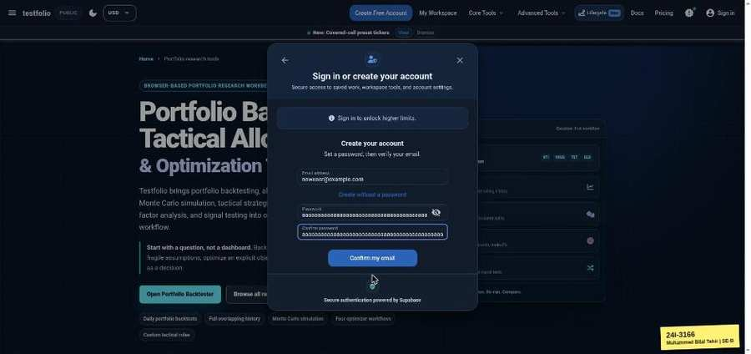 | 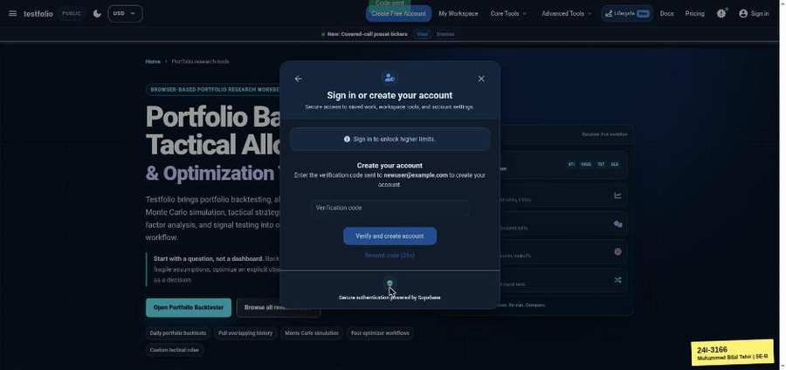

TC-EP-002 | Email | input: (empty) | result: Pass
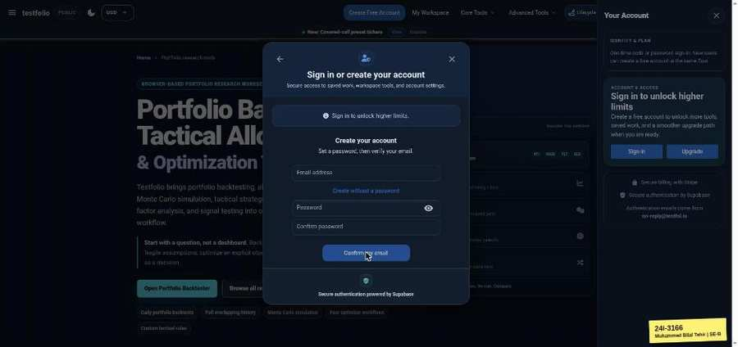

TC-EP-003 | Email | input: notanemail | result: Pass
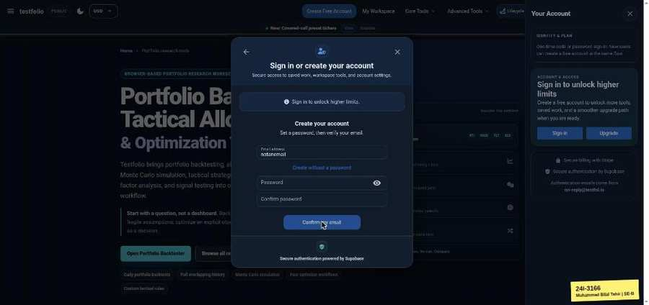

TC-EP-004 | Email | input: a@b | result: Fail
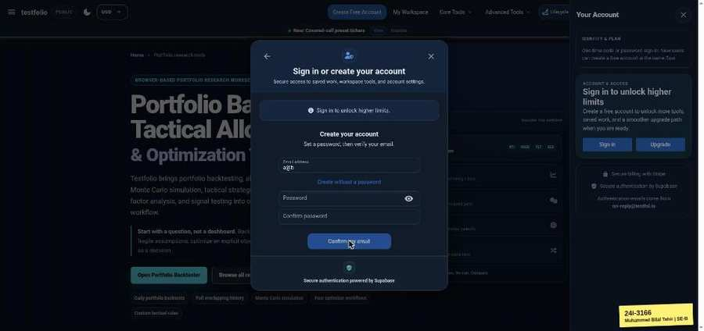

TC-EP-005 | Email | input: (your registered email) | result: Fail
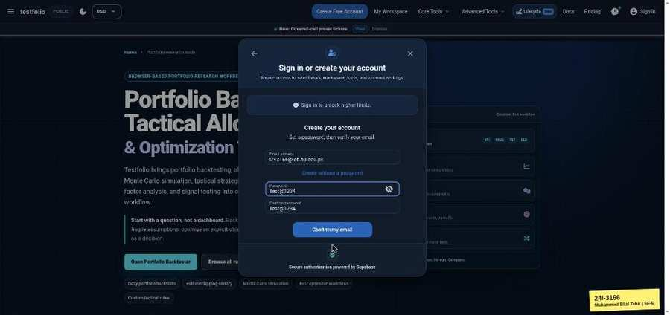 | 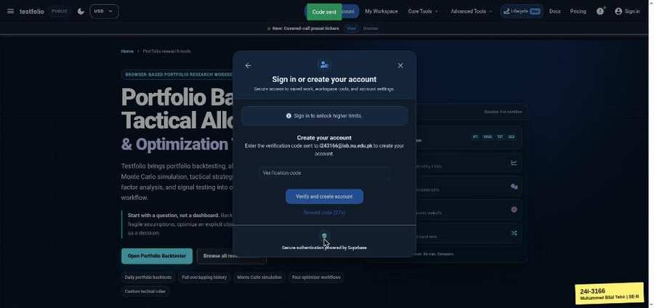

TC-EP-006 | Password | input: Test@1234 | result: Pass

TC-EP-007 | Password | input: (empty) | result: Pass
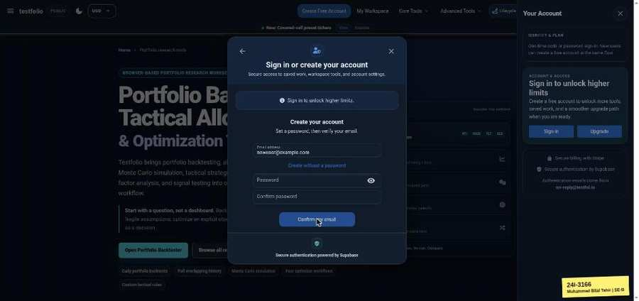

TC-EP-008 | Password | input: abcde | result: Pass
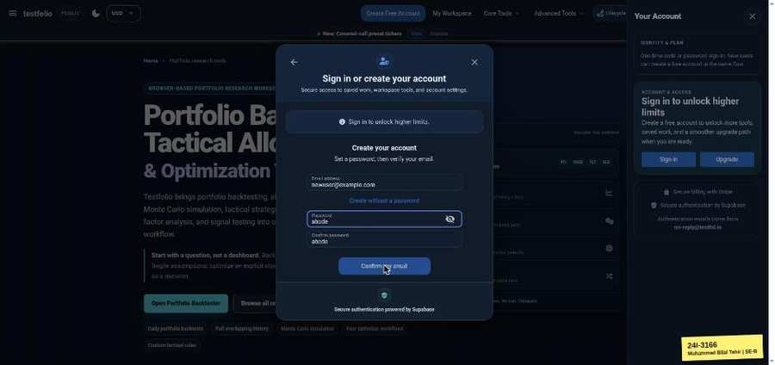 | 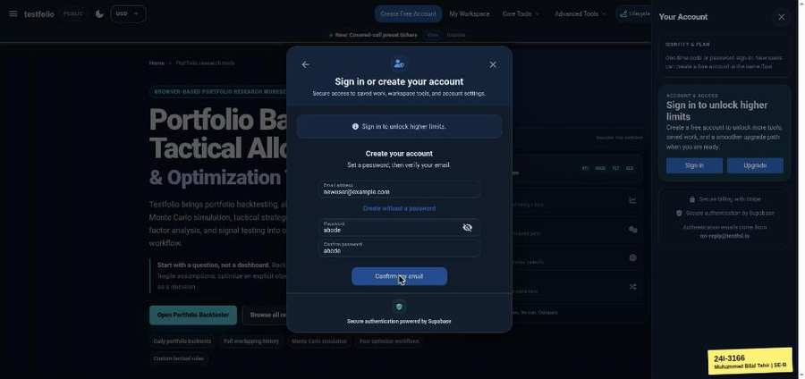

TC-EP-009 | Password | input: 73 x a | result: Fail

Sign In (testfol.io/login)
TC-EP-010 | Email | input: (your registered email) | result: Pass
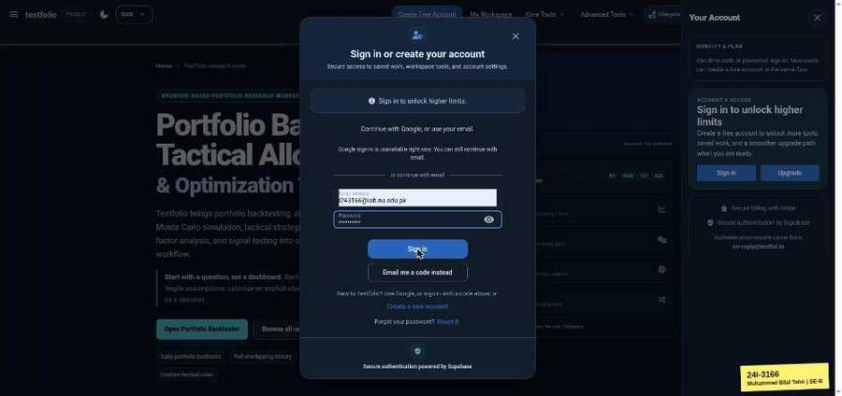

TC-EP-011 | Email | input: (empty) | result: Pass
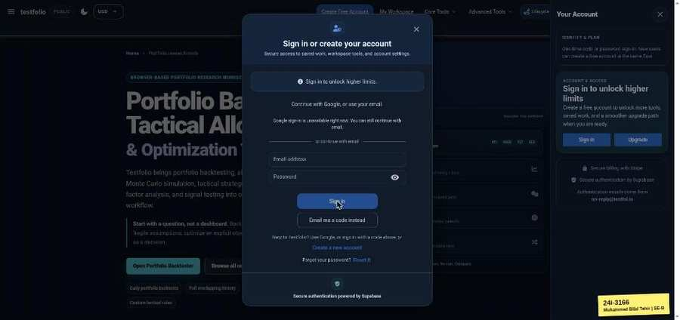

TC-EP-012 | Email | input: notanemail | result: Pass
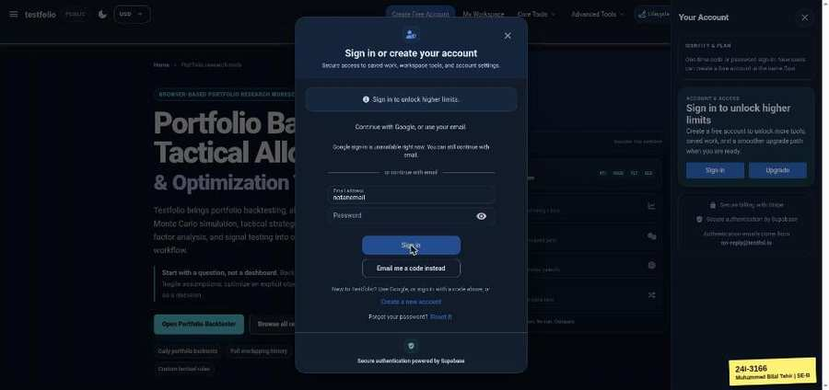

TC-EP-013 | Email | input: nobody@x.com | result: Pass
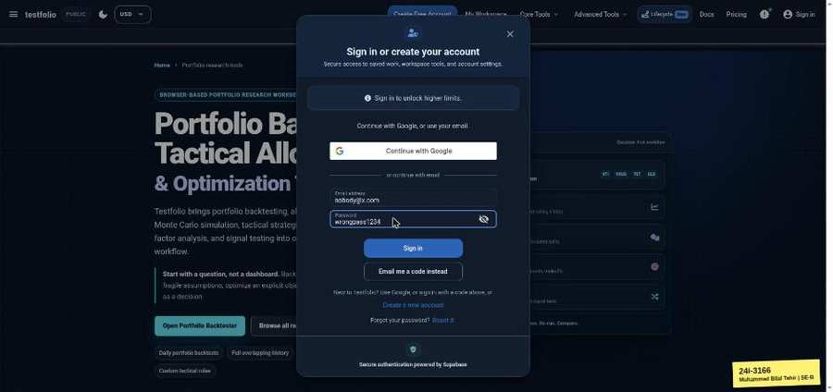 | 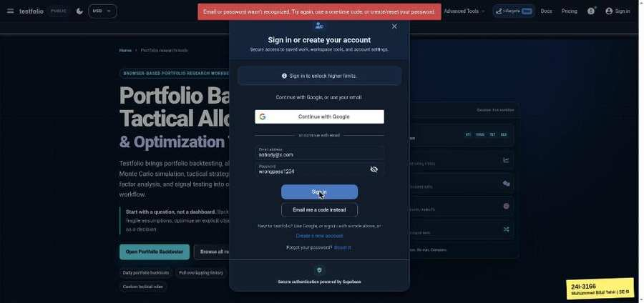

TC-EP-014 | Password | input: (correct password) | result: Pass
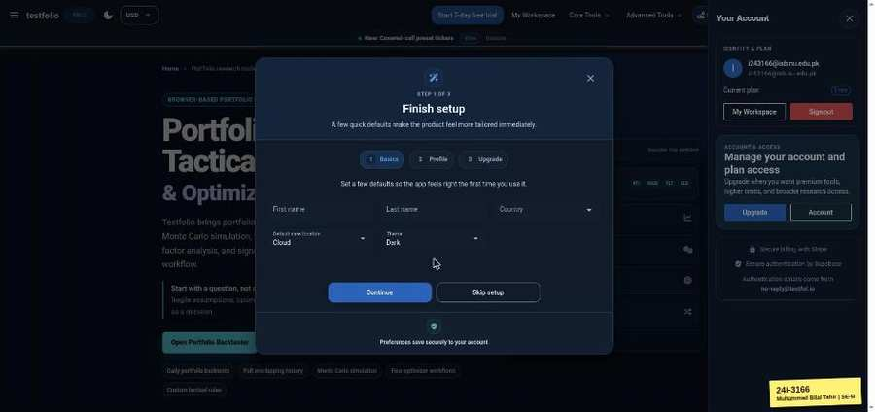

TC-EP-015 | Password | input: (empty) | result: Pass
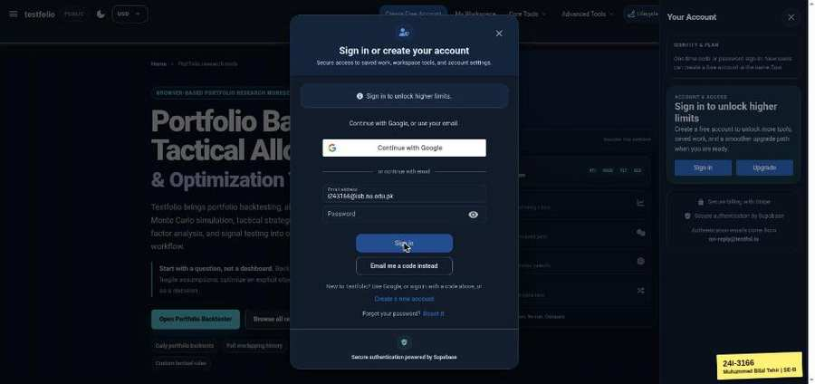

TC-EP-016 | Password | input: wrongpass1234 | result: Pass
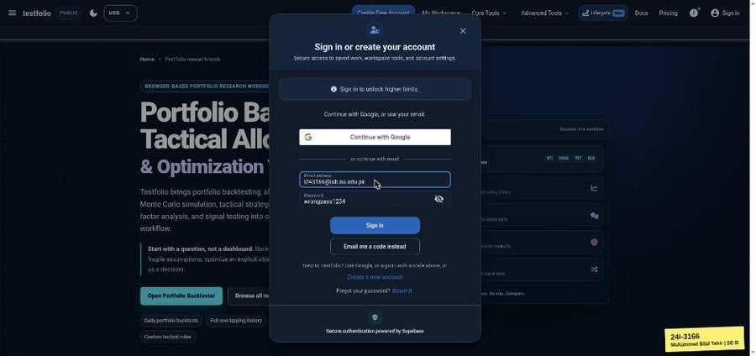 | 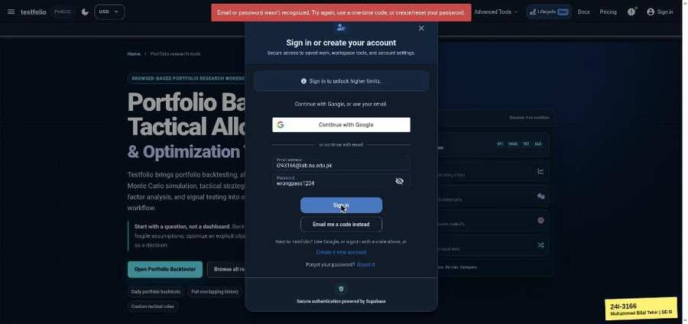

Portfolio Backtester (testfol.io/)
TC-EP-017 | Start Date | input: 2020-01-01 (end 2021-01-01) | result: Pass
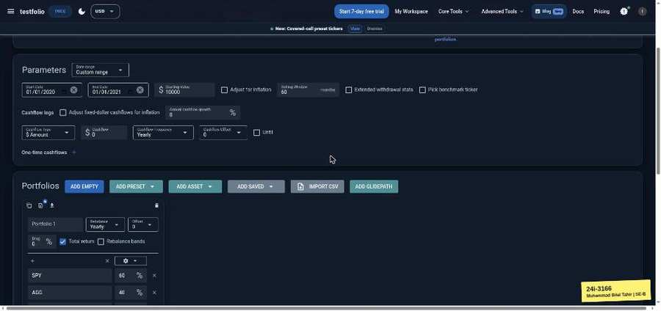 | 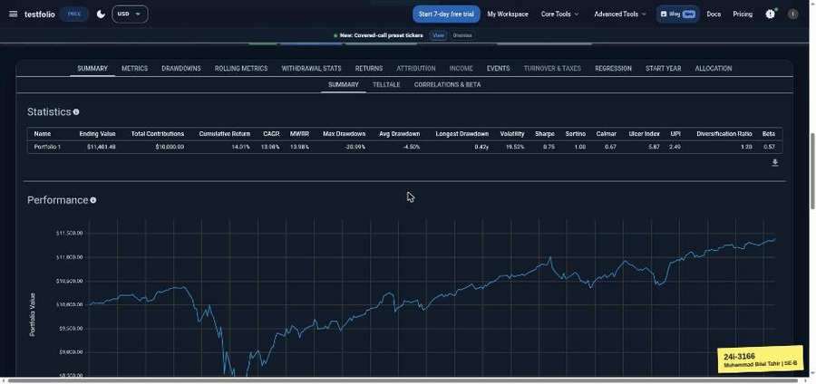

TC-EP-018 | Start Date | input: (empty) | result: Pass
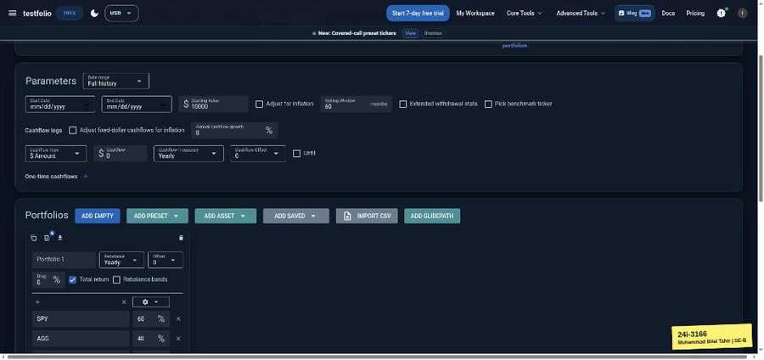 | 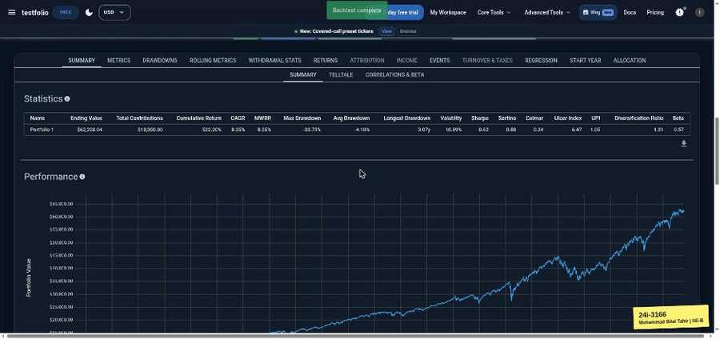

TC-EP-019 | Start Date | input: 2020-01-01 (end 2019-01-01) | result: Pass
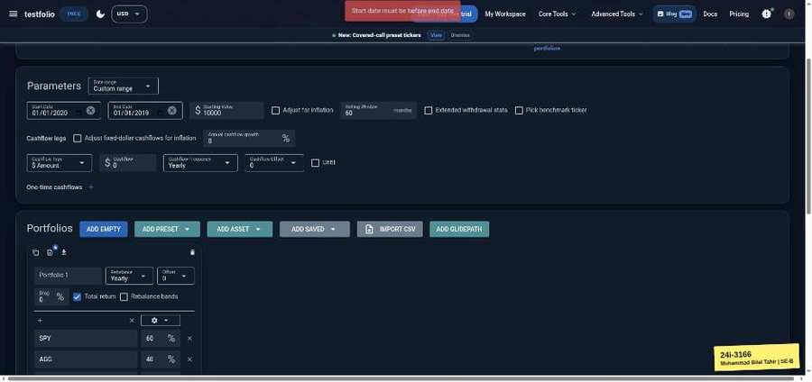

TC-EP-020 | Start Date | input: 2020-01-01 (end 2020-01-01) | result: Pass
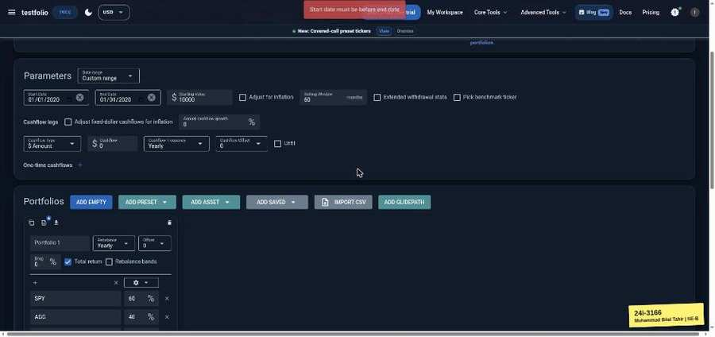

TC-EP-021 | Start Date | input: 1990-01-01 (end 2020-01-01) | result: Fail
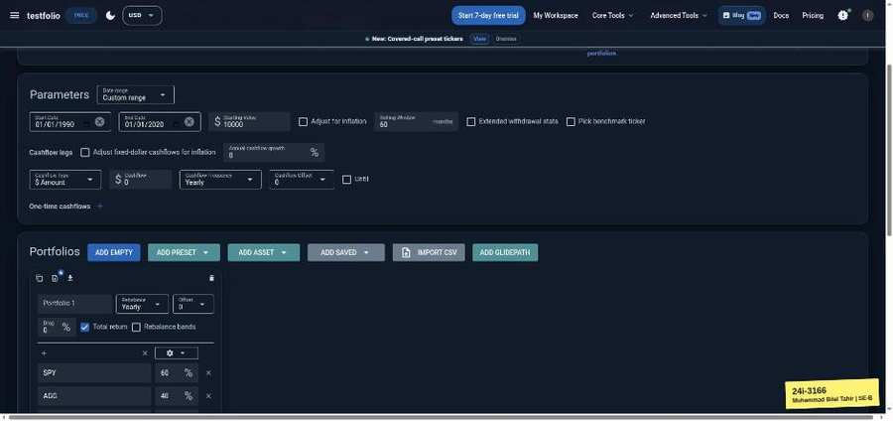 | 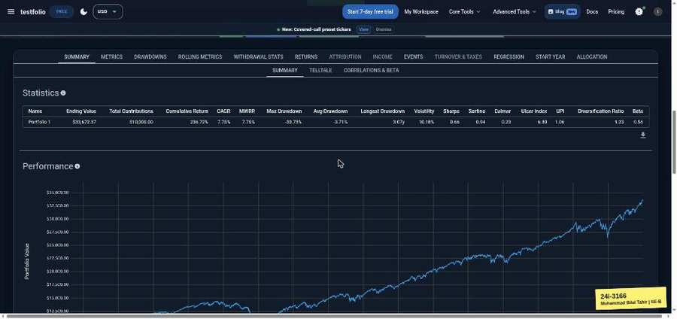

TC-EP-022 | Start Date | input: 2099-01-01 (end 2100-01-01) | result: Pass
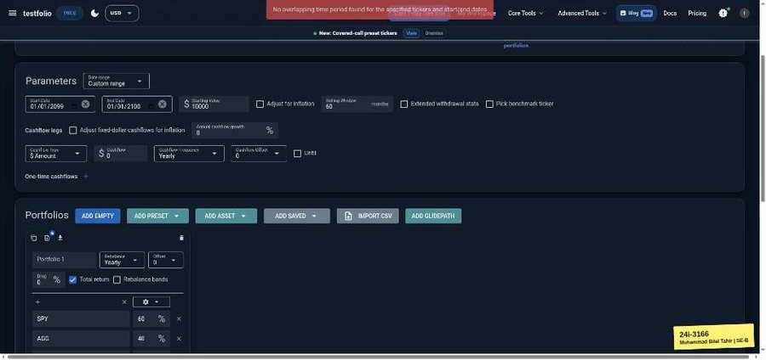

TC-EP-023 | End Date | input: 2020-01-01 (start empty) | result: Pass
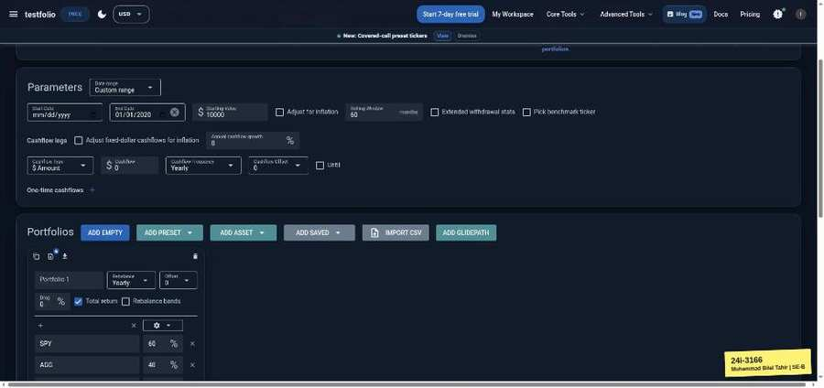 | 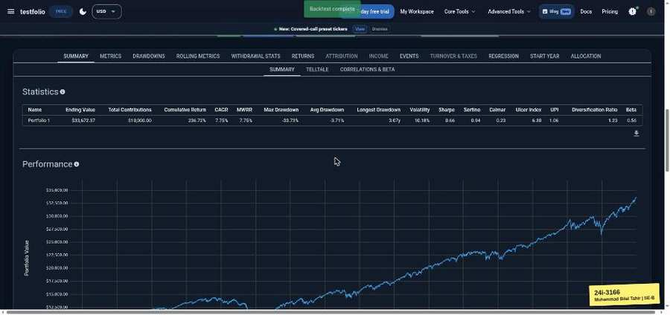

TC-EP-024 | End Date | input: 2020-01-01 (end empty) | result: Pass
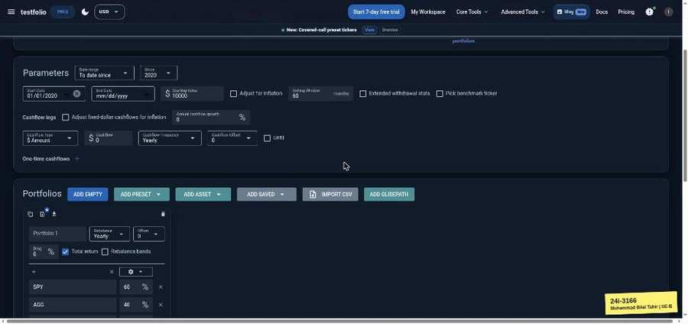 | 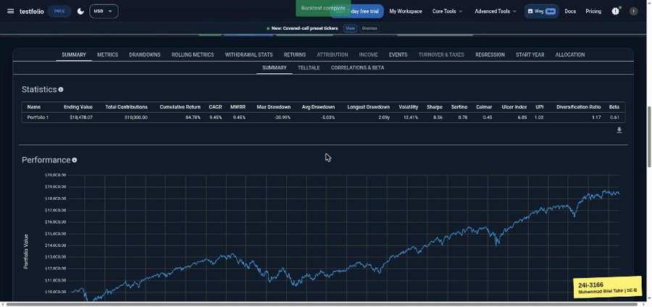

TC-EP-025 | End Date | input: 2020-01-01 to 2030-01-01 | result: Fail
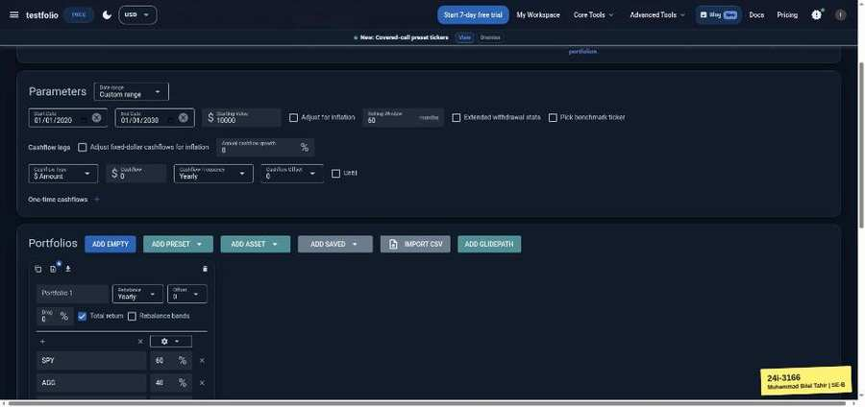 | 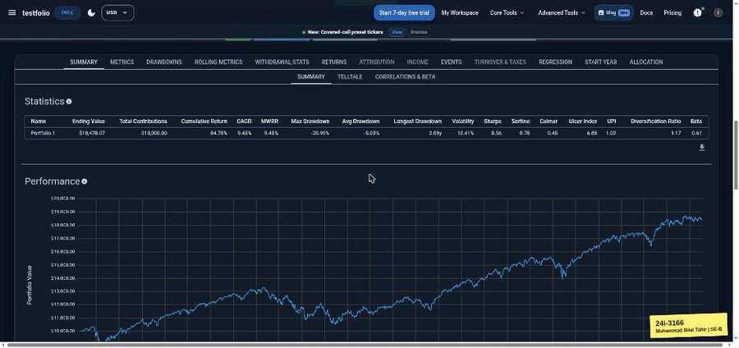

TC-EP-026 | Starting Value | input: 10000 | result: Pass
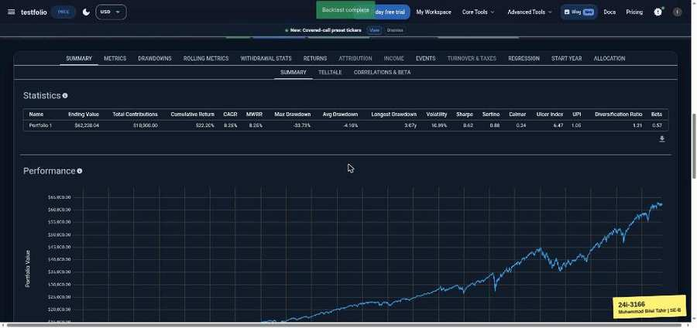

TC-EP-027 | Starting Value | input: 0 | result: Pass
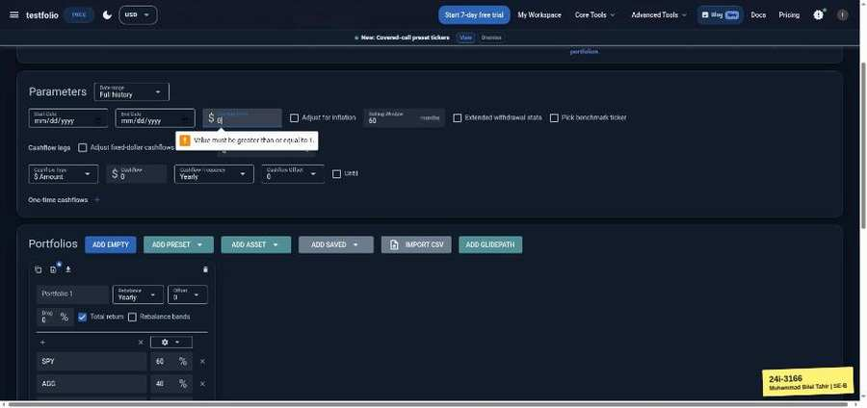

TC-EP-028 | Starting Value | input: -5 | result: Pass
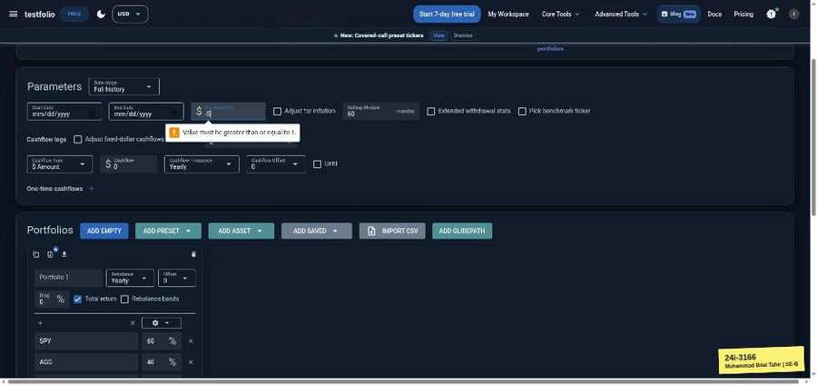

TC-EP-029 | Starting Value | input: 0.5 | result: Pass
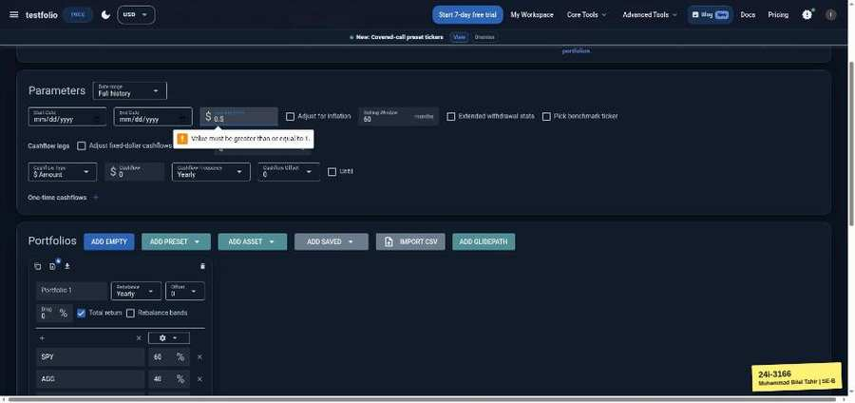

TC-EP-030 | Starting Value | input: (empty) | result: Pass
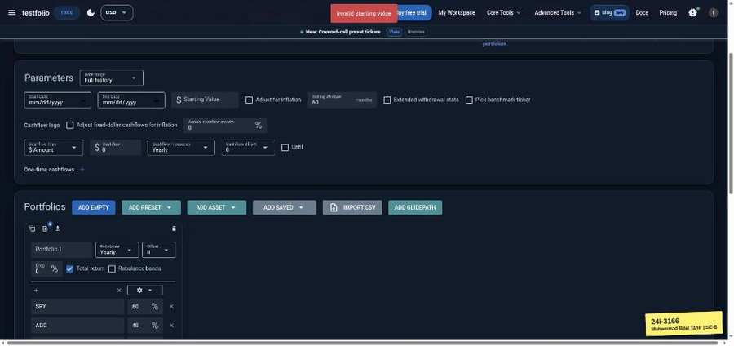

TC-EP-031 | Starting Value | input: 5000000000000 | result: Pass
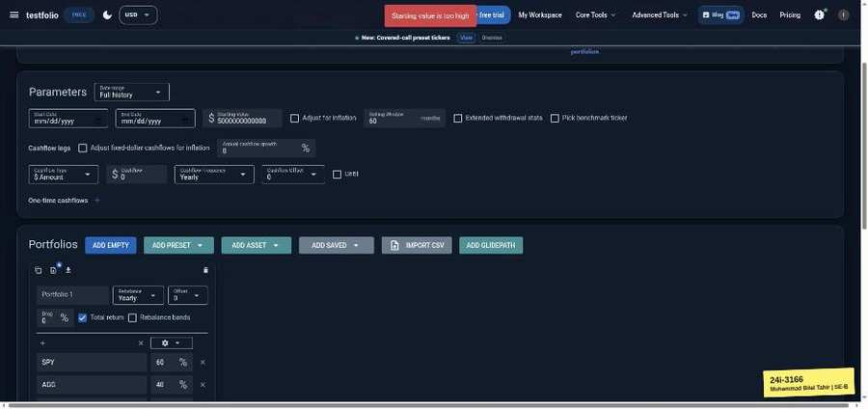

TC-EP-032 | Rolling Window | input: 60 | result: Pass
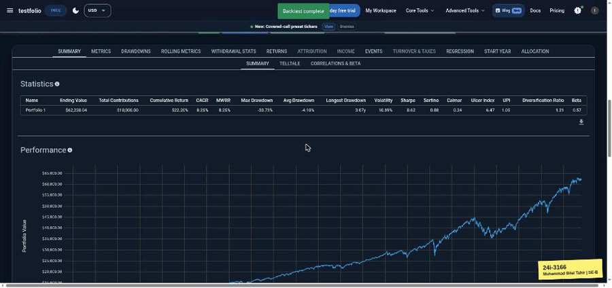

TC-EP-033 | Rolling Window | input: 0 | result: Pass
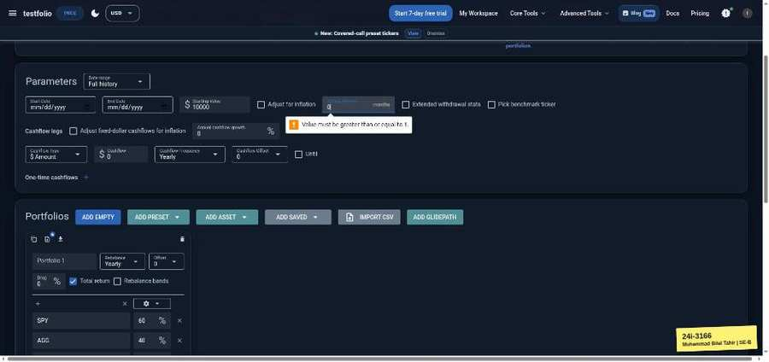

TC-EP-034 | Rolling Window | input: -1 | result: Pass
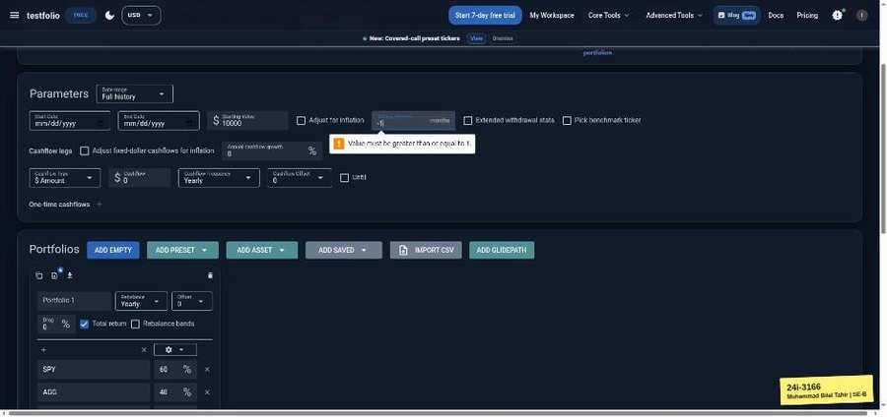

TC-EP-035 | Rolling Window | input: 1.5 | result: Pass
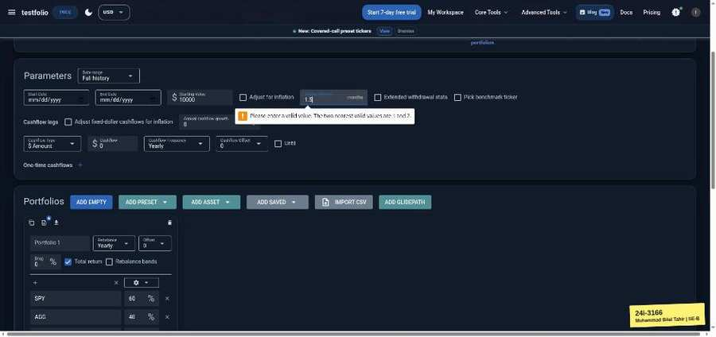

TC-EP-036 | Rolling Window | input: 20000 | result: Pass
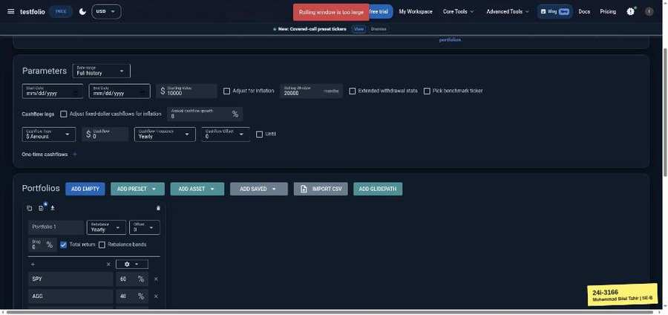

TC-EP-037 | Annual cashflow growth | input: 2 | result: Pass
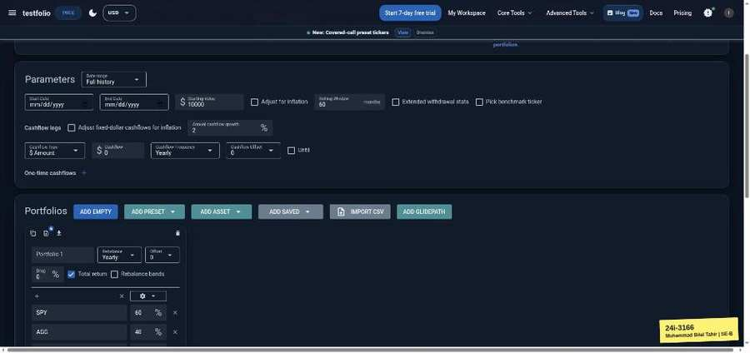

TC-EP-038 | Annual cashflow growth | input: -100 | result: Pass
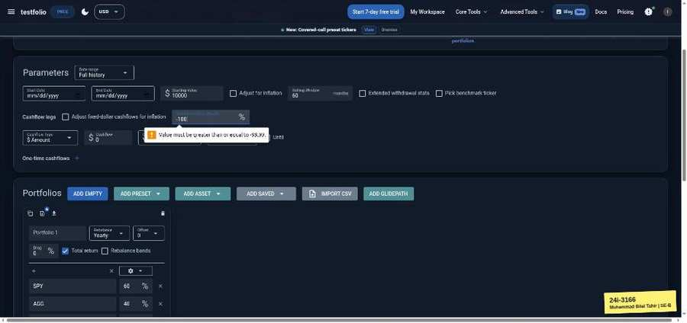

TC-EP-039 | Annual cashflow growth | input: 101 | result: Pass
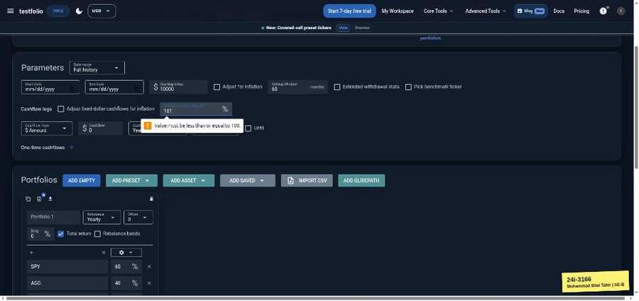

TC-EP-040 | Cashflow amount | input: 1000 | result: Pass
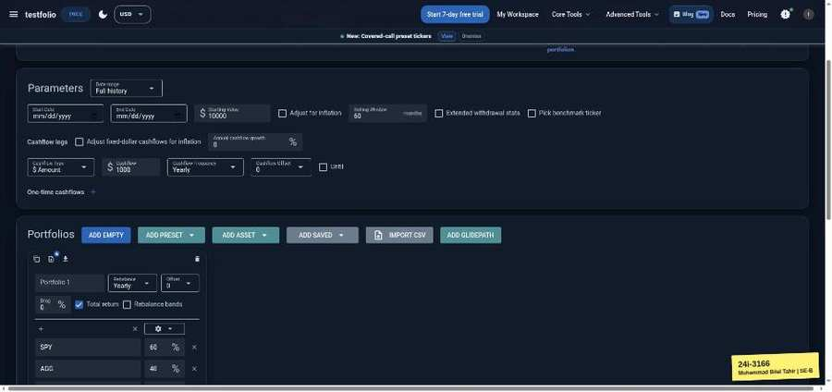 | 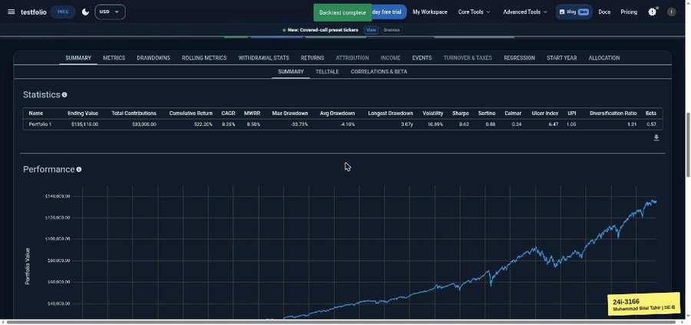

TC-EP-041 | Cashflow amount | input: -500 | result: Pass
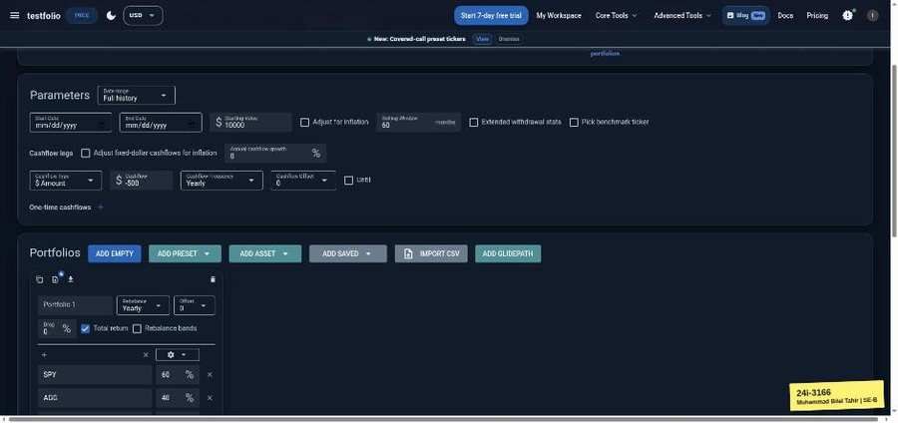 | 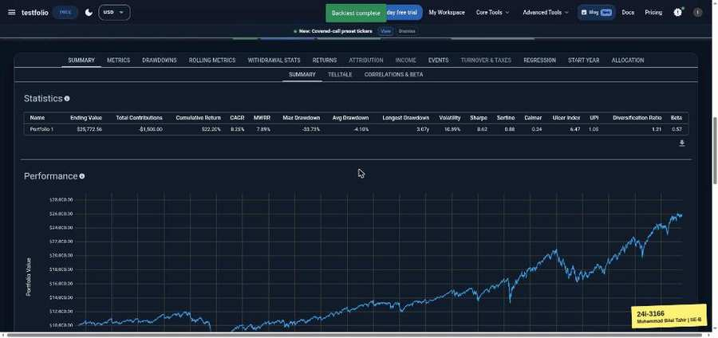

TC-EP-042 | Cashflow amount | input: 0 | result: Pass
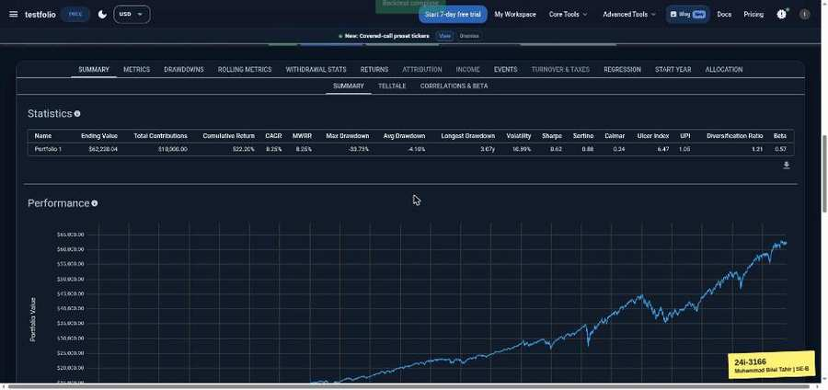

TC-EP-043 | Drag (annual fee %) | input: 0.5 | result: Pass
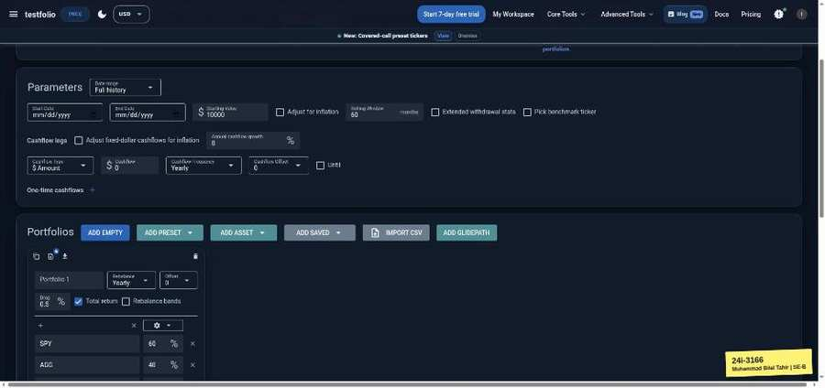 | 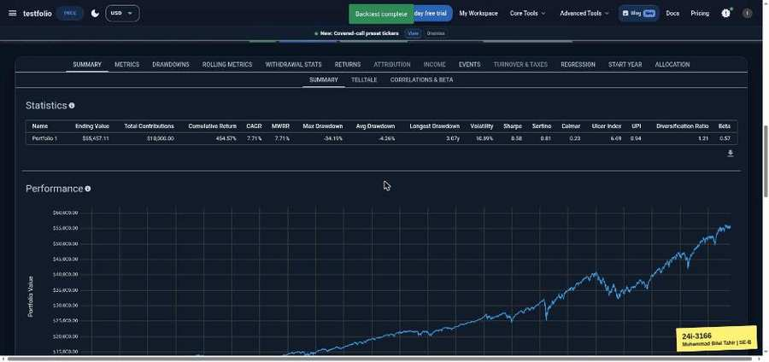

TC-EP-044 | Drag (annual fee %) | input: -1 | result: Fail
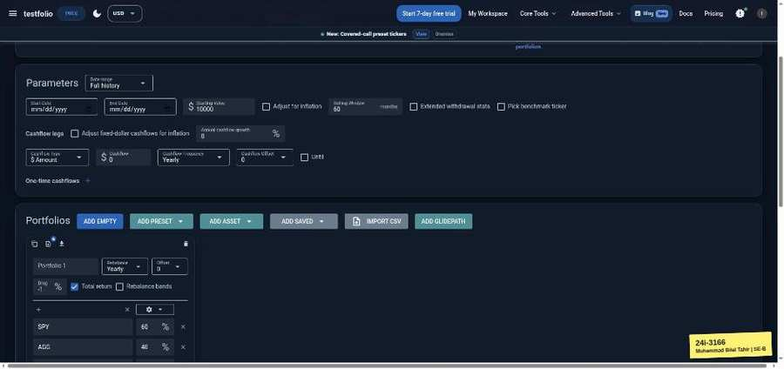 | 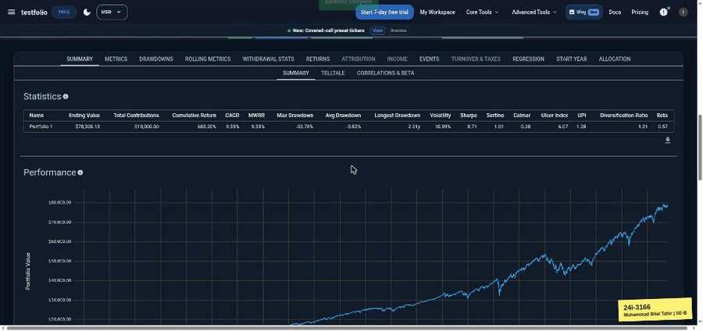

TC-EP-045 | Drag (annual fee %) | input: 150 | result: Fail
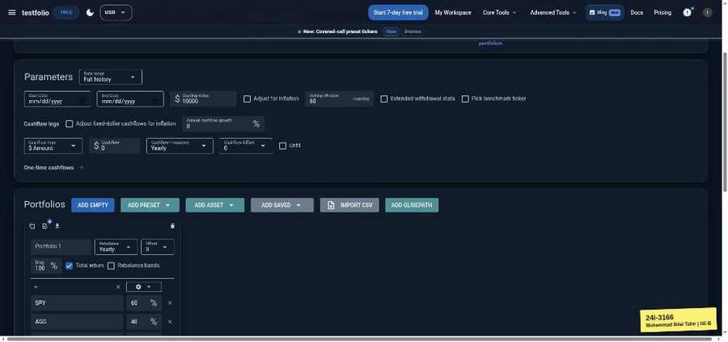 | 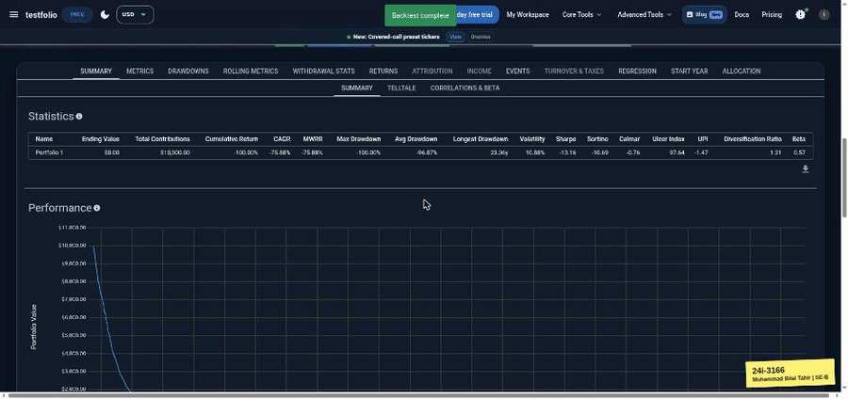

TC-EP-046 | Ticker | input: SPY | result: Pass

TC-EP-047 | Ticker | input: spy | result: Pass

TC-EP-048 | Ticker | input: ZZZZZZ | result: Pass
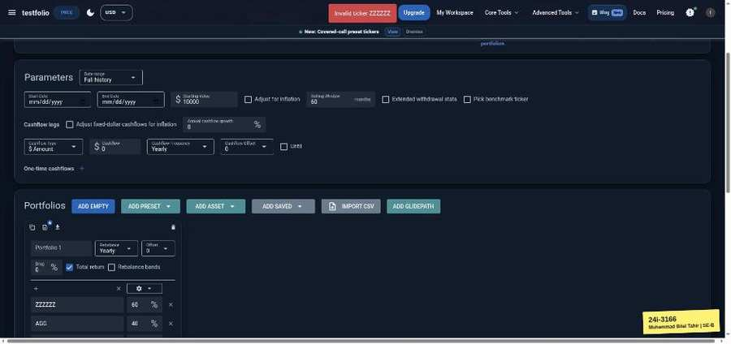

TC-EP-049 | Ticker | input: (empty) | result: Pass
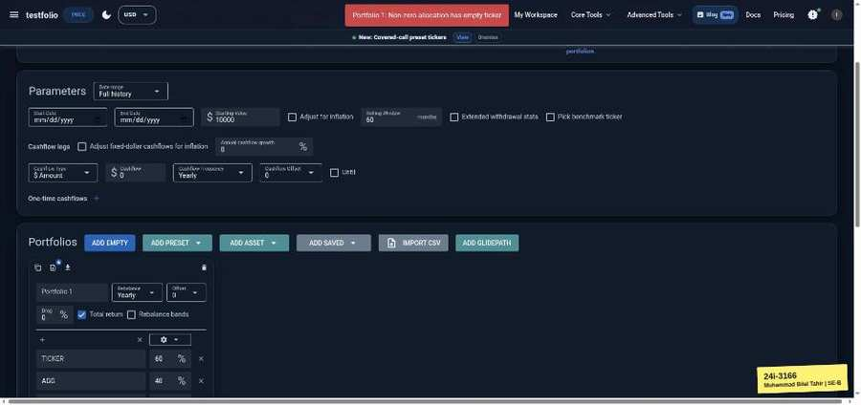

TC-EP-050 | Ticker | input: ' OR 1=1 -- | result: Pass
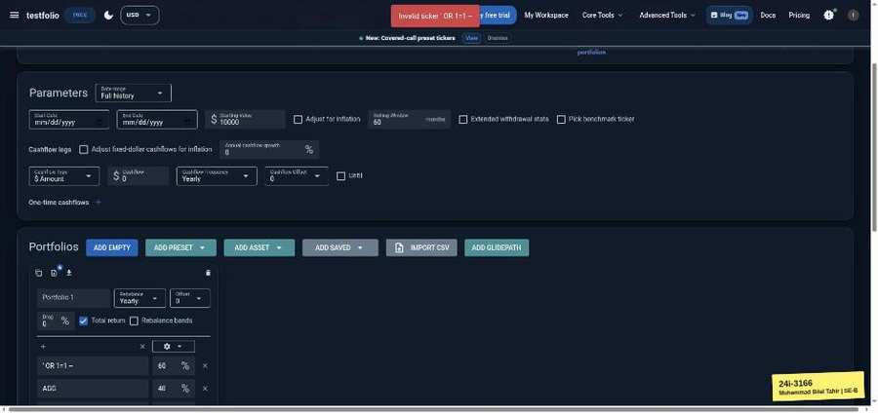

TC-EP-051 | Ticker | input: ÄÖÜ | result: Pass
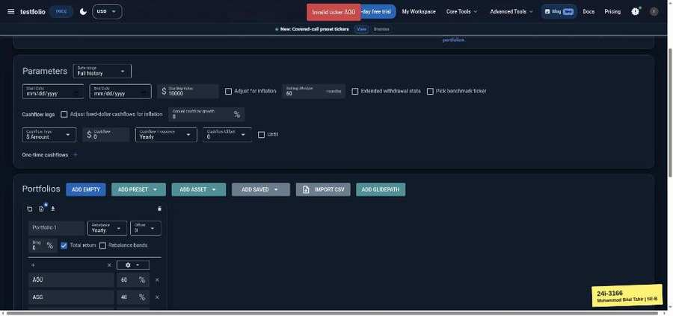

TC-EP-052 | Ticker | input: S PY | result: Pass
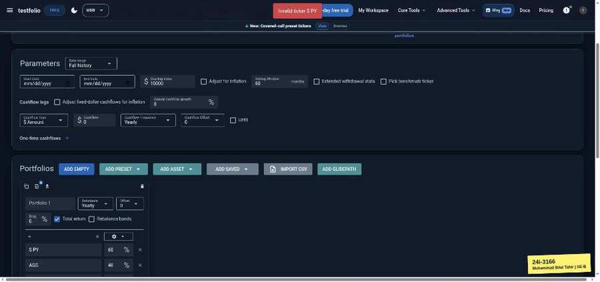

TC-EP-053 | Ticker | input: ABCDEFGHIJ x5 | result: Pass
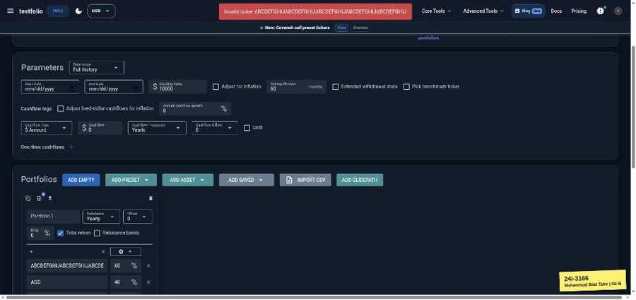

TC-EP-054 | Allocation % (portfolio total) | input: SPY 60 / AGG 40 | result: Pass
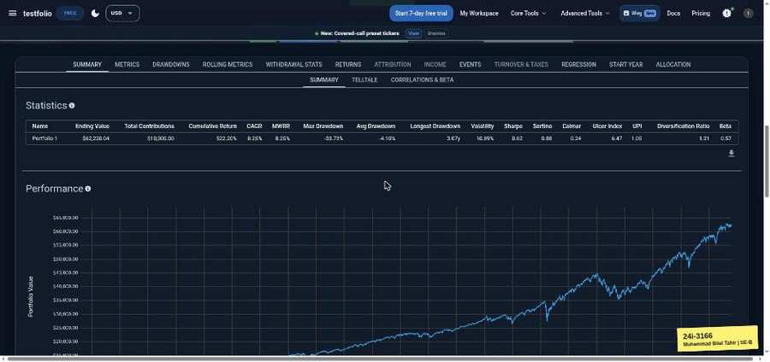

TC-EP-055 | Allocation % (portfolio total) | input: SPY 100 / AGG 0 | result: Pass
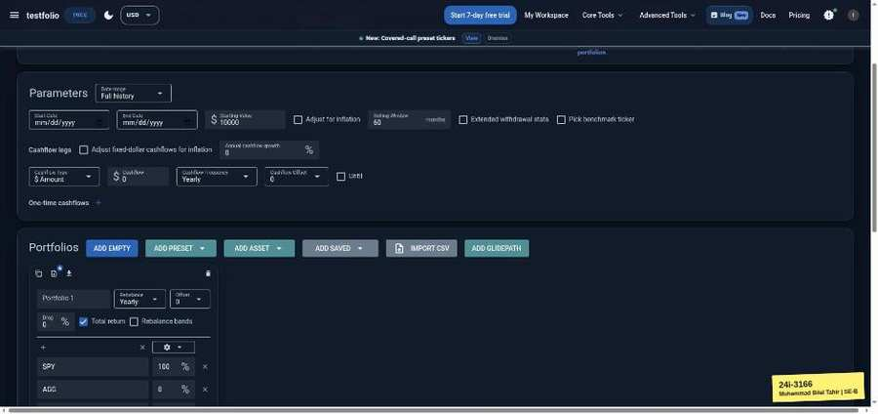 | 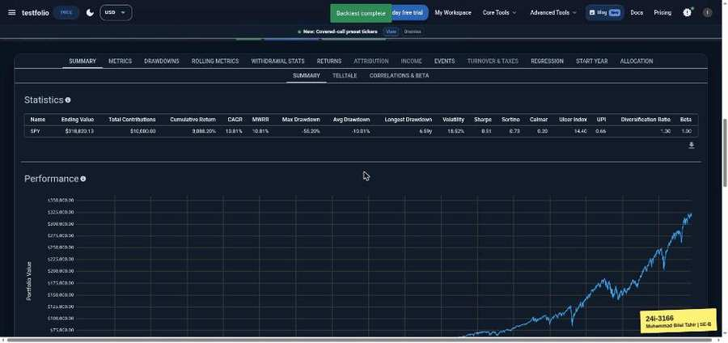

TC-EP-056 | Allocation % (portfolio total) | input: SPY 60 / AGG 30 (90) | result: Pass
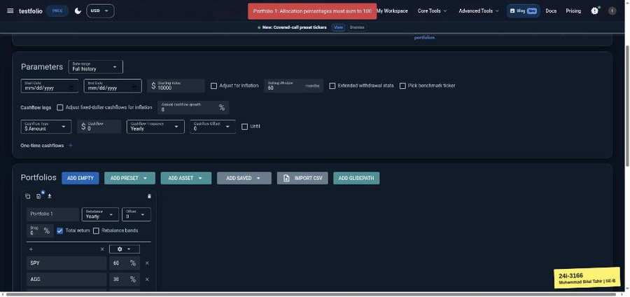

TC-EP-057 | Allocation % (portfolio total) | input: SPY 60 / AGG 60 (120) | result: Pass
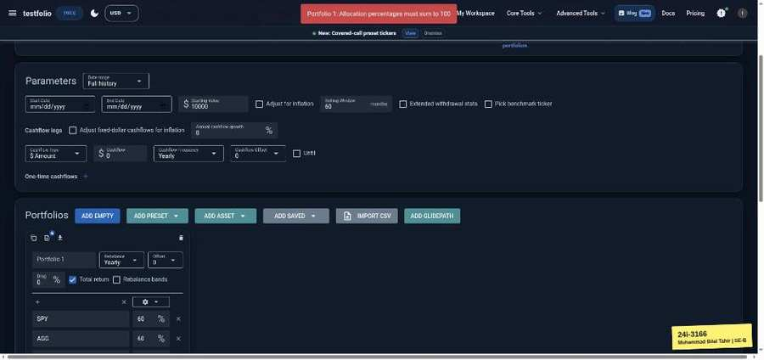

TC-EP-058 | Allocation % (portfolio total) | input: SPY -10 / AGG 110 | result: Fail
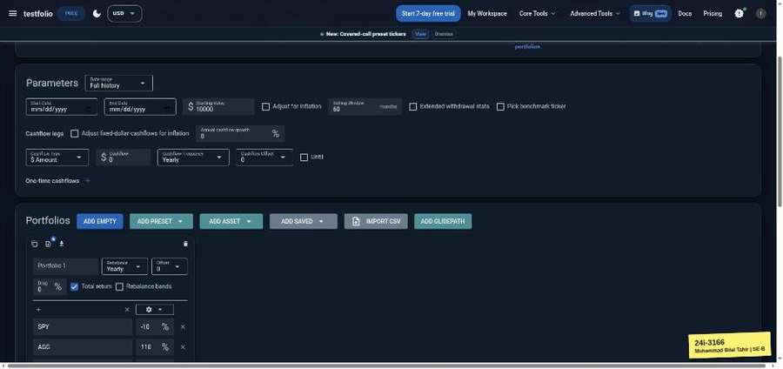 | 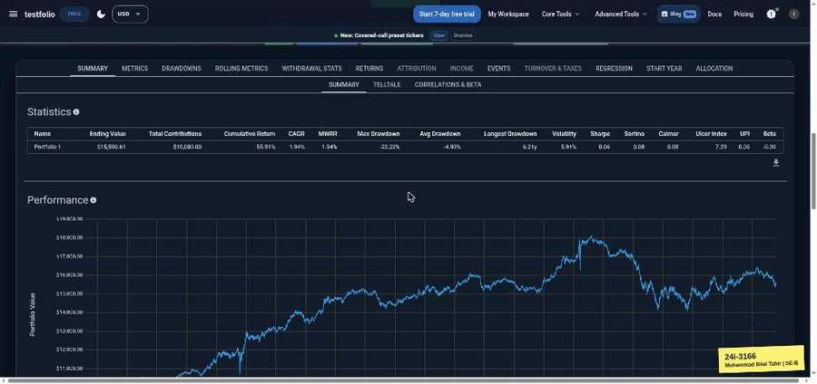

TC-EP-059 | Rebalance frequency | input: Yearly | result: Pass

Monte Carlo Simulator (testfol.io/monte-carlo)
TC-EP-060 | Start / End Date | input: (empty) | result: Pass
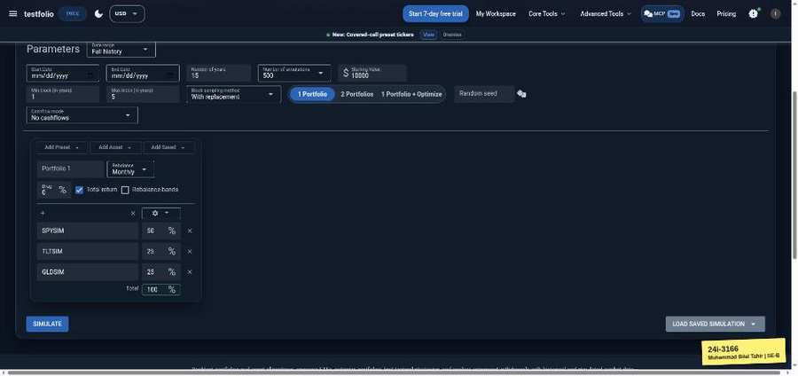 | 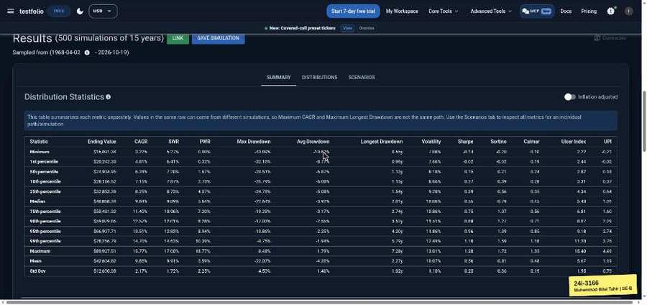

TC-EP-061 | Start / End Date | input: 2020-01-01 / 2019-01-01 | result: Pass
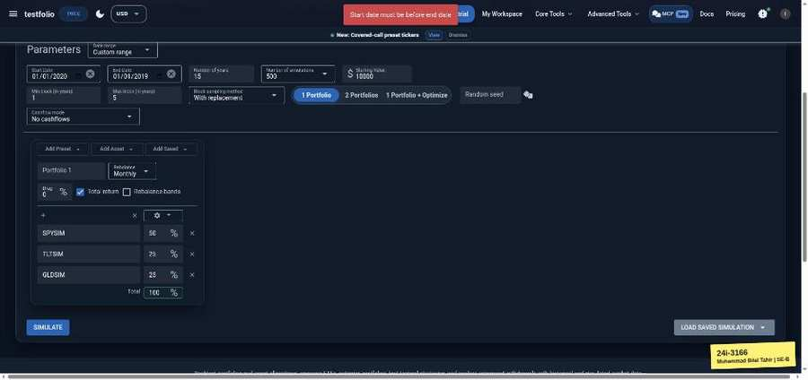

TC-EP-062 | Number of years | input: 10 | result: Pass
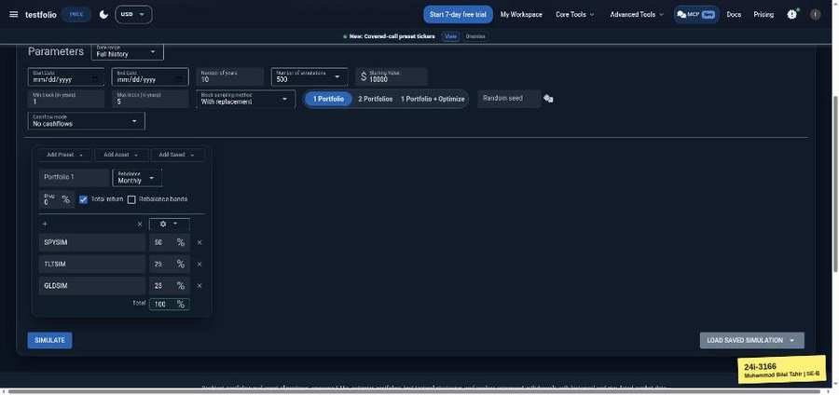 | 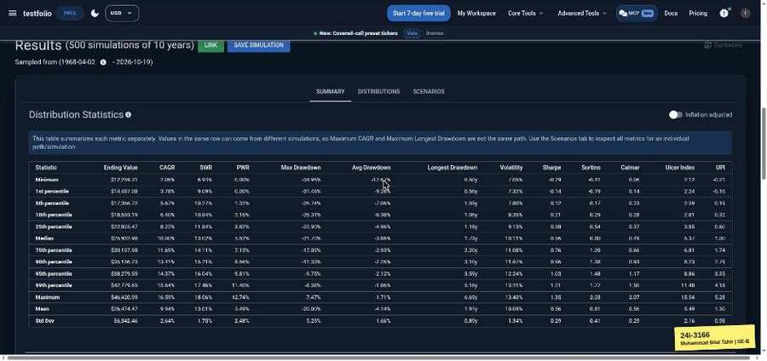

TC-EP-063 | Number of years | input: 0 | result: Pass
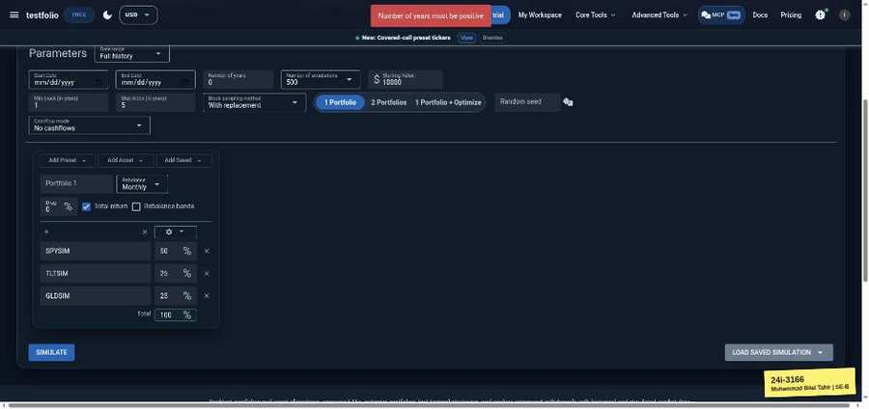

TC-EP-064 | Number of years | input: 50 | result: Pass
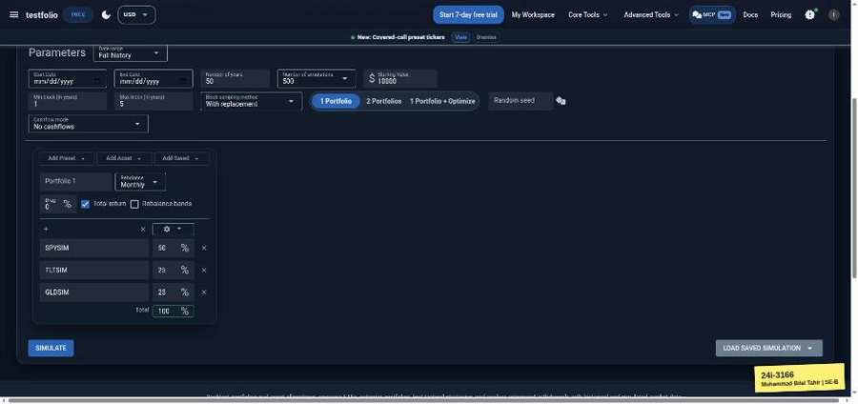 | 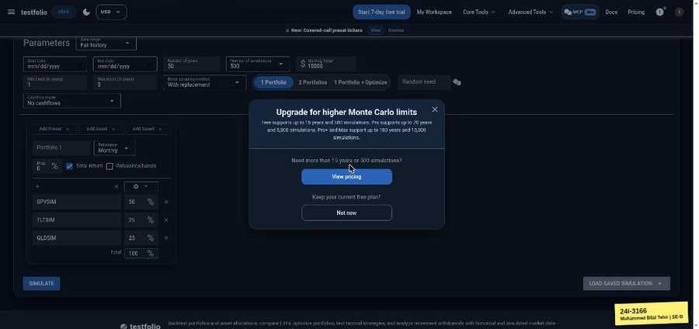

TC-EP-065 | Number of years | input: 150 | result: Pass
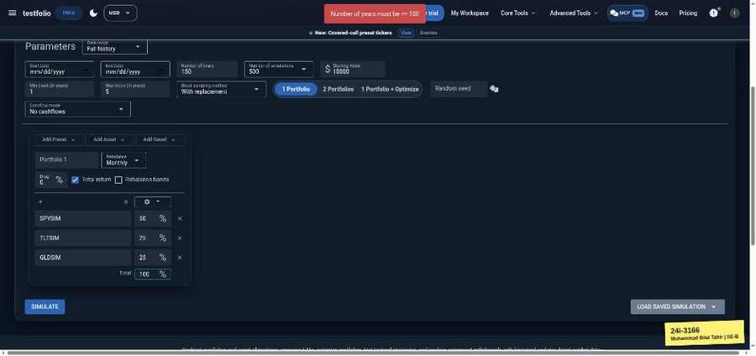

TC-EP-066 | Number of years | input: 2.5 | result: Pass
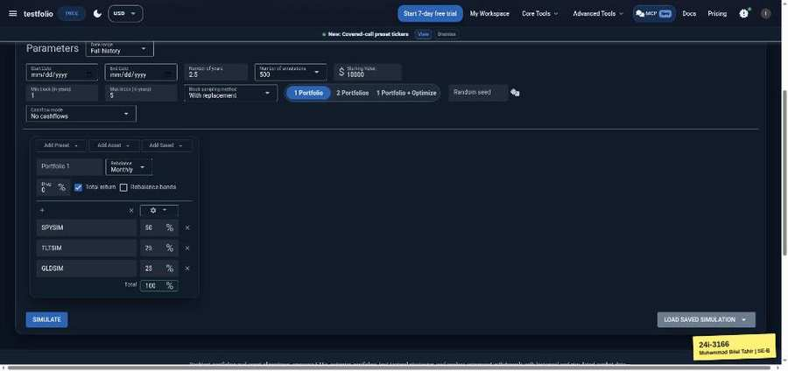 | 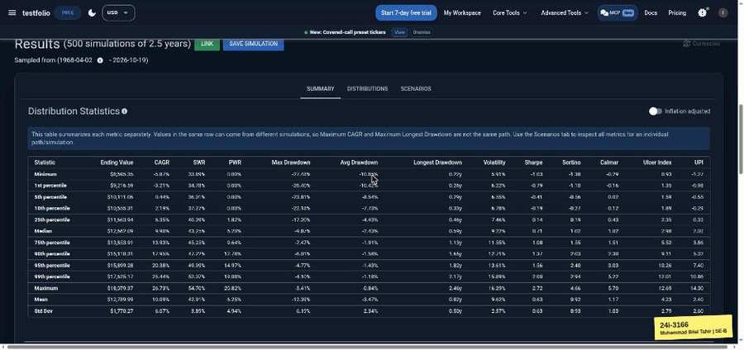

TC-EP-067 | Starting Value | input: 10000 | result: Pass
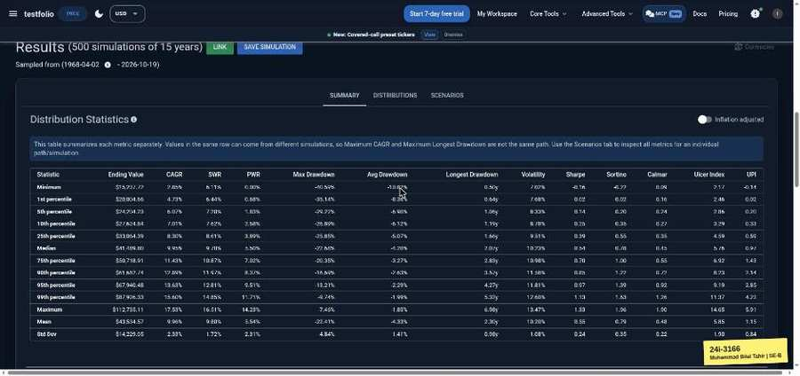

TC-EP-068 | Starting Value | input: 0 | result: Pass
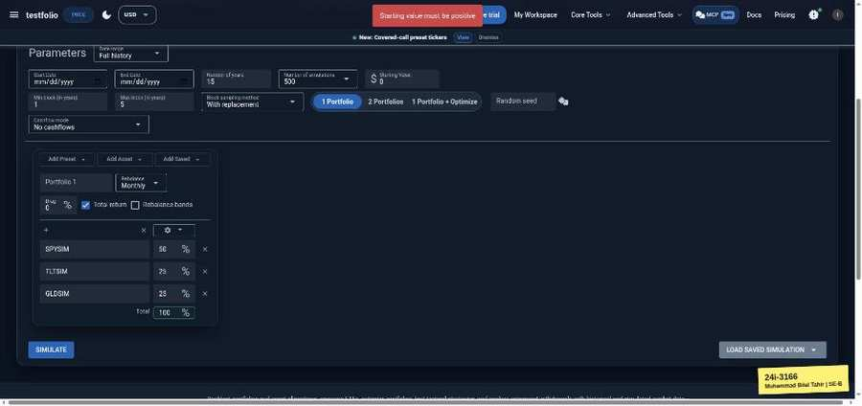

TC-EP-069 | Min block (years) | input: 1 | result: Pass
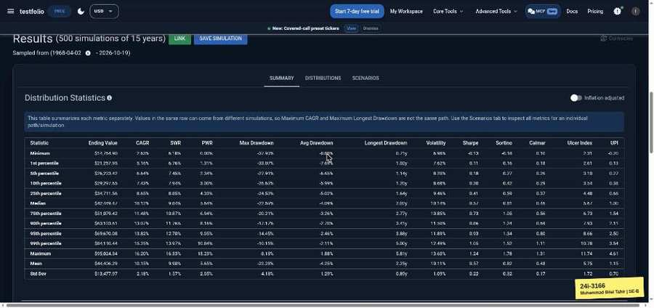

TC-EP-070 | Min block (years) | input: 0.01 | result: Fail
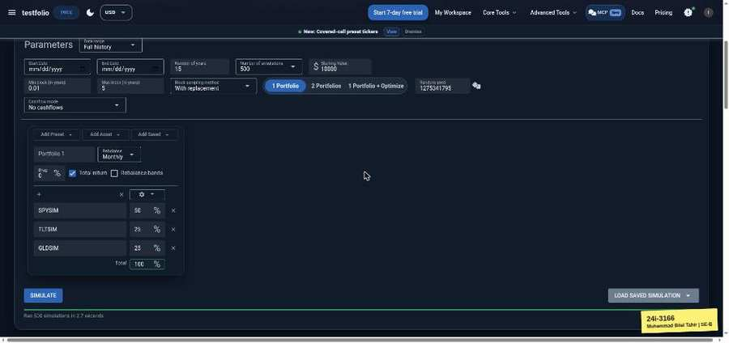

TC-EP-071 | Max block (years) | input: 5 | result: Pass
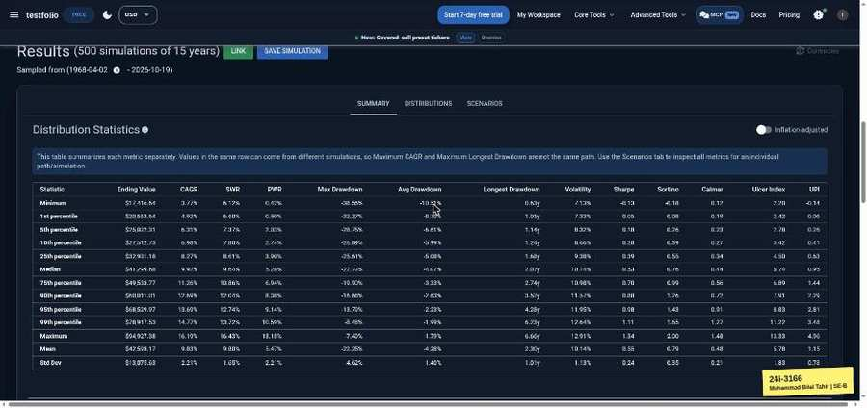

TC-EP-072 | Max block (years) | input: 25 | result: Pass
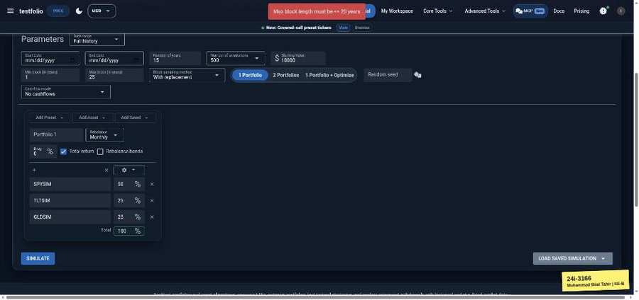

TC-EP-073 | Max block (years) | input: 0.01 | result: Pass
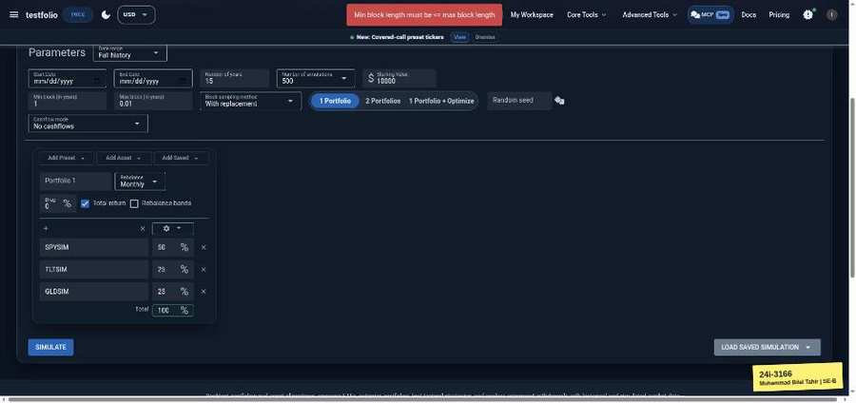

TC-EP-074 | Random seed | input: (empty) | result: Pass
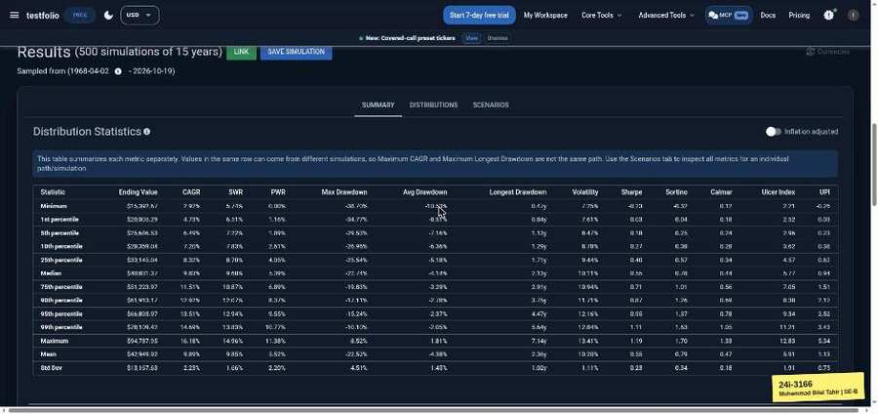

TC-EP-075 | Random seed | input: 42 | result: Pass
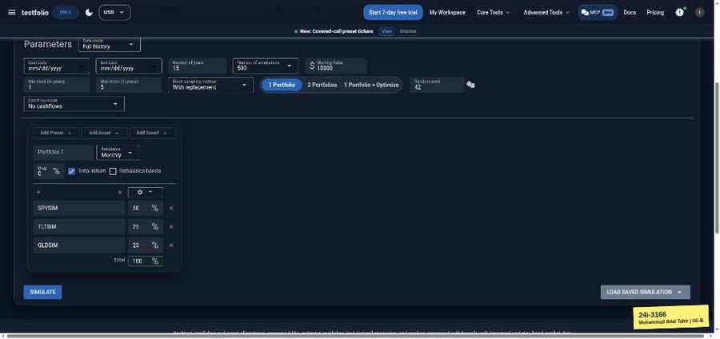 | 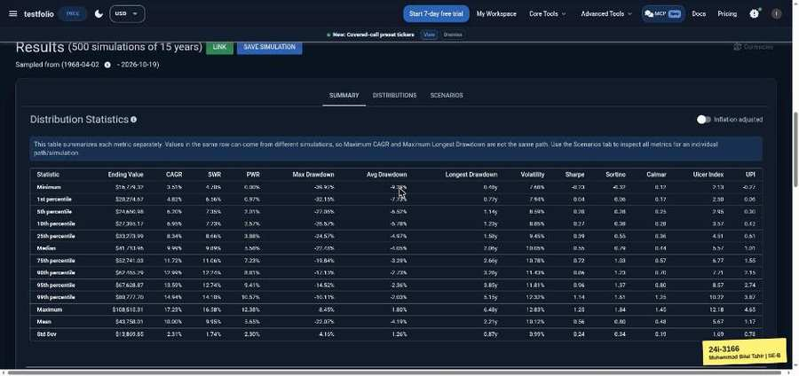

TC-EP-076 | Random seed | input: -1 | result: Fail
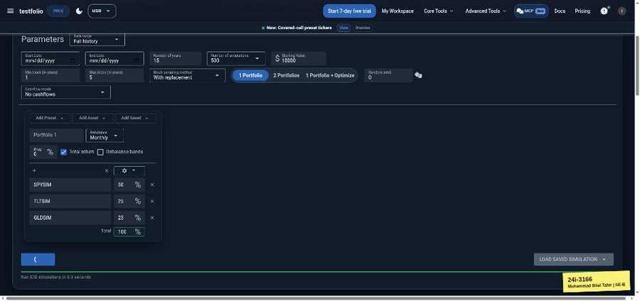 | 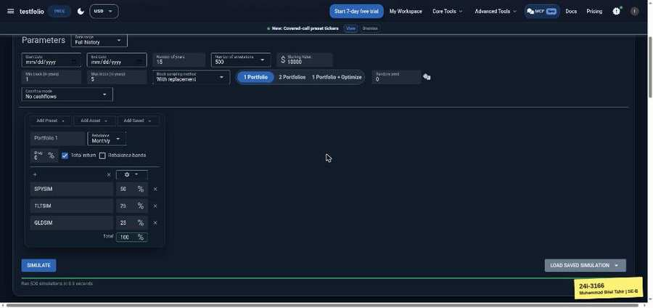

TC-EP-077 | Random seed | input: 1.5 | result: Fail
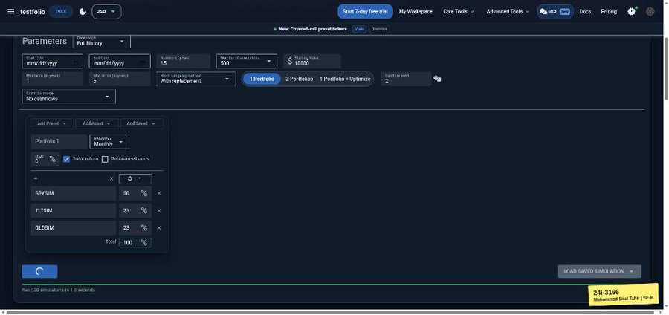 | 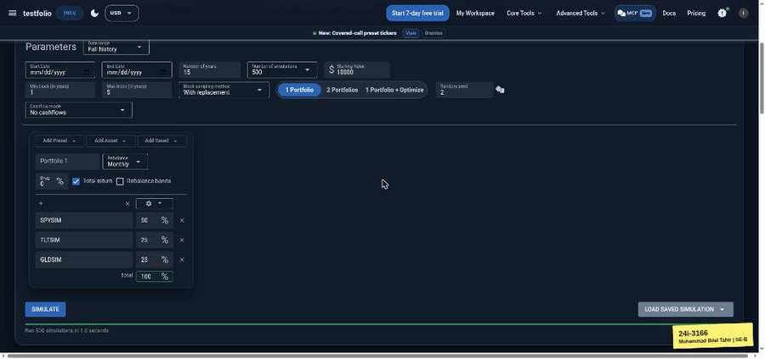

TC-EP-078 | Allocation % (portfolio total) | input: 50/25/25 | result: Pass
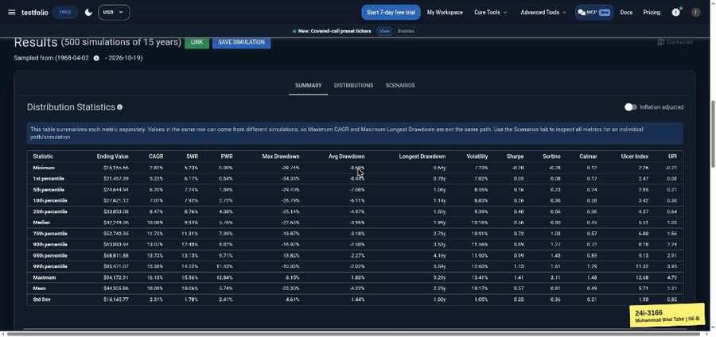

TC-EP-079 | Allocation % (portfolio total) | input: 50/25/20 (95) | result: Pass
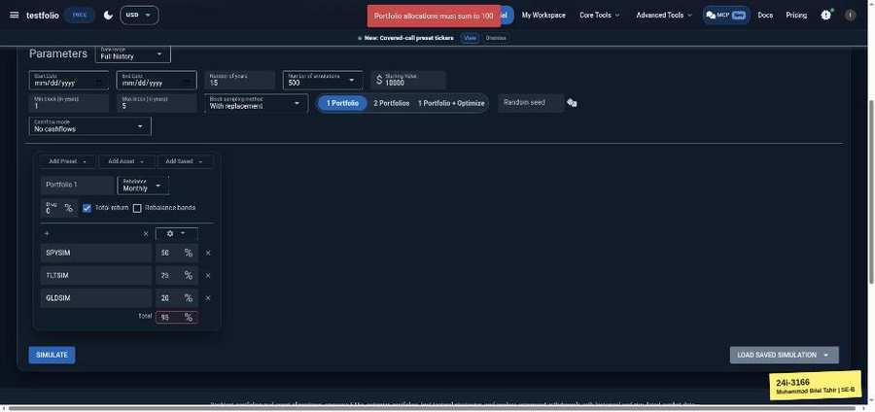

Safe Withdrawal Rate Calculator (testfol.io/safe-withdrawal-rate-calculator)
TC-EP-080 | Retirement horizon (years) | input: 30 | result: Pass
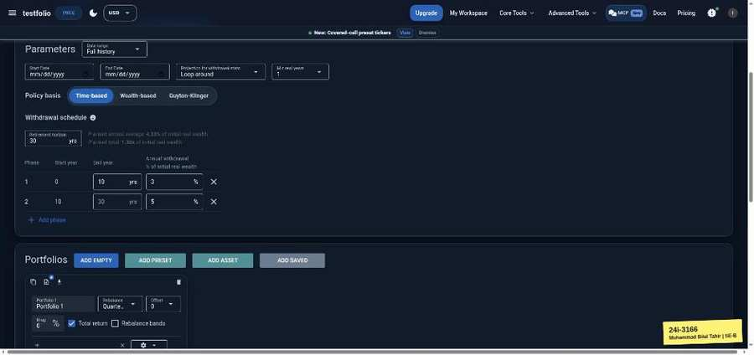 | 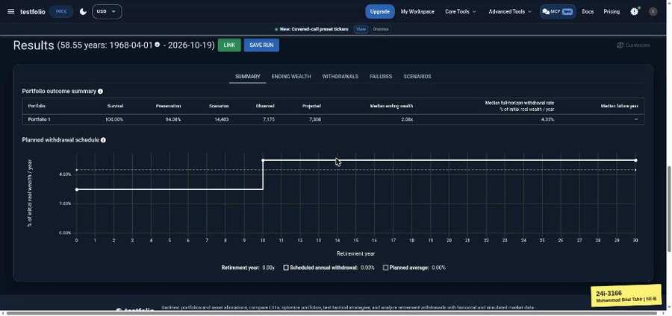

TC-EP-081 | Retirement horizon (years) | input: 0 | result: Pass
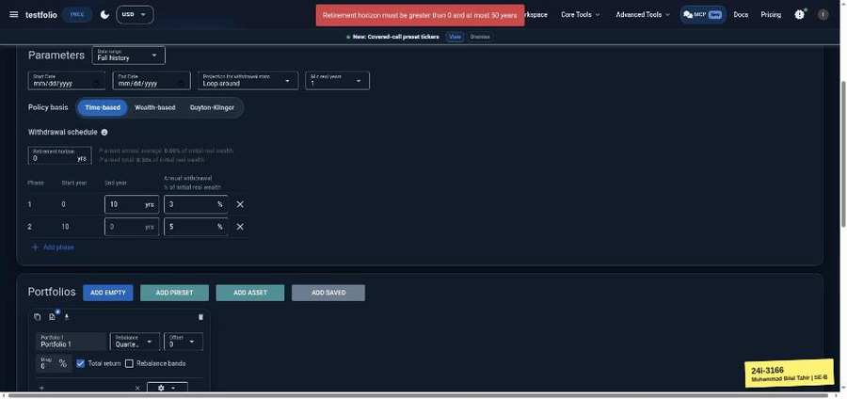

TC-EP-082 | Retirement horizon (years) | input: 60 | result: Pass
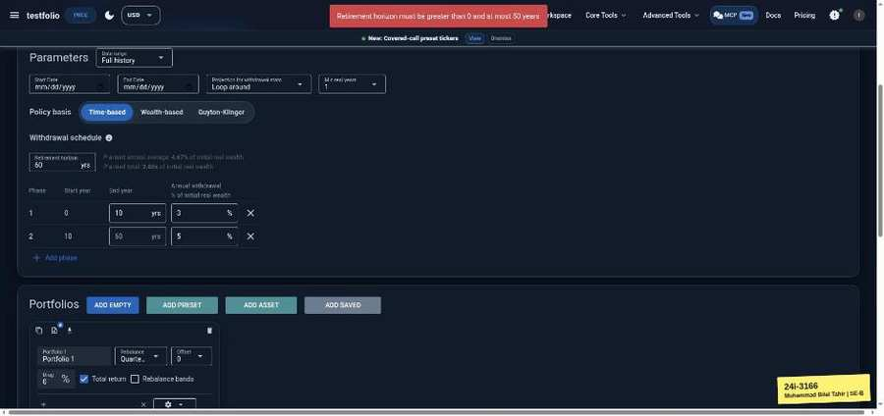

TC-EP-083 | Phase 1 end year | input: 10 | result: Pass
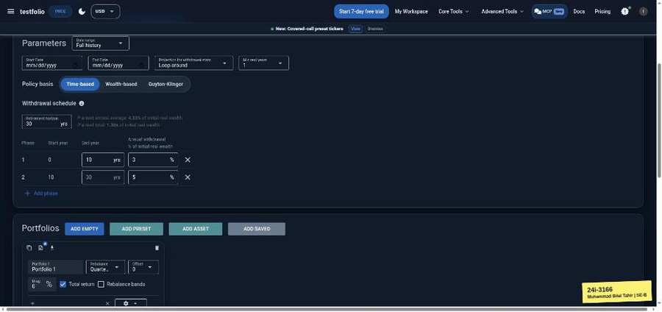 | 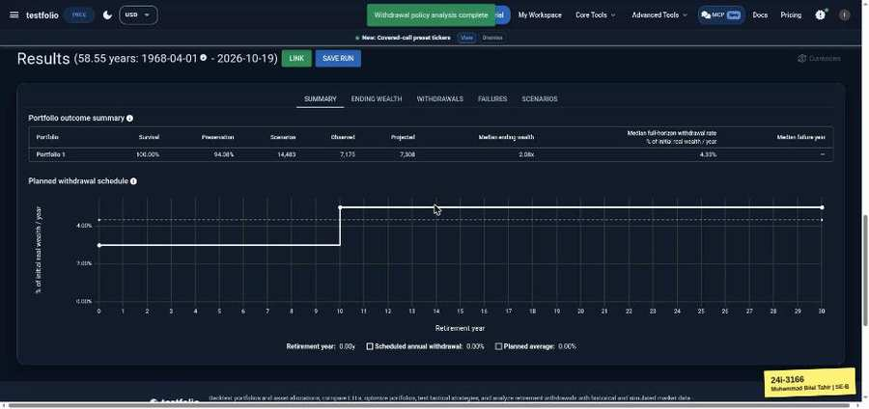

TC-EP-084 | Phase 1 end year | input: 0 | result: Pass
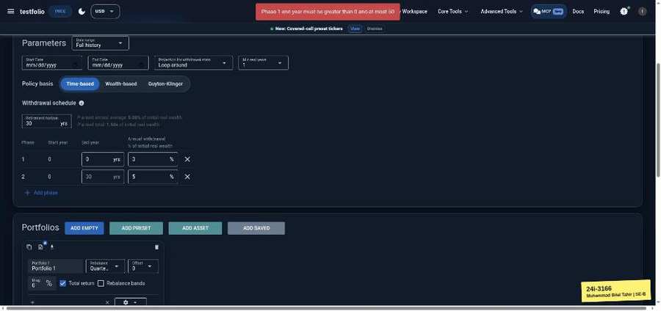

TC-EP-085 | Phase 1 end year | input: 40 (horizon 30) | result: Pass
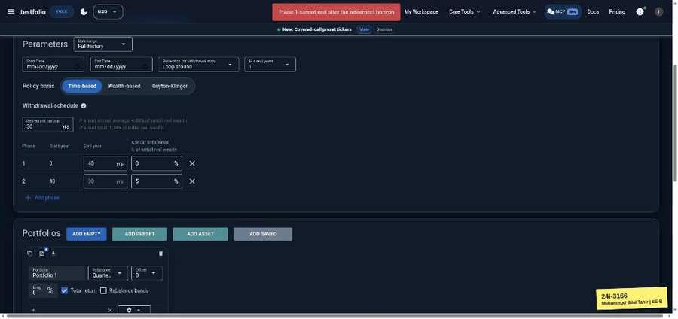

TC-EP-086 | Phase 1 annual withdrawal % | input: 4 | result: Pass
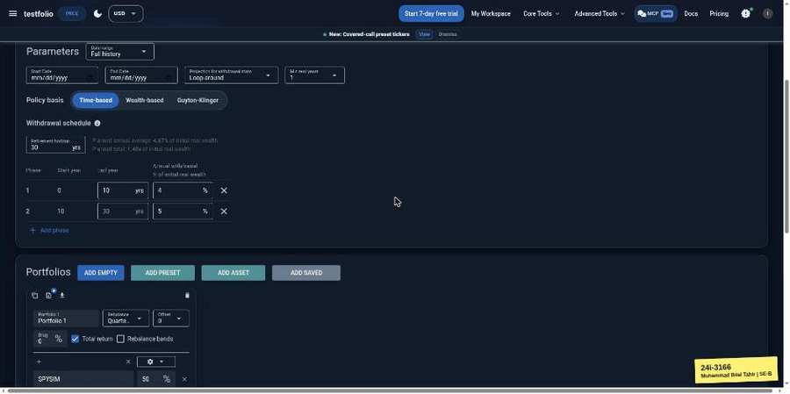 | 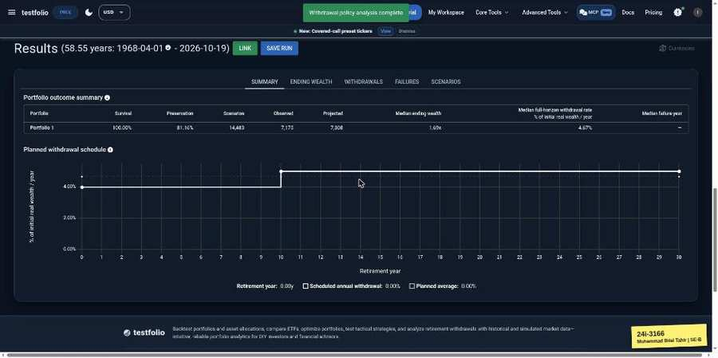

TC-EP-087 | Phase 1 annual withdrawal % | input: -5 | result: Pass
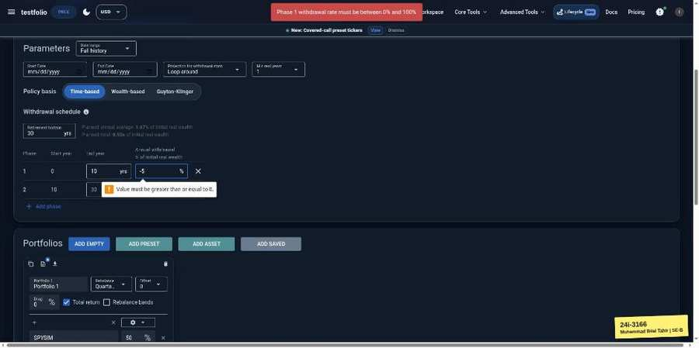

TC-EP-088 | Phase 1 annual withdrawal % | input: 150 | result: Pass
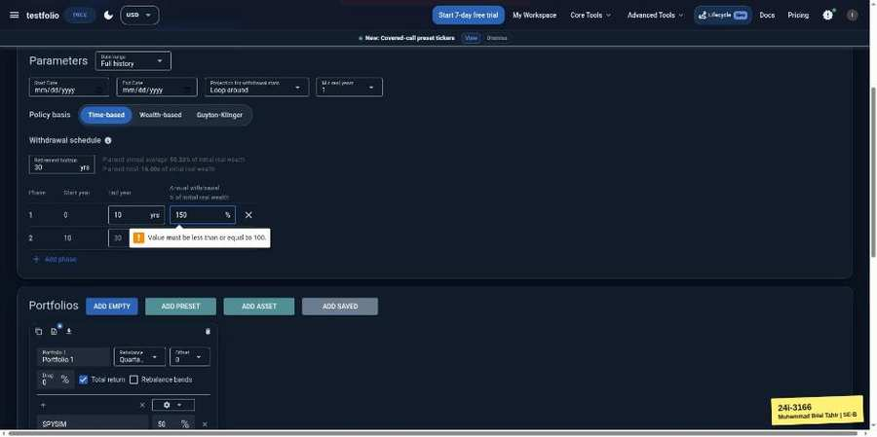

TC-EP-089 | Phase 2 annual withdrawal % | input: 6 | result: Pass
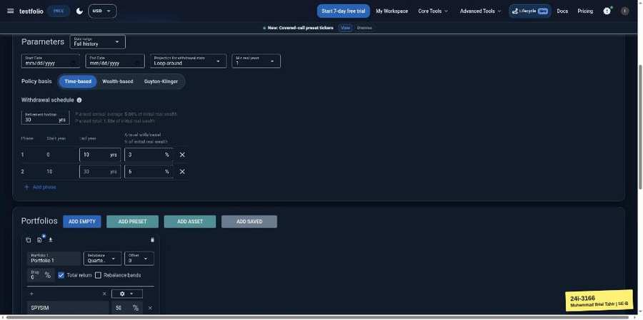 | 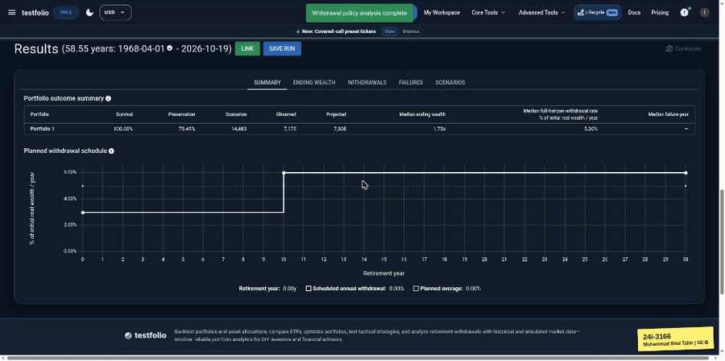

TC-EP-090 | Phase 2 annual withdrawal % | input: -5 | result: Pass
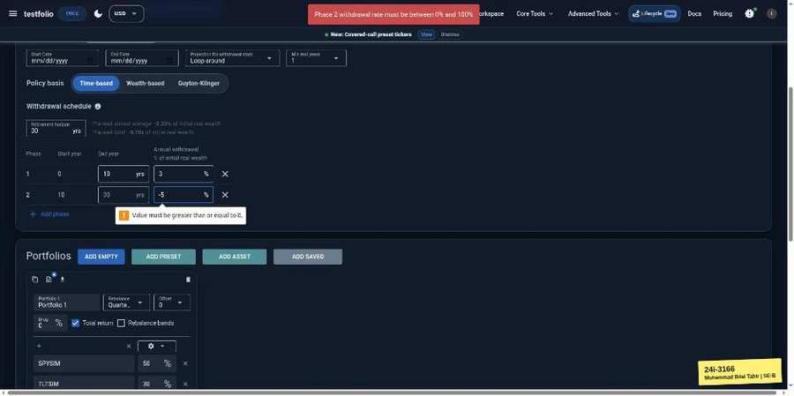

TC-EP-091 | Phase 2 annual withdrawal % | input: 150 | result: Pass
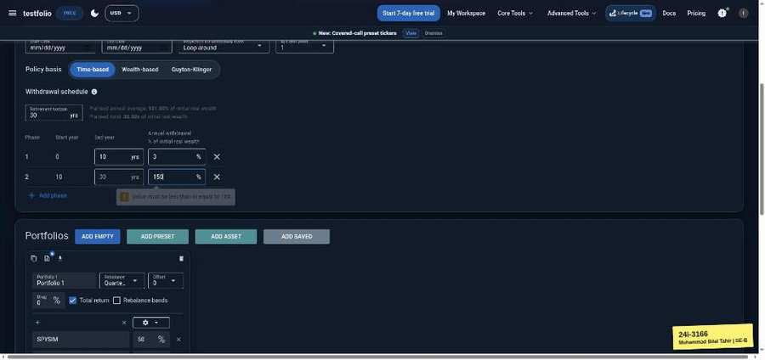

TC-EP-092 | Start / End Date | input: (empty) | result: Pass
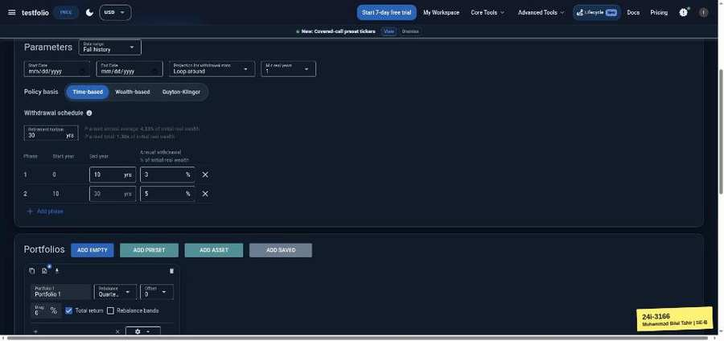 | 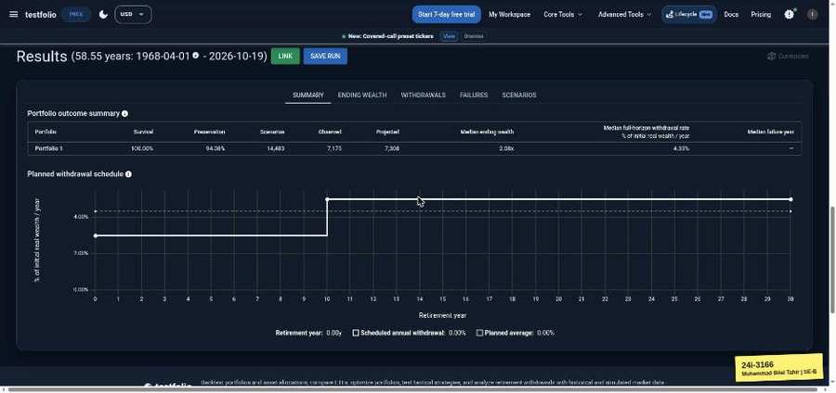

TC-EP-093 | Start / End Date | input: 2020-01-01 / 2019-01-01 | result: Pass
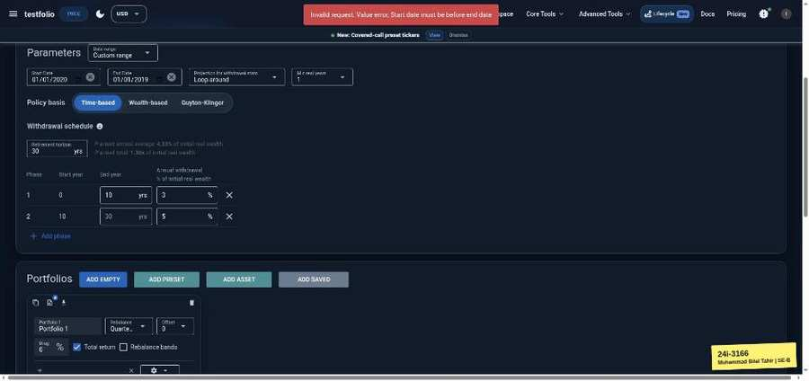

TC-EP-094 | Allocation % (portfolio total) | input: 50/30/20 | result: Pass

TC-EP-095 | Allocation % (portfolio total) | input: 50/30/10 (90) | result: Pass
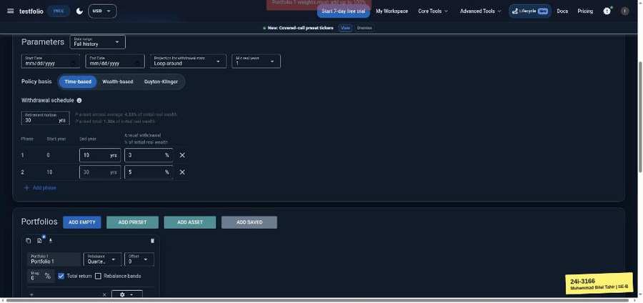

Backtest Optimizer (testfol.io/backtest-optimizer)
TC-EP-096 | Tickers | input: SPY AGG GLD | result: Pass
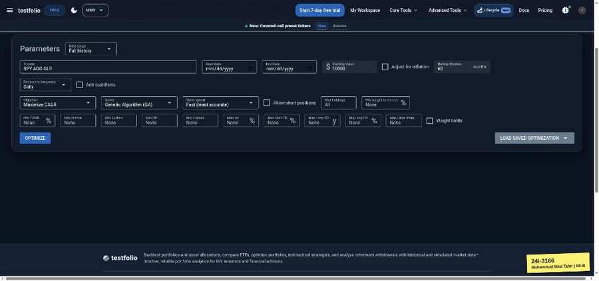 | 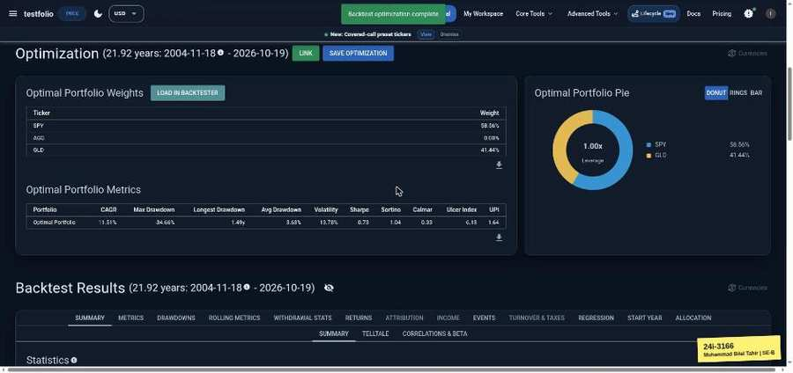

TC-EP-097 | Tickers | input: SPY AGG | result: Pass
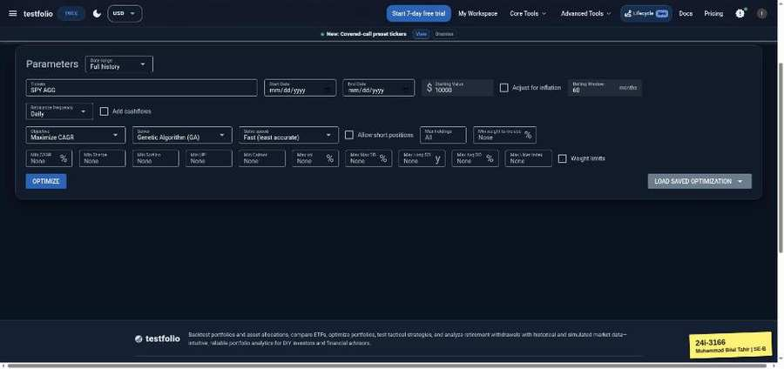 | 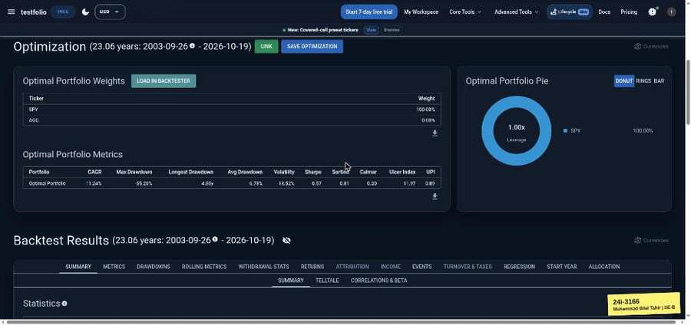

TC-EP-098 | Tickers | input: SPY | result: Pass
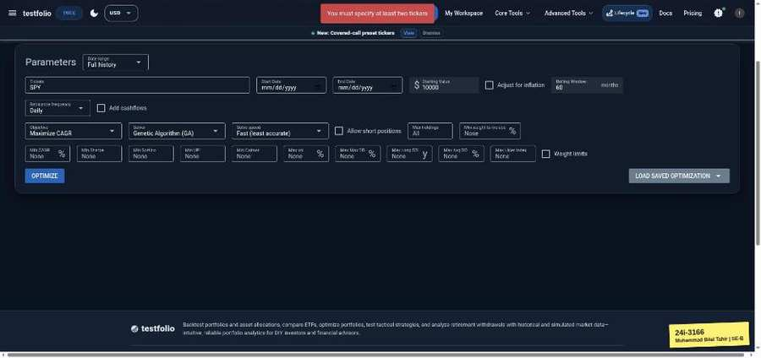

TC-EP-099 | Tickers | input: (empty) | result: Pass
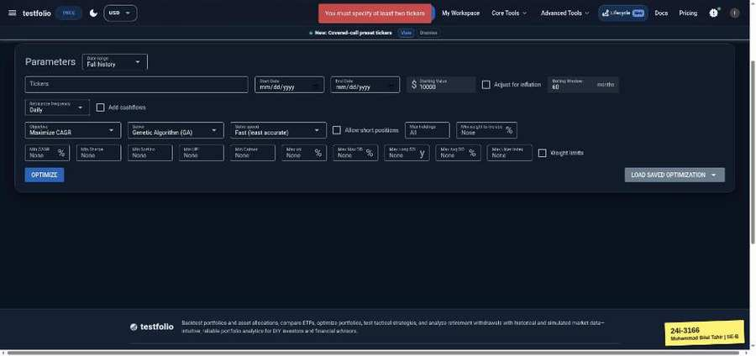

TC-EP-100 | Tickers | input: SPY ZZZZZZ | result: Pass
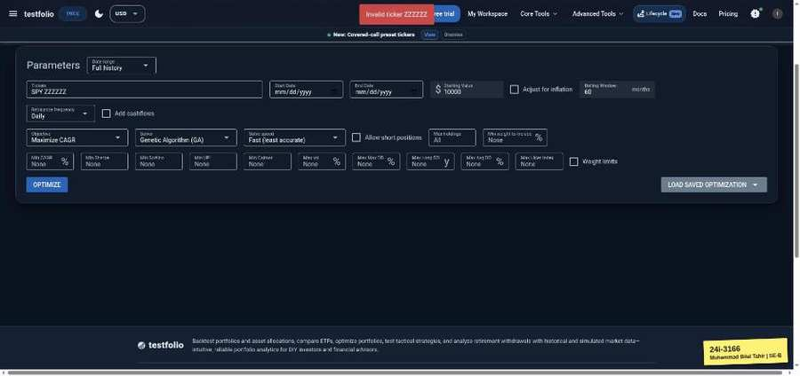

TC-EP-101 | Tickers | input: SPY,AGG,GLD | result: Pass
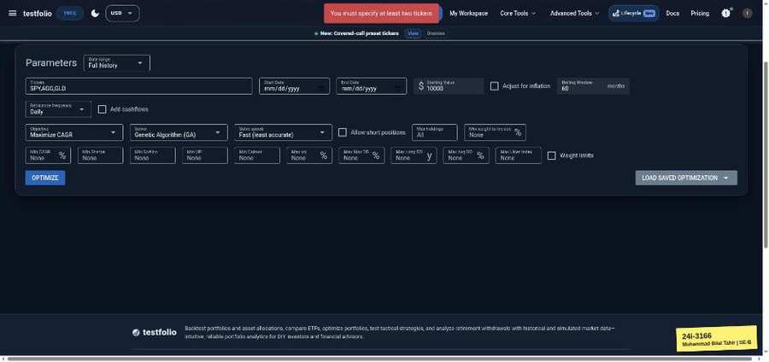

TC-EP-102 | Start / End Date | input: (empty) | result: Pass
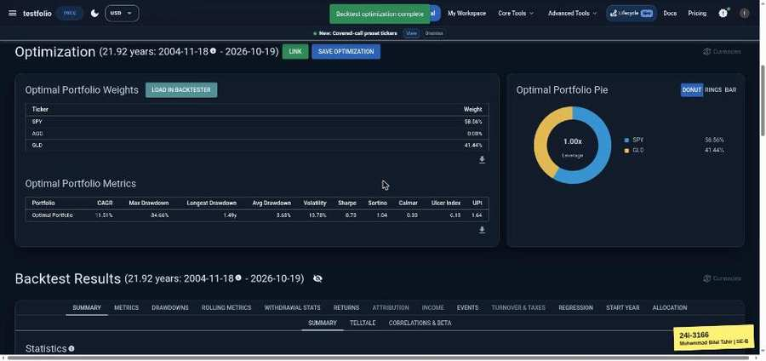

TC-EP-103 | Start / End Date | input: 2020-01-01 / 2019-01-01 | result: Pass
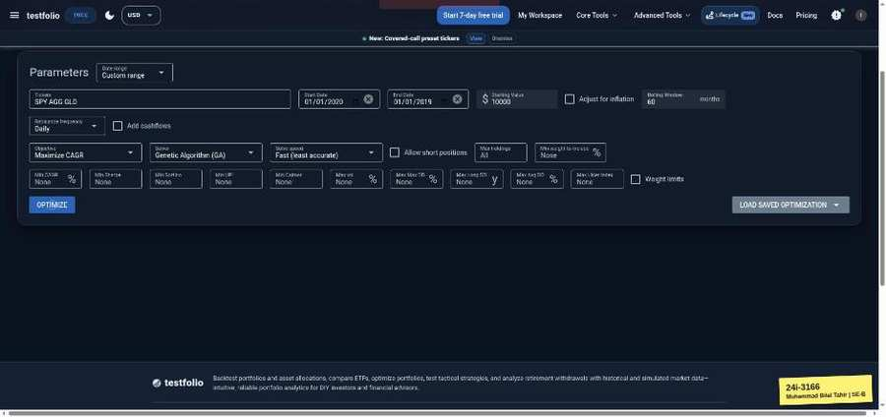

TC-EP-104 | Starting Value | input: 10000 | result: Pass
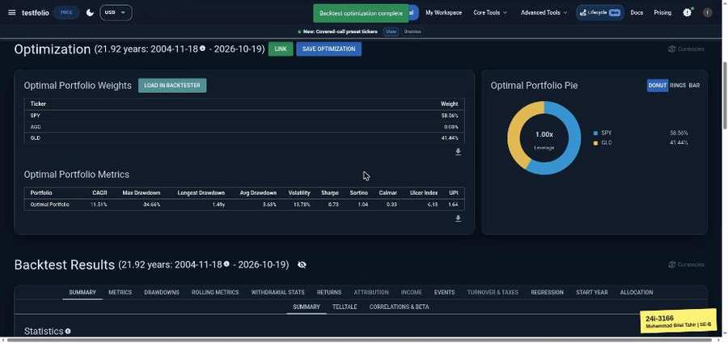

TC-EP-105 | Starting Value | input: 0 | result: Pass
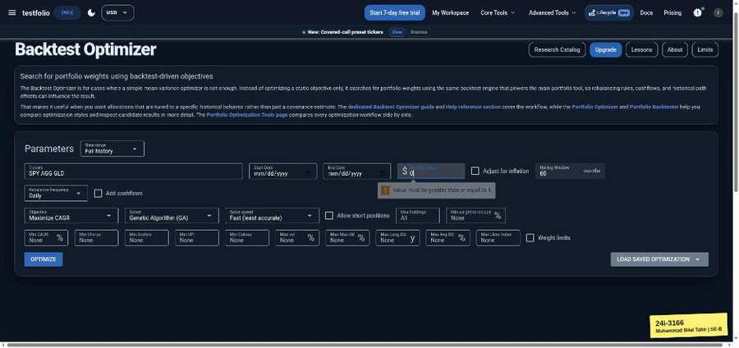

TC-EP-106 | Rolling Window | input: 60 | result: Pass

TC-EP-107 | Rolling Window | input: 0 | result: Pass
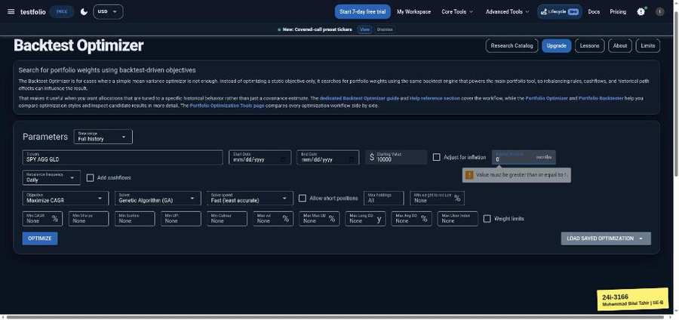

TC-EP-108 | Max holdings | input: 2 | result: Pass
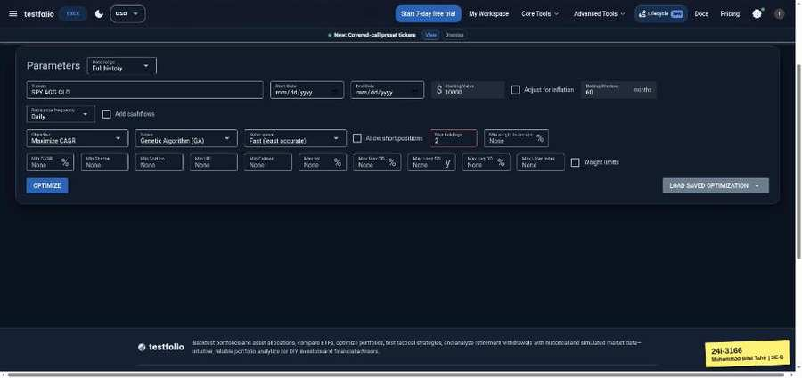 | 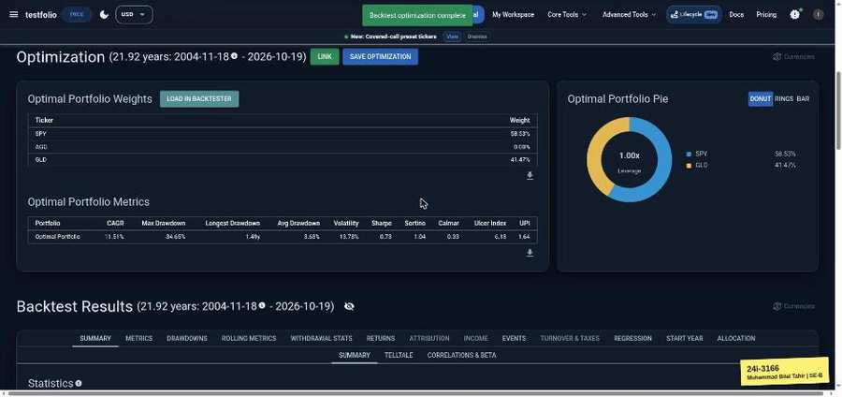

TC-EP-109 | Max holdings | input: 0 | result: Pass
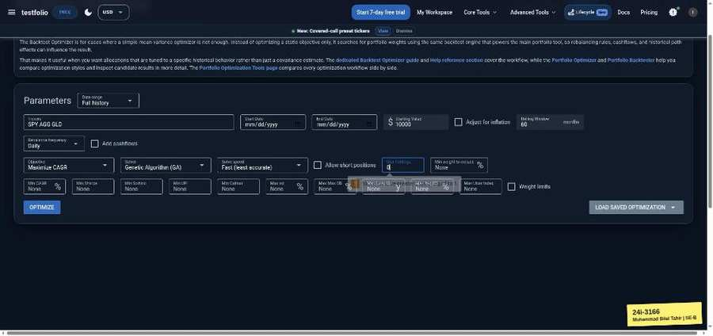

TC-EP-110 | Min weight to include (%) | input: 10 | result: Pass
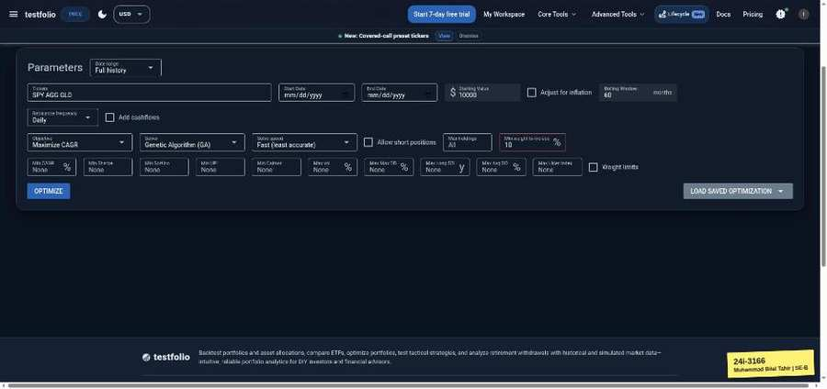 | 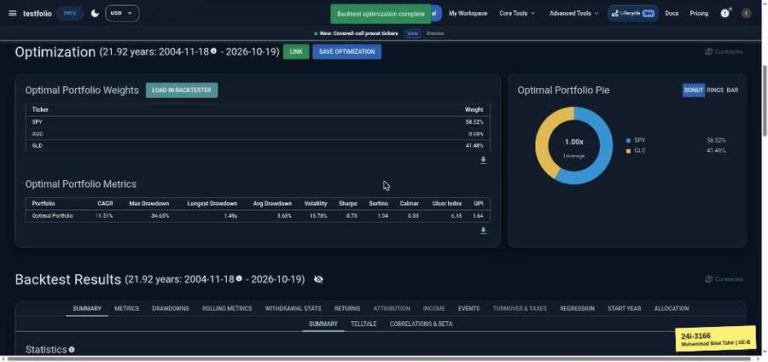

TC-EP-111 | Min weight to include (%) | input: -5 | result: Pass
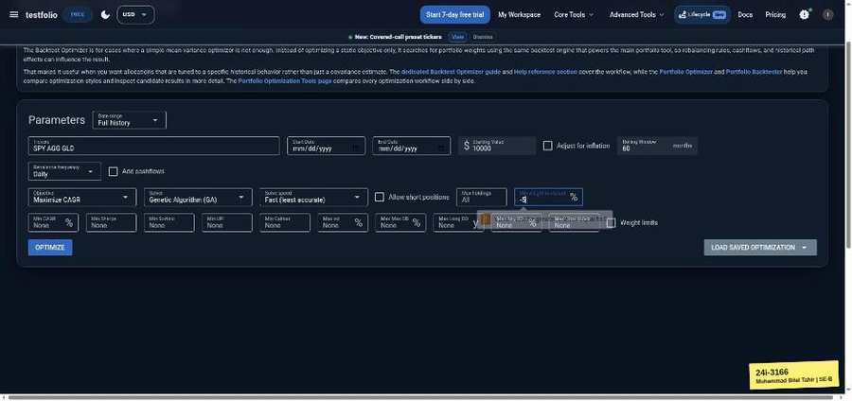

TC-EP-112 | Min weight to include (%) | input: 150 | result: Pass
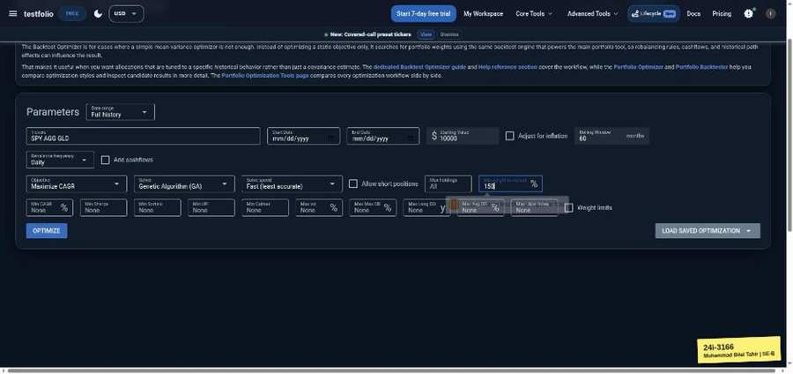

TC-EP-113 | Max vol (%) | input: 20 | result: Pass
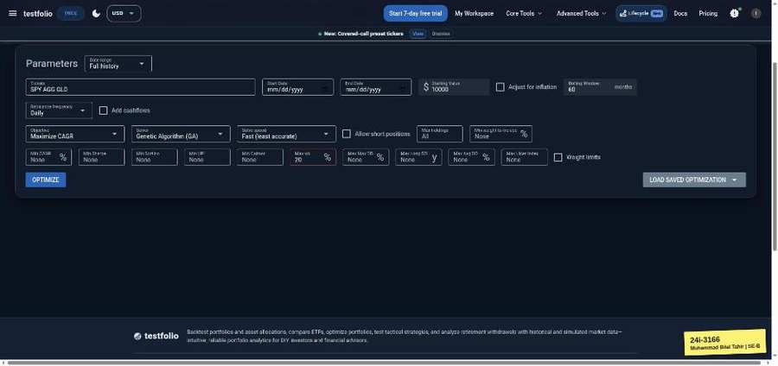 | 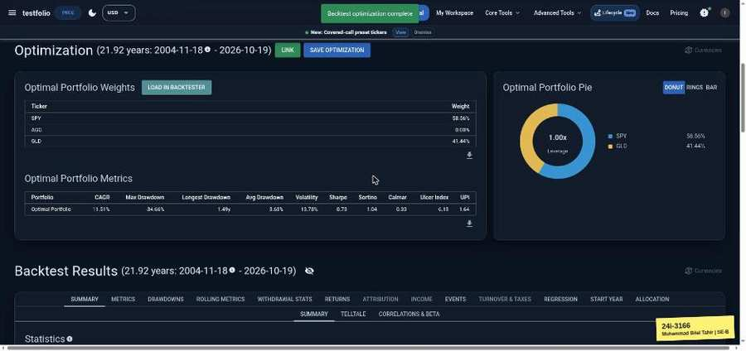

TC-EP-114 | Max vol (%) | input: -5 | result: Pass
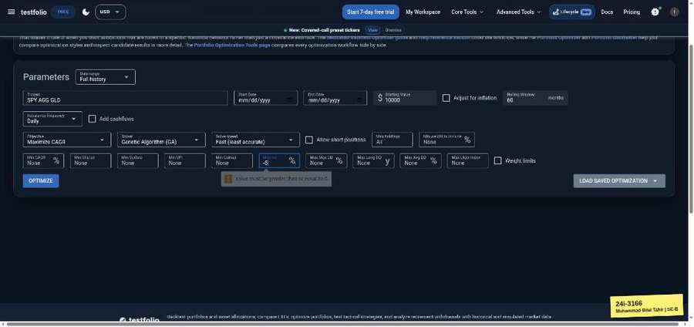

Efficient Frontier (testfol.io/efficient-frontier)
TC-EP-115 | Tickers | input: SPY AGG | result: Pass
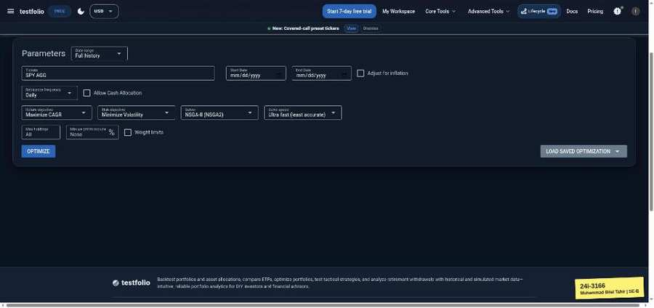 | 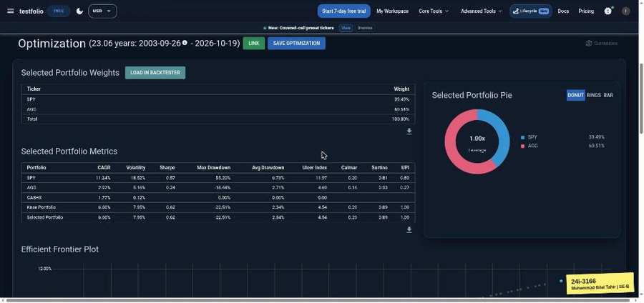

TC-EP-116 | Tickers | input: SPY | result: Pass
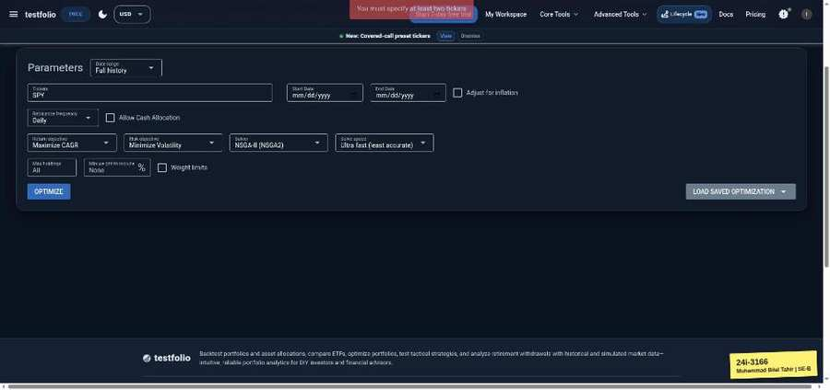

TC-EP-117 | Tickers | input: (empty) | result: Pass
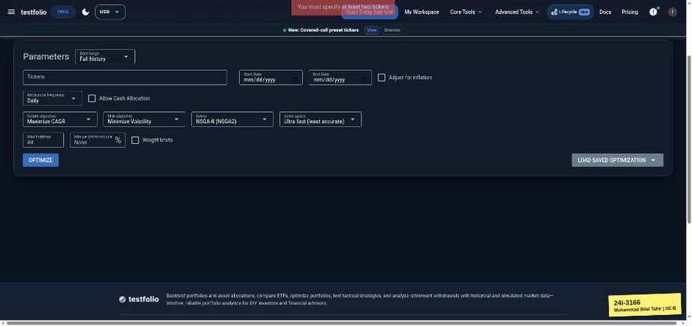

TC-EP-118 | Tickers | input: SPY AGG GLD | result: Pass
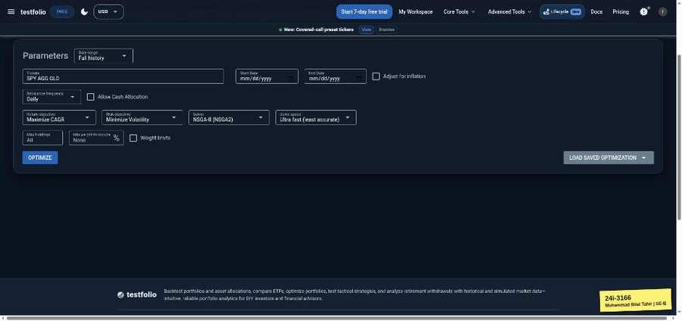 | 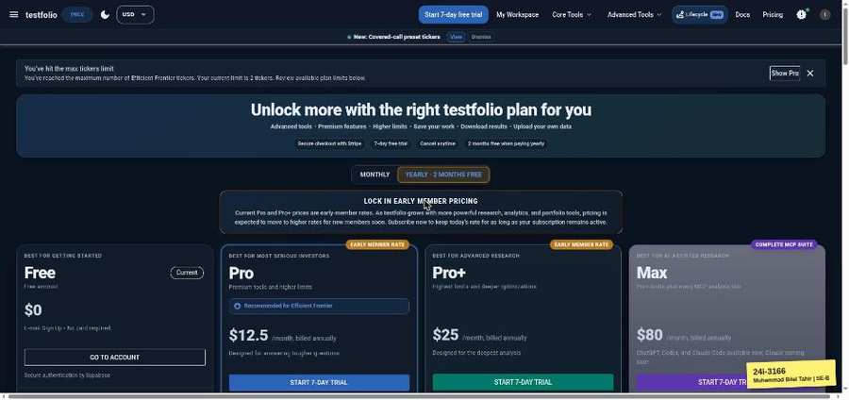

TC-EP-119 | Start / End Date | input: (empty) | result: Pass
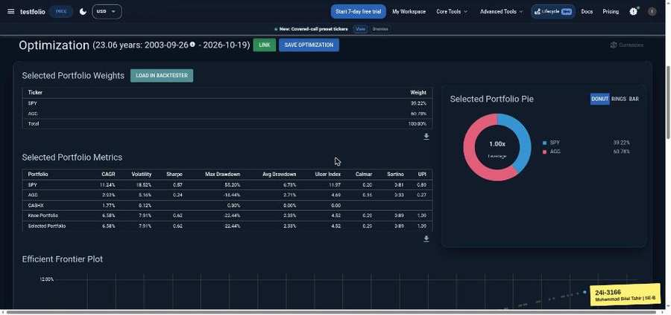

TC-EP-120 | Start / End Date | input: 2020-01-01 / 2019-01-01 | result: Pass
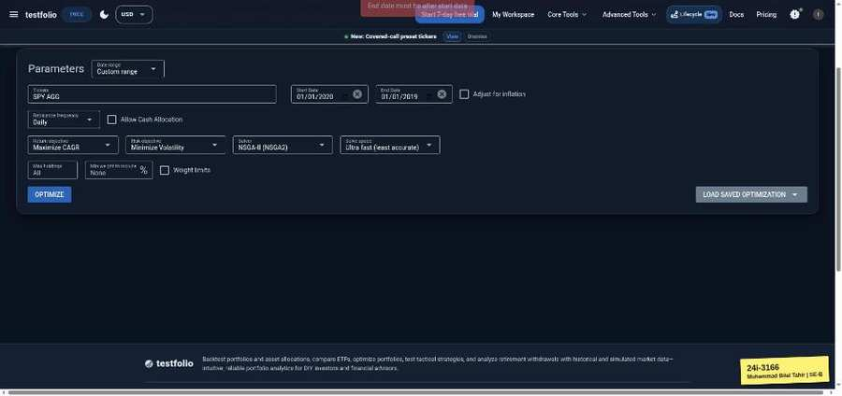

TC-EP-121 | Max holdings | input: 2 | result: Pass
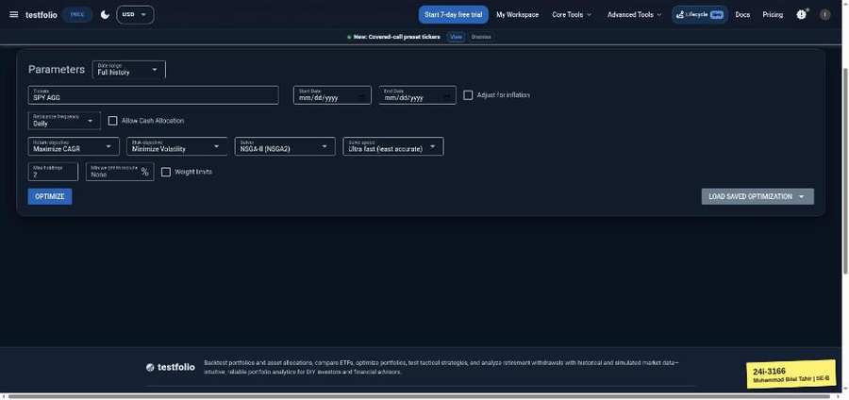 | 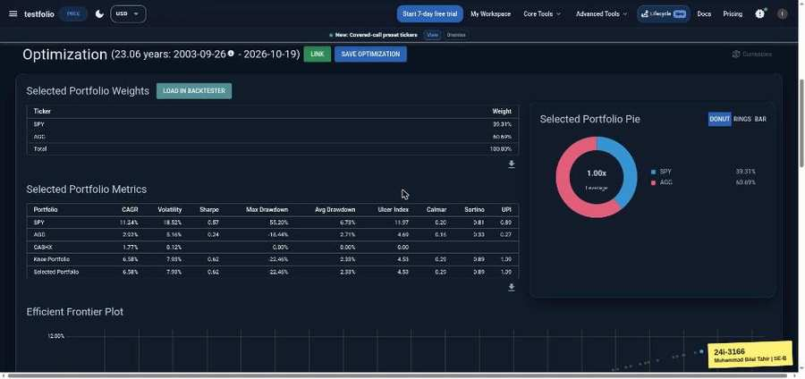

TC-EP-122 | Max holdings | input: 0 | result: Pass
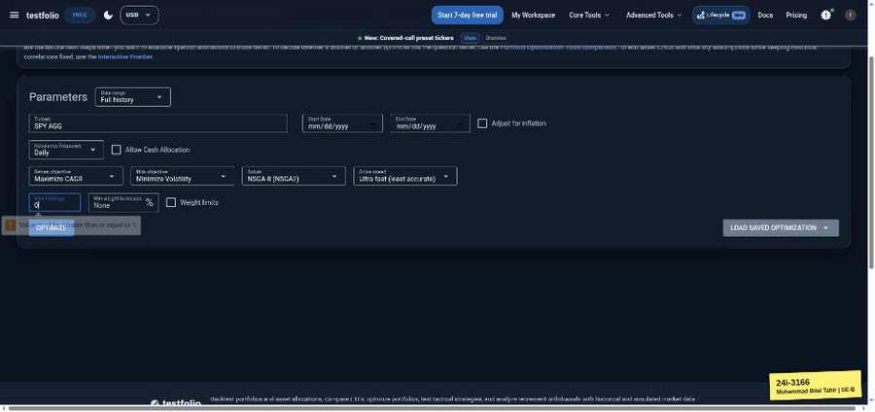

TC-EP-123 | Min weight to include (%) | input: 10 | result: Pass
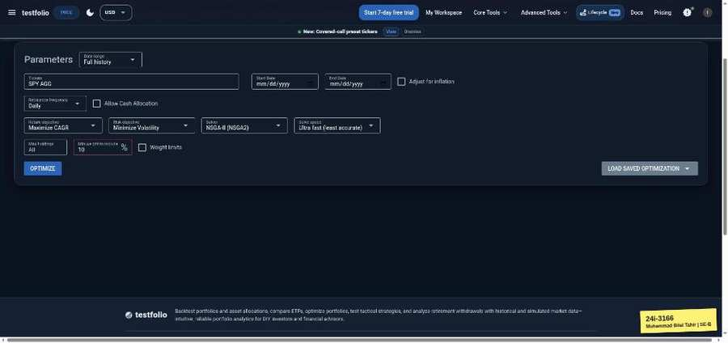 | 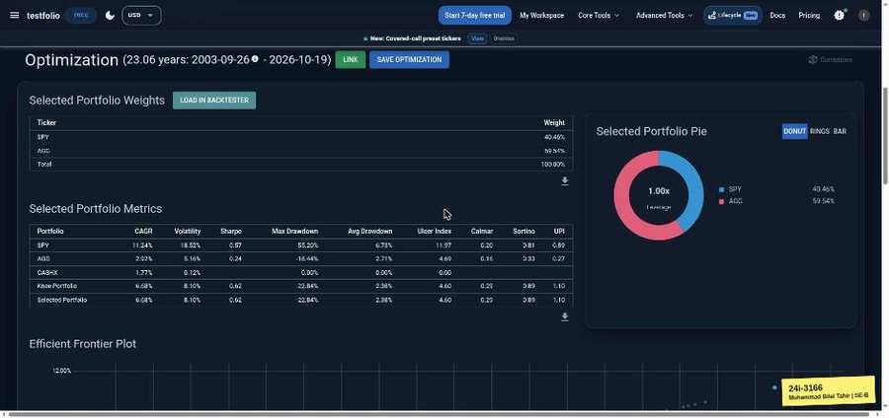

TC-EP-124 | Min weight to include (%) | input: -5 | result: Pass
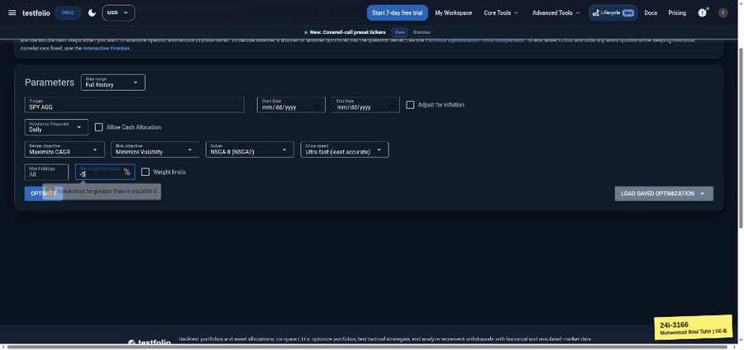

TC-EP-125 | Min weight to include (%) | input: 150 | result: Pass
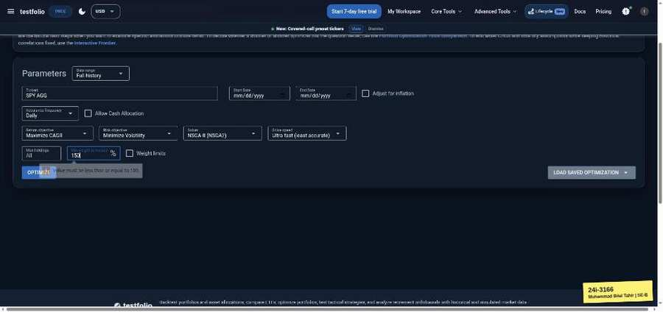

Contact Form (testfol.io/contact)
TC-EP-126 | Name | input: Muhammad Bilal Tahir | result: Pass
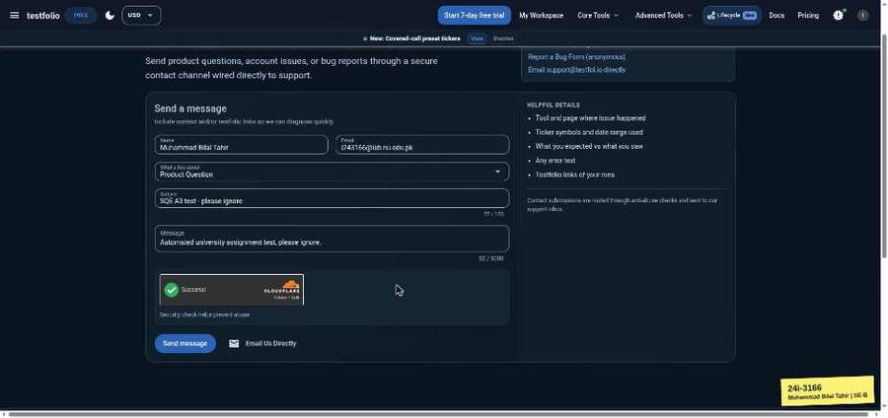

TC-EP-127 | Name | input: (empty) | result: Fail
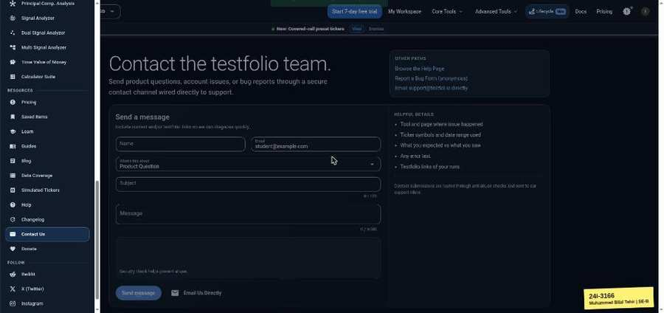

TC-EP-128 | Name | input: 121 x a | result: Pass
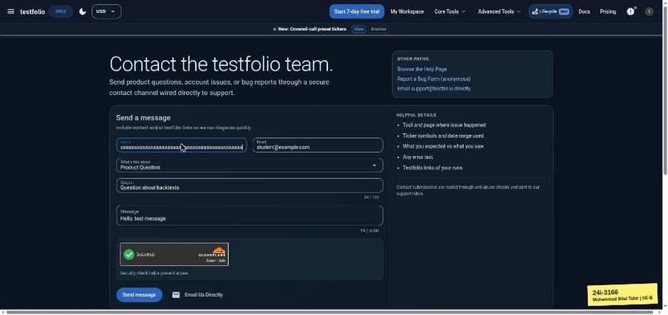 | 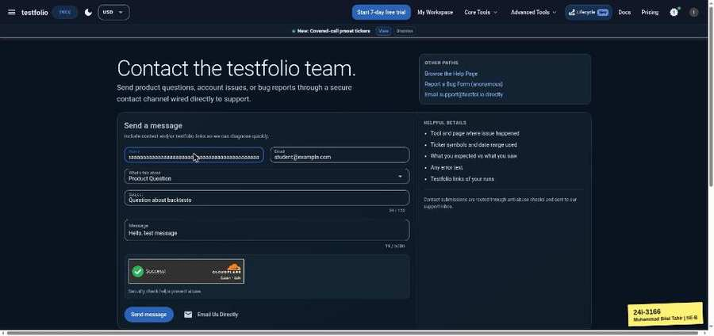

TC-EP-129 | Email | input: student@example.com | result: Pass

TC-EP-130 | Email | input: (empty) | result: Fail
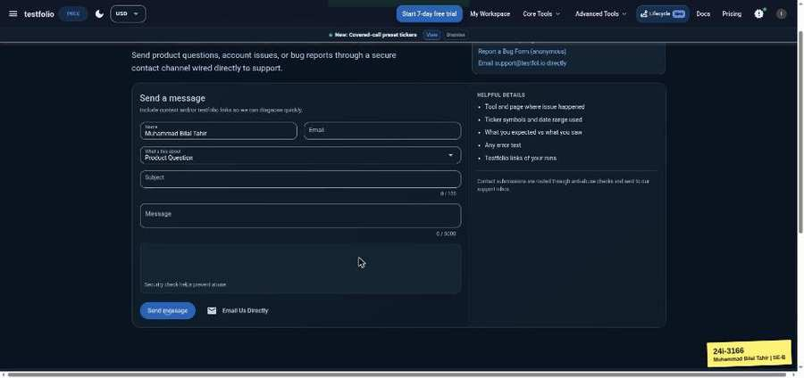

TC-EP-131 | Email | input: notanemail | result: Fail
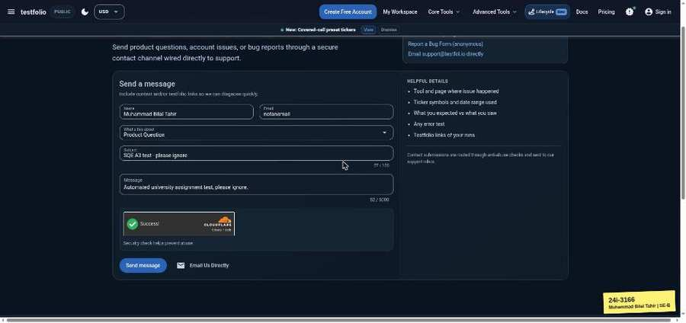 | 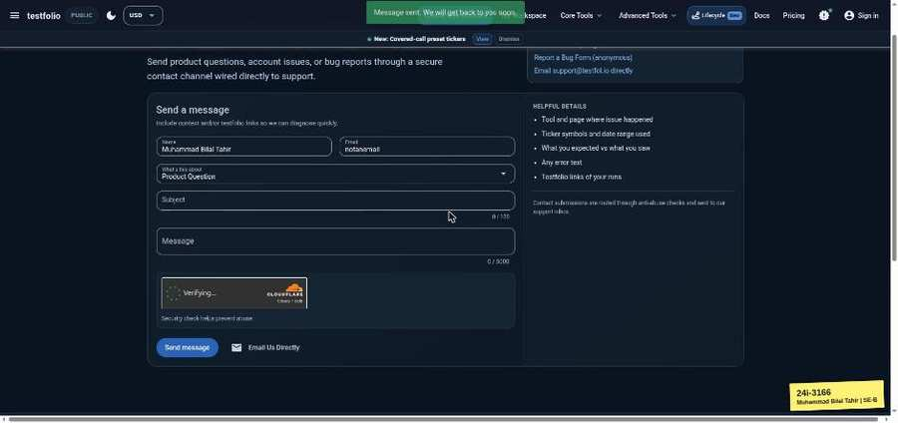

TC-EP-132 | Subject | input: Question about backtests | result: Pass

TC-EP-133 | Subject | input: (empty) | result: Pass
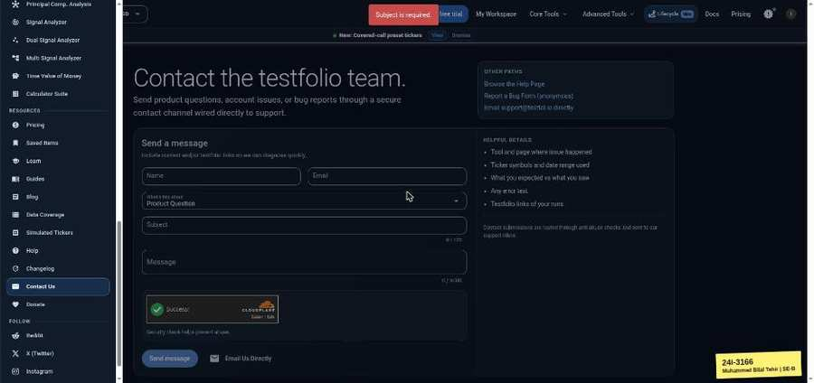

TC-EP-134 | Subject | input: 121 x a | result: Pass
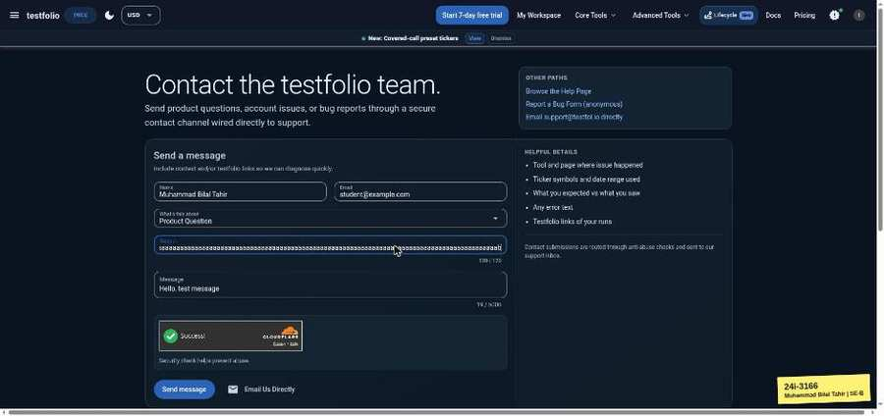 | 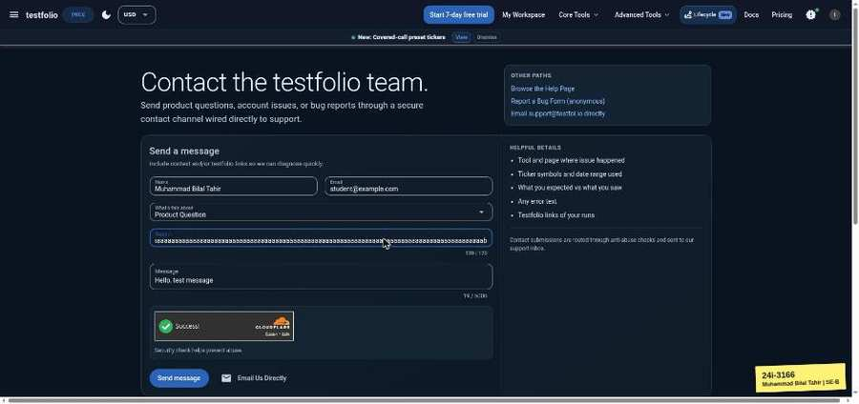

TC-EP-135 | Message | input: Hello, test message | result: Pass

TC-EP-136 | Message | input: (empty) | result: Pass
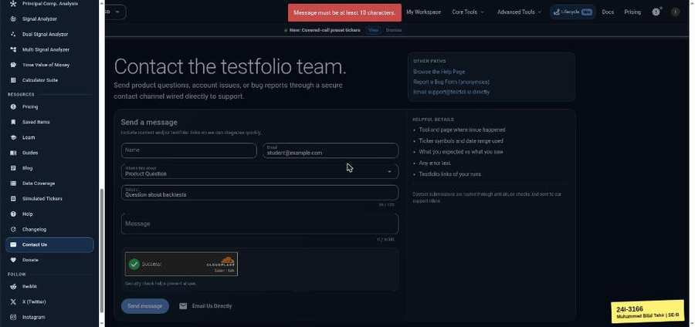

TC-EP-137 | Message | input: 5001 x a | result: Pass
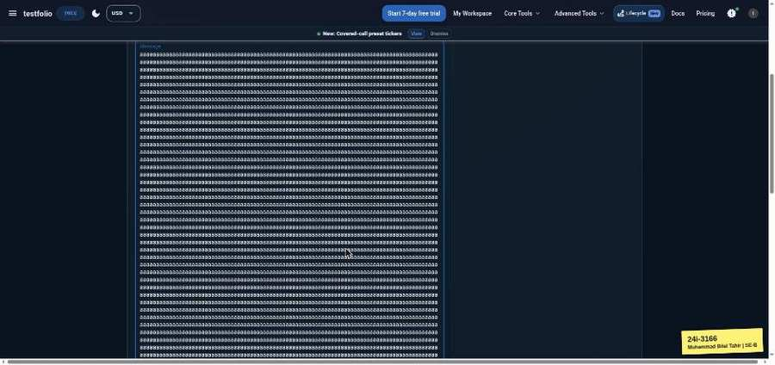 | 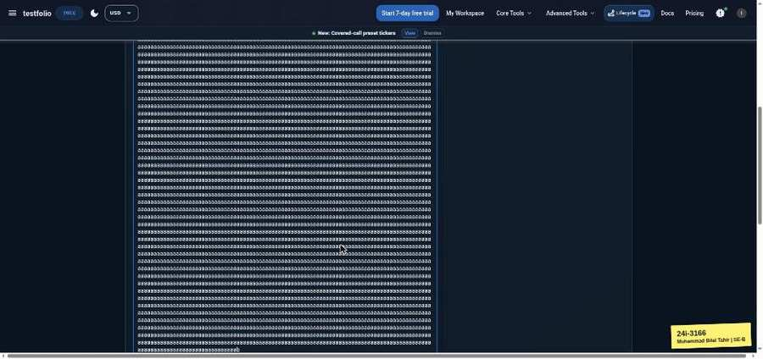

Lump Sum vs DCA (testfol.io/lumpsum-vs-dca)
TC-EP-138 | Starting Value | input: 10000 | result: Blocked
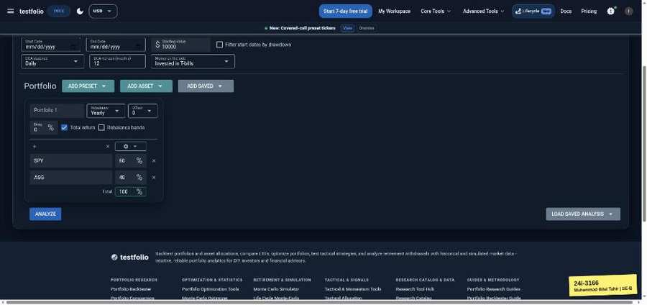 | 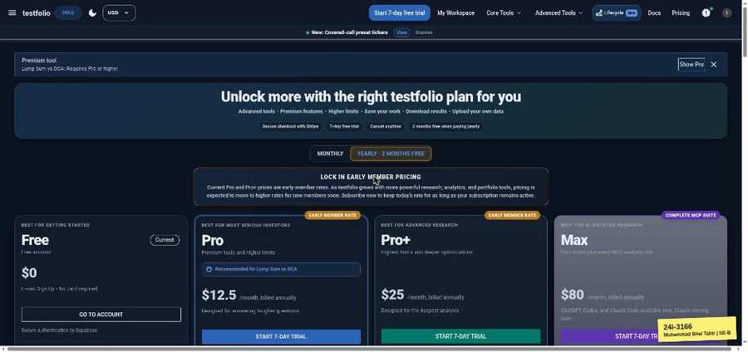

TC-EP-139 | Starting Value | input: 50 | result: Blocked
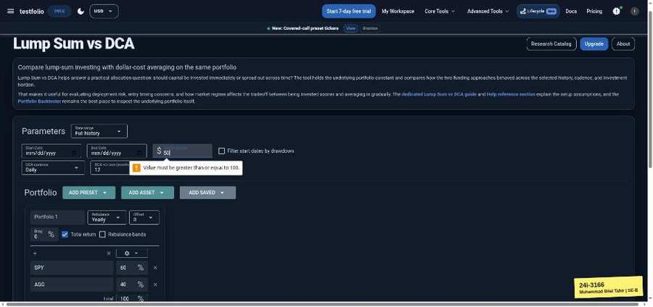

TC-EP-140 | DCA horizon (months) | input: 12 | result: Blocked

TC-EP-141 | DCA horizon (months) | input: 0 | result: Blocked
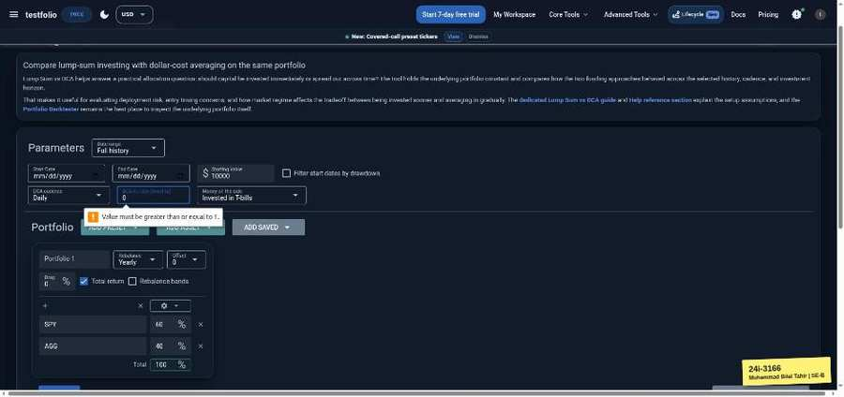

TC-EP-142 | DCA horizon (months) | input: 200 | result: Blocked
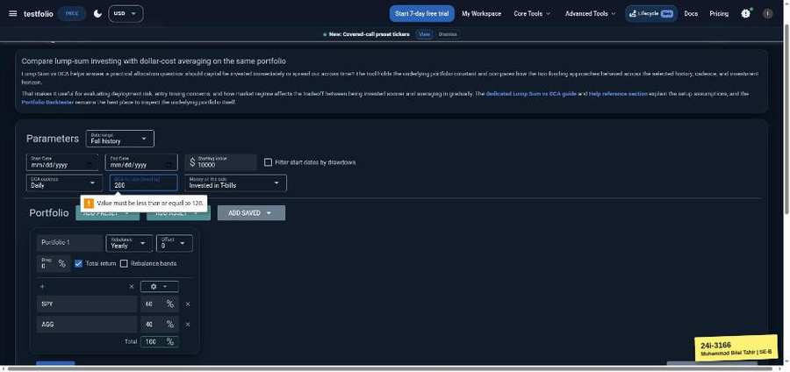

TC-EP-143 | Ticker | input: SPY | result: Blocked

TC-EP-144 | Ticker | input: ZZZZZZ | result: Blocked
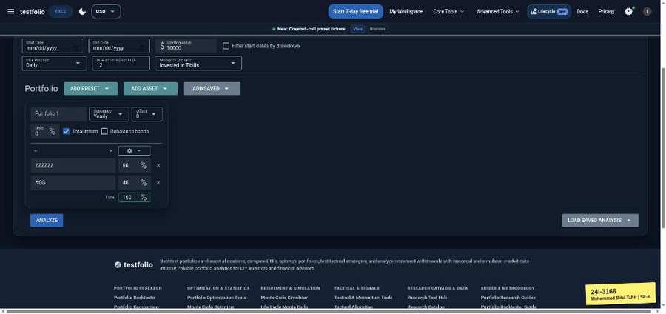

TC-EP-145 | Allocation % (portfolio total) | input: 60/40 | result: Blocked

TC-EP-146 | Allocation % (portfolio total) | input: 60/30 (90) | result: Blocked
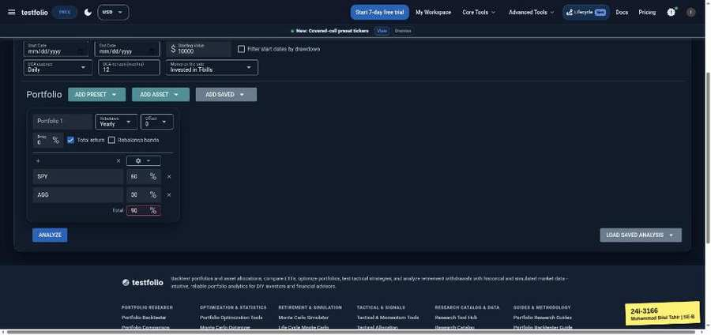

Time Value of Money Calculator (testfol.io/time-value-of-money)
TC-EP-147 | Starting Value | input: 10000 | result: Pass
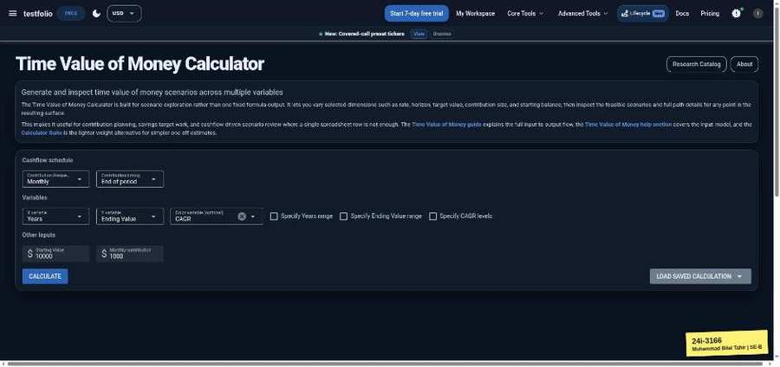 | 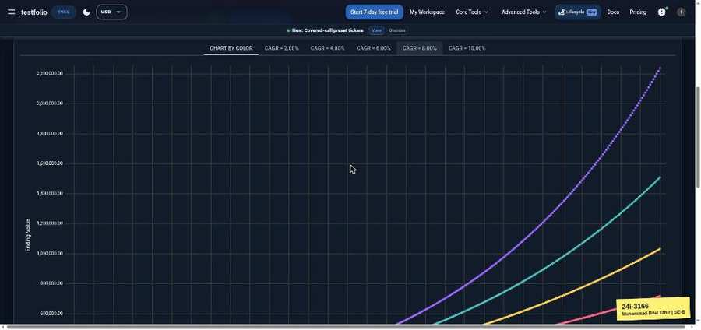

TC-EP-148 | Starting Value | input: -500 | result: Pass
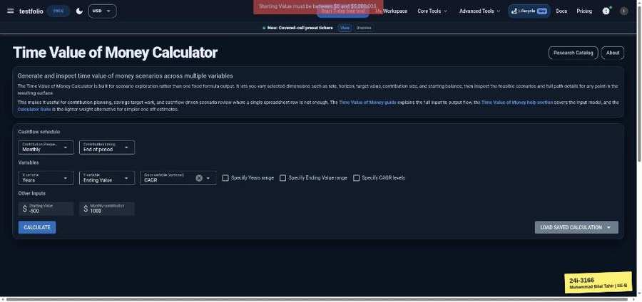

TC-EP-149 | Starting Value | input: 9000000 | result: Pass
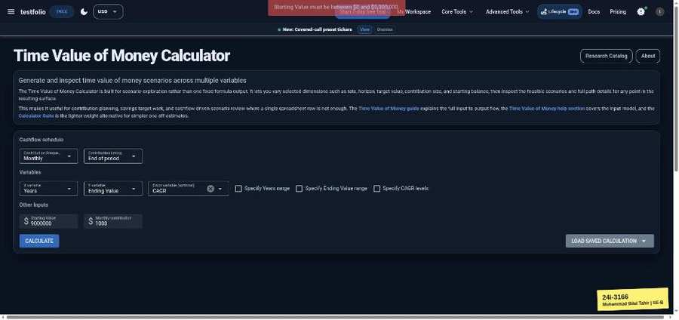

TC-EP-150 | Starting Value | input: (empty) | result: Pass
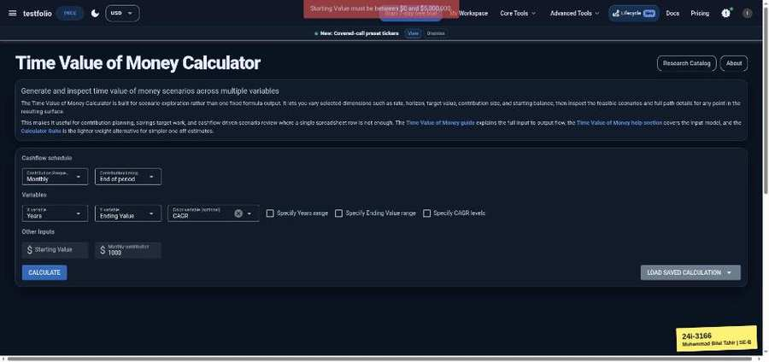

TC-EP-151 | Monthly contribution | input: 1000 | result: Pass
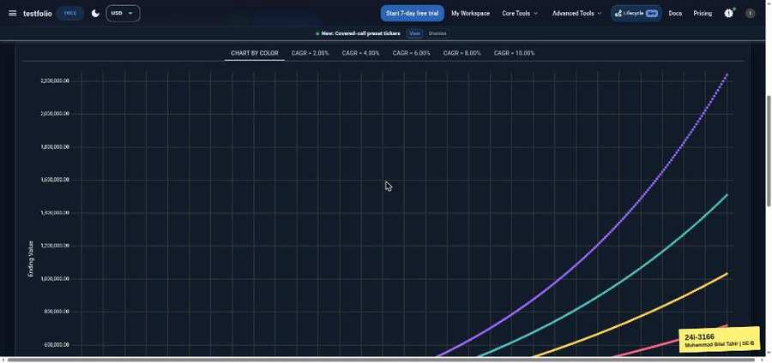

TC-EP-152 | Monthly contribution | input: -50 | result: Pass
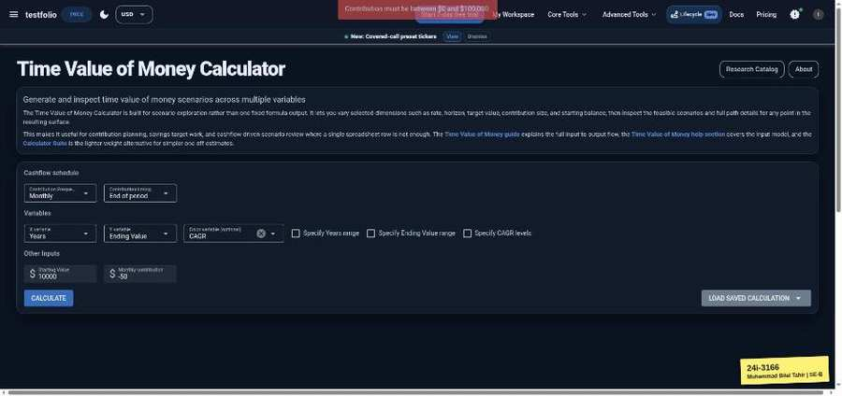

TC-EP-153 | Monthly contribution | input: 500000 | result: Pass
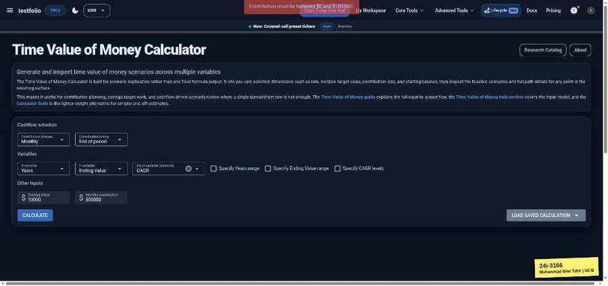

Rebalancing Sensitivity (testfol.io/rebalancing-sensitivity)
TC-EP-154 | Start / End Date | input: (empty) | result: Blocked
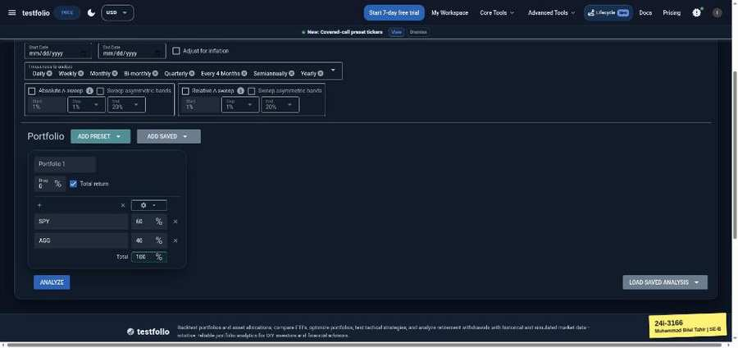 | 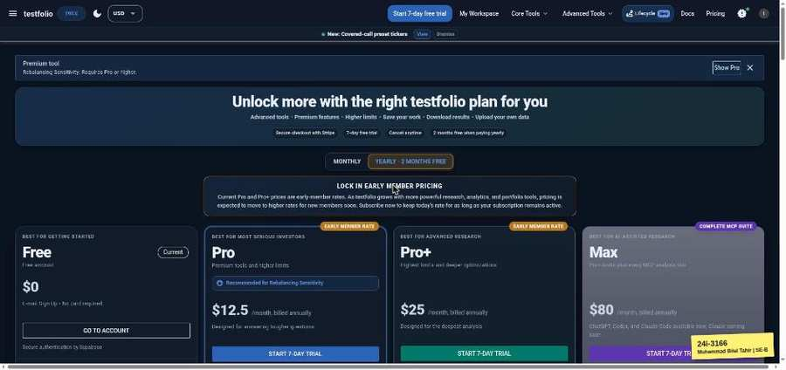

TC-EP-155 | Start / End Date | input: 2020-01-01 / 2019-01-01 | result: Blocked
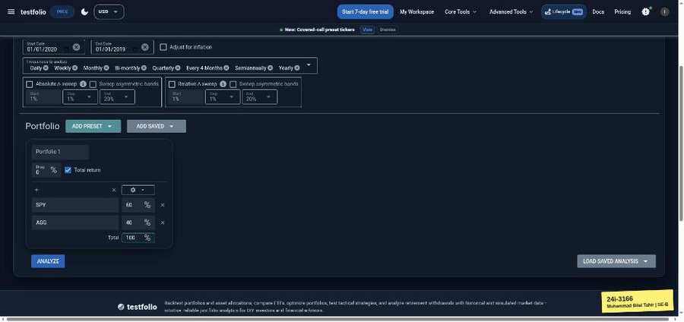

TC-EP-156 | Drag (annual fee %) | input: 0.5 | result: Blocked
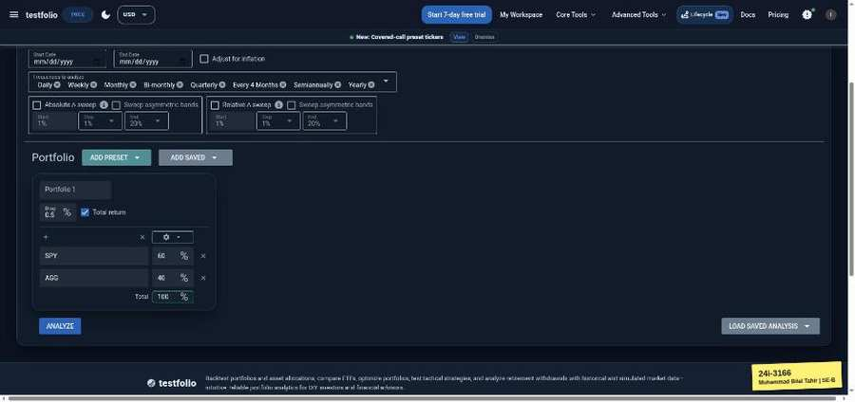 | 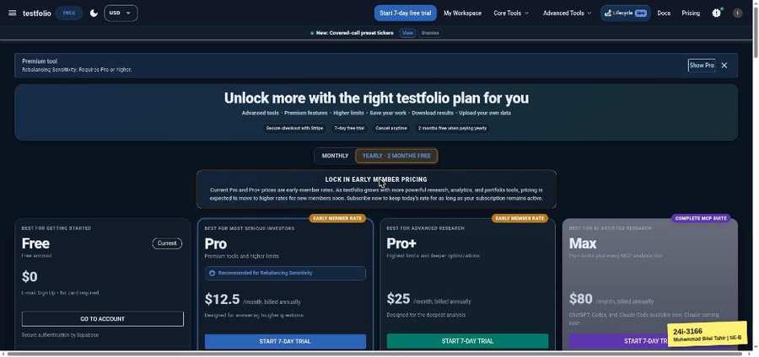

TC-EP-157 | Drag (annual fee %) | input: -2 | result: Blocked
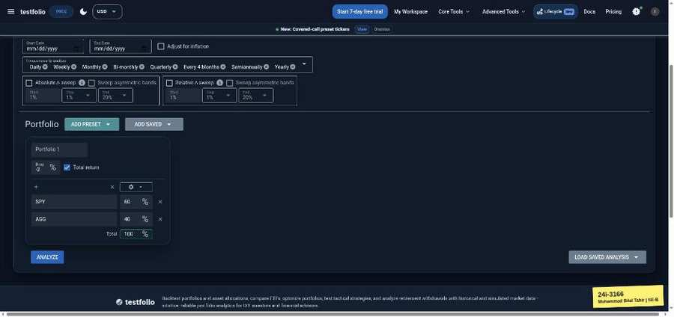

TC-EP-158 | Allocation % (portfolio total) | input: 60/40 | result: Blocked

TC-EP-159 | Allocation % (portfolio total) | input: 60/30 (90) | result: Blocked
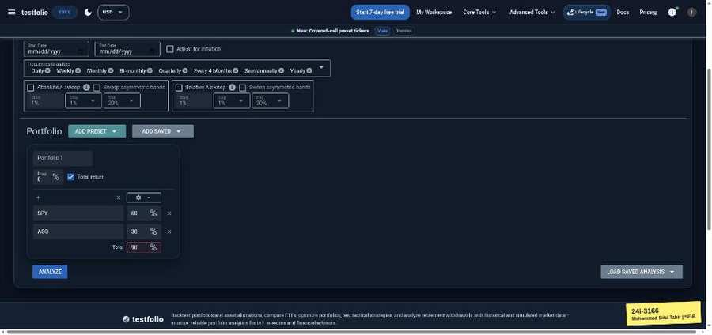

Portfolio Backtester (testfol.io/)
TC-EP-S1 | multiple fields | input: Start 2015-01-01, End 2020-01-01, SV 50000, RW 36, growth 2, cashflow 100, drag 0.5, SPY60/AGG40 | result: Pass
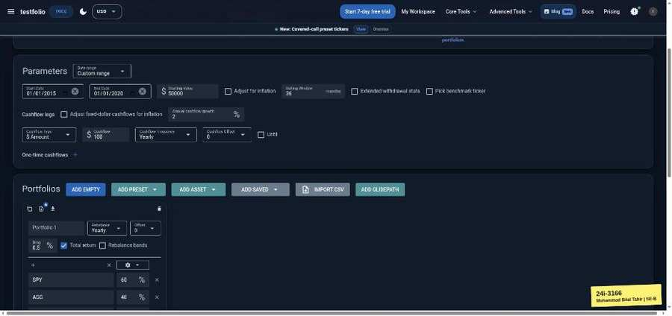 | 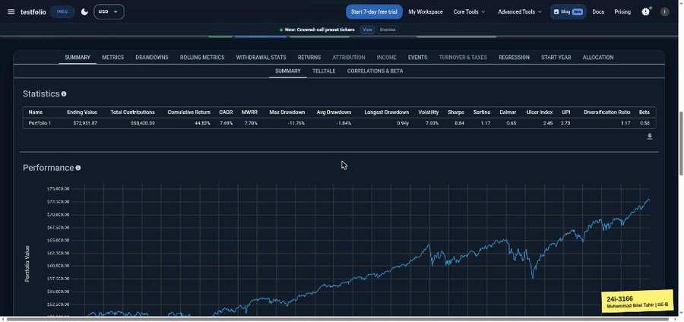

TC-EP-S2 | multiple fields | input: SV 0, RW 0, growth -100 | result: Pass
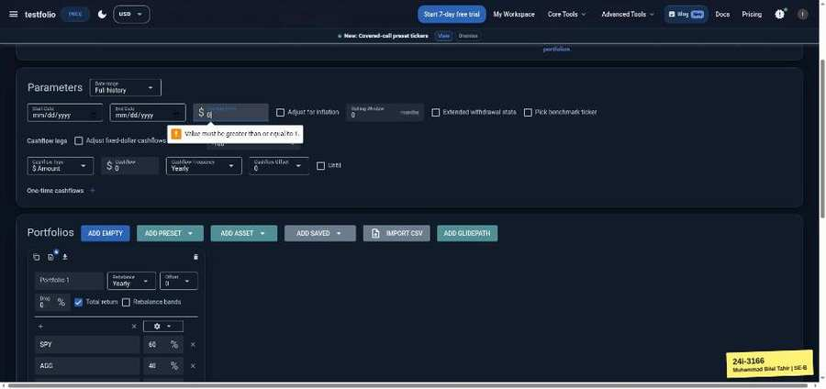

TC-EP-S3 | multiple fields | input: ticker ZZZZZZ, alloc 60/30 | result: Fail
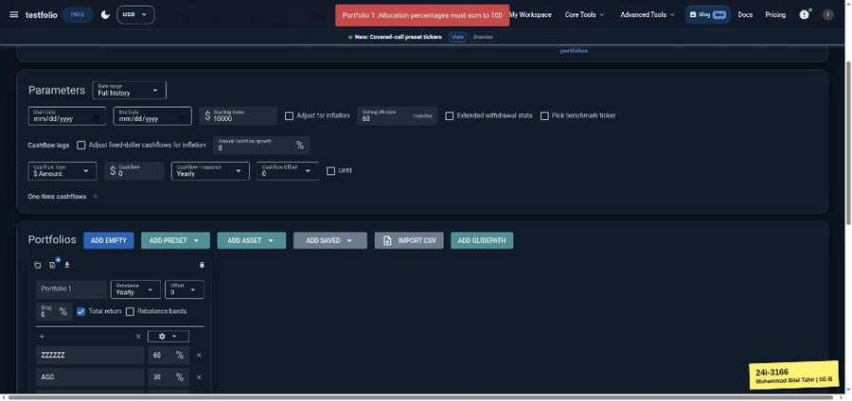

TC-EP-S4 | multiple fields | input: 2020-01-01/2019-01-01, SV empty, ZZZZZZ, 60/60 | result: Fail
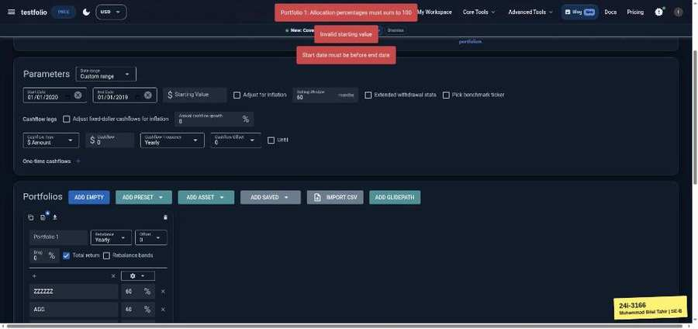

TC-EP-S5 | multiple fields | input: 2015-01-01/2020-01-01, SV 50000, alloc -10/110 | result: Fail
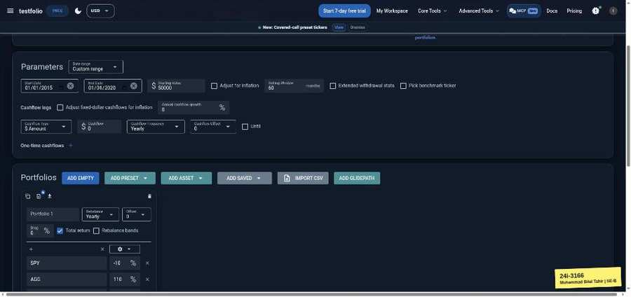 | 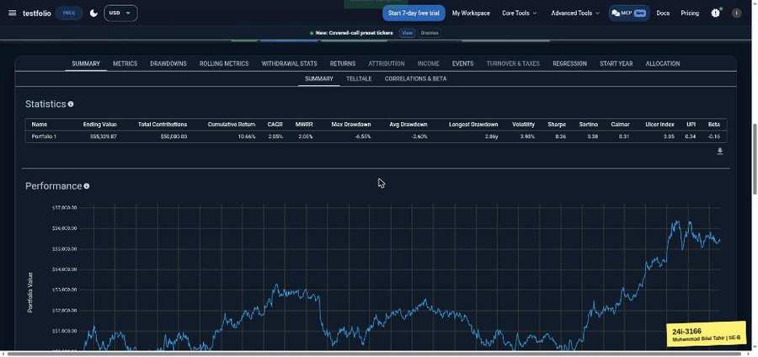

TC-EP-S6 | multiple fields | input: ticker empty, drag 150 | result: Fail
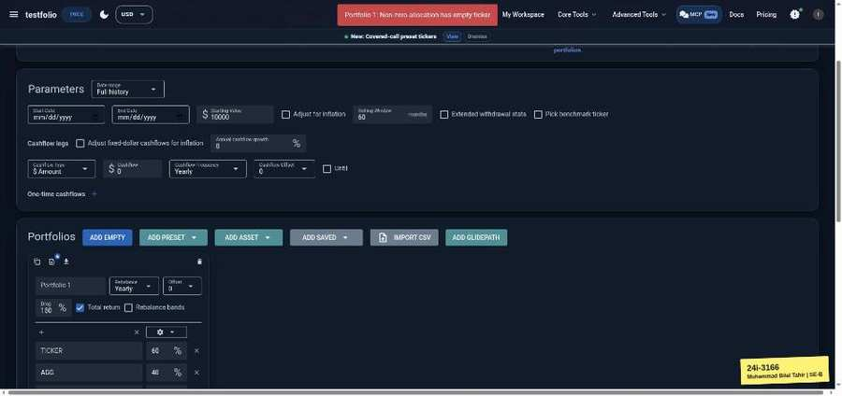

Sign Up (testfol.io/start)
TC-BVA-001 | Password | input: 7 chars | result: Pass
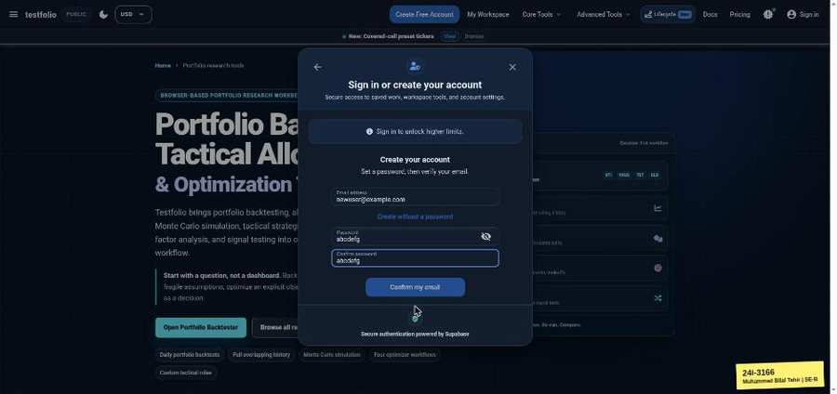

TC-BVA-002 | Password | input: 8 chars | result: Pass
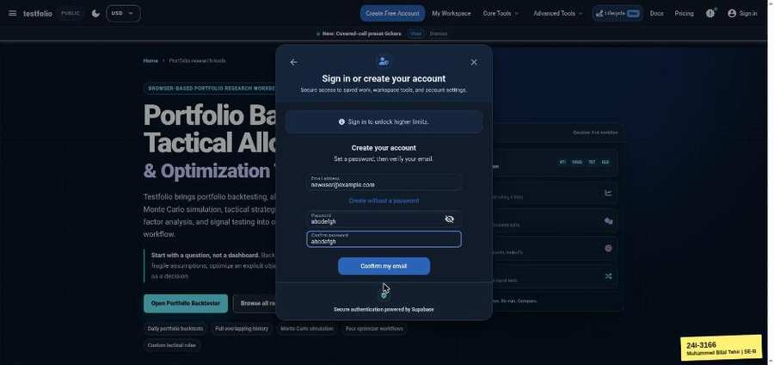

Portfolio Backtester (testfol.io/)
TC-BVA-003 | Starting Value | input: 0.99 | result: Pass
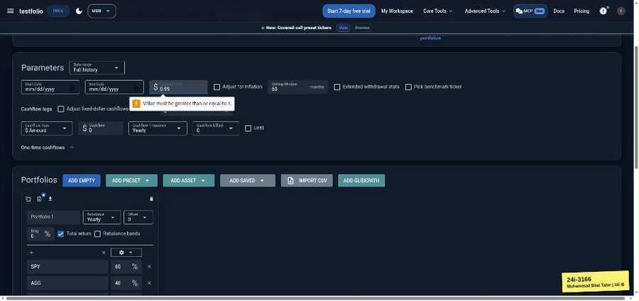

TC-BVA-004 | Starting Value | input: 1 | result: Pass
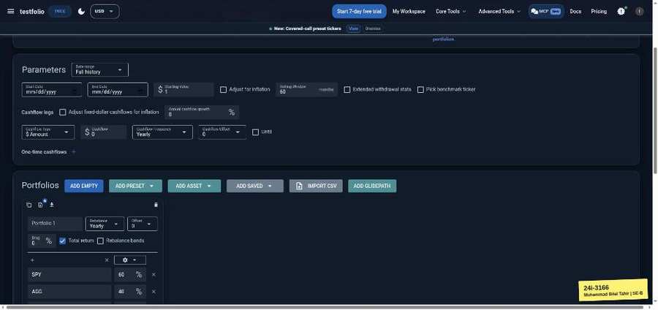 | 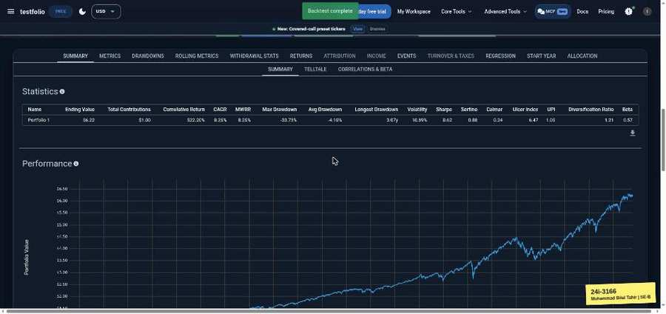

TC-BVA-005 | Starting Value | input: 2 | result: Pass
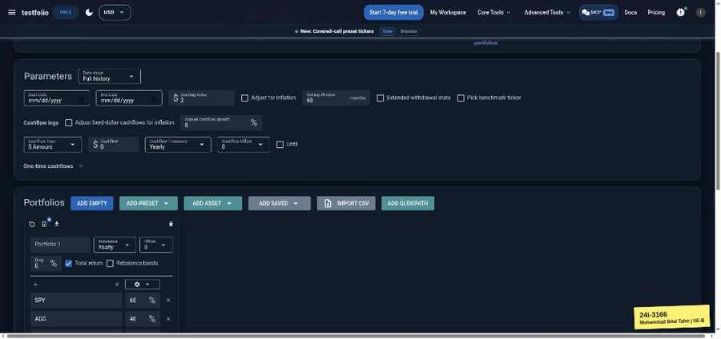 | 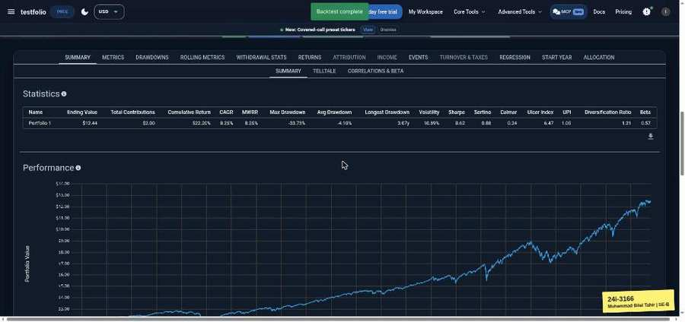

TC-BVA-006 | Starting Value | input: 999,999,999,998 | result: Pass
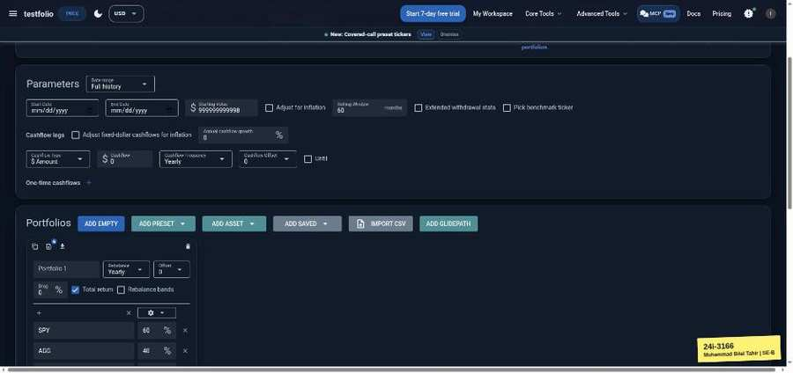 | 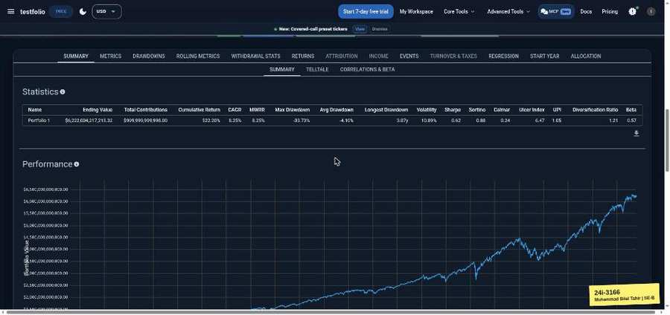

TC-BVA-007 | Starting Value | input: 999,999,999,999 | result: Pass
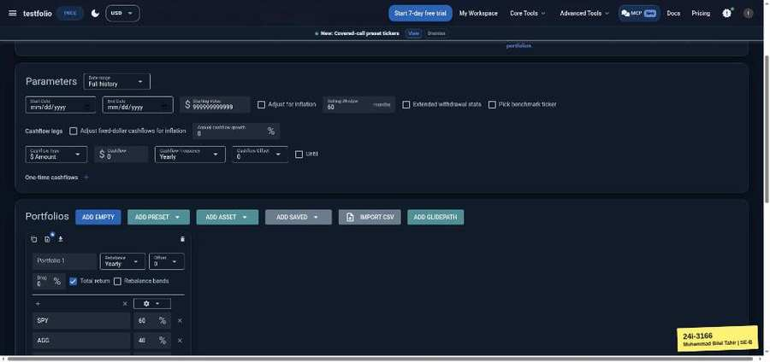 | 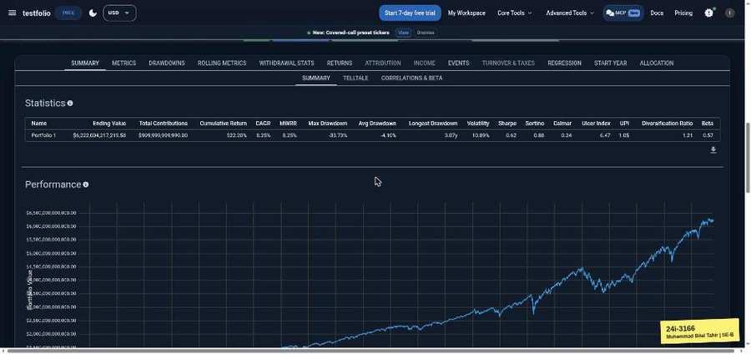

TC-BVA-008 | Starting Value | input: 1,000,000,000,000 | result: Pass
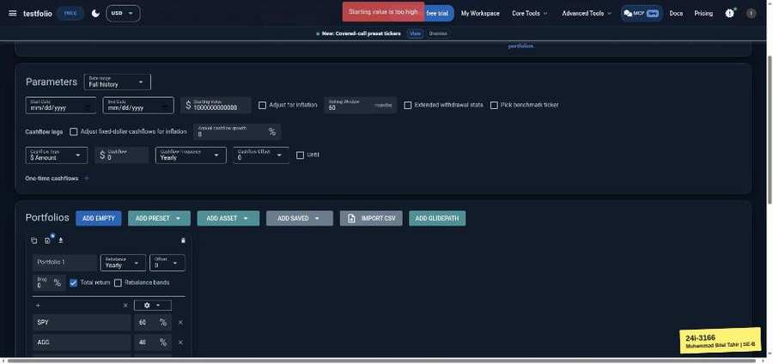

TC-BVA-009 | Rolling Window | input: 0 | result: Pass
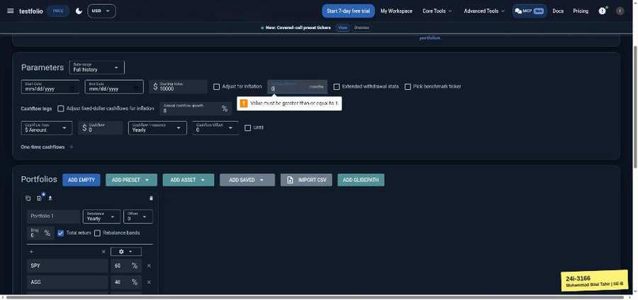

TC-BVA-010 | Rolling Window | input: 1 | result: Pass
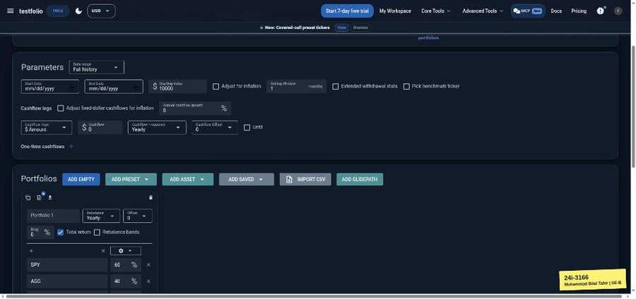 | 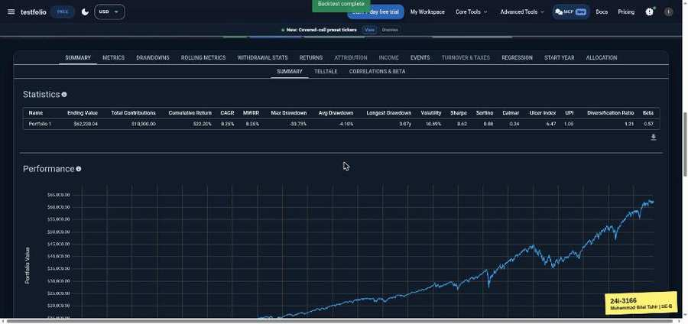

TC-BVA-011 | Rolling Window | input: 2 | result: Pass
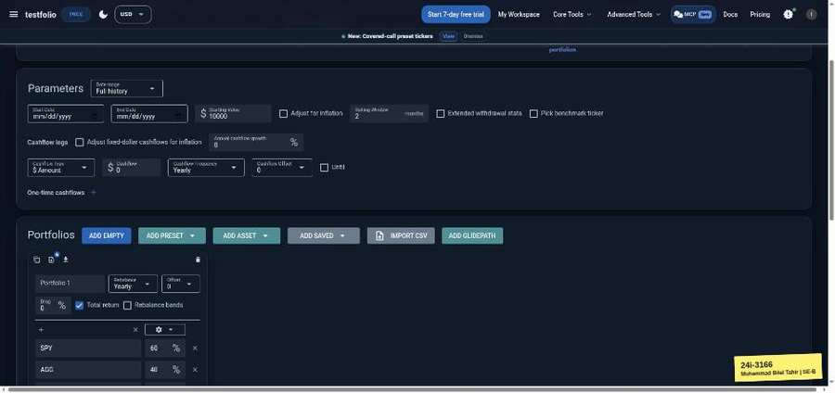 | 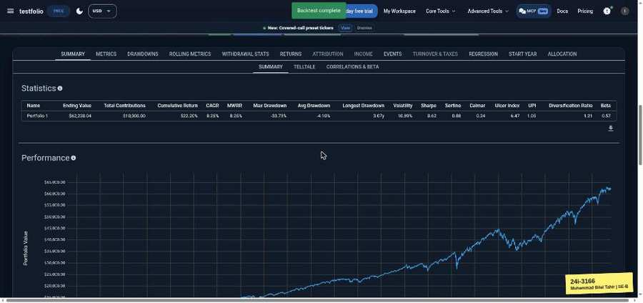

TC-BVA-012 | Rolling Window | input: 11998 | result: Pass
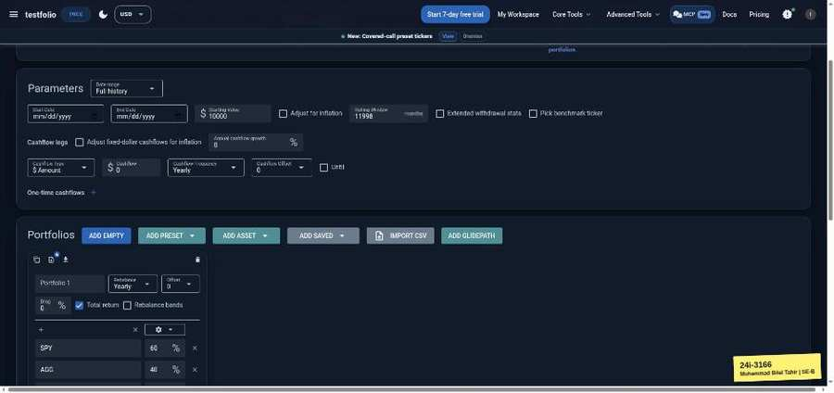 | 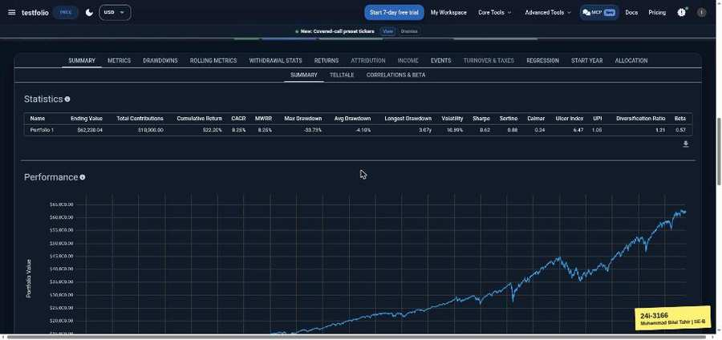

TC-BVA-013 | Rolling Window | input: 11999 | result: Pass
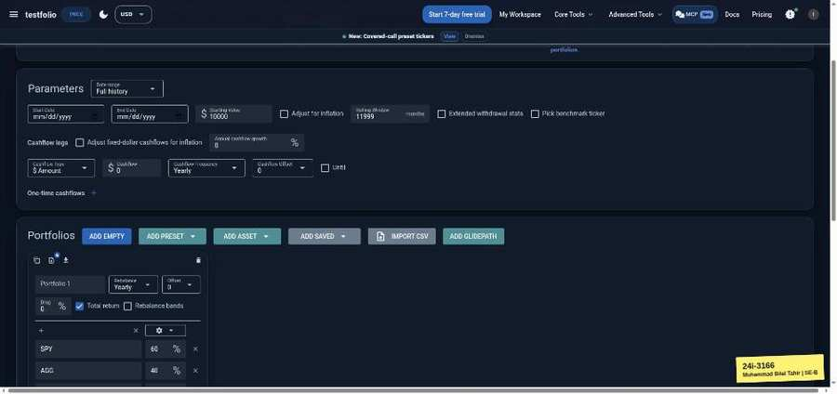

TC-BVA-014 | Rolling Window | input: 12000 | result: Pass
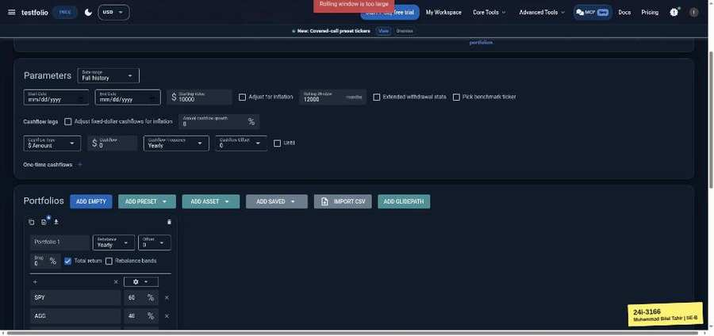

TC-BVA-015 | Annual cashflow growth | input: -100 | result: Pass
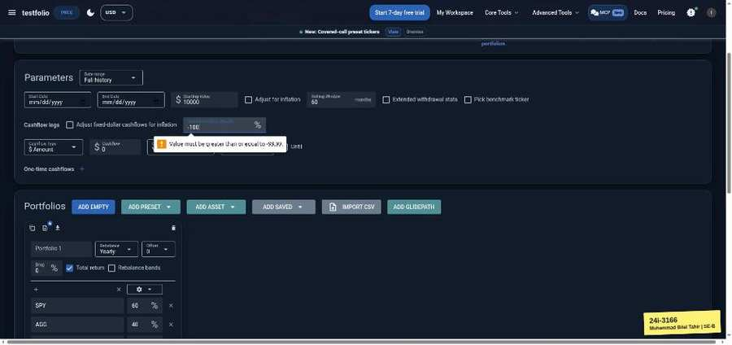

TC-BVA-016 | Annual cashflow growth | input: -99.99 | result: Pass
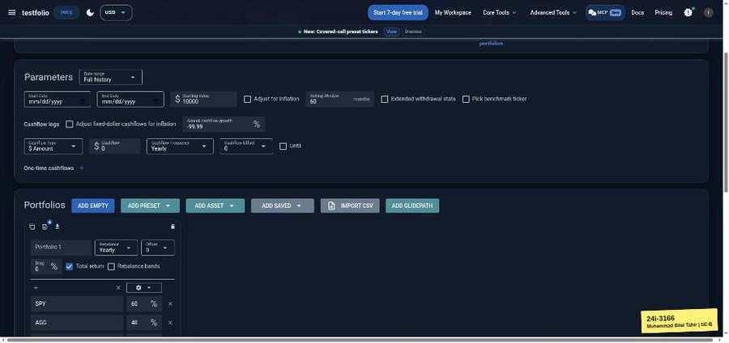

TC-BVA-017 | Annual cashflow growth | input: -99.98 | result: Pass
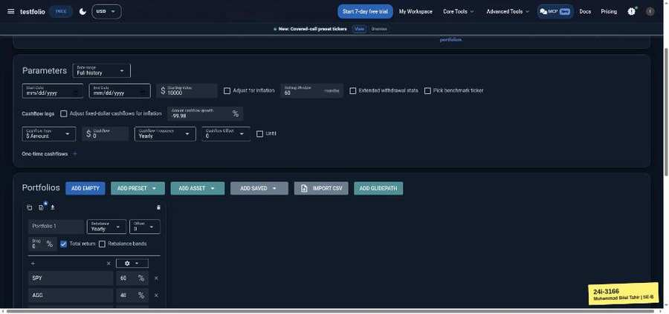 | 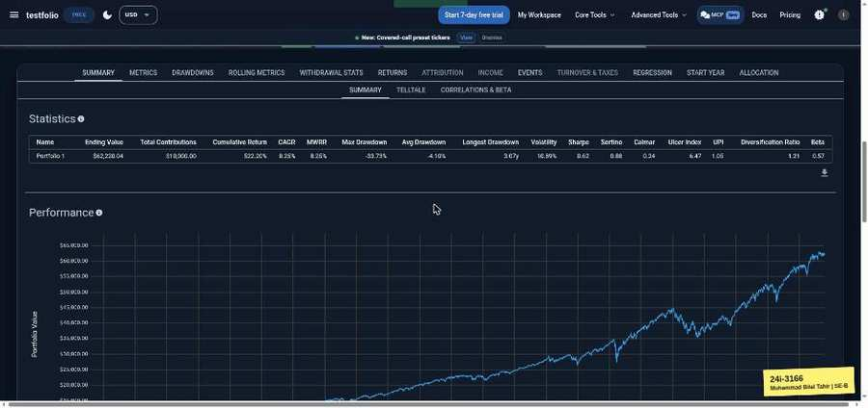

TC-BVA-018 | Annual cashflow growth | input: 99.99 | result: Pass
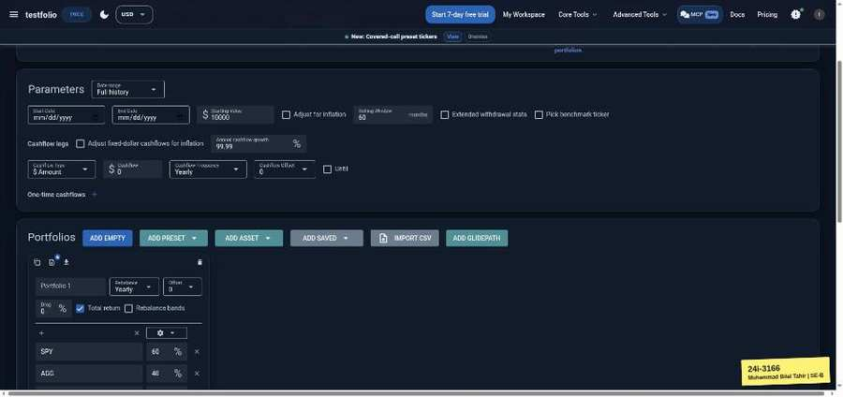

TC-BVA-019 | Annual cashflow growth | input: 100 | result: Pass
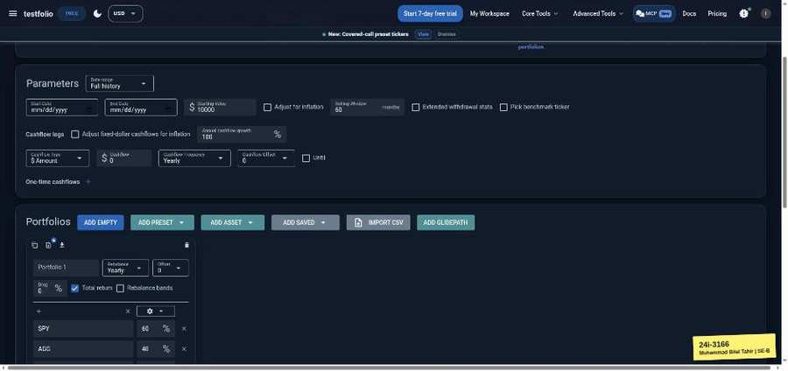 | 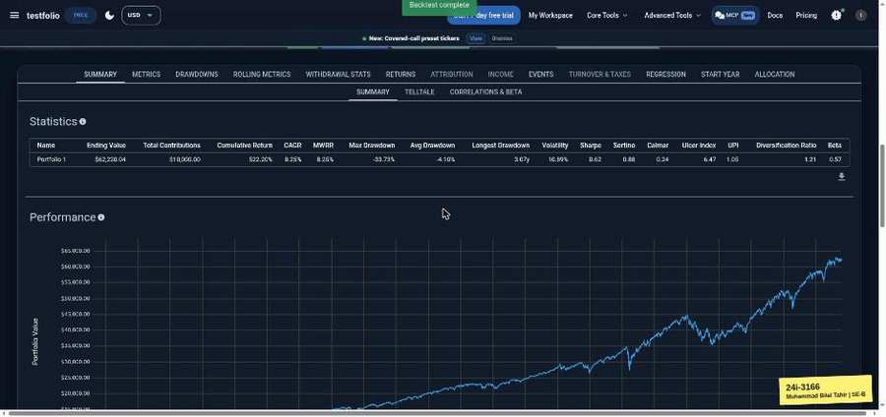

TC-BVA-020 | Annual cashflow growth | input: 100.01 | result: Pass
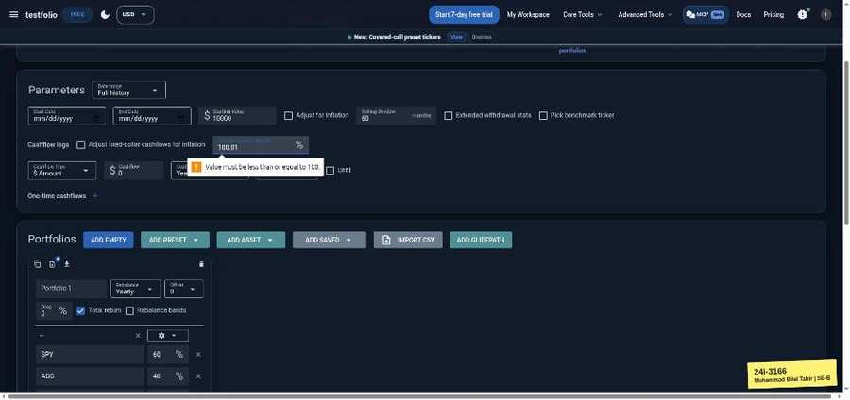

TC-BVA-021 | Allocation % (portfolio total) | input: 99.99 (60/39.99) | result: Pass
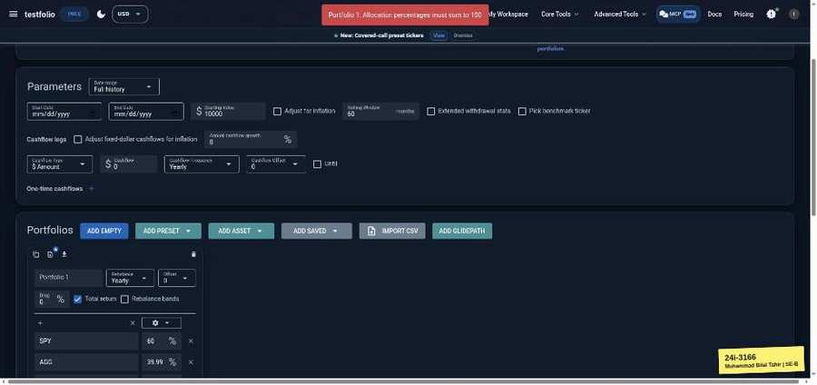

TC-BVA-022 | Allocation % (portfolio total) | input: 100 (60/40) | result: Pass
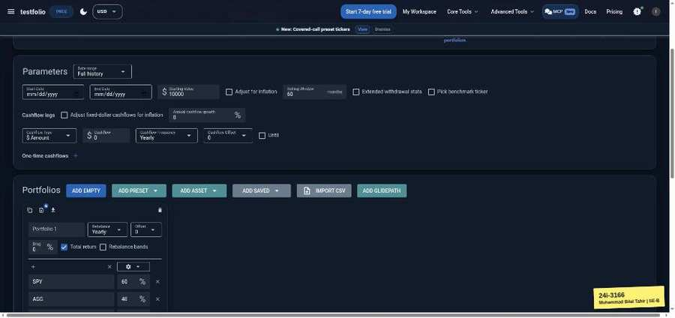 | 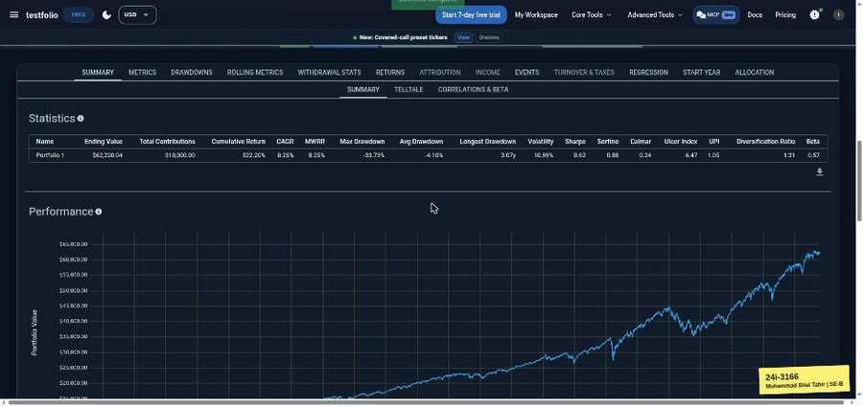

TC-BVA-023 | Allocation % (portfolio total) | input: 100.01 (60/40.01) | result: Pass
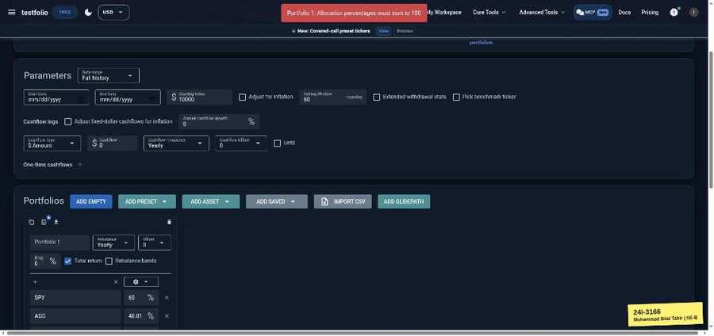

TC-BVA-024 | Start Date / End Date | input: end 2019-12-31 | result: Pass
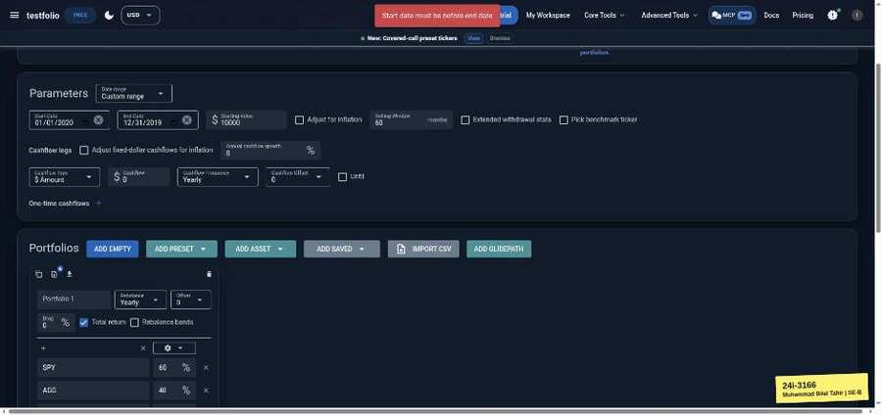

TC-BVA-025 | Start Date / End Date | input: end 2020-01-01 | result: Pass
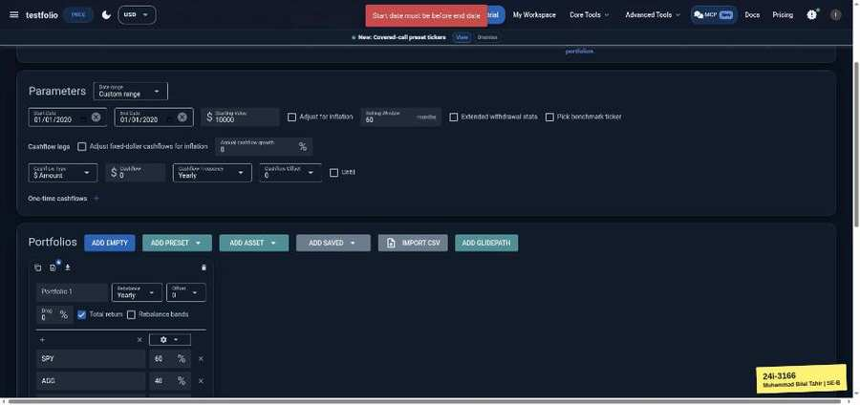

TC-BVA-026 | Start Date / End Date | input: end 2020-01-02 | result: Pass
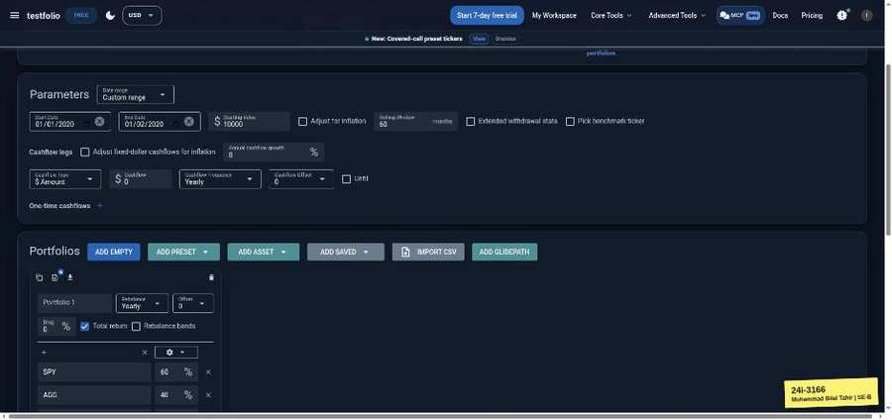 | 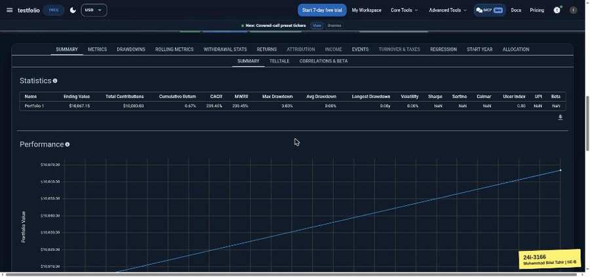

TC-BVA-027 | Drag (annual fee %) | input: -1 | result: Fail
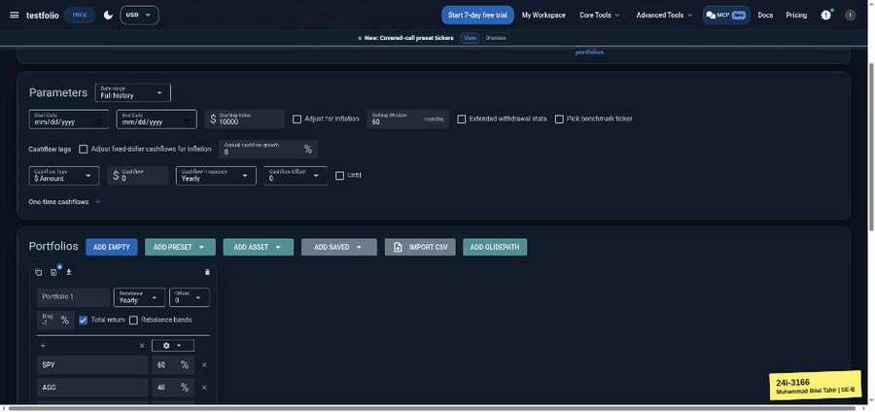 | 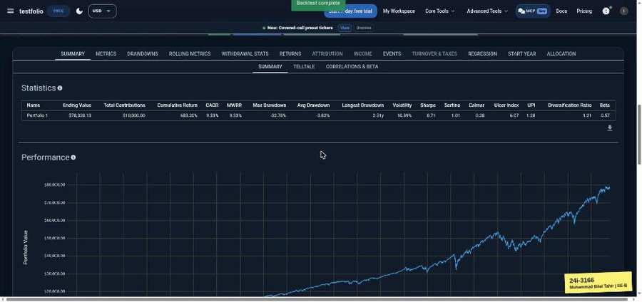

TC-BVA-028 | Drag (annual fee %) | input: 0 | result: Pass
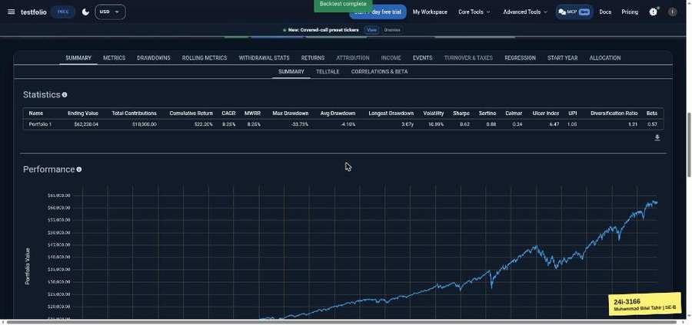

TC-BVA-029 | Drag (annual fee %) | input: 1 | result: Pass
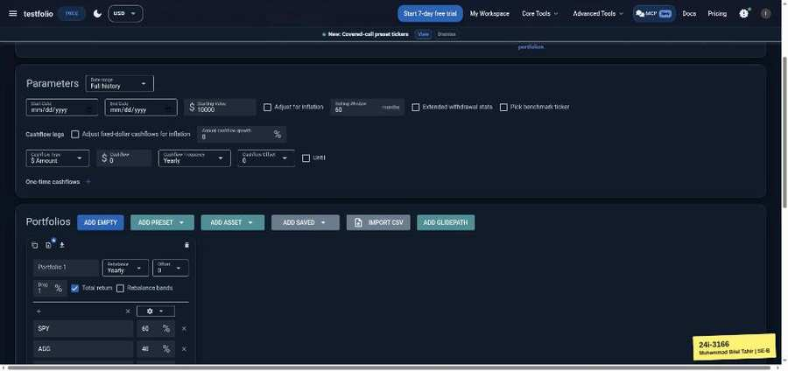 | 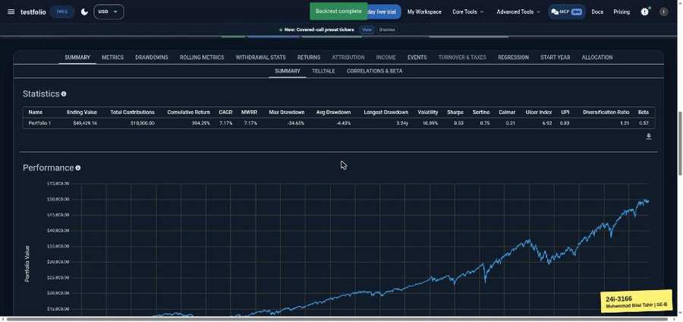

TC-BVA-030 | Drag (annual fee %) | input: 99 | result: Pass
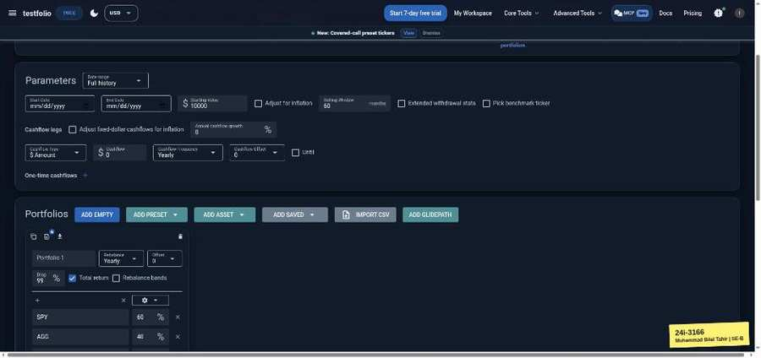 | 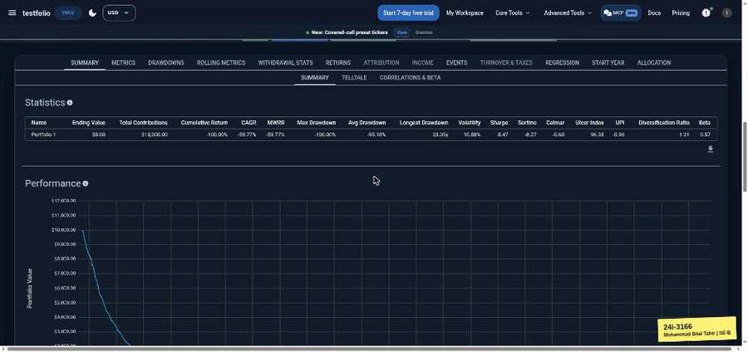

TC-BVA-031 | Drag (annual fee %) | input: 100 | result: Pass
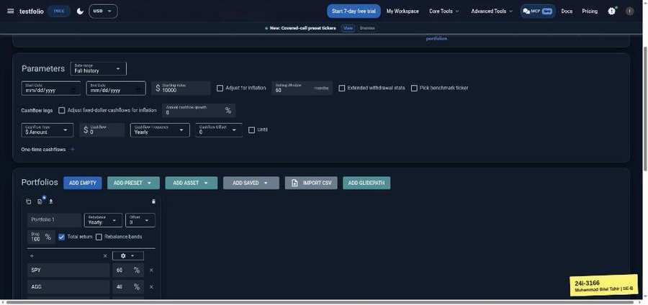 | 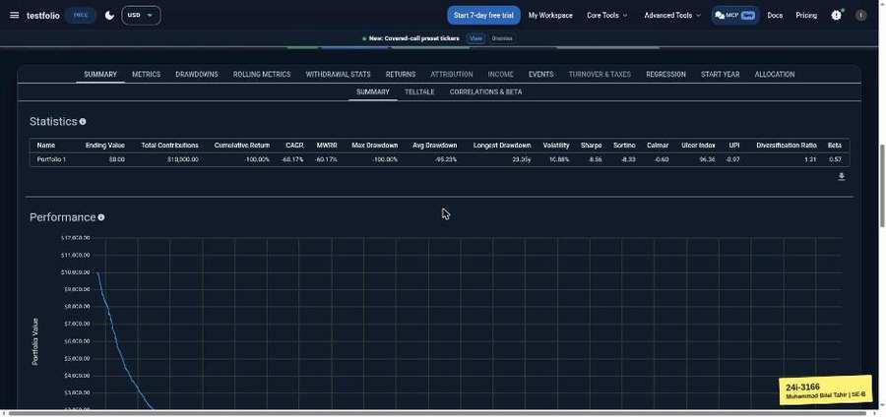

TC-BVA-032 | Drag (annual fee %) | input: 101 | result: Fail
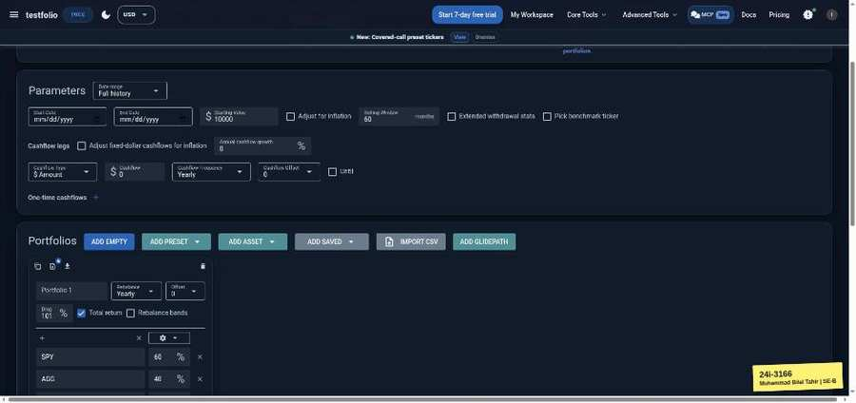 | 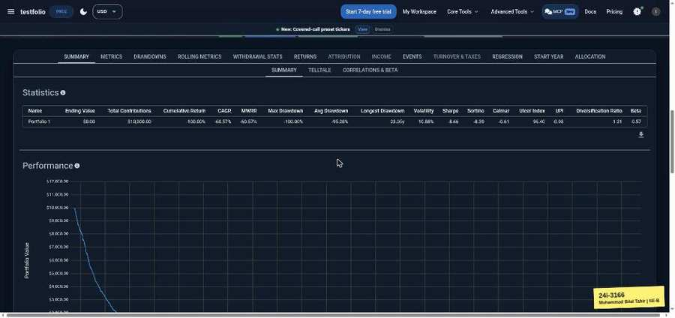

Monte Carlo Simulator (testfol.io/monte-carlo)
TC-BVA-033 | Number of years | input: 0 | result: Pass
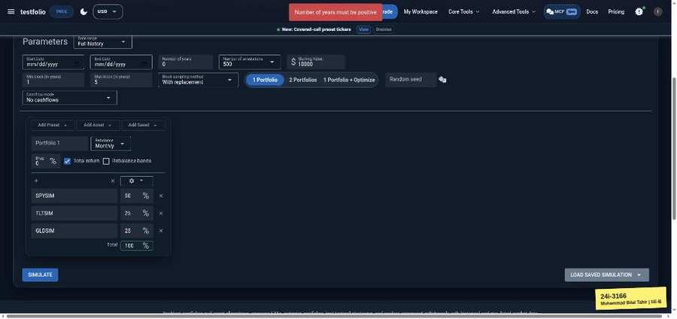

TC-BVA-034 | Number of years | input: 1 | result: Pass
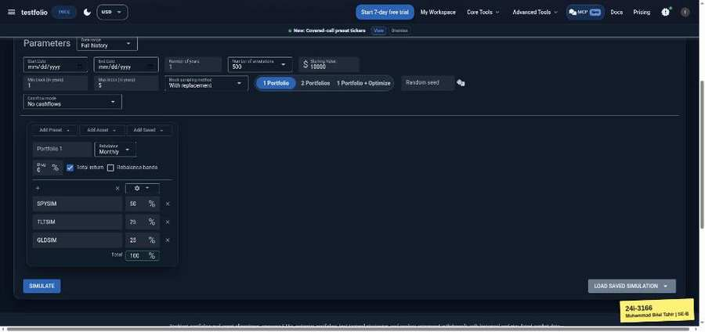 | 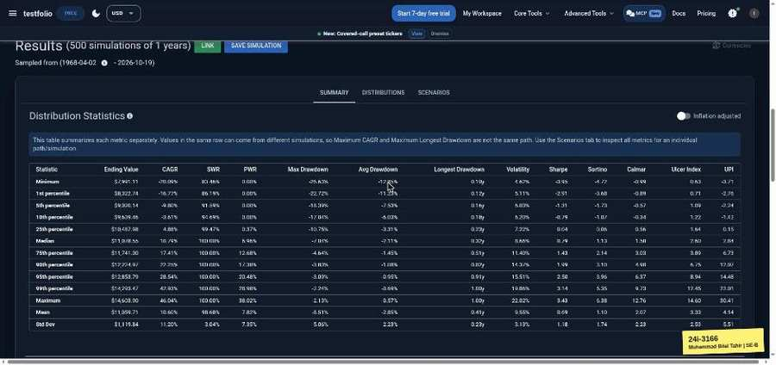

TC-BVA-035 | Number of years | input: 15 | result: Pass
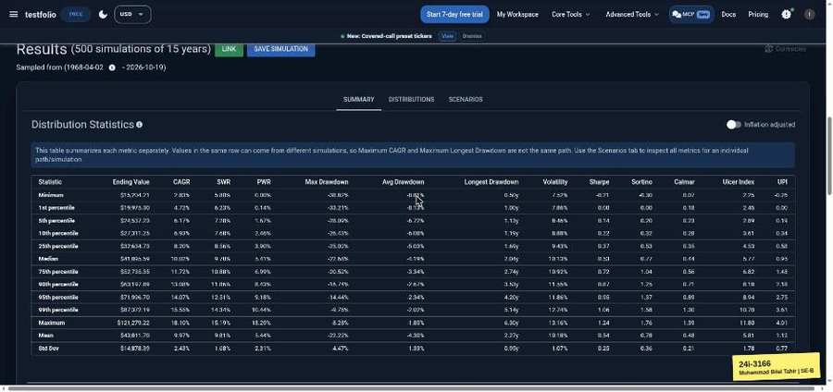

TC-BVA-036 | Number of years | input: 16 | result: Pass
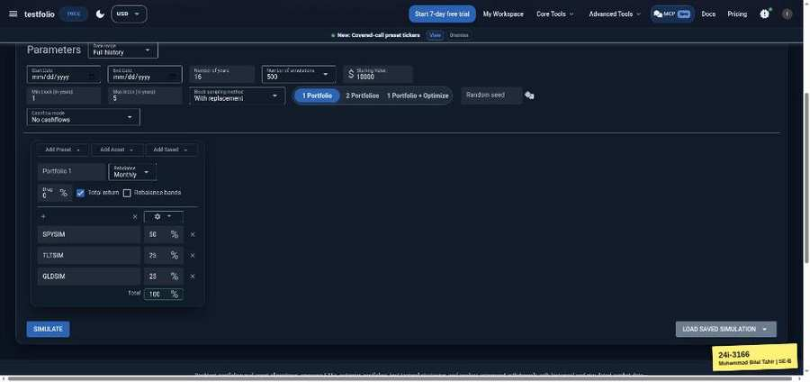 | 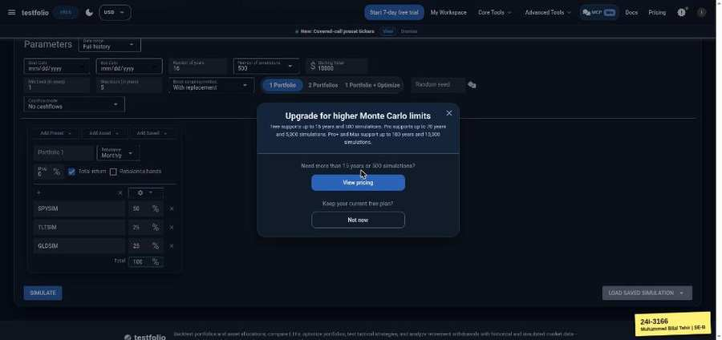

TC-BVA-037 | Number of years | input: 100 | result: Pass
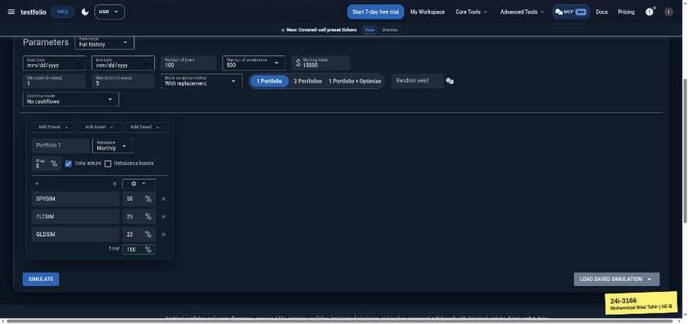 | 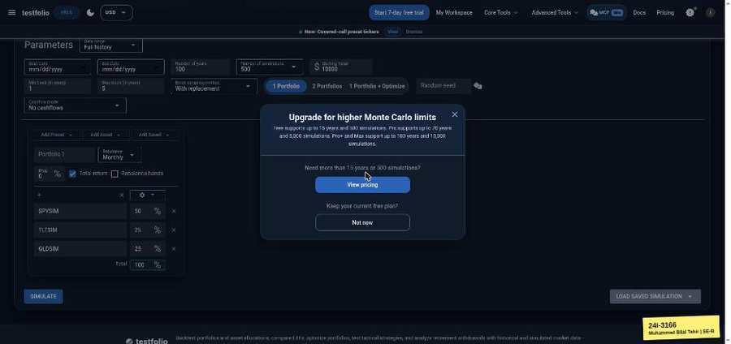

TC-BVA-038 | Number of years | input: 101 | result: Pass
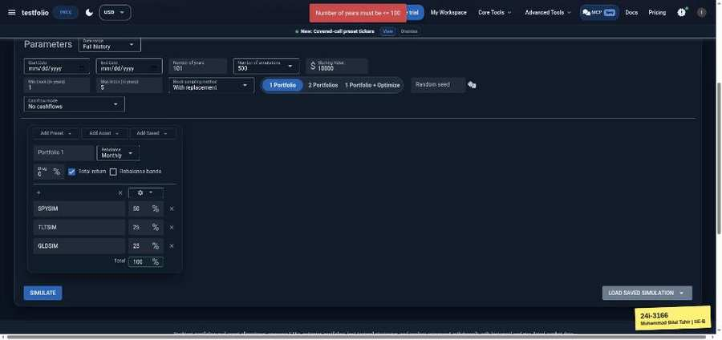

TC-BVA-039 | Starting Value | input: 0 | result: Pass

TC-BVA-040 | Starting Value | input: 1 | result: Pass
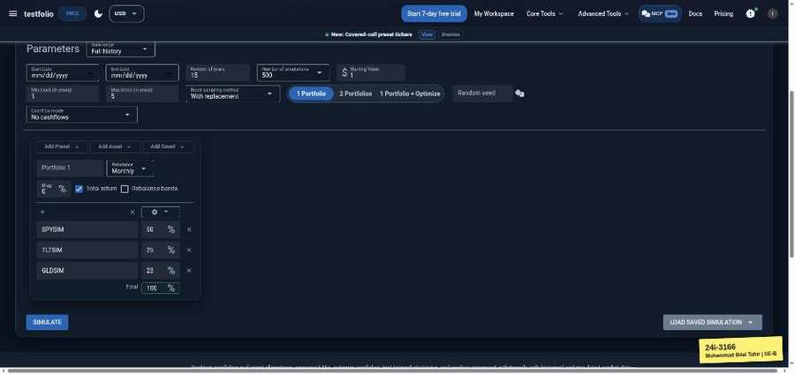 | 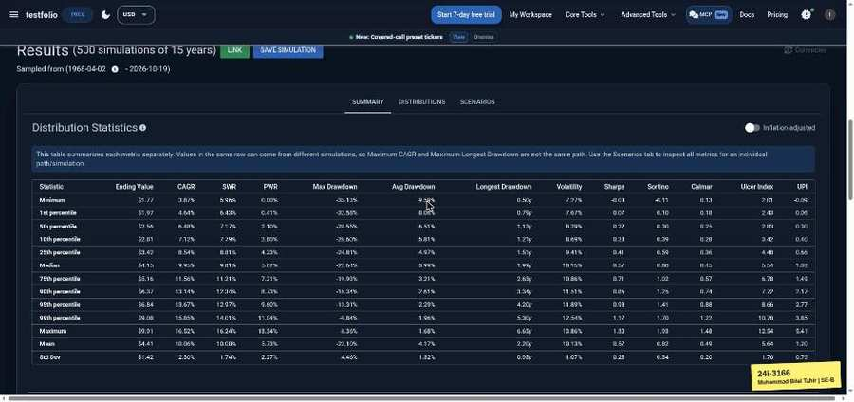

TC-BVA-041 | Min block (years) | input: 0.04 | result: Fail
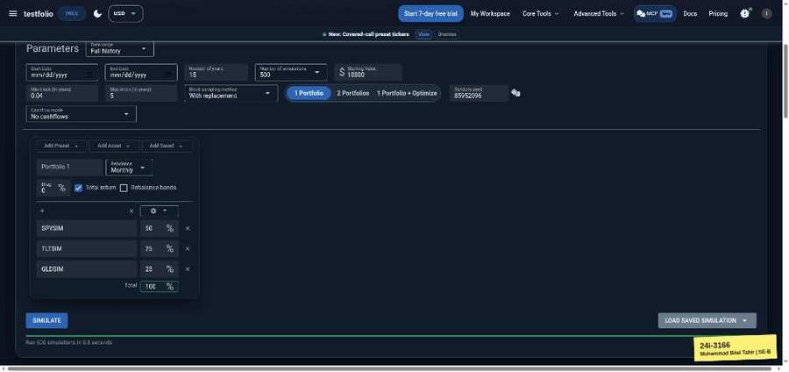

TC-BVA-042 | Min block (years) | input: 0.05 | result: Pass
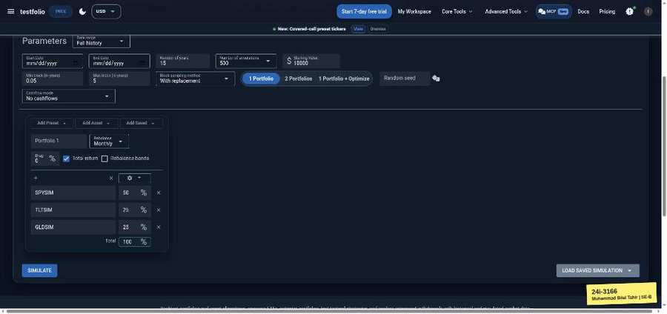 | 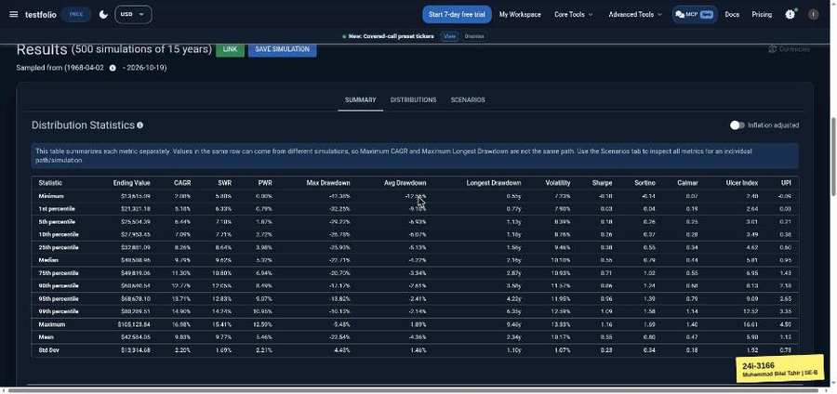

TC-BVA-043 | Max block (years) | input: 20 | result: Pass
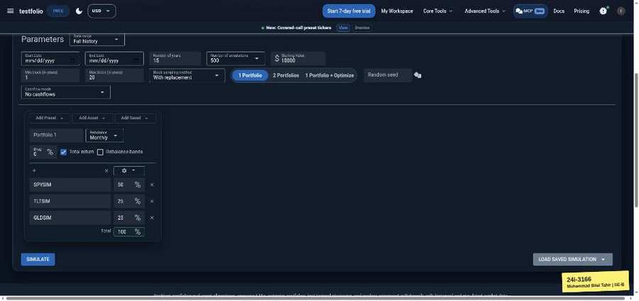 | 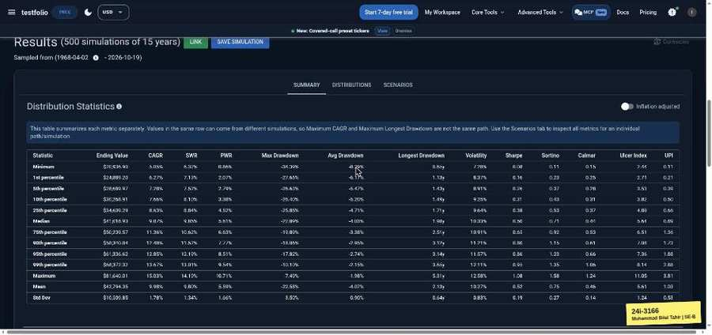

TC-BVA-044 | Max block (years) | input: 21 | result: Pass
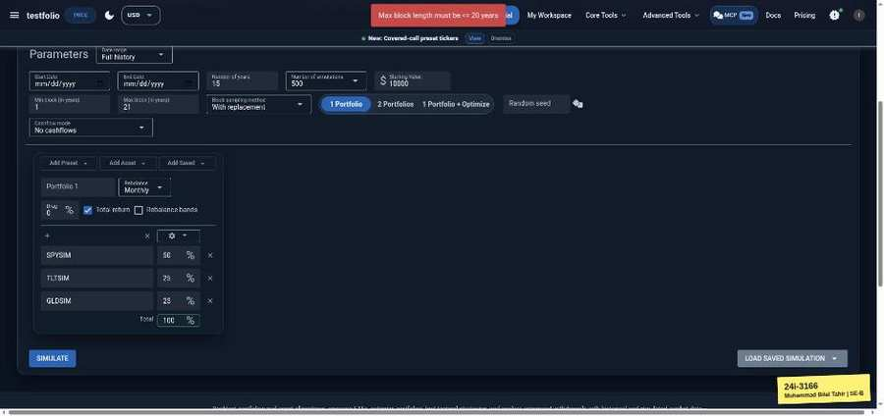

TC-BVA-045 | Random seed | input: -1 | result: Fail
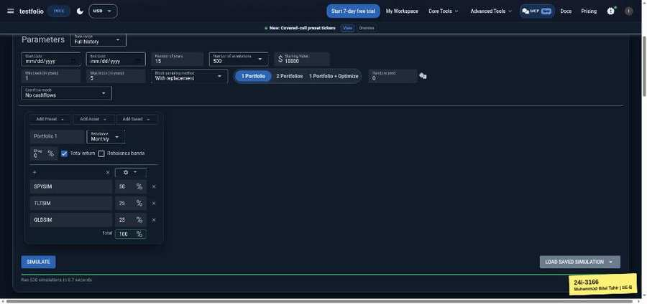

TC-BVA-046 | Random seed | input: 0 | result: Pass
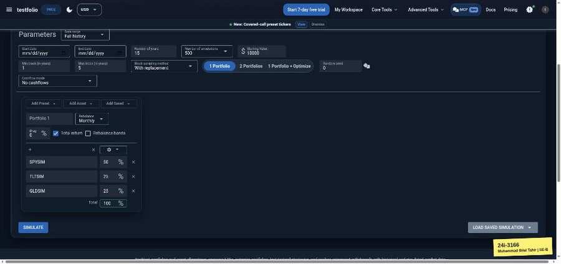 | 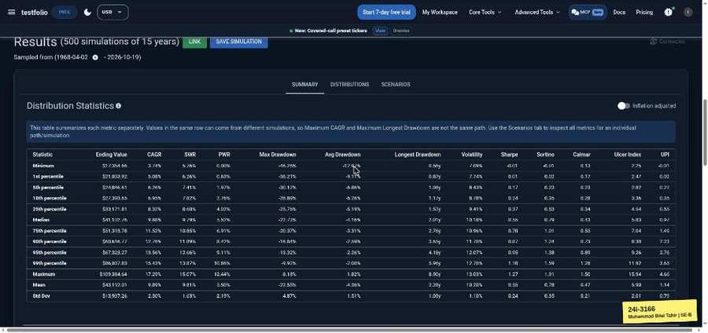

Safe Withdrawal Rate Calculator (testfol.io/safe-withdrawal-rate-calculator)
TC-BVA-047 | Retirement horizon (years) | input: 0 | result: Pass
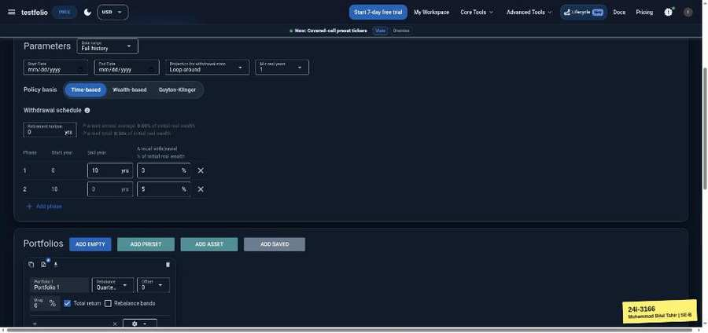

TC-BVA-048 | Retirement horizon (years) | input: 2 (Phase 1 end 1) | result: Pass
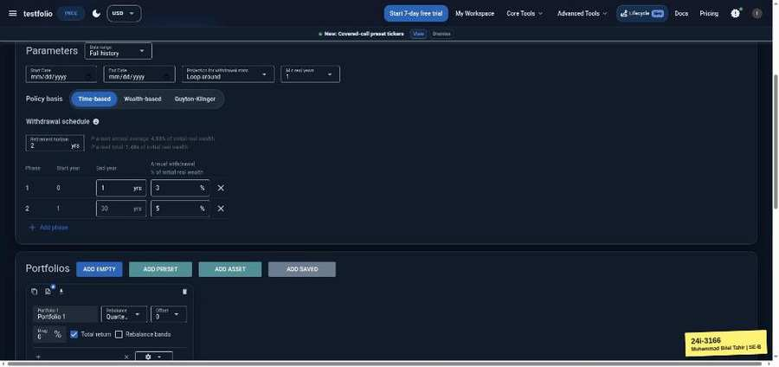 | 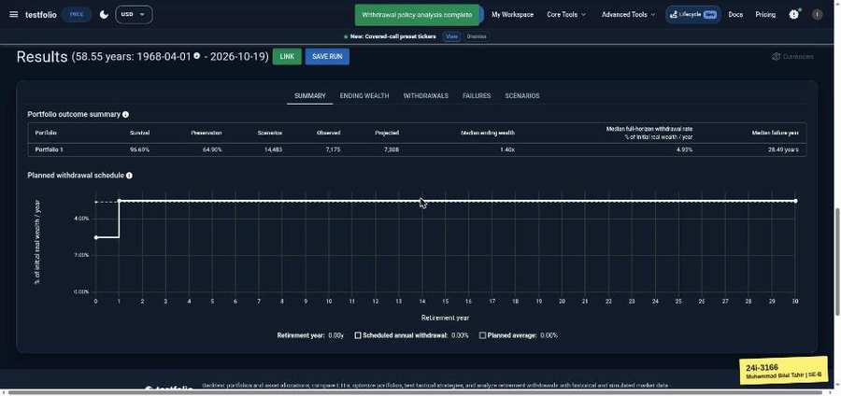

TC-BVA-049 | Retirement horizon (years) | input: 50 | result: Pass
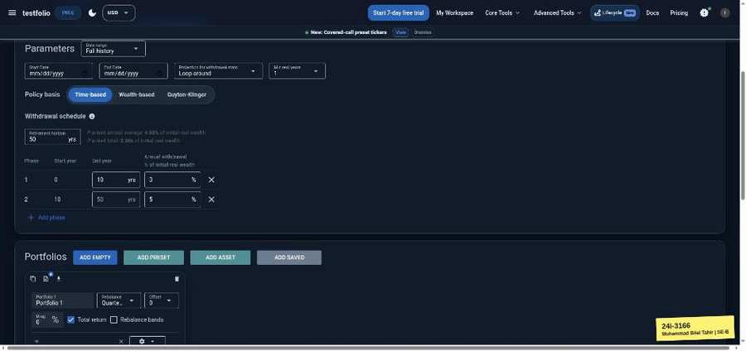 | 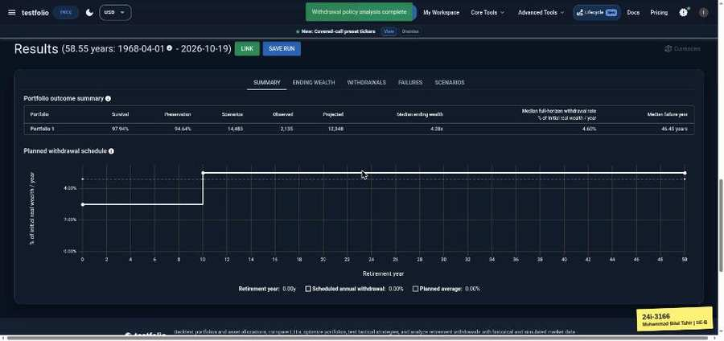

TC-BVA-050 | Retirement horizon (years) | input: 51 | result: Pass
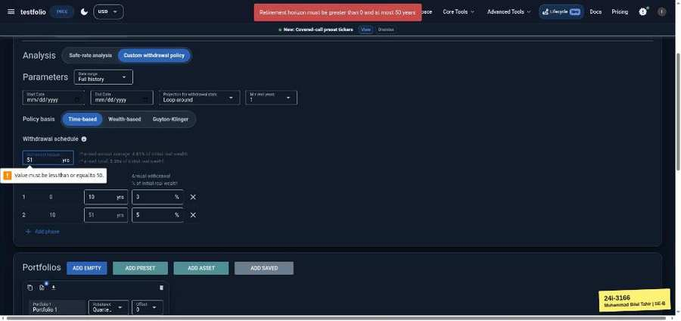

TC-BVA-051 | Phase 1 end year | input: 0 | result: Pass
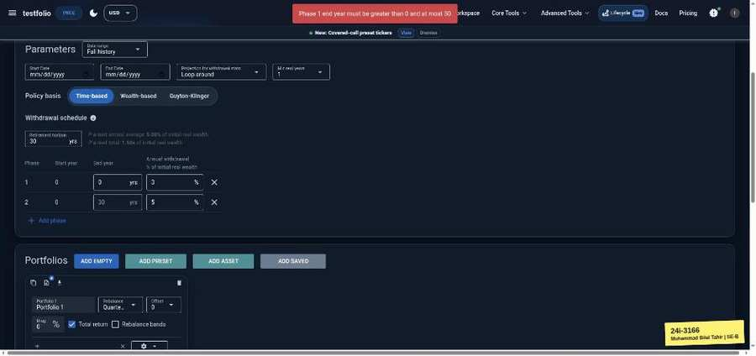

TC-BVA-052 | Phase 1 end year | input: 1 | result: Pass
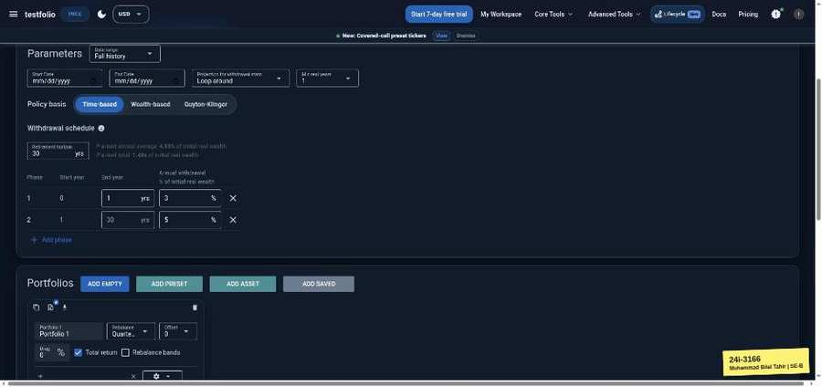 | 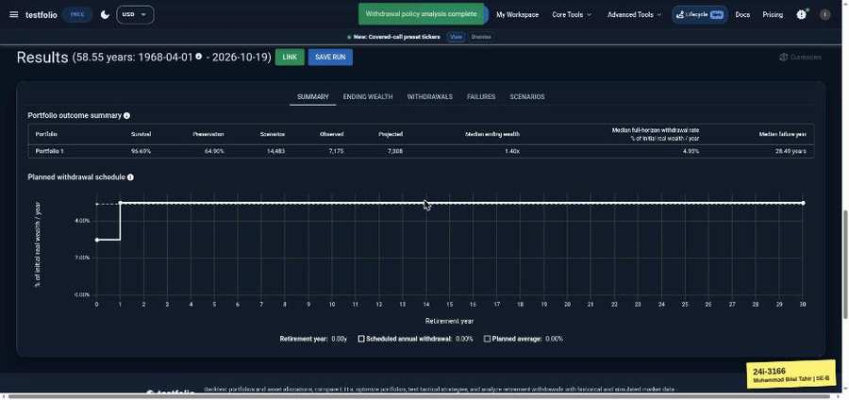

TC-BVA-053 | Phase 1 end year | input: 29 | result: Pass
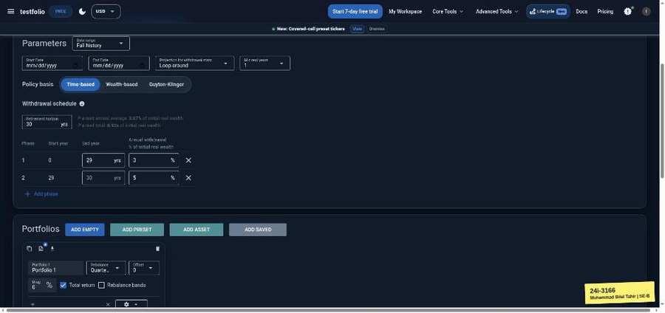 | 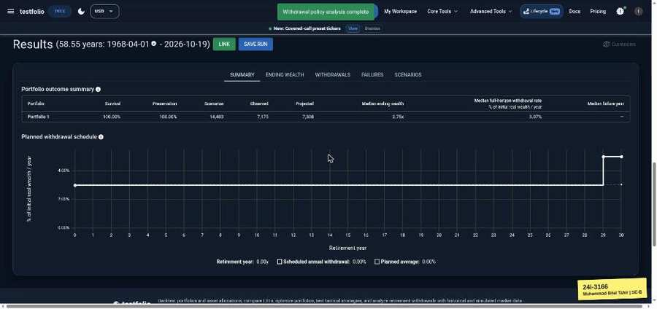

TC-BVA-054 | Phase 1 end year | input: 30 | result: Pass
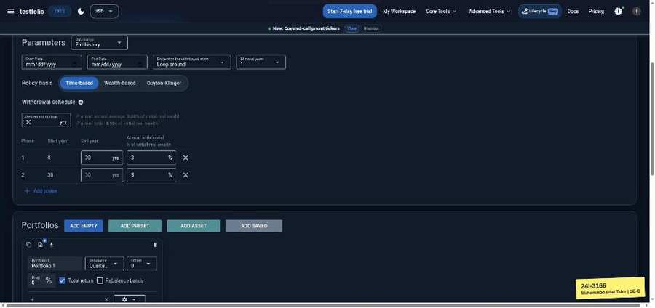

TC-BVA-055 | Phase 1 annual withdrawal % | input: -1 | result: Pass
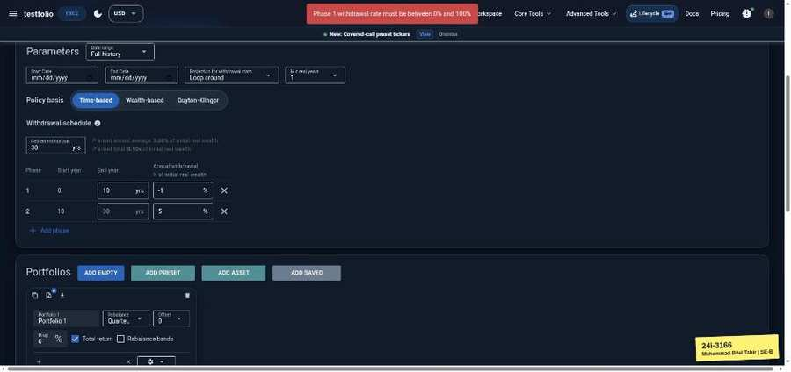

TC-BVA-056 | Phase 1 annual withdrawal % | input: 0 | result: Pass
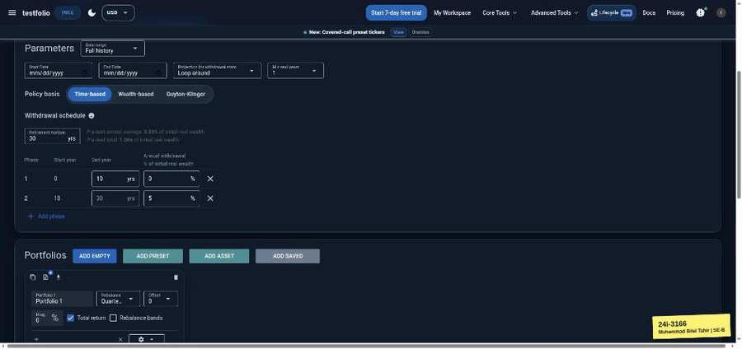 | 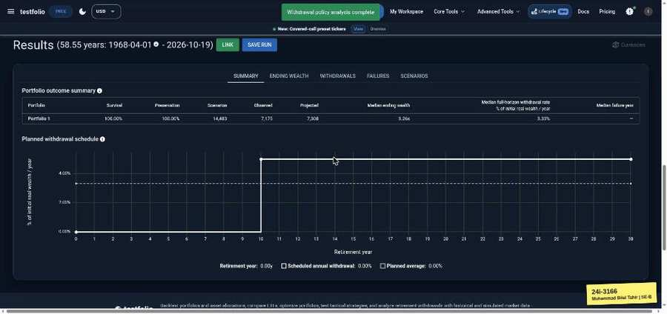

TC-BVA-057 | Phase 1 annual withdrawal % | input: 100 | result: Pass
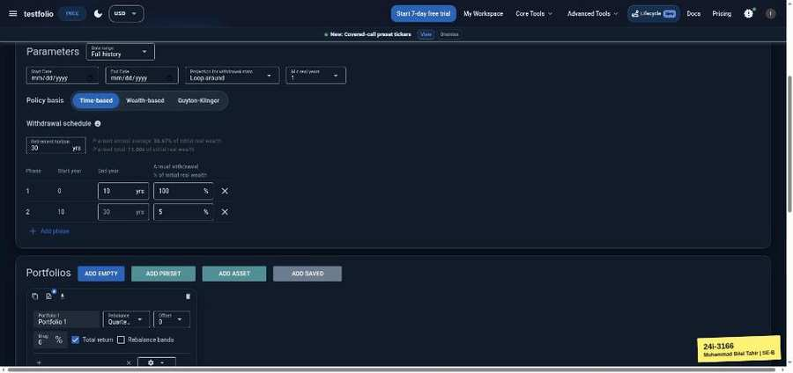 | 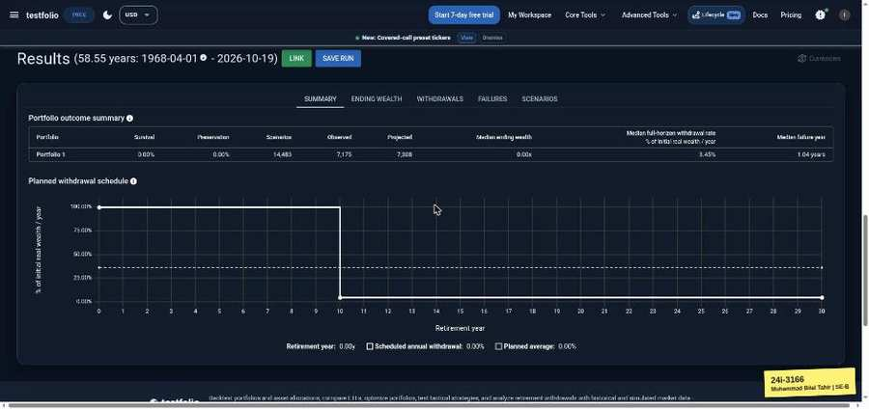

TC-BVA-058 | Phase 1 annual withdrawal % | input: 101 | result: Pass
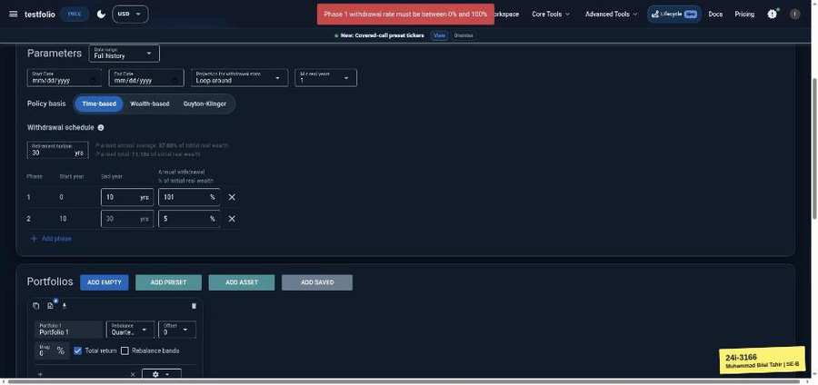

TC-BVA-059 | Phase 2 annual withdrawal % | input: -1 | result: Pass
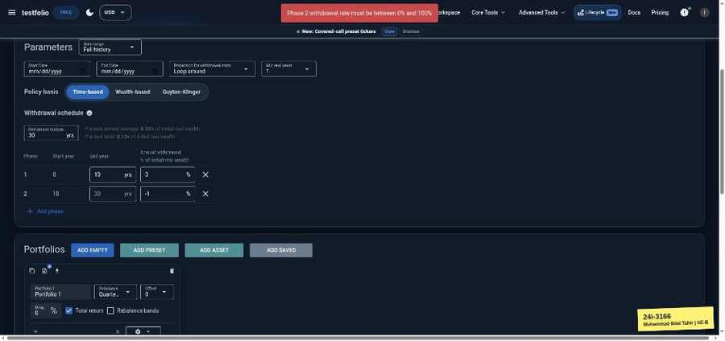

TC-BVA-060 | Phase 2 annual withdrawal % | input: 0 | result: Pass
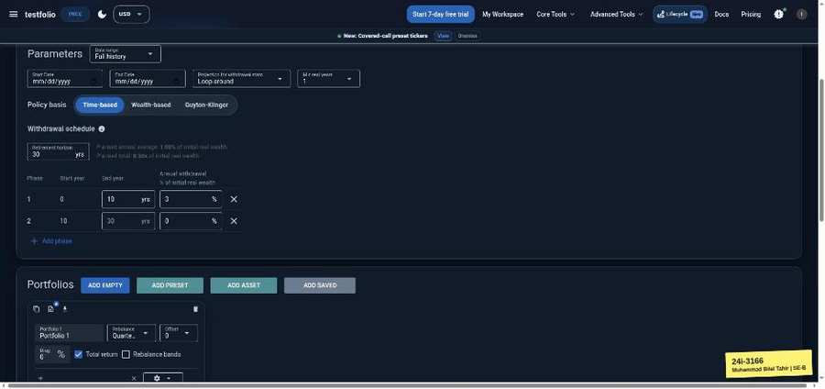 | 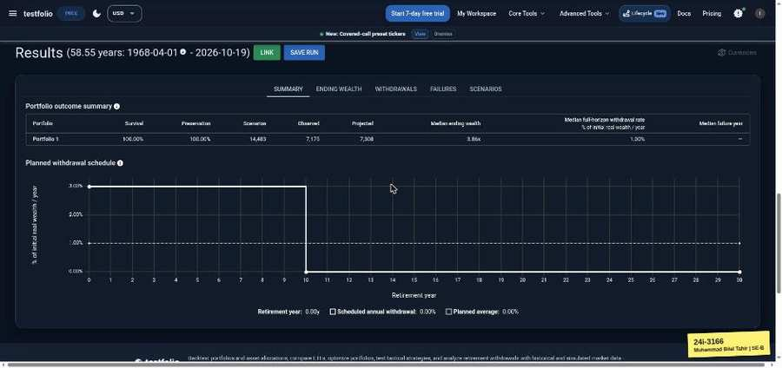

TC-BVA-061 | Phase 2 annual withdrawal % | input: 100 | result: Pass
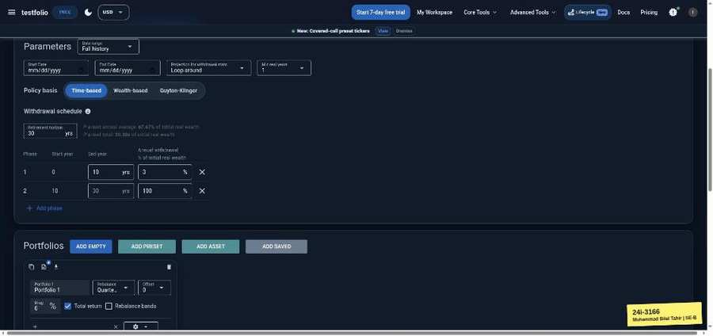 | 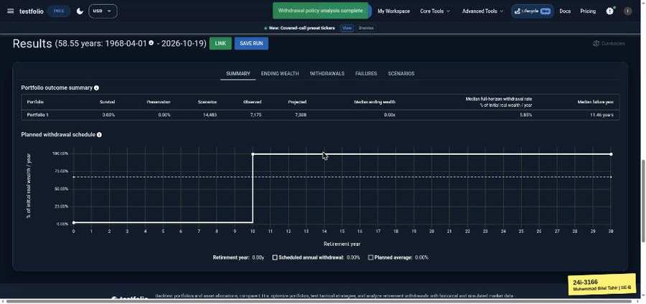

TC-BVA-062 | Phase 2 annual withdrawal % | input: 101 | result: Pass
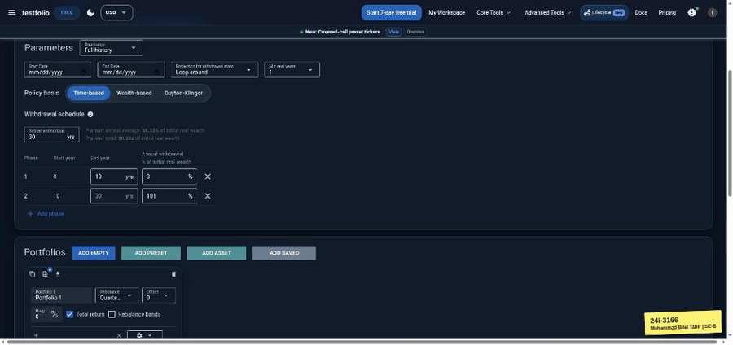

Backtest Optimizer (testfol.io/backtest-optimizer)
TC-BVA-063 | Starting Value | input: 0 | result: Pass
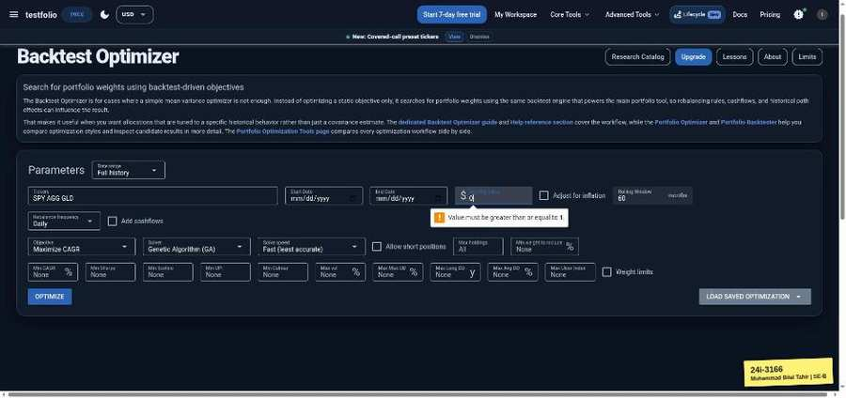

TC-BVA-064 | Starting Value | input: 1 | result: Pass
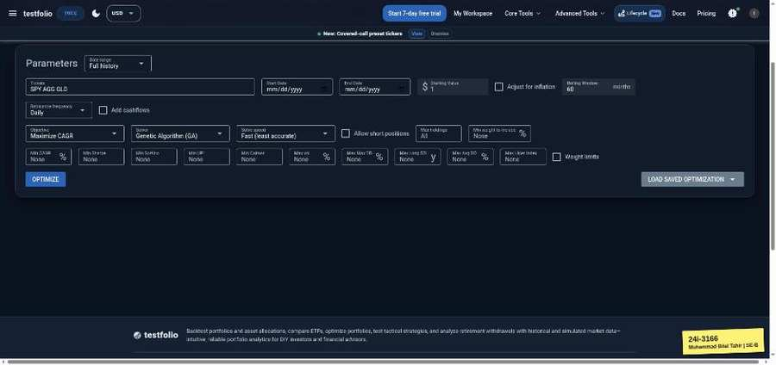 | 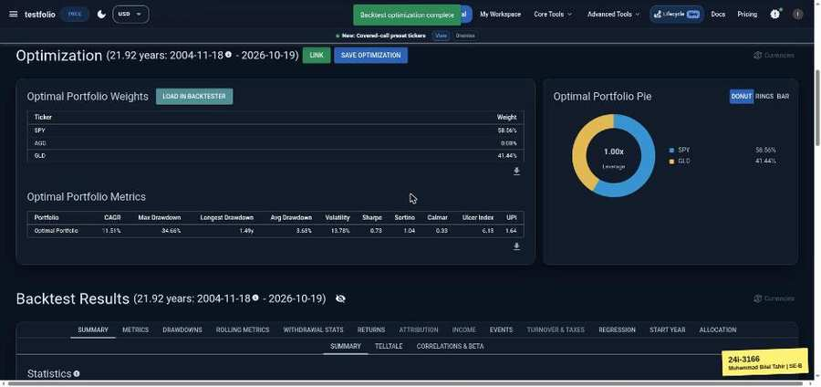

TC-BVA-065 | Rolling Window | input: 0 | result: Pass
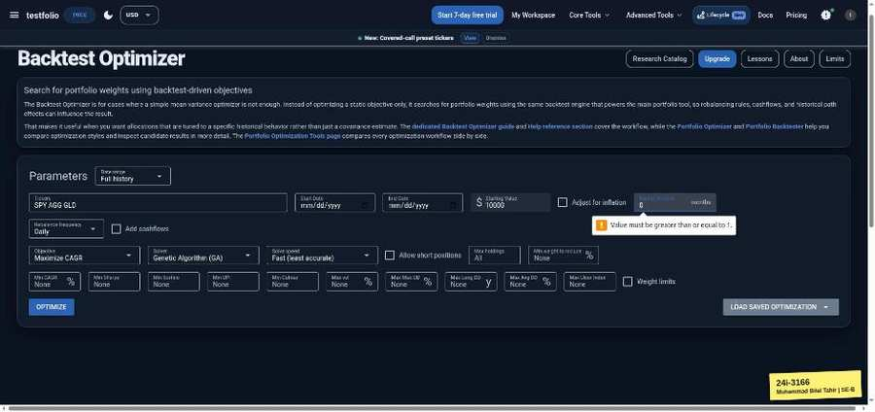

TC-BVA-066 | Rolling Window | input: 1 | result: Pass
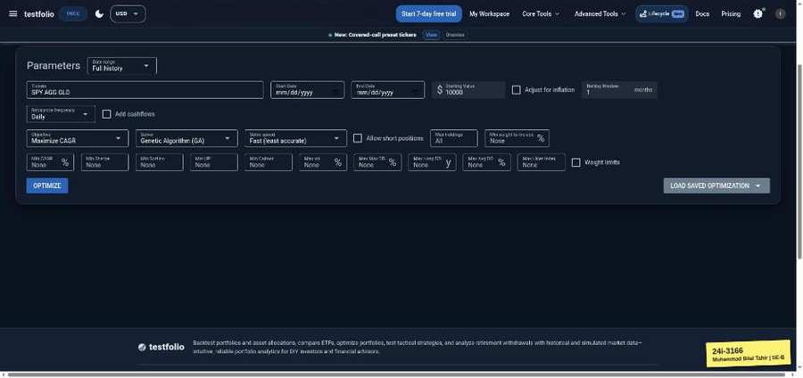 | 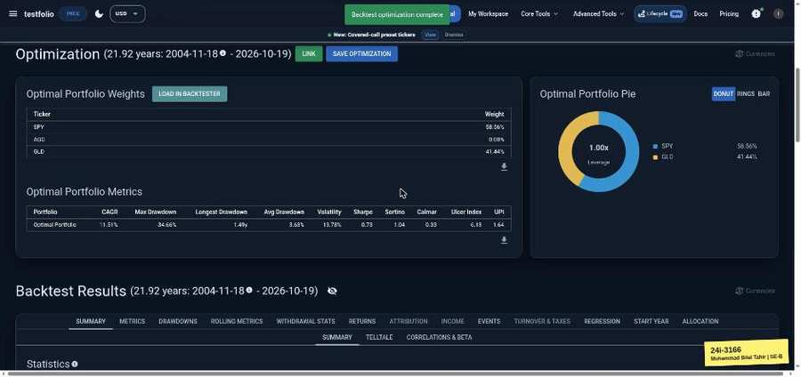

TC-BVA-067 | Max holdings | input: 0 | result: Pass
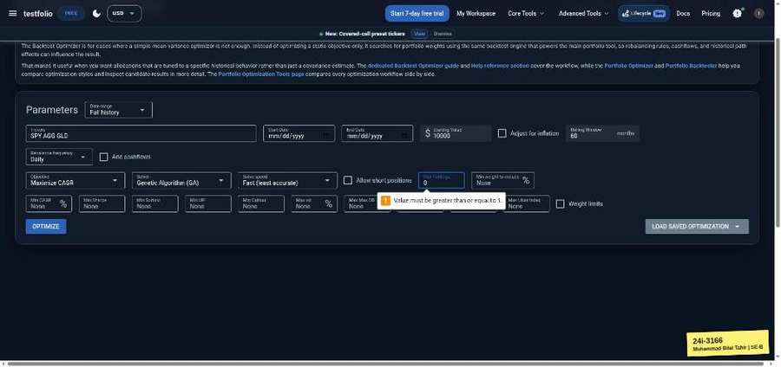

TC-BVA-068 | Max holdings | input: 1 | result: Pass
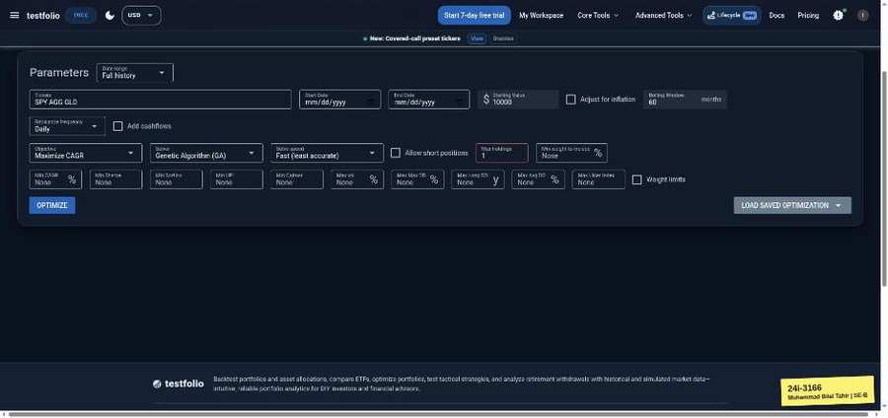 | 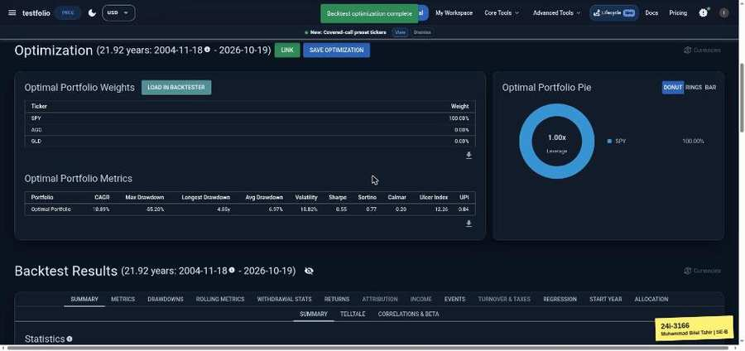

TC-BVA-069 | Min weight to include (%) | input: -1 | result: Pass
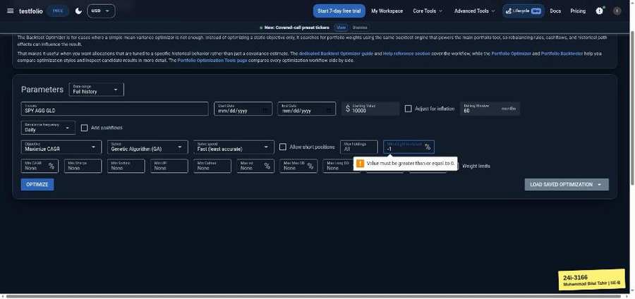

TC-BVA-070 | Min weight to include (%) | input: 0 | result: Pass
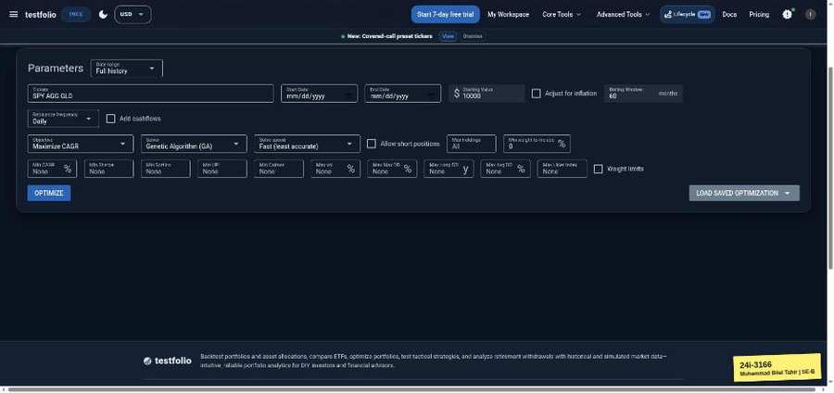 | 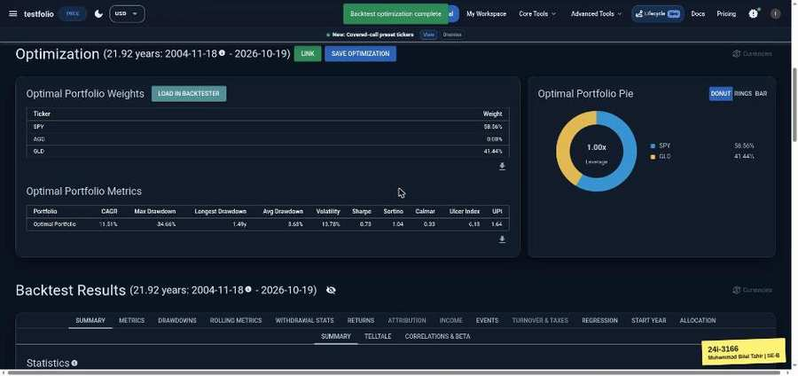

TC-BVA-071 | Min weight to include (%) | input: 100 | result: Pass
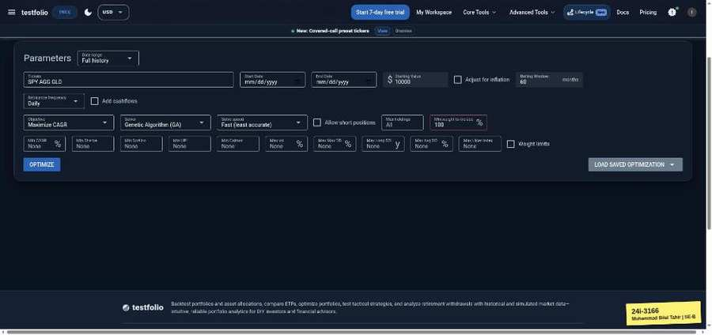 | 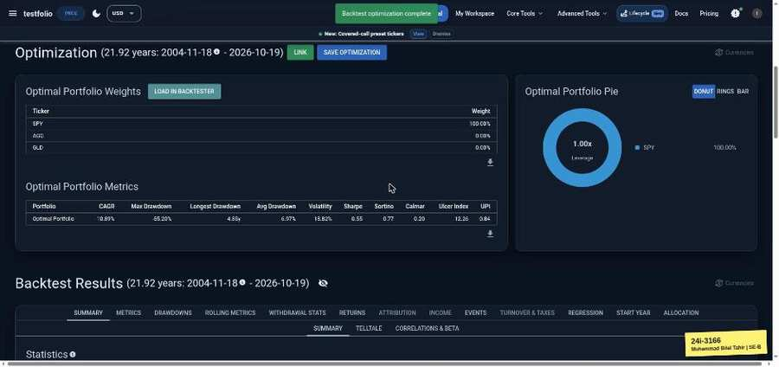

TC-BVA-072 | Min weight to include (%) | input: 101 | result: Pass
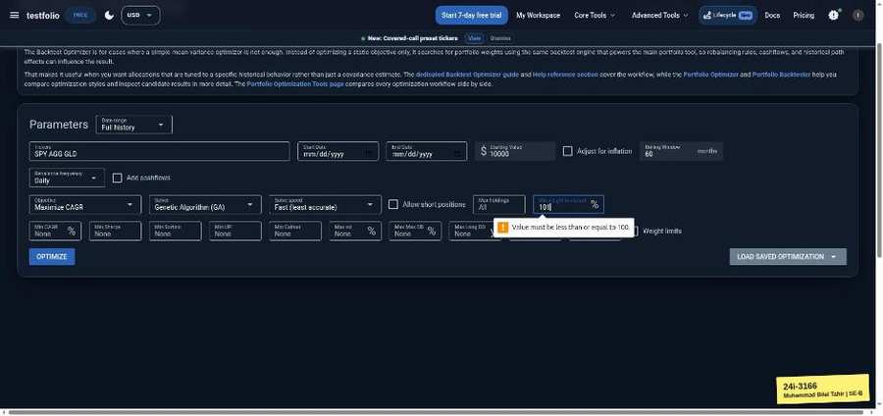

TC-BVA-073 | Max vol (%) | input: -1 | result: Pass
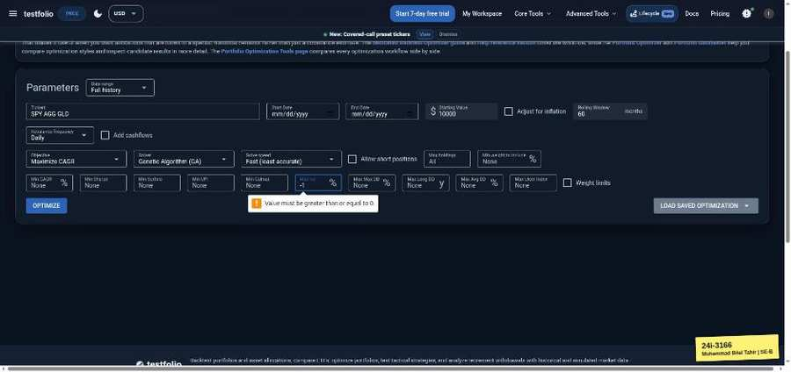

TC-BVA-074 | Max vol (%) | input: 0 | result: Pass
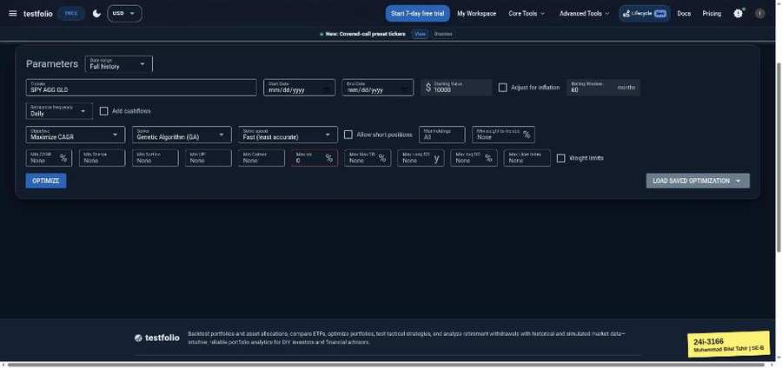 | 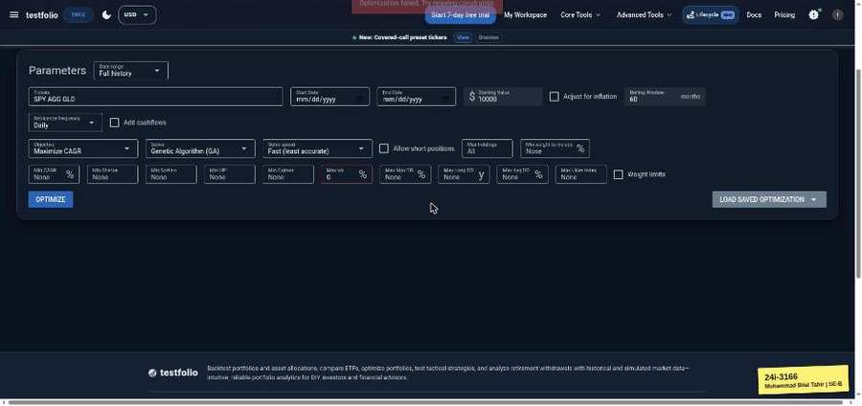

TC-BVA-075 | Tickers | input: 1 ticker (SPY) | result: Pass
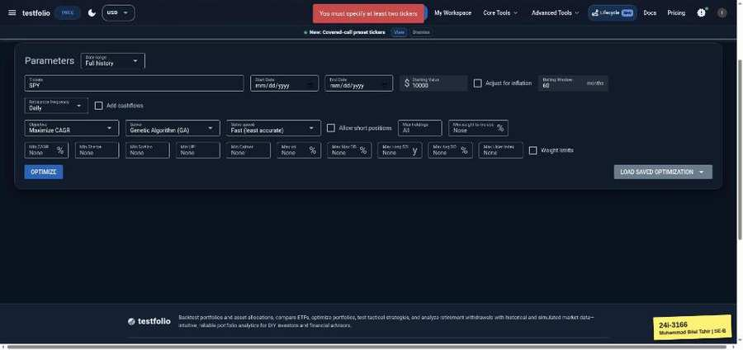

TC-BVA-076 | Tickers | input: 2 tickers (SPY AGG) | result: Pass
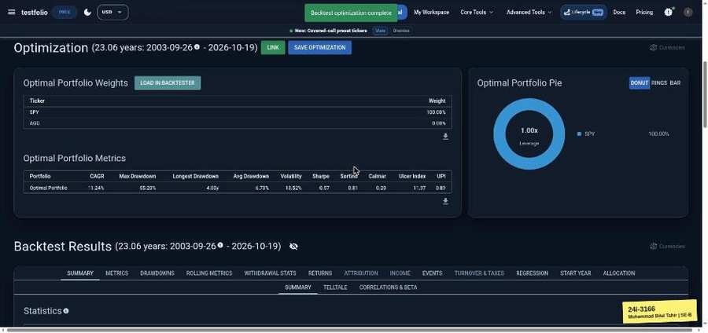

Efficient Frontier (testfol.io/efficient-frontier)
TC-BVA-077 | Tickers | input: 1 ticker (SPY) | result: Pass
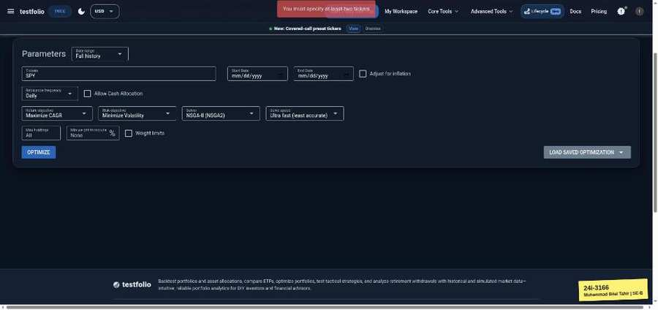

TC-BVA-078 | Tickers | input: 2 tickers (SPY AGG) | result: Pass
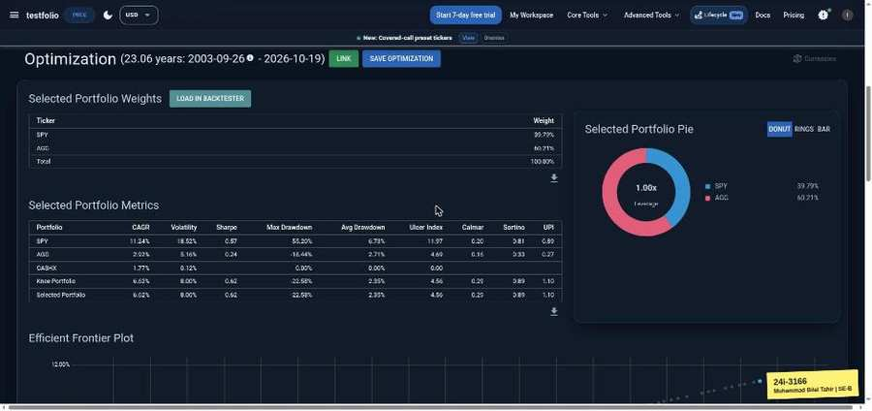

TC-BVA-079 | Tickers | input: 2 tickers (SPY AGG) | result: Pass
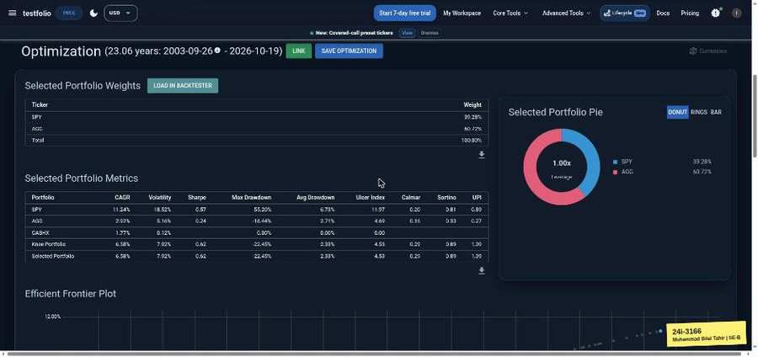

TC-BVA-080 | Tickers | input: 3 tickers (SPY AGG GLD) | result: Pass

TC-BVA-081 | Max holdings | input: 0 | result: Pass
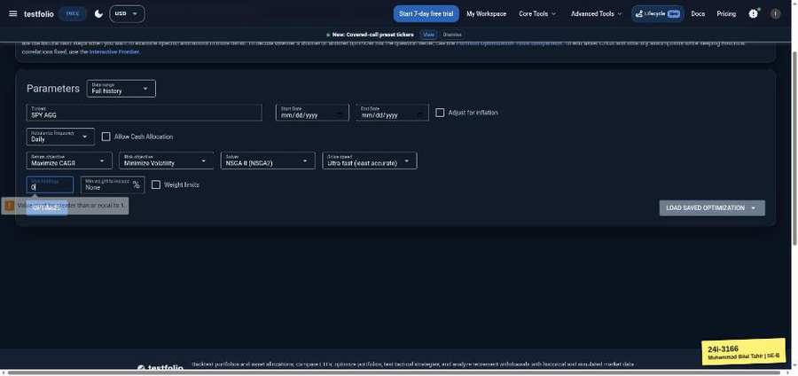

TC-BVA-082 | Max holdings | input: 1 | result: Pass
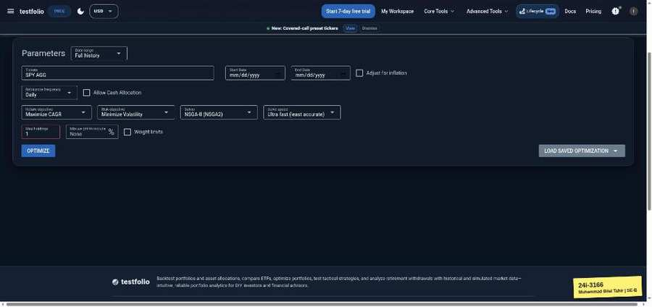 | 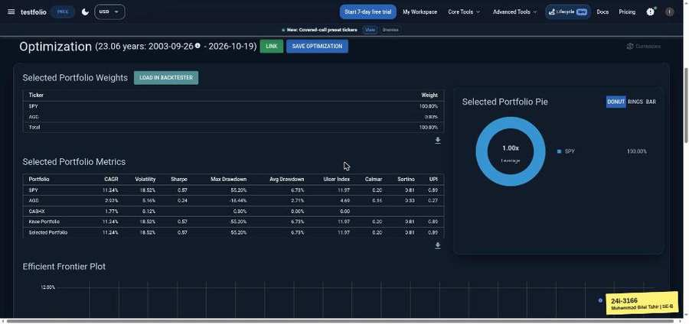

TC-BVA-083 | Min weight to include (%) | input: -1 | result: Pass
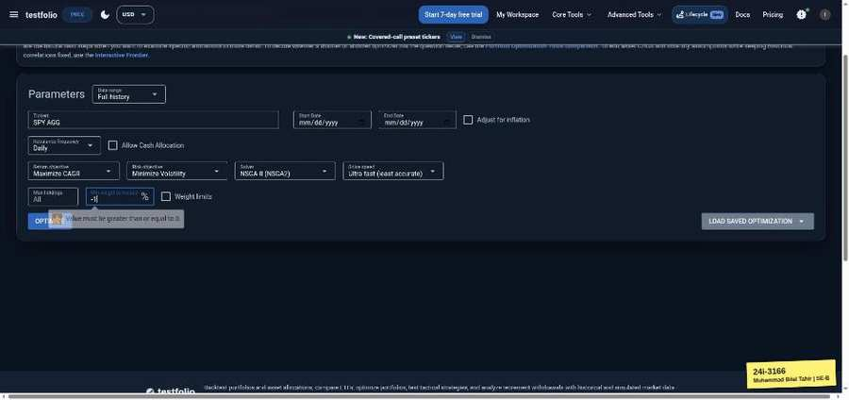

TC-BVA-084 | Min weight to include (%) | input: 0 | result: Pass
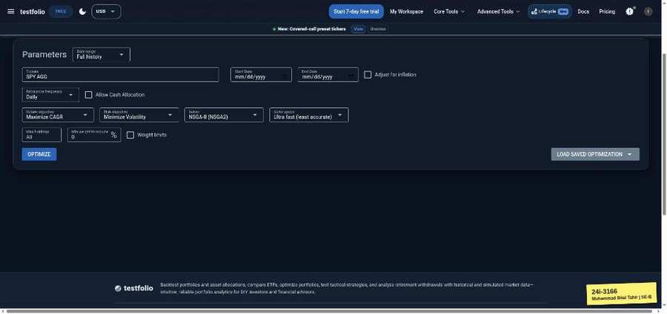 | 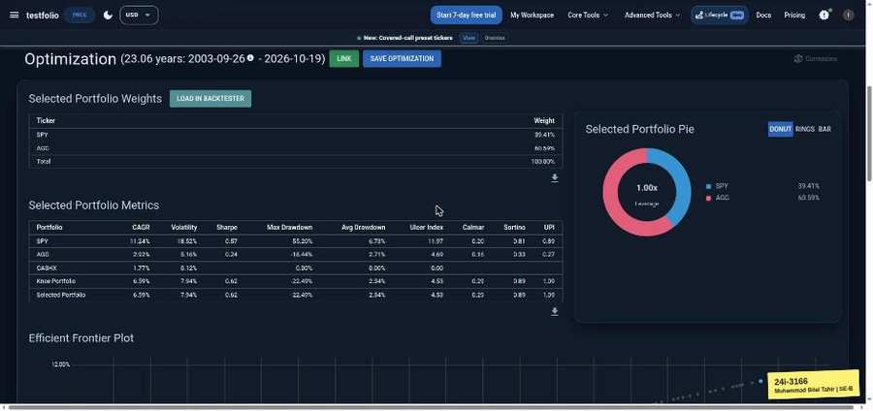

TC-BVA-085 | Min weight to include (%) | input: 100 | result: Pass
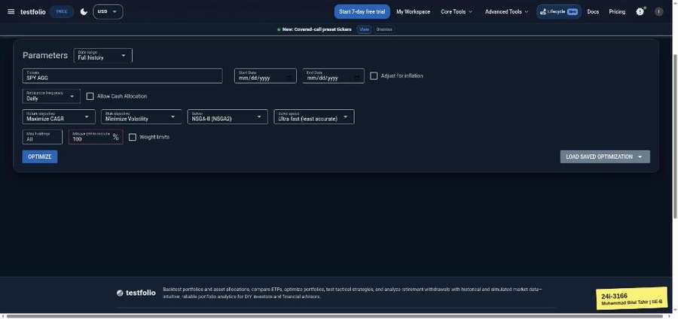 | 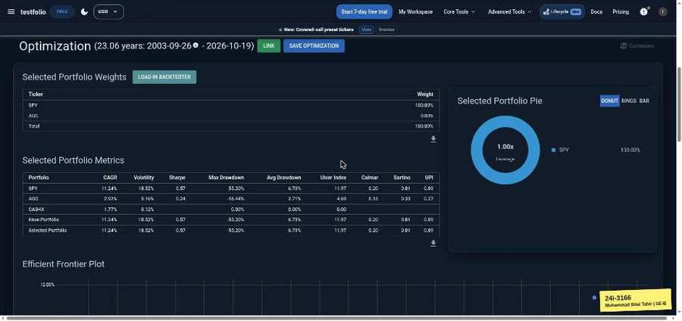

TC-BVA-086 | Min weight to include (%) | input: 101 | result: Pass
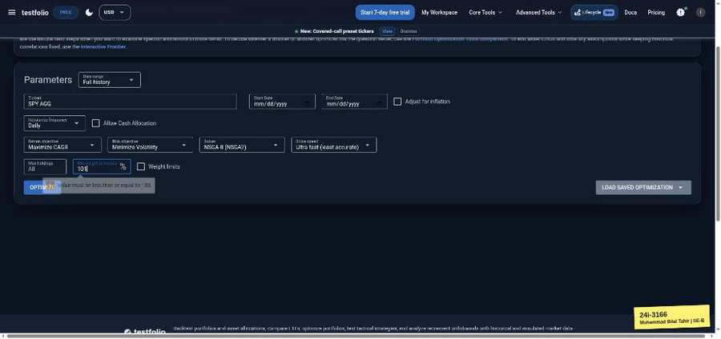

Contact Form (testfol.io/contact)
TC-BVA-087 | Name | input: 120 chars | result: Pass

TC-BVA-088 | Name | input: 121 chars | result: Pass

TC-BVA-089 | Subject | input: 120 chars | result: Pass

TC-BVA-090 | Subject | input: 121 chars | result: Pass

TC-BVA-091 | Message | input: 5000 chars | result: Pass

TC-BVA-092 | Message | input: 5001 chars | result: Pass

Lump Sum vs DCA (testfol.io/lumpsum-vs-dca)
TC-BVA-093 | Starting Value | input: 99 | result: Blocked
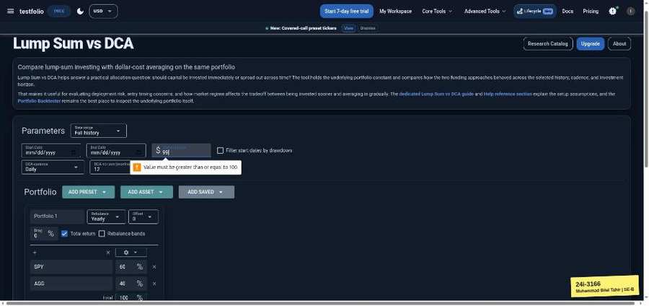

TC-BVA-094 | Starting Value | input: 100 | result: Blocked
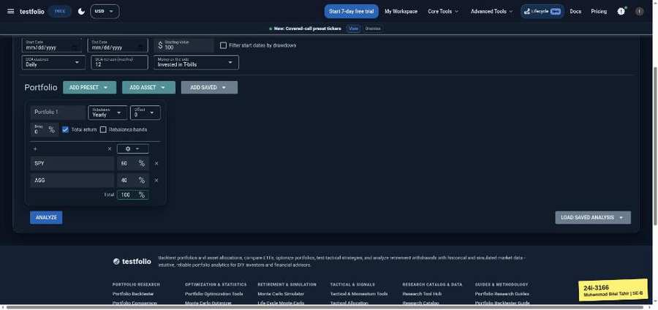

TC-BVA-095 | DCA horizon (months) | input: 0 | result: Blocked
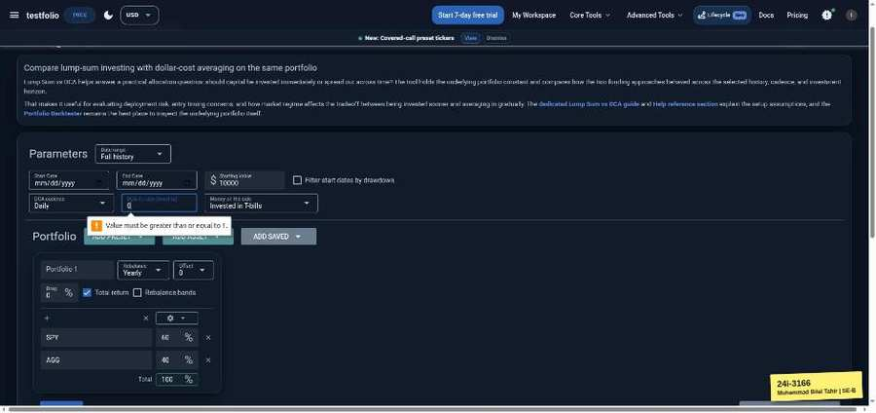

TC-BVA-096 | DCA horizon (months) | input: 1 | result: Blocked
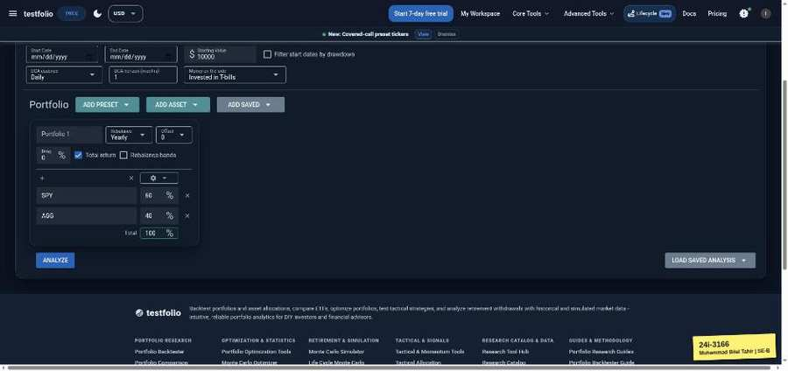

TC-BVA-097 | DCA horizon (months) | input: 120 | result: Blocked
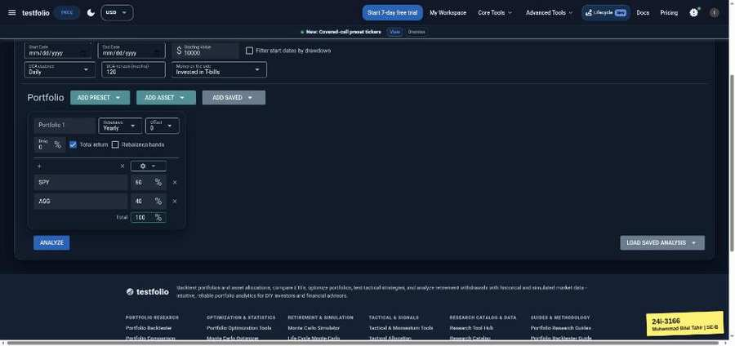

TC-BVA-098 | DCA horizon (months) | input: 121 | result: Blocked
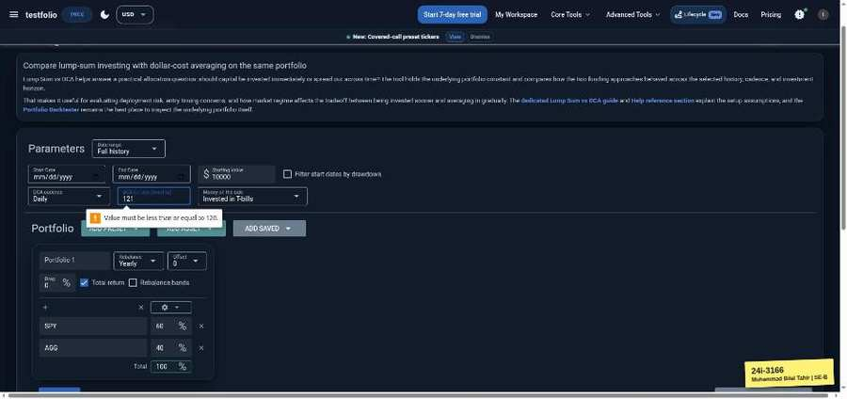

Time Value of Money Calculator (testfol.io/time-value-of-money)
TC-BVA-099 | Starting Value | input: -1 | result: Pass
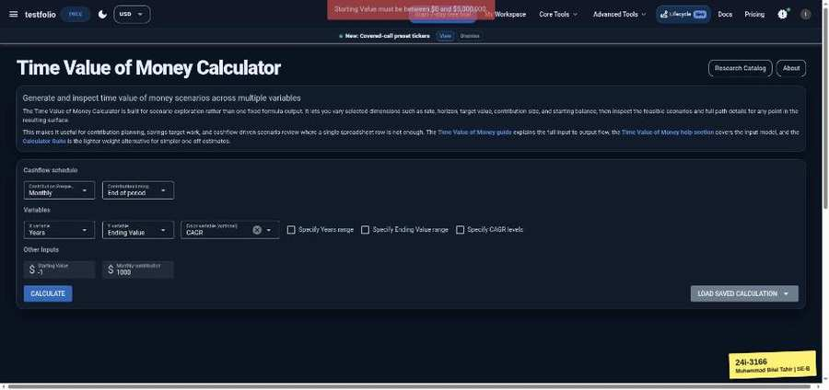

TC-BVA-100 | Starting Value | input: 0 | result: Pass
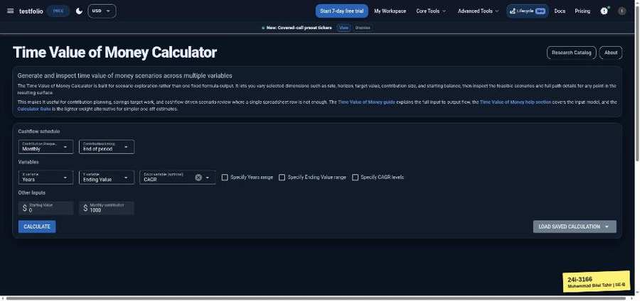 | 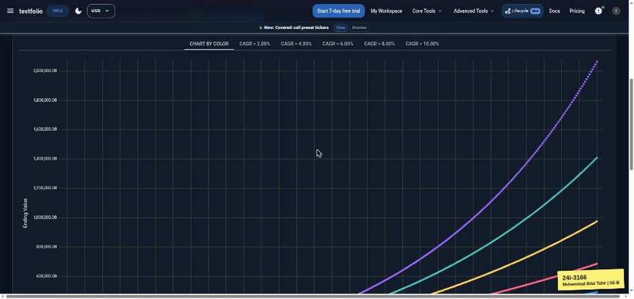

TC-BVA-101 | Starting Value | input: 5,000,000 | result: Pass
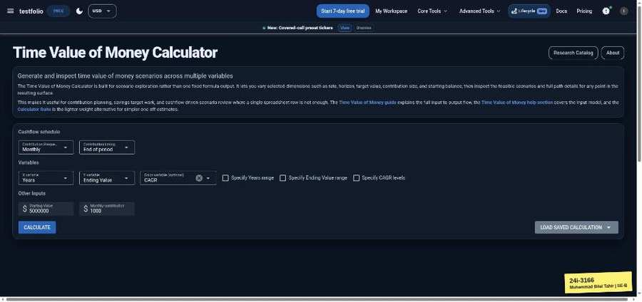 | 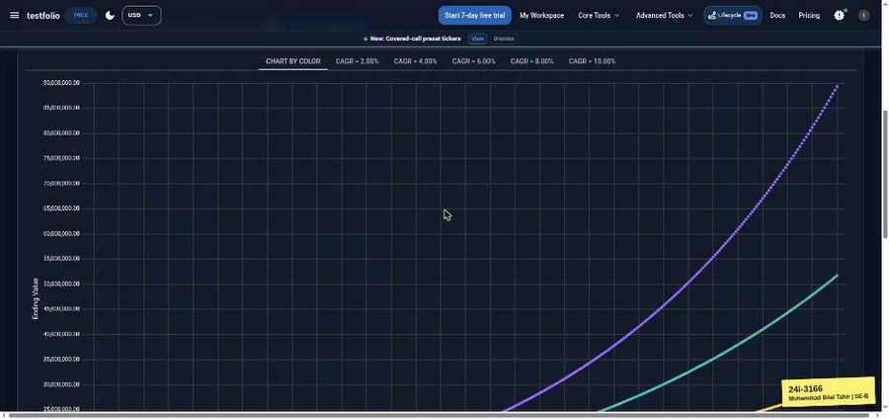

TC-BVA-102 | Starting Value | input: 5,000,001 | result: Pass
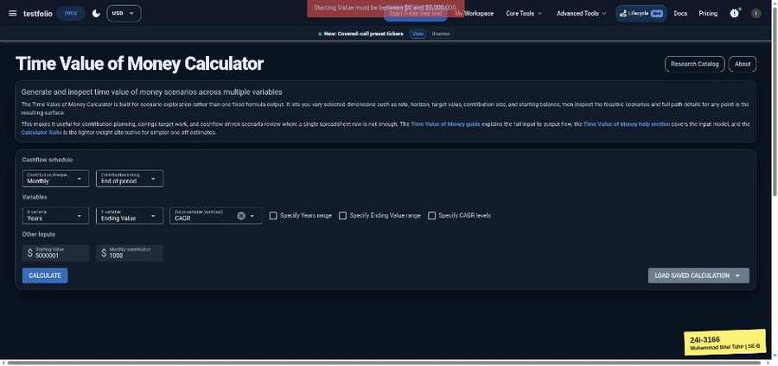

TC-BVA-103 | Monthly contribution | input: -1 | result: Pass
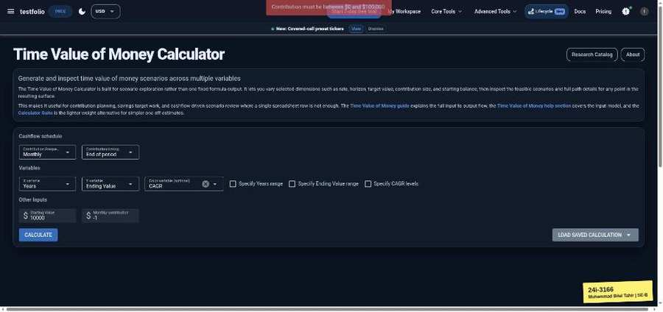

TC-BVA-104 | Monthly contribution | input: 0 | result: Pass
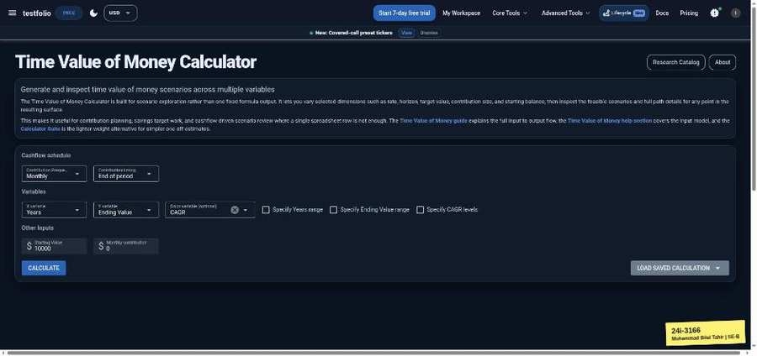 | 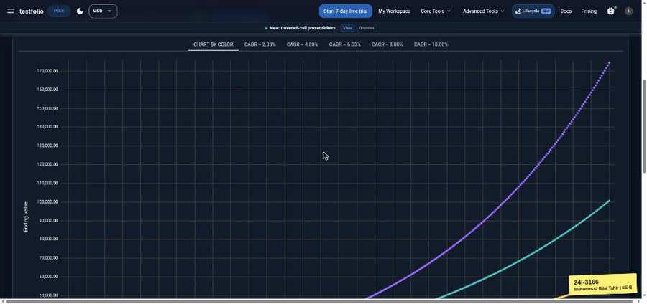

TC-BVA-105 | Monthly contribution | input: 100,000 | result: Pass
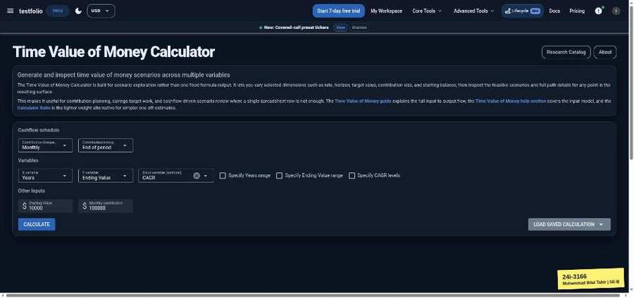 | 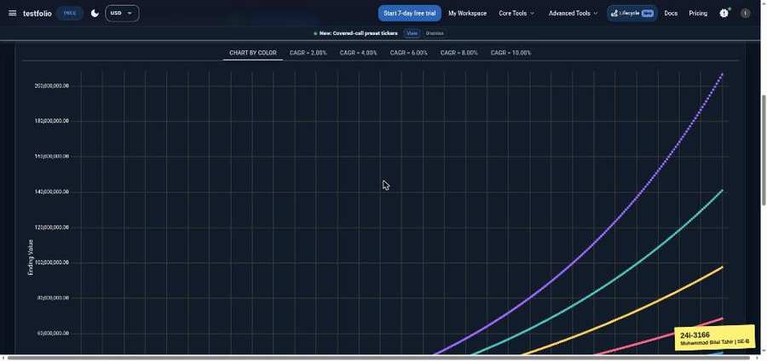

TC-BVA-106 | Monthly contribution | input: 100,001 | result: Pass
