##### SRS

##### Barebones

##### Lab-2

##### { Section : B }

***Md. Ifaj Hossan Omi***

**20-42387-1**

**Software System**

Reliable Online Studio

**Features**

Features are listed below.  **High**, **Medium** and **Low** are used to indicate the importance of each feature.

|  |  |  |  |
| --- | --- | --- | --- |
| **Feature ID** | **Description** | **Priority** | **Requester** |
| **FE01** | Check all credential for login or create a new account.  redirect to destination account. | High |  |
| **FE02** | Photographer will manage job related to all operations: job finding, contacting with client, delivery, viewing progress report. | High |  |
| **FE03** | Clients will deal with finding photographer, post jobs, receive delivery. | High |  |
| **FE04** | Stuffs will resolve reports from photographers and clients. | High |  |

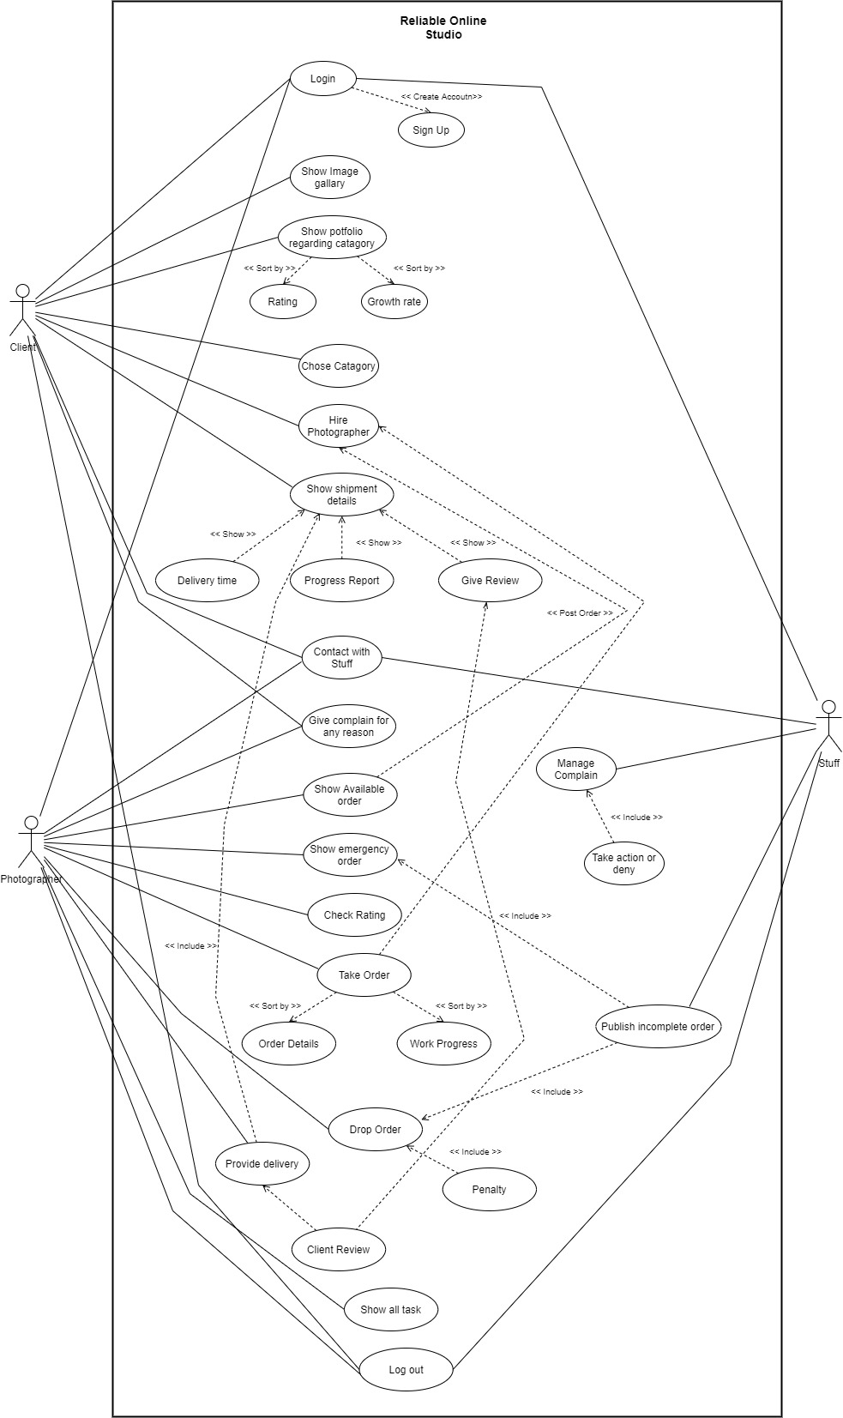**Use case diagram**

**Use Cases**

|  |  |
| --- | --- |
| **FE01 – Login and authorization** | |
| **FE01_UC01** – Login and signup | |
| **Brief Description** | The user opens up the login page and this page asks for login credentials and also shows an option for creating account. |
| **Pre-condition/s** | * User is not logged in already |
| **Priority** | High |
| **Actor/s** | Users of all classes. |
| **Main Success Scenario** | 1. User opens up the web page 2. The system displays a login form and a button for creating account 3. User enters his/her user id and password 4. The system matches user credentials against its date store 5. The system then redirects user to the appropriate page based on user class. 6. If the customer selects create account, then the customer will be redirected to the create account page. 7. The page shows the sign-up form 8. If user fills up the form the system will store the data from the user into the data base for creating an account 9. Then redirect to the login page |
| **Alternative Scenario** | * The system cannot find a match for the user and displays an error message in the login form. * The system runs into internal error (i.e. database unavailable) and notifies user and asks the user to refresh the page. |
| **Notes/Questions** | Must need clarification on dashboard for each user type. The system will not store information from incomplete form. A form will be incomplete when all the ‘must be filled’ fields are not filled. |

|  |  |
| --- | --- |
| **FE02 – Photographer Job** | |
| **FE02_UC01** – Hire Photographer | |
| **Brief Description** | Photographer will manage all their job operation: job searching, contacting with client, viewing progress report |
| **Pre-condition/s** | * User must be logged in |
| **Priority** | High |
| **Actor/s** | Photographer |
| **Main Success Scenario** | 1. User can see and update their personal information in this page.  2. This system will use the username to show the task to the photographer from the task table.  3. The tasks will be shown in a data grid view and the photographer can accept or deny tasks from this form.  4. Username will be used and the photographer will be shown his growth progress page.  5. All the tasks that the photographer received will be brought to the datagrid view using username. From there the photographer will be able to select a task for delivery.  6. From that list the photographer will select the task that he wants to deliver.  7. This data will be saved in the table and the task status will go to delivered.  8. Since report page can be used by all users, here username and table will be used as attributes. User will first enter the name of the complainee and write his complaint.  9. If the user clicks on submit then it will be stored in the table.  8. User can see all the previous complaints and staff reply to all those complaints by clicking the previous button.  10. If user wants to delete their profile, they can do it so by providing username and password. Then the account information will be deleted and the form will be closed and then the login form will appear. |
| **Alternative Scenario** | * The system is unable to store the information in database and generates operation not complete message. * The system runs into internal error (i.e. database unavailable) and notifies user and asks the user to refresh the page. |
| **Notes/Questions** | Progress report will contain both growth rate and rating. |
|  | |

|  |  |
| --- | --- |
| **FE04 – Resolve reports** | |
| **FE04_UC01** – Manage Complain | |
| **Brief Description** | Photographers and client will send reports stuff which will be resolved by the stuff |
| **Pre-condition/s** | * User must be logged in |
| **Priority** | High |
| **Actor/s** | Stuff |
| **Main Success Scenario** | 1. The system displays the existing reports. 2. User can select any report 3. User can reply to reports and take action or deny 4. The system also stores complaints details into the complaint table in the database. |
| **Alternative Scenario** | * The system is unable to store the information in database and generates operation not complete message. * The system runs into internal error (i.e. database unavailable) and notifies user and asks the user to refresh the page. |
| **Notes/Questions** | Denied complaints can be reconsidered if special case arises. |
|  | |

**Non-Functional requirements**

**1.** Application will be efficient about resources like memory and CPU usage.

**2.** Runtime performance will be good.

**3.** Security of the application will be of high standard.