

**INTEGRATED DESIGN PROJECT (IDP II)**

**SYSTEM DEVELOPMENT REPORT**

**GOLF – SECTION A**

**GROUP MEMBERS:**

**TASNIA IQBAL : 201814030**

**TASNEEM MUBASHSHIRA : 201814054**

**IFATH ARA : 201814060**

**FARIHA AMIN : 201814061**

**Platforms used:**

**Raspberry pi :** The Raspberry Pi is a low cost, credit-card sized computer that plugs into a computer monitor or TV, and uses a standard keyboard and mouse. It is a capable little device that enables people of all ages to explore computing, and to learn how to program in languages like Scratch and Python.

**Arduino :** Arduino is an open-source hardware and software company, project and user community that designs and manufactures single-board microcontrollers and microcontroller kits for building digital devices.

**Github:** GitHub, Inc. is a provider of Internet hosting for software development and version control using Git. It offers the distributed version control and source code management functionality of Git, plus its own features.

**Pycharm** :PyCharm is an integrated development environment used in computer programming, specifically for the Python language.

**Google colab:** Colaboratory, or “Colab” for short, is a product from Google Research. Colab allows anybody to write and execute arbitrary python code through the browser, and is especially well suited to machine learning, data analysis and education.

**Visual Code Studio:** Visual Studio Code is a freeware source-code editor made by Microsoft for Windows, Linux and macOS. Features include support for debugging, syntax highlighting, intelligent code completion, snippets, code refactoring, and embedded Git.

**Front end:**

1. **Hyper Text Markup Language (HTML):** Hyper Text Markup Language (HTML) is the backbone of any website development process. A markup language indicates text can be turned into images, tables, links, and other representations. It is the HTML code that provides an overall framework of how the site will look.

2. **Cascading Style Sheets (CSS):** CSS controls the presentation aspect of the site and allows your site to have its own unique look. It does this by maintaining style sheetswhich sit on top of other style rules and are triggered based on other inputs, such as device screen size and resolution.

3. **JavaScript:** JavaScript is an event-based imperative programming language that is used to transform a static HTML page into a dynamic interface. JavaScript code can use the Document Object Model (DOM), provided by the HTML standard, to manipulate a web page in response to events, like user input.

**Backend:**

**OpenCv:** OpenCV is a library of programming functions mainly aimed at real-time computer vision. Originally developed by Intel, it was later supported by Willow Garage then Itseez. The library is cross-platform and free for use under the open-source Apache 2 License.

**Deep Learning Model :** Deep learning model is part of a broader family of machine learning methods based on artificial neural networks with representation learning.

**Flask :**Flask is a micro web framework written in Python. It is classified as a microframework because it does not require particular tools or libraries. It has no database abstraction layer, form validation, or any other components where pre-existing third-party libraries provide common functions.

**Scenario 1:**

Mr. Kabir a truck driver, had all night duty yesterday. He had to deliver raw material to a factory. Due to this covid-19 situation, the schedules are quite hectic. So, next morning one of his co-worker is sick so he has to do his job as a replacement. His owner has set an AI based driver state monitoring device in the car. After driving for a while, Mr. Kabir was very drowsy due to lack of sleep. His face features are captured through the camera, and so his drowsiness is detected. An alarm went off and he was alerted by this. So he took parked the truck and took rest for some time. Then he was quite refreshed again, and started his journey.



**Fig :**  DFD of scenario 1

**Scenario 2:**

Mr. Shakib is very careful when it comes to his family’s and own safety. He’s also very cautious about road safety and traffic rules. That’s why he had set oversee- an AI based driver state monitoring device in the car. One morning when he was driving his daughter to school, he had lot of phone calls coming due to some emergency at work. So, he was carried away for a bit and started talking on phone for some time. Oversee has a hand detection feature. He was holding the phone with one hand which is quite risky in roads of Dhaka. So his hand was detected for a certain time and it alarm buzzed and alerted him that he was inattentive. So Mr. Shakib parked the car, finish talking on phone then again started his journey.



**Fig :**  DFD of scenario 2

**Ui snapshots:**

This is the homepage :

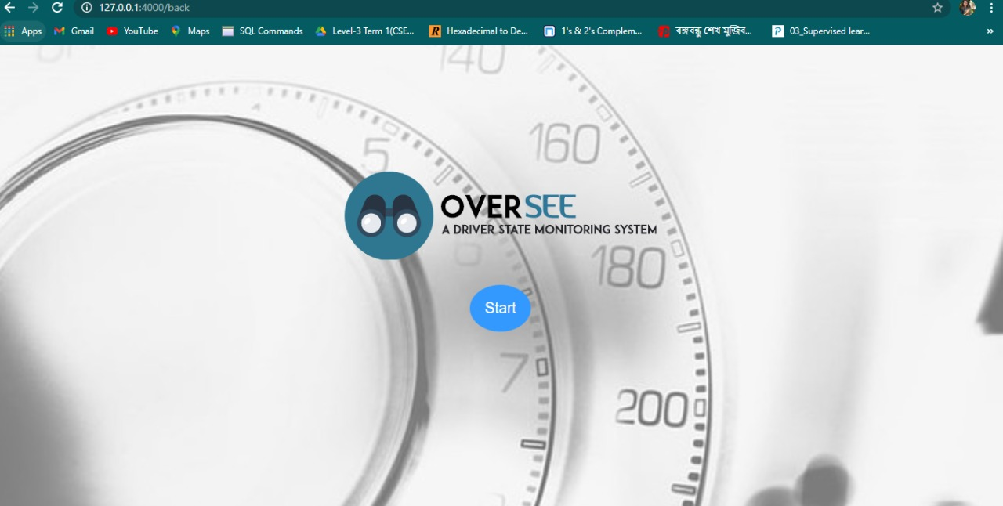

Navigation page: driver can select option to check his/her emotional state or nearby location.

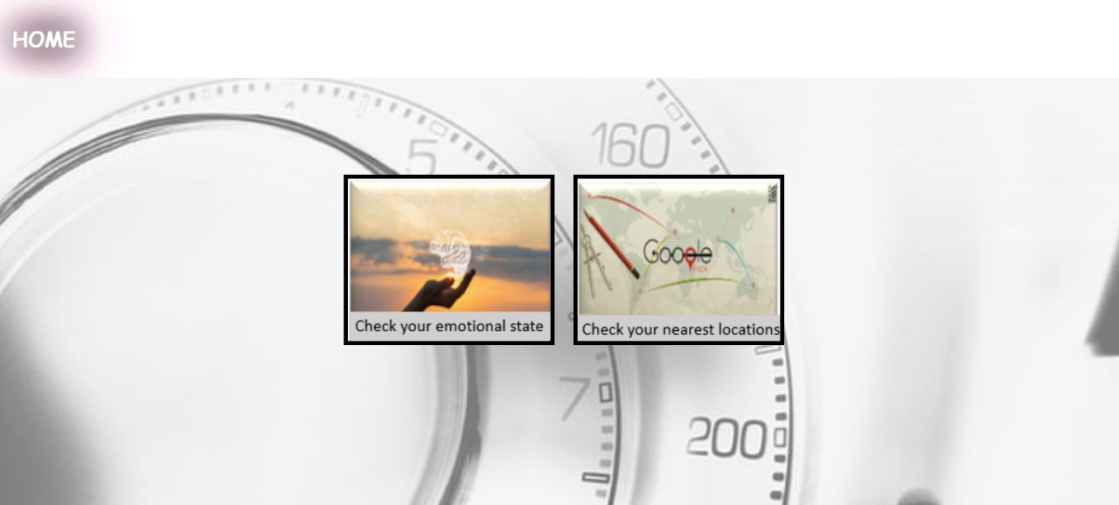

Showing current state and camera extracting feature:

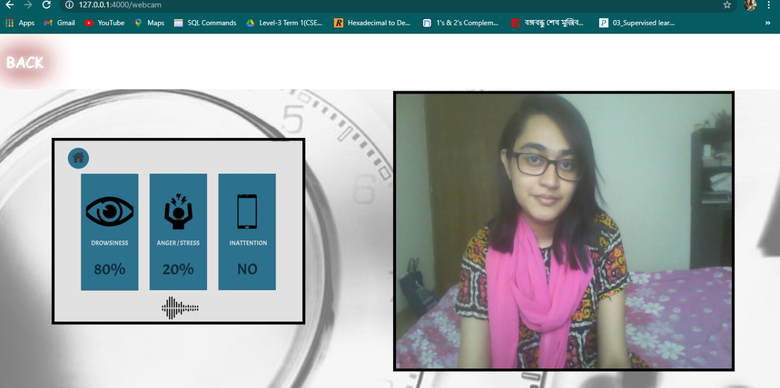

Showing current location and nearby parking spots:

