YOLO V3 Architecture
A walkthrough of the You Only Look Once v3 detector: backbone, heads, output format, and the loss function that ties it all together.

Introduction

In 2016, Redmon, Divvala, Girshick, and Farhadi revolutionized object detection with a paper titled You Only Look Once: Unified, Real-Time Object Detection. In the paper, they introduced a new approach to object detection. Feature extraction and object localization were unified into a single monolithic block, and the localization and classification heads were also united.
Their single-stage architecture, named YOLO (You Only Look Once), delivers very fast inference. On a Titan X GPU, the frame rate for 448×448 pixel images was 45 fps (0.022 s per image) while still achieving state-of-the-art mAP (mean Average Precision). Smaller, slightly less accurate versions of the network reached 150 fps. This new approach together with other detectors built on lightweight backbones such as Google's MobileNet brought the vision (pun intended) of running detection networks and other CV tasks on edge devices ever closer to reality. The original YOLO project can be found here.
By the way, Redmon seems to be quite a colorful character. His YOLO project site can be found here, where you can also find his resume.
Looking at the GluonCV model-zoo chart I presented in the previous post, a fair comparison shows that the different versions of YOLO-V3 (the red dots), as trained by GluonCV, achieve excellent accuracy — second only to the much slower Faster R-CNN family.

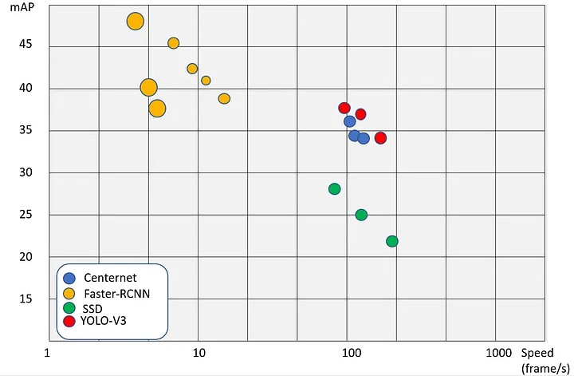

Detector performance chart — representative architectures, plotted on mAP vs. inference speed (frames per second).

The idea behind YOLO is this: there are no separate classification and detection modules that need to be synchronized, and no recurring region-proposal loops as in the previous two-stage detectors (see my post on early object detectors like R-CNN). It is basically convolutions all the way down, with the occasional max-pool layer. Instead of cropping out regions with high object probability and feeding them to a network that refines boxes, a single monolithic network takes care of feature extraction, box regression, and classification at once. While previous models had two output layers one for the class probability distribution and one for box predictions here a single output layer contains everything, separated across different feature channels.

YOLO-V1 Architecture

YOLO-V1 popularized the one-stage detector concept. The architecture employed batch normalization (BN) and leaky ReLU activations, both of which were relatively new at the time. I am not going to elaborate on V1 here it is largely outdated and lacks several strong features that were introduced in later versions.

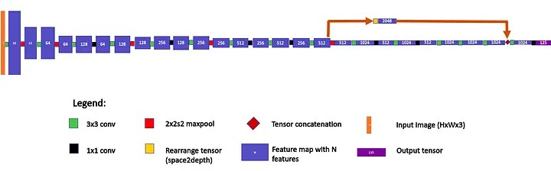

YOLO-V1 architecture — 24 conv layers followed by two fully connected layers, with a passthrough connection to a finer-grained feature map.

YOLO-V2 Architecture
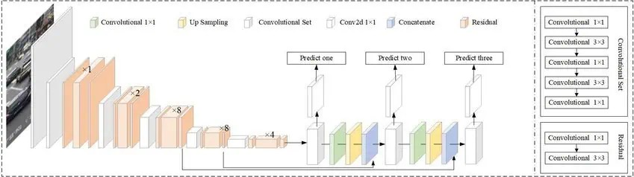

YOLO-V2 (Darknet-19) contains 19 conv layers and 5 max-pool operations. Feature-map height represents spatial resolution.
The 125-feature output is for the VOC PASCAL dataset with 20 classes and 5 anchors.

In YOLO-V2 the authors, among other changes, removed the fully-connected layer at the end. This made the architecture truly resolution-independent that is, the network parameters can fit any input resolution. It does not mean, however, that the network will perform equally well at every resolution. A resolution-augmentation routine was used during training to ensure good coverage. Redmon created multiple flavors of YOLO-V2, including smaller, faster (and less accurate) variants such as Tiny-YOLO-V2.
Tiny-YOLO-V2 has an extremely simple architecture: it does not have the strange passthrough and rearrange operation that, unlike its older sibling, makes the full YOLO-V2 harder to read on a single page. The tiny version is just a long chain of convolutions and max-pools.
cfg

The configuration files describing these architectures can be found in the GitHub repository.
section of the Darknet

YOLO-V3 Architecture

Inspired by ResNet and FPN (Feature-Pyramid Network), the YOLO-V3 feature extractor called Darknet-53 (it has 53 convolutional layers) contains skip connections (à la ResNet) and three prediction heads (à la FPN), each processing the image at a different spatial compression.

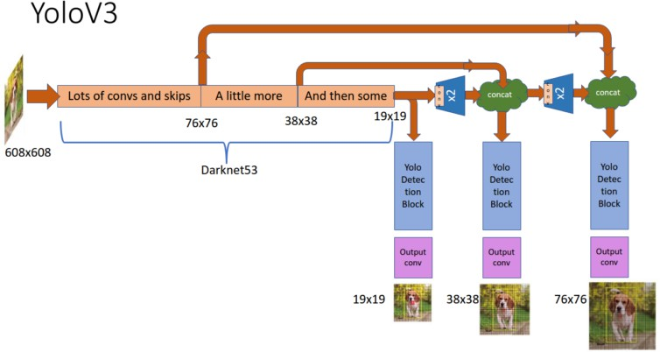
YOLO-V3 architecture — Darknet-53 backbone with three detection heads at 19×19, 38×38, and 76×76.

Like its predecessors, YOLO-V3 boasts good performance over a wide range of input resolutions. In GluonCV's model zoo you can find several checkpoints, each for a different input resolution, but the network parameters stored in those checkpoints are actually identical. Tested at an input resolution of 608×608 on the COCO-2017 validation set, YOLO-V3 scored 37 mAP. This score is identical to GluonCV's trained version of Faster R-CNN with a ResNet-50 backbone but 17× faster. In that model zoo, the only detectors fast enough to compete with YOLO-V3 (the MobileNet-SSD family) scored 30 mAP or below.

Feature Pyramid Network (FPN): Dancing at Two Weddings

A feature pyramid is a topology introduced in 2017 by FAIR (Facebook AI Research) in which the feature map gradually decreases in spatial dimension (as is the usual case) but later expands again and is concatenated with the earlier feature maps of corresponding size. This procedure is repeated, and each concatenated feature map is fed to a separate detection head.

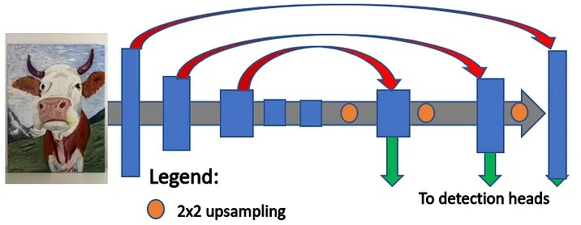

Feature Pyramid Network — top-down pathway with 2× upsampling and lateral connections to multiple detection heads.

Referring to the YOLO-V3 illustration above, the FPN topology lets YOLO-V3 learn objects at different sizes. The 19×19 detection block has a broader context but poorer resolution compared with the other detection blocks, so it specializes in detecting large objects, while the 76×76 block specializes in detecting small objects. Each detection head has its own set of anchor scales.
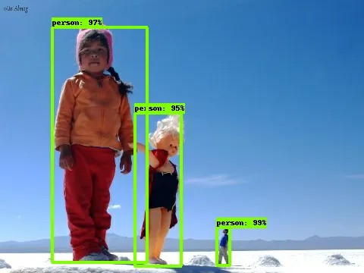
YOLO-V3 detecting objects at different sizes in a single image.

Unlike SSD (Single-Shot Detector) architectures, in which the 38×38 and 76×76 blocks receive only the high-resolution, partly processed activations from the middle of the feature extractor (the top two arrows in the diagram), in the FPN architecture those features are concatenated with the low-resolution, fully processed features at the end of the feature extractor.

This enables the network to "dance at two weddings", as the Yiddish expression goes utilizing both the highly-processed-but-narrow-context features and the partly-processed-but-wide-context features for its predictions.

YOLO V2 and V3 Output Layer

The output scheme for YOLO-V3 is the same as in V2, and both differ from the older V1.

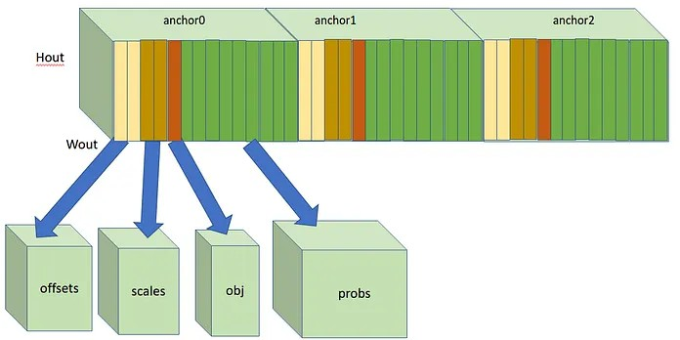

YOLO-V2 and YOLO-V3 output layer. Wout and Hout are spatial dimensions of the output feature map. For each anchor, the features are arranged in the order shown (offsets, scales, objectness, class probabilities).

Each cell in the output layer's feature map predicts three boxes in YOLO-V3 and five boxes in YOLO-V2 one box per anchor. Each box prediction consists of:
- Two values for box-center offsets (in x and y, relative to the cell center).
- Two values for box-size scales (in x and y, relative to anchor dimensions).
- One value for objectness score (between 0 and 1).
- A number-of-classes value for class score (between 0 and 1) — one per class.
To be precise, the box-size values are residual values. At post-processing they are used to recover the box width as box_width = anchor_width × exp(residual_value_of_box_width) .
The YOLO-V2 illustration above is designed for the 20-class VOC PASCAL dataset and has 5 anchors. The 125-feature output is arranged as follows: for each spatial cell there are 125 features. Feature 0 is the objectness score, features 1–2 are the x and y offsets of the box center (relative to the cell coordinates), features 3–4 are the x and y scales of the box, and features 5–24 are the 20 class scores —

all for the first anchor. Features 25–49 repeat the same layout for the second anchor, and so on. Note that the anchor dimensions are not expressed directly in the features; the scale values are passed to the post-process and combined with the corresponding anchor scales for box decoding.
Objectness is a new concept and is worth a discussion that will take place in a few paragraphs. For now, let's think of it as the network's confidence that some object exists in a given box, and the class score as the conditional probability of class c given that an object exists in the box. The total confidence score for each class is therefore the product of the objectness and the class score.
The output of the network then goes through NMS and a confidence threshold to produce the final predictions, as explained in my post on detector basics.

Why Does YOLO Perform Better Than Previous Architectures?

If there is one thing I learned while working on YOLO and its smaller versions, it is that looks can be deceiving. YOLO has such a small and simple topology how complicated can it be? Well. What enables it to have such a compact structure is, more precisely, the fact that its loss function is very complicated. It is the loss that gives the features their meaning. A carefully and thoughtfully crafted loss function can pack a lot of information into a small feature map.
In the next section, we will discuss the most important features of the YOLO loss function.

YOLO Training and Loss Mechanism

This section is based on research I did on the training flow of the Darknet framework (the framework developed by Redmon) when I was working on an independent TensorFlow implementation of that framework.

Input Resolution Augmentation
As a fully-convolutional network that does not contain fully-connected layers for the classification task, unlike previous detectors, YOLO can process input images of any size. But because different input resolutions give rise to different effective network parameters, the network is trained with resolution augmentation. The authors used 10 input resolution steps between 384×384 and 672×672 pixels that alternate randomly every few training batches, enabling the network to generalize its predictions across resolutions.

Loss Coefficients: Divide and Conquer
Different boxes are treated differently by the loss function. Each spatial cell in the network's output layers predicts multiple boxes (3 in YOLO-V3, 5 in previous versions), all centered in that cell, via a

mechanism called anchors.
The YOLO loss for each box prediction is comprised of the following terms:
- Coordinate loss — due to a box prediction not exactly covering an object.
- Objectness loss — due to a wrong box-object IoU prediction.
- Classification loss — due to deviations from predicting 1 for the correct class and 0 for all other classes for the object in that box.
- A special loss term that we will elaborate on two sections down.
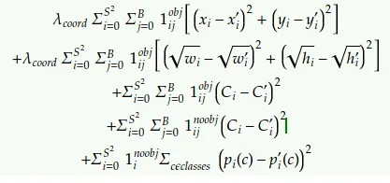
YOLO-V1 loss function. The λs are loss coefficients. The top three lines are the loss contributed by the “best boxes” (those that best capture GT objects in each spatial cell), and the fourth line is the loss for boxes that did not capture any object. In YOLO-V2 and YOLO-V3, the direct width and height predictions and the square root are replaced with residual-scale prediction to make the loss argument proportional to relative rather than absolute scale error.

The quality of a box prediction is measured by its IoU (Intersection over Union) with the object it tries to predict — more precisely, with the ground-truth box for that object. IoU values range from 0 (the box completely misses the object) to 1.0 (a perfect fit).
For each spatial cell, for each box prediction centered in that cell, the loss function finds the box with the best IoU with the object centered in that cell. This distinguishing mechanism between "best boxes" and all the other boxes is at the heart of the YOLO loss.
The best boxes — and them alone — incur coordinate loss (due to a less-than-perfect fit) and classification loss (due to classification errors). This pushes the network parameters associated with those boxes to improve the box scale and location and the classification. These boxes also incur objectness loss, which will be explained immediately. All the other boxes incur only the objectness loss.

Objectness Loss: Knowing One's Worth
With each box prediction is associated a prediction called objectness. It comes in the place where, in previous detectors like R-CNN, came the confidence that a region proposal contains an object, because it is multiplied by the class score to give the absolute class confidence. However, contrary to what you might expect, this prediction is actually an IoU prediction i.e., how well the network thinks the box

covers the object. The objectness-loss term teaches the network to predict a correct IoU, while the coordinate loss teaches the network to predict a better box (which eventually pushes the IoU toward 1.0). All box predictions contribute to the objectness loss, but only the best-fitting box in each spatial cell also contributes coordinate and classification loss.
Why do we need objectness loss?
At inference we usually have multiple boxes with varying coverage for each object. We want the post-processing algorithm to choose the box that covers the object in the most exact way, and to choose the box that gives the correct class prediction for the object. How can the algorithm know which box to choose?
First, the objectness tells us how good the coverage is, so boxes with very small objectness (< 0.005) are discarded and do not even make it to the NMS block. This helps remove about 90% of the boxes that are just artifacts of the architecture and not real detections — of course, this depends on the task and the data. If your task is to detect bottle caps in a box full of bottle caps, you can expect to have a large number of real detections.
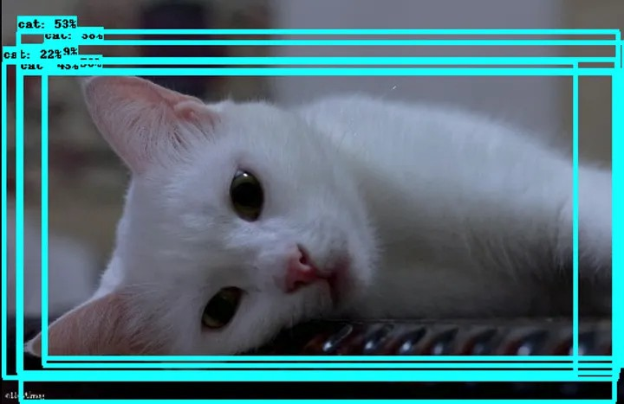
Multiple-box detection result when NMS is suppressed. The objectness score tells the NMS which boxes to keep and which to drop.

Second, NMS is performed per class, so the class score is scaled by the box objectness for a meaningful comparison. If we have two boxes with high overlap the first with objectness 0.9 and person probability 0.8 (weighted score 0.72), and the second with objectness 0.5 and person probability 0.3

(weighted score 0.15) the first box will persist and the second will be dropped in NMS, because the first box's objectness made it more trustworthy.

Precision for Small Objects
The chart below (taken and modified from the YOLOv3 paper) shows the average precision (AP) of detecting small, medium, and large objects with various algorithms and backbones. The higher the AP, the more accurate the detector is for that object size.
The precision for small objects in YOLOv2 was far inferior to other algorithms. This was due to how inaccurate YOLO was at detecting small objects. With an AP of 5.0, it paled in comparison to algorithms like RetinaNet (21.8) or SSD513 (10.2), which had the second- and third-lowest APs for small objects.
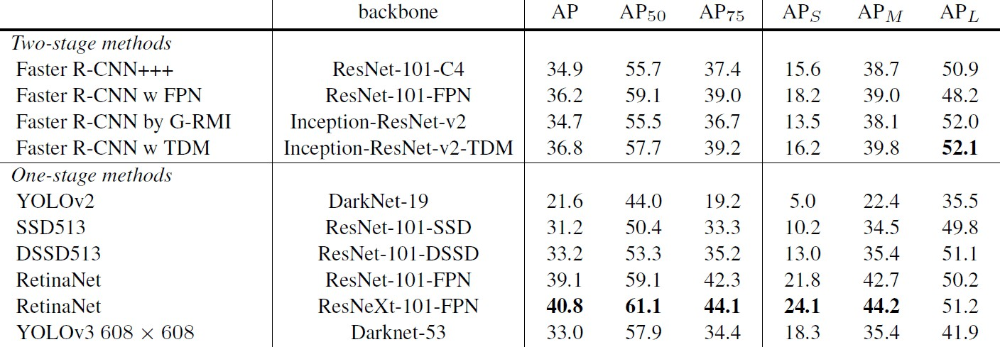

YOLOv3 comparison for different object sizes — average precision (AP) broken down into APS (small), APM (medium), and APL (large).

Contraction Loss: Exploit vs. Explore
An interesting mechanism I call anchor contraction is not mentioned explicitly in the paper, but I found it in the code. Each box prediction incurs a small loss proportional to its deviation from its original anchor shape and location. This action persists weakly but steadily during the first training epochs, after which the loss coefficient is scheduled to vanish.
While this loss term is non-zero, it generates a weak force that acts to contract each box prediction back to its anchor form.

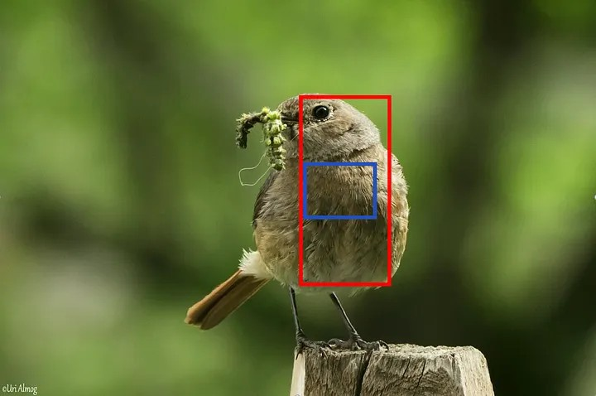

Contraction loss. During training, the two boxes are compared with the object centered at their cell (the bird). The red box has the best IoU and will incur coordinate and classification loss, pushing it to better cover the bird and predict its category. The blue box will be pushed back toward its anchor shape, which may put it in a better position to capture other objects in future attempts.

This clever mechanism has the following effect. The boxes that did not succeed in capturing an object (those that are not in the "best box" group mentioned above) are pushed to return to their original anchor shape. Since the anchors were designed to be the best priors for capturing objects in the dataset, this increases the chance that the weights associated with those boxes will generate more successful boxes in future attempts. Meanwhile, the successful boxes (the "best box" group) also experience this loss, but the coordinate and classification losses are much greater (their coefficients are larger) and dominate the direction in which the parameters associated with those boxes will shift.
After a few epochs it is assumed that the network has already learned to predict boxes reasonably well. The anchor contraction stops, allowing the network parameters to fine-tune on the actual ground truth.

