Is our AI oversight working? A choice for the board
Prepared by Mohanned Elhagar · October 2026 · for decision
What we found
Our compliance team says reviewers agree with the AI 81% of the time, so oversight works. We tested that claim on a published study of 35,670 real decisions, in which people answered a question, saw advice, then gave a final answer. They agreed with the advice 81% of the time, the same figure. But:
- When the advice was wrong, people still went along with it two times in three. Only about one wrong recommendation in three was caught.
- People caught a mistake almost only when they already knew the answer. One in three who had it right switched to the wrong advice.
- The more confident the wrong advice looked, the more people it fooled; and telling people the tool was very accurate made them check less.
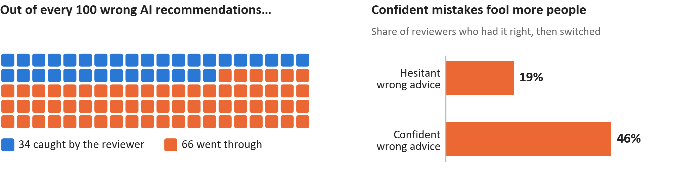
So a high agreement rate does not show that oversight works: a perfect reviewer would agree less often than ours do. The study used volunteers on simple puzzles, not bank staff, so the exact numbers will differ here; the pattern is the warning.
Four routes: what each costs and what it would miss
Route | What it costs | What it tells us | What it would miss
A. Keep reporting agreement | Nothing | How often reviewers follow the AI | Whether the AI was right. From what we found, it can look best exactly when oversight is worst.
B. Measure how often reviewers catch AI errors | Analyst time, using cases whose outcome is later known | Whether reviewers overturn the AI when it is wrong: the regulator's actual question | Errors in cases closed and never investigated
C. Audit a random sample of closed cases | Investigator time; more for a bigger sample | The errors that route B cannot see | Rare errors, unless the sample is large
D. Change the review so staff decide before seeing the AI | Slower reviews; staff may dislike it | Likely fewer errors waved through, if the research holds in a bank | It is a fix, not a measurement: without B we could not tell if it worked
What I would fund first
Route B, with a small route C sample alongside. B is the only route that answers what the regulator asks: do our reviewers catch the AI when it is wrong? It uses cases we already investigate, so it is cheap to start. A small random audit (C) covers B's blind spot, the cases nobody looked at again. I would hold D until B gives us a starting figure, so that we can tell whether the change helps. A costs nothing but, on this evidence, tells us the least. The decision is the board's.
The one thing to ask compliance to measure first
“Of the alerts where the AI later turned out to be wrong, what share did our reviewers overturn?”
Report it every quarter, next to the agreement rate, and broken down by how confident the AI was.
Source: Vodrahalli et al. (2022), Human-AI Interactions Dataset; full method and figures in the repository.

