SOLUTION TO ASSIGNMENT
Write a query in SQL to find the name and year of the movies.
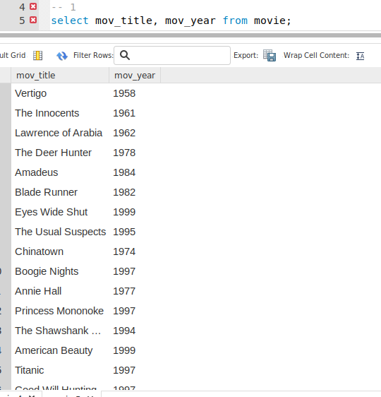
• Write a query in SQL to find the year when the movie American Beauty released.
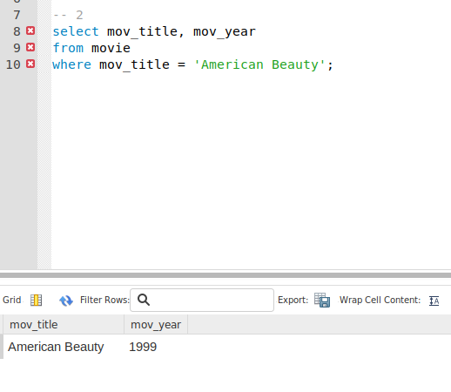

• Write a query in SQL to find the movie which was released in the year 1999
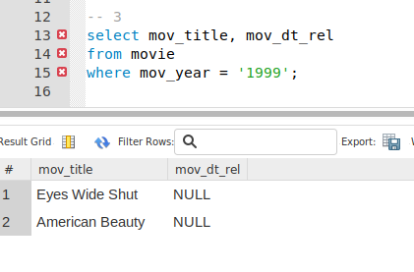

• Write a query in SQL to find the movies which was released before 1998
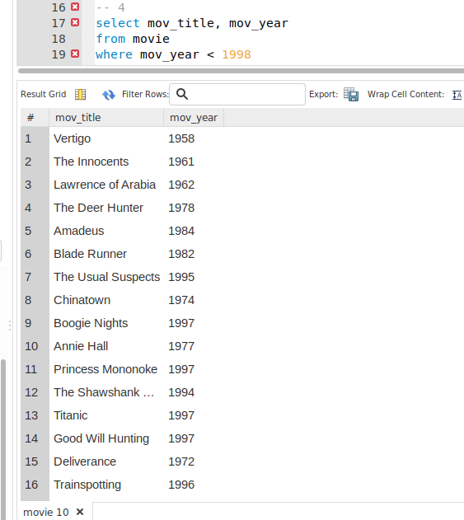

- Write a query in SQL to find the movie which was released in the year 1999
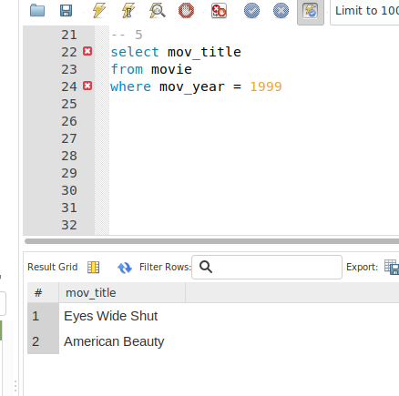

• Write a query in SQL to return the name of all reviewers and name of movies together in a single
list

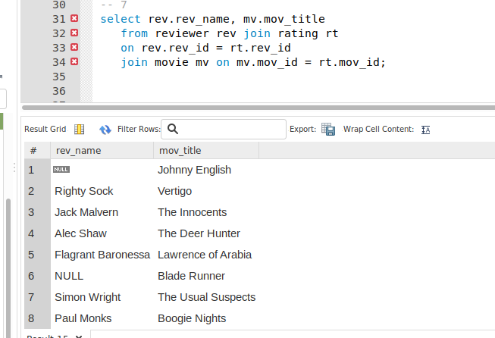

• Write a query in SQL to find the name of all reviewers who have rated 7 or more stars to their
rating
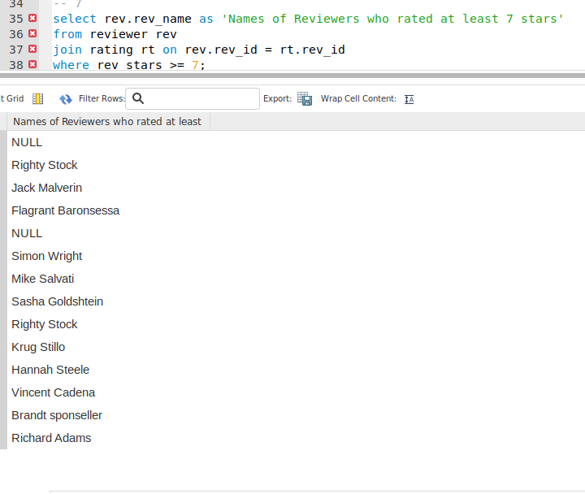

• Write a query in SQL to find the titles of all movies that have no ratings.
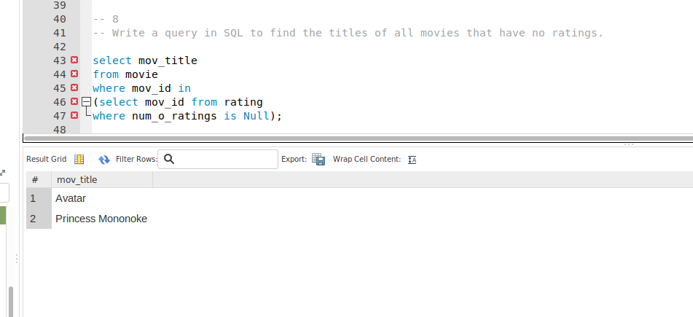

• Write a query in SQL to find the name of all reviewers who have rated their ratings with a NULL
value
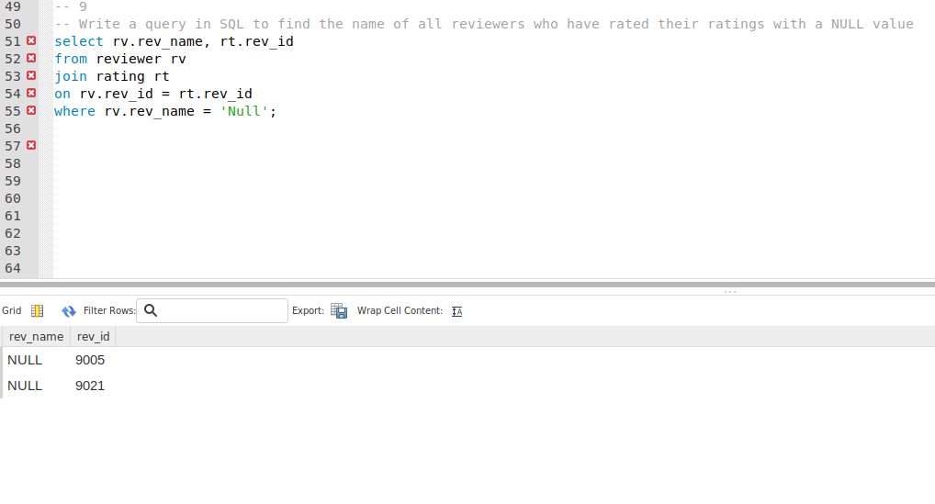
• Write a query in SQL to find the name of movie and director (first and last names) who directed a
movie that casted a role for 'Eyes Wide Shut'.

