Hi
Current package has been uploaded from Unity 2020.3.13 lts on july 2021
You can see the URP Lighting Box 2 version from top of the window:
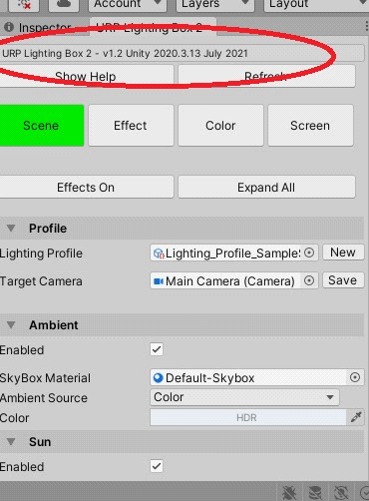
First you must install Universal RP into your project or use default sample creator from Unity Hub.
There are some useful links:
https://docs.unity3d.com/Packages/com.unity.render-pipelines.universal@7.1/manual/InstallingAndConfiguringURP.html

Now watch the videos to learn how to use Lighting Box 2 for URP :
https://www.youtube.com/watch?v=mKi0jX2O2G0&list=PLVXvfvDWvto32hdpX_e-mkzhdgUWczkyK

My youtube Channel:
https://www.youtube.com/channel/UCKGKwkmZagsc0QKTkWn_w-w

October 2023 Update:
You can find SRP Lens Flare pack in the “Lens Flare” folder
You can find tree shaders pack in the “Shaders/ TreeShaders” folder

