**🌏 "Explore the World with Us: Your Perfect Travel Package Awaits!" 🌟**

**🏖️ Whether you’re dreaming of pristine beaches, bustling cities, or serene mountains, our Tourism Package has it all!**

**✈️ Discover:**

* **Stunning destinations ✨**
* **Unbeatable prices 💰**
* **Tailor-made experiences 💼**

**📄 Dive into the details now and see how our team collaborates to make travel planning seamless and exciting!**

**This packages contains 3 country which is Japan,Italy and Turkiye!**

**For this package we will discuss about:**

**1.Country**

**2.Price**

**3.Days of trip**

**4.Place in country**

**5.Accomodation**

**6.Travel time**

**7.Place will be visit**

**8.Transportation**

**9.Insurance (if want)**

**10.pax for trip**

**11. Meals provided**

**12.English tour guide**

**DISCOVER JAPAN: 3-DAY HOLIDAY PACKAGE**

**1. Country:** Japan  
**2. Price:** Starting from RM 5,800 per person  
**3. Days of Trip:** 3 Days, 2 Nights

**Itinerary Overview**

**Day 1: Arrival in Tokyo**

* Arrival at Narita or Haneda Airport.
* Visit Asakusa’s Sensoji Temple and Nakamise Street for souvenirs.
* Evening: Explore Shibuya Crossing and Harajuku.

**Day 2: Day Trip to Mount Fuji and Hakone**

* Travel to Mount Fuji’s 5th Station.
* Lake Ashi cruise with a view of Mount Fuji.
* Hakone Ropeway to Owakudani Valley for hot springs.

**Day 3: Departure**

* Morning free for shopping in Ginza or Akihabara.
* Transfer to the airport for departure.

**4. Places in Country:**

* **Tokyo**
* **Hakone**
* **Mount Fuji**

**5. Accommodation:**

* 4-Star Hotel in Tokyo
* Room: 1 Double Room (Twin Beds Available)

**6. Travel Time:**

* Season: Spring **(March-May)** for cherry blossoms or Autumn **(October-November)** for foliage

**7. Place will be visit *(Images)*:**

*(Placeholder for Tokyo, Hakone, and Mount Fuji visuals)*

**8. Transportation:**

* Private car for airport transfers and day trips
* Public transportation in Tokyo (JR Pass or metro card included)

**9. Insurance:**

* Travel insurance optional: RM120 per person

**10. Pax for Trip:**

* Maximum 10 people

**11. Meals Provided:**

* Daily breakfast included

**12. Translator Tour Guide:**

* Optional: RM100 per day

Discover **Italy** amazing history, delicious food, and iconic landmarks like the Colosseum and Vatican City. A trip you’ll never forget!

**DISCOVER ITALY: 5-DAY HOLIDAYS PACKAGE**

* + **Country:** Japan
  + **Price:** Starting from 8,500 per person
  + **Days of Trip:** 5 Days, 4 Nights

**Itinerary Overview:**

**Day 1: Arrival in Rome**

* Arrival at Leonardo da Vinci–Fiumicino Airport.
* Visit the Colosseum and the Roman Forum for a glimpse of ancient Rome.
* Evening: Stroll around Piazza Navona and enjoy a classic Italian dinner.

**Day 2: Explore Vatican City**

* Morning: Guided tour of St. Peter’s Basilica, Vatican Museums, and the Sistine Chapel.
* Afternoon: Visit the Trevi Fountain and Spanish Steps for iconic photo spots.
* Evening: Leisure time for shopping or relaxing at a Roman café.

**Day 3: Day Trip to Florence**

* Take a high-speed train to Florence (1.5 hours).
* Visit the Florence Cathedral (Duomo) and Ponte Vecchio.
* Explore the Uffizi Gallery for Renaissance art masterpieces.
* Evening: Return to Rome by train.

**Day 4: Day Trip to Venice**

* Travel to Venice by train (approx. 3.5 hours).
* Visit St. Mark’s Basilica and Doge’s Palace.
* Enjoy a gondola ride through the canals of Venice.
* Evening: Return to Rome by train.

**Day 5: Departure**

* Morning free for last-minute shopping or exploring local markets in Rome.
* Transfer to the airport for departure.
  1. **Place in Country:**
* **Rome**
* **Florence**
* **Venice**
  1. **Accommodation:**
* 4-star hotels (double occupancy)
* **Rome**: Hotel Quirinale
* **Florence:** Hotel Rivoli Boutique
* **Venice:** Hotel Carlton on the Grand Canal
  1. **Travel Time:**
* Season: Spring **(April-May)** for blooming flowers and pleasant weather or Autumn **(September-October)** for vibrant foliage and cooler temperatures.
  1. 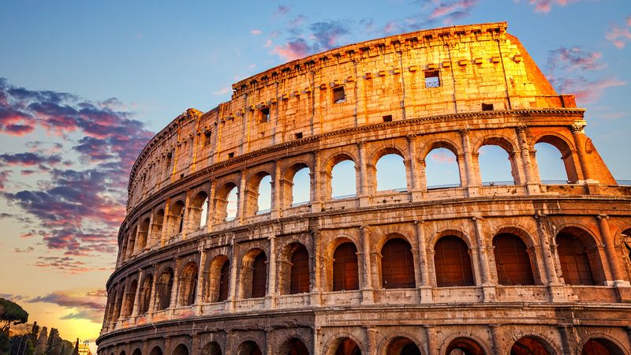**Places to visit (Images):**

*Colosseum of Rome*

*(Placeholders for Rome, Florence, Venice)*

* 1. **Transportation:**
* Flight (round trip from Malaysia)
* High-speed trains within Italy
* Private coach for city tours
  1. **Insurance:**
* Travel insurance optional: RM 150 per person for full travel insurance coverage
  1. **Pax for Trip:**
* Maximum 15 people
  1. **Meals Provided:**
* Breakfast daily at the hotel
* 3 lunches and 2 dinners included (Local Italian cuisine experience)
  1. **Translator Tour Guide:**
* Optional: RM 150 per day

Discover **Turkey** amazing history, delicious food, and iconic landmarks like the Istanbul and Cappadocia City. A trip you’ll Discover Turkey's Beauty

**DISCOVER TURKEY: 4-DAY HOLIDAYS PACKAGE**

* + **Country:** Turkey
  + **Price:** Starting from 3,588 per person
  + **Days of Trip:** 4 Days, 3 Nights

**Itinerary Overview:**

**Day 1: Istanbul – The Gateway Between Europe and Asia**

* **Morning:**Visit tour of *Hagia Sofia*, *Blue Mosque* and *Hippodrome of Constantinople*
* **Afternoon:** Wander through the *Grand Bazaar*, one of the oldest and largest covered markets in the world
* **Evening:** Enjoy a *Bosphorus sunset cruise*, admiring the city’s skyline.

**Day 2: Cappadocia – Land of Fairy Chimneys**

* **Morning:** Taking a *magical hot air ballon ride* and visit *Goreme Open Air Museum*
* **Afternoon:** Explore city of *Kaymali* and Walk through the *Love Valley*,
* **Evening:** Dine at a cave restaurant and experience Cappadocian cuisine, such as pottery kebabs.

**Day 3: Pamukkale and Hierapolis – Natural and Ancient Wonders**

* **Morning:** Travel to *Pamukkale* and visit the *travertine terraces*
* Afternoon: Walk along the *Cotton Castle* for panoramic views,
* Evening: Relax in a thermal spa hotel near *Pamukkale*

**Day 4: Antalya – The Jewel of the Turkish Riviera**

* **Morning:** Visit the stunning *Düden Waterfalls*
* **Afternoon:** Visit the ancient ruins of *Perge* or
* **Evening :** End your trip with a seafood dinner by the marina and goes to the airport for departure
  1. **Place in Country:**
* **Istanbul**
* **Cappadocia**
* **Pamukkale and Hierapolis**
* **Antalya**
  1. **Accommodation:**
* Luxury Hotel
* **Istanbul :** Four Seasons Hotel Istanbul at Sultanahmet
* **Cappadocia :** Museum Hotel Cappadocia
* **Pamukkale and Hierapolis :** Doga Thermal Health & Spa
* **Antalya :** Akra Hotel
  1. **Travel Time:**
* Season: Spring **(April-June)** for blooming flowers and pleasant weather (15–25°C / 59–77°F) **(September-November)** for vibrant foliage and cooler temperatures (20–30°C / 68–86°F),.
  1. **Places to visit (Images):**

*(Placeholders for Istanbul, Cappadocia, Pamukkale and Hierapolis, Antalya)*

* 1. **Transportation:**
* Flight
* Private car with Driver
* Public Transportation
  1. **Insurance:**
* Travel insurance optional: RM 100 per person for full travel insurance coverage
  1. **Pax for Trip:**
* Maximum 10 people
  1. **Meals Provided:**
* Breakfast at the hotel
* lunches and dinners included (Local Turkey cuisine experience)
  1. **Translator Tour Guide:**
* Optional: RM 100 per day