**Activity Diagram for Courses Offered –**

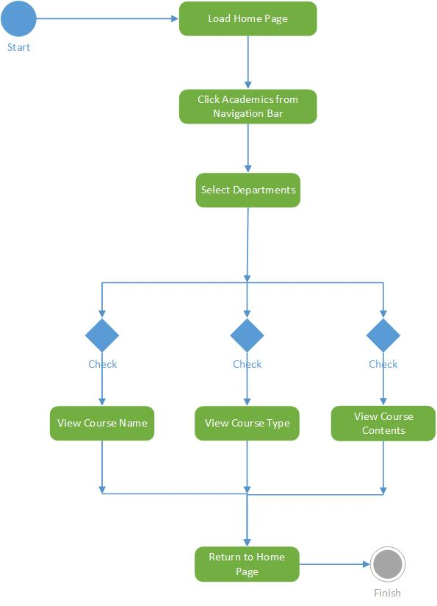

**Activity Diagram for Research–**

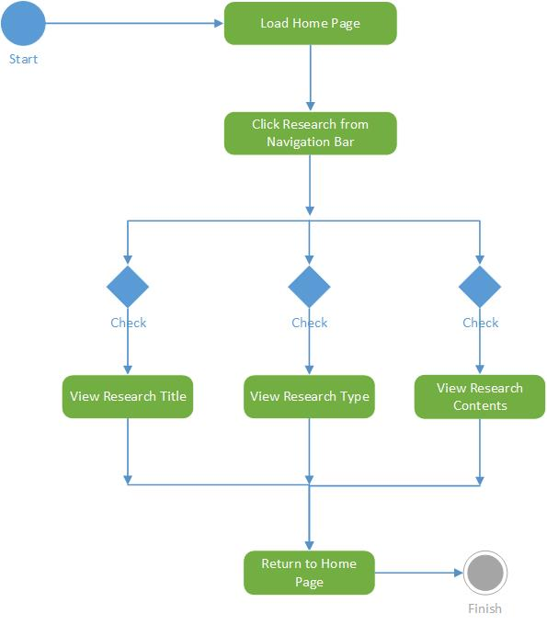

**Activity Diagram for News–**

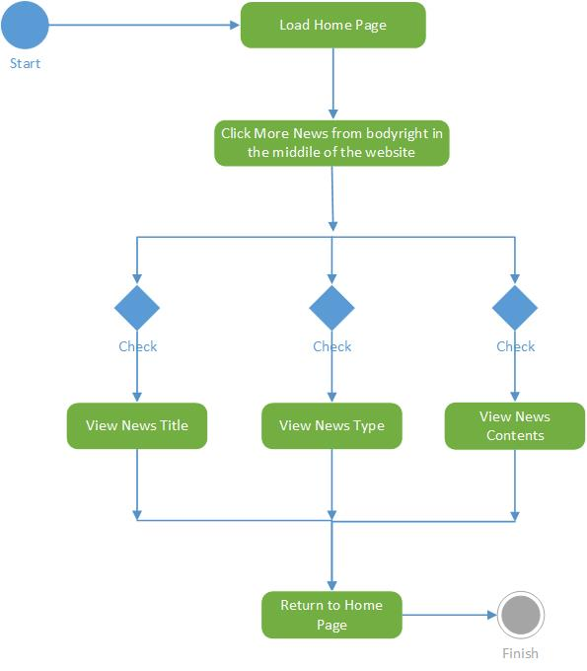

**Activity Diagram for Success Stories of previous students–**

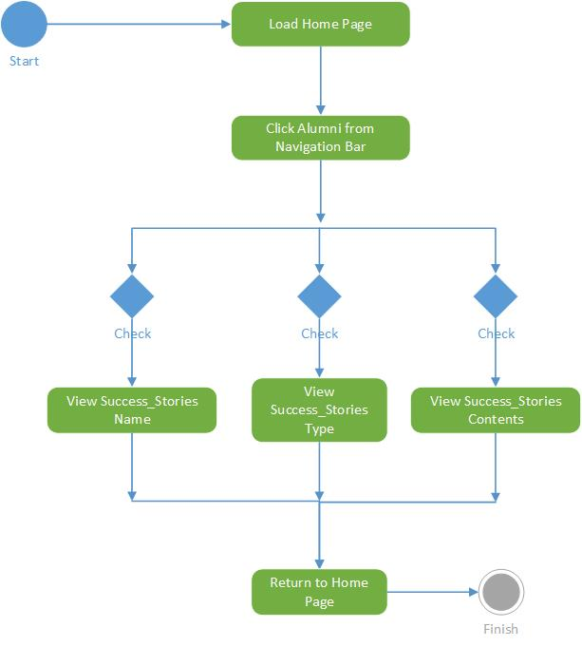

**Activity Diagram for School/College Information–**

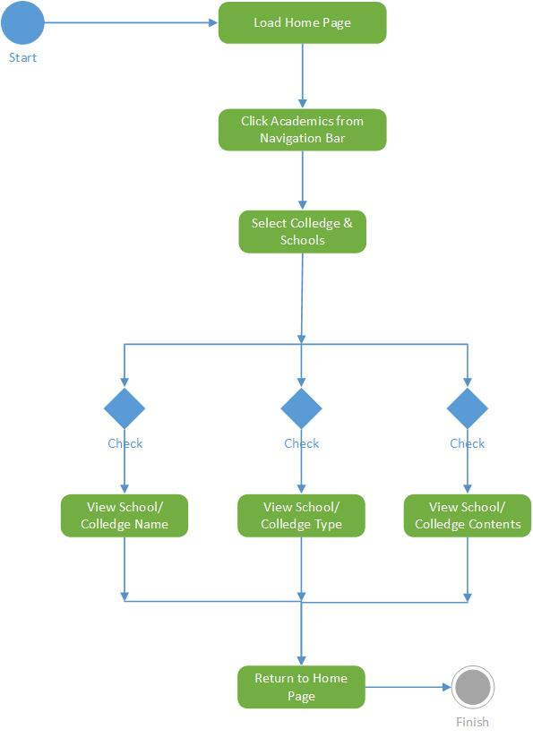

**Activity Diagram for Public Engagement–**

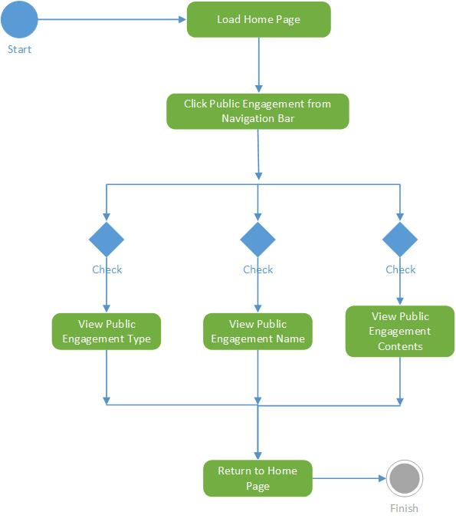

**Activity Diagram for About University–**

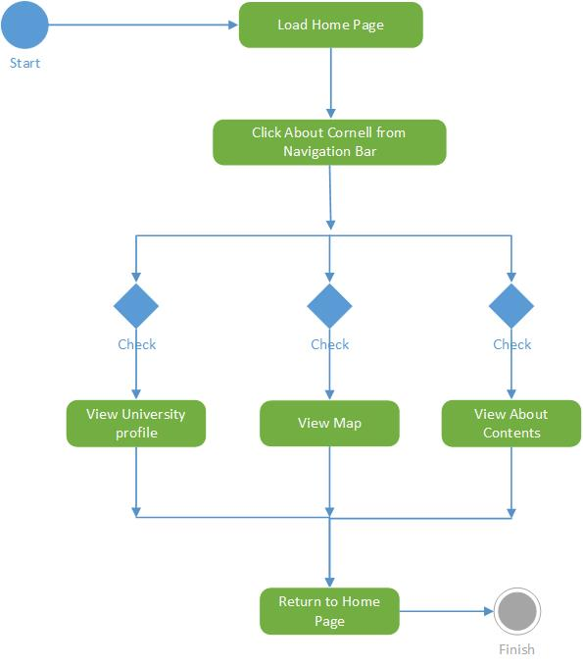

**Activity Diagram for Contact Details–**

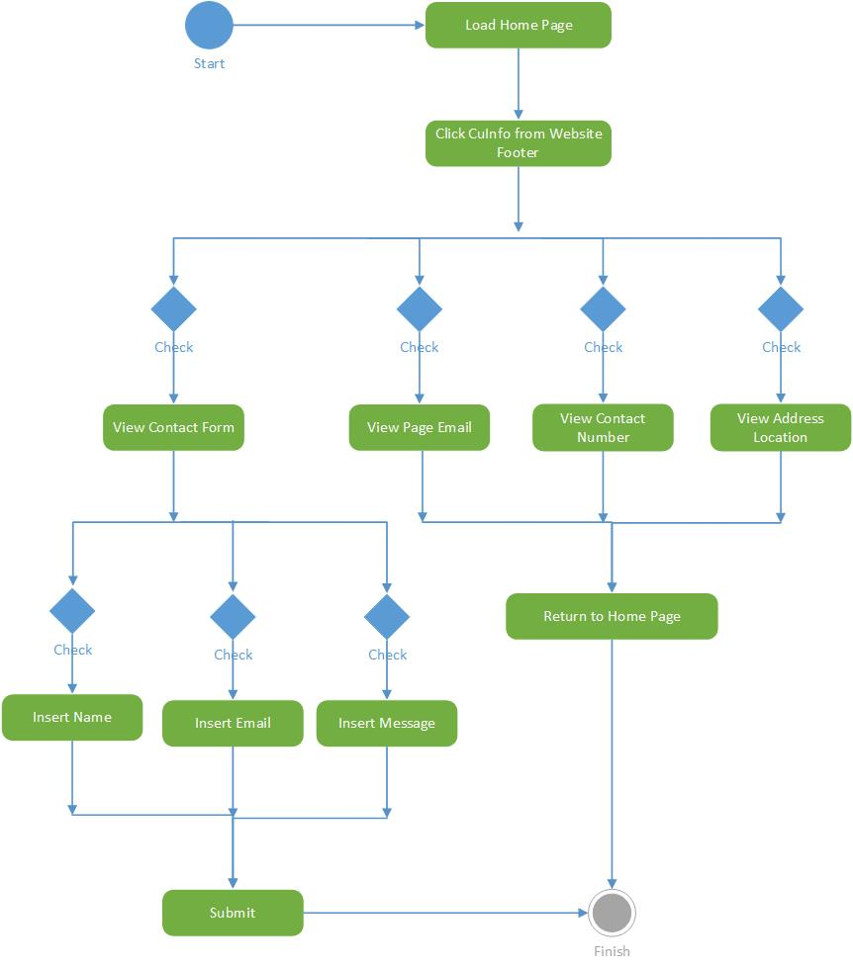

**Activity Diagram for Enquiry-**

