Data Structures and Algorithms lab 3

Data types:
Below shows a table identifying the data types of each variable in the files flavourcompounds.csv and worldregions_ingredients.csv as well as accompanying screenshots to show this.

File name | Variables | Data Types | Example
flavourcompounds.csv | Ingredient 1 | String | 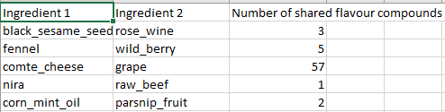
 | Ingredient 2 | String
 | Number of shared flavour compounds | Integer
worldregions_ingredients.csv | World region | String | 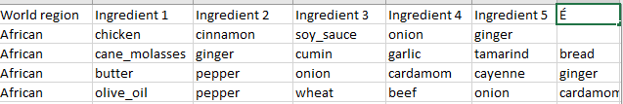
 | Ingredient 1 | String
 | Ingredient 2 | String
 | Ingredient 3 | String
 | Ingredient 4 | String
 | Ingredient 5 | String
 | É | String
Yes, this is an appropriate representation of the data types.

Data structure:
Adjacency matrix: A matrix has a size on n by n nodes. It stores information on all possible relationships between nodes and where there are none it stores 0. In datasets where there are many nodes that don’t share an edge this results in wasted memory space. The maximum space complexity is O(V^2), where V is the number of vertices or nodes in the matrix.
However, the maximum time to find a relationship between two nodes is constant as only a single lookup of the matrix is needed, which gives us O(1) time. In a scenario where we are looking for related recipes or ingredients a matrix would be useful as it is time efficient but it is memory inefficient as there would be many edges containing 0.
The above is correct but the description is generic. For the recipes and ingredients, what would a node and an edge represent? You will get a better idea in the next few weeks.
Adjacency list: Adjacency lists only stores relationships between nodes, and is therefore more memory efficient with a maximum space complexity of O(V + E), where V is the number of nodes in the list and E is the number of edges or relationships between nodes. In most cases V + E is less than V^2 so an adjacency list would typically take less memory space than an adjacency matrix.
However, it takes a maximum of O(V), the total amount of nodes in the list, to find a relationship between two nodes. This is because in the case where the node relationship we are searching for the node has a relationship with every other node in the list, each connected node has to be checked for the node we are looking for.
In flavourcompounds.csv every ingredient is paired with another ingredient, and each pairing has a flavour components number. This could be stored as an undirected, weighted list where the weight is the favour component number. Good.
This would be memory efficient but not time efficient when searching for relationships between ingredients. The same can be done with worldregions_ingredients.csv.
It would not be time efficient due to the maximum time to find a relationship between recipes or ingredients would be the total amount of recipes or ingredients in the list, giving a maximum time complexity of O(total recipes/ total ingredients). As there are tens of thousands of records in worldregions_ingredients.csv and hundreds of thousands of records in flavourcompounds.csv searching for relationships could take a very long time. Correct, but it is ‘linear’, i.e., if you add one more recipe, the time it takes will be one more step (or if you add 10 more recipes, then you will need 10 more steps to search) – computationally speaking, this is actually preferable and not slow at all!
Dictionary: A dictionary would be a good way to store information on recipes and ingredients. The time to find a recipe or ingredient pairing would be O(1) but it would not be the most suitable structure for finding relationships between nodes as each entry would only contain information on itself, not its relationships with other entries. It would be best used in a scenario where the aim is to find information about specific recipes or ingredients.
Give examples to justify some of the above statements.

