**Add a collection called ‘capstones’ and add at least 5 documents to**

**your collection.**

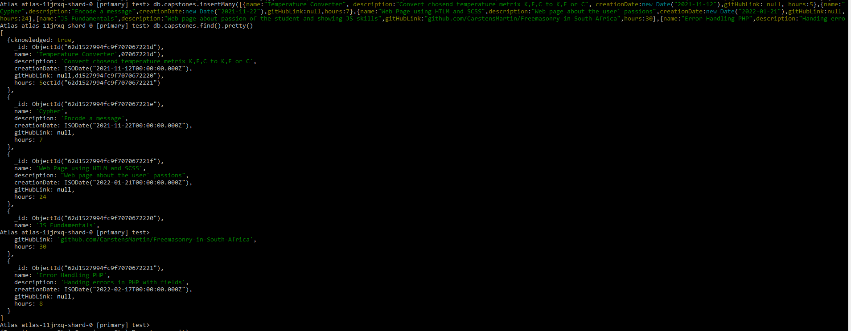

**Include another document that contains the following information:**



**Display all the documents you have added**

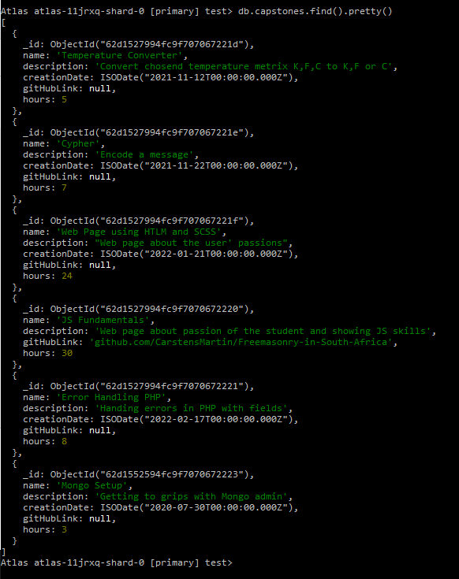

**Add Date to: JS Fundamentals**

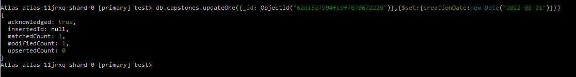

**Update the Mongo project’s description to also include Mongo shell usage**

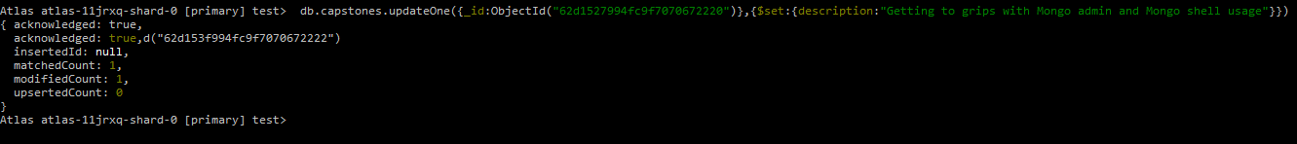

**Increment the number of hours for the Mongo project by 2**

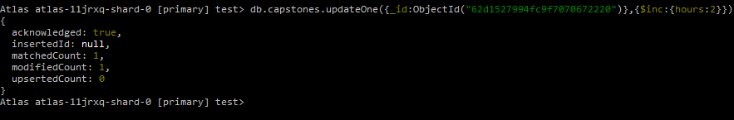

**Display all projects created in the last month**

* Note – there is no files created in the last month



* In the last 12 months there was 5 files created
* The Mongo file was more than 12 months ago so will not display

