**Website:**

**“CARE”**



## PROJECT GROUP MEMBERS

|  |  |
| --- | --- |
| Students Id | **Student Name** |
| **Student1424628** | **Ifra Asif** |
| **Student1424612** | **Hanzala Khan** |
| **Student1425119** | **Asad Afzal** |
| **Student1417959** | **Abdul Moiz** |

**CURRICULUM BATCH**

**6740 2210B3**

## FACULTY

**SR. Ebad Uddin**

## CO-ORDINATOR

**MS. Munazza**

# Certificate

This is to certify that the dissertation entitled **“Care”** is submitted by **Ifra Asif Student 1424628, Hanzala Khan Student1424612, and Abdul Moiz Student1417959 , Asad Afzal Student1425119** in their partial fulfilment of the requirement of the award of the Aptech Computer Certified.

Care

# Acknowledgement

The success and final outcome of this project required a lot of guidance and assistance from many people and I am extremely privileged to have got this all along the completion of my project. All that I have done is only due to such supervision and assistance and I would not forget to thank them.

I respect and thank Aptech for providing me an opportunity to do the project work in ACE and giving us all support and guidance, which made me complete the project duly. I am extremely thankful to Aptech for providing such a nice support and guidance.

I owe my deep gratitude to our project guide **Sr. Ebad Uddin**, who took keen interest on our project work and guided us all along, till the completion of our project work by providing all the necessary information for developing a good system.

**Student1424628 Ifra Asif Student1424612 Hanzala Khan Student1417595 Abdul Moiz**

**Student1425119 Asad Afzal**

Care

# Abstract

This project is aimed at developing an Care for the facilities in the campus. This is an Intranet based application that can be accessed throughout the campus. This system can be used to automate the workflow of service requests for the various facilities in the campus. This is an integrated system that covers different kinds of facilities like class-rooms, labs, hostels, mess, canteen, gymnasium, computer center, faculty club etc. Registered users (students, faculty, lab-assistants and others) will be able to log in a request for service for any of the supported facilities.

These requests will be sent to the concerned people, who are also valid users of the system, to get them resolved. There are features like email notifications/reminders, addition of a new facility to the system, report generators etc.

Care

**Table of Contents**

Certificate 3

Acknowledgement 4

Abstract 5

CHAPTER # 1 7

INTRODUCTION 7

CHAPTER # 2 9

FUNCTION REQUIREMENT 9

CHAPTER # 3 11

REQUIREMENT SPECIFICATION 11

CHAPTER # 4 14

ANALYSIS 14

CHAPTER # 5 20

DESIGN 20

CHAPTER # 6 27

TESTING 27

CHAPTER # 7 31

SCREEN SHOTS 31

Create Account 32

Home Page Header 34

Footer 34

Weight Converter 35

Industries 35

About Us 36

Our Services 36

Track Your Order 37

Create A Shipment 37

Contact Us 38

Login 38

CHAPTER # 8 39

TASK SHEET 39

TASK SHEET 40

CHAPTER # 9 41

SUBMISSION CHECKLIST 41

CHAPTER # 10 43

Conclusion 43

Online Post Office Management System



# CHAPTER # 1 INTRODUCTION

Online Post Office Management System

#### Introduction:

TARS Delivery System is a postal organization with different branches at different cities delivering the mails

through various options like courier, speed post, Normal post, VPP etc… and money orders. They used to charge for the delivery of the mails based on the type of the service preferred, weight of the mail and as well based on the distance.

#### Problem Introduction:

They want an online application through which the offices at different cities can be connected through a single application and they want to avoid using multiple applications, one each at a city office. Also, they want that the application should perform all the tasks of the application that they are using, like calculating the charges. Also, it should hold the information of the details of the charges, pin codes, contact details of the offices based on the location.

#### Modules:

The entire project mainly consists of 3 modules, which are

* + - Head (Admin)
    - Employee (Facility-Heads)
    - Customer (Users)

#### Head Module:

* + - 1. New User (Add / Update / Delete / View over all report)
      2. Create User Account (Add / Update / Delete / View over all report)
      3. Create Facilities (Add / Update / Delete / View over all report)
      4. Create Assignee (Add / Update / Delete / View over all report)
      5. Create New Facilities (Add / Update / Delete / View over all report)

*NOTE

Admin panel have all rights to access all area of the Educational System. Admin panel give authorities to staff and general public users.

#### Employee Module:

* + - 1. Create Request (Add / Update)
      2. Check Status (Add / Update)

#### Customer Module:

* + - 1. Create Request (Add)
      2. Assign People (Add)

Online Post Office Management System

# CHAPTER # 2

# FUNCTION REQUIREMENT

Care

**1.3.1 Functional Requirement:**

The website will have three users/roles:

1. Administrator
2. Doctor
3. Patient

The Administrator should be able to do the following:

1. Add Cities to the master database.
2. Add Doctors to the Master database.
3. Modify Doctor Details.
4. Modify Patient Details.
5. Delete Cities
6. Delete Doctors
7. Delete Patients
8. Create/Manage Users/Logins
9. Manage information/details on the WEBSITE

The Doctor should be able to do the following:

1. Login into the system with his USER/PASSWORD
2. View his/her profile details
3. Add details to his/her profile
4. Modify his/her profile
5. View Appointments
6. Update his availability for DAY/WEEK/MONTH

The Patient should be able to do the following:

1. Register/Create Account [USERID should be unique].
2. Search Doctor based on location, Specialist
3. Book Appointment [Check Availability]

Online Post Office Management System

# CHAPTER # 3

# REQUIREMENT SPECIFICATION

Online Post Office Management System

#### INTRODUCTION

1. The thirst for learning, upgrading technical skills and applying the concepts in real life environment at a fast pace is what the industry demands from IT professionals today. However busy work schedules, far-flung locations, unavailability of convenient time-slots pose as major barriers when it comes to applying the concepts into realism. And hence the need to look out for alternative means of implementation in the form of laddered approach.
2. The above truly pose as constraints especially for our students too! With their busy schedules, it is indeed difficult for our students to keep up with the genuine and constant need for integrated application which can be seen live especially so in the field of IT education where technology can change on the spur of a moment. *Well, technology does come to our rescue at such times!!*
3. Keeping the above in mind and in tune with our constant endeavour to use Technology in our training model, we at Aptech have thought of revolutionizing the way our students learn and implement the concepts using tools themselves by providing a *live and synchronous eProject learning environment!*

#### HARDWARE REQUIREMENTS:

**Hardware**

* A minimum computer system that will help you access all the tools in the courses is a Pentium 166 or better
* 128 Megabytes of RAM or better

**Operating System**

* LINUX / Windows 2000 Server (or higher if possible)

**Software**

* PHP
* MySQL
* PERL
* Apache

#### HARDWARE REQUIREMENTS FOR PRESENT PROJECT:

PROCESSOR : Intel dual Core, i3 RAM : 4 GB

HARD DISK : 250 GB

Online Post Office Management System

#### SOFTWARE REQUIREMENTS:

Software Requirements deal with defining software resource requirements and pre-requisites that need to be installed on a computer to provide optimal functioning of an application. These requirements or pre-requisites are generally not included in the software installation package and need to be installed separately before the software is installed.

#### SOFTWARE REQUIREMENTS FOR PRESENT PROJECT:

OPERATING SYSTEM : Windows 7/ XP/8/10

SOFTWARE : Visual Studio 2013/2017

FRONT END : ASP.NET MVC, C#

DATABASE : SQL Server

Online Post Office Management System

# CHAPTER # 4 ANALYSIS

Online Post Office Management System

#### PROPOSED SYSTEM:

In the proposed system, in this software once the timer is being arranged, it put up updates and uploads automatically and does not need anyone to do so. Also, it is easily available due to its speed and programming part and using it is quite an easy task and well as due to its speed the information which will be available by one or two clicks, will get available in few seconds only.

#### FEASIBILITY STUDY:

The feasibility of the project is analysed in this phase and business proposal is put forth with a very general plan for the project and some cost estimates. During system analysis the feasibility study of the proposed system is to be carried out. This is to ensure that the proposed system is not a burden to the company. For feasibility analysis, some understanding of the major requirements for the system is essential.

Three key considerations involved in the feasibility analysis are:

#### Economic Feasibility:

This study is carried out to check the economic impact will have on the system will have on the organization. The amount of fund that the company can pour into the research and development of the system is limited. The expenditures must be justified. Thus, the developed system as well within the budget and this was achieved because most of the technologies used are freely available. Only the customized products have to be purchased.

#### Technical Feasibility:

This study is carried out to check the technical feasibility, that is, the technical requirements of the system. Any system developed must not have a high demand on the available technical resources. This will lead to high demands being placed on the client. The developed system must have a modest requirement, as only minimal or null changes for the implementing this system.

#### Operational Feasibility:

The aspect of study is to check the level of acceptance of the system by the user. This includes the process of training the user to use the system efficiently. The user must not feel threatened by the system, instead must accept it as a necessity. The level of acceptance by the users solely depends on the methods that are employed to educate the user about the system and to make

Online Post Office Management System

him familiar with it. His level of confidence must be raised so that he is also able to make some constructive criticism, which is welcomed, as he is the final user of the system.

#### LANGUAGE SPECIFICATION

* + 1. **C#.NET**

C# programs run on the .NET Framework, an integral component of Windows that includes a virtual execution system called the common language runtime (CLR) and a unified set of class libraries. The CLR is the commercial implementation by Microsoft of the common language infrastructure (CLI), an international standard that is the basis for creating execution and development environments in which languages and libraries work together seamlessly.

Source code written in C# is compiled into an [intermediate language](https://docs.microsoft.com/en-us/dotnet/standard/managed-code) [(IL)](https://docs.microsoft.com/en-us/dotnet/standard/managed-code) that conforms to the CLI specification. The IL code and resources, such as bitmaps and strings, are stored on disk in an executable file called an assembly, typically with an extension of .exe or. dlt. An assembly contains a manifest that provides information about the assembly's types, version, culture, and security requirements.

#### ASP.Net MVC

ASP.NET MVC is an open-source web development framework from Microsoft that provides a Model View Controller architecture.ASP.net MVC offers an alternative to ASP.net web forms for building web applications. It is a part of the .Net platform for building, deploying and running web apps. You can develop web apps and website with the help of HTML, CSS, jQuery, JavaScript, etc.

#### SQL SERVER

Microsoft SQL Server is a relational database management system (RDBMS) that supports a wide variety of transaction processing, business intelligence and analytics applications in corporate IT environments. Microsoft SQL Server is one of the three market-leading database technologies, along with Oracle Database and IBM's [DB2](https://searchdatacenter.techtarget.com/definition/DB2).

Like other [RDBMS](https://searchdatamanagement.techtarget.com/definition/RDBMS-relational-database-management-system) software, Microsoft SQL Server is built on top of [SQL](https://searchsqlserver.techtarget.com/definition/SQL), a standardized programming language that database administrators ([DBAs](https://searchsqlserver.techtarget.com/definition/database-administrator)) and other IT professionals use to manage databases and query the data they contain. SQL Server is tied to Transact-SQL ([T-](https://searchsqlserver.techtarget.com/definition/T-SQL) [SQL](https://searchsqlserver.techtarget.com/definition/T-SQL)), an implementation of SQL from Microsoft that adds a set of proprietary programming extensions to the standard language.

Online Post Office Management System

# CHAPTER # 5 DESIGN

Online Post Office Management System

### SYSTEM DESIGN:

#### INTRODUCTION TO UML: UML Design

The Unified Modelling Language (UML) is a standard language for specifying, visualizing, constructing, and documenting the software system and its components. It is a graphical language, which provides a vocabulary and set of semantics and rules. The UML focuses on the conceptual and physical representation of the system. It captures the decisions and understandings about systems that must be constructed. It is used to understand, design, configure, maintain, and control information about the systems.

The UML is a language for:

* + - * Visualizing
      * Specifying
      * Constructing
      * Documenting

##### Visualizing

Through UML we see or visualize an existing system and ultimately, we visualize how the system is going to be after implementation. Unless we think, we cannot implement. UML helps to visualize, how the components of the system communicate and interact with each other.

##### Specifying

Specifying means building, models that are precise, unambiguous and complete UML addresses the specification of all the important analysis design, implementation decisions that must be made in developing and deploying a software system.

##### Constructing

UML models can be directly connected to a variety of programming language through mapping a model from UML to a programming language like JAVA or C++ or VB. Forward Engineering and Reverse Engineering is possible through UML.

Online Post Office Management System

##### Documenting

The Deliverables of a project apart from coding are some Artifacts, which are critical in controlling, measuring and communicating about a system during its developing requirements, architecture, desire, source code, project plans, tests, prototypes releasers, etc.

#### UML Approach

**UML Diagram**

A diagram is the graphical presentation of a set of elements, most often rendered as a connected graph of vertices and arcs. You draw diagram to visualize a system from different perspective, so a diagram is a projection into a system. For all but most trivial systems, a diagram represents an elided view of the elements that make up a system. The same element may appear in all diagrams, only a few diagrams, or in no diagrams at all. In theory, a diagram may contain any combination of things and relationships. In practice, however, a small number of common combinations arise, which are consistent with the five most useful views that comprise the architecture of a software- intensive system. For this reason, the UML includes nine such diagrams:

1. Class diagram
2. Object diagram
3. Use case diagram
4. Sequence diagram
5. Collaboration diagram
6. State chart diagram
7. Activity diagram
8. Component diagram
9. Deployment diagram

Online Post Office Management System

#### USE CASE DIAGRAM:

A use case diagram in the Unified Modelling Language (UML) is a type of behavioural diagram defined by and created from a use-case analysis. Its purpose is to present a graphical overview of the functionality provided by a system in terms of actors, their goals (represented as use cases), and any dependencies between those use cases.

Use case diagrams are formally included in two modelling languages defined by the OMG: the unified modelling language (UML) and the systems modelling language (sysML)

#### Use case diagram of our project:

**Flow Chart:**

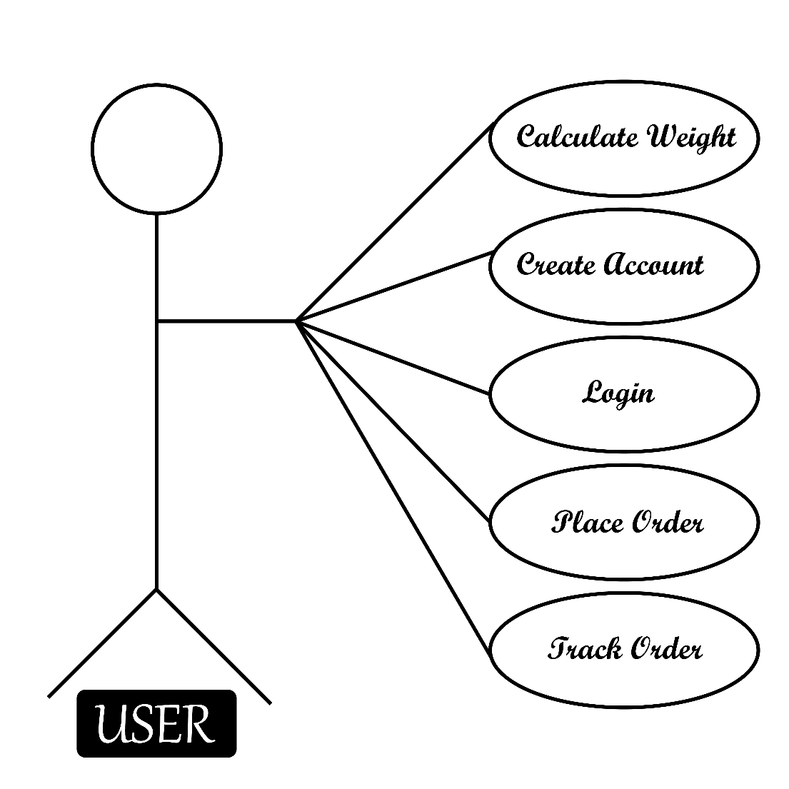A flowchart is a type of diagram that represents a workflow or process. A flowchart can also be defined as a diagrammatic representation of an algorithm, a step-by- step approach to solving a task. The flowchart shows the steps as boxes of various kinds, and their order by connecting the boxes with arrows

Online Post Office Management System

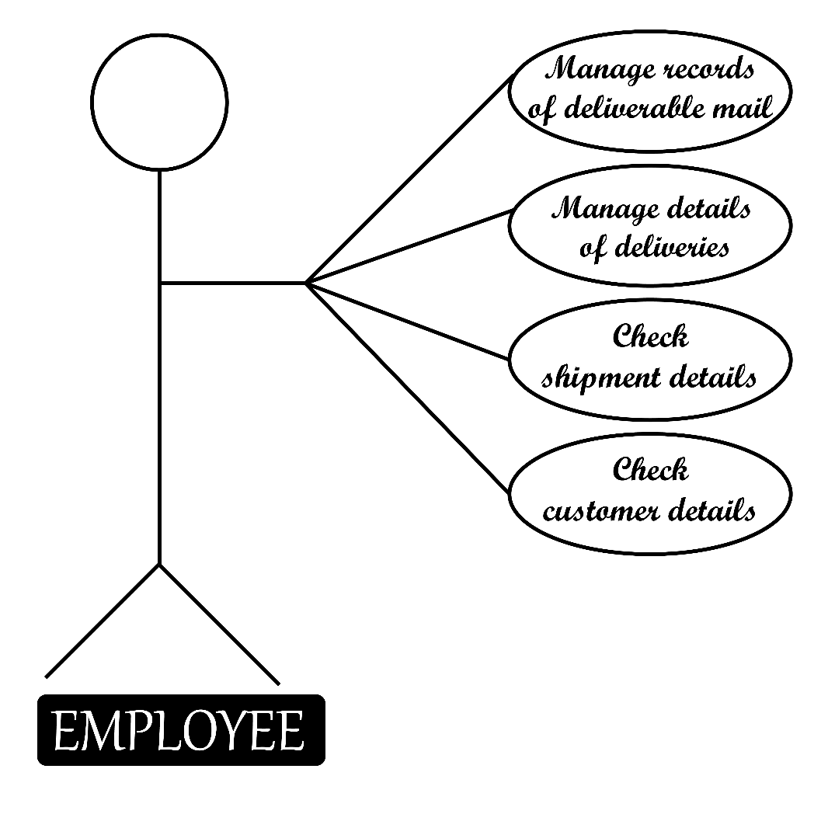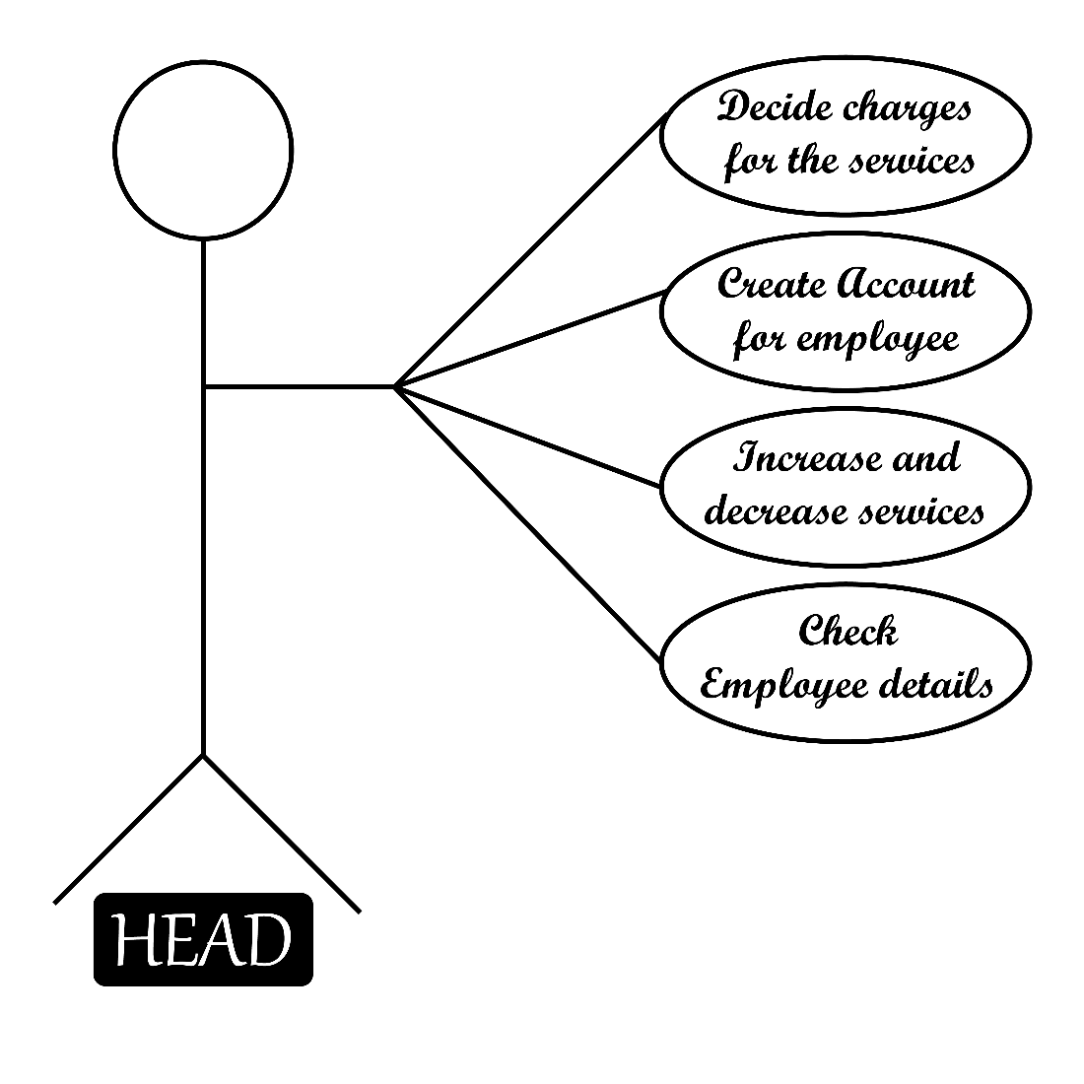

Online Post Office Management System

#### Activity Diagram:

An activity diagram is a behavioural diagram i.e., it depicts the behaviour of a system. An activity diagram portrays the control flow from a start point to a finish point showing the various decision paths that exist while the activity is being executed.

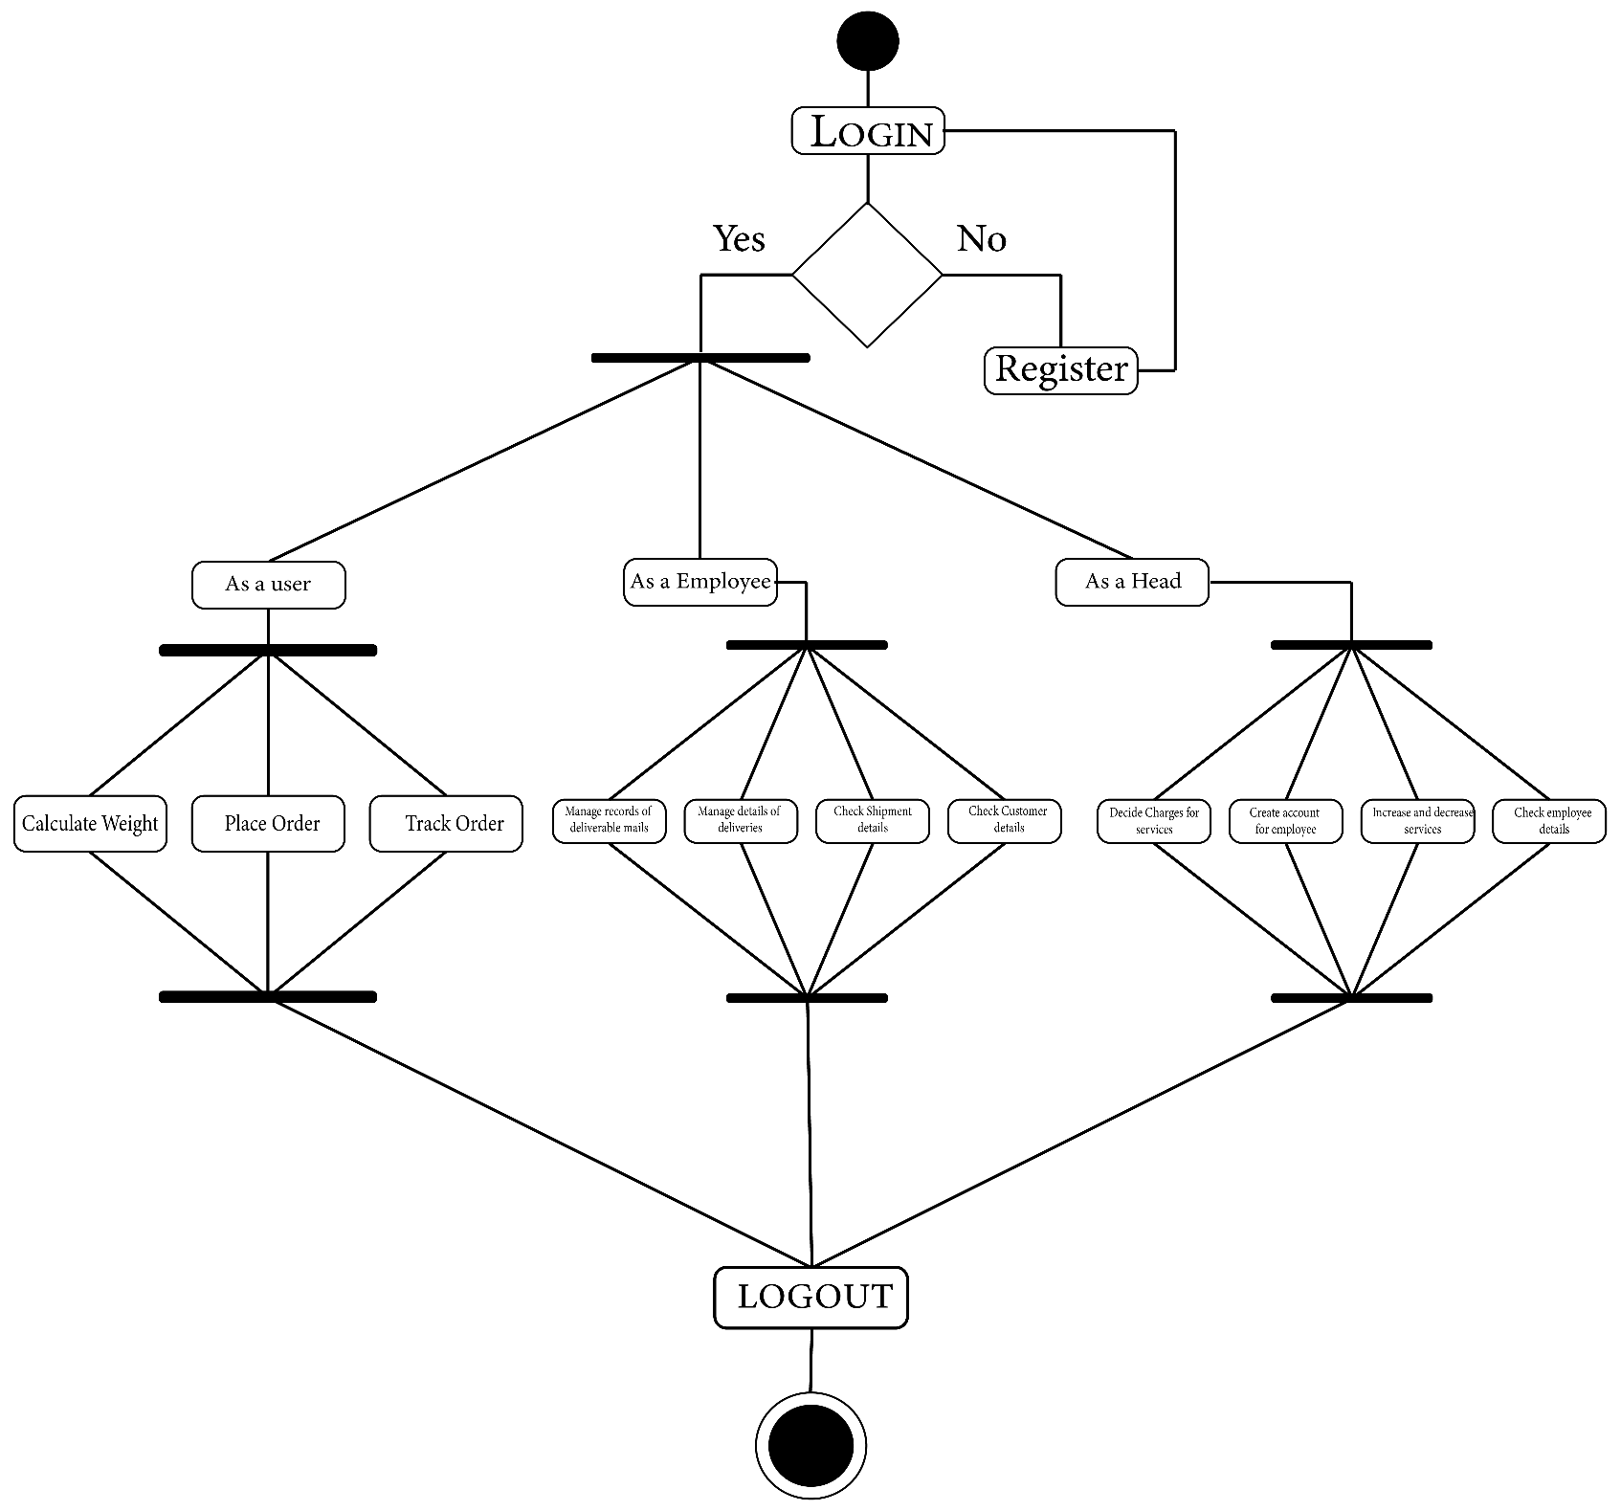

Online Post Office Management System

### ERD Diagram:

An entity–relationship model describes interrelated things of interest in a specific domain of knowledge. A basic ER model is composed of entity types and specifies relationships that can exist between entities

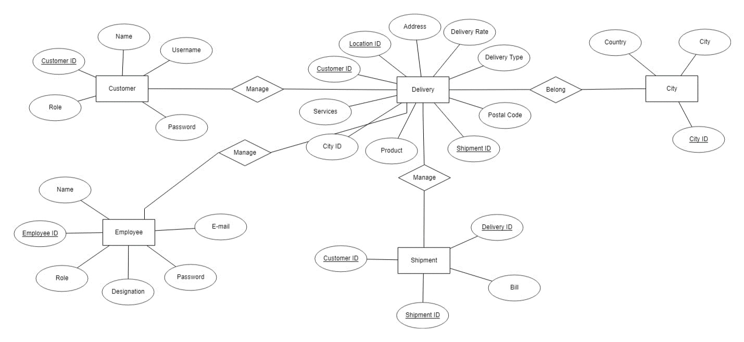

Online Post Office Management System

# CHAPTER # 6 TESTING

Online Post Office Management System

#### 6.1 INTRODUCTION TO SYSTEM TESTING:

The purpose of testing is to discover errors. Testing is the process of trying to discover every conceivable fault or weakness in a work product. It provides a way to check the functionality of components, sub-assemblies, assemblies and/or a finished product It is the process of exercising software with the intent of ensuring that the Software system meets its requirements and user expectations and does not fail in an unacceptable manner. There are various types of test. Each test type addresses a specific testing requirement.

#### TYPES OF TESTING:

**Unit testing:**

Unit testing involves the design of test cases that validate that the internal program logic is functioning properly, and that program inputs produce valid outputs. All decision branches and internal code flow should be validated. It is the testing of individual software units of the application .it is done after the completion of an individual unit before integration. This is a structural testing, that relies on knowledge of its construction and is invasive. Unit tests perform basic tests at component level and test a specific business process, application, and/or system configuration. Unit tests ensure that each unique path of a business process performs accurately to the documented specifications and contains clearly defined inputs and expected results.

#### Integration testing:

Integration tests are designed to test integrated software components to determine if they actually run as one program. Testing is event driven and is more concerned with the basic outcome of screens or fields. Integration tests demonstrate that although the components were individually satisfaction, as shown by successfully unit testing, the combination of components is correct and consistent. Integration testing is specifically aimed at exposing the problems that arise from the combination of components.

Online Post Office Management System

#### Functional test:

Functional tests provide systematic demonstrations that functions tested are available as specified by the business and technical requirements, system documentation, and user manuals.

Functional testing is centred on the following items:

Valid Input : identified classes of valid input must be accepted. Invalid Input : identified classes of invalid input must be rejected. Functions

: identified functions must be exercised.

Output : identified classes of application outputs must be exercised. Systems/Procedures: interfacing systems or procedures must be invoked.

Organization and preparation of functional tests is focused on requirements, key functions, or special test cases. In addition, systematic coverage pertaining to identify Business process flows; data fields, predefined processes, and successive processes must be considered for testing. Before functional testing is complete, additional tests are identified and the effective value of current tests is determined.

#### System Test:

System testing ensures that the entire integrated software system meets requirements. It tests a configuration to ensure known and predictable results. An example of system testing is the configuration-oriented system integration test. System testing is based on process descriptions and flows, emphasizing pre-driven process links and integration points.

#### White Box Testing:

White Box Testing is a testing in which in which the software tester has knowledge of the inner workings, structure and language of the software, or at least its purpose. It is purpose. It is used to test areas that cannot be reached from a black box level.

#### Unit Testing:

Unit testing is usually conducted as part of a combined code and unit test phase of the software lifecycle, although it is not uncommon for coding and unit testing to be conducted as two distinct phases.

Online Post Office Management System

#### Black Box Testing:

Black Box Testing is testing the software without any knowledge of the inner workings, structure or language of the module being tested. Black box tests, as most other kinds of tests, must be written from a definitive source document, such as specification or requirements document, such as specification or requirements document. It is a testing in which the software under test is treated, as a black box. you cannot “see” into it. The test provides inputs and responds to outputs without considering how the software works.

#### Test strategy and approach

Field testing will be performed manually and functional tests will be written in detail.

#### Test objectives

* All field entries must work properly.
* Pages must be activated from the identified link.
* The entry screen, messages and responses must not be delayed.

#### Features to be tested

* Verify that the entries are of the correct format
* No duplicate entries should be allowed
* All links should take the user to the correct page.

#### Integration Testing:

Software integration testing is the incremental integration testing of two or more integrated software components on a single platform to produce failures caused by interface defects.

The task of the integration test is to check that components or software applications, e.g., components in a software system or – one step up – software applications at the company level

– interact without error.

#### Test Results:

All the test cases mentioned above passed successfully. No defects encountered.

Online Post Office Management System

# CHAPTER # 7 SCREEN SHOTS

Online Post Office Management System

## Create Account

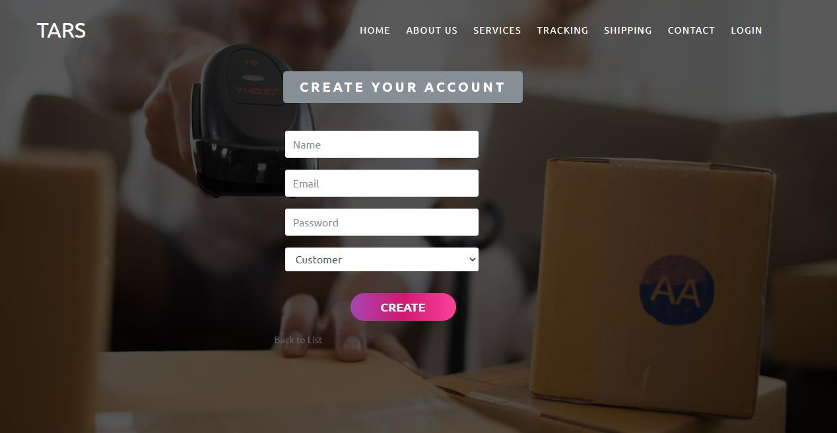

**Read Details**

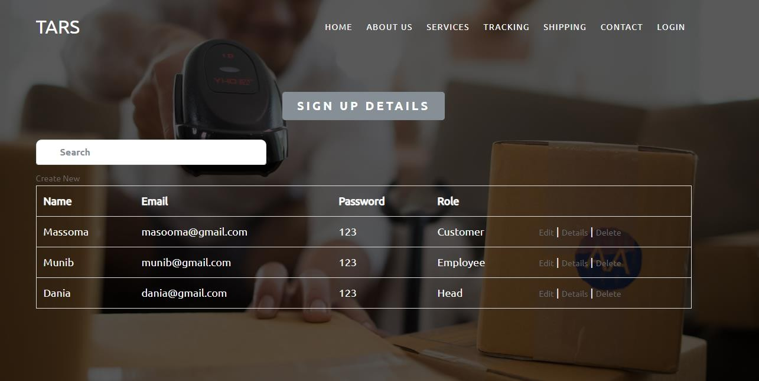

Online Post Office Management System

## Update Details

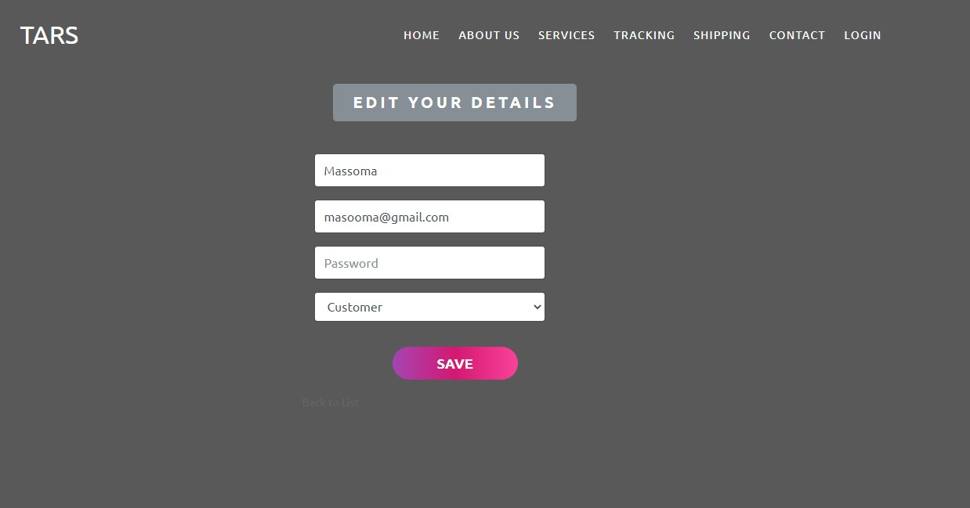

**Delete Details**

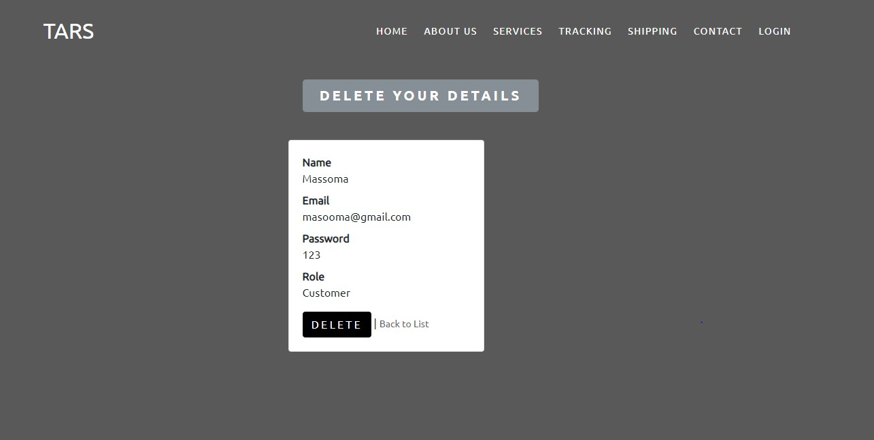

Online Post Office Management System

## Home Page Header

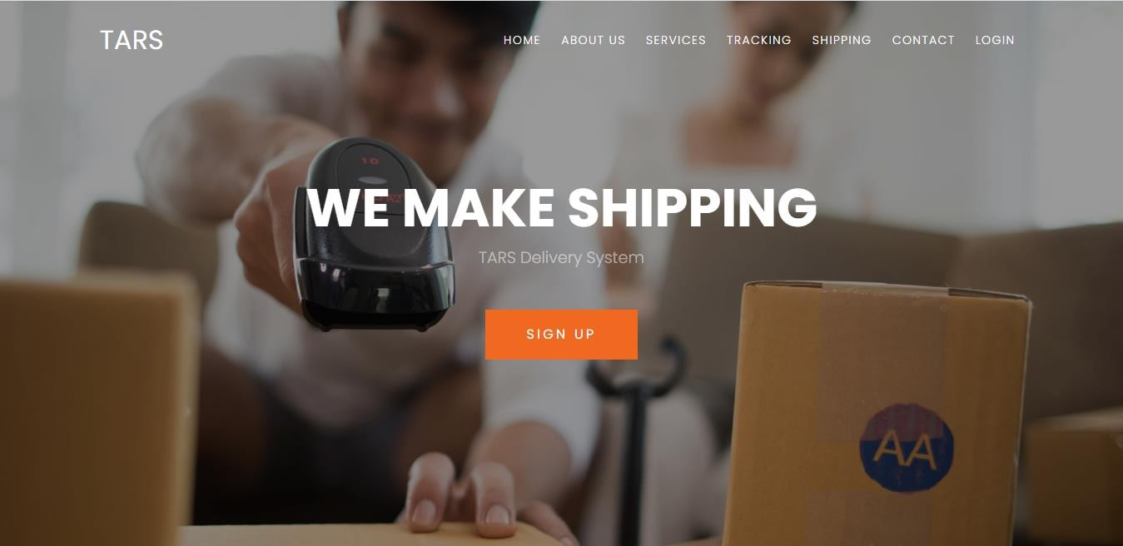

**Footer**

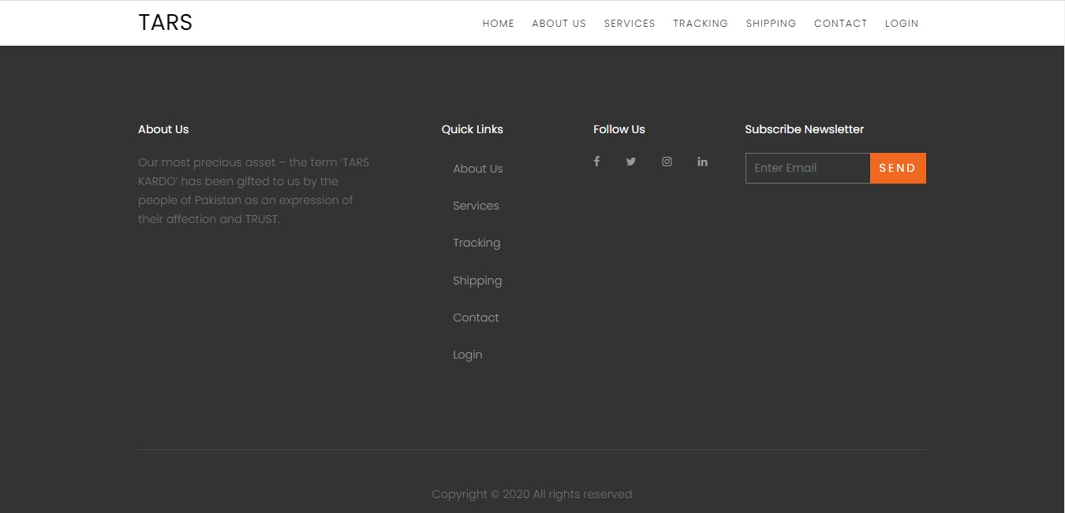

Online Post Office Management System

## Weight Converter

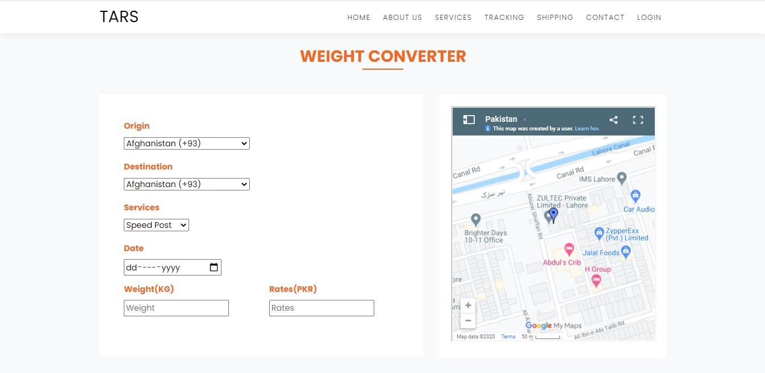

**Industries**



Online Post Office Management System

## About Us



**Our Services**

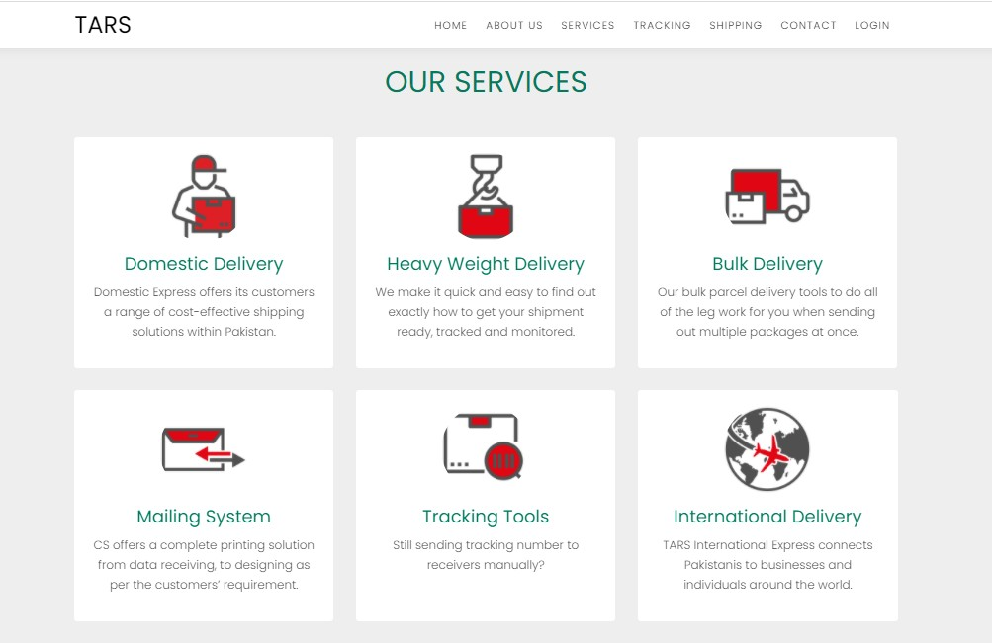

Online Post Office Management System

## Track Your Order

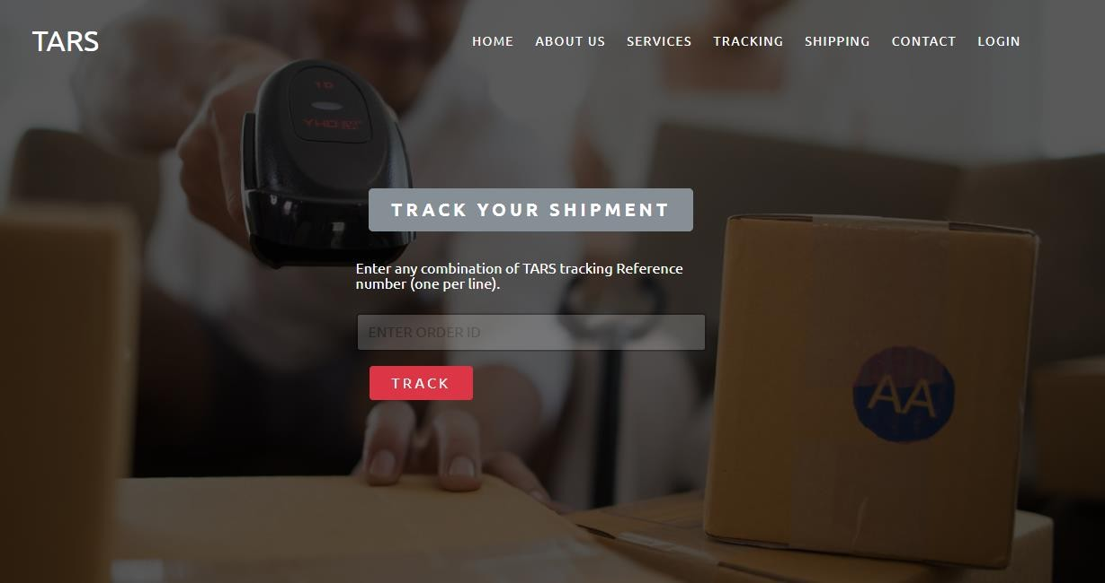

**Create A Shipment**

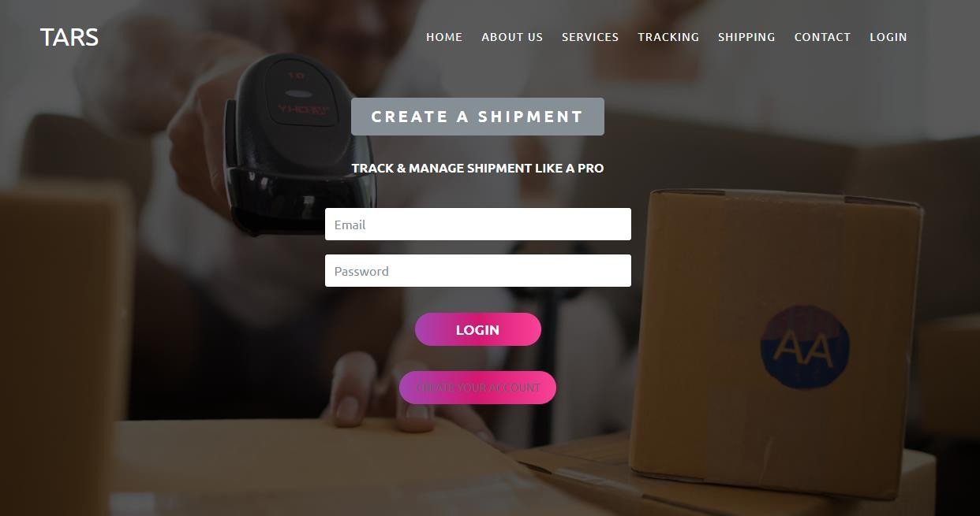

Online Post Office Management System

## Contact Us

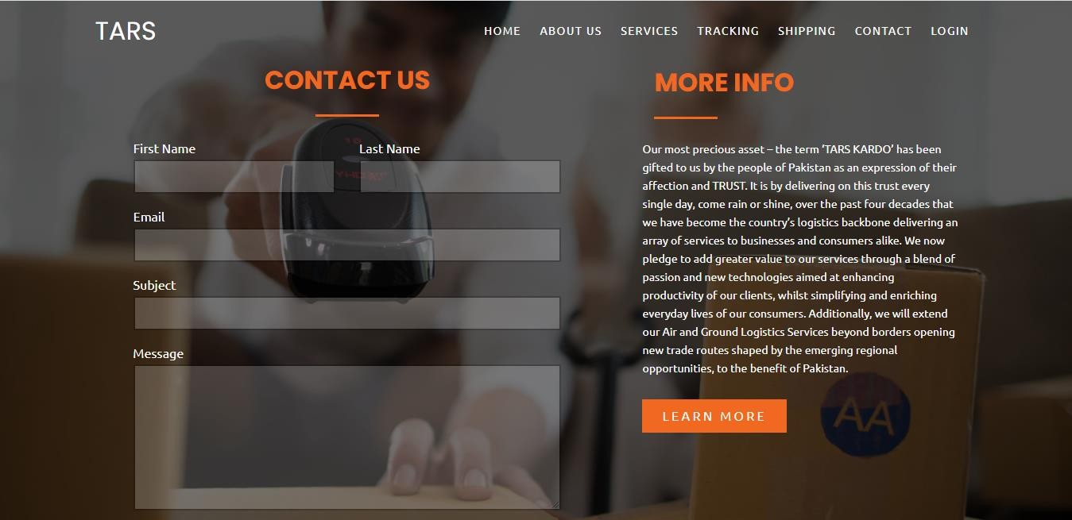

**Login**

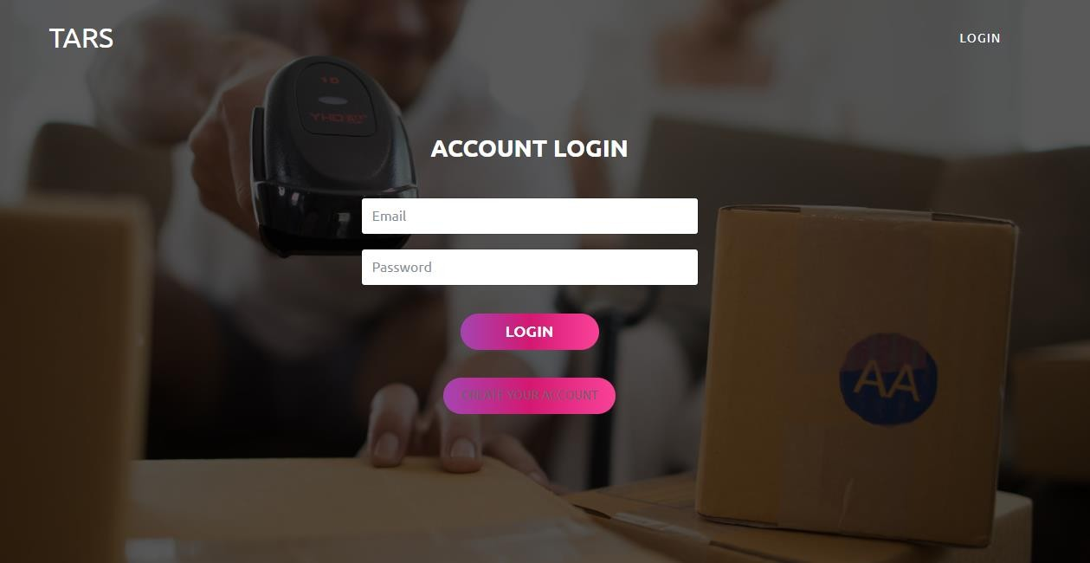

Online Post Office Management System

# CHAPTER # 8 TASK SHEET

Online Post Office Management System

## TASK SHEET

|  |  |  |  |
| --- | --- | --- | --- |
| S# | Task | Team Member Name | Status |
| 1. | Analysis | Dania Shabih Masooma Taha Naeem | ✓ |
| 2. | Design | Dania Shabih Masooma Taha Naeem | ✓ |
| 3. | Development | Dania Shabih Masooma Taha Naeem | ✓ |
| 4. | Documentation | Dania Shabih Masooma Taha Naeem | ✓ |
| 5. | Finalization | Dania Shabih Masooma Taha Naeem | ✓ |

Online Post Office Management System

# CHAPTER # 9

# SUBMISSION CHECKLIST

Online Post Office Management System

## SUBMISSION CHECKLIST

|  |  |  |  |
| --- | --- | --- | --- |
| S.no | List of items | Remarks | Comments |
| **1.** | Do All Pages Linked  together | **Yes** | ✓ |
| **2.** | Authorization | **Yes** | ✓ |
| **3.** | Crud Operations | **Yes** | ✓ |
| **4.** | Database Connection | **Yes** | ✓ |
| **6.** | Feedback Form  Included | **Yes** | ✓ |
| **7.** | Project Zip File | **Yes** | ✓ |

Online Post Office Management System

# CHAPTER # 10

# Conclusion

Online Post Office Management System

#### Conclusion:

A computerized postal department system has been developed and the system was tested with sample data. The system results in regular timely preparations of required outputs. In comparison with manual system the benefits under a computer system are considerable in the saving of man power working hours and Eiffel. Provision for addition and deletion of customers is there in the system it is possible to view that proper filling system has been adopted to slate date for future. The entire project runs on windows environments. The system can be used to make better management described at appropriate time. The user gets amount and timely information system.