# Bytewise Fellowship

# Bytewise Limited | LinkedIn

# Submitted by:

# Ifra Razzaq

# Track:

# Flutter Android

# Fellowship Program Report:

Flutter is an open-source software development kit (SDK) created by Google, specifically designed for building cross-platform applications. It provides developers with a powerful framework and a comprehensive set of tools to create visually appealing and high-performance apps that can run on multiple platforms, including iOS, Android, web, desktop, and embedded devices.

At the core of Flutter's architecture is a widget-based system. In Flutter, everything you see on the screen is a widget. Widgets are the building blocks of the user interface, representing various UI components such as buttons, text inputs, images, and layouts. Flutter offers a vast collection of pre-built widgets that you can easily customize, and you can also create your own custom widgets by combining existing ones. This widget-based approach allows for flexible and modular UI development.

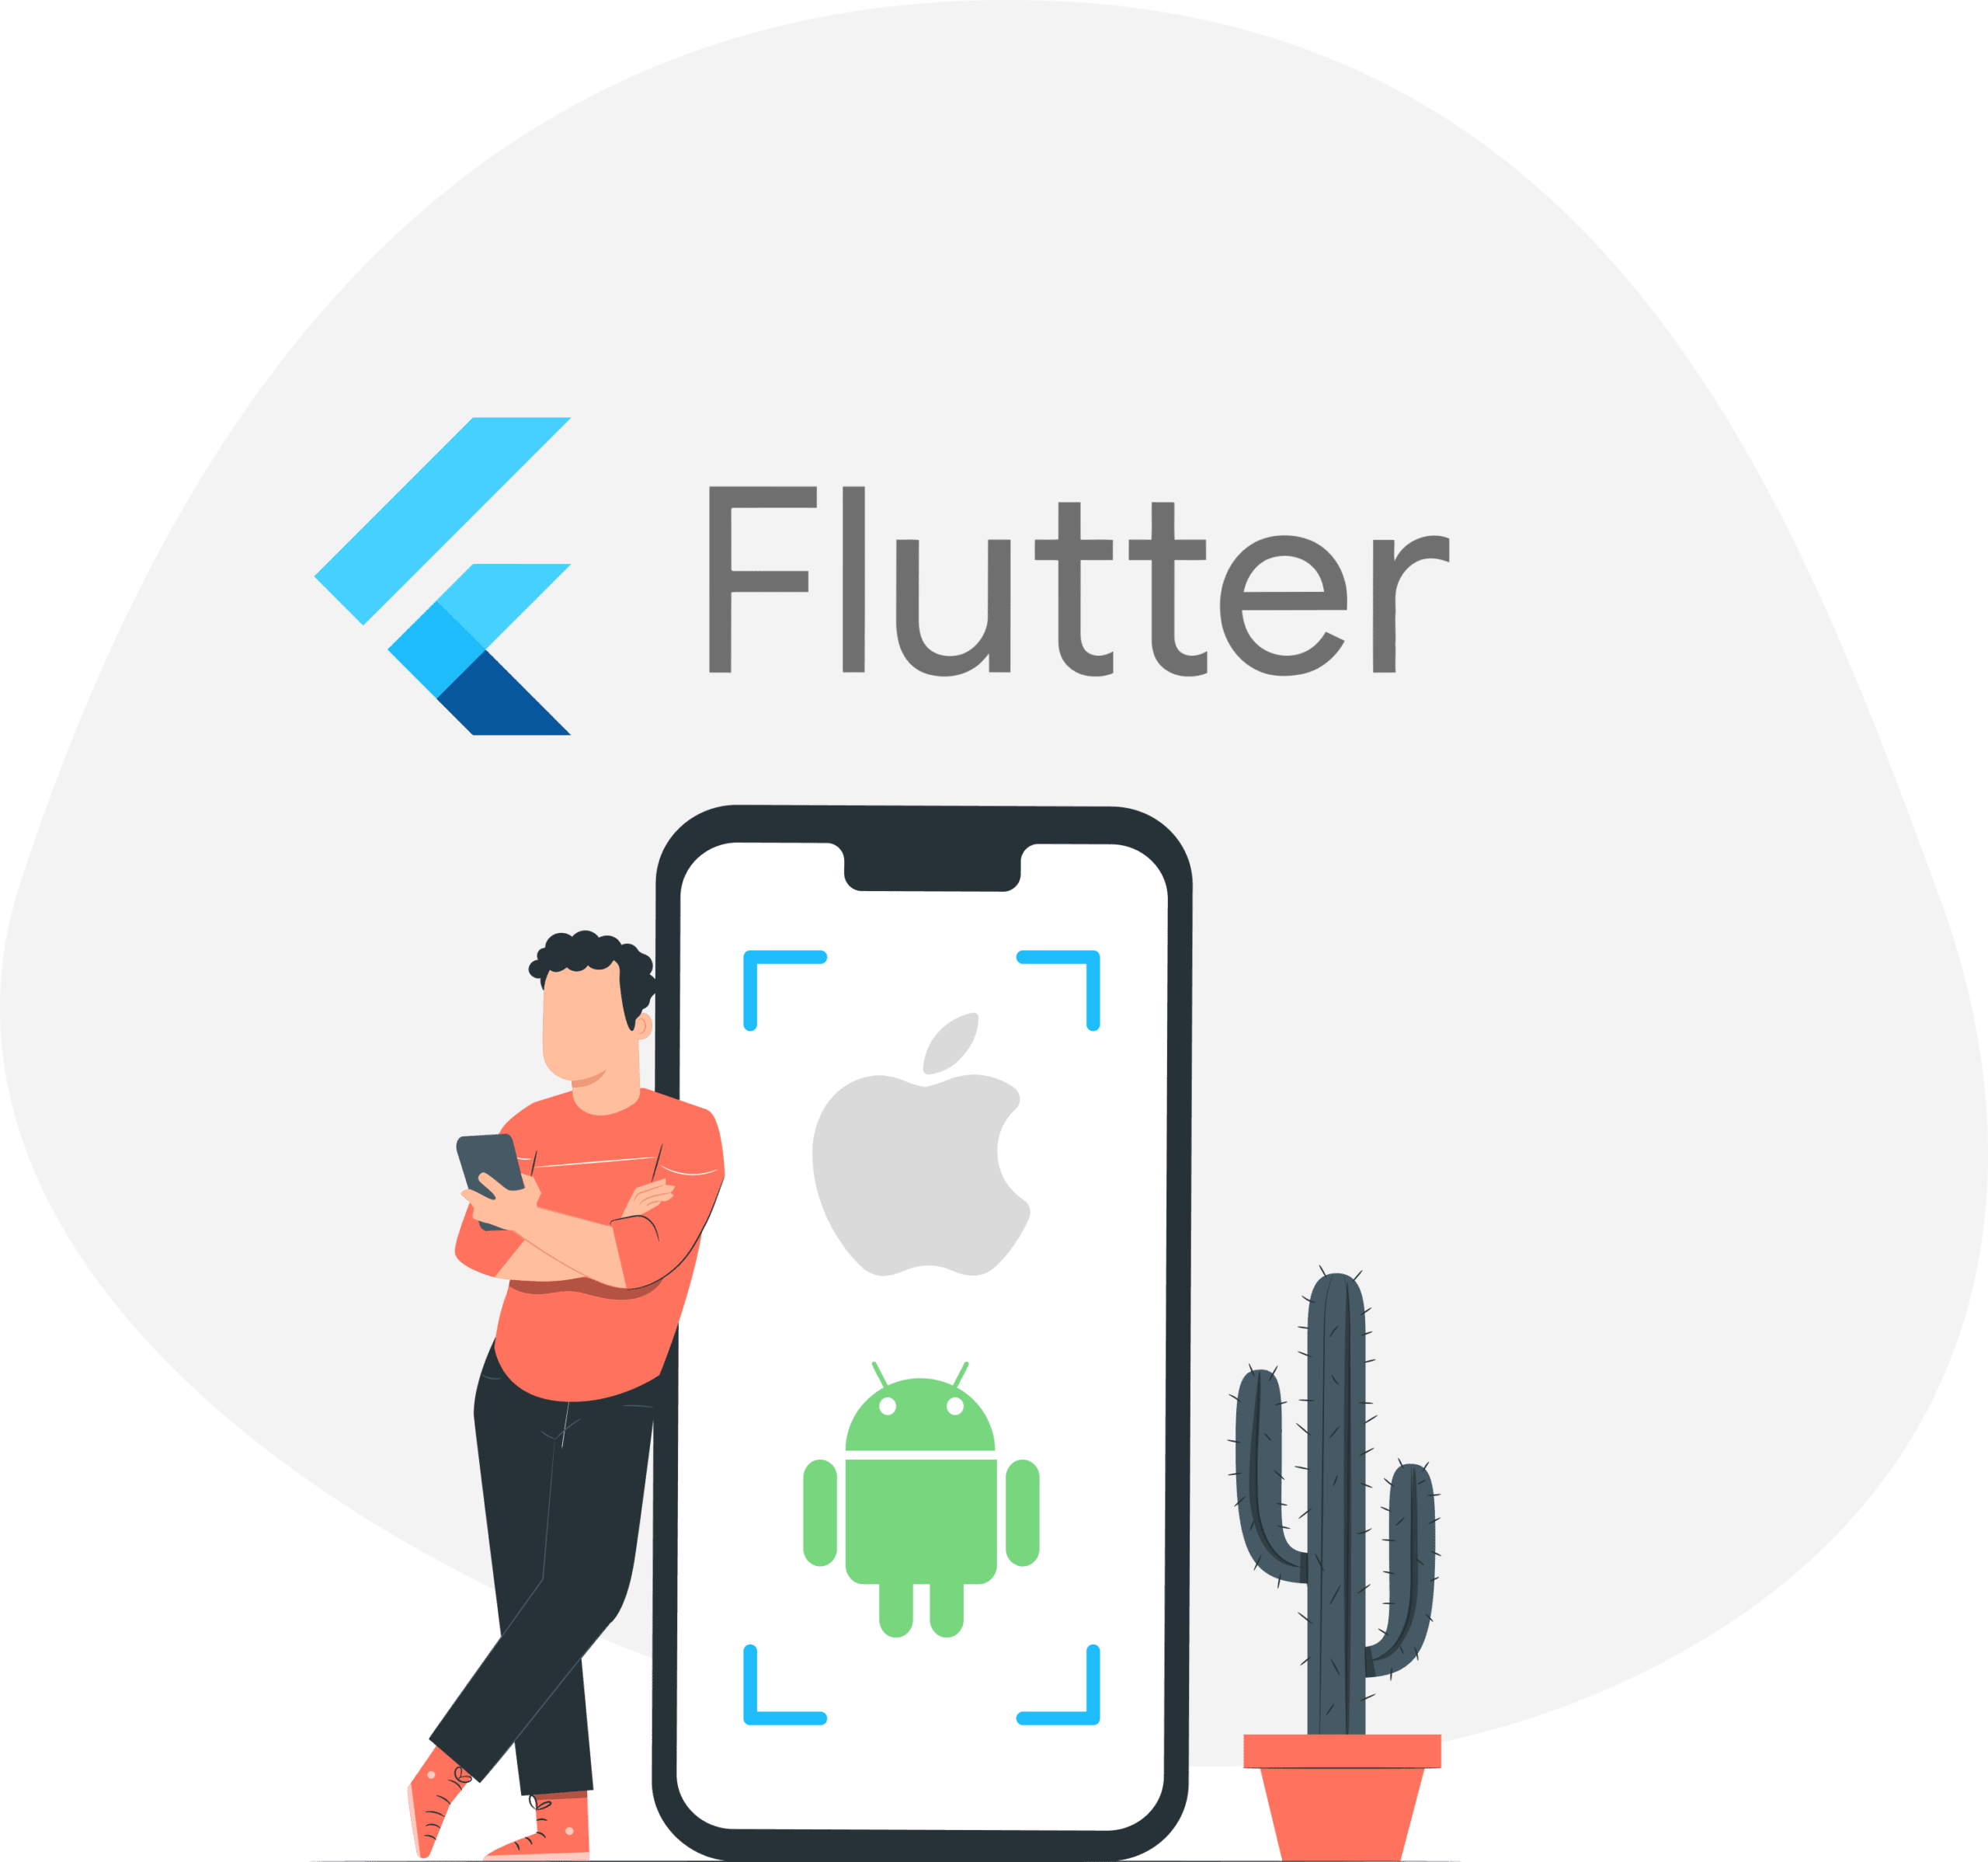

One of the most notable features of Flutter is its **hot reload** capability. With hot reload, developers can make changes to the code and instantly see the results reflected in the app without restarting or losing the app's state. This feature significantly speeds up the development process and enables developers to iterate quickly, experiment with different designs, and fix issues on the fly.

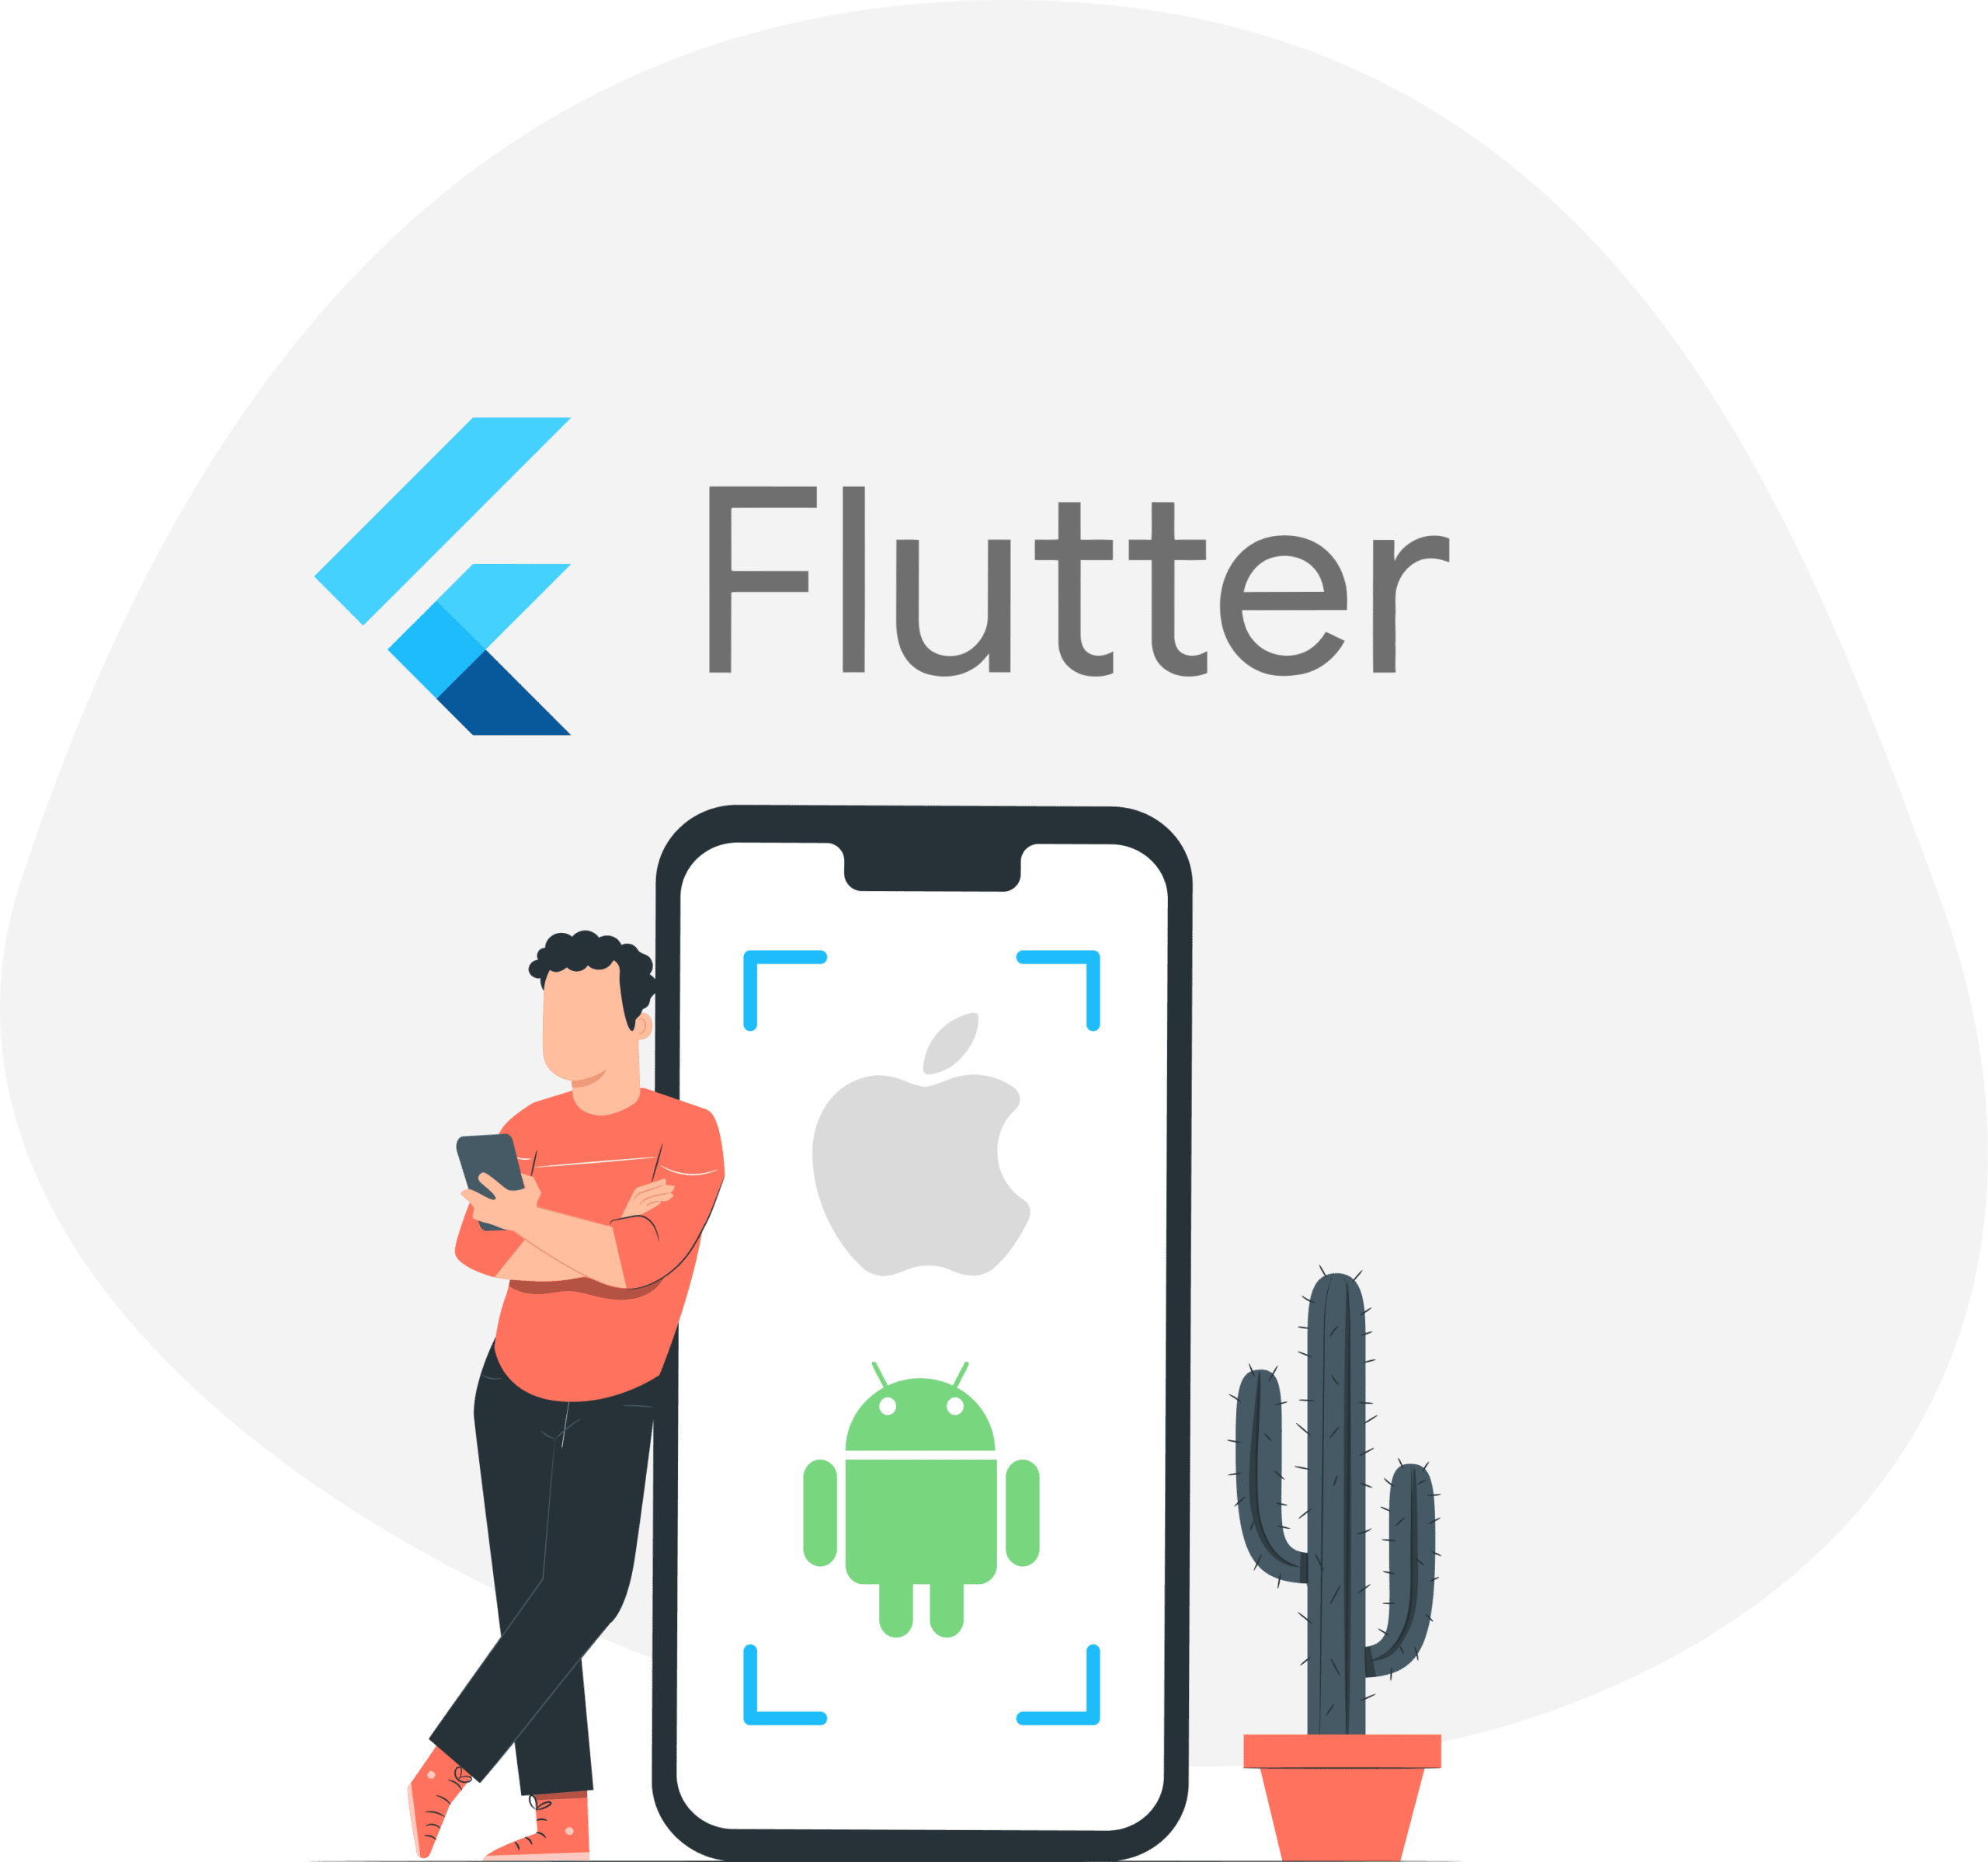Flutter apps are written in the **Dart programming language**. Dart is an object-oriented language that is easy to learn and has features like

strong typing and asynchronous programming support. It provides a solid foundation for building reactive and performant UIs in Flutter. Dart also comes with a rich set of libraries and tools that facilitate app development.

To ensure a consistent and platform-specific look and feel, Flutter provides two sets of widgets: **Material Design** widgets for Android apps and **Cupertino** widgets for iOS apps. These widgets follow the respective platform's design guidelines, allowing developers to create apps that feel native on

each platform while still sharing the majority of the codebase. Customization options are available to tailor the UI to specific platform requirements or to create a unique and branded user experience.

**State management** is a crucial aspect of app development, and Flutter offers various approaches to handle state. The built-in **Stateful Widget** and **Stateless Widget** classes are the foundation for managing state within a Flutter app. Additionally, Flutter has a vibrant ecosystem of third-party state management solutions, such as Provider, MobX, Redux, and BloC. These solutions help developers efficiently manage and synchronize the app's state, making it easier to handle user interactions and keep the UI up-to-date.

Flutter also provides seamless integration with platform-specific features and APIs through plugins and packages. Whether you need to access device capabilities like the camera, sensors, or location services, or interact with platform-specific functionalities, Flutter has a wide range of plugins available to facilitate platform integration. This enables developers to create apps that harness the native capabilities of the underlying platform without sacrificing code sharing or developer productivity.

Testing and debugging are essential aspects of app development, and Flutter offers robust tools for these tasks. The framework includes a comprehensive testing library that allows developers to write unit tests, integration tests, and widget tests to verify the correctness of their code. Additionally, Flutter DevTools provides a suite of debugging and performance profiling tools that help developers analyze and optimize their apps' performance, diagnose issues, and improve the overall quality of their applications.

Flutter has a thriving and supportive community of developers worldwide. The community actively contributes to the Flutter ecosystem by creating and maintaining packages, libraries, and frameworks that extend Flutter's capabilities. This vast ecosystem offers a wide range of packages for various functionalities, such as networking, database access, state management, UI components, and more. These packages help developers accelerate their development process by reusing existing code and leveraging community-driven solutions.

Overall, Flutter simplifies the process of building cross-platform applications by providing a comprehensive SDK, a widget-based architecture, and a rich set of tools. It allows developers to create visually stunning and high-performance apps that run seamlessly on multiple platforms. With its hot reload feature, customizable widgets, extensive state management options, and platform integration capabilities, Flutter empowers developers to deliver beautiful and feature-rich applications with increased productivity and code sharing.