Isabel Frade

CSC-415

9/27/20

1. Option 2: My proposal is to create a library of resources on Immigration reform. The websites, books, articles will be separated by type, and then tagged by topic. The website will also include a page of organizations connected to immigration reform. Each resource will have their official description, and the books will also include reviews. Users will be able to submit resource recommendations.
2. Human Rights- Within the United Nations Declaration of Human Riights there are several articles on the rights of migrants. Therefore, I believe consolidating resources on immigration reform in the United States can help address this issue. By creating a site that has images, descriptions and tags for the books and websites, it will provide a jumping off point for people researching the subject. For instance, an activist looking for a book specifically on the green card process can identify it from a list.
3. Immigration Reform Library
4. The resources will be tagged by topic, and organizations will also be tagged by location.
5. To search for resources the database by title (and author, if applicable), I’ll use quicksort and binary search. Tags can also point to relevant resources.
6. I will likely need to use postgresSQL to store links, descriptions and tags. User recommendations may be able to be stored in a basic csv table.

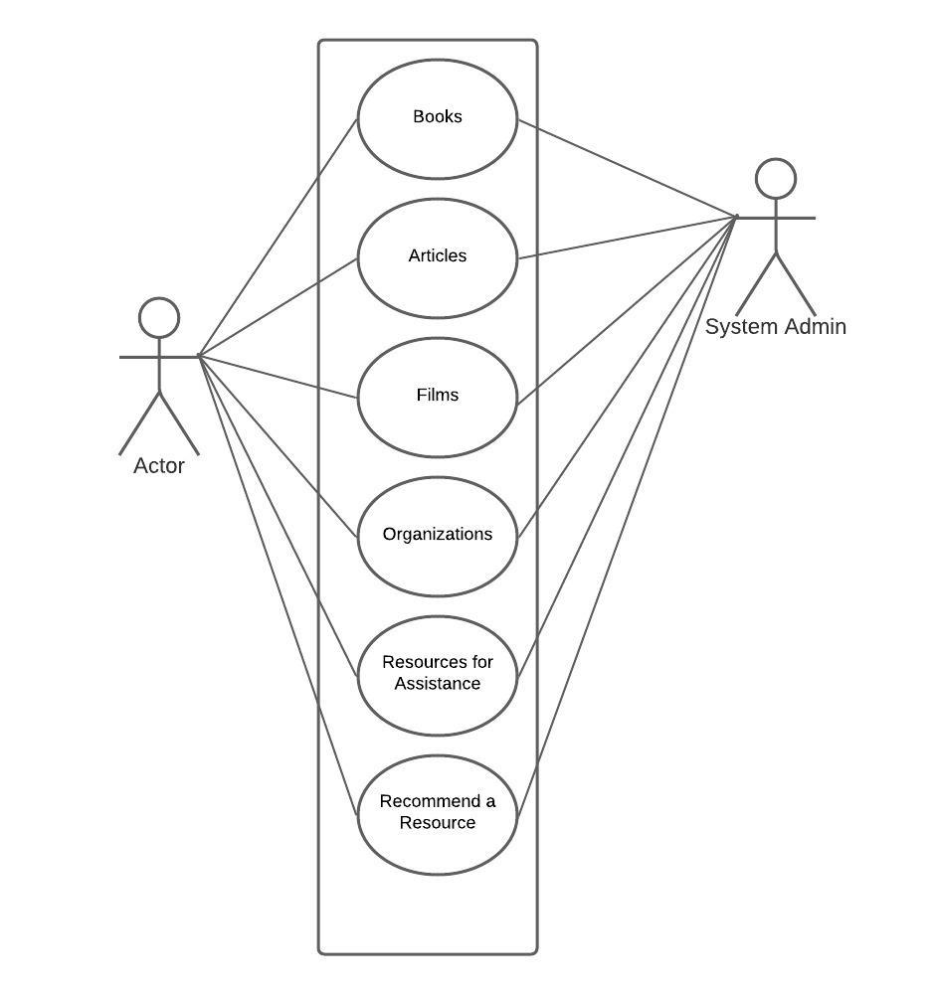

|  |  |  |
| --- | --- | --- |
| **Functionality for this semester** | **Functionality to be implemented with time** | **Future Functionality** |
| *Pages for books, informative videos, organizations, resources for assistance. (Resources for assistance is the page with highest priority)  *Searching algorithm for resources  *page to allow users to submit recommendations | *Articles page since its sources relevance is more time-sensitive | *reviews for books and films  *resources in different languages |

1. Timeline:

|  |  |  |  |  |  |
| --- | --- | --- | --- | --- | --- |
| 10/4-10/10 | 10/11-10/17 | 10/18 | | 10/25 | 11/1 |
| *Gather resources (minimum 5 for each page)  *learn aout PostgresSql,  *continue to fix assignment 1 | *Assignment 3 due  *Draw up UML diagrams  *Draw up User interface mockup | Work on displaying resources on each page. | *Work how resources will be sort and searched | | *Create page for user recommendations page |

|  |  |
| --- | --- |
| 11/8 | 11/15 |
| *buffer time to test user interaction | Final Assignment due |