CRUD with image





If we want to use mysql database then we need to go .env file and go ‘DB connection’ line

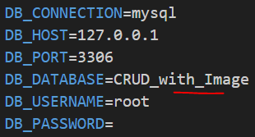

Now we need to create a db in mysql which name is “CRUD_with_Image”

Then we need to run



Then auto created all the tables in our database



This creates Model, migration file, controller file together

Now we need to go my created migration file

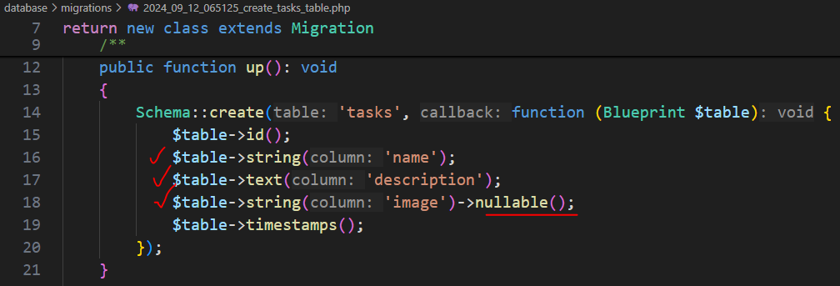

Nullable means they can add image or take it blank



Now this table is added in our database

In our web.php

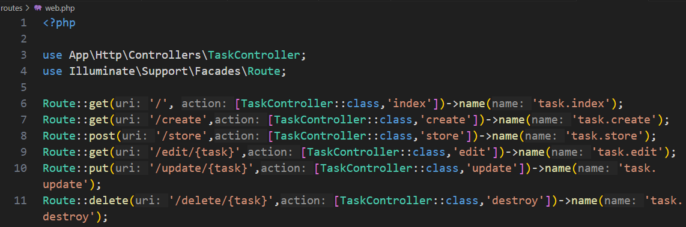

Now we need to write logic for controller

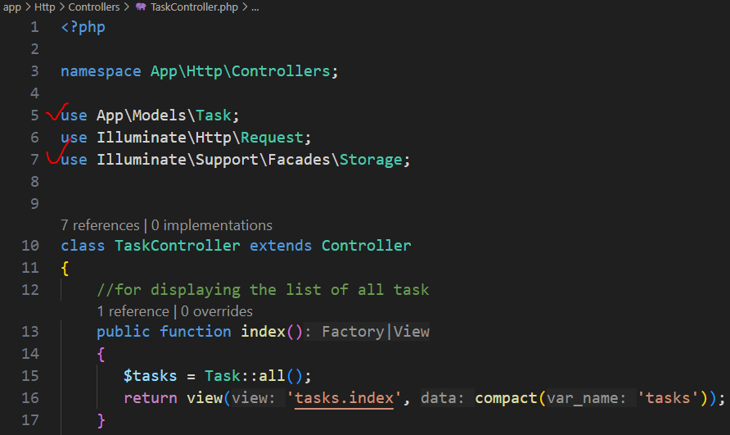

We should import class after write method

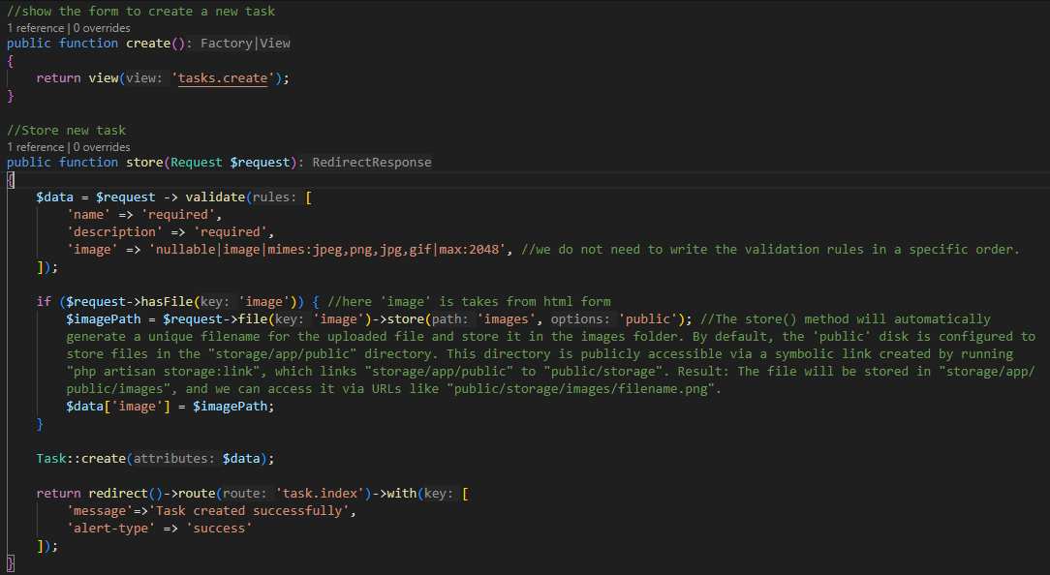

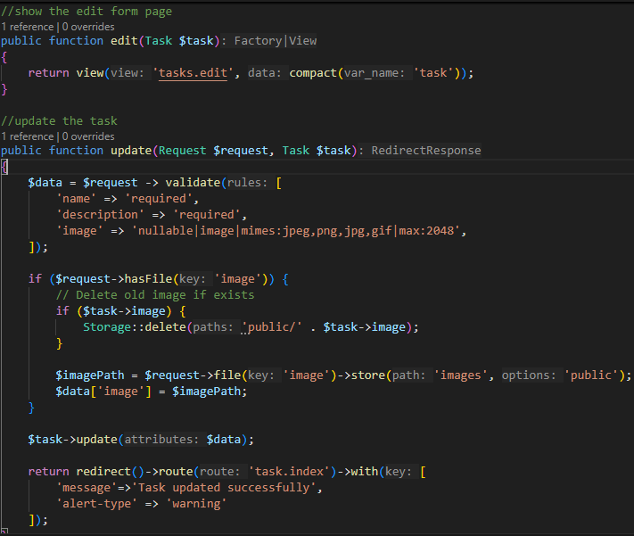

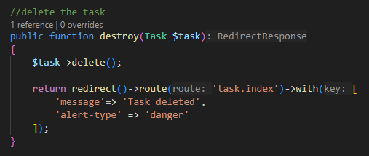

Now we are work with view

First we create a component layout

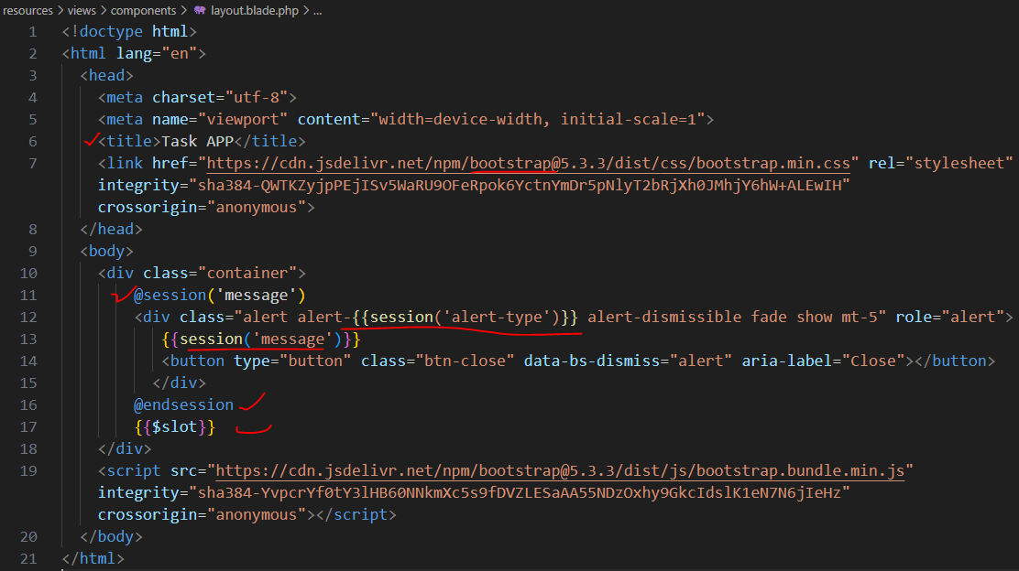

Now we create task folder in our views

And make templates for methods

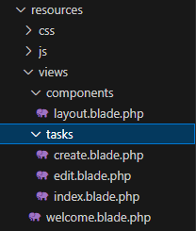

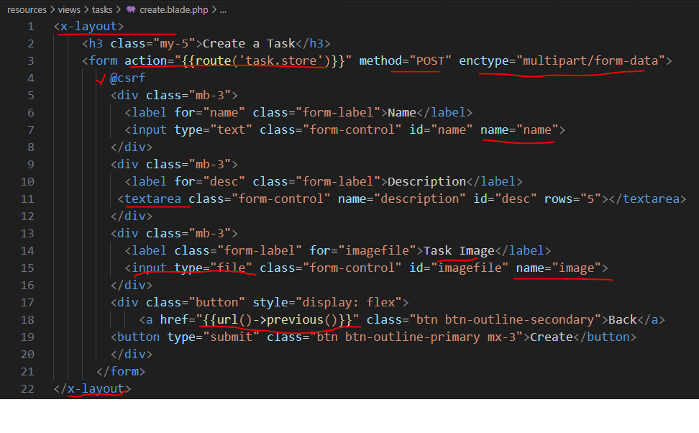

“url()->previous()” is use for go previous page

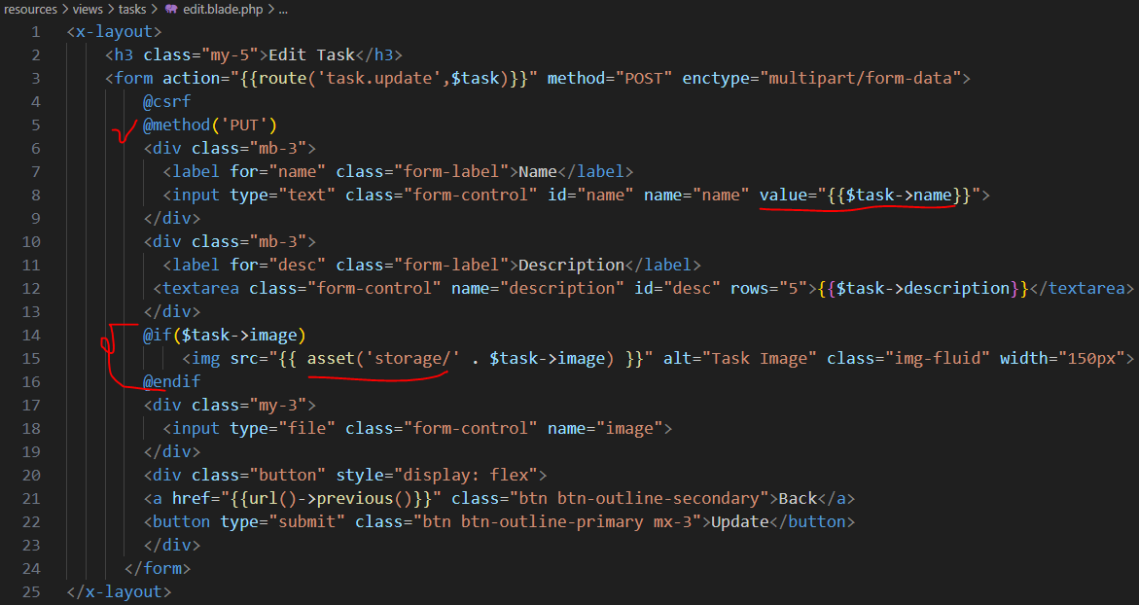

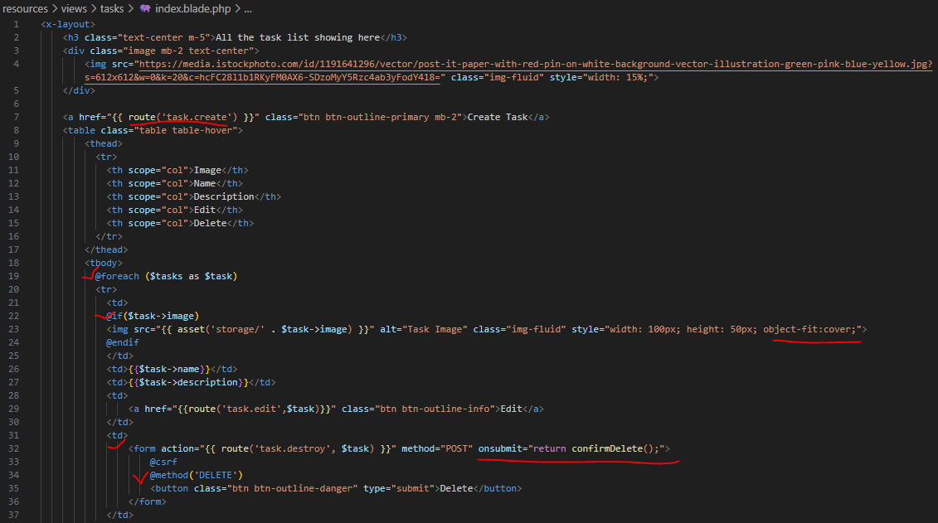

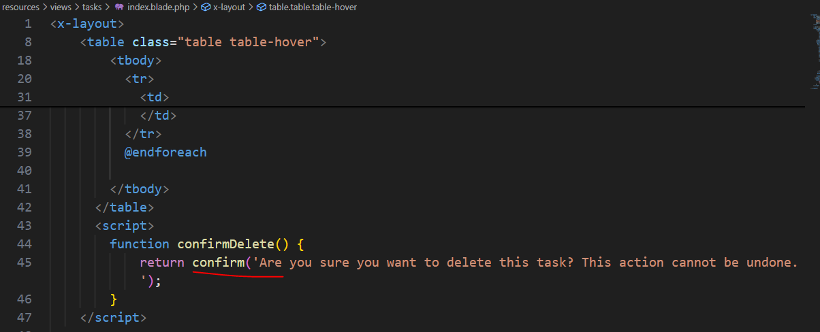

Now after we run the server we got out view

homepage

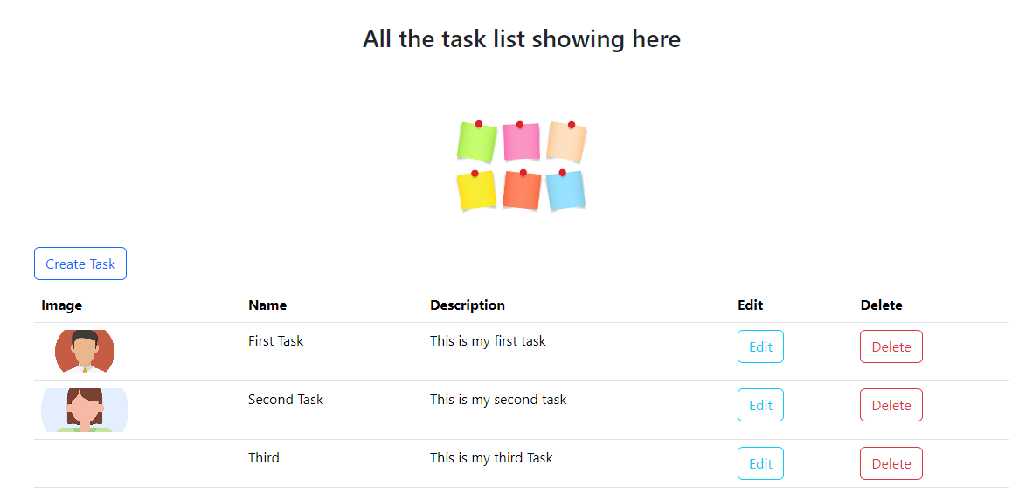

Create task page

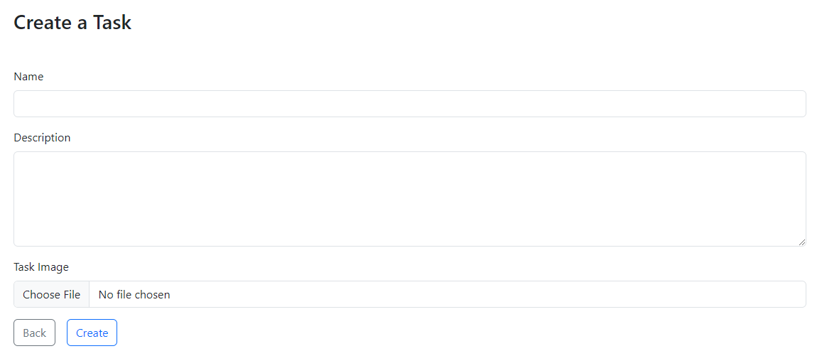

Edit page



When we click delete button

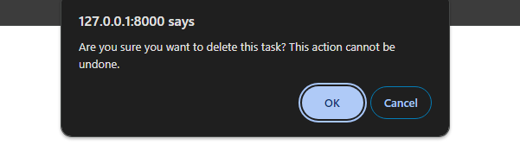

This popup will comes