**Lab02**

Iftekhar Al-Mahmud

ID: 20201120

**Website Image**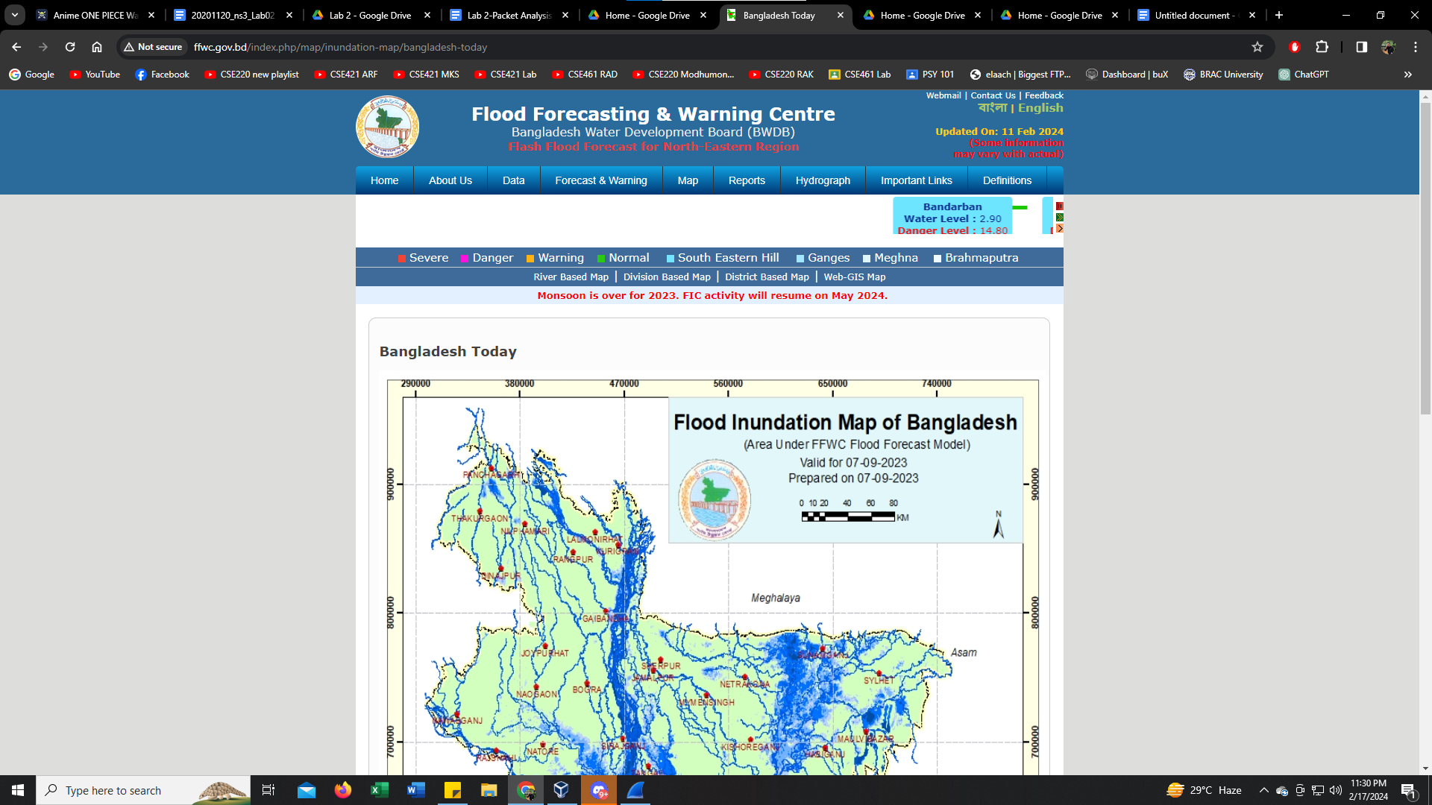

**Wireshark captures:**

**Http Request**

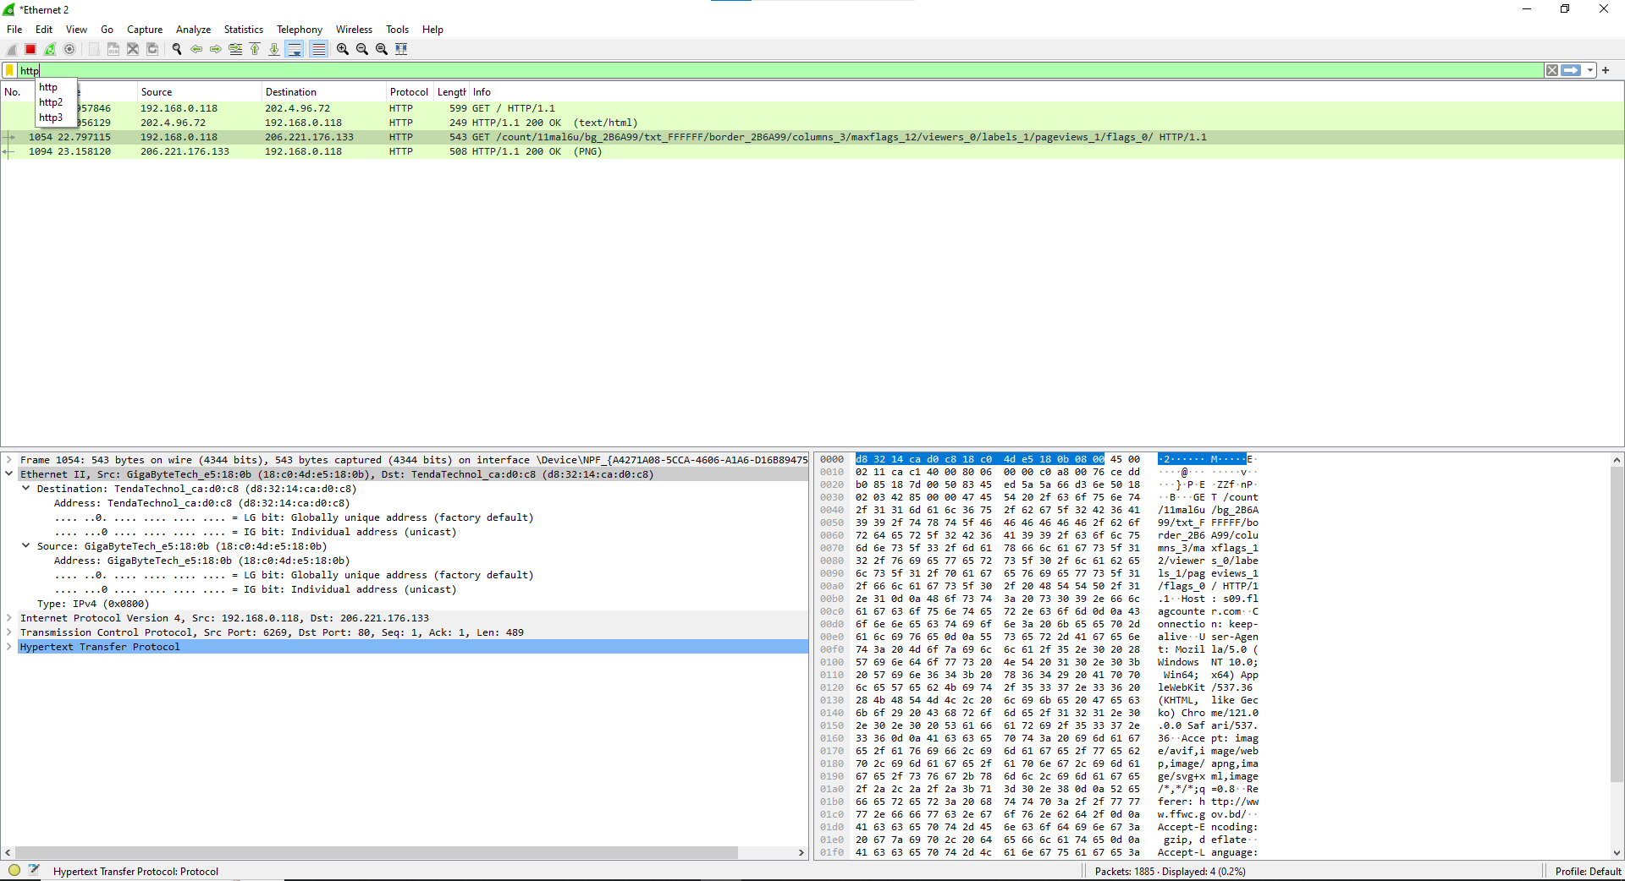

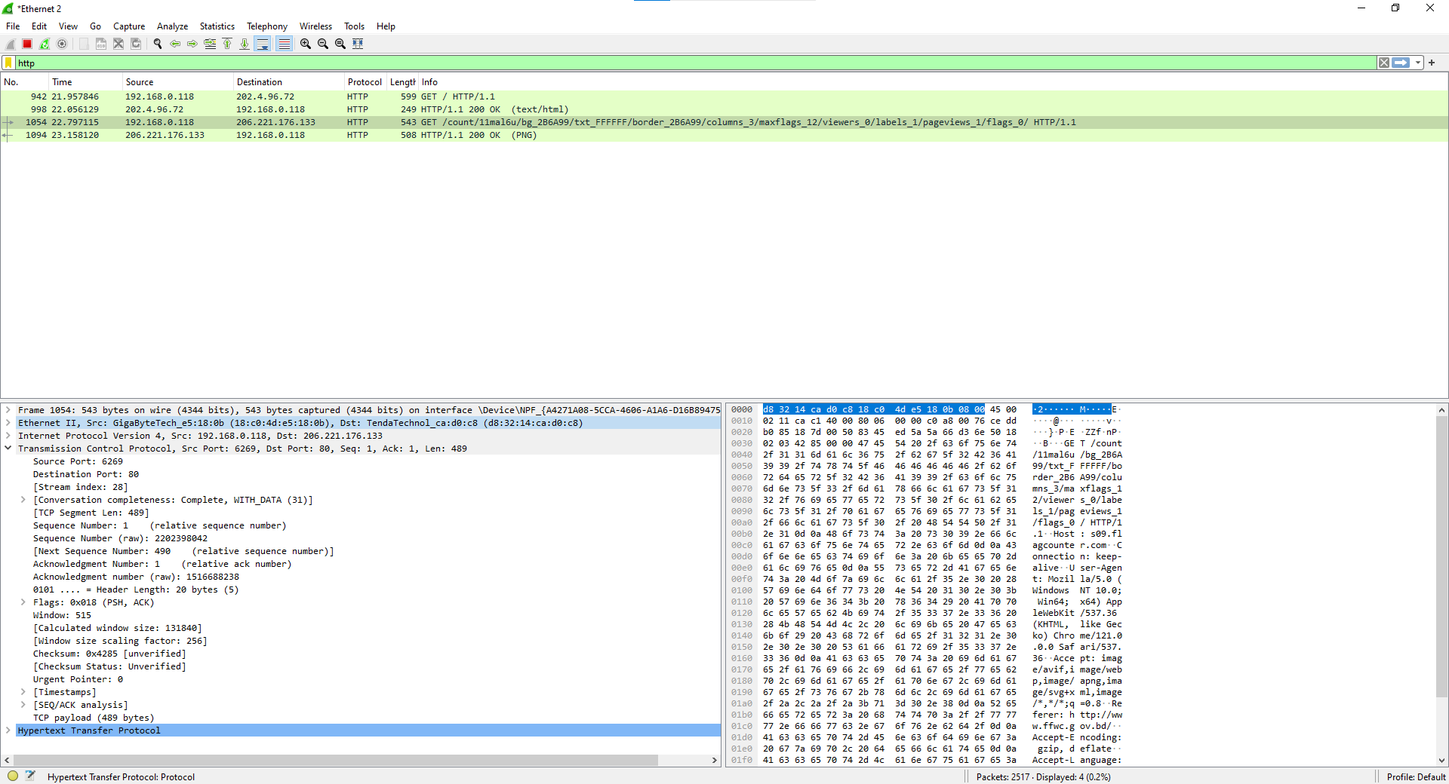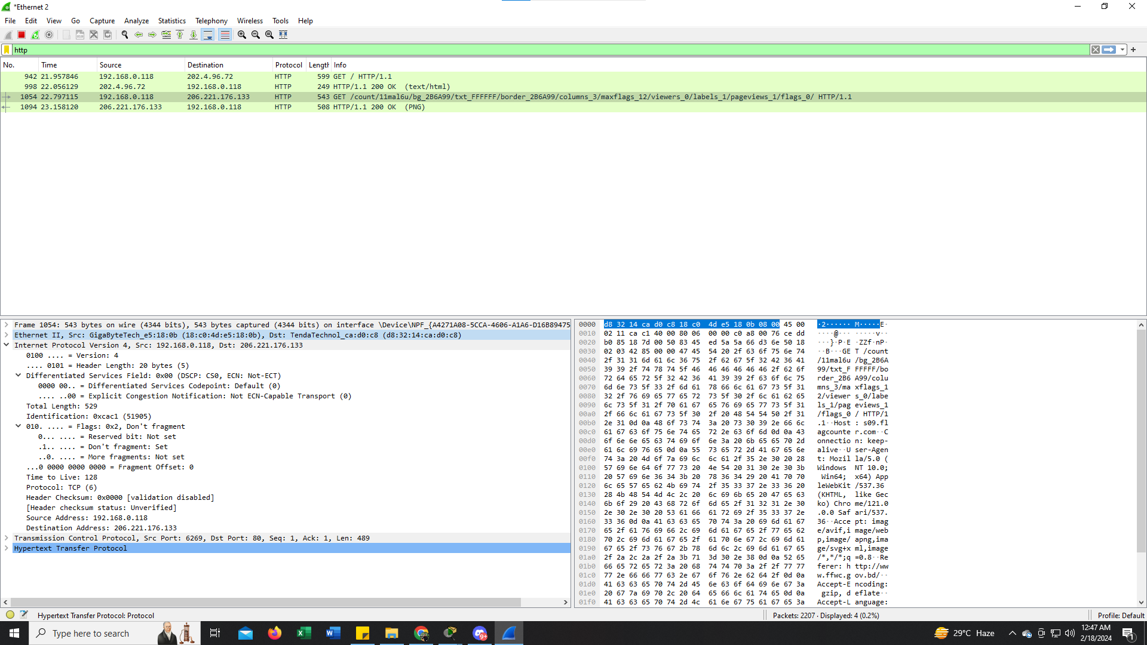

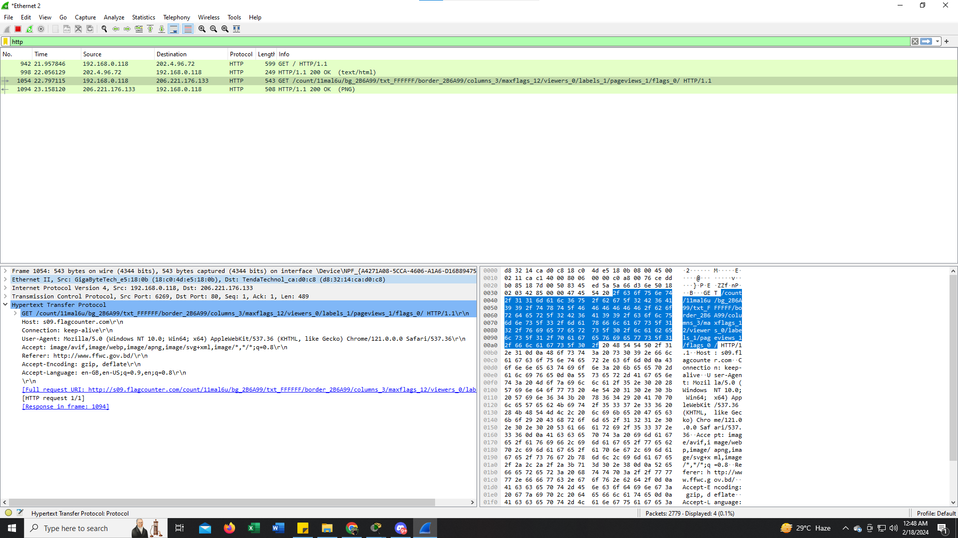

**HTTP Response**

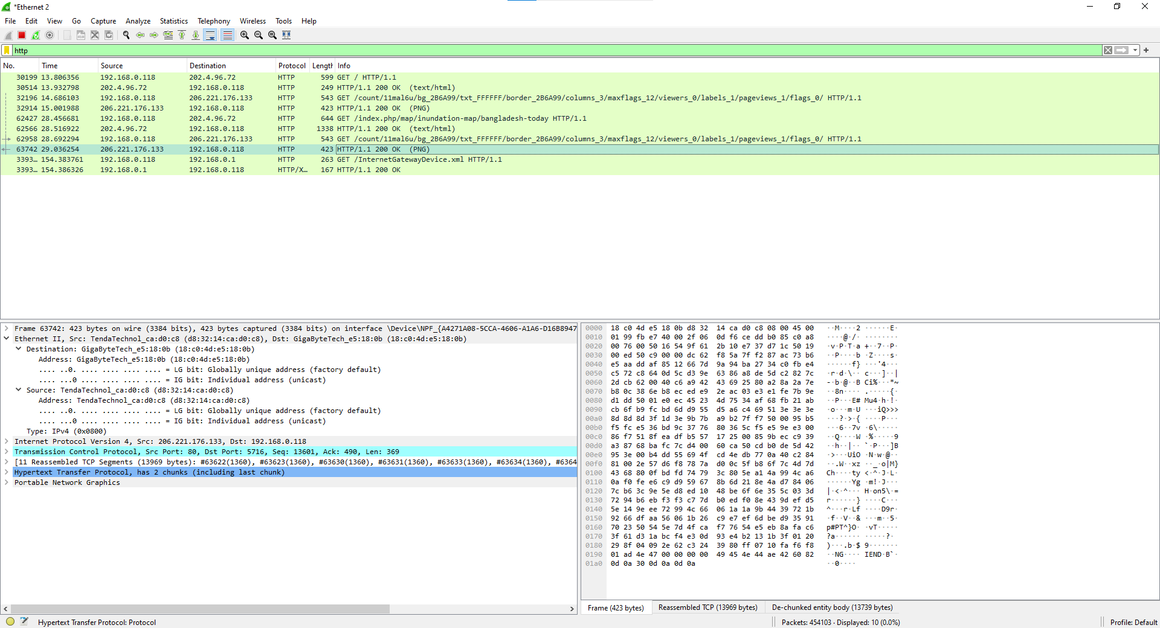

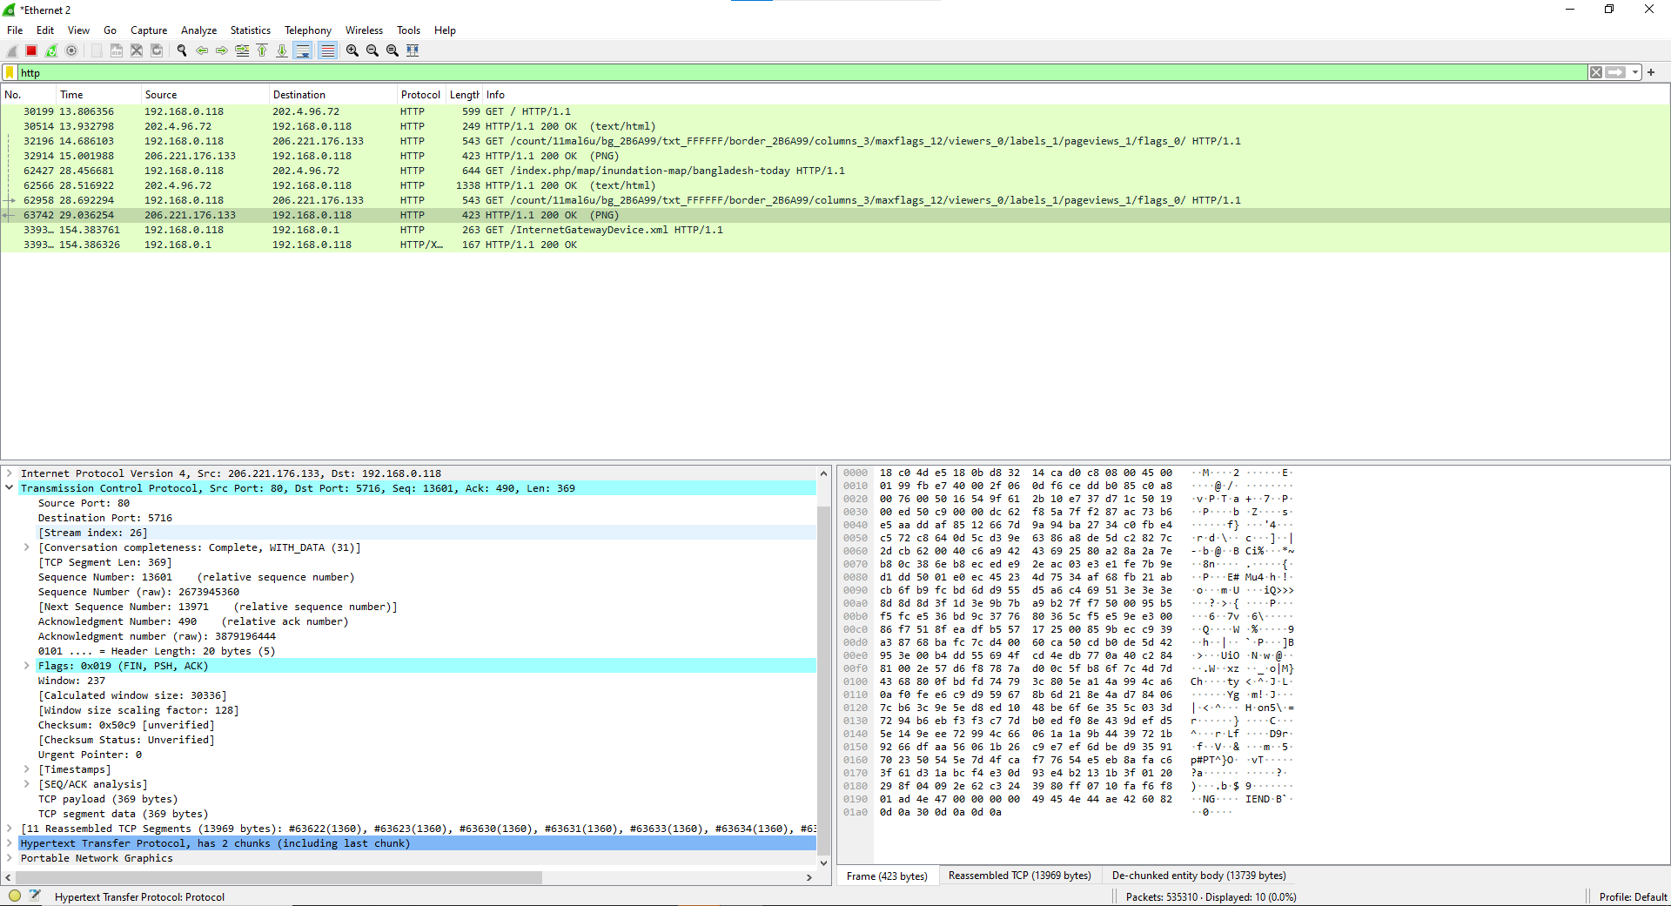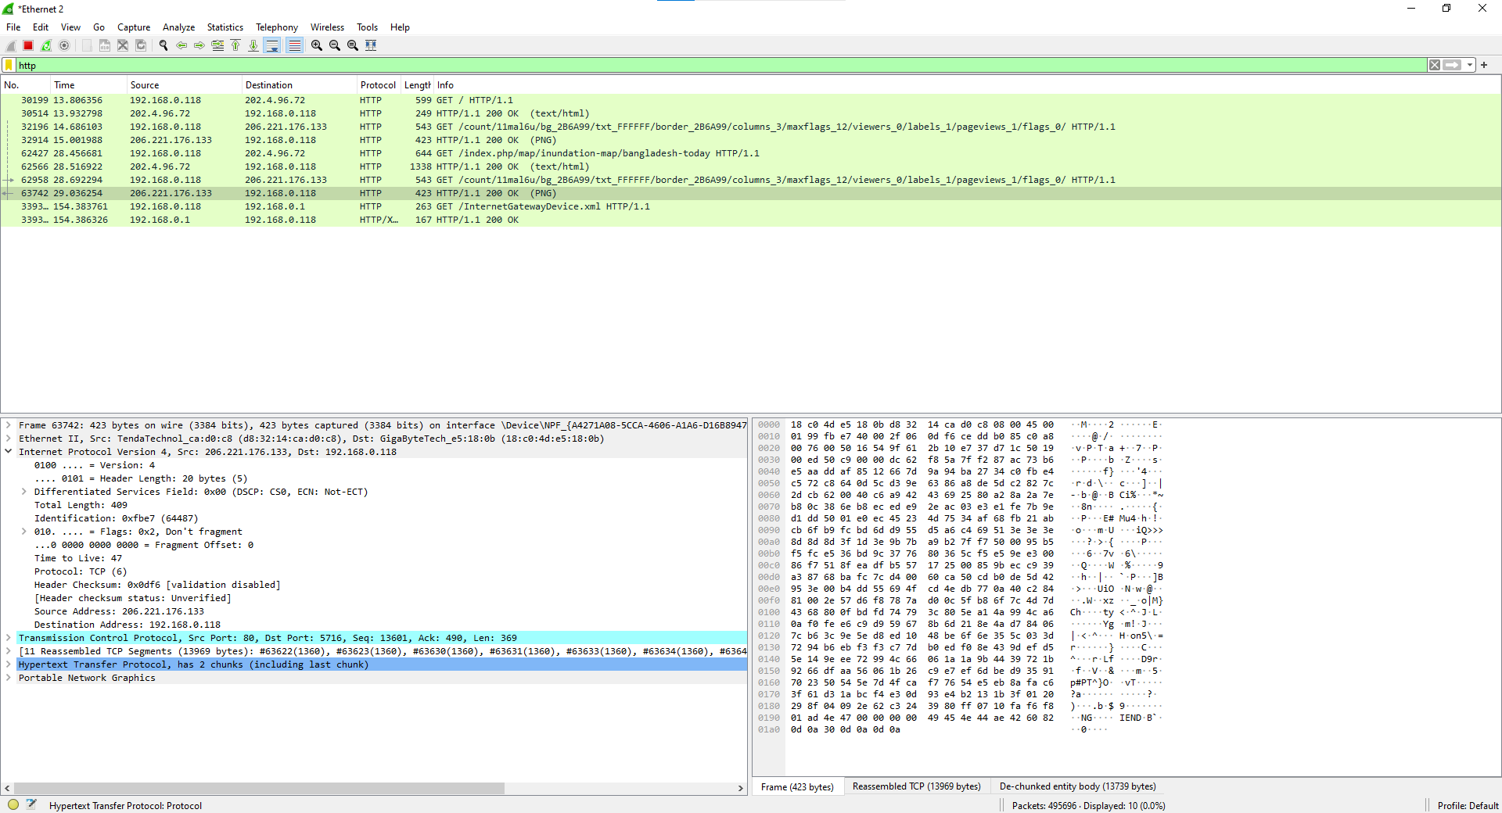

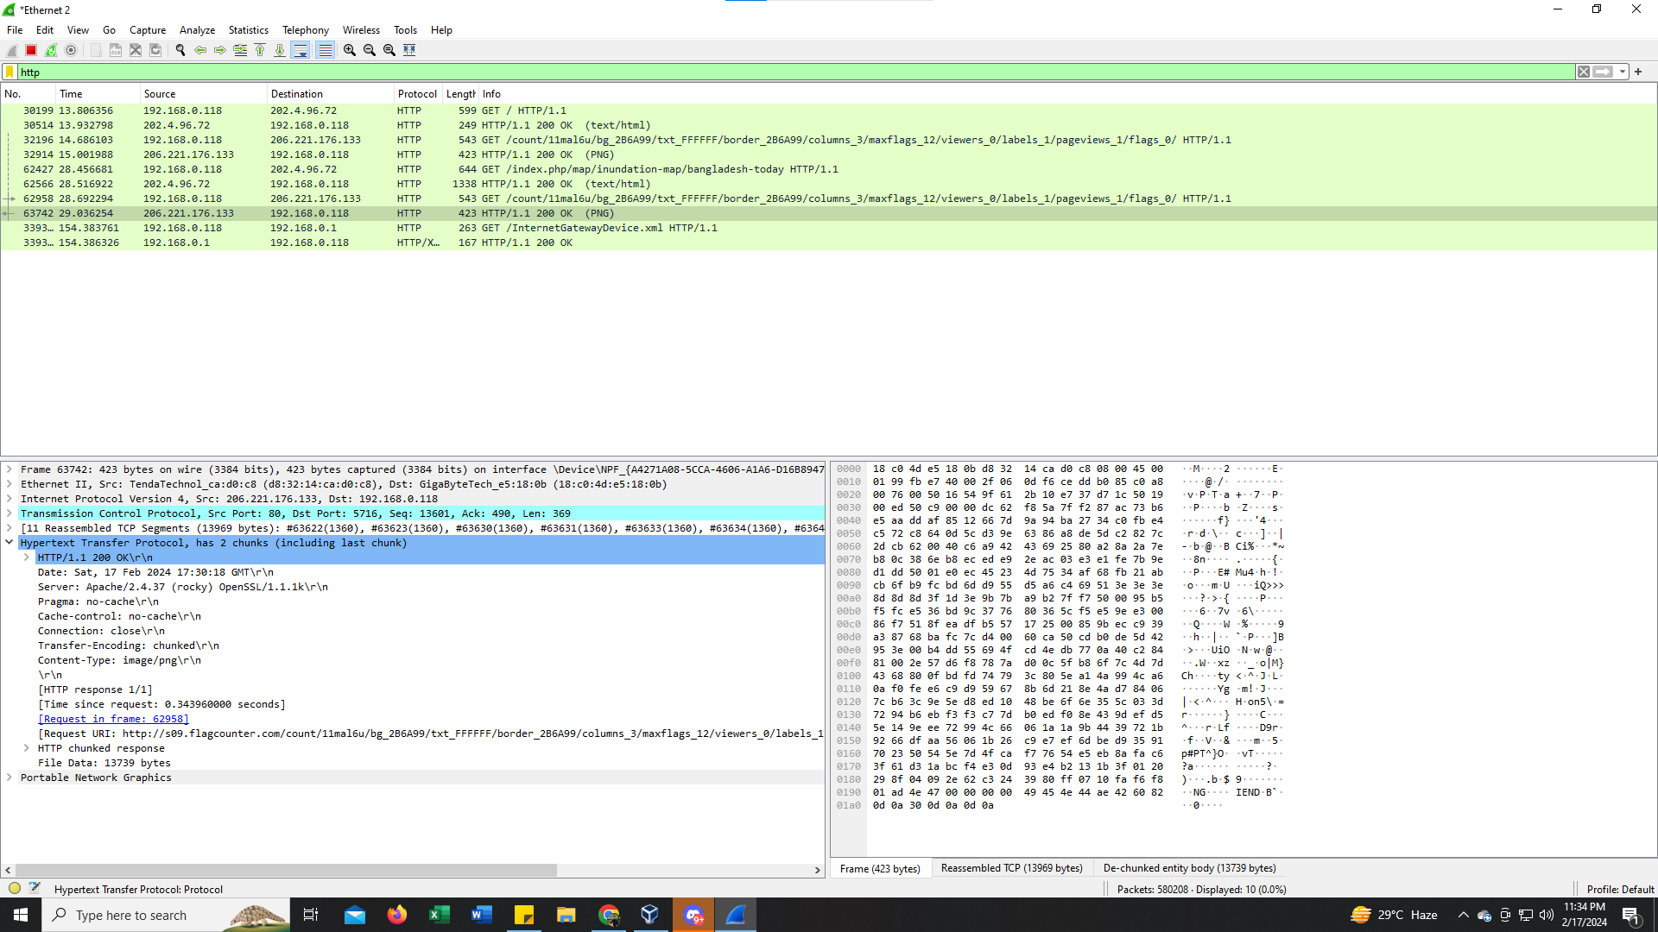

**Description:**

The http website that i have accessed is the source which has an ip address of 206.221.176.133 and my pc is the destination which has an ip address of 192.168.0.118 this is the network layer information. In the application layer the data that i have requested is an image which is in jpg format the http GET request date is saturday, 17th of february and the time is 16:03:27 GMT. As i have an image data so it is an http response message because i'm getting a response from the server which is an image. As it is an http website so it is using TCP(transmission control protocol). As the server is sending me the response message, the server is the source so the source port is 80 and the destination port is the dynamic port number of my pc which is 4470. The sequence number is 164623452 and the acknowledge number is 3621134219 This is the information in the transport layer. In the data link layer we can see the mac address information where the source mac address is d8:32:14:ca:d0:c8 which is the server mac address and the destination address is 18:c0:4d:e5:18:0b which is the mac address of my pc