**United International University**

**BOLBO KOTHA: COMMUNICATION AID FOR NON VERBAL PEOPLE**

A Thesis

Submitted to the department of Computer Science of

United International University

By

**IFTEKHAR HOSSAIN**

**AMRAN HOSSAIN**

**ID#011132132**

**ID#011132122**

Under the Supervision of

**Dr. Khondaker Abdullah Al Mamun**

Associate Professor and Director - AIMS Lab

Department of Computer Science and Engineering,

United International University,

Dhanmondi, Dhaka, Bangladesh.

For the Degree of

**Bachelor of Science in Computer Science and Engineering**

May 2017

Declaration

This is to certify that the work entitled "Bolbo Kotha: Communication aid for nonverbal people" is the outcome of the research carried out by us under the supervision of Dr. Khondaker Abdullah Al Mamun Associate Professor and Director - AIMS Lab Department of Computer Science and Engineering, United International University, Dhanmondi, Dhaka, Bangladesh.

IFTEKHAR HOSSAIN

Student ID: 011132132

AMRAN HOSSAIN

Student ID: 011132122

In my capacity as supervisor of the candidate's thesis, I certify that the above statements are true to the best of my knowledge.

Dr. Khondaker Abdullah Al Mamun

Associate Professor and Director - AIMS Lab

Department of Computer Science and Engineering,

United International University,

Dhanmondi, Dhaka, Bangladesh.

ACKNOWLEDGMENT

To start with, thanks to Almighty Allah. Under the guidance and supervision of our professor Dr. Khondaker Abdullah Al Mamun, we were motivated and encouraged to work on this topic and finally could come up with satisfactory result. Despite of his daily inflexible schedule, sir has tried his best to discuss and solve our problems. The door to his office was always open whenever we ran into a trouble spot or had a question about our research or writing. He inspired us to do something for the mute and non-verbal people of our country so that they could communicate with other people.

We would like to thank Mr. Hamudi Hasan Sonet for his useful suggestion and technical assistance.

Finally, we would like to thank Almighty Allah to make this happen and made the entire obstacle easier for us to pass through.

Certificate

I do here by declare that the research works embodied in this thesis entitled "Bolbo Kotha: Communication aid for non-verbal people" is the outcome of an original work carried out by  *Iftekhar Hossain and Md. Amran Hossain* under my supervision. I further certify that the dissertation meets the requirements and the standard for the degree of Bachelor of Science in Computer Science and Engineering.

Signed:

Date:

**(Dr. Khondaker Abdullah Al Mamun)**

Associate Professor and Director –AIMS Lab

Department of Computer Science and Engineering,

United International University,

Dhanmondi, Dhaka, Bangladesh.

ABSTRACT

This paper illustrates the design and implementation of a communication aid where non-verbal people can communicate with their peers through selecting words and making sentences. The main objective of this thesis paper was to develop an Application through which anyone can communicate. One of the major challenges of this App was to implement word prediction for users to make a meaningful sentence. As Bangla language is grammatically complicated, it was difficult to implement the complex features. But we took the challenge to stand beside the mute and non-verbal people, thinking that if we can ensure a better communication for them, they might be able to take part in the society. While developing the Application, we used Bangla Text to Speech service provided by Google. First of all, we studied Bangla grammar and understood how a sentence is formed. Then we selected several words from different Bangla parts of speech and found out the pattern of making a sentence. We wanted to help the users providing word prediction after selecting a particular word to make meaningful sentences. For this, we manually mapped words according to preorder tree traversal algorithm. Google TTS is a requirement for using “Bolbo Kotha” App. Before we start working on this thesis we gathered information about the existing Applications on this topic and found only few. Mostly they used type and speak service with no prediction or intelligence. “Bolbo Kotha” is the first ever Bangla Augmentative and Alternative (AAC) communication App developed with sentence making feature and implemented TTS for voice service. But this is the second Bangla App developed for the nonverbal people. Firstly, Bolte Chai was developed in Bangla for nonverbal children. Bolte Chai was developed with image to speak service and did not use any TTS. Children will use Bolte Chai App before using “Bolbo Kotha” App. Children who have knowledge of Bangla words will use “Bolbo Kotha” App. There are almost 250 million Bangla speakers who will be benefited from this App directly if they suffer in Stroke, Cancer, Brain Injury ALSetc) or injury.

## Table of Contents

**1. Introduction** ...........................................................................................................................................7

1.1 Motivation ................................................................................................................................7

1.2 Objectives …………………………………………………………………………………….7

1.3 Chapter roadmaps .....................................................................................................................8

**2. System Study** .......................................................................................................................................9

2.1 Introduction …………………………………………………………….................................9

2.2Evaluated current systems.......................................................................................................14

2.3 Conclusion……………….......................................................................................................15

**3. System Requirement Specifications**.................................................................................................16

3.1 Introduction …………………………………………………………………………………16

3.1.1 Purpose …………………………………………………………………………...16

3.1.2 Project Scop.............................................................................................................16

3.2 Overall Description.................................................................................................................17

3.2.1 Product Features......................................................................................................17

3.2.2 Operating Environment...........................................................................................17

3.2.3 Design and Implementation Constraints...............................................................17

3.2.4 User Documentation………………………………………………………………18

3.2.5 Assumptions and Dependencies……………………………………………….….18

3.3 External Interface Requirement...............................................................................................21

3.3.1 User Interface..........................................................................................................21

3.3.2 Hardware Interfaces................................................................................................26

3.3.3 Software Interfaces………...................................................................................26

3.4 Nonfunctional Requirements.................................................................................................. 26

3.4.1 Performance Requirement.......................................................................................26

3.4.2 Safety Requirements...............................................................................................27

3.4.3 Security Requirements............................................................................................27

3.4.4 App Quality Attributes............................................................................................27

3.5 Other Requirements..............................................................................................................28

3.5.1 Data Requirements..................................................................................................28

3.6Conclusion...............................................................................................................................29

**4. Bolbo Kotha: Proposed Application**……………………………………………………………..….30

4.1 Introduction.......................................................................................................................…..30

4.2 Class diagram..........................................................................................................................31

4.3 Use case diagram.....................................................................................................................32

4.4 Activity diagram .....................................................................................................................33

4.5 Detailed Design.......................................................................................................................37

4.6 Text to Speech (TTS)..............................................................................................................44

4.7 Concusion................................................................................................................................45

**5. Discussion and Conclusion**……………………………………………………………..……………46

5.1 Summary…………………………………………………………………………………….46

5.2 Limitation……………………………………………………………………………………47

5.3. Future work............................................................................................................................48

**6. References** ......................................................................................................................................... 50

**CHAPTER** **1**

**Introduction**

**1.1 Motivation**

Every year many children are born in Bangladesh with non-verbal criteria. After a few years when they grow up, they face problems to communicate with anyone others. Non-verbal people are those people who cannot functionally communicate with others using their voice. It is estimated that as many as 25 percent of individuals living with autism spectrum disorders are minimally verbal or entirely non-verbal [10]. A normal people can become non-verbal if he is affected by disease (Stroke, Cancer, Brain Injury ALSetc) or injury. Now to help those nonverbal people, we developed an effective android Application which will help them to communicate any people. We named this App as “Bolbo Kotha”.

**1.2 Objectives**

“Bolbo Kotha”is an Augmentative and Alternative Communication App. This App has been developed by considering non-verbal people disability. It has some principle objectives to develop which are mentioned below:

* To develop an Augmentative and Alternative Communication (AAC) Application for non-verbal people with Text to Speech service.
* To develop sentence making feature in this App.
* To provide word prediction for users to make sentences easily.
* To implement type and speak service for those who can type in Bangla.
* To develop a dynamic App where users can add words according to their needs.

**1.3 Chapter Roadmaps**

The fulfillment of the thesis objectives is addressed in Chapters 1 and 2. chapter 2 begins with the system study of previously developed AAC mobile Applications. In Chapter 3 discuss about the System Requirement Specification(SRS) of ‘'“Bolbo Kotha”'' mobile Application. In SRS, Introduction, Overall description, External Interface Requirement, Nonfunctional Requirements are described. In Chapter 4 and 5 shows the Design of “Bolbo Kotha”Application.

The name of Chapter 4 is Bolbo Kotha: Proposed Application where we discuss about Class diagram, Activity diagram, Use case diagram, Text to Speech. In Chapter 5 has Discussion and Conclusion where we discuss about summary, limitation and directions for future works.

**CHAPTER** **2**

**System Study**

**2.1 Introduction**

System study is a detailed study to determine whether, to what extent, and how automatic data-processing equipment should be used. It usually includes an analysis of the existing system and the design of the new system, including the development of system specifications which provide a basis for the selection of equipment. Before developing "Bolbo Kotha”, we have studied some AAC Android Apps and complied this list of Apps.We did analysis of functionality and usability of these Apps. Some Apps are used regularly by non-verbal people. But most of them are image and icon based. Existing Applications for Android don’t support Bangla language. Features of some Apps are following:

## 2.2 Evaluated current systems

Before developing Bolbo Kotha, we evaluate different many current systems which are relevant with “Bolbo Kotha”App. Every system is different from other system for its unique feature. Some current system is described below:

**2.2.1 Bolte Chai**

Bolte Chai is the first Bangla android Application for non-verbal children to communicate with people and also learn Bangla Language with entertainment [6]. It has some unique features which has given below:

* A list of some categories will be shown like “Home, Out, Hungry” etc.and for Bangla “ঘুরেবেড়ানো, খাওয়াদাওয়া, খেলাধুলা, টয়লেট” ইত্যাদি।
* Tap on the up corner right where you can change language in English or Bangla, child mood to parent mode or parent mood to child mode.
* Set up Help Contacts as you want to for your child safety.
* In parent mode, any word or category can be added by user.
* Any word also can be updated or deleted.

**2.2.2 AAC Speech Communicator**

AAC Speech Communicator is an android Application which was developed for disable

verbal people to remove their disability [6]. It has some features which are:

* A generic, easy-to-learn communication tool for anyone with speech disabilities, which forms grammatically correct sentences when a series of pictograms are clicked and then speaks them aloud (text-to-speech).
* The Application includes 1000+ icons, categorized and accessible through search. It supports French pretty well, and there is a prototype for English.
* There is option to display text in capital letters.
* Option to softly speak each individual word when icon is pressed.

**2.2.3 My Next Voice**

My Next Voice is an Application for non-verbal people to make conversion between verbal people. This Application has some effective feature which are:

* Just type your message, press a button and your message is read aloud.
* Message catalogs can be stored on your device to be used later on. You can have multiple message catalogs for work, leisure time etc.
* Show your message full-screen, so you can communicate in loud environments.
* The App is based on the Android text-to-speech (TTS) function.
* The spoken message can be enhanced with controls for pitch, speed and volume. Even the language may be changed during speech.

**2.2.4 Talk – Text to Voice Free**

There have many different Application for non-verbal people Talk – Text to Voice Free is one of them [6]. Talk – Text to Voice Free has some features which are:

* This App lets you convert text to voice using the Text-to-speech engine on your Smartphone.
* It allows importing web pages directly from the browser to listen to them. You can also import selected text from other Apps.
* Play / Pause / Stop options available.
* Export audio as WAV file.
* Lots of languages (internet connection required for some).

**2.2.5 LetMeTalk Free AAC Talker**

LetMeTalk Free AAC Talker has been developed by considering non-verbal people, how a nonverbal people can communicate with people [6]. This App has different unique features which escribed below:

* LetMeTalk enables you to line up images in a meaningful way to read this row of images as a sentence. To line up images is known as AAC (Augmentative and Alternative Communication).
* More than 9,000 images from ARASAAC included.
* Voice support for images and sentences.
* Unlimited creation of new categories and adding new images.
* Pre-configured for kids with autism spectrum disorder (ASD).
* Keep several profiles on your devices and switch fast between them. Load / save your current profile (vocabulary).
* Share your profile easily with other devices.
* Switch fast between 2 languages and use LetMeTalk as translator.
* supported languages: English, Spanish, French, Italian and German, Chinese, Portuguese, Brazilian Portuguese, Arabic, Russian, Polish, Bulgarian, Romanian, Galician, Catalan, Basque.

**2.2.6 Type and Speak**

Type and Speak is a keyboard based Application for nonverbal people to communicate with

verbal people [6]. This App has some features which are:

* This App lets you convert text to voice using the Text-to-speech engine on your Smartphone.
* It allows importing web pages directly from the browser to listen to them.
* Option for saving texts to library.
* Export audio as WAV file while saving texts into library.
* Lots of languages (internet connection required for some).
* Option for “speak while typing”.
* Option to control speed and pitch foe voice.

**2.2.7 TalkNow**

TalkNow is also an android Application which was develop for verbal disable people to talk

with normal people [6]. Some key features are described below:

* Talk Now lets you use your Android phone or tablet to vocalize your needs.
* Select a phrase from a set of categories to have it spoken.
* Talk Now comes pre-loaded with common phrases and categories, or you can add your own.
* Talk Now can even play recorded messages and show images taken with the camera.
* You can also use a built-in blackboard to draw words and pictures to aid in your communications.
* Talk Now can be customized by adding picture buttons that speak words or phrases.
* Picture buttons can also make whatever sounds you want simply by recording your own voice.

**2.2.8 Easy Speak - AAC Soundboard**

Easy Speak - AAC Soundboard is also helpful Application for nonverbal people [6]. It’s some unique features are described below:

* Simply click the buttons and Easy Speak will say what you clicked.
* User can create thousands of complex sentences with the predefined words that cover a variety of daily tasks like using the bathroom, eating, taking a bath, and going to bed.
* Specific words are color coded to make finding crucial words easier to help the user increase their speed completing sentences.

**2.2.9 Visual Talker**

Visual Talker is an Application which can help non-verbal people to make communication with people according to their needs [6]. It has some important key features for verbal disable people which are:

* Heuristic Algorithm: suggestion next word by basic sentence information initially then learning as use
* You can add new words instantly and reuse them by Extra button
* Full sentence suggestion by self-learning
* Download customized voice and option for recording your own voice.
* A sentence strip with pictures and words to Appear on, which, when tapped, reads the message for the user
* option to say words when pictures are tapped, when sentence strip is tapped, or both  
  extensive image library via search engines as well as taking photos and camera roll
* history, color code, search for sentences, words.

**2.2.10 Speech Assistant AAC**

Speech Assistant AAC is very powerful an Augmentative and alternative communication (AAC) Application which was developed by considering non-verbal people [6]. It supports Multilanguage and also has many users define feature which are described below:

* Portrait and landscape layout for all devices.
* Add, change or delete your own phrases.
* You can create categories to organize your phrases for quick access.
* Long press (optional setting) to easily edit the phrase and category buttons.
* Option to Backup and Restore your categories and phrases.
* The size of the buttons, the textbox and the text can be adjusted.
* The App has various color schemes and you can also create a personal color scheme.
* Show your message full screen with a very large font.
* Useful for communicating in a noisy environment.
* Connect a Bluetooth keyboard and create shortcuts for the functions Speak and Show.
* Button to share your message to mail, text and social media.

**2.3 Conclusion**

In this chapter described the System Study **.** In this System Study part we has studied different Application and analysis them very attentively which is concurrent of our desire system. By studing these different system we has understood which feature is very essential and which feature gives non-verbal people which effective facilities .

**CHAPTER** **3**

**System Requirent Specification(SRS)**

**3.1 Introduction**

**3.1.1 Purpose**

Non-verbal people are those people who has some minimal verbal disability and cannot functionally communicate with others using their voice. In Bangladesh, here have no record how many non-verbal child is born every year. It is estimated that as many as 25 percent of individuals living with autism spectrum disorders are minimally verbal or entirely non verbal. A normal people can become non-verbal if he is affected by disease (Stroke, Cancer, Brain Injury ALSetc) or injury. Now to help those nonverbal people, we developed an effective android Application which will help them to communicate any people. Its name is “Bolbo Kotha”.

“Bolbo Kotha” is an Augmentative and Alternative Communication (AAC) Application for non-verbal people[17]. It has broken the frustration of non-verbal people by allowing him/her to communicate easily and effectively. Now “Bolbo Kotha” can help these people to make conversation with normal people and also to express thoughts, wants, needs, ideas without taking help of any normal people.

## 3.1.2 Project Scope

This is an android based Application for nonverbal people to easily communicate with any people.

Users can make meaningful sentences by selecting different words and get voice support for each word and sentence. The system helps user providing probable words corresponding to a particular word when user selects a word. Users can also add words to different categories depending to their needs.

# 3.2 Overall Description

## 3.2.1 Product Features

This Application will allow non-verbal users to be able to communicate with any verbal people with their android mobile phone. Some core features of this App are:

* This App is user friendly and very easy to use.
* Voice support for every word and sentence.
* User can make meaningful sentences selecting words from different categories.
* User will get provided with probable data if he selects a word from a category. He will get suggested with some words corresponding to the selected word to make the sentence easily.
* User can add data according to his/her needs which will be organized by category.

## 3.2.2 Operating Environment

This Application will run on the Android operating system version 4.0. All devices that support this version of the Android operating system will be able to run the software. The software is developed by Android Studio IDE.

## 3.2.3 Design and Implementation Constraints

To Develop “Bolbo Kotha” developer faces some challenging constraints to make design and implement. The most Some are describing below:

* The App will only run on Android operating system.
* Implementing prediction of words to make a sentence is challenging.
* Making a dynamic App by implementing 'add word/category' is very tough.
* Manual mapping of words was difficult due to complexity of Bangla grammar

## 3.2.4 Assumptions and Dependencies

The system is dependent on Google Text to Speech App. To use this App user, need to download Google Build in Text-to-Speech voice data for Bangla user. Also need a good configuration of android device so that user can listen text to voice conversation.

## 3.2.5 User Documentation

First of all, user has to install the App. When user opens the App, he will see some subjects to start of making a sentence. If he selects a subject, then some categories of objects according the selected subject will be predicted automatically. User can select any of the categories according to his need and he will get some words under the selected category. After selecting the object, predicted verbs will be shown. Thus user can make a meaningful sentence. In the bottom right corner of the screen, there is a play button. When user click on the play button, he will get the voice support. In top right corner of the screen, a menu bar is implemented. User can add category or words selecting option from the menu bar. User can also get type and speak service from the menu bar. As, Google TTS is the requirement of this App, user has to install it to get voice support of sentences.

Here we have shown how to get voice service using Google text to Speech App [8]. We have added screenshots to configure the settings of device.

**Step 1**: User has to go to settings menu of the device. Then he has to select "Language and input" option and follow the screenshots.

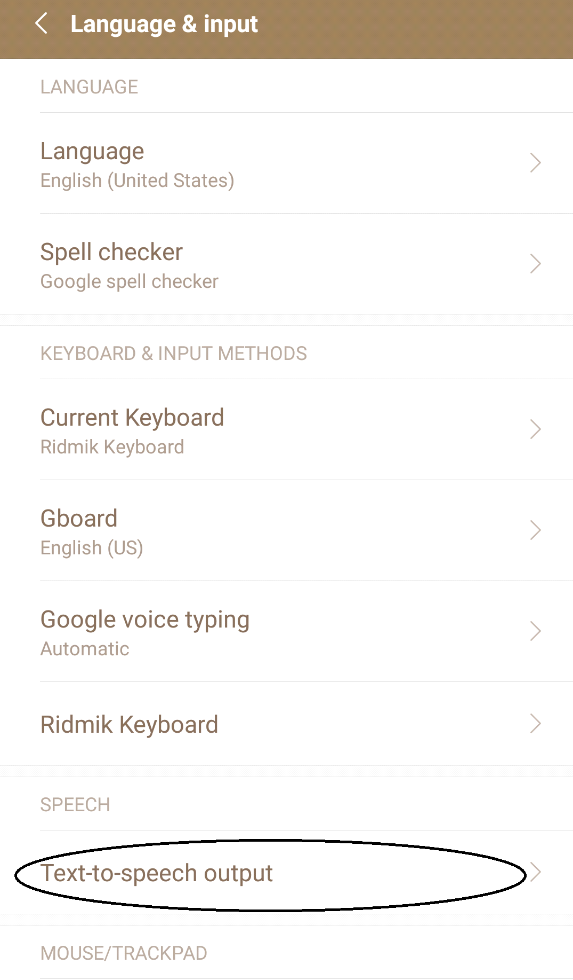

Figure 3.1: Text-To-Speech output option in Language and Input Setting menu

**Step 2**: After selecting TTS output option, user need to select Google Text-to-speech Engine

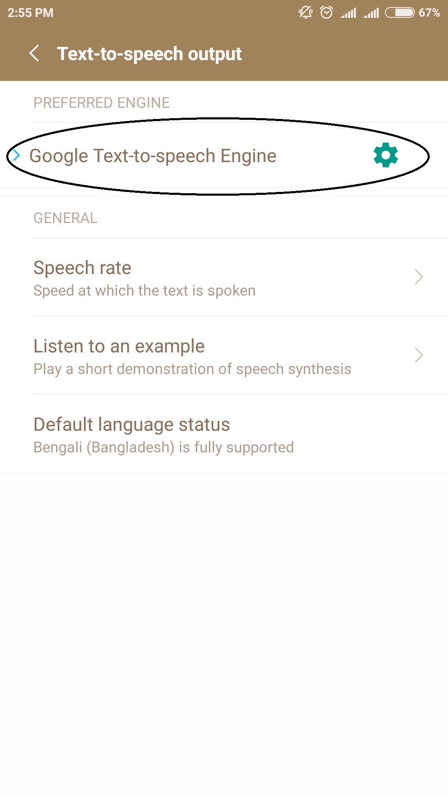

Figure 3.2: Google Text-to-speech Engine Option.

**Step 3**: In the final step, user has to select 'Bengali(Bangladesh)' option.

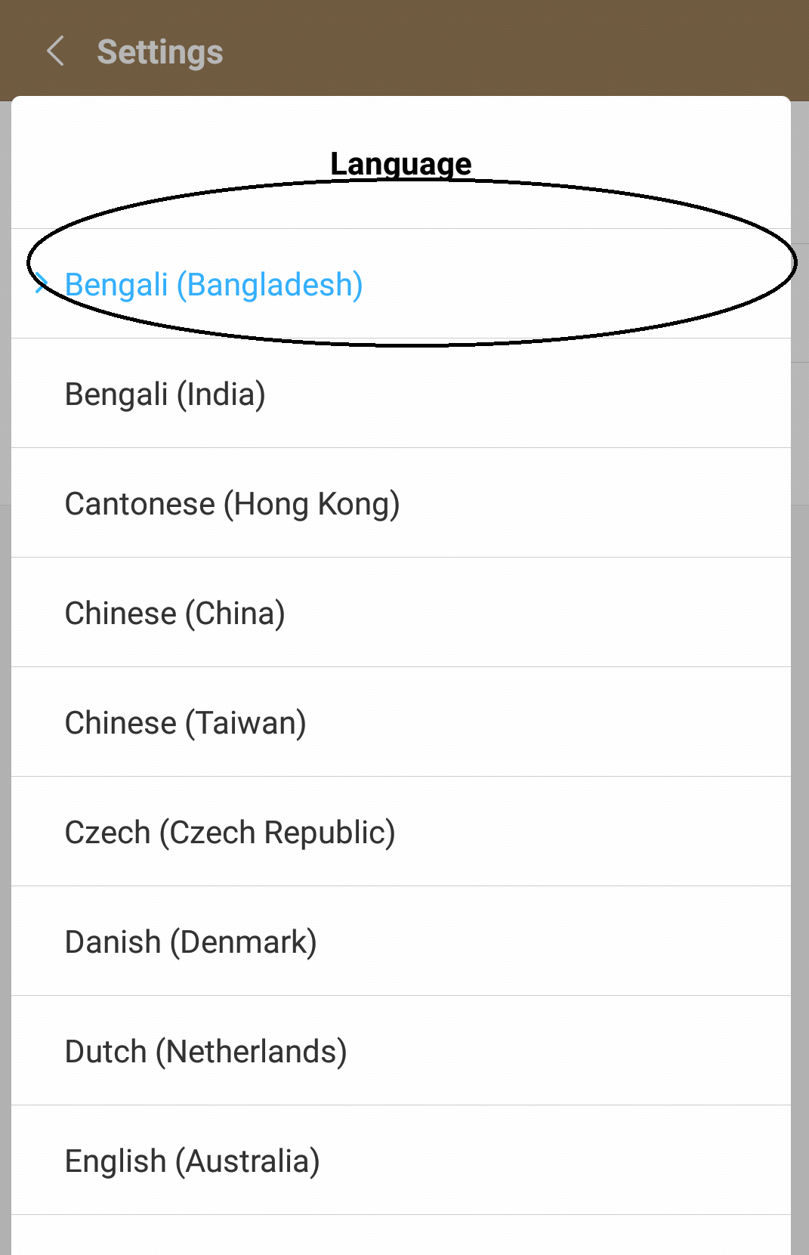

Figure 3.3: Language Bengali(Bangladesh) option.

**3.3 External Interface Requirements**

**3.3.1 User Interface**

A user interface, also called a "UI” is the means in which a person controls an Application or hardware device. A good user interface provides a "user-friendly" experience, allowing the user to interact with the Application or hardware in a natural and intuitive way. [6] “Bolbo Kotha”App User Interface are given below:

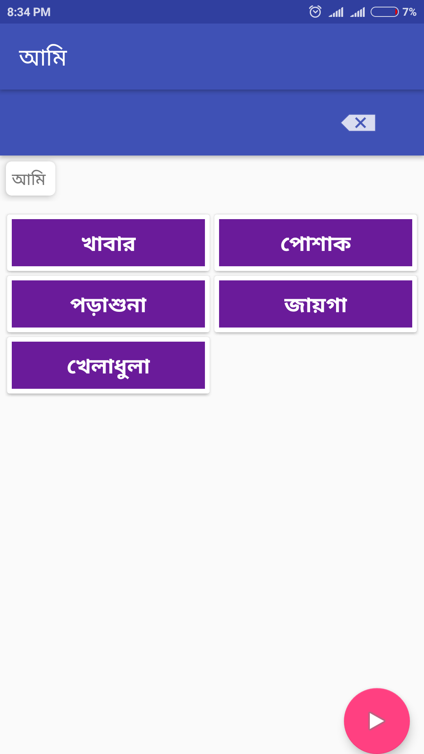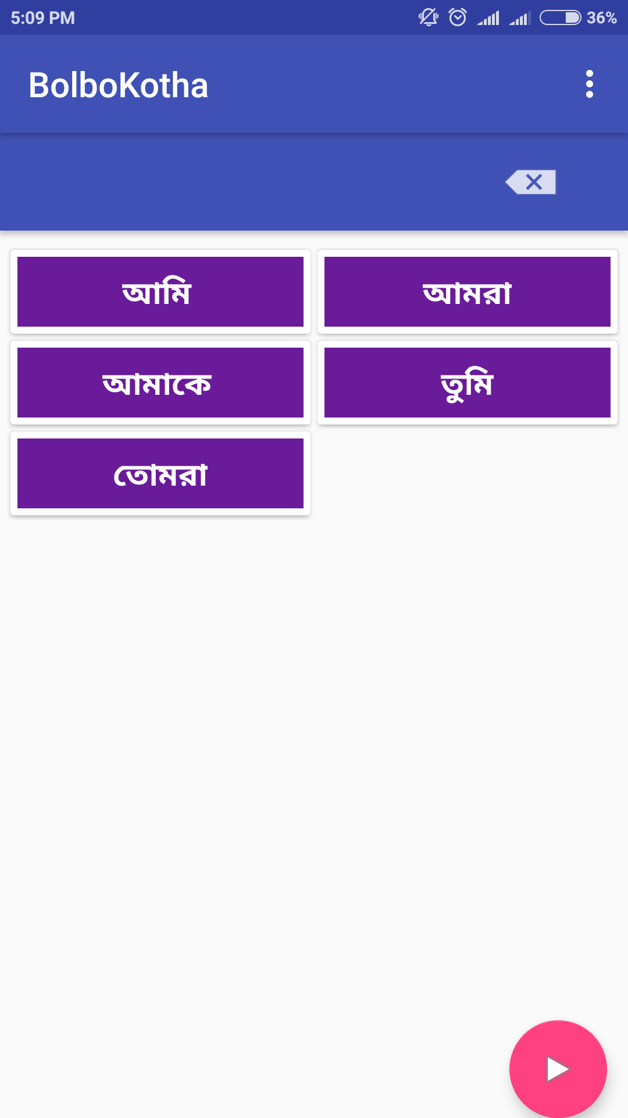

## Figure 3.4: All Subjects in Home page Figure 3.5: Categories Based on Subject

## 

## 

## Figure3.6: Objects of “POSHAK” categories. Figure 3.7: Verb corresponding Object

## 

## Figure 3.8: Choosing Verb Corresponding Object Figure 3.9: Sound generate after selecting Play button

## 

## Figure 3.10: Add new categories and type Option. Figure 3.11: Type Field generate after choosing “PoreShunai” option

## Figure 3.12: Add new categories Option. Figure3.13: Verb is adding corresponding category.

## 3.3.2 Hardware Interfaces

“Bolbo Kotha” will be an Android Application it will be designed to interface with the hardware present on the Android phone. The Application will be able to run by other devices that can emulate the Android, but this will not be a consideration during design. There are 3 physical buttons on the phone [6]. The options button will be used specifically in multiple instances to bring up menus, such as in bringing up the ability to add a word during the sentence generation phase. As this is an offline android Application, so user need not to connect with internet.

## 3.3.3 Software Interfaces

This product will be connecting automatically to a SQLite database that is already set up. When user insert new data. this data will store in SQLite database software interface can connect with the keyboard, mouse, menus of a computer system. The software interface allows the user to communicate with the operating system through Application.the languages and codes that the Applications use to communicate with each other and with the hardware.

# 3.4 Nonfunctional Requirements

## 3.4.1 Performance Requirements

It means how system response in different situation of a system like sometimes system needs to load so much data from other timeless data that system can be call perfect system. How system give output that is response time it is the most important thing. Here is some important thing for performance requirements

* throughput
* utilization
* static volumetric

For our system mostly its depend on the android system and hardware specification of a system.

## 3.4.2 Safety Requirements

Data should not be corrupted by external thing suppose user read the data simultaneously if one data is invalid whole system will be crushed. System safety should ensure for perfect system. Our system ensures this by using some tight security lock.

## 3.5.3 App Quality Attributes

The primary attribute of this Application will be usability which will be given the essential amounts of data and information that will be sufficient for a user to communicate with any people. As usability is hard to quantify, substantial user testing will be needed and feedback gathered in order to determine if the Application can generally be considered usable.

Because this Application will be on an android phone, portability is also important. We don’t want it to take up so much space or be too slow causing the user’s to not be able to fit it on the device.

**3.5.4 Reliability**

It is the most valuable thing how much trustworthy the system is when the user need it. System can be used for long time data need to be changed, data need to be updated system should ensure that after short period of time data and system specification should be updated. For our system data can insert by the user so that when user need some data for long time user can save it and use it further. Monitoring the system performance also need to ensure system reliability.

**3.5 Other Requirements**

**3.5.1 Data Requirements**

In this Application we will input some essential data and user also can input data according his/her needs which must be stored in the existing SQLite databases.

**Category**

In this Application, there have different category corresponding different subject. For every category here have many different words. Again for every word it has corresponding verbs. Some are described below:

Table 3.1*:* Database Table for Categories

|  |  |
| --- | --- |
| **1. কর্তা** | **7. জায়গা** |
| **2. খাবার** | **8. রোগ** |
| **3. অনুভূতি** | **9. পরিচয়** |
| **4. পড়াশুনা** | **10. প্রশ্ন** |
| **5. পোশাক** | **11. খেলাধুলা** |
| **6. অঙ্গ-প্রত্যঙ্গ** | **12. ক্রিয়া** |

**Items in Different categories:**

Table 3.2*:* Database Table for Subjects (কর্তা)

|  |  |
| --- | --- |
| **1. কর্তা** | |
| আমি  আমার  আমরা  আমাদের | আমাকে  তুমি  তোমাদের  তোমার |

Table 3.3*:* Database Table for Foods (খাবার)

|  |  |
| --- | --- |
| **2. খাবার** | |
| নাস্তা  ভাত  পানি  ডাল  সবজি  মাংস  পাউরুটি  বিস্কুট  মুরগীর মাংস  মাছ  গরুরমাংস | ডিম  আইসক্রিম  দুধ  আপেল  কমলা  কলা  রুটি  চা  কফি  জুস |

Table 3.4: Database Table for Dresses (পোশাক)

|  |  |
| --- | --- |
| **3. পোশাক** | |
| শার্ট  গেঞ্জী  পাঞ্জাবি  প্যান্ট  লুঙ্গি  জুতা | পায়জামা  কামিজ  থ্রিপিছ  ওড়না  স্কার্ট  স্যান্ডেল |

Table 3.5: Database Table for Places (জায়গা)

|  |  |
| --- | --- |
| **4. জায়গা** | |
| স্কুলে  বাসায়  মসজিদে  মন্দিরে | ওয়াসরুমে  বাগানে  বাজারে |

Table 3.6: Database Table for Body Parts (অঙ্গ-প্রত্যঙ্গ)

|  |  |
| --- | --- |
| **5.অঙ্গ-প্রত্যঙ্গ** | |
| হাত  পা  চোখ  দাঁত  বুক  জিহ্বা | মুখ  ঠোঁট  পেট  গলা  মাথা  চুল |

Table 3.7: Database Table for Diseases (রোগ)

|  |  |
| --- | --- |
| **6. রোগ** | |
| জ্বর | হাঁচি |

Table 3.8: Database Table for Education (পড়াশুনা)

|  |  |
| --- | --- |
| **7. পড়াশুনা** | |
| খাতা  কলম  বই  ব্যাগ | পেন্সিল  রাবার  কাটার |

Table 3.9: Database Table for Sports (খেলাধুলা)

|  |  |
| --- | --- |
| **8. খেলাধুলা** | |
| ক্রিকেট  ফুটবল  গান | মোবাইল  গেমস  লুডু  দাবা |

Table 3.10: Database Table for Emotion (অনুভূতি)

|  |  |
| --- | --- |
| **9. অনুভূতি** | |
| ভাল  খারাপ  কষ্ট  ভয় | আনন্দ  ঠান্ডা  গরম |

Table 3.11: Database Table for W/H Questions (প্রশ্ন)

|  |  |
| --- | --- |
| **10. প্রশ্ন** | |
| কি  কোথায়  কেন | কেমন  কিভাবে  কত |

Table 3.12: Database Table for Introduction (পরিচয়)

|  |  |
| --- | --- |
| **11. পরিচয়** | |
| নাম  বয়স | বাড়ি |

Table 3.13: Database Table for Verbs (ক্রিয়া)

|  |  |
| --- | --- |
| **12. ক্রিয়া** | |
| চাও  যাব  খাব  পরবো  খেলবো  দাও  যাও | দরকার  এসেছ  আসছে  লেগেছে  কিনবো  চাই  লাগবে |

**3.6 Conclusion**

In this chapter has described about System Requirent Specification(SRS) .In SRS has contained about Operating Environment, Design and Implementation Constraints, Assumptions and Dependencies, User Documentation, External Interface Requirements, User Interface, Hardware interfaces, Software Interfaces, Nonfunctional Requirements, Safety, Requirements Attributes, Reliability, Data Requirements. Also described Application database table and which table will be mapped with which subject relatively.

**CHAPTER** **4**

**Bolbo Kotha: Proposed Application**

**4.1 Introduction**

Project design is an early phase of the project where a project’s key features, structure, criteria for success, and major deliverables are all planned out. The point is to develop one or more designs which can be used to achieve the desired project goals. Stakeholders can then choose the best design to use for the actual execution of the project. A good project plan makes any project manager’s life easier. From preventing scope creep, overblown budgets, and missed goals to minimizing general stress and frustration, in this case, an ounce of prevention really is worth a pound of cure It is a creative process to envision and in creating a feasible concrete project plan of what we desire to realize in the society. It is a cycle of processes to generate ideas, to conceptualize the ideal project, develop a feasible plan to achieve what we envision, to deliver and to realize the innovative framework we designed.

The project design phase might generate a variety of different outputs, including sketches, flowcharts, site trees, HTML screen designs, prototypes, photo impressions and more. To identify the essence and the fundamental principles of social phenomena and create innovative ideas. Engage in rigorous discussions and to conduct field-research. Deliver and communicate the Project Design to stakeholders.

Here we have added the Class diagram, Use case diagram and Activity diagram of our product.

**4.2 Class Diagram**

A class diagram in the Unified Modeling Language (UML) is a type of static structure diagram that describes the structure of a system by showing the system's classes, their attributes, operations, methods, and the relationships among objects**.**

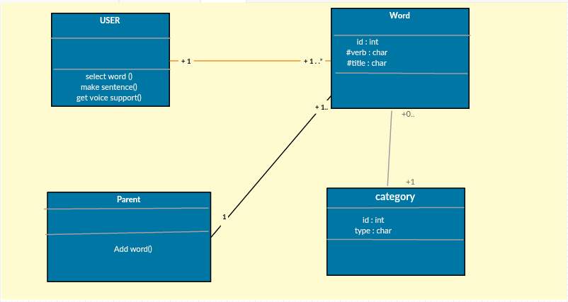

**Figure 4.1: Class diagram of “Bolbo Kotha”Application**

## 4.3 Use Case Diagram

A use case diagram is a graphic depiction of the interactions among the elements of a system. A use case is a methodology used in system analysis to identify, clarify, and organize system requirement.

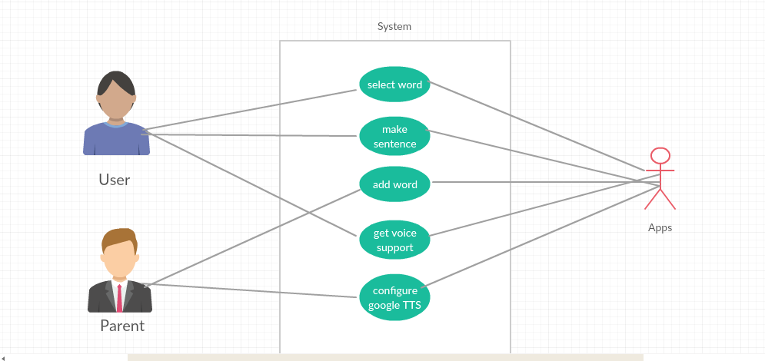

## Figure 4.2: Use Case Diagram of “Bolbo Kotha”Application

## 4.4 Activity Diagram

Activity diagram is another important diagram in UML to describe the dynamic aspects of the system. Activity diagram is basically a flowchart to represent the flow from one activity to another activity. The activity can be described as an operation of the system. The control flow is drawn from one operation to another.

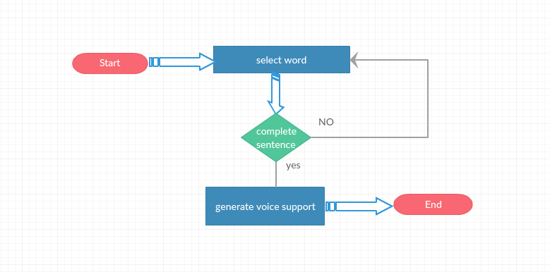

## Figure 4.3: Activity diagram of “Bolbo Kotha”Application

.

**4.5 Detailed Design**

Detailed design is the phase where the design is refined and plans, specifications and estimates are created. Detailed design will include outputs such as 2D and 3D models, P & ID's, cost build up estimates, procurement plans etc. [6]. This phase is where the full cost of the project is identified.

During this phase, the design team uses both the Requirements Specification and the Architectural Specification provided by the previous phases to develop a detailed design of the system. This design will provide a detailed specification for each component, thoroughly describing interfaces and functions provided by each component. This detailed design will serve as the basis for the implementation phase. Here we have shown that how we manually mapped different words to help the user to make meaningful sentences.

**4.5.1 Sentence Making (বাক্য তৈরী)**

Bangla is very interesting and self-sufficient Language be comparing other. So It is very challenging to make meaningful sentence by maintaining grammatical rules. How to make a Bangla sentence by maintaining grammar, we have given some of them below?

**আমিঃ**

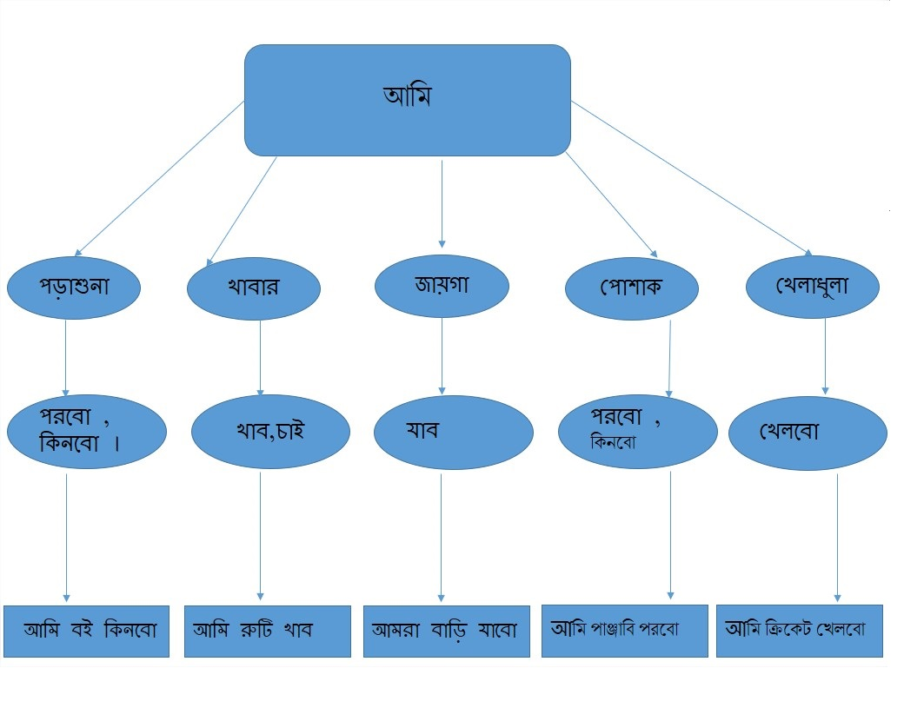

## Figure 4.1: Sentence Making tree by Subject “Ami”

**তুমিঃ**

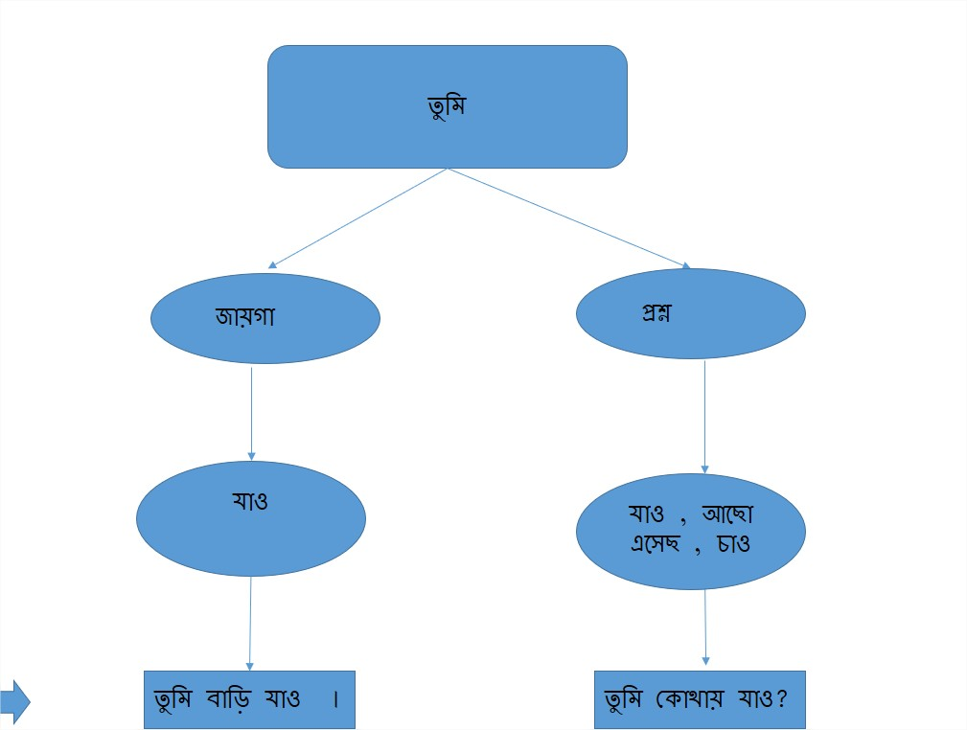

## Figure 4.2: Sentence Making tree by Subject “TUMI”

**আমরাঃ**

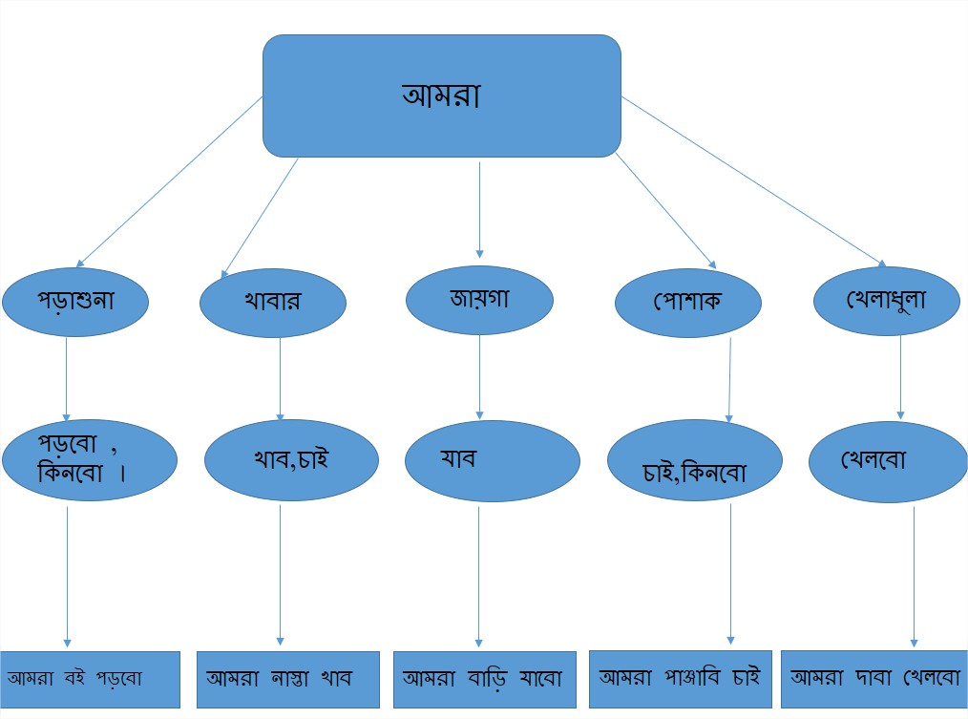

## Figure 4.3: Sentence Making tree by Subject “Amar”

**আমাকেঃ**

4.4: **Sentence Making tree by Subject “Amake”**

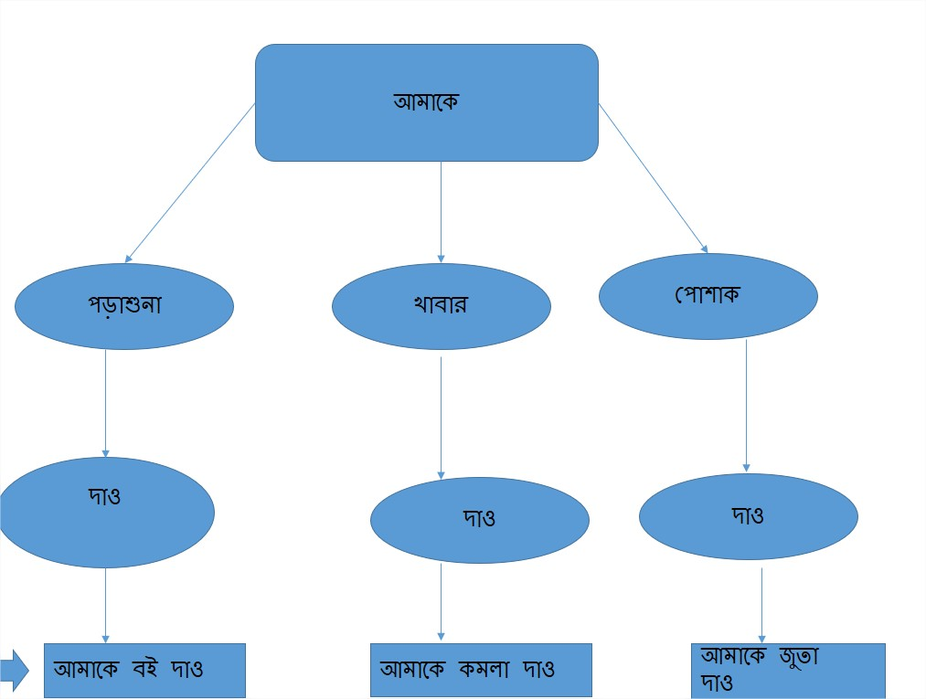

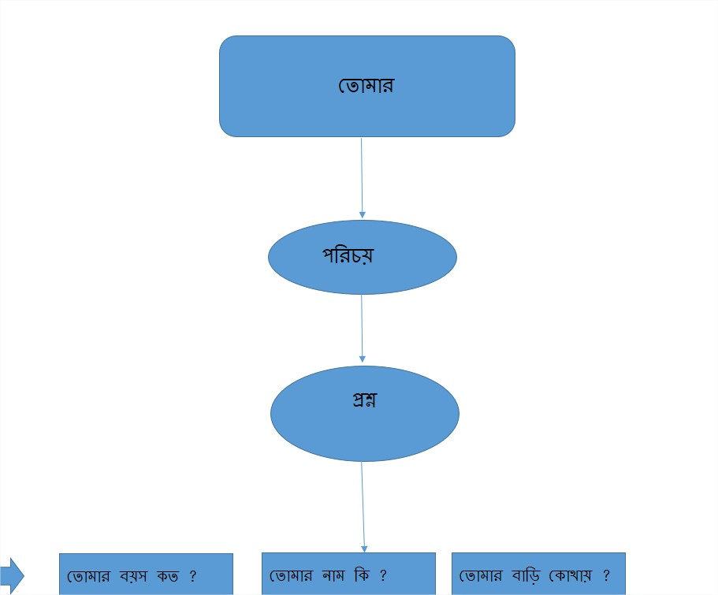**তোমারঃ**

## Figure 4.5: Sentence Making tree by Subject “Tomar”

**তোমরাঃ**

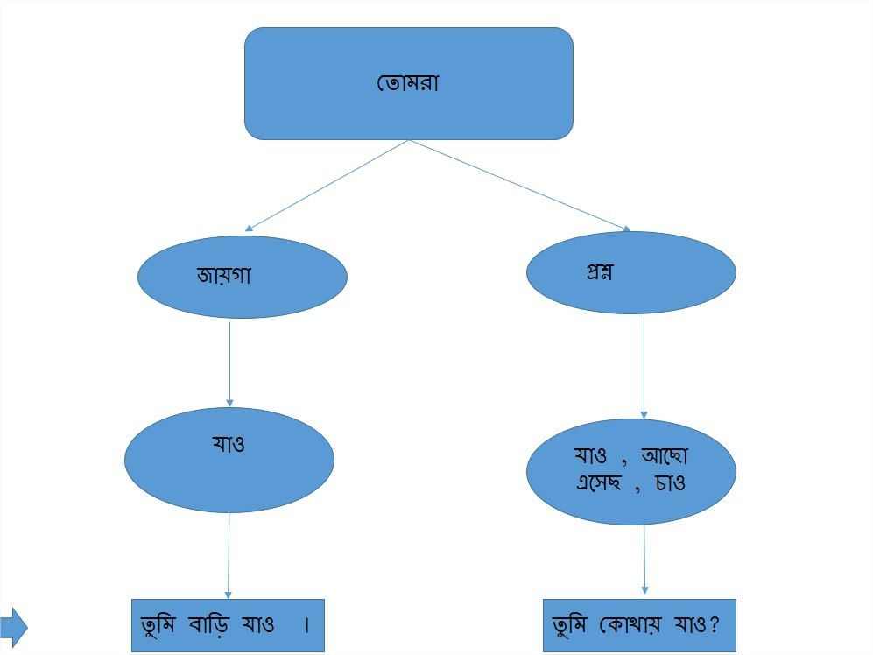

## Figure 4.6: Sentence Making tree by Subject “Tomra”

**4.6 Text To Speech**

Google text-to-speech used as a screen readerfor android operating system. It is a great assistance for the people which has some physical impairments. It is also a huge indulgence for people who works multiple work at a time. Initially release date November 6 in 2013 when android 4.2.2 jelly bean was originated [8]. It has ability to read aloud which text now on the screen. Google TTS supportive languages are increasing day by day. Google Text-to-speech powers Applications to read the text on your screen aloud. Recently Bangla was included in TTS for giving help to Bangladeshi people. It used some Apps for its internal works.

Here is the list ---

# Google play books

# Google translator

# Google talkback

# Spoken feedback accessibility based Applications.

To use Google Text-to-speech on your Android device, go to Settings > Language & Input > Text-to-speech output. Select Google Text-to-speech Engine as your preferred engine. Note, on many Android devices, Google Text-to-speech is already turned on, but you can update to the latest version here.

**Most important thing is that we have to install voice data for the language which we want to use.**

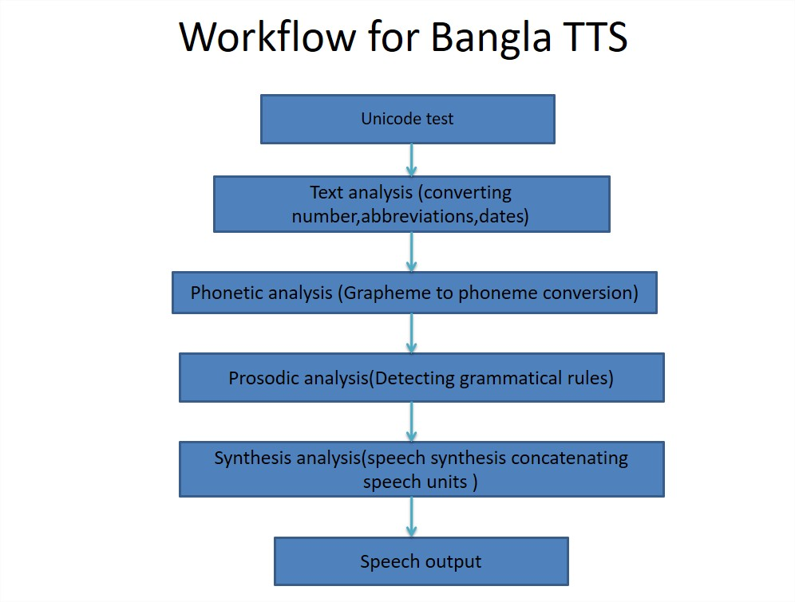

**Figure 4.7: Work flow diagram of Bangla TTS**

**4.7 Conclusion**

In this chapter, “Bolbo Kotha” Application’s detailed design is described about how to make Bangla grammatically correct sentence. It has contained about Class diagram and Use Case Diagram, Activity Diagram which described how this App will work according to the individual user behaviour. It is very challenging for maintaining Bangla grammar to make correct form of Bangla sentence which are shown upon. We have also shown how Bangla TTS works in our application.

**CHAPTER** **5**

**Discussion And Conclusion**

**5.1 Summary**

We have developed “Bolbo Kotha” App to help the people who speech impaired. It is very easy and simple to use the App for everyone. We have presented a mobile Application helping children with speech disabilities to communicate by “translating” text into speech a. A novel Approach to mapping text to speech which allows easy integration with existing natural language generation systems. The solution Applies to adults too, but it benefits children the most, who have much fewer alternatives than the adults. We have released our Application as an open-source – hoping to participate in filling the availability gap - at least for the Bengali speakers.

Because of its natural language processing features from Google Text to Speech, after finishing the work left it’s going to become a fully featured one of the most advanced Applications on the market, and it's free. If we would add artificial intelligence into this App then it would provide almost seamless assistance, and is closest to the natural speech.

Nonverbal people will be able to express their thoughts and feelings more Apparently using this App. It would be great to implement artificial intelligence to provide auto suggestions of words while making sentences. we will try to work with this in near future. The App will be uploaded on Google Play store to download free for everyone.

**5.2 Limitation**

“Bolbo Kotha” is the first Google TTS (Text to Speech) based Augmentative and Alternative Communication Application which was developed for non-verbal people. Although it is very essential Application for verbal disable people, it has some limitation which are mentioned following:

Almost every product has technical limitations. Though “Bolbo Kotha” is the first Bangla sentence making App, it has some limitations. This App only supports Bangla language. We did not work with other languages yet. We didn’t implement artificial intelligence to provide auto suggestions of words rather we manually mapped words and provided prediction of words to user while making sentences. Users can’t add subjects but they can add category under subjects. Users have to add both object and verb together under a category.

**5.3 Future Work**

“Bolbo Kotha” is an Application which was developed to make non-verbal people into verbal people. It is also our dream Application to help this disable verbal people and connect these disable people to our running society. We have thought if we can make non-verbal people to verbal, they can also keep contribution in our family, society, country and world according to their ability with their people unique talent and strength.

As the Application presented was developed during a short extension-project, there is still much work to be done to improve the Application. Some key future work is described below:

Though “Bolbo Kotha” is very helpful for non-verbal people who have knowledge of Bangla words, we have lot to improve in this App. We will work with multiple languages and extend user interface. Auto suggestions of words will be implemented to make the App more efficient. All data of this App will be stored in cloud database to prevent unexpected data loss. “Bolbo Kotha” will also be developed on iOS and Windows platform.

**References**

[1] Md. Nasfikur R. Khan, Mohammad N. H. Pias, K. Habib, M. Hossain, F. Sarkar and K. A. Mamun,”Bolte Chai: An Augmentative and Alternative Communication Device for Enhancing Communication for Nonverbal Children”

[2] Beukelman, D. R.; Mirenda, P. (2005) ,“Augmentative and alternative communication”

Link: https://en.wikipedia.org/wiki/Augmentative_and_alternative_communication

[3] D. Beukelman, P. Mirenda, “Augmentative and Alternative Communication” Vol. ISBN 1-55766-333-5 Key: citeulike:309352

Link: http://www.citeulike.org/group/408/article/309352

[4] Adam Colgate ,“non-verbal communication”,

Link: http://www.businessdictionary.com/definition/non-verbal-communication.html

[5] Andersen, Peter (2007).Nonverbal Communication: Forms and Functions (2nd ed.). Waveland Press, [Burgoon, J. K.](https://en.wikipedia.org/wiki/Burgoon,_J._K.), Guerrero, L. K., & Floyd, K. (2011). [Nonverbal communication](http://www.pearsonhighered.com/educator/product/Nonverbal-Communication/9780205525003.page). Boston: Allyn & Bacon. [ISBN](https://en.wikipedia.org/wiki/International_Standard_Book_Number) [9780205525003](https://en.wikipedia.org/wiki/Special:BookSources/9780205525003).

“Nonverbal communication”,

Link: https://en.wikipedia.*org*/wiki/Nonverbal_communication

[6] “aac communication”, Link:https://play.google.com/store/search?q=aac%20communication&c=Apps

[7] “[এভারগ্রীন বাংলা](http://www.evergreenbangla.com/)”,

Link:http://www.ebanglalibrary.com/banglagrammar/

[8] [Google Text-to-Speech engine arrives to Google Play"](http://www.androidauthority.com/google-text-to-speech-314826/). *Android Authority*. Retrieved 23 November 2014. , Bogdan Petrovan (6 March 2014). ["Google updates Text-to-Speech engine with new and high-quality voices"](http://www.androidauthority.com/google-text-to-speech-high-quality-voices-354394/). Android Authority. Link:https://en.wikipedia.org/wiki/Google_Text-to-Speech

[9] [Burgoon, J. K.](https://en.wikipedia.org/wiki/Burgoon,_J._K.), Guerrero, L. K., & Floyd, K. (2011) ,“Augmentative and Alternative Communication (AAC),”

Link:http://www.asha.org/public/speech/disorders/AAC/

[10] Remland, Martin S. (2009) ,” About autism

Link: http://www.autism.org.uk/about.aspx

[11] Light, J.; McNaughton, Language-Systems

Link:https://www.prentrom.com/prc_advantage/language-systems

[12] Chatterji, Suniti Kumar. *Bengali Self-Taught.* Calcutta: Rupa & Co., 1991.

Link:https://en.wikipedia.org/wiki/Bengali_grammar

[13] Alam, Firoj; Nath, Promila Kanti, Khan, Mumit,” Text to speech for Bangla language using festival”

Link:http://123.49.46.157/handle/10361/675

[14] Christine Smith,  “Text-To-Speech”.

Link:https://tunesgo.wondershare.com/android/text-to-speech.html

[15] KnApp, Mark L., & Hall, Judith A. (2007) , Remland, Martin S. (2009). “nonverbal-communication”

Link:https://www.skillsyouneed.com/ips/nonverbal-communication.html

[16] Batshaw, M. L.; Shapiro, B. (2002). Batshaw, M. L., ed.Children with disabilities(5th ed.). Baltimore: Paul H. Brookes Publishing Company.*ISBN* *0-86433-137-1*. ,“AAC and Autism: Using Communication Devices for Non-Verbal Children”

Link:https://www.speechandlanguagekids.com/giving-voice-non-verbal-children-autism-aac-autism/

[17] Jennifer Ledford, Ph.D., BCBA-D,” What is augmentative and alternative communication?”

Link:http://vkc.mc.vanderbilt.edu/ebip/augmentative-and-alternative-communication/