**Half-Course Assessment**

E-mail address:

Write your name:

**1.** We have to postpone the class on 4th July, Saturday for some unavoidable reasons. Which time would you prefer for the makeup class?

* 5th July, Sunday at 12 pm
* 7th July, Tuesday at 12 pm. The next classes will be on next Tuesday and Saturday consequently.
* Anyone would be OKAY for me
* Option 4

**2.** What will be the output of this code? (2 points)

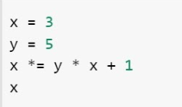

* 16
* 47
* 48
* 15

**3.** What will be the output of this code? (2 points)

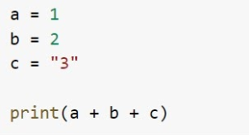

* 123
* 12’3’
* 3’3’
* 6
* Error

**4.** Which of these collections define/defines a LIST? (2 points)

* ["Dog", "Cat", "Monkey"]
* {"Dog", "Cat", "Monkey"}
* ("Dog", "Cat", "Monkey")
* list. “Dog", "Cat", "Monkey"

**5.** Which of the following is/are true? (5 points)

* The ‘in’ operator is used to check if a value exists within an iterable object container such as a list. Evaluates to true if it finds a variable in the specified sequence and false otherwise.
* A string is immutable in Python means every time when we modify the string, Python Always create a new String and assign a new string to that variable.
* In Python 3, the maximum value for an integer is 263 – 1
* In Python "Hello World" is same as 'Hello World'
* Set is defined with {} in Python

**6.** What will be the output of this code? (2 points)

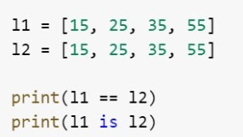

* True --- True
* False --- True
* True --- False
* False --- False

**7.** Which of the following is/are not true? (4 points)

* Python can run on any type of platform
* The statements with the same indentation belong to the same group called a suite.
* >= , <=, +=, x= are some valid operators of Python
* <> operator can be used to compare two values.

**8.** What will be the output of this code? (3 points)

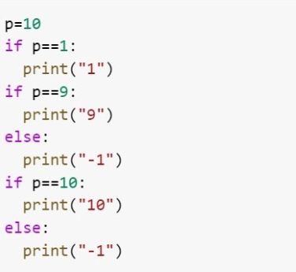

* -1 --- 10
* 10 --- -1
* 10
* -1 --- -1

**9.** Which method can be used to remove any white-space from both the beginning and the end of a string? (2 points)

* strip()
* title()
* trim()
* len()

**10.** What will be the output of this code? (5 points)

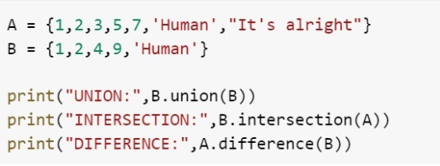

* Option 1



* Option 2



* Option 3



* Option 4



**11.** Which of the following are valid ways to specify the string literal I'm going home in Python? (3 points)

* 'I'm going home'
* "I'm going home"
* 'I' 'm going home'
* " " "I'm going home" " "
* 'I\'m going home'

**12.** What will be the output of this code? (2 points)



* Index Error
* 'love my country'
* ' love my country'
* 'ove my country'

**13.** What will be the output of this code? (3 points)

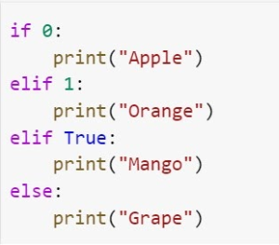

* Apple
* Orange
* Mango
* Grape

**14.** How do you insert COMMENTS in Python 3? (2 points)

* //Comment is here
* #Comment is here
* /*Comment is here*/
* @Comment is here

**15.** What command is used to insert 3 in a list ‘‘L1’’ at 3rd position?

(2 points)

* L1.insert(3,3)
* L1.insert(2,3)
* L1.add(3,3)
* L1.append(2,3)

**16.** What will be the output of this code? (5 points)

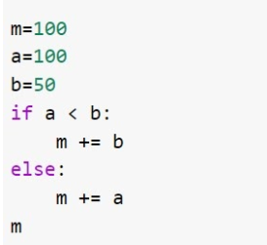

* 50
* 100
* 200
* 150

**17.** What will be the output of this code? (3 points)

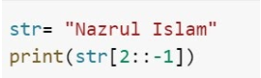

* mal
* zaN
* malsI lurzaN
* Naz

**18.** What will be the output of this code? (3 points)

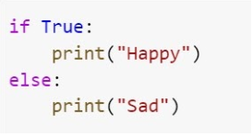

* Happy
* Sad
* Nothing will be printed
* Error