A proposal in a marriage

It is believe that in a marriage occasion it is about knotting a tie not about proposal. There happens to be a cause which is contractitory to this fact. Where proposal is embedded in a marriage. Actually not the couple proposal but the another person proposal on their wedding day. This happens that in their

It was just magical because no person in ther event would have taught of that as the bride turn around and hand over flower to her female friend during bouquet toss. She was even surprised and as she turn around she saw her bofy friend on one kneel with a ring trying to propose to her. This wedding actually went viral with many people on internet castigating about the weird action that it ought not to be since it is once in a life time, all things about the day should be about them and not any other person many even said that they would not allow such a thing in the wedding.

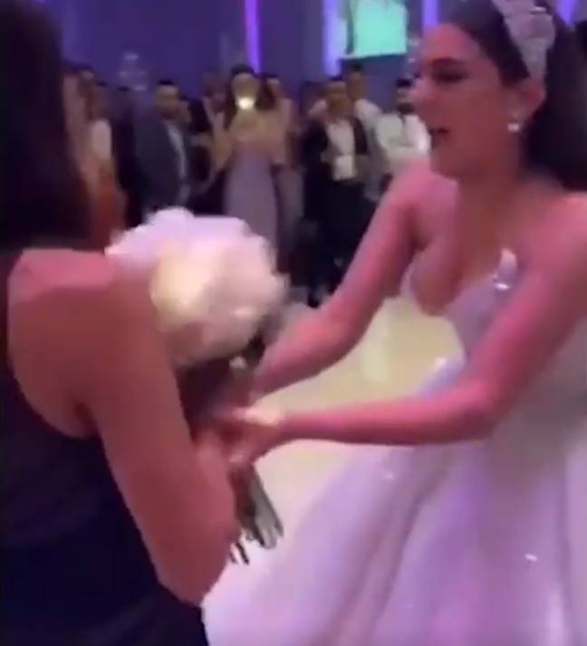

The pair will now get married in two months' time