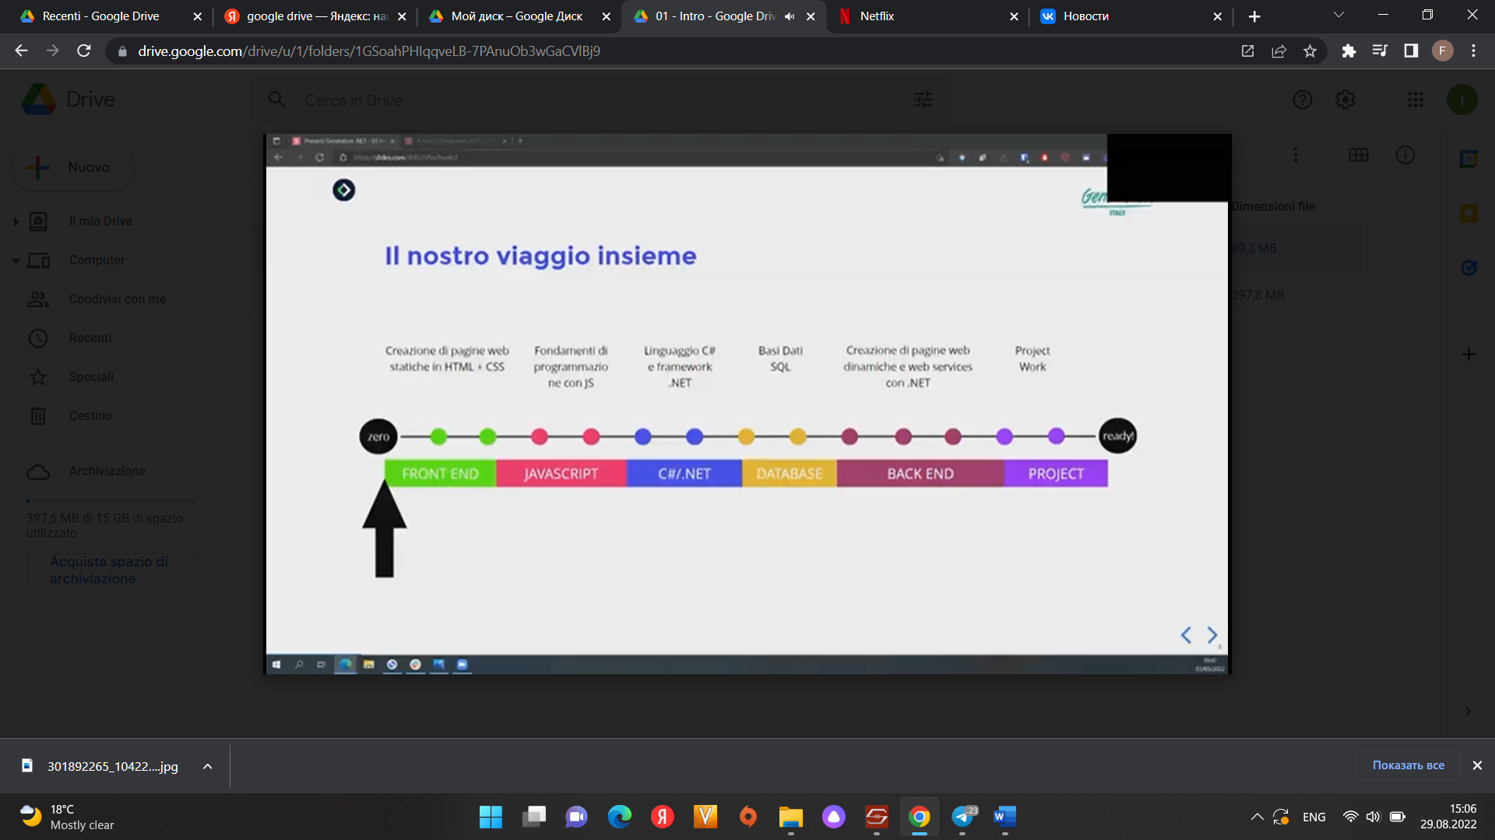

1.HTML/CSS

* How can you open a link in a new tab/browser window?
* Начало формы
* Конец формы
* <a href=”url” target=”_blank”>
* What is the correct HTML for making a checkbox?Начало формы
* <input type=”checkbox”>
* What is the correct HTML for making text input field?
* <input type=”text”>
* Correct HTML for making a drop-down list for choose some predefined values
* <input type="text" name="product" list="productName" />
* <datalist id="productName">
* <option value="Pen">Pen</option>
* <option value="Pencil">Pencil</option>
* <option value="Paper">Paper</option>
* </datalist>
* For making a text area in the HTML code must write
* <input type=”textbox”>
* In HTML:
* <input type=”range”>
* Defines a control for entering a number whose exact value is not important (like a slider control). Default range is from 0 to 100.
* The HTML **element** is everything from the start tag to the end tag:
* <h1>My First Heading</h1>
* <p>My first paragraph.</p>

|  |  |  |
| --- | --- | --- |
| **Start tag** | **Element content** | **End tag** |
| <h1> | My First Heading | </h1> |
| <p> | My first paragraph. | </p> |
| <br> | *none* | *none* |

* All HTML elements can have **attributes**
* The href attribute of <a> specifies the URL of the page the link goes to
* The src attribute of <img> specifies the path to the image to be displayed
* The width and height attributes of <img> provide size information for images
* The alt attribute of <img> provides an alternate text for an image
* The style attribute is used to add styles to an element, such as color, font, size, and more
* The lang attribute of the <html> tag declares the language of the Web page
* The title attribute defines some extra information about an element

<pre> - tag che consente di conservare tutti gli spazi e interruzioni di riga.

<em>- attributo che si usa per sottolineare un testo.