УДК 51-72, 51-74, 519.688 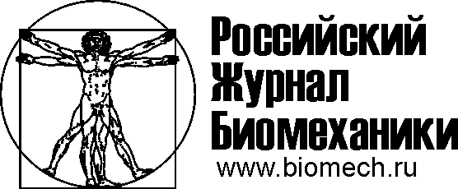
model of the deviation of the medical needle during the movement in human TISSUE
V.G. Druzhinin¹ ², V.A. Morozov¹, S.A. Nikitin², V.V. Harlamov²
¹ Department of Physical Mechanics, St. Petersburg State University, Russia, 199034, St. Petersburg, Universitetskaya Embankment Building 7-9, e-mail: vasily.dr.mob@gmail.com, v.morozov@spbu.ru
² Russian State Scientific Center for Robotics and Technical Cybernetics (RTC), Russia, 194064, St. Petersburg, Tikhoretskiy Avenue 21, e-mail: vasily.dr.mob@gmail.com, s.nikitin@rtc.ru
Abstract. In this paper, a mathematical model describing the deviation of the medical steel needle when it moves in the phantom of soft tissues (human tissues). This model will expect for use in the operational mode, where high precision positioning of the tip of the needle is necessary. The needle have asymmetric tip and because when the needle moves, it to deviate from rectilinear motion. Thus, by inserting and rotating the needle around its axis, it is possible to move the tip of the needle along a predetermined path. Consequently, having developed the model with its help, it will be possible to track the movement of the needle in the tissues or to predict optimal puncture points. The general formulation of the problems is considered and one of the sub-tasks is solved, as well as the available calculation of the needle tip deflection during the translational movement in a homogeneous material. The article shows the model used and the simulation results for different material densities and different needle tip angles. Comparison of the experimental data with the results obtained in the calculation using the proposed model is given.
Key words: : brachytherapy, robotic system, medical needle.

Introduction
In our days robotic complexes are widely used in medicine for performing operations of varying complexity. To date, Russian State Scientific Center for Robotics and Technical Cybernetics (RTC) has developed a mock-up of the "OnkoRobot" robotic system for prostate cancer brachytherapy [1, 2]. This procedure is carried out through the introduction of micro sources of radio emission into the prostate gland as close as possible to the tumor. The main difficulty lies in bringing the needle tip to the target point (tumor) during the operation.
The advantages of using robots compared to traditional methods are that the robotic manipulator is able to provide almost any desired accuracy of tool pointing and its controlled force action, which allows us to rely not only on improving the quality of currently mastered operations, but also creating a basis for developing new surgical technology. Another important advantage is the absence of direct contact of the physician with radioactive sources, which will make it possible to protect medical personnel from concomitant radiation exposure.
Due to its geometrical features and the applied loads, the needle is deformed in the process of performing the operation, which leads to a deviation of the needle from a straight-line trajectory.
Thus, it is necessary to develop the model and create on its basis such a software product that allows you to predict and correct the movement of the needle during operation of the robotic system.
By combining this product with other systems, it will be possible to predict more optimal puncture points during the operation, control the needle movement to increase accuracy. Having debugged this model and complementing it with a model of viscoelastic tissues, it will be possible to simulate the process of conducting an operation for various purposes, for example, to train medical specialists.
The movement of the needle is controlled by turning the needle around its axis. At the same time, the needle tip is rotated, and with it the arc bending plane, and thereby changing the direction of further movement. When inserting a needle along a straight trajectory, it must be constantly rotated.
The possibility of using flexible needles [3] is also considered. The main advantages provided by the use of such needles are the possibility of realizing the curved paths of the needle in the patient’s body, the possibility of adjusting the needle’s trajectory during the introduction and the possibility of a significant reduction in the total amount of injured human tissue during operations. Needles with a high degree of flexibility are made of special materials. For operations, needles begin to be made more complex and multifunctional.
To simulate the deflection of the needle as it moves in human tissues currently a fairly large number of approaches are used. In [4], the simulation was performed using a nonholonomic kinematic model. As the authors themselves note, since the work was carried out in the first approximation, the simulation results are very different from the experimental.
In [5], mathematical modeling of the optimal curvilinear trajectory of the needle was carried out using the trajectory planning algorithms. The formation of the trajectory is carried out using coordinates that configure the area. Here were allocated those parts that need to be circumvented, and those parts that may be a possible variant of the trajectory. It is proposed to select such areas using four methods: the method of potential fields, the method of roadmaps, the method of decomposition planning and the method of coordinate grids.
In work [6] several methods are considered for modeling the movement of a needle. The first approach is kinematic. It describes the trajectory of movement, based on the binding to the global coordinate system, and assumes that due to the design features of the tip, the needle will move along a circular trajectory. For this description method, the use of the unicycle model and bicycle model is assumed. These methods were first used in [7]. Since the proposed models do not consider the interaction of the needle with the surrounding tissues, they are suitable for describing the interaction of the needle with tissues.
The second approach is mechanical. It describes the system of interaction of forces between the needle and the tissue in which it is located. On the one hand, forces are required to move the needle inside the tissue, on the other hand, the needle body is affected by friction forces, distributed load forces, and due to the asymmetry of the needle tip, it is also affected by the force exerting pressure from the tissue.
Also, for the mechanical description of the needle, you can use the bending equation of thin flexible rods [8]. With this approach it will be convenient to assess the stability of the rod - the needle.
In the “classic” systems, only regular metal straight needles are used for brachytherapy procedures. On this basis, it is advisable to develop a model for simulation the deviation of a steel needle during movement in human tissues. In this paper, a new approach will be used to describe the forces acting on the needle tip.

Problem statement

General problem
It is necessary to develop a model for determining the position of the tip of an asymmetric medical injection needle (Fig. 1) in the coordinate system of the Oxyz manipulator during the translational and rotational movement of the needle.
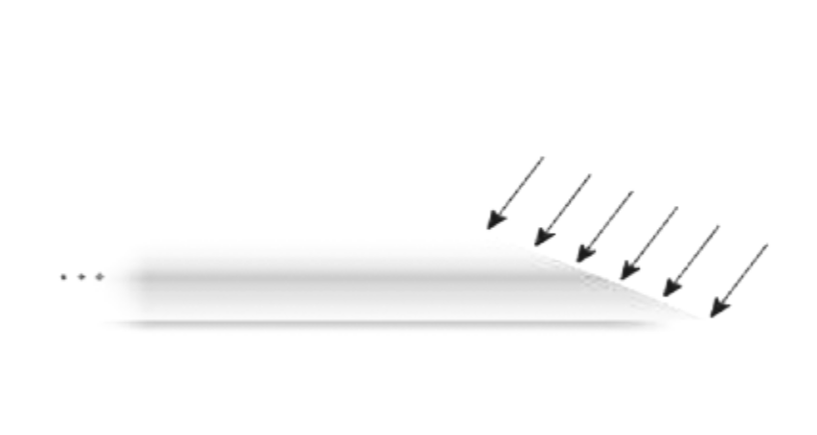
Fig. 1. Needle shape.
This task is voluminous and interdisciplinary. To solve it, we need to touch on several sections of mechanics and take into account a large number of initial and boundary conditions. The proposed numerical solution should not occupy a sufficiently large amount of resources and should be suitable for an iterative solution during system operation. Here are the possible tasks:
- The simulation of the movement of the needle in the plane Oxy, the deformation of the needle depending from the translation movement it in tissue.
- Simulation of the movement of the needle in three-dimensional space, depending on the rotational and translational motion.
- Simulation of the puncture process, obtaining the needle bending before its introduction in the tissue (loading and unloading of the needle during the puncture).
- Simulation of needle movement through materials of different density (skin, muscles, organ).
- Modeling the effect of forces created by the tissue during its deformation on the surface of the needle.
- Simulation of the friction force during the introduction of the needle into the tissue.
- Modeling deformation of viscoelastic tissues.
As can be seen from the above points, for a complete solution of the problem it is necessary to take into account quite a lot of parameters. This paper discusses the first point.

Posing the problem being solved
Необходимо разработать модель для определения положения кончика ассиметричной иглы (Рис. 1, 2, 3) в системе координат Oxy при поступательном движении иглы в тканях человека (1). Модель должна учитывать параметры иглы и параметры среды, с которой она взаимодействует.
Также примем, что игла не может сжиматься, поскольку плотность среды намного ниже, чем плотность иглы.
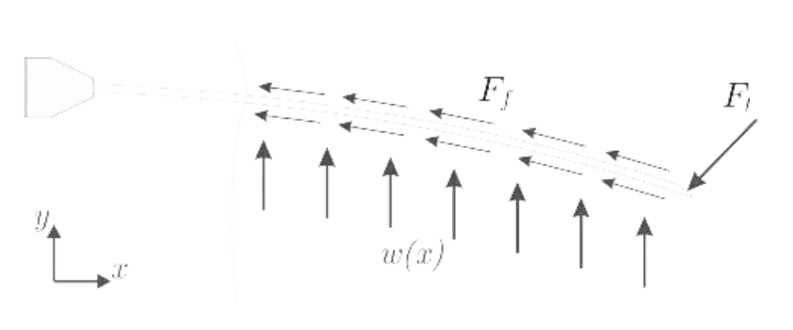
Fig.2. Needle which moving in human tissue.
On fig. 2 you can see the possible forces acting on the needle during its movement:
- Ft – force acting on the needle tip;
- Ff - friction force that occurs when the needle moves inside the tissue;
- w(x) – distributed load (the force exerted by the tissue on the surface of the needle).

The equation of equilibrium of forces can be represented as follows:
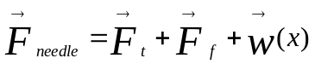 (1)

where F_{needle} – the force with which the needle is inserted.
In This paper will consider a simpler formulation of the problem:
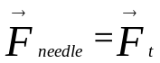 (2)
Figure 3 shows the considered forces acting on the needle, which will be considered when solving the problem in the first approximation.
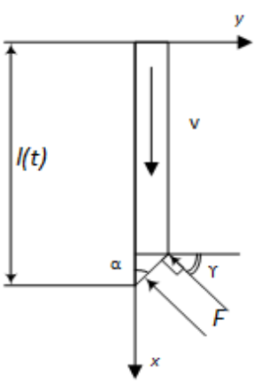
Fig.3. Acting forces on the tip of the needle.
- F – is the force acting on the needle tip;
- l(t) – needle length;
- v – translational velocity in tissue;
- 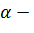 the angle of the tip of the needle;
- 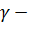 angle at which the force acts.
In this formulation, we will not take into account the bending of the needle under the action of gravity, since during the experiment the needle pierced the phantom of soft tissues from top to bottom. With such a needle movement, the effect of gravity is negligible and does not affect the curvature of the needle.

Mathematical model
To solve the problem, the tip deviation and the deflection angle will be calculated using the formulas [9]:

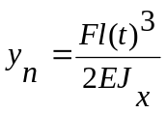 (1)
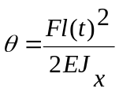 (2)
where:
current simulation iteration;
deviation of needle tip at the current time;
the force acting on the tip of the needle as it moves;
axial moment of inertia;
needle length located in human tissues;
time;
Young's modulus;
deviation angle.
В данном случае осевой момент вычисляется по формуле:
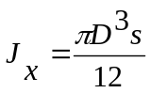 (3)
where:
needle wall thickness;
diameter of the middle section of the needle (Fig. 4).

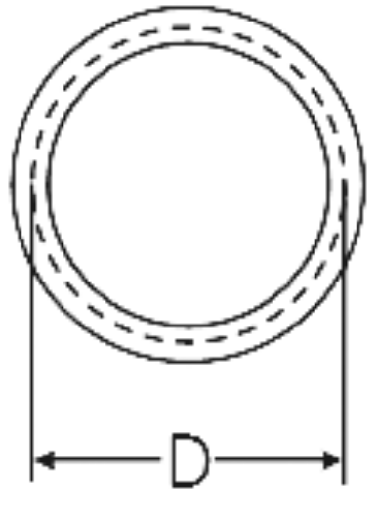
Fig 4. Parameter D to calculate the axial moment of inertia.
In this case, the needle is presented in the form of a beam with a rigid seal, on the one hand. Place of fixation will be considered a puncture site. Then it turns out that with increasing time the length of the beam will increase. Thus, at each time step, a new deviation will be calculated.
The size of the elementary cells (molecules) is many times smaller than the overall dimensions of the needle. The speed of movement of the needle in the medium is quite low, and the density of the medium is rather high compared to air. On this basis, to simulate an external force when a needle is moved in human tissues, one can use a frontal drag force.
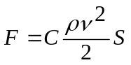 (4)
where:
resistance coefficient;
density;
translational velocity;
characteristic body area, , где body volume [10].
Table 1 shows the parameters that will be used in the calculations.
Table 1
Parameters for simulation
Parameter name | Value
external needle diameter, m | 0,001
internal needle diameter, m | 0,0008
Young's modulus, n / m2 | 2.0•1011
density, kg/m3 | 900 – 1500
translational velocity, m/s | 0,003 – 0,03
form resistance coefficient | 0,82
maximum needle length, m | 0,1
To calculate the needle deviation by expressions (1) and (2), used only the projection of force F on the axis Oy is considered.
Fig. 5 shows the diagram of the applied force from tissue, when needle moving in it.
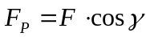 (5)
where:
projection on the axis Oy of the force acting on the needle tip as it moves.
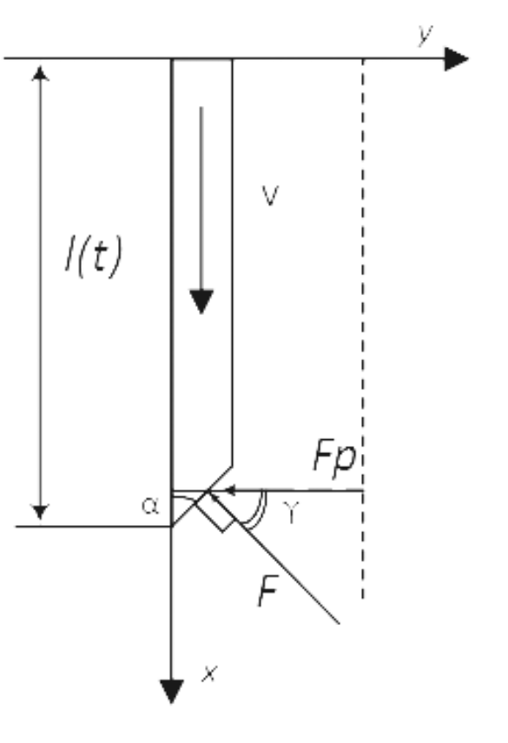
Fig. 5. The scheme of the applied force from tissue when needle moving.
Using the proposed expressions (1), (2), (4), we will calculate the deviation iteratively, summing it up with the previous steps. This will keep the deviation at each step of the simulation:
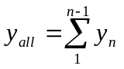 (6)
where:
current simulation iteration;
total needle deviation as it moves in human tissues;
needle deviation at current time step.

Result of model simulation
Since the tissue can be heterogeneous or in each individual case its average density can be different, the simulation is carried out for different values of the density of the medium (from 900 to 1500 kg/m³). Simulation is also carried out for speeds in the range from 0.003 to 0.03 m / s. For the simulation, the angles of the needle tip α = 30, 45, 60 degrees will be used.
Table 2, 3, and 4 show the results of simulation for the corresponding angles of the needle tips.
Table 2.
The results of simulation of the loaded state for the angle of the tip of the needle 30 degrees at different densities of the material and the rate of introduction.
Translational velocity, mm/s | Needle tip deviation, mm
Translational velocity, mm/s | 1500 kg/m³ | 1300 kg/m³ | 1100 kg/m³ | 1000 kg/m³ | 900 kg/m³
3 | 0,026 | 0,022 | 0,019 | 0,017 | 0,016
6 | 0,104 | 0,090 | 0,076 | 0,069 | 0,062
9 | 0,233 | 0,202 | 0,171 | 0,155 | 0,140
12 | 0,414 | 0,359 | 0,304 | 0,276 | 0,248
15 | 0,647 | 0,561 | 0,474 | 0,431 | 0,388
18 | 0,932 | 0,807 | 0,683 | 0,621 | 0,559
21 | 1,268 | 1,099 | 0,930 | 0,845 | 0,761
24 | 1,656 | 1,435 | 1,214 | 1,104 | 0,994
27 | 2,096 | 1,816 | 1,537 | 1,397 | 1,258
30 | 2,588 | 2,243 | 1,898 | 1,725 | 1,553

Table 3.
The results of simulation of the loaded state for the angle of the tip of the needle 45 degrees at different densities of the material and the rate of introduction..
Translational velocity, mm/s | Needle tip deviation, mm
Translational velocity, mm/s | 1500 kg/m³ | 1300 kg/m³ | 1100 kg/m³ | 1000 kg/m³ | 900 kg/m³
3 | 0,037 | 0,032 | 0,027 | 0,024 | 0,022
6 | 0,146 | 0,127 | 0,107 | 0,098 | 0,088
9 | 0,329 | 0,285 | 0,242 | 0,220 | 0,198
12 | 0,585 | 0,507 | 0,429 | 0,390 | 0,351
15 | 0,915 | 0,793 | 0,671 | 0,610 | 0,549
18 | 1,317 | 1,142 | 0,966 | 0,878 | 0,790
21 | 1,793 | 1,554 | 1,315 | 1,195 | 1,076
24 | 2,342 | 2,030 | 1,717 | 1,561 | 1,405
27 | 2,964 | 2,569 | 2,174 | 1,976 | 1,778
30 | 3,659 | 3,171 | 2,683 | 2,440 | 2,196

Table 4.
The results of simulation of the loaded state for the angle of the tip of the needle 60 degrees at different densities of the material and the rate of introduction.
Translational velocity, mm/s | Needle tip deviation, mm
Translational velocity, mm/s | 1500 kg/m³ | 1300 kg/m³ | 1100 kg/m³ | 1000 kg/m³ | 900 kg/m³
3 | 0,045 | 0,039 | 0,033 | 0,030 | 0,027
6 | 0,179 | 0,155 | 0,131 | 0,120 | 0,108
9 | 0,403 | 0,350 | 0,296 | 0,269 | 0,242
12 | 0,717 | 0,621 | 0,526 | 0,478 | 0,430
15 | 1,120 | 0,971 | 0,822 | 0,747 | 0,672
18 | 1,613 | 1,398 | 1,183 | 1,076 | 0,968
21 | 2,196 | 1,903 | 1,610 | 1,464 | 1,318
24 | 2,868 | 2,486 | 2,103 | 1,912 | 1,721
27 | 3,630 | 3,146 | 2,662 | 2,420 | 2,178
30 | 4,482 | 3,884 | 3,287 | 2,988 | 2,689

Figure 6 shows graphs showing the needle deviation when it is inserted with a different tip angle at a material density of 1500 kg/m³.
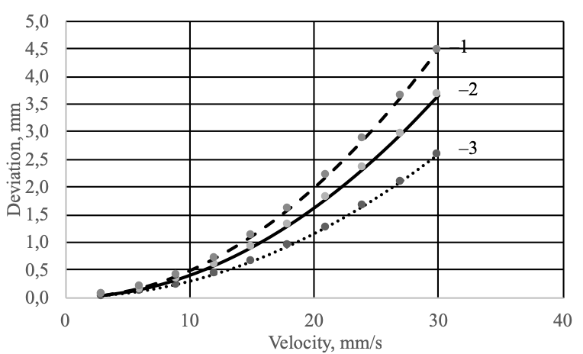
Fig. 6. Graphs of needle deviation as a function of speed at various angles of the tip, 1 - at an angle of the tip of 30 degrees, 2 - at an angle of the tip of 45 degrees,
3 - at an angle of 60 degrees.
It can be seen from the graphs (fig. 6) that a needle with a smaller tip angle deviates less from straight-line trajectory.
Fig. 7 shows the graphs of the tip deviation for a needle with a tip of 45 degrees as it moves in materials with different densities.
From the graphs (fig. 7), it can be seen that a medium with a lower density has less effect on needle deflection.
For the correct simulation, a sufficiently small-time step is required. Table 5 shows data the required time step for the respective needle penetration rates.

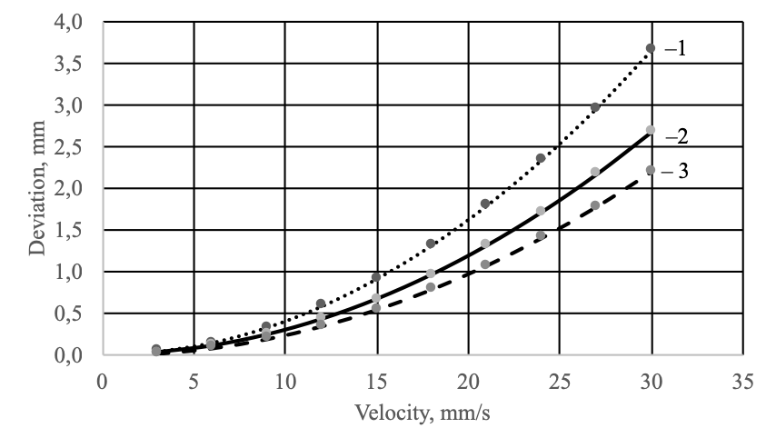
Fig. 7. Graphs of needle deviation as a function of speed at various material densities, 1 - at a material density of 1500 kg / m3, 2 - at a material density of 1100 kg / m3, 3 - at a material density of 900 kg / m3.
Table 5.
Time step for simulation
№ | Translational velocity, mm/s | Time step, sec
1 | 3 | 3,33·10⁻⁶
2 | 9 | 1,11·10⁻⁶
3 | 15 | 6,67·10⁻⁷
4 | 21 | 4,77·10⁻⁷
5 | 24 | 4,17·10⁻⁷
6 | 27 | 3,71·10⁻⁷
7 | 30 | 3,34·10⁻⁷

Experimental result
On fig. 8 you can see the test setup for the experiment.

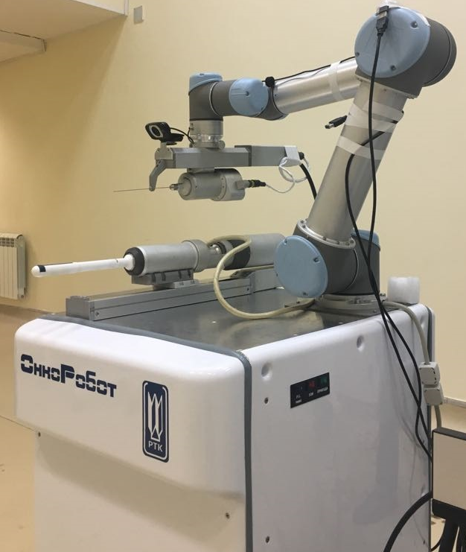
Fig. 8. The layout of the robotic system "OnkoRobot"
On fig. 9, 10 you can see an example of a used needle for conducting experiments and soft tissue phantom, in the body of which punctures are made. The needle has angle of 45 degrees. Phantom density fabrics ≈ 1500 kg / m3.

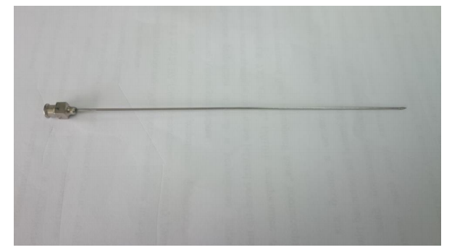
Fig. 9. Medical injection needle.
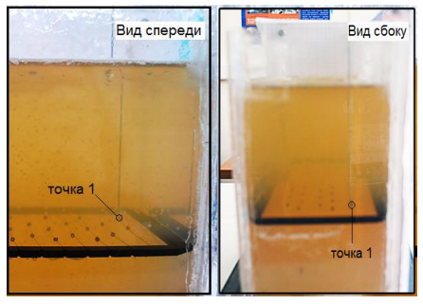
Fig. 10. Soft tissue phantom and needle.
The needle was moved vertically in the speed range from 3 to 30 mm / s with the help of a robotic arm. A motorized microscope was used to verify the position of the needle tip with a grid.
The grid in the form of a rectangle located at a depth of 100 mm includes 100 points with a step of 10 mm.
Table 6 presents the results of the experiment.
Table 6.
Experiment data.
№ | Translational velocity, mm/s | Needle tip deviation, mm
1 | 3 | 0,1
2 | 6 | 0,16
3 | 9 | 0,24
4 | 12 | 0,39
5 | 15 | 0,62
6 | 18 | 0,93
7 | 21 | 1,44
8 | 24 | 2,2
9 | 27 | 3,3
10 | 30 | 4,94

Analysis of simulation results
In the table 7 shows the experimental data and results of simulation for a needle with a tip angle of 45 degrees and a density of soft tissue phantom of 1500 kg / m3.

Table 7.
Simulation result and experiment data.
Translational velocity, mm/s | Needle tip deviation, mm
Translational velocity, mm/s | Experimental | Result of simulation
3 | 0,1 | 0,037
6 | 0,16 | 0,146
9 | 0,24 | 0,329
12 | 0,39 | 0,585
15 | 0,62 | 0,915
18 | 0,93 | 1,317
21 | 1,44 | 1,793
24 | 2,2 | 2,342
27 | 3,3 | 2,964
30 | 4,94 | 3,659

On fig.11 you can see the experimental and calculated graphs of the depended deviation from velocity. It can be seen from the figure that these dependences do not differ much from each other. From which we can conclude that this approach is applicable to determine the deviation of needle while it moving in human tissue.
The inaccuracy of the simulation can be explained by a large number of assumptions that will be considered in the next iterations of the model development.
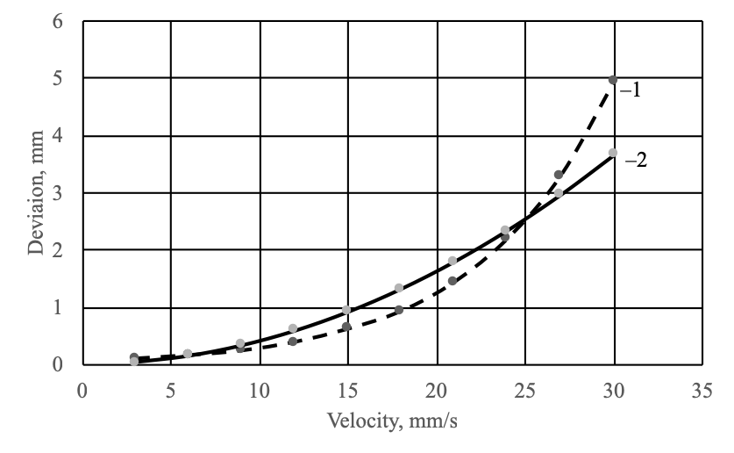
Fig 11. Graphs of the dependence of the needle tip deviation on speed, 1 - experimental results, 2 - simulation results.
From the graph in fig. 11, we can conclude that the experimental dependence of the needle deflection has a greater non-linearity than the calculated one.
To further describe the behavior of the medium and consider these nonlinearities as the needle moves, it will be possible to use the Chaplygin-Blasius formulas. This approach will allow us to more accurately consider the influence of the needle shape when interacting with the external environment. A more correct formulation of the force created by the medium will increase the accuracy over the entire speed range.

Conclusions
In this paper, an analysis was made of existing methods for describing needle deflection when it moves in human tissues.
Decomposition of the process of developing a complete model describing the needle deflection during its interaction with the given medium was carried out; the stages of model development were determined.
A model describing needle deflection in real time has been developed. To build the model, a new approach was used. Its essence was that the external force acting on the needle was represented as a force of drag. This approach was taken from hydraulic aero mechanics, which made it possible to simplify the model quite strongly. This simplified model can be easily integrated into control systems.

Funding source
The study was carried out with financial support of the of the Ministry of Science and Higher Education of the Russian Federation as part of the implementation of the state task
№ 12.4161.2017 / 4.6

References
- N.A. Gryaznov, G.S. Kireeva, V.V. Kharlamov, K.Yu. Senchik, D.V. Novitsky, S.A. Nikitin. Controlling a brachytherapy robot based on ultrasound sensor information // Robotics and technical cybernetics. 1 (10). 2016. C 67-71.
- N.A. Gryaznov, G.S. Kireeva, V.V. Kharlamov, K.Yu. Senchik, D.V. Novitsky, S.A. Nikitin. Prospects for using the original robotic system for brachytherapy for prostate cancer // Herald of Surgery. I.I. Grekov. Vol. 176, Issue 1. 2017. C 107-111.
- Seong Y.K., Luca F., Ferdinando R. Closed-Loop Planar Motion Control of a Steerable Probe with a “Programmable bevel” Inspired by Nature // Department of Mechanical Engineering, Imperial College London., UK. 2010. 970-983 pp.
- Jienan D. et al. Medical needle steering for lung biopsy: experimental results in tissue phantoms using a robotic needle driver // Imaging Science and Information Systems (ISIS), Department of Radiology, Goergetown University Medical Center, USA. Washington, DC. 2008. № 77628.
- Kemal F. Advanced Path Planning for a Neurosurgical Flexible Catheter // Delft University of Technology. 2012, 14–18 pp.
- Abayazid M. et al. Integrating Deflection Models and Image Feedback for Real-Time Flexible Needle Steering // IEEE Transactions on Robotics. – 2013. – Vol. 29. – P. 542– 553.
- Webster R. J., Kim,N. J. S., Cowan J., Chirikjian G. S., Okamura A. M., “Nonholonomic modeling of needle steering,” Int. J. Robot. Res., vol. 25, no. 5/6, 2006, pp. 509–525.
- V.A. Ikrin Resistance of materials with elements of the theory of elasticity and plasticity. Publishing house DIA 2004. P 159-165.
- Belyaev N.M. Resistance materials / 15th ed. Recycling - Moscow: Science 1976 - 607 p.
- A.E. Idelchik, Handbook of Hydraulic Resistances, Ed. M.O. Steinberg - 3rd ed., Publishing house Mashinostroenie 1992, С469 - 500.

