УДК 51-72, 51-74, 519.688 

THREE-DIMENSIONAL MODEL FOR DESCRIBING THE DEFLECTIONS OF AN ASYMMETRIC NEEDLE WHEN MOVING IN SOFT TISSUE
V.G. Druzhinin¹ ², V.A. Morozov¹, S.A. Nikitin², V.V. Harlamov²
¹ Department of Physical Mechanics, St. Petersburg State University, Russia, 199034, St. Petersburg, Universitetskaya Embankment Building 7-9, e-mail: vasily.dr.mob@gmail.com, v.morozov@spbu.ru
² Russian State Scientific Center for Robotics and Technical Cybernetics (RTC), Russia, 194064, St. Petersburg, Tikhoretskiy Avenue 21, e-mail: vasily.dr.mob@gmail.com, s.nikitin@rtc.ru
Abstract. In the modern world, more and more operations are performed by robots. Currently, their accuracy allows them to be used not only in industry, but also in the medical field for high-precision operations. This paper discusses a robotic system for brachytherapy. Currently, there is a prototype of this system and work is underway on its improvement. The complexity of this operation lies in leading the needle tip to the target point (tumor). To improve the accuracy, it is supposed to use the model as one of the means of determining the position of the needle tip. This system will describe the deviation of the needle when moving in human tissues. The article will present the main expressions for which the calculation is made. The simulation was performed at different initial parameters, namely, the translational velocity, the rotational velocity, the density, the angle of the needle point. The results of calculations are compared with the experimental data. Found a way to refine the models in the next steps of development and carried out the first iteration of the simulation with this method. The software environment and modeling methods are described. The principle of using the developed model for parametric calculations, generating third-party libraries, and using the model for virtual tests is described.
Key words: brachytherapy, robotic system, medical needle.

Введение
Today robots often replace human manual labor. Robots can already perform both monotonous production activities and replace a human in more complex operations. For example, the performance of medical operations, both minimally invasive and more complex, can be referred.
This article discusses the performance of prostate cancer brachytherapy operations. Today the Russian state scientific center for robotics and technical cybernetics has developed a model of the robotic system «OncoROBOT» for carrying out such operations [1, 2].
This procedure is carried out by introducing micro-sources of radio emission into the prostate gland as close as possible to the tumor. The main difficulty is bringing the needle tip to the target point (tumor) during the operation.
The advantages of using robots in comparison with traditional methods are that a robotic manipulator is able to provide a higher accuracy of positioning the tool than a human, as well as is able to control the force effect. It makes it possible to count not only on improving the quality of currently carried out operations, but also on creating a basis for development of fundamentally new surgical technologies.
Another important advantage of using robots is the absence of direct contact of the doctor with radioactive sources, which will make it possible to protect medical personnel from concomitant irradiation.
Due to its geometric features and applied loads during the operation, the needle is deformed. It leads to deviation of the needle from the rectilinear movement.
In the study [3] presents an analysis of development stages of this model, provides an analysis of existing methods and approaches, presents a two-dimensional model describing the deviation of the needle when moving in human tissues.
In this work the task of positioning the needle in Cartesian coordinate system Oxyz will be solved, as well as ways to improve the accuracy of the model will be considered.
The movement of the needle is controlled by its rotation around its axis. In this case, the needle tip rotates together with the plane of bending of the needle arc, and as a result the direction of further tip movement changes. When the needle is inserted along a straight path, it must be constantly rotated.
The developed model can be used to synthesize “MPC-controllers” – systems based on predictive models (Model predictive control). For example, the article [4] shows the development of such system, but the approach for designing the model was other. In [4] the authors used the Lagrange equation to determine position of the needle tip. Also conditions of the experiment and the needle were significantly different from those considered in this article.

Model

Two-dimensional model
In this work, a steel medical injection needle 100 mm long, 1 mm in diameter with different tip angles of 30, 45, 60 degrees is considered as a simulated object (Fig. 1).
Earlier, in [3], a two-dimensional model was analyzed in detail. The main content of the model is considered below. The needle will be considered as a beam with a pinched end at the puncture site, on the other end (tip) of which the reaction force of the medium acts, represented by the force of frontal resistance

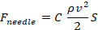 (1)
where
C is resistance coefficient;
ρ is density;
v is needle speed;
S is characteristic body area, S = V^{2/3}, V is body volume [5].

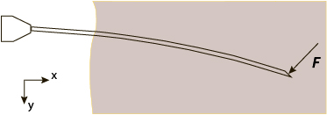
Fig. 1: Shape of used needle, F – reaction force of medium
To calculate the deviation of the needle, the following expressions are used [5]
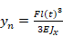, (2)
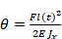, (3)
where
n is current simulation iteration;
y_{n} is deviation of the needle tip at the current simulation step;
F is force acting on the tip of the needle when it moves;
J_{x} is axial moment of inertia;
l(t) is length of part of the needle in human tissue;
t is time;
E is Young's modulus;
θ is deviation angle.
When calculating the deviation in expressions (2) and (3), only the projection of the force F_{needle} onto the Оу axis is taken into account.
According to the presented expressions (1), (2), (3) the deviation is calculated iteratively, adding up with its values of the previous simulation steps. Thus, the deviation is preserved at each step of the simulation:
, (4)
where
y_{all} is total deviation of the needle tip when it moves in human tissues;
y_{n} is deviation of the needle tip at the current simulation step.

Three-dimensional model
For a three-dimensional model, the coordinate system shown in Figure 2 is used. In this case, the angle of rotation is value by which the needle cut plane will rotate.
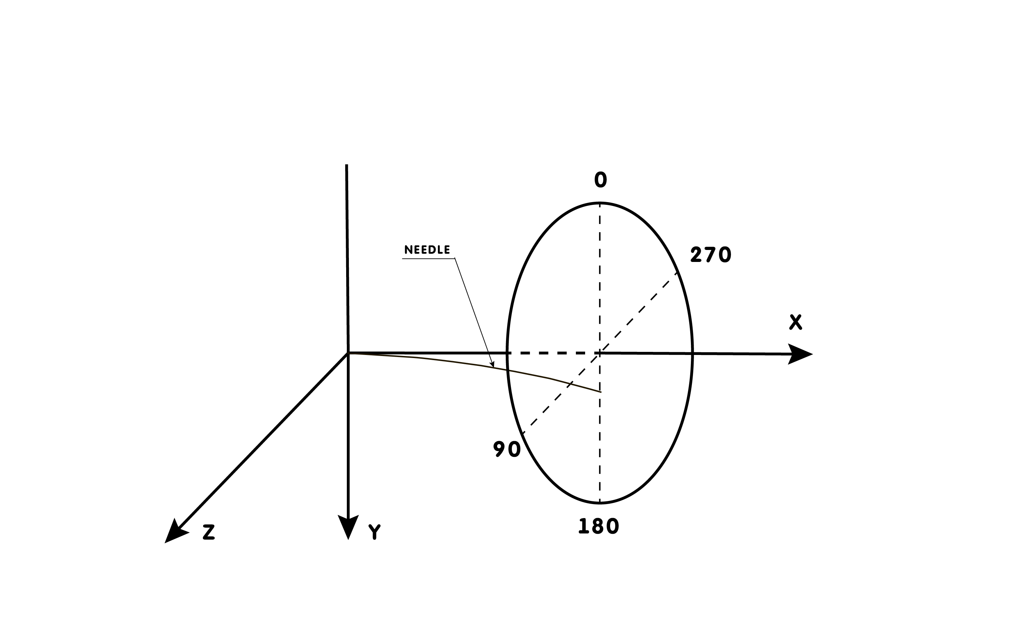
Fig. 2. The considered coordinate system
To calculate the coordinates of position of the needle tip, the following expressions are used:
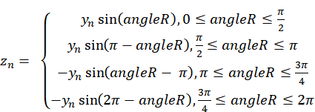, (5)
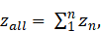 (6)
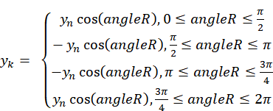, (7)
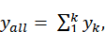 (8)

where
angleR is angle of rotation of the needle during the simulation;
z_{all} is deviation component along the Oz axis;
To calculate the deviation from the Ox axis, the following expression are used:
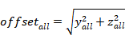, (9)
where
offset_{all} is total deviation of the needle tip from the Ox axis.
Thus, at each simulation step the angle of needle rotation will be analyzed. Further the deviation at this step will be calculated and converted into coordinates of Cartesian coordinate system. And from these values of coordinates y and z, the total deviation from the Ox axis is calculated.
Further the simulation results and comparison the deviation of the needle tip with experimental data will be considered.

Calculation of resistance coefficients
The solved task is multiparameter and depends on several variables, namely on the translational and rotational speeds of the needle movement in tissues. It is necessary to find such solution so that the difference between the experimental and calculated data is minimal.
Expression (1) is used to simulation the external environment. In the previous work [3] in process of simulation the coefficient C was used as the most suitable for the conditions of processes occurring in this system. Value C see in handbook [7]. As a result, there are large deviations between the simulation and experiment data. In this work the coefficient C is selected based on experimental data.
Taking into account the operation algorithm of the model, it is possible to accurately select the coefficients. Using (1), (2), (3), (4) the following expression will be obtained:
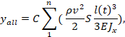 (10)
from which the coefficient C will be expressed:
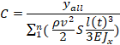, (11)
where y_{all} was obtained from the experiment at fixed values of linear speed of the needle movement (3, 6, 9, 12, 15, 18, 21, 24, 27, 30 mm/s) and values of its rotation speed (0, 3, 4, 5 rad/s).
Calculation of the coefficients according to expression (11) was carried out with following parameters of the object and environment: the density ρ of the material is 1000 kg/m³ and a needle cut angle is 30 degrees.
The calculation results of the coefficients C by expression (11) are summarized in Table 1.

Table 1.
Results of calculating the coefficients C.
Linear speed,  mm/s | Coefficients C
Linear speed,  mm/s | 0 rad/s | 3 rad/s | 4 rad/s | 5 rad/s
3 | 2,665844 | 97,13341 | 114,2592 | 247,5463
6 | 1,066686 | 15,73135 | 19,05791 | 38,10639
9 | 0,711157 | 6,365846 | 7,064885 | 13,06272
12 | 0,650224 | 3,230796 | 3,700964 | 6,11262
15 | 0,661623 | 1,84293 | 2,204077 | 3,438567
18 | 0,689513 | 1,204555 | 1,455902 | 2,214431
21 | 0,784529 | 0,795032 | 0,941747 | 1,480804
24 | 0,917968 | 0,559047 | 0,662774 | 1,068637
27 | 1,088267 | 0,403247 | 0,498426 | 0,792121
30 | 1,318834 | 0,312718 | 0,380221 | 0,626484

The calculated coefficients will provide the required accuracy for calculating the needle deviation.

Software
The proposed model was developed in the MATLAB/Simulink environment. During the development process all advantages of this software were used. As can be seen from Figure 3, the system has a distributed architecture, namely calculation of the deviation is performed in various functions. It allows them to be modified independently of each other.
Also this environment allows to use the developed model for several solutions at once. From this system it’s possible to generate a library for C# or C++ or generate directly executable code that can be loaded onto the board. The proposed function can be used in Simulink models to conduct virtual tests of the system as a whole.
A system was also developed to automate the process of parametric calculations. The vectors of translational and rotational speeds are input signals of this system. This system is decomposed (flexible) enough that it allows to quickly adapt the output parameters for testing models, as well as to compare experimental and calculated data in an automatic mode.

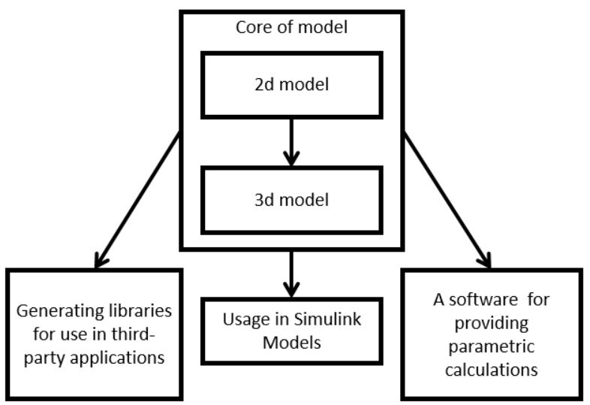
Fig. 3. Program architecture

Simulation
At this stage of the work, simulation was carried out using a three-dimensional model for various parameters.
Table 2 shows data used for calculations.
Table 2.
Parameters for calculations.
Parameter name | Value
d_{outer} – outer diameter of the needle, m | 0,001
d_{inner} – inner diameter of the needle, m | 0,0008
E – Young's modulus, N/m² | 2.0∙10¹¹
ρ – density, kg/m³ | 1000
l – maximum needle length, m | 0,1

Table 3 shows the simulation results. In the process of simulation, the values of coefficients C from Table 1 were used for the corresponding translational and rotational speeds of the needle movement.
Table 3.
Simulation results.
Linear speed,  mm/s | Deviation of the needle tip, mm
Linear speed,  mm/s | 0 rad/s | 3 rad/s | 4 rad/s | 5 rad/s
3 | 0,1 | 0,17 | 0,15 | 0,26
6 | 0,16 | 0,22 | 0,2 | 0,32
9 | 0,24 | 0,3 | 0,25 | 0,37
12 | 0,39 | 0,36 | 0,31 | 0,41
15 | 0,62 | 0,4 | 0,36 | 0,45
18 | 0,93 | 0,45 | 0,41 | 0,5
21 | 1,44 | 0,47 | 0,42 | 0,53
24 | 2,2 | 0,49 | 0,44 | 0,57
27 | 3,3 | 0,5 | 0,47 | 0,6
30 | 4,94 | 0,53 | 0,49 | 0,65

Following graphs, built according to the data in Table 3, show the dependence of deviation value of the needle tip from rectilinear movement.
Figure 4 shows a graph of the dependence of deviation of the needle from rectilinear movement only on the speed of translational movement.
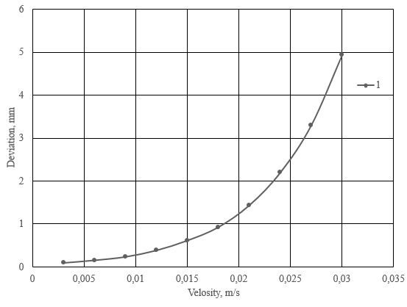
Fig. 4. Graph of the needle deviation depending on translational speed
Figure 5 shows the dependence of deviation of the needle on the speed of translational movement at rotational speed of 3, 4, 5 rad/s.
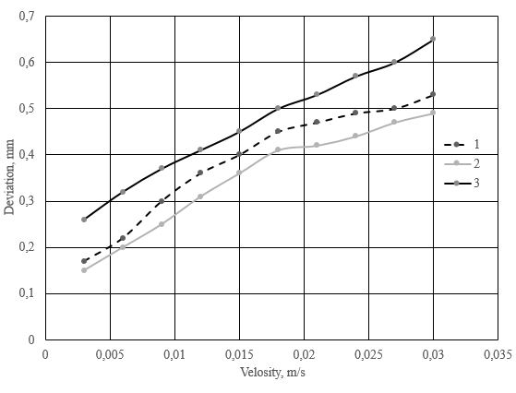
Fig. 5. Graphs of the needle deviation depending on translational speed at rotational speed 1) 3 rad/s, 2) 4 rad/s, 3) 5 rad/s

Заключение
This article presented the development of a three-dimensional model describing the deviation the medical injection needle from the rectilinear motion when it moves in human tissues. The method of selection of resistance coefficients C for simulation at various parameters of object and environment is shown. The method made it possible to minimize the difference between the simulation results and experimental data. This becomes obvious when comparing the results of calculating the deviation of the needle in this work and in [3], where the drag coefficient was a constant value.
As can be seen from the above tables and graphs, the rotation of the needle at different speeds can significantly reduce deviation of the needle from rectilinear motion. It was shown, that at an angular speed of 4 rad/s, linear injection speed from 3 to 30 mm/s and needle injection depth of 100 mm, its deviation value is in the range from 0.15 mm to 0.49 mm.
A system for quick and automated calculation of coefficients has been developed. Also the program was created to simplify and optimize the development of the model and its validation and application in other stages of research and development of a robotic system.

Sources of Funding
The study was carried out with the financial support of the Ministry of Science and Higher Education of the Russian Federation, project 12.4161.2017/ПЧ.

Список литературы
- N.A. Gryaznov, G.S. Kireeva, V.V. Kharlamov, K.Yu. Senchik, D.V. Novitsky, S.A. Nikitin. Controlling a brachytherapy robot based on ultrasound sensor information // Robotics and technical cybernetics. 1 (10). 2016. pp. 67-71.
- N.A. Gryaznov, G.S. Kireeva, V.V. Kharlamov, K.Yu. Senchik, D.V. Novitsky, S.A. Nikitin. Prospects for using the original robotic system for brachytherapy for prostate cancer // Herald of Surgery. I.I. Grekov. Vol. 176, Issue 1. 2017. pp. 107-111.
- V.G. Druzhinin, V.A. Morozov, S.A. Nikitin, V.V. Harlamov. Model of the deviation of the medical needle during the movement in human tissue // Russian Journal of Biomechanics Issue 4 2018 pp. 459-472.
- Ivan M. Buzurovic, Slavisa Salinic, Peter F. Orio1, Paul L. Nguyen. A novel approach to an automated needle insertion in brachytherapy procedures // International Federation for Medical and Biological Engineering 2017, 56:273–287.
- Belyaev N.M. Resistance materials / 15th ed. Recycling - Moscow: Science pp. 1976 – 607.
- A.V. Kobelev, L.T. Smolyuk, R.M. Kobeleva, Yu.L. Protsenko. Nonlinear viscoelastic properties of biological tissues // Russian Academy of Sciences Ural Branch Institute of Immunology and Physiology Institute of Physics of Metals, Yekaterinburg 2012, pp. 115 - 138.
- A.E. Idelchik, Handbook of Hydraulic Resistances, Ed. M.O. Steinberg - 3rd ed., Publishing house Mashinostroenie 1992, pp. 469 - 500.
THREE-DIMENSIONAL MODEL DESCRIBING THE DEVIATIONS OF THE ASYMMETRIC NEEDLE DURING MOVEMENT IN SOFT TISSUES
V.A. Morozov, V.G. Druzhinin, S. A. Nikitin, V.V. Harlamov (Saint Petersburg, Russia)
In the modern world, more and more operations are performed by robots. Currently, their accuracy allows them to be used not only in industry, but also in the medical field for high-precision operations. This paper discusses a robotic system for brachytherapy. Currently, there is a prototype of this system and work is underway on its improvement. The complexity of this operation lies in leading the needle tip to the target point (tumor). To improve the accuracy, it is supposed to use the model as one of the means of determining the position of the needle tip. This system will describe the deviation of the needle when moving in human tissues. The article will present the main expressions for which the calculation is made. The simulation was performed at different initial parameters, namely, the translational velocity, the rotational velocity, the density, the angle of the needle point. The results of calculations are compared with the experimental data. Found a way to refine the models in the next steps of development and carried out the first iteration of the simulation with this method. The software environment and modeling methods are described. The principle of using the developed model for parametric calculations, generating third-party libraries, and using the model for virtual tests is described.
Key words: brachytherapy, robotic system, medical needle.

