Report - Health Insurance personal attributes and incurred medical insurance costs
Group 4: Julie Huynh, Haleh Farzaneh, Ilana Berger Fridman, Iga Meddie, Giridhar Kodakalla Venkata, Gokhan Istanbullugil

Introduction
As medical services, medications and other healthcare-related costs are rising, the ability to predict incurred costs by personal attributes of the policyholders is of value for both the insured individual and for the insurance company, committed to cover costs according to the coverage and terms of the policy. For example, development of predictive models for healthcare costs incurred by insurance holders can serve as valuable tools in calculating insurance premiums, to cover for future claims. Here, we chose to analyze a healthcare insurance dataset to determine what policyholders’ variables correlate with medical insurance costs and build predictive regression models for healthcare charges.
The Dataset:
The dataset used in this report was retrieved from an open database found on Kaggle^{[1]}. This is a synthetic dataset in a CSV format, and is based on US census data. The dataset is composed of 1,338 rows of insurance holders’ data, containing seven variables, as described in Table 1.
Table 1. Variable types and input
Variable | Description | Variable Type | Variable Values, min - max
Age | Insurance holder age | Continuous, int64 | 18 – 64 (years old)
Sex | Gender | object | male / female
BMI | Body Mass Index, a measure of body fat based on height and weight | Continuous, float64 | 15.96 – 53.13 (kg/m²)
Children | The number of dependents covered | int64 | 0 / 1 / 2 / 3 / 4 / 5
Smoker | Whether the insured is a smoker (yes / no) | object | yes / no
Region | The geographic area of coverage | object | southeast, southwest, northwest, northeast
Charges | The medical insurance costs incurred by the insured person | Continuous, float64 | 1121.87 - 63770.42 (USD)

Personal attributes, such as age, sex, BMI, children, smoker, and region were assigned as input variables. Charges, which describes the insurance costs incurred by the insurance holder, was chosen as our response variable.

Objectives
- Preparation of the dataset for analysis - Cleaning the dataset and removing duplicates and outliers, and dealing with missing values. The goal in this step is to prepare the dataset for analysis so that there are no internal biases that can affect our model, such as using duplicate or missing data.
- Analysis – How are variables distributed, how independent variables are correlated, with the dependent variable and other independent variables.
- Applying regression models to build a predictive model for insurance costs.

Hypothesis
Our hypothesis is that personal attributes associated with health issues, such as High BMI, smoking, and age, will positively and significantly correlate with insurance costs. We hypothesize that smoking, BMI and age have the most significant impact on the model's performance. Our hypothesis is that sex, region and number of dependents have low to zero correlation with insurance costs.

Methodology
Complete list of libraries used is shown in the code. For data cleaning, plotting and regression analysis we imported pandas, numpy, matplotlib, seaborn, scipy, sklearn, and statsmodels. Specific functions of high importance that were used are specified and described in the Analysis section. The data was analyzed and fitted using Ordinary Least Squares (OLS) and decision tree linear regression models.

5. Analysis

5.1. Dataset Preparation
The dataset contains 1,338 rows of insurance holders’ data, defined by seven variables, six of which are personal attributes: Age, Sex, BMI, Children, Smoker, and Region, and one response variable, which is the Charges, describing the insurance costs incurred by the insurance holder, as exemplified in Table 2.
Table 2. Dataset head.
df.head()
 | age | sex | bmi | children | smoker | region | charges
0 | 19 | female | 27.900 | 0 | yes | southwest | 16884.92400
1 | 18 | male | 33.770 | 1 | no | southeast | 1725.55230
2 | 28 | male | 33.000 | 3 | no | southeast | 4449.46200
3 | 33 | male | 22.705 | 0 | no | northwest | 21984.47061
4 | 32 | male | 28.880 | 0 | no | northwest | 3866.85520

The dataset required very little cleaning. There were no null values and there was one duplicate entry removed using the drop_duplicates() function (Table 3), resulting in 1,337 remaining rows.
Table 3. Dataset main features.
Number of Duplicate Entries: | 1
Number of Missing Values: | 0
Number of Features: | 7
Number of Observations: | 1338

5.2. Preliminary Analysis using Descriptive Statistics

5.2.1. Variable types and variable visualization
The dataset includes object variables, such as sex, region, smoker, and children, and continuous variables: age, BMI, and charges, as described in Table 1. Table 4 summarizes a few key descriptive statistics for the numerical variables.
Table 4. Descriptive statistics.
 | Age | BMI (kg/m²) | Children | Charges (USD)
count | 1337.000000 | 1337.000000 | 1337.000000 | 1337.000000
mean | 39.222139 | 30.663452 | 1.095737 | 13279.121487
std | 14.044333 | 6.100468 | 1.205571 | 12110.359656
min | 18.000000 | 15.960000 | 0.000000 | 1121.873900
25% | 27.000000 | 26.290000 | 0.000000 | 4746.344000
50% | 39.000000 | 30.400000 | 1.000000 | 9386.161300
75% | 51.000000 | 34.700000 | 2.000000 | 16657.717450
max | 64.000000 | 53.130000 | 5.000000 | 63770.428010

- The mean age of policyholders is 39.2, and the SD is 14.04, indicating age variability, with 50% of insured at the age of 39. People of under 51 years old make 75% of the dataset.
- Mean BMI is 30.6, which is considered obese (generally defined as BMI ≥ 30), and SD is 6.1. Overall, 75% of the BMI values are below 34.70.
- Mean number of children per policyholder is 1.09, and the median is 1. 75% of the insurance holders have 2 children or less. SD equals 1.21, pointing to low variation in this variable.
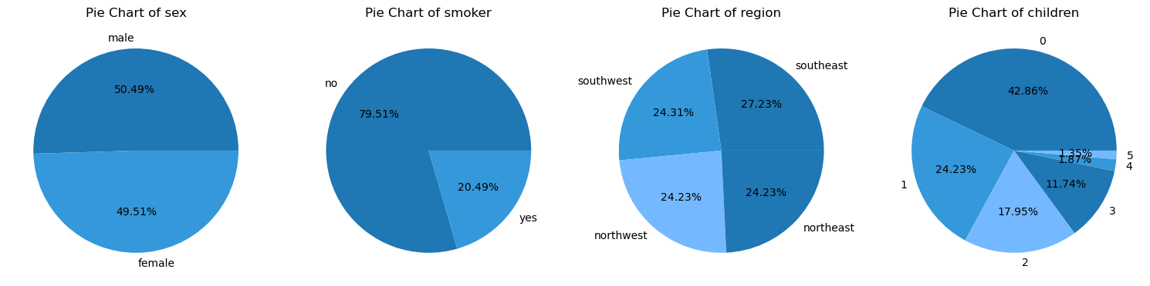

- Mean charge is 13,279 USD. SD of 12,110.36 USD indicates high variability in charges, with min charge of 1,121 USD, max charge 63,770 USD, and 50% of charges mounting to 9386.16 USD.
(a)
(b)
(c)
(d)
Fig. 1. Dataset distribution by sex, smoker, region, and children. Pie plot for percentile distribution by sex(a), smoker (b), region (c), and children (d).
A pie chart was plotted to visualize object type variables (Fig. 1) to view percentile distribution. Representation of policyholders by sex was found to be representative of general distribution in the US population (Fig. 1, a). According to 2022 Census data^{[2]}, women comprise 50.4% of the US population, where in our dataset female insurance holders comprise 50.49% of the dataset. Smokers, however, comprise 20.49% of the set (Fig. 1, b), which is much higher compared to the general percentage of smokers in US, which were estimated to comprise 11.5% of US adults in 2021^{[3]}.
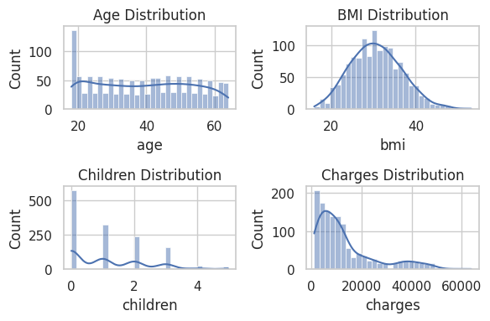
Region distribution was roughly equal (Fig. 1, c), with each comprising roughly a quarter of the dataset. Most of the insurance holders are without dependent children (42.86%), 24.23% are with one child, 17.95% with two, and <15% are with three to five kids (Fig. 1, d). Looking at numeric variables distribution, age, BMI, charges and children, using histogram plotting, shows different distribution patterns (Fig. 2). Age seemed to be evenly distributed (Fig. 2, a), similar to overall population US age distribution^{[4]}. BMI showed fairly normal distribution (Fig. 2, b). Children distribution showed discrete skewed distribution towards 0 - 1 children, as shown previously (Fig. 2, c). Charges were predominantly skewed towards the lower charges (Fig. 2, d), though the long tail is indicative of a smaller portion of insurance holders incurring relatively high insurance costs.
(a)
(c)
(b)
(d)
Fig. 2. Numerical variables distribution. Histogram distribution for age (a), BMI (b), children (c), and charges (d). Plotted using the seaborn data visualization library, using sns.histplot (), bins=30.
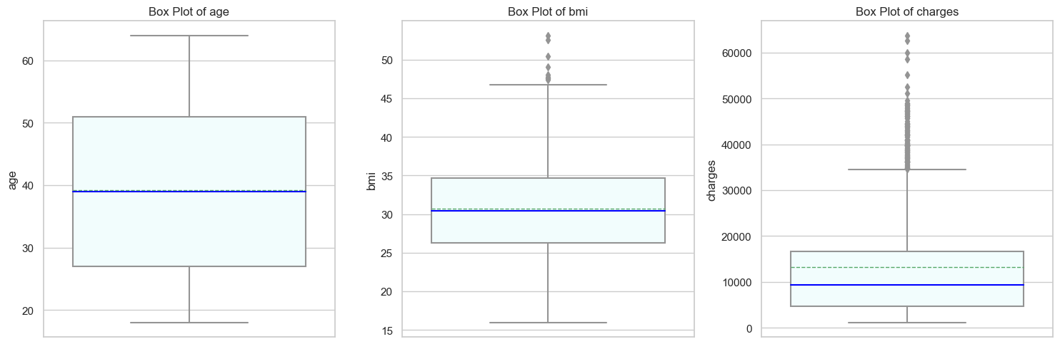
Plotting age, BMI and charge using a box plot (Fig. 3) showed relatively symmetric distribution for age and BMI (Fig. 3, a-b), with overlapping mean and median, where charges showed a varied distribution, with many outliers outside the upper whisker (Fig. 3, c), in accordance with the upper long tail shown in Fig. 2(d).
Box plot for age (a), BMI, and charges (c). Box plot is depicted as the 5-95 percentile, where the whiskers show the data range within this percentile, the bar denotes the values in the 25th to the 75th percentile, the horizontal solid blue line denoting the median and the dashed green denoting mean. The dots bellow and above the whiskers denote the min and max values in the dataset.
(a)
(b)
(c)
Fig. 3. Age, BMI and charges distribution

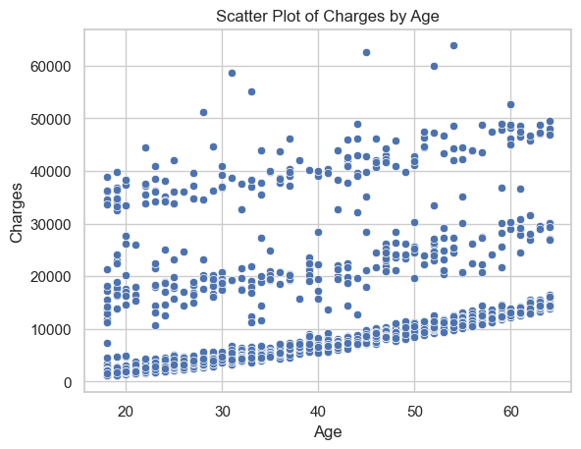
5.2.2. Charges as a function of a single variable.
Fig. 4. Charges distribution by age. Scatter plot generated using sns.scatterplot()
Figure 4. Charges distribution by age.

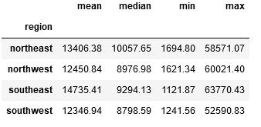
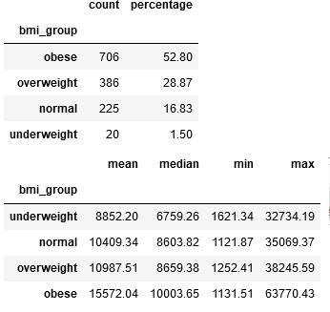

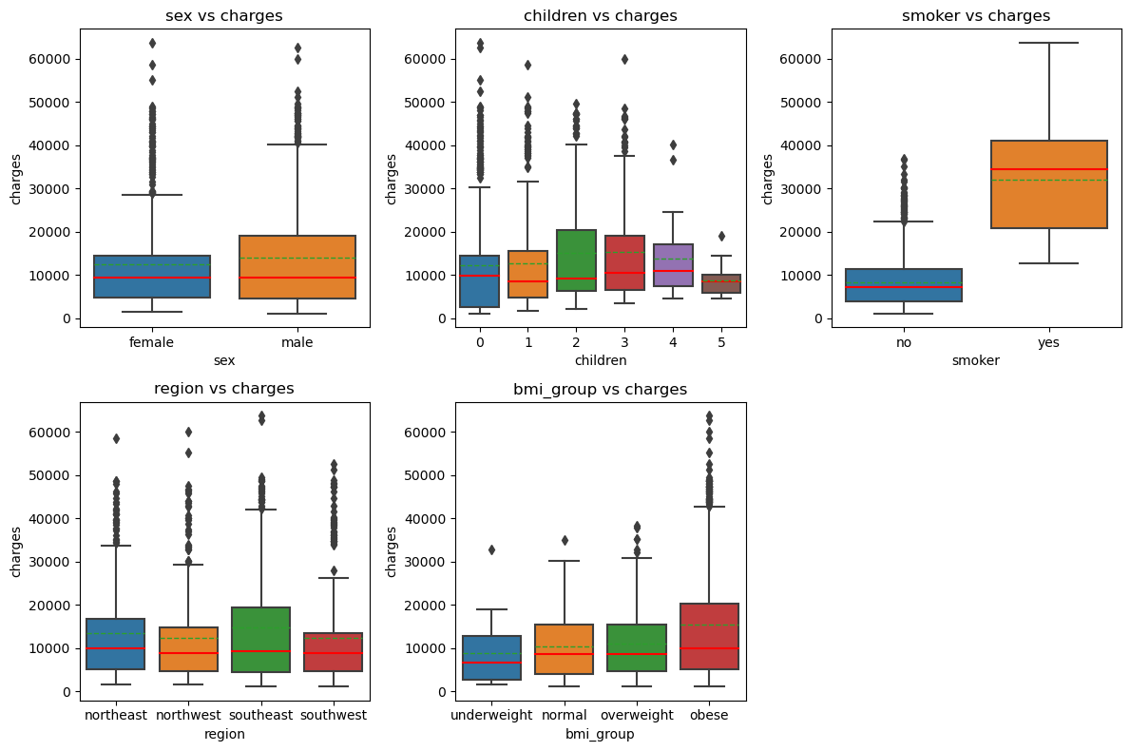
Next, we looked at the distribution of charges by independent variables. Plotting Charges versus Age (Fig. 4) clearly shows a positive trend between age and charges, with older insurance holders incurring higher insurance costs. However, the scatter plot is also indicative of some variability in charges for insurance holders of the same age, pointing to additional attributes at play in medical costs. Median charges incurred by male and female policyholders were similar, though charges by male policyholders showed wider distribution (Fig. 5, a). Variability was observed for insurance holders with a different number of children, though similar medians (Fig. 5, b). A significant difference in charges was observed for non-smokers versus smokers, with considerably higher costs for smokers (Fig. 5, c). Median charge by region were similar for all regions (Fig. 5, d), though a wider spread in charges was observed for southeast insurance holders. This may be explained by the relatively larger percentage of southeast insured individuals (27% vs. ~24% in other regions). The median charges in all regions were similar (Table 5). In order to visualize charge distribution by BMI, BMI values were grouped according to BMI definitions, creating an additional object variable, bmi_group, with individuals with BMI (expressed as kg/m²) under 18.5 categorized as “underweight”, BMI of 18.5-25 as “normal”, 25-30 as “overweight”, and individuals with BMI of 30 and above as “obese”. Charges by BMI group show higher charges for obese individuals (Fig. 5, e, and Table 6). Obese individuals compose > 50% of all insurance holders, with a median of 10,003 USD in charges. This is in contrast to overweight and normal weight individuals, with a median charge of ~8,600 USD. The underweight group was the smallest group, with 1.5% of all insured individuals, and with a median charge of 6,759 USD. Looking at the charge distribution, individuals with higher BMI incurred higher costs, with a large number of upper whisker outliers in the “obese” group (Fig. 5, e). Similarly to the distribution patterns observed in Fig. 2, box plotting of age, BMI, children and charges shows there are outliers in the
Table 5. Charges by regions.
Table 6. BMI statistics and charges.
Fig. 5. Charges by individual object variables.
Box plot of charges by sex(a), children (b), smoker (c), region (d), and BMI (e). Box plot is depicted as the 5-95 percentile, the whiskers show the data range within this percentile, the box denotes the values in the 25th to the 75th percentile, the horizontal solid red line denotes the median and the dashed green the mean. The dots bellow and above the whiskers denote min and max values.
(a)
(b)
(c)
(d)
(e)

charges and BMI variables (Fig. 6).
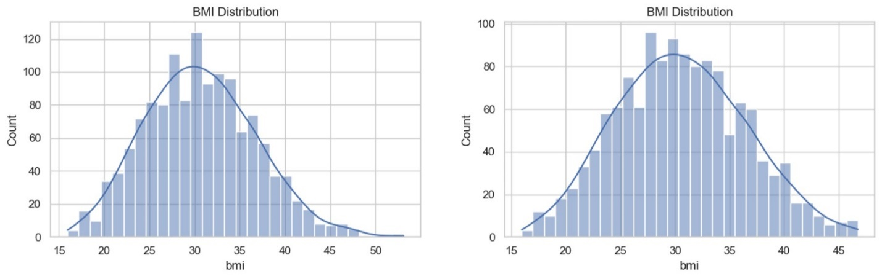
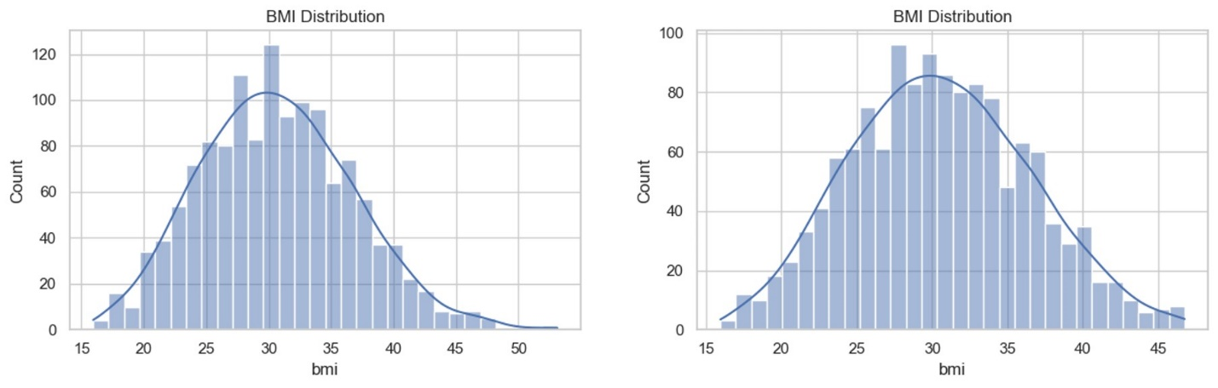
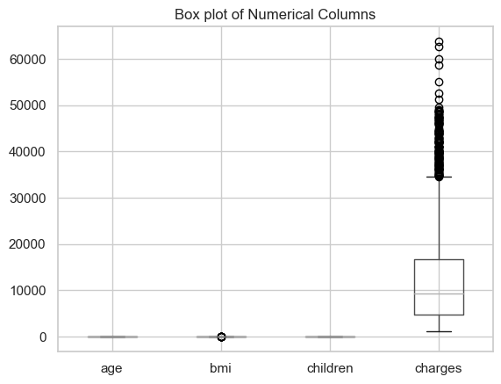
We opted to not remove upper whiskers outliers in the charges attribute, as these observations are thought to serve as important data points in predicting high insurance costs. We then followed by applying the Interquartile range (IQR) method for detecting and removing outliers in the BMI group. Using this method, nine BMI outliers were selected and removed from the dataset (all of BMI >= 47). Plotting BMI distribution after removing the outliers indeed showed a better normal distribution (Fig. 7).
Histogram plotting for BMI before (upper panel) and after (bottom panel) outlier removal. Plotted using sns.histplot(), bins=30.
Fig. 7. BMI distribution
Fig. 6. Age, BMI, children and charges distribution by box plotting.
Box plot plotted as previously described, with the horizontal solid line denoting the median.

5.2.3. Charges as a function of multiple variables and linear regression fitting.
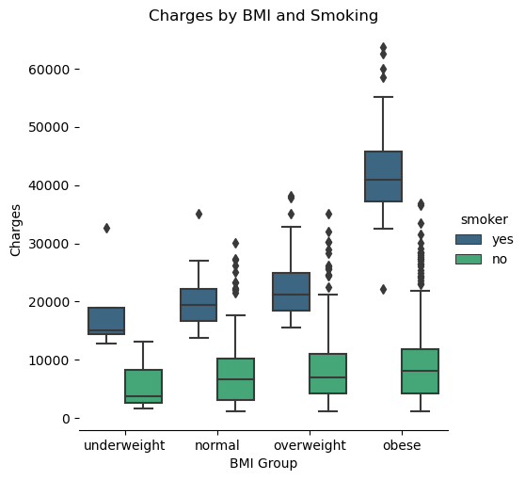
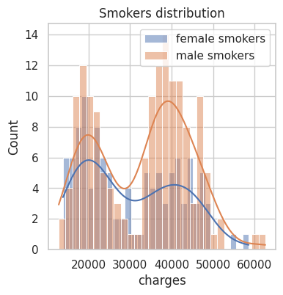
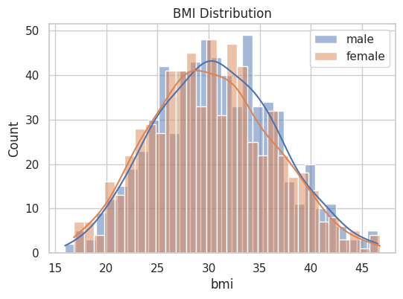
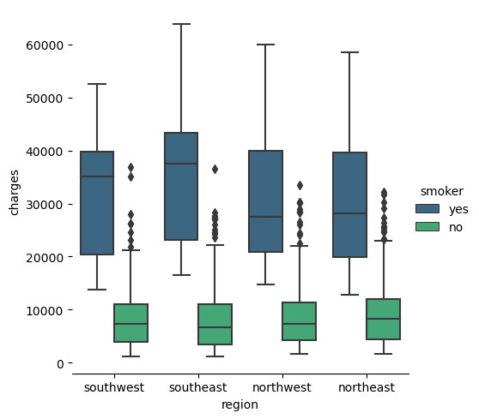
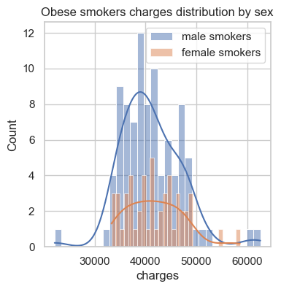
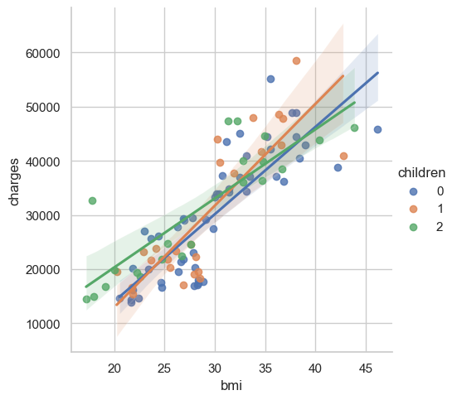
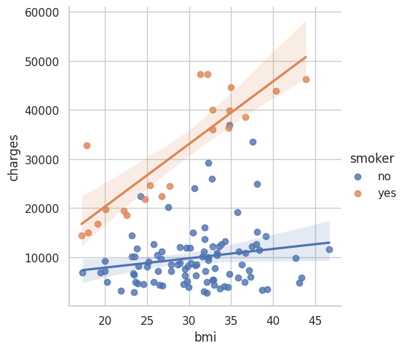
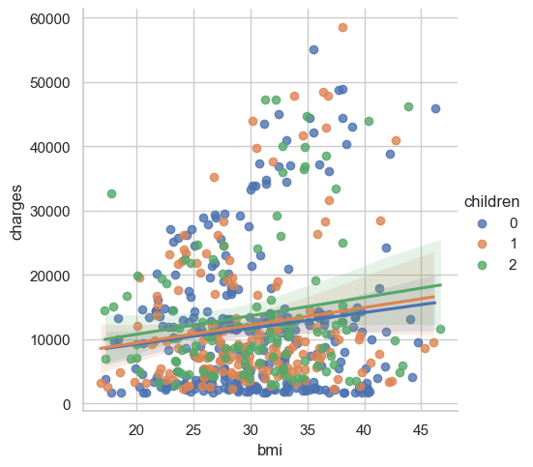
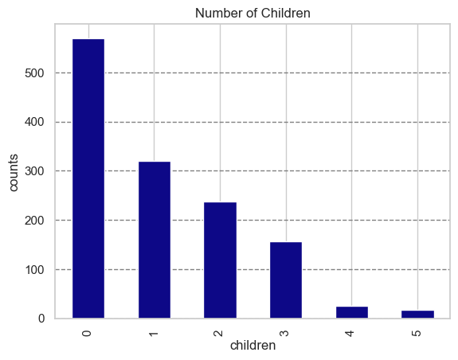
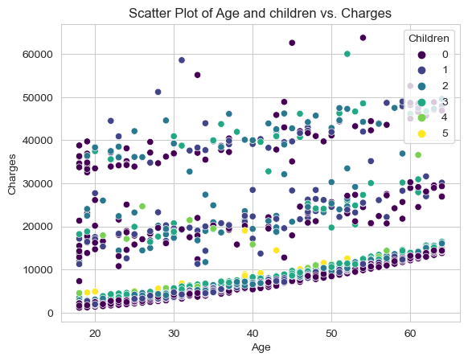
Next, we sought to find meaningful correlations between multiple variables and charges. First, as a clear correlation was shown between smoking and charges and between BMI and charges, we sought to see the combined effect of smoking and BMI on charges, and if they are related to sex. Though BMI distribution was similarly distributed between males and females (Fig. 8, a), there seems to be some difference in charge distribution (Fig. 8, b). Male smokers’ charges distribution exhibit positive, leptokurtic kurtosis, with a higher peak and fatter tails, meaning a high concentration of charges around the mean, whereas female charges distribution appears to be closer to a normal distribution, with less pronounced tails and a slightly lower peak, meaning higher variance in charges. Plotting charges by BMI groups and smoking, it was very clear that the highest charges were incurred by obese smokers (Fig. 8, c). Smoking resulted in higher insurance costs for all weight groups, where non-smoker median charges were of similar values, suggesting that the main attribute affecting charges is smoking over BMI. Looking closely at obese smokers’ charges by sex, it seems charges are similar for both obese female and obese male smokers (Fig. 8, d). Interestingly, southern smokers seemed to incur higher insurance charges compared to northern smokers (Fig. 8, e). Most insurance holders have zero to two child dependents (Fig. 9, a). Charges by number of children showed high variability, with many observations outside the upper whisker (Fig. 5, b), mainly for 0-2 children. Some of this may result from heterogeneous group of policyholders, for example policyholders with zero dependents that are either relatively young without children and older insurance holders without dependents. It may also be attributed to other factors that affect charges, other than number of children. Plotting charges distribution by age and number of children clearly showed that charges are mainly correlated to age rather than children, which were observed to be evenly distributed for all charges (Fig. 9, b). Looking more closely at BMI and children and how they correlate with charges, the distribution of charges by BMI for females with zero to two children, showed some positive correlation between charges and BMI, with higher costs for women with two children (Fig. 10). However, dispersion around the linear regression line was observed, pointing to other underlying variables that are correlated to charges. Looking at charges by smoking females’ BMI and zero to two children, resulted in much more tight linear regression fitting (Fig. 11). The fitting was observed to correlate with BMI, with similar patterns for all children values. Thus, charges seem to correlate with BMI and mainly smoking rather than number of dependents. Additional analysis of charges by females by BMI, children and smoking can be viewed in the code, In
Fig. 8. BMI, sex and smoking effect on charges
(a) Histogram plot for BMI distribution by sex (males, blue, and females, orange); (b) Histogram plot for charges distribution for female smokers (blue) and male smokers (orange); Histogram plots were plotted as previously described, with the horizontal lines denoting the density estimate line; (c) box plot for charges distribution by BMI group and smoking; (d) histogram plot for obese smokers’ charges by sex; (e) charge distribution by region and smoking. Box plot plotted as previously described, with the horizontal solid line denoting the median.
(a)
(c)
(b)
(d)
Fig. 11. Charges distribution by smoking female BMI with 0 – 2 children. Scatter plotting and linear regression fitting using sns.lmplot().
Fig. 12. Charges distribution by BMI and 0-2 children, for smoking and non-smoking females. Scatter plotting and linear regression fitting using sns.lmplot().
Fig. 10. Charges distribution by female BMI with 0 – 2 children. Scatter plotting and linear regression fitting using sns.lmplot().
Fig. 9. Children distribution and charges by age and children. (a) Bar plot for Children distribution; (b) Scatter plot for charges distribution by age and number of children. Scatter plot generated using sns.scatterplot().
(a)
(b)
cells [85] – [88]. Indication to the significance of smoking in incurred charges was observed in comparing charges distribution for females by BMI and 0-2 children, for smoking and non-smoking females (Fig. 12). Clearly, smoking females incurred higher costs, regardless of BMI and children (data not shown). Combined, there is low positive correlation between BMI and charges, as well as BMI and age. Smokers were observed to show a strong positive correlation between BMI and charges in the overweight and obese groups, regardless of number of children. Together, data shows that age, BMI and smoking seem to be strong predictors of high costs.
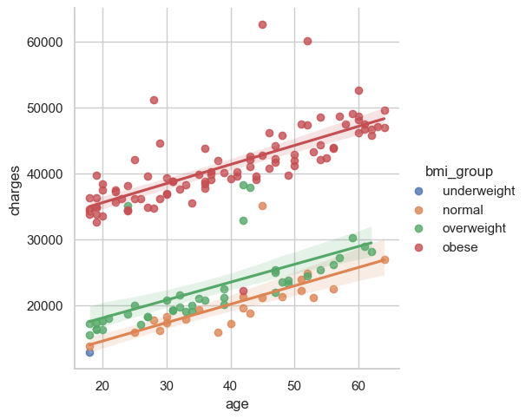
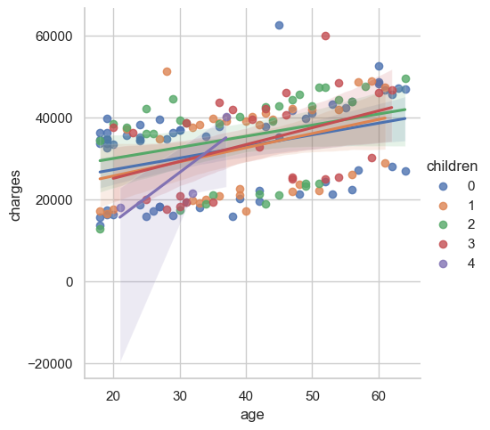
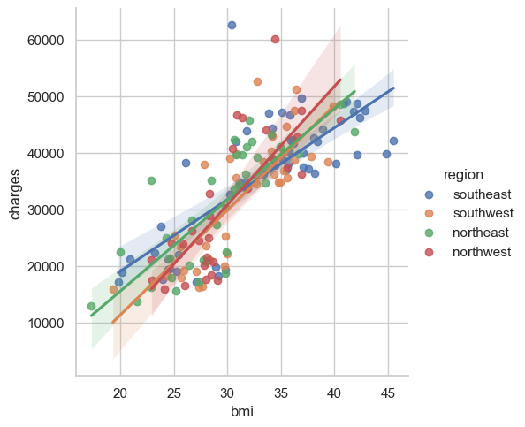
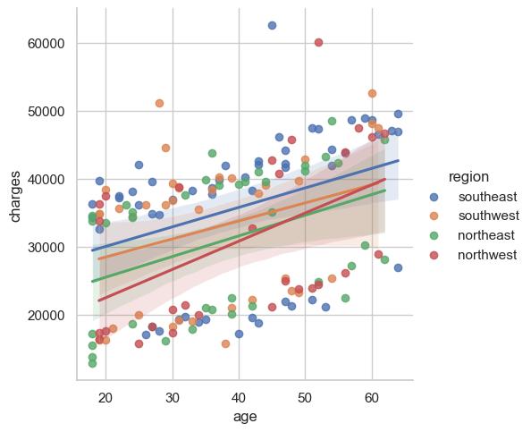
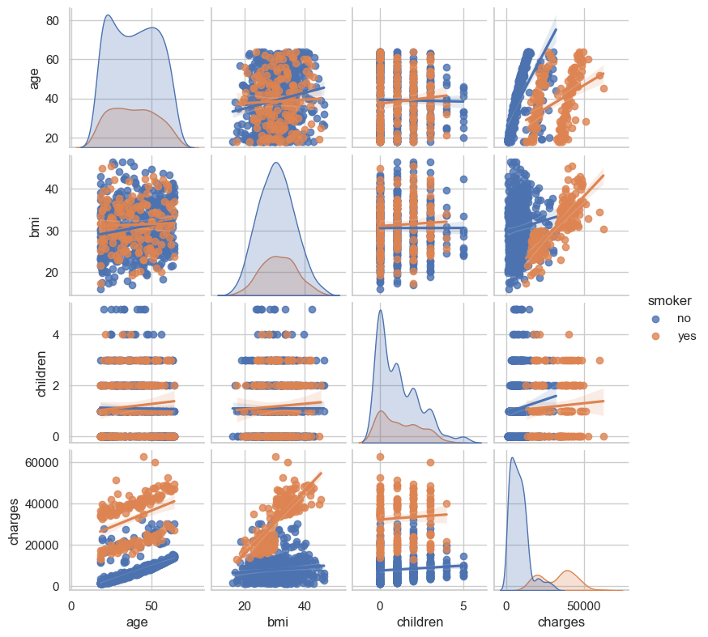
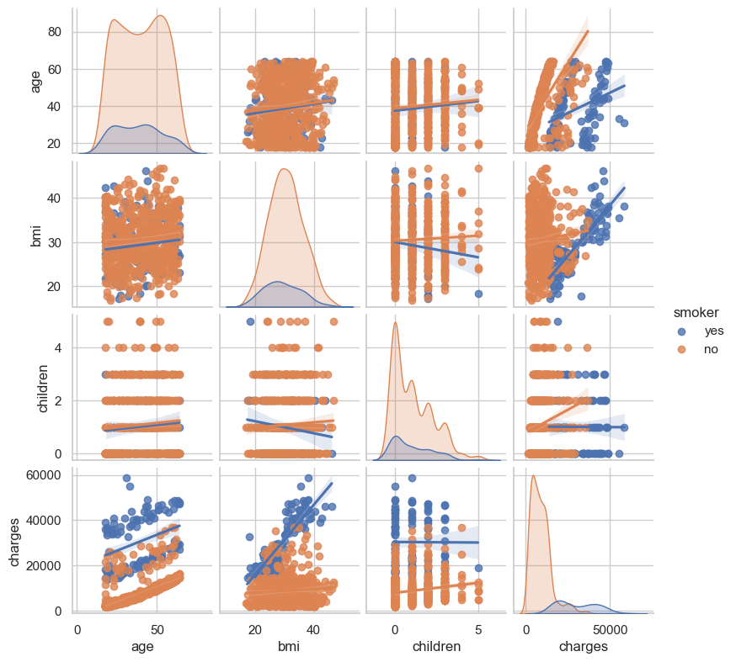
Looking at male smokers, a positive correlation between age and BMI was observed (Fig. 13, a). A distinctly higher charges were correlated for obese males at all ages. However, a clear correlation with age was observed, with higher charges with age for all BMI groups. Number of dependents does not seem to be a reliable predictor for costs (Fig. 13, b), as does region (Fig. 13, c), where charges were correlated with BMI rather than region. Interestingly, looking at age and region, it seems male smokers in the southeast incur the highest costs (Fig. 13, d). Analysis of regions for charges by BMI and sex, BMI and smoking, age and sex, age and smoking, and age and BMI group did not show significant differences between regions (code and figures are in the code file, lines [43] – [42], hidden). Summarizing all variables by sex and smoking showed very little difference in distribution, thus sex is apparently not a significant predictor for charges (Fig. 14).
(a)
(b)
(c)
(d)
Fig. 13. Charges distribution by smoking males
Scatter plotting and linear regression fitting using sns.lmplot(). For charges by age and BMI Group (a); age and children (b); BMI and region (c); age and region (d).
Linear plotting of charges by BMI, age and children, for smoking and non-smoking males (top panel) and females (bottom panel). Plotted by sns.pairplot(), hue=smoker.
Fig. 14. Summary of charge linear correlations

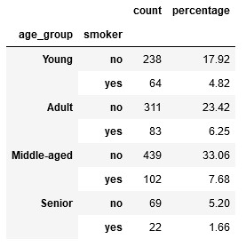
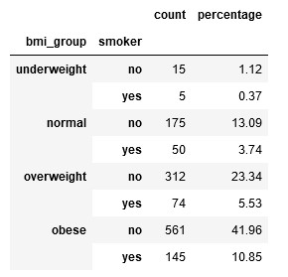
Age was shown to display intermediate correlation with charges (Fig. 9, b). by generating a new variable, age_group, we were able to better categorize age distribution in the dataset. For that, age values were categorized as “Young” for policyholders under 25, “Adult” for 25-40, “Middle-aged” for 40-60, and “Senior” for policyholders over 60. The majority of policyholders are middle-aged (40.74%) and adults (29.67%). Young and senior policyholders comprise 22.74% and 6.85% of the dataset, respectively. Most smokers are adults and middle-aged (Table 7).
Table 7. Age groups by smoking.
Table 8. BMI groups by smoking.

Overall, by this point it was observed that children, sex, and region attributes do not seem to significantly correlate with charges. BMI and smoking displayed strong correlation, as most smokers are overweight or obese (Table 8), most smokers are adults and middle-aged, and finally, BMI, age and smoking displayed strong correlation with charges.
Next, we set out to plot a correlation matrix to plot the correlation between our independent variables and the target variable, i.e., charges, and finally, prepare our dataset for modelling. To achieve that, we need to transform categorical variables (such as region) into numerical variables. Specifically, we assigned categorical variables into binary columns, by using the pd.get_dummies() function, what is also referred to as One-hot encoding. Categorical variables such as region are converted into binary columns, assigning 1 or 0 value to the column. Each category is represented by its own binary column. For example, region was replaced by four new binary columns: region_northeast, region_northwest, region_southeast, and region_southwest. A policyholder from the northeast will be assigned “1” in the region_northeast column, and “0” in the other three region columns. One-hot encoding allows algorithms to operate on categorical data without biasing the model towards any particular category. This way, each category is treated as a separate entity, enabling algorithms to learn different categories independently. Smoker variable was encoded into numerical values, generating a new column, “smoker_encoded”, assigning “0” for non-smokers and “1” to smokers. Same was applied to the sex variable, generating the new column “sex_encoded”, assigning “1” to males and “0” to females in the dataset. Of note, these changes were applied to a new dataframe, named “df_encoded”, to not disturb analysis performed on the original dataframe. Finally, the dataframe “df_encoded” was composed of the following fields: age, bmi, children, charges, bmi_group, age_group, region_northeast, region_northwest, region_southeast, and region_southwest, smoker_encoded, and sex_encoded. Excluding categorical the columns “bmi_group” and “age_group” a correlation matrix was generated sns.heatmap() (Fig. 15). Generally, a strong positive correlation is defined as 0.6 ≤ x ≤ 1, when a rise in one variable is strongly correlated with a rise in a second variable, and a strong negative correlation is -1 ≤ x ≤ -0.6, where a rise in one variable is strongly correlated with a decline in a second variable. Only smoking (r² = 0.79) and age (r² = 0.3) show significant positive correlation with charges.

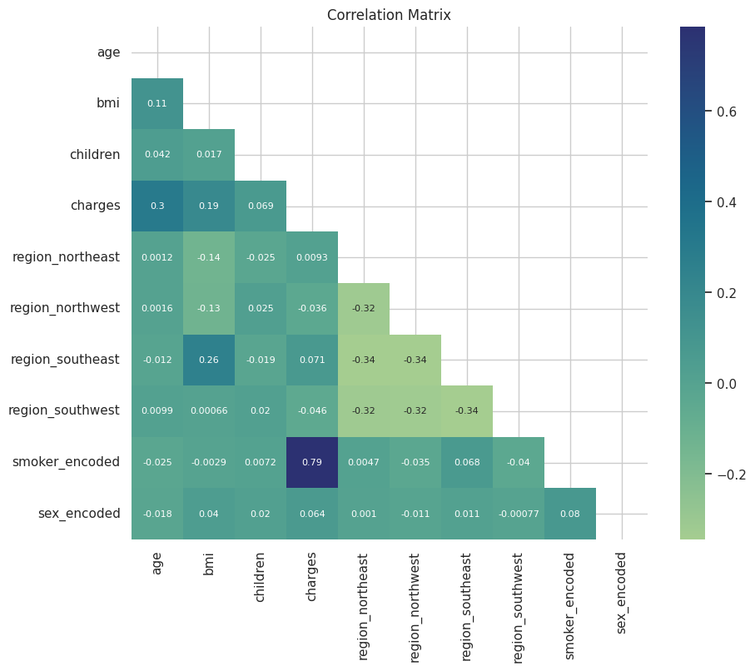
5.3. Regression models
Fig. 15. Correlation heatmap
Correlation heatmap was plotted using the sns.heatmap() function. All variables are numerical (age, BMI, children, charges) or binary (regiont, smoker, and sex).

5.3.1. OLS Linear Regression
In this step, the dataset was split into training and testing sets and a linear regression model was constructed. Retrieving the coefficients of the linear regression model (Table 9) shows:
- Smoker Status: Strong positive effect (+23743). Smoker status significantly increases medical charges.
- Age: Positive effect (+259). In another word, older individuals tend to have higher medical charges.
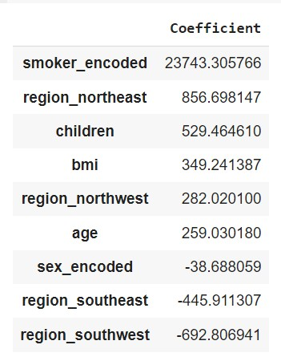
- Children: Having more children is associated with slightly higher charges.
Table 9. Test attributes coefficients.

- BMI: Higher BMI is associated with higher medical charges.
- Region:
  - region_north: Living in the north region was associated with slightly higher charges.
  - region_south: Living in the south region was associated with slightly lower charges and decreases charges slightly.
- Sex: Sex was associated with slightly lower charges.
Overall, smoking status is the most influential factor in determining medical charges. The result of OLS Regression shows that in this model, R-squared is 0.749, indicating that approximately 75% of the variance in charges can be explained by age and smoker_encoded. Additionally, the adjusted R-squared here is 0.748, which is very close to the R-squared value, indicating that the additional predictor (smoker_encoded) contributes meaningfully to the model (Table 10).
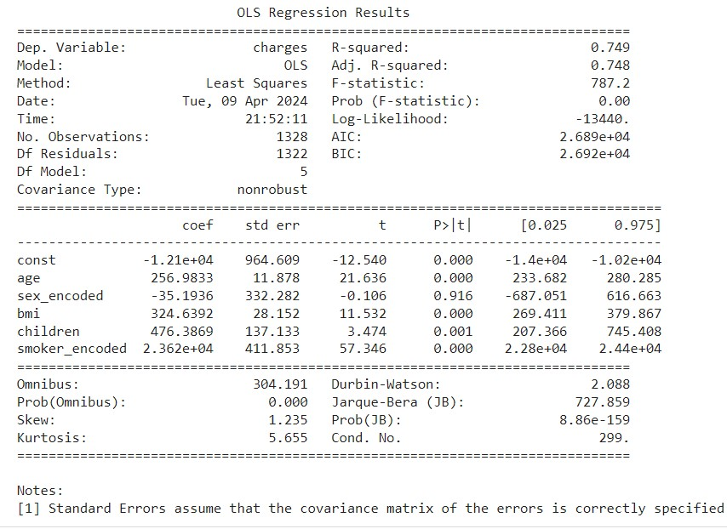
Overall, the regression model suggests that both age and smoking status are significant predictors of charges, with smokers having substantially higher charges compared to non-smokers, even after controlling for age. Additionally, the model's diagnostics indicate potential issues with non-normality and skewness in the residual distribution, which might warrant further investigation or model refinement. The residual plot of the model is not consistently overestimating or underestimate the actual values (Fig. 16). However, it is difficult to say definitively from this plot alone whether the residuals are normally distributed, as there are not many data points, and the vertical axis scale is very small. The density plot appears to be roughly symmetrical around zero, which is consistent with the idea that the residuals are centered around zero. However, the shape of the distribution is difficult to determine precisely due to the limited number of data points. It's possible that the true distribution may not be perfectly normal, even though it appears somewhat symmetrical in this plot.
Table 10. OLS Regression Results

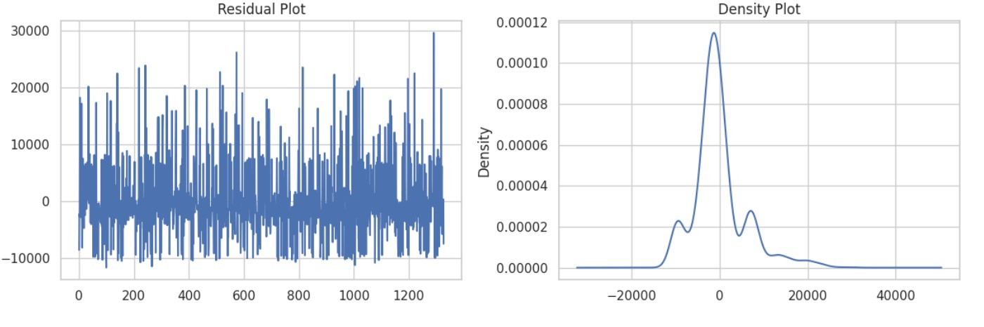
Finally, by considering age, BMI, and smoking status as relevant features, the intercept value (-12009.425) represents the estimated value of charges when all independent variables (age, BMI, and smoker status) are zero. The coefficients (262.0671 for age, 328.98 for BMI, and 23765.27 for smoker status) indicate the change in charges for a one-unit increase in each respective independent variable, holding other variables constant. The R-squared value (0.749) indicates the proportion of the variance in the dependent variable (charges) that is predictable from the independent variables (age, BMI, smoker status). Plotting actual values vs. predicted values showed overlapping, indicative of a good fit of the model (Fig. 17). A good model would have the blue curve closely matching the green curve, indicating accurate predictions. Overall, with an R-squared value of 0.805, the linear regression model appears to explain a significant portion of the variance in charges based on the selected features (age, BMI, smoker status). However, further analysis, such as evaluating residuals and checking for model assumptions, could provide additional insights into the model’s performance and potential areas for improvement.
Fig. 16. Residual and density plot.
5.3.2. Decision tree regression model
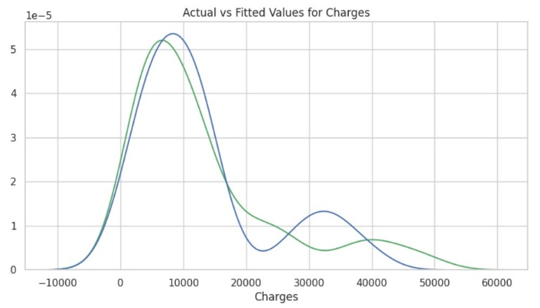
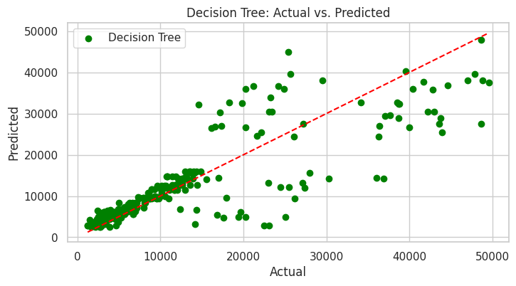
A decision tree regression model was generated as well. First, the independent variables shown to correlate with charges were selected (X, ‘bmi’, ‘age’, ‘smoker_encoded’), and the dependent variable (y, charges). A decision tree regression model was generated using the DecisionTreeRegressor() function, using the training data, and finally used to make predictions using the predict() function on the X_test data. Plotting the actual values vs. the predicted values using the prediction tree is shown in Fig. 18. Fitting metrics are summarized in Table 11. Importance represents the percentage of splits in the decision tree that involve a specific attribute. A higher importance value indicates that the feature is of higher value for prediction purposes, thus, identifying key variables in the dataset. Importance values for age and smoking are summarized in Table 12. Lower importance for age indicates that smoking is the most valuable variable in the model.
Fig. 17. Actual charges vs. predicted charges. Actual charges are shown in green, predicted in blue.

Fig. 18. Decision tree regression model for charges. A decision tree regression model for charges was generated to predict charges. A linear regression r² score (red) was plotted to evaluate fit with actual data.
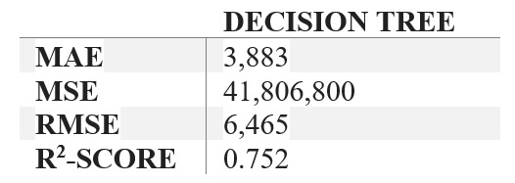
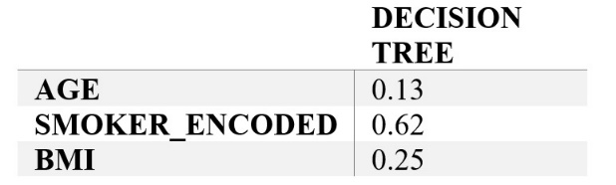
Table 11. Regression models fitting metrics.
Table 12. Regression model variable importance.

6. Discussion
Establishing predictive models for medical insurance costs, based on policyholders’ data is of high value for both insurance companies in establishing premium charges, and for policyholders to evaluate their predicted charges based on their personal attributes. The dataset used here, composed of 1,338 insurance holders’ data, was used to find what variables are in strong correlation with insurance charges, and generating predictive regression models for charges. We used OLS and decision tree linear regression models for predicting charges. OLS is used to minimize the sum of squared differences between the actual values and the predicted values, hence, improving model accuracy. OLS works by calculating the coefficients of the independent variables that best fit the data by minimizing the sum of squared residuals, finding a line that fits the data best by minimizing the distance between the observed values and the predicted values along this line^{[5]}. A decision tree algorithm uses a tree-like model of decisions to predict the target value^{[6]}. A decision tree model is simple yet powerful algorithm for regression. Here, the decision tree regression has resulted in a good prediction model, with relatively low error values. However, decision trees should be carefully interpreted, as small changes in data can result in significantly different trees. Decision trees are prone to overfitting and capturing noise, especially deep trees. Thus, decision tree in our dataset results in a good fit between actual and predicted values, but should be examined carefully when applied on larger datasets with variable exhibiting larger spread. Our analysis and the predictive models generated supported our hypothesis. Smoking, BMI and age were initially shown to positively correlate with insurance costs. Of the six independent variables (smoking, age, children, sex, region, BMI), smoking, BMI, and age showed strong correlation with insurance charges. The models used here assume linear correlation. However, it would be interesting to test non-linear models for this dataset, for example, a polynomial regression model. For improved model accuracy, we believe that including more insurance holders’ data (more rows), or including additional variables such as pre-existing medical conditions, socioeconomic status or cancer predisposition parameters, could increase the accuracy of the model, and can serve to generate improved prediction models in the future.

References
[1] Arun Jangir and willian oliveira, https://doi.org/10.34740/KAGGLE/DSV/6678394. 2023.
[2] US Census Burea, https://www.census.gov/quickfacts/fact/table/US/LFE046222.
[3] Centers for Disease Control and Prevention, https://www.cdc.gov/tobacco/campaign/tips/resources/data/cigarette-smoking-in-united-states.html#:~:text=In%202021%2C%20an%20estimated%2011.5,U.S.%20adults%20currently%20smoked%20cigarettes.
[4] Statista, https://www.statista.com/.https://www.statista.com/statistics/270000/age-distribution-in-the-united-states/
[5] www.xlstat.com. https://www.xlstat.com/en/solutions/features/ordinary-least-squares-regression-ols
[6] analyticsvidhya.com. https://www.analyticsvidhya.com/blog/2021/08/decision-tree-algorithm/

