Health Insurance personal attributes and incurred medical insurance costs
Group 4: Julie Huynh, Haleh Farzaneh, Ilana Berger Fridman, Iga Meddie, Giridhar Kodakalla Venkata, Gokhan Istanbullugil

Introduction
As medical services, medications and other healthcare-related costs are rising, the ability to predict incurred healthcare charges by the personal attributes of the policyholders is of value for both the insured individual and for the insurance company. This report examines what healthcare policy holders’ personal attributes correlate with higher incurred insurance charges, and describes regression models to predict healthcare charges.
The dataset used for this analysis was retrieved from an open database found on Kaggle, at this link:
kaggle.com/datasets/healthcare-insurance/
This is a synthetic dataset in a CSV format, and is based on US census data. The dataset is composed of 1,338 rows of insurance holders’ data, containing seven variables, as described here:
Variable | Description | Variable Type | Variable Values, min - max
Age | Insurance holder age | Continuous, int64 | 18 – 64 (years old)
Sex | Gender | object | male / female
BMI | Body Mass Index, a measure of body fat based on height and weight. | Continuous, float64 | 15.96 – 53.13 (kg/m²)
Children | The number of dependents covered | int64 | 0 / 1 / 2 / 3 / 4 / 5
Smoker | Whether the insured is a smoker (yes / no) | object | yes / no
Region | The geographic area of coverage | object | southeast, southwest, northwest, northeast
Charges | The medical insurance costs incurred by the insured person | Continuous, float64 | 1121.87 - 63770.42 (USD)

Methods
For data cleaning, plotting and regression analysis we imported pandas, numpy, matplotlib, seaborn, scipy, sklearn, and statsmodels. The data was analyzed and fitted using Linear Ordinary Least Squares (OLS) and decision tree regression models.

Hypothesis
We hypothesized that personal attributes associated with health issues, such as High BMI, smoking, and age, will positively and significantly correlate with insurance costs, while sex, region and number of dependents have low to zero correlation with insurance costs.

Results
The dataset required very little cleaning, with no null values and just one duplicate. Plotting the charges histogram, we observed a long upper tail, indicating high charges. This result intrigues us and we set out to find what are the characteristics of the policy holders that incur high charges. Our challenge here was to find which of the six attributes highly correlate with higher charges.
Upon inspection of the data, we started to see that the main personal attributes correlated with higher charges are age, smoking and BMI. Plotting and analyzing single and multiple variables vs. charges, showed that smokers unequivocally incur higher charges, as well as policy holders that are older and of higher BMI. Plotting a correlation heatmap showed high correlation between smoking and age to charges (R2 = 0.79 and 0.3, respectively). We used linear OLS and decision tree models to build predictive models for charges. Both models resulted in good fitting (R2 = 0.749 and 0.752, respectively) to the actual data, and can serve as good preliminary models for predicting healthcare charges by personal attributes.

Conclusions
Smoking and age were shown to positively correlate with insurance costs. Of the six independent variables (smoking, age, children, sex, region, BMI), smoking and age showed strong correlation with insurance costs. For improved model accuracy, we believe that including more insurance holders’ data (more rows), and including additional variables such as pre-existing medical conditions, socioeconomic status or cancer predisposition parameters, could increase the accuracy of the models, and can serve to generate improved prediction models in the future.
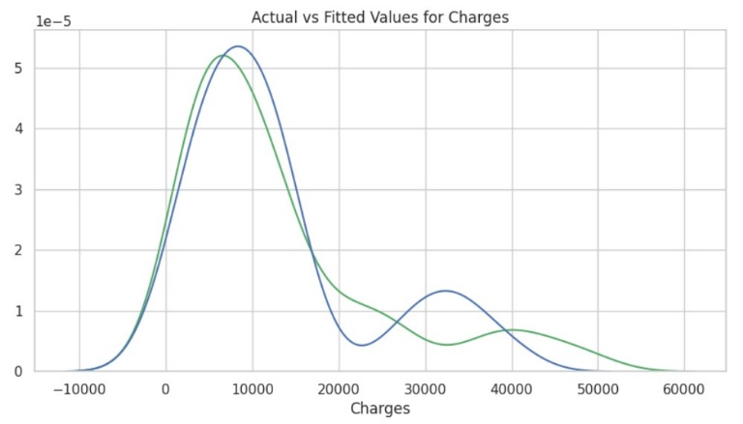
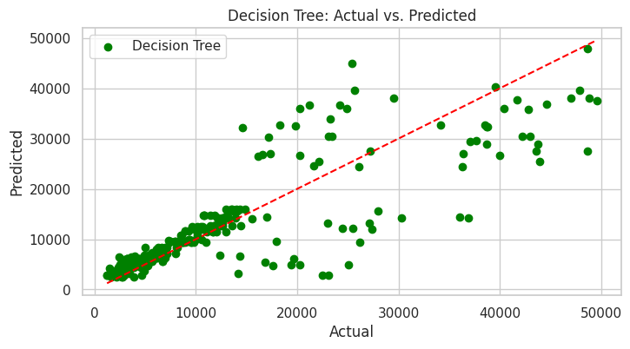
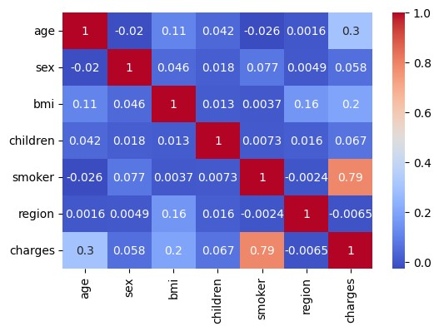
(a) Correlation heatmap; (b) Actual charges vs. predicted charges by the linear OLS model. Actual charges are shown in green, predicted in blue; (c) Fit of the decision tree regression model. A linear regression r² score (red) was plotted to evaluate fit with actual data.
(a)
(c)
(b)

