Table of Contents
History 2
User menu for administrator 3
Results extraction 3
Queries management 8
New query 8
Edit queries 9
Delete queries 10
Administrator specific menu 11
Customers management 11
Projects management 12
Users management 13
Block report 15
Labels management 15
Calendar management 17
Projects and Users evaluation 18

History
Sep 2001
Igalia S.L. is created and soon appears the need for a task tracking system. An XML DTD and a set of processing scripts are developed and the offline XML reports are used by all the company employees.
Dec 2003 - PhpReport 1.0
Some company employees think that editing XML reports by hand is a hard and uncomfortable task and suggest the idea of creating a web reporting application. PhpReport was born.
Year 2004 - PhpReport 1.1 & 1.2
The time goes by and company staff uses PhpReport daily. The application helps company managers to do poject cost and competitive power analysis. Some minor bugs are fixed and some new features, like quick statistics or label editing, are implemented. The desire of publishing PhpReport appears
Jun 2005 - Phpreport 1.3
PhpReport is licensed under GPL and prepared to be published: the app is debianized, SQL auth backend and user administration is implemented and project publishing infrastructure is set up.
Sept 2007 – Phpreport 1.5
Documentation is provided and package debian is improvement in order to use dialog into install process.

User menu for administrator
As administrator role, you can do much more than an user can do, thought you also can do user tasks. In “Phpreport user manual” had been explained some as these tasks:
- Report edition
- XML import
- User evaluation
- Password change
You can find out about this functions in document indicates above. Anyway, “result extraction menu” as administrator role is larger than “result extraction menu” as user role. We only will document here these extra functions:
- Result extraction (all queries: user and specific admin queries)
- Queries management (create, edit and view)

Results extraction
Query | Description | User | Admin
Q1 | < New Query > | - | X
Q2 | Add Compensation | - | X
Q3 | Delete Compensation | - | X
Q4 | Delete Worker Tasks and Reports (over time slot) | - | X
Q5 | Delete all Workers Reports (over time slot) | - | X
Q6 | Delete Orphan Reports | - | X
Q7 | List all Blocks | - | X
Q8 | List all Compensations | - | X
Q9 | List all Orphans Reports | - | X
Q10 | List all Queries | - | X
Q11 | List all Workers Hours (at current week) | X | X
Q12 | List all Workers Hours (over time slot) | X | X
Q13 | List all Workers Tasks | - | X
Q14 | Project Hours | X | X
Q15 | Project Hours (over time slot) | X | X
Q16 | Project Hours (total VS time slot) | - | X
Q17 | Project Stories Duration (by days, hours - no comp) | X | X
Q18 | Worker Hours (by date, type - no comp) | X | X
Q19 | Worker Hours (by date, project, story, task, type - NULL include) | X | X
Q20 | Worker Hours (by date, project, story, type) | X | X
Q21 | Worker Hours (by date, project, text, type) | X | X
Q22 | Worker Hours (by date, project, task, type) | X | X
Q23 | Worker Hours (by date, project, task, type - NULL include) | X | X
Q24 | Worker Hours (by date, project, type - no comp) | X | X
Q25 | Worker Hours (by project, type) | X | X
Q26 | Worker Tasks (by date, project) | X | X
Q27 | Worker Tasks (by date, project, type) | X | X

- Format date in database is DD-MM-YYYY
- Hack % is valid in order to fill text fields
- Type VS Task . “Type” is a company task (Holidays, Hackfest, Sales, Coordination...); “Task” is a project task (Analysis, Design, Publication, ...)
- < New Query> (queries index)
View “Queries management” section.
- Add compensation (queries index)
This query inserts a new compensation into database. A compensation is a concept created to reduce extra hours in exchange of money. So, when a compensation is granted to a user, the total amount of worked hours is reduced by “num_hours” and the “cantidad_pagada” paid amount is annotated for accounting purposes.
The main part of the queries featured in PhpReport take compensations into account, therefore modifying the total number of hours computed and shown. On the other hand, a few queries don't take compensations into account, and that fact should be bore in mind by the user.
The compensation applies in a limited time range only. So, queries spreading into that time range should take the compensation into account, and queries not spreading into the range shouldn't. That is: if you ask for the worked hours before the compensation range, the hours are taken into account. If you ask for them inside or after the range, the total hours are reduced by the compensation hour amount.
- Delete compensation (queries index)
Delete compensation in database from user “uid_trabajador” over time slot (init date – end date). Delete will be successful only if time slot fit in with compensation.
- Delete Worker Tasks and Reports (over time slot) (queries index)
Delete all tasks and reports from user “uid_trabajador” over time slot (init date – end date). It's necessary to introduce “ok” key at “confirmation” field. It's done to prevent delete reports by chance.
- Delete report from all workers in one intervalo (queries index)
Delete all reports from all users over time slot (init date – end date). It's necessary to introduce “ok” key at “confirmation” field. It's done to prevent delete reports by chance.
- Delete orphan reports (queries index)
Delete reports which don't have to link some task.
- List all blocks (queries index)
An administrator role can blocks the edition report from user over time slot. The users can't to edit the reports at blocked days. This query list bloks from all users.
- List all compensations (queries index)
Compensation is a mechanism wich make posible change worked hours by money, holidays, etc. This extra hours will don't count when you generate “total worked hours recount”. It will does seem that these hours never had exist, because they are compensated.
This query list all compensations.
- List all orphan reports (queries index)
Orphan reports haven't linked some task. This query list all orphans reports.
- List all queries (queries index)
List all queries.
- List all Worker Hours (current week) (queries index)
This query calculates the worked hours from all users at current week. The compensated hours at current week are descounted.
- List all Worker Hours (over intervale) (queries index)
Calculate the worked hours from all users over time slot (init date – end date). The compensated hours over this slot time are descounted.
- List all Worker Task (queries index)
List all worker tasks order by user and date.
- Project Hours (queries index)
Show worked hours from a project (or all projects if you use % hack).
- Project Hours (over time slot) (queries index)
Show worked hours from a project over time slot.
- Project Hours (Total VS Time slot) (queries index)
Compare total hours from a project and hours from a project over slot time. It's only showed projects which they have tasks at slot time indicated.
- Project Stories Duration (by days, hours)(NO COMP) (queries index)
Show days and hours from each project story. This query don't take into account compensated hours.
Originally, compensated hours were taken into account, but it caused wrong conclusions about real worked hours into a project. For this, now don't take in account compensated hours.
- Worker Hours (by type and date)(NO COMP) (queries index)
Calcule worked hours from a user by a company task (“type”) over time slot (init date – end date). This query don't take into account compensated hours.
- Worker Hours (by date, project, story, task, type) (NULL include) (queries index)
Calcule worked hours from a user by a company task (“type”), project task (“task”), project and story project over time slot (init date – end date). It's useful query in order to view projects hours by use case.
The NULL clausule indicates what the fields “task” and “story” return NULL values too. For instance, if you filter the query where “task” value equals to "analisis" and “story” value equals “test-c1”, they returns registers which “task” value is "analisis" or null and story value is “test-c1” or null.
- Worker Hours (by date, project, story, type) (queries index)
Calculate worker hours over time slot (init date – end date) by company task (“type”), project and project story.
- Worker Hours (by date, project, text, type) (queries index)
Calculate worker hours over time slot (“fecha fin”-”fecha inicio”) by company task (“type”), project and project task text (task with same text are grouped).
- Worker Hours (by date, project, task, type) (queries index)
Calculate worker hours over time slot (init date – end date) by company task (“type”), project task (“task”) and project.
- Worker Hours (by date, project, task, type)(NULL include, NOT COMP) (queries index)
Calculate worker hours over time slot (init date – end date) by company task (“type”), project task (“task”) and project. This query don't take into account compensated hours.
The queries Q22 and Q23 seem the same but they aren't. "Date", "project" and "type" fields are required, but not "task" fields. That's what make them different:
- Returning registers. If you execute Q22 query and there is a register in database wich “task” value is null, the execution result don't return this register. Even though, the Q23 execute result returns the null task field too.
- Filtering registers. If you filter the Q22 query where “task” value equals to "analisis", it only returns registers which “task” value is "analisis". Even though, the Q23 query returns register which “task” value is "analisis" or null.
- Worker Hours (by date, project, type)(NO COMP) (queries index)
Calculate worker hours over time slot (init date – end date) by company task (“type”) and project.
- Worker Hours (project, type) (queries index)
Calculate worker hours over time slot (init date – end date) by project.
- Worker Tasks (by date, project) (queries index)
List worker tasks over time slot (init date – end date) by project.
- Worker Tasks (by date, project, type) (queries index)
List worker tasks over time slot (init date – end date) by project and company task (“type”).

Queries management

New Query
As administrator role, you can create new queries. You can write them with parameters wich will be asked to you when you want execute this query. It's recommended that you read the “Technical manual” in order to know the database structure. You can consult the Postgres documentation (8.2) too.
A new query require to define next fields:
- Title: phrase wich show into result extraction menu.
- Description: a query description and work in order to explain what it does.
- SQL: sql code which will be executed. If sql code isn't correct, query will not add. It's strongly recommend that you probe your code before introduce it into database.
- Parameter list (separated by comas): here, you can introduce some parameter wich will be asked to you before you executed this query. Into file “include/predefined_vars.php” are defined two vars (“uid_worker”, “_date_end”) wich you can use in this field. “uid_worker” takes its value from session uid worker (user who is connected to phpreport) and “_date_end” is current data. These vars are include because can be necessary have some public queries but limit results by user by example. This way, user can't view data from others users when he execute this query. Actually, this functionality isn't used.
- Allow all users to use this query: you can shared the query with all users if you select this button. Other way, the query only will show to administrator role. At “result extraction table” is indicated the queries what both administrator and user role can view and the queries that only administrator role can view.
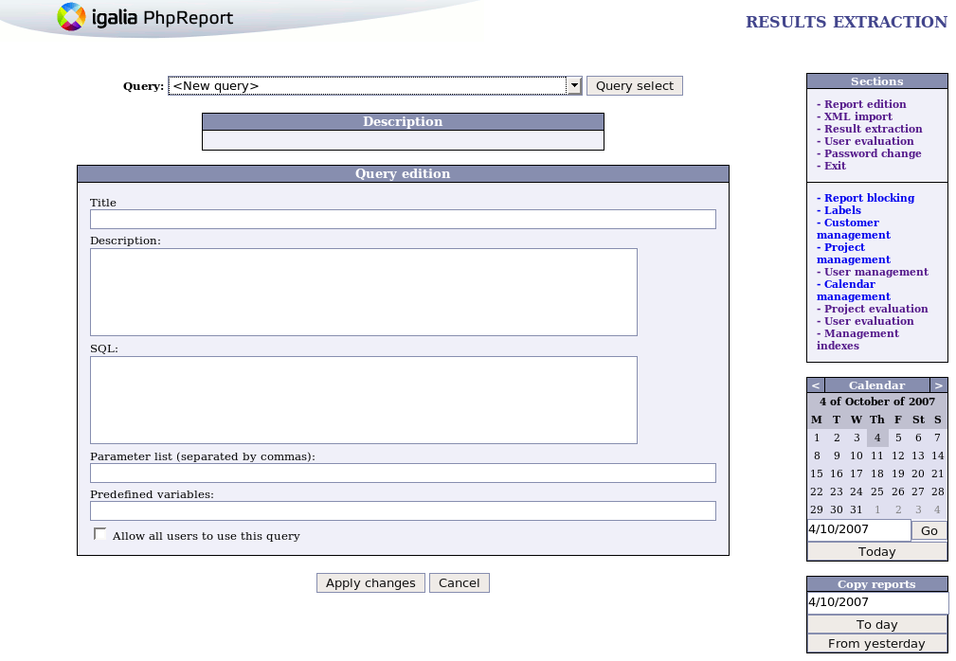

Edit Queries
It's posible edit queries too:
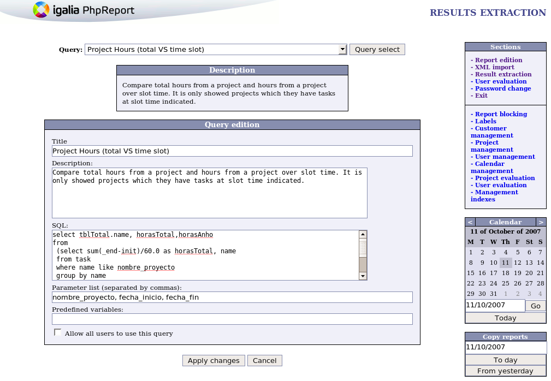

Delete Queries
It's posible delete queries too:
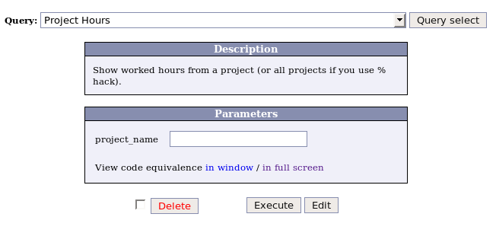

Administrator specific menu
This section contains the specific tasks what only a administrator role can do.
- Customers management
- Projects management
- Users management
- Projects evaluation and Users evaluation
- Block report
- Labels management
- Calendar management

Customers management
- Create a new customer. When create a new customer, don't forget introduce its “id”. If you don't introduce it, you will can't edit its “id” customer though it has assign some project.
- Edit customer.
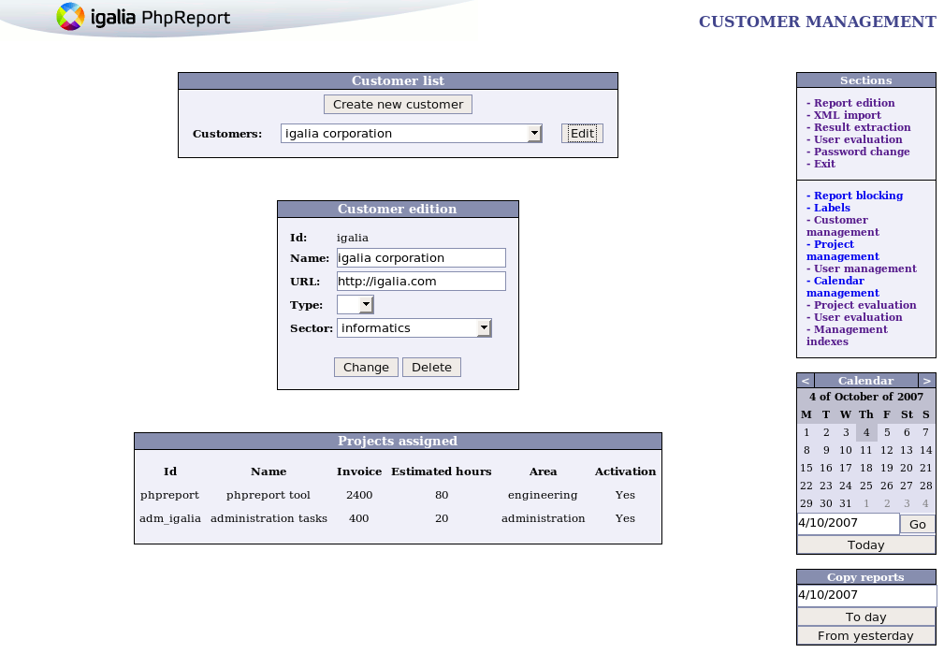

Projects management
- Create a new project. Activation checkbox field controls the project wich can be assign to users in user management. “Estimated hours” and “invoice” are required fields. Even though “name” and “description” aren't required fields, it's strongly recommend you write them. If you don't introduce them, you will can't edit this project though neither assign some user.
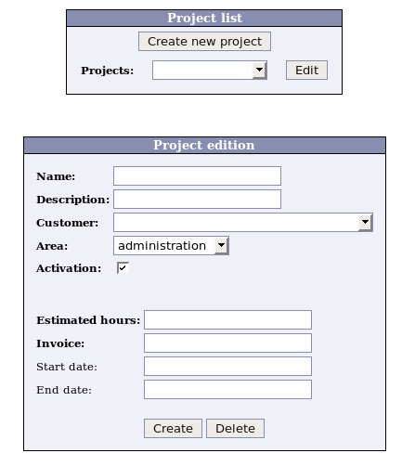
- Edit project.
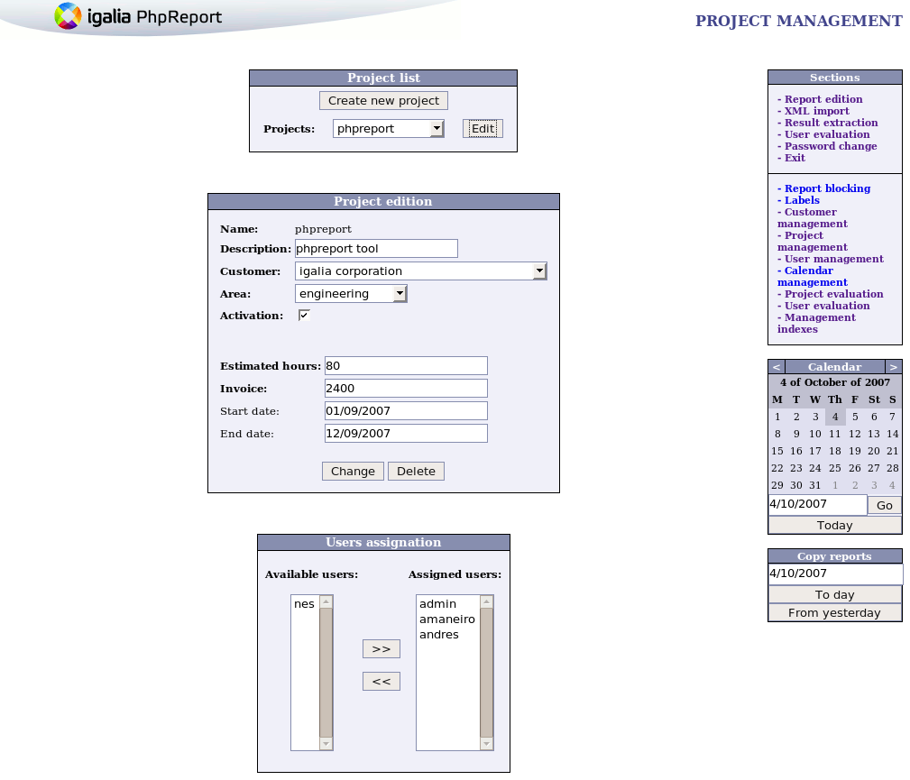

Users management
- Create a new user. Staff checkbox indicates if a user is a company staff member. These users will be showed into R2 and R3 reports (view reports table).
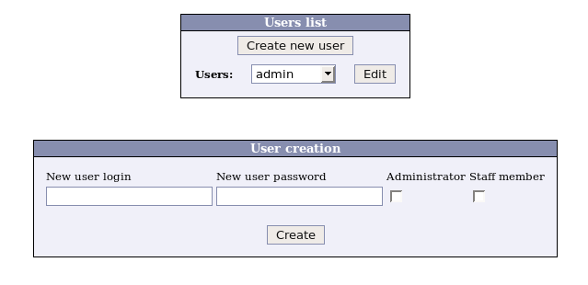
- Edit user. Once a user is created, you must assign periods and projects. User can be assign to several distinct periods.
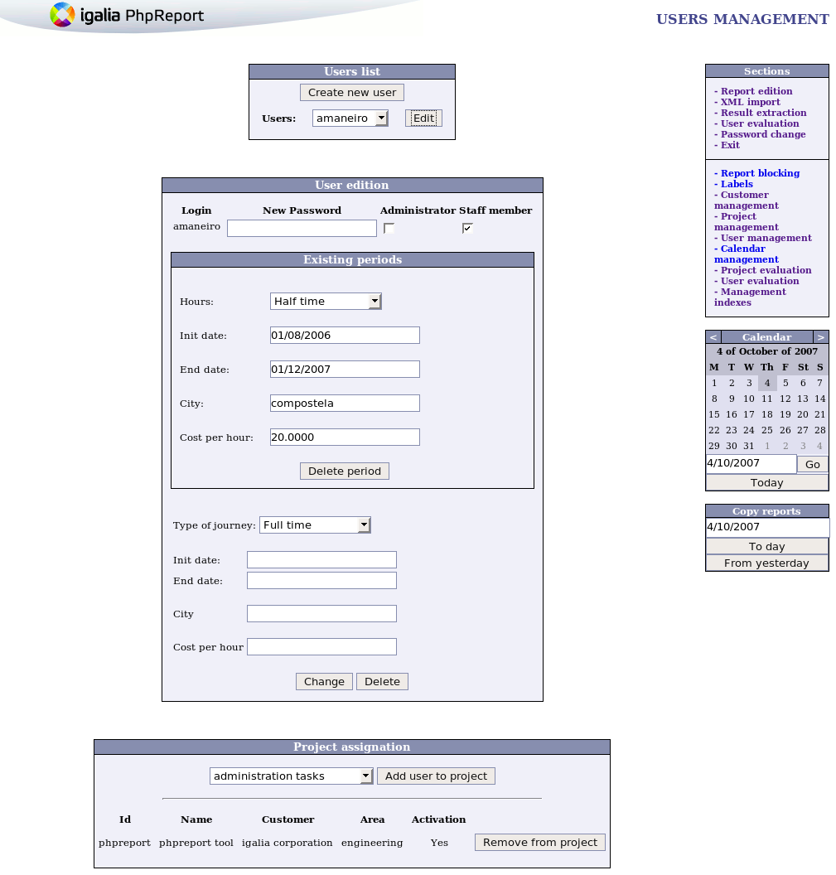

Block report
This option allow to block tasks edition for each user or all users over time slot.
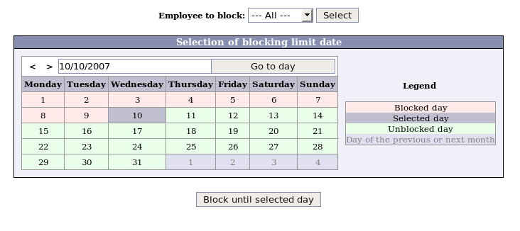

Labels management
Administrator role can add new label, delete label or active/desactive label. At present, this labels type exists: customer, csector, ctype, name, parea, phase, ttype, type.
customer: customer name. It can't to be edit, add neither active/desactive from here. This tasks can do an administrator role from customer management menu. All the customers are always active.
name: project name. It can't to be edit, add neither active/desactive from here. This tasks can do an administrator role from customer management menu. Projects can be active or desactive.
Other labels are manageg from this menu: csector (customer sector), ctype (customer type), parea ( project area), phase (project phase), ttype (project task type), type (company task type).
Notice: “Task type” VS “Task type for this project”. “Task type” field (type) is a long task into company (by example: coordination, sales, administration, holidays, ...). In other hand, “task type project” field (ttype) is a shortest task from one project (by example: analysis, design, community, implementation, documentation, ...).
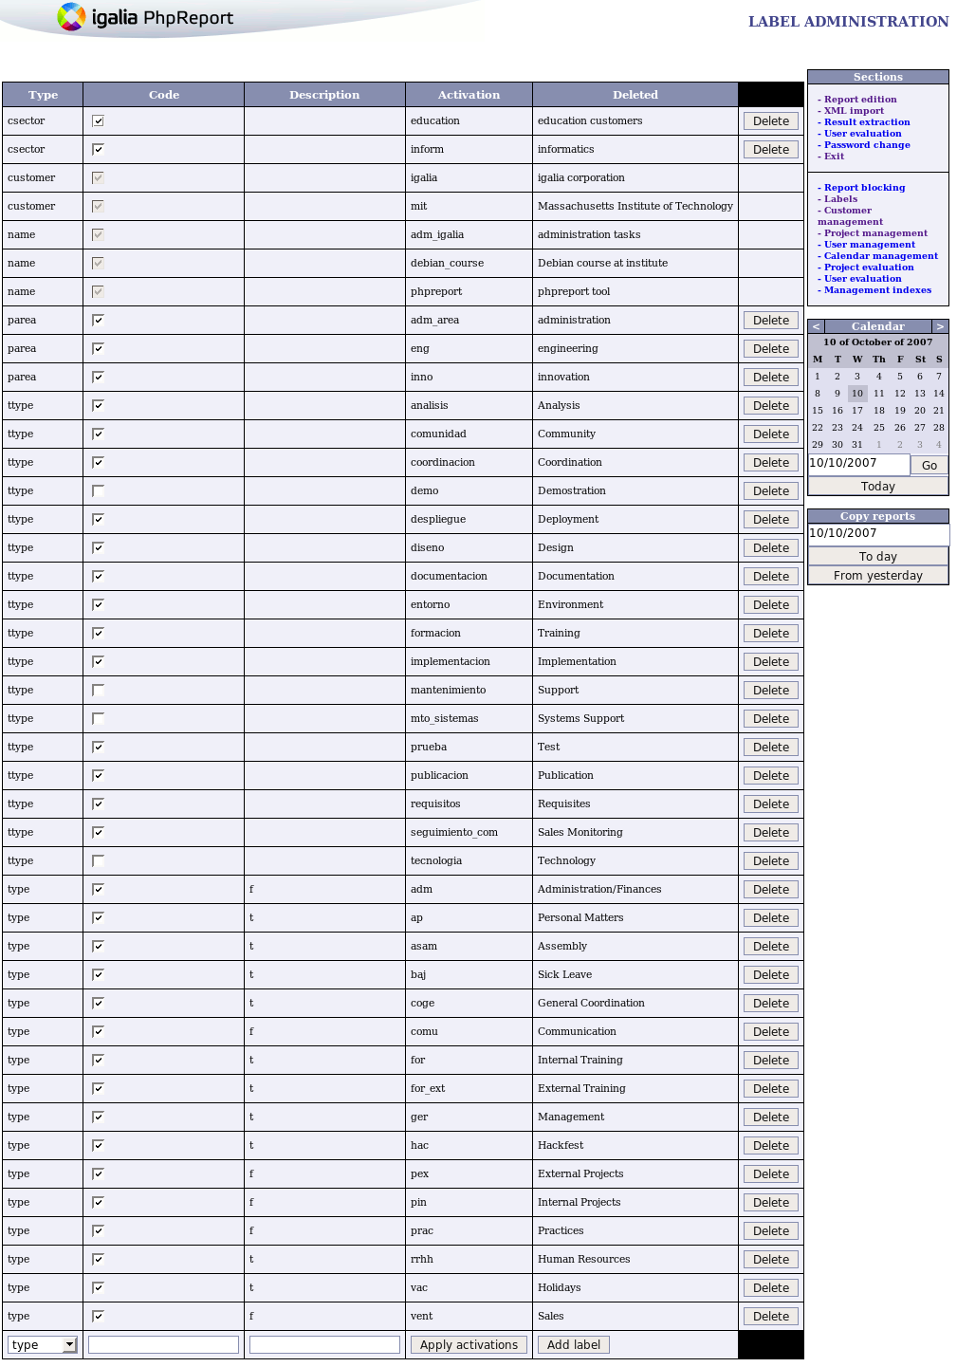

Calendar management
From this menu you will can:
- Add new city. Once you creates a new city, it's necesary that you must assign one non-workable day at least.
- Edit festives days by city. Once you had selected one city, if you pulse over a week day (except a weekend day) it switch between non-workable/workable day. You also can copy non-workable days from previous year.
- Delete city. For this, it's necesary that you delete all festive days for this city.
Bugs knowed: Today, an user can be assign to any city thought it don't exists. It's a bug which igalia team will treat to resolve as fast as it can.
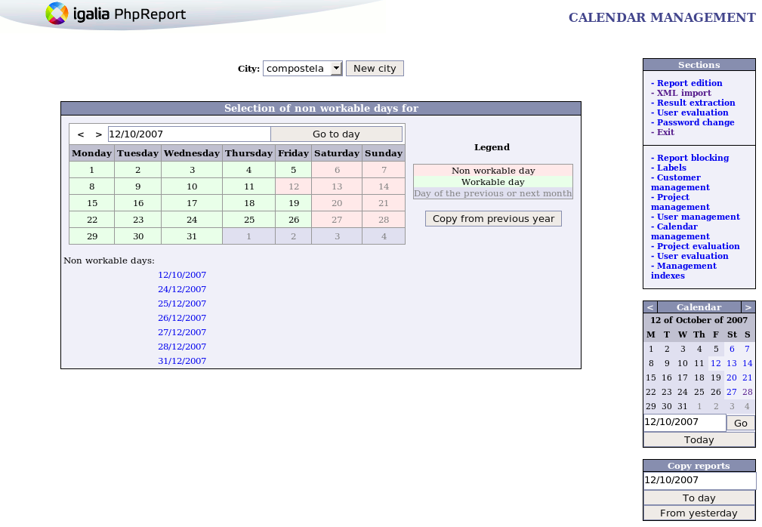

Projects and Users evaluation
Reports | Briefly description | User | ProjecT
R1 | Project / person | X | X
R2 | Hourly personal (briefly) | X | -
R3 | Hourly personal (explained) | X | -
R4 | Person / task type | X | -
R5 | Person / task type (by project) – Project details | X | X
R6 | Project / task type (by user) – User details | X | X
R7 | Project / task type | - | X
R8 | Project evaluation (global) | - | X
R9 | Project evaluation (period) | - | X
From these menus, you can view nine distinct reports as it's indicated at table above. From “users evaluation” you can view R1-R6 reports, and from “projects evaluation” you can view R5-R9 and R1 reports. R5 and R6 reports are showed when you pulse a project or person name from any others reports, they don't show from “sheets” combo.
At first, you must know that dates are always required field. Now, it's explanied what each report do:
- Project / person (reports index)
Report shows worker hours by project over time slot. Rows print all projects which had worked hours, columns show all users.
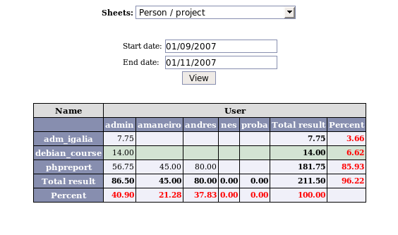
- Hourly personal (briefly) (reports index)
Report prints extra hours by user from worker starts work into company to date indicates into “end date” field. Rows only show staff users, columns show extra hours. You must view special process to calculate extra hours at apendix.
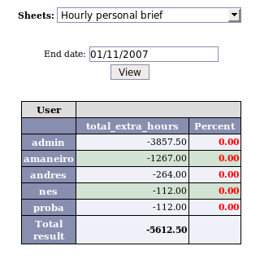
- Hourly personal (explanied) (reports index)
Report shows extra hours by user over time slot. Rows only show staff users, columns show total hours, workable hours, extra hours for this slot time, and total extra_hours. You must view special process to calculate extra hours at apendix.
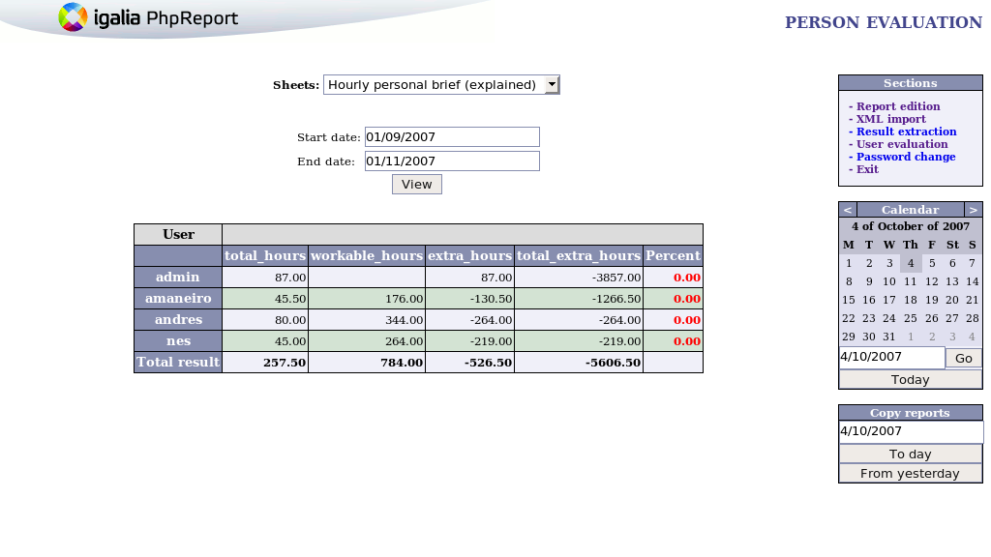
- Person / task type (reports index)
Report prints users and their company task types over time slot. Rows show all users, columns show all distinct company task types.
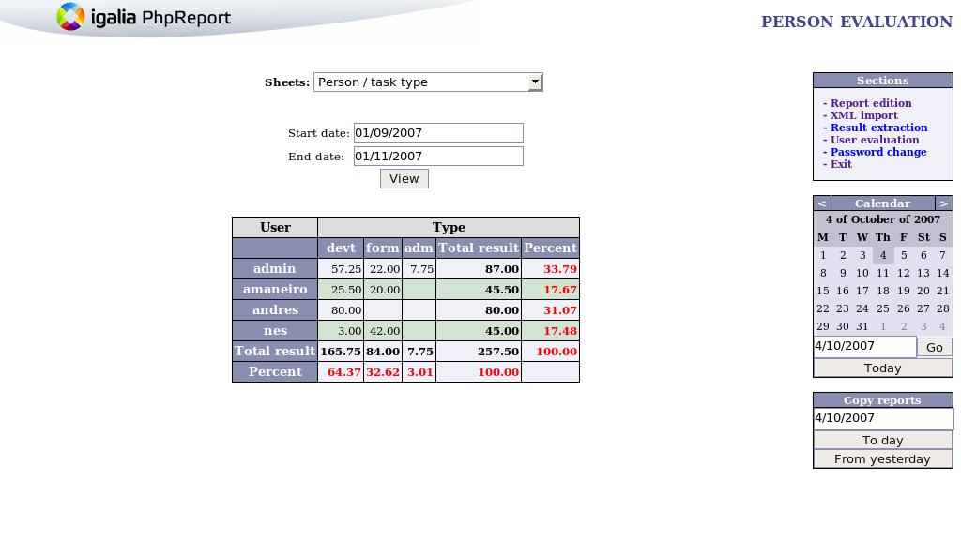
- Person / task type (by project) - Project details (reports index)
Report shows project by user and company task type over time slot. This report prints two frames. First frame is a summary about project info (name, description, worked hours, cost per hour, ...). Second frame shows all users who had participated (rows), and all company task types for each user (columns). It also prints statistic graphics.
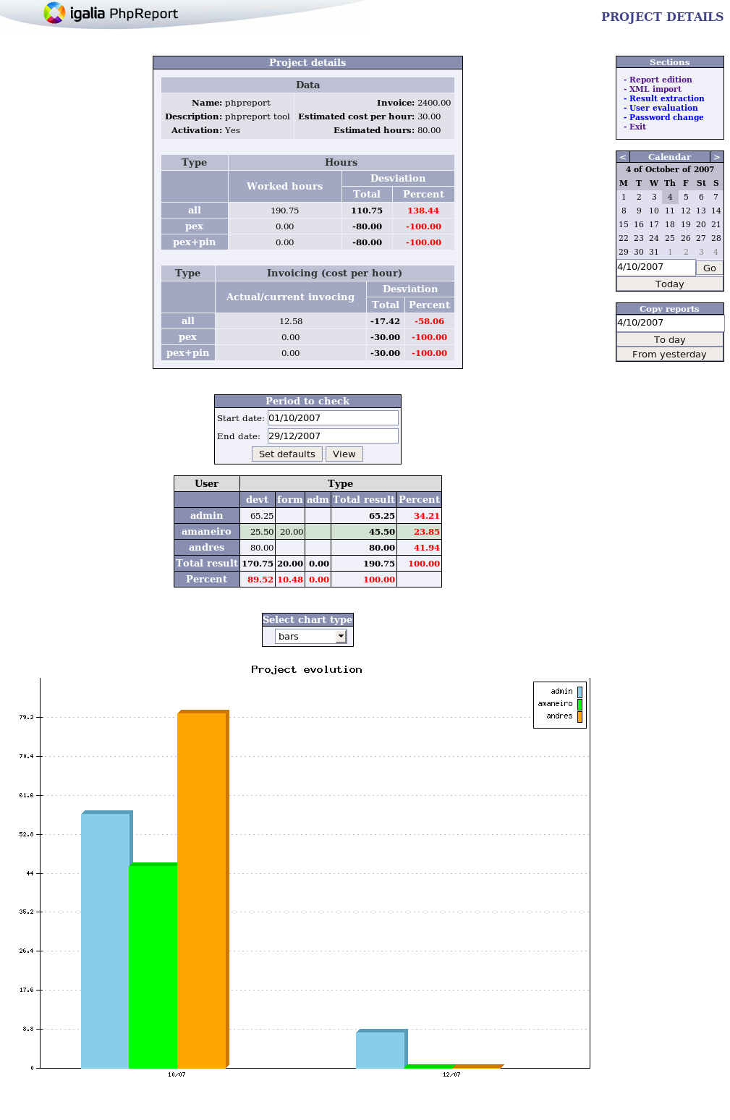
- Project / task type (by user) – User details (reports index)
Report about user by project and company task type over time slot. Rows show all projects which user had participated, columns show all company task types for each project. It also prints statistic graphics.
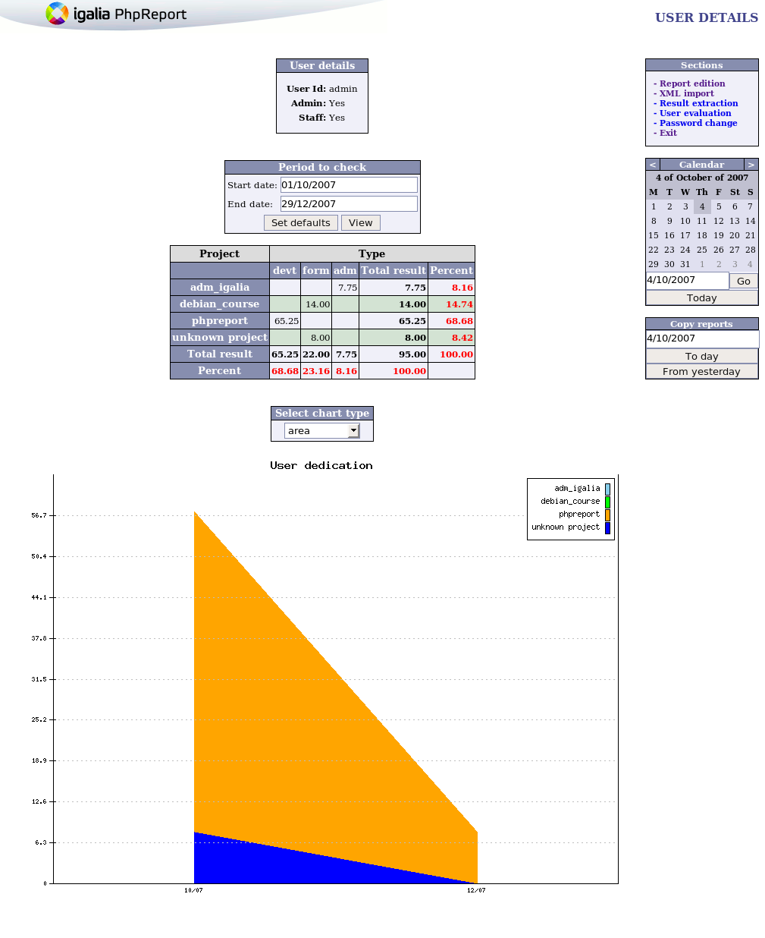
- Project / task type (reports index)
Report about all project by company task types over time slot. Rows show all projects which had tasks in this time slot, columns show all company task types.
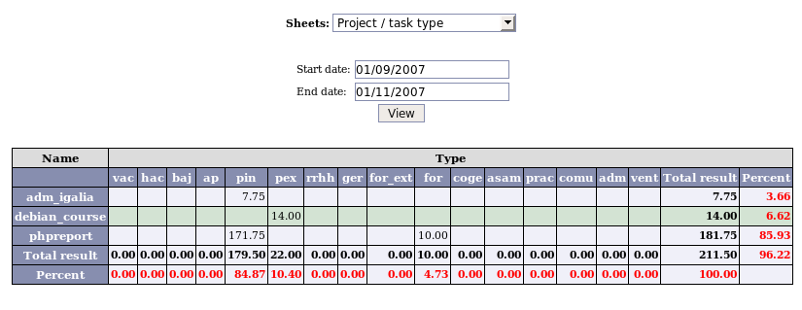
- Project evaluation (global) (reports index)
Report list hours (estimated, worked), invoiced (estimated, real) and cost (staff, profit and profit per hour) by project wich you can filter by area, activation or invoice. Rows show selected projects, columns show hours, invoice and more for each one.
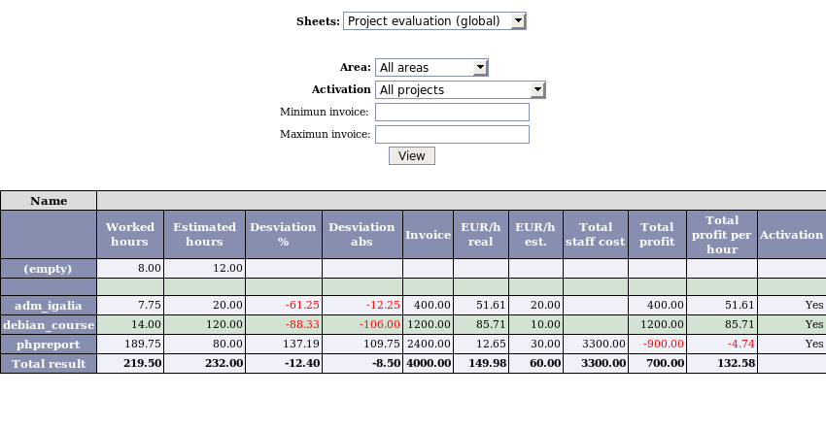
- Project evaluation (period) (reports index)
This report seems to R8 report (project evaluation global) but you can filter by period also.
