Table of Contents
History 2
Introducing data 3
Report edition 3
XML import 5
Viewing data 8
User evaluation 8
Result extraction 13
Other user tasks 19
Password change 19
Calendar: edit and copy reports 19
Apendix: how extra hours are calculated? 21

History
Sep 2001
Igalia S.L. is created and soon appears the need for a task tracking system. An XML DTD and a set of processing scripts are developed and the offline XML reports are used by all the company employees.
Dec 2003 - PhpReport 1.0
Some company employees think that editing XML reports by hand is a hard and uncomfortable task and suggest the idea of creating a web reporting application. PhpReport was born.
Year 2004 - PhpReport 1.1 & 1.2
The time goes by and company staff uses PhpReport daily. The application helps company managers to do poject cost and competitive power analysis. Some minor bugs are fixed and some new features, like quick statistics or label editing, are implemented. The desire of publishing PhpReport appears
Jun 2005 - Phpreport 1.3
PhpReport is licensed under GPL and prepared to be published: the app is debianized, SQL auth backend and user administration is implemented and project publishing infrastructure is set up.
Sept 2007 – Phpreport 1.5
Documentation is provided and package debian is improvement in order to use dialog into install process.

Introducing data
In this section you will learn how you can introduce data.
- Report edition
- XML import

Report edition
First time you go into phpreport any day this prompt is showed:
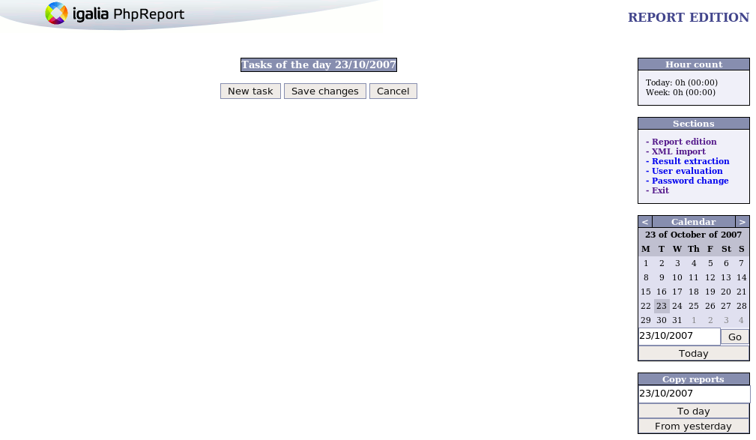
And once you had pulse “new task” button, some like this is printed. You can view that some fields are required:
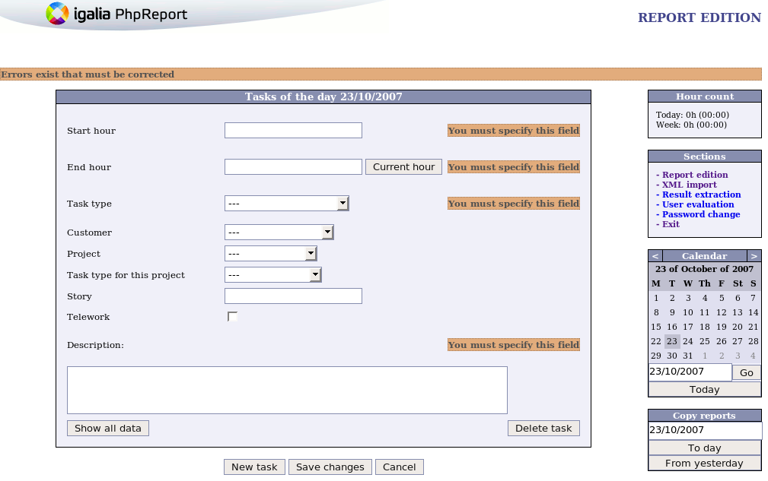
and when finish one task, you can add other:
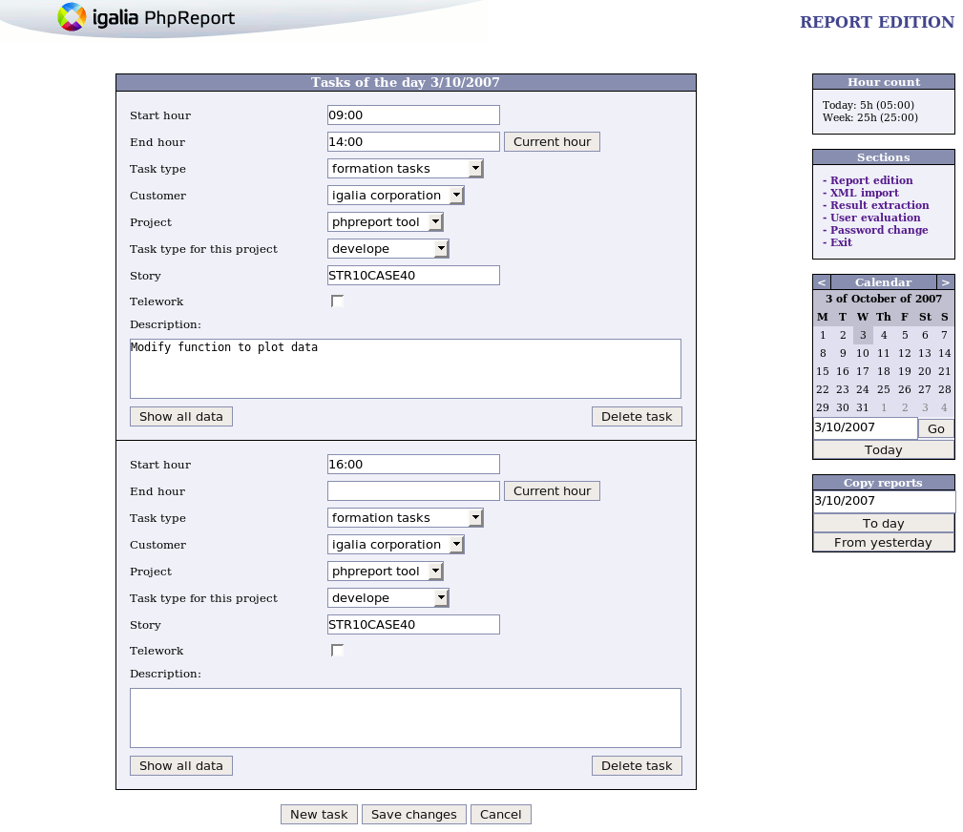
You must save changes (“save changes” button) or you could lost all introduced info in a day if you don’t save the last input.
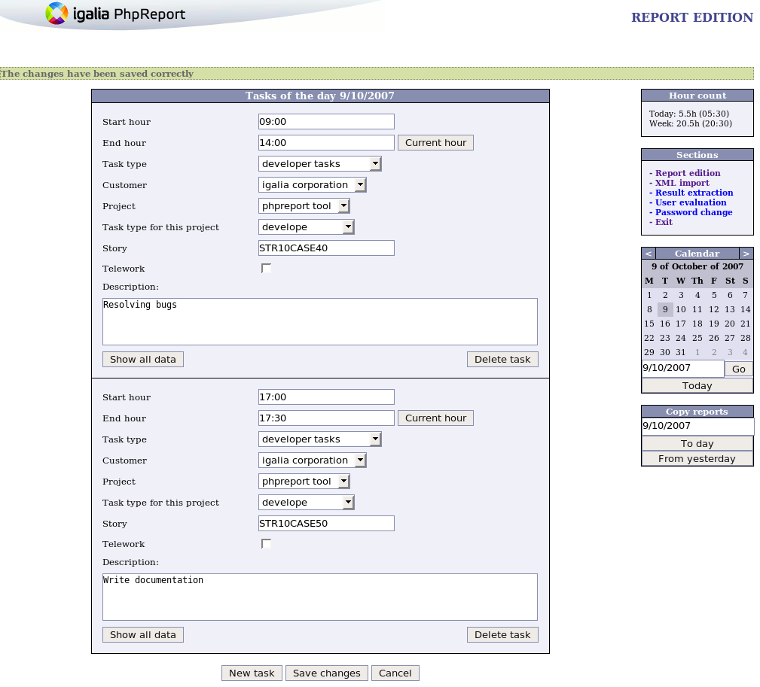
In this point, two fields must be explained: “Task type” VS “Task type for this project”. “Task type” field (type) is a long task into company (by example: coordination, sales, administration, holidays, ...). In other hand, “task type project” field (ttype) is a shortest task from one project (by example: analysis, design, community, implementation, documentation, ...).
Good practices: you can input the data each quarter of an hour. This way, the results are more exactly and they aren’t as perodic numbers... for example 10,33333333333h VS 10,25h.

XML import
This option allows load a xml file with tasks. There two ways to use xml import:
- load individual xml file
- load a tar.gz file (with several xml file)
In order to load a xml file you must format with a correct title. Format is: “weeklyreport-user-firstdayintoweek-lastdayintoweek.xml”, where:
- user: user name whom load this tasks
- firstdayintoweek: first day into this week (format YYYY-MM-DD), for instance, 2007-11-22. It always must be monday.
- lastdayintoweek: last day into week (format YYYY-MM-DD), for instance, 2007-11-28. It always must be sunday.
Process is divided into two phases. Once upload file, it is untar (if tar.gz is provided) and do some checks about formated title. Next, XML is transformed to PHP file (a XSL rules set do it), and then it executed some queries wich introduce data into database.
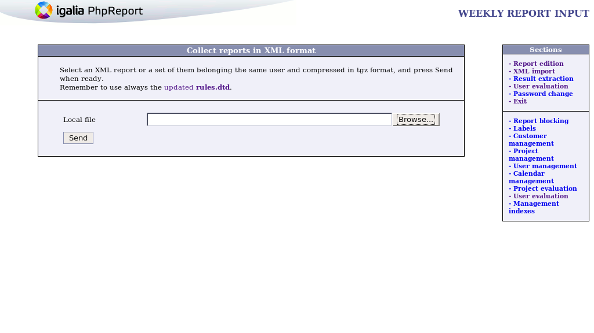

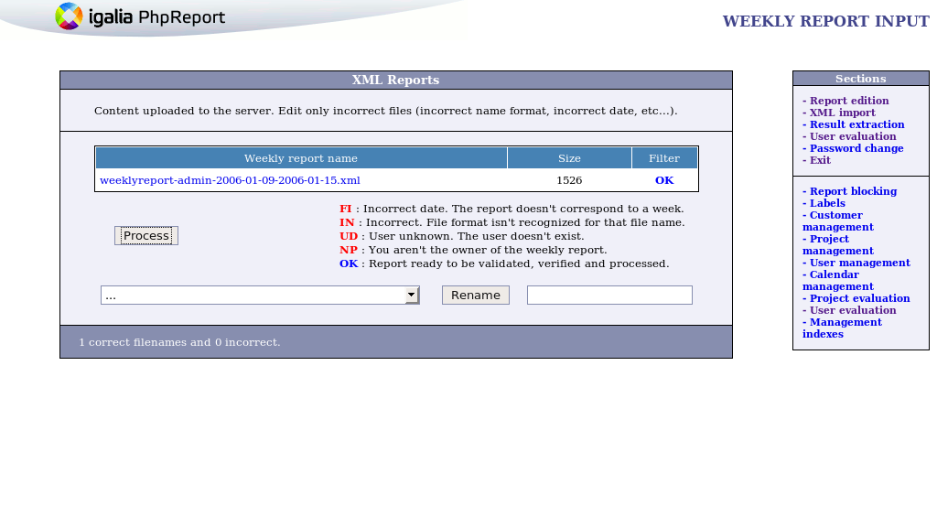
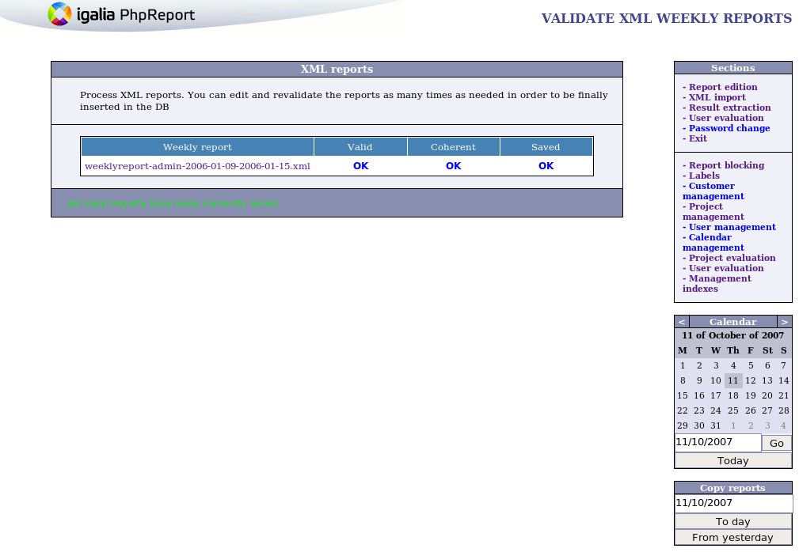

Viewing data
It this section, you will learn what reports you can view.
- User evaluation
- Result extraction

User evaluation
Reports | Briefly description
R1 | Project / person
R2 | Hourly personal (briefly)
R3 | Hourly personal (explained)
R4 | Person / task type
R5 | Person / task type (by project) – Project details
R6 | Project / task type (by user) – User details
From this menu, you can view six distinct reports as it's indicated at table above. From “sheets” combo you can select from R1 to R4 reports. R5 and R6 reports are showed when you pulse a project or person name from any others reports.
At first, you must know that dates are always required field. Now, it's explanied what each report do:
- Project / person (reports index)
Report shows worker hours by project over time slot. Rows print all projects which had worked hours, columns show all users.
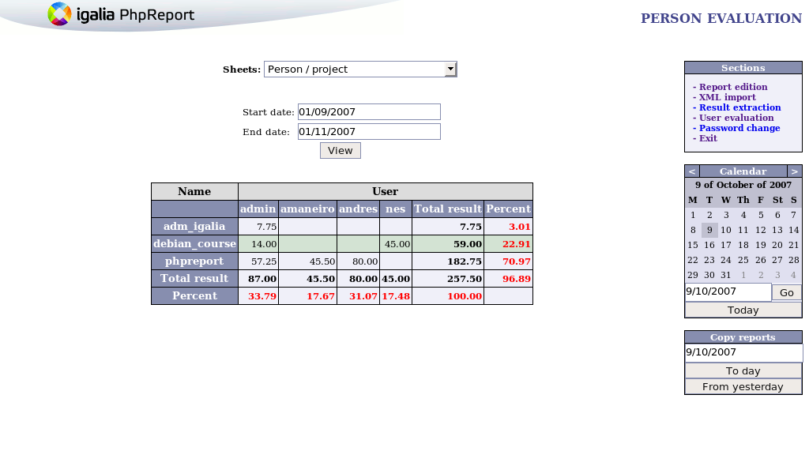
- Hourly personal (briefly) (reports index)
Report prints extra hours by user from worker starts work into company to date indicates into “end date” field. Rows only show staff users, columns show extra hours. You must view special process to calculate extra hours at apendix.
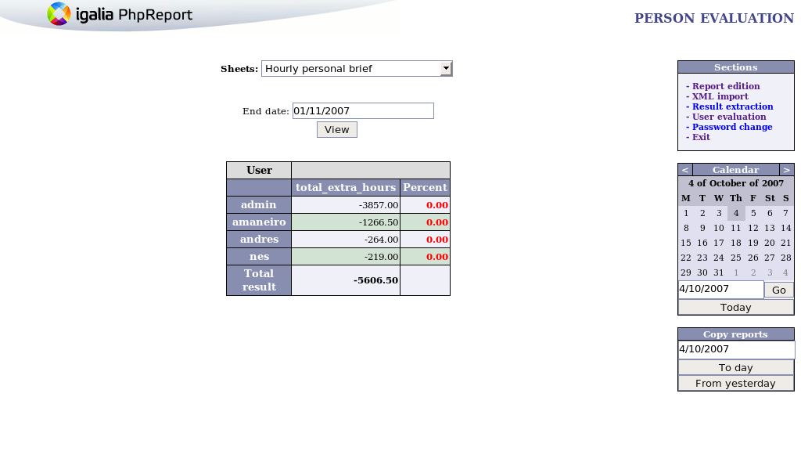
- Hourly personal (explanied) (reports index)
Report shows extra hours by user over time slot. Rows only show staff users, columns show total hours, workable hours, extra hours for this slot time, and total extra_hours. You must view special process to calculate extra hours at apendix.
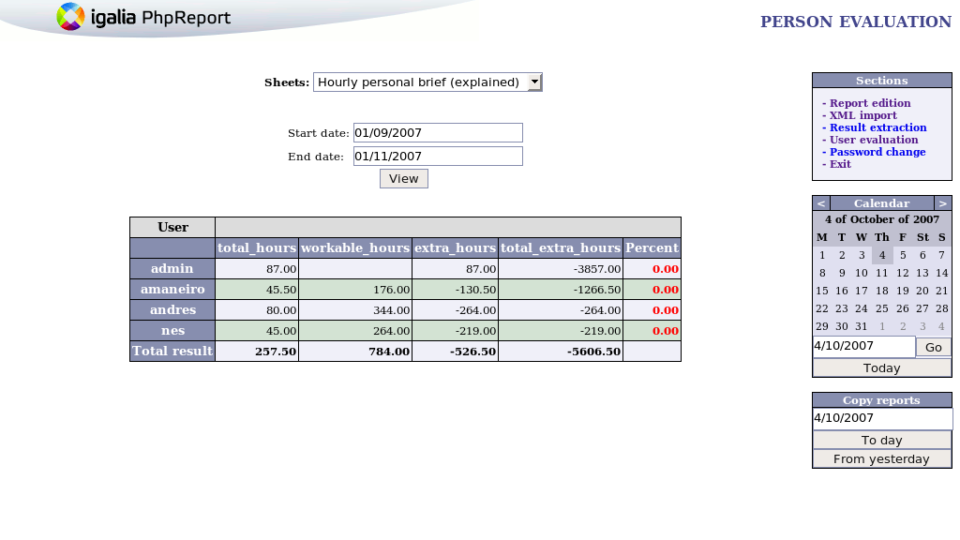
- Person / task type (reports index)
Report prints users and their company task types over time slot. Rows show all users, columns show all distinct company task types.
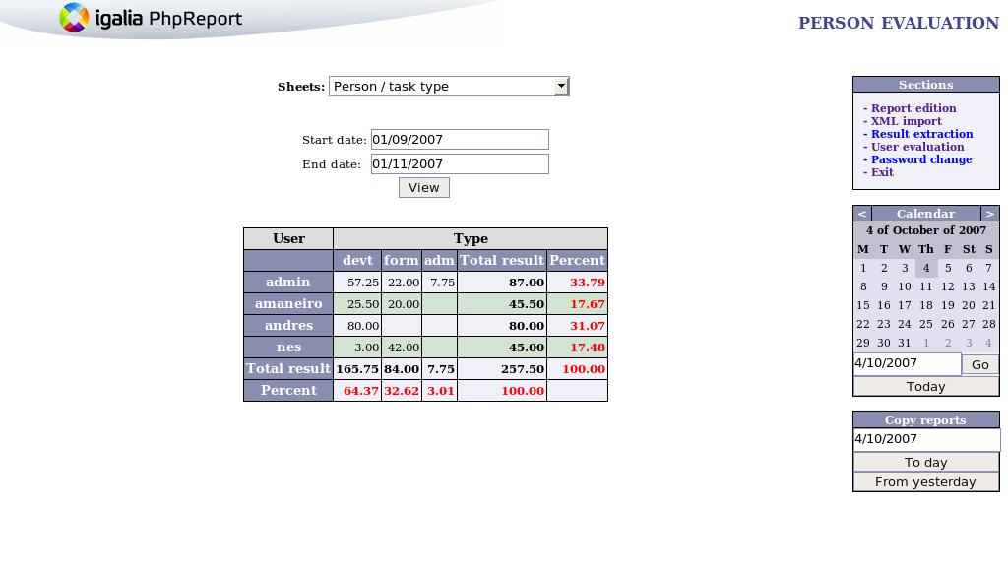
- Person / task type (by project) - Project details (reports index)
Report shows project by user and company task type over time slot. This report prints two frames. First frame is a summary about project info (name, description, worked hours, cost per hour, ...). Second frame shows all users who had participated (rows), and all company task types for each user (columns). It also prints statistic graphics.
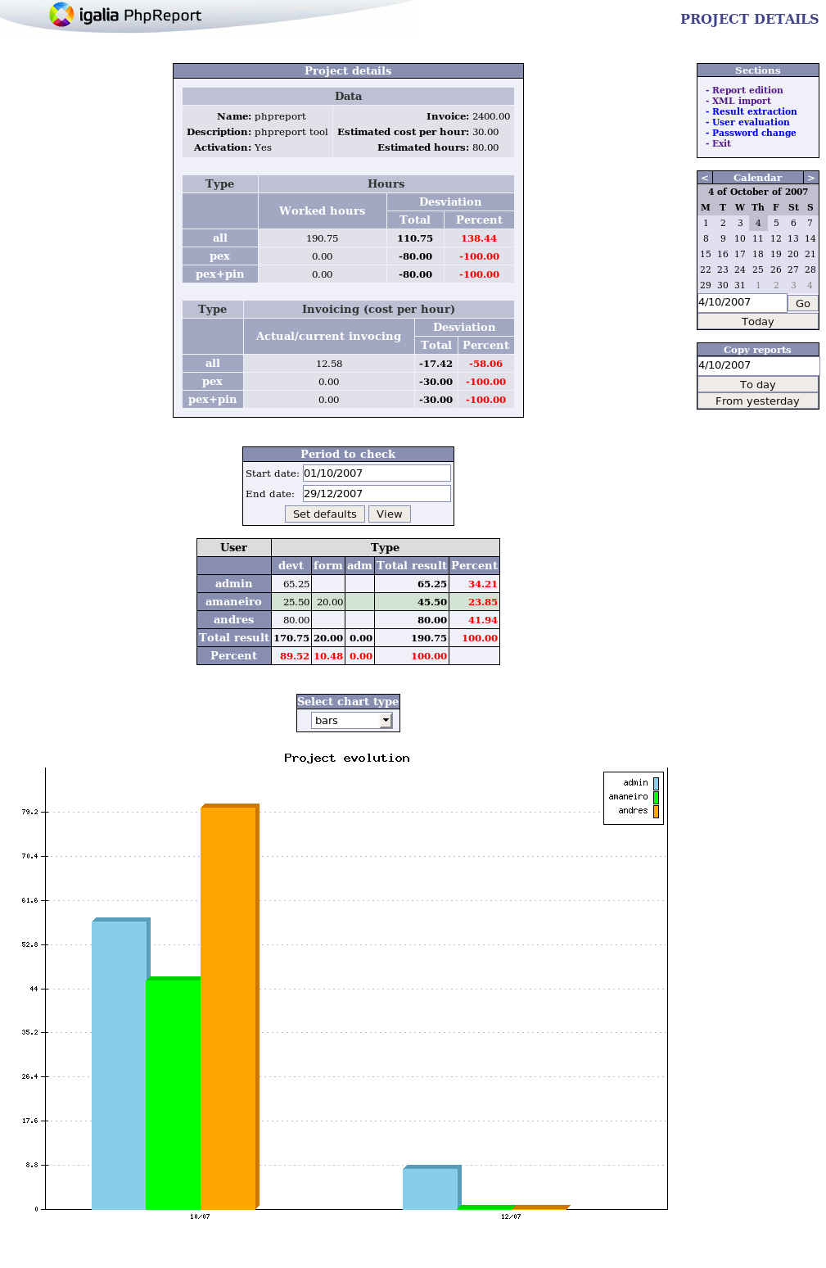
- Project / task type (by user) – User details (reports index)
Report about user by project and company task type over time slot. Rows show all projects which user had participated, columns show all company task types for each project. It also prints statistic graphics.
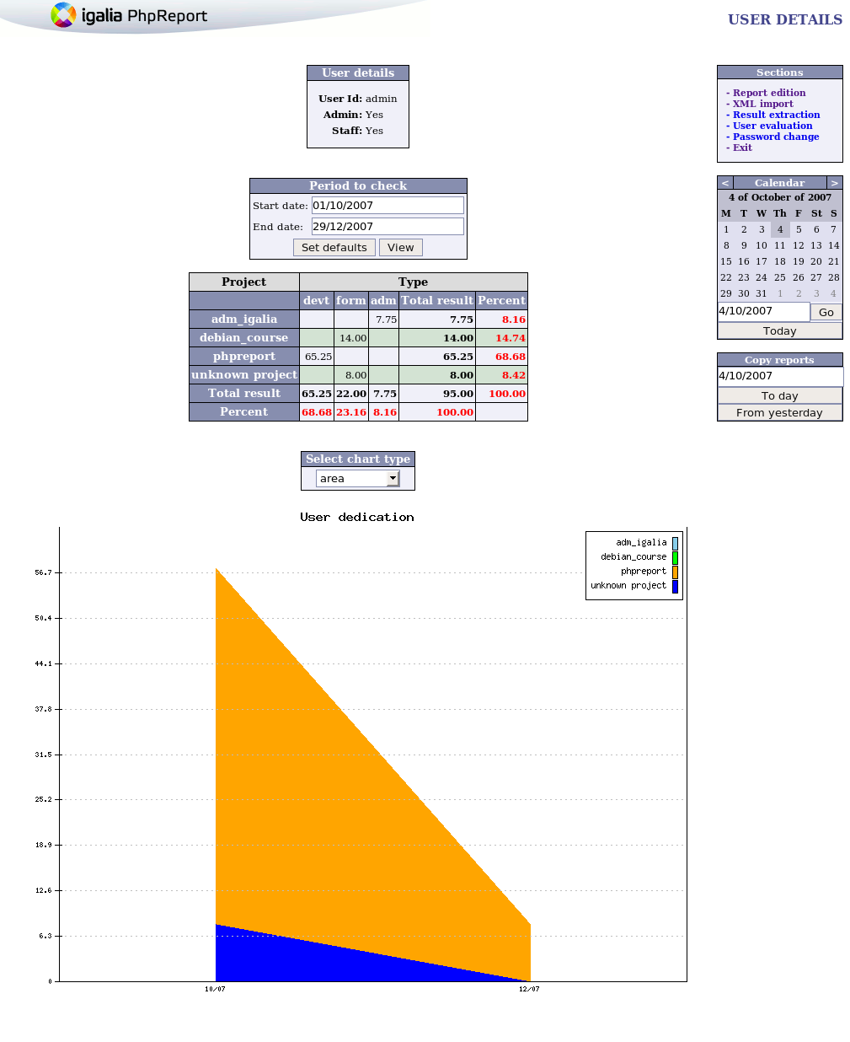

Result extraction
Query | Description | User | Admin
Q1 | < New Query > | - | X
Q2 | Add Compensation | - | X
Q3 | Delete Compensation | - | X
Q4 | Delete Worker Tasks and Reports (over time slot) | - | X
Q5 | Delete all Workers Reports (over time slot) | - | X
Q6 | Delete Orphan Reports | - | X
Q7 | List all Blocks | - | X
Q8 | List all Compensations | - | X
Q9 | List all Orphans Reports | - | X
Q10 | List all Queries | - | X
Q11 | List all Workers Hours (at current week) | X | X
Q12 | List all Workers Hours (over time slot) | X | X
Q13 | List all Workers Tasks | - | X
Q14 | Project Hours | X | X
Q15 | Project Hours (over time slot) | X | X
Q16 | Project Hours (total VS time slot) | - | X
Q17 | Project Stories Duration (by days, hours - no comp) | X | X
Q18 | Worker Hours (by date, type - no comp) | X | X
Q19 | Worker Hours (by date, project, story, task, type - NULL include) | X | X
Q20 | Worker Hours (by date, project, story, type) | X | X
Q21 | Worker Hours (by date, project, text, type) | X | X
Q22 | Worker Hours (by date, project, task, type) | X | X
Q23 | Worker Hours (by date, project, task, type - NULL include) | X | X
Q24 | Worker Hours (by date, project, type - no comp) | X | X
Q25 | Worker Hours (by project, type) | X | X
Q26 | Worker Tasks (by date, project) | X | X
Q27 | Worker Tasks (by date, project, type) | X | X

Tricks:
- Format date in database is DD-MM-YYYY
- Hack % is valid in order to fill text fields
- “Task type” VS “Task type for this project”. “Task type” field (type) is a long task into company (by example: coordination, sales, administration, holidays, ...). In other hand, “task type project” field (ttype) is a shortest task from one project (by example: analysis, design, community, implementation, documentation, ...).
- < New Query> (queries index)
View explanation into administrator manual.
- Add compensation (queries index)
This query inserts a new compensation into database. A compensation is a concept created to reduce extra hours in exchange of money. So, when a compensation is granted to a user, the total amount of worked hours is reduced by “num_hours” and the “cantidad_pagada” paid amount is annotated for accounting purposes.
The main part of the queries featured in PhpReport take compensations into account, therefore modifying the total number of hours computed and shown. On the other hand, a few queries don't take compensations into account, and that fact should be bore in mind by the user.
The compensation applies in a limited time range only. So, queries spreading into that time range should take the compensation into account, and queries not spreading into the range shouldn't. That is: if you ask for the worked hours before the compensation range, the hours are taken into account. If you ask for them inside or after the range, the total hours are reduced by the compensation hour amount.
- Delete compensation (queries index)
Delete compensation in database from user “uid_trabajador” over time slot (init date – end date). Delete will be successful only if time slot fit in with compensation.
- Delete Worker Tasks and Reports (over time slot) (queries index)
Delete all tasks and reports from user “uid_trabajador” over time slot (init date – end date). It's necessary to introduce “ok” key at “confirmation” field. It's done to prevent delete reports by chance.
- Delete report from all workers in one intervalo (queries index)
Delete all reports from all users over time slot (init date – end date). It's necessary to introduce “ok” key at “confirmation” field. It's done to prevent delete reports by chance.
- Delete orphan reports (queries index)
Delete reports which don't have to link some task.
- List all blocks (queries index)
An administrator role can blocks the edition report from user over time slot. The users can't to edit the reports at blocked days. This query list bloks from all users.
- List all compensations (queries index)
Compensation is a mechanism wich make posible change worked hours by money, holidays, etc. This extra hours will don't count when you generate “total worked hours recount”. It will does seem that these hours never had exist, because they are compensated.
This query list all compensations.
- List all orphan reports (queries index)
Orphan reports haven't linked some task. This query list all orphans reports.
- List all queries (queries index)
List all queries.
- List all Worker Hours (current week) (queries index)
This query calculates the worked hours from all users at current week. The compensated hours at current week are descounted.
- List all Worker Hours (over intervale) (queries index)
Calculate the worked hours from all users over time slot (init date – end date). The compensated hours over this slot time are descounted.
- List all Worker Task (queries index)
List all worker tasks order by user and date.
- Project Hours (queries index)
Show worked hours from a project (or all projects if you use % hack).
- Project Hours (over time slot) (queries index)
Show worked hours from a project over time slot.
- Project Hours (Total VS Time slot) (queries index)
Compare total hours from a project and hours from a project over slot time. It's only showed projects which they have tasks at slot time indicated.
- Project Stories Duration (by days, hours)(NO COMP) (queries index)
Show days and hours from each project story. This query don't take into account compensated hours.
Originally, compensated hours were taken into account, but it caused wrong conclusions about real worked hours into a project. For this, now don't take in account compensated hours.
- Worker Hours (by type and date)(NO COMP) (queries index)
Calcule worked hours from a user by a company task (“type”) over time slot (init date – end date). This query don't take into account compensated hours.
- Worker Hours (by date, project, story, task, type) (NULL include) (queries index)
Calcule worked hours from a user by a company task (“type”), project task (“task”), project and story project over time slot (init date – end date). It's useful query in order to view projects hours by use case.
The NULL clausule indicates what the fields “task” and “story” return NULL values too. For instance, if you filter the query where “task” value equals to "analisis" and “story” value equals “test-c1”, they returns registers which “task” value is "analisis" or null and story value is “test-c1” or null.
- Worker Hours (by date, project, story, type) (queries index)
Calculate worker hours over time slot (init date – end date) by company task (“type”), project and project story.
- Worker Hours (by date, project, text, type) (queries index)
Calculate worker hours over time slot (“fecha fin”-”fecha inicio”) by company task (“type”), project and project task text (task with same text are grouped).
- Worker Hours (by date, project, task, type) (queries index)
Calculate worker hours over time slot (init date – end date) by company task (“type”), project task (“task”) and project.
- Worker Hours (by date, project, task, type)(NULL include, NOT COMP) (queries index)
Calculate worker hours over time slot (init date – end date) by company task (“type”), project task (“task”) and project. This query don't take into account compensated hours.
The queries Q22 and Q23 seem the same but they aren't. "Date", "project" and "type" fields are required, but not "task" fields. That's what make them different:
- Returning registers. If you execute Q22 query and there is a register in database wich “task” value is null, the execution result don't return this register. Even though, the Q23 execute result returns the null task field too.
- Filtering registers. If you filter the Q22 query where “task” value equals to "analisis", it only returns registers which “task” value is "analisis". Even though, the Q23 query returns register which “task” value is "analisis" or null.
- Worker Hours (by date, project, type)(NO COMP) (queries index)
Calculate worker hours over time slot (init date – end date) by company task (“type”) and project.
- Worker Hours (project, type) (queries index)
Calculate worker hours over time slot (init date – end date) by project.
- Worker Tasks (by date, project) (queries index)
List worker tasks over time slot (init date – end date) by project.
- Worker Tasks (by date, project, type) (queries index)
List worker tasks over time slot (init date – end date) by project and company task (“type”).

Other user tasks
- Password change
- Calendar: edit and copy reports

Password change
It's easy knows that it goes. Into database is stored hash password (make with md5 postgres function, view technical manual).
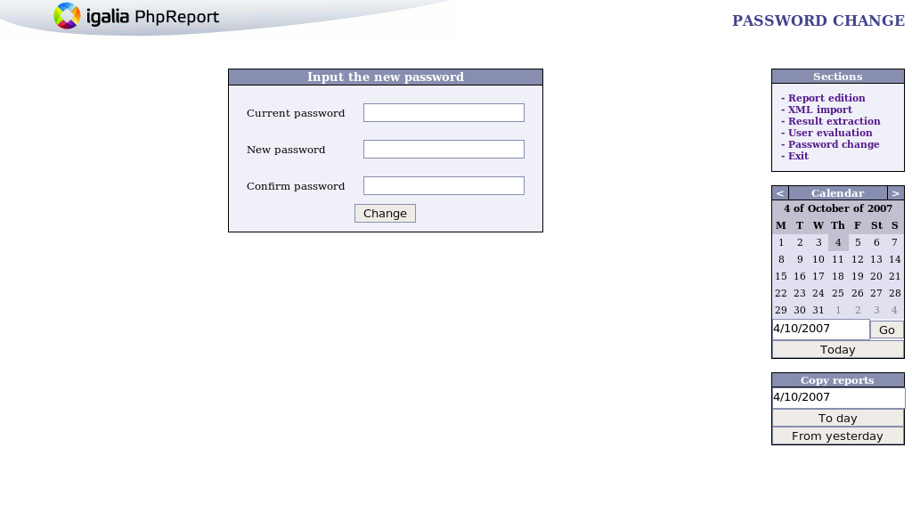

Calendar: edit and copy reports
Within calendar, you can edit and copy reports day to day. In order to edit a specific report, you must go to this day and then you can edit the daily tasks. If you can't edit these task, it's posible that an administrator had blocked the task edition. You must get in contact with your administrator.
Two modes exist to copy reports:
- “Day-to-day” mode
First step: go to day from you want copy. Second step: at “Copy reports” menu you must select day to copy and then pulse “To day” menu.
- “From yesterday” mode
You must go on day in which you must copy tasks. Then, pulse button “From yesterday” and yesterday report will be copy at day what you had selected.
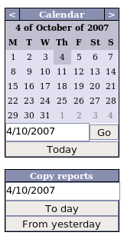

Apendix: how extra hours are calculated?
- extra_hours = worked_hours – workable_hours
- worked_hours = sum(“all time tasks”)
- workable_hours is a very little complex calculation. Figure below indicates how it goes:

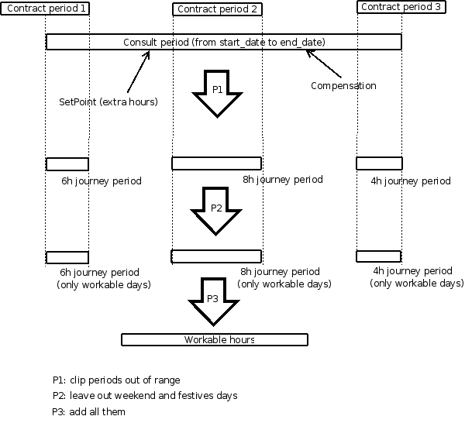
extra_hours can be positive or negative value. If they are positive, it means that worker has worked more hours than she/he must have at this slot time. If they are negative, it means that worker has worked less hours than she/he must have at this slot time.
In other hand, there is two special thing about extra_hours calculation: setpoint and compensation.
Setpoint. Into a table in database (table extra_hours, view technical manual) is stored a value (only to certain users) which indicates number of extra_hours for a certain date. When extra_hours is calculated, this value is taken as initial reference to calculation. For instance, if user admin has this value as 1789h at 13-april-1934, this hours are init extra_hours and hours dates before will be ignored (they could be different than zero). This value have to be set from a client database for your database server, you can't do this from phpreport aplication.
Compensation. This is a mechanism wich make posible change worked hours by money, holidays, etc. This extra hours will don't count when you generate “total worked hours recount”. It will does seem that these hours never had exist, because they are compensated.

