词汇

recollect 回忆

bar 封锁

一堵墙挡住了进房间的路

a wall bar the way into the garden

在狱中behind bars

他才貌出众。she far transcends other in beauty and intelligence.

对和平的渴望超越了政治的分歧。The desire for peace transcended political difference.

未能建立很好的运输网络限制了贸易的发展。Failure to set up a good transport network inhibited the expansion of trade.

禁止某人做某事。 inhibit sb from doing sth

提出某事作为理由 allge sth as a reason

上任 take up a appointment

凝视美丽的落日 contemplate a beautiful sunset

那封信是对我们的法律立场的直截了当的声明。The letter was a bald statement of our legal position.

它的一切努力无济于事。all his efforts avail to nothing.

一种语言中不是每个词都在另一种语言中有对等的词。

Not every word in one language has an equivalent in another.

她施展手腕使自己进入了公司的最高领导层。she maneuvered her way to the top of the company.

杰夫把全部财产全押在这次的投骰子上。Jeff ventured his whole fortune on one throw of the dice.

讨论促进了思想的自由发展。The discussions stimulated a free exchange of ideas.

一个富有启发性的教师可以激励学生取得成功。An inspiring teacher can stimulate students to succeed.

我们把她惹得很不高兴

we incurred her displeasure.

在许多职业中，钱仍是主要的激励因素。money is still a major incentive in most occupations.

易冲动的人 a man of impulse

孩子们遇到了暴风雨。a storm overtook the children.

小小的误会引起了他们之间的不和。A trivial misunderstanding caused a breach between them.

对我来说节食需要极大的意志力。For me,dieting requires a supreme effort of will.

登上月球开启了太空探索的新纪元。The moon landing inaugurated a new era in space exploration.

We need to bring warmth to those who are in adversity.我们需要将温暖带给那些处于逆境中的人

这个事件震惊全国。The event staggered the whole country.

假期被错开以便工人正常运作。The holidays are staggered so that we can keep the factory running.

他听到这一消息两腿摇晃起来。

he gave a stagger on hearing the news.

云聚集的快，散的也快 The clouds dispersed as quickly as they had gathered.

This decision signified a radical change in their policies. 这个决定表明了他们的政策发生了根本的变化。

大教堂高高矗立，俯瞰整个城市。The cathedral dominate the city.

联系是语言学习必不可少的一部分。Practice is a integral part of language learning.

一位称职的法官应该刚正不阿。A qualified judge should be complete integrity.

他们竭尽全力保持自己的文化完整无缺。They tried hard to keep the integrity of their culture.

这个孩子虽然才领养一年，但她已经完全融入了这个家庭的生活。The child was only adopted a year ago,but she has completely integrated into the family’s life.

服从上级 obey one’s superior

许多人加入我们以示团结一致。A lot of people joined with us as an act of solidarity.

旧车市场已经饱和。The market of used car is saturated.

水果的产量高 a high yield of fruit

对......让步 make a concession to

uncompromising 不妥协的坚定的

三峡工程建设需要大规模移民。The construction of the Three Gorges Project entails large migration.

他的讲话激发了我的思绪。 Her speech gave an impetus to my idea.

判断往往因利害关系而产生偏差。 Judgement is often biased by interest.

你对这个问题的回答矛盾百出。 Your answer to the question is full of paradox.

我百感交集。 my emotion was in a complete tangle.

资金缺少对他的生意十分不利。lack of money handicapped him in his business badly.

作文

很多人将税收看作经济负担，减少了他们的可支配收入。然而，我认为税收是一个有必要的，因为没有税收，它是很困难的对于国家高效运行。

Most people perceive tax as a financial burden which can reduce their disposable income.However,i consider taxation a necessary evil,because without tax revenue it is difficult for a country to function effectively.

政府可以将税收投资到对于公共生活必不可缺的公共服务和设施的供应上。。

The government can invest tax money in the provision of public services and facilities which are indispensable to the daily lives of the public.

税收被收集来支付这些人的工作，谁的工作可以满足公民的需求，就像消防队和警察机关，谁保护公众免除火灾和罪恶。

Tax money is collected to pay for the labour of these people,whose work can address the needs of citizens.such as fire brigades and police forces,which protect the public from fire accidents and crime.

更严重的是，人们可以经历很多的不便，如果一个城市没有如公交站，学校，医疗服务和废物处理厂。这些设施不能正常运行，如果没有来自由税收组成的的政府赞助。私人投资者有时在教育服务和医疗健康上投资，但往往改变成高价，远超不同大众的能力。

Furthermore，people could experience tremendous inconvenience if a city did not have public facilities such as bus station,school,medical service and waste treatment plants.These facilities could not be available without the found of the government,most of which is from tax receipts.Private investors sometimes invest on the educational service and healthcare,but normally change a high price which is out of the reach of the general public.

税收是一个强有力的工具去实现社会的再分配，对社会的稳定至关重要。很多国家采用渐进式的税收，意味更高的收入，更多的税收需要支付，

taxation is powerful tool to achieve the goal of distribution,which is important to social stability.Many countries impose progressive tax,meaning that the higher income a taxpayer earns,the more tax she or he should pay.

从高收入者中收取的税收可以被使用提供一个安全的小屋为低收入家庭，像无工作者的低保，残障人士的经济支持和低收入家庭的救济金。在低收入等级的人们通常受低税率管制，所以他们能够保留他们口袋中的大部分收入去满足他们的基本收入。这可以缩小富人和穷人之间的差距并降低由于经济不一致而导致的社会不安。

A tax levied from high-income earners can be used to provide a safety net for needy people,such as benefits for the jobless,financial support for those with disabilities and allowance for low-income families.People in the low-income bracket are normally subject to a low tax rate so they can retain a large proportion of income in their pockets to cover basic needs.This can close the gap between the haves and have-nots and reduce the possibility of social unrest arising from economical disparity.

总的来说，政府收税是合理的，税收对于国家运行和社会稳定至关重要。

Overall,it is reasonable for the government to charge tax,which is central to the running of a country as well as its stability.

人们现在经常光顾餐厅，因为快的生活节奏和不规律的工作时间。

Many people today frequent restaurants,because of fast pace of life and irregular working hour.

快餐在很多文化里已经威胁了传统的烹饪方式，人们需要重视潜在的问题。

Fast food has posed a threat to traditional cuisine in mant cultures,and people should pay attention to potential problems.

快餐在某些国家，如美国，已经成为一个健康问题，在那些国家，肥胖人口迅速增加。

Fast food has become a health issue in many countries,such as American,where the number of overweight people has increased dramatically.

这不仅因为快餐含高脂肪、糖分、盐分和卡路里，也因为快餐的份量很大。

It is not only because fast food in high in fat、sugar、salt and calories but also because fast food is served in large portions.

肥胖的人更可能患有心脏病及其他健康疾病。

Those obese people have a higher risk of suffering from heart diseases and other health problems.

这会给一个国家的医疗系统造成巨大负担，也会影响经济发展。

It can impose a burden on the medical system of society,and have an adverse impact on economical development.

另一个问题就是快餐也会影响人们的生活方式，包括饮食习惯。

Another social issue is that it can have a negative effect on people’s lifestyles including eating habits.

传统食物的特点是食材、烹饪方式和口味的多样性，体现了烹饪文化在不同地区的演变。

Traditional food in the world is diverse in the ingredients,cooking styles and flavours,and it also represents the evolution of cuisine in different regions.

目前，绝大部分的快餐店店铺提供美国或欧洲的时评，包括汉堡包、炸鸡和比萨饼。

At present,most fast food restaurants only provide American and European food,including hamburgers、fried chicken and pizza.

假如快餐店垄断市场，人们的饮食会逐渐变得单调，而一些传统菜谱可能会消失。

if fast restaurant predominate，people’s diet is increasingly monotonous,while some traditional recipes may vanish.

快餐也会对家庭关系有负面影响，因为人们不像从前一样那么频繁参加家庭聚餐。

Eating too much cooked-food can also be harmful to family relationship,as people attend family meals less frequently than before.

家庭聚餐给家庭成员提供了相互交流，相互理解的机会。

Family meals provide family members with an opportunity to communicate with each other and improve their mutual understanding.

假如人们经常在外面吃饭，他们就不太可能知道家人的近况，人们很少能够照顾家人的感情需要。

if they often eat out in fast food restaurants,they will not be able to keep up to date with family issues and respond ti emotional needs of their family members.

这会导致家庭关系越来越疏远，而很多人在生活中遇到问题时会感到孤独和无助。

This may lead to distant family relationships and people will feel lonely and helpless when facing problems in daily lives.

因此，我赞同快餐会产生很大的负面作用。

Thus,I agree with the idea that fast food can have a negative impact on both families and society.

快餐不仅会威胁人们的健康，还会破坏饮食文化和社会关系。

It would pose a threat to people’s health,cuisine culture and social relationships.

阅读

她有一头浓密的棕发 she has a mass of auburn hair

他的音乐很商业化，针对的是普罗大众。His music is commercial.It is aimed at the masses.

强烈的感受到的只有深深的震惊和愤怒。The overwhelming feeling is just deep,profound shock and anger.

这是一本充满高深，新颖且富有挑战性见解的书。This is a book full of profound,original and challenging insights.

这是一个社会分化的使其，社区和家庭纽带已经遭受破坏。This is a time of social fragmentation,when communal and family bonds have ended.

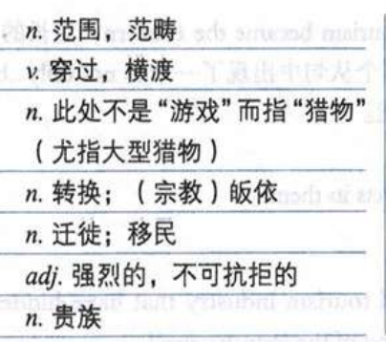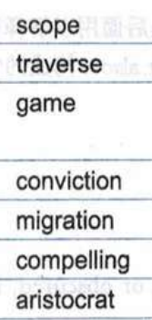我们会忽视关于自身健康的各种预警。We overlook all sorts of warning signals about our own health.

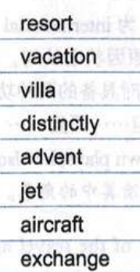

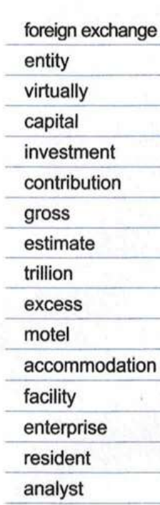

 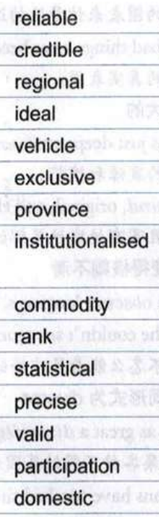

The unit has become part of a larger department and no longer exists as a separate entity . 这个单位已附属于一个大的部门，不再作为一个实体独立存在。

每次危机都会使我们抛弃思考食物的传统方式。

Every crisis make us discard our traditional way of looking at things.

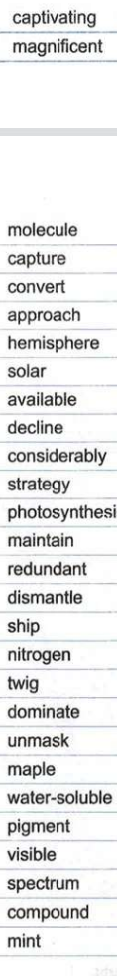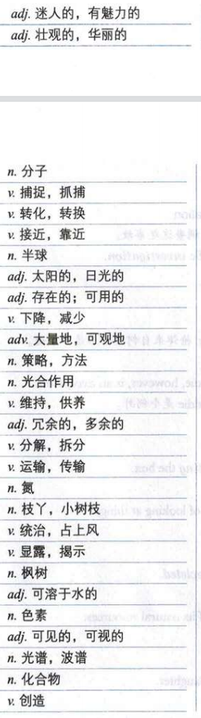

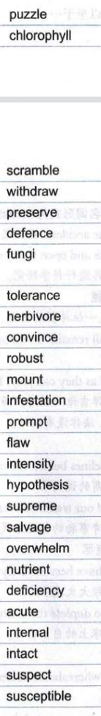

this unmasking explains 这个揭露解释了

maple  槭树；枫树