词汇\阅读

缓解病人的痛苦

alleviate the cancer patients’ suffering

幻想小说是想象的产物

Fantasies are creature of imagination.

evolve a new management style

Instead of strict legal restrictions and force enforcement, the government should evolve new management methods，which may use the power of attraction to get the citizen to do what the government would think is desirable behaviour.

对这项提议保留态度

express reservations about the proposal

without reservation 无保留地

with reservation of 除某物之外，以某物为保留条件

people can give more support to the technology with reservation of private information.

养活一大家子

sustain a whole family

 negotiations for a durable peace 为持久和平而进行的谈判

有教养的人

a man of great culture

“每一票都很重要”是政治上的老生常谈

“Every vote counts”is a familiar refrain in politics.

牛奶里含有丰富的钙

Milk is a very good source of calcium.

我们除了观望之外没有其他方法。

we had no other resource but to wait and see.

这里一年到头都有很多橙子

Oranges abound hear all the year round.

Talents abound Jiaxing all the dynasty of China

Jiaxing in the past dynasties and generations of talents

Nanchang in the past dynasties and generations of heros

Heros abound Nanchang all the dynasty of China

the intrinsic value of education 教育的固有价值

他承认我提的意见的内在价值，但又说还需要大量细致的改进。

He admitted the intrinsic merits of my idea,but he said it would need a lot of refinement.

a blast of wind

the price of the milk has been hiked 牛奶价格被提高

The US has imposed a technology blockade on China

他的批评用语十分谨慎

He phased his criticisms in careful terms.

言语具体表现各种思想和感情

Words embody thoughts and feelings.

These elements can be combined in a multitude of different ways. 这些因素可以通过无数不同的方式进行组合

[artificial intelligence](javascript:;)

个人崇拜泛滥

The cult of personality is rampant in （）

The cult of personality has spread like wildfire

文学的本质是情感与理智的斗争

The every essence of literature is the war between emotion and intellect.

The university students resent having to ask the leader of college permission in entering and living school.

During the lockdown, college students resented the need for strict reporting of any travel.

a hostile climate/environment

hostility n 敌意敌对

一份详细的分析报告

a detailed analysis of the economy.

毒害公众的思想

contaminate the mind of the public

他在音乐方面的爱好与她丈夫一致

Her taste in music coincides with her husband’s

这两条线重合

These two lines coincide with each other.

The tastes of us coincide with each other

他怒气冲冲地用拳头猛击桌子

He smashed his fist down on the table in a fury

意想不到的消息使他所有的希望都破灭了。

There are few restrictions on freedom in exchange for the right to live

他是一个有良好教育的男孩

He is a well-bred boy.

傲慢酿成他的失败

Arrogance breeds his failure.

总有一天人类会征服大自然

One day people will tame nature.

他头脑冷静

he is presence of mind

我们没能注意到两个案例的相同之处

we fail to note the identities in the two cases.

In terms of inclusiveness, a country with only a few decades of reform and opening up can hardly compare with the

They are more exclusive

It's a capital crime in my country  
a bleak outlook/prospect 暗淡的前景╱前途

但是由于没有任何降水的迹象，收获的前景看起来很渺茫

With no signs of any precipitation,the prospect of the harvest looks bleak.

东西方可以为彼此共同的利益和进步而合作

The East and the West can work together for their mutual benefit and progress.

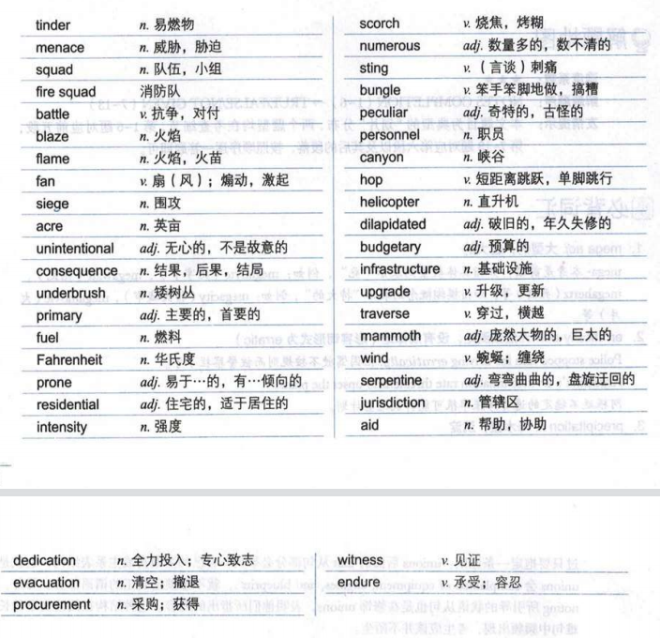

政府官员和当地居民都有这样的感觉，来自几个州和辖区的消防元的速度、投入和合作构成了比先前围攻大火情形下更高的救灾效率。

There is a sense among both government officials and residents that the speed,dedication,and coordination of firefighters from several states and jurisdictions are resulting in greater efficiency than in past ‘siege fire’ situations.

The problem of gender antagonism are becoming an increasing menace in the modern China.

性别对立问题在中国越来越成为一个威胁。

he antagonism he felt towards his old enemy was still very strong. 他对宿敌的仇恨仍然十分强烈。

尽管他们比以前有更好的准备以及几十年来应对的经验。

despite better preparedness than ever and decades of experience fighting fires fanned by the wind.

despite better preparedness than ever and decades of experience fighting rumors fanned by the Western media

I was surprised by his preparedness to break the law. 我对他打算以身试法感到惊讶。  
a mammoth task 巨大的任务

 the serpentine course of the river 蜿蜒曲折的河道

We must do everything possible to lift the siege.  
 我们必须尽一切可能解除包围。

evacuation

撤离疏散撤退转移

There were waves of evacuation during the blitz.

a full-scale evacuation of city centre.

我开始尝试解开这个谜

I started to try and untangle the mystery

该罪行没有政治动机

The crime was not politically motivated

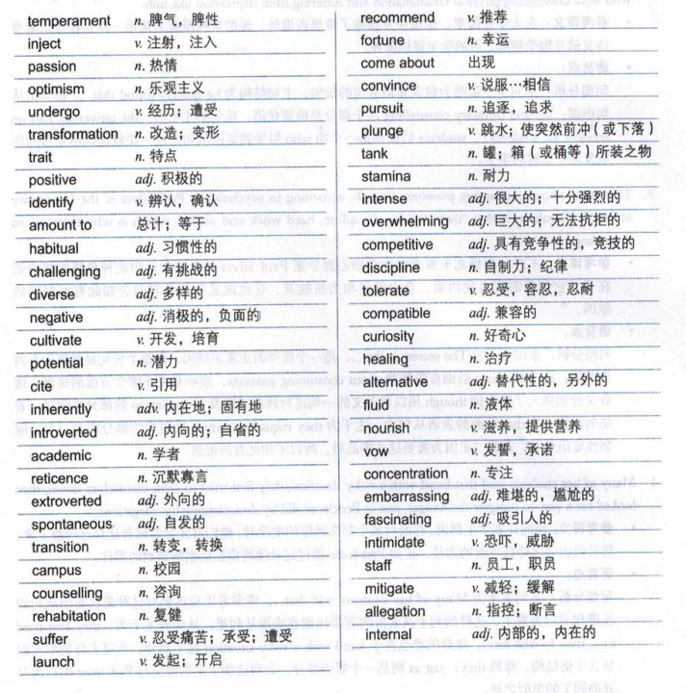

They say that portraying introduced species as inherently bad is an unscientific approach.

他们说把外来物种描绘成天生的坏物种是一种不科学的做法。  
Man is not inherently violent.

人类并非生来就暴力。

Machen was a lonely, introverted child.

梅琴是个孤独，内向的孩子。

在大学校园里，他很快发现了常规咨询外，他的学校没有像他一样正在经历着身体复健并饱受抑郁之苦的学生提供服务。

On campus,he quickly found that beyond ordinary counselling,the university had no services for students who were undergoing physical rehabilitation and suffering from depression like him.

以任何有意义的方式

in any meaningful way

人性中的那些重要特点

the key trait of personality

他们正在逐渐发现的是：这些品质中有许多实际上就是习惯性行为，他们决定了我们对这个世界作出反应的方式。

What they are discovering is that many of these qualities amount to habitual behaviour that determines the way we respond to the world.

many of our perceptions amount to the environment that determines the way wo respond to the world.

现在我的外向举止是自发的

Now my extroverted behaviour is spontaneous.

于是他发起组织了一个团队来帮助其他有着类似状况的人

He therefore lauched a support group to help others in similar situations.

提升乐观心态的关键在于通过培养乐观的行为而非正面思维。

The key to increasing optimism is through cultivating optimistic behaviour,rather than positive thinking.

她建议你训练自己去关注那些好事，具体做法是每天写下当天发生的三件具有积极意义的事情。

She recommends you train yourself to pay attention to good fortune by writing down these positive things that come about each day.

这会有助于令你相信，好的结果其实时刻都会发生，这使得采取行动也会更容易。

This will help you To convince yourself that favourable outcomes actually happen all the time,making it easier to take action.

It takes a lot of stamina to run a marathon. 跑马拉松需要很大的耐力。

他的研究与他对治疗方法的好奇并不兼容。

He was miserable as his research was not compatible with his curiosity about healing.

从长远来看，获得一个新的人格特点也许能帮助你朝向你想要成为的那个人迈进，在短期内看来，这种努力本身就能出乎意料的带来感恩，这是一场内心的冒险。

In the long term,picking up a new character trait may help you move toward being this person you want to be.And in the short term,the effort itself could be surprisingly rewarding,a kind of internal adventure.

移民在很多国家都是一个有争议的问题

Immigration is a controversial issue in many countries.

无限制地满足人类需求而不会使环境恶化的能力

The ability of meeting human needs indefinitely without degrading the environment.

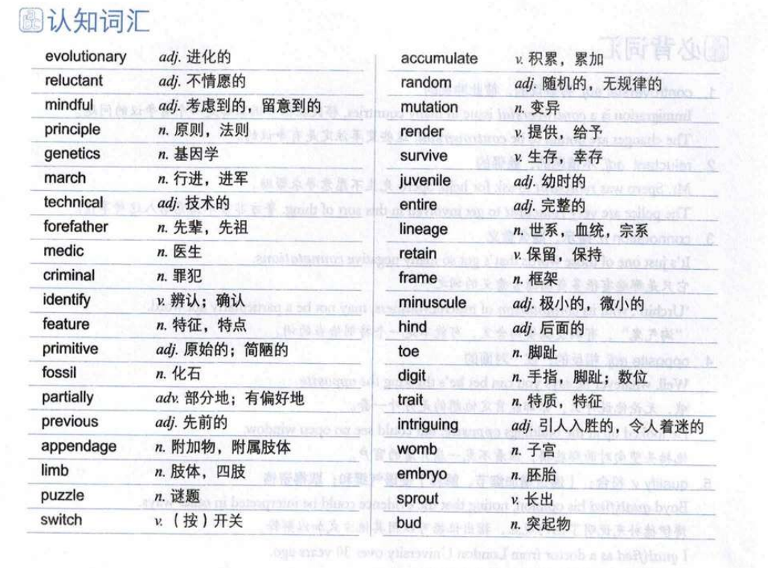the march of progress/technology/time 平稳的进步；技术的稳步提高；时光的推移

funeral march 葬礼进行曲

The word ‘professional’ has connotations of skill and excellence. professional这个词隐含着技艺和专长的意思。

 irreversible brain damage (= that will not improve) 无法治愈的脑损伤

cells affected by mutation 受到突变影响的细胞

an atavistic urge/instinct/fear 返祖倾向╱本能；返祖性畏惧

The likelihood is that these companies now will show excellent profits on a two-year timescale.