Mark

Team name: | A5
Homework number: | HOMEWORK 5
Due date: | 29/10/2023
Contribution | NO | Partial | Full
Luca Daidone |  |  | x
Leonardo Ritter |  |  | x
Luca Cordaro |  |  | x
Lorenzo Strechelli |  |  | x
Ignazio Neto Dell'Acqua |  |  | x
Notes:

Project name | ADC Scan mode and LDR measurement
Not done | Partially done  (major problems) | Partially done  (minor problems) | Completed
 |  |  | x
Explanation:
We successfully completed the homework.

Excercise 3a - ADC scan using DMA:

CubeIDE Settings:
- We begin by configuring the potentiometer's output as an input for our STM32, specifically setting it as the first input to ADC1, with PA1 designated as ADC1_IN.

- In the “Analog” section we activate the IN1 in the “Mode” panel. The configuration must be as follow:
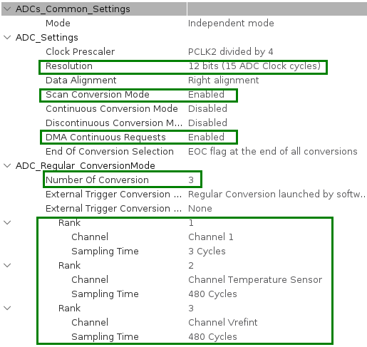
We enable "Scan Conversion Mode" to allow the ADC to scan and convert multiple channels sequentially.
We enable "DMA continuous request" to ensure that the conversion results are sent by DMA to memory continuously.
We set the "Number of conversions" to 3, considering the 3 different channels to measure.
For the T and Vref channels, we set the sampling time to 480 cycles, as these signals change slowly.
We initiate the conversion by software.

- We employ two DMA controllers, one for ADC data and the other for the USART protocol. We configure the ADC DMA to operate in "circular" mode, which ensures it automatically restarts to write to the first memory cell when the last memory cell is written. We set the direction of the ADC DMA as "peripheral to memory" and the USART DMA as "memory to peripheral."

- USART2 is activated in asynchronous mode, with the following configurations:
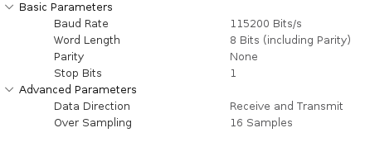

- The NVIC table must be set as follow:
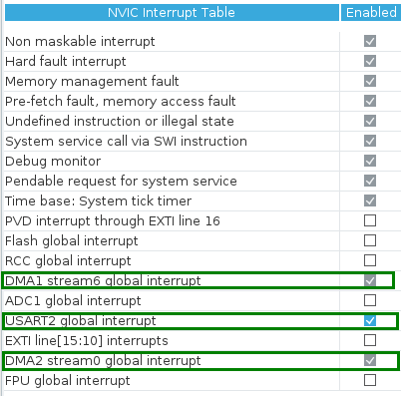
The DMA interrupts are automatically set up when we enable the DMA peripherals.
We enable the global interrupt for USART2 to ensure that the USART DMA continues sending data.
There's no need to activate the ADC1 global interrupt since we've observed that the ADC DMA interrupt serves the same purpose.

Code:
In the infinite loop, first the ADC is started in DMA mode with the “HAL_ADC_Start_DMA()” function, and after that a simple 1s delay is introduced.
The HAL_ADC_Start_DMA() requires as parameters: the ADC handler, an array of data where the DMA pheripheral will store the conversion results, called adc_val[3], and a parameter that specifies the size of the memory pointed by the DMA.
In the "void HAL_ADC_ConvCpltCallback()" routine, which is called after the ADC completes all three conversions and the DMA fills the memory, we handle all the conversions as follows:

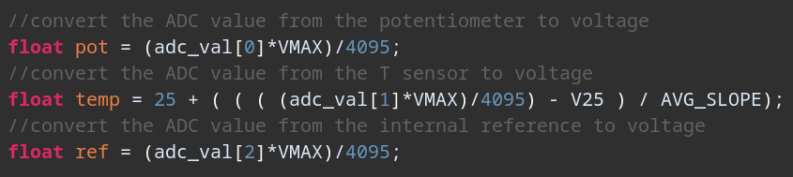
- for the potentiometer, the ADC value is simply converted into voltage
- for the Temperature, the following formula is used:
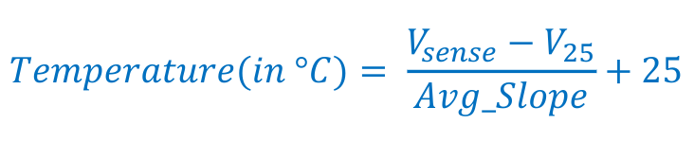

- for the reference voltage, again the value is simply converted into voltage

All the float results are then written into a buffer string with the “snprintf” function and sent over UART through the HAL-function “HAL_UART_Transmit_DMA”.
The program counter will go back to the infinite loop, where the ADC will be started again after the 1s delay.

Excercise 3b – Light dependent resistor:

CubeIDE Settings:

Professor comments:

