Mark

Team name: | A5
Homework number: | HOMEWORK 10
Due date: | 17/12/2023
Contribution | NO | Partial | Full
Luca Daidone |  |  | x
Leonardo Ritter |  |  | x
Luca Cordaro |  |  | x
Lorenzo Strechelli |  |  | x
Ignazio Neto Dell'Acqua |  |  | x
Notes:

Project name | IR Communication
Not done | Partially done  (major problems) | Partially done  (minor problems) | Completed
 |  |  | x
Explanation:
We successfully completed the homework.

IR Transmit:
Referring to the schematic of the "green PCB," we observe that PB10 is directly connected to the PWM channel of TIM2, serving as the driving circuit for the IR LED, which requires a PWM signal. To facilitate keyboard operation, essential for generating data destined for the IR-UART protocol, it is necessary to activate all pins configured in the previous project. It's worth noting that for the four row pins, we designate the GPIO pins as external interrupts.

CubeIDE Settings:
- we set the PB10 as PWM output of TIM2
- we set PC2, PC3, PC12 and PC13 like GPIO_EXTIx (with falling edge detection) and PC8,PC9,PC10,PC11 as GPIO_Output in order to control the keyboard.
- Enable the TIM10, used to iteratively activate the keyboard’s columns, the TIM11 used for the IR-UART baud rate and enable their corresponding interrupts in the NVIC table.

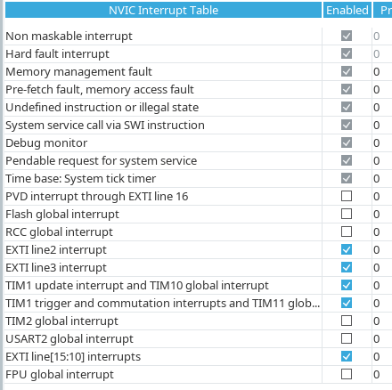
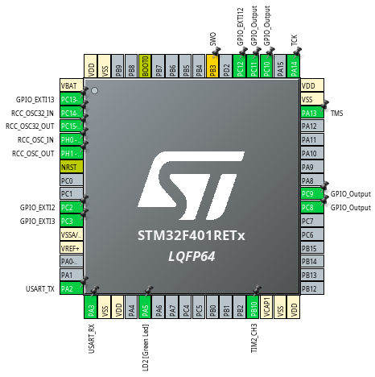

Code:
Following the same principle as in HOMEWORK_09, we employ a 4x4 keyboard scanning approach to detect pressed buttons. When a button is pressed, an interrupt is triggered. By identifying the corresponding row, we can determine the specific button pressed out of the 16 available. Utilizing a matrix to store the time elapsed since the last press event on a button, we can discern whether the press event is valid or should be disregarded. Once the pressed button is identified and its position calculated, we initiate IR-UART transmission by starting TIM11 and activating PWM. It's noteworthy that the start bit on the receiver side must be a low logic level. Therefore, if the LED is driven in PWM mode, the receiver will receive a '0,' while if PWM is off, the receiver will detect a high logic level.
For IR-UART transmission, the baud rate is determined by the time between TIM11 interrupt events. Each interrupt signifies the completion of a bit-time, indicating that the next bit should be transmitted. This timing synchronization is crucial for successful communication between the transmitter and receiver.
Upon each TIM11 interrupt, a "transmitCounter" variable is employed to keep track of the bit being sent within the 10-bit packet (start + 7-bit payload + parity + stop). The data to be sent over IR-UART is stored in the "transmitPayload" uint8_t variable. The "transmitCounter" is also utilized to specify the index of the bit within "transmitPayload" to be sent during each TIM11 interrupt event. A '0' activates the PWM, while a '1' keeps it inactive. Once the 10th bit is transmitted, the communication halts, and TIM11 is stopped.

IR Receive:
The receiver board has to save the data sent by the other board in a variable that is used to display the character (corresponding to the key pressed on the transmitter keyboard) on the led matrix.
Pin PA10 is connected to the IR receiver circuit, and is set as EXTIx in order to trigger an interrupt when a communication starts.

CubeIDE Settings:
- we set the pin PB6 as GPIO_Output
- we set the pin PA10 as GPIO_EXTIx
- we set PA5 as SPI1_SCK, PA7 as SPI1_MOSI and we configured the SPI like in homework 7, with its DMA
- we configured TIM2 in order to raise an interrupt flag every 2.5 s, TIM3 every 2.3 ms to drive the LED array and TIM10 every 42 ms for the UART baud rate
- eventually we enabled the required interrupts in the NVIC interrupt table

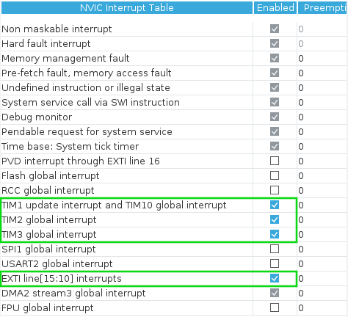
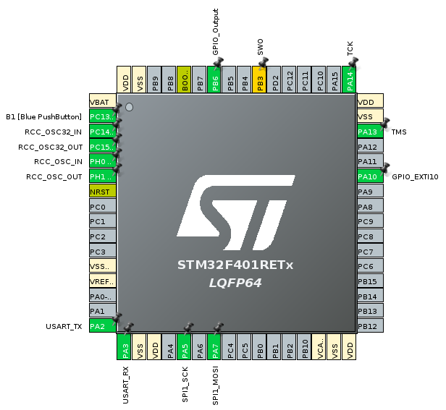

Code:
Upon receiving a start bit and triggering an interrupt, the HAL_GPIO_EXTI_Callback() function sets a flag, enabling communication initiation within the while(1) loop. Subsequently, in the while(1) loop the output value from the IR receiver is read, and the corresponding bit is appended at position 0 of the "payload" variable. Finally, TIM10, responsible for tracking bit-time, is initiated. Each TIM10 interrupt increments the "bit_counter" variable, aiding in tracking the number of received bits.
The interval between two bits, determined by TIM10, is set to 42ms—slightly below the suggested maximum of 0.417 ms (2400bps). This timing synchronization is crucial for consistency between transmitting and receiving boards.
Within the while(1) loop, at the conclusion of each iteration, both the UART_started_flag and tim_elapsed flags are reset to 0, ensuring entry into the conditional statement only upon receiving new data. Upon the arrival of the stop bit, the "payload" is reset, along with the flags, and timer10 is halted.
The "payload" variable is populated with the value read via the HAL_GPIO_ReadPin() function, appropriately shifted into the required position.
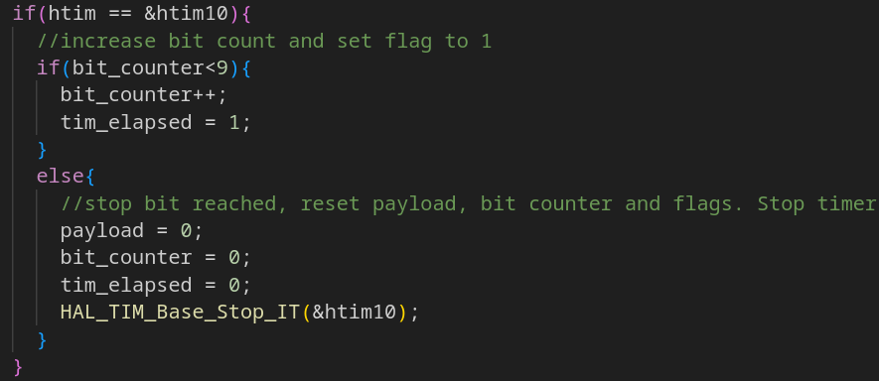
In the while(1) loop, at the end of each iteration both UART_started_flag and tim_elapsed flags are set to 0, in order to enter in the if only when a new data has been received. When also the stop bit arrived, payload is reset, as well as the flags and the timer10 is stopped.
The variable payload is filled with the bit_val value read thanks to HAL_GPIO_ReadPin() function and shifted in the position needed.

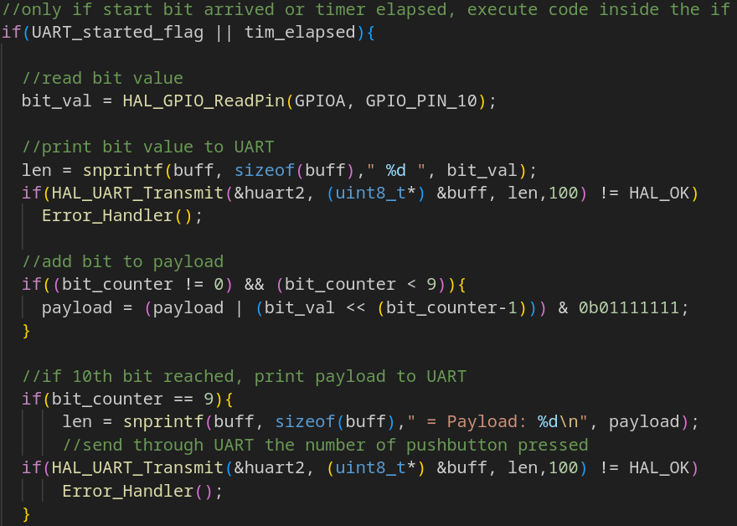
Eventually we add the code of the lab 7 slightly modified, in order to display the desired character on the led matrix and clear the matrix if no data is received for more than 2.5 seconds.
Professor comments:

