Mark

Team name: | A5
Homework number: | HOMEWORK 8
Due date: | 26/11/2023
Contribution | NO | Partial | Full
Luca Daidone |  |  | x
Leonardo Ritter |  |  | x
Luca Cordaro |  |  | x
Lorenzo Strechelli |  |  | x
Ignazio Neto Dell'Acqua |  |  | x
Notes:

Project name | Encoder 1a & 1b
Not done | Partially done  (major problems) | Partially done  (minor problems) | Completed
 |  |  | x
Explanation:
We successfully completed the homework.

Part a) Encoder readout

CubeIDE Settings:
- First we set the pins PC6 and PC7 respectively as CH1 and CH2 of the TMR3.
In the timer section, we activate TMR3 in “Encoder Mode” through the “Combined channels” menu.
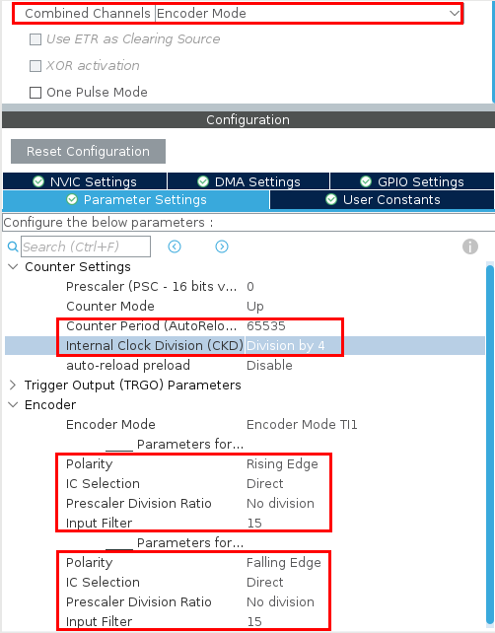
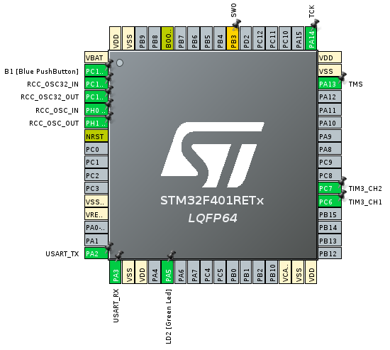
The parameters must be set as follow: internal clock division by 4, polarity of first channel as rising edge, polarity of second chanel as falling edge and filter set to 15 for both channels. Setting the filter to 15 activates a 12.2us digital filter, mitigating spurious pulses resulting from contact bouncing.
The pulses emitted from the two outputs of the encoder are quadrature-encoded, meaning that when the incremental encoder is moving at a constant velocity, the output waveforms are square waves and there is a 90 degree phase difference between them. In order to specify to the STM32 how to define the sign of the phase difference between our 2 channels, we use the polarity settings.
The timer will extract a clock from the two channels active edges and will increment or decrements its register accordingly.

- USART2 is activated in asynchronous mode, with the following configurations:
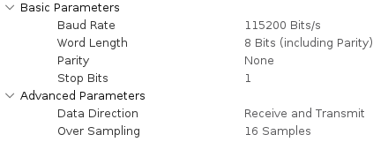

Code:
Before the infinite loop, we start the timer in encoder mode with the HAL_TIM_Encorder_Start() function, then in the while(1) loop, we first save the content of the counter register into a int16 variable called “curr_count” using the __HAL_TIM_GET_COUNTER() function.
To determine the number of "ticks" the encoder has experienced in the past second, we firste read the actual value of the TIM register, we calculate the delta by subtracting from the actual value the past value, and then we store the current value in the “previous value” variable before idling the system for 1 second.
To address potential overflow and underflow issues, we use int16_t for the "current" and "previous" variables, as well as the "delta" variable. This choice ensures that the subtraction operation between two 16-bit variables, considering 2's complement, effectively discards the 17th bit, preserving only the necessary LSBs and eliminating detrimental information from larger bits (17th and beyond). This ensures correct delta computation even across overflow/underflow conditions.
We then multiply the delta by 60 and divide it by 24 (the maximum number of ticks per revolution) to compute the speed in rounds per minute. Finally, we send the calculated value to the PC via UART.
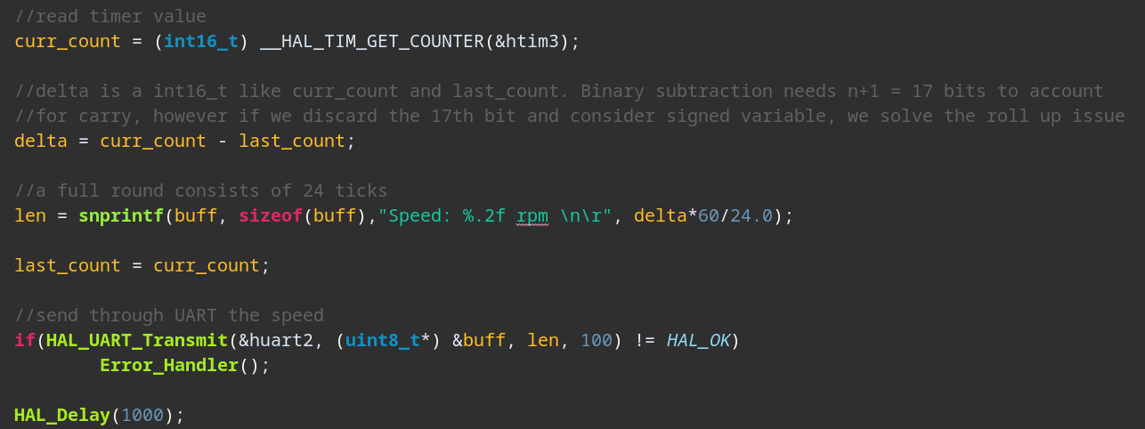

Part b) Encoder readout with TMR and DMA

CubeIDE Settings:
- TMR3 settings are the same as before (encoder mode)
- TIM10 is enabled and configured such as an interrupt is generated every second (PSC = 4800-1, Period = 10000-1).
- he SPI pins are set like in the previous point. The DMA2 Stream3 is emploied to manage the SPI comunication. Besides TMR10, now also TMR2 is emploied to switch between letters. Its ARR is filled every seconds.
- USART2 is activated in asynchronous mode, as in the previous point.
- We employ one DMA controller for the USART2. We configure it to operate in "normal" mode with direction as “memory to peripheral".
- Under “System Core” tab we set in the NVIC section both the USART2 global interrrupt and the TIM10 global interrupt. The DMA interrupt is automatically set.
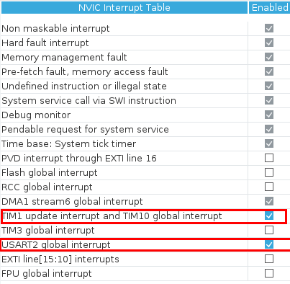

Code:
The mechanism is the same as the point before, with the only difference that the code that calculates the RPM speed is executed in the TIM10 ISR, and that the HAL_UART_Transmit_DMA() function is emploied.

Professor comments:

