Mark | A

Team name: | A5
Homework number: | HOMEWORK 6
Due date: | 12/11/2023
Contribution | NO | Partial | Full
Luca Daidone |  |  | x
Leonardo Ritter |  |  | x
Luca Cordaro |  |  | x
Lorenzo Strechelli |  |  | x
Ignazio Neto Dell'Acqua |  |  | x
Notes:

Project name | I2C temperature sensor – I2C Accelerometer
Not done | Partially done  (major problems) | Partially done  (minor problems) | Completed
 |  |  | x
Explanation:
We successfully completed the homework.

Excercise 1b – Temperature sensor:
CubeIDE Settings:
- We started looking where the LM75 sensor was placed in the green board schematic and we found out that it is connected to pins PB8 (SCL) and PB9 (SDA) of I2C1. So we set in the CubeIDE graphical interface these two pins as I2C1_SCL and I2C1_SDA and then in the connectivity tab we set the I2C1 mode as I2C.
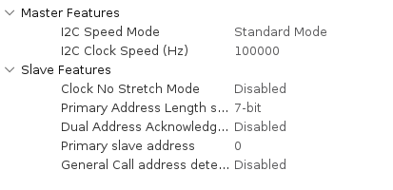

- USART2 is activated in asynchronous mode, with the following configurations:
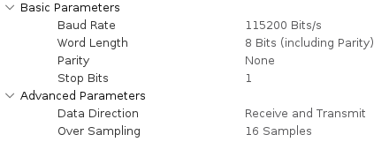

- TIM2 is enabled and configured such as an interrupt is generated every second (PSC = 4800-1, Period = 10000-1).
- Under “System Core” tab we set in the NVIC section both the USART2 global interrrupt and the TIM2 global interrupt.
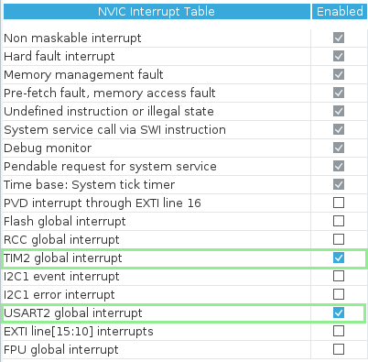
Code:
In order to start the communication with the LM75 sensor, we first have to use HAL_I2C_Master_Transmit() function, before the infinite loop, to set the LM75’s pointer value to 0x00, such as the sensor will send us the temperature data. Now the timer can be started in interrupt mode, and in its callback function we acquire the registers containing the MSBs and the LSBs with the HAL_I2C_Master_Receive() function:
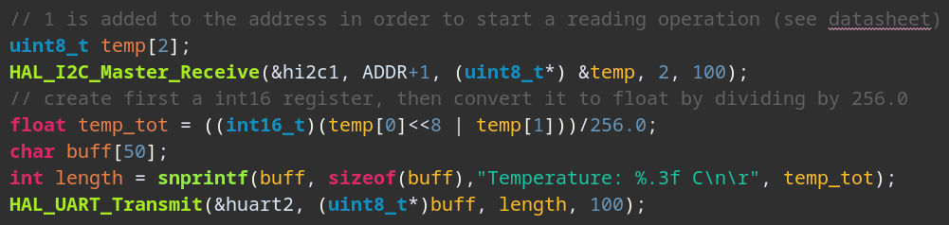
To do so, two 8bits variables are declared and then given as parameters of the HAL_I2C_Master_Receive() function. Note how +1 was added to the address of the sensor, since the first 7bits represent the real address while the LSB represents the I2C read command.
The two 8 bit variables are then combined in a 16bit register, and the float value is obtained by dividing by 256.0 (first we multiply by 256 through the left shift, then we need to divide in order to obtain the correct value).
Lastly we send the string with the temperature value via UART to the PC.

Verification of correctness of sign:
Binary to Celsius conversion works correctly even with negative temperatures since the bits received with I2C protocol are converted in int16_t and then in float, so they are treated like signed numbers. We took all the precautions and put a board in the freezer for a brief time, and verified that the conversion works correclty indeed.

Bug when temperature rapidly changes:
We think this bug occurs when we read the LM75 register containing the MSB and LSB bytes, and it is due to the delay between the transmission of the two bytes. While the controller on the sensor is sending the first byte, the second one might have changed. In order to avoid this bug we should read the two registers in parallel, but I2C protocol does not allow to do that. Hence in order to reduce the probability of having this bug, we read the two register one after the other (using one HAL_I2C_Master_Receive function for both registers) working at the maximum speed available for I2C controller of the STM32 (400 kbps). If the bottleneck is the sensor itself, only software low pass filtering can reduce this bug.

Excercise 1b – Accelerometer:
CubeIDE Settings:
- I2C protocol is set up exaclty as in the previous point.
- USART2 is activated in asynchronous mode, as in the previous point.
- We employ one DMA controller for the USART2. We configure it to operate in "normal" mode with direction as “memory to peripheral".
- TIM2 is enabled and configured such as an interrupt is raised every second (PSC = 4800-1, Period = 10000-1).
- Under “System Core” tab we set in the NVIC section both the USART2 global interrrupt and the TIM2 global interrupt. The DMA interrupt is automatically set.
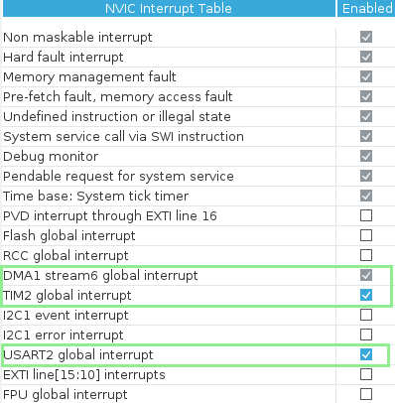
Code:
In order to start the communication with the LIS2DE sensor, we first have to use 3 HAL_I2C_Master_Transmit() functions, before the infinite loop, in order to send the configuration values to the following control registers:
- CTRL_REG1: Normal mode (1Hz), x,y,z axis enabled (ODR0 , Zen, Yen, Xen bits high);
- CTRL_REG2: Normal mode, Filter bypassed (all bits to zeros);
- CTRL_REG4: Continous update, +/- 2g, self-test disabled (all bits to zero).
The sensors I2C address used is 0b01010000, last bit is set to 0 since we are writing.

Now the timer can be started in interrupt mode.
In the timer callback function we first tell to the LIS2DE which register we want to read from by sending the address of the register ACC_OUT_X as data on the I2C bus : the address used is 0x29+0x80, such as the MSB of this subaddress is set to 1 and the auto increment mode is activated. In this way the sensor will automatically keep sending the values of the following registers, without the need of requesting it through I2C. Note the registers containing the X, Y and Z values are not adjacent, but are spaced out by other registers. We need to save the received bytes in a 5 elements buffer, and take only the data in the position 0, 2 and 4.
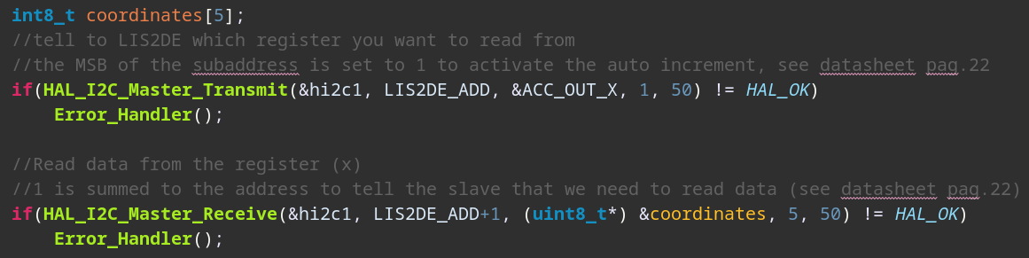
In order to tell the sensor we want to read values, we also need to set the LSB of the address to 1, as specified in the datasheet, therefore +1 is added to the address.
Finally we convert the values to ‘g’ by dividing by 64.0, and transmit them via UART using DMA.
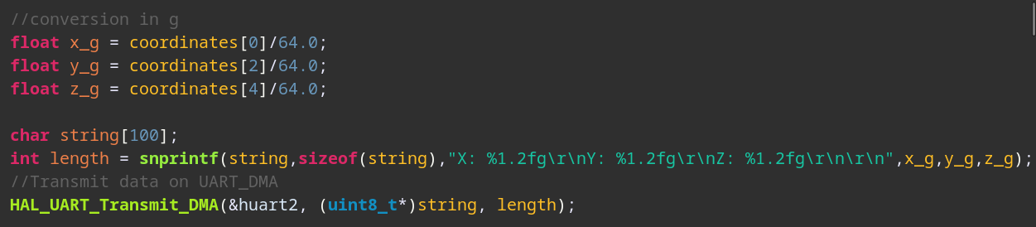
Excercise 1c – Accelerometer:
CubeIDE Settings:
The core setup and code are exactly the same as the previous point (1b), with the only difference that the I2C RX is made using DMA. In order to do that:
- We added a I2C1 RX DMA1 Stream 0 (Perpheral To Memory, normal mode) and enabled its NVIC event interrupt. The DMA1 Stream 6 is still used for the USART
- TIM2, USART2 and I2C are set up exactly as before.
- The NVIC table is set up as before, but now also “I2C1 event interrupt” must be enabled

Code:
Exactly as before, we initially set up the 3 control registers, and then start the timer in interrupt mode. On each timer interrupt, we first request the data from the ACC_OUT_X register by sending its address to the sensor, setting up also the auto-scrolling as we did before, and then we request a DMA acquisition for all the coordinates at once. The 5 elements buffer is still used.
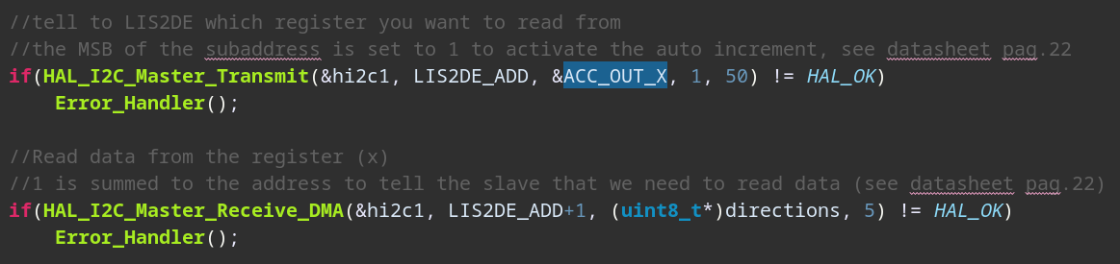
We move the calculation of x,y,z in ‘g’ and the transmission in UART via DMA in the HAL_I2C_MasterRxCpltCallback, called every time an I2C RX event is rised.
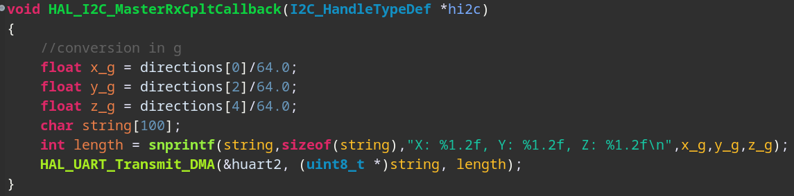
Professor comments:

