Mark

Team name: | A5
Homework number: | HOMEWORK 9
Due date: | 16/10/2023
Contribution | NO | Partial | Full
Luca Daidone |  |  | x
Leonardo Ritter |  |  | x
Luca Cordaro |  |  | x
Lorenzo Strechelli |  |  | x
Ignazio Neto Dell'Acqua |  |  | x
Notes:

Project name | 4x4 keyboard
Not done | Partially done  (major problems) | Partially done  (minor problems) | Completed
 |  |  | x
Explanation:
We successfully completed the homework.

Part a) Scan each column and read the keyboard using polling:
The idea is to enter in a timer ISR every 1 ms, pull down a column at a time (the other columns are set to a high level) and check if an input pin has been driven low, i.e. if a button is pressed.

CubeIDE Settings:
- First we set PC2,PC3,PC12,PC13 as GPIO_EXTI and PC8,PC9,PC10,PC11 as GPIO_Output. We set USART2 in DMA mode, with default settings. Eventually we set the EXTI lines interrupt required and the USART global interrupt.
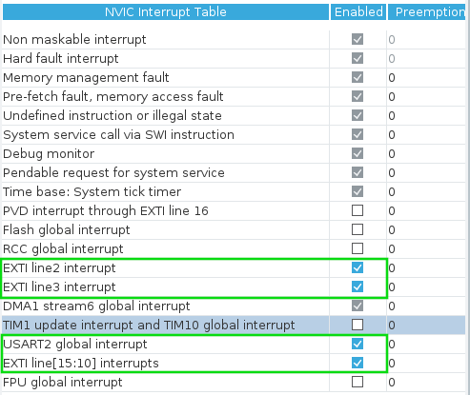
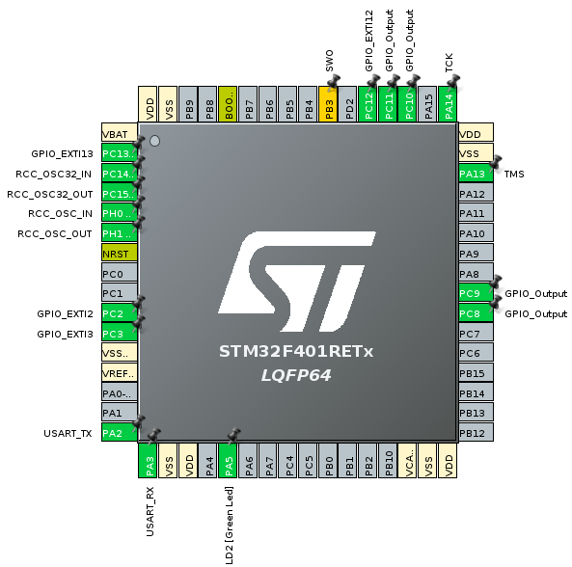

Code:

Part b)

CubeIDE Settings:
- We set pins PC8,PC9,PC10,PC11 as before, but then

Code:

Problems encountered:

Professor comments:

