Mark | A

Team name: | A5
Homework number: | HOMEWORK 6a
Due date: | 12/11/2023
Contribution | NO | Partial | Full
Luca Daidone |  |  | x
Leonardo Ritter |  |  | x
Luca Cordaro |  |  | x
Lorenzo Strechelli |  |  | x
Ignazio Neto Dell'Acqua |  |  | x
Notes:

Project name | I2C temperature sensor
Not done | Partially done  (major problems) | Partially done  (minor problems) | Completed
 |  |  | x
Explanation:
We successfully completed the homework.

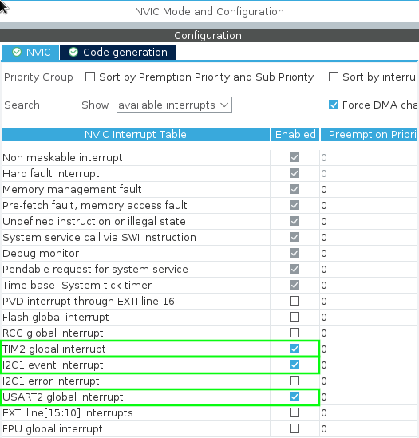
Part a:
We started looking where the LM75 sensor was placed in the green board schematic and we found out that it is connected to pins PB8 (SCL) and PB9 (SDA) of I2C1. So we set in the CubeIDE graphical interface these two pins as I2C1_SCL and I2C1_SDA and then in the connectivity tab we set the I2C1 mode as I2C. Under System Core tab we set in the NVIC section both the I2C1 event interrupt and the USART2 global interrrupt. We also configured a timer filling its ARR in 1s.

In order to start the communication with the LM75 sensor, we have to use HAL_I2C_Master_Transmit() function to send the data needed to initialize it correctly (0x00). Now the timer can be started and in its callback function we acquire the registers containing the MSBs and the LSB(s) with HAL_I2C_Master_Receive() function. Then we put the two registers in a int16_t variable and we multiply it for the LSB (this operation is done in order to convert the 16 bits variable to the correct decimal temperature value). Lastly we send the string with the temperature value via UART.

Verification of correctness of sign:

Binary to Celsius conversion should work fine even with negative temperatures (although we have not tested it) since the bits received with I2C protocol are converted in int16_t and then in float, so they are treated like signed numbers. Then this number is multiplied by the value of the LSB (0.5 or 0.125 °C), so the correct sign is mantained.

Bug when temperature rapidly changes:
We think this bug occurs when we read the LM75 register containing the MSBs and then wait some time before reading the register containing the LSB(s). In order to avoid this bug we should read the two registers in parallel, but I2C protocol does not allow to do that. Hence in order to strongly reduce the probability of having this bug, we read the two register one after the other (using one HAL_I2C_Master_Receive function for both registers) and, considering we are working at the maximum speed available for I2C controller of the STM32 (400 kbps), it is very unlikely we have this bug.

Note:
There are many ways to find out which is the sensor mounted on the board. Probably the simplest one is try to put in the code both values of LSB and understand which are the more reasonable values.
Professor comments:

